Pre-Extension Demonstration of the Newly Released Qey-Bure Common Bean Variety with Full Package Application in Boricha District, Sidama National Regional State

Abstract
Early-maturing, disease-resistant, drought-tolerant and high-yielding common bean varieties are important for improving production and productivity under smallholder conditions. This pre-extension demonstration was conducted at Boricha District, Sidama National Regional State, to promote the newly released Qey Bure common bean variety with its full production package, assess farmers' preferences and estimate its economic advantage compared with the standard check, Gegebe. Ten farmers were selected based on willingness, land availability and accessibility, in collaboration with kebele development agents. Training was provided for participating farmers, development agents, woreda extension personnel and other stakeholders to establish a shared understanding of the demonstration activity, agronomic practices and package implementation procedures. Each farmer hosted two 200 m2 plots for Qey Bure and Gegebe, with the same seed rate, fertiliser application and management practices. Land preparation, planting, follow-up, monitoring, evaluation, field visits and field days were conducted jointly with farmers and extension actors. Agronomic and yield-related data, including maturity, disease resistance, drought tolerance and yield, were collected through direct measurement and observation. Farmers' preference data were gathered using predetermined criteria, and the data were analysed using means, percentages, preference score ranking and partial budget analysis. Qey Bure produced a mean yield of 22.5 qt/ha, compared with 15.55 qt/ha for Gegebe, representing a 30.88% yield advantage. Farmers preferred Qey Bure for grain yield, pods per plant, drought tolerance and disease resistance, whereas Gegebe was preferred for early maturity. The partial budget analysis showed a net benefit of 150,080 ETB/ha from Qey Bure. The findings indicate that Qey Bure has practical potential for wider popularisation in the study area.
Keywords: Pre-extension demonstration; common bean; Qey Bure; Gegebe; full package application; yield performance; farmers' preference; drought tolerance; disease resistance; partial budget analysis
1. Introduction
1.1 Background and Justification
Legumes are major sources of protein in Ethiopia, where common bean (Phaseolus vulgaris L.) accounts for a large proportion after faba bean and field pea (Asfaw et al., 2004). It is also an important cash crop and export commodity that generates foreign currency for the country (Abebe, 2009). Common bean is one of the major grain legumes widely cultivated by smallholder farmers in Southern Ethiopia. It is a basic component of small-scale farmers' cropping systems and diets in Ethiopia, as in many other countries in East, Central and Southern Africa (Solomon and Walelegn, 2018).
Common bean is used as a source of income by farmers, and it is an important hunger-break crop during the belg season, when food scarcity reaches a peak at the time of meher planting. Because beans have a short growing period, the crop can be produced twice a year. Common bean has been one of Ethiopia's leading exportable pulse crops for the last four decades (Ferris and Kaganzi, 2008), and Ethiopia is a leading exporter of common bean in Africa. The major bean market class for export is small white pea bean; however, other bean market classes, such as small red, sugar bean, pinto and cream beans, are also exported to Europe, the Middle East and Asia (Fitsum and Tasew, 2022).
In Ethiopia, where 73.4% of common bean production is used for household consumption (CSA, 2011), its importance as a source of income for smallholder farmers has increased over the years. The leading destinations for Ethiopian common beans are European, Middle Eastern, African and Far Eastern countries. Ethiopia exports red and navy beans, much of which are produced by smallholder farmers. Red bean exports account for more than 10% of the country's common bean volume, while navy beans account for 90%.
Despite the importance of the crop to farmers and the national economy, average yields obtained by farmers in Ethiopia remain very low (Mulugeta et al., 2023). The national average yield of common bean is low, ranging from 0.5 to 0.8 tonnes ha-1, which is far below the corresponding yield recorded at research sites (2.5-3 tonnes ha-1) using improved varieties. The national average yield (of both white and red types), calculated for the meher and belg seasons of 2015/16, was 1208 kg/ha, while the regional average yield for the belg season in the southern part of the country was 880 kg/ha (CSA, 2016). The low national mean yield observed for common bean could be attributed to various constraints, including low adoption of improved agricultural technologies, drought, lack of improved varieties, poor cultural practices, disease and environmental degradation.
Recent global crop-risk evidence further emphasises that hot-dry extremes and synchronised low-yield events can reduce crop performance and threaten food security, strengthening the rationale for farmers' access to locally adapted, drought-tolerant and disease-resistant varieties (Heino et al., 2023; Kornhuber et al., 2023).
In the Sidama region, many farmers use local varieties that are readily available to them rather than improved varieties, and production and productivity remain low. Therefore, demonstrating early-maturing, disease-resistant, drought-tolerant and high-yielding varieties is an important tool for enhancing diffusion and increasing common bean production and productivity in the selected areas.
For grain legumes, yield-component analysis has also shown that traits such as pods per plant, seeds per plant and biological yield can guide the selection of high-yielding genotypes, which supports the participatory evaluation of Qey Bure based on yield, maturity, drought tolerance and disease resistance (Srilatha et al., 2026).
Although improved common bean varieties have been released, their practical performance and acceptability under farmers' field conditions in Boricha District have not been sufficiently demonstrated. In particular, farmers require locally observed evidence on yield, drought tolerance, disease resistance, maturity, grain colour and economic return before adopting a newly released variety. This demonstration therefore addressed the need to link the Qey Bure variety with the extension system and farmers' selection criteria under local production conditions.
1.2 Objectives
1.2.1 General Objective
The overall objective of this demonstration activity was to promote the newly released common bean variety and highlight its increased yield and other relevant characteristics.
1.2.2 Specific Objectives
- To demonstrate the high-yielding, drought-tolerant and early-maturing Qey Bure common bean variety with its full package.
- To assess farmers' preferences regarding the improved common bean variety.
- To compute the economic advantage of the newly released common bean variety.

2. Materials and Methods
2.1 Description of the Study Areas
Boricha Woreda is an administrative district located in the Northern Sidama Zone of Sidama National Regional State, Ethiopia. It is located approximately 32 km south-west of Hawassa, the zonal and regional capital, and about 307 km from Addis Ababa. The woreda, which is part of the Great Rift Valley, shares borders with Darara Woreda to the south, Bilate Zuriya Woreda to the west, Hawassa Zuriya Woreda to the north and Shebedino Woreda to the east.
The geographical location of Boricha Woreda extends from 6º46'N and 38º04'E to 7º01'N and 38º24'E, and the area is characterised by flat-lying topography in terms of altitudinal variation. Boricha Woreda is composed predominantly of plain lowland, accounting for about 78% of its total area, with the remaining 22% consisting of rougher terrain. Agro-ecologically, the woreda is categorised into two zones: 35% midland (Woynadega) and 65% lowland (Kola). Woynadega has a medium altitude, whereas Kola has a low altitude. The altitude of the woreda ranges from 1769 to 2077 metres above sea level. This elevation contributes to a climate that is generally considered semi-arid, mainly due to high temperatures and relatively low rainfall. The mean annual rainfall typically ranges from 700 mm to 1242 mm, with an erratic distribution. The rainy season is divided into two main periods: belg (short rains) from February to May, which is characterised by erratic rainfall, and meher (main rains) from June to mid-September, which usually brings more consistent rainfall. The meher season contributes approximately 80% of the total annual rainfall.
The woreda has a total population of 132,242, of whom 64,695 (49%) are male and 67,583 (51%) are female. Of the total population, 127,712 (62,414 male and 65,298 female) are rural residents, and 4530 (2245 male and 2285 female) live in urban and peri-urban areas. The woreda has 17,108 rural households, comprising 15,489 male-headed households and 1619 female-headed households. The woreda comprises 14 kebele administrations, among which 13 are rural kebeles and one is an urban/peri-urban kebele. The total land area of the woreda is 9818.4 ha, with an average holding of 0.25 ha (minimum 0.125 ha and maximum 1 ha). Of the total land, 8027.2 ha is cultivated/cropland (4010 ha annual and 4017.2 ha perennial), 931.7 ha is covered by forest (244 ha natural forest and 687.7 ha plantation forest), 360.5 ha is grazing land, 216.2 ha is covered by other land-use types, and 282.8 ha is uncultivable land.
Agriculture is the primary livelihood and economic activity in Boricha Woreda, with a mixed farming system involving both crop and livestock production. Crop production comprises 75% of the entire agricultural activity, while the livestock sector accounts for the remaining 25%. Maize, enset, common bean and sweet potato are the main crops grown in the area. Approximately 60% of the woreda's farmers produce common bean, covering 3216 ha of land. Among the common bean types grown, 60% are red types, 10% are white types and the remaining 30% are mixed. Old varieties such as Hawassa Dume, Nassir and Ibadu are known in the area, although recent and more productive varieties have not yet been popularised. Fruits are also part of agricultural production in the area, with 30% of farmers engaged in fruit production. A total of 105 ha of land is covered by fruits, of which 60% is covered by avocado, 5% by mango and 40% by banana.
Another important farming activity in Boricha Woreda is dairy production. Cattle (both domestic and crossbreeds), sheep, goats, fowl (both domestic and foreign varieties), horses, mules and donkeys are among the livestock types raised. The woreda's livestock population includes 77,750 dairy animals, 13,729 oxen/bulls, 22,585 sheep, 34,335 goats, 3042 equines and 328,174 local and exotic fowl. There is a promising beekeeping practice in the woreda, with 6323 hives (1840 traditional hives, 3506 transitional hives and 131 contemporary hives).
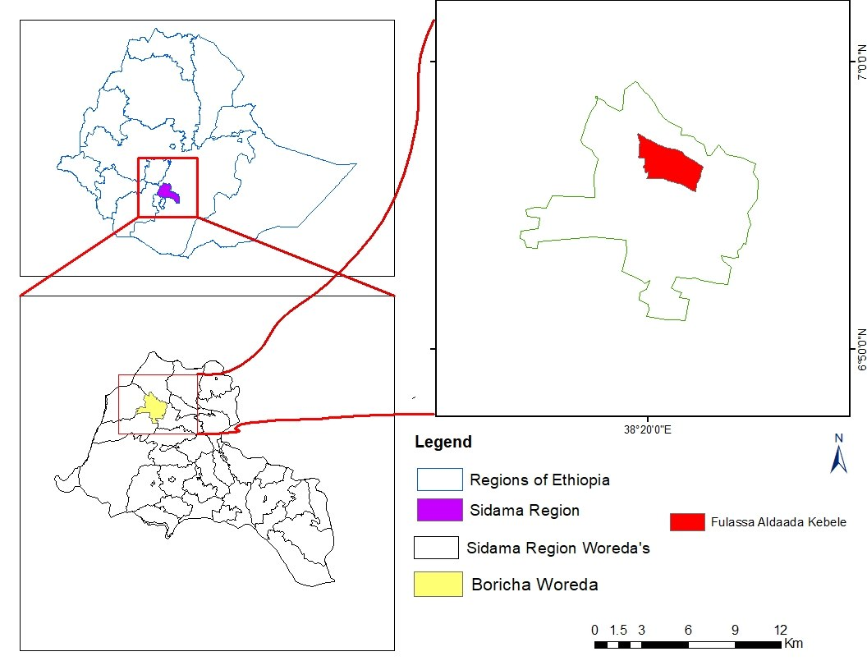
Map 1. Administrative map of Boricha District
2.3 Training and Awareness Creation
Training was provided to participating farmers, DAs, woreda extension agents and other stakeholders to establish a common understanding of the KT project intervention areas, the common bean demonstration activity, the agronomic practices of the variety and the procedures for implementing the technology package. The KT project coordinator, the common bean breeder and technology demonstration researchers delivered the training.

  - Land Preparation and Planting
Farmers were trained on implementation procedures before land preparation began. They were largely responsible for preparing their plots for planting by ploughing them at least three times. Seeds were obtained from the centre's on-station seed multiplication site and distributed to each farmer in adequate quantities. After proper site preparation was ensured, all farmers planted their seeds with technical support from researchers and development agents. DAP chemical fertiliser was applied according to the recommended rate for common bean production.
  - Detailed Implementation Procedures and Design
The demonstration activity was conducted on two plots, each with an area of 200 m2 for the improved and standard check varieties, respectively, in each farmer's field. The newly demonstrated variety was Qey Bure, while the older standard check variety was Gegebe, which has been known to farmers and the extension system for several years. The newer Qey Bure variety was demonstrated for higher yield and drought resistance.
Regarding the implementation procedures, the seed rate was 100 kg/ha for both varieties. Inorganic fertiliser was applied at a rate of 100 kg/ha DAP. Spacing between plants and rows was 10 cm by 40 cm, respectively. Ten farmers participated in the demonstration activity based on willingness, land availability and accessibility. The farmers were selected in collaboration with kebele-level development agents (DAs).
  - Management, Follow-up and Evaluation
Farm management and follow-up were conducted regularly in partnership with farmers and development agents. Weeds were managed three times in each farmer's plot. Farmers were evaluated at various phases of crop growth, and a mini-visit and field day were undertaken to examine the differences between varieties in several agronomic features, as well as farmers' preferences.
2.7 Methods of Data Collection and Analysis
Yield and other agronomic data, such as date of maturity, resistance to disease/pest occurrence and related traits, were collected through direct measurement and observation. Farmers' preference data were also collected from participant farmers using a score-ranking method. Feedback was obtained from joint evaluation with farmers and from the field-day event. Finally, input costs and economic return data were recorded from the farmers and based on the contemporary market structure.
Regarding data analysis, means, frequencies and percentages were employed to analyse quantitative and yield-related data. Score ranking and partial budget analysis were used to analyse farmers' preferences and cost-benefit analysis, respectively.

3. Results and Discussion
3.1 Implementation and Communication Procedures
3.1.1 Training
Participating farmers and development agents received training on the overall activities and processes. All 10 participating farmers attended training on the nutritional content, economic benefits and agronomic practices of the newly released Qey Bure bean variety. The training was conducted by breeders, agronomy and technology transfer researchers in partnership with the Boricha Woreda agricultural and natural resource management office. The KT project provided financial assistance for the training and overall activity, and it monitored the demonstration activity until completion. Table 1 summarises the training participants.
3.1.2 Field Day
Monitoring, evaluation and mass communication of the technology took place at different stages of crop growth. At the germination stage, farmers were gathered to evaluate the germination performance of the varieties. After flowering, a mini-visit was organised with farmers, woreda extension personnel and a guest from the regional bureau. Regional media were also invited to popularise the technology at a wider level. Finally, a field day and discussion forum were organised by gathering neighbouring farmers to visit the performance of the newly introduced common bean variety and share experiences. The new variety was largely demonstrated in the target kebele and surrounding areas. Table 1 summarises the participants in the field visit and field day.
 | Participants |  |  |  |  |  |  |  |  | Grand Total
 | Farmers |  |  | Extension Agents |  |  | Researchers |  |  | Grand Total
 | Male | Female | Total | Male | Female | Total | Male | Female | Total | Grand Total
Training | 10 | 0 | 10 | 4 | 0 | 4 | 4 | 0 | 4 | 18
Field Visit | 20 | 5 | 25 | 4 | 0 | 4 | 5 | 0 | 5 | 34
Field Day | 39 | 11 | 50 | 4 | 1 | 5 | 5 | 0 | 5 | 60
Total | 69 | 16 | 85 | 12 | 1 | 13 | 14 | 0 | 14 | 112
Table 1. Summary of training, field visit and field-day participants
3.2 Yield Performance of the Varieties
The varieties showed better mean yield performance than the standard check. As farmers reported, the local average yield remained far below the performance of the new variety. The table below presents the yield performance of the varieties.
 |  | Qey Bure (Qt/ha) | Gegebe (Qt/ha)
1 | F1 | 25 | 17.5 | Yield Advantage (%)
2 | F2 | 23 | 20
3 | F3 | 24 | 20
4 | F4 | 26 | 14
5 | F5 | 20 | 12
6 | F6 | 20 | 10
7 | F7 | 17 | 10
8 | F8 | 25 | 20
9 | F9 | 24.5 | 14.5
10 | F10 | 23 | 17.5
 | Mean Yield | 22.5 | 15.55 | 30.88
 | SD | 2.90 | 4.01
Table 2. Yield performance of common bean varieties at Boricha Woreda
As shown in the table, Qey Bure outperformed the Gegebe variety, with a mean yield of 22.5 qt/ha, compared with 15.55 qt/ha for Gegebe. The yield advantage of the newer variety was 30.88% compared with the standard check.
3.3 Farmers’ Preferences Among the Demonstrated Varieties
The varieties were ranked based on grain yield, days to maturity, pods per plant, disease resistance, drought tolerance and colour after cooking. Because there was a shortage of rain during the belg season, drought resistance was discussed in terms of the variety remaining green on dry days. The occurrence of rust also helped farmers identify the resistant variety. The score-ranking results are presented in the chart below.

Chart 1. Farmers' preferences regarding the demonstrated common bean varieties
Regarding early maturity, all farmers selected Gegebe over Qey Bure at Boricha Woreda. This is because Gegebe is known for early maturity; it is sometimes called "fetenech", which means fast. However, it showed low resistance to disease and moisture stress. It was attacked by rust and suffered from a shortage of rainfall. In contrast, Qey Bure resisted, survived and produced a better yield under rust occurrence and rainfall shortage. Regarding colour, farmers hardly detected a significant difference between the two varieties, and both varieties received 50% of farmers' votes. Hence, Qey Bure was highly preferred by the farmers and is recommended for further popularisation.
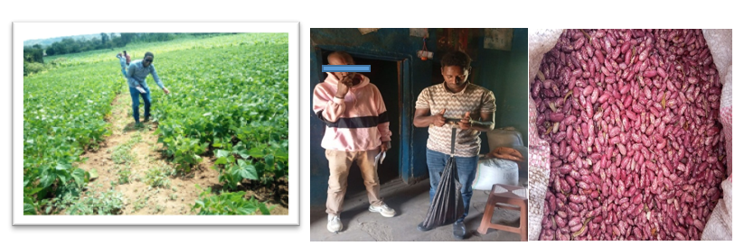
Picture 1. Performance of common bean in the field and after harvesting, and the researcher recording the yield
3.4 Cost-Benefit Analysis
Another way to assess the value of a technology is to examine its economic benefits. Therefore, a partial budget was computed to demonstrate the overall benefits of the newly introduced Qey Bure variety. The following assumptions were based on the current market structure, input prices at woreda level and labour accessibility in the area, and the table below presents the partial budget analysis of the Qey Bure variety at Boricha Woreda.
Production Cost/ha |  |  |  |  | Benefit from Output/ha
Activity | Unit | Quantity | Unit Price (ETB) | Total Price (ETB) | Average seed (Qt /ha) | Unit Price | Total Price (ETB)
Land Preparation (3 times) | Person | 30*3 | 150 per day | 13,500 | 22.5 | 10,000 ETB | 225,000
Seed Purchase | Kg | 80 | 100 | 8000 | 22.5 | 10,000 ETB | 225,000
DAP | Kg | 120 | 91 | 10,920 | 22.5 | 10,000 ETB | 225,000
Planting | Person | 30 for three days | 150*3 | 13,500 | 22.5 | 10,000 ETB | 225,000
Weed management and follow up (3 times) | Person | 30*3 | 150*3 | 13,500 | 22.5 | 10,000 ETB | 225,000
Harvesting | Person | 30 for two days | 150*2 | 9,000 | 22.5 | 10,000 ETB | 225,000
Feed for laborers | - | - | - | 4,500 | 22.5 | 10,000 ETB | 225,000
Transportation | - | - | - | 2,000 | 22.5 | 10,000 ETB | 225,000
Total |  |  |  | 74,920*A |  |  | 225,000 *B
Net Benefit |  | B-A= |  |  |  |  | 150,080
Table 3. Partial budget analysis of the Qey Bure bean variety at Boricha Woreda

4.1 Conclusion
This pre-extension demonstration introduced the newly released Qey Bure common bean variety, together with its recommended production package, to farmers and extension actors in Boricha District, Sidama National Regional State. Ten farmers hosted paired demonstration plots of Qey Bure and the standard check, Gegebe, each on 200 m2, under comparable agronomic management. Training, field visits and field-day activities supported farmers, development agents and other stakeholders in observing the performance of the varieties under local conditions. The results showed that Qey Bure produced a mean grain yield of 22.5 qt/ha, whereas Gegebe produced 15.55 qt/ha, giving Qey Bure a yield advantage of 30.88%. Farmers also preferred Qey Bure for grain yield, pods per plant, drought tolerance and disease resistance, although Gegebe was preferred for early maturity. The partial budget analysis indicated that Qey Bure generated a net benefit of 150,080 ETB/ha under the reported market and input-cost conditions. On the basis of the observed agronomic performance, farmers' preferences and economic return, Qey Bure can be considered a suitable option for further popularisation in comparable agro-ecological areas. Continued collaboration among research, extension and farmers will be important for supporting wider use of the variety. This should be accompanied by regular technical follow-up.

4.2 Limitations of the Study
This demonstration was limited in scope and should be interpreted in relation to its design and implementation conditions. The activity was conducted in Boricha District with ten participating farmers, and the varieties were evaluated on paired 200 m2 plots at each farmer's field. Therefore, the results may not represent performance across wider agro-ecological zones, soil types, seasons or farm-management conditions. The demonstration compared Qey Bure with one standard check, Gegebe, and did not include a broader set of released or local varieties. Yield and preference data were collected during one implementation period, when rainfall shortage and disease occurrence influenced farmers' observations of drought tolerance and disease resistance. The economic analysis was based on contemporary input prices, labour access and market prices, which may change over time and affect net benefits. Further multi-location and multi-season demonstrations would strengthen the evidence for wider scaling and help refine recommendations for different production environments.
Disclaimer (Artificial intelligence)

Author(s) hereby declare that NO generative AI technologies such as Large Language Models (ChatGPT, COPILOT, etc.) and text-to-image generators have been used during the writing or editing of this manuscript.

References
Abebe, G. (2009). Effect of NP fertilizer and moisture conservation on the yield and yield components of haricot bean (Phaseolus vulgaris L.) in the semi-arid zones of the central rift valley in Ethiopia. Advances in Environmental Biology, 3(3), 302–307.
Asfaw, A., Dauro, D., & Kimani, P. M. (2004). Decentralized participatory bean breeding in southern Ethiopia. In Proceedings of the 11th Conference of the Crop Science Society of Ethiopia. Crop Science Society of Ethiopia. https://erepository.uonbi.ac.ke/items/97fd326b-1c63-4860-96a0-dcf7243491f9
Central Statistical Agency (CSA). (2011). Agricultural sample survey 2010/2011 (2003 E.C.): Volume I, report on area and production of major crops (private peasant holdings, meher season). Central Statistical Agency. https://catalog.ihsn.org/catalog/1389/download/41524
Central Statistical Agency (CSA). (2016). Agricultural sample survey 2015/2016 (2008 E.C.): Volume V, report on area, production and farm management practice of Belg season crops for private peasant holdings (Statistical Bulletin No. 578). Central Statistical Agency.
Ferris, S., & Kaganzi, E. (2008). Evaluating marketing opportunities for haricot beans in Ethiopia (IPMS Working Paper No. 7). International Livestock Research Institute. https://hdl.handle.net/10568/479
Alemayehu, F., & Derese, T. (2022). Progress of common bean breeding and research achievements in Southern Ethiopia. International Journal of Research Studies in Agricultural Sciences, 8(5), 13–19. https://doi.org/10.20431/2454-6224.0805002
Habte, M., Assefa, A., & Ayalew, A. (2023). Yield response of common bean to different types and rates of blended fertilizers in Hawassa Zuria Woreda, Southern Ethiopia. International Journal of Science and Research Archive, 8(1), 995–1000. https://doi.org/10.30574/ijsra.2023.8.1.0187
Yokamo, S., & Wotro, W. (2018). Preextension demonstration of improved common bean (Phaseolus vulgaris L.) with its full packages in Gamogofa and Segen Area Peoples Zone, SNNPRs, Ethiopia. International Journal of Environmental Sciences & Natural Resources, 13(4), 102–107. https://doi.org/10.19080/IJESNR.2018.13.555868
Heino, M., Kinnunen, P., Anderson, W., Ray, D. K., Puma, M. J., Varis, O., Siebert, S., & Kummu, M. (2023). Increased probability of hot and dry weather extremes during the growing season threatens global crop yields. Scientific Reports, 13, Article 3583. https://doi.org/10.1038/s41598-023-29378-2
Kornhuber, K., Lesk, C., Schleussner, C. F., Jägermeyr, J., Pfleiderer, P., & Horton, R. M. (2023). Risks of synchronized low yields are underestimated in climate and crop model projections. Nature Communications, 14, Article 3528. https://doi.org/10.1038/s41467-023-38906-7
Srilatha, L., Anusha, K., Dubey, R. K., & Singh, S. K. (2026). Dissecting yield determinants using correlation and path coefficient analysis in field pea (Pisum sativum L.). Journal of Experimental Agriculture International, 48(4), 233–241. https://doi.org/10.9734/jeai/2026/v48i44155

