Comparative Prediction of Survival Outcomes Among Patients Evaluated for Diphtheria Using Linear Discriminant Analysis and Logistic Regression
ABSTRACT
Background: Diphtheria remains clinically important where immunity gaps and delayed recognition permit severe disease. This exploratory study compared linear discriminant analysis (LDA) and logistic regression (LR) for classifying survival outcomes using age and recorded final diphtheria classification. Methods: The analytic dataset contained 58 complete observations. Outcome was coded 0 for death and 1 for survival; final classification was coded 0 for negative and 1 for positive diphtheria classification, and age was recorded in months. Analyses were performed in Python. Model performance was examined using a single held-out test set, five-fold cross-validation, probability plots, and confusion matrices. Results: Thirty-nine of 58 patients (67.2%) survived and 19 (32.8%) died; 18 of 58 records (31.0%) had a positive final classification. In the 18-observation held-out evaluation, LDA had higher accuracy (77.8% vs. 72.2%), precision (75.0% vs. 70.6%), F1 score (85.7% vs. 82.8%), and ROC-AUC (0.750 vs. 0.736), while both models had recall of 100% for survival. In contrast, five-fold cross-validation yielded slightly higher mean accuracy and lower variability for LR (0.670 ± 0.124) than for LDA (0.652 ± 0.156). The full-sample confusion matrices likewise gave descriptive accuracies of 67.2% for LR and 65.5% for LDA. Conclusion: The ranking of LDA and LR depended on the evaluation scheme. The single held-out split favoured LDA, whereas cross-validation and the full-sample classification summary slightly favoured LR. The present sample therefore does not establish stable superiority of either method. Larger, clinically richer datasets and external validation are required before either model is considered for clinical decision support.
Keywords: clinical prediction; cross-validation; diphtheria; linear discriminant analysis; logistic regression; survival outcome
1. INTRODUCTION
Diphtheria is a toxin-mediated infectious disease caused primarily by toxigenic Corynebacterium diphtheriae. Although vaccination has substantially reduced disease burden, outbreaks continue to occur when population immunity, surveillance, or access to timely care is insufficient. Global surveillance analyses have documented persistent transmission and substantial heterogeneity in the age and vaccination status of reported cases (Clarke et al., 2019). A systematic review further emphasised that respiratory diphtheria can progress to severe complications and death, while vaccination remains highly protective against symptomatic disease (Truelove et al., 2020).
Clinical outcome is influenced by more than diagnostic status alone. Historical outbreak data have linked fatal outcomes to incomplete immunisation and delayed antitoxin administration (Quick et al., 2000). More recent studies have identified clinical and laboratory markers of severity. In an Indonesian multicentre paediatric cohort, incomplete primary immunisation, stridor, bull neck, leukocytosis, and thrombocytopenia were associated with mortality (Arguni et al., 2021). A later Indonesian study reported associations of myocarditis, airway obstruction, and thrombocytopenia with mortality (Dinanti et al., 2024). In Nigeria, a prospective hospital study identified neck swelling, abnormal respiratory findings, hypoxaemia, and elevated serum creatinine as predictors of in-hospital death (Alege et al., 2025). These findings illustrate that diphtheria prognosis is multifactorial and strongly dependent on case mix and available clinical information.
Statistical classification models can summarise relationships between patient features and binary outcomes, but comparative performance depends on data structure and validation strategy. Logistic regression estimates outcome probabilities through the logit link and is widely used because of its interpretability and relatively modest distributional assumptions. Linear discriminant analysis derives a linear rule using class-specific means and a pooled covariance structure; its performance can be competitive when its modelling assumptions are reasonably compatible with the data (Graf et al., 2024). Comparative clinical studies have shown that LDA and LR may produce similar discrimination even when their point estimates differ slightly (Shariatnia et al., 2022), and conventional logistic regression can perform as well as more complex machine-learning algorithms when predictors are limited and relationships are not highly nonlinear (Nusinovici et al., 2020).
The present study evaluates whether LDA or LR more effectively classifies survival among patients evaluated for diphtheria using two available predictors: age in months and final diphtheria classification. Because the dataset is small and contains only two predictors, the analysis is treated as exploratory. Model comparison is based on both a held-out test evaluation and five-fold cross-validation so that conclusions do not depend solely on one split of the data.
1.1 Aim and Objectives
The aim was to compare the predictive performance of LDA and LR for classifying survival outcomes among patients evaluated for diphtheria on the basis of age and final diphtheria classification.
1. To describe the distribution of survival outcome, final diphtheria classification, and age in the analytic dataset.
2. To compare LDA and LR using accuracy, precision, recall, F1 score, and ROC-AUC in a held-out evaluation.
3. To assess the stability of model accuracy using five-fold cross-validation and to examine confusion matrices.
4. To describe the relative numerical contribution of age and final classification while avoiding unsupported claims of statistical significance.
2. RELATED LITERATURE
Previous diphtheria outcome studies provide an important clinical benchmark for prediction work. Quick et al. (2000) analysed hospitalised cases during the Georgian epidemic and demonstrated that vaccination history and treatment delay were related to fatal outcomes. Arguni et al. (2021), using 283 paediatric cases from six Indonesian referral hospitals, reported a 3.5% case-fatality rate and identified combinations of immunisation status and markers of severe respiratory or haematological involvement as predictors of death. Dinanti et al. (2024) subsequently reported significant associations between mortality and myocarditis, airway obstruction, and thrombocytopenia. In a contemporary Nigerian cohort of 246 confirmed cases, Alege et al. (2025) observed a 23.6% in-hospital mortality rate and identified severe respiratory findings and renal impairment among the independent predictors of death. Together, these studies show that mortality varies across clinical settings and that prognostic information generally extends beyond age and diagnostic classification.
Methodologically, LDA and LR represent established approaches to binary classification. LDA seeks a linear combination of predictors that separates outcome groups under a pooled within-class covariance structure, whereas LR models the log odds of the outcome directly. Graf et al. (2024) demonstrated that LDA can remain competitive across a range of binary-classification settings but also showed that performance differences depend on the chosen metric and distributional characteristics. In a clinical comparison for coronary artery disease, Shariatnia et al. (2022) found only small differences between LDA and LR and no meaningful difference in ROC-AUC, despite a modest accuracy advantage for LDA. Nusinovici et al. (2020) similarly showed that logistic regression performed comparably to several machine-learning algorithms for predicting major chronic diseases using simple clinical predictors. These studies support evaluating model performance with multiple metrics rather than declaring superiority from a single accuracy estimate.
Transparent reporting and validation are particularly important when prediction models are developed from small datasets. The TRIPOD statement emphasises complete reporting of participants, predictors, outcomes, model development, and validation so that predictive performance can be critically appraised (Collins et al., 2015). Sample-size guidance for clinical prediction models likewise stresses the risks of overfitting and imprecise model performance when development data are limited (Riley et al., 2020). These principles motivate a cautious interpretation of the present two-predictor, 58-observation analysis.
3. MATERIALS AND METHODS
3.1 Study Design and Analytic Dataset
This study was an exploratory secondary analysis of an existing patient-level dataset containing age, final diphtheria classification, and vital outcome. The final analytic dataset comprised 58 observations. Each of the three analysed variables had 58 recorded values, indicating that the analytic file contained no missing values for these fields. Analyses were performed in Python after data cleaning and coding. The available dataset documentation did not specify the original enrollment period, sampling frame, or detailed eligibility criteria; consequently, the analysis is restricted to descriptive and predictive statements about the observed analytic sample rather than population-incidence or causal claims.
Outcome was the target variable and was coded 0 for death and 1 for survival. Final classification was coded 0 for a negative diphtheria classification and 1 for a positive diphtheria classification. Age was recorded continuously in months. Because the dataset includes both negative and positive final classifications, the study population is described as patients evaluated for diphtheria rather than as a cohort restricted to laboratory-confirmed diphtheria.
3.2 Classification Models
Two linear classifiers were compared. LDA estimates class separation from predictor means and a pooled within-class covariance matrix. In its classical form, LDA is most directly justified when predictors are approximately multivariate normal within outcome classes and the covariance structure is similar between classes. LR estimates the log odds of survival as a linear function of the predictors and converts the fitted log odds to an estimated probability. The two methods therefore impose different modelling structures even though both can yield linear decision boundaries (Graf et al., 2024; Shariatnia et al., 2022).
The analysis used age in months and final classification as predictors. The reported probability plots apply a 0.50 classification threshold. Because one predictor is binary and the available summarised output does not include formal diagnostics for LDA distributional assumptions, comparisons are interpreted primarily as empirical predictive performance within this dataset rather than as evidence that all underlying LDA assumptions were satisfied.
3.3 Model Evaluation
Performance was assessed in complementary ways. First, a single held-out test evaluation contained 18 observations, as shown by the 18 cases plotted in Figure 3 and the internally consistent metric fractions reported in Table 2. Accuracy, precision, recall, F1 score, and ROC-AUC were calculated for this held-out evaluation, with survival (outcome = 1) treated as the positive class. Second, five-fold cross-validation was used to summarise mean accuracy and its standard deviation across folds. Third, confusion matrices were examined across the full 58-observation dataset as a descriptive classification summary. Because the full-sample confusion matrices are not an independent validation set, their accuracies are interpreted as apparent descriptive performance rather than external or out-of-sample estimates.
The use of both a single split and repeated fold-based validation is important because small samples can produce unstable rankings when a small number of classification errors changes the estimated accuracy. Accordingly, the comparative conclusion gives greater weight to consistency across evaluation procedures than to any single point estimate (Collins et al., 2015; Riley et al., 2020).
3.4 Statistical Interpretation
Performance metrics are reported descriptively. Precision and recall refer to the survival class. ROC-AUC summarises ranking discrimination across probability thresholds. The exploratory coefficient-magnitude visualisation in Figure 5 shows how the two predictors entered the fitted models; however, raw coefficient magnitudes are not interpreted as formal statistical significance or as directly comparable feature-importance scores across LDA and LR because the predictors are measured on different scales and the coefficients have model-specific meanings.
4. RESULTS
4.1 Descriptive Characteristics
Table 1 summarises the 58 observations. The mean outcome value was 0.672, corresponding to 39 survivors (67.2%) and 19 deaths (32.8%). Final classification had a mean of 0.310, corresponding to 18 positive classifications (31.0%) and 40 negative classifications (69.0%). Age ranged from 2 to 576 months, with a mean of 116.0 months (approximately 9.7 years), a median of 96 months, and an interquartile range of 48–153 months. The maximum age was substantially above the upper quartile, indicating a right-tailed age distribution rather than supporting a claim of only slight skewness.
Table 1. Descriptive statistics for the analytic dataset
Variable | n | Mean (SD) | Median (Q1–Q3) | Range
Outcome | 58 | 0.672414 (0.473432) | 1 (0–1) | 0–1
Final classification | 58 | 0.310345 (0.466675) | 0 (0–1) | 0–1
Age in months | 58 | 116.0345 (99.64304) | 96 (48–153) | 2–576
Note. Outcome: 0 = death and 1 = survival. Final classification: 0 = negative and 1 = positive diphtheria classification. Q1 = first quartile; Q3 = third quartile; SD = standard deviation.
4.2 Held-Out Test Performance
Table 2 and Figure 1 summarise performance in the 18-observation held-out evaluation. LDA had accuracy of 0.778 compared with 0.722 for LR. LDA also had slightly higher precision (0.750 vs. 0.706), F1 score (0.857 vs. 0.828), and ROC-AUC (0.750 vs. 0.736). Recall for survival was 1.000 for both models. Thus, in this particular held-out split, both models identified all survival cases, while LDA generated one fewer false-positive survival classification and therefore achieved a modestly higher accuracy.
Table 2. Performance of LDA and LR in the held-out test evaluation
Metric | Linear discriminant analysis | Logistic regression
Accuracy | 0.777778 | 0.722222
Precision | 0.750000 | 0.705882
Recall | 1.000000 | 1.000000
F1 score | 0.857143 | 0.827586
ROC-AUC | 0.750000 | 0.736111
Note. Metrics use survival (outcome = 1) as the positive class. The held-out evaluation contains 18 observations, as represented in Figure 3.
Figure 1. Comparison of held-out performance metrics for LDA and LR
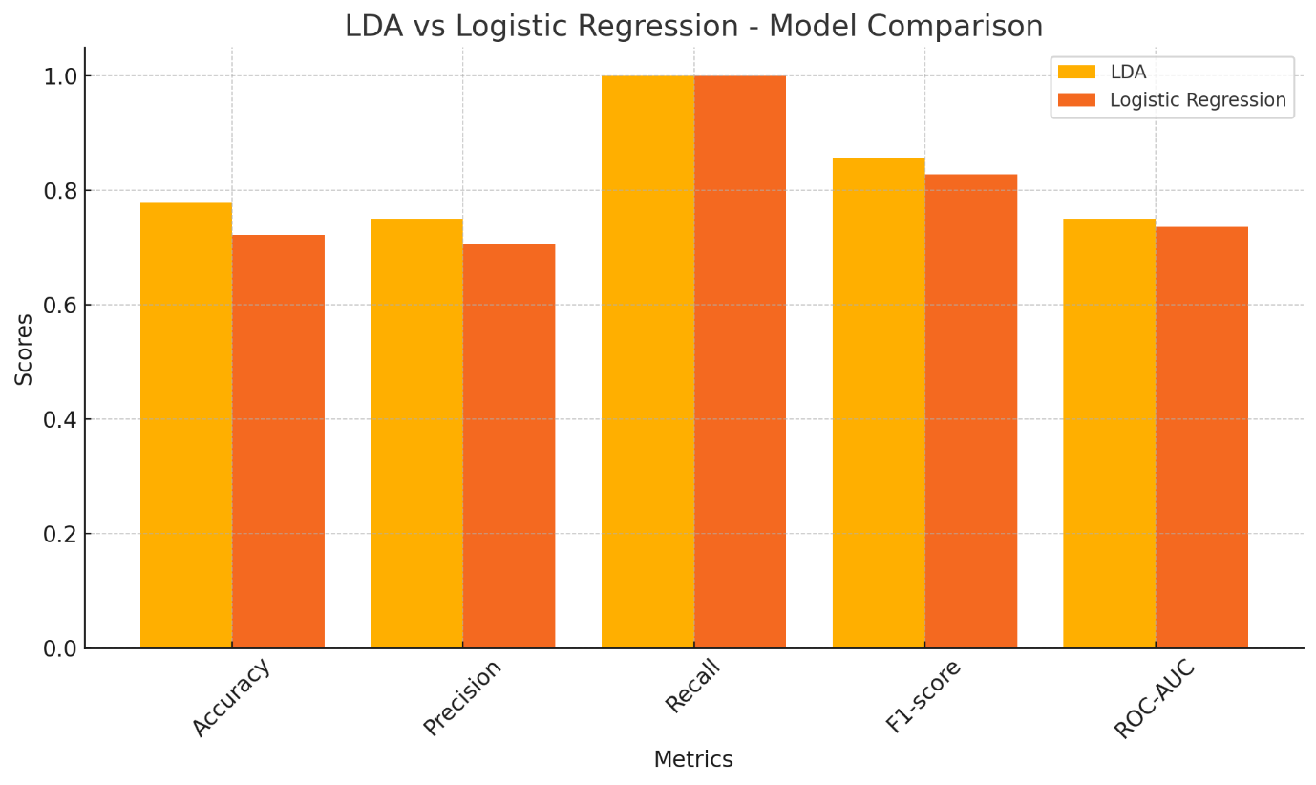
Figure 1 shows that the between-model differences in the held-out split were small in absolute terms except that both models shared perfect recall for the survival class. The figure should therefore be read as a split-specific comparison rather than evidence of a stable performance advantage.
4.3 Predicted Probability Distributions
Figure 2. Distribution of predicted survival probabilities for LDA and LR
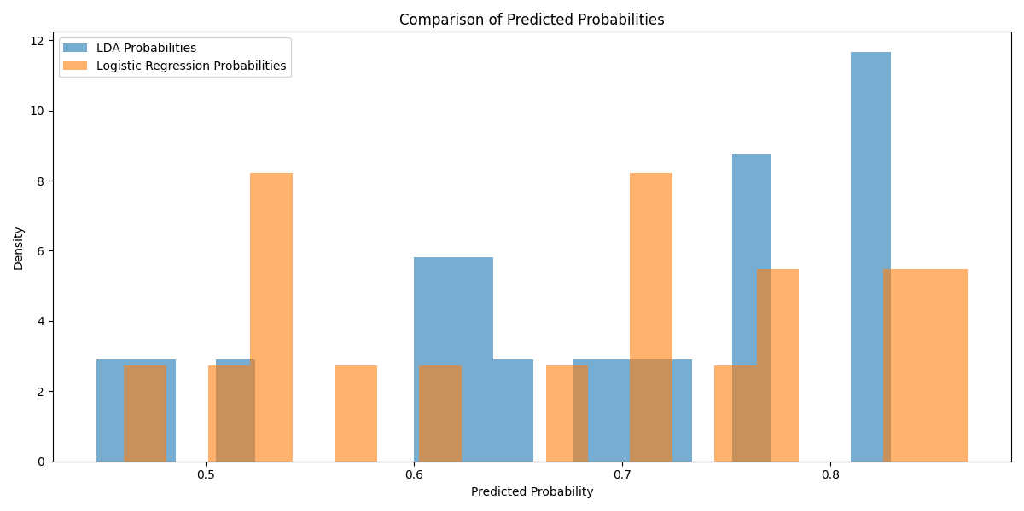
Figure 2 compares the distributions of predicted probabilities for survival. The two distributions overlap substantially. LDA places relatively more observations towards the upper end of the displayed probability range, whereas LR is more concentrated around intermediate probabilities. This visual difference indicates different probability assignments by the two fitted models, but it does not by itself establish better calibration or clinical usefulness; neither calibration slope nor calibration-in-the-large was available from the reported analysis.
4.4 Predicted Probabilities Versus Observed Outcomes
Figure 3. Predicted survival probabilities versus observed outcomes in the held-out evaluation
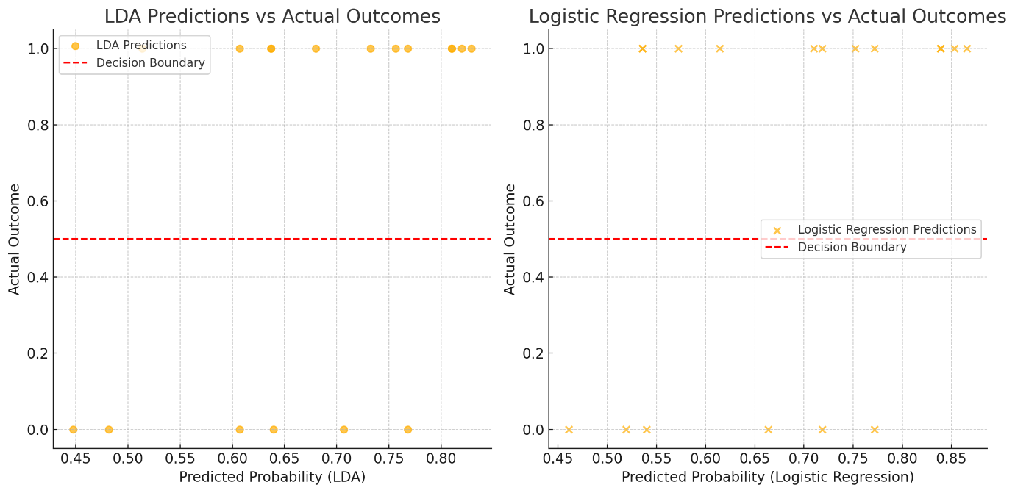
Figure 3 displays 18 held-out observations for each model, with predicted survival probability on the horizontal axis and observed binary outcome on the vertical axis. The dashed horizontal line separates the two observed outcome levels; because predicted probability is plotted on the horizontal axis, classification at a 0.50 probability threshold is determined by whether a point lies to the right of 0.50 on that axis. All observed survival cases have predicted probabilities above 0.50 for both models, consistent with the recall of 1.000 in Table 2. Several death cases also receive probabilities above 0.50, producing false-positive survival classifications. The LDA plot contains slightly fewer such errors in this split, consistent with its higher precision and accuracy.
4.5 Five-Fold Cross-Validation
Table 3 presents five-fold cross-validation results. LR achieved a mean accuracy of 0.6697 compared with 0.6515 for LDA. The standard deviation of accuracy was also lower for LR (0.1236 vs. 0.1563), indicating less variation across folds. These results reverse the ordering observed in the single held-out split and therefore show that the apparent LDA advantage is not stable across resampling schemes.
Table 3. Five-fold cross-validation accuracy
Model | Mean accuracy | SD of accuracy
Linear discriminant analysis | 0.651515 | 0.156288
Logistic regression | 0.669697 | 0.123613
Note. SD = standard deviation across the five validation folds.
4.6 Full-Sample Confusion Matrices
Figure 4. Full-sample confusion matrices for LDA and LR
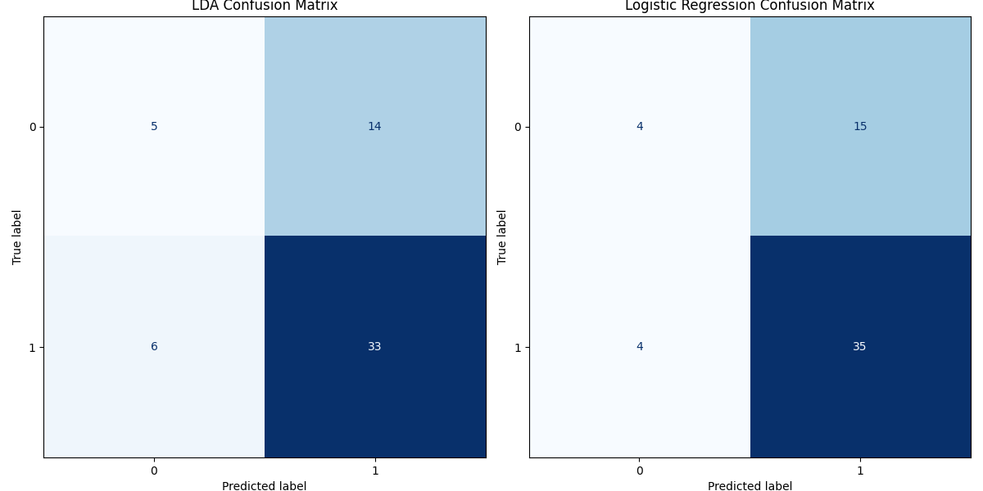
Figure 4 summarises classifications across all 58 observations. For LDA, the matrix contains 5 true negatives, 14 false positives, 6 false negatives, and 33 true positives; for LR, it contains 4 true negatives, 15 false positives, 4 false negatives, and 35 true positives. These counts yield apparent accuracies of 65.5% for LDA and 67.2% for LR. With survival as the positive class, apparent recall is 84.6% for LDA and 89.7% for LR, while precision is 70.2% and 70.0%, respectively. Because these matrices summarise the full dataset rather than an independent test set, they are descriptive and should not be compared directly with the held-out metrics in Table 2 as if they represented the same evaluation sample.
The full-sample matrices also show poor identification of the death class at the 0.50 threshold: specificity is 26.3% for LDA and 21.1% for LR. This class-specific weakness is obscured when performance is summarised primarily by survival recall. For a prognostic application concerned with mortality, future analyses should prespecify whether death is the clinically relevant positive class and report class-specific sensitivity, specificity, calibration, and decision consequences accordingly.
4.7 Exploratory Predictor Coefficient Magnitudes
Figure 5. Exploratory comparison of model coefficient magnitudes for age and final classification
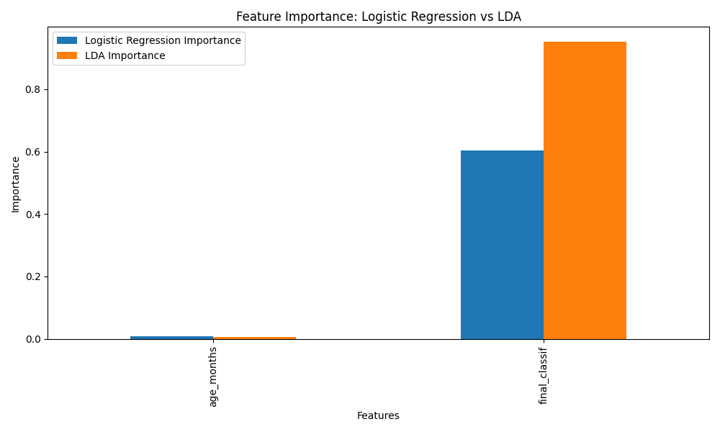
Figure 5 shows much larger numerical coefficient magnitudes for final classification than for age in both fitted models. This pattern is descriptive only. Age is measured in months whereas final classification is binary, and the coefficient scales differ between LDA and LR. Consequently, the bars do not demonstrate that age is statistically insignificant, nor do they provide a formally comparable feature-importance scale across the two methods. Formal inference about predictor effects would require model coefficients with their uncertainty measures and, for LR, clinically interpretable odds ratios with confidence intervals.
5. DISCUSSION
This exploratory study compared LDA and LR for classifying survival from only two available variables: age and recorded final diphtheria classification. The principal finding is not stable superiority of one method, but sensitivity of the model ranking to the evaluation procedure. LDA performed better in the single held-out split, with 77.8% accuracy compared with 72.2% for LR. However, five-fold cross-validation slightly favoured LR and showed lower fold-to-fold variability, and the full-sample confusion matrices likewise produced a slightly higher apparent accuracy for LR. The appropriate interpretation is therefore that the two methods showed broadly comparable performance in this small dataset, with no robust evidence that LDA should replace LR.
This mixed pattern is compatible with previous comparative work. Shariatnia et al. (2022) reported a small accuracy advantage for LDA over LR in coronary artery disease classification, but the AUC values were nearly identical and pairwise AUC differences were not significant. Graf et al. (2024) similarly demonstrated that LDA performance relative to alternative classifiers depends on the underlying distribution and on whether overall performance, discrimination, or calibration is emphasised. In a large clinical cohort using simple predictors, Nusinovici et al. (2020) found that logistic regression performed as well as several machine-learning methods. Together, these studies caution against treating small differences in a single performance metric as proof of algorithmic superiority.
The clinical interpretation also requires restraint. The present models contain only age and final classification, whereas previous diphtheria studies have identified immunisation status, treatment timing, airway and respiratory severity, myocarditis, thrombocytopenia, leukocyte abnormalities, hypoxaemia, renal function, and related clinical findings as important correlates or predictors of mortality (Alege et al., 2025; Arguni et al., 2021; Dinanti et al., 2024; Quick et al., 2000). The absence of these variables limits the prognostic information available to either classifier. It also means that the models should not be interpreted as comprehensive clinical risk models.
The outcome distribution further illustrates the importance of case mix. The current dataset contains 19 deaths among 58 observations (32.8%). Published hospital cohorts have reported substantially different mortality levels across settings; for example, Arguni et al. (2021) reported a 3.5% case-fatality rate in a multicentre Indonesian paediatric cohort, whereas Alege et al. (2025) reported 23.6% in a Nigerian tertiary-hospital cohort of confirmed cases. These differences are not evidence that the present dataset is invalid; rather, they show why population definition, diagnostic criteria, referral severity, treatment access, and study setting must be clearly documented before a model is generalised beyond the source data.
The two evaluation schemes also highlight the instability expected from limited sample size. In a test set of 18 observations, a change of only one correctly classified case changes accuracy by approximately 5.6 percentage points. The observed accuracy difference between LDA and LR in the held-out split is exactly 5.6 percentage points, so the apparent advantage corresponds to a one-case difference. Cross-validation is therefore informative because it demonstrates that the ordering changes across partitions. Modern guidance for clinical prediction models emphasises adequate sample size, control of optimism, and transparent validation because small development datasets can yield imprecise and unstable performance estimates (Collins et al., 2015; Riley et al., 2020).
Finally, the role of final classification requires attention in future prospective modelling. If this variable is determined only after diagnostic work-up or after information that would not be available at the intended prediction time, using it as a predictor could introduce information leakage or limit real-time clinical applicability. Future studies should define a clear prediction time point, include only predictors available at that time, and distinguish diagnostic classification from prognostic outcome prediction.
5.1 Strengths and Limitations
A strength of the study is the direct comparison of two interpretable classifiers using multiple performance summaries rather than accuracy alone. The inclusion of both a held-out evaluation and five-fold cross-validation exposes the instability that would have been missed if the conclusion were based solely on one data split. The probability plots and confusion matrices also permit class-specific inspection of model behaviour.
Several limitations constrain inference. First, the sample contains only 58 observations and 19 deaths, so performance estimates are imprecise and sensitive to data partitioning. Second, only two predictors were available, omitting established markers of diphtheria severity and treatment. Third, the source documentation does not provide the original enrollment period, sampling frame, or detailed eligibility criteria. Fourth, the available analytic outputs do not provide confidence intervals for model-performance differences, formal calibration measures, or external validation. Fifth, formal LDA assumption diagnostics are not available from the summarised analysis. Sixth, the original analysis record does not specify the Python package versions or randomisation seed, limiting exact computational reproducibility. Seventh, the coefficient-magnitude visualisation does not provide inferential significance. Eighth, the full-sample confusion matrices are apparent descriptive summaries and not independent validation results. These limitations preclude clinical deployment and support treating the findings as exploratory.
6. CONCLUSION
LDA and LR both provided modest-to-moderate classification performance for survival outcomes in this 58-observation exploratory dataset. LDA performed better in the single 18-observation held-out split, whereas LR achieved slightly higher and more stable mean accuracy in five-fold cross-validation and slightly higher apparent accuracy in the full-sample confusion matrix. The combined evidence therefore does not establish stable superiority of either classifier. The results support further comparative evaluation rather than a recommendation for clinical adoption. Future prediction models should use larger, more diverse datasets; include established clinical, treatment, immunisation, and laboratory predictors; define the intended prediction time point; quantify uncertainty and calibration; and undergo external validation before use in patient management.
7. RECOMMENDATIONS FOR FURTHER RESEARCH
1. Increase the sample size and number of outcome events before model development, with sample-size planning appropriate for prediction research.
2. Include clinically established prognostic variables such as immunisation history, timing of antitoxin treatment, respiratory severity, cardiac complications, blood counts, oxygenation, and renal function when available at the intended prediction time.
3. Use resampling-based internal validation and report confidence intervals for discrimination and classification metrics; assess calibration as well as discrimination.
4. Prespecify the clinically relevant positive class and evaluation threshold. If the intended use is mortality risk identification, sensitivity for death and the consequences of false-negative mortality predictions should be explicitly prioritised.
5. Undertake external validation in an independent population before any clinical decision-support recommendation is made.
Ethical Approval
Permission to access and use the study data for research purposes was obtained from the relevant authorities before analysis, including the World Health Organization and the Federal University Teaching Hospital, Lafia, as reported in the study records.
COMPETING INTERESTS
The authors declare that they have no competing interests.
DECLARATION OF AI USE
This manuscript was prepared through the intellectual contributions of the author(s) to the study design, data analysis, interpretation of results, and scholarly content. Grammarly and ChatGPT were used solely to assist with grammatical refinement and reference formatting during manuscript revision. The author(s) accept full responsibility for the accuracy, integrity, and final content of the manuscript.
REFERENCES
Alege, A., Ibrahim, O. R., Ibraheem, R. M., Aladesua, O., Lugga, A. S., Yahaya, Y. Y., Sanda, A., & Suleiman, B. M. (2025). Clinical presentation and predictors of hospital mortality of diphtheria in Nigeria, July 2023 to April 2024: A single-center study. BMC Infectious Diseases, 25, Article 8. https://doi.org/10.1186/s12879-024-10401-4
Arguni, E., Karyanti, M. R., Satari, H. I., & Hadinegoro, S. R. (2021). Diphtheria outbreak in Jakarta and Tangerang, Indonesia: Epidemiological and clinical predictor factors for death. PLOS ONE, 16(2), e0246301. https://doi.org/10.1371/journal.pone.0246301
Clarke, K. E. N., MacNeil, A., Hadler, S., Scott, C., Tiwari, T. S. P., & Cherian, T. (2019). Global epidemiology of diphtheria, 2000–2017. Emerging Infectious Diseases, 25(10), 1834–1842. https://doi.org/10.3201/eid2510.190271
Collins, G. S., Reitsma, J. B., Altman, D. G., & Moons, K. G. M. (2015). Transparent reporting of a multivariable prediction model for individual prognosis or diagnosis (TRIPOD): The TRIPOD statement. BMJ, 350, g7594. https://doi.org/10.1136/bmj.g7594
Dinanti, S. P., Ramayani, O. R., & Pasaribu, A. P. (2024). Determinants of mortality in relationship between clinical and laboratory characteristics with the outcomes of children with diphtheria: A cross-sectional study at a national hospital of Sumatra region in 2020–2023. Narra J, 4(2), e776. https://doi.org/10.52225/narra.v4i2.776
Graf, R., Zeldovich, M., & Friedrich, S. (2024). Comparing linear discriminant analysis and supervised learning algorithms for binary classification—A method comparison study. Biometrical Journal, 66(1), e2200098. https://doi.org/10.1002/bimj.202200098
Nusinovici, S., Tham, Y. C., Yan, M. Y. C., Ting, D. S. W., Li, J., Sabanayagam, C., Wong, T. Y., & Cheng, C.-Y. (2020). Logistic regression was as good as machine learning for predicting major chronic diseases. Journal of Clinical Epidemiology, 122, 56–69. https://doi.org/10.1016/j.jclinepi.2020.03.002
Quick, M. L., Sutter, R. W., Kobaidze, K., Malakmadze, N., Strebel, P. M., Nakashidze, R., & Murvanidze, S. (2000). Epidemic diphtheria in the Republic of Georgia, 1993–1996: Risk factors for fatal outcome among hospitalized patients. The Journal of Infectious Diseases, 181(Supplement 1), S130–S137. https://doi.org/10.1086/315550
Riley, R. D., Ensor, J., Snell, K. I. E., Harrell, F. E., Jr., Martin, G. P., Reitsma, J. B., Moons, K. G. M., Collins, G. S., & van Smeden, M. (2020). Calculating the sample size required for developing a clinical prediction model. BMJ, 368, m441. https://doi.org/10.1136/bmj.m441
Shariatnia, S., Ziaratban, M., Rajabi, A., Salehi, A., Abdi Zarrini, K., & Vakili, M. (2022). Modeling the diagnosis of coronary artery disease by discriminant analysis and logistic regression: A cross-sectional study. BMC Medical Informatics and Decision Making, 22, Article 85. https://doi.org/10.1186/s12911-022-01823-8
Truelove, S. A., Keegan, L. T., Moss, W. J., Chaisson, L. H., Macher, E., Azman, A. S., & Lessler, J. (2020). Clinical and epidemiological aspects of diphtheria: A systematic review and pooled analysis. Clinical Infectious Diseases, 71(1), 89–97. https://doi.org/10.1093/cid/ciz808

