Unsteady Radiative MHD Flow of Jeffrey Fluid through a Porous Medium with Hall and Soret Effects in the presence of Convective Boundary Condition

ABSTRACT
This study examines the combined effects of Hall current and Soret diffusion on the unsteady natural-convection magnetohydrodynamic (MHD) flow of a viscous, incompressible, electrically conducting Jeffrey fluid through a porous medium in the presence of thermal radiation and chemical reaction. The governing nonlinear equations for momentum, energy, and species transport are transformed into a dimensionless system and solved numerically using a sixth-order Runge–Kutta method coupled with a shooting technique. The resulting velocity, temperature, and concentration profiles are analysed graphically for different parameter values. The numerical simulations are implemented in Maple. The principal novelty of the study lies in the simultaneous consideration of Hall current and thermo-diffusive Soret effects in unsteady Jeffrey-fluid flow through a porous medium under radiative and chemically reactive conditions, thereby providing a more comprehensive description of coupled momentum, heat, and mass transport. The analysis reveals that increasing the Hall parameter enhances the velocity profiles, whereas the opposite trend is observed with increases in the viscosity ratio and chemical reaction parameter. Thermal radiation elevates the temperature profiles, whereas increasing the frequency of oscillations suppresses them. Furthermore, concentration decreases with increasing Schmidt number but increases with an increase in the chemical reaction parameter. These results have significant practical implications for solar-physics applications, including solar-cycle dynamics and sunspot development, as well as for the design of MHD sensors and rotating MHD induction energy generators. The study provides valuable insights into optimising heat and mass transfer in porous-media systems where electromagnetic and thermo-diffusive effects are dominant.

KEYWORDS;- Soret and chemical reaction, Unsteady MHD flow, Hall current, Thermal radiation, Jeffrey fluid.

.
- INTRODUCTION
Natural convection flow induced by combined thermal and solutal buoyancy forces in a porous medium is critical to understanding many natural phenomena and industrial processes. Pure fluids are rarely attainable due to the ubiquitous presence of foreign particulates in atmospheric flows. Key processes such as waste dispersion, fog evaporation, photosynthesis, transpiration, sea breeze formation, and ocean currents are driven by these buoyancy forces arising from temperature and concentration gradients. Industrial applications include molten metal cooling, heat exchangers, petroleum reservoirs, insulation systems, filtration, nuclear waste management, catalytic reactors, desert coolers, frost formation, and wet-bulb thermometry.
The study of unsteady magnetohydrodynamic (MHD) flow of non-Newtonian fluids through porous media has gained considerable attention due to its wide range of applications in engineering and industrial processes, including geothermal systems, petroleum recovery, cooling technologies, and energy generation. The interaction between magnetic fields and electrically conducting fluids provides an effective mechanism for controlling flow behaviour and heat transfer characteristics in such systems.
Among non-Newtonian models, the Jeffrey fluid has received significant interest because of its ability to capture both relaxation and retardation effects, making it more suitable for describing viscoelastic fluids encountered in practical applications. For instance, Madan Kumar et al. (2025) investigated the thermal and diffusion effects on MHD Jeffrey-fluid flow and reported that viscoelastic parameters significantly influence velocity and temperature distributions in boundary-layer flows.
Abdou and Al-Rashidi (2022) numerically examined MHD boundary-layer flow of a micropolar nanofluid under internal heat generation using Runge-Kutta integration.
The Hall-current effect arises directly from the Lorentz force, which governs the behaviour of charged particles in a magnetic field. This force is responsible for the deflection of electron beams in magnetically deflected cathode-ray tubes and the rotation of electric-motor armatures. Early applications of the Hall effect were limited to laboratory settings because the output voltage from the materials available at the time was too low for practical use. However, the advent of semiconductors introduced new materials with high charge mobilities, making it possible to manufacture commercially feasible Hall devices. Hall current refers to the voltage difference that develops across an electrical conductor, transverse to both the flow of electric current and a magnetic field applied normal to that current. When the magnetic-field strength is very high, the influence of Hall current becomes critically important. To enhance the electrical conductivity of a fluid, it is necessary to induce a current along a channel perpendicular to both the x- and y-directions, that is, in the z-direction. This induced current is known as Hall current. A strong magnetic field actually reduces the electrical conductivity of a fluid. Vaidya et al. (2025) investigated how Hall current, together with Joule heating, contributes to an increased temperature field within the fluid, which is relevant to heat- and mass-transfer indicators such as the Nusselt and Sherwood numbers. Abbas and Nazar (2025) focused on the application of the Hall effect to the flow field of an electrically conducting fluid with low density or a strong magnetic field, noting that this phenomenon causes secondary flow. Venthan et al. (2024) examined the impact of fluid-flow characteristics on convective heat transfer using an MHD non-Newtonian fluid model with Hall current. Kommaddi et al. (2023) showed that Hall current, porous-medium permeability, radiation absorption, and the diffusion-thermo parameter tend to accelerate fluid flow in both the primary and secondary directions.
Researchers in engineering science and applied mathematics continue to be interested in the study of electrically conducting fluids (MHD) because of the broad applications of such flows in aerodynamics, engineering, geophysics, and aeronautics. The Soret effect is one of the processes involved in transport phenomena, in which molecules move across a multicomponent mixture because of a temperature gradient. Owing to its applicability in various fields, such as geophysics, solar-power collectors, electronic-system cooling, and chemical catalytic reactors, convective heat and mass transfer in porous media has also been a subject of interest over the last several decades. This has contributed to the growing body of research on this topic. Kodi and Konduru (2022) examined MHD convective unsteady flow of a Jeffrey fluid past an inclined vertical porous plate with thermal-diffusion Soret and aligned-magnetic-field effects. Kodi et al. (2023) analysed unsteady magnetohydrodynamic flow of a Jeffrey fluid through porous media with thermal radiation, Hall current, and Soret effects. Sridhar and Muthtamilselvan (2025) explored the stability of Jeffrey fluids in anisotropic porous media, incorporating Soret effects and microbial systems. Mahla and Kaladhar (2024) discussed Jeffrey-fluid flow in a sloping channel with Hall current, thermal radiation, and inclined-magnetic-field effects. Haritha et al. (2023) examined the Soret effect in MHD Jeffrey-nanofluid flow, focusing on heat and mass transfer over an inclined plate. Bafakeeh et al. (2022) studied the Soret effect in unsteady MHD free-convection heat and mass transfer flow of an electrically conducting fluid past a vertical plate in a porous medium, considering thermal radiation and chemical reactions. The impact of Soret-Dufour and radiation effects on the laminar flow of a rotating liquid past a porous plate via chemical reaction was investigated by M. A. Kumar et al. (2025). The Soret effect on MHD flow in the presence of Hall current and an induced magnetic field was studied by Agrawal and Panda (2023). Instability of Jeffrey-fluid throughflow in a porous layer induced by a heat source and the Soret effect was reported by Sen et al. (2024). Huang (2023) analysed chemical reaction and activation energy in heat and mass transfer for convective flow along an inclined surface in a Darcy porous medium with Soret and Dufour effects.
More recently, Singh et al. (2026) investigated Soret-driven convective instability of Jeffrey fluid in a porous layer, with emphasis on the roles of viscoelasticity and thermally induced mass transport.
The interplay between thermal radiation and hydromagnetic natural convection significantly affects heat and mass transfer characteristics in manufacturing environments. Processes such as steel rolling, glass fabrication, casting, and furnace design rely heavily on these dynamics. Because modern technical processes increasingly operate at ultra-high temperatures, accurately modelling radiative transport is a critical prerequisite for engineering reliable thermal systems. Viskanta and Grosh (1962) were the first researchers to examine the effects of thermal radiation on temperature distribution and heat transfer in a medium flowing over a wedge. The Rosseland approximation for the radiant heat-flux vector is used to simplify the complex energy equation because a general solution to the governing equations is not possible. Aly and Ebaid (2021) studied the MHD Marangoni boundary-layer problem for hybrid nanofluids with thermal radiation. Mahesh et al. (2023) analysed the impact of CNTs on an MHD Casson Marangoni boundary-layer flow over a porous medium with suction/injection and thermal radiation. Shah et al. (2023) examined the effect of thermal radiation on convective heat transfer in MHD boundary-layer Carreau fluid with chemical reaction. Mahabaleshwar et al. (2022) studied the effect of MHD fluid-flow heat transfer using CNTs with thermal radiation and a heat source/sink across a stretching/shrinking sheet. Irshad et al. (2023) examined numerical simulations of MHD generalised-Newtonian-fluid flow effects on a stretching sheet in the presence of permeable media.
Abo-Dahab et al. (2026) investigated unsteady MHD free convection past a moving porous plate while accounting for thermal radiation, mass transfer, heat generation, and chemical reaction.
Investigating chemically reactive heat and mass transfer flows has become increasingly important across diverse chemical-engineering applications. This class of transport phenomena serves as a foundational model for diverse environmental and industrial systems, ranging from cooling-tower dynamics and thermal regulation to atmospheric-haze dispersion and agricultural frost protection. Additional applications occur in agricultural environments and forest ecosystems containing fruit-bearing trees, where coupled heat and mass transfer with chemical reactions play an important role in environmental and biological processes. Gowda et al. (2021) examined the impact of binary chemical reaction and activation energy on the heat and mass transfer of Marangoni-driven boundary-layer flow of a non-Newtonian nanofluid. Li et al. (2022) analysed the numerical treatment of time-dependent magnetohydrodynamic nanofluid flow involving mass and heat transport subject to chemical reaction and a heat source. The impact of a chemical reaction on the heat and mass transfer mechanisms in a dissipative and radiative nanofluid flow over a nonlinear stretching sheet was examined by Abbas et al. (2024). Karthik et al. (2024) investigated the numerical simulation of magnetohydrodynamic fluid flow with a heat sink, chemical diffusion, and Powell-Eyring fluid behaviour using the Cattaneo–Christov source term. Roja et al. (2024) analysed the computational role of homogeneous–heterogeneous chemical reactions and a mixed-convective ternary hybrid nanofluid in a vertical porous microchannel. Roja et al. (2025) explored aspects of motile microorganisms and thermophoretic particle deposition in a binary chemically reactive ternary hybrid nanofluid past a porous microchannel. Variable thermophysical properties of a magnetohydrodynamic Cross-fluid model with the effects of energy dissipation and chemical reaction were discussed by Awais and Salahuddin (2024). Madhukesh et al. (2021) examined Bio-Marangoni convection flow of a Casson nanoliquid through a porous medium in the presence of chemically reactive activation energy. Xia et al. (2021) analysed the dynamics of unsteady reactive flow of a viscous nanomaterial subject to Ohmic heating, a heat source, and viscous dissipation. Nayak et al. (2022), Ahmed et al. (2020), and Ratha et al. (2024) explored the impact of dissipative heat and mass transfer with the Richardson number on MHD convection Maxwell-nanofluid flow. Razaq et al. (2023) and Madhura and Babitha (2025) explored stretching-sheet and heat-transfer parameters in nanomaterials.
Ojo and Nwabuzor (2026) analytically investigated MHD energy and mass transport in a chemically reacting porous channel under thermal radiation.
This study addresses the lack of a unified analysis of Hall current, Soret diffusion, thermal radiation, and chemical reaction effects on unsteady MHD Jeffrey-fluid flow over inclined surfaces in a porous medium. The fluid is assumed to be viscous, incompressible, and electrically conducting, while the effects of thermal radiation and chemical reaction are incorporated into the mathematical model. The governing nonlinear equations are rendered dimensionless through suitable transformations and solved using a sixth-order Runge–Kutta scheme coupled with a shooting algorithm. The effects of key dimensionless parameters, namely the magnetic parameter, Hall parameter, Prandtl number, Schmidt number, thermal and mass Grashof numbers, radiation parameter, chemical reaction parameter, and Soret number, on the velocity, temperature, and concentration fields are analysed. The findings provide valuable insight into the coupled heat and mass transfer mechanisms associated with MHD transport phenomena in porous media.
Objectives
The objective of this study is to numerically evaluate the coupled effects of Hall current, Soret diffusion, thermal radiation, and chemical reaction on unsteady MHD Jeffrey-fluid flow through a porous medium by examining the resulting velocity, temperature, and concentration fields.

- FORMULATION OF THE PROBLEM
A Cartesian coordinate system is adopted, with the $x$-axis oriented vertically upward along the plate and the $y$-axis normal to the plate surface. A uniform transverse magnetic field of strength $B_{0}$ is applied perpendicular to the y-axis. The species concentration at the plate surface and within the fluid is maintained at a constant value $C$ throughout the process. The free-stream temperature is denoted by $T_{∞}$, while the plate surface is raised to and maintained at a uniform target temperature. Likewise, the species concentration at the plate surface is raised to and maintained at a uniform target concentration. Fig. 1 illustrates the geometry of the problem. Owing to the infinite extent of the plate in the $x$ and $z$ directions, all flow variables are assumed to be functions of the transverse coordinate $y$ and time $t$ only, except for the pressure field. The plate is considered electrically non-conducting, thereby preventing the flow of electric current through its surface. Furthermore, in the absence of externally applied electric fields and induced polarisation effects, the influence of fluid polarisation is neglected. Consequently, no electrical energy is supplied to or extracted from the fluid, and the electromagnetic interaction arises solely from the imposed magnetic field. The induced magnetic field produced by the fluid velocity is presumed to be insignificant compared with the applied magnetic field. This assumption is reasonable because the magnetic Reynolds number is relatively low for partially ionised fluids and liquid metals often used in various industrial applications.
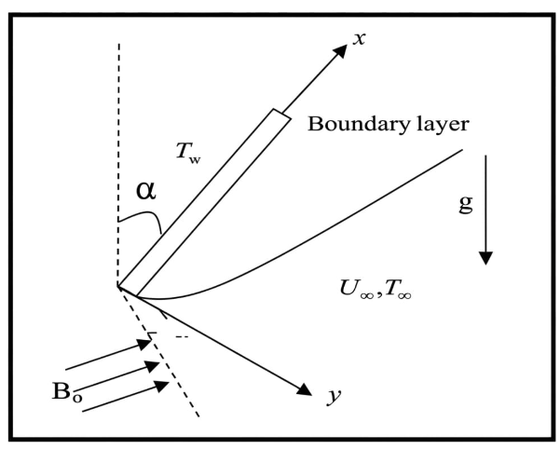
Fig. 1. The geometry of the problem
Considering the aforementioned assumptions, the governing equations for natural-convection flow with heat and mass transfer of an electrically conducting, viscous, incompressible fluid past an infinite vertical plate embedded in a uniform porous medium in a rotating system are given below. These equations account for Hall current and the Soret effect, following Zeng et al. (2023) and Deepthi et al. (2022).
 | $$\frac{∂u}{∂x}+\frac{∂u}{∂y}=0$$ | (1)
 | $$\frac{∂u}{∂t}+w\frac{∂u}{∂z}=-\frac{1}{ρ}\frac{∂p}{∂x}+ϑ\left(\frac{1}{1+β}\right) \frac{∂^{2}u}{∂z^{2}}+\frac{σB_{0}}{ρ\left(1+H^{2}\right)} \left(Hv-u\right)+gβ_{T}\left(T-T_{∞}\right) Cosα+gβ_{C}\left(C-C_{∞}\right)Cosα-\left(\frac{1}{1+β}\right)\frac{ϑ}{k^{*}}u+\frac{∂^{2}u}{∂z^{2}} w\frac{∂u}{∂z}$$ | (2)
 | $\frac{∂v}{∂t}+w\frac{∂v}{∂z}=$ $-\frac{1}{ρ}\frac{∂p}{∂y}+ϑ\left(\frac{1}{1+β}\right) \frac{∂^{2}v}{∂z^{2}}-\frac{σB_{0}}{ρ\left(1+H^{2}\right)}\left(Hu+v\right)-\left(\frac{1}{1+β}\right)\frac{ϑ}{k^{*}}v+\left(Hu+v\right)\frac{∂^{2}u}{∂z^{2}}$ | (3)
 | $$\frac{∂T}{∂t}+w\frac{∂T}{∂z}=\frac{k_{1}}{ρC_{p}}\frac{∂^{2}T}{∂z^{2}}-\frac{Q_{0}}{ρC_{p}}\left(T-T_{∞}\right)-\frac{1}{ρC_{p}}\frac{∂q_{r}}{∂z}$$ | (4)
 | $$\frac{∂C}{∂t}+w\frac{∂C}{∂z}=D\frac{∂^{2}C}{∂z^{2}}-K\left(C-C_{∞}\right)+D_{1}\frac{∂^{2}T}{∂z^{2}}$$ | (5)

The boundary conditions are specified under the aforementioned assumptions for the velocity distributions, thermodynamics, and intensity:
 | $$u^{*}=U_{0}, v=0, T=T_{w}+ε\left(T_{w}-T_{∞}\right)e^{iwt}, C=C_{w}+ε\left(C_{w}-C_{∞}\right)e^{iwt} at z=0$$ | (6)
 | $$u→U_{∞}, v→0, T→T_{∞} C→C_{∞} as z→∞$$ | (7)

We consider a mathematical formulation for an optically thin grey-gas limit close to equilibrium, as specified by Zeng et al. (2023) and Deepthi et al. (2022):
 | $$\frac{∂q_{r}^{*}}{∂y^{*}}=4\left(T^{*}-T_{w}^{*}\right)I$$ | (8)
Where $I=\int_{0}^{∞}{K_{λω}{\left(\frac{∂_{ebλ}}{∂T} \right)}_{ω}dλ}$ is the absorbance factor at the wall, and $ebλ$ is Planck’s function. We suppose that, since the continuity equation shows that $wi$ is either a constant or a time-related function.
 | $$w=-w_{0}(1+Aεe^{nt})$$ | (9)

Where $A$ is a positive constant, $ε$and $Aε$ are small quantities less than unity, and $w_{0}$ is the suction velocity balanced by a non-zero positive constant.
Let $q=u+iv$ and $ξ=x-iy$, and combine Eqs. (15) and (16) to obtain:
 | $$\frac{∂q}{∂t}-w\left(1+εAe^{nt}\right)\frac{∂q}{∂z}= -\frac{1}{ρ}\frac{∂p}{∂ξ}+v\left(\frac{1}{1+β}\right)\frac{∂^{2}q}{∂z^{2}}-\frac{σB_{0}}{ρ\left(1-iH\right)}q+gβ\left(T-T_{∞}\right)Cosα +gβ^{*}\left(C-C_{∞}\right)Cosα-\left(\frac{1}{1+β}\right)\frac{1}{k^{*}}q$$ | (10)
Outside the boundary layer, Equation (10) becomes
 | $$-\frac{1}{ρ}\frac{∂p}{∂ξ}=\frac{∂U_{∞}}{∂t}+\frac{v}{k} U_{∞}+\frac{σB_{0}^{2}}{ρ}U_{∞}$$ | (11)
To systematically express the physical problem in dimensionless form enabling a clear identification of the governing parameters, the following non-dimensional variables and parameters are introduced.
 | $$q^{*}=\frac{q}{w_{0}}, w^{*}=\frac{w}{w_{0}}, { z}^{*}=\frac{w_{0}z}{ϑ}, U_{0}^{*}=\frac{U_{∞}}{w_{0}}, t^{*}=\frac{tw_{0}^{2}}{ϑ}, θ=\frac{T-T_{∞}}{T_{w}-T_{∞}}, φ=\frac{C-C_{∞}}{C_{w}-C_{∞}}, M^{2}=\frac{σB_{0}^{2}ϑ}{ρw_{0}^{2}}, Pr=\frac{ϑρC_{p}}{k_{1}}=\frac{ϑ}{α}, Sc=\frac{ϑ}{D}, Gr=\frac{ϑgβ_{T}\left(T_{w}-T_{∞}\right)}{w_{0}^{3}}, Gm=\frac{ϑgβ_{c}\left(C_{w}-C_{∞} \right)}{w_{0}^{3}}, k^{*}=\frac{w_{0}^{2}k}{ϑ^{2}}, Q=\frac{ϑQ_{0}}{ρC_{p}w_{0}^{2}}, S=\frac{w_{0}^{2}α_{1}}{ρϑ^{2}}, K=\frac{K_{c}ϑ}{w_{0}^{2}}, S_{0}=\frac{D_{1}\left(T_{w}-T_{∞}\right)}{w_{0}(C_{w}-C_{∞})}, R=\frac{4I_{1}ϑ}{ρC_{p}w_{0}^{2}}$$ | (12)
Using the dimensionless variables defined above, the governing equations (2)–(5) reduce to the following non-dimensional form:
 | $$\frac{∂q}{∂t}-\left(1+Aεe^{nt}\right)\frac{∂q}{∂z}=\frac{∂U_{∞}}{∂t}+\left(\frac{1}{1+β}\right)\frac{∂^{2}q}{∂z^{2}}-\left(\frac{M^{2}}{1-iH}+\left(\frac{1}{1+β}\right)\frac{1}{k}\right)q+GrθCosα+GmφCosα$$ | (13)

 | $$\frac{∂θ}{∂t}-\left(1+Aεe^{nt}\right)\frac{∂θ}{∂z}=\frac{1}{P_{r}}\frac{∂^{2}θ}{∂z^{2}}-\left(Q-R\right)θ$$ | (14)

 | $$\frac{∂θ}{∂t}-\left(1+Aεe^{nt}\right)\frac{∂ϑ}{∂z}=\frac{1}{Sc}\frac{∂^{2}φ}{∂z^{2}}-K_{c}φ+S_{0}\frac{∂^{2}θ}{∂z^{2}}$$ | (15)

The transformed system is subject to the following boundary conditions:
 | $$q=U_{0}, θ=1+εe^{nt}, φ=1+εe^{nt} at z=0$$ | (16)
 | $$q=0, θ=0, φ=0 as z→∞$$ | (17)

Velocity, temperature, and concentration can be represented as follows:
 | $$q=q_{0}\left(z\right)+εe^{nt}q_{1}\left(z\right)+Ο(ε^{2})$$ | (18)

 | $$θ=θ_{0}\left(z\right)+εe^{nt}θ_{1}\left(z\right)+Ο(ε^{2})$$ | (19)

 | $$ϕ=ϕ_{0}\left(z\right)+εe^{nt}ϕ_{1}\left(z\right)+Ο(ε^{2})$$ | (20)

Equations (18), (19), and (20) are substituted into Eqs. (13), (14), and (15). By combining the harmonic and non-harmonic terms and neglecting higher-order terms of $Ο(ε^{2})$, the following pairs of equations are obtained: $(q_{0}, 0_{0}, ϕ_{0})$ and ${(q}_{1}, θ_{1}, ϕ_{1})$.
 | $$\left(\frac{1}{1+β}\right) q_{0}^{''}+q_{0}^{'}-\left[\frac{M^{2}}{1-iH}+\left(\frac{1}{1+β}\right)\frac{1}{k}\right] q_{0}=-Gr θ_{0}Cosα-Gm φ_{o}Cosα$$ | (21)

 | $$\left(\frac{1}{1+β}\right) q_{1}^{''}+q_{1}^{'}-\left[\frac{M^{2}}{1-iH}+\left(\frac{1}{1+β}\right)\frac{1}{k}+n\right] q_{1}= =-Grθ_{1}Cosα-Gm φ_{1}Cosα-A{ q}_{0}^{'}$$ | (22)

 | $$θ_{0}^{''}+Pr θ_{0}^{'}-\left(Q-R\right)Pr{ θ}_{0}=0$$ | (23)

 | $$θ_{1}^{''}+Prθ_{1}^{'}-\left(Q-R+n\right)Pr{ θ}_{1}=-A Pr θ_{0}^{'}$$ | (24)

 | $$φ_{0}^{''}+Sc φ_{0}^{'}-Sc K_{c}{ φ}_{0}=Sc So{ θ}_{0}^{''}$$ | (25)

 | $$φ_{1}^{''}+Sc φ_{1}^{'}-\left(n+K_{c}\right)Sc{ φ}_{1}=-(A φ_{0}^{'}+So θ_{0}^{''})Sc$$ | (26)

The corresponding boundary conditions are as follows:
 | $$q_{0}=U_{0}, { q}_{1}=0, θ_{0}=1, θ_{1}=1, φ_{0}=1, φ_{1}=0 at z=0$$  $$q_{0}=0, q_{1}=0, { θ}_{0}=0, θ_{1}=0, φ_{0}=0, φ_{1}=0 as z→∞$$ | (27)

- NUMERICAL PROCEDURE
The nonlinear differential equations (21)–(26), subject to the boundary conditions (27), were solved numerically using the sixth-order Runge–Kutta method together with the shooting technique (Nachtsheim & Swigert, 1965). This technique is described as follows:

- The higher-order nonlinear differential equations are transformed into a system of first-order simultaneous differential equations.
- The resulting IVP (initial-value problem) is solved using a sixth-order Runge–Kutta scheme (Jain, 2003; Fehlberg, 1969).
- Suitable arbitrary values are obtained using the Newton–Raphson method.
- The calculations were performed using Maple.
The iteration process is repeated until the boundary conditions are satisfied.
- RESULTS AND DISCUSSION
The effect of the Grashof number Gr on the primary (u) and secondary (v) velocity profiles is shown in Fig. 2. Gr, defined as the ratio of thermal buoyancy forces to viscous forces, characterises the relative importance of natural convection in the flow. An increase in Gr, whether due to enhanced buoyancy or reduced viscosity, promotes fluid acceleration by diminishing the retarding influence of viscous stresses. Consequently, higher values of Gr are associated with augmented velocity profiles within the boundary layer. The effect of the modified solutal Grashof number Gm on both velocity distributions is shown in Fig. 3.

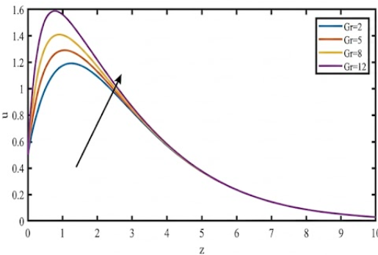 | 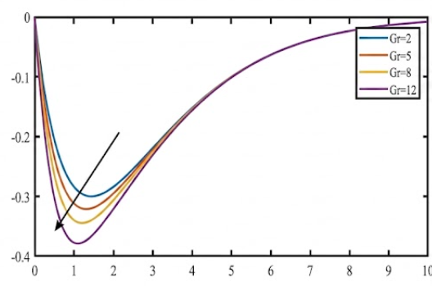

Fig. 2. The velocity profiles for u and v against Gr with M = 2, k = 0.5, So = 1, Gm = 3, H = 0.2, Pr = 0.71, Q = 1, Sc = 0.22, Kc = 1, n = 0.5, t = 0.5, R = 1, β = 1.0.
The solutal Grashof number (Gm) characterises the influence of solutal buoyancy forces relative to viscous forces in the flow. An increase in Gm indicates a stronger solutal buoyancy effect relative to viscous resistance, which generally enhances fluid motion and, consequently, increases the velocity within the boundary layer. Fig. 4 shows the influence of the Hartmann number M on the different velocity components. An increase in the Hartmann number M leads to a reduction in the primary velocity (u) component, while the secondary velocity (v) component increases because of the influence of Hall current. The enhancement of the secondary velocity is attributed to the Hall effect, which modifies the electromagnetic response of the electrically conducting fluid and promotes motion in the transverse direction. Conversely, increasing M suppresses the overall fluid motion, resulting in a decrease in the resultant velocity. This behaviour is consistent with the action of the Lorentz force, which acts against the motion of the electrically conducting fluid and consequently enhances resistance to flow. As the magnetic-field strength increases, the opposing Lorentz force becomes more pronounced, leading to a reduction in fluid velocity and, consequently, a thinner momentum boundary layer.
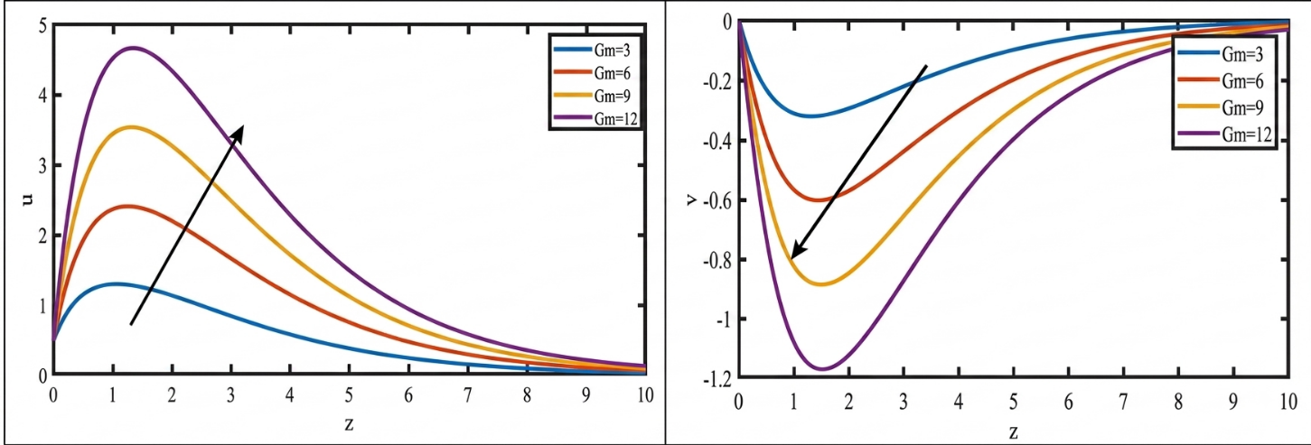
Fig. 3. The velocity profiles for u and v against Gm with M = 2, k = 0.5, R = 1, So = 1, Gr = 5, Gm = 3, H = 0.2, Pr = 0.71, Q = 1, Sc = 0.22, Kc = 1, n = 0.5, t = 0.5, β = 1.0.
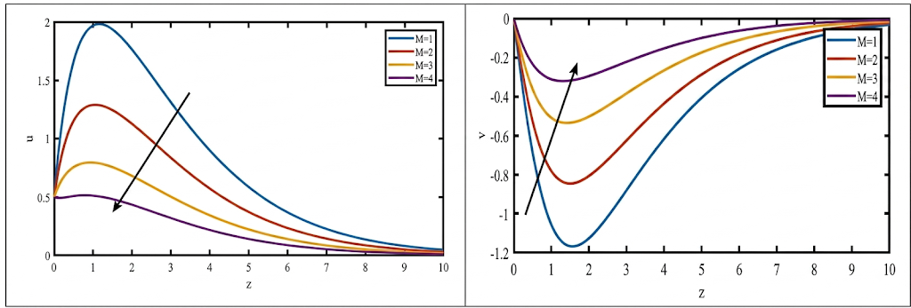
Fig. 4. The velocity profiles for u and v against M with k = 0.5, R = 1, Gr = 5, So = 1, Gm = 3, H = 0.2, Pr = 0.71, Q = 1, Sc = 0.22, Kc = 1, n = 0.5, t = 0.5, β = 1.0.
The effect of the Hall parameter $m$ on the velocity field is presented in Fig. 5, which illustrates the influence of the Hall parameter m on the velocity profiles. As the Hall parameter increases, the primary velocity increases, affecting the secondary velocity components within the fluid domain. This enhancement is attributed to the Hall effect, which modifies the electromagnetic force distribution and promotes fluid motion in both the streamwise and transverse directions. Consequently, the resultant velocity increases with increasing Hall parameter, accompanied by a corresponding thickening of the momentum boundary layer. Figs. 6 and 7 show the effects of the angle of inclination (α) and the Jeffrey-fluid parameter (β). The primary velocity u diminishes with increasing inclination angle and aligned magnetic-field parameter, whereas the secondary velocity v is enhanced.

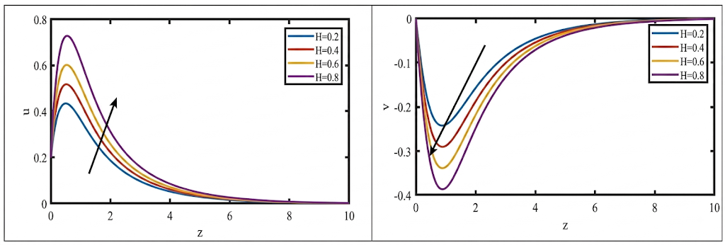
Fig. 5. The velocity profiles for u and v against H with M = 2, k = 0.5, Gr = 5, So = 1, Gm = 3, R = 1, Pr = 0.71, Q = 1, Sc = 0.22, Kc = 1, n = 0.5, t = 0.5, β = 1.0.
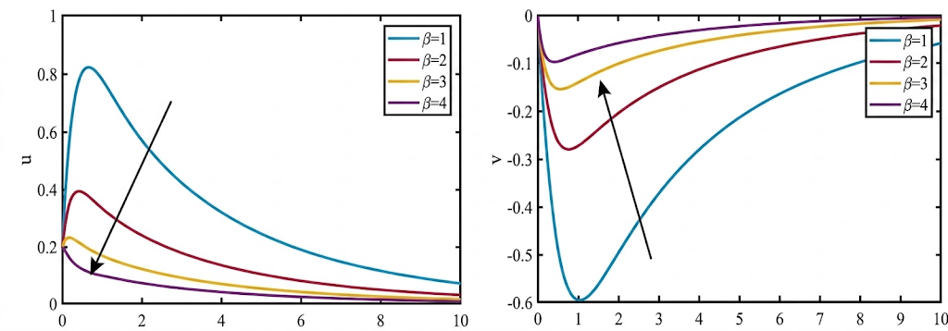
Fig. 6. The velocity profiles for both u and v plotted versus Jeffrey parameter (β) with M = 2, k = 0.5, Gr = 5, So = 1, Gm = 3, R = 1, Pr = 0.71, Q = 1, Sc = 0.22, Kc = 1, n = 0.5, t = 0.5
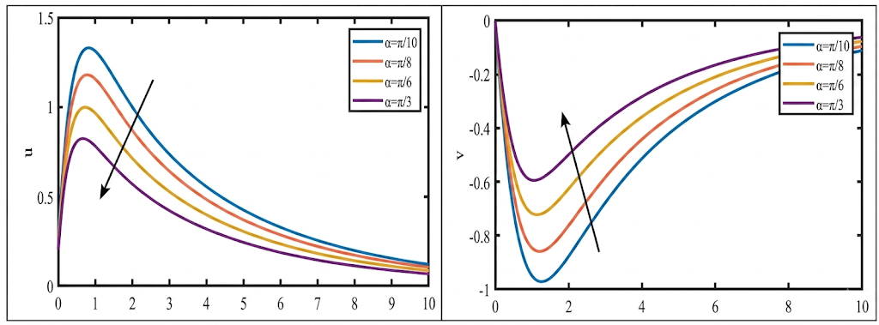
Fig. 7. The velocity profiles for both u and v plotted versus inclined parameter (α) with M = 2, k = 0.5, Gr = 5, So = 1, Gm = 3, R = 1, Pr = 0.71, Q = 1, Sc = 0.22, Kc = 1, n = 0.5, t = 0.5, β = 1.0
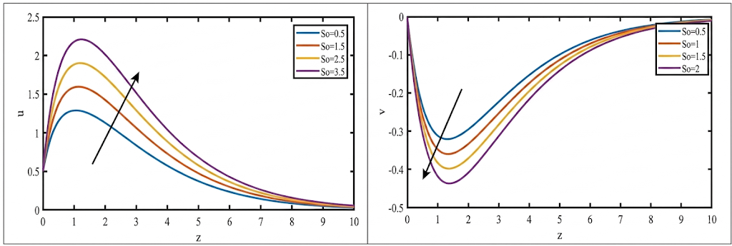
Fig. 8. The velocity profiles for u and v against So with M = 2, k = 0.5, Gr = 5, So = 1, Gm = 3, R = 1, Pr = .71, Q = 1, Sc = 0.22, Kc = 1, n = 0.5, t = 0.5, β = 1.0.
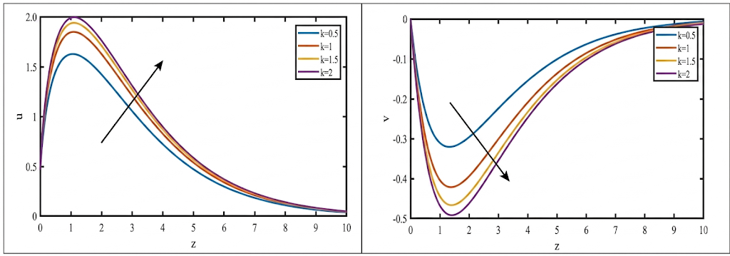
Fig. 9 The velocity profiles for u and v against k with M = 2, R = 1, Gr = 5, So = 1, Gm = 3, H = 0.2, Pr = 0.71, Sc = 0.22, Kc = 1, n = 0.5, t = 0.5, Q = 1, β = 1.0.
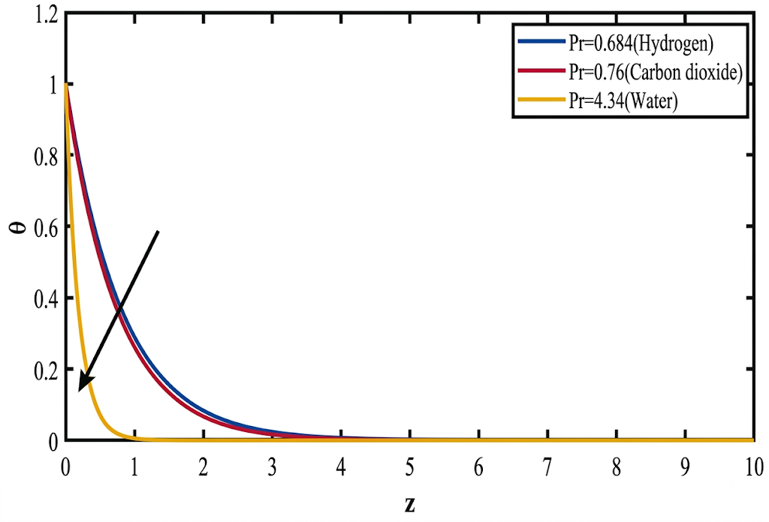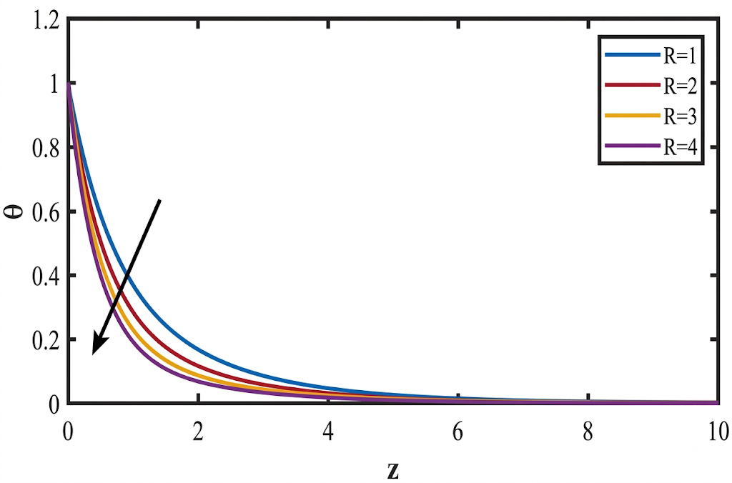
Fig. 10. Effect of Prandtl number parameter Pr on Temperature profiles. | Fig.11. Effect of Radiation parameter R on Temperature profiles.
Fig. 8 depicts the influence of the Soret number $So$ on the primary velocity $u$, the secondary velocity $v$, and the concentration field. Increasing $So$ enhances the primary velocity while diminishing the secondary velocity. Physically, an increase in $Sr$ corresponds to a reduction in the effective viscosity of the nanofluid, which weakens viscous resistance and amplifies inertial effects, thereby accelerating the primary flow within the boundary layer.
The influence of the permeability parameter $K$ on the velocity field is presented in Fig. 9. Increasing $k$ suppresses the secondary velocity component $v$ while enhancing the primary component $u$. The enhancement of $u$ is further amplified by the Hall-current effect, which influences the entire fluid domain. Consequently, the resultant velocity increases with $k$, accompanied by a corresponding thickening of the momentum boundary layer. Conversely, lower permeability impedes fluid motion, resulting in reduced velocity magnitudes throughout the flow field.
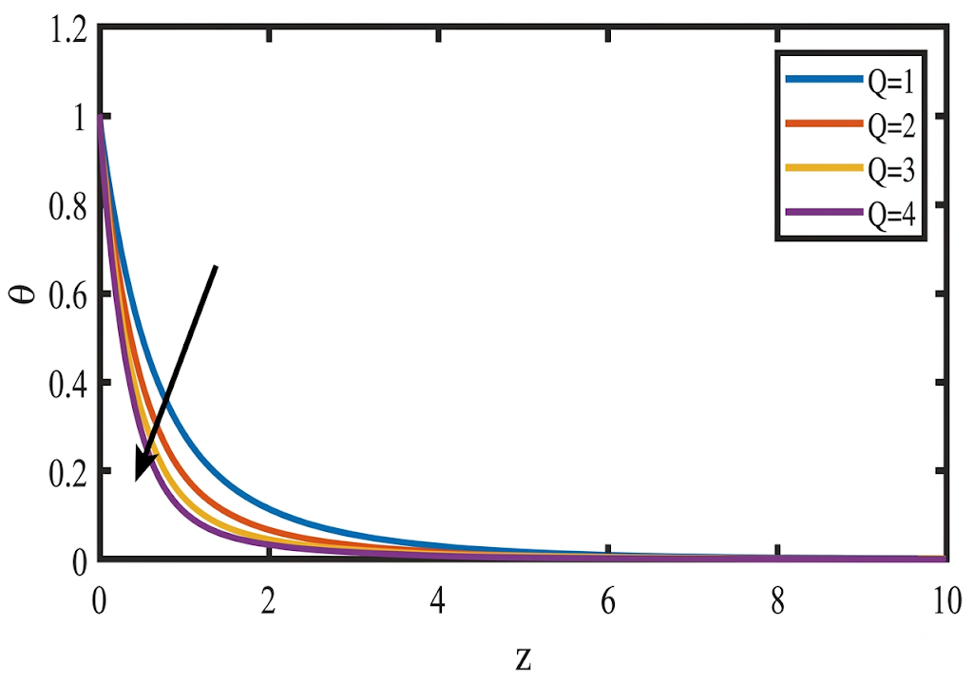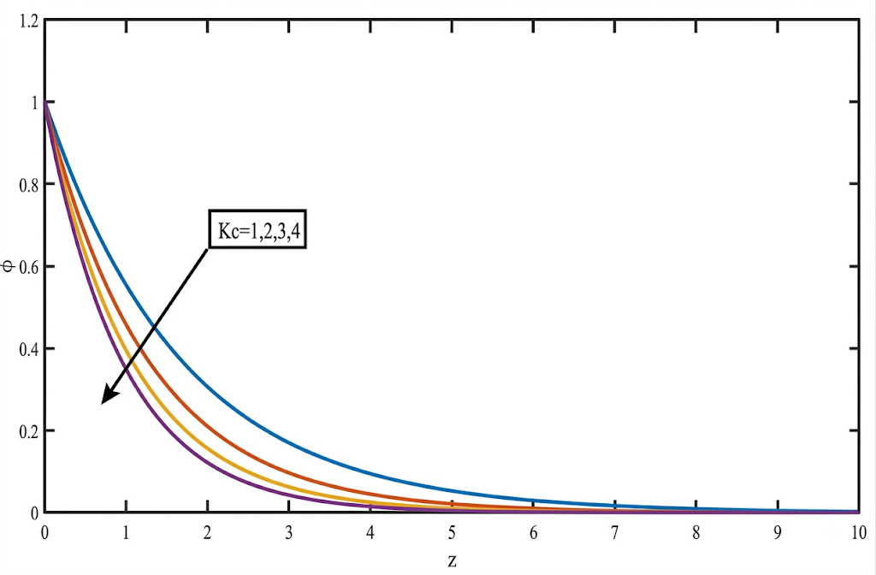
Fig. 12. Effect of Heat source parameter Q on Temperature profiles. | Fig. 13. Effect of Chemical reaction parameter Kr on Concentration profiles.

Figs. 10–12 illustrate the effects of the Prandtl number Pr, thermal-radiation parameter R, and heat-source parameter Q on the temperature profiles, respectively. The Prandtl number represents the ratio of momentum diffusivity to thermal diffusivity. An increase in the Prandtl number corresponds to a reduction in thermal diffusivity, thereby limiting the rate at which thermal energy is transported through the fluid. Consequently, the temperature profile diminishes, indicating a reduction in the thermal boundary-layer thickness. A similar decreasing trend in the temperature profile is observed with increasing thermal-radiation and heat-source parameters, as depicted in Figs. 11 and 12, respectively.
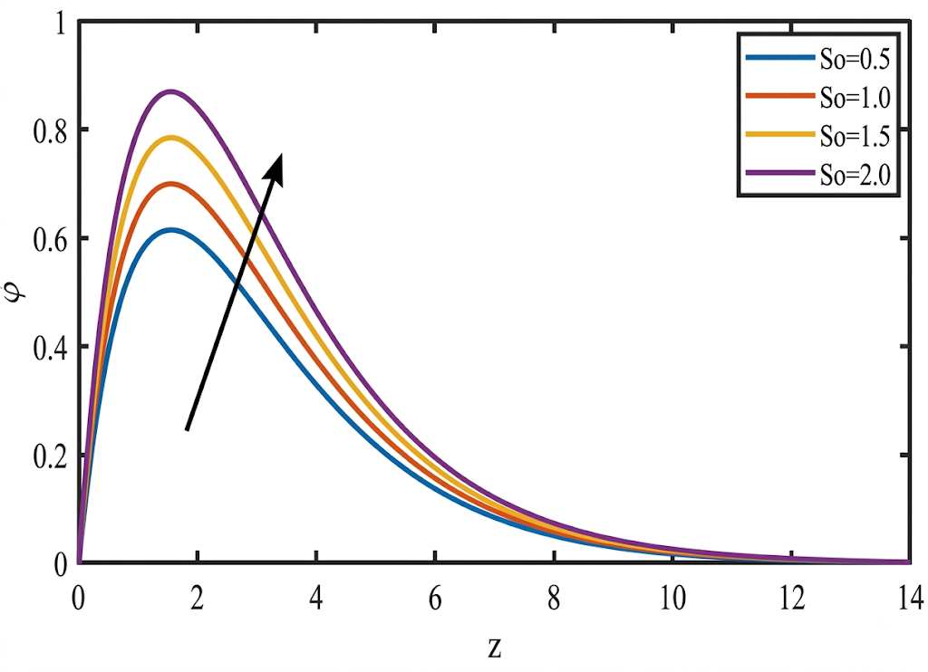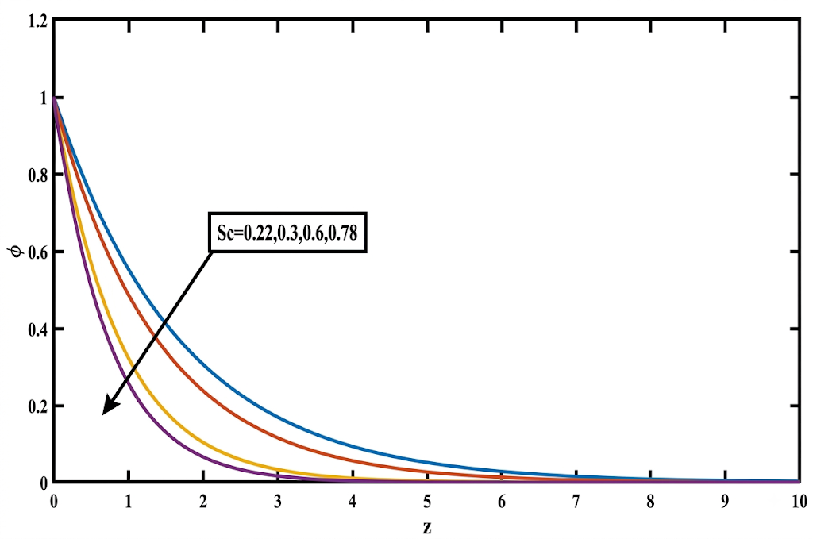
Fig. 14. Effect of Soret parameter So on Concentration profiles. | Fig. 15. Effect of Schmidt number parameter Sc on Concentration profiles.

Figs. 13–15 illustrate the respective effects of the chemical-reaction parameter $Kr$, the Soret number $Sr$, and the Schmidt number $Sc$ on the concentration profiles. Fig. 13 depicts the influence of a destructive chemical reaction ($Kr>0$) on the concentration field. Increasing $Kr$ leads to a monotonic decrease in the concentration distribution, as the enhanced molecular disturbances intensify mass transport and accelerate species depletion. Fig. 14 demonstrates that the concentration profile increases with the Soret number $So$. This behaviour is attributed to the enhanced thermophoretic migration of nanoparticles under stronger thermal gradients, which augments the species concentration within the boundary layer. The effect of the Schmidt number $Sc$ on the concentration profiles is presented in Fig. 15. The Schmidt number, defined as the ratio of kinematic viscosity to mass diffusivity, quantifies the relative effectiveness of momentum and mass transport. Higher $Sc$ values correspond to reduced mass diffusivity, which restricts species penetration into the boundary layer and consequently suppresses the concentration profiles.

- CONCLUSIONS
This study numerically investigated the influence of Hall current and Soret effects on the unsteady magnetohydrodynamic (MHD) natural-convection flow of a viscous, incompressible, electrically conducting fluid. The transport phenomena were evaluated past an infinite vertical plate embedded in a fluid-saturated porous medium in the presence of thermal radiation and chemical reaction. The nonlinear governing partial differential equations were converted into a system of ordinary differential equations and solved using a sixth-order Runge–Kutta scheme coupled with a shooting algorithm. Comprehensive graphical analyses were conducted to evaluate velocity, temperature, and species-concentration distributions across various dimensionless flow parameters. The principal findings are summarised as follows:
- Hall Current Influence: An increase in the Hall-current parameter accelerates the primary velocity while having the opposite effect on the secondary velocity profile (v) within the momentum boundary layer.
- Thermo-diffusive (Soret) Effect: Higher Soret numbers enhance both the primary and secondary velocity distributions across the boundary layer due to temperature gradient-driven mass transport.
- Thermal Buoyancy Response: The thermal buoyancy force impedes the secondary fluid velocity within the boundary-layer region. The thermal buoyancy force tends to increase the primary fluid velocity near the plate. Conversely, it has the opposite effect on the primary fluid velocity farther from the plate.
- Concentration Buoyancy: An increase in the concentration buoyancy force enhances both the primary and secondary velocity components, whereas mass diffusion produces an opposing effect on the velocity field.
- Porous Medium Permeability: Increasing the permeability parameter enhances the secondary-flow velocity while having the opposite effect on the primary velocity component within the boundary layer.
- Temperature Field: Thermal diffusion and thermal radiation tend to reduce the fluid temperature, whereas the fluid temperature increases over time within the boundary-layer region.
- Species Concentration Distributions: Species concentration is suppressed by thermal- and mass-diffusion effects but is significantly enhanced by increasing the Soret number and with the progression of time.
Limitation
The analysis is limited to the assumptions adopted in the mathematical formulation, including an infinite plate, an electrically non-conducting surface, negligible fluid polarisation, and a negligible induced magnetic field under a low magnetic Reynolds number. The results are therefore specific to the selected Jeffrey-fluid model, porous-medium configuration, boundary conditions, and dimensionless parameter ranges used in the numerical simulations. Their interpretation should remain within this modelling framework.
DECLARATION OF COMPETING INTEREST
The authors declare that they have no known competing financial interests or personal relationships that could have appeared to influence the work reported in this paper.
DATA AVAILABILITY
No data were used for the research described in the article.

Declaration of AI Use
This manuscript was prepared through the intellectual contributions of the author(s) to the study design, data analysis, interpretation of results, and scholarly content. Grammarly and ChatGPT were used solely to assist with grammatical refinement and reference formatting during manuscript revision. The author(s) accept full responsibility for the accuracy, integrity, and final content of the manuscript.
References

Abbas, S., & Nazar, M. (2025). Fractional analysis of unsteady magnetohydrodynamics Jeffrey flow over an infinite vertical plate in the presence of Hall current. Mathematical Methods in the Applied Sciences, 48(1), 253–272. https://doi.org/10.1002/mma.10326
Abbas, W., Megahed, A. M., & Fares, E. (2024). The impact of a chemical reaction on the heat and mass transfer mechanisms in a dissipative and radiative nanofluid flow over a nonlinear stretching sheet. Scientific Reports, 14, Article 7712. https://doi.org/10.1038/s41598-024-57952-9
Abdou, M. M. M., & Al-Rashidi, E. A. (2022). Effects of slip velocity and viscous dissipation on MHD boundary layer flow of a micropolar-nanofluid over a wedge with internal heat generation. Asian Journal of Mathematics and Computer Research, 29(4), 23–45. https://doi.org/10.56557/ajomcor/2022/v29i48001
Abo-Dahab, S. M., Jaradat, E. K., Mohamed, R. A., & Elidy, E. S. (2026). Unsteady MHD free convection radiation interaction and mass transfer flow past a vertical moving porous plate. Journal of Thermal Analysis and Calorimetry, 151, 9839–9855. https://doi.org/10.1007/s10973-026-15627-9
Agrawal, A., & Panda, J. P. (2023). Soret effect on MHD flow with Hall current and induced magnetic field. International Journal of Ambient Energy, 44(1), 450–462. https://doi.org/10.1080/01430750.2022.2128416
Ahmed, A., Khan, M., Irfan, M., & Ahmed, J. (2020). Transient MHD flow of Maxwell nanofluid subject to non-linear thermal radiation and convective heat transport. Applied Nanoscience, 10(12), 5361–5373. https://doi.org/10.1007/s13204-020-01375-1
Aly, E. H., & Ebaid, A. (2021). MHD Marangoni boundary layer problem for hybrid nanofluids with thermal radiation. International Journal of Numerical Methods for Heat & Fluid Flow, 31(3), 897–913. https://doi.org/10.1108/HFF-05-2020-0245
Awais, M., & Salahuddin, T. (2024). Variable thermophysical properties of magnetohydrodynamic Cross-fluid model with the effect of energy dissipation and chemical reaction. International Journal of Modern Physics B, 38(16), Article 2450197. https://doi.org/10.1142/S0217979224501972
Bafakeeh, O. T., Raghunath, K., Ali, F., Khalid, M., Tag-ElDin, E. S. M., Oreijah, M., Guedri, K., Ben Khedher, N., & Khan, M. I. (2022). Hall current and Soret effects on unsteady MHD rotating flow of second-grade fluid through porous media under the influences of thermal radiation and chemical reactions. Catalysts, 12(10), Article 1233. https://doi.org/10.3390/catal12101233
Deepthi, V. V. L., Lashin, M. M. A., Kumar, N. R., Raghunath, K., Ali, F., Oreijah, M., Guedri, K., Tag-ElDin, E. S. M., Khan, M. I., & Galal, A. M. (2022). Recent development of heat and mass transport in the presence of Hall, ion slip and thermo diffusion in radiative second grade material: Application of micromachines. Micromachines, 13(10), Article 1566. https://doi.org/10.3390/mi13101566
Fehlberg, E. (1969). Low-order classical Runge–Kutta formulas with stepsize control and their application to some heat transfer problems (NASA Technical Report R-315). National Aeronautics and Space Administration. https://ntrs.nasa.gov/citations/19690021375
Gowda, R. J. P., Kumar, R. N., Jyothi, A. M., Prasannakumara, B. C., & Sarris, I. E. (2021). Impact of binary chemical reaction and activation energy on heat and mass transfer of Marangoni driven boundary layer flow of a non-Newtonian nanofluid. Processes, 9(4), Article 702. https://doi.org/10.3390/pr9040702
Haritha, A., Vishali, B., & Venkata Lakshmi, C. (2023). Heat and mass transfer of MHD Jeffrey nanofluid flow through a porous media past an inclined plate with chemical reaction, radiation, and Soret effects. Heat Transfer, 52(2), 1178–1197. https://doi.org/10.1002/htj.22735
Huang, J. S. (2023). Chemical reaction and activation energy on heat and mass transfer for convective flow along an inclined surface in Darcy porous medium with Soret and Dufour effects. Journal of Mechanics, 39, 88–104. https://doi.org/10.1093/jom/ufad006
Irshad, S., Majeed, A. H., Jahan, S., Riaz, A., Eldin, S. M., & Shahzad, H. (2023). Numerical simulations of MHD generalized Newtonian fluid flow effects on a stretching sheet in the presence of permeable media: A finite difference-based study. Frontiers in Physics, 11, Article 1121954. https://doi.org/10.3389/fphy.2023.1121954
Jain, M. K., Iyengar, S. R. K., & Jain, R. K. (2003). Numerical methods for scientific and engineering computation (4th ed.). New Age International.
Karthik, S., Iranian, D., & Al-Mdallal, Q. M. (2024). Numerical simulation of magneto-hydrodynamic fluid flow with heat sink, chemical diffusion and Powell Eyring fluid behavior using Cattaneo–Christov source term. International Journal of Thermofluids, 22, Article 100616. https://doi.org/10.1016/j.ijft.2024.100616
Kodi, R., & Konduru, V. (2022). Heat and mass transfer on MHD convective unsteady flow of a Jeffrey fluid past an inclined vertical porous plate with thermal diffusion Soret and aligned magnetic field. Materials Today: Proceedings, 50(5), 2128–2134. https://doi.org/10.1016/j.matpr.2021.09.436
Kodi, R., Vaddemani, R. R., Khan, M. I., Abdullaev, S. S., Habibullah, Boudjemline, A., Boujelbene, M., & Bouazzi, Y. (2023). Unsteady magneto-hydrodynamics flow of Jeffrey fluid through porous media with thermal radiation, Hall current and Soret effects. Journal of Magnetism and Magnetic Materials, 582, Article 171033. https://doi.org/10.1016/j.jmmm.2023.171033
Kommaddi, H. B., Kodi, R., Ganteda, C., & Lorenzini, G. (2023). Heat and mass transfer on unsteady MHD chemically reacting rotating flow of Jeffrey fluid past an inclined plates under the impact of Hall current, diffusion thermo and radiation absorption. Journal of Advanced Research in Fluid Mechanics and Thermal Sciences, 111(2), 225–241. https://doi.org/10.37934/arfmts.111.2.225241
Kumar, M. A., Mebarek-Oudina, F., Mangathai, P., Shah, N. A., Vijayabhaskar, C., Venkatesh, N., & Fouad, Y. (2025). The impact of Soret Dufour and radiation on the laminar flow of a rotating liquid past a porous plate via chemical reaction. Modern Physics Letters B, 39(10), Article 2450458. https://doi.org/10.1142/S021798492450458X
Li, Y.-X., Mishra, S. R., Pattnaik, P. K., Baag, S., Li, Y.-M., Khan, M. I., Khan, N. B., Alaoui, M. K., & Khan, S. U. (2022). Numerical treatment of time dependent magnetohydrodynamic nanofluid flow of mass and heat transport subject to chemical reaction and heat source. Alexandria Engineering Journal, 61(3), 2484–2491. https://doi.org/10.1016/j.aej.2021.07.030
Madhukesh, J. K., Ramesh, G. K., Prasannakumara, B. C., Shehzad, S. A., & Abbasi, F. M. (2021). Bio-Marangoni convection flow of Casson nanoliquid through a porous medium in the presence of chemically reactive activation energy. Applied Mathematics and Mechanics (English Edition), 42(8), 1191–1204. https://doi.org/10.1007/s10483-021-2753-7
Madhura, K. R., & Babitha. (2025). Numerical study on magnetohydrodynamics micropolar Carreau nanofluid with Brownian motion and thermophoresis effect. International Journal of Modelling and Simulation, 45(2), 651–664. https://doi.org/10.1080/02286203.2023.2234240
Mahabaleshwar, U. S., Sneha, K. N., Chan, A., & Zeidan, D. (2022). An effect of MHD fluid flow heat transfer using CNTs with thermal radiation and heat source/sink across a stretching/shrinking sheet. International Communications in Heat and Mass Transfer, 135, Article 106080. https://doi.org/10.1016/j.icheatmasstransfer.2022.106080
Mahesh, R., Mahabaleshwar, U. S., Aly, E. H., & Manca, O. (2023). An impact of CNTs on an MHD Casson Marangoni boundary layer flow over a porous medium with suction/injection and thermal radiation. International Communications in Heat and Mass Transfer, 141, Article 106561. https://doi.org/10.1016/j.icheatmasstransfer.2022.106561
Mahla, R., & Kaladhar, K. (2024). Irreversibility analysis of Jeffrey fluid flow in a sloping channel with Hall current, thermal radiation, and inclined magnetic field effects. Journal of Thermal Analysis and Calorimetry, 149, 7705–7716. https://doi.org/10.1007/s10973-024-13335-w
Madan Kumar, R., Srinivasa Raju, R., Kumar, M. A., & Venkateswarlu, B. (2025). A numerical study of thermal and diffusion effects on MHD Jeffrey fluid flow over a porous stretching sheet with activation energy. Numerical Heat Transfer, Part A: Applications, 86(13), 4423–4444. https://doi.org/10.1080/10407782.2024.2319344
Nachtsheim, P. R., & Swigert, P. (1965). Satisfaction of asymptotic boundary conditions in numerical solution of systems of nonlinear equations of boundary-layer type (NASA Technical Note D-3004). National Aeronautics and Space Administration. https://ntrs.nasa.gov/citations/19650026350
Nayak, B., Acharya, S., & Mishra, S. R. (2022). Impact of dissipative heat and thermal radiation on the steady magnetohydrodynamic nanofluid flow with an interaction of Brownian motion and chemical reaction. International Journal of Applied and Computational Mathematics, 8, Article 144. https://doi.org/10.1007/s40819-022-01345-x
Ojo, A. S., & Nwabuzor, P. O. (2026). Analytical investigation of energy and mass transport in magnetohydrodynamic Fe3O4–water nanofluid flow through a chemically reacting porous channel with thermal radiation. Physical Science International Journal, 30(5), 30–54. https://doi.org/10.9734/psij/2026/v30i5968
Ratha, P. K., Tripathy, R. S., & Mishra, S. R. (2024). On the impact of temperature and space dependent heat source/sink with Richardson number for the MHD convection flow of nanofluid. International Journal of Applied and Computational Mathematics, 10, Article 166. https://doi.org/10.1007/s40819-024-01798-2
Razaq, A., Hayat, T., Khan, S. A., & Momani, S. (2023). ATSS model based upon applications of Cattaneo-Christov thermal analysis for entropy optimized ternary nanomaterial flow with homogeneous-heterogeneous chemical reactions. Alexandria Engineering Journal, 79, 390–401. https://doi.org/10.1016/j.aej.2023.08.013
Roja, A., Saadeh, R., Madhukesh, J. K., Shamshuddin, M. D., Prasad, K. V., Khan, U., & Hussain, S. (2024). Computational role of homogeneous–heterogeneous chemical reactions and a mixed convective ternary hybrid nanofluid in a vertical porous microchannel. High Temperature Materials and Processes, 43(1), Article 20240057. https://doi.org/10.1515/htmp-2024-0057
Roja, A., Khan, U., Ramachandran, T., Kulshreshta, A., Neelima, N., Prakash, C., Sherif, E.-S. M., & Pop, I. (2025). Aspects of motile microorganism and thermophoretic particle deposition in the binary chemical reactive ternary hybrid nanofluid past a porous microchannel. ZAMM – Journal of Applied Mathematics and Mechanics / Zeitschrift für Angewandte Mathematik und Mechanik, 105(5), Article e70017. https://doi.org/10.1002/zamm.70017
Sen, R., Roy, S., Narayana, P. A. L., & Kairi, R. R. (2024). Instability of Jeffrey fluid throughflow in a porous layer induced by heat source and Soret effect. Journal of Heat and Mass Transfer, 146(7), Article 072702. https://doi.org/10.1115/1.4065116
Shah, S. A. G. A., Hassan, A., Karamti, H., Alhushaybari, A., Eldin, S. M., & Galal, A. M. (2023). Effect of thermal radiation on convective heat transfer in MHD boundary layer Carreau fluid with chemical reaction. Scientific Reports, 13, Article 4117. https://doi.org/10.1038/s41598-023-31151-4
Singh, N., Chetteti, R., Sen, R., & Vajravelu, K. (2026). On weakly nonlinear convective instability of Soret-driven Jeffrey fluid flow through a porous layer. Transport in Porous Media, 153, Article 60. https://doi.org/10.1007/s11242-026-02310-8
Sridhar, S., & Muthtamilselvan, M. (2025). Exploring stability of Jeffrey fluids in anisotropic porous media: Incorporating Soret effects and microbial systems. International Journal of Numerical Methods for Heat & Fluid Flow, 35(1), 66–86. https://doi.org/10.1108/HFF-02-2024-0145
Vaidya, H., Tripathi, D., Saadaoui, S., Rajashekhar, C., Rafiq, M., Abdullaeva, B. S., Alanazi, M. M., & Prasad, K. V. (2025). Enhanced understanding of peristaltic flow in a uniform channel with Hall current and Joule heating: A study on the effects of a mixed convective Jeffrey fluid. Case Studies in Thermal Engineering, 68, Article 105917. https://doi.org/10.1016/j.csite.2025.105917
Venthan, S. M., Kumar, P. S., Kumar, S. S., Sudarsan, S., & Rangasamy, G. (2024). A computational study of the impact of fluid flow characteristics on convective heat transfer with Hall current using the MHD non-Newtonian fluid model. Chemical Engineering Research and Design, 203, 789–799. https://doi.org/10.1016/j.cherd.2024.02.013
Viskanta, R., & Grosh, R. J. (1962). Boundary layer in thermal radiation absorbing and emitting media. International Journal of Heat and Mass Transfer, 5(9), 795–806. https://doi.org/10.1016/0017-9310(62)90180-1
Xia, W.-F., Khan, M. I., Khan, S. U., Shah, F., & Khan, M. I. (2021). Dynamics of unsteady reactive flow of viscous nanomaterial subject to Ohmic heating, heat source and viscous dissipation. Ain Shams Engineering Journal, 12(4), 3997–4005. https://doi.org/10.1016/j.asej.2021.02.025
Zeng, L., Lv, T., Chen, H., Ma, T., Fang, Z., & Shi, J. (2023). Flow accelerated corrosion of X65 steel gradual contraction pipe in high CO2 partial pressure environments. Arabian Journal of Chemistry, 16, Article 104935. https://doi.org/10.1016/j.arabjc.2023.104935

