Assessment of Genetic Variability, Heritability and Genetic Advance for Yield and Yield-Associated Traits in Barnyard Millet (Echinochloa frumentacea (Roxb.) Link) Genotypes

Abstract
The present investigation was undertaken to assess the magnitude of genetic variability, heritability and genetic advance for yield and yield-associated traits in barnyard millet (Echinochloa frumentacea (Roxb.) Link) genotypes. The study included thirteen important morphological and yield-related characters, namely days to 50% flowering, days to maturity, plant height, number of productive tillers per plant, number of leaves on the main tiller, peduncle length, ear length, finger length, number of fingers per ear, biological yield per plant, harvest index, 1000-seed weight and grain yield per plant. The estimates revealed considerable variation among the genotypes for most of the traits. Phenotypic coefficient of variation (PCV) was higher than the corresponding genotypic coefficient of variation (GCV) for all the characters, indicating the influence of environmental factors on trait expression. The highest GCV was recorded for peduncle length (12.55%), followed by biological yield per plant (12.39%), finger length (11.73%), 1000-seed weight (11.51%) and number of fingers per ear (11.12%). High broad-sense heritability was observed for finger length (83.70%), plant height (75.70%), peduncle length (66.40%), days to 50% flowering (66.00%) and biological yield per plant (64.50%). The highest genetic advance as a percentage of the mean was recorded for finger length (22.10%), followed by peduncle length (21.08%), biological yield per plant (20.50%) and 1000-seed weight (17.33%). High heritability coupled with relatively higher genetic advance for finger length and peduncle length indicated the predominance of additive genetic effects and suggested good scope for improvement through selection for these traits. The findings suggest that traits showing higher heritability and genetic advance can be effectively utilised as selection criteria in barnyard millet breeding programmes for improving grain yield and related attributes.
Keywords: Barnyard millet, Echinochloa frumentacea, genetic variability, GCV, PCV, heritability, genetic advance, yield-associated traits.
Introduction
Barnyard millet (Echinochloa frumentacea (Roxb.) Link) is an important minor millet belonging to the family Poaceae and is widely cultivated in India as a food and fodder crop. It is a short-duration, hardy and climate-resilient crop capable of performing well under rainfed and marginal production conditions. Its relatively low water requirement, early maturity and adaptability to adverse environmental conditions make it particularly suitable for sustainable agriculture and low-input farming systems. In recent years, increasing awareness regarding the nutritional importance of millets has further enhanced the significance of barnyard millet as an alternative food crop.
The grain of barnyard millet is a valuable source of carbohydrates, protein, dietary fibre, minerals and other nutritionally important components. Its potential role in diversified diets and climate-resilient agriculture has generated renewed interest in the genetic improvement of the crop. However, the productivity of barnyard millet is still constrained by limited availability of improved high-yielding genotypes and inadequate exploitation of its genetic resources. Therefore, systematic evaluation and characterisation of available germplasm are essential for identifying superior genotypes and broadening the genetic base of future breeding programmes.
Recent research on barnyard millet has documented substantial diversity at both phenotypic and molecular levels, reinforcing the value of systematic germplasm characterisation for parent selection and crop improvement (Nehru et al., 2023; Roy et al., 2024; A. Singh et al., 2025; B. Singh et al., 2025). A broader review of small-millet breeding similarly highlights the continued importance of germplasm exploitation and the complementary use of conventional and genomics-based approaches in improvement programmes (Nagaraja et al., 2024).
Genetic variability is the basic requirement for effective selection and genetic improvement. The extent of variability present in a breeding population determines the possibility of selecting desirable genotypes for important agronomic and yield-associated traits. The phenotypic expression of quantitative characters is influenced by both genetic and environmental components. Hence, estimation of genotypic and phenotypic variances is important for determining the magnitude of heritable variation and for assessing the potential effectiveness of selection.
The genotypic coefficient of variation (GCV) and phenotypic coefficient of variation (PCV) are useful measures for assessing the extent of variability associated with different quantitative traits. The difference between GCV and PCV provides an indication of the influence of environmental factors on the expression of a character. In addition, heritability estimates provide information regarding the proportion of phenotypic variation that is attributable to genetic differences among genotypes. However, heritability alone may not adequately indicate the expected gain from selection. Therefore, heritability estimates should preferably be considered together with genetic advance as a percentage of the mean (GAM) to understand the probable nature of gene action and the effectiveness of selection.
High heritability coupled with high genetic advance is generally considered an indication of the predominance of additive genetic effects and suggests that improvement through phenotypic selection may be effective. On the other hand, high heritability accompanied by low genetic advance may indicate the influence of non-additive gene action or limited exploitable genetic variability. Thus, the simultaneous estimation of genetic variability, heritability and genetic advance is particularly important for identifying characters that can be effectively utilised as selection criteria in breeding programmes.
Yield and its associated traits in barnyard millet are quantitative in nature and are influenced by several component characters. Characters such as days to flowering, days to maturity, plant height, productive tillers, peduncle length, ear length, finger length, number of fingers per ear, biological yield, harvest index and seed weight may contribute to differences in grain yield among genotypes. A better understanding of the genetic variability and inheritance of these characters can facilitate the identification of desirable genotypes and help breeders formulate effective selection strategies.
Despite the recognised importance of genetic variability, the present germplasm set requires trait-specific quantification of the relative genetic and environmental components of variation and of the expected response to selection. Such an assessment is necessary to identify the morphological and yield-associated characters that can serve as reliable selection criteria under the study conditions.
Therefore, the present investigation was undertaken to assess the magnitude of genetic and phenotypic variability and to estimate broad-sense heritability and genetic advance for important morphological and yield-associated traits in barnyard millet genotypes. The study was aimed at identifying characters with substantial heritable variation and higher expected genetic gain, which could be effectively exploited for the improvement of grain yield and other desirable attributes in barnyard millet.
Materials and Methods
Experimental Site
The present investigation was conducted at the Organic Research Farm, Department of Genetics and Plant Breeding, Institute of Agricultural Sciences, Bundelkhand University, Jhansi, Uttar Pradesh, India. The experimental site represents the agro-climatic conditions of the Bundelkhand region of Uttar Pradesh. The experiment was conducted to assess the extent of genetic variability, heritability and genetic advance for important morphological and yield-associated traits in barnyard millet germplasm.
Experimental Material
The experimental material comprised 15 barnyard millet (Echinochloa frumentacea (Roxb.) Link) germplasm/genotypes. The germplasm lines were selected to represent diverse genetic material and were evaluated for their variability in morphological, phenological and yield-related characteristics. Each genotype was evaluated under identical field conditions to minimise environmental variation and facilitate reliable comparison among genotypes.
Experimental Design
The experiment was laid out in a Randomised Block Design (RBD) with three replications. Each replication consisted of all 15 germplasm entries, and the genotypes were randomly allocated to the experimental plots within each replication. Recommended agronomic practices were followed uniformly throughout the crop period to ensure proper crop establishment and growth.
Observations Recorded
Observations were recorded on randomly selected individual plants from each plot for the following morphological, phenological and yield-associated traits:
- Days to 50% flowering
- Days to maturity
- Plant height (cm)
- Number of productive tillers per plant
- Number of leaves on main tiller
- Peduncle length (cm)
- Ear length (cm)
- Finger length (cm)
- Number of fingers per ear
- Biological yield per plant (g)
- Harvest index (%)
- 1000-seed weight (g)
- Grain yield per plant (g)
For each character, observations were recorded following standard procedures. Days to 50% flowering and days to maturity were recorded on a plot basis, whereas observations for morphological and yield-associated traits were recorded from randomly selected representative plants from each experimental unit. Grain yield per plant was recorded after harvesting and threshing of the selected plants. The 1000-seed weight was determined from randomly selected seeds from each genotype.
Statistical Analysis
The analysis of variance was carried out according to the procedure suggested for a Randomised Block Design to determine the significance of differences among the genotypes for the characters studied. The variance components were estimated from the expected mean squares obtained from the analysis of variance. The estimates of GCV, PCV, broad-sense heritability and genetic advance as a percentage of the mean were used to assess the magnitude of genetic variability and the expected response to selection for different morphological and yield-associated traits in barnyard millet germplasm.
RESULTS AND DISCUSSION
Genetic Variability
The analysis of genetic parameters revealed considerable variability among the barnyard millet (Echinochloa frumentacea (Roxb.) Link) genotypes for the morphological, phenological and yield-associated characters under study. The estimates included genotypic variance, phenotypic variance, environmental variance, genotypic coefficient of variation (GCV), phenotypic coefficient of variation (PCV), broad-sense heritability and genetic advance as a percentage of the mean.
Phenotypic variance was higher than genotypic variance for all the characters, indicating that environmental factors contributed to the phenotypic expression of the traits. Similarly, PCV was higher than GCV for all the characters, suggesting that environmental variation influenced the expression of quantitative characters. Burton (1952) and Burton and DeVane (1953) emphasised that GCV provides a useful measure of the magnitude of genetic variability, whereas comparison of GCV and PCV helps to assess the relative contribution of environmental variation to phenotypic expression. Johnson et al. (1955) further emphasised the importance of genetic variability parameters in determining the potential effectiveness of selection.
The present findings are in agreement with recent studies in barnyard millet. Nehru et al. (2021) reported considerable genetic variability among Indian barnyard millet genetic resources, while Monika et al. (2021) observed substantial variability and significant associations among yield-related traits in segregating populations. Raju et al. (2022) also reported higher PCV than GCV for most of the characters evaluated at different altitudes, indicating the influence of environmental factors on quantitative traits. Similar observations were reported by Deepak et al. (2023) under multiple environments and by Darji and Patil (2023) in barnyard millet genotypes.
Among the traits evaluated in the present investigation, relatively high GCV values were observed for peduncle length (12.55%), biological yield per plant (12.39%), finger length (11.73%), 1000-seed weight (11.51%) and number of fingers per ear (11.12%). The corresponding PCV values were 15.40, 15.43, 12.82, 15.74 and 16.74 per cent, respectively. The relatively high GCV values for these characters indicated the presence of appreciable genetic variability and suggested greater scope for selection and genetic improvement. Similar variability for important morphological, yield and quality-related traits has been reported in barnyard millet by Patil et al. (2021), Raju et al. (2022), Darji and Patil (2023), Harikrishna et al. (2024), Bhuyar et al. (2024) and Shinde et al. (2025).
Plant height recorded a genotypic variance of 43.19 and phenotypic variance of 57.08. The GCV and PCV were 6.79 and 7.80 per cent, respectively, indicating a relatively small difference between the two estimates and consequently a comparatively lower influence of environmental factors. Broad-sense heritability was high (75.70%), suggesting substantial genetic control over the observed phenotypic variation. The high heritability observed for plant height indicates that selection based on phenotypic performance may be relatively effective for this trait. Similar high heritability for plant height has been reported by Raju et al. (2022), Darji and Patil (2023) and other recent barnyard millet studies.
Peduncle length exhibited comparatively high variability, with GCV and PCV values of 12.55 and 15.40 per cent, respectively. The trait showed high broad-sense heritability (66.40%) and high genetic advance as a percentage of the mean (21.08%). The combination of relatively high heritability and high genetic advance indicates considerable exploitable genetic variation for this character. Johnson et al. (1955) suggested that high heritability coupled with high genetic advance is generally indicative of the predominance of additive genetic effects and consequently greater response to selection. Recent findings of Shinde et al. (2025) also demonstrated high heritability for peduncle-related traits in barnyard millet, supporting the potential usefulness of this character in selection programmes.
Heritability and Genetic Advance
The estimates of broad-sense heritability ranged from 17.40% for number of productive tillers per plant to 83.70% for finger length. High heritability was recorded for finger length (83.70%), plant height (75.70%), peduncle length (66.40%), days to 50% flowering (66.00%) and biological yield per plant (64.50%). Moderate heritability was recorded for 1000-seed weight (53.40%), grain yield per plant (49.90%), number of fingers per ear (44.10%), harvest index (41.30%) and days to maturity (40.50%). Low heritability was observed for the number of leaves on the main tiller (31.10%), ear length (28.90%) and number of productive tillers per plant (17.40%).
The highest heritability was observed for finger length (83.70%), indicating that a major proportion of the phenotypic variation for this trait was attributable to genetic differences among the genotypes. Falconer and Mackay (1996) stated that heritability represents the proportion of phenotypic variance attributable to genetic variance, although its magnitude is dependent upon the population and environmental conditions. High heritability for important morphological and yield-associated characters has also been reported in recent barnyard millet studies by Raju et al. (2022), Darji and Patil (2023) and Shinde et al. (2025).
The highest genetic advance as a percentage of the mean was observed for finger length (22.10%), followed by peduncle length (21.08%), biological yield per plant (20.50%), 1000-seed weight (17.33%) and number of fingers per ear (15.22%). The lowest genetic advance was observed for days to maturity (1.01%), followed by ear length (3.53%) and number of productive tillers per plant (5.06%).
High heritability coupled with high genetic advance was particularly evident for finger length and peduncle length. This combination is generally considered an indication of the predominance of additive genetic effects and suggests that selection may be effective for improving these characters. Johnson et al. (1955) demonstrated that joint consideration of heritability and genetic advance provides a better indication of expected response to selection than heritability alone. Similar relationships between heritability and genetic advance have been reported by Burton (1952), Robinson et al. (1949) and Lush (1945).
Recent studies have provided further support for this interpretation in barnyard millet. Raju et al. (2022) reported high heritability coupled with high genetic advance for several morphological and yield-contributing traits across different altitudes. Darji and Patil (2023) also reported high heritability and genetic advance for several important yield-associated traits, indicating the possibility of effective selection. Shinde et al. (2025) similarly reported substantial genetic variability and high heritability for important agronomic traits, strengthening the evidence that genetic parameters can be effectively used to identify promising traits in barnyard millet breeding.
Variability in Yield and Yield-Associated Traits
Biological yield per plant recorded GCV and PCV values of 12.39 and 15.43 per cent, respectively. The broad-sense heritability was 64.50%, while genetic advance as a percentage of the mean was 20.50%. The relatively high heritability coupled with high genetic advance suggests substantial genetic variability and good prospects for selection. These results indicate that biological yield may serve as an important selection criterion in barnyard millet breeding programmes. Similar considerable variability for biomass and yield-associated traits has been reported by Nehru et al. (2021), Raju et al. (2022), Deepak et al. (2023) and Darji and Patil (2023).
The 1000-seed weight trait recorded a GCV of 11.51% and a PCV of 15.74%. Broad-sense heritability was 53.40%, while genetic advance as a percentage of the mean was 17.33%. These estimates indicate moderate-to-high genetic variability and moderate heritability, suggesting that seed weight can be improved through selection, although environmental effects should also be considered. The appreciable genetic advance observed for 1000-seed weight further indicates the presence of exploitable genetic variation. Similar results for seed weight and related yield traits have been reported by Patil et al. (2021), Raju et al. (2022), Darji and Patil (2023) and Shinde et al. (2025).
The number of fingers per ear recorded GCV and PCV values of 11.12 and 16.74 per cent, respectively. The trait showed moderate heritability (44.10%) and genetic advance as a percentage of the mean (15.22%). The relatively large difference between GCV and PCV suggests considerable environmental influence on the expression of this character. Therefore, selection based solely on phenotypic performance may be less effective unless evaluation is conducted under replicated environments. Similar environmental influences on yield-associated quantitative traits have been reported in barnyard millet by Deepak et al. (2023) and Bhuyar et al. (2024).
Grain yield per plant had a mean value of 4.71 g, with GCV and PCV values of 9.16 and 12.97 per cent, respectively. Its broad-sense heritability was 49.90% and genetic advance as a percentage of the mean was 13.34%. The moderate heritability and genetic advance indicate that both genetic and environmental factors contributed to variation in grain yield. Since grain yield is a complex quantitative trait governed by several components and strongly influenced by environmental conditions, indirect selection through highly heritable yield-associated traits may be useful. Falconer and Mackay (1996) and Allard (1999) emphasised the importance of component traits and genetic parameters in selection for complex quantitative characters.
Recent studies also support the importance of evaluating yield through its component characters. Deepak et al. (2023) observed significant genetic variability and associations among yield and yield-contributing traits under multiple environments. Bhuyar et al. (2024) reported genetic divergence for grain yield and its contributing traits across environments, emphasising the importance of exploiting diverse germplasm in barnyard millet improvement. Large-scale characterisation studies have further demonstrated considerable phenotypic and genetic diversity among barnyard millet germplasm, providing opportunities for selection of superior genotypes (B. Singh et al., 2025).
The harvest index recorded GCV and PCV values of 7.55 and 11.75 per cent, respectively, with heritability of 41.30%; genetic advance as a percentage of the mean was 10.00%. The greater difference between GCV and PCV indicated environmental influence on the trait. The moderate heritability suggested that genetic and environmental components both contributed substantially to the observed variation. Similar observations regarding environmental sensitivity of yield-related traits have been reported by Vikram et al. (2020), Dhanalakshmi et al. (2019) and recent multi-environment studies by Deepak et al. (2023).
Phenological Traits
Days to 50% flowering had a mean of 53.31 days, with heritability of 66.00% and genetic advance as a percentage of the mean of 6.79%. The relatively high heritability indicated substantial genetic control of flowering time. However, the moderate magnitude of genetic advance suggested comparatively limited scope for rapid improvement through direct selection. The relatively high heritability of flowering time nevertheless indicates that genotypic differences for this character can be identified with reasonable reliability.
Raju et al. (2022) specifically evaluated early flowering and yield-contributing traits of barnyard millet under different altitudes and reported considerable genetic variation for flowering-related traits. Their findings emphasised the importance of early flowering as a useful breeding objective, particularly for adaptation to different agro-ecological environments.
Days to maturity showed a mean of 131.45 days, with GCV and PCV values of 0.77 and 1.21 per cent, respectively. The trait recorded moderate heritability (40.50%) and very low genetic advance as a percentage of the mean (1.01%). The low genetic variability and genetic advance indicate limited scope for substantial improvement in maturity duration through selection within the evaluated material. The relatively narrow variation observed for days to maturity may be attributed to genetic similarity or limited diversity for maturity duration among the evaluated genotypes.
Sood et al. (2015) reported variation in maturity-related traits among small millet genotypes, emphasising the importance of diverse germplasm for modifying crop duration. Prabu et al. (2020) also examined early maturity and yield-contributing traits in barnyard millet under high-altitude conditions. More recently, Raju et al. (2022) highlighted the importance of early flowering and adaptation-related traits in barnyard millet grown under contrasting altitudes.
The present investigation demonstrated substantial genetic variability for several important morphological, phenological and yield-associated traits in barnyard millet. The estimates of GCV, PCV, heritability and genetic advance indicated that the magnitude of genetic control differed considerably among traits. In general, PCV values were higher than the corresponding GCV values, indicating the influence of environmental factors on the expression of quantitative traits.
Among the characters evaluated, finger length, peduncle length, plant height and biological yield per plant appeared particularly promising because of their relatively high heritability and genetic advance. Finger length recorded the highest heritability (83.70%) and the highest genetic advance as a percentage of the mean (22.10%), indicating good prospects for effective phenotypic selection. Peduncle length also showed high heritability (66.40%) coupled with high genetic advance (21.08%), suggesting substantial exploitable genetic variation and a probable predominance of additive genetic effects.
Biological yield per plant also exhibited a favourable combination of heritability (64.50%) and genetic advance (20.50%), indicating that selection for this trait may contribute to improvement in biomass production. Similarly, 1000-seed weight showed appreciable GCV (11.51%), moderate heritability (53.40%) and relatively high genetic advance (17.33%), indicating potential for selection for improved seed size.
In contrast, number of productive tillers per plant, ear length and days to maturity showed relatively low genetic advance, indicating comparatively limited opportunities for direct improvement through selection within the present material. The moderate heritability observed for grain yield per plant further suggests that selection based directly on grain yield may be less reliable than selection based on suitable component traits with stronger genetic control.
The findings of the present investigation are broadly consistent with recent reports in barnyard millet. Nehru et al. (2021), Monika et al. (2021), Raju et al. (2022), Deepak et al. (2023), Darji and Patil (2023), Bhuyar et al. (2024), Shinde et al. (2025), A. Singh et al. (2025) and B. Singh et al. (2025) reported significant genetic variability, heritability or genetic divergence for important agronomic and yield-related traits in barnyard millet. These recent studies reinforce the importance of genetic variability parameters for identifying promising traits and genotypes for use in breeding programmes.
The present results suggest that finger length and peduncle length are particularly useful traits for phenotypic selection because of their high heritability and high genetic advance. Plant height and biological yield per plant also showed considerable genetic control and genetic gain. Therefore, these traits may be given greater emphasis during selection for improvement of barnyard millet under the agro-ecological conditions represented by the present study.
The results further indicate that the effectiveness of selection can be enhanced by considering heritability together with genetic advance rather than relying on heritability alone. Johnson et al. (1955) and Panse (1957) emphasised that high heritability accompanied by high genetic advance generally provides better evidence of additive genetic variation and expected response to selection. The recent evidence from barnyard millet germplasm studies during 2021–2025 also supports this approach. Thus, the present findings provide useful information for the identification of promising traits and genotypes and may contribute to the development of improved barnyard millet cultivars with desirable agronomic and yield characteristics.

Table 1. Analysis of variance (ANOVA) for different morphological and yield-associated characters in barnyard millet genotypes
S. No. | Character | Replication MSS (df = 2) | Treatment MSS (df = 13) | Error MSS (df = 26)
1 | Days to 50% flowering | 1.23 | 16.47** | 2.41
2 | Days to maturity | 0.77 | 4.57** | 1.50
3 | Plant height (cm) | 8.80 | 143.46** | 13.89
4 | Number of productive tillers plant⁻¹ | 0.07 | 0.23* | 0.14
5 | Number of leaves on main tiller | 0.08 | 0.40** | 0.17
6 | Peduncle length (cm) | 1.36 | 7.95** | 1.14
7 | Ear length (cm) | 0.75 | 1.42** | 0.64
8 | Finger length (cm) | 0.04 | 1.09** | 0.07
9 | Number of fingers ear⁻¹ | 1.54 | 12.81** | 3.80
10 | Biological yield plant⁻¹ (g) | 7.73 | 98.52** | 15.29
11 | Harvest index (%) | 1.89 | 2.46** | 0.79
12 | 1000-seed weight (g) | 0.15 | 0.51** | 0.11
13 | Grain yield plant⁻¹ (g) | 0.32 | 0.58** | 0.15
Note: *Significant at 5% level; **Significant at 1% level.
Table 2. Estimates of genetic variability, heritability and genetic advance for different morphological and yield-associated traits in barnyard millet genotypes
S. No. | Character | Mean | σ²g | σ²p | σ²e | GCV (%) | PCV (%) | ECV (%) | h²b (%) | GA as % of mean
1 | Days to 50% flowering | 53.31 | 4.69 | 7.10 | 2.42 | 4.06 | 5.00 | 2.92 | 66.00 | 6.79
2 | Days to maturity | 131.45 | 1.02 | 2.52 | 1.50 | 0.77 | 1.21 | 0.93 | 40.50 | 1.01
3 | Plant height (cm) | 96.82 | 43.19 | 57.08 | 13.89 | 6.79 | 7.80 | 3.85 | 75.70 | 12.16
4 | No. of productive tillers plant⁻¹ | 2.95 | 0.03 | 0.17 | 0.14 | 5.88 | 14.07 | 12.78 | 17.40 | 5.06
5 | No. of leaves on main tiller | 6.21 | 0.08 | 0.25 | 0.17 | 4.47 | 8.02 | 6.66 | 31.10 | 5.14
6 | Peduncle length (cm) | 12.00 | 2.27 | 3.41 | 1.15 | 12.55 | 15.40 | 8.92 | 66.40 | 21.08
7 | Ear length (cm) | 15.98 | 0.26 | 0.90 | 0.64 | 3.19 | 5.93 | 5.01 | 28.90 | 3.53
8 | Finger length (cm) | 4.97 | 0.34 | 0.41 | 0.07 | 11.73 | 12.82 | 5.18 | 83.70 | 22.10
9 | No. of fingers ear⁻¹ | 15.58 | 3.00 | 6.80 | 3.80 | 11.12 | 16.74 | 12.52 | 44.10 | 15.22
10 | Biological yield plant⁻¹ (g) | 42.50 | 27.74 | 43.03 | 15.29 | 12.39 | 15.43 | 9.20 | 64.50 | 20.50
11 | Harvest index (%) | 9.87 | 0.56 | 1.35 | 0.79 | 7.55 | 11.75 | 9.00 | 41.30 | 10.00
12 | 1000-seed weight (g) | 3.15 | 0.13 | 0.25 | 0.11 | 11.51 | 15.74 | 10.74 | 53.40 | 17.33
13 | Grain yield plant⁻¹ (g) | 4.71 | 0.15 | 0.29 | 0.15 | 9.16 | 12.97 | 9.18 | 49.90 | 13.34

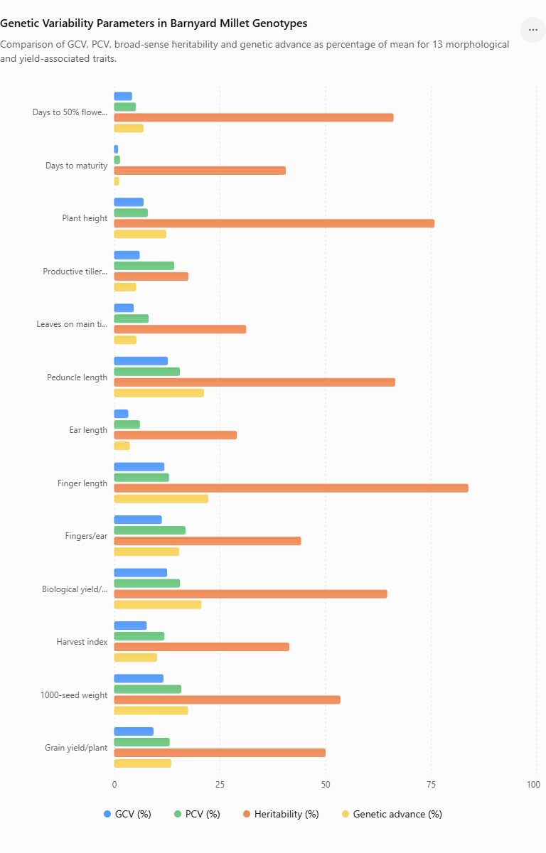
Fig 1- Genotypic coefficient of variation (GCV), phenotypic coefficient of variation (PCV), broad-sense heritability and genetic advance as percentage of mean for thirteen morphological and yield-associated traits in barnyard millet (Echinochloa frumentacea (Roxb.) Link) genotypes
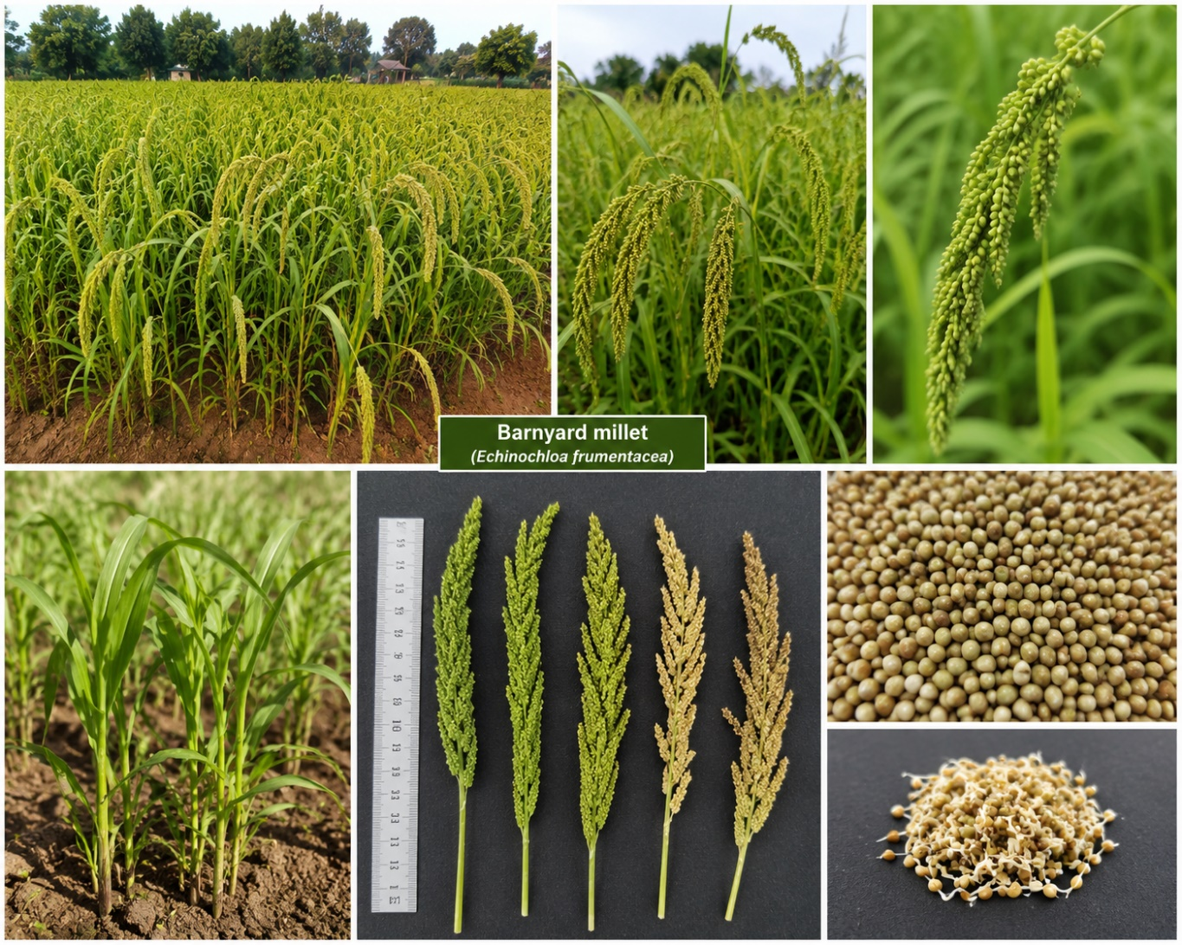
Fig 2- Morphological characteristics of barnyard millet (Echinochloa frumentacea (Roxb.) Link), showing field-grown plants, panicle variation and harvested grains.

Conclusion
The present investigation demonstrated substantial genetic variability among the evaluated barnyard millet (Echinochloa frumentacea (Roxb.) Link) genotypes for several morphological, phenological and yield-associated traits. The analysis of variance revealed significant differences among genotypes for all the characters studied, indicating the presence of adequate variability that can be exploited in barnyard millet improvement programmes.
The estimates of GCV and PCV indicated that environmental factors contributed to the expression of quantitative traits, although the magnitude of genetic variability was appreciable for several characters. Higher GCV values were observed for peduncle length, finger length, 1000-seed weight, biological yield per plant and number of fingers per ear, suggesting greater scope for selection for these traits.
High broad-sense heritability was recorded for finger length, plant height, peduncle length, days to 50% flowering and biological yield per plant. Among these traits, finger length and peduncle length showed high heritability coupled with high genetic advance as a percentage of the mean, indicating a greater contribution of heritable genetic variation and good prospects for improvement through selection. Biological yield per plant and 1000-seed weight also showed comparatively favourable genetic parameters.
Grain yield per plant exhibited moderate heritability and genetic advance, suggesting that direct selection for grain yield may be influenced by environmental factors. Therefore, selection based on highly heritable yield-associated traits may provide a more effective strategy for improving grain yield.
The findings indicate that the evaluated barnyard millet germplasm possesses useful genetic variability for crop improvement. Finger length, peduncle length, biological yield per plant and 1000-seed weight may be given greater emphasis during selection. Further evaluation of the promising genotypes across different environments and seasons, together with correlation and path coefficient analysis, would help validate these traits as reliable selection criteria and facilitate the development of high-yielding and well-adapted barnyard millet genotypes.

Limitations

The study was conducted at a single experimental site using a limited set of barnyard millet germplasm; therefore, the broad-sense heritability and genetic-advance estimates are specific to the evaluated population and field conditions. Genotype-by-environment interaction and the stability of the identified selection criteria could not be established. Further evaluation across environments and seasons, together with correlation and path-coefficient analyses, would strengthen validation of the relationships between component traits and grain yield and improve the reliability of selection recommendations.
Declaration of AI Use

This manuscript was prepared through the intellectual contributions of the author(s) to the study design, data analysis, interpretation of results, and scholarly content. Grammarly and ChatGPT were used solely to assist with grammatical refinement and reference formatting during manuscript revision. The author(s) accept full responsibility for the accuracy, integrity, and final content of the manuscript.

References
Allard, R. W. (1999). Principles of plant breeding (2nd ed.). John Wiley & Sons. https://agris.fao.org/search/en/providers/122535/records/65dde43fb766d82b18fad9e2
Bhuyar, S. A., Ghorade, R. B., & Gomashe, S. S. (2024). Multi-environment genetic divergence analysis in barnyard millet germplasm (Echinochloa frumentacea L.) for grain yield with its contributing traits and nutritional contents. International Journal of Advanced Biochemistry Research, 8(2), 649–652. https://doi.org/10.33545/26174693.2024.v8.i2h.647
Burton, G. W. (1952). Quantitative inheritance in grasses. Proceedings of the Sixth International Grassland Congress, 1, 277–283. https://cir.nii.ac.jp/crid/1574231874841953792
Burton, G. W., & DeVane, E. H. (1953). Estimating heritability in tall fescue (Festuca arundinacea) from replicated clonal material. Agronomy Journal, 45(10), 478–481. https://doi.org/10.2134/agronj1953.00021962004500100005x
Darji, T., & Patil, H. E. (2023). Genetic variability study in barnyard millet [Echinochloa frumentacea (Roxb.) Link] for yield and yield attributes. The Pharma Innovation Journal, 12(12), 2190–2196. https://www.thepharmajournal.com/archives/?ArticleId=24878&issue=12&vol=12&year=2023
Deepak, M. S., Vanniarajan, C., Chandirakala, R., Renuka, R., & Kanchana, S. (2023). Genetic variability and association analysis in barnyard millet (Echinochloa frumentaceae) under multiple environments. Electronic Journal of Plant Breeding, 14(2), 458–463. https://doi.org/10.37992/2023.1402.045
Dhanalakshmi, R., Subramanian, A., Thirumurugan, T., Elangovan, M., & Kalaimagal, T. (2019). Genetic variability and association studies in barnyard millet (Echinochloa frumentacea (Roxb.) Link) germplasm under sodic soil condition. Electronic Journal of Plant Breeding, 10(2), 430–439. https://doi.org/10.5958/0975-928X.2019.00055.3
Falconer, D. S., & Mackay, T. F. C. (1996). Introduction to quantitative genetics (4th ed.). Longman. https://www.ncbi.nlm.nih.gov/nlmcatalog/9602029
Harikrishna, S., Amasiddha, B., Malathi, V. M., & Sameerkumar, C. V. (2024). Correlation and cluster analysis in phenotypic diversity studies of barnyard millet (Echinochloa frumentacea Roxb. L.). International Journal of Advanced Biochemistry Research, 8(8), 895–898. https://doi.org/10.33545/26174693.2024.v8.i8l.1900
Johnson, H. W., Robinson, H. F., & Comstock, R. E. (1955). Estimates of genetic and environmental variability in soybeans. Agronomy Journal, 47(7), 314–318. https://doi.org/10.2134/agronj1955.00021962004700070009x
Lush, J. L. (1945). Animal breeding plans (3rd ed.). Iowa State College Press.
Monika, S., Vanniarajan, C., Chandirakala, R., & Renuka, R. (2021). Genetic variability and association analysis in the segregating population of extra early barnyard millet [Echinochloa frumentaceae (Roxb.) Link] involved crosses. Electronic Journal of Plant Breeding, 12(3), 841–848. https://doi.org/10.37992/2021.1203.117
Nagaraja, T. E., Gazala Parveen, S., Meenakshi, J., Murtujasab, S., Chetana, Manjunatha, M., Bhat, S., & Nandini, C. (2024). Panorama of small millets breeding: A review. Plant Breeding, 143(6), 810–827. https://doi.org/10.1111/pbr.13211
Nehru, G., Trivikrama Reddy, A., Chandramohan Reddy, C. V., & Sreenivasulu, K. N. (2021). Assessment of genetic variability in Indian barnyard millet genetic resources [Echinochloa frumentacea (L.)]. Journal of Research ANGRAU, 49(4), 134–137. https://angrau.ac.in/downloads/Publications/The_Journal_of_Research_ANGRAU_Oct_Dec_2021.pdf
Nehru, G., Trivikrama Reddy, A., Chandra Mohan Reddy, C. V., & Sreenivasulu, K. N. (2023). Study of genetic diversity in Indian barnyard millet genetic resources [Echinochloa frumentacea (L.)]. International Journal of Environment and Climate Change, 13(10), 3094–3110. https://doi.org/10.9734/ijecc/2023/v13i102978
Panse, V. G. (1957). Genetics of quantitative characters in relation to plant breeding. Indian Journal of Genetics and Plant Breeding, 17, 318–328.
Patil, H. E., Darji, T. A., & Pali, V. (2021). Genetic diversity studies for yield and quality traits in barnyard millet. Journal of Innovative Agriculture, 8(1), 21–26. https://doi.org/10.37446/jinagri/rsa/8.1.2021.21-26
Prabu, R., Vanniarajan, C., Vetriventhan, M., Gnanamalar, R. P., Shanmughasundaram, R., & Ramalingam, J. (2020). Association studies in barnyard millet (Echinochloa frumentacea (Roxb.) Link) for early maturity and yield contributing traits at high altitude region. Electronic Journal of Plant Breeding, 11(1), 192–196. https://doi.org/10.37992/2020.1101.033
Raju, P., Vanniarajan, C., Vetriventhan, M., Gnanamalar, R. P., Shanmughasundaram, R., & Ramalingam, J. (2022). Genetic variability of early flowering and yield contributing traits in barnyard millet [Echinochloa frumentacea (Roxb.) Link] grown at different altitudes. Indian Journal of Experimental Biology, 60(2), 131–136. https://doi.org/10.56042/ijeb.v60i02.34096
Robinson, H. F., Comstock, R. E., & Harvey, P. H. (1949). Estimates of heritability and degree of dominance in corn. Agronomy Journal, 41(8), 353–359. https://doi.org/10.2134/agronj1949.00021962004100080005x
Roy, B., Tiwari, S., Tripathi, N., & Thakur, V. V. (2024). Molecular diversity analysis among Indian barnyard millet [Echinochloa frumentacea (L)] genotypes using RAPD markers. Journal of Global Agriculture and Ecology, 16(1), 1–7. https://doi.org/10.56557/jogae/2024/v16i18506
Shinde, C. N., Kamble, M. S., Ban, Y. G., Mote, M. S., Gajbhiye, P. N., Dhumal, R. S., & Gound, R. H. (2025). Genetic variability studies in barnyard millet (Echinochloa frumentacea). International Journal of Research in Agronomy, 8(10), 723–728. https://doi.org/10.33545/2618060X.2025.v8.i10j.4053
Singh, A., Kashyap, S. C., Rai, G. K., Kumar, B., & Kumawat, R. (2025). Assessment of genetic diversity and population structure of barnyard millet [Echinochloa frumentacea (Roxb.) Link.] genotypes for yield and quality traits. Indian Journal of Genetics and Plant Breeding, 85(4 Suppl.), 806–812. https://doi.org/10.31742/ISGPB.85.suppl.14
Singh, B., Pandey, S., Nivedhitha, S., Shekhawat, N., Singh, M., Jat, B., Pandey, C. D., Semwal, D. P., Arya, L., Gautam, R. K., & Singh, G. P. (2025). Comprehensive phenotyping of 1,807 Indian barnyard millet (Echinochloa frumentacea Link) accessions from Indian national genebank: Unlocking diversity for core set development. Frontiers in Plant Science, 16, 1644491. https://doi.org/10.3389/fpls.2025.1644491
Sood, S., Khulbe, R. K., Arun Kumar, R., Agrawal, P. K., & Upadhyaya, H. D. (2015). Barnyard millet global core collection evaluation in the submontane Himalayan region of India using multivariate analysis. The Crop Journal, 3(6), 517–525. https://doi.org/10.1016/j.cj.2015.07.005
Vikram, S., Sudhagar, R., Masilamani, P., & Vanniarajan, C. (2020). Genetic variability and association analysis in barnyard millet mutants. Electronic Journal of Plant Breeding, 11(1), 210–216. https://doi.org/10.37992/2020.1101.036

