Case report

Therapeutic synergy: triple regimen with calcipotriol, clobetasol propionate, and phototherapy in generalized lichen planus in an adolescent

ABSTRACT

Objective: To highlight the synergistic efficacy of high-potency topical corticosteroids, vitamin D analogues, and narrow-band UVB (NB-UVB) phototherapy in achieving rapid clinical remission of pruritus and lesions, while minimising the morbidity and adverse effects associated with conventional systemic therapies in paediatric patients.
Case report: A 14-year-old male adolescent presented with a generalised, bilateral, and symmetrical dermatosis of three months' duration, characterised by purpuric papules that coalesced to form plaques with fine scales and pruritus. Dermoscopy revealed Wickham striae, and onychoscopy showed leukonychia of the third and fourth fingernails of the right hand. With psoriasis vulgaris and eruptive LP considered in the differential diagnosis, skin biopsy confirmed LP. Combination therapy was initiated with topical clobetasol propionate 0.05% at night for 21 days, calcipotriol 0.005% in the morning for two months, and narrow-band UVB phototherapy twice weekly for two months. The patient had a satisfactory clinical course, with remission of pruritus and resolution of the lesions, leaving residual post-inflammatory hyperpigmentation.
Conclusion: The combination of high-potency corticosteroids, topical calcipotriol, and phototherapy may represent an effective and well-tolerated alternative for generalised lichen planus in paediatric patients. This regimen may provide synergistic effects that accelerate clinical remission while minimising long-term adverse effects.

Keywords: Clobetasol; Lichen Planus; Pediatrics; Phototherapy.

- INTRODUCTION
Lichen planus (LP) is defined as a chronic inflammatory dermatosis of unknown aetiology that affects the skin, mucous membranes, and skin appendages (Pertuz Suárez et al., 2021). Globally, its prevalence in adults ranges from 0.2 to 1%, with a marked female predominance and a peak incidence between the third and sixth decades of life; in contrast, its presentation in the paediatric age group is uncommon, accounting for only 1 to 4% of cases (Bolognia et al., 2018). Although the exact aetiopathogenesis remains unclear, numerous studies support an immunological basis. In this process, T lymphocytes, activated by Langerhans cells, attack the basement membrane, while epidermal keratinocytes produce proinflammatory cytokines such as interleukin (IL)-1β, IL-4, IL-6, and tumour necrosis factor-alpha (TNF-α). These mediators activate tissue macrophages and mononuclear cells, triggering antigen-specific and non-specific inflammatory mechanisms that lead to the accumulation and migration of CD8+ T cells, with subsequent apoptosis of keratinocytes (De Paola et al., 2014).
A clinicopathological series of lichen planus also demonstrated the practical importance of correlating clinical morphology with histopathological findings when characterising disease variants (Fathima & Lilly, 2021). A recent case report of symptomatic reticular oral lichen planus described treatment with topical clobetasol propionate, providing a site-specific example of local corticosteroid therapy in a mucosal lichen planus presentation (Deokar et al., 2026; Dutra et al., 2021).
Conventional treatments for LP typically include topical corticosteroids as first-line therapy, reserving systemic corticosteroids, phototherapy, retinoids, immunosuppressants such as cyclosporine, or disease-modifying antirheumatic drugs (DMARDs) such as methotrexate for more severe or generalised cases (Gregory et al., 2026). Recent review and cohort data underscore that the evidence base and therapeutic response in lichen planus remain heterogeneous across clinical presentations, supporting individualised treatment selection (Goekcimen et al., 2026; Tekin et al., 2024). In generalised lichen planus, a recent prospective comparative study reported favourable disease-control and patient-reported outcomes with narrow-band UVB as a steroid-sparing modality, while also noting the need for longer-term evidence (Mithra et al., 2025).
In the search for effective therapeutic alternatives with a favourable long-term safety profile, the role of vitamin D analogues has been evaluated (Mahajan et al., 2020; Patel et al., 2023). Calcipotriol is a synthetic derivative of vitamin D3, initially approved by the FDA in 1993 for the management of psoriasis (Patel et al., 2023). This drug exerts potent immunosuppressive and anti-inflammatory functions by stimulating cellular differentiation and inhibiting the proliferation of keratinocytes and lymphocytes. These biological actions are mediated by the vitamin D receptor (VDR), a steroid receptor located on T lymphocytes (Patel et al., 2023). Furthermore, calcipotriol is an effective inhibitor of the production of proinflammatory cytokines such as IL-1, IL-2, and IL-8, while increasing the levels of IL-10, a cytokine with immunosuppressive properties (De Paola et al., 2014).
Based on this pathogenic rationale, Bayramgürler et al. (2002) conducted a prospective study in which they analysed 16 patients with histopathologically confirmed LP treated with topical calcipotriol twice daily for three months. The authors reported an overall clinical response in 56.3% of cases, comprising partial improvement in 25% and complete resolution with residual post-inflammatory hyperpigmentation in 31.3%; conversely, 43.7% showed no response to treatment. Similarly, Theng et al. (2004) compared the efficacy of calcipotriol with 0.1% betamethasone valerate for 12 weeks in 31 patients with cutaneous lichen planus (15 received calcipotriol and 16 received betamethasone). Flattening of the lesions was observed in 46.7% of the calcipotriol group and 50.0% of the betamethasone group. Complete resolution was achieved in only one patient in the calcipotriol group.
Because the management of cutaneous LP represents an ongoing therapeutic challenge, the combination of a high-potency corticosteroid such as clobetasol propionate with calcipotriol emerges as a promising alternative based on their potential immunomodulatory and anti-inflammatory synergism. The literature summarised above provides limited evidence specifically on the concurrent use of a super-potent topical corticosteroid, topical calcipotriol, and NB-UVB in generalised paediatric cutaneous lichen planus, particularly with respect to short-term clinical response and tolerability. The objective of this report is to describe the clinical evolution, efficacy, and tolerability of this combined therapy in a patient with cutaneous LP, providing scientific evidence on the use of joint therapeutic regimens, while discussing their probable biological mechanisms of synergy and safety considerations.

- CASE PRESENTATION
The study presents the case of a 14-year-old male, born and residing in Valencia, Carabobo State, Venezuela, the product of a seventh controlled pregnancy and a simple eutocic delivery. No relevant personal or family history was reported. The patient reported a 3-month history of the current illness, which began with purpuric flat-topped papules on the lateral aspect of the right leg. These lesions coalesced to form plaques and subsequently became generalised. Consequently, he visited the nearest outpatient centre in January 2026, where topical treatment with betamethasone, clotrimazole, and gentamicin cream was prescribed. He applied this treatment for two weeks without clinical improvement. For this reason, he presented to the paediatric dermatology service of the Ciudad Hospitalaria "Dr. Enrique Tejera" on 9 March 2026.
Physical examination: Fitzpatrick skin phototype IV/VI. He presented with a generalised, bilateral, and symmetrical dermatosis characterised by purpuric flat-topped papules that coalesced into plaques with poorly defined, regular borders, variable in shape and size, with fine scales on their surface. Excoriations with hematic crusts and areas of lichenification were also observed (Fig 1).
Dermoscopic examination revealed an erythematous-violaceous background with fine surface scales and Wickham striae (Fig 2).
Onychoscopy: Leukonychia was observed on the third and fourth fingernails of the right hand. The remaining nail plates were unaffected.

Given the clinical findings, the following differential diagnoses were considered: generalized lichen planus, acute eruptive lichen planus, and psoriasis vulgaris.
Laboratory tests showed non-reactive HIV and VDRL serology.
The histopathological study showed hyperkeratosis, parakeratosis, irregular acanthosis, and a band-like lymphocytic inflammatory infiltrate in the papillary dermis, along with Civatte bodies (Fig 3).
A combined therapeutic regimen was initiated, consisting of topical 0.05% clobetasol propionate cream applied at night for 21 days and 0.005% calcipotriol ointment applied in the morning for two months. Additionally, narrow-band UVB (NB-UVB) phototherapy was administered twice weekly for two months. After completing the therapeutic regimen, the patient showed a satisfactory clinical response, characterised by significant resolution of the skin lesions with residual post-inflammatory hyperpigmentation and complete remission of pruritus.

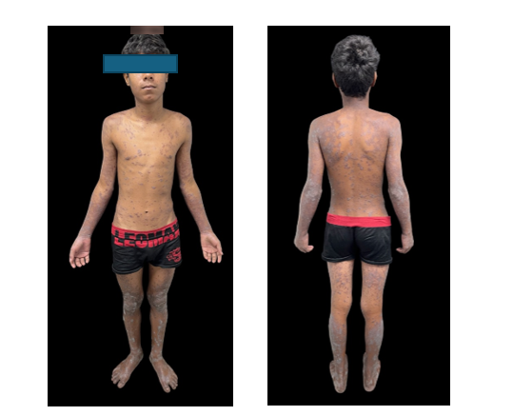

Fig 1. Purpuric flat-topped papules that coalesced into plaques with poorly defined regular borders, variable in shape and size, with the presence of fine scales on their surface. Excoriations with hematic crusts and areas of lichenification were also observed.

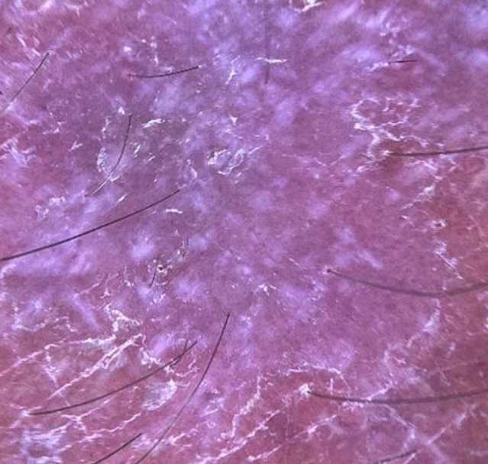

Fig 2. Dermoscopic examination revealed an erythematous-violaceous background with fine surface scales was visualized, along with the presence of Wickham striae

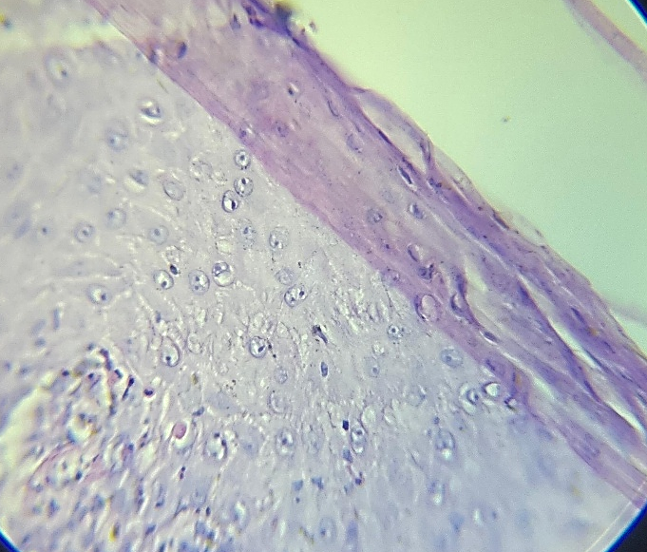

Fig 3. The histopathological study showed hyperkeratosis, parakeratosis, irregular acanthosis, and a band-like lymphocytic inflammatory infiltrate in the papillary dermis, along with Civatte (H&E, 40x).

- DISCUSSION

The therapeutic approach to cutaneous lichen planus is primarily determined by the location of the lesions and clinical severity, with topical corticosteroids being the first-line treatment of choice. As second-line therapies, various alternatives are available, such as topical calcineurin inhibitors, retinoids, systemic steroids, cyclosporine, metronidazole, and griseofulvin (Bermúdez-Barrios et al., 2023); in extensive forms, escalation to systemic therapies and complementary modalities such as phototherapy is considered (Estrella-Tejeda et al., 2025).

With the aim of optimising the resolution of cutaneous lesions and limiting the need for prolonged systemic corticosteroid therapy, a synergistic topical approach was chosen as the initial strategy in this case. The mechanism of action of topical corticosteroids is based on the inhibition of T-lymphocyte proliferation and the suppression of inflammatory immune mediators (Nair et al., 2022); however, their continued use, especially of very high-potency formulations such as clobetasol, carries significant limitations: cutaneous atrophy, characterised by a reduction in skin thickness and elasticity, telangiectasias, and purpura, as well as local effects that can compromise tissue integrity (Norsgaard et al., 2014). In this context, combined therapy with vitamin D analogues emerges as a promising alternative because of complementary mechanisms of action (Austad et al., 1998).

Calcipotriol induces terminal differentiation and inhibits keratinocyte proliferation, in addition to suppressing the lymphocyte response by decreasing interleukins (IL)-1 and IL-8 (De Paola et al., 2014). Although the anti-inflammatory properties of calcipotriol alone are inferior to those of corticosteroids, comparative clinical trials, such as that conducted by Guenther et al. (2002), have documented a synergistic effect when these agents are used in combination, achieving greater efficacy. Furthermore, a clinical trial by Katoh and Kishimoto (2003) evaluated a premixed ointment of calcipotriol and clobetasol propionate and reported greater clinical improvement in psoriasis than with calcipotriol monotherapy.

It is important to highlight that although calcipotriol is formally approved by regulatory agencies exclusively for the management of psoriasis vulgaris, its biological properties pathophysiologically support its off-label use in lichen planus. A crucial point justifying the regimen used in this case is the ability of calcipotriol to counteract the side effects of corticosteroids. In the experimental study conducted by Norsgaard et al. (2014), it was demonstrated that, through the modulation of key extracellular matrix components, calcipotriol reduces early signs of cutaneous atrophy by restoring hyaluronic acid synthesis in keratinocytes and preventing epidermal thinning. It should be noted that, although this study was conducted using betamethasone, the biological principle of tissue preservation may be relevant to other very high-potency corticosteroids such as clobetasol.

As a complementary pillar in scenarios of generalised and disseminated involvement, phototherapy using narrow-band ultraviolet B (NB-UVB) radiation has demonstrated therapeutic efficacy. Clinical studies, such as the study by Dawood et al. (2022), have reported efficacy of NB-UVB in disseminated lichen planus, including complete lesion clearance and prolonged periods of remission. This modality exerts anti-inflammatory and immunosuppressive biological effects by penetrating the epidermis and superficial dermis, where it alters antigen presentation in Langerhans cells. Additionally, phototherapy is recognised to induce the synthesis of regulatory cytokines such as interleukins (IL)-6, IL-8, IL-10, IL-12, and IL-15, granulocyte colony-stimulating factor, and IL-1 receptor antagonist, while decreasing the synthesis of IL-2 (Estrella-Tejeda et al., 2025).

Regarding its use in the paediatric population, Magdaleno-Tapial et al. (2020) demonstrated that NB-UVB phototherapy has a favourable safety and efficacy profile in children, comparable to that observed in adults, with adverse effects reported in 16% of paediatric patients; these adverse effects were predominantly mild erythema.

In this case, the joint implementation of this multidisciplinary regimen (dual topical regimen combined with NB-UVB phototherapy) was associated with marked clinical improvement and flattening of the disseminated lesions two months after treatment initiation. During this period, no manifestations of cutaneous atrophy, capillary fragility, or persistent local adverse reactions were observed.

Following resolution of the active inflammatory phase, the patient developed residual post-inflammatory hyperpigmentation. This phenomenon is an expected and characteristic clinical finding in the evolution of lichen planus, resulting from pigmentary incontinence with consequent phagocytosis of melanin by dermal melanophages. Therefore, this benign clinical course does not represent therapeutic failure but rather reflects the biological healing process typical of interface dermatoses.

- CONCLUSION

This case illustrates the short-term clinical course of generalised cutaneous lichen planus in an adolescent treated with clobetasol propionate, calcipotriol, and NB-UVB phototherapy. The combined regimen was followed by remission of pruritus and marked resolution of active lesions, with residual post-inflammatory hyperpigmentation. During the reported treatment period, no cutaneous atrophy, capillary fragility, or persistent local adverse reactions were observed. The therapeutic rationale rests on combining anti-inflammatory topical corticosteroid activity, the immunomodulatory effects of calcipotriol, and phototherapy for widespread disease. However, the clinical outcome in a single patient does not establish that the three components act synergistically or that the regimen is superior to individual or alternative therapies. Accordingly, the observations should be interpreted as case-based evidence rather than confirmation of efficacy or safety. Prospective studies involving larger paediatric cohorts and defined treatment protocols are required to determine reproducibility of response, durability of remission, and the safety profile of this multimodal approach.
Limitations
The principal limitation is the single-patient case-report design, which limits generalisability and does not permit attribution of the observed response to any individual component of the combined regimen. Because all three modalities were administered within the same treatment period, comparative or additive effects cannot be determined. The report documents the clinical outcome at completion of the two-month regimen; therefore, the durability of remission and delayed adverse effects cannot be assessed from the available follow-up.

Consent

As per international standards, parental written consent has been collected and preserved by the author(s).

Ethical Approval

As per international standards or university standards written ethical approval has been collected and preserved by the author(s).

Competing Interests
Authors have declared that no competing interests exist.

Declaration of AI Use

This manuscript was prepared through the intellectual contributions of the author(s) to the study design, data analysis, interpretation of results, and scholarly content. Grammarly and ChatGPT were used solely to assist with grammatical refinement and reference formatting during manuscript revision. The author(s) accept full responsibility for the accuracy, integrity, and final content of the manuscript.

References

Austad, J., Bjerke, J. R., Gjertsen, B. T., Helland, S., Livden, J. K., Morken, T., & Mørk, N. J. (1998). Clobetasol propionate followed by calcipotriol is superior to calcipotriol alone in topical treatment of psoriasis. Journal of the European Academy of Dermatology and Venereology, 11(1), 19–24. https://doi.org/10.1111/j.1468-3083.1998.tb00948.x
Bayramgürler, D., Apaydın, R., & Bilen, N. (2002). Limited benefit of topical calcipotriol in lichen planus treatment: A preliminary study. Journal of Dermatological Treatment, 13(3), 129–132. https://doi.org/10.1080/09546630260199497
Bermúdez-Barrios, N., Hernández-Pérez, D. M., & Vivas-Toro, S. C. (2023). Manifestación clásica del liquen plano simple [Classic presentation of lichen planus simplex]. Dermatología Revista Mexicana, 67(5), 770–773. https://doi.org/10.24245/drm/bmu.v67i5.9148
Bolognia, J. L., Schaffer, J. V., & Cerroni, L. (2018). Dermatology (4th ed.). Elsevier.
Dawood, M., Sizopoulou, C., Greenberger, S., Barzilai, A., & Pavlotsky, F. (2022). Narrowband ultraviolet B radiation for lichen planus: Long-term follow-up of 192 patients. The Journal of Clinical and Aesthetic Dermatology, 15(4), 31–35. https://pubmed.ncbi.nlm.nih.gov/35465030/
De Paola, M., Fimiani, M., Batsikosta, A., Pisani, C., & Bilenchi, R. (2014). Unilateral hypertrophic lichen planus successfully treated with topical calcipotriol. Giornale Italiano di Dermatologia e Venereologia, 149(2), 274–276. https://pubmed.ncbi.nlm.nih.gov/24819650/
Deokar, I., Vaje, S., & Chavan, M. (2026). Management of symptomatic reticular oral lichen planus involving the buccal and labial mucosa: A case report. Journal of Disease and Global Health, 19(2), 54–60. https://doi.org/10.56557/jodagh/2026/v19i210772
Dutra, T. T. B., Bezerra, T. M. M., Chaves, F. N., Feitosa, S. G., Costa, F. W. G., & Pereira, K. M. A. (2021). Therapeutic alternative for oral lichen planus treatment in an unusual location: Case report. Archives of Health Investigation, 10(5), 734–739. https://doi.org/10.21270/archi.v10i5.4970
Estrella-Tejeda, L. B., Aguilar-Pérez, J. C., Jiménez-Peña, D. V., Peña-Alonso, R. C., & Rodríguez-Castellanos, M. A. (2025). Liquen plano eruptivo tratado con fototerapia [Eruptive lichen planus treated with phototherapy]. Dermatología Revista Mexicana, 69(1), 82–88. https://doi.org/10.24245/dermatolrevmex.v69i1.10316
Fathima, M. N., & Lilly, S. M. (2021). The clinicopathological study of lichen planus. Journal of Pharmaceutical Research International, 33(20B), 21–29. https://doi.org/10.9734/jpri/2021/v33i20B31355
Goekcimen, K., Knoch, C., Fröhlich, F., Kuendig, T., Greis, C., & Meier-Schiesser, B. (2026). Evaluation of comorbidities and treatment outcome in various subtypes of lichen planus: A single-center retrospective study. Journal of Clinical Medicine, 15(11), 4101. https://doi.org/10.3390/jcm15114101
Gregory, M., Esfandiari, N., & Daveluy, S. (2026). Off-label use of upadacitinib for treatment of lichen planus: A narrative review. Dermatology Practical & Conceptual, 16(2), 6449. https://doi.org/10.5826/dpc.1602a6449
Guenther, L., Van de Kerkhof, P. C. M., Snellman, E., Kragballe, K., Chu, A. C., Tegner, E., Garcia-Diez, A., & Springborg, J. (2002). Efficacy and safety of a new combination of calcipotriol and betamethasone dipropionate (once or twice daily) compared to calcipotriol (twice daily) in the treatment of psoriasis vulgaris: A randomized, double-blind, vehicle-controlled clinical trial. British Journal of Dermatology, 147(2), 316–323. https://doi.org/10.1046/j.1365-2133.2002.04967.x
Katoh, N., & Kishimoto, S. (2003). Combination of calcipotriol and clobetasol propionate as a premixed ointment for the treatment of psoriasis. European Journal of Dermatology, 13(4), 382–384. https://pubmed.ncbi.nlm.nih.gov/12948920/
Magdaleno-Tapial, J., Ortiz-Salvador, J. M., Valenzuela-Oñate, C., Marí-Cornejo, P., Esteve-Martínez, A., & Pérez-Ferriols, A. (2020). Experiencia en el uso de fototerapia en pacientes pediátricos y comparación de esta técnica frente a pacientes adultos [Comparison of phototherapy in pediatric and adult patients]. Actas Dermo-Sifiliográficas, 111(1), 41–46. https://doi.org/10.1016/j.ad.2019.03.012
Mahajan, H., Deshmukh, G., Dhoot, D., Mamadi, R., & Barkate, H. (2020). Comparative clinical assessment of effectiveness and safety of calcitriol and calcipotriol in mild plaque psoriasis. International Journal of Clinical Dermatology, 3(2), 28–31. https://doi.org/10.11648/j.ijcd.20200302.13
Mithra, S., Kumar, P., & Sowmiya, R. (2025). Comparative study of the efficacy of azathioprine, dapsone, and NB-UVB phototherapy as steroid-sparing modalities in generalised lichen planus. Indian Journal of Dermatology, Venereology and Leprology, 91(1), 59–64. https://doi.org/10.25259/IJDVL_383_2023
Nair, A. B., Kumar, S., Dalal, P., Nagpal, C., Dalal, S., Rao, R., Sreeharsha, N., & Jacob, S. (2022). Novel dermal delivery cargos of clobetasol propionate: An update. Pharmaceutics, 14(2), 383. https://doi.org/10.3390/pharmaceutics14020383
Norsgaard, H., Kurdykowski, S., Descargues, P., Gonzalez, T., Marstrand, T., Dünstl, G., & Røpke, M. (2014). Calcipotriol counteracts betamethasone-induced decrease in extracellular matrix components related to skin atrophy. Archives of Dermatological Research, 306(8), 719–729. https://doi.org/10.1007/s00403-014-1485-3
Patel, R. T., Gay, J. J., Fagan, K. K., & Eikenberg, J. D. (2023). Non-psoriatic uses of calcipotriol: A concise updated review. Dermatology Online Journal, 29(3), 1. https://doi.org/10.5070/D329361422
Pertuz Suárez, M. J., Buján, M. M., Centeno, M. V., & Cervini, A. B. (2021). Liquen plano, estudio retrospectivo en un hospital pediátrico [Lichen planus: A retrospective study at a pediatric hospital]. Dermatología Argentina, 27(2), 64–68. https://doi.org/10.47196/da.v27i2.2168
Tekin, B., Xie, F., & Lehman, J. S. (2024). Lichen planus: What is new in diagnosis and treatment? American Journal of Clinical Dermatology, 25(5), 735–764. https://doi.org/10.1007/s40257-024-00878-9
Theng, C. T. S., Tan, S. H., Goh, C. L., Suresh, S., Wong, H. B., Machin, D., & Singapore Lichen Planus Study Group. (2004). A randomized controlled trial to compare calcipotriol with betamethasone valerate for the treatment of cutaneous lichen planus. Journal of Dermatological Treatment, 15(3), 141–145. https://doi.org/10.1080/09546630410031891

