Case Report
Arteriovenous Malformation Mimicking Inflammatory Polyp: An Unusual Case Presentation
Abstract
Arteriovenous malformations (AVMs) are fast-flow vascular malformations characterised by direct arteriovenous shunting without an intervening normal capillary bed. Sinonasal involvement is uncommon and may mimic benign polypoid disease. We report a 55-year-old man with several months of unilateral nasal obstruction and no epistaxis. Rigid nasal endoscopy showed a papillomatous mass arising from the posterior end of the right inferior turbinate. A bedside biopsy was interpreted as an inflammatory polyp. Computed tomography of the paranasal sinuses demonstrated a 1.9 x 1.0 x 1.2 cm posterior right inferior turbinate mass without bony erosion, together with bilateral maxillary and ethmoid mucosal thickening. During functional endoscopic sinus surgery, polypoidal lesions were identified over both inferior turbinates, and bilateral turbinectomy was performed. Histopathological examination of the resected tissue was reported as showing an arteriovenous malformation of the bilateral inferior turbinates. The postoperative course was uncomplicated, nasal obstruction resolved, the operative sites healed, and no recurrent mass was observed at follow-up. This case illustrates that AVM should remain in the differential diagnosis of an atypical polypoid nasal mass. When a vascular lesion is suspected clinically or radiologically, appropriate vascular characterisation before biopsy or definitive intervention may reduce diagnostic uncertainty and procedural haemorrhagic risk.
Keywords: arteriovenous malformation; inferior turbinate; nasal obstruction; nasal mass; vascular malformation; case report

Introduction
Vascular anomalies comprise vascular tumours and vascular malformations, categories that differ in biology, natural history, diagnostic evaluation, and treatment. Under the current International Society for the Study of Vascular Anomalies framework, arteriovenous malformations are fast-flow vascular malformations rather than vascular tumours (Goldenberg et al., 2025; Oomen & Wreesmann, 2022). AVMs contain abnormal direct communications between arterial and venous channels without an intervening normal capillary bed and may remain clinically inconspicuous until later in life, when expansion can produce bleeding, pain, tissue changes, functional impairment, or other site-specific symptoms (Gallant et al., 2021; Tanoue et al., 2023).
AVMs involving the nose and paranasal sinuses are uncommon. Published reports demonstrate substantial variation in location and presentation, including nasal-tip lesions, extensive nasal AVMs, and maxillary-sinus AVMs; obstruction or a polypoid mass may therefore coexist with or occur in the absence of the more recognisable features of a vascular lesion (Kim et al., 2020; Noh et al., 2020; Rodriguez et al., 2018). Vascular malformations of the inferior turbinate are also rarely reported, including a documented inferior-turbinate venous malformation (Abi Zeid Daou & Korban, 2019). Endoscopic appearance alone may be non-specific. Flow-sensitive and contrast-enhanced imaging, including duplex ultrasonography, computed tomography angiography, magnetic resonance imaging or angiography, and catheter angiography when appropriate, can help define lesion extent, flow characteristics, feeding vessels, drainage, and nidus architecture (Schmidt et al., 2021; Werba et al., 2024).
Management of extracranial head and neck AVMs is individualised according to symptoms, anatomical extent, flow architecture, treatment morbidity, and the feasibility of complete nidus control. Surgical resection, endovascular or percutaneous embolisation, and multimodality strategies may be used in selected patients, ideally within a multidisciplinary framework (Dorrity et al., 2022; Fernández-Alvarez et al., 2020; Lilje et al., 2022; Tanoue et al., 2023). Residual AVM can persist or recur, and long-term surveillance is therefore important, particularly after incomplete treatment (Liu et al., 2010; Shiraishi et al., 2024). The reports reviewed above do not describe the combined presentation of bilateral inferior-turbinate AVM as a clinically unilateral polypoid mass initially interpreted as an inflammatory polyp. This report describes bilateral inferior-turbinate AVM presenting clinically as a unilateral nasal mass that was initially interpreted on biopsy as an inflammatory polyp, with emphasis on the diagnostic and management implications of this uncommon presentation.

Case Presentation
A 55-year-old man with bronchial asthma presented with unilateral nasal obstruction for several months. He denied epistaxis, cacosmia, facial pain, neck swelling, symptoms suggestive of acute sinusitis, visual changes, constitutional symptoms, fever, headache, ear symptoms, and recent trauma. The remainder of the review of systems was unremarkable. He was alert, comfortable, and not in acute distress. General examination was unremarkable. Rigid nasal endoscopy demonstrated a papillomatous polypoid mass arising from the posterior end of the right inferior turbinate (Figure 1).
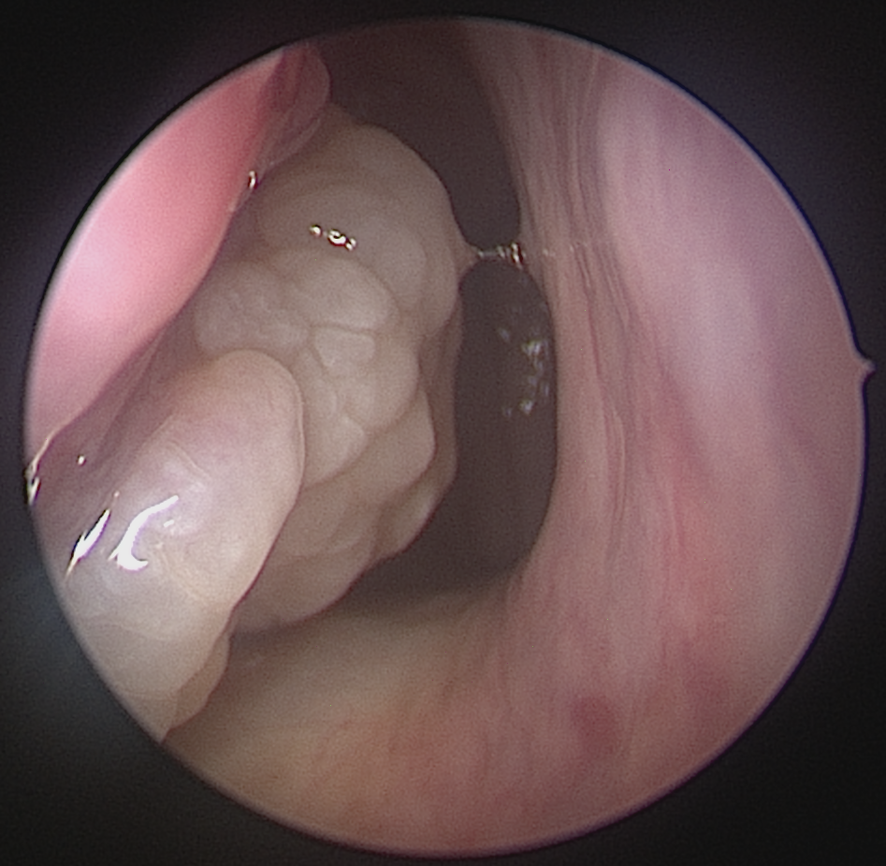
Figure 1. Rigid nasal endoscopic view demonstrating a papillomatous polypoid mass arising from the posterior right inferior turbinate.
A bedside biopsy of the lesion was performed, and the initial histopathological examination was interpreted as an inflammatory polyp. Computed tomography of the paranasal sinuses was subsequently obtained. The scan demonstrated a posterior right inferior-turbinate soft-tissue mass measuring approximately 1.9 x 1.0 x 1.2 cm, with bilateral maxillary and ethmoid sinus mucosal thickening. No bony erosion, hyperostosis, or widened bony foramina were reported (Figure 2).
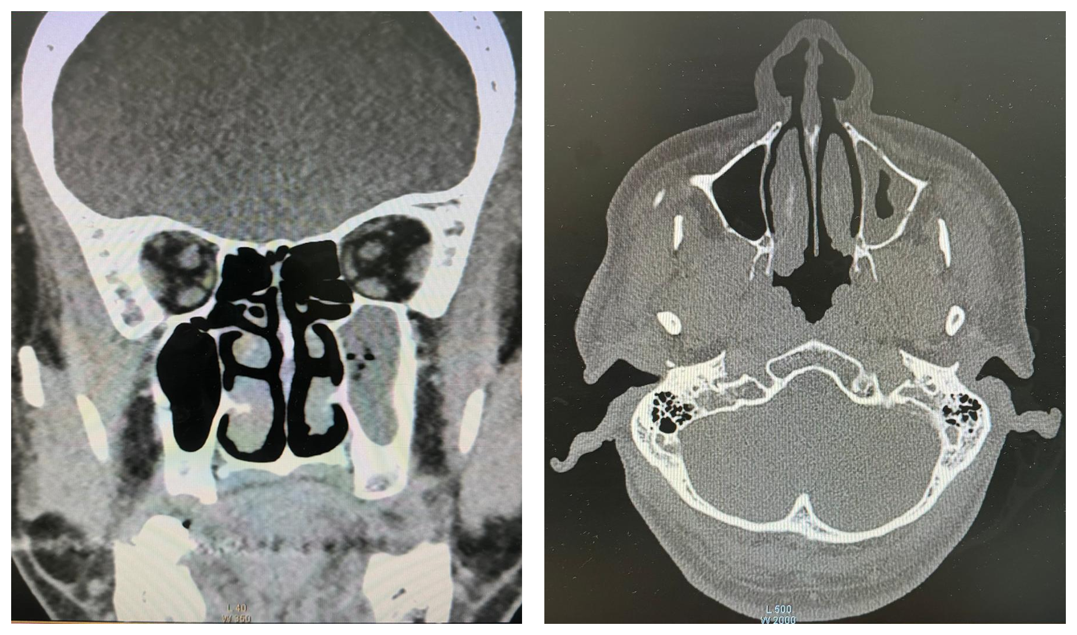
Figure 2. Coronal (left) and axial (right) computed tomography images of the paranasal sinuses demonstrating the right inferior-turbinate soft-tissue lesion without bony erosion. Bilateral sinonasal mucosal thickening was also present.
The patient underwent functional endoscopic sinus surgery and turbinectomy. Intraoperatively, polypoidal lesions were identified over both inferior turbinates, and bilateral turbinectomy was performed. Resected tissue was submitted for histopathological examination, which was reported as showing an arteriovenous malformation of the bilateral inferior turbinates. The postoperative course was uncomplicated, and estimated blood loss was reported as minimal. Nasal obstruction resolved, the operative sites healed well, and no recurrent mass was observed at postoperative follow-up.

Discussion
This case is clinically notable because an AVM at an uncommon intranasal site presented primarily with obstruction rather than epistaxis, appeared endoscopically as a papillomatous or polypoid lesion, and was initially interpreted on biopsy as an inflammatory polyp. Published nasal AVMs have presented with recurrent epistaxis, external nasal deformity, pulsatile or hypervascular lesions, and nasal obstruction, whereas a reported inferior-turbinate venous malformation presented as an obstructive intranasal vascular mass (Abi Zeid Daou & Korban, 2019; Kim et al., 2020; Noh et al., 2020; Rodriguez et al., 2018). These reports support maintaining a vascular malformation within the differential diagnosis when a nasal mass has atypical clinical, endoscopic, or radiological features.
The difference between the initial biopsy interpretation and the final resection diagnosis is an important diagnostic feature of the present case. Histopathological classification of vascular malformations depends on recognition of the dysmorphic vessel types and vascular architecture represented in the examined specimen, and interpretation is strengthened by correlation with the clinical and imaging findings (Fernández-Flores et al., 2023; Pang et al., 2023). Diagnostic discordance between clinical and histopathological classification has also been reported in vascular malformations, supporting a cautious interpretation of limited pathological material (Pang et al., 2023). Small biopsy specimens may not represent the full architecture of a lesion, and instrumentation of an unsuspected AVM can carry haemorrhagic risk. In the maxillary-sinus AVM reported by Kim et al. (2020), recurrent epistaxis followed a prior nasal polypectomy, illustrating the potential consequences of manipulating a vascular lesion before its vascular nature is recognised. Contemporary reviews likewise emphasise careful characterisation of AVM flow and vascular anatomy before intervention when clinical or imaging findings raise suspicion of a high-flow lesion (Tanoue et al., 2023). Therefore, biopsy should not be viewed as a routine first step when an intranasal mass is clinically suspected to be vascular. Where tissue has already been obtained, however, histopathological findings are most appropriately interpreted together with the clinical and radiological context rather than as an isolated basis for vascular-malformation subtyping (Pang et al., 2023).
Imaging serves complementary diagnostic and treatment-planning roles. Duplex ultrasonography can demonstrate flow in accessible lesions, whereas magnetic resonance imaging and dynamic magnetic resonance angiography are particularly useful for defining soft-tissue extent and haemodynamic characteristics. Computed tomography and computed tomography angiography can provide information about osseous relationships and vascular anatomy. Catheter angiography remains especially valuable when detailed nidus architecture and endovascular treatment planning are required (Schmidt et al., 2021; Werba et al., 2024). In the present case, conventional computed tomography identified the right inferior-turbinate mass and the absence of bony erosion but did not establish the lesion as a high-flow AVM before surgery. Accordingly, the designation of AVM in the present report is based on the final histopathological diagnosis rather than on preoperative demonstration of high-flow arteriovenous shunting. Although characteristic AVM morphology may be identified histologically, its high-flow nature can be corroborated using flow-sensitive techniques such as Doppler ultrasonography or dynamic magnetic resonance imaging (Fernández-Flores et al., 2023). The case therefore illustrates the diagnostic limitation of relying on non-flow-sensitive imaging when the vascular nature of a nasal lesion is not initially suspected.
Treatment of head and neck AVMs should be tailored to lesion size, distribution, angioarchitecture, symptoms, and anticipated morbidity. The therapeutic objective, when definitive treatment is pursued, is to control or eradicate the arteriovenous shunt or nidus while preserving function and minimising complications (Dorrity et al., 2022; Fernández-Alvarez et al., 2020; Lilje et al., 2022; Tanoue et al., 2023). Preoperative embolisation can facilitate resection in selected high-flow or extensive lesions, as illustrated by published nasal AVM cases (Noh et al., 2020; Rodriguez et al., 2018), but it is not obligatory for every localised lesion; a maxillary-sinus AVM has also been completely excised without preoperative embolisation (Kim et al., 2020). In the present case, surgery proceeded because the lesion had not been recognised preoperatively as an AVM. The absence of reported intraoperative or postoperative complications indicates that the localised surgical approach was tolerated in this patient, but a single case does not establish surgery without vascular assessment or embolisation as a general treatment standard.
Recurrence remains a central consideration in extracranial AVM management. In a large historical cohort, Liu et al. (2010) reported frequent re-expansion after intervention, with recurrence particularly common after embolisation alone. More recent surgical data also emphasise the importance of completeness of resection: Shiraishi et al. (2024) reported recurrence in 20.0% of cases after total resection compared with 73.7% after partial resection. Reviews of extracranial head and neck AVMs further note that recurrence may occur years after treatment, supporting prolonged clinical surveillance (Fernández-Alvarez et al., 2020). The absence of a recurrent mass at the reported postoperative follow-up in the present case is encouraging, but it should not be interpreted as evidence of durable cure without a defined long-term surveillance interval.

Limitations
This report has limitations inherent to the available case documentation. The lesion was not prospectively characterised as an AVM with Doppler ultrasonography, magnetic resonance angiography, computed tomography angiography, or catheter angiography because a vascular malformation was not suspected before surgery. Detailed histopathological criteria and ancillary staining information were not available for inclusion, and the duration of postoperative follow-up was not specified. Consequently, the present report does not provide independent haemodynamic confirmation of high-flow arteriovenous shunting or sufficient microscopic detail for external reassessment of the vascular-malformation subtype. The term AVM is therefore used in accordance with the reported final histopathological diagnosis, while recognising that flow-sensitive vascular imaging was not performed. Accordingly, the report is best interpreted as a clinicopathological description of an unusual diagnostic presentation rather than evidence for a specific treatment algorithm.

Conclusion
Arteriovenous malformation should be considered in the differential diagnosis of an atypical inferior-turbinate or other polypoid nasal mass, even when epistaxis and obvious vascular features are absent. Endoscopic appearance and a limited biopsy may be misleading. When a vascular lesion is suspected, flow-sensitive vascular imaging before biopsy or definitive intervention can improve diagnostic characterisation and treatment planning. Management should be individualised, and long-term surveillance is appropriate because residual or recurrent AVM can become clinically evident after treatment.

Consent
As per international standards or university standards, patient(s) written consent has been collected and preserved by the author(s).

Declaration of AI Use
Grammarly and ChatGPT were used to assist with grammar checking, language refinement, manuscript organisation, and reference formatting. These tools were not used to generate or alter patient data, clinical findings, imaging, or the reported histopathological diagnosis. Responsibility for the accuracy, integrity, and final content of the manuscript remains with the authors.

References
Abi Zeid Daou, C., & Korban, Z. R. (2019). A venous malformation of the inferior turbinate: A case report with review of the literature. Indian Journal of Otolaryngology and Head & Neck Surgery, 71(Suppl 3), 2143–2147. https://doi.org/10.1007/s12070-019-01635-9
Dorrity, J., Mack, J., Wong, K., & Richter, G. T. (2022). Multimodality treatment of vascular anomalies of the head and neck. Journal of Oral Pathology & Medicine, 51(10), 860–871. https://doi.org/10.1111/jop.13322
Fernández-Alvarez, V., Suárez, C., de Bree, R., Nixon, I. J., Mäkitie, A. A., Rinaldo, A., Downer, J., & Ferlito, A. (2020). Management of extracranial arteriovenous malformations of the head and neck. Auris Nasus Larynx, 47(2), 181–190. https://doi.org/10.1016/j.anl.2019.11.008
Fernández-Flores, A., Cassarino, D., & Colmenero, I. (2023). Vascular malformations: A histopathologic and conceptual appraisal. Actas Dermo-Sifiliográficas, 114(3), 213–228. https://doi.org/10.1016/j.ad.2022.10.035
Gallant, S. C., Chewning, R. H., Orbach, D. B., Trenor, C. C., III, & Cunningham, M. J. (2021). Contemporary management of vascular anomalies of the head and neck—Part 1: Vascular malformations: A review. JAMA Otolaryngology–Head & Neck Surgery, 147(2), 197–206. https://doi.org/10.1001/jamaoto.2020.4353
Goldenberg, D. C., Vikkula, M., Penington, A., Blei, F., Schultze-Kool, L., Wassef, M., & Frieden, I. J. (2025). Updated classification of vascular anomalies: A living document from the International Society for the Study of Vascular Anomalies Classification Group. Journal of Vascular Anomalies, 6(2), e113. https://doi.org/10.1097/JOVA.0000000000000113
Kim, D., Choi, K.-U., Kim, H.-J., & Cho, K.-S. (2020). Arteriovenous malformation of the maxillary sinus: A rare clinical entity. Brazilian Journal of Otorhinolaryngology, 86(6), 820–823. https://doi.org/10.1016/j.bjorl.2016.08.003
Lilje, D., Wiesmann, M., Hasan, D., Riabikin, A., Ridwan, H., Hölzle, F., & Nikoubashman, O. (2022). Interventional therapy of extracranial arteriovenous malformations of the head and neck—A systematic review. PLOS ONE, 17(7), e0268809. https://doi.org/10.1371/journal.pone.0268809
Liu, A. S., Mulliken, J. B., Zurakowski, D., Fishman, S. J., & Greene, A. K. (2010). Extracranial arteriovenous malformations: Natural progression and recurrence after treatment. Plastic and Reconstructive Surgery, 125(4), 1185–1194. https://doi.org/10.1097/PRS.0b013e3181d18070
Noh, Y., Ryu, G., & Kim, H. Y. (2020). A case of arteriovenous malformation of the nasal tip. Korean Journal of Otorhinolaryngology-Head and Neck Surgery, 63(3), 123–128. https://doi.org/10.3342/kjorl-hns.2019.00199
Oomen, K. P. Q., & Wreesmann, V. B. (2022). Current classification of vascular anomalies of the head and neck. Journal of Oral Pathology & Medicine, 51(10), 830–836. https://doi.org/10.1111/jop.13353
Pang, C., Abu-Hanna, J., Lim, C. S., Brookes, J., Tsui, J., Hamilton, G., Onuba, L., & Deroide, F. (2023). Histopathological analysis of vascular malformations. Phlebology, 38(6), 370–379. https://doi.org/10.1177/02683555231175022
Rodriguez, I. E., Khechoyan, D. Y., Deleyiannis, F. W.-B., & French, B. (2018). Surgical management of a nasal AVM in a pediatric patient: A case report. JPRAS Open, 16, 93–97. https://doi.org/10.1016/j.jpra.2017.09.001
Schmidt, V. F., Masthoff, M., Czihal, M., Cucuruz, B., Häberle, B., Brill, R., Wohlgemuth, W. A., & Wildgruber, M. (2021). Imaging of peripheral vascular malformations—Current concepts and future perspectives. Molecular and Cellular Pediatrics, 8(1), 19. https://doi.org/10.1186/s40348-021-00132-w
Shiraishi, M., Narushima, M., Banda, C. H., Moriwaki, Y., Fujisawa, K., Nakajima, M., Yamagata, K., Kondo, C., Okada, Y., Mitsui, K., Hashimoto, K., Danno, K., Hosomi, K., Ishiura, R., Kurita, M., & Okazaki, M. (2024). Treatment effectiveness and recurrence of extracranial arteriovenous malformations following surgical operations: A 15-year retrospective cohort study. Annals of Plastic Surgery, 92(6), 688–693. https://doi.org/10.1097/SAP.0000000000003924
Tanoue, S., Tanaka, N., Koganemaru, M., Kuhara, A., Kugiyama, T., Sawano, M., & Abe, T. (2023). Head and neck arteriovenous malformations: Clinical manifestations and endovascular treatments. Interventional Radiology, 8(2), 23–35. https://doi.org/10.22575/interventionalradiology.2022-0009
Werba, N., Ludwig, J., Weiss, C., Struebing, F., Schoenberg, S., & Sadick, M. (2024). Extracranial arteriovenous malformations: A 10-year experience at a German vascular anomaly center and evaluation of diagnostic imaging for endovascular therapy assessment. Frontiers in Medicine, 11, 1473685. https://doi.org/10.3389/fmed.2024.1473685

