Mapping the Intellectual Structure of Climate Change Vulnerability and Resilience Research (2020–2026): A Bibliometric Analysis Using the Bibliometrix R Package

Abstract
Risk, vulnerability, and resilience have become central concepts across disaster studies, climate adaptation, development, public health, urban planning, and economic policy. This study maps the recent intellectual, conceptual, and social structure of research that connects these concepts with developing and emerging economies. A corpus of 560 English-language records published between 2020 and July 2026 was retrieved from the Web of Science Core Collection and analysed with the bibliometrix package in R. Performance analysis was combined with author, source, country, co-authorship, keyword co-occurrence, thematic, and reference co-citation analyses. The corpus comprised 312 sources and displayed an annual growth rate of 16.02%, an average of 14.99 citations per document, 3.94 co-authors per document, and 38.21% international co-authorship. China and India contributed the largest numbers of corresponding-author publications, while Sustainability and the International Journal of Disaster Risk Reduction were the most productive sources. Climate change, adaptation, disaster management, and sustainability formed the dominant conceptual core, whereas agriculture, food security, poverty, adaptive capacity, and governance constituted a more applied livelihood-oriented strand. The keyword communities were only weakly separated, indicating overlap rather than discrete subfields. The country network also showed multiple collaboration groupings, but these patterns should not be treated as direct evidence of research leadership or funding dependence. Co-citation results indicated a substantially shared intellectual foundation rooted in vulnerability assessment, social–ecological resilience, community resilience, and disaster-risk scholarship. The study shows a rapidly expanding and interdisciplinary literature in which climate-related concerns are prominent, while also identifying opportunities for stronger integration across policy, institutional, household, and livelihood scales.
Keywords: bibliometric analysis; resilience; vulnerability; risk; developing countries; climate change
JEL classifications: O11, Q54, Q56, I32, C80

1. Introduction
Vulnerability and resilience have developed from specialised concepts in ecology, hazards research, and engineering into broad analytical frameworks used across environmental change, disaster-risk reduction, public health, urban studies, development economics, and organisational research. Vulnerability generally refers to susceptibility to harm and the conditions that shape exposure, sensitivity, and capacity to respond, whereas resilience concerns the ability of systems, communities, institutions, or economies to absorb disturbance, adapt, recover, and, where necessary, transform. Although these concepts overlap, they are not interchangeable. Vulnerability emphasises the distribution and production of risk, while resilience directs attention to capacities, processes, and trajectories following disturbance (Adger, 2006; Gallopín, 2006; Smit & Wandel, 2006).
The modern literature is grounded in several complementary traditions. Ecological resilience emerged from the analysis of stability and persistence in ecological systems (Holling, 1973) and later developed into a social–ecological perspective concerned with adaptability and transformability (Folke, 2006; Folke et al., 2010). Hazards and sustainability research, by contrast, gave sustained attention to exposure, social differentiation, place-based vulnerability, and multiscale interactions (Cutter et al., 2003; Turner et al., 2003; Blaikie et al., 2004). Subsequent frameworks integrated exposure, susceptibility, coping, adaptation, and societal response into multidimensional risk assessment (Birkmann et al., 2013). Community-resilience research similarly emphasised interconnected economic, social, informational, and institutional capacities rather than recovery as a purely technical outcome (Bruneau et al., 2003; Cutter et al., 2008; Norris et al., 2008).
These debates have particular relevance to developing and emerging economies. Rapid urbanisation, livelihood dependence on climate-sensitive sectors, uneven infrastructure, fiscal constraints, and persistent social inequality can intensify the consequences of climatic, economic, epidemiological, and geopolitical shocks. At the same time, developing-country settings have generated influential approaches to livelihood vulnerability, local adaptation, community resilience, and indicator-based assessment (Ahsan & Warner, 2014; Hahn et al., 2009). The Sixth Assessment Report of the Intergovernmental Panel on Climate Change further reinforced the need to understand interacting risks, unequal vulnerability, adaptation limits, and climate-resilient development (Intergovernmental Panel on Climate Change [IPCC], 2023). Recent studies similarly emphasise the need to treat climate-resilient development as context dependent and to analyse multidimensional vulnerability across interacting drivers and scales (Ayanlade et al., 2023; Sánchez Rodríguez & Fernández Carril, 2024).
The rapid expansion of this literature creates a need for systematic mapping. Narrative synthesis can clarify concepts and mechanisms, but it is less well suited to describing the structure of large publication corpora, collaboration networks, recurring keywords, or the shared references that organise a field. Bibliometric analysis provides a reproducible set of techniques for performance assessment and science mapping, including co-authorship, co-word, thematic, and co-citation analysis (Aria & Cuccurullo, 2017; Donthu et al., 2021; Zupic & Čater, 2015). These methods do not replace substantive reading; rather, they identify patterns that can guide closer examination and reveal how intellectual and social structures evolve. Recent bibliometric studies have mapped community-resilience trajectories and geographical specialisation in climate-change research, while also cautioning that aggregate global patterns can underrepresent the thematic priorities of countries with lower publication volumes (Debernardi et al., 2024; Hu et al., 2024).
Previous bibliometric work has examined narrower domains such as economic resilience to disasters. Suherningtyas et al. (2025), for example, analysed Scopus-indexed publications from 2004 to 2023 and described successive phases of emergence, acknowledgement, and rapid growth. The present study adopts a broader scope, examining research that connects risk or vulnerability with resilience in developing and emerging economy contexts during 2020–2026. Because the search strategy did not require a climate term, the corpus should not be interpreted as an exhaustive census of climate-resilience research. Instead, the analysis evaluates a wider risk–vulnerability–resilience literature and determines the extent to which climate change, adaptation, disaster management, livelihoods, and related themes organise that literature.
Taken together, the studies reviewed above do not provide an integrated, recent account of the intellectual, conceptual, and social structure of research that connects risk or vulnerability with resilience specifically in developing and emerging economy contexts. The present study addresses this gap through a combined performance-analysis and science-mapping design for the 2020–2026 corpus.
The study addresses four research questions: (1) What publication and citation patterns characterise the corpus between 2020 and 2026? (2) Which authors, sources, and corresponding-author countries contribute most strongly to the literature, and what patterns of international co-authorship are visible? (3) What conceptual structures emerge from author keywords, thematic mapping, and keyword co-occurrence? (4) Which foundational references form the shared intellectual base of the field, and what research directions follow from the observed structure?

2. Conceptual and methodological background

2.1 Vulnerability, resilience, and risk
Risk, vulnerability, and resilience are relational concepts whose meaning depends on the unit of analysis, disturbance, spatial scale, and temporal horizon. Vulnerability may be treated as an antecedent condition, an outcome, or a dynamic property generated by exposure and social organisation. Adger (2006) emphasised its social character, while Turner et al. (2003) proposed a coupled human–environment framework linking exposure, sensitivity, and resilience across scales. The MOVE framework later integrated hazard, exposure, vulnerability, risk, and societal response while recognising that vulnerability contains physical, social, economic, environmental, cultural, and institutional dimensions (Birkmann et al., 2013).
Resilience has also accumulated multiple meanings. In ecology, it concerns the capacity to persist despite disturbance and the possibility of shifts between system states (Holling, 1973). In social–ecological research, resilience encompasses persistence, adaptation, learning, and transformation (Folke, 2006; Folke et al., 2010). Engineering and infrastructure research often focuses on robustness, redundancy, resourcefulness, and rapidity of recovery (Bruneau et al., 2003). Economic-resilience scholarship distinguishes between the ability to maintain function during disruption and the ability to recover or reallocate resources after loss (Rose, 2004). These meanings are related but should not be collapsed into a single universal construct.
Indicator-based approaches translate these multidimensional concepts into empirical measures. The Social Vulnerability Index demonstrated how census-based socioeconomic and demographic indicators can identify geographically differentiated vulnerability (Cutter et al., 2003). The Livelihood Vulnerability Index combined exposure, sensitivity, and adaptive capacity in a framework suitable for household-level climate research (Hahn et al., 2009). Place-based resilience models have similarly integrated social, economic, institutional, infrastructure, ecological, and community-capital dimensions (Cutter et al., 2008). Such measurement frameworks have increased the visibility of index construction, adaptive capacity, and community resilience within the bibliometric landscape.

2.2 Bibliometric science mapping
Bibliometric science mapping examines relationships among publications, authors, keywords, references, institutions, and countries. Performance analysis describes production and impact through publication counts, citation indicators, productivity measures, and source distributions. Science mapping focuses on relational structures. Co-authorship networks approximate patterns of scientific collaboration; keyword co-occurrence networks reveal concepts that are repeatedly used together; and co-citation networks identify publications that later authors jointly treat as intellectually related (Small, 1973; Zupic & Čater, 2015).
Co-word analysis originated as a means of mapping interactions among research themes and of examining their relative centrality and internal development (Callon et al., 1991). Strategic diagrams commonly position themes according to centrality, indicating their connection to the wider field, and density, indicating internal cohesion (Cobo et al., 2011). These positions are descriptive and sensitive to term selection, frequency thresholds, field normalisation, and clustering choices. A theme in an emerging or declining quadrant cannot be classified as emerging rather than declining without longitudinal evidence.
Network visualisation also requires interpretive restraint. Association-strength normalisation is frequently used to reduce the influence of highly frequent nodes (Waltman et al., 2010), while fractional counting can prevent publications with many co-authors from receiving disproportionate weight (Perianes-Rodriguez et al., 2016). Clustering algorithms provide an exploratory partition of a network, not a definitive taxonomy. Modularity, cluster stability, and the substantive coherence of nodes should therefore be considered before strong claims are made. Database coverage is another source of bias: Web of Science and Scopus differ in disciplinary, regional, language, and document-type representation, which can affect rankings and network structures (Mongeon & Paul-Hus, 2016).

3. Data and methods

3.1 Study design and scope
The study used a bibliometric performance-analysis and science-mapping design. The unit of analysis was the bibliographic record indexed in the Web of Science Core Collection. The scope was deliberately broader than climate-change research alone: records were required to connect risk or vulnerability with resilience and to contain a developing- or emerging-economy descriptor. Climate change and environmental adaptation were treated as empirical themes that could emerge from the corpus rather than as mandatory search concepts.
The analysis covered publications from 2020 to July 2026. The 2026 data represent a partial year and were retained to show the most recent indexed activity available at retrieval. Annual output for 2026 was therefore interpreted descriptively and was not treated as a complete basis for year-on-year comparison.

3.2 Data source and search strategy
Bibliographic records were retrieved from the Web of Science Core Collection in July 2026. The following Boolean expression was applied to the Title, Abstract, and Author Keywords fields: (risk OR vulnerability) AND (resilience OR "economic resilience") AND ("developing nations" OR "emerging economies" OR "developing countries" OR "emerging markets" OR BRICS). The search was limited to English-language records published from 2020 through 2026. The query produced 560 records after duplicate and format checks.
Records were exported in BibTeX format with full records and cited references. Because Web of Science limits the number of records in a single export, the data were downloaded in two batches and merged before analysis. The merged data contained 560 records, 559 abstracts, 555 cited-reference fields, 2,093 Author Keywords, and 1,177 Keywords Plus terms. The broad search was expected to include research on climatic, disaster, economic, urban, health, organisational, and other shocks; this breadth was considered during interpretation.

3.3 Data processing and analytical procedures
The BibTeX files were imported into R with the convert2df() function in bibliometrix and analysed using biblioAnalysis() and related functions (Aria & Cuccurullo, 2017). Records were checked for duplicate entries and incomplete formats before analysis. The study calculated annual scientific production, document and source counts, citation indicators, author productivity, co-authorship measures, corresponding-author country output, and source productivity. Raw and fractionalised author counts were both reported because fractional counting reduces the influence of large author teams.
Country collaboration was assessed from author-affiliation metadata. Single-country publications (SCPs) contained authors from one country, whereas multiple-country publications (MCPs) included at least two countries. The MCP ratio was calculated as MCP divided by the total corresponding-author publications attributed to a country. This ratio indicates the prevalence of international co-authorship; it does not directly measure intellectual leadership, funding control, study location, or agenda setting (Glänzel & Schubert, 2004).
Keyword co-occurrence analysis used Author Keywords and the 50 most frequent terms. Association-strength normalisation was applied, the Fruchterman–Reingold algorithm was used for layout, and walktrap community detection was used for exploratory clustering. The analysis did not treat the resulting clusters as fixed disciplinary boundaries. Network centrality was summarised through betweenness and PageRank measures. Thematic mapping used Callon centrality and density to position recurrent themes in four quadrants: motor, basic or transversal, niche, and emerging or declining themes (Callon et al., 1991; Cobo et al., 2011).
Reference co-citation analysis used the 30 most frequently co-cited references. Two references were connected when they appeared together in the cited-reference list of one or more corpus documents. Association-strength normalisation and walktrap clustering were applied for visual exploration. Because the co-citation network displayed extremely low modularity, the revised interpretation emphasised the shared intellectual base rather than treating algorithmic communities as substantively separate schools.

3.4 Interpretive approach and reproducibility considerations
Bibliometric indicators were interpreted as properties of the retrieved corpus, not as direct measures of research quality. Citation counts vary with publication year, field, document type, database coverage, and indexing delay. Author and country rankings can also be affected by name ambiguity and affiliation completeness. Network position was therefore used to describe relational prominence rather than scholarly superiority.
The analyses provide a transparent structural overview, but reproducibility depends on the dated database export, the cleaned bibliographic file, software environment, and parameter settings. In keeping with good practice for bibliometric research (Donthu et al., 2021), the search expression, counting rules, normalisation method, clustering algorithm, and node-selection criteria are reported explicitly. Results that rely on incomplete 2026 indexing or low-modularity partitions are identified as exploratory.

4. Results

4.1 Descriptive bibliometric profile
The corpus contained 560 documents published in 312 sources between 2020 and July 2026 (Table 1). The annual growth rate reported by bibliometrix was 16.02%. Documents had an average age of 2.44 years and received an average of 14.99 citations, equivalent to 3.354 citations per document per year. The records cited 36,900 references and involved 2,000 authors. Collaboration was the dominant mode of authorship: the corpus averaged 3.94 co-authors per document, only 64 documents were single-authored, and 38.21% of publications involved international co-authorship. These values indicate a young and highly collaborative corpus, although citation averages are influenced by a small number of highly cited publications and by unequal citation windows.
Table 1. Main descriptive information for the analytical corpus.
Indicator | Value
Timespan | 2020–2026
Sources (journals, books, etc.) | 312
Documents | 560
Annual growth rate (%) | 16.02
Document average age (years) | 2.44
Average citations per document | 14.99
Average citations per year per document | 3.354
References | 36,900
Author Keywords (DE) | 2,093
Keywords Plus (ID) | 1,177
Authors | 2,000
Author appearances | 2,209
Authors of single-authored documents | 61
Single-authored documents | 64
Documents per author | 0.28
Co-authors per document | 3.94
International co-authorship (%) | 38.21

4.2 Annual scientific production
Annual publication output increased from 41 documents in 2020 to 133 in 2025 (Figure 1). Production remained below 80 documents per year through 2024 before rising sharply in 2025. The 2026 value of 100 records reflects only the portion of the year indexed by July and should not be compared directly with complete calendar years. The observed increase is consistent with expanding interest in interacting climate, disaster, health, economic, and urban risks, but the bibliometric data do not establish the specific causes of the 2025 increase.
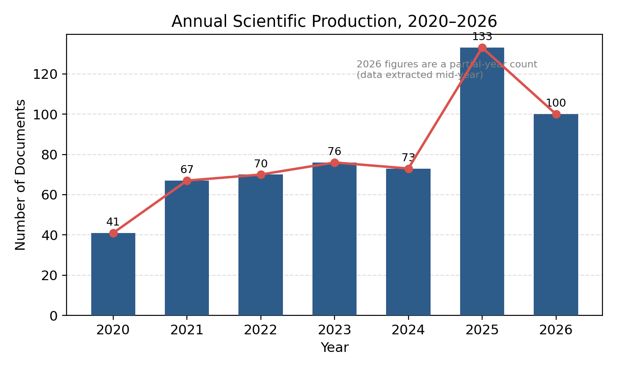
Figure 1. Annual scientific production in the risk–vulnerability–resilience corpus, 2020–2026. The 2026 value represents a partial year.

4.3 Most productive authors
Table 2 compares raw publication counts with fractionalised contributions. Sarker MNI had the highest raw count, with seven publications, while Li Y, Liu J, and Wang Y each had five. Fractionalisation changed the ranking because each contribution was divided by the number of co-authors. Kuhl L, Gnangnon SK, and Tu Dam Ngoc Le TDNL therefore ranked most highly by fractional count. The contrast between the two rankings confirms that apparent productivity partly reflects team size. Initial-based author names may combine homonymous researchers, and the results should be interpreted as database-name entities rather than fully disambiguated individual identities.
Table 2. Ten most productive author-name entities by raw and fractionalised publication counts.
Rank | Author (raw count) | Articles | Author (fractionalised) | Fractional articles
1 | Sarker MNI | 7 | Kuhl L | 2.33
2 | Li Y | 5 | Gnangnon SK | 2.00
3 | Liu J | 5 | Tu Dam Ngoc Le TDNL | 2.00
4 | Wang Y | 5 | Afzal M | 1.67
5 | Afzal M | 4 | Ahmad D | 1.67
6 | Ahmad D | 4 | Keshavarz M | 1.58
7 | Ansari MA | 4 | Cevik S | 1.50
8 | Anwar S | 4 | Jalles JT | 1.50
9 | Das U | 4 | Ansari MA | 1.37
10 | Ekanayake EMAC | 4 | Das U | 1.37

4.4 Most-cited publications
The ten most-cited documents demonstrate the disciplinary breadth produced by the search strategy (Table 3). Eriksen et al. (2021) examined how adaptation interventions can reduce or reproduce vulnerability in developing countries and was the most-cited document. Reverter et al. (2020) linked aquaculture, global warming, and antimicrobial resistance, while Rai et al. (2021) addressed organisational resilience and socioeconomic sustainability during COVID-19. Other highly cited contributions concerned health expenditure and economic growth (Jakovljevic et al., 2020), urban flood vulnerability (Abdrabo et al., 2023), urban resilience assessment (Wang et al., 2023), climate shocks and sovereign bonds (Cevik & Jalles, 2022), climate risk and sovereign borrowing (Beirne et al., 2021), fossil-fuel-dependent development pathways (Ansari & Holz, 2020), and energy resilience and adaptation policy (Aldieri et al., 2021). Their diversity confirms that the corpus extends beyond climate adaptation in a narrow sense and includes health, finance, energy, urban systems, and development policy.
Table 3. Ten most-cited publications in the corpus.
Rank | Publication | Total citations | Citations per year | Normalised citations
1 | Eriksen et al. (2021), World Development | 580 | 96.7 | 15.05
2 | Reverter et al. (2020), Nature Communications | 423 | 60.4 | 10.85
3 | Rai et al. (2021), Environment, Development and Sustainability | 169 | 28.2 | 4.39
4 | Jakovljevic et al. (2020), Globalization and Health | 138 | 19.7 | 3.54
5 | Abdrabo et al. (2023), Urban Climate | 133 | 33.2 | 6.03
6 | Wang et al. (2023), Environmental Impact Assessment Review | 110 | 27.5 | 4.99
7 | Cevik and Jalles (2022), Energy Economics | 106 | 21.2 | 5.82
8 | Beirne et al. (2021), International Review of Economics & Finance | 105 | 17.5 | 2.72
9 | Ansari and Holz (2020), World Development | 104 | 14.9 | 2.67
10 | Aldieri et al. (2021), Energy Policy | 100 | 16.7 | 2.59

4.5 Country-level contribution and collaboration
China was the leading corresponding-author country with 92 publications, followed by India with 44, and Australia and the United States with 32 each (Table 4; Figure 2a). China also had the largest numbers of both SCPs and MCPs. International collaboration intensity varied substantially. Bangladesh had the highest MCP ratio among the ten leading countries, followed by the United Kingdom and Australia. These ratios show how frequently internationally co-authored papers occurred within each country’s corresponding-author output; they do not establish which country initiated the research or controlled its intellectual direction.
Table 4. Top corresponding-author countries by single-country and multiple-country publications.
Rank | Country | Articles | Frequency | SCP | MCP | MCP ratio
1 | China | 92 | 0.166 | 63 | 29 | 0.315
2 | India | 44 | 0.080 | 37 | 7 | 0.159
3 | Australia | 32 | 0.058 | 16 | 16 | 0.500
4 | United States | 32 | 0.058 | 21 | 11 | 0.344
5 | South Africa | 27 | 0.049 | 21 | 6 | 0.222
6 | United Kingdom | 23 | 0.042 | 7 | 16 | 0.696
7 | Iran | 22 | 0.040 | 19 | 3 | 0.136
8 | Bangladesh | 16 | 0.029 | 4 | 12 | 0.750
9 | Pakistan | 15 | 0.027 | 8 | 7 | 0.467
10 | Brazil | 12 | 0.022 | 7 | 5 | 0.417

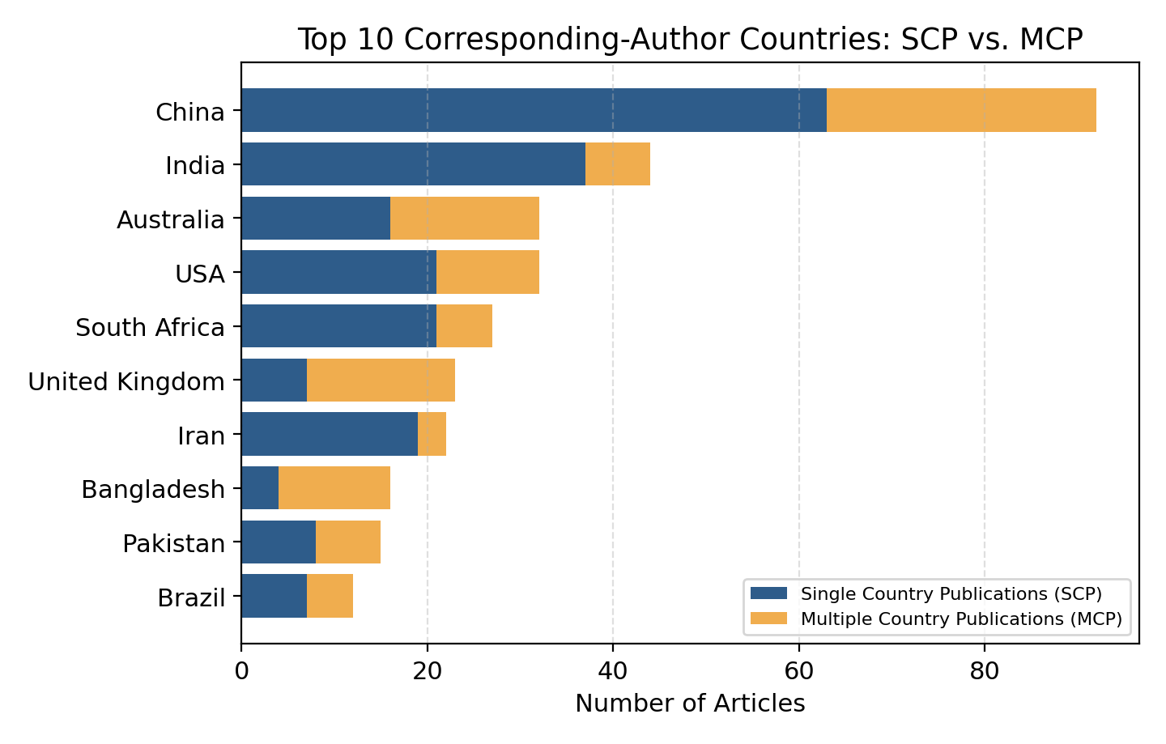
Figure 2a. Top corresponding-author countries by article count, decomposed into single-country publications (SCPs) and multiple-country publications (MCPs).
Country citation totals produced a different ordering from publication volume (Table 5). China had the largest aggregate citation count, but Norway and France had much higher average citations per article because a small number of exceptionally cited papers dominated their country totals. Such averages are unstable when the number of publications is small and should not be interpreted as a general measure of national research quality.

Table 5. Total and average citations by country for the ten leading citation totals.
Rank | Country | Total citations | Average citations per article
1 | China | 1,675 | 18.21
2 | Australia | 583 | 18.22
3 | Norway | 580 | 580.00
4 | India | 565 | 12.84
5 | France | 539 | 134.75
6 | United States | 374 | 11.69
7 | United Kingdom | 372 | 16.17
8 | Iran | 292 | 13.27
9 | Pakistan | 274 | 18.27
10 | Portugal | 247 | 49.40

The country co-authorship network included the 30 most connected countries and was partitioned by walktrap into six algorithmic communities (Figure 2b). The visual layout nevertheless showed two broad concentrations of links: one contained several South and East Asian countries together with European, Australian, and North American partners, while another contained the United States, the United Kingdom, and several African and European countries. China, the United States, and the United Kingdom occupied prominent bridging positions. The pattern indicates a multi-centred and partially fragmented collaboration structure, but the network alone cannot determine the effects of funding arrangements, institutional hierarchy, or study-site dependence.
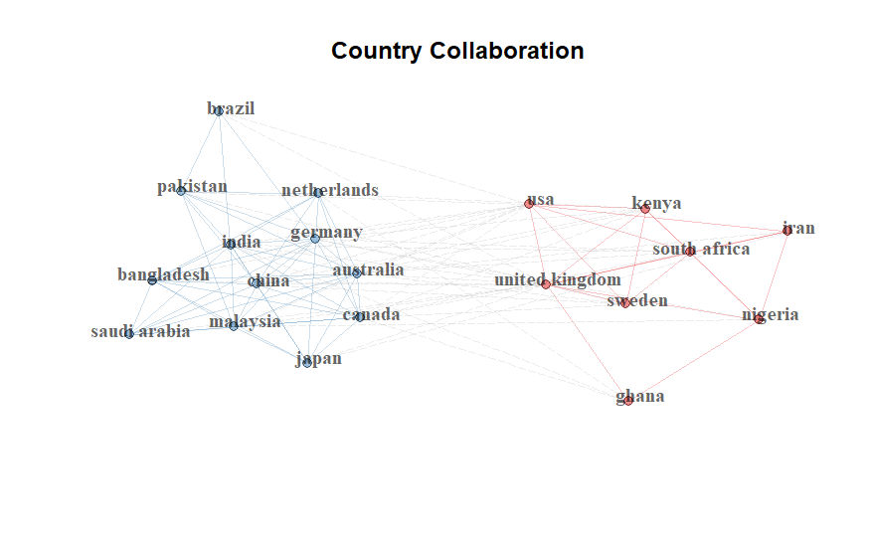
Figure 2b. Country co-authorship network for the 30 most connected countries. Node size reflects betweenness centrality and colour indicates walktrap community.

4.6 Source analysis
Sustainability and the International Journal of Disaster Risk Reduction published 32 and 30 corpus documents, respectively, and together accounted for 11.1% of the dataset (Table 6). The remaining leading sources included journals in environmental sustainability, water and land systems, development, climate policy, finance, and multidisciplinary open-access publishing. The distribution illustrates the field’s cross-disciplinary character, although journal counts alone do not quantify interdisciplinarity.
Table 6. Ten most productive sources in the corpus.
Rank | Source | Articles
1 | Sustainability | 32
2 | International Journal of Disaster Risk Reduction | 30
3 | Environment, Development and Sustainability | 8
4 | Water | 8
5 | Discover Sustainability | 7
6 | Land | 7
7 | World Development | 7
8 | Climate and Development | 6
9 | Finance Research Letters | 6
10 | Heliyon | 6

4.7 Keyword frequency and co-occurrence structure
Resilience, climate change, vulnerability, developing countries, and adaptation were the most frequent Author Keywords (Table 7). Among Keywords Plus terms, vulnerability, resilience, impact, adaptation, and climate-change were most frequent. COVID-19 ranked sixth among Author Keywords, showing that the corpus captured compound and non-climatic shocks as well as environmental hazards. The prominence of climate change despite its absence from the required search terms indicates that climate-related scholarship forms a major component of the broader corpus.
Table 7. Ten most frequent Author Keywords and Keywords Plus terms.
Rank | Author Keyword | Articles | Keywords Plus | Articles
1 | Resilience | 104 | Vulnerability | 133
2 | Climate Change | 86 | Resilience | 104
3 | Vulnerability | 59 | Impact | 64
4 | Developing Countries | 40 | Adaptation | 62
5 | Adaptation | 32 | Climate-Change | 59
6 | COVID-19 | 29 | Management | 48
7 | Sustainability | 19 | Risk | 48
8 | Agriculture | 14 | Framework | 46
9 | Sustainable Development | 13 | Impacts | 45
10 | Bangladesh | 12 | Strategies | 29

The co-occurrence network of the 50 most frequent terms yielded two broad exploratory communities (Figure 3; Table 8). The first contained 30 nodes centred on vulnerability, resilience, adaptation, climate-change, disaster management, risk, frameworks, and policy. The second contained 20 nodes centred on impacts, agriculture, food security, poverty, adaptive capacity, farmers, governance, and communities. The network modularity was 0.069, indicating only weak separation. The clusters are therefore best understood as overlapping emphases—a hazard and policy orientation and a livelihood and agriculture orientation—rather than as statistically discrete subfields.
Table 8. Exploratory communities in the Author Keyword co-occurrence network.
Cluster | Interpretive label | Selected core keywords | Number of nodes
1 | Climate vulnerability, disaster risk, and policy resilience | vulnerability; resilience; adaptation; climate-change; disaster management; risk; framework; strategies; policy; natural hazards; community resilience | 30
2 | Agricultural livelihoods, adaptive capacity, and food security | impacts; agriculture; food security; poverty; adaptive capacity; farmers; governance; communities; variability; perceptions | 20

Betweenness centrality was highest for vulnerability, resilience, adaptation, risk, and framework (Table 9). These terms linked otherwise less-connected areas of the network. Impacts and poverty were the principal high-betweenness terms in the livelihood-oriented community. PageRank values were also highest for the major general concepts. Centrality does not indicate conceptual superiority; it identifies terms whose network positions connect a larger number of keyword paths.
Table 9. Centrality measures for the ten Author Keywords with the highest betweenness values.
Keyword | Cluster | Betweenness centrality | PageRank centrality
vulnerability | 1 | 40.32 | 0.0325
resilience | 1 | 38.22 | 0.0324
adaptation | 1 | 35.41 | 0.0312
risk | 1 | 29.17 | 0.0293
framework | 1 | 28.93 | 0.0299
strategies | 1 | 28.41 | 0.0282
climate-change | 1 | 28.24 | 0.0293
impacts | 2 | 20.82 | 0.0262
management | 1 | 23.24 | 0.0280
poverty | 2 | 9.51 | 0.0206

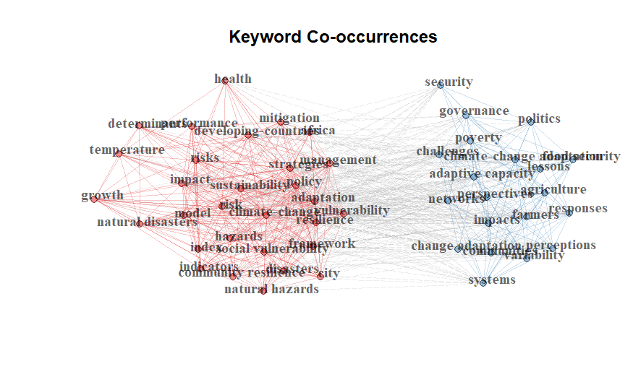
Figure 3. Author Keyword co-occurrence network. Node size reflects betweenness centrality; colours represent exploratory walktrap communities.

4.8 Strategic thematic map
The thematic map positioned recurrent term groups according to centrality and density (Figure 4). Flood, sustainable development, gender, and community resilience appeared in the motor-theme quadrant, indicating themes that were both internally developed and connected to other parts of the corpus. Risk, poverty, sustainable, supply-chain resilience, and resilience appeared as basic or transversal themes: they were connected to the field but displayed lower internal density. Geopolitical risk, flood-risk management, and social appeared as niche themes, while retrofitting, sustainable finance, Pakistan, COVID-19, climate risk, and economic growth occupied the emerging-or-declining quadrant.
These positions should be interpreted as descriptive outcomes of the selected keywords and parameters. The map does not establish whether a lower-left theme is genuinely emerging or declining, and it does not imply that a country-specific term is methodologically immature. Longitudinal thematic-evolution analysis and sensitivity testing would be required to distinguish growth, decline, and terminological fragmentation. Nevertheless, the map shows that the corpus combines established disaster- and community-resilience themes with newer or less densely connected topics in finance, economic growth, pandemic response, and retrofitting.
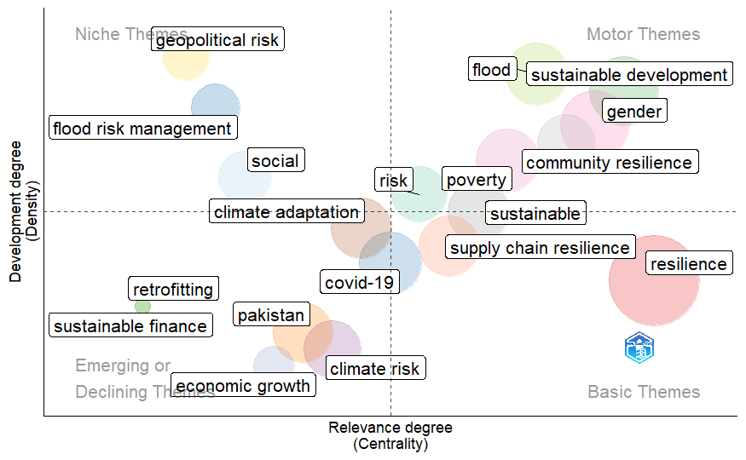
Figure 4. Strategic thematic map based on Callon centrality and density.

4.9 Co-citation network of foundational references
The co-citation network of the 30 most frequently co-cited references brought together the principal intellectual traditions of the corpus (Figure 5). The central region contained foundational work on social vulnerability, coupled human–environment vulnerability, adaptation, community resilience, and social–ecological resilience, including Adger (2006), Cutter et al. (2003, 2008), Turner et al. (2003), Smit and Wandel (2006), Folke (2006), Folke et al. (2010), Hahn et al. (2009), Meerow et al. (2016), and Blaikie et al. (2004). Indicator-oriented and disaster-risk frameworks were closely connected with ecological and social–ecological theory, suggesting that empirical measurement and conceptual development draw on a shared reference base.
The network modularity was 0.001, indicating almost no meaningful separation into independent co-citation communities. The coloured partitions should therefore be regarded as a visual aid rather than evidence of distinct schools. Methodological references can also appear near substantive work because they are co-cited within empirical articles. The dominant finding is consequently the coherence of the field’s foundational canon, not fragmentation of its intellectual base. This shared base contrasts with the somewhat looser differentiation observed in contemporary keyword use.
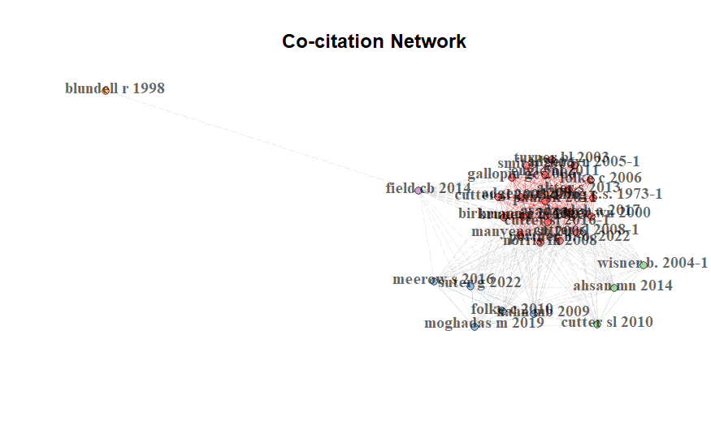
Figure 5. Reference co-citation network for the 30 most frequently co-cited works. Colours show exploratory walktrap partitions; the very low modularity indicates a largely shared intellectual base.

5. Discussion

5.1 Expansion and interdisciplinary breadth
The corpus shows that risk, vulnerability, and resilience research connected with developing and emerging economies expanded rapidly during 2020–2025. The annual growth rate and increasing output indicate sustained scholarly attention, while the partial 2026 count suggests that activity remained substantial. The results should not be interpreted as proof of a discrete evolutionary stage, because the search window is short and the 2026 year is incomplete. They nevertheless demonstrate that resilience language has become widely embedded across environmental, disaster, urban, health, financial, and development research.
The most-cited publications illustrate both the value and the breadth of the search. Eriksen et al. (2021) addressed maladaptation and vulnerability, directly reflecting the core concern of climate-resilient development. Abdrabo et al. (2023) and Wang et al. (2023) developed urban vulnerability and resilience assessments, while Cevik and Jalles (2022), Beirne et al. (2021), and Aldieri et al. (2021) connected climate and energy risks with sovereign finance and policy. Reverter et al. (2020), Jakovljevic et al. (2020), and Rai et al. (2021) show that health, antimicrobial resistance, and pandemic-related organisational sustainability also entered the corpus. This diversity is analytically useful, but it confirms that the dataset is broader than a climate-change-only collection.

5.2 Geography of production and collaboration
China and India led corresponding-author output, consistent with their large research systems and substantial exposure to climate, urban, environmental, and development challenges. Australia, the United States, South Africa, the United Kingdom, Iran, Bangladesh, Pakistan, and Brazil also contributed prominently. The high international co-authorship rate indicates that the literature is embedded in transnational research networks rather than organised solely within national systems.
The MCP ratios reveal differences in the frequency of international collaboration, but they should not be used as proxies for dependence or leadership. A highly international paper may be initiated and led by researchers in any participating country, and bibliographic affiliation data do not reveal funding authority, fieldwork location, data ownership, or decision-making power. Stronger assessment of knowledge-production equity would require corresponding- and first-author analysis, institutional roles, funding acknowledgements, research-site coding, and contribution statements. The current network supports a more limited conclusion: international collaboration is substantial but unevenly distributed, and a small number of countries occupy bridging positions between several collaboration communities.

5.3 Relationship between policy-oriented and livelihood-oriented research
The keyword analysis identified a broad hazard, policy, and measurement emphasis alongside a more applied livelihood, agriculture, food-security, and poverty emphasis. The low modularity of the two-community solution is important. It indicates that the two orientations overlap considerably and share core concepts such as vulnerability, resilience, adaptation, and impacts. The field should therefore not be portrayed as two isolated conversations. A more accurate interpretation is that common concepts are applied at different scales and in different empirical domains.
Even so, the relative position of livelihood terms suggests opportunities for stronger multilevel integration. Macro-level policies, infrastructure systems, financial resilience, and institutional planning ultimately affect household, farm, and community capacities. Conversely, household vulnerability and livelihood adaptation influence whether national or urban resilience policies produce equitable outcomes. Research that links policy implementation to distributional and livelihood effects would help connect these scales. Such work could combine longitudinal household data, institutional analysis, spatial risk assessment, and evaluation of adaptation interventions.

5.4 A shared intellectual foundation with diverse applications
The co-citation analysis shows that contemporary applications continue to rely on a common set of foundational concepts. The social production of vulnerability, place-based exposure, adaptive capacity, social–ecological resilience, community capacities, and disaster-risk frameworks are not independent traditions in the citation network; they are repeatedly cited together. This finding is consistent with the conceptual evolution described in major syntheses of vulnerability and adaptation (Adger, 2006; Field et al., 2014; Smit & Wandel, 2006).
The near-zero modularity of the co-citation network cautions against constructing elaborate narratives around small algorithmic partitions. It instead suggests that conceptual coherence is stronger at the level of foundational references than at the level of recent terminology. New applications in finance, supply chains, health, and urban systems appear to extend a relatively concentrated canon. Future bibliometric work could test whether this canon is broadening by using bibliographic coupling, temporal co-citation windows, or cited-reference age analysis.

5.5 Methodological implications for bibliometric research
The study also demonstrates why transparent search construction is essential. A search based on generic resilience and vulnerability terms captures a wide range of systems and shocks. This breadth can reveal interdisciplinary transfer, but it also introduces records that would be irrelevant to a narrowly framed climate-resilience review. Titles and conclusions must therefore reflect the actual query, and corpus validation should accompany any claim that a dataset represents a specialised domain.
Network outputs require similar discipline. Visual density, proximity, and colour can invite causal or evaluative interpretations that are not contained in the data. Co-authorship does not measure leadership; centrality does not measure quality; and thematic-map quadrants do not independently establish maturity or decline. Reporting modularity and acknowledging low cluster separation materially improves interpretive reliability. Sensitivity analyses using alternative thresholds, counting methods, and clustering algorithms would further strengthen future studies.

6. Future research directions
First, future studies should develop multilevel designs that connect national and urban resilience policies with household, community, and livelihood outcomes. Such work would clarify whether institutional investments translate into reduced vulnerability across social groups and locations.
Second, compound and cascading risks require greater attention. The prominence of COVID-19 alongside climate, economic, and food-security terms shows that resilience research increasingly addresses interacting shocks. Comparative studies could examine how climatic extremes, health emergencies, energy-price shocks, debt stress, and supply-chain disruption reinforce or offset one another.
Third, the equity of knowledge production should be studied directly rather than inferred from co-authorship ratios. First- and corresponding-authorship, institutional location, funding acknowledgements, contribution statements, data governance, and research-site information would permit a more defensible assessment of leadership and partnership structures.
Fourth, the relationship between climate vulnerability and macroeconomic resilience remains suitable for focused study, but it should be investigated through a purpose-built search strategy. A dedicated corpus could distinguish sovereign risk, fiscal resilience, economic diversification, firm continuity, and livelihood recovery rather than treating all economic references as one theme.
Fifth, future bibliometric monitoring should use complete calendar years and compare multiple databases. Repeating the analysis after full 2026 and 2027 indexing would show whether the 2025 increase represents a durable trend. Cross-database comparison would also help identify regional and language biases associated with Web of Science coverage (Mongeon & Paul-Hus, 2016).
Finally, methodological robustness should be assessed through alternative keyword thesauri, full and fractional counting, different node thresholds, and more than one clustering algorithm. Reporting the stability of central nodes and themes would distinguish durable structures from parameter-sensitive visual patterns.

7. Conclusion
This study mapped 560 Web of Science records published between 2020 and July 2026 that connected risk or vulnerability with resilience in developing and emerging economy contexts. The corpus expanded rapidly, was highly collaborative, and drew contributions from environmental, disaster, development, urban, health, energy, and financial research. China and India led corresponding-author output, while Sustainability and the International Journal of Disaster Risk Reduction were the most productive sources.
Climate change, adaptation, disaster management, sustainability, and vulnerability formed the principal conceptual core even though climate terminology was not mandatory in the search. Livelihood, agriculture, food security, poverty, adaptive capacity, and governance formed a second applied emphasis, but low modularity showed that these areas overlap substantially with the hazard and policy literature. Country collaboration was multi-centred and partially fragmented, although bibliographic networks alone do not establish leadership or dependence.
The co-citation network revealed a largely shared intellectual foundation centred on vulnerability assessment, adaptation, social–ecological resilience, community capacities, and disaster-risk scholarship. The literature is therefore conceptually anchored but increasingly diverse in application. The most productive next step is not to impose sharper boundaries on this field, but to connect institutional and policy research with household and livelihood outcomes, improve direct analysis of equitable research partnerships, and apply more transparent and robust bibliometric methods.

Limitations
This study has several limitations. First, the search strategy was broad and did not require a climate-related term. The corpus therefore contains relevant work on health, finance, urban systems, organisations, and other forms of risk and resilience, but it should not be treated as an exhaustive climate-change corpus. Second, the analysis used a single bibliographic database. Web of Science coverage differs across disciplines, countries, languages, and journal systems, and may underrepresent regional scholarship.
Third, the search included English-language records only. Research published in Chinese, Spanish, Portuguese, French, Arabic, and other languages may be particularly important for the geographical scope of the study. Fourth, 2026 was incomplete at the time of retrieval, creating partial-year bias in annual-production and citation comparisons. Fifth, citation counts favour older records and can be strongly influenced by a small number of highly cited publications.
Sixth, author and institution names were not fully disambiguated beyond bibliographic cleaning. Common initial-based names may combine multiple researchers, while spelling and affiliation variants may divide one entity. Seventh, keyword networks depend on author terminology and may retain synonyms, hyphenation variants, or differences between singular and plural forms. Eighth, clustering and thematic positions are parameter-sensitive. The low modularity values, particularly in the co-citation network, limit strong claims about independent intellectual communities.
Finally, bibliometric relations describe publication metadata rather than the quality, validity, or causal content of individual studies. Co-authorship does not establish research leadership, and co-occurrence does not demonstrate substantive integration. The results should therefore be used as a structural guide for further content-based and empirical investigation.

Declaration of AI Use

This manuscript was prepared through the combined contributions of all author(s), including contributions to the study design, data, content development, results, interpretation, and related scholarly work. The author(s) acknowledge the use of Grammarly and ChatGPT to assist with grammar checking, language refinement, reference formatting. These AI-assisted tools were not used as authors and did not replace the intellectual contributions or scholarly judgment of the author(s). All AI-assisted outputs, including content, references, and interpretations, were carefully reviewed, revised, verified, and approved by the author(s). The author(s) accept full responsibility for the accuracy, integrity, and final content of the manuscript.

References
Abdrabo, K. I., Kantoush, S. A., Esmaiel, A., Saber, M., Sumi, T., Almamari, M., Elboshy, B., & Ghoniem, S. (2023). An integrated indicator-based approach for constructing an urban flood vulnerability index as an urban decision-making tool using the PCA and AHP techniques: A case study of Alexandria, Egypt. Urban Climate, 48, Article 101426. https://doi.org/10.1016/j.uclim.2023.101426
Adger, W. N. (2006). Vulnerability. Global Environmental Change, 16(3), 268–281. https://doi.org/10.1016/j.gloenvcha.2006.02.006
Ahsan, M. N., & Warner, J. (2014). The socioeconomic vulnerability index: A pragmatic approach for assessing climate change led risks–A case study in the south-western coastal Bangladesh. International Journal of Disaster Risk Reduction, 8, 32–49. https://doi.org/10.1016/j.ijdrr.2013.12.009
Aldieri, L., Gatto, A., & Vinci, C. P. (2021). Evaluation of energy resilience and adaptation policies: An energy efficiency analysis. Energy Policy, 157, Article 112505. https://doi.org/10.1016/j.enpol.2021.112505
Ansari, D., & Holz, F. (2020). Between stranded assets and green transformation: Fossil-fuel-producing developing countries towards 2055. World Development, 130, Article 104947. https://doi.org/10.1016/j.worlddev.2020.104947
Aria, M., & Cuccurullo, C. (2017). bibliometrix: An R-tool for comprehensive science mapping analysis. Journal of Informetrics, 11(4), 959–975. https://doi.org/10.1016/j.joi.2017.08.007
Ayanlade, A., Smucker, T. A., Nyasimi, M., Sterly, H., Weldemariam, L. F., & Simpson, N. P. (2023). Complex climate change risk and emerging directions for vulnerability research in Africa. Climate Risk Management, 40, Article 100497. https://doi.org/10.1016/j.crm.2023.100497
Beirne, J., Renzhi, N., & Volz, U. (2021). Feeling the heat: Climate risks and the cost of sovereign borrowing. International Review of Economics & Finance, 76, 920–936. https://doi.org/10.1016/j.iref.2021.06.019
Birkmann, J., Cardona, O. D., Carreño, M. L., Barbat, A. H., Pelling, M., Schneiderbauer, S., Kienberger, S., Keiler, M., Alexander, D., Zeil, P., & Welle, T. (2013). Framing vulnerability, risk and societal responses: The MOVE framework. Natural Hazards, 67(2), 193–211. https://doi.org/10.1007/s11069-013-0558-5
Blaikie, P., Cannon, T., Davis, I., & Wisner, B. (2004). At risk: Natural hazards, people’s vulnerability and disasters (2nd ed.). Routledge. https://doi.org/10.4324/9780203714775
Bruneau, M., Chang, S. E., Eguchi, R. T., Lee, G. C., O’Rourke, T. D., Reinhorn, A. M., Shinozuka, M., Tierney, K., Wallace, W. A., & von Winterfeldt, D. (2003). A framework to quantitatively assess and enhance the seismic resilience of communities. Earthquake Spectra, 19(4), 733–752. https://doi.org/10.1193/1.1623497
Callon, M., Courtial, J.-P., & Laville, F. (1991). Co-word analysis as a tool for describing the network of interactions between basic and technological research: The case of polymer chemistry. Scientometrics, 22(1), 155–205. https://doi.org/10.1007/BF02019280
Cevik, S., & Jalles, J. T. (2022). This changes everything: Climate shocks and sovereign bonds. Energy Economics, 107, Article 105856. https://doi.org/10.1016/j.eneco.2022.105856
Cobo, M. J., López-Herrera, A. G., Herrera-Viedma, E., & Herrera, F. (2011). An approach for detecting, quantifying, and visualizing the evolution of a research field: A practical application to the fuzzy sets theory field. Journal of Informetrics, 5(1), 146–166. https://doi.org/10.1016/j.joi.2010.10.002
Cutter, S. L., Boruff, B. J., & Shirley, W. L. (2003). Social vulnerability to environmental hazards. Social Science Quarterly, 84(2), 242–261. https://doi.org/10.1111/1540-6237.8402002
Cutter, S. L., Barnes, L., Berry, M., Burton, C., Evans, E., Tate, E., & Webb, J. (2008). A place-based model for understanding community resilience to natural disasters. Global Environmental Change, 18(4), 598–606. https://doi.org/10.1016/j.gloenvcha.2008.07.013
Debernardi, C., Seeber, M., & Cattaneo, M. (2024). Thirty years of climate change research: A fine-grained analysis of geographical specialization. Environmental Science & Policy, 152, Article 103663. https://doi.org/10.1016/j.envsci.2023.103663
Donthu, N., Kumar, S., Mukherjee, D., Pandey, N., & Lim, W. M. (2021). How to conduct a bibliometric analysis: An overview and guidelines. Journal of Business Research, 133, 285–296. https://doi.org/10.1016/j.jbusres.2021.04.070
Eriksen, S., Schipper, E. L. F., Scoville-Simonds, M., Vincent, K., Adam, H. N., Brooks, N., Harding, B., Khatri, D., Lenaerts, L., Liverman, D., Mills-Novoa, M., Mosberg, M., Movik, S., Muok, B., Nightingale, A. J., Ojha, H., Sygna, L., Taylor, M., Vogel, C., & West, J. J. (2021). Adaptation interventions and their effect on vulnerability in developing countries: Help, hindrance or irrelevance? World Development, 141, Article 105383. https://doi.org/10.1016/j.worlddev.2020.105383
Field, C. B., Barros, V. R., Dokken, D. J., Mach, K. J., Mastrandrea, M. D., Bilir, T. E., Chatterjee, M., Ebi, K. L., Estrada, Y. O., Genova, R. C., Girma, B., Kissel, E. S., Levy, A. N., MacCracken, S., Mastrandrea, P. R., & White, L. L. (Eds.). (2014). Climate change 2014: Impacts, adaptation, and vulnerability. Part A: Global and sectoral aspects. Cambridge University Press. https://doi.org/10.1017/CBO9781107415379
Folke, C. (2006). Resilience: The emergence of a perspective for social–ecological systems analyses. Global Environmental Change, 16(3), 253–267. https://doi.org/10.1016/j.gloenvcha.2006.04.002
Folke, C., Carpenter, S. R., Walker, B., Scheffer, M., Chapin, T., & Rockström, J. (2010). Resilience thinking: Integrating resilience, adaptability and transformability. Ecology and Society, 15(4), Article 20. https://doi.org/10.5751/ES-03610-150420
Gallopín, G. C. (2006). Linkages between vulnerability, resilience, and adaptive capacity. Global Environmental Change, 16(3), 293–303. https://doi.org/10.1016/j.gloenvcha.2006.02.004
Glänzel, W., & Schubert, A. (2004). Analysing scientific networks through co-authorship. In H. F. Moed, W. Glänzel, & U. Schmoch (Eds.), Handbook of quantitative science and technology research (pp. 257–276). Kluwer Academic Publishers. https://doi.org/10.1007/1-4020-2755-9_12
Hahn, M. B., Riederer, A. M., & Foster, S. O. (2009). The Livelihood Vulnerability Index: A pragmatic approach to assessing risks from climate variability and change. Global Environmental Change, 19(1), 74–88. https://doi.org/10.1016/j.gloenvcha.2008.11.002
Holling, C. S. (1973). Resilience and stability of ecological systems. Annual Review of Ecology and Systematics, 4, 1–23. https://doi.org/10.1146/annurev.es.04.110173.000245
Hu, H., Yan, K., Zhu, Z., & Lv, T. (2024). Building forwards: Bibliometric analysis and framework construction for community resilience. Journal of Contingencies and Crisis Management, 32(3), Article e12604. https://doi.org/10.1111/1468-5973.12604
Intergovernmental Panel on Climate Change. (2023). Climate change 2023: Synthesis report (Core Writing Team, H. Lee, & J. Romero, Eds.). https://doi.org/10.59327/IPCC/AR6-9789291691647
Jakovljevic, M., Timofeyev, Y., Ranabhat, C. L., Fernandes, P. O., Teixeira, J. P., Rancic, N., & Reshetnikov, V. (2020). Real GDP growth rates and healthcare spending—Comparison between the G7 and the EM7 countries. Globalization and Health, 16, Article 64. https://doi.org/10.1186/s12992-020-00590-3
Meerow, S., Newell, J. P., & Stults, M. (2016). Defining urban resilience: A review. Landscape and Urban Planning, 147, 38–49. https://doi.org/10.1016/j.landurbplan.2015.11.011
Mongeon, P., & Paul-Hus, A. (2016). The journal coverage of Web of Science and Scopus: A comparative analysis. Scientometrics, 106(1), 213–228. https://doi.org/10.1007/s11192-015-1765-5
Norris, F. H., Stevens, S. P., Pfefferbaum, B., Wyche, K. F., & Pfefferbaum, R. L. (2008). Community resilience as a metaphor, theory, set of capacities, and strategy for disaster readiness. American Journal of Community Psychology, 41(1–2), 127–150. https://doi.org/10.1007/s10464-007-9156-6
Perianes-Rodriguez, A., Waltman, L., & van Eck, N. J. (2016). Constructing bibliometric networks: A comparison between full and fractional counting. Journal of Informetrics, 10(4), 1178–1195. https://doi.org/10.1016/j.joi.2016.10.006
Rai, S. S., Rai, S., & Singh, N. K. (2021). Organizational resilience and social-economic sustainability: COVID-19 perspective. Environment, Development and Sustainability, 23(8), 12006–12023. https://doi.org/10.1007/s10668-020-01154-6
Reverter, M., Sarter, S., Caruso, D., Avarre, J.-C., Combe, M., Pepey, E., Pouyaud, L., Vega-Heredia, S., de Verdal, H., & Gozlan, R. E. (2020). Aquaculture at the crossroads of global warming and antimicrobial resistance. Nature Communications, 11, Article 1870. https://doi.org/10.1038/s41467-020-15735-6
Rose, A. (2004). Defining and measuring economic resilience to disasters. Disaster Prevention and Management: An International Journal, 13(4), 307–314. https://doi.org/10.1108/09653560410556528
Sánchez Rodríguez, R. A., & Fernández Carril, L. R. (2024). Climate-resilient development in developing countries. Current Opinion in Environmental Sustainability, 66, Article 101391. https://doi.org/10.1016/j.cosust.2023.101391
Small, H. (1973). Co-citation in the scientific literature: A new measure of the relationship between two documents. Journal of the American Society for Information Science, 24(4), 265–269. https://doi.org/10.1002/asi.4630240406
Smit, B., & Wandel, J. (2006). Adaptation, adaptive capacity and vulnerability. Global Environmental Change, 16(3), 282–292. https://doi.org/10.1016/j.gloenvcha.2006.03.008
Suherningtyas, I. A., Pitoyo, A. J., & Widayani, P. (2025). Bibliometric analysis of economic resilience to disaster studies in 2004–2023 using VOSviewer. IOP Conference Series: Earth and Environmental Science, 1462(1), Article 012009. https://doi.org/10.1088/1755-1315/1462/1/012009
Turner, B. L., Kasperson, R. E., Matson, P. A., McCarthy, J. J., Corell, R. W., Christensen, L., Eckley, N., Kasperson, J. X., Luers, A., Martello, M. L., Polsky, C., Pulsipher, A., & Schiller, A. (2003). A framework for vulnerability analysis in sustainability science. Proceedings of the National Academy of Sciences of the United States of America, 100(14), 8074–8079. https://doi.org/10.1073/pnas.1231335100
Waltman, L., van Eck, N. J., & Noyons, E. C. M. (2010). A unified approach to mapping and clustering of bibliometric networks. Journal of Informetrics, 4(4), 629–635. https://doi.org/10.1016/j.joi.2010.07.002
Wang, H., Liu, Z., & Zhou, Y. (2023). Assessing urban resilience in China from the perspective of socioeconomic and ecological sustainability. Environmental Impact Assessment Review, 102, Article 107163. https://doi.org/10.1016/j.eiar.2023.107163
Zupic, I., & Čater, T. (2015). Bibliometric methods in management and organization. Organizational Research Methods, 18(3), 429–472. https://doi.org/10.1177/1094428114562629

