Morphological Characterization and Growth Analysis of Black Gram (Vigna mungo L.) Genotypes under Field Conditions

ABSTRACT

Black gram (Vigna mungo (L.) Hepper) is an important pulse crop valued for its nutritional quality, adaptability, and role in sustainable cropping systems. This study evaluated morphological variation and growth performance among twelve black gram genotypes under field conditions during the kharif season of 2025 at Bundelkhand University, Jhansi, Uttar Pradesh, India. Five traits were assessed: plant height, number of primary branches per plant, number of clusters per plant, number of pods per plant, and biological yield per plant. The recorded data were analysed using analysis of variance, range, standard error of the mean, coefficient of variation, and critical difference. Considerable variation was observed among the genotypes for all five traits. PDU-1 recorded the greatest plant height (44.50 cm), whereas RASHMI recorded the lowest value (30.15 cm). MIR-503 produced the highest number of primary branches per plant (3.56), while PDU-9 recorded the highest number of clusters per plant (13.40) and the greatest biological yield per plant (26.13 g). BG-10 produced the highest number of pods per plant (43.93). The observed differences indicate useful variability among the evaluated genotypes. PDU-9, PDU-1, BG-10, MIR-503, and MIR-514 performed favourably for one or more growth or yield-attributing traits and may be considered for further evaluation. Multi-location and multi-season testing is required before broader recommendations can be made.
Keywords: Black gram, genetic variability, yield components, varietal evaluation, harvest index, quantitative traits.

INTRODUCTION
Black gram (Vigna mungo L. Hepper) is an important grain legume crop belonging to the family Fabaceae and is widely cultivated in tropical and subtropical regions of the world. It is one of the major pulse crops of India and contributes significantly to nutritional security because of its high protein content (about 24–26%), carbohydrates, essential amino acids, vitamins, and minerals. In addition to its dietary importance, black gram plays a vital role in improving soil fertility through biological nitrogen fixation and is therefore an integral component of sustainable cropping systems and pulse-based agro-ecosystems. Its short duration, drought tolerance, and suitability for intercropping and mixed-cropping systems make it highly adaptable to diverse agro-climatic conditions. Genetic variability provides the foundation for the selection and improvement of economically important traits in crop plants. The magnitude of variability present in a population determines the scope for selection and the potential genetic gain achievable through breeding. Quantitative traits such as flowering time, maturity duration, plant height, branching pattern, pod number, seed size, and yield are governed by polygenic systems and are highly influenced by environmental factors. Variability studies also enable the estimation of important genetic parameters such as the phenotypic coefficient of variation (PCV), genotypic coefficient of variation (GCV), heritability, and genetic advance, which guide breeders in selecting appropriate breeding methodologies.
Recent evidence indicates that phenotypic variability, heritability, and associations among quantitative traits remain central to identifying useful selection criteria in black gram breeding programmes (Nair et al., 2024; Kumawat et al., 2024; Shoba et al., 2024).
Yield in black gram is a complex trait governed by several interrelated components. Traits such as the number of clusters per plant, pods per cluster, total pods per plant, seeds per pod, and seed weight directly or indirectly contribute to final seed yield. Improvement in these yield-attributing characters through selection can significantly enhance productivity. Moreover, biological yield and harvest index are important indicators of dry-matter production and partitioning efficiency, respectively. A higher harvest index reflects better translocation of photosynthates from vegetative parts to economic yield and is often used as a selection criterion in pulse-breeding programmes. Systematic evaluation of genotypes using statistical parameters such as mean performance, standard error, coefficient of variation, and critical difference helps to determine the significance of varietal differences. Such analyses facilitate the identification of superior genotypes with desirable combinations of traits for direct cultivation and use as parental lines in hybridisation programmes.
Field-based evaluations have also identified plant height, branching, pod number, biological yield, and related yield components as informative traits for discriminating black gram genotypes and guiding selection (Gnanasekaran et al., 2025; Reddy et al., 2026).
However, comparative evidence remains limited for the specific set of twelve varieties evaluated under the semi-arid field conditions of the Bundelkhand region, particularly for the growth traits reported in the present study.
Therefore, the present investigation was undertaken to assess the performance and extent of variability among twelve black gram varieties for thirteen quantitative traits related to phenology, growth, yield components, biological yield, and harvest index. The findings of this study will help to identify promising genotypes and provide valuable information for designing effective breeding strategies aimed at yield improvement in black gram.

Materials and Methods
The experiment was conducted during the kharif season of 2025 at the Rainfed Agriculture Farm, Narayan Bagh, Department of Genetics and Plant Breeding, Institute of Agricultural Sciences, Bundelkhand University, Jhansi, Uttar Pradesh, India. The experimental field is located in the Bundelkhand region, which is characterised by a semi-arid climate with erratic rainfall.

Growth parameters in black gram, such as plant height, number of primary branches per plant, number of clusters per plant, number of pods per plant, and biological yield per plant, were measured over time.
  - Plant Height (cm): Plant height was measured from the base of the plant to the tip of the main stem at maturity using a measuring scale and was expressed in centimetres.

2.2 Number of primary branches per plant: The total number of primary branches arising from the main stem was counted manually on selected plants at maturity.

2.3 Number of clusters per plant: The total number of clusters produced on each selected plant was counted at the harvesting stage.

2.4 Number of pods per plant: The total number of mature pods present on each plant was counted manually, and the average was recorded.

2.5 Biological yield per plant (g): The total biomass produced per plant, including seed and straw yield, was recorded after harvesting and expressed in grams.
Statistical analysis

The recorded data were subjected to analysis of variance (ANOVA) to test the significance of differences among genotypes. The extent of variability was assessed using the range, standard error of the mean (SEm), coefficient of variation (CV%), and critical difference (CD) at the 5% and 1% probability levels. Phenotypic correlation coefficients were computed to determine the degree of association between yield and its component traits.

RESULTS AND DISCUSSION
3.1 Plant Height (cm): Plant height varied significantly among the black gram genotypes, revealing substantial genetic variability for this trait. The tallest plants were recorded in PDU-1 (44.50 cm), followed by PDU-9 (43.47 cm) and T-9 (41.00 cm), while the shortest plants were observed in RASHMI (30.15 cm). Greater plant height may be associated with vigorous vegetative growth and efficient nutrient utilisation. Similar findings regarding variability in plant height among black gram genotypes were reported by Panigrahi et al. (2014) and Konda et al. (2009), who observed considerable differences among genotypes because of genetic constitution and environmental interactions.

Table 1: Growth parameters of Black gram

Genotype | Plant Height (cm) | Number of Primary Branches/Plant | Number of Clusters/Plant | Number of Pods/Plant | Biological Yield/Plant (g)
T-9 | 41.00 | 2.75 | 11.47 | 31.87 | 21.83
PU-31 | 38.18 | 3.25 | 7.87 | 19.73 | 18.93
PU-30 | 31.94 | 3.18 | 7.51 | 22.37 | 20.30
PDU-1 | 44.50 | 2.77 | 10.67 | 36.07 | 20.39
PDU-9 | 43.47 | 3.11 | 13.40 | 38.33 | 26.13
RASHMI | 30.15 | 2.54 | 9.20 | 29.73 | 17.52
BG-6 | 39.42 | 2.77 | 8.01 | 21.73 | 15.17
BG-10 | 33.36 | 3.49 | 11.60 | 43.93 | 19.69
MIR-514 | 39.52 | 2.77 | 9.80 | 33.57 | 22.50
MIR-503 | 33.53 | 3.56 | 11.14 | 32.87 | 19.53
MIR-507 | 30.26 | 3.25 | 9.68 | 36.20 | 20.50
KU-551 | 32.21 | 2.53 | 9.27 | 25.02 | 18.77
GM | 35.76 | 3.05 | 10.33 | 32.23 | 19.70
SEm ± | 1.19 | 0.10 | 0.52 | 1.65 | 0.94
CD (5%) | 3.34 | 0.27 | 1.45 | 4.63 | 2.63
CV (%) | 5.77 | 5.41 | 8.68 | 8.85 | 8.23

  - Number of Primary Branches per Plant: The number of primary branches per plant ranged from 2.53 to 3.56. Genotype MIR-503 produced the highest number of branches (3.56), followed by BG-10 (3.49), whereas KU-551 recorded the lowest number (2.53). Greater branching generally provides additional sites for cluster and pod formation, thereby improving yield potential. Similar observations were reported by Makeen et al. (2007) and Johnson et al. (1955), who emphasised the importance of branching habit in improving the yield of pulse crops.

  - Number of Clusters per Plant: Considerable variation was observed in the number of clusters per plant among the tested genotypes. The highest number of clusters was recorded in PDU-9 (13.40), followed by BG-10 (11.60) and T-9 (11.47). The minimum number of clusters per plant was observed in PU-30 (7.51). A higher number of clusters contributes directly to increased reproductive efficiency and pod production. Similar results were reported by Reni et al. (2013) and Mathivathana et al. (2015) in black gram genotypes.

  - Number of Pods per Plant: The number of pods per plant ranged from 19.73 to 43.93. BG-10 recorded the highest number of pods per plant (43.93), followed by PDU-9 (38.33) and MIR-507 (36.20), while PU-31 showed the lowest number (19.73). The number of pods per plant is one of the most important yield-attributing characters and contributes significantly to final seed yield. Similar findings were reported by Saran et al. (2023), Parveen et al. (2011), and Sohel et al. (2016), who observed substantial variability in pod-bearing capacity among black gram genotypes.

  - Biological Yield per Plant (g): Biological yield per plant exhibited significant variation among the genotypes. The highest biological yield was recorded in PDU-9 (26.13 g), followed by MIR-514 (22.50 g) and T-9 (21.83 g), whereas the lowest value was observed in BG-6 (15.17 g). Higher biological yield indicates superior biomass accumulation and better growth performance. Similar observations were made by Gowsalya et al. (2016) and Kumar et al. (2022), who reported that genotypes with higher biomass production generally exhibited better yield performance.
Fig 1- Mean performance of twelve black gram (Vigna mungo L.) genotypes for major growth and yield-attributing parameters under field conditions.
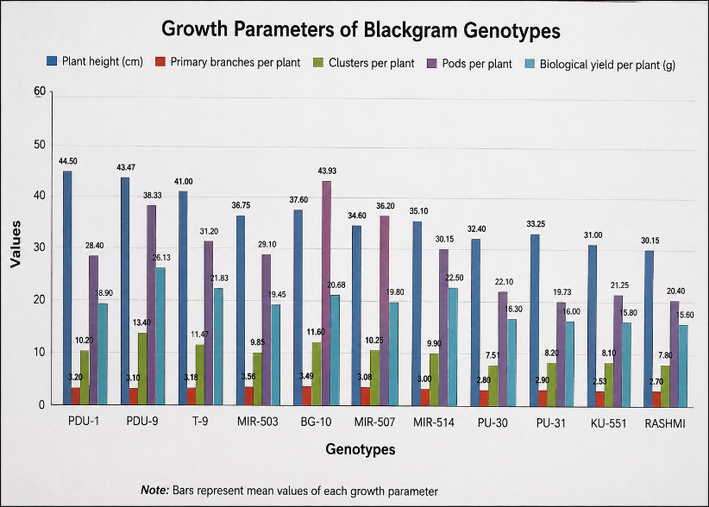

The present investigation revealed significant variability among the black gram genotypes for all the growth traits studied, indicating the existence of substantial genetic diversity among the experimental materials. Such variability provides greater opportunities for the selection and improvement of desirable traits through breeding programmes. The observed differences among genotypes may be attributed to their diverse genetic backgrounds and differential responses to environmental conditions. Plant height is an important vegetative growth trait associated with crop vigour and biomass production. In the present study, genotype PDU-1 recorded the maximum plant height, whereas RASHMI showed the minimum value. The variation in plant height among genotypes may be due to differences in genetic makeup and growth habit. Taller plants generally possess a greater photosynthetic surface area and greater dry-matter accumulation, which ultimately contribute to higher productivity. Similar findings regarding variability in plant height were reported by Panigrahi et al. (2014), Konda et al. (2009), Vijay Kumar et al. (2015), and Gangadhar et al. (2022) in black gram. The number of primary branches per plant showed considerable variation among the genotypes. Genotype MIR-503 recorded the maximum number of primary branches, while KU-551 showed the minimum value. Branching is an important character because it increases the number of sites available for reproductive growth and pod development. Genotypes with more branches generally exhibit better canopy spread and higher assimilate production. The results obtained in the present investigation agree with the findings of Makeen et al. (2007), Tank and Sharma (2019), Shanthi et al. (2019), Sivakumar and Lavanya (2022), and Priya et al. (2018), who also observed substantial variability in branching patterns in black gram. Biological yield per plant also differed significantly among the genotypes studied. The highest biological yield was recorded in PDU-9, whereas BG-6 produced the lowest value. Higher biological yield indicates superior biomass production and efficient accumulation of dry matter. Genotypes with higher biomass may possess a more effective source–sink relationship and utilise available resources more efficiently, which ultimately improves seed-yield potential. Similar findings were reported by Gowsalya et al. (2016), Kumar et al. (2022), and Usharani and Ananda Kumar (2015). The significant variability observed in growth parameters in the present study suggests the possibility of selecting superior genotypes for future breeding and crop-improvement programmes in black gram.
Fig 2- Comparative variability among black gram genotypes for plant height, primary branches, clusters per plant, pods per plant and biological yield per plant.

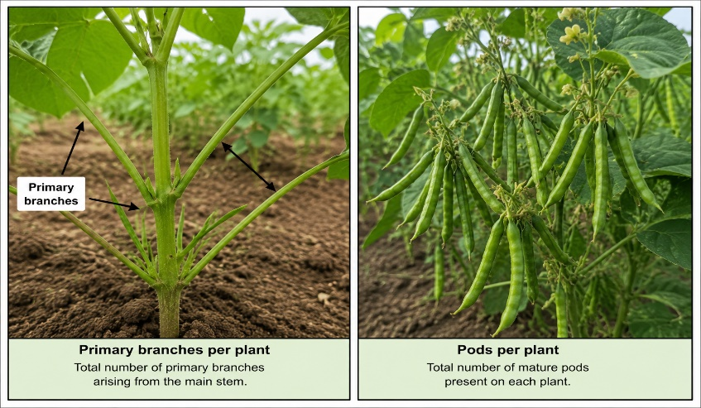
CONCLUSION
The present investigation of growth parameters in black gram genotypes revealed significant variability among the experimental materials for all the characters studied. The wide range of variation observed in plant height, number of primary branches per plant, number of clusters per plant, number of pods per plant, and biological yield per plant indicated substantial genetic diversity among the genotypes. Such variability is highly useful for crop-improvement programmes because it provides opportunities for the effective selection and development of superior varieties with enhanced growth and yield potential.
Among the evaluated genotypes, considerable differences were observed in vegetative growth and biomass accumulation. Plant height varied significantly among the genotypes, with PDU-1 and PDU-9 exhibiting comparatively taller plants, indicating better vegetative vigour and adaptability. Increased plant height may contribute positively to dry-matter production and the efficient utilisation of environmental resources. Similarly, the number of primary branches per plant showed marked variation, with MIR-503 and BG-10 producing a higher number of branches. Increased branching is considered an important growth trait because it provides more sites for cluster and pod formation, thereby contributing indirectly to yield enhancement.
The numbers of clusters and pods per plant are major yield-attributing characters in black gram. Genotype PDU-9 recorded the highest number of clusters per plant, while BG-10 exhibited the maximum number of pods per plant. The superior performance of these genotypes may be attributed to their favourable genetic constitution and better partitioning of assimilates to reproductive organs. Higher cluster and pod production generally indicates greater reproductive efficiency and ultimately contributes to increased seed-yield potential. The variability observed in these characters suggests that they can be effectively utilised as selection criteria in breeding programmes.
Biological yield per plant also differed significantly among the tested genotypes. The highest biological yield was recorded in PDU-9, followed by MIR-514 and T-9, indicating superior biomass accumulation and better growth performance. Higher biological yield reflects efficient photosynthetic activity and dry-matter production, which are essential for improved crop productivity. Genotypes exhibiting higher biological yield together with better pod production may serve as promising breeding materials for future genetic-improvement programmes.
The results of the present study demonstrated that genotypes PDU-9, PDU-1, BG-10, MIR-503, and MIR-514 performed better for several important growth parameters and may therefore be considered promising genotypes for further evaluation and utilisation in black gram improvement programmes. The significant variability observed among the genotypes indicates the presence of valuable genetic resources that can be exploited for the development of high-yielding and adaptable varieties. Thus, the present investigation provides useful information regarding the performance of black gram genotypes for important growth characters and highlights the possibility of selecting superior genotypes for future breeding programmes aimed at enhancing growth, productivity, and overall crop performance under similar agro-climatic conditions.
Limitations
The study evaluated only five growth and yield-attributing traits at one location during one season. Although thirteen traits are mentioned in the existing abstract and objective, data for flowering, maturity, pod length, seeds per pod, test weight, seed yield, and harvest index are not presented. Details of the experimental design, replication, plot size, spacing, and crop management are incomplete. These constraints limit reproducibility, assessment of genotype-by-environment effects, and the generalisation of the findings.
Declaration of AI Use

This manuscript was prepared through the combined contributions of all author(s), including contributions to the study design, data, content development, results, interpretation, and related scholarly work. The author(s) acknowledge the use of Grammarly and ChatGPT to assist with grammar checking, language refinement, and reference formatting. These AI-assisted tools were not used as authors and did not replace the intellectual contributions or scholarly judgement of the author(s). All AI-assisted outputs, including content, references, and interpretations, were carefully reviewed, revised, verified, and approved by the author(s). The author(s) accept full responsibility for the accuracy, integrity, and final content of the manuscript.

REFERENCES
Gangadhar, L., Lal, G. M., Lavanya, G. R., Karthik, U., & Varaprasad, K. (2022). Genetic variability, correlation and path coefficient analysis for yield and yield components in blackgram (Vigna mungo (L.) Hepper): Experimental investigation. International Journal of Plant & Soil Science, 34(23), 519–531. https://doi.org/10.9734/ijpss/2022/v34i2331615
Gnanasekaran, M., Gunasekaran, M., Thiyagu, K., Muthuramu, S., Ramkumar, J., & Venudevan, B. (2025). Genetic variability, heritability, genetic advance and association studies in blackgram [Vigna mungo (L.) Hepper]. Legume Research, 48(9), 1442–1446. https://doi.org/10.18805/LR-5203
Gowsalya, P., Kumaresan, D., Packiaraj, D., & Kannan Bapu, J. R. (2016). Genetic variability and character association for biometrical traits in blackgram (Vigna mungo (L.) Hepper). Electronic Journal of Plant Breeding, 7(2), 317–324. https://doi.org/10.5958/0975-928X.2016.00039.9
Johnson, H. W., Robinson, H. F., & Comstock, R. E. (1955). Estimates of genetic and environmental variability in soybeans. Agronomy Journal, 47(7), 314–318. https://doi.org/10.2134/agronj1955.00021962004700070009x
Konda, C. R., Salimath, P. M., & Mishra, M. N. (2009). Genetic variability studies for productivity and its components in blackgram [Vigna mungo (L.) Hepper]. Legume Research, 32(1), 59–61. https://arccjournals.com/journal/legume-research-an-international-journal/ARCC2022
Kumar, D. P., Lal, G. M., Babu, K. S., & Rajasekhar, J. (2022). Assessment on genetic variability correlation and path analysis for quantitative traits in blackgram (Vigna mungo L. Hepper). International Journal of Plant & Soil Science, 34(22), 663–672. https://doi.org/10.9734/ijpss/2022/v34i2231421
Kumawat, R., Kumar, S., Kashyap, S. C., & Singh, A. (2024). Assessment of genetic variability in blackgram (Vigna mungo) under rainfed conditions of Jammu and Kashmir. The Indian Journal of Agricultural Sciences, 94(6), 688–691. https://doi.org/10.56093/ijas.v94i6.141743
Makeen, K., Abrahim, G., Jan, A., & Singh, A. K. (2007). Genetic variability and correlations studies on yield and its components in mungbean (Vigna radiata (L.) Wilczek). Journal of Agronomy, 6(1), 216–218. https://doi.org/10.3923/ja.2007.216.218
Mathivathana, M. K., Shunmugavalli, N., Muthuswamy, A., & Vijulan Harris, C. (2015). Correlation and path analysis in black gram. Agricultural Science Digest, 35(2), 158–160. https://doi.org/10.5958/0976-0547.2015.00030.0
Nair, R. M., Chaudhari, S., Devi, N., Shivanna, A., Gowda, A., Boddepalli, V. N., Pradhan, H., Schafleitner, R., Jegadeesan, S., & Somta, P. (2024). Genetics, genomics, and breeding of black gram [Vigna mungo (L.) Hepper]. Frontiers in Plant Science, 14, 1273363. https://doi.org/10.3389/fpls.2023.1273363
Panigrahi, K. K., Mohanty, A., & Baisakh, B. (2014). Genetic divergence, variability and character association in landraces of blackgram (Vigna mungo [L.] Hepper) from Odisha. Journal of Crop and Weed, 10(2), 155–165. https://www.cropandweed.com/vol10issue2.html
Parveen, S. I., Sekhar, M. R., Reddy, D. M., & Sudhakar, P. (2011). Correlation and path coefficient analysis for yield and yield components in blackgram (Vigna mungo (L.) Hepper). International Journal of Applied Biology and Pharmaceutical Technology, 2(3), 619–625.
Priya, L., Pillai, M. A., Shoba, D., Kumari, S. M. P., & Aananthi, N. (2018). Genetic variability and correlation studies in black-gram [Vigna mungo (L.) Hepper]. Electronic Journal of Plant Breeding, 9(4), 1583–1587. https://doi.org/10.5958/0975-928X.2018.00197.7
Reddy, Y. V. K., Sundari, K. S., Mohan, K. K., Lalkota, R. K., Reddy, K. S., Chandrashekhar, T., & Saritha, D. (2026). Estimation of genetic parameters for quantitative traits for genetic variability in black gram [Vigna mungo (L.) Hepper]. Journal of Biology and Nature, 18(1), 1–12. https://doi.org/10.56557/joban/2026/v18i110077
Reni, Y. P., Rao, Y. K., Satish, Y., & Babu, J. S. (2013). Estimates of genetic parameters and path analysis in blackgram (Vigna mungo (L.) Hepper). International Journal of Plant, Animal and Environmental Sciences, 3(4), 231–234.
Saran, R., Sharma, P. P., & Dashora, A. (2023). Correlation and path coefficient analysis for seed yield and its attributing traits in blackgram [Vigna mungo (L.) Hepper]. Legume Research, 46(4), 417–420. https://doi.org/10.18805/LR-4385
Shanthi, P., Ganesan, K. N., Manivannan, N., & Natarajan, C. (2019). Correlation and path analysis in blackgram (Vigna mungo L.). Electronic Journal of Plant Breeding, 10(3), 1218–1222. https://doi.org/10.5958/0975-928X.2019.00154.6
Shoba, D., Jecintha, J., Joyci, J. J., Joshi, J. L., Pillai, M. A., & Hepziba, S. J. (2024). Genetic variability and association studies on yield and yield-attributing traits in blackgram (Vigna mungo (L.) Hepper). Asian Research Journal of Agriculture, 17(4), 901–907. https://doi.org/10.9734/arja/2024/v17i4600
Sivakumar, A., & Lavanya, G. R. (2022). Genetic variability and character association studies on blackgram (Vigna mungo (L.) Hepper) for seed yield, maturity and resistance to yellow mosaic virus. International Journal of Plant & Soil Science, 34(20), 238–247. https://doi.org/10.9734/ijpss/2022/v34i2031148
Sohel, M. H., Miah, M. R., Mohiuddin, S. J., Islam, A. K. M. S. U., Rahman, M. M., & Haque, M. A. (2016). Correlation and path coefficient analysis of blackgram (Vigna mungo L.). Journal of Bioscience and Agriculture Research, 7(2), 621–629. https://doi.org/10.18801/jbar.070216.74
Tank, H. K., & Sharma, P. P. (2019). Correlation and path coefficient analysis in blackgram [Vigna mungo (L.) Hepper]. Electronic Journal of Plant Breeding, 10(3), 1333–1338. https://doi.org/10.5958/0975-928X.2019.00171.6
Usharani, K. S., & Ananda Kumar, C. R. (2015). Induced polygenic variability using combination treatment of gamma rays and ethyl methane sulphonate in blackgram (Vigna mungo (L.) Hepper). African Journal of Biotechnology, 14(20), 1702–1709. https://doi.org/10.5897/AJB2015.14438
Vijay Kumar, G., Vanaja, M., Jyothi Lakshmi, N., & Maheswari, M. (2015). Studies on variability, heritability and genetic advance for quantitative traits in black gram [Vigna mungo (L.) Hepper]. Agricultural Research Journal, 52(4), 28–31. https://doi.org/10.5958/2395-146X.2015.00056.3

