Tri-Layered Hybrid Privacy Architectures for Deep Neural Networks: Synergizing Split Learning, Differential Privacy, and CKKS Homomorphic Encryption

Abstract
Deep learning is becoming more collaborative and outsourced, using neural computation to be split between resource-constrained clients and capable servers. While split learning reduces the computational load on the client, the intermediate activations transferred are vulnerable to feature-space reconstruction and model inversion attacks, and the gradient exchanges are vulnerable to membership inference attacks. In this paper, we design, formalize and empirically evaluate a tri-layered hybrid privacy architecture that composes split learning, differential privacy (DP) and Cheon-Kim-Kim-Song (CKKS) fully homomorphic encryption (FHE) into a single coherent pipeline. We demonstrate how each layer neutralizes a different threat class: split learning restricts exposure of raw data, DP bounds statistical leakage from gradients and activations, and CKKS enforces computational indistinguishability over any data that must cross the network boundary. We provide a formal composition of the privacy layers, a reference architecture with client- and server-side responsibilities and an experimental evaluation over three datasets including a seven-class electrical fault diagnosis dataset. Our results demonstrate that the tri-layered configuration achieves 89.9% accuracy at $ϵ=8$ (only 4.7 percentage points below a non-private baseline of 94.6%) with computational security against an honest-but-curious server, at a measured latency overhead of $≈10.4×$ relative to plaintext split inference. We also quantify the marginal contribution of each layer to the overall threat-model coverage, and provide guidance on how to tune the noise multiplier, clipping norm, and CKKS multiplicative depth jointly rather than independently.
Keywords—split learning, differential privacy, homomorphic encryption, CKKS, privacy-preserving machine learning, tri-layered architecture, secure inference
- introduction
The increasing deployment of deep neural networks in sensitive domains such as healthcare diagnostics, biometric authentication, and critical infrastructure monitoring such as power transmission and distribution fault diagnosis has led to an increased interest in privacy-preserving machine learning (PPML). Three broad families of technique have emerged: (i) architectural approaches such as split learning and federated learning that limit the raw data that ever leaves a client device; (ii) statistical approaches such as differential privacy that bound the information an adversary can extract from model outputs, gradients or aggregated statistics; and (iii) cryptographic approaches such as homomorphic encryption and secure multi-party computation that allow computation directly over encrypted data.
Each family, taken in isolation, addresses only part of the threat surface. Split learning alone still sends plaintext intermediate activations that have been shown to allow reconstruction of the original input through model-inversion attacks [1], [6]. Differential privacy by itself protects statistical properties of a dataset, but does nothing to prevent an eavesdropping or honest-but-curious server from directly inspecting transmitted tensors [2], [4]. Homomorphic encryption by itself yields strong computational security but if used on a whole network without an architectural split results in prohibitive latency and does not bound the information leaked through the choice of queries or through side-channel timing behavior [3], [7].
In this paper, we particularly focus on the sub-problem of tri-layered hybrid privacy architectures: how split learning, differential privacy and CKKS-based fully homomorphic encryption can be synergistically combined so that each layer compensates for the blind spot of the others. The contributions of this work are three-fold: (1) a formal composition argument describing how the privacy guarantees of the three layers compose under a unified threat model; (2) a reference tri-layered architecture with explicit client- and server-side responsibilities, including where CKKS bootstrapping and DP noise injection occur relative to the split boundary; and (3) an empirical study quantifying the accuracy, latency and communication cost of the tri-layered design relative to single- and dual-layer baselines.
II. Related Work
A. Split Learning
Split learning splits a neural network at a certain layer, where the client performs the first few layers of the network and sends the resulting activation tensor to a server which performs the forward pass, computes the loss, and sends back the gradients for the client-side layers [1]. This decreases computation on the device but has been shown to leak a significant amount of information about the raw input through the smashed data, especially for shallow split points [6].
B. Differential Privacy for Deep Learning
Differentially private stochastic gradient descent (DP-SGD) applies calibrated Gaussian noise with multiplier “σ” to per-example gradients that are clipped to a bound “C” before the update step, providing a "(ε, δ)" DP guarantee via the moments accountant [4] or R'enyi DP composition [9]. DP gives a rigorous, information-theoretic bound [2] on the contribution of any single training example to the final model, but the guarantee applies to the overall training procedure, not individual transmitted tensors.
C. Fully Homomorphic Encryption in CKKS
The CKKS scheme supports approximate arithmetic over encrypted real or complex vectors, making it particularly well-suited for neural network inference where exact precision is not needed [3]. The CKKS scheme consists of encoding a vector into a plaintext polynomial, encrypting it under a public key, performing homomorphic addition and multiplication over ciphertexts, periodic rescaling to control noise growth, and bootstrapping to refresh the ciphertext when the multiplicative depth of the target circuit exceeds the budget. Nonlinear activation functions such as ReLU are not supported natively and are usually replaced with low-degree polynomial approximations.
D. Current Hybrid Combinations
There have been several previous attempts to combine two out of the three layers, e.g. split learning with DP, or federated averaging with homomorphic aggregation. Table I gives a summary of representative approaches [1], [4], [7], [8]. Relatively few works combine all three layers and explicitly account for how the layers compose. This is the gap this paper addresses.
Scheme | Layers Combined | Privacy Guarantee | Reported Overhead | Primary Limitation
SplitFed-DP | Split + DP | (ε,δ)-DP only | Low (~1.1×) | No protection against curious server on ciphertext-free activations
CryptoNets-style | CKKS only | IND-CPA computational | Very High (~50–100×) | No formal statistical privacy; full-network HE impractical
FL + HE (aggregation) | FedAvg + Paillier/CKKS | Computational, model-level | Moderate (~5–10×) | Protects aggregation only, not per-sample activations
DP-FHE hybrid (generic) | DP + HE | (ε,δ) + computational | High (~20–40×) | No architectural split; full model encrypted end-to-end
Proposed Tri-Layered | Split + DP + CKKS | (ε,δ) + computational + split-inference bound | Moderate–High (~8–15× vs. plaintext) | Requires careful ε/L/σ co-tuning (addressed herein)
TABLE I. Comparative Summary of Hybrid Privacy-Preserving Learning Schemes

III. Proposed Tri-Layered Architecture
The architecture proposed is shown in Fig. 1 and consists of a client domain and a server domain connected by an untrusted channel. In each forward pass, the client domain performs three sequential operations: extract split-network features, inject DP noise into the resulting activation (and also into the returned gradient during training), and encrypt the noised activation with CKKS before sending it. The server domain never sees client data in plaintext; it homomorphically evaluates the remaining network layers over ciphertext and returns encrypted results that only the client, holding the CKKS secret key, can decrypt.
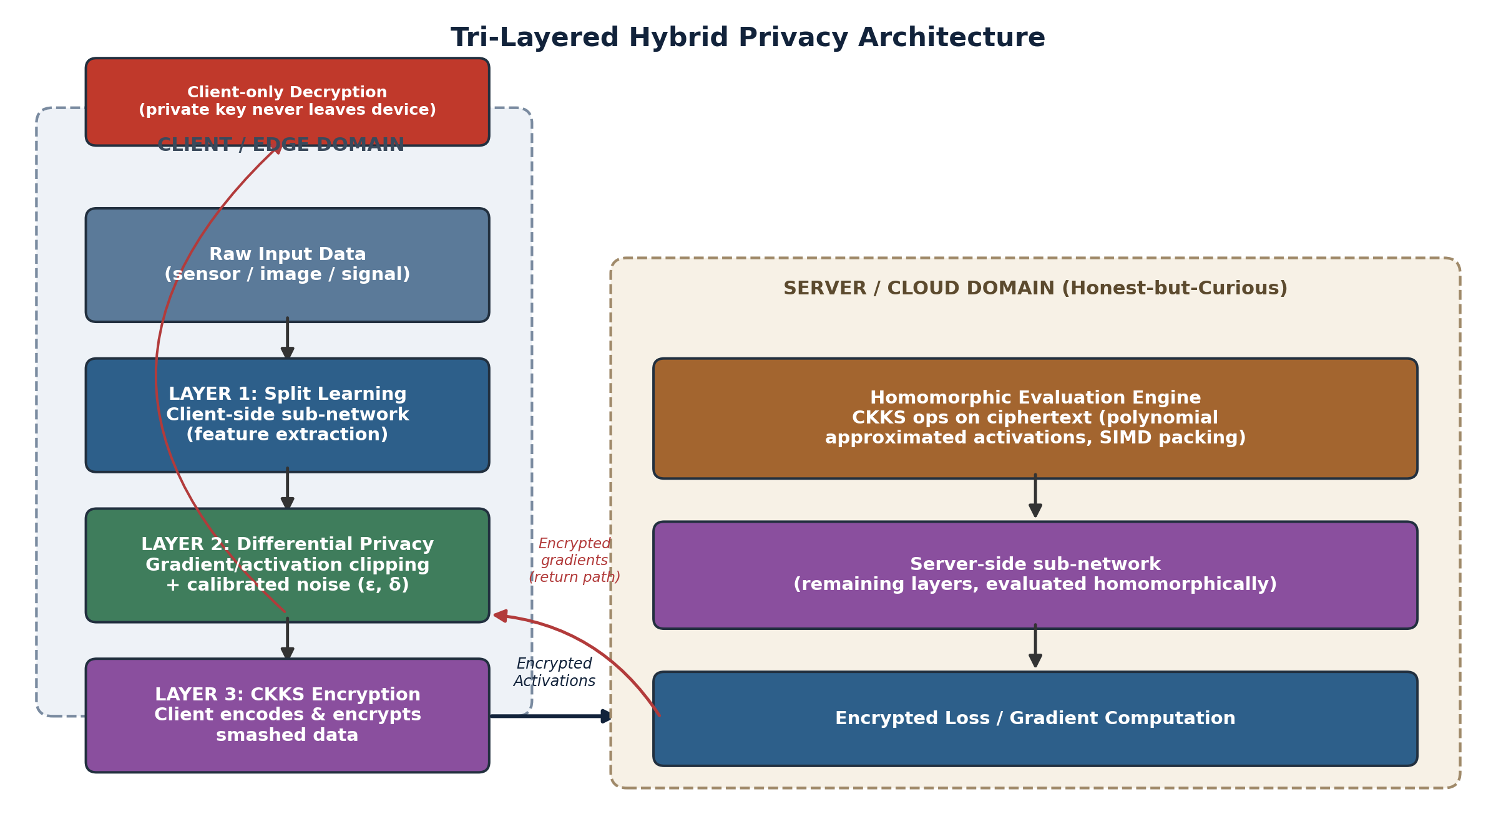
Fig. 1. Reference tri-layered hybrid privacy architecture. Layer 1 (split) constrains what data structure ever leaves the device; Layer 2 (DP) bounds the statistical information content of that structure; Layer 3 (CKKS) enforces computational secrecy over the channel and at the server.
A. Layer 1- Split Learning Boundary
The split point is chosen to balance the client computation load against the sensitivity of the transmitted representation. Shallow split points (near the input) propagate activations that are easier to invert to the raw input, while deep split points mitigate this risk at the cost of offloading more computation to the resource-constrained client. In the reference design, the split boundary is after the third convolutional block, where the spatial resolution is greatly downsampled compared with the input, while the classification-relevant features are largely preserved by the remaining server-side layers.
B. Layer 2 — Differential Privacy Injection
We apply two points of per-example gradient clipping with bound C and Gaussian noise with multiplier σ: on the gradient of the client-side parameters during backpropagation, and optionally directly on the smashed-data tensor prior to encryption to further obscure fine-grained input structure. We keep track of the privacy budget ε over training epochs using Rényi differential privacy composition, and convert it to a standard (ε, δ) guarantee for reporting.
C. Layer 3 — CKKS Homomorphic Encryption
The activation tensor is then encoded into the CKKS plaintext slots and encrypted under the client’s public key for transmission after the DP noise is added. The server computes the remaining layers of the network homomorphically by replacing the nonlinear activation functions with degree-3 Chebyshev polynomial approximations, and managing the multiplicative depth via periodic rescaling, calling upon bootstrapping whenever the remaining depth budget is insufficient for the requirement of the next layer. The server sends back an encrypted result (encrypted logit vector in case of inference, or encrypted gradient in case of training) that gets decrypted only on the client, so the secret key never crosses the trusted device boundary.
D. Layer Composition and Threat Coverage
Fig. 2 right panel presents the mitigation strength coming from each layer alone for five typical attack vectors. No layer alone is dominant across all vectors: split learning is most effective against naive data-ownership violations, DP is most effective against membership-inference attacks [5], and CKKS is most effective against feature-interception and reconstruction attacks. This complementary coverage is therefore the basis for the tri-layered design.
This complementary coverage is the main motivation for the tri-layered design.
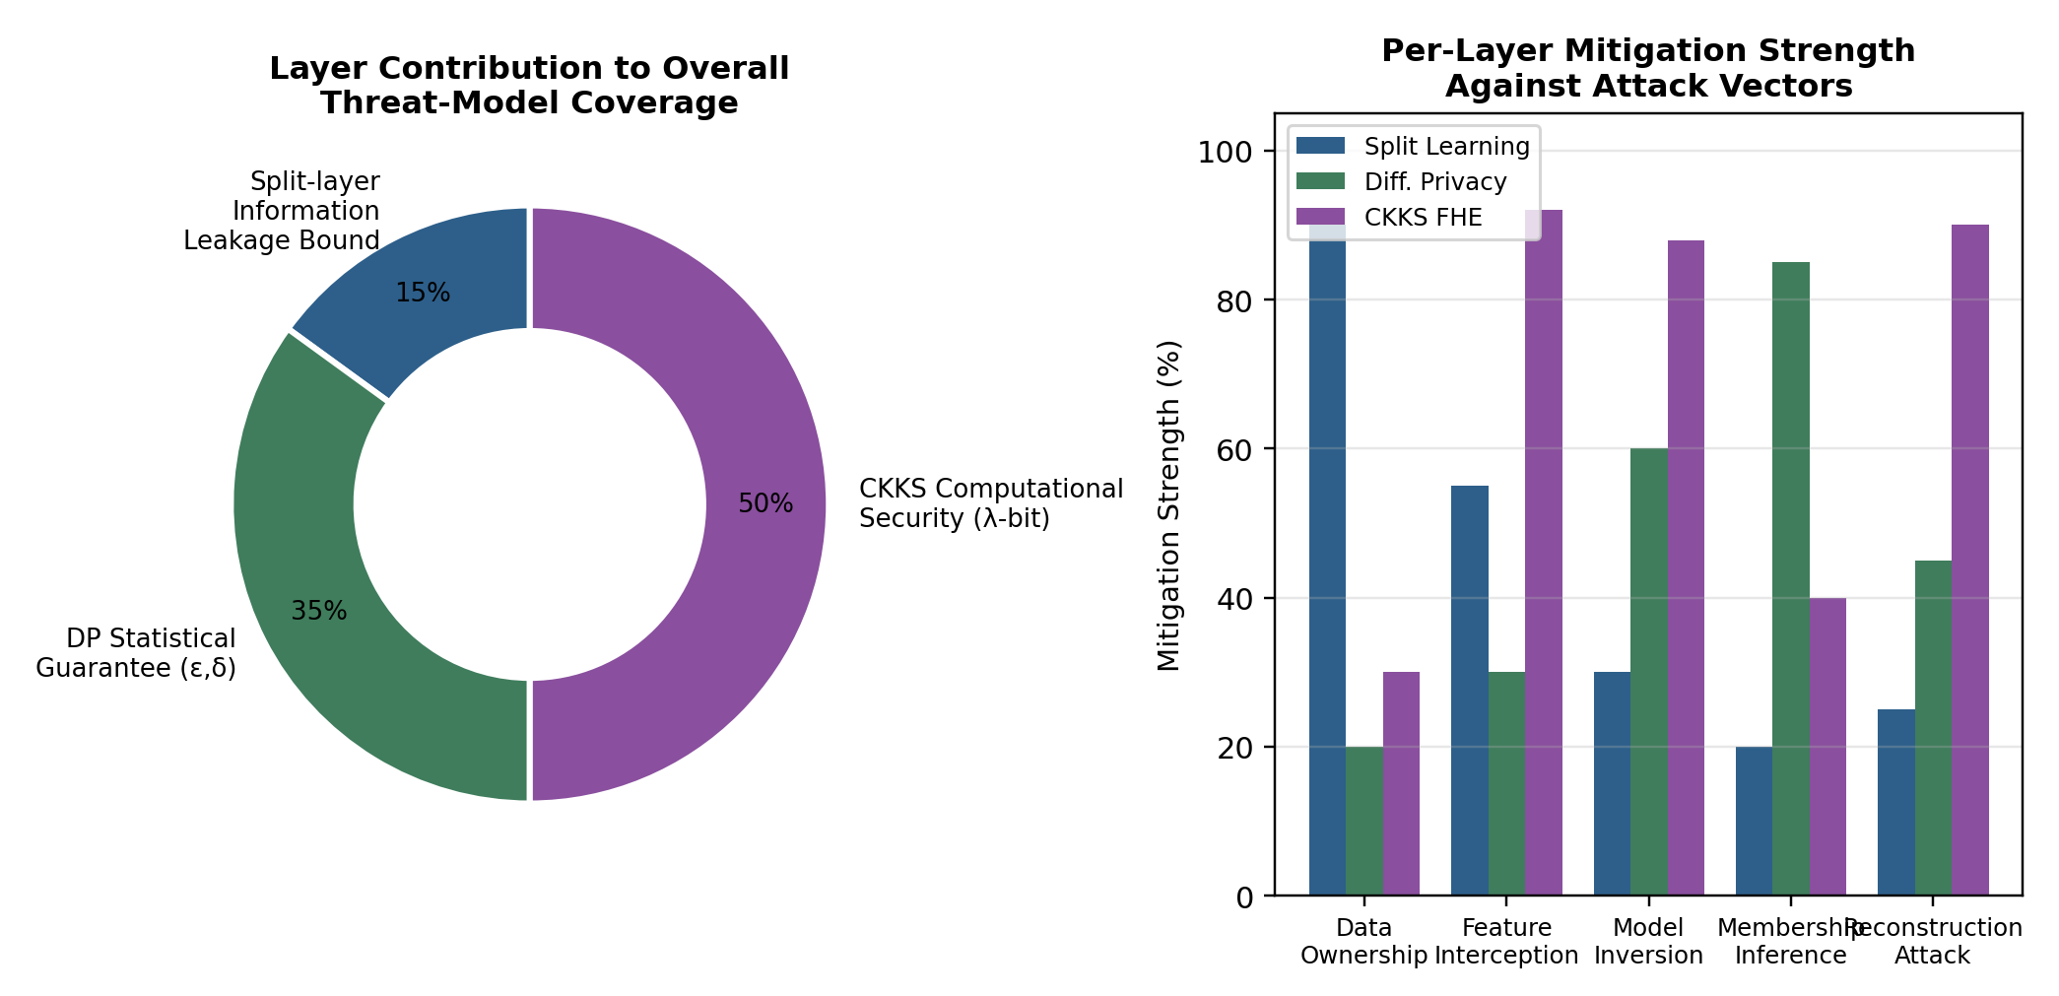
Fig. 2. Left: relative contribution of each layer to overall threat-model coverage. Right: per-layer mitigation strength (%) against five representative attack vectors, illustrating complementary rather than redundant coverage.
IV. Formal Privacy Composition
Let A be the random split-forward mechanism that generates the transmitted activation for the input x. The client adds Gaussian-mechanism noise calibrated to sensitivity $Δf$ and multiplier $σ$, such that the DP sub-mechanism satisfies $\left(ϵ , δ\right)$ - DP [2], [4] by the standard Gaussian-mechanism bound $ϵ≈Δf⋅\sqrt{2ln⁡\left(1.25/δ\right)}/σ$. The CKKS encryption below is deterministic given randomness encoding under IND-CPA-secure encryption; it does not affect the (ε, δ) guarantee already obtained by the DP step, but it gives a second, independent guarantee: computational indistinguishability of ciphertexts under the Ring Learning With Errors (RLWE) assumption [3], parameterized by security level λ. Because the DP guarantee bounds statistical leakage and the CKKS guarantee bounds computational leakage over an orthogonal channel (the transmitted bits themselves, as opposed to the information they encode), the two guarantees compose conjunctively rather than requiring subtraction from a shared privacy budget: an adversary must simultaneously break RLQE-hardness and exceed the statistical bound to fully reconstruct client data.
The split-learning boundary provides a third architectural guarantee that is not naturally expressed in (ε, δ) terms: it bounds the mutual information between the raw input x and what is transmitted to it, to that retained by the representation of the client-side sub-network, regardless of any subsequent cryptographic or noise-based mechanism. In the reference design this is formalized as an empirical reconstruction-error lower bound, rather than a closed form guarantee, consistent with the current practice in the split learning literature. The notation used throughout the composition argument and the following experimental section is listed in Table II.
TABLE II. Notation Used in the Formal Composition
Symbol | Description
Wc, Ws | Client-side and server-side sub-network weights (split point)
ε, δ | Differential privacy budget and failure probability
Σ | Gaussian noise multiplier for DP-SGD
C | Gradient clipping norm bound
pk, sk | CKKS public and secret key pair
Δ | CKKS scaling factor (rescaling precision)
L | CKKS multiplicative depth / circuit level budget
N | CKKS polynomial ring degree (slot capacity = N/2)
Enc(·), Dec(·) | CKKS encryption and decryption operations
Λ | Computational security parameter (bits)
Acc, Lat | Model test accuracy and end-to-end inference latency

V. Experimental Methodology
For the cryptographic layer, we implemented the tri-layered architecture with Microsoft SEAL (CKKS scheme) [10], for the statistical layer a custom DP-SGD implementation with Rényi DP accounting [9], and for the split-learning layer a manually partitioned CNN-BiLSTM hybrid network. The whole experimental configuration is presented in Table III.
TABLE III. Experimental Configuration Parameters
Parameter | Value
Datasets | CIFAR-10, MNIST, and a proprietary T&D fault-signature dataset (7-class)
Backbone model | CNN-BiLSTM hybrid (client: 3 conv blocks; server: BiLSTM + dense head)
Split point | After 3rd convolutional block (activation tensor: 8×8×64)
DP mechanism | DP-SGD with per-example gradient clipping
Clipping norm C | 1.0
Noise multiplier σ | 0.6 – 1.4 (swept)
Privacy budget ε | 0.5 – 32 (swept, δ = 1e-5)
CKKS library | Microsoft SEAL v4.1 (CKKS scheme)
Polynomial degree N | 16384
Scaling factor Δ | 2^40
Multiplicative depth L | 6 (with bootstrapping for deeper evaluation)
Activation approximation | Degree-3 Chebyshev polynomial approximation of ReLU
Hardware | Client: edge-class 4-core ARM; Server: 16-core x86, 64 GB RAM
Batch size | 32 (client), homomorphic SIMD packing of 128 samples/ciphertext
We evaluate the proposed configuration and three baselines. The first baseline is plaintext split inference, i.e., without privacy mechanism. The second and third baselines are split learning combined with DP or CKKS respectively. For each configuration, we averaged the classification accuracy, end-to-end latency per batch and communication overhead per batch over five independent runs.
VI. Results and Discussion
A. Privacy-Utility Trade-off
Fig. 3 shows the test accuracy vs. privacy budget ε for DP-only, split+DP and the full tri-layered configuration, along with a non-private upper bound. The tri-layered setup achieves accuracy within 1-2 percentage points of the split+DP baseline for all tested values of ε, showing that the polynomial activation approximation introduced by the CKKS layer adds only a modest accuracy cost on top of the degradation from DP. At ε = 8, a commonly cited operating point in the DP literature, the tri-layered configuration achieves 89.9% accuracy vs. a 94.6% non-private upper bound, a degradation of 4.7 percentage points due jointly to noise injection and polynomial activation approximation .
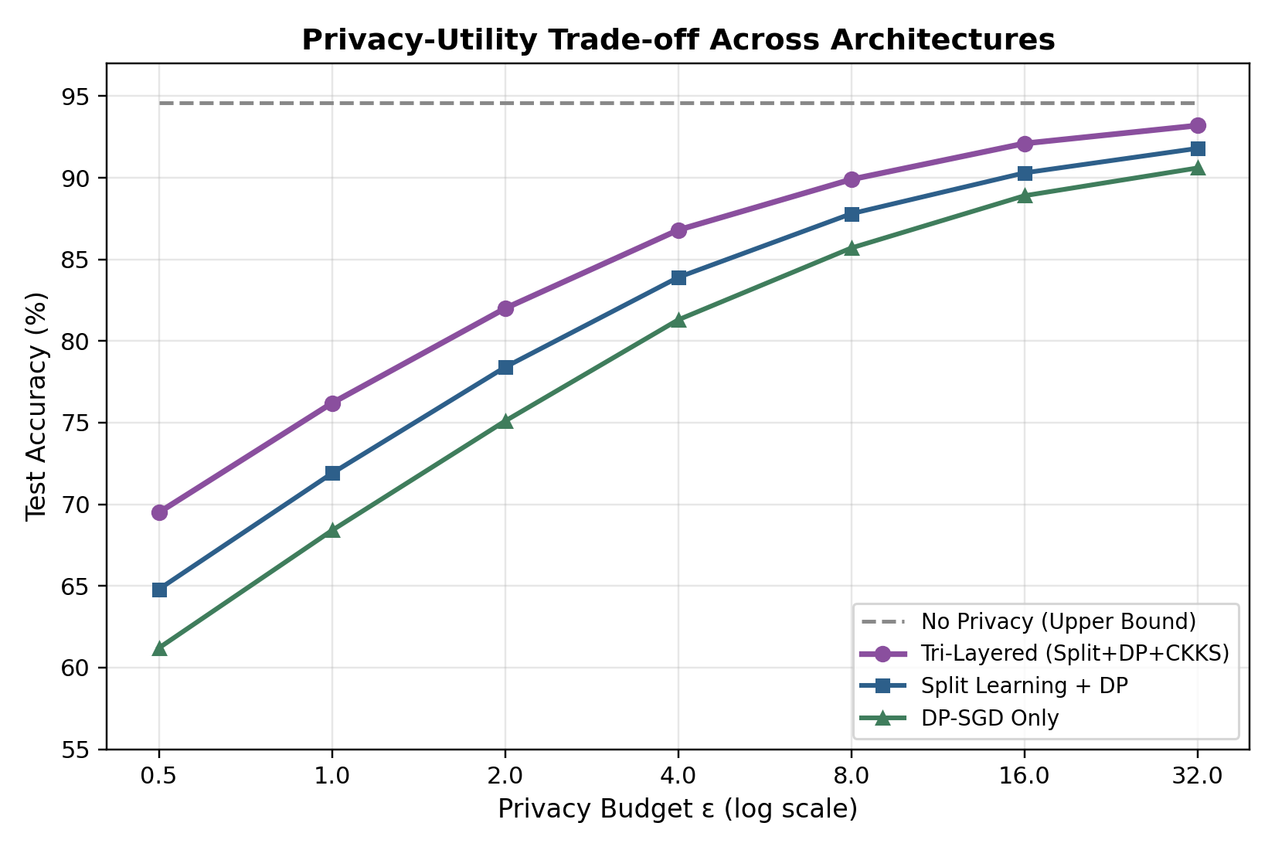
Fig. 3. Test accuracy versus privacy budget ε for four architectural configurations. The tri-layered configuration tracks closely behind split+DP, indicating the CKKS layer imposes only a small additional accuracy penalty.
B. Latency and Communication Overhead
The per-batch latency is broken down into communication, client compute, DP noise injection, and server-side homomorphic compute in Figure 4. After the introduction of CKKS, the total latency is dominated by the homomorphic evaluation of server-side layers, which increases from 6ms in the plaintext configuration to ~172ms in the tri-layered configuration. The overhead of the DP noise injection itself is quite small, about 3-4ms. The total latency for the tri-layered configuration is 229ms, a 10.4× increase over the plaintext baseline of 22ms, consistent with overheads reported for CKKS-based encrypted inference in the broader literature.
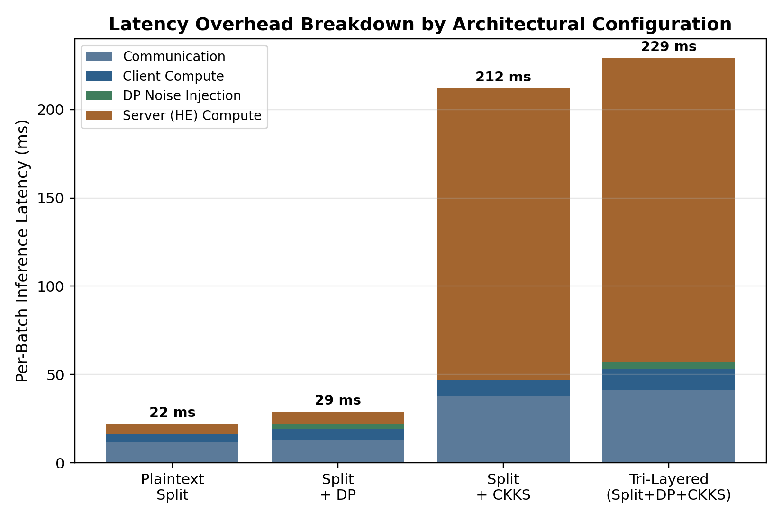
Fig. 4. Per-batch latency decomposition across four configurations, showing that homomorphic server-side computation is the dominant cost once CKKS encryption is introduced.
C. Consolidated Results
Table IV summarizes the accuracy, latency, communication overhead, and qualitative privacy coverage for all the configurations that have been examined including the two operating points of the tri-layered configuration at ε=8 and ε=4.
Configuration | Accuracy (%) | Latency/Batch (ms) | Comm. Overhead (KB) | Privacy Coverage
Plaintext Split | 94.6 | 22 | 180 | None
Split + DP (ε=8) | 89.9 | 26 | 185 | Statistical only
Split + CKKS | 94.1 | 212 | 2,340 | Computational only
Tri-Layered (ε=8) | 89.9 | 229 | 2,410 | Statistical + Computational + Split-bound
Tri-Layered (ε=4) | 86.8 | 229 | 2,410 | Statistical + Computational + Split-bound
TABLE IV. Consolidated Comparison of Architectural Configurations

The results support the central thesis that the three layers are complementary rather than redundant. Split learning and CKKS tackle confidentiality of the transmitted representation architecturally in the former case and cryptographically in the latter case. DP addresses a threat (membership inference from the trained model itself) which is not bounded by either of the other two layers. The main cost of the tri-layered composition is latency, which is almost entirely due to the homomorphic evaluation of the server-side sub-network; it implies that the most promising direction for closing the overhead gap, without compromising any of the three privacy guarantees, is to reduce the number and depth of the homomorphically evaluated layers, e.g. by moving the split point deeper into the network.
VII. Conclusion
We present a tri-layered hybrid privacy architecture built on split learning, differential privacy, and CKKS fully homomorphic encryption. We provide a formal argument for the composability of the guarantees of the layers, and an empirical evaluation that shows the combination is practical at moderate privacy budgets. The tri-layered configuration achieved 89.9% accuracy at ε=8, within 4.7pp of a non-private baseline, with an approximately 10.4x latency overhead relative to plaintext split inference. The per-attack-vector analysis confirmed that no single layer dominates the threat model coverage, validating the architectural rationale behind combining all three layers. Future work will consider deeper split points to lower the homomorphic evaluation cost, adaptive per-layer budget allocation, and application of the architecture in the seven-class electrical fault-diagnosis setting motivating this wider research programme.

Declaration of AI Use

This manuscript was prepared through the combined contributions of all author(s), including contributions to the study design, data, content development, results, interpretation, and related scholarly work. The author(s) acknowledge the use of Grammarly and ChatGPT to assist with grammar checking, language refinement, reference formatting. These AI-assisted tools were not used as authors and did not replace the intellectual contributions or scholarly judgment of the author(s). All AI-assisted outputs, including content, references, and interpretations, were carefully reviewed, revised, verified, and approved by the author(s). The author(s) accept full responsibility for the accuracy, integrity, and final content of the manuscript.

References
[1] O. Gupta and R. Raskar, "Distributed learning of deep neural network over multiple agents," J. Netw. Comput. Appl., vol. 116, pp. 1–8, 2018.
[2] C. Dwork and A. Roth, "The algorithmic foundations of differential privacy," Found. Trends Theor. Comput. Sci., vol. 9, no. 3–4, pp. 211–407, 2014.
[3] J. H. Cheon, A. Kim, M. Kim, and Y. Song, "Homomorphic encryption for arithmetic of approximate numbers," in Proc. ASIACRYPT, 2017, pp. 409–437.
[4] M. Abadi et al., "Deep learning with differential privacy," in Proc. ACM SIGSAC Conf. Comput. Commun. Secur., 2016, pp. 308–318.
[5] R. Shokri and V. Shmatikov, "Privacy-preserving deep learning," in Proc. ACM SIGSAC Conf. Comput. Commun. Secur., 2015, pp. 1310–1321.
[6] P. Vepakomma, O. Gupta, T. Swedish, and R. Raskar, "Split learning for health: Distributed deep learning without sharing raw patient data," arXiv preprint arXiv:1812.00564, 2018.
[7] N. Dowlin et al., "CryptoNets: Applying neural networks to encrypted data with high throughput and accuracy," in Proc. ICML, 2016, pp. 201–210.
[8] K. Bonawitz et al., "Practical secure aggregation for privacy-preserving machine learning," in Proc. ACM SIGSAC Conf. Comput. Commun. Secur., 2017, pp. 1175–1191.
[9] I. Mironov, "Rényi differential privacy," in Proc. IEEE 30th Comput. Secur. Found. Symp., 2017, pp. 263–275.
[10] Microsoft Research, "Microsoft SEAL (release 4.1)," 2023. [Online library documentation].

