Original Research Article

Spatial distribution and properties of soil series West Coast Plains and Hills Zone of Kerala

ABSTRACT

The present study was conducted in Kavummandam, Kottattara, and Vengappalli villages of Vaittiri Tehsil, Wayanad District, Kerala, under the National Soil Mapping Programme (NSMP) to characterize soils and prepare a detailed soil resource database. The study integrated high-resolution Resourcesat LISS-IV satellite imagery, GIS techniques, field surveys, and laboratory analyses to delineate physiographic units, identify soil series, and evaluate their chemical properties. Five soil series, namely Padivayal, Nedumbala, Kottanad, Madakkimala, and Muttil, were identified and mapped. Padivayal was the dominant soil series, occupying 48.98% of the study area, followed by Nedumbala (25.13%) and Kottanad (14.11%). The soils were predominantly very deep (>100 cm), covering 96.48% of the total geographical area. The landscape is characterized mainly by hillside slopes (74.11%) and plantation land use (74.97%), while agriculture occupies 21.50% of the area. Moderate soil erosion affected 74.11% of the area. Soil analyses revealed strongly to moderately acidic soils (pH 4.51–5.98), high to moderate organic carbon (1.08–2.81%), low electrical conductivity (0.02–0.09 dS m⁻¹), low exchangeable sodium percentage (0.30–2.92%), and moderate cation exchange capacity (6.69–18.26 cmol(p⁺) kg⁻¹). Land capability evaluation showed that 48.98% of the area belongs to Class VI, while 25.13% falls under Class IV. The generated soil resource database provides a valuable scientific basis for site-specific land use planning, soil fertility management, watershed development, and sustainable agricultural production in the West Coast Plains and Hills Zone of Kerala

Keywords: Digital Soil Mapping, land capability class, soil properties, Soil series, Soil erosion

1. INTRODUCTION

Soil is the most critical natural resource for agriculture, as it provides the foundation for plant growth, nutrient cycling, water regulation, and ecosystem sustainability. Soil characterization provides the basic information of soil properties which are the outcome of several soil forming processes operating in a particular area. Soil properties are continuously influenced by land uses with profound influence on its productivity and sustainability [Seema et al., 2020 and Joseph et al., 2023]. Hence, knowledge on the impact of land uses on soil property is indispensable for sustainable agricultural production and soil health maintenance. Soil classification, on the other hand, helps to organize our knowledge, facilitates the transfer of experience and technology from one place to another and helps to compare soil properties. A good data bank on soil properties and related site characteristics is inevitable for one to be able to advise both current and potential land users on how to use the land in the best possible way. Recognizing the importance of precise soil information, large-scale initiatives now aimed at creating village-level soil databases to support digital agriculture and sustainable intensification (Ardak et al., 2010). The resulting spatial soil information assists farmers, planners, and researchers in optimizing productivity while maintaining long-term soil health and environmental sustainability (Lal and Stewart, 2010 and Kumar et. al., 2016).
Mapping of soil resources is important, providing valuable information regarding formation, spatial distribution of soil properties, and types of soil present for implementation of sustainable land use management [Pereira et al., 2017]. From the historical perspective, during the middle of the 18th century, the earliest soil maps were generated to identify the homogeneous areas of similar soil attributes for suitable land management (Minasny and McBratney, 2016). Thus, soil survey and mapping have evolved from simple resource inventory preparation to a comprehensive decision-support framework integrating field observations, laboratory analysis, and spatial modeling. This article therefore examines the concepts, methodologies, technological advancements, and applications of soil survey and mapping and highlights their role in sustainable land resource management and climate-resilient agriculture.
This study undertook a land resources inventory through a detailed soil survey conducted at a 1:10k scale in the agro-climatic zone of the West Coast Plains and Hills, specifically within Vaittiri Tehsil of Wayanad District, Kerala. The work was carried out under the National Soil Mapping Programme (NSMP), an initiative of the Soil and Land Use Survey of India (SLUSI). The primary objective of NSMP is to establish a comprehensive scientific database of India’s soils and land use patterns. To generate village level data on soil using the remote sensing, GIS and mapping techniques. Such a database supports watershed-based soil and water conservation planning, ensuring the protection of finite soil resources. Ultimately, this initiative aims to promote sustainable crop production by integrating soil resource information into agricultural planning and management.

2. material and methods

The study area, Kavummandam, Kottattara, Vengappalli villages of Vaittiri Tehsil, Wayanad District, was located between 11 36' 19'' to 11 42' 00'' N latitude and 75 57' 28'' to 76 5' 32'' E longitude (Fig. 1). It was chosen as the study area because it is situated in Kerala's rural region in the Western Ghats Mountains. The major land use/ land cover categories identified in the study area are: Agriculture, plantations, forest, water bodies, habitation and other miscellaneous lands. Detailed soil survey was carried out by using “On Screen Interpretation Technique” on high resolution (5.8 mt) LISS-IV sensor of Resourcesat-1 and /or 2 satellite data at 1:10,000 Scale, Survey of India Toposheets and field survey, the Geology and physiography of the district was identified and delineated. On screen satellite data interpretation carried out to separate probable soil units based on image elements namely colour, tone, texture, size, shape, site and association to develop satellite data interpretation key through recording of reflectance and probable soil units code have been prepared.
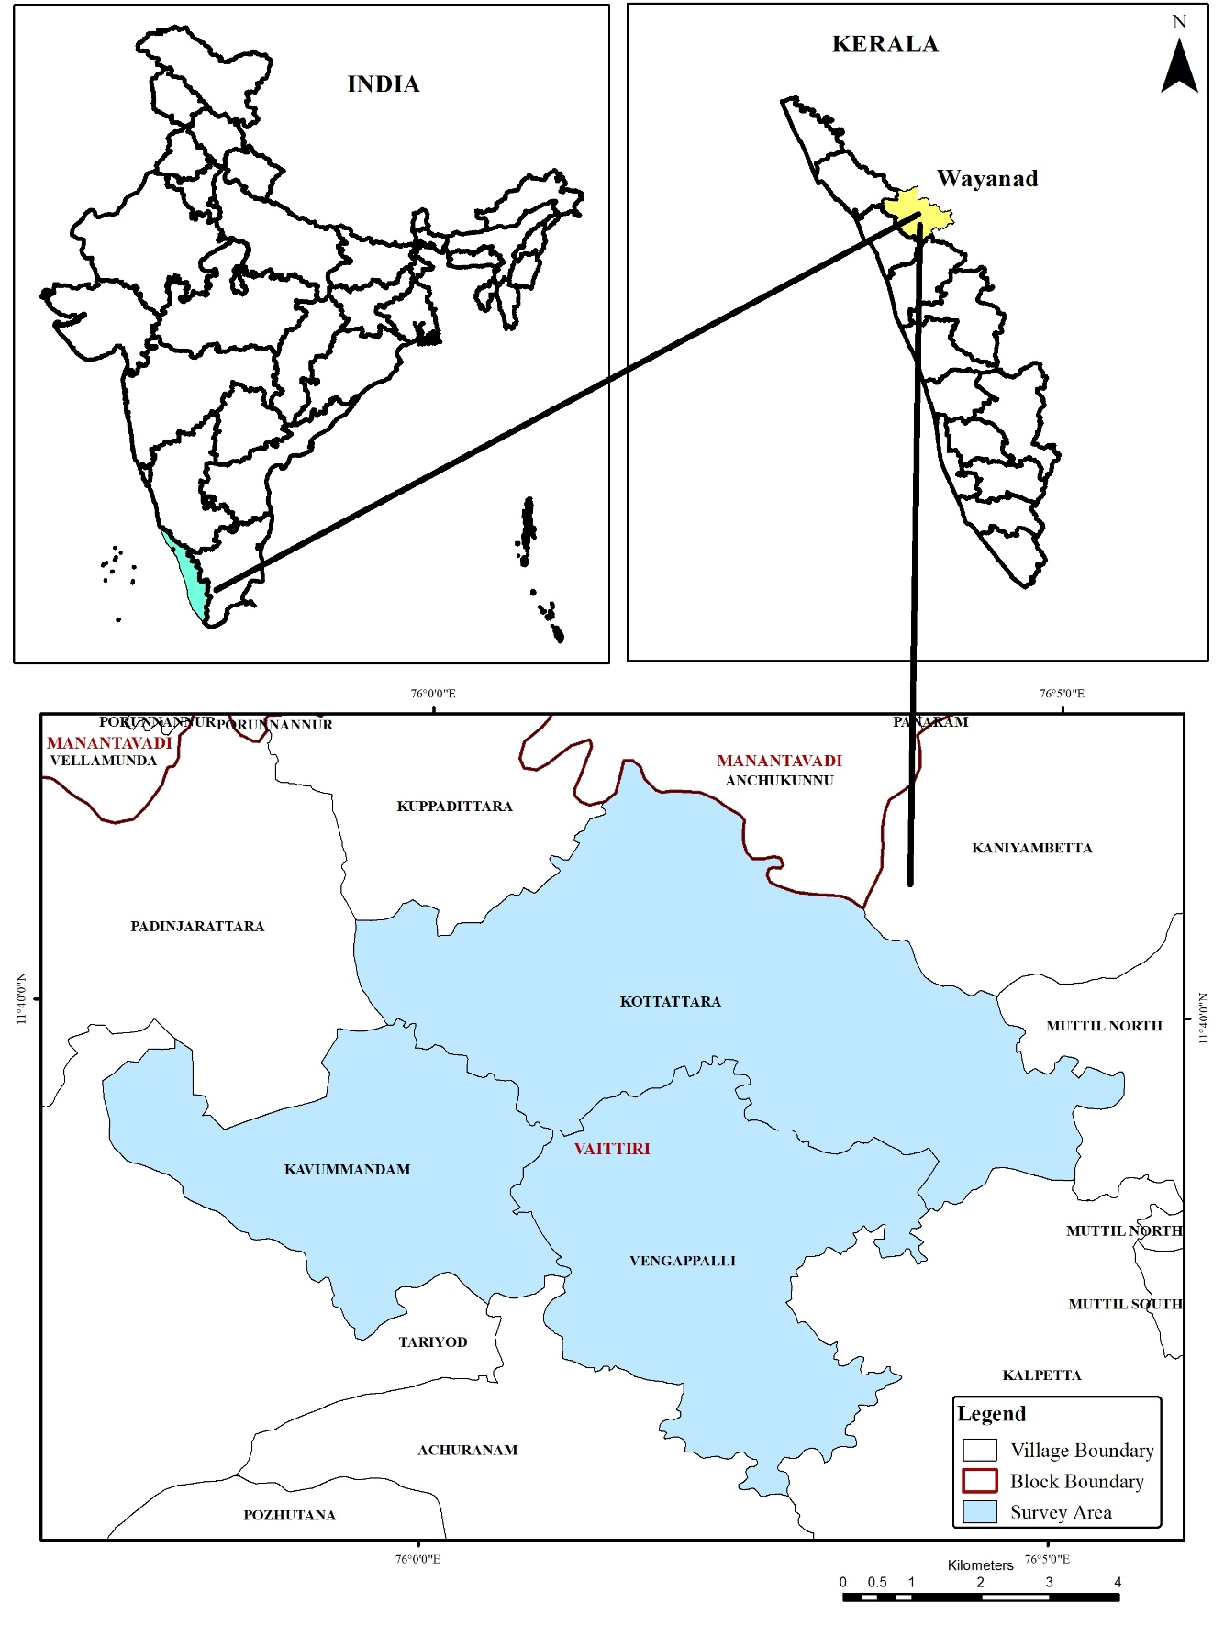
Fig. 1. Location map of study area

Soil mapping was carried in field ground truthing by traversing and studying soil profiles, augur bores and shallow pits as required depending upon the physiographic heterogeneity of the area. Soils profiles up to d5 depth (>100 cm) or up to depth of parent material whichever comes earlier were exposed and examined in details to record the morphology of the soils. The shallow pits and soil auger bore were examined for confirming extent of soil unit boundary. The morphological description of these profiles was recorded in field according to the guidelines of Soil Survey Manual developed by Soil and Land Use Survey of India organisation (AIS & LUS 1970).
The collected soil samples from the selected profiles were analysed for their basic physico-chemical properties. Soil reaction (pH) and electrical conductivity (EC) were estimated by the procedures outlined by Jackson (1973). The organic carbon content was estimated by the Walkley and Black (1934) wet digestion method. Cation exchange capacity (CEC) was determined by a centrifuge extraction procedure using the neutral normal ammonium acetate method (Thomas, 1982). Exchangeable sodium percentage (ESP) is determined by dividing the amount of exchangeable sodium by the cation exchange capacity. Based on physiography-soil relationship, total 5 soil series have been identified viz. Padivayal, Nedumbala, Kottanad, Madakkimala and Muttil and mapped in the survey area.
3. results and discussion

[(The interpretation of satellite data and validated through ground-truthing, revealed the presence of three major physiographic units in the study area. Based on physiography-soil relationship total 5 soil series have been identified and mapped in the survey area. The soil mapping of the region highlights the dominance of the Padivayal series, which covers the maximum area of 3419 ha, accounting for 48.98% of the total surveyed land. This is followed by the Nedumbala series with 1754 ha (25.13%), the Kottanad series with 985 ha (14.11%), the Madakkimala series with 482 ha (6.91%), and finally the Muttil series occupying 94 ha (1.35%). Forest area covers 120 ha that’s 1.72% in total area (Fig. 2).
These spatial patterns are consistent with digital soil mapping approaches in which field observations are integrated with environmental covariates, terrain attributes and remotely sensed information to predict soil classes and improve the reliability of soil resource inventories (McBratney et al., 2003; Grunwald, 2009; Mulder et al., 2011).

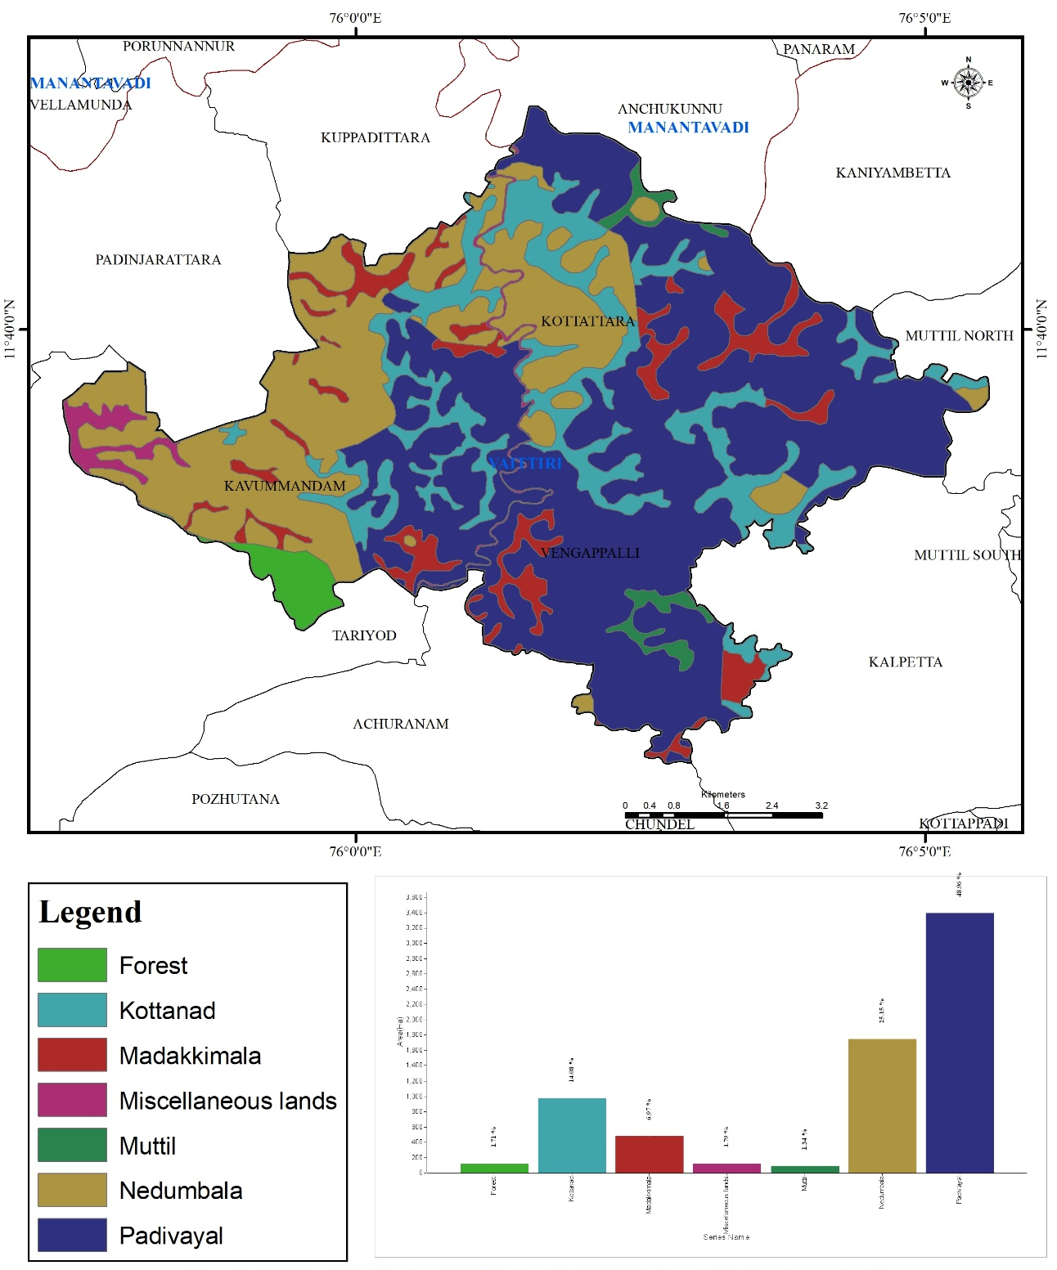
Fig. 2. Spatial distribution of identified soil series of study area
Based on slope, soil type, erosion intensity, and surface conditions, the physiographic units of the study area were further classified into 13 soil mapping units (Fig.3). These units shown that the soils of Kavummandam, Kottattara and Vengappalli villages are highly variable and are strongly influenced by the undulating topography whereas Padivayal and Kottanad mapping units reflects their adaptability to the prevailing geomorphic conditions.
The subdivision of the landscape into soil mapping units is useful because land evaluation depends on combined terrain-soil relationships rather than on single soil attributes alone, particularly in heterogeneous hill environments (Rossiter, 1996; McBratney et al., 2003; Mulder et al., 2011).
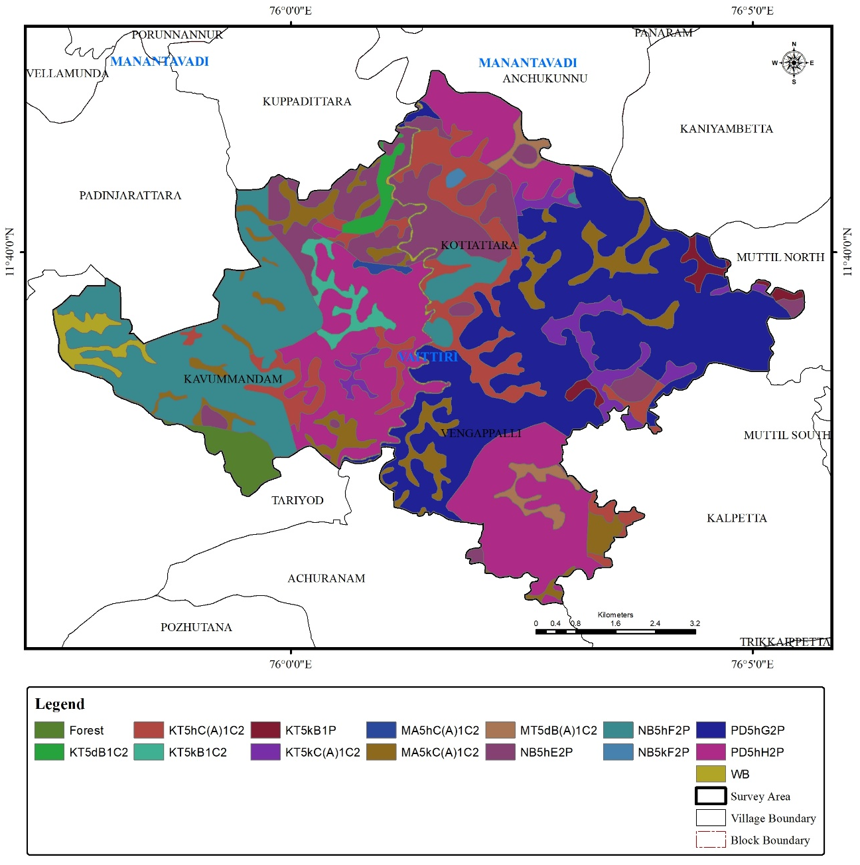
Fig. 3. Spatial distribution of soil mapping unit of study area.

The study area, covering 6,734 ha (96.48% of the total geographical area), is predominantly characterized by very deep soils with depths exceeding 100 cm (Fig. 4). The analysis indicate that nearly 100% of the cultivated land in the study area falls under the very deep soil category, providing favorable conditions for crop growth and root development. The remaining area comprises miscellaneous lands and forest land, which are categorized as non-agricultural land.
The predominance of very deep soils is agronomically important because deeper rooting zones can improve water storage and root exploration; however, their practical suitability must still be interpreted together with slope, erosion risk and chemical constraints (Rossiter, 1996; Oldfield et al., 2019).
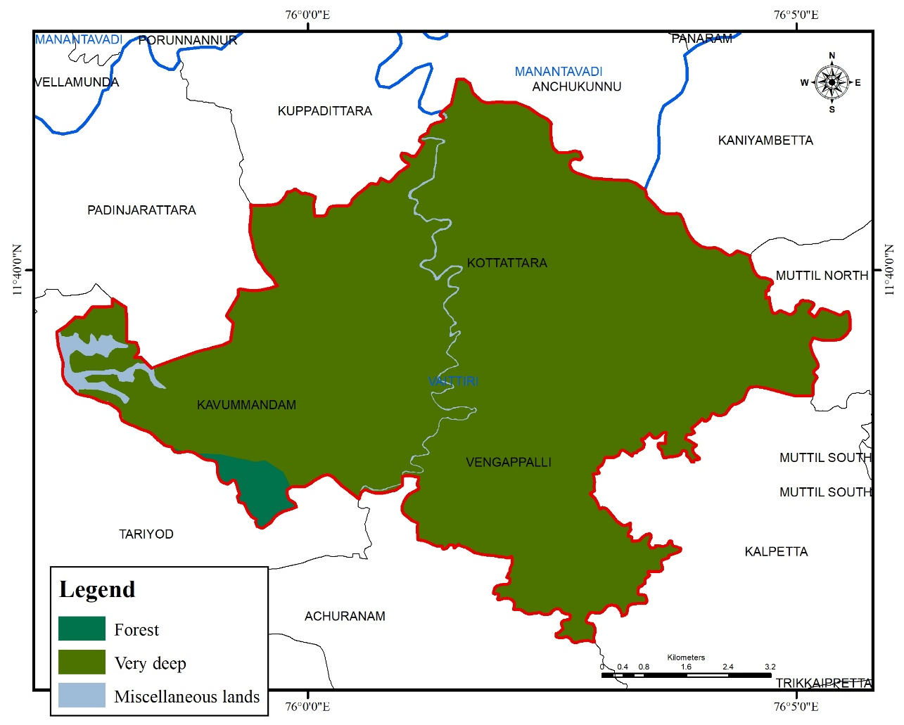
Fig. 4. Spatial distribution of soil depth classes in the study area.

The spatial pattern of erosion clearly demonstrates that soil erosion is one of the major land degradation problems in the study area. The spatial distribution maps of soil erosion classes of the study area revealed that the study area is predominantly affected by moderate soil erosion (74.11%), while comparatively smaller areas fall under the none to slight erosion category (22.36%) (Fig. 5). The spatial pattern of erosion clearly indicated that soil erosion is one of the major land degradation problems in the study area.
This observation is important because water erosion is widely recognized as a major soil-degradation process that can remove nutrient-rich surface soil, reduce organic matter and weaken long-term land productivity if conservation measures are not adopted (Panagos et al., 2015; Borrelli et al., 2017).
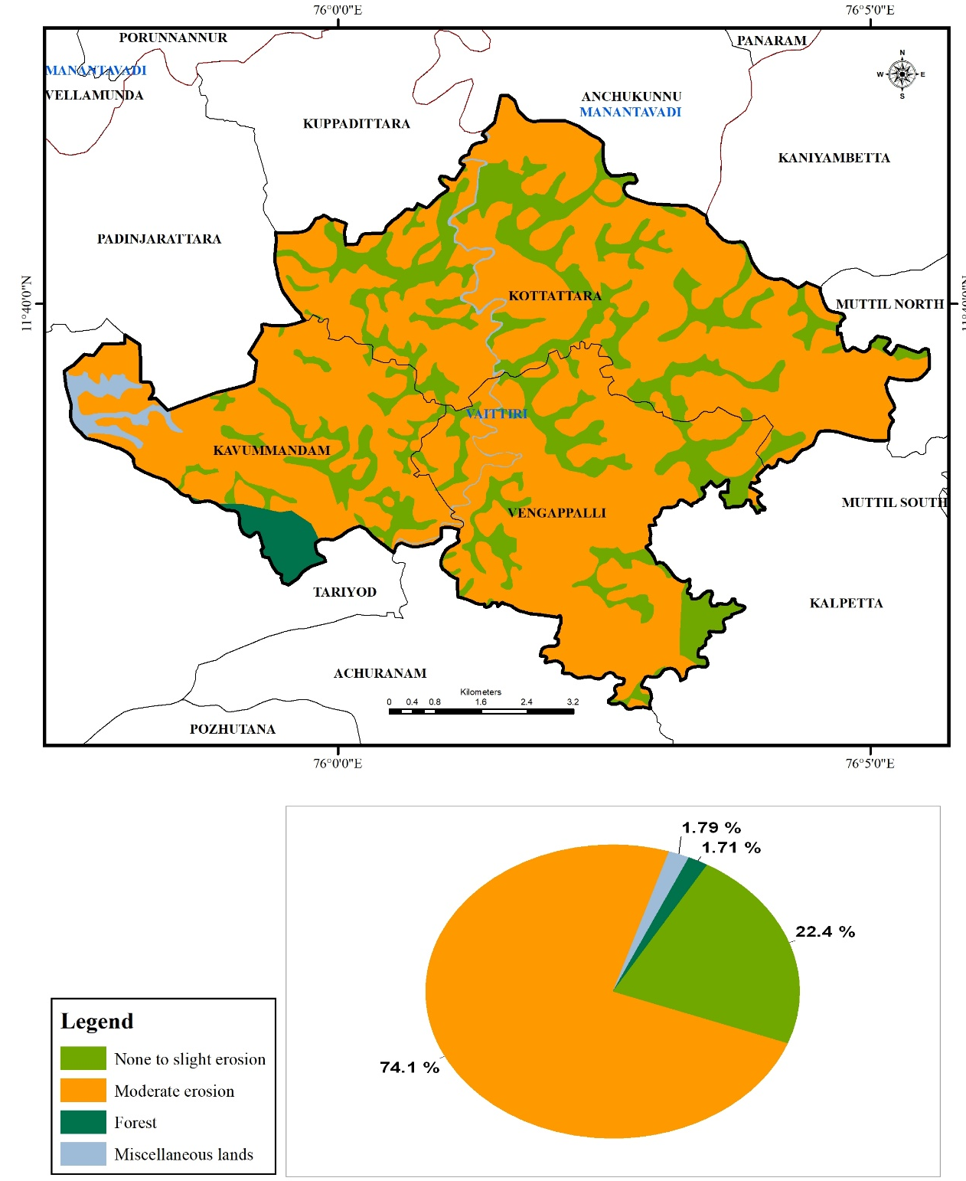
Fig. 5. Spatial distribution of soil erosion classes in the study area.

The study area was classified into seven slope classes, namely very gently sloping, gently terraced sloping, moderately steep sloping, strongly sloping, steep sloping, very gently terraced sloping and very steep sloping. Of these, the majority of the area, 1933 ha (27.69%), is classified as steep slope (25-33%), followed by 1486 ha (21.29%) under very steep slope (33-50%), and 1261 ha (18.07%) under gently terraced slope (0–5%) (Fig. 6).
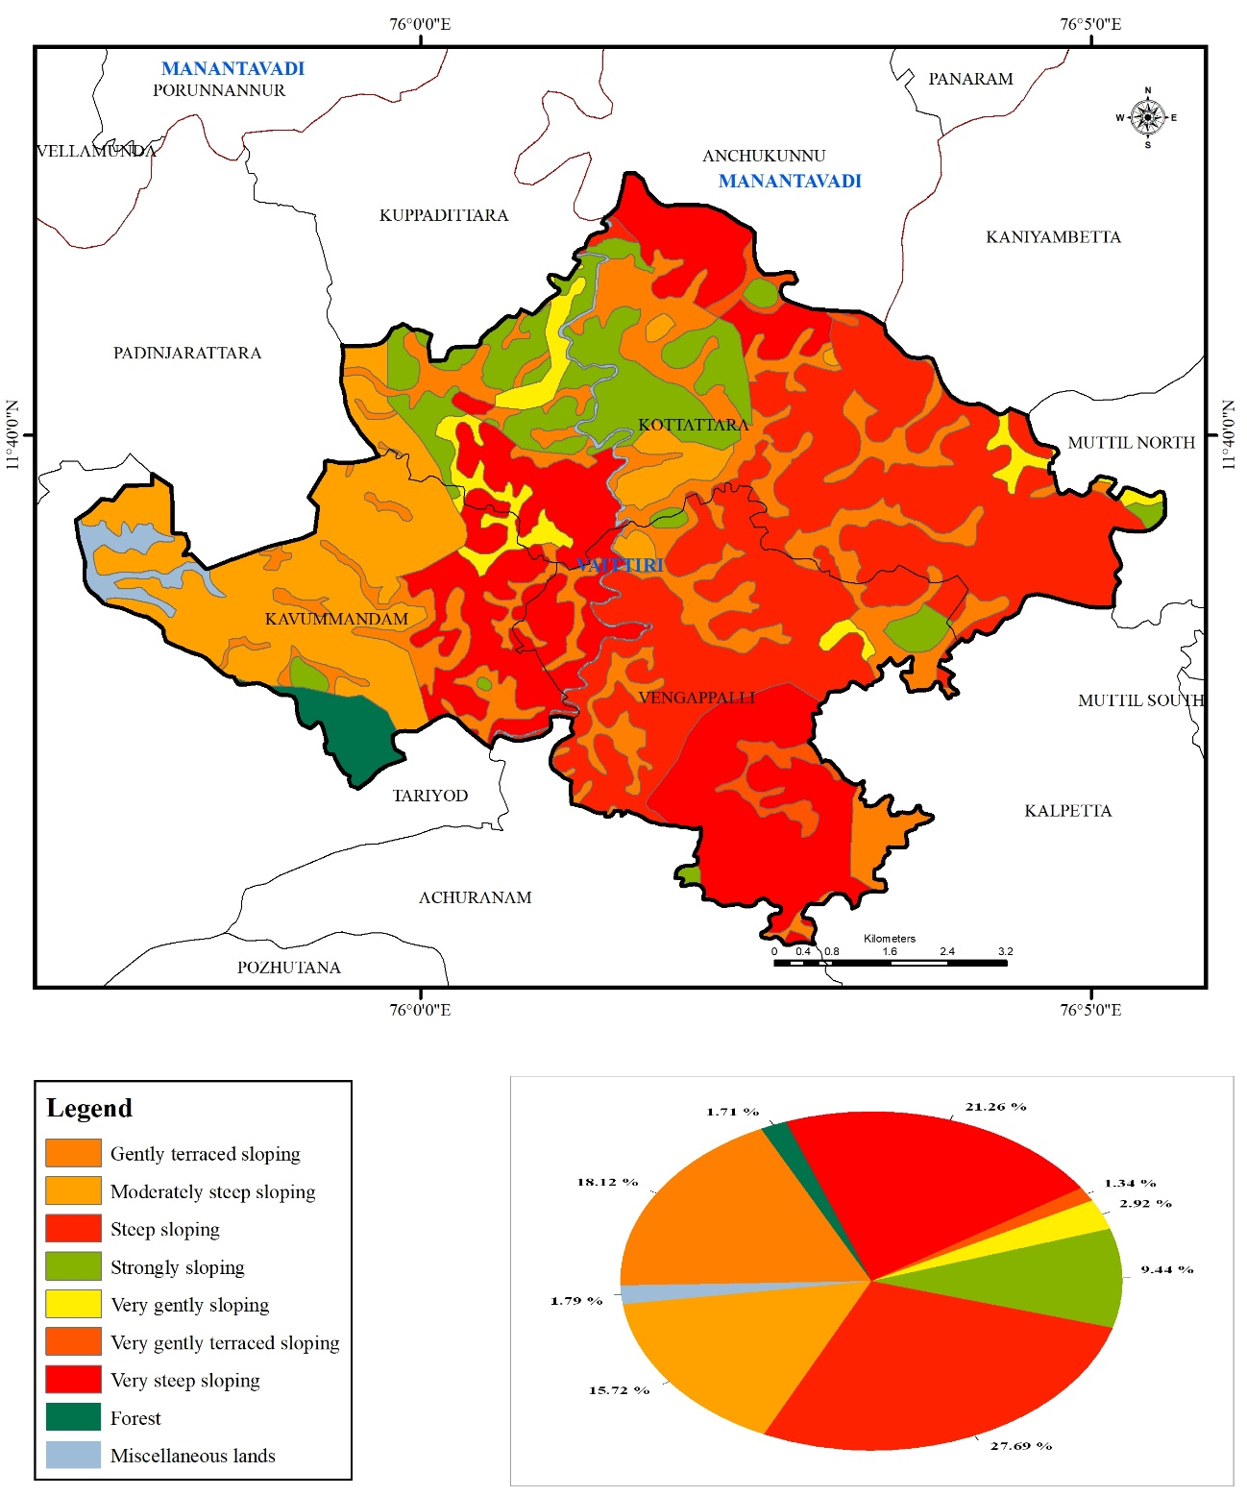
Fig. 6. Spatial distribution of soil slope classes in the study area.

Collectively, these findings underscore the predominance of very deep Gneiss soils, moderate erosion, and steep slopes, which together highlight the region’s strong potential for sustainable and intensive plantation practices. Furthermore, land capability classification (LCC) analysis indicates that 3419 ha (48.98%) of the surveyed area falls under LCC-VI, representing suitable for pasture and forestry with minor limitations (Fig. 7), while 1754 ha (25.13%) is categorized as LCC-IV, denoting Land Suitable for Cultivation, Fairly Good Land with Occasional Cultivation and Major Limitations based cropping systems. While only 22.40% falls under the relatively productive Class II category. These lands have well for crop growth and production whit slight to moderate limitations and are considered among the most productive agricultural lands within the study area. Similar result was observed by Seema et al. (2020)
The dominance of steep and very steep slopes provides a clear explanation for the large proportion of land placed in restrictive capability classes, as slope gradient and erosion hazard are key criteria in land evaluation and suitability assessment (Rossiter, 1996; Panagos et al., 2015; Borrelli et al., 2017).
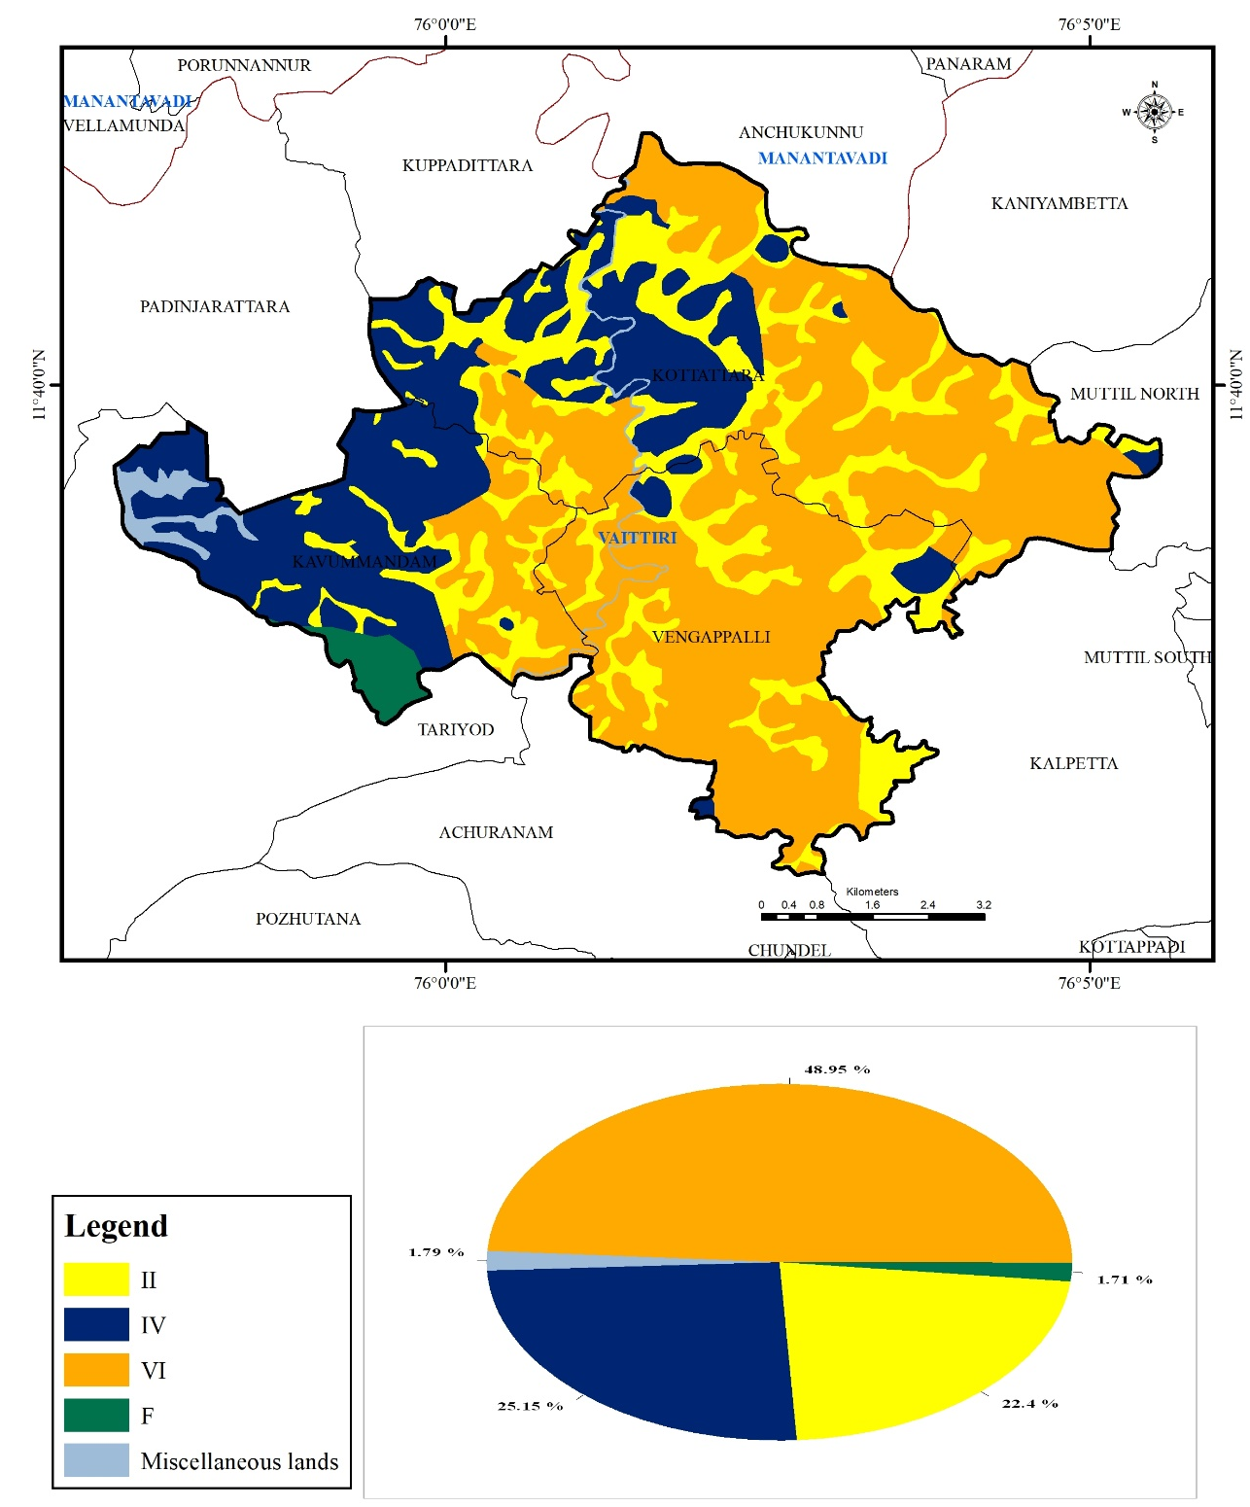
Fig. 7. Spatial distribution of Land Capability Classes (LCC) in the study area

The soil pH indicates that all mapping units are strongly to moderately acidic. Surface soil pH ranges from 4.51 to 5.80, while subsurface pH varies from 4.55 to 5.98 (Table 1). The lowest surface pH was observed in Kottanad (4.51–4.67), indicating strongly acidic conditions, whereas Padivayal (5.50–5.80) exhibited comparatively less acidic surface soils. Similarly, aoil electrical conductivity (EC) values are very low (0.02–0.09 dS m⁻¹) in both surface and subsurface soils. Surface soil organic carbon (OC) varied from 1.08–2.81%, with the highest values recorded in Madakkimala (2.68–2.81%) and Padivayal (2.54–2.67%). While, Subsurface soil OC decreases markedly in most soil series, except in Madakkimala. The exchangeable sodium percentage (ESP) is uniformly low, ranging from 0.30 to 2.92%, which is well below the threshold for sodic soils (ESP >15%). The highest surface ESP was observed in Kottappadi (2.92%), while the lowest was recorded in Nedumbala (0.44%). The cation exchange capacity (CEC) varies from 6.69 to 17.72 cmol(p⁺) kg⁻¹ in the surface soils and 7.50 to 18.26 cmol(p⁺) kg⁻¹ in the subsurface soils. The highest CEC was recorded in Muttil, followed by Kottanad and Nedumbala. These findings align with previous research by Pragnya et al. (2023), Devdas et al. (2021).
The acidic soil reaction observed in the mapping units is consistent with humid landscapes where intense weathering and leaching commonly lower soil pH, while the high organic carbon and low ESP values indicate limited sodicity risk and potentially favorable nutrient retention under appropriate management (Slessarev et al., 2016; Ramos et al., 2018; Oldfield et al., 2019).
Table 1. Chemical properties of soil series of study area
Soil series | Soil pH |  | Soil EC (dS m⁻¹) |  | Soil organic carbin (%) |  | Soil ESP (%) |  | Soil CEC (cmol(p⁺) kg⁻¹)
Soil series | Surface | Sub-surface | Surface | Sub-surface | Surface | Sub-surface | Surface | Sub-surface | Surface | Sub-surface
Kottanad | 4.51-4.67 | 5.05-5.16 | 0.07 | 0.09 | 2.48-2.76 | 0.98-1.09 | 1.14 | 0.74 | 14.7 | 11.76
Kottappadi | 4.82-5.12 | 5.54-5.72 | 0.09 | 0.04 | 1.55-1.86 | 0.6-0.70 | 2.92 | 0.49 | 10.43 | 9.7
Madakkimala | 5.2-5.32 | 5.31-5.41 | 0.02 | 0.02 | 2.68-2.81 | 3.0-3.20 | 0.65 | 0.3 | 6.69 | 7.82
Muttil | 4.86-5.01 | 5.91-5.98 | 0.04 | 0.02 | 1.08-1.21 | 0.65-0.81 | 0.64 | 0.61 | 17.72 | 18.26
Nedumbala | 4.78-4.84 | 4.55-4.61 | 0.04 | 0.02 | 1.31-1.42 | 1.01-1.06 | 0.44 | 0.6 | 14.9 | 9.43
Padivayal | 5.5-5.8 | 4.64-4.9 | 0.08 | 0.04 | 2.54-2.67 | 0.88-0.96 | 0.68 | 0.43 | 11.7 | 7.5

Conclusions
Five soil series were delineated in the surveyed villages, with Padivayal and Nedumbala occupying the largest proportions. Most of the landscape contains very deep soils, but steep terrain and moderate erosion impose important limitations on land use. The soils are strongly to moderately acidic, non-saline, and non-sodic, with variable organic carbon and moderate cation exchange capacity. Land capability assessment indicates that nearly half of the area belongs to Class VI and is generally better suited to permanent vegetation, pasture, plantation, or forestry than regular cultivation, whereas smaller areas fall within Classes IV and II. The integrated field, laboratory, remote-sensing, and GIS approach provides a spatial soil database that can guide site-specific conservation, land-use planning, and soil-management decisions in the surveyed area.

Limitations
The assessment was restricted to three villages and selected soil chemical indicators. The manuscript does not report the survey period, number and spatial distribution of profiles and auger observations, independent map-accuracy validation, or uncertainty estimates. Seasonal changes in soil properties were not evaluated. Consequently, the findings should be interpreted as a location-specific soil resource inventory rather than as evidence of temporal trends or performance under particular crops and management systems.

Declaration of AI Use

This manuscript was prepared through the combined contributions of all author(s), including contributions to the study design, data, content development, results, interpretation, and related scholarly work. The author(s) acknowledge the use of Grammarly and ChatGPT to assist with grammar checking, language refinement, reference formatting. These AI-assisted tools were not used as authors and did not replace the intellectual contributions or scholarly judgment of the author(s). All AI-assisted outputs, including content, references, and interpretations, were carefully reviewed, revised, verified, and approved by the author(s). The author(s) accept full responsibility for the accuracy, integrity, and final content of the manuscript.

Competing interests

Authors have declared that no competing interests exist.

References

All India Soil & Land Use Survey Organization. (1970). Soil survey manual. Indian Agricultural Research Institute, New Delhi.
Ardak, S.A., Nagaraju, M. S. S., Prasad, J., Srivastava, R., & Barthwal, A. K. (2010). Characterization and evaluation of land resources in Khapri village of Nagpur district, Maharashtra using high resolution satellite data and GIS. Agropedology, 20(1), 7–18.
Borrelli, P., Robinson, D. A., Fleischer, L. R., Lugato, E., Ballabio, C., Alewell, C., Meusburger, K., Modugno, S., Schutt, B., Ferro, V., Bagarello, V., Van Oost, K., Montanarella, L., & Panagos, P. (2017). An assessment of the global impact of 21st century land use change on soil erosion. Nature Communications, 8, Article 2013. https://doi.org/10.1038/s41467-017-02142-7
Devdas, D., Srivastava, L. K., & Mishra, V. N. (2021). Characterization and classification of different soil types of Gariyaband district of Chhattisgarh. International Journal of Current Microbiology and Applied Sciences, 10(2), 1667–1677.
Grunwald, S. (2009). Multi-criteria characterization of recent digital soil mapping and modeling approaches. Geoderma, 152(3-4), 195-207. https://doi.org/10.1016/j.geoderma.2009.06.003
Jackson, M. L. (1973). Soil chemical analysis (1st ed.). Prentice Hall of India.
Joseph W. A. M., Nath, K., Wadodkar, M., Meena, R., Mahendra, A., Seetharaman, R., Shivakumar, R., & Sureshkumar, P. (2023). Generation of detailed soil information for the Virudhunagar aspirational district of Tamil Nadu using remote sensing and GIS techniques for developmental planning. Agropedology, 33(1), 1–12.
Kumar Y. S., Gahlod, N. S., & Arya, V. S. (2016). Geospatial technology in soil resource inventory and land capability assessment for sustainable development: Wayanad district, Kerala. Journal of Soil and Water Conservation, 15(3), 218–225.
Lal, R., & Stewart, B. A. (2010). Food security and soil quality. CRC Press.
McBratney, A. B., Mendonca Santos, M. L., & Minasny, B. (2003). On digital soil mapping. Geoderma, 117(1-2), 3-52. https://doi.org/10.1016/S0016-7061(03)00223-4
Minasny, B., & McBratney, A. B. (2016). Digital soil mapping: A brief history and some lessons. Geoderma, 264, 301–311.
Mulder, V. L., de Bruin, S., Schaepman, M. E., & Mayr, T. R. (2011). The use of remote sensing in soil and terrain mapping: A review. Geoderma, 162(1-2), 1-19. https://doi.org/10.1016/j.geoderma.2010.12.018
Oldfield, E. E., Bradford, M. A., & Wood, S. A. (2019). Global meta-analysis of the relationship between soil organic matter and crop yields. SOIL, 5, 15-32. https://doi.org/10.5194/soil-5-15-2019
Panagos, P., Borrelli, P., Poesen, J., Ballabio, C., Lugato, E., Meusburger, K., Montanarella, L., & Alewell, C. (2015). The new assessment of soil loss by water erosion in Europe. Environmental Science & Policy, 54, 438-447. https://doi.org/10.1016/j.envsci.2015.08.012
Pereira, P., Brevik, E. C., Muñoz-Rojas, M., Miller, B. A., Smetanova, A., Depellegrin, D., Misiune, I., Novara, A.& Cerdà, A. (2017). Soil mapping and processes modeling for sustainable land management. In: Soil mapping and process modeling for sustainable land use management. Elsevier, pp. 29–60.
Pragnya, M., Prasad R. M., Jayasree, G., & Reddy S. I. V. (2023). Characterization and classification of oil palm growing soils of Khammam and Bhadradri Kothagudem districts of Telangana. Biological Forum – An International Journal, 15(9), 932–937.
Ramos, F. T., Dores, E. F. C., Weber, O. L. S., Beber, D. C., Campelo, J. H., Jr., & Maia, J. C. S. (2018). Soil organic matter doubles the cation exchange capacity of tropical soil under no-till farming in Brazil. Journal of the Science of Food and Agriculture, 98(9), 3595-3602. https://doi.org/10.1002/jsfa.8881
Rossiter, D. G. (1996). A theoretical framework for land evaluation. Geoderma, 72(3-4), 165-190. https://doi.org/10.1016/0016-7061(96)00031-6
Seema, Ghosh, A. K., & Yadav, S. (2020). Characterization and fertility assessment of soils of Chandauli district of Eastern Uttar Pradesh for sustainable land use planning. Indian Journal of Agricultural Sciences, 90(8), 1521–1527.
Slessarev, E. W., Lin, Y., Bingham, N. L., Johnson, J. E., Dai, Y., Schimel, J. P., & Chadwick, O. A. (2016). Water balance creates a threshold in soil pH at the global scale. Nature, 540, 567-569. https://doi.org/10.1038/nature20139
Thomas, G. W. (1982). Exchangeable cations. In A. L. Page (Ed.), Methods of soil analysis: Part 2. Chemical and microbiological properties (Agronomy Monograph No. 9, pp. 159–164). American Society of Agronomy.
Walkley, A., & Black, I. A. (1934). An examination of the Degtjareff method for determining soil organic matter, and a proposed modification of the chromic acid titration method. Soil Science, 37, 29–38.

