Silent Predators of Chhattisgarh: A Baseline Survey of Owls and Their Conservation Perspectives

ABSTRACT: Owls (Order: Strigiformes) are among the most ecologically significance nocturnal raptors, playing a vital role in ecosystem balance by controlling rodent populations and serving as indicators of environmental health. Despite their importance, owls remain poorly studied in many parts of India, including Chhattisgarh, a state characterized by rich forest cover and biodiversity. This study represents one of the first systematic attempts to document the distribution, diversity, and habitat use of owls across selected forest divisions of Chhattisgarh. Surveys were conducted between 1983 to 2025, employing nocturnal field walks, call surveys, and opportunistic observations across multiple habitat types, including tropical moist deciduous forests, dry deciduous forests, agricultural landscapes, and village fringes. A total of 17 owls and owlet species were recorded, belonging to two families Strigidae and Tytonidae. Among these, the Jungle Owlet (Glaucidium radiatum), Spotted Owlet (Athene brama), Barn Owl (Tyto alba), and Brown Fish Owl (Ketupa zeylonensis), were the most frequently encountered. Species richness was highest in mosaic habitats combining forest and agricultural land, indicating the adaptability of certain species to human-modified landscapes. However, larger forest-dependent species such as the Eagle Owl were restricted to undisturbed patches, highlighting their sensitivity to habitat alteration. The study also revealed anthropogenic threats to owl populations, including habitat loss due to deforestation, road expansion, and negative perceptions rooted in local superstitions. Community interactions suggested the persistence of traditional beliefs associating owls with ill omens, which may hinder conservation efforts. Our findings emphasize the urgent need for long-term ecological monitoring, awareness programs to mitigate myths, and habitat-based conservation strategies. Establishing baseline data on owl diversity in Chhattisgarh provides a critical foundation for future avifaunal research and contributes to the broader understanding of raptor ecology in central India.
KEYWORDS; Owls, Owlets, occurrence, distribution, breeding, threats, Chhattisgarh

Introduction
Owls, belongs to the order Strigiformes, are globally distributed predatory birds characterized by unique adaptations for nocturnal hunting. This order comprises two families: Strigidae (true owls) and Tytonidae (barn and grass owls). Of the ~250 owl species found worldwide, approximately 36 species are recorded in India. Owls are primarily nocturnal and carnivorous. All species in India are protected under the Wildlife (Protection) Act, 1972 (WPA), with any form of poaching, trade, or exploitation considered a punishable offence. The Forest Owlet (Heteroglaux blewitti), a rare and endangered species, is listed in Schedule I of the WPA, while other Indian owls are under Schedule IV. Internationally, H. blewitti is listed in Appendix I of CITES, while the rest are listed in Appendix II (Badola & Fernandes, TRAFFIC, 2021).
Owls inhabit a wide range of habitats, including dense forests, rocky cliffs, wooded ravines, groves near villages, and even ruins or occupied buildings. Their presence is primarily revealed by vocalizations, especially at night. Morphological diversity exists among owl species, but they typically share features such as large rounded heads, forward-facing eyes, cryptic plumage, a curved bill, and strong talons. The feet are adapted with a reversible outer toe, enabling a powerful grip rather than striking action (Baker, 1927; Ali & Ripley, 1987). Owlets, distinguished from larger owls, generally lack ear tufts, have feathered tarsi, no distinct facial disc, and more rounded wings and tails. Ear tufts in owls are elongated feathers on the head, often mistaken for ears. All owls possess acute hearing and a distinctive facial disc that channels sound toward the ears. Their large eyes are fixed within the skull, restricting eye movement but enabling a wide field of view through head rotation up to 270 degrees (König & Weick, 2008; Baker, 1927). Owl flight is notable for its silence, owing to specialized feather structures that reduce aerodynamic noise. Their diet includes insects, spiders, worms, amphibians, reptiles, birds, and small mammals. After feeding, owls regurgitate compact pellets of indigestible material such as bones and fur, due to the absence of a crop (König & Weick, 2008; Bikash Ghimire, 2014–2016).
Owls may travel significant distances to forage. Most species use a perch-and-pounce strategy, swooping down silently on prey. Smaller insectivorous species may capture prey in mid-air, while fish owls snatch aquatic prey from near the water’s surface. Prey is either consumed immediately or carried away using the beak or talons. While the majority of species are active at dusk or night, a few show partial diurnal activity. Roosting behaviors vary; individuals may preen, stretch, or bathe before becoming active at night. Owls also exhibit characteristic head-bobbing behavior to enhance depth perception. When threatened, they adopt aggressive postures, such as ruffling feathers, spreading wings, and snapping their bills especially during nesting or when defending young (König & Weick, 2008; Baker, 1927). Vocalizations increase during the onset of the breeding season, generally in late winter or early spring. Males sing to claim territory and attract mates. Both sexes may vocalize in duets, and once pair bonds are formed, calling subsides. Owls usually nest in tree cavities or abandoned woodpecker holes. A shallow depression is created for the eggs, often cushioned by regurgitated pellets. Only the female incubates, and the clutch usually consists of pure white eggs laid at intervals. Vocal and non-vocal sounds territorial calls, courtship songs, alarm calls, bill snapping, and wing clapping aid in communication and species identification (König & Weick, 2008; Baker, 1927).
The avifaunal diversity of Central India has been extensively documented through national and regional studies. Foundational works include Ali & Ripley (1987), Grimmett et al. (1998, 2014), and Rasmussen & Anderton (2012). Regional records specific to Central India include those by D’Abreu (1931, 1934), Hewetson (1956), Majumdar (1984), and Chandra & Singh (2004). More recent studies have been conducted by Chandra & Boaz (2018a–d), Dutta (2017), Arjun et al. (2023), and Bharos et al. (2025), along with numerous contributions by Bharos (1983–2025). Personal field observations across Chhattisgarh since 1965 have contributed valuable data to the documentation of owl distribution. Noteworthy references include Chandra et al. (2015), Bharos et al. (2019a), Arjun et al. (2023), and Bharos et al. (2025). Complementary studies from neighboring states have also been examined, including Price (1979) on the Eastern Ghats; Srinivasulu (2004) on Kawal WLS, Andhra Pradesh; Govind Raj (2008); Das et al. (2010) on Simlipal TR, Odisha; Lahkar et al. (2015) on Sunabeda WLS; Raju & Ramachandran (2016) on Madhya Pradesh; Palei et al. (2018) on Mayurbhanj-Simlipal, and Bayani & Dandekar (2017) on Tadoba Andhari TR, Maharashtra.
The biogeographical importance of Central India has been emphasized by several authors. Tyabji (1994) highlighted the occurrence of Himalayan and sub-Himalayan species in northern Madhya Pradesh and Chhattisgarh. Hora (1949) proposed the Satpura range as a critical migration corridor for species moving southwest, while Abdulali (1949) emphasized the role of the Eastern Ghats in bird dispersal. D’Abreu (1933) noted the eastward movement of Western Ghats avifauna. The Simlipal Hills in Odisha, connected to Chhattisgarh’s Bastar region through the Dandakaranya range, show affinities with northeastern India and the Himalayas (Rahmani & Nair, 2012). Bharos et al. (2019a) documented the range extension of 24 bird species into Bastar from the Eastern Ghats, underscoring the region’s importance in avian biogeography.

Study area and Methodology
Chhattisgarh, encompassing an area of 135,192 sq. km, situated between latitudes 17.47°N and 24.06°N and longitudes 80.15°E and 84.24°E, the state experiences a tropical hot and humid climate. Annual rainfall ranges from 100 mm to 1700 mm, while temperatures vary from 11°C to 47°C. The total recorded forest area in the state is approximately 59,772 sq. km, comprising 40.4% reserve forest, 52.5% protected forest, and 7.1% unclassified forest (Rahmani et al., 2018). The state shares its borders with Madhya Pradesh to the northwest, Uttar Pradesh to the north, Jharkhand to the northeast, Odisha to the southeast, Telangana to the south, and Maharashtra to the southwest. Geographically, Chhattisgarh lies within the East Deccan zone and is divided into three distinct agro-climatic regions: the Chhattisgarh Plains, the Northern Hills of Chhattisgarh, and the Bastar Plateau. These zones support diverse forest types, as classified by Champion and Seth (1968).
Map 1. Study area map of Chhattisgarh
The state's rich biodiversity is protected under its network of four national parks/tiger reserves and eleven wildlife sanctuaries, collectively covering about 11% of its area (Islam & Rahmani, 2004; Rahmani et al., 2018). Among its regions, Bastar stands out as a particularly important habitat for avifauna. Kanger Valley National Park is characterized by highly heterogeneous terrain, ranging from flatlands and gentle slopes to rugged plateaus, deep valleys, and stream corridors. The Dandakaranya Hills, forming part of the Eastern Ghats in the Bastar region, support an abundance of flora and fauna and serve as a natural corridor for avian movement into Chhattisgarh (Price, 1979; Islam & Rahmani, 2004).
Methodology
The owl species encountered during the study were identified using standard ornithological references, including Baker (1927), Ali and Ripley (1987), Grimmett et al. (1998, 2014), König and Weick (2008), and Rasmussen and Anderton (2012). Species identification was further validated through expert consultation. Field observations were conducted opportunistically across various landscapes in Chhattisgarh, including forested areas, open countryside, and the peripheries of human settlements. Binoculars were employed for distant observations, while photographic documentation was obtained using digital cameras. Wherever feasible, vocalizations were recorded using built-in camera audio systems and subsequently compared with published call data for species confirmation.
Special emphasis was placed on recording nesting and associated reproductive behaviors, including courtship displays, roosting, fledgling activity, and vocal interactions. Observations related to these behaviors were recorded systematically and have been periodically disseminated through regional publications and field reports. This documentation provides a foundational understanding of the owl diversity and breeding ecology in the state of Chhattisgarh.

Result and discussion

- Common Barn Owl (Tyto alba)
The Barn Owl (Tyto alba) (Fig.1) is widely distributed across all districts of Chhattisgarh, inhabiting both urban and rural environments, including densely populated areas. Its breeding season is undefined, occurring throughout the year. The species does not construct a nest; instead, eggs are laid on accumulated pellets and prey remains within cavities in ruins or roof spaces of buildings. Clutch sizes typically range from 4 to 7 eggs (Ali & Ripley, 1987), with a maximum of 13 recorded (Marti, 1994). A brood of eight hatchlings (2023) and seven (2024) was observed at Gadchiroli, Maharashtra (Channawar et al., 2023). The female incubates alone, and asynchronous hatching often leads to size uniformity by fledging (König & Weick, 2008). The diet primarily consists of rodents, but opportunistic predation on House Geckos near artificial lighting has been documented, with owls repeatedly capturing geckos from vertical walls in urban settings (Bharos, 2012), demonstrating adaptive foraging behavior.
- Eastern Grass Owl (Tyto longimembris)

The Eastern Grass Owl (Tyto longimembris) (Fig. 2) has previously been reported from Barnawapara Wildlife Sanctuary (Bharos et al., 2016a, b), identified based on morphological features and habitat preferences. Subsequent sightings occurred in the grassy plains of New Raipur, Kanger Valley National Park (KVNP), and Udanti-Sitanadi Tiger Reserve (USTR) in Gariaband district. A solitary individual was observed in 2020 at Jatmai and Torenga by members of the Chhattisgarh Wildlife Society (CWS). The species appears to be rare and may be frequently overlooked due to its resemblance to the Barn Owl (Tyto alba). No nests have been documented in the state to date.
- Collared Scops Owl (Otus bakkamoena)

The species has been documented across nearly all protected areas and districts within the state, inhabiting diverse forest types, including Kanger Valley National Park (KVNP), Indravati Tiger Reserve (ITR) (Bharos et al., 2025), Guru Ghasidas Tiger Reserve (GGNP), Gomardha Wildlife Sanctuary (GWLS), Surguja (Bharos et al., 2023), Bhoramdeo Wildlife Sanctuary (BWLS), and Udanti-Sitanadi Tiger Reserve (USTR) (Prateek Thakur, pers. comm.). Its occurrence is notably higher in KVNP of Bastar and is particularly abundant in ITR, Bijapur district, where vocalizations were consistently recorded throughout the night (Fig. 3).
- Oriental Scops Owl (Otus sunia)
The species has been recorded across several locations in Chhattisgarh, including Kanger Valley National Park (KVNP), Machkote Forest Range (MFR), Bastar districts (Jagdalpur, Sukma, Bijapur, Dantewada, Kondagaon, Narayanpur, Kanker), Jashpur, and Surguja (Bharos et al., 2023, 2025; Chandra et al., 2015, 2016; Fergus and Tiwari, 2023). On 16 January 2020, a bird was sighted at Milkulwada (18.864012°N, 82.012622°E), KVNP, with vocalizations confirmed via Xeno-canto and Grimmett et al. (2014). In December 2019, multiple calls were heard in Dholkal village, suggesting a healthy, possibly breeding population. A rufous morph individual was photographed in Chendra Forest, Ambikapur, in February 2024 (Dr. Gupta, pers. comm.), marking the first state record (Fig. 4).
- Eurasian Eagle Owl (Bubo bubo)
The Eurasian Eagle Owl (Bubo bubo) is widely distributed across all districts of Chhattisgarh, occupying diverse habitats including outskirts of towns and cities such as Korba, Bastar, Kondagaon, Durg (Chandra and Boaz 2018a); Surguja Saranggarh (Bharos et al., 2023); and Dhamtari, Gariaband, Rajnandgaon, and Bhoramdeo Wildlife Sanctuary (Prateek Thakur, pers. comm.). Primarily nocturnal, its distinctive calls are often heard at night, while during the day it has been observed crossing open terrain, sometimes harassed by crows.
Breeding records from 2017–2020 indicate nest sites and juvenile observations in varied habitats: tree stumps (3 eggs), Banyan tree cavities (3 chicks), old school buildings (solitary juvenile), Pipal tree cavities (2 adults and 3 juveniles), an island in Jhanjh tank, New Raipur (4 chicks), and earthen bunds of harvested paddy fields (2–5 eggs or chicks). Notably, (Anurag Vishwakarma, pers. comm.) recorded this species with one chick inside the State Forest Research and Training Institute campus, nesting in a small mud bund within a lake. Historically, the species was targeted for illegal trade to Southeast Asian zoos (Fig. 5).
- Indian Eagle Owl (Bubo nipalnensis)
In Chhattisgarh, the species has been documented in Bastar (Chandra & Singh, 2004), where it is hypothesized to have dispersed from Odisha via the Eastern Ghats and subsequently established a localized population. Additional records exist from Kanger Valley National Park (KVNP), Bastar (Bharos et al., 2019a); Jashpur district; Achanakmar Tiger Reserve (ATR), Bilaspur district (Fergus and Tiwari, 2023); and the Surguja region (Bharos et al., 2023). Further occurrences have been reported from Naya Raipur, Mangatta Forest in Rajnandgaon, and Barnawapara Wildlife Sanctuary. Recent photographic evidence and confirmed sightings have extended its range to Khandwa district in western Madhya Pradesh (D. Pare, pers. comm.) and Rajnandgaon district, Chhattisgarh (Prateek Thakur, pers. comm.) (Fig. 6).
- Dusky Eagle Owl (Bubo Coromandus)

In Chhattisgarh, the species has been recorded in Kanger Valley National Park (KVNP), Bastar (Chandra et al., 2015; Chakraborty, 2008), as well as other locations on the southern Bastar plateau (Chandra and Boaz, 2018a), where its vocalizations have been regularly detected and solitary individuals observed. The first record outside Bastar was documented in 2016 from the Barbaspur area of Bhoramdeo Wildlife Sanctuary (BWLS), Baloda Bazar district (Ajit Bharos, pers. comm.). Additional reports indicate its presence in Bastar, Bilaspur, Raipur, Guru Ghasidas National Park (GGNP), and Surguja regions (Chandra and Boaz, 2018a; Bharos et al., 2023). Due to its uncommon status in the state, limited information is available regarding its distribution, behavior, and breeding ecology (Fig. 7).

- Spot-bellied Eagle Owl (Bubo Nipalennsis)
The species has been repeatedly recorded at Kurandi (Machkote Forest Range), Kanger Valley National Park (KVNP), where the discovery of a deceased hatchling beneath a tree—alongside consistent sightings of an adult confirms successful breeding in this locality (Bharos et al., 2018b). Palei et al. (2018) documented a juvenile individual from the Athagarh Forest Division, Odisha, indicating probable breeding, and reported its presence in Similipal Tiger Reserve, Mayurbhanj district. They further hypothesized the existence of two distinct populations within Odisha. The species has also been reported from eastern Madhya Pradesh and Chhattisgarh (Rasmussen & Anderton, 2012), including Achanakmar Tiger Reserve (ATR), Bilaspur district (Chandra and Boaz, 2018d). Although considered uncommon in Chhattisgarh, the species is likely present in additional regions pending more intensive surveys across suitable habitats. In Madhya Pradesh, Kanha Tiger Reserve (KTR) is noted as a prime location for observing this species (Raju and Ramachandran, 2016) (Fig. 8).
- Brown Fish Owl (Ketupa zeylonensis)
The species has been consistently recorded in proximity to water sources throughout Chhattisgarh, ranging from Guru Ghasidas National Park (GGNP), Surguja, to Gangrel Dam, Dhamtari; and from Kanger Valley National Park (KVNP) to Indravati Tiger Reserve (ITR), Bastar (Chandra et al., 2015). Additional records include Gariaband (Bharos et al., 2018), Tamor-Pingla Wildlife Sanctuary, Surguja (Bharos et al., 2023), and Rajnandgaon (Prateek Thakur, pers. comm.). Near Raipur, the species has been observed in Naya Raipur adjacent to the Sendh wetland, where a juvenile was also sighted and a roosting site identified in Sector-19, indicating probable local breeding. Furthermore, two individuals were recorded simultaneously at a small pond within the ACC mining complex, Bhilai-Durg. These observations suggest a strong association of the species with aquatic or semi-aquatic habitats across its regional range (Fig. 9).
- Mottled Owl (Strix ocellata)
The species is widely distributed across Chhattisgarh, with confirmed records from Bastar, Raipur, Durg, Surguja (Chandra and Boaz 2018a,b,c,d), Rajnandgaon, Kabirdham, Gariaband (Bharos et al., 2018), Dhamtari, Mungeli, Korba, Raigarh districts, Achanakmar Tiger Reserve (ATR) (Fergus and Tiwari, 2023; Bharos et al., 2023), Bhoramdeo Wildlife Sanctuary (Prateek Thakur, pers. comm.), among other locations.
On 22 December 2017, a nest was documented on a flat upper surface of a thick horizontal branch of an old mango tree at village Beldarseoni (21.354°N, 81.904°E), Raipur district. The nest consisted of a shallow depression exposed to direct sunlight, containing two eggs. By 2 January 2018, a female was observed on the nest branch while the male remained nearby. A hatchling found injured on the ground succumbed shortly thereafter. Between 10 and 15 January, the female exhibited protective behavior by spreading her wings over the nest. On 4 February, the female was seen with a white-plumaged chick bearing black streaks on the nesting tree, and on 15 February, with the chick on a nearby tree approximately 15 meters away. By 10 March 2018, the female was accompanied by a near-juvenile. This exposed nesting site on a horizontal branch is atypical for the species, which is generally known to nest in tree cavities (Bharos et al., 2019). Additionally, the species is vulnerable to vehicle collisions, as evidenced by the recovery of a severely injured bird on a highway (Fig. 10).
- Brown Wood Owl (Strix ocellata ocellata )

The species was initially observed at Bhoramdeo Wildlife Sanctuary (BWLS) perched on a slanting branch overhanging a forest road. Upon disturbance, it immediately flew to a nearby tree approximately 7 meters away, where it was identified by its distinctive morphological features and characteristic perching behavior on an inclined branch. The following morning, a systematic search within a 150-meter radius located the individual concealed within dense foliage; it flushed deeper into the forest upon approach. Pellets attributable to the species were subsequently found beneath the roost tree. Additional records include Kanger Valley National Park (KVNP), Bastar (Bharos et al., 2019), Udanti-Sitanadi Tiger Reserve (USTR), Gariaband (Bharos et al., 2018), Raipur and Bilaspur districts (Chandra and Boaz, 2018d), Achanakmar Tiger Reserve (ATR) (Fergus and Tiwari, 2023), Raigarh, Surguja (Bharos et al., 2023), and several other regions within the state (Fig. 11).
- Asian Barred Owlet (Glaucidium cuculoides)

This species was recorded and photographed at Kanger Valley National Park (KVNP), Bastar (Bharos et al., 2019), with identification confirmed through consultation with the Bombay Natural History Society (BNHS) and other subject matter experts. It is likely one of the rarest owl species in the state, currently restricted to KVNP. Earlier, Tayabji (1994) and Abdulali (1949) hypothesized the occurrence of Himalayan and Sub-Himalayan species within Chhattisgarh, while Islam and Rahmani (2012) proposed that such species may have dispersed via the Similipal Hills in Odisha. The species is also reported from Odisha (exact locality unspecified) according to Avibase (2025). These findings suggest that the population recorded in KVNP may have colonized the region following a dispersal route through the Similipal Hills into Chhattisgarh. Comprehensive and systematic surveys are required to ascertain its presence in other areas. Notably, the species has not been reported from Madhya Pradesh (Raju and Ramachandran, 2016) (Fig. 12).

- Jungle Owlet (Glaucidium radiatum)
The Jungle Owlet (Glaucidium radiatum) (Fig. 13) primarily preys upon locusts, grasshoppers, cicadas, other large insects, molluscs, lizards, small birds, and rodents (Ali & Ripley, 1987). However, on 28 October 2001, at Rawan village in Bhoramdeo Wildlife Sanctuary (BWLS), at approximately 1900 hrs, an individual was observed perched on a small roadside tree, capturing and consuming a frog approximately 60–70 mm in length. The owlet was seen tearing flesh chunks from the prey with its beak. Upon disturbance due to close proximity, it relocated to a larger nearby tree while retaining the prey.
A notable dietary variation was recorded on 26 May 2005 in the same forest during early morning hours. A honey bee comb, measuring approximately 25–30 cm in length and 15–20 cm in width, was found discarded on a forest path, likely by a honey collector. Shortly thereafter, two Jungle Owlets descended from a nearby leafy tree and began pecking at the comb, each consuming two to three morsels before flying back to the canopy upon disturbance. Examination of the comb revealed the presence of bee larvae, traces of honey, and residual wax. This behavior suggests the owlets were feeding on the larvae within the discarded comb, representing a significant and previously undocumented dietary adaptation in this species.
- Forest Owlet (Heteroglaux blewiti)

A tentative record of the Forest Owlet (Heteroglaux blewitti) exists from Gomardah Wildlife Sanctuary (WLS), Chhattisgarh, based primarily on vocalizations and a brief sighting (Fig. 14). On 9 February 2013, between 18:00 and 18:30 hrs, a team led by A. M. K. Bharos heard the distinctive call near Laxman Talab, Compartment 908 (21.48869°N, 83.05708°E), and observed a bird in fading light. However, a subsequent two-day survey in May–June 2015 failed to detect any individuals, feathers, or pellets indicative of the species’ presence. Due to this lack of confirmatory evidence, the Forest Owlet remains on the tentative species list for Chhattisgarh. Additionally, Bastar district has been suggested as a potential habitat for the species, based on habitat suitability and indirect reports (Rahmani et al., 2018). Further systematic surveys are essential to verify the species’ presence and assess its conservation status within the state.

- Spotted Owlet (Athene brama)
This species is widely distributed throughout Chhattisgarh, inhabiting forested areas, open countryside, and human settlements, where it is known to breed successfully (Fig. 15). A maximum of five juveniles were observed with an adult pair near Kurud Tank in Raipur district, adjacent to three ruins of old staff quarters frequently used by the birds. Additionally, a large family group of approximately 7–8 individuals was recorded within a mango grove near Mandhar Tank. The species has also been documented within Raipur city, including a confirmed nesting site on the campus of the Chief Minister’s residence. Its diet primarily consists of rodents, lizards, and large insects. Direct observations include an individual feeding on a lizard near a residential area in Raipur and another consuming a frog while perched on a boundary wall close to the Mahanadi River. The species has also been reported from Bhoramdeo Wildlife Sanctuary (Prateek Thakur, pers. comm.).
- Brown Hawk Owl (Ninox Scutulata)
This Brown Hawk owl (Ninox Scutulata) (Fig. 16) has been recorded in multiple locations across central and eastern India. Notably, it was documented in Kanger Valley National Park (KVNP), Bastar (Bharos et al., 2019), and later observed in the Dhamni area of Balodabazar District in 2022 during dusk. Additional records include Indravati Tiger Reserve, Bastar (Mazumdar, 1984); Guru Ghasidas National Park (GGNP), Surguja (Chakraborty, 2008); Koriya district (Bharos et al., 2023); and multiple sites within Bastar such as Kurandi and Ganeshbahar Nullah (Chandra and Boaz, 2018a; Bharos et al., 2023). The species has also been reported from Bhoramdeo Wildlife Sanctuary (Prateek Thakur, pers. comm.) and near Gangrel Dam, Dhamtari (Mulwani, pers. comm.). Outside Chhattisgarh, nesting has been confirmed in Kamrup district, Assam (Ranade, 2021).
- Short-Eared Owl (Asio flammeus)
In Raipur district, the species was first recorded at Bangoli Dam in 1990. Since 2017, solitary or pairs have been observed regularly, with a peak of 5 to 6 individuals during the winter of 2018. At Kharora area, specifically villages Sandi and Jara (21.46°N, 82.046°E), three individuals were repeatedly sighted between January 2018 and March 2019, primarily roosting on Babool trees within harvested paddy fields. Along the Khauli to Kosrangi Road near Malidih village (21.32°N, 81.917°E), 18 to 31 individuals were observed on Babool trees between March 2018 and April 2019. Similarly, between May 15–18, 2018, and February–March 2019, up to five individuals were recorded along the Amsena to Amodi Road (21.341°N, 82.117°E), with 2 to 22 individuals noted on January 27–28, 2025. Following intermittent presence of 1–3 birds, the population vacated the area. Additional observations include a solitary bird near Nisda Barrage, Arang (on NH), and two birds at Kumhari Tank, Tilda Tehsil (Bharos et al., 2023). Sightings have also been reported from Nayakbandha and Sankra (Abhanpur) in Raipur district. Chandra and Boaz (2018d) documented the species in Achanakmar Tiger Reserve (ATR), Bilaspur district, as well as Jashpur, Raigarh, and Surguja districts in northern Chhattisgarh. Janjgir-Champa district records include photographic evidence of the species in flight (Kumar Singh, pers. comm., 2018). Although absent in subsequent years, two individuals were sighted in Bilaspur district in 2023. Additionally, Himanshu Gupta (pers. comm.) reported two birds near Ambikapur, Surguja, in 2023. The majority of observations are concentrated in Raipur district, central Chhattisgarh (Fig. 17).

Discussion
India supports a remarkable diversity of owl species, each exhibiting distinct ecological adaptations and occupying a wide range of habitats across the subcontinent. Among the most widespread is the Common Barn Owl (Tyto alba), found across urban and rural landscapes up to 1000 m elevation. A nocturnal species, it roosts in buildings, ruins, and wells. Breeding occurs year-round, with clutch sizes typically ranging from 4 to 7 eggs (Ali & Ripley, 1987), though larger broods have been reported up to 13 (Marti, 1994). Notably, field data from Gadchiroli, Maharashtra, recorded broods of 8 and 7 in 2023 and 2024, respectively (Channawar et al., 2023).
Closely related, the Eastern Grass Owl (Tyto longimembris) is adapted to grasslands in the Terai, Gangetic plains, and Peninsular India. Distinguished by longer tarsi and darker facial ruff, it breeds on grass platforms between October and March, laying 4–6 eggs (Ali & Ripley, 1987).
Among scops owls, the Collared Scops Owl (Otus lettia) and Oriental Scops Owl (Otus sunia) are prevalent across forested habitats. O. lettia inhabits foliage-rich areas in north and east India, emitting a mellow “buuo” call, whereas O. sunia, recorded from the Himalayan foothills and Western Ghats, is known for its monotonous barbet-like call (Rasmussen & Anderton, 2012). The eagle owls include the Eurasian Eagle Owl (Bubo bubo), which occurs in rocky ravines and wooded areas throughout India, nesting from October to May and preying on medium-sized vertebrates such as peafowl and jackals. In contrast, the Dusky Eagle Owl (Bubo coromandus) is more elusive and typically found near old mango and tamarind groves. It is partly diurnal, vocal during monsoon and winter, and breeds near water bodies (Sachin Ranade et al., 2020). The Spot-bellied Eagle Owl (Ketupa nipalensis), an uncommon and secretive species, inhabits moist forests in the Himalayas and Western Ghats. It preys on mammals, birds, and reptiles, and its breeding varies regionally from February–March in the Himalayas to December–January in Kerala (Artuso, 2018). Similarly, the Brown Fish Owl (Ketupa zeylonensis) is widespread near water bodies and exhibits semi-diurnal activity.
Among Strix owls, the Mottled Wood Owl (Strix ocellata) is found in peninsular woodlands and nests in tree hollows, while the Brown Wood Owl (Strix leptogrammica) is distributed across central India. The small, diurnal Collared Owlet (Glaucidium brodiei) is known for tail-wagging behavior and occurs in the Himalayan foothills. Its congener, the Jungle Owlet (G. radiatum), is crepuscular and found in deciduous forests of central India, feeding on frogs and small vertebrates (Chandra & Boaz, 2018). The Forest Owlet (Heteroglaux blewitti), endemic and Critically Endangered, is restricted to open teak-dominated forests of central India. Since its rediscovery in 1997, individuals have been recorded mainly from Melghat and Satpura regions (Mehta et al., 2017). It is legally protected under Schedule I of the Wildlife (Protection) Act, 1972. The Spotted Owlet (Athene brama) is common across rural habitats and breeds from February to April. The Brown Hawk Owl (Ninox scutulata) is a widely distributed resident species, while the Short-eared Owl (Asio flammeus), a Palaearctic migrant, visits Indian grasslands in winter.
Threated and conservation

The greatest threat to owls is the increasing destruction of their natural habitats, extensive logging even in developed countries. The use of pesticides also endangers owls as well as other wildlife. In some regions owls are still persecuted as birds of ill-omen, though a section of people possess a feeling of reverences for them. Trade in many species is prohibited under the Washington Convention (CITES) but nevertheless a black market persists. Some practical measures can be undertaken locally to aid owl conservation. The loss of nesting sites by tree felling may be partly compensated for by installing artificial nest boxes. It is pertinent to conserve the food base of owls, where recorded, prey items are known for each species, although the diet of many species is still poorly known. Many of the smaller owls are exclusively insectivorous but larger species take a range of vertebrate prey. Prachi Mehta (2016) has very diligently analysed the threats the owls are facing and suggested the remedial measures, it has been mentioned that owls are of immense importance to farmers as they feed on rodents and ensure a prosperous harvest. Annually, about 56% of crops are damaged due to rodent infestation that is counteracted by liberal use of rodenticides. The harmful chemical in the rodenticide not only kills rats, but affects the survival of many birds and small mammals that feed on them. Owls are natural rodent controllers and should be welcomed in the farms. Intrusion of camel and sheep grazers with their stocks in the area of short eared owls have compelled them to shift to nearby localities A national level drive to educate the community and inculcate in them the spirit of conservation need to be started for not only owls bur all wildlife , their habitats and food resources. These mitigation measures may help to a large extent in preservation of the valuable wild life and nature

Conclusion
The compiled records indicate that Chhattisgarh supports a diverse owl assemblage across forests, wetlands, agricultural areas and settlements. Common species were documented in several human-modified environments, whereas uncommon forest-associated species were reported mainly from protected and relatively undisturbed landscapes. The records provide preliminary information on occurrence, breeding activity, feeding behaviour and potential conservation threats. However, inconsistent historical survey effort, reliance on opportunistic observations and unresolved taxonomy prevent reliable conclusions about abundance, habitat preference or population change. Future work should apply standardised nocturnal transects, repeated call surveys, acoustic archiving and occupancy-based analysis. Confirmed and tentative records should be reported separately, and sensitive nesting or threatened-species localities should remain protected. These measures would strengthen the value of the current compilation as a foundation for long-term owl monitoring in Chhattisgarh.

Limitations
The records were collected over more than four decades using variable and mainly opportunistic effort. Survey duration, distance, detection probability and site coverage were not standardised. Several observations originated from personal communications or historical publications, and some uncommon species lack independently archived photographic or acoustic evidence. The checklist also contains taxonomic inconsistencies requiring revalidation. No abundance, occupancy, habitat-selection or temporal-trend analysis was performed. Exact locations of rare species may create disturbance or poaching risks. Therefore, the study should be interpreted as a preliminary historical occurrence compilation rather than a complete systematic baseline survey.
Declaration of AI Use

This manuscript was prepared through the combined contributions of all author(s), including contributions to the study design, data, content development, results, interpretation, and related scholarly work. The author(s) acknowledge the use of Grammarly and ChatGPT to assist with grammar checking, language refinement, reference formatting. These AI-assisted tools were not used as authors and did not replace the intellectual contributions or scholarly judgment of the author(s). All AI-assisted outputs, including content, references, and interpretations, were carefully reviewed, revised, verified, and approved by the author(s). The author(s) accept full responsibility for the accuracy, integrity, and final content of the manuscript.

REFERENCES
Abdulali, H. (1972). A catalogue of the birds in the collection of the Bombay Natural History Society–II. Journal of the Bombay Natural History Society, 76(1).
Adejumọ, I. O. (2018). Strategies of owl reproduction. In Owls. IntechOpen. https://doi.org/10.5772/intechopen.82425
Ali, S., & Ripley, S. D. (1987). Compact handbook of the birds of India and Pakistan together with those of Bangladesh, Nepal, Bhutan & Sri Lanka. Oxford University Press.
Anthony, F. M., & Tiwari, G. (2023). Birds of Achanakmar Tiger Reserve, Lormi, Chhattisgarh: A study on their diversity, distribution and seasonality. CIBTech Journal of Zoology, 12(1), 1–13. http://www.cibtech.org/cjz.htm
Arjun, M. S., Panda, B. P., Arun, P. R., & Bharos, A. M. K. (2023). Status of ornithological works from the state of Chhattisgarh, India, and conservation implications: A review. Journal for Nature Conservation, 75, 126471. https://doi.org/10.1016/j.jnc.2023.126471
Artuso, C. (2018). Owls of the Indian subcontinent and islands. In Birds, wildlife birding, conservation, ecology and animal behavior.
Badola, S., & Fernandes, M. (2021). Illegal owl trade in India. TRAFFIC & WWF-India.
Baker, E. C. S. (1927). The fauna of British India including Ceylon and Burma: Birds (Vol. IV, 2nd ed.). Taylor and Francis.
Bayani, A., & Dandekar, N. (2017). A revised avian checklist of Tadoba-Andhari Tiger Reserve (TATR), Chandrapur, Maharashtra. Indian Birds, 13(5).
Bharos, A. (2012). Interesting hunting behaviour of Barn Owl. Newsletter for Birdwatchers, 52(6), 89.
Bharos, A. M. K., Vishwakarma, A., Bharos, A., & Naidu, R. (2023). Diversity and conservation status of avifauna in the Surguja region, Chhattisgarh, India. Journal of Threatened Taxa, 15(8), 23710–23728. https://doi.org/10.11609/jott.7314.15.8.23710-23728
Bharos, A. M. K., Bharos, A., & Bharos, A. (2016a). Bird life in Barnawapara Wildlife Sanctuary, Dist. Baloda Bazar–Bhatapara, Chhattisgarh (Part 1). Newsletter for Birdwatchers, 56(3), 29–34.
Bharos, A. M. K., Bharos, A., & Bharos, A. (2016b). Bird life in Barnawapara Wildlife Sanctuary, Dist. Baloda Bazar–Bhatapara, Chhattisgarh (Part 2). Newsletter for Birdwatchers, 56(4), 29–34.
Bharos, A. M. K., Bux, F., Basak, K., Ahmed, M., & Bharos, A. (2018). Avian diversity and range extension records from Udanti-Sitanadi Tiger Reserve, Chhattisgarh, India. International Journal of Fauna and Biological Studies, 5(1), 214–227.
Bharos, A. M. K., Mandavia, A., Bux, F., Naidu, R., & Bharos, A. (2019a). Avian diversity and range extension records of eastern ghat, western ghat and Himalayan species to Kanger Valley National Park and adjoining Machkote forest range, Bastar division, Chhattisgarh, India. International Journal of Fauna and Biological Studies, 6(3), 33–47.
Bharos, A. M. K., Mandavia, A., & Naidu, R. (2019b). First sighting record of Spot-billed Eagle Owl (Bubo nipalensis) from Kanger Valley National Park, Bastar Division, Chhattisgarh, India. Cheetal, 56(2), 21–28.
Bharos, A. M. K., Vishwakarma, A., Naidu, R., Mandavia, A., & Bharos, A. (2025). The avian diversity of Deccan/Western Bastar Plateau, Bastar Division, Chhattisgarh, India. Uttar Pradesh Journal of Zoology, 46(5), 87–102. https://doi.org/10.56557/upjoz/2025/v46i54826
Bikash, G. (2014–2016). Common owls of India and Nepal [Term paper]. Forest Research Institute, Dehradun, Uttarakhand.
Champion, H. G., & Seth, S. K. (1968). A revised survey of forest types of India. Government of India.
Chakraborty, R. (2008). Vertebrate fauna of Kanger-Ghati, Guru Ghasidas and Sanjay National Parks: An overview. Zoological Survey of India, Conservation Area Series, 36, 1–35.
Chandra, K., Dutta, S. K., Gupta, R. K., & Raha, A. (2015). Diversity and conservational status of avifauna in Bastar Plateau of Chhattisgarh, India. Ambient Science, 2(1), 31–43.
Chandra, K., & Boaz, A. A. (2018a). Faunal diversity of Bastar District, Chhattisgarh (pp. 1–706). State Forest Research and Training Institute & Zoological Survey of India.
Chandra, K., & Boaz, A. A. (2018b). Faunal diversity of Surguja, Chhattisgarh (pp. 1–477). State Forest Research and Training Institute & Zoological Survey of India.
Chandra, K., & Boaz, A. A. (2018c). Faunal diversity of Guru Ghasi Das National Park, Koriya District, Chhattisgarh (pp. 1–534). State Forest Research and Training Institute & Zoological Survey of India.
Chandra, K., & Boaz, A. A. (2018d). Faunal diversity of Achanakmar Tiger Reserve, Bilaspur District, Chhattisgarh (pp. 1–486). State Forest Research and Training Institute & Zoological Survey of India.
Channawar, N., Bharos, A. M. K., & Bharos, A. (2023). Barn Owl—Brood of eight nestlings. Newsletter for Birdwatchers, 63(6), 3.
D’Abreu, E. A. (1932). Notes on the fauna of British India: Birds, chiefly with reference to the Central Provinces. Journal of the Bombay Natural History Society, 35, 217–219.
D’Abreu, E. A. (1933). Note on the Vernay Scientific Survey of the Eastern Ghats (Ornithological Section) with reference to the races of Otocompsa jocosa, Chloropsis aurifrons, etc. Journal of the Bombay Natural History Society, 36(3), 749–750.
D’Abreu, E. A. (1935). A list of the birds of the Central India Province. Journal of the Bombay Natural History Society, 38(1), 95–116.
Das, S. K., Dash, N., Ahmed, R. A., & Debata, S. (2010). Birds of North Orissa University Campus at the base of Simlipal Biosphere Reserve, Orissa, India. Newsletter for Birdwatchers, 50(2), 25–29.
Govind Raj, K. (2008). Avifauna of Hosur Forest Division, Eastern Ghats. Indian Birds, 4.
Grimmett, R., Inskipp, C., & Inskipp, T. (1998). Birds of the Indian Subcontinent. Oxford University Press.
Grimmett, R., Inskipp, C., & Inskipp, T. (2014). Birds of the Indian Subcontinent (Helm Field Guide). Oxford University Press.
Hewetson, C. E. (1956). Observations on the bird life of Madhya Pradesh. Journal of the Bombay Natural History Society, 53(4), 595–645.
Hora, S. L. (1949). Satpura hypothesis of the distribution of the Malayan fauna and flora to peninsular India. Proceedings of the National Institute of Sciences of India, 15, 309–314.
Islam, M. Z., & Rahmani, A. R. (2004). Important bird areas in India: Priority sites for conservation. Indian Bird Conservation Network, BNHS & BirdLife International (U.K.).
IUCN. (2015–2025). IUCN Red Data List. http://www.india.com/education/iucn-red-list-for-birds-2015-25-released-1576231/
König, C., & Weick, F. (2008). Owls of the world (2nd ed.). Christopher Helm Publishers.
Lahkar, D., Sahu, H. K., & Rahman, S. M. T. (2015). Avifauna of Sunabeda Wildlife Sanctuary, Odisha. Newsletter for Birdwatchers, 55(1), 5–8.
Majumdar, N. (1984). On a collection of birds from Bastar District, Madhya Pradesh. Zoological Survey of India, 1–54.
Marti, C. D. (1994). Reproduction patterns and variation near the limit of the species’ distribution. The Condor, 96, 468–484.
Mehta, P. (2016). The night birds. Wild-O-Pedia, SAEVUS, 4, March–May.
Mehta, P. (2017). A study on population, demography and ecology of the Forest Owlet in East Khandwa District, Madhya Pradesh (Final technical report). Raptor Research and Conservation Foundation.
Palei, N. C., Palei, H. S., Rath, B. P., & Mishra, A. K. (2018). Spot-bellied Eagle-Owl: Range extension of Bubo nipalensis Hodgson, 1836 (Strigiformes: Strigidae) in Odisha, eastern India. ZOO’s Print, 33(6), 6–8.
Rahmani, A. R., Bharos, A. M. K., Mandavia, A., Vishwakarma, A., & Bharos, A. (2018). Threatened birds of Chhattisgarh. Chhattisgarh Wildlife Society.
Rahmani, A. R., & Nair, M. V. (2012). Threatened birds of Odisha. Bombay Natural History Society and Oxford University Press.
Raju, D., & Ramachandran, S. (2016). Photographic field guide: Wildlife of Central India. Notion Press.
Ranade, S. P. (2021). A breeding record of the Brown Hawk Owl (Ninox scutulata) in Assam, India. Taprobanica, 10(2), 152–153.
Ranade, S., Ghosh, R., & Prakash, V. (2020). Recent breeding records of the Dusky Eagle Owl (Bubo coromandus) from Upper Assam. Indian Birds, 16(3), 94.
Rasmussen, P. C., & Anderton, J. C. (2012). Birds of South Asia: The Ripley guide (2nd ed., Vols. 1–2). Smithsonian Institution & Lynx Edicions.
Santhanakrishnan, R., Mohamed Samsoor Ali, A., & Anbarasan, U. (2011). Notes on the reproduction of Barn Owl (Tyto alba) in Madurai District, Tamil Nadu, India. ZOO’s Print, 26(8), 15–17.
Srinivasulu, C. (2004). Birds of Kawal Wildlife Sanctuary, Andhra Pradesh. Journal of the Bombay Natural History Society, 101(1), 3–25.
Sushil Kumar Dutta. (2017). Avifaunal diversity and conservation status in Bastar District of Chhattisgarh, India: An update. Ambient Science, 4(2), 31–35. https://doi.org/10.21276/ambi.2017.04.2.ra06
Tyabji, H. N. (1994). The birds of Bandhavgarh National Park, Madhya Pradesh. Journal of the Bombay Natural History Society, 91(1), 96.
Xeno-Canto. (2020, May 30). http://www.xeno-canto.org

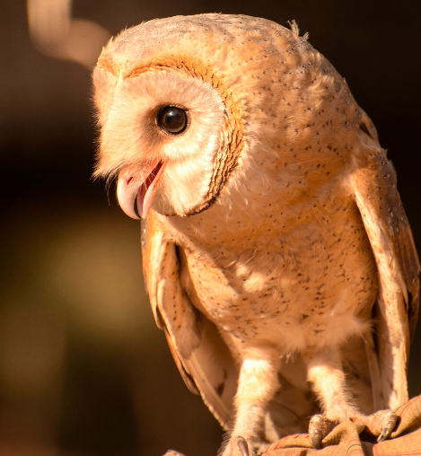 | 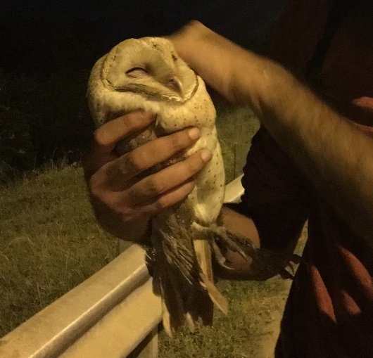 | 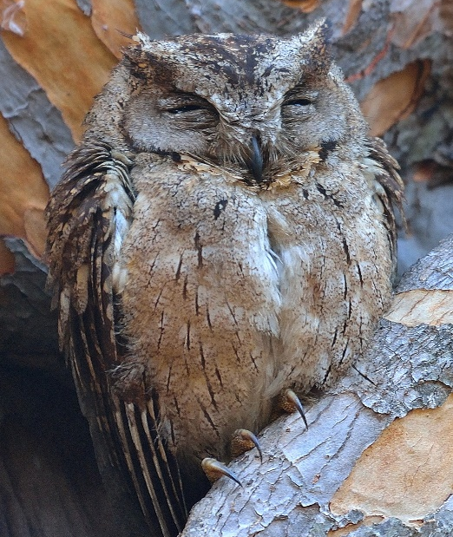
Fig. 1 Common Barn Owl (Tyto alba)  Pic. Credit: Ameet Mandavia | Fig. 2 Eastern Grass Owl (Tyto longimembris)  Pic. Credit: Ameet Mandavia | Fig. 3 Collared Scops Owl (Otus bakkamoena),  Pic. Credit: Ameet Mandavia
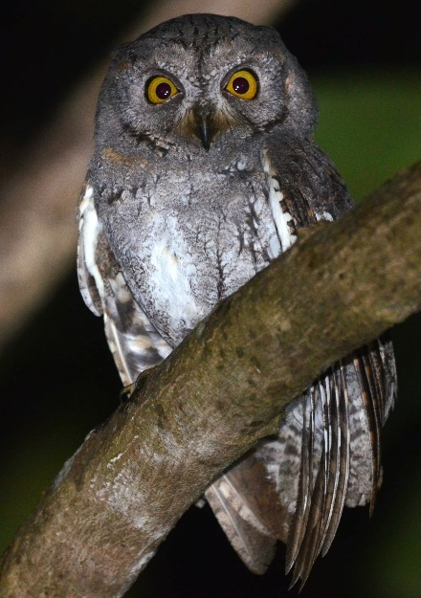 | 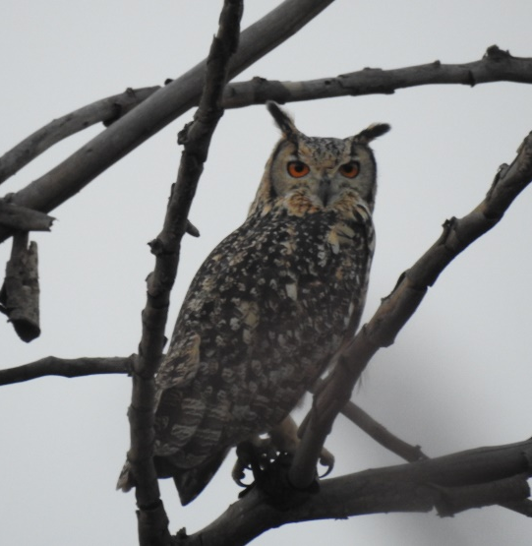 | 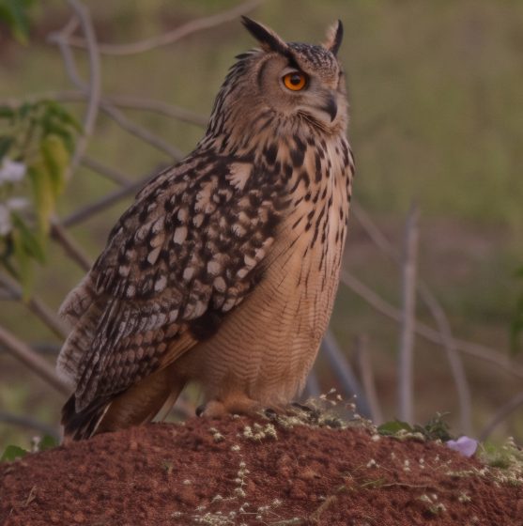
Fig. 4 Oriental Scops Owl (Otus sunia)  Pic. Credit: Ameet Mandavia | Fig. 5 Eurasian Eagle Owl (Bubo bubo)  Pic. Credit: Anurag Vishwakarma | Fig. 6 Indian Eagle Owl (Bubo nipalnensis)  Pic. Credit: Anurag Vishwakarma
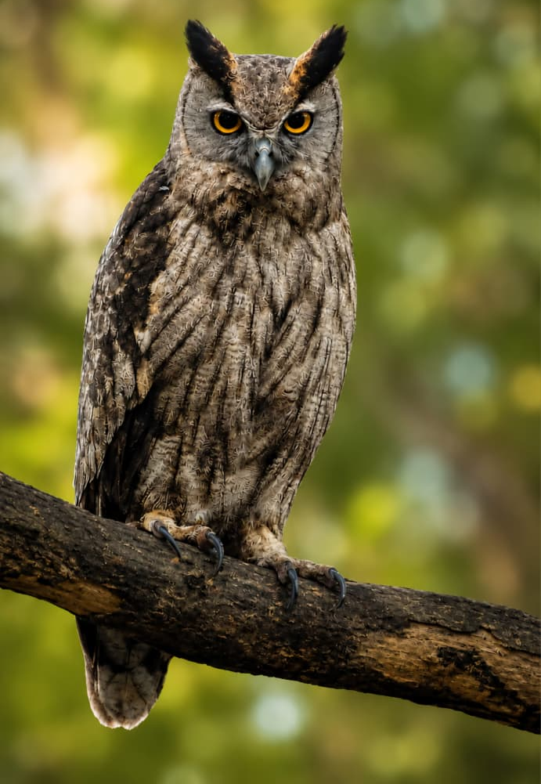 | 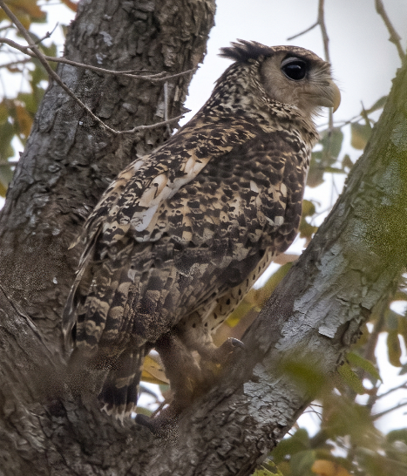 | 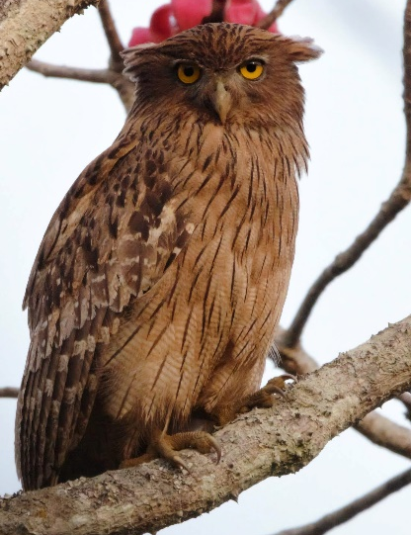
Fig. 7. Dusky Eagle Owl (Bubo Coromandus)  Pic credit: Mohammad Jat | Fig. 8 Spot-bellied Eagle Owl (Bubo Nipalennsis)  Pic. Credit: Ameet Mandavia | Fig. 9 Brown Fish Owl (Ketupa zeylonensis)  Pic. Credit: Ameet Mandavia
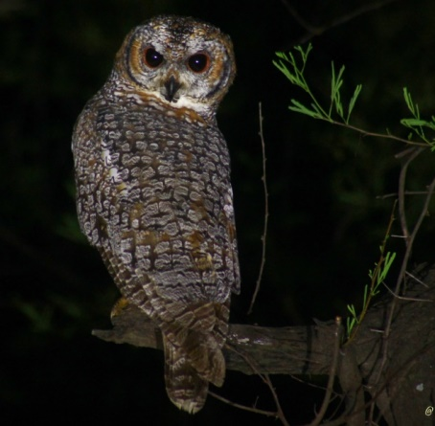 | 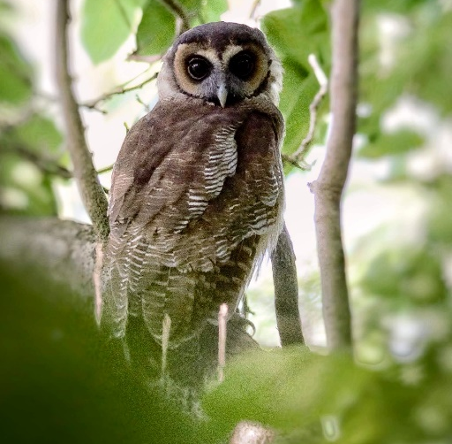 | 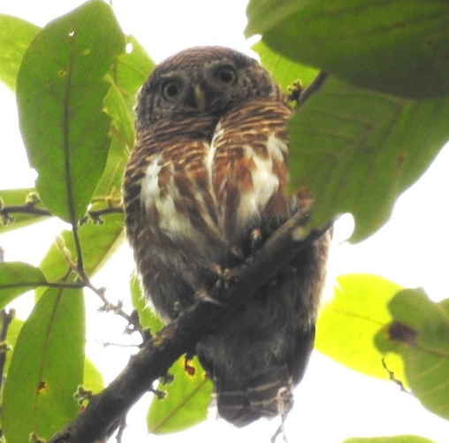
Fig. 10 Mottled Owl (Strix ocellata)  Pic. Credit: Ameet Mandavia | Fig. 11 Brown Wood Owl (Strix ocellata ocellata )  Pic. Credit: Ameet Mandavia | Fig. 12 Asian Barred Owlet (Glaucidium cuculoides)  Pic. Credit: Anurag Vishwakarma
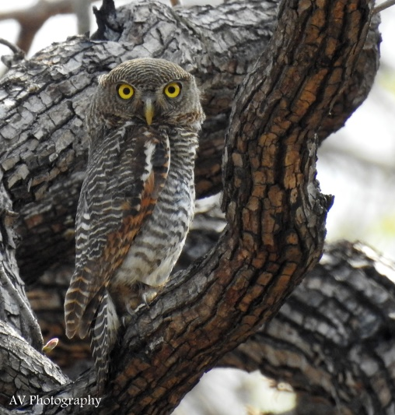 | 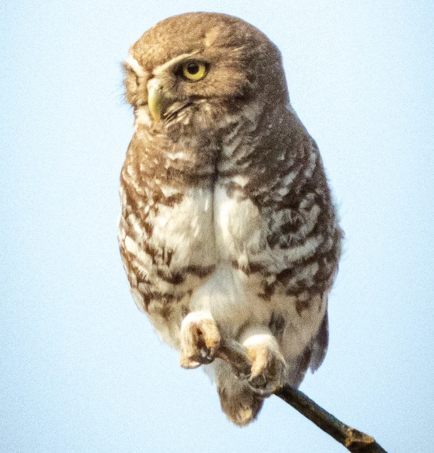 | 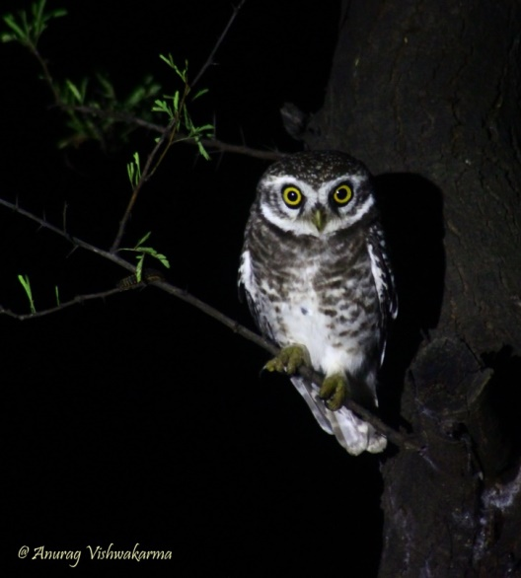
Fig. 13 Jungle Owlet (Glaucidium radiatum)  Pic. Credit: Anurag Vishwakarma | Fig. 14 Forest Owlet (Heteroglaux blewiti)  Pic. Credit: Raju Kasambe | Fig. 15 Spotted Owlet (Athene brama)  Pic. Credit: Anurag Vishwakarma
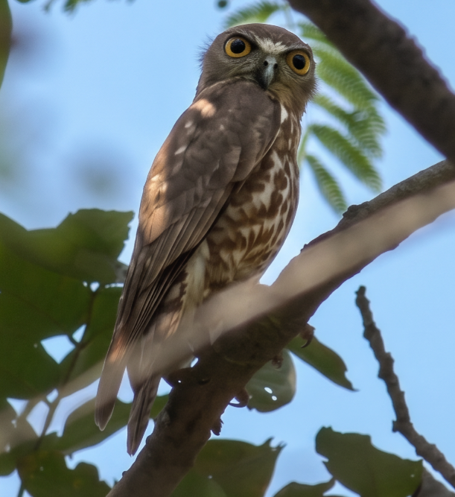 | 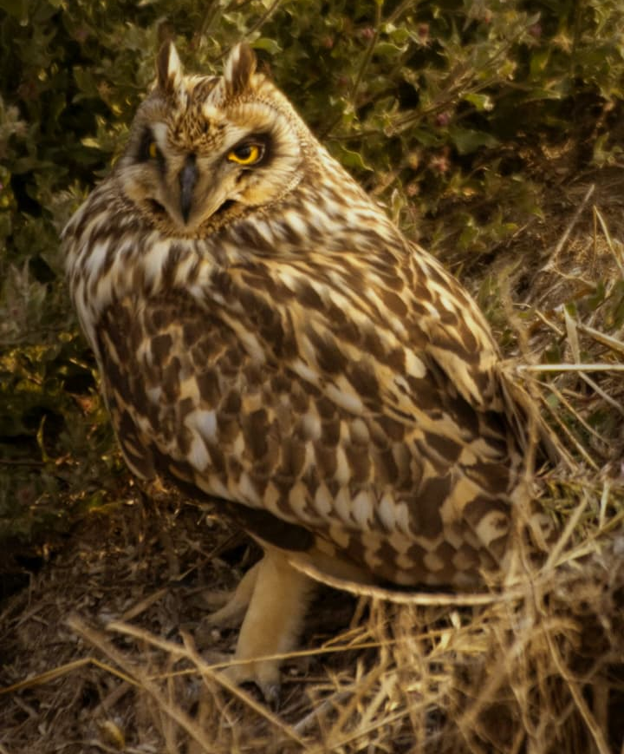
Fig. 16 Brown Hawk Owl (Ninox Scutulata)  Pic. Credit: Ameet Mandavia | Fig. 17 Short-Eared Owl (Asio flammeus)  Pic. Credit: Aviral Jadhav

