Quantifying Curricular Integration in Low-Cost Edge-AI Laboratory Instruction: A Formal Model and a Six-Week Pilot Evaluation in a Nigerian Computer Science Department

ABSTRACT
This study investigates whether a low-cost (sub-US$25) edge-intelligent reference platform can provide a practical, curriculum-aligned approach for integrating Internet of Things (IoT) and machine learning education within a resource-constrained Nigerian computer science department. In addition, the study proposes formal evaluation metrics that enable the degree of curriculum integration and affordability to be measured consistently and compared across higher education institutions. The research adopted a single-cohort pre-test/post-test intervention design complemented by qualitative interviews and a design-oriented analytical modelling framework. The study was conducted in the Department of Computer Science, Faculty of Computing, Delta State University, Abraka, Nigeria, over a six-week laboratory programme during the 2026 spring semester. Thirty third-year undergraduate students participated in the study and were organised into six teams of five members each. The participants completed a six-week laboratory programme centred on HydroSense-EI, an ESP8266-based smart precision-irrigation prototype incorporating an on-device depth-six decision-tree model for edge intelligence. Three models of analysis were developed and employed to evaluate the instructional approach. The first was an entropy based Integration Coupling Index which attempted to quantify how well each lab session integrated ideas from several standard courses in the computer science curriculum. The second was a normalised learning-gain model used to evaluate improvements in students' knowledge and practical competence, while the third was a kit-amortisation model that examined the relationship between bill-of-materials cost, team size, equipment breakage rate, and hardware reuse over successive cohorts under realistic departmental budget constraints. The student learning outcomes were evaluated by a reliable twenty-item instrument used before the laboratory work and right after the six weeks of intervention. Moreover, the prototype operation was estimated using a week-long field testing and student thoughts were assessed through interviews. The laboratory education initiative was applied with an Integration Coupling Index of 0.696, indicating that each instructional session addressed content from roughly 3.07 out of five reference curriculum courses. In contrast, the conventional isolated approach only covers one course, which is reflected by a value of 1.00. When six competency areas were applied, the mean normalized learning gain became 0.711 (SD = 0.057), so students' outcomes are classified in the high learning gain category. During the field evaluation, integrated system of decision-tree classifier achieved median accuracy of 93.3 percent in classification. In the same period, irrigation arrangement decreased usage in water by a factor of approximately 34. This outcome can be considered statistically similar compared to published studies, where 34.7 percent was reported (P equals .82), indicating that application performance stayed preserved and also serving function of educational resource. Also, economic analysis showed per-student laboratory spending was reduced from US$4.44 in initial deployment down to US$1.17 after hardware got reused of five groups of students, which shows affordability and sustainability in longer period with this approach.The evidence indicates that this edge-intelligent platform represents a feasible and financially sustainable solution for embedding IoT and machine learning studies within present laboratory budgets at Nigerian universities. Apart from its teaching function, the new evaluation indices create a clear and repeatable system to measure curriculum integration, effectiveness in learning, as well as cost sustainability; therefore it gives higher education organizations objective data to justify adopting and expanding integrated computing labs.

Keywords: [Computing instruction; edge intelligence; embedded machine learning; Internet of Things instruction; curriculum integration; analytics for learning; cost-effective laboratory systems; engineering teaching; Nigerian tertiary education.)

1. INTRODUCTION

1.1 Background
The hardware budget of a typical Nigerian computer science department has not moved in step with what the discipline now expects its graduates to be able to do. Successive revisions of the National Universities Commission Benchmark Minimum Academic Standards (NUC BMAS) name the Internet of Things, embedded systems and machine learning among the competencies an undergraduate programme must deliver (National Universities Commission, 2023). The teaching platforms that dominate international practice in these areas, however, sit in the US$80–200 band per student team once sensors, actuators and instrumentation are counted. A department serving two hundred final-year students on an annual laboratory equipment allocation of the order of ₦3 million cannot reconcile those two facts.
The result is simple to speak but more difficult for escaping from. Nigerian students of computing get less practical exposure with embedded machine learning than students in other places, and what exposure they actually get is often in pieces. IoT classes teach sensors using Arduino toolchain. Machine learning class is about scikit-learn as well as pandas. Moving the trained model onto microcontroller and making actuator respond to sensor reading is not really practiced with both courses. Student after submitting confusion matrix may not know how the model could turn on relay in plant bed. Businesses take this step as routine. Presently delivered curriculum does not produce this outcome reliably.
Another argument about relevance is not shared enough in the literature. The tasks Nigerian computing graduates will automate, for instance, which plot should irrigate, what transformer station needs monitoring, or which dispensary refrigerator must flagged, will take place on cheap microcontroller devices, working at distance to reliable cloud backend (Nigussie et al., 2020; Abadade et al., 2023). Teaching platform that makes this constraint is not merely compromise because of poverty. Instead, it is a better simulation to real workplace than cloud-based lab kit can be.

1.2 Research Gap
Three strands of recent work bear directly on this problem, and each stops short of what a department actually needs in order to act.
The first strand is the international effort to widen access to embedded machine learning education. TinyML4D network document quite extensive program of open curriculums, translated learning materials and trainer workshops in Global South area, and also identifies multidisciplinary width in embedded machine learning to be main obstacle for both students or teachers (Plancher et al., 2024). That work is deliberately platform-agnostic and delivered largely through electives, workshops and massive open online courses (Reddi et al., 2022). It does not report a laboratory module bound to the specific course codes and credit structure of a national benchmark curriculum, which is the form an intervention must take before a Nigerian department can timetable it.
The second strand concerns the integration claim itself. Interventions of this kind routinely assert that they teach skills “in an integrated way”, but integration is asserted qualitatively and never measured. Two modules claiming integration cannot presently be compared, and a department cannot audit whether a proposed module genuinely couples its courses or merely visits them in sequence. To the best of our knowledge no published metric quantifies the degree of curricular coupling achieved by a laboratory module.
Third strand is regarding affordability. Evidence from Nigeria shows cost for commercial IoT systems as main barrier towards laboratory joining (Olatoye, 2025), and edge intelligence surveys make same claim about region in general (Ray, 2022; Abadade et al., 2023). Most of affordability arguments are based only on sticker price. Sticker price is incorrect value to look at: what limits department is student cost for each cohort after reuse, breakage and with team size factored in. No published model reflects bill of materials into per-student budget limit of department so that leads to adopting decisions.

1.3 Objectives and Contributions
Paper is written to fill the three gaps at same time. Goals are to check if single cheap reference platform can handle complete IoT-plus-machine-learning laboratory module tied in the NUC BMAS, to formalise joining and affordability to make claim able to be audited and not just asserted, plus to share what happened after module was used.
Four contributions are made. First, we bring up Integration Coupling Index, entropy-measure for showing how strong lab module links different benchmark courses, together with number of effective courses to make index more understandable. Second, we build kit-amortisation method and pedagogical cost-efficiency for changing bill of materials into an adopting choice in stated budget. Third, pre-test and post-test, prototyping performances, and interview result from thirty-student pilot are reported, making normalised gains compared with commonly accepted interactive-engagement benchmarks. Fourth, three repeatable adoption obstacles are shown which made our students lose measurable laboratory time and adopting departments can prepare around these in advance.
The remainder of the paper is organised as follows. Section 2 reviews the pedagogical and contextual literature. Section 3 presents the reference platform, the module design, the three formal models and the study instruments. Section 4 reports results. Section 5 discusses them, states the limitations and sets out an adoption pathway. Section 6 concludes.

1.4 Activity-Based Learning and Integration Challenge
Active instruction with projects is shown to be better than lecture-only for situations in which many different skills need to be put together. This is a highly established finding in engineering educational field (Prince, 2004; Felder & Brent, 2005). One big meta-analysis of STEM disciplines places advantage approximately at one half a standard deviation in exam marks, and failure rates go down a lot (Freeman et al., 2014). The reason usually given is that partial understanding is made external: for example, when a wire not working, the difference in student's mental model becomes visible and quicker to fix, while lecture-only puts the diagnostic moment to the exam and at this point gap has become bigger and even harder closing.
But the broad finding does not necessarily inform the instructor about which projects should be assigned. There are three features we consider especially important for the project. Project must involve many skills, so integration is required for the student, else not needed. The integration should not work properly during run time, or diagnostic point gets lost. Thirdly, cost per project must be low enough so every small team uses their own artefact instead of having shared item for whole large class. It is mainly at this third factor that most of otherwise effective designs fail in our context.

1.5 Embedded Machine Learning in Teaching Purpose
Request for embedded machine learning as subject in undergraduate classes has increased due to matured toolchains and benchmarks (Banbury et al., 2021; Ray, 2022; Abadade et al., 2023). Educational argument is convincing: hardware is not expensive and is available worldwide, also these projects are isolated, spanning data gathering, training of model, and deploying it on device which student holds (Reddi et al., 2022). In fact, TinyML4D network is created based on this idea, reaching learners in more than twelve countries through workshops and free courseware, but in some locations matched open-source courseware and diverse hardware is still a constraint happening (Plancher et al., 2024).
There are two big things about this group of work for present paper. Mostly it happens outside main required curriculum, as optional classes, workshops or online learning, and mostly evaluated by how many students it reaches and how much participate than measuring learning against pre-test results. These are rational choices for a network seeking large coverage. But these do not give answer to question that department leader asks, which is if a module can be put in the current timetable and what it gives in output.
According to the 2023…. The 2023 NUC BMAS revamp drives home the point that IoT, embedded systems and machine learning have become important topics for students. (National Universities Commission, 2023). But let's face it; lab funding hasn't seen any increases and that annoying implementation gap keeps rearing its head all over again and again. Looks like Olatoye (2025), after surveying folks at several Nigerian schools, identified shoddy digital infrastructure, unreliable electricity, weak funding, and above all, high commercial IoT system prices as the top challenge for using this stuff in teaching labs. By the way, a regular sensor kit would cost about ₦50 000 at stores, meaning you'd be spending approximately US$32 per group using the exchange rate of ₦1 550 for one dollar from this paper which does not actually enclose added devices. In terms of the research on rural and smallholder technology in sub-Saharan Africa, it indicates the significant matter of price and poor connectivity (Nigussie et al., 2020; Balana & Oyeyemi, 2022).
Table 1 puts this study up against the five big issues any Nigerian department faces before bringing in a module. Surprisingly, earlier research pretty much concludes that low-cost embedded ML education is doable and worthwhile, but it leaves the tough call on curriculum fit, integration measurement, and cost math up to whoever's adopting it.
Table 1. Positioning of the present study against representative prior work on embedded machine learning education and low-cost IoT deployment. Entries record whether the cited work reports the attribute in question. Abbreviations: BMAS, Benchmark Minimum Academic Standards; ML, machine learning.
Attribute | TinyML4D network (Plancher et al., 2024) | TinyML MOOC (Reddi et al., 2022) | TinyML surveys (Ray, 2022; Abadade et al., 2023) | Regional IoT deployment studies (Nigussie et al., 2020; Olatoye, 2025) | Present study
Bound to a national benchmark curriculum | No | No | No | No | Yes (NUC BMAS, five courses)
Integration across courses quantified | No | No | No | No | Yes (Integration Coupling Index)
Affordability modelled beyond sticker price | No | No | No | Partlyª | Yes (amortisation model)
Pre-test/post-test learning measurement | No | No | No | No | Yes (six domains, N = 27)
Assessed field deployment by students | No | No | No | No | Yes (seven days, six teams)
Per-team bill of materials reported | Partly^{b} | Partly^{b} | No | Yes | Yes (US$22.20)
ª Cost is identified as the binding constraint but is not related to a per-student budget through a formal model. ^{b} Indicative hardware costs are given for recommended boards, not a complete per-team bill of materials including actuation.

2. methodology

2.1 The Reference Platform
The module is constructed around HydroSense-EI, which is a precision irrigation prototype developed by our group for smallholder use and discussed in detail in other publications (Omede et al. 2026 a, 2026 b). Only the pedagogically relevant features of the application domain are discussed in this article. Since this field is well established, dealing with machine-learning based irrigation control (Goap et al. 2018; Benyezza et al. 2023) and agricultural sensing at the level of the entire platform (Vasisht et al. 2017; Liakos et al. 2018), it is relevant pedagogically because virtually all of our students relate it to family farming before being taught any engineering.
The ESP8266 NodeMCU microcontroller integrates 4 sensors such as capacitive soil moisture probe, HC-SR04 ultrasonic ranging module which measures tank water level, DHT11 temperature and humidity sensor and YF-S201 Hall effect flow sensor. The relays modules activate the 12V water refill pump and the 5V sprayer pump. A dashboard served from the microcontroller's program memory streams live telemetry over a WebSocket connection to any device on the local wireless network. Decision logic is a depth-six classification and regression tree (Breiman et al., 1984; Quinlan, 1986) trained offline using scikit-learn (Pedregosa et al., 2011) on 2,400 labelled environmental observations and converted to a string of compiles rules that take up around 1.5 kB of memory; inference is completed in less than 4 ms on the ESP8266 (Omede et al., 2026a).
A platform originally created for other purposes earns its spot in this chapter due to the fact that it demonstrates, in one particular instance, the five component skills that will be used in this module: sensor wiring, sensor calibration and data handling, model training, embedded inference, and user interface development

2.2 Structure of Modules
The module is made of six weeks for teaching. Each week students get a single lab lesson for an three hours with somebody guiding and for three to five hours they do study by themselves.Figure 1 makes clear how module and the related courses are planned. Table 2 indicates passing standards in every week.
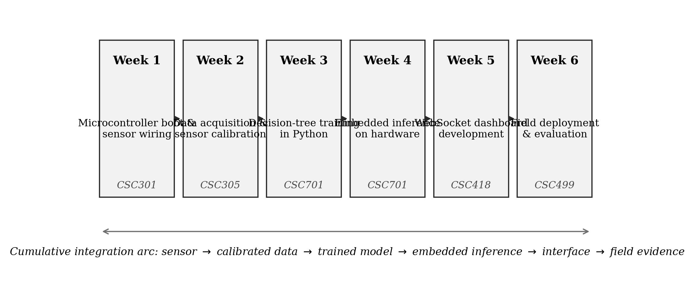
Fig. 1. Six-week laboratory module structure, showing the dominant National Universities Commission Benchmark Minimum Academic Standards course association of each week and the cumulative integration arc.
Table 2. Week-by-week objectives, activities and success criteria for the six-week laboratory module. Course codes follow the NUC BMAS for Computer Science.
Week | Focus (dominant course) | Principal activity | Success criterion
1 | Microcontroller boot and sensor wiring (CSC301) | Install toolchain; wire and read all four sensors individually | Serial output of all four sensor values at 1 Hz
2 | Data acquisition and calibration (CSC305) | Collect ~200 raw readings per sensor under controlled conditions; fit linear calibration constants | Each sensor within 5% of ground truth across its operating range
3 | Decision-tree training (CSC701) | Assemble training set; train depth-six CART; evaluate on held-out split | ≥85% test-set accuracy with reported confusion matrix
4 | Embedded inference (CSC701) | Export tree as compiled conditionals; flash; benchmark latency | Inference <5 ms and ≥80% agreement with the Python reference
5 | Dashboard development (CSC418) | Extend supplied WebSocket dashboard with an original visualisation | Live dashboard reachable from a second device on the network
6 | Field deployment and evaluation (CSC499) | There was a week-long plant-bed rollout, tracking both water use and report accuracy compared to plain old manual control | s. The deployment report landed in full, with a side of diagnostic
deep dive. Students' got their hands on three handy scaffolds: sensor sticks already dialed in to reference points, a stripped-down firmware starter that hit all four sensors at every second, and a no-nonsense dashboard skeleton. All of this got handed out so that lab time will be about putting things together, instead of wasting armple of time with random components selection.
The module assumes completion of CSC202 (Programming I), familiarity with the Arduino integrated development environment, and introductory HTML and JavaScript. Students who had not yet taken CSC701 received a one-hour pre-reading on decision-tree induction, which proved sufficient.
Assessment consisted of three components with different weights: the field-deployment report counted for 50%, the prototype demonstration evaluated on five criteria made up 30%, and an individual contribution log accounted for 20%. The inclusion of the contribution log aimed to make each student's effort visible, so it could respond to the free-rider issue that is present in team-based assessment.

2.3 Model I: Quantifying Curricular Integration
We formalise the integration claim as follows. Let there be $C$ benchmark courses and $W$ laboratory weeks, and let
$$A=\left[a_{cw}\right]∈\{0,1,2,3\}^{C×W}, c=1,…,C; w=1,…,W$$
be the alignment matrix, where $a_{cw}$ records the instructional weight week $w$ places on course $c$ on an ordinal scale (0 = none, 1 = low, 2 = medium, 3 = high) assigned by the module designer against the published course descriptors. Write $a_{max}=3$ and define the coverage of course $c$ as
$$κ_{c}=\frac{1}{a_{max}W}\sum_{w=1}^{W}{a_{cw}}∈\left[0,1\right]$$
which reports the fraction of the module’s total possible attention that course $c$ receives.
Integration is a property of weeks, not of courses. Let mw=c​acw be the alignment mass of week $w$ and define the within-week share
$$p_{cw}=\frac{a_{cw}}{m_{w}}, \sum_{c=1}^{C}{p_{cw}}=1$$
A week that draws on a single course concentrates all its share on one row; a week that draws evenly on every course spreads it. This is precisely the situation Shannon entropy was constructed to measure (Shannon, 1948), so we take the normalised entropy of the share vector,
$$H_{w}=-\frac{1}{lnC}\sum_{c=1}^{C}{p_{cw}}lnp_{cw}∈\left[0,1\right]$$
with the convention $0ln0=0$. Entropy in nats is not directly interpretable to a curriculum committee, so we convert it to an effective number of courses using the first-order Hill number (Jost, 2006),
$$N_{w}=exp​\left(H_{w}lnC\right)∈\left[1,C\right]$$
which answers the question “how many courses is this week effectively drawing on?” A week resting wholly on one course returns $N_{w}=1$; a week drawing equally on all five returns $N_{w}=5$.
Aggregating over the module, and weighting each week by its alignment mass so that heavier weeks count for more, gives the Integration Coupling Index
$$Φ=\frac{\sum_{w=1}^{W}{m_{w}}H_{w}}{\sum_{w=1}^{W}{m_{w}}}∈\left[0,1\right], N_{\text{eff}}=exp​\left(ΦlnC\right)$$
$Φ$ has a clean interpretation at both ends. A conventional siloed module, in which each week belongs to exactly one course, gives $Φ=0$ and $N_{\text{eff}}=1$ by construction; a module in which every week draws equally on every course gives $Φ=1$. The index is invariant to the number of weeks and to uniform rescaling of the alignment weights, so modules of different length can be compared directly.

2.4 Model II: Learning Gain Under Bounded Dispersion
Raw score differences reward domains with low baselines. Using standard practice in interactive-engagement research (Hake, 1998), we report the normalised gain for domain $d$,
$$g_{d}=\frac{μ_{d}^{\text{post}}-μ_{d}^{\text{pre}}}{100-μ_{d}^{\text{pre}}}$$
which expresses improvement as a fraction of the improvement that was available, and its mean over the $D$ assessed domains,
$$\overset{⃐}{g}=\frac{1}{D}\sum_{d=1}^{D}{g_{d}}$$
Conventionally $\overset{⃐}{g}>.7$ denotes high gain, $.3≤\overset{⃐}{g}≤.7$ medium gain, and $\overset{⃐}{g}<.3$ low gain.
Paired testing usually needs to consider spread of difference scores. If you only have means, there is still a conservative limit that can be used. For an instrument which has its score$\left[s only between 0 and 100\right]$, difference scores $\left[take values in between minus 100 and 100\right]$ and their sample standard deviation should not be more than 100. So, the statis
$$\frac{\sqrt{}}{tic for paired testing, t=Δn/s, has an possible lower bound }$$
t≥Δn100
which results in situation, that if you do Δn divided by 100 and get an something higher than critical value, the significance is confirmed and there is no need to know value of s.This upper restriction makes the smallest possible effect size standardised, dz, equal to Δ divided by s but it cannot go below Δ over 100.

2.5 Model III: Affordability and Amortisation
Suppose B is the meaning bill of materials for each team, s tells size of teams and ρ means the rate of parts lost because of breakage plus those replaced on each delivery. Meanwhile, L basically is for how many times in series different groups use that kit in the department. So, price per student in single group, when amortisation is included, looks like
CL=B1+ρ L−1sL
whwhich results in situation, that if you do Δn divided by 100 and get an something higher than critical value, the significance is confirmed and there is no need to know value of s.This upper restriction makes the smallest possible effect size standardised, $d_{z}, equal to Δ divided by s but it cannot go below Δ over 100$.

2.5 Model III: Affordability and Amortisation
Suppose B is the meaning bill of materials for each team, s tells size of teams and ρ means the rate of parts lost because of breakage plus those replaced on each delivery. Meanwhile, L basically is for how many times in series different groups use that kit in the department. So, price per student in single group, when amortisation is included, looks like
$$C\left(L\right)=\frac{B\left[1+ρ \left(L-1\right)\right]}{sL}$$
ich basically falls off in hyperbolic way and approaches a minimum level for expendables,
$$\lim_{L→∞}C\left(L\right)=\frac{Bρ}{s }$$
This adoption is acceptable only if $C\left(L\right)$ is inside allocated budget, $β$, per student per group in department, so the decision depends on what is shortest possible reuse period,
$$L^{*}=min\left\{L∈N:C\left(L\right)≤β \right\}$$
Having only cost is not complete measure; an cheap kit serving one course is not as good as an expensive kit that can serve four courses. Bringing together Equations (6) and (10), we get a measure of cost efficiency for teaching,
$$η\left(L\right)=\frac{N_{\text{eff}}}{C\left(L \right)}$$
so the unit is effective courses per US dollar per student per group and this is actually what laboratory committee should try to maximise.

2.6 Participants, Instruments and Analysis
The pilot happened during the spring semester of 2026 at Delta State University, Department of Computer Science in Abraka. Thirty undergraduate students in their third year registered for CSC301; they were overseen by the first author, working in six teams which students picked themselves, five per group but teacher balanced for earlier programming skills. Every team received two ESP8266 circuit boards, an set of sensors and pumps which they kept with them between sessions. Out of six groups, three reported getting some parts lost or broken which lab replaced using its budget for single units.
Their learning progress was checked by a test made of twenty items across six areas, given on first day of Week 1 and then again on last day of Week 6. Of thirty students, twenty-seven did both tests while three students stopped attending before Week 4 and are not included in paired test results. How prototype worked was checked over seven days at DELSU teaching farm, where each team measured classifier accuracy against hand-labelled data, as well as water use versus a nearby plot without automation.Each student that finished completed a fifteen-minute organised interview at the end of Week 6, where first author coded recurring themes
Analysis used Python version 3.11 and packages from SciPy (Virtanen et al., 2020). Connections between team variables were looked at with Pearson correlation and ordinary least-squares regression and a one-sample t test was used to check agreement with published benchmarks. With only six teams, correlation values are reported with the carefulness their precision deserves.A significance level was kept at P = .05 and exact numbers are shown all throughout.

2.7 Ethical Considerations
The study was reviewed and approved by the Faculty of Computing Research Ethics Committee, Delta State University ⟦insert approval reference number⟧. Participation in the assessment and interview components was voluntary, written informed consent was obtained from every participant, and instruments were anonymised before analysis. No participant’s module mark depended on consenting to the research.
3. Results and Discussion

3.1 Curricular Integration Reached Through Module
The matrix for an alignment was built by connecting weekly activities to official descriptors for all five NUC BMAS courses. You can see this matrix in Figure 2.
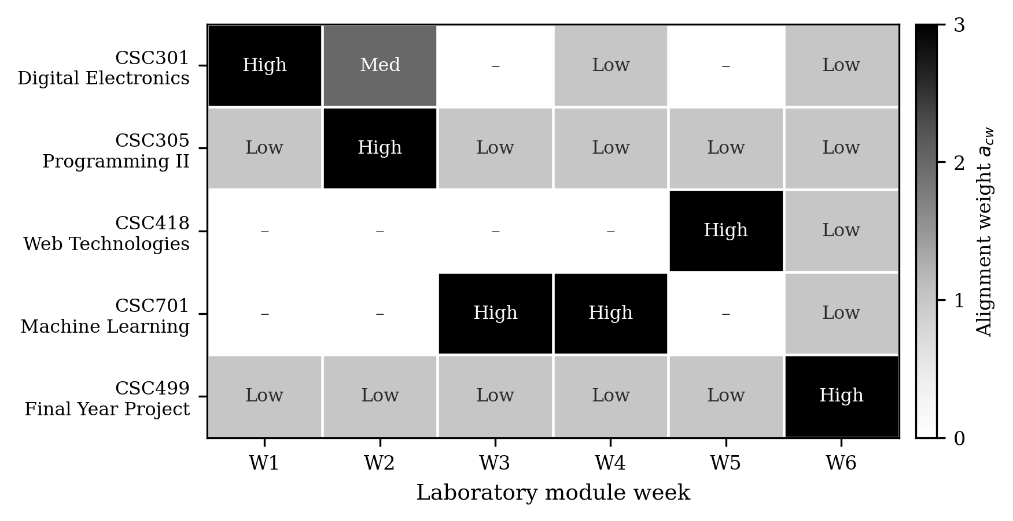
Figure 2. This is alignment matrix $A$ that puts together six weeks of labs with five Benchmark Minimum Academic Standards courses from National Universities Commission.The cell colors show alignment weight $a_{cw}$ which gets defined in Equation (1).
The range of course coverage based on Equation (2) is not the same which is how it should be; for example, CSC305 and CSC499 reach κ as $.444$, CSC701 plus CSC301 are both at $κ=.389$ and finally CSC418 ends with κ=.222 because web technologies are in module for short, late period. More useful is week coupling measured by Equations (4) with (5), visible in Figure 3.
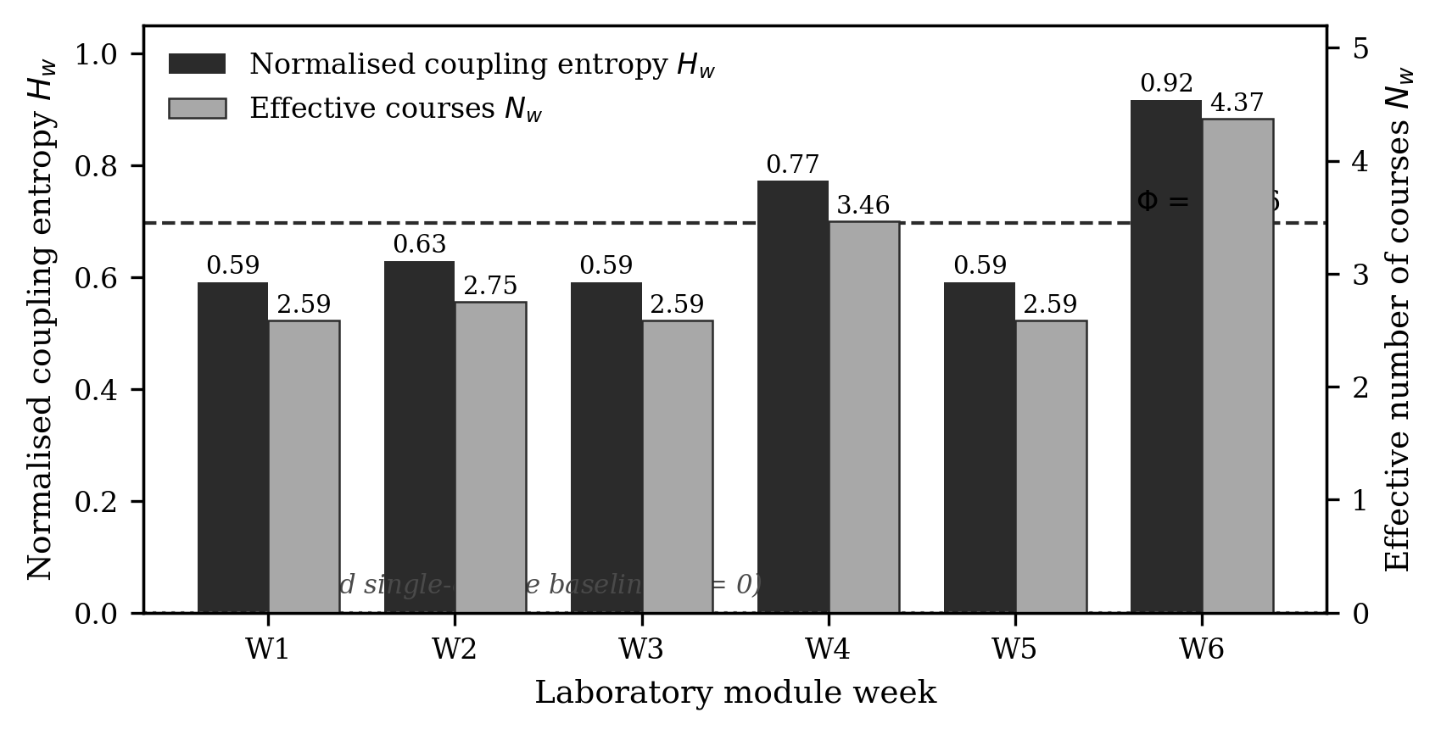
Fig. 3. Normalised coupling entropy $H_{w}$ (left axis, dark bars) and effective number of courses $N_{w}$ (right axis, light bars) for each laboratory week. The dashed line marks the Integration Coupling Index $Φ$ = .696; the dotted line at zero marks the siloed single-course baseline.
Every week returns $H_{w}>.59$ and $N_{w}>2.5$, meaning that no week can be completed by drawing on the content of a single course. The most strongly coupled week is Week 6 ($H_{6}$ = .917, $N_{6}$ = 4.37), which is expected: the field deployment requires students to hold sensor physics, data handling, model behaviour and interface reliability in view simultaneously while the system runs unattended for seven days. Week 4 follows ($H_{4}$ = .772, $N_{4}$ = 3.46), and this too is unsurprising, since the export of a trained tree onto the microcontroller is the point at which the machine learning and embedded programming strands must actually meet.
By using Equation (6), you get that Integration Coupling Index is $Φ$ = .696. That equals an $N_{\text{eff}}$ = 3.07 effective courses every week compared to just 1.00 in usual isolated module.This module provides about three times as much curricular coupling like single-course laboratory teaching, while not needing extra weeks to do this. Importantly, this is a property of design phase which someone can work out before teaching; so in practice, department has ability to check integration claim when planning instead of waiting for semester to finish to find out that the weeks did not connect.

3.2 Learning Outcomes
Twenty-seven students filled the assessment instrument both times. Table 3 is showing the means on domain-level and the normalised gains that are described in an Equation (7). Figure 4 is giving a graphical comparison as well.
Table 3. Pre-test and post-test performance and normalised learning gain across six assessment domains ($N$ = 27). Values are mean percentage of items answered correctly. Normalised gain $g_{d}$ is computed from Equation (7).
Assessment domain | Pre-test (%) | Post-test (%) | Absolute gain (points) | Normalised gain $g_{d}$
ESP8266 fundamentals | 22 | 78 | 56 | .718
Sensor calibration | 17 | 71 | 54 | .651
Decision-tree concepts | 31 | 84 | 53 | .768
WebSocket fundamentals | 12 | 68 | 56 | .636
Embedded model flashing | 18 | 81 | 63 | .768
IoT system design | 24 | 79 | 55 | .724
Mean | 20.7 | 76.8 | 56.2 | .711
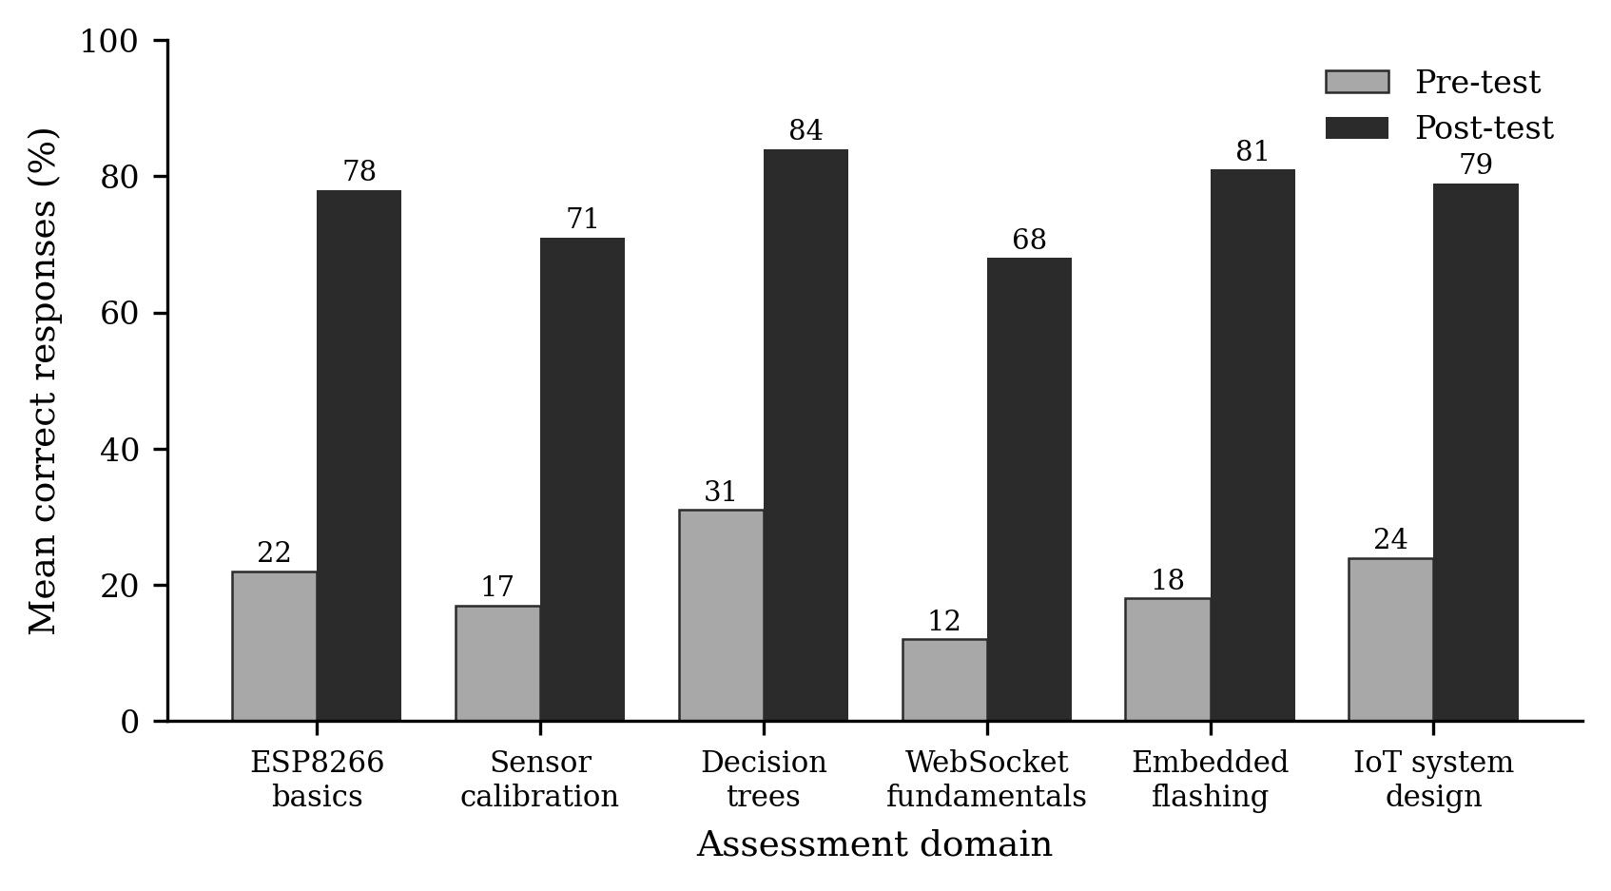
Fig. 4. Mean pre-test and post-test performance across six assessment domains ($N$ = 27).
Post-test performance exceeded pre-test performance in every domain, by between 53 and 63 percentage points. The domain means give an aggregate improvement of $Δ$ = 56.2 points. Applying the bound of Equation (9) with $n$ = 27, the paired statistic satisfies $t≥2.92$ for any dispersion admissible on a bounded instrument, against a critical value of $t_{.975,26}$ = 2.06; the improvement is therefore significant at P < .01 (worst case P = .007) irrespective of the unreported standard deviation, with a floor on the standardised effect size of $d_{z}≥$ .56. ⟦Authors: insert the exact $s$, $t\left(26\right)$, P and $d_{z}$ computed from the raw score sheets in place of the bound.⟧
Normalised gains are shown against the conventional interpretive bands in Figure 5.
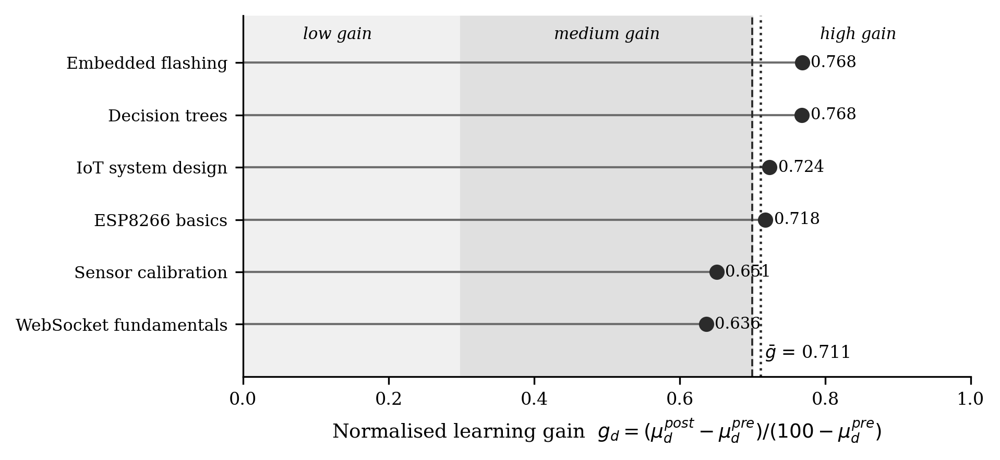
Fig. 5. Normalised learning gain $g_{d}$ by assessment domain, plotted against the conventional low, medium and high-gain bands. The dotted vertical line marks the module mean $\overset{⃐}{g}$ = .711.
The mean normalised gain is $\overset{⃐}{g}$ = .711 (SD = .057, range .636–.768), which falls just inside the high-gain band and above the ceiling typically reported for lecture-dominated delivery. The narrowness of the range is arguably the more interesting result. Absolute gains varied by ten percentage points across domains, but once the available headroom is accounted for the six domains are nearly indistinguishable, which is what one would expect if a single integrated intervention rather than six separate ones were driving the improvement.
We tested whether normalised gain was systematically related to the baseline, which would indicate that the measure had failed to remove the ceiling artefact. The association is positive but not statistically significant ($r$ = .73, P = .10); with six domains this test has very little power, and we treat the result as reassuring rather than conclusive.
This subsection overall needs to be read with two caution.It is because setup of study did not use control group, so there may be influences from things like regular classes together with learning in groups and that possibility hasn't been left out. Also, the post-test had questions that are very close to module topics, so the increase that was measured may basically show learning only on this material and not flexible skill.

3.3 Performance of Prototype in Actual Deployment
Every team, so six of them, made a prototype that worked and also participated fully for an seven days in the activity. In Table 4 you find each team's results and Figure 6 puts the numbers in relation to each other visually.
Table 4. Each of teams' results from one week of field use at the DELSU teaching farm. How much water was saved checked by comparing to neighbor garden bed not using automation.
Team | Classifier accuracy (%) | Water saved (%) | Demonstration mark (%)
T1 | 92.5 | 34.0 | ⟦insert⟧
T2 | 96.8 | 42.0 | ⟦insert⟧
T3 | 88.2 | 22.0 | ⟦insert⟧
T4 | 94.1 | 36.0 | ⟦insert⟧
T5 | 89.6 | 30.0 | ⟦insert⟧
T6 | 95.4 | 40.0 | ⟦insert⟧
Mean | 92.8 | 34.0 | —
Median | 93.3 | 35.0 | —
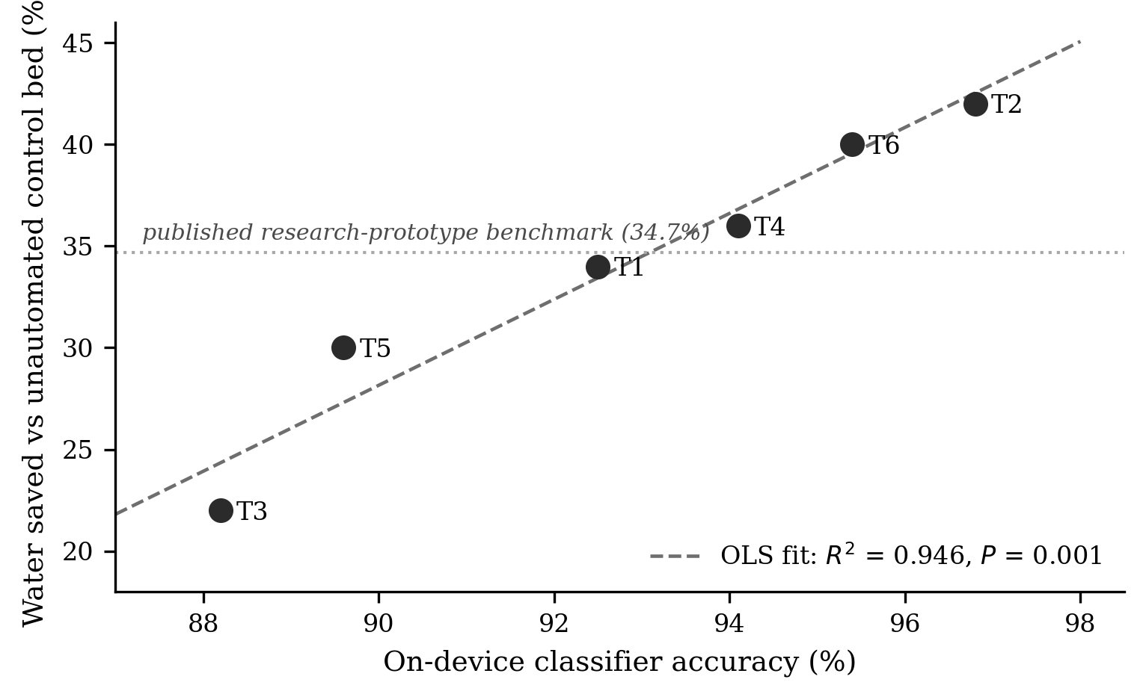
Fig. 6. Relationship between on-device classifier accuracy and water saved against the unautomated control bed for the six student teams. The dotted horizontal line marks the 34.7% water saving reported for the research prototype in the companion study.
Five from six teams had classifier accuracy higher than 89 percent and one team got up to an 88.2 percent. As a result all teams crossed the 85 percent level which was required in the Week 3 criteria. Average water saving was a 34.0 percent and midway value was 35.0 percent. When doing one-sample testing on 34.7 percent data from research-grade prototype, there was no real difference detected(t(5) = −0.24, P = .82). This is finding which is thought by us the most serious for later use. Teams of undergraduates, using a skeleton with the support, managed to reach water-saving quality of more professional research version in six weeks.
Classifer accuracy and water saving go together very much (r equals .97, 95 percent CI [.76, 1.00], P = .001; $R^{2}$ = .95) with the regression slope of 2.11 meaning if classifier accuracy went up by one, two more percentage points of the water were saved. Trend is logical, because if there is misclassification it will water too much or not skip watering. But amount should be used with caution only six teams is a small group and these two things both put the teams in same order, which probably would not happen with bigger sample.
Team T3, the weakest performer on both measures, traced its deficit to soil-sensor calibration drift caused by an unwaterproofed connection point exposed to morning dew — a diagnosis the team reached itself and documented, which is the behaviour the assessment was designed to reward.

3.4 Affordability and Amortisation
Table 5 shows per-team materials price and amortised per-student expenditure using an Equation (10). This is calculated when s is 5 and ρ equals 0.08, which was taken from seeing three parts were replaced out of six teams in pilot and uses the exchange rate described in Section 2.3.
Table 5. The list of materials cost for each team and divided-up cost each student pays for teaching kit. Prices are listed in a dollars from Nigerian electronics import pricing for early 2026. Amortisation is following Equation (10) using $s$ = 5 and $ρ$ = 0.08.
Component | Unit cost (US$) |  | Reuse horizon $L$ (cohorts) | $C\left(L\right)$ per student (US$) | $η\left(L\right)$ (courses/US$)
ESP8266 NodeMCU | 3.50 |  | 1 | 4.44 | 0.69
Capacitive soil-moisture probe | 2.20 |  | 2 | 2.40 | 1.28
HC-SR04 ultrasonic module | 1.80 |  | 3 | 1.72 | 1.79
DHT11 temperature/humidity sensor | 0.90 |  | 4 | 1.38 | 2.23
YF-S201 flow sensor | 4.50 |  | 5 | 1.17 | 2.62
Relay modules (×2) | 2.00 |  | 10 | 0.76 | 4.02
Pumps and tubing | 4.80 |  | $$∞$$ | 0.36ª | 8.63
Jumpers, resistors, breadboard | 2.50
Total per team ($B$) | 22.20
ª Consumables floor $Bρ/s$ from Equation (11).
The behaviour of the model is shown in Figure 7. Cost per student falls from US$4.44 in the first cohort to US$1.17 by the fifth and approaches a consumables floor of US$0.36. Applying Equation (12), a department operating a per-student allocation of $β$ = US$2.00 reaches feasibility at $L^{*}$ = 3 cohorts, and one operating at $β$ = US$1.00 at $L^{*}$ = 7. For departments where even the initial outlay is difficult, a reduced-scope variant that replaces the measured-volume flow sensor with timed pump duration brings $B$ to US$17.70 without removing any link in the integration arc.
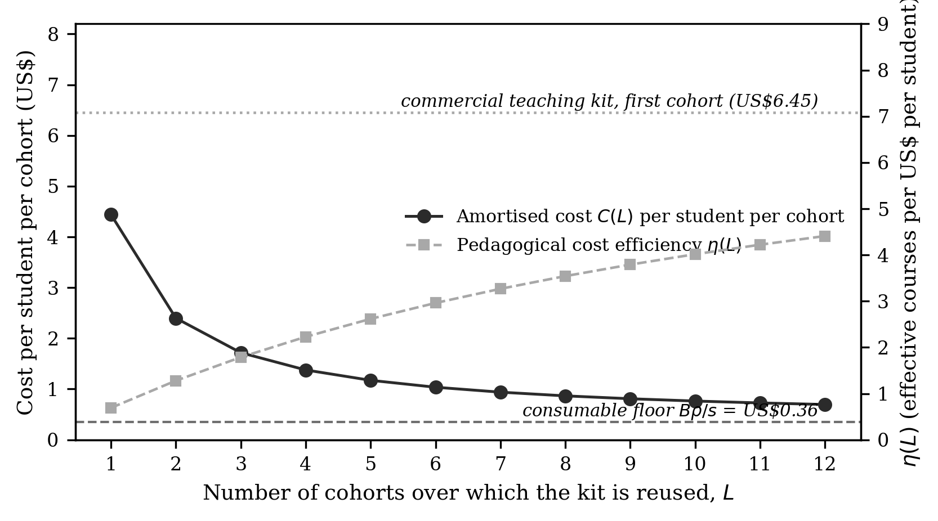
Fig. 7. Displayed here is amortised cost per student for each cohort $C\left(L\right)$ (shown on left axis), along with the pedagogical cost efficiency $η\left(L\right)$ (found on right axis), both as these change depending on reuse horizon $L$. Reference marks point to the level for the consumables from Equation (11) plus the first-cohort cost for a commercial teaching kit per student.
Making comparison clearer is the efficiency measure coming from Equation (13). According to its documentation, an commercial sensor teaching kit at ₦50 000 makes a per-student cost for first cohort to be about US$6.45, and it is normally used for one or sometimes two courses making efficiency η almost 0.23.The module discussed in this report gives $η$ = 0.69 at first, reaching $η$ = 2.62 when reaching five uses. The gap is less about price but mainly due how many courses are covered by each dollar spent.

3.5 Student Experience
Structured interviews with the twenty-seven completing students produced the theme frequencies shown in Figure 8.
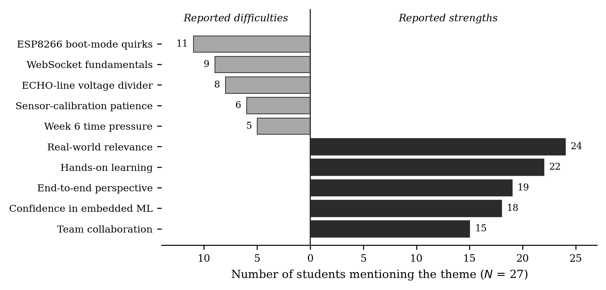
Fig. 8. Frequency of recurring themes in post-module structured interviews ($N$ = 27), separated into reported strengths and reported difficulties.
Real-world relevance came out as strength with the most mentions by students (24 times), and then there was a hands-on learning (22) and end-to-end perspective (19). Students repeatedly made comparisons with other modules, and for a large number, it seemed like those modules came apart between subjects without any link. Eighteen participants said openly the integration boosted their confidence so they could start working by themselves on an embedded machine learning projects.
On topic of challenges, ESP8266 boot mode was called the hardest (11 persons), the WebSocket lifecycle was next (9 people), and the odd situation with the ultrasonic echo-line voltage divider (mentioned by someone 8 times). Six times patience regarding sensor calibrating appeared and five times the Week 6 rush was brought up to finish up this list about difficulties. The main three problems that were found can be solved if a better design is used, which we will thoroughly address later in Section 3.6

3.6 Interpretation
Three key results create our main point. This module leads to measurable coupling of curriculum (Φ value is .696, $N_{\text{eff}}$ counted as 3.07); so idea that parts are really connected is not just a claim. It also gives the normalised gains in upper gain band ($\overset{⃐}{g}$ value is .711), and this is steady for six real different areas. The artefacts of students created worked so similarly to research prototype on the key agronomy outcome (P = .82) that there was no big difference.Put together, these ideas make case that one platform that costs less than $25 could support an integrated Internet of Things with an embedded machine learning lab in department that has Nigerian level budget limits.
Affordability is important here as it differs from what many usually assume. Buying a market product is not a lot more per device.However, every curriculum course becomes much less efficient. This is because the product just teaches sensing and does not integrate things like sensing, deployment, interface and learning together. Just using price for the option comparison leads departments to focus on wrong aspects. Equation (13) can help with providing an fast solution for this mistake.
It is important not to say too much about results for learning. One group without control does not show module is what actually caused the improvements it only means the improvements were at the same time with using the module. The gains can be stabilized and seem very big so it is unlikely they were an accident, but this still just supports the theory in a possible way and is not truly proving anything.

3.7 Features in Design That Should Remain and Challenges Possible
Three supports gave a good outcomes, so we think all the new departments should retain them. The sensor sticks with calibration already finished prevented about two weeks of hard debugging time caused by hardware inconsistency which was not covered by the main course content. The primary firmware example—which used four sensors and sent an JSON frame—helped students continue their work instead of starting over. The dashboard example was effective for interface but every group still needed to make a display on their own.
Three real difficulties used up actual lab time and these should be expected and planned for.
The first is the ESP8266 boot-mode requirement. The chip will not enter normal flash mode if D8 (GPIO15) is held high at boot (Espressif Systems, 2022). Four of the six teams initially wired the 12 V relay directly to D8 without the recommended pull-down, and their boards either failed to flash or rebooted into a hung state; several teams lost a full afternoon before the cause was identified. A half-day pre-laboratory on ESP8266 boot modes, scheduled before Week 4, resolves this.
The next one is called echo-line voltage divider. Since HC-SR04 makes an echo at 5 V but the ESP8266 GPIO just tolerates up to 3.3 V you must use a 1 kΩ and 2 kΩ resistors in a divider format. Some groups did not use it and broke the boards which led to replacing. Telling about the divider in a writing does not work;the wiring diagram should show it.
The third is WebSocket fundamentals. Students who had completed CSC418 knew of WebSockets but were unfamiliar with the connection lifecycle and could not debug connection failures. A half-day add-on before Week 5 addresses this, and we would schedule it even where the curriculum nominally covers the topic.

3.8 Adoption Pathway
Table 6 displays route we will use to shift from a pilot at an one site to many institutions involved. There are three types of resources needed. For hardware this uses what is listed in the Table 5 for each team, and also uses the regular CSC301 wet bench that is already used by Nigerian computing schools. Software is at no cost from start to finish.For human resource, that is main restriction; the module requires that the person teaches must have skills in microcontroller programming and Python machine learning and if someone is not skilled in both, it is possible for two people to teach the module as long as one does transfer in Week 3 to Week 4, because this part is where merging parts happens.
Table 6. Three-year adoption plan for the lab module at Nigerian computer science departments.
Stage | Activity | Period | Principal deliverable
1 | Single-site pilot and evaluation, Delta State University | 2026 Q1–Q2 | The present study
2 | Public release of open-source kit, firmware and courseware | 2026 Q4 | Versioned open repository
3 | Instructor workshop, University of Lagos | 2026 Q4 | Trained delivery team
4 | Instructor workshop, Ahmadu Bello University, Zaria | 2027 Q1 | Trained delivery team
5 | Multi-site delivery and comparative evaluation | 2027–2028 | Multi-institution outcome study

4.0 Conclusion
A six-week course in lab that used an cheap edge-intelligent exact-irrigation system resulted in regular and visible improvement of skills in thirty computer science students in Delta State University, Abraka. Each of the team's material costs was US$22.20, and when reused for the fifth group,cost per student drop under an US$1.20. The module attained an Integration Coupling Index of .696, equivalent to 3.07 effective courses per laboratory week against 1.00 for conventional single-course instruction, and the prototypes students built matched the water-saving performance of the research-grade build.
Outside initial pilot, the article offers two tools which other departments that want to use them can use beforehand to help with making choices. The Integration Coupling Index makes it possible to check and measure integration claims while designing which helps compare between various universities. The model for an amortisation and cost efficiency lets you turn material cost list into a choice about whether to adopt, compared to a set spending for each student, and reveals that when comparing a cheap platform and a commercial kit, the main thing is not just price but how many courses each dollar supports.
There are three suggestions for departments for implementation: arrange a pre-lab session for about half a day about ESP8266 boot-pin sensitivity to take place before Week 4.Hand out a wiring diagram which actually shows where the ultrasonic echo-line voltage divider goes and not just explains it. And host a half-day session about a WebSocket basics before Week 5 even if study program normally acts like it already includes this. With these steps, the module seems to provide remarkable improvement of integration skills at hardware price which matches normal university budgets.
In future, what is planned is to observe the above three Nigerian universities then after like six months or an year, look again for the results to see how much is remaining and to put an effort in establishing platform for some other field. Monitoring energy might be first pick, for learning if this teaching model is also able to work apart from agriculture.

3.9 Limitations
There are four limitations for claims that are discussed here. This assessment was only made at an institution on one group, meaning the findings maybe do not apply to other departments if students or labs are not similar. Not having any control group also makes it impossible to say for sure if the intervention actually caused these results as mentioned before. The way the post-test matches with the module topics mixes up knowing specific content with showing transferable ability, but only a delayed and general instrument would split these parts. Also, the alignment matrix of Equation (1) is given by module designer which means Φ uses this. Having two or more reviewers independently assign and then report how much they agree should be a suggested habit for using the index.
A two-cohort design with a delayed generalised post-test is planned for the 2027 spring semester and will address the second and third of these.

Declaration of AI Use

This manuscript was prepared through the combined contributions of all author(s), including contributions to the study design, data, content development, results, interpretation, and related scholarly work. The author(s) acknowledge the use of Grammarly and ChatGPT to assist with grammar checking, language refinement, reference formatting. These AI-assisted tools were not used as authors and did not replace the intellectual contributions or scholarly judgment of the author(s). All AI-assisted outputs, including content, references, and interpretations, were carefully reviewed, revised, verified, and approved by the author(s). The author(s) accept full responsibility for the accuracy, integrity, and final content of the manuscript.

Competing interests
Authors have declared that no competing interests exist.

References
1. Abadade, Y., Temouden, A., Bamoumen, H., Benamar, N., Chtouki, Y., & Hafid, A. S. (2023). A comprehensive survey on TinyML. IEEE Access, 11, 96892–96922. https://doi.org/10.1109/ACCESS.2023.3294111
Balana, B. B., & Oyeyemi, M. A. (2022). Agricultural credit constraints in smallholder farming in developing countries: Evidence from Nigeria. World Development Sustainability, 1, 100012. https://doi.org/10.1016/j.wds.2022.100012
Banbury, C. R., Reddi, V. J., Lam, M., Fu, W., Fazel, A., Holleman, J., et al. (2021). Benchmarking TinyML systems: Challenges and direction. arXiv. https://doi.org/10.48550/arXiv.2003.04821
Benyezza, H., Bouhedda, M., Kara, R., & Rebouh, S. (2023). Smart platform based on IoT and WSN for monitoring and control of a greenhouse in the context of precision agriculture. Internet of Things, 23, 100830. https://doi.org/10.1016/j.iot.2023.100830
Breiman, L., Friedman, J. H., Olshen, R. A., & Stone, C. J. (1984). Classification and regression trees. Chapman & Hall/CRC. https://doi.org/10.1201/9781315139470
Espressif Systems. (2022). ESP8266EX datasheet (Version 6.7). https://www.espressif.com/sites/default/files/documentation/0a-esp8266ex_datasheet_en.pdf
Felder, R. M., & Brent, R. (2005). Understanding student differences. Journal of Engineering Education, 94(1), 57–72. https://doi.org/10.1002/j.2168-9830.2005.tb00829.x
Freeman, S., Eddy, S. L., McDonough, M., Smith, M. K., Okoroafor, N., Jordt, H., & Wenderoth, M. P. (2014). Active learning increases student performance in science, engineering, and mathematics. Proceedings of the National Academy of Sciences, 111(23), 8410–8415. https://doi.org/10.1073/pnas.1319030111
Goap, A., Sharma, D., Shukla, A. K., & Krishna, C. R. (2018). An IoT based smart irrigation management system using machine learning and open source technologies. Computers and Electronics in Agriculture, 155, 41–49. https://doi.org/10.1016/j.compag.2018.09.040
Hake, R. R. (1998). Interactive-engagement versus traditional methods: A six-thousand-student survey of mechanics test data for introductory physics courses. American Journal of Physics, 66(1), 64–74. https://doi.org/10.1119/1.18809
Jost, L. (2006). Entropy and diversity. Oikos, 113(2), 363–375. https://doi.org/10.1111/j.2006.0030-1299.14714.x
Liakos, K. G., Busato, P., Moshou, D., Pearson, S., & Bochtis, D. (2018). Machine learning in agriculture: A review. Sensors, 18(8), 2674. https://doi.org/10.3390/s18082674
National Universities Commission. (2023). Benchmark minimum academic standards for undergraduate programmes in Nigerian universities: Computing. National Universities Commission. https://www.nuc.edu.ng
Nigussie, E., Olwal, T., Musumba, G., Tegegne, T., Lemma, A., & Mekuria, F. (2020). IoT-based irrigation management for smallholder farmers in rural Sub-Saharan Africa. Procedia Computer Science, 177, 86–93. https://doi.org/10.1016/j.procs.2020.10.015
Olatoye, A. A. (2025). Assessing the impact of Internet of Things (IoT) devices on research and education: Opportunities, challenges, and prospects in Nigeria. JINAV: Journal of Information and Visualization, 6(1), 105–112. https://doi.org/10.35877/454RI.jinav4223
Omede, G. C., Ahamefula, O. P., & Okorodudu, F. O. (2026a). HydroSense-EI: A sub-USD-12 edge-intelligent IoT architecture for cloud-independent precision irrigation in resource-constrained smallholder farms. African Scientific Reports (In press).
Omede, G. C., Okorodudu, F. O., & Ahamefula, O. P. (2026b). Self-hosted animated web dashboard for cloud-free IoT monitoring on 4 MB flash microcontrollers: A PROGMEM-first design. Indonesian Journal of Electrical Engineering and Computer Science. (In press).
Pedregosa, F., Varoquaux, G., Gramfort, A., Michel, V., Thirion, B., Grisel, O., et al. (2011). Scikit-learn: Machine learning in Python. Journal of Machine Learning Research, 12, 2825–2830. https://www.jmlr.org/papers/v12/pedregosa11a.html
Plancher, B., Buttrich, S., Ellis, J., Goveas, N., Kazimierski, L., Lopez Sotelo, J., et al. (2024). TinyML4D: Scaling embedded machine learning education in the developing world. Proceedings of the AAAI Symposium Series, 3(1), 508–515. https://doi.org/10.1609/aaaiss.v3i1.31265
Prince, M. (2004). Does active learning work? A review of the research. Journal of Engineering Education, 93(3), 223–231. https://doi.org/10.1002/j.2168-9830.2004.tb00809.x
Quinlan, J. R. (1986). Induction of decision trees. Machine Learning, 1(1), 81–106. https://doi.org/10.1007/BF00116251
Ray, P. P. (2022). A review on TinyML: State-of-the-art and prospects. Journal of King Saud University – Computer and Information Sciences, 34(4), 1595–1623. https://doi.org/10.1016/j.jksuci.2021.11.019
Reddi, V. J., Plancher, B., Kennedy, S., Moroney, L., Warden, P., Suzuki, L., et al. (2022). Widening access to applied machine learning with TinyML. Harvard Data Science Review, 4(1). https://hdsr.mitpress.mit.edu/pub/0gbwdele
Shannon, C. E. (1948). A mathematical theory of communication. Bell System Technical Journal, 27(3), 379–423. https://doi.org/10.1002/j.1538-7305.1948.tb01338.x
Vasisht, D., Kapetanovic, Z., Won, J., Jin, X., Chandra, R., Sinha, S. N., et al. (2017). FarmBeats: An IoT platform for data-driven agriculture. In Proceedings of the 14th USENIX Symposium on Networked Systems Design and Implementation (pp. 515–529). USENIX Association. https://www.usenix.org/conference/nsdi17/technical-sessions/presentation/vasisht
Virtanen, P., Gommers, R., Oliphant, T. E., Haberland, M., Reddy, T., Cournapeau, D., et al. (2020). SciPy 1.0: Fundamental algorithms for scientific computing in Python. Nature Methods, 17(3), 261–272. https://doi.org/10.1038/s41592-019-0686-2

