Original Research Article

Adoption of Improved Food Barley Production Technology Package by Smallholder Farmers in Alicho Woriro District, Siltie Zone, Ethiopia
Abstract
Enhancing the adoption and application of improved agricultural technologies by smallholder farmers is not an easy task because various factors influence the adoption decision of the producers. Hence, this study aimed to assess the adoption status and intensity of improved food barley production technology package in Alicho Woriro Woreda, Southern Ethiopia. Primary data mainly were collected from 140 sample smallholder food barley producers, selected using simple random sampling technique, through semi-structured questionnaires. Descriptive statistical tools were used for data analysis. The adoption index score revealed that 38.6, 28.6 and 21.4% of respondents were high, medium and low adopters of improved food barley production technology package, respectively, while 11.4% of sample households were non-adopters. The overall adoption intensity of the package by smallholder farmers, based on the adoption index, was 60%; implying that significant proportion of the package is yet not adopted. Hence, the study recommended that development interventions by the government, NGOs and other concerned stakeholders should emphasize to improve institutional support systems including agricultural FTC based trainings and research endeavors to enhance the adoption level of the package by smallholder farmers.
Keywords: Food Barley, Technology Package, Adoption Index, Adoption Intensity

Introduction
  - Background and Justification
Barley (Hordeum vulgarre L.) is among the major cereal crops produced in Ethiopia (MoA, 2018). It is one of the most important staple food crops in the world which ranks fourth next to wheat, rice, and maize. According to Martin et al. (2006), barley, a cool-season crop, is endowed with comparative potential as the most dependable and early maturing cereal crop. It has relatively high yielding potential in diverse agro-ecologies including marginal areas where other cereal crops are not adapted. The crop is grown in more than 100 countries globally; over 133 million tons of barley is produced annually on about 55.4 million hectares. Over the last four decades, Europe has led the world in barley production followed by North and Central America and Asia, while Africa, South America, and Oceania have not exceeded 11 million tons (Bayeh and Grando, 2011).
Ethiopia is the center of origin and diversity for barley, and landraces have been cultivated for more than 5,000 years (Kosmowski et al., 2020; MoA, 2018). The crop has significant socio-economic contributions such as food, feed, beverages, roof thatching and income generation. Unlike in industrialized countries where barley is mainly used for animal feed and malting, it is one of the staple food crops in Ethiopia, accounting for 6% of the per capita calorie consumption (Shahidur et al., 2015).
Barley grows in all regions of Ethiopia. However, the major barley producing regions include Oromia, Amhara, Tigray and Southern Nations, Nationalities and Peoples Region (SNNPR) which altogether account for 99.5% of the total annual production (Yigezu et al., 2015). Promising attention is given to the high land areas of Ethiopia, like Bale, Arsi, Gojam, and the central part of the country where barley is potentially produced. Yet, there are also other barley producing highland areas such as Siltie and Guraghe with high production potential that need the same attention by the government and other stakeholders.
However, Yigezu et al. (2015) argued that despite the importance of the crop and the research and development efforts exerted so far to innovate technologies, the productivity of the crop remains low. The argument triggered the need for empirical research on agricultural technology adoption, the factors affecting adoption decisions and the action-behavior of smallholder farmers in adopting agricultural technologies. This justifies the need for undertaking an agrological context based empirical study on the assessment of smallholder producers’ adoption of improved food barley production technology package in Alicho Woriro district. Therefore, this study aimed at assessing farmers’ adoption status and intensity of improved food barley production technology package in the district to be able to suggest some ways to improve the scenario.
  - Statement of the Problem
Nearly 79% of Ethiopia's 112 million population are rural populations who primarily work in agriculture (Kosmowski et al., 2020). However, despite agriculture's significant contribution, the sector's production is low because of underutilization of advanced agricultural technologies, hazards related to weather, conflict, diseases, pests, etc. (Shahidur et al., 2015).
Despite being one of Ethiopia's most important crops, barley's productivity during the past ten years has been less than half that of other key cereals. A poor level of production is attributable to a variety of reasons, according to several research findings. Among the primary causes are the use of local cultivars and conventional farming techniques, as well as the absence or inadequate adoption of inputs, particularly fertilizer and improved seeds (Berhanu et al., 2016; Mulatu and Lakew, 2011).
One of Ethiopia's prospective food barley-producing agro-ecologies is Alicho Woriro District of the Central Ethiopia Region. The primary crop grown in the area is food barley, which is followed by sorghum, wheat, chickpeas, maize, and potatoes (Eyob et al., 2015). Regardless of the district's potential, the crop's productivity is less than the 1.96 t/ha national average. The primary cause of this is the farmers' failure to use the improved food barley production technology package (Lake and Bezabih, 2018).
However, the aforementioned research findings did not identify local context-based contributing factors to smallholder food barley producers in the study area's limited or nonexistent adoption of the package. In order to better plan and execute development interventions that increase the productivity of smallholder food barley producers in the study area, this study was started in order to empirically and methodically evaluate the factors that impede the adoption of IFBPTP in the study area. A factor that promotes a certain technology's adoption in one area at a time may impede or have no bearing on the technology's adoption in another. Therefore, the purpose of this study was to evaluate the underlying variables that prevent the improved food barley production technology package from being adopted in the particular study district.
Objectives of the Study
    - General Objective
The general objective of this study was to assess smallholder farmers’ adoption of improved food barley production technology package.
    - Specific Objectives
- To assess the status of smallholder farmers’ adoption of improved food barley production technology package
- To assess the intensity of adoption of improved food barley production technology package among smallholder farmers
  - Research Questions
The study was guided by the following research questions.
1. What is the status of smallholder farmers’ adoption of improved food barley production technology package in the study area?
2. What is the adoption intensity of improved food barley production technology package by smallholder farmers in the study area?

Research Methodology
2.1 Description of the Study Area
The study was conducted in Alicho Woriro district in Siltie Zone, Southern Ethiopia, which is located 217 km away from Addis Ababa. The district is situated in 7.850-8.009 N latitude and 38.079-38.281 E longitude with the elevation ranging from 2350-3290 meters above sea level (masl). The area is characterized by a uni-modal rainfall pattern. The mean annual rainfall is about 1092 mm and varies between 543 and 1998 mm. Very high intensity of rainfall is observed in July and August. The average annual minimum and maximum temperatures are 9.6 and 16.6 degrees Celsius. There is a frost hazard during autumn starting from October to the end of November causing severe crop losses when the temperature varies between 8.1-8.4 degrees Celsius. Mixed crop-livestock system occupies the main land-use systems in the study area. Barley is a highly dominant crop grown over Sorghum, Wheat, Chickpea, Enset, Maize and Potato. Agriculture is entirely rain-fed. There are a few types of natural vegetation and different grass species covering the grazing land (Eyob et al, 2015).
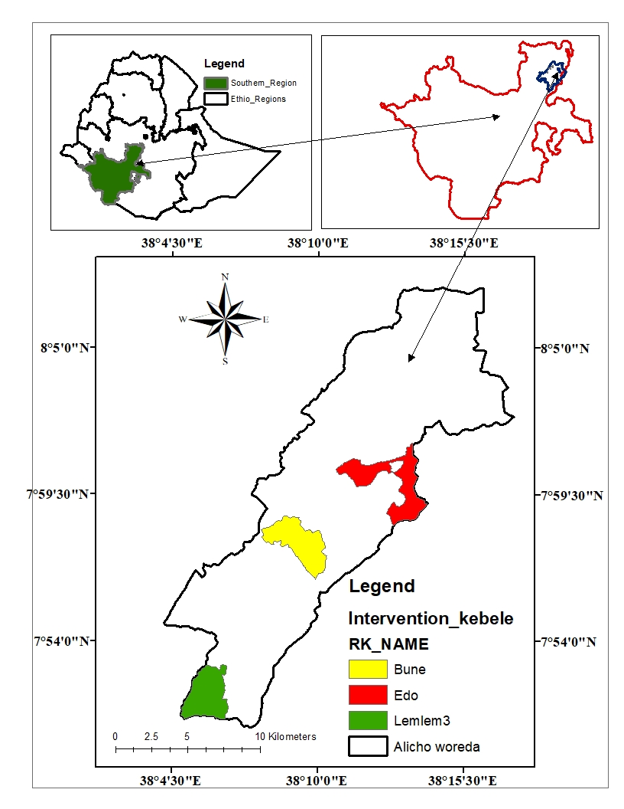
Fig-1 Map of Alicho Woriro District: Adopted from Ethiopian Administrative map
2.2 Research design
The study employed a cross-sectional research design to guide the data collection process. According to Bryman (2008), the cross-sectional survey research design uses structured interviews to collect quantitative and/or qualitative data at a single time period.
2.3 Study Population, sampling procedure and sample size
The study followed a multi-stage sampling procedure. In the first stage, Alicho Woriro woreda was selected purposively based on the barley production potential among the districts in Siltie zone. Secondly, three major Barley producing kebeles, namely, Edo (500 HHs), Bune (470 HHs), and Lemlem 3 (450 HHs), were selected purposively based on their barley production potential in the Woreda. Finally, respondents were selected using a simple random sampling technique. From the sampling frame of 1420 barley-producing HHs, 140 sampled HHs were selected using Yamane's sample determination formula (Yamane, 1967) indicated below. This technique was applied for its simplicity and convenient than other methods. Because of the low level of variability within the population under study, 8% of precision level was used.
n =$\frac{N}{1+N\left(e\right)2}$……………………………………………………… (1)
Where n is the sample size, N is the total population size (total household head size in the study kebeles), and e is the level of precision. To ensure representativeness of the population, proportionate sampling size (PPS) was selected in each kebele. As the population under the study is less heterogeneous, 0.08% margin of error was used. Accordingly, the sample was calculated and determined as follows.
n =$\frac{1420}{1+1420\left(0.08\right)2}$=140…………………………….………………. (2)
The distribution of the sampled households proportional to each kebele is summarized below (Table 1)

Table- 1: Sample distribution of respondent households in the study kebeles
 | Kebele | Total food barley producer households* | Sampled household**
 | Bune | 500 | 49
 | Edo 1 | 470 | 47
 | Lemlem 3 | 450 | 44
Total |  | 1420 | 140

Source: * kebele admiration office; ** own computation in proportion to the total population

2.4 Methods of data collection

2.4.1 Data Types and Sources
Both quantitative and qualitative data types were collected from primary and secondary sources. The primary data were collected through questionnaire-led interviews, Group discussions and personal observations carried out on sampled respondents during the 2021 cropping season; while the secondary data were collected from different sources, such as regional and district agricultural and natural resource offices, published and unpublished materials, journals, scientific research works, and report documents.

2.4.2 Data collection tools
To meet the stated objectives, the researcher used different data collection tools such as household surveys, focus group discussions, and key informants interview to collect both qualitative and quantitative data. Besides, different literatures were reviewed to support the rationale of the study and its findings with relevant evidences.

Household Survey
The questionnaire was developed in a way that it meets the study objectives. It was pretested prior to the collection of the actual data at neighbor food barley producing kebeles in order to cross-check the relevance and quality of the questionnaire. Necessary revision and modifications were made and incorporated. Enumerators were given preparatory training to avoid unnecessary mistakes in data collection. Following this, an interview schedule was held at farmers’ homestead.

Key Informants Interview
Key informants interview (KII) was conducted with experts and development agents about the intensity and factors of adoption of improved food barley production technology package in the study area. Accordingly, one expert from Siltie zone Agricultural Office, two experts from Alicho Woriro Woreda Agriculture and Natural Resource Development Office, and three Development Agents (one from each kebele), a total of six key informants were interviewed.

Focus Group Discussion
In addition to the above-mentioned data collection methods, Focus Group Discussions (FGD) were employed to obtain in-depth information on the study subject. Hence, one focus group having six members was formed in each kebele. Food barley producers; model farmers and female headed households were included in the groups and provided information about the technology adoption and affecting factors they perceived.

2.5 Methods of Data Analysis
The study employed different statistical tools with consideration of the data types collected in line with addressing the respective specific objectives of the study. Two statistical package software, SPSS version 20 and STATA version 14, were applied as tools to facilitate the data analysis. Accordingly, respondents’ characterization such as demographic, socio-economic and institutional characteristics were analyzed and described using descriptive statistical tools such as mean, frequency, percentage and standard deviation, with SPSS. In addition, inferential statistical analysis methods such as chi-square (cross-tabulation) and one-way ANOVA were applied for dummy and continuous variables, respectively, to test the association of the explanatory variables with the adoption of improved food barley production technology package in the study area. Moreover, descriptive statistical measures were also used in the analysis of adoption status of food barley production technology package by smallholder producers in the study area.
With respect to the second specific objective, the study applied adoption index method to analyze smallholder farmers’ adoption intensity of improved food barley production technology package in the study area. The model is appropriate in case of measuring the adoption intensity of a technology package constituted with multiple components. The adoption index of the intensity of adoption of improved food barley technology package for adopters was computed using the following formula, (Taha, 2007).
𝐴𝐼𝑖 $=\sum_{i=1}^{n}{ \frac{\left( \frac{ATi}{RTi} \right)}{NP}}$ .…………………………………….………. (3)
Where AIi is adoption index of ith farmer where i= 1, 2, 3…. n; n is a total number of farmers. ATi is the level or quantity of input the farmer applied; RTi denotes the recommended level or quantity of an input the farmer ought to apply and NP is the number of component practices.
After summing up all the components, the maximum obtainable adoption score is fixed at 1 or 100% adoption level, which shows an appropriate application of all the components of the package according to their recommended level. Based on the above general formula of adoption index, the following specific formula was derived for this study, considering five components of the package.
𝐴𝐼𝑖 $=\sum_{i=1}^{n}{ \frac{\left( \frac{PFA}{PFR} + \frac{SRA}{SRR}+ \frac{NPSA}{NPSR}+\frac{UA}{UR}+\frac{FWA }{FWR}+\frac{LCIP }{LCTP}\right)}{NP}}$………………………… (4)
Where, PFA =Plowing frequency applied; PFR = Plowing frequency recommended,
SRA= Seed rate applied; SRR= Seed rate recommended,
NPSA= NPS fertilizer applied; NPSR= NPS fertilizer rate recommended,
UA= Urea fertilizer applied, UR= Urea fertilizer rate recommended,
FWA= Weeding frequency applied; FWR= Weeding frequency recommended,
LCIS= Land covered by improved food barley package; LCTS= Land covered by total food barley production and NP= 6 Spacing between rows was omitted because it was similar for almost all respondents. Additionally, land allocated for food barley production was added to capture and incorporate the extent of adoption of IFBPTP by farmers.
In this study, an adoption index was used as a continuous dependent variable and its values range from 0 to 1. Based on the adoption index value, respondent farmers were categorized into four adoption categories, such as non-adopters (0), low adopters (0.1-0.33), medium adopters (0.34-0.66), and high adopters (0.67-1) (Tariku, 2012 and Endashaw, 2019). An adoption index score of 0 indicates non-adoption and values greater than 0 and less than or equal to 1 (>0 and ≤1) imply adopters with various levels.

Results and Discussions
This chapter presents the findings of the study, such as the status and intensity of improved food barley production technology package.

3.1 Farmers’ Adoption Status of Improved Food Barley Production Technology Package in the Study Area
One of the objectives of this study was to assess the status of the adoption of an improved food barley production technology package in the study area. Accordingly, the finding of the study revealed that 11.4% of the respondents were non-adopters of improved food barley production technology package. The rest of the adopter categories constitute 88.6% of the total respondents. Regarding the share of each category, low, medium, and high adopters constitute 21.4, 38.6, and 28.6 percent of the total respondent households, respectively (fig. 3). The mean adoption index of the low, medium and high adopters was 0.28±0.05, 0.64±0.02, and 0.88±0.12, respectively. Hence, the majority of the respondents fall under the medium adopters’ category. High adopters constitute only 28.6% of the total respondents. Non-adopters and low adopters also share 32.8% of the respondents which implies that the status of adoption of improved food barley production technology package has not yet reached its satisfactory level in the study area.

Fig. 2: Adoption status of improved food barley production technology package Source: Own field survey

3.2 Farmers’ Intensity of Adoption of Improved Food Barley Production Technology Package in the Study Area
The intensity of adoption of each component of improved food barley production technology package as well as the overall intensity of adoption of the package among the adopter categories, according to the results of the analysis, is summarized in the table below.

 | Adopter Categories
Component of the Package | Low |  | Medium |  | High |  | Mean Intensity |  | F | P-Value
Component of the Package | Mean | SD | Mean | SD | Mean | SD | Mean | SD
Land Preparation | 0.40 | 0.05 | 0.70 | 0.03 | 0.88 | 0.12 | 0.66 | 0.06
Seed Rate | 0.23 | 0.07 | 0.75 | 0.02 | 0.90 | 0.15 | 0.62 | 0.08
NPS Rate | 0.19 | 0.06 | 0.80 | 0.03 | 0.98 | 0.10 | 0.65 | 0.06
UREA | 0.18 | 0.03 | 0.45 | 0.01 | 0.75 | 0.09 | 0.46 | 0.04
Weeding Frequency | 0.40 | 0.05 | 0.60 | 0.01 | 1.00 | 0.12 | 0.66 | 0.06
Land allocated | 0.32 | 0.04 | 0.54 | 0.02 | 0.77 | 0.14 | 0.54 | 0.06
Overall  Intensity 0.28 0.05 0.64 0.02 0.88 0.12 |  |  |  |  |  |  | 0.60 | 0.06 | 35.6 | 0.005
Table-2 the intensity of adoption of improved food barley production technology package by the adopter categories
As the table depicts, the overall intensity of adoption of improved food barley production technology package is 0.6. This shows that farmers in the study area adopted 60% of the recommended level of the package. The table also depicts the adoption intensity of each component of the package.
Conclusion
The study concluded that the adoption of the improved food barley production technology package among smallholder farmers in Alicho Woriro District was moderate but not complete. Most sampled farmers had adopted at least some components of the package, while 11.4% remained non-adopters. The largest proportion of respondents fell within the medium adopter category, followed by high adopters, low adopters, and non-adopters. The overall adoption intensity was 0.60, showing that farmers applied about 60% of the recommended package. This indicates that a considerable part of the recommended food barley production technology package was still not fully adopted. Differences were also observed across individual components, including land preparation, seed rate, fertilizer application, weeding frequency, and land allocation. The findings suggest that there is an opportunity to improve adoption by building on the experience of medium and high adopters and by supporting low and non-adopting farmers through practical extension services, training, demonstrations, and improved institutional support.
.

Recommendations
Based on the conclusions made from the findings of the study, the following recommendations are put forward to enhance the adoption status and intensity of improved food barley production.
Government (extension service, seed enterprise and research systems) and non-governmental organizations, who are concerned with the improvement of food barley sub-sector, should use the experience of medium and high adopters as a spring board, to support farmers under non-adopters’ and low adopters’ categories. They should also implement measures to address problems associated with the use of improved food barley production package. These include raising the awareness of smallholder farmers about improved food barley production technology package through demonstrations, field visits and farmer-to-farmer experience sharing.
Skill based and practical trainings should be given by district agricultural office and the extension workers on application of each component of the package. Farmers’ Training Centers (FTCs) should function properly to give awareness to the farmers on the advantages of using recommended components of improved food barley production technology package.
Limitation
This study was limited to 140 smallholder food barley-producing households in three selected kebeles of Alicho Woriro District. Therefore, the findings may not fully represent all food barley producers in other districts or agro-ecological zones. The study mainly used descriptive statistics and an adoption index, which limits explanation of the determinants of adoption. Some information was based on farmers’ self-reported practices and may be affected by recall or reporting bias. The study also focused on selected components of the improved food barley production technology package, while other production, market, institutional, and environmental factors may influence adoption.

Declaration of AI Use

This manuscript was prepared through the combined contributions of all author(s), including contributions to the study design, data, content development, results, interpretation, and related scholarly work. The author(s) acknowledge the use of Grammarly and ChatGPT to assist with grammar checking, language refinement, reference formatting. These AI-assisted tools were not used as authors and did not replace the intellectual contributions or scholarly judgment of the author(s). All AI-assisted outputs, including content, references, and interpretations, were carefully reviewed, revised, verified, and approved by the author(s). The author(s) accept full responsibility for the accuracy, integrity, and final content of the manuscript.

References
Bayeh Mulatu and Stefania Grando (2011). Barley Research and Development in Ethiopia. Proceedings of the 2nd National Barley Research and Development Review Workshop. 28-30 November 2006, HARC, Holetta, Ethiopia.
Berhanu A., Dereje A., Alemtsehay T., Addis A., Kebede, M. and Girmay S. (2016). Enhancement of barley productivity through improved crop management practices in the semi-arid highlands of northern Ethiopia. RUFORUM Working Document Series. No. 14 (1): 743-749.
Eyob Tilahun, Kibebew Kibret, Tekalign Mamo and Hailu Shiferaw (2015). Assessment and Mapping of some soil nutrients status in agricultural land of Alicho Woriro Woreda, Silte Zone, Southern Ethiopia. American Journal of Plant Nutrition and Fertilization Technology vol 5 pp. 16-25
Kosmowski F., Alemu S., Mallia P., Stevenson J. and Macours K. (2020). Shining a Brighter Light: Comprehensive Evidence on Adoption and Diffusion of CGIAR-Related Innovations in Ethiopia. Rome: Standing Panel on Impact Assessment (SPIA).
Lake Mekonnen and Bezabih W/kiros (2018). Response of Food Barley (Hordeum Vulgare L.) to Various Levels of P Fertilizer. International Journal of Research in Agriculture and Forestry. vol 5(2), pp. 21-26
Martin J. H., Walden R. P., and Stamp D. L. (2006). Principles of field crop production. Pearson Education, Inc. USA.
Ministry of Agriculture (2018). Crop Production Package. Addis Ababa, Ethiopia.
Mulatu B. and Lakew B. (2011). Barley research and development in Ethiopia – an overview in: Mulatu B. and Grando S. (eds). 2011. Barley Research and Development in Ethiopia. Proceedings of the 2nd National Barley Research and Development Review Workshop. 28-30 November 2006, HARC, Holetta, Ethiopia. ICARDA, PO Box 5466, Aleppo, Syria.
Shahidur Rsashid, Gashaw T. Abate, Solomon Lemma, James Warner, Leulsegged Kasa and Nicholas Minot (2015). The Barley Value Chain in Ethiopia. International Food Policy Research Institute (IFPRI) Washington DC.
Yigezu A., Chilot Y. Tizale and Aden A. Hassan (2015). Modeling Farmers’ Adoption Decisions of Multiple Crop Technologies: The Case of Barley and Potatoes in Ethiopia.

