Pre-Extension Demonstration of Newly Released Qey-Bure Common Bean variety with Full Package Application at Boricha District, Sidama National Regional State

Abstract
Demonstrating early maturing, disease resistant, drought tolerant and high yielder varieties is the main tool to enhance diffusion, and increase production and productivity of common bean. That was the reason why this demonstration activity was initiated and conducted. In addition to analyzing farmers' preferences and the variety's economic benefits, the demonstration project sought to promote the recently launched common bean variety for increased yield and disease and drought resistance. Participating farmers, DAs, and Woreda Extension agents received training to develop a common knowledge of the demonstration activities, agronomic practices of the varieties, and technology package implementation procedures. In close collaboration with the farmers, land preparation, planting, follow-up, assessment, monitoring, and evaluation, as well as field days and short visits, are all successfully finished. Through direct measurement and observation, the study gathered agronomic and yield related data, such as drought resistance, date of maturity, number of cobs per plant and number of seed per cob. Feedbacks and preferences of the farmers were assessed according to predetermined criteria. The data were analyzed using the mean and percentage, partial budget, and preference score ranking, respectively. According to the results, the average yield of Key Bure was 22.5 qt/ha, which dominated the standard check, Gegebe. Because of its yield advantage, farmers chose Qey Bure over the standard check. Based on Early maturity, Pods per plant, Drought tolerance, Disease resistance and color, farmers also selected Qey Bure over Gegebe. The cost-benefit analysis also shows a positive return of 150,080 ETB/ha for Qey Bure which is another testimony for the variety’s advantage. Therefore, it is highly advised to widely popularize these varieties in order to improve productivity and reap the nutritional and financial benefits.
Key Words- Pre-Extension Demonstration, Variety, Qey Bure, Yield, Farmers’ Preference
1. Introduction
1.1 Background and Justification
Legumes are the major sources of protein in Ethiopia where common bean (Phaseolus vulgaris L.) takes large proportion next to Faba Bean and field pea (Asfaw et al., 2004). It is also an important cash crop and export commodity that generates foreign currency for the country (Abebe, 2009). Common bean is one of the major grain legumes widely cultivated by the smallholder farmers in the Southern Ethiopia. It is a basic component of cropping systems of small-scale farmers and diets of people of Ethiopia as in many other countries in east, central and southern Africa (Solomon and Walelign, 2018).
In addition to the fact that common bean is used as the source income by farmers, it is the main hunger break at belg season just at the planting of meher plantings when the food scarcity reached a peak. Because of the short growing period of beans, it allows the production of the crop two times a year. Common bean has been one of the leading exportable pulse crops in Ethiopia for the last four decades (Ferris and Kaganzi, 2008), Ethiopia being the leading exporter of common bean in Africa. The major bean market class for export is small white pea bean, but currently, other bean market classes such as small red, sugar bean, pinto, and cream beans are also exported to Europe, the Middle East, and Asia (Ministry of trade unpublished report) (Fitsum and Tasew, 2022).
While in Ethiopia, where 73.4% of the common bean production is used for household consumption (CSA 2011/12), its importance as source of income for smallholder farmers has increased over the years. The leading destinations for Ethiopian common beans are European, Middle East, African and Far East countries. Ethiopia exports red and navy beans, much of which, are produced by smallholder farmers. Red bean exports account for more than 10% of the country’s common bean volume while navy beans accounts for 90%.
Despite the importance of the crop to farmers and its importance for the national economy, average yields obtained by farmers in Ethiopia are very low (Mulugeta et al., 2023). The National average yield of common beans is low ranging from 0.5 to 0.8 tone ha–1, which is far below the corresponding yield recorded at research sites (2.5-3 tones ha-1) using improved varieties. The national average yield (of both white and red type) calculated for Meher and Belg seasons of 2015/16 was 1208 kg/ha, while the regional average yield of Belg season in the southern part was 880 kg/ha (CSA, 2018). The low national mean yield observed for common bean could be attributed to various constraints related to low adoption of improved agricultural technologies, drought, and lack of improved varieties, poor cultural practices, disease, and environmental degradation.
In the Sidama region, many farmers use more of local variety that are available on their hands than improved variety and the production and productivity were low. So, to overcome these problems, demonstrating early maturing, disease resistance, drought tolerant and high yielder variety are the main tools to enhance diffusion and increase production and productivity of the common bean in the selected areas.
1.2 Objectives
1.2.1 General Objective
The overall goal of this demonstration activity was to promote the newly released common bean varieties and highlight their increased yield and other relevant characteristics.
1.2.2 Specific Objectives
- To demonstrate high yielding, drought tolerant and early maturing Qey Bure common bean variety with its full package
- To assess farmers’ preference regarding improved common bean variety
- To compute economic advantage of the newly released common bean variety

2. Methods and Materials
2.1 Description of the Study Areas
Boricha Woreda is an administrative district located in the Northern Sidama Zone, Sidama National Regional State of Ethiopia. It is located approximately 32 km south west from Hawassa, the Zonal and regional capital and about 307 km from Addis Ababa. The woreda, which is part of the Great Rift Valley, shares borders with Darara Woreda to the south, Bilate Zuriya Woreda to the west, Hawassa Zuriya woreda to the north and Shebedino Woreda to the east.
The geographical location of Boricha Woreda extends from 6º46'N and 38º04'E to 7º01'N and 38º24'E characterized by flat laying topography as far as the altitudinal variation of the area is concerned. Boricha Woreda composed of predominantly plain lowland, accounting for about 78% of its total area, with the remaining 22% consisting of rougher geography. Agro-ecologically, the woreda is categorized into two: 35% is midland (Woynadega) and 65% is lowland (Kola). Woynadega has medium altitude, whereas kola has low altitude. The altitude of the woreda ranges from 1769 to 2077 meters above sea level. This elevation contributes to a climate that is generally considered semi-arid, primarily due to high temperatures and relatively low rainfall. The mean annual rainfall typically lies between 700 mm and 1242 mm, with an erratic distribution. The rainy season is divided into two main periods: "belg" (short rains) from February to May, which is characterized by erratic rainfall, and "meher" (main rains) from June to mid-September, which usually brings more consistent rainfall. The "meher" season contributes approximately 80% of the total annual rainfall.
The woreda has a total population of 132,242 of whom 64,695 (49%) are male and 67,583 (51%) are female. From among the total population, 127, 712 (62,414 Male and 65,298 Female) are rural residents and 4530 (2245 Male and 2285 Female) live in urban and peri-urban areas. The number of rural households of the woreda is 17,108 HHs with 15,489 MHHs and 1619 FHHs. The Woreda comprises 14 kebele administrations, among which 13 are rural kebeles and 1 urban/peri-urban kebele. The total land area of the woreda is 9818.4 ha with an average holding of 0.25 ha (minimum 0.125 ha and maximum 1 ha). From the total land, 8027.2 ha is cultivated/crop land (4010 annual and 4017.2 perennial), 931.7 ha covered by forest (244 natural forest and 687.7 plantation forest) and 360.5 ha grazing land, 216.2 covered by other land use type and 282.8 uncultivable land.
Agriculture is the primary livelihood and economic activity in Boricha Woreda with mixed farming system, involving both crop and livestock production. Crop production comprises 75% of the entire agricultural activity and the livestock sector shares the rest 25%. Maize, Enset, common bean and sweet potato are the crops that are grown in the area. 60% of the woreda’s farmers produce common bean covering 3216ha of land. From the common bean types grown, 60% are red type, 10% are white and the other 30% are mixed. Old varieties such as Hawassa Dume, Nassir and Ibadu are known in the area though recent and more productive varieties are not yet popularized. Fruits are also part of the agricultural production in the area with 30% of the farmers being engaged in. 105ha land is covered by fruits of which 60% is covered by Avocado, 5% with Mango and 40% with Banana.
Another important farming activity of Boricha Woreda is dairy production. Cattle (both domestic and crossbreed), sheep, goats, fowl (both domestic and foreign varieties), horses, mule, and donkeys are among the livestock types raised. The woreda's livestock population includes 77,750 dairy animals, 13,729 oxen/bull, 22,585 sheep, 34,335 goats, 3042 equines, and 328,174 local and exotic fowl. There is a promising beekeeping practice in the woreda, with 6,323 hives (1840 traditional hives, 3506 transitional hives and 131 contemporary hives).
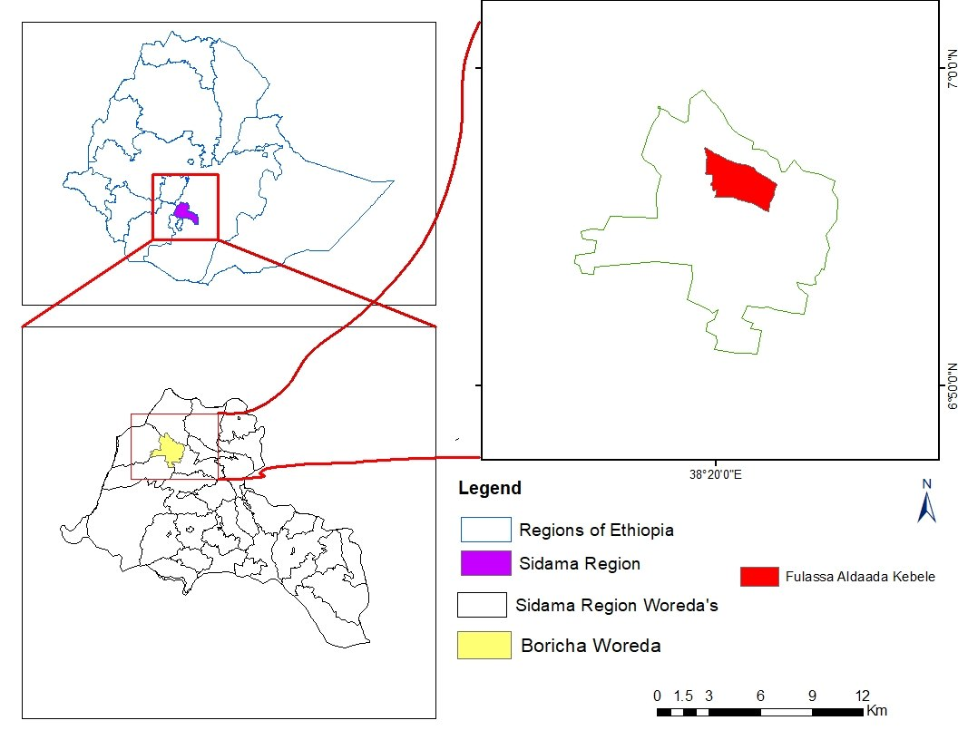
Map 1- Administrative map of Boricha District
2.3 Training and Awareness Creation
Training was provided to participating farmers, DAs, Woreda Extension agents, and other stakeholders in order to establish a common understanding of the KT project intervention areas and the common bean demonstration activity, as well as its agronomic practices and technology implementation procedures. KT project coordinator and common bean breeder, as well technology demonstration researchers delivered the training.

  - Land Preparation and Planting
Farmers were trained on implementation processes before beginning land preparation. They were largely responsible for preparing their plots for planting by ploughing them at least three times. Seeds were carried from the center’s on-station seed multiplication site and distributed to each farmer in adequate quantities. After ensuring proper site preparation, all farmers planted their seeds, with technical support from researchers and development agents. DAP chemical fertilizer was applied according to the recommended rate for common bean production.
  - Detailed Implementation Procedures and Design
The demonstration activity was conducted on two plots with an area of 200 m² for improved and standard check varieties, respectively, at each farmer’s field. The demonstrated newer variety was Key Bure, the older standard check variety being Gegebe which is known for years with the farmers and the extension system. The newer Key Bure was demonstrated for higher yield and drought resistant.
Regarding the implementation procedures, the seed rate was 100 kg/ha for both varieties. Inorganic fertilizer was applied with a rate of 100 kg/ha DAP. Spacing between plants and rows was 10 cm by 40 cm, respectively. 10 farmers were participated in the demonstration activity based on willingness, land availability and accessibility. The farmers were selected in collaboration with kebele level development agents (DAs).
  - Management, Follow up and Evaluation
Farm management and follow-up were done often in partnership with farmers and development agents. Weeds were managed three times on each farmer's plot. Farmers were evaluated at various phases of crop growth, and a mini-visit and field day were undertaken to examine the difference between varieties in several agronomic features as well as farmers' preferences.
2.7 Methods of Data Collection and Analysis
Yield and other agronomic data such as date of maturity, resistance to disease/pest occurrence and others were collected by direct measurement and observation. Farmers’ preference data was also collected by using a score ranking method from participant farmers. Feedbacks were obtained from joint evaluation with farmers and field day festival. And, finally, input costs and economic return data were recorded from the farmers and based on contemporary market structure.
Regarding data analysis, Mean, frequencies and percentage were employed to analyze quantitative and yield related data. Score ranking and partial budget were used to analyze farmers’ preferences and cost-benefit analysis, respectively.

3. Result and Discussion
3.1 Implementation and Communication Procedures
3.1.1 Training
Participating farmers and development agents received training on the overall activities and processes. All 10 farmers from both woredas attended the training on the nutritional content, economic benefits and agronomic practices of the newly released Key Bure bean variety. The training was conducted by breeders, agronomic and technology transfer researchers in partnership with the Boricha Woreda agricultural and natural resource management office. The KT project provided financial assistance for the training and overall activity, and it monitored the demonstration activity until its completion. Table 1 summarizes the participants of the training.
3.1.2 Field Day
The monitoring and evaluation, as well as mass communication of the technology, took place at different stages of the crop’s growth. At the germination stage, farmers were gathered to evaluate the germination performance of the varieties. After flowering, a mini visit was organized with farmers, woreda extension personnel and guest from regional bureau. Regional media also invited in order to popularize the technology in mass level. Finally, filed day and discussion forum was organized by gathering neighboring farmers together in order to visit the performance of the newly introduced common bean variety and share experience. The new variety was largely demonstrated in the target kebele and around. Table 1 summarizes the participants of field visit and field day.
 | Participants |  |  |  |  |  |  |  |  | Grand Total
 | Farmers |  |  | Extension Agents |  |  | Researchers |  |  | Grand Total
 | Male | Female | Total | Male | Female | Total | Male | Female | Total | Grand Total
Training | 10 | 0 | 10 | 4 | 0 | 4 | 4 | 0 | 4 | 18
Field Visit | 20 | 5 | 25 | 4 | 0 | 4 | 5 | 0 | 5 | 34
Field Day | 39 | 11 | 50 | 4 | 1 | 5 | 5 | 0 | 5 | 60
Total | 69 | 16 | 85 | 12 | 1 | 13 | 14 | 0 | 14 | 112
Table-1- Summary of training, field visit and field day participants
3.2 Yield Performance of the Varieties
The varieties shown a better mean yield at both woredas than the standard checks. As the farmers reported, the local average yield stayed way far below the new varieties’ performance. The table below depicts the yield performances of the varieties.
 |  | Qey Bure (Qt/ha) | Gegebe (Qt/ha)
1 | F1 | 25 | 17.5 | Yield Advantage (%)
2 | F2 | 23 | 20
3 | F3 | 24 | 20
4 | F4 | 26 | 14
5 | F5 | 20 | 12
6 | F6 | 20 | 10
7 | F7 | 17 | 10
8 | F8 | 25 | 20
9 | F9 | 24.5 | 14.5
10 | F10 | 23 | 17.5
 | Mean Yield | 22.5 | 15.55 | 30.88
 | SD | 2.90 | 4.01
Table-2- Yield performance of common bean varieties at Boricha Woreda
As the table shows, Qey Bure outperformed Gegebe variety with a mean yield of 22.5 Qt/ha, while that of Gegebe being 15.55 Qt/ha, and the yield advantage of the newer variety is 30.88% compared to the standard check.
3.3 Farmers’ Preferences Among the Demonstrated Varieties
The varieties were ranked based on grain yield, days of maturation, pod per plant, disease resistance, drought tolerance and color after cooking. Due to the fact that there was a shortage of rain during the belg season, drought resistance was discussed in terms of the variety remaining green on dry days. The occurrence of rest also helped farmers to identify the resistant variety. The score ranking results are given in the chart below.

Chart-1- Farmers’ preferences regarding the demonstrated common bean varieties
Regarding early maturity, all farmers selected Gegebe over Key Bure at Boricha woreda. This is due to the fact that Gegebe is known for its early maturity. That is why it is sometimes named as “fetenech”, which means fast. However, it suffers low resistance of disease and moisture stress. It was attacked by rest and suffered shortage of rainfall. However, Qey Bure resisted, survived and gave better yield while there was the occurrence of rest and shortage of rain. Regarding color, farmers hardly detected a significant difference between the two varieties and both varieties got a 50% vote from farmers. Hence, Key Bure is highly preferred by the farmers and recommended for further popularization.
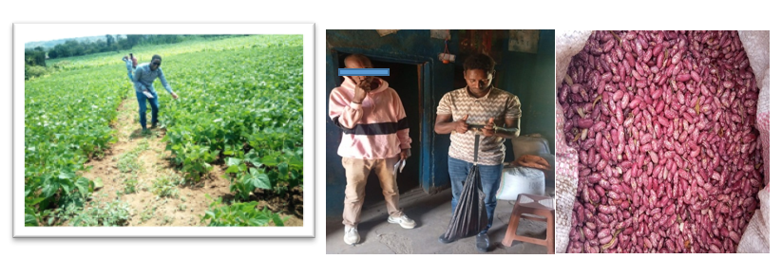
Picture-1- Performance of common bean at the field and after harvesting, and the researcher recording the yield
3.4 Cost-Benefit Analysis
Another way to assess the value of a technology is to look at its economic benefits. As a result, a partial budget is computed to demonstrate the overall benefits of the newly introduced Qey Bure variety. The following assumptions are based on the current market structure, prices of inputs at woreda level and labor accessibility in the area and the table below shows the partial budget analysis of Key Bure variety at Boricha woreda.
Production Cost/ha |  |  |  |  | Benefit from Output/ha
Activity | Unit | Quantity | Unit Price (ETB) | Total Price (ETB) | Average seed (Qt /ha) | Unit Price | Total Price (ETB)
Land Preparation (3 times) | Person | 30*3 | 150 per day | 13,500 | 22.5 | 10,000 ETB | 225,000
Seed Purchase | Kg | 80 | 100 | 8000 | 22.5 | 10,000 ETB | 225,000
DAP | Kg | 120 | 91 | 10,920 | 22.5 | 10,000 ETB | 225,000
Planting | Person | 30 for three days | 150*3 | 13,500 | 22.5 | 10,000 ETB | 225,000
Weed management and follow up (3 times) | Person | 30*3 | 150*3 | 13,500 | 22.5 | 10,000 ETB | 225,000
Harvesting | Person | 30 for two days | 150*2 | 9,000 | 22.5 | 10,000 ETB | 225,000
Feed for laborers | - | - | - | 4,500 | 22.5 | 10,000 ETB | 225,000
Transportation | - | - | - | 2,000 | 22.5 | 10,000 ETB | 225,000
Total |  |  |  | 74,920*A |  |  | 225,000 *B
Net Benefit |  | B-A= |  |  |  |  | 150,080
Table-3- partial budget analysis of Key Bure bean variety at Boricha woreda

4.1 Conclusion
This demonstration project was initiated and implemented to introduce the improved Qey Bure bean variety to farmers and the extension system. After Boricha district of the Sidama national regional state was purposively selected based on the potential of the area, accessibility and, besides, for the reason that the area is where the variety trial research was conducted, ten farmers were also selected and trained to host the demonstration activity. The woreda agricultural office and development agents at the kebele level worked together to choose the farmers. Development agents, along with participant farmers, attended the training organized by Hawassa Agricultural Research Center with an integration with Kirkhouse Trust (KT) project. At the plots of 200 m², the newly released common bean variety was planted with Gegebe variety as a standard check on the same size plot, other agronomic practices being constant. Land preparation, planting, follow-up, monitoring, and evaluation were carried out together with the farmers. As the result of the demonstration activity revealed, the newly released Qey Bure variety has shown a better performance in terms of grain yield, drought tolerance, disease resistance and other agronomic characteristics and social aspects. Farmers also preferred Qey Bure over the old variety Gegebe, though Gegebe is one of the few bean varieties that are under utilization for the last several years. The partial budget analysis also shows that producing Qey Bure variety is economically feasible and has a positive return by far.
According to the outcome, farmers' preferences, and feedback, the proven varieties are very productive and appropriate for the agro-ecological zones of the areas. As a result, it is advised that these varieties be widely adopted in the regions through extensive popularization efforts and scaling-ups.

References
Abebe G (2009). Effect of NP fertilizer and moisture conservation on the yield and yield components of haricot bean (Phaseolus vulgaris L.) in the semi-arid zones of the central rift valley in Ethiopia: Adv Environ Biol 3: 302-307.
Asfaw A, Dauro D, Kimani PM (2004). Decentralized participatory bean breeding in southern Ethiopia. In Proceedings of the 11th conference of the crop sciences society of Ethiopia. Addis Ababa, Ethiopia.
CSA (2011) Agricultural sample survey 2010/2011 (2003 EC) Report on area and production of major crops. Central Statistical Agency of Ethiopia, Addis Ababa, Ethiopia.
CSA (Ethiopian central statistics agency), (2018) Report on Area, Production and Farm Management Practice of Belg Season Crops for Private Peasant Holdings, Agricultural Sample Survery 2015/16 (2008 E.C) Volume V. Addis Ababa Ethiopia.
Ferris, S. and Kaganzi, E. (2008). Evaluating marketing opportunities for haricot beans in Ethiopia. IPMS (Improving Productivity and Market Success) of Ethiopian Farmers Project, Working Paper No. 7. ILRI (International Livestock Research Institute), Nairobi, Kenya. pp. 68.
Fitsum Alemayehu and Tasew Derese (2022). Progress of Common Bean Breeding and Research achievements in Southern Ethiopia. International Journal of Research Studies in Agricultural Sciences (IJRSAS). Vol.8(5), pp. 13-19
Mulugeta Habte, Atinafu Assefa and Abay Ayalew (2023). Yield response of common bean to different types and rates of blended fertilizers in Hawassa Zuria Woreda, Southern Ethiopia. International Journal of Science and Research Archive, 2023, 08(01), 995–1000
Solomon Yokamo and Walelegn Wotro (2018). Pre Extension Demonstration of Improved Common Bean (Phaseolus Vulgaris (l.)) with its Full Packages in Gamogofa and Segen Area Peoples Zone, SNNPRs, Ethiopia. Int J Environ Sci Nat Res. 2018; 13(4): 555868.

