KNOWLEDGE AND ATTITUDE OF CERVICAL CANCER SCREENING AMONG FEMALE SEX WORKERS LIVING WITH HIV IN BENUE STATE

ABSTRACT
Background: Cervical cancer remains a major public health concern, particularly among women living with HIV who are at increased risk of persistent human papillomavirus infection and rapid disease progression. Female sex workers living with HIV represent a highly vulnerable group; however, evidence on their knowledge, attitude, and uptake of cervical cancer screening in Benue State remains limited. This study assessed knowledge, attitude, uptake, and barriers to cervical cancer screening among this population. Methodology: A descriptive cross-sectional design was adopted. A total of 440 female sex workers living with HIV were recruited from selected HIV care facilities in Benue State using a structured questionnaire. Data were analyzed using descriptive statistics (frequencies and percentages) and inferential statistics (Chi-square test) at a 5% level of significance to determine associations between socio-demographic variables, knowledge, attitude, and screening uptake. Results: Findings revealed moderately high knowledge, with 43.1% demonstrating good knowledge, 35.1% moderate knowledge, and 21.8% poor knowledge. Attitude toward screening was generally positive, as over 70% acknowledged its importance and expressed willingness to recommend it. However, uptake was suboptimal; only 48.3% reported sometimes or always undergoing screening, and 54.9% had missed scheduled appointments. Significant associations were found between screening uptake and age, educational status, income level, knowledge level, and attitude (p < 0.05). Major barriers included inadequate information (64.5%), fear of positive results (61.1%), fear of pain (57.3%), embarrassment (56.4%), and HIV-related stigma (54.0%). Conclusion: Despite moderately high knowledge and positive attitudes, cervical cancer screening uptake among female sex workers living with HIV in Benue State remains low due to psychological, informational, and socio-demographic barriers. Recommendation: Integration of routine cervical cancer screening into HIV care services with strengthened counseling and targeted health education is recommended to improve uptake.

Keywords: Cervical cancer screening; Female sex workers; HIV; Knowledge and attitude; Screening uptake.

INTRODUCTION
Cervical cancer is one of the leading causes of cancer-related morbidity and mortality among women globally, with a relatively higher burden in low- and middle-income countries (LMICs), including Nigeria (Castle et al., 2021). The World Health Organization (WHO) estimates that more than 85% of cervical cancer deaths occur in LMICs, because of the limited access to effective screening and early treatment services. In Nigeria, cervical cancer is the second most common cancer among women, and its burden is particularly significant among vulnerable sub-populations such as female sex workers (FSWs), especially those living with HIV (Singh et al., 2023).
Female sex workers represent a high-risk group for both human papillomavirus (HPV) infection (the primary cause of cervical cancer) and HIV. Co-infection with HIV increases the risk of persistent HPV infection, increases the progression of cervical intraepithelial neoplasia, and reduces the likelihood of spontaneous viral clearance. Despite the high level of risk, screening uptake among FSWs living with HIV remains very low. Numerous factors, including limited knowledge about cervical cancer, fear of diagnosis, stigma, inadequate access to health services, and poor attitudes towards screening, contribute to this gap in preventive health behavior (Farahmand et al., 2020).
Benue State, located in North-Central Nigeria, has one of the highest HIV prevalence rates in the country (Abu & Kotur, 2022). The State also has a high population of female sex workers, many of whom operate in urban and semi-urban areas such as Makurdi, Otukpo, and Gboko. These women face different kinds of vulnerability that heighten their risk of cervical cancer, yet at the same time limit their access to information and health services. Public health interventions have made progress in addressing HIV treatment and care; however, cervical cancer prevention particularly through regular screening is not yet a priority, especially among key populations like FSWs. Understanding the knowledge and attitude of FSWs living with HIV towards cervical cancer screening is therefore crucial for designing culturally sensitive, and effective interventions. Knowledge influences awareness and informed decision-making, while attitude shapes motivation and willingness to seek preventive care. Without a good understanding of these factors, policy efforts and programmatic interventions may fail to reach those most at risk such as these FSWs (Abu & Kotur, 2022).
Previous empirical studies indicate that knowledge, attitudes, and uptake of cervical cancer screening remain suboptimal, particularly among high-risk populations. In an international study conducted in Douala Municipality, Cameroon, et al. (2024) examined knowledge, attitudes, and practices related to cervical cancer prevention among female sex workers. The findings showed that only 35.5% of participants had adequate knowledge, 43.8% exhibited negative attitudes, and merely 26.6% demonstrated good preventive practices. The authors concluded that female sex workers, despite their heightened risk of Human Papilloma Virus (HPV) infection, had inadequate knowledge, unfavorable attitudes, and poor engagement in cervical cancer prevention, underscoring the need for targeted interventions.
In Nigeria, Owolabi (2023) investigated knowledge, attitudes, and predictors of cervical cancer screening uptake among women in Oyo State. The study reported low awareness of cervical cancer (38.0%) and poor knowledge of its causes and symptoms, with over 60.0% of respondents displaying negative attitudes towards screening. Although knowledge did not significantly predict screening uptake, perceived benefits, perceived severity, and risk perception were significant determinants. Socio-cultural factors, including stigma, cost of screening, fear of pain, religious beliefs, and limited access to screening services, were identified as major barriers.
While these studies provide important insights, they did not specifically focus on female sex workers living with HIV, a population with increased vulnerability to cervical cancer. Moreover, existing Nigerian studies have largely examined the general female population, leaving a contextual gap in Benue State. Therefore, there is a clear need for the present study to assess the knowledge, attitudes, and uptake of cervical cancer screening among female sex workers living with HIV in Benue State, Nigeria, in order to inform targeted and context-specific interventions.
This study matters because it speaks to the health and dignity of a group of women whose voices are often overlooked; female sex workers living with HIV in Benue State. Cervical cancer continues to claim the lives of many women in Nigeria, yet it is one of the most preventable forms of cancer when detected early. Sadly, many women in vulnerable circumstances never get the chance for timely screening, not because they do not care about their health, but because of a mix of limited knowledge, fear, stigma, and barriers in accessing care.
This study seeks to assess the knowledge and attitude towards cervical cancer screening among female sex workers living with HIV in Benue State. The findings will not only help to identify gaps in awareness and negative perceptions but will also guide the development of appropriate health education and screening programs. Ultimately, the study aims to contribute to the national and global agenda of reducing cervical cancer-related deaths through early detection and equitable access to care. The aim of this study is to assess the knowledge and attitude towards cervical cancer screening among female sex workers living with HIV in Benue State. Objectives of the Study;
- To ascertain the level of knowledge of cervical cancer among female sex workers living with HIV in Benue State.
- To determine the level of knowledge of cervical cancer screening among female sex workers living with HIV in Benue State.
Hypotheses
- There is no relationship between knowledge and attitude towards cervical cancer screening among female sex workers living with HIV in Benue State.
- There is no relationship between knowledge and uptake of cervical cancer screening among female sex workers living with HIV in Benue State.

METHODOLOGY
This study will adopt a descriptive cross-sectional research design. The population of this study will comprise female sex workers living with HIV who are enrolled in HIV care at the APIN Makurdi Community Service Coordination Centre under the APIN Public Health Initiative in Benue State, Nigeria. The sample size for this study was determined using the Taro Yamane (1967) formula, which is appropriate for calculating sample size from a finite population. A total of 1901 female sex workers are enrolled currently in care at the APIN Makurdi Community Service Coordination Centre, hence the sample size will be calculated from this population as follows:
$$n= \frac{N}{1+N{(e)}^{2}}$$
Where N = population size
e = error margin
n = sample size
1 = a constant
Thus n = $\frac{1901}{1+1901{(0.05)}^{2}}$
n$=\frac{1901}{1+1901(0.0025) }$
n$=\frac{1901}{1+4.7525}$
n$=\frac{1901}{4.7525}$
n = 400
Therefore, the sample size is 400.
Therefore, the minimum required sample size is 400. To account for possible attrition or non-response during data collection, an additional 10% of the sample will be added, bringing the total sample size to approximately 440 participants. Data for this study will be collected using a structured interviewer-administered questionnaire developed by the researcher in line with the specific objectives of the study and guided by a review of relevant literature on cervical cancer, cervical cancer screening, and HIV among key populations. Data collected from the structured questionnaires will be coded, cleaned, and entered into the Statistical Package for the Social Sciences (SPSS) version 25 for analysis. Both descriptive and inferential statistical techniques will be used to address the study objectives and test the hypotheses.

RESULTS AND DISCUSSION

Results

4.1.1 Socio-Demographic Information of Respondents

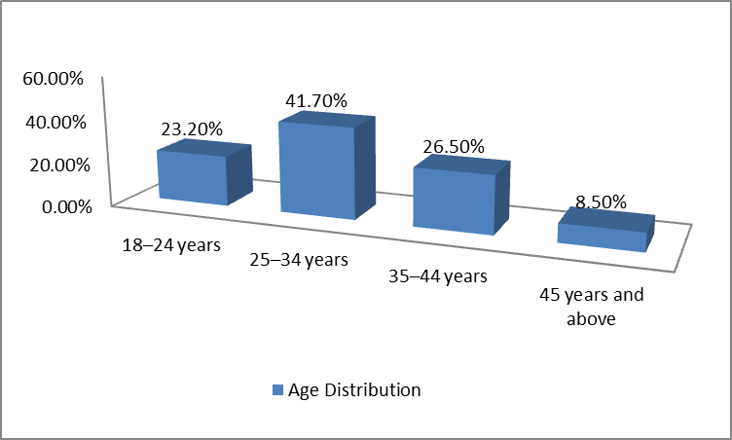
Figure 1: Age Distribution of Respondents
Source: Field Survey 2026
The age distribution of respondents shows that the majority of female sex workers living with HIV were within the 25–34 years age group, accounting for 41.7% of the sample. This was followed by participants aged 35–44 years, representing 26.5%, and those in the 18–24 years category, who constituted 23.2% of the respondents. The smallest proportion, 8.5%, were aged 45 years and above. Overall, these findings indicate that the study population was predominantly young to middle-aged adults, with more than two-thirds (67.5%) of respondents falling between 25 and 44 years.

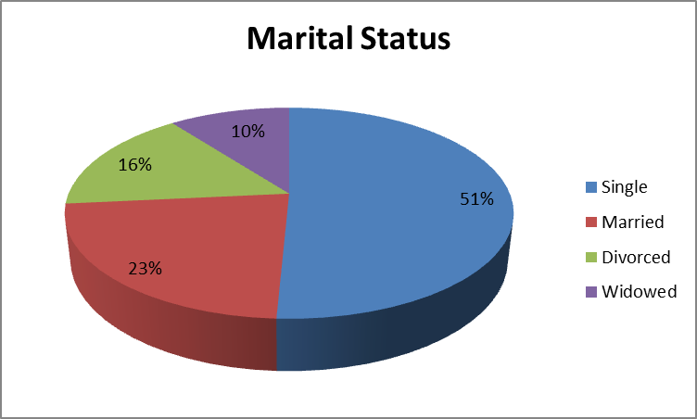
Figure 2: Marital Status of Respondents
Source: Field Survey 2026
The distribution of respondents by marital status indicates that slightly over half (51%) of the female sex workers living with HIV were single at the time of the study. Those who were married constituted 23%, while 16% were divorced. The smallest proportion of respondents (10%) was widowed.
These findings suggest that the study population was predominantly unmarried, with nearly half (49%) having experienced marriage either currently or previously. This distribution is important in understanding potential social support structures and relationship dynamics that may influence knowledge, attitude, and uptake of cervical cancer screening among the respondents.

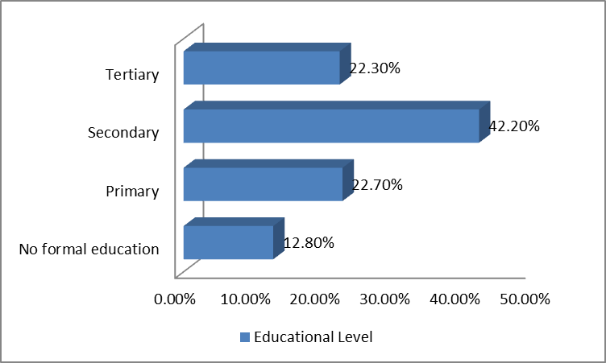
Figure 3: Educational Level of Respondents
Source: Field Survey 2026
The distribution of respondents by educational level shows that the largest proportion (42.2%) had attained secondary education, indicating that most participants had at least a basic level of formal schooling. Respondents with primary education constituted 22.7%, while a comparable proportion (22.3%) had attained tertiary education. A smaller percentage (12.8%) reported having no formal education.
Overall, the findings suggest that the majority of female sex workers living with HIV in the study possessed at least secondary-level education, with nearly two-thirds (64.5%) having completed secondary or tertiary education. This educational profile is important, as level of education may influence health literacy, awareness of cervical cancer, and utilization of screening services.
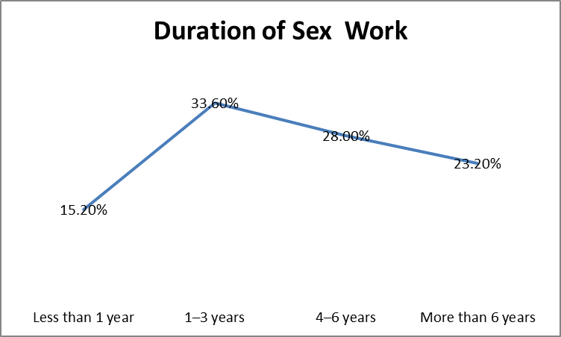
Figure 4: Duration of Sex Work among Respondents
Source: Field Survey 2026
The findings on the duration of sex work among respondents in figure 4 indicate that the majority had been engaged in sex work for a relatively extended period. Specifically, 33.6% of the respondents reported being involved in sex work for 1–3 years, representing the largest proportion in the distribution. This suggests that a significant segment of the study population is within the early-to-mid phase of occupational exposure.
Additionally, 28.0% of the respondents had been engaged in sex work for 4–6 years, while 23.2% reported more than 6 years of involvement. When combined, over half of the respondents (51.2%) had spent four years or more in sex work. This indicates prolonged exposure to occupational and sexual health risks, including increased vulnerability to sexually transmitted infections and cervical cancer, particularly among women living with HIV.
In contrast, only 15.2% of respondents had been involved in sex work for less than one year, representing the smallest proportion. This suggests that new entrants constitute a minority within the study population.
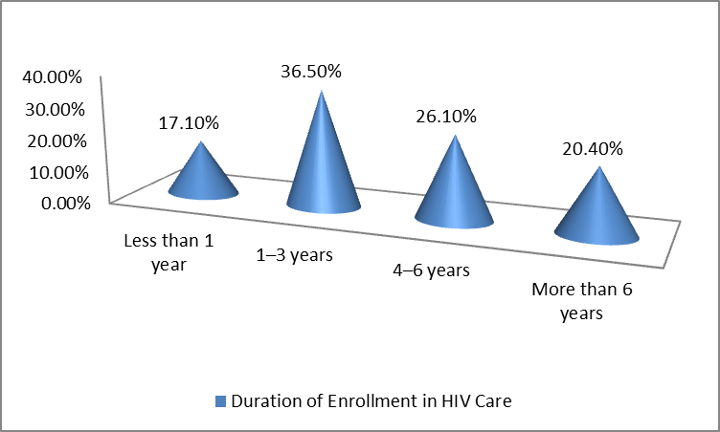
Figure 5: Duration of Enrollment in HIV Care among Respondents
Source: Field Survey 2026
Figure 5 presents the distribution of respondents according to their duration of enrollment in HIV care. The findings indicate that the largest proportion of respondents (36.5%) had been enrolled in HIV care for 1–3 years. This suggests that a considerable number of participants are relatively recent entrants into structured HIV treatment and follow-up services.
Furthermore, 26.1% of the respondents reported being enrolled in HIV care for 4–6 years, while 20.4% had been in care for more than six years. When combined, nearly half of the respondents (46.5%) had been enrolled for four years or longer, reflecting sustained engagement with HIV care services among a substantial proportion of the study population.
In contrast, 17.1% of the respondents had been enrolled in HIV care for less than one year, representing the smallest category. This indicates that newly diagnosed or newly enrolled individuals constitute a minority within the sample. The presence of a sizeable proportion of recently enrolled individuals underscores the need for early incorporation of cervical cancer education and screening into HIV care programs to enhance uptake from the onset of treatment.

4.1.2 Knowledge of cervical Cancer among respondents
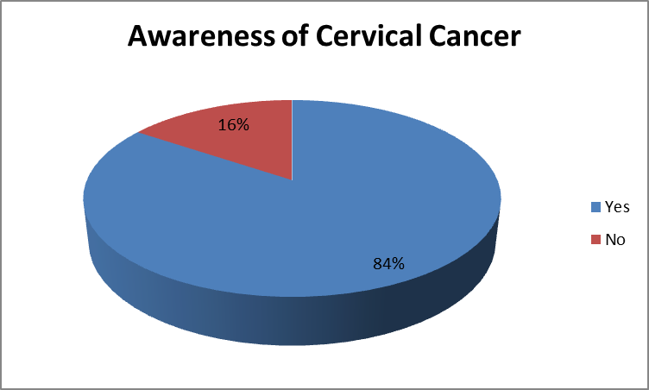
Figure 6: Awareness of Cervical Cancer among Respondents
Source: Field Survey 2026
Figure 6 shows the distribution of respondents based on awareness of cervical cancer. The findings indicate that a substantial majority of the respondents, 354 (84.0%), reported that they had heard of cervical cancer. In contrast, 68 respondents (16.0%) indicated that they had not heard of the disease prior to the study. The high level of awareness observed suggests that information regarding cervical cancer has reached a significant proportion of female sex workers living with HIV in Benue State. This may be attributable to health education provided during HIV clinic visits, community outreach programs, or exposure to media campaigns. However, the presence of 16% of respondents with no awareness remains concerning, given the increased vulnerability of women living with HIV to cervical cancer. This finding underscores the need for strengthened health education interventions within HIV care services to ensure universal awareness among this high-risk population.
Table 1: Knowledge of main cause of cervical cancer
Response Category | Frequency (f) | Percentage (%)
Human Papillomavirus (Correct) | 228 | 54.0
Incorrect Responses | 194 | 46.0
Total | 422 | 100.0

Table 1 presents respondents’ knowledge regarding the main cause of cervical cancer. The findings reveal that 228 respondents (54.0%) correctly identified Human Papillomavirus (HPV) as the primary cause of cervical cancer, while 194 respondents (46.0%) provided incorrect responses. The fact that just over half of the respondents were able to correctly identify HPV as the causative agent indicates a moderate level of specific knowledge about the etiology of cervical cancer. While general awareness of cervical cancer may be high, understanding of its biological cause appears less comprehensive. This distinction is important, as knowledge of HPV as the primary cause is crucial for appreciating the importance of preventive strategies such as HPV vaccination and routine cervical cancer screening.
The relatively high proportion of incorrect responses (46.0%) suggests a substantial knowledge gap within this high-risk population. Given that female sex workers living with HIV are particularly vulnerable to persistent HPV infection and progression to cervical cancer, limited understanding of the disease’s cause may reduce risk perception and negatively influence preventive health behaviors. From a public health perspective, this finding underscores the need for more focused educational interventions within HIV care programs. Health education sessions should emphasize the link between HPV infection and cervical cancer, particularly among women with compromised immune systems. Strengthening knowledge of causation may enhance perceived susceptibility and promote improved uptake of screening services.
Table 2 Knowledge of Cervical Cancer Symptoms (Multiple Responses) (N = 422)
Correct Symptoms | f | %
Post-coital bleeding | 232 | 55.0
Heavy/prolonged menstruation | 210 | 49.8
Foul-smelling discharge | 196 | 46.4
Pelvic pain | 218 | 51.7
Incorrect Symptoms | f | %
Headache | 96 | 22.7
Fever | 88 | 20.9

The findings in Table 2 indicate that the knowledge of cervical cancer symptoms among female sex workers living with HIV in Benue State was moderate. More than half of the respondents correctly identified post-coital bleeding (55.0%) and pelvic pain (51.7%) as symptoms of cervical cancer, while slightly fewer recognized heavy or prolonged menstruation (49.8%) and foul-smelling discharge (46.4%). This suggests that awareness of classic cervical cancer symptoms exists but is not comprehensive.
Conversely, a notable proportion of respondents mistakenly attributed unrelated symptoms to cervical cancer, with 22.7% identifying headache and 20.9% identifying fever as symptoms. This highlights gaps in accurate knowledge and potential misconceptions that could affect timely recognition and screening behaviors.

Table 3 Overall Level of Knowledge of Cervical Cancer (N = 422)
Knowledge Level | Frequency (f) | Percentage (%)
Good | 176 | 41.7
Moderate | 150 | 35.5
Poor | 96 | 22.8
Total | 422 | 100.0

Table 3 shows that the overall level of knowledge of cervical cancer among female sex workers living with HIV in Benue State was varied. A substantial proportion of respondents (41.7%) demonstrated good knowledge, indicating awareness of risk factors, symptoms, and preventive measures. However, over one-third (35.5%) had only moderate knowledge, and 22.8% exhibited poor knowledge, reflecting significant gaps in understanding. These findings suggest that while some respondents are well-informed, a considerable number may lack sufficient knowledge to recognize symptoms or seek timely screening, highlighting the need for targeted educational interventions.

4.1.3 Knowledge of Cervical Cancer Screening
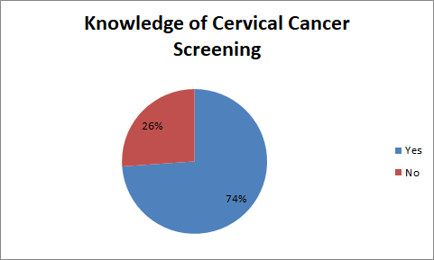
Figure 7: Knowledge of Cervical Cancer Screening among Respondents
Source: Field Survey 2026
Figure 7 shows that a clear majority of the respondents had heard of cervical cancer screening. Specifically, 312 respondents (74%) reported that they were aware of cervical cancer screening, while 110 respondents (26%) indicated that they had not heard of it. This finding suggests a relatively high level of awareness among female sex workers living with HIV in Benue State. The fact that nearly three-quarters of the respondents are aware of screening is encouraging and may reflect exposure to health education within HIV care settings. However, the presence of over one-quarter (26%) who lack awareness indicates a significant knowledge gap. This gap is concerning given that women living with HIV are at increased risk of cervical cancer and require regular screening.
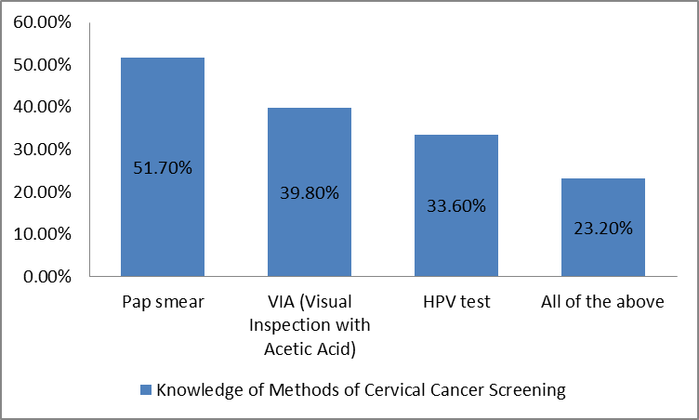
Figure 8: Knowledge of Methods of Cervical Cancer Screening
Source: Field Survey 2026
Figure 8 presents respondents’ knowledge of the methods of cervical cancer screening. The findings indicate that the most recognized method was Pap smear, identified by 218 respondents (51.7%). This suggests that Pap smear is the most widely known screening technique among female sex workers living with HIV in Benue State. Knowledge of VIA (Visual Inspection with Acetic Acid) was reported by 168 respondents (39.8%), while 142 respondents (33.6%) identified the HPV test as a screening method. Although these proportions reflect some level of awareness, they are notably lower than that of Pap smear, indicating uneven knowledge across available screening options. Importantly, only 98 respondents (23.2%) correctly selected “All of the above,” demonstrating comprehensive knowledge that all listed options are valid screening methods. This relatively low percentage suggests that while many respondents are familiar with individual methods, fewer possess complete knowledge of the full range of screening modalities.
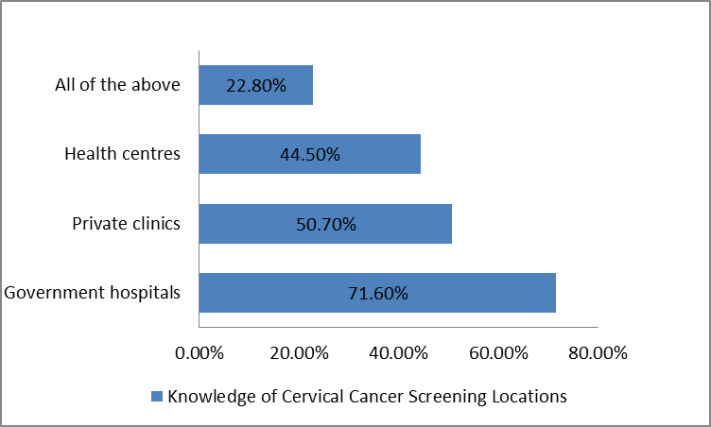
Figure 9: Knowledge of Cervical Cancer Screening Locations among the Respondents
Source: Field Survey 2026
Figure 9 illustrates respondents’ knowledge of locations where cervical cancer screening services can be accessed. The findings show that the majority of respondents identified government hospitals, with 302 respondents (71.6%) recognizing them as screening centers. This indicates that public health facilities are the most widely known source of cervical cancer screening services among female sex workers living with HIV in Benue State. Knowledge of private clinics was reported by 214 respondents (50.7%), while 188 respondents (44.5%) identified health centres as possible screening locations. Although these figures reflect moderate awareness, they are considerably lower than that for government hospitals, suggesting that respondents may associate screening services more strongly with public tertiary or secondary facilities. Notably, only 96 respondents (22.8%) selected “All of the above,” demonstrating comprehensive knowledge that screening services are available across different levels of healthcare facilities. This relatively low percentage suggests limited awareness of the full range of accessible screening points.
Table 4 Overall Knowledge of Cervical Cancer Screening Among Female Sex Workers Living with HIV (N = 422)
Knowledge Level | Score Range (%) | Frequency (f) | Percentage (%)
Good Knowledge | 70–100 | 182 | 43.1
Moderate Knowledge | 50–69 | 148 | 35.1
Poor Knowledge | 0–49 | 92 | 21.8
Total |  | 422 | 100.0

Table 4 shows that the overall knowledge of cervical cancer screening among female sex workers living with HIV in Benue State was moderately high. A total of 182 respondents (43.1%) demonstrated good knowledge (score range 70–100%), indicating that they correctly identified key aspects of screening, including methods, frequency, locations, and its preventive role. Additionally, 148 respondents (35.1%) had moderate knowledge (50–69%), suggesting partial understanding but with some gaps in important areas. However, 92 respondents (21.8%) exhibited poor knowledge (0–49%), reflecting limited awareness or misconceptions about cervical cancer screening. While a significant proportion of respondents possess good knowledge, more than half (56.9%) fall within moderate or poor categories, highlighting the need for strengthened health education and targeted sensitization programs within HIV care settings to improve comprehensive understanding and promote informed uptake of screening services.

4.1.4 Attitude toward Cervical Cancer Screening
Table 5 Attitude toward Cervical Cancer Screening among Female Sex Workers Living with HIV (N = 422)
Items | SA | A | D | SD | % A | % D
Cervical cancer screening is important for my health | 210 | 142 | 46 | 24 | 83.4 | 16.6
I feel comfortable attending a cervical cancer screening at a clinic | 168 | 134 | 78 | 42 | 71.6 | 28.4
Cervical cancer screening is necessary even if I feel healthy | 186 | 138 | 62 | 36 | 76.8 | 23.2
I would recommend cervical cancer screening to friends or peers | 174 | 150 | 64 | 34 | 76.8 | 23.2
Cervical cancer screening could interfere with my daily activities | 58 | 96 | 170 | 98 | 36.5 | 63.5

The data presented in table 5 indicate a generally positive attitude toward cervical cancer screening among female sex workers living with HIV in Benue State. A substantial majority of respondents, 352 (83.4%), agreed that cervical cancer screening is important for their health, demonstrating strong recognition of its value. Similarly, 324 respondents (76.8%) agreed that screening is necessary even when feeling healthy, reflecting good preventive health orientation. Comfort with accessing screening services was also relatively high, with 302 respondents (71.6%) expressing agreement that they feel comfortable attending screening at a clinic. Furthermore, 324 respondents (76.8%) indicated willingness to recommend screening to friends or peers, suggesting positive peer influence potential within this population. Regarding perceived barriers, only 154 respondents (36.5%) agreed that screening could interfere with their daily activities, while a larger proportion, 268 (63.5%), disagreed. This suggests that most respondents do not view screening as significantly disruptive to their routine.

4.2 Test of Hypotheses

4.2.1 Test of Hypothesis One
H₀₁: There is no significant relationship between knowledge and attitude towards cervical cancer screening among female sex workers living with HIV in Benue State.
Table 6- Pearson Correlation Matrix Showing Relationship between Knowledge and Attitude (N = 422)
Variable | Mean | SD | 1 | 2
1. Knowledge | 2.21 | 0.74 | 1
2. Attitude | 2.96 | 0.68 | 0.452** | 1
**P<0.01
Table 6 shows the Pearson correlation analysis between knowledge and attitude towards cervical cancer screening. The result revealed a moderate positive relationship (r = 0.452, p < 0.01). This indicates that higher knowledge is significantly associated with a more positive attitude. Therefore, the null hypothesis was rejected.

4.2.2 Test of Hypothesis Two
H₀₂ There is no relationship between knowledge and uptake of cervical cancer screening among female sex workers living with HIV in Benue State.
Table 7 Cross-tabulation of Knowledge and Uptake of Cervical Cancer Screening (N = 422)
Knowledge Level | High Uptake n (%) | Low Uptake n (%) | Total n (%)
Good Knowledge | 120 (68.2%) | 56 (31.8%) | 176 (100%)
Moderate Knowledge | 60 (40.0%) | 90 (60.0%) | 150 (100%)
Poor Knowledge | 24 (25.0%) | 72 (75.0%) | 96 (100%)
Total | 204 (48.3%) | 218 (51.7%) | 422 (100%)

Table 8 Chi-Square Test of Association between Knowledge and Uptake (N = 422)
Test | χ² | df | p-value | Cramér’s V
Pearson Chi-Square | 48.63 | 2 | 0.000 | 0.24

Decision Rule
Reject H₀ if p ≤ 0.05.
Fail to reject H₀ if p > 0.05.
The data presented in table 8 shows the Chi-Square Test of Association between Knowledge and Uptake. The result indicates a statistically significant relationship between knowledge and uptake of cervical cancer screening among female sex workers living with HIV in Benue State (χ² = 48.63, df = 2, p < 0.05). Since the p-value (0.000) is less than 0.05, the null hypothesis is rejected. The cross-tabulation shows that respondents with good knowledge demonstrated the highest proportion of high uptake (68.2%), compared to those with moderate knowledge (40.0%) and poor knowledge (25.0%). Conversely, low uptake was highest among respondents with poor knowledge (75.0%). The strength of association, measured using Cramér’s V (0.24), indicates a moderate relationship between knowledge and screening uptake. These findings suggest that improved knowledge of cervical cancer screening is significantly associated with increased likelihood of utilizing screening services among female sex workers living with HIV.

Discussion of Findings

Discussion of Knowledge of cervical Cancer among respondents
Figure 6 indicates that 354 respondents (84.0%) had heard of cervical cancer, while 68 (16.0%) had no prior awareness of the disease. This high level of awareness suggests that cervical cancer information has reached a large proportion of female sex workers living with HIV in Benue State, possibly through HIV clinic visits, outreach activities, or media exposure. Nevertheless, the 16% without awareness remains concerning given their heightened vulnerability.
This finding is higher than that reported by Getachew et al. (2019), where less than half of respondents had heard of cervical cancer screening, and also contrasts with Taneja et al. (2021), who documented generally low knowledge levels across multiple studies in India. The higher awareness observed in the present study may reflect the structured nature of HIV care programs, where health education is often integrated into routine services. However, similar to findings by Okunowo et al. (2018), high awareness does not necessarily translate into adequate knowledge of risk factors or increased screening uptake. Therefore, while awareness in this study is encouraging, it does not automatically imply comprehensive understanding or optimal screening behavior.
Table 1 presents respondents’ knowledge regarding the main cause of cervical cancer. The findings reveal that 228 respondents (54.0%) correctly identified Human Papillomavirus (HPV) as the primary cause of cervical cancer, while 194 respondents (46.0%) provided incorrect responses. The fact that just over half of the respondents were able to correctly identify HPV as the causative agent indicates a moderate level of specific knowledge about the etiology of cervical cancer. While general awareness of cervical cancer may be high, understanding of its biological cause appears less comprehensive. This distinction is important, as knowledge of HPV as the primary cause is crucial for appreciating the importance of preventive strategies such as HPV vaccination and routine cervical cancer screening.
The relatively high proportion of incorrect responses (46.0%) suggests a substantial knowledge gap within this high-risk population. Given that female sex workers living with HIV are particularly vulnerable to persistent HPV infection and progression to cervical cancer, limited understanding of the disease’s cause may reduce risk perception and negatively influence preventive health behaviors. From a public health perspective, this finding underscores the need for more focused educational interventions within HIV care programs. Health education sessions should emphasize the link between HPV infection and cervical cancer, particularly among women with compromised immune systems. Strengthening knowledge of causation may enhance perceived susceptibility and promote improved uptake of screening services.
The findings in Table 2 show that knowledge of cervical cancer symptoms among female sex workers living with HIV in Benue State was moderate. Slightly over half correctly identified post-coital bleeding (55.0%) and pelvic pain (51.7%) as symptoms, while fewer recognized heavy or prolonged menstruation (49.8%) and foul-smelling discharge (46.4%). However, misconceptions were evident, as 22.7% and 20.9% incorrectly identified headache and fever, respectively, as symptoms.
This pattern is comparable to findings by Okunowo et al. (2018), who reported that although awareness of cervical cancer was relatively high among women attending a tertiary hospital in Nigeria, knowledge of symptoms and risk factors remained poor. Similarly, Taneja et al. (2021) documented low overall knowledge of cervical cancer symptoms and screening practices across multiple studies in India, emphasizing persistent informational gaps.
In contrast, scientific reviews such as Perkins et al. (2023) clearly outline abnormal vaginal bleeding particularly post-coital bleeding as a hallmark symptom of cervical cancer. The moderate recognition of such key symptoms in the present study suggests partial alignment with established medical knowledge but also indicates incomplete understanding.
The presence of misconceptions (e.g., attributing headache and fever to cervical cancer) reflects gaps similar to those identified by Getachew et al. (2019), who found inadequate knowledge of screening and disease characteristics among women in Ethiopia. For a high-risk group such as female sex workers living with HIV, inaccurate symptom recognition may delay health-seeking behavior and screening uptake. Therefore, targeted health education within HIV care services should emphasize accurate symptom identification to improve early detection and preventive screening practices.
Table 3 reveals that 41.7% of respondents demonstrated good knowledge of cervical cancer, 35.5% had moderate knowledge, and 22.8% exhibited poor knowledge. Although a notable proportion appears well-informed, over half of the respondents (58.3%) had either moderate or poor knowledge, indicating persistent informational gaps within this high-risk population.
This finding is slightly higher than the overall knowledge level reported by Taneja et al. (2021), who found that only about 40% of women across reviewed studies demonstrated adequate knowledge of cervical cancer and screening. Similarly, Tekle et al. (2020) reported that 43.1% of respondents had good knowledge, a figure closely comparable to the 41.7% observed in the present study. In contrast, Getachew et al. (2019) documented even lower levels of adequate knowledge, with less than one-third of participants demonstrating sufficient understanding of cervical cancer screening. Although the present study shows relatively better knowledge compared to some African and Asian settings, the substantial proportion of respondents with moderate and poor knowledge aligns with findings by Okunowo et al. (2018), who noted that awareness did not necessarily translate into comprehensive understanding of cervical cancer risk factors and prevention.

Discussion of Knowledge of Cervical Cancer Screening
Figure 7 indicates that 74% of respondents had heard of cervical cancer screening, while 26% had not. This reflects a relatively high level of screening awareness among female sex workers living with HIV in Benue State. The high awareness may be linked to exposure to health education during HIV clinic visits or outreach activities. However, the 26% without awareness represents a significant gap, particularly given the increased vulnerability of women living with HIV to cervical cancer.
This level of awareness is higher than that reported by Getachew et al. (2019), where less than half of respondents were aware of cervical cancer screening. Similarly, Taneja et al. (2021) documented generally low screening awareness and practice across multiple studies in India. The comparatively higher awareness observed in the present study may reflect the structured nature of HIV care services, where health education is more routinely integrated. However, consistent with findings by Okunowo et al. (2018), awareness alone does not necessarily translate into actual screening uptake. Scientific reviews such as Bedell et al. (2020) and Perkins et al. (2023) emphasize that effective cervical cancer prevention requires not only awareness but also regular and accessible screening services.
Figure 8 shows that Pap smear was the most recognized screening method (51.7%), followed by Visual Inspection with Acetic Acid (VIA) (39.8%) and HPV testing (33.6%). However, only 23.2% correctly identified that all listed options are valid screening methods, indicating limited comprehensive knowledge of the full range of screening modalities. The dominance of Pap smear awareness is consistent with findings by Okunowo et al. (2018), who reported that Pap smear was the most commonly known screening method among women attending a tertiary hospital in Nigeria, although actual uptake remained low. This suggests that Pap smear continues to be the most publicized and historically established screening technique in many low- and middle-income settings.
Table 4 indicates that 43.1% of respondents demonstrated good knowledge of cervical cancer screening, 35.1% had moderate knowledge, and 21.8% exhibited poor knowledge. Although a substantial proportion appears well-informed, the fact that 56.9% fall within moderate or poor categories reveals persistent gaps in comprehensive understanding of screening methods, frequency, locations, and preventive benefits. This finding is comparable to Tekle et al. (2020), who reported that fewer than half of participants had good knowledge of cervical cancer screening, with many demonstrating partial or inadequate understanding. Similarly, Taneja et al. (2021) documented generally low levels of knowledge and screening practice across multiple studies, indicating that incomplete knowledge remains a widespread challenge.
In Nigeria, Okunowo et al. (2018) observed that awareness of Pap smear was relatively high; however, detailed understanding and actual uptake were low, reinforcing the distinction between awareness and comprehensive knowledge. Likewise, Getachew et al. (2019) found that limited knowledge significantly affected screening behavior, particularly where structured education was lacking. Although the present study shows a relatively higher proportion of good knowledge compared to some African and Asian settings, the substantial percentage of respondents with moderate and poor knowledge underscores the need for strengthened, structured health education within HIV care services. For a high-risk population such as female sex workers living with HIV, comprehensive knowledge is critical to fostering informed decision-making and improving consistent uptake of cervical cancer screening.

4.2.4 Discussion of Attitude toward Cervical Cancer Screening
The findings in Table 5 demonstrate a predominantly positive attitude toward cervical cancer screening among female sex workers living with HIV in Benue State. The high proportion of respondents who acknowledged the importance of screening for their health (83.4%) aligns with evidence from several Nigerian and sub-Saharan African studies reporting favorable attitudinal dispositions among women engaged in HIV care services. For instance, studies conducted in Southwestern Nigeria and parts of East Africa have similarly reported high levels of agreement regarding the importance of cervical cancer screening among women living with HIV, often attributed to routine counselling integrated into antiretroviral therapy clinics. This pattern suggests that structured health education within HIV treatment settings plays a critical role in shaping positive health attitudes.
The finding that 76.8% of respondents agreed that screening is necessary even in the absence of symptoms reflects a strong preventive health orientation. Comparable results have been documented in studies conducted in tertiary health facilities in Southern Nigeria, where women receiving continuous HIV care demonstrated increased understanding of asymptomatic disease progression and the need for routine screening. However, in contrast, some studies in Northern Nigeria and rural East African settings have reported lower proportions of women endorsing preventive screening when asymptomatic, largely due to limited awareness and sociocultural misconceptions about cancer. The comparatively higher proportion observed in the present study may therefore reflect improved integration of reproductive health counselling within HIV programmes in Benue State.
Regarding perceived barriers, the majority (63.5%) disagreed that screening interferes with daily activities, indicating relatively low perceived structural disruption. This contrasts with findings from some rural Nigerian studies where time constraints, clinic waiting periods, and opportunity costs were identified as significant deterrents. The lower perception of disruption observed in the present study may reflect better service organization within HIV clinics or greater prioritization of health among women already engaged in chronic care management.

5.3 Conclusion
This study assessed the knowledge, attitude, uptake, and perceived barriers to cervical cancer screening among female sex workers living with HIV in Benue State. Based on the findings, it can be concluded that although respondents demonstrated moderately high knowledge and generally positive attitudes toward cervical cancer screening, actual uptake of screening services remains suboptimal. The study established that a considerable proportion of respondents possessed good knowledge of cervical cancer screening; however, notable knowledge gaps persist, particularly regarding screening frequency, procedural details, and its preventive significance. While attitudinal disposition toward screening was largely favorable with most respondents acknowledging its importance and expressing willingness to recommend it to peers but this positive outlook did not sufficiently translate into consistent screening behavior.

5.4 Recommendations
The following recommendations are made based on the specific objectives and findings of this study:
1. Recommendations Based on Knowledge of Cervical Cancer Screening
Given that a significant proportion of respondents demonstrated only moderate or poor knowledge of cervical cancer screening, there is a need to strengthen comprehensive health education within HIV care settings.
2. Recommendations Based on Attitude toward Cervical Cancer Screening
Although respondents generally exhibited positive attitudes toward screening, efforts should be made to sustain and further strengthen these favorable perceptions. HIV clinics should institutionalize routine counseling that emphasizes the importance of preventive screening even in the absence of symptoms. Positive testimonials from screened clients and peer-led advocacy initiatives may be incorporated to enhance motivation. Healthcare workers should also maintain respectful, non-judgmental, and confidential service environments to preserve the comfort level already expressed by many respondents.

REFERENCES
Abu, G. A., & Kotur, L. N. (2022). Impact of HIV/AIDS on farmers’ productivity in Nigeria: Evidence from Benue State, Nigeria. Direct Research Journal of Agriculture and Food Science, 10(8), 185-192.
Akinfenwa, A. T., & Monsur, T. A. (2018). Burden of cervical cancer in Northern Nigeria. Tropical Journal of Obstetrics and Gynaecology, 35(1), 25-29.
Austin, R. M., Onisko, A., & Zhao, C. (2018). Enhanced detection of cervical cancer and precancer through use of imaged liquid-based cytology in routine cytology and HPV cotesting. American journal of clinical pathology, 150(5), 385-392.
Bedell, S. L., Goldstein, L. S., Goldstein, A. R., & Goldstein, A. T. (2020). Cervical cancer screening: past, present, and future. Sexual medicine reviews, 8(1), 28-37.
Bhat, D. (2022). The ‘Why and How’of cervical cancers and genital HPV infection. Cytojournal, 19, 22.
Black, E., Hyslop, F., & Richmond, R. (2019). Barriers and facilitators to uptake of cervical cancer screening among women in Uganda: a systematic review. BMC women's health, 19(1), 1-12.
Canfell, K., Kim, J. J., Brisson, M., Keane, A., Simms, K. T., Caruana, M., ... & Hutubessy, R. (2020). Mortality impact of achieving WHO cervical cancer elimination targets: a comparative modelling analysis in 78 low-income and lower-middle-income countries. The Lancet, 395(10224), 591-603.
Canfell, K., Kim, J. J., Brisson, M., Keane, A., Simms, K. T., Caruana, M., ... & Hutubessy, R. (2020). Mortality impact of achieving WHO cervical cancer elimination targets: a comparative modelling analysis in 78 low-income and lower-middle-income countries. The Lancet, 395(10224), 591-603.
Carvalho, N. S. D., Silva, R. J. D. C. D., Val, I. C. D., Bazzo, M. L., & Silveira, M. F. D. (2021). Brazilian protocol for sexually transmitted infections 2020: Human papillomavirus (hpv) infection. Revista da Sociedade Brasileira de Medicina Tropical, 54(suppl 1), e2020790.
Castle, P. E., Einstein, M. H., and Sahasrabuddhe, V. V. (2021). Cervical cancer prevention and control in women living with human immunodeficiency virus. CA: a cancer journal for clinicians, 71(6), 505-526.
Chan, D. N., Law, B. M., So, W. K., & Fan, N. (2022). Factors associated with cervical cancer screening utilisation by people with physical disabilities: A systematic review. Health Policy, 126(10), 1039-1050.
Chien, S. Y., Chuang, M. C., & Chen, I. P. (2020). Why people do not attend health screenings: factors that influence willingness to participate in health screenings for chronic diseases. International journal of environmental research and public health, 17(10), 3495.
Chow, E. P., Grulich, A. E., & Fairley, C. K. (2019). Epidemiology and prevention of sexually transmitted infections in men who have sex with men at risk of HIV. The lancet HIV, 6(6), e396-e405.
Chrysostomou, A. C., & Kostrikis, L. G. (2020). Methodologies of primary HPV testing currently applied for cervical cancer screening. Life, 10(11), 290.
Daponte, N., Valasoulis, G., Michail, G., Magaliou, I., Daponte, A. I., Garas, A., ... & Daponte, A. (2023). HPV-based self-sampling in cervical cancer screening: an updated review of the current evidence in the literature. Cancers, 15(6), 1669.
Denny, L., de Sanjose, S., Mutebi, M., Anderson, B. O., Kim, J., Jeronimo, J., ... & Sankaranarayanan, R. (2017). Interventions to close the divide for women with breast and cervical cancer between low-income and middle-income countries and high-income countries. The Lancet, 389(10071), 861-870.
Devarapalli, P., Labani, S., Nagarjuna, N., Panchal, P., & Asthana, S. (2018). Barriers affecting uptake of cervical cancer screening in low- and middle-income countries: A systematic review. Indian Journal of Cancer, 55(4), 318-326.
Farahmand, M., Moghoofei, M., Dorost, A., Abbasi, S., Monavari, S. H., Kiani, S. J.,and Tavakoli, A. (2020). Prevalence and genotype distribution of genital human papillomavirus infection in female sex workers in the world: a systematic review and meta-analysis. BMC Public Health, 20(1), 1455.
Farahmand, M., Moghoofei, M., Dorost, A., Abbasi, S., Monavari, S. H., Kiani, S. J., & Tavakoli, A. (2020). Prevalence and genotype distribution of genital human papillomavirus infection in female sex workers in the world: a systematic review and meta-analysis. BMC Public Health, 20(1), 1455.
Osunde, N. R., Anayo, M. N., Patience, O., and Omoregie, F. E. (2024). Cervical cancer screening utilization among HIV-positive women in Edo State, Nigeria. MGM Journal of Medical Sciences, 11(2), 318-324.
Oyervides-Muñoz, M. A., Pérez-Maya, A. A., Rodríguez-Gutiérrez, H. F., Gómez-Macias, G. S., Fajardo-Ramírez, O. R., Treviño, V., ... & Garza-Rodríguez, M. L. (2018). Understanding the HPV integration and its progression to cervical cancer. Infection, Genetics and Evolution, 61, 134-144.
Pimple, S., & Mishra, G. (2022). Cancer cervix: Epidemiology and disease burden. Cytojournal, 19, 21.
Plotzker, R. E., Vaidya, A., Pokharel, U., & Stier, E. A. (2023). Sexually transmitted human papillomavirus: update in epidemiology, prevention, and management. Infectious Disease Clinics, 37(2), 289-310.
Singh, D., Vignat, J., Lorenzoni, V., Eslahi, M., Ginsburg, O., Lauby-Secretan, B., ... and Vaccarella, S. (2023). Global estimates of incidence and mortality of cervical cancer in 2020: a baseline analysis of the WHO Global Cervical Cancer Elimination Initiative. The lancet global health, 11(2), e197-e206.
Sowemimo, O. O., Ojo, O. O., & Fasubaa, O. B. (2017). Cervical cancer screening and practice in low resource countries: Nigeria as a case study. Tropical Journal of Obstetrics and Gynaecology, 34(3), 170-176.
Swailes, A. L., Hossler, C. E., & Kesterson, J. P. (2019). Pathway to the Papanicolaou smear: The development of cervical cytology in twentieth-century America and implications in the present day. Gynecologic oncology, 154(1), 3-7.
Swanson, A. A., & Pantanowitz, L. (2024). The evolution of cervical cancer screening. Journal of the American Society of Cytopathology, 13(1), 10-15.
Taneja, N., Chawla, B., Awasthi, A. A., Shrivastav, K. D., Jaggi, V. K., & Janardhanan, R. (2021). Knowledge, attitude, and practice on cervical cancer and screening among women in India: a review. Cancer Control, 28, 10732748211010799.
Tekle, T., Wolka, E., Nega, B., Kumma, W. P., & Koyira, M. M. (2020). Knowledge, attitude and practice towards cervical cancer screening among women and associated factors in hospitals of Wolaita Zone, Southern Ethiopia. Cancer management and research, 993-1005.
Vimpere, L., Sami, J., & Jeannot, E. (2023). Cervical cancer screening programs for female sex workers: a scoping review. Frontiers in public health, 11, 1226779.
Wanyenze, R. K., Musinguzi, G., Kiguli, J., Nuwaha, F., Mujisha, G., Musinguzi, J., ... & Matovu, J. K. (2017). “When they know that you are a sex worker, you will be the last person to be treated”: perceptions and experiences of female sex workers in accessing HIV services in Uganda. BMC international health and human rights, 17(1), 11.

