KNOWLEDGE, PERCEPTIONS, AND PRACTICES OF FOOD HYGIENE AMONG URBAN STREET VENDORS IN ABAKALIKI METROPOLIS

Abstract
Background: Food‑borne diseases remain a major public health concern in Nigeria, where unsafe food handling by street vendors contributes to outbreaks of diarrhoea, cholera, and typhoid. Street‑vended foods are essential for urban food security but often prepared under poor sanitary conditions. This study assessed the knowledge, perceptions, and practices of food hygiene among urban street food vendors in Abakaliki metropolis and examined associated socio‑demographic predictors.
Methods: A descriptive cross‑sectional survey was conducted among 358 randomly selected vendors using a structured interviewer‑administered questionnaire adapted from WHO/FAO guidelines. Descriptive statistics summarized socio‑demographics, knowledge, perceptions, and practices, while chi‑square tests and logistic regression identified predictors. Statistical significance was set at p<0.05.
Results: Most vendors were female (79.4%) and married (53.2%), with relatively high education levels (40.3% tertiary). Overall, 89.3% demonstrated excellent knowledge of food hygiene, though only 79.4% acknowledged the importance of regular medical checks. Perceptions were generally positive (mean=3.42±0.23), yet 76.6% held less positive views. Hygiene practices were strong, with 91.3% showing excellent compliance in handwashing, food covering, and use of clean water, though medical monitoring was weak. Predictor analysis revealed that vendors aged ≥41 years (aOR=8.35, 95% CI: 1.658–42.055), females (aOR=3.742, 95% CI: 1.717–8.157), and those with tertiary education (aOR=8.716, 95% CI: 2.911–26.098) were more likely to have excellent knowledge. Marital status influenced perceptions, with married (aOR=2.832, 95% CI: 1.261–6.359) and divorced/separated vendors (aOR=7.429, 95% CI: 2.082–26.499) more likely to hold highly positive perceptions. No significant predictors were found for hygiene practices.
Conclusion: Street food vendors in Abakaliki demonstrated commendably high knowledge and practices of food hygiene, but weaker perceptions and poor adherence to medical monitoring. Continuous training, improved infrastructure, and stronger enforcement are needed to sustain safe food handling and reduce food‑borne disease burden.
Keywords: Food hygiene, Street food vendors, Knowledge, Perceptions, Practices, Nigeria

Introduction
Food hygiene remains a pressing public health concern globally, particularly in low‑ and middle‑income countries (LMICs), where food‑borne diseases continue to contribute significantly to morbidity and mortality despite decades of interventions. The World Health Organization (WHO, 2025) emphasizes that safe food handling is fundamental to preventing contamination and ensuring consumer health. In Nigeria, rapid urbanization has intensified reliance on street‑vended foods, which provide affordable and accessible meals but often operate under poor sanitary conditions. Consequently, diarrhoea, cholera, and typhoid remain common, with unsafe food handling practices frequently implicated in outbreaks (WHO, 2025).
Street‑vended foods are vital to urban food security in LMICs, offering affordable nutrition to millions of households. However, they are frequently implicated in food‑borne risks due to inadequate hygiene practices and weak regulatory oversight (Salamandane et al., 2023a). The Hazard Analysis and Critical Control Points (HACCP) system provides a globally recognized preventive framework for food safety, emphasizing hazard identification, critical control points, and monitoring procedures. While HACCP principles are essential for minimizing contamination risks, their application among street vendors remains inconsistent, largely due to infrastructural limitations, lack of formal training, and weak enforcement (WHO, 2025). Nigerian studies report mixed levels of hygiene knowledge and practice across states, underscoring the importance of context‑specific inquiry (Osman et al., 2025). Evidence from Ebonyi State suggests that targeted training can improve vendor knowledge and practices, yet the everyday realities of street‑level vending in Abakaliki remain under‑explored qualitatively (Onuoha, 2022).
Behavioural models provide additional insight into hygiene behaviour. The Theory of Planned Behaviour (TPB) explains how attitudes, subjective norms, and perceived behavioural control influence intentions and actions, while the Health Belief Model (HBM) highlights the role of perceived susceptibility, severity, benefits, and barriers in shaping preventive behaviours (Ajzen, 2021; Asefa et al., 2022). Applied to food vending, these models suggest that vendors’ beliefs about contamination, social pressures from customers or inspectors, and infrastructural constraints interact to determine hygiene practices. Integrating HACCP principles with behavioural frameworks therefore offers a comprehensive lens for exploring both knowledge and practice among street food vendors.
Despite evidence from other Nigerian cities showing variable hygiene knowledge and inconsistent practices, little is known about the situation in Abakaliki. Understanding vendors’ perceptions and practices is critical because knowledge alone does not guarantee compliance; external barriers such as inadequate facilities and economic constraints often prevent translation into safe behaviour (Okojie & Isah, 2019). This study therefore seeks to explore the perceptions and practices of food hygiene among urban street vendors in Abakaliki Metropolis, with the aim of generating context‑specific evidence to inform public health interventions and strengthen food safety outcomes.

Methodology

Research Design
This study adopted a descriptive cross sectional survey design to quantitatively assess the knowledge, perceptions, and practices of food hygiene among street food vendors in Abakaliki Metropolis, Ebonyi State. The design was appropriate for systematically collecting and analyzing numerical data to describe the characteristics and behaviours of the target population.

Study Area
The research was conducted in Abakaliki, the capital of Ebonyi State in southeastern Nigeria. The metropolis covers approximately 106 km² and comprises Abakaliki and Ebonyi Local Government Areas. Street food vending is concentrated in major markets (e.g., Kpirikpiri, Meat Market, International Market), motor parks, schools, and roadside kiosks. The city faces challenges of waste management, inadequate water supply, and weak regulatory enforcement, making it a suitable context for examining food hygiene practices.

Study Population
The study population consisted of street food vendors operating within the Abakaliki metropolis. Vendors were included if they sold ready to eat foods, were aged 18 years or older, had operated for at least three months, and could communicate in English or Igbo. Vendors selling only factory sealed foods were excluded.

Sample Size Determination
The sample size was calculated using the formula for an unknown population as described by Cochran (1963).
$$n=\frac{Z^{2}×p×\left(1-p\right)}{d^{2}}$$
Where Z = standard normal deviate (i.e. 1.96 at α = 0.05)
p = prevalence of good level of hygiene practice (Chukuezi, 2010) i.e. 37%
d = error value (i.e. 0.05)
$$n=\frac{{1.96}^{2}×0.37×\left(1-0.37\right)}{{0.05}^{2}}$$
$$n=\frac{3.8416×0.37×0.63}{0.0025}=\frac{0.8955}{0.0025}=358.19≈358$$
Thus, a sample size of 358 vendors was selected.

Sampling Technique
A stratified random sampling technique was employed to ensure representation across different vending locations. The metropolis was stratified into major markets, motor parks, and roadside vending clusters. Within each stratum, vendors were randomly selected using simple random sampling. This approach minimized bias and enhanced generalizability.

Instrument for Data Collection
Data were collected using a structured questionnaire adapted from WHO/FAO guidelines and previous studies (Hassan et al., 2020; Johnson et al., 2020c). The instrument contained forty‑two items organized into four sections. The first section captured socio‑demographic characteristics of respondents, while the second assessed their knowledge of food hygiene based on international standards. The third section explored perceptions and attitudes toward food hygiene, and the final section examined hygiene practices during food preparation, storage, and sales. The questionnaire was originally developed in English, but to ensure inclusivity, research assistants provided translation into Igbo for vendors with limited literacy. This approach enabled all participants to engage meaningfully with the survey regardless of language barriers. Responses were recorded using structured formats, including dichotomous options such as Yes or No, Likert scales to measure attitudes and perceptions, and frequency scales to capture hygiene practices. The standardized structure of the questionnaire ensured consistency across responses and facilitated accurate quantitative analysis.

Validity and Reliability
Face and content validity were established through expert review by specialists in Public Health and Food & Nutrition at Alex Ekwueme Federal University Teaching Hospital. Reliability was tested via a pilot study among 36 vendors in Enugu, yielding a Cronbach’s alpha of 0.837, indicating strong internal consistency.

Data Collection
Questionnaires were administered by the researcher and trained assistants using an interviewer administered technique to minimize literacy barriers. Data collection spanned five to six weeks, ensuring coverage across different vending clusters and days of operation.

Data Analysis
data were coded and analyzed using IBM SPSS Statistics version 30. Descriptive statistics, including frequencies and percentages, were used to summarize socio‑demographic characteristics, knowledge, perceptions, and hygiene practices of the respondents. Knowledge of food hygiene was scored by assigning one point for each correct response, with scores of seventy percent and above classified as good knowledge, while scores below this threshold were regarded as poor. Perceptions and practices were assessed using Likert scale items, and similar cut‑offs were applied, with scores of seventy percent and above considered good and those below seventy percent considered poor. Inferential statistics were employed to examine associations between knowledge, perceptions, and practices. Chi‑square tests and odds ratios were calculated, and statistical significance was determined at a p‑value of less than 0.05.

Ethical Considerations
Approval was obtained from the Health Research Ethics Committees of Ebonyi State Ministry of Health and Alex Ekwueme Federal University Teaching Hospital. Participants were briefed on the study objectives and provided oral informed consent. Participation was voluntary, with assurances of confidentiality and the right to withdraw at any stage.

Result
The data collection shows that out of the three hundred and fifty-eight (358) copies of the questionnaire that were provided, three hundred and fifty-five (99.2%) were returned, correctly completed, and fitted for analysis.

Socio-demographics of Urban Street Vendors in Abakaliki Metropolis
The socio‑demographic profile of respondents (Table 1) shows that the majority of vendors were middle‑aged and older adults, with 35.2% aged 41 years and above and 33.0% between 31 and 40 years. Only 3.7% were 20 years or younger. Women dominated the trade, accounting for 79.4% compared to 20.6% men. Most vendors were married (53.2%), while 33.8% were single, 7.6% widowed, and 5.4% divorced or separated. Educational attainment was relatively high, with 40.3% having tertiary education and 40.0% secondary, while only 8.2% had no formal education. In terms of experience, more than half (54.4%) had been vending for one to five years, 24.5% for six to ten years, and 15.8% for more than a decade. Cooked meals dominated the types of food sold (Figure 1), accounting for 79%, while snacks and pastries represented 21%.

Table 1: Socio-demographics of Urban Street Vendors in Abakaliki Metropolis
Characteristics | Frequency | Percentage
Age (years)
<=20 | 13 | 3.7
21-30 | 100 | 28.2
31-40 | 117 | 33.0
41 & above | 125 | 35.2
Sex
Male | 73 | 20.6
Female | 282 | 79.4
Marital status
Single | 120 | 33.8
Married | 189 | 53.2
Divorced/Separated | 19 | 5.4
Widowed | 27 | 7.6
Highest level of education
No formal education | 29 | 8.2
Primary | 41 | 11.5
Secondary | 142 | 40.0
Tertiary | 143 | 40.3
Years of experience in street food vending
<1 | 19 | 5.4
1-5 | 193 | 54.4
6-10 | 87 | 24.5
>10 | 56 | 15.8

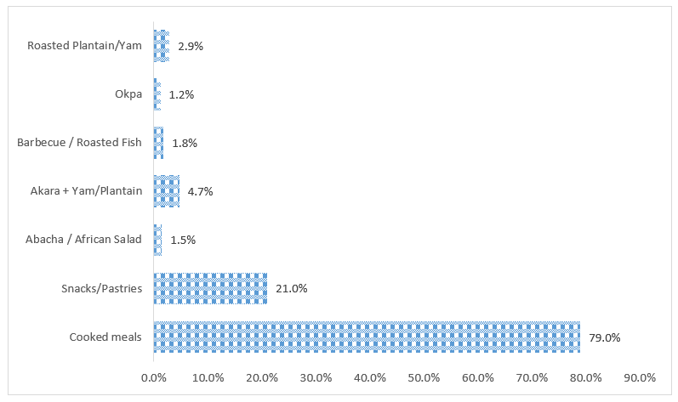

Fig. 1: Column Chart Showing Type of food sold by Urban Street Vendors in Abakaliki Metropolis

Knowledge of Food Hygiene among Urban Street Vendors in Abakaliki Metropolis
Knowledge of food hygiene among vendors was generally excellent (Table 2). Almost all respondents recognized fundamental hygiene principles: 98.3% acknowledged that food can be contaminated by dirty hands, 98.6% agreed that handwashing with soap and water reduces disease transmission, and 99.4% confirmed that washing fruits and vegetables before use is necessary. Similarly, 98% agreed that leftover food should be properly reheated before resale, and 97.5% recognized the importance of cleaning food preparation surfaces. However, a notable gap was observed in medical examination practices, with only 79.4% agreeing that vendors should undergo regular medical checks. Overall, 89.3% of respondents scored at or above 90% in knowledge assessments (Figure 2), indicating a very high level of awareness.

Perceptions and Attitudes Toward Food Hygiene among Urban Street Vendors in Abakaliki Metropolis
Perceptions and attitudes toward food hygiene were also positive (Table 3). Vendors strongly agreed that hygiene is important for protecting customers’ health (mean score 3.83±0.39) and that proper hygiene improves customer trust and sales (3.78±0.42). They also emphasized the importance of government support (3.70±0.56) and the provision of handwashing facilities (3.78±0.47). However, cost and time were perceived as challenges, with the statement that hygiene practices are “too costly and time‑consuming” recording the lowest mean score (2.20±1.10). Overall, the grand mean score of 3.42±0.23 suggests that vendors generally hold positive perceptions, though structural barriers remain. In terms of perception levels (Figure 3), 23.4% demonstrated highly positive perceptions, while 76.6% had less positive perceptions.

Hygiene Practices among Urban Street Vendors in Abakaliki Metropolis
Hygiene practices were reported to be strong (Table 4), with most vendors adhering to basic standards. The highest mean scores were recorded for using clean water (3.95±0.24), using clean utensils (3.93±0.33), covering food to protect it from contamination (3.92±0.31), and washing hands before food preparation (3.92±0.29). Practices such as reheating leftover food (3.88±0.44) and disposing of waste safely (3.87±0.39) were also widely observed. Compliance was relatively weaker in wearing protective clothing (3.80±0.49) and undergoing medical check-ups (3.48±0.72). Overall, the grand mean score of 3.85±0.22 indicates excellent hygiene practices, with 91.3% of vendors demonstrating high levels of compliance (Figure 4).

Table 2: Knowledge of Food Hygiene among Urban Street Vendors in Abakaliki Metropolis
Items | Incorrect  n (%) | Correct  n (%)
Food can become contaminated by dirty hands | 6(1.7) | 349(98.3)
Washing hands with soap and water before food preparation reduces disease transmission. | 5(1.4) | 350(98.6)
Covering food prevents contamination from flies and dust. | 6(1.7) | 349(98.3)
Using clean utensils for serving food is important for preventing food-borne diseases. | 14(3.9) | 341(96.1)
Leftover food should be properly reheated before resale. | 7(2) | 348(98)
Food vendors should undergo medical examination regularly. | 73(20.6) | 282(79.4)
Using untreated water for cooking or washing utensils can spread diseases. | 20(5.6) | 335(94.4)
Wearing protective clothing (e.g., aprons, gloves) helps maintain food hygiene. | 10(2.8) | 345(97.2)
Storing food at the correct temperature prevents spoilage and contamination. | 5(1.4) | 350(98.6)
Washing fruits and vegetables before use is necessary to remove harmful substances. | 2(0.6) | 353(99.4)
Food prepared in unclean environments can cause food poisoning. | 7(2) | 348(98)
Regular cleaning of food preparation surfaces reduces the risk of disease. | 9(2.5) | 346(97.5)

Table 3: Perceptions and Attitudes Toward Food Hygiene among Urban Street Vendors in Abakaliki Metropolis
Items | SD  n (%) | D  n (%) | A  n (%) | SA  n (%) | Mean±Std
Food hygiene is important for protecting customers’ health. | 0 (0.0) | 2(0.6) | 57(16.1) | 296(83.4) | 3.83±0.39
Following proper hygiene practices improves customer trust and sales. | 0 (0.0) | 0 (0.0) | 78(22) | 277(78) | 3.78±0.42
It is the responsibility of vendors, not the government, to ensure food safety. | 9(2.5) | 21(5.9) | 117(33) | 208(58.6) | 3.48±0.72
Food hygiene practices are too costly and time-consuming for vendors. | 119(33.5) | 114(32.1) | 55(15.5) | 67(18.9) | 2.2±1.1
Customers are concerned about the hygiene of food vendors. | 11(3.1) | 138(38.9) | 75(21.1) | 131(36.9) | 2.92±0.94
Good personal hygiene among vendors increases food quality and safety. | 2(0.6) | 12(3.4) | 68(19.2) | 273(76.9) | 3.72±0.55
Regular inspection by health officers helps improve hygiene standards. | 0 (0.0) | 20(5.6) | 72(20.3) | 263(74.1) | 3.68±0.57
Training on food hygiene should be mandatory for all food vendors. | 25(7) | 67(18.9) | 102(28.7) | 161(45.4) | 3.12±0.96
Vendors can sell food safely even without formal hygiene training. | 10(2.8) | 26(7.3) | 91(25.6) | 228(64.2) | 3.51±0.75
Observing hygiene rules reduces the chances of foodborne diseases. | 3(0.8) | 4(1.1) | 73(20.6) | 275(77.5) | 3.75±0.51
Government support is necessary to improve hygiene facilities at vending sites. | 1(0.3) | 16(4.5) | 72(20.3) | 266(74.9) | 3.7±0.56
Providing handwashing facilities near vending sites promotes better hygiene. | 2(0.6) | 3(0.8) | 65(18.3) | 285(80.3) | 3.78±0.47
Maintaining hygiene attracts more customers to a food vendor’s stand. | 0 (0.0) | 7(2) | 66(18.6) | 282(79.4) | 3.77±0.46
Street food vending conditions make it difficult to maintain good hygiene. | 66(18.6) | 100(28.2) | 70(19.7) | 119(33.5) | 2.68±1.12
Vendors who neglect hygiene should face penalties or suspension. | 6(1.7) | 23(6.5) | 155(43.7) | 171(48.2) | 3.38±0.69
Mean of Perception |  |  |  |  | 3.42±0.23
SA = Strongly Agree; A = Agree; D = Disagree; SD = Strongly Disagree

Table 4: Hygiene Practices among Urban Street Vendors in Abakaliki Metropolis
Items | N  N (%) | R  N (%) | S  N (%) | A  N (%) | Mean ±St.dev
Wash hands with soap and water before food preparation. | 0 (0.0) | 2(0.6) | 24(6.8) | 329(92.7) | 3.92±0.29
Wash hands with soap and water after using the toilet. | 0 (0.0) | 3(0.8) | 25(7) | 327(92.1) | 3.91±0.31
Use clean utensils for cooking and serving. | 2(0.6) | 1(0.3) | 18(5.1) | 334(94.1) | 3.93±0.33
Store raw and cooked foods separately. | 3(0.8) | 10(2.8) | 40(11.3) | 302(85.1) | 3.81±0.51
Cover foods to protect them from flies, dust, and other contaminants. | 0 (0.0) | 5(1.4) | 17(4.8) | 333(93.8) | 3.92±0.31
Use clean water for cooking, washing, and drinking. | 0 (0.0) | 2(0.6) | 14(3.9) | 339(95.5) | 3.95±0.24
Reheat leftover food before selling. | 4(1.1) | 3(0.8) | 26(7.3) | 322(90.7) | 3.88±0.44
Wear protective clothing (e.g., apron, hair cover) while preparing food. | 3(0.8) | 5(1.4) | 51(14.4) | 296(83.4) | 3.8±0.49
Dispose of food waste in a clean and safe manner. | 2(0.6) | 1(0.3) | 37(10.4) | 315(88.7) | 3.87±0.39
Go for medical check-up as required. | 6(1.7) | 30(8.5) | 108(30.4) | 211(59.4) | 3.48±0.72
Mean of Practice |  |  |  |  | 3.85±0.22
A = Always; S = Sometimes; R = Rarely; N = Never
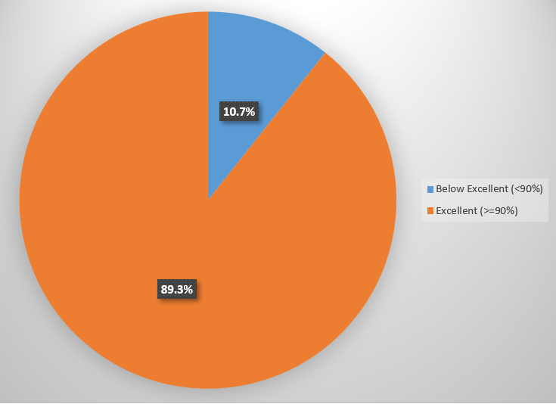

Fig. 2: Pie Chart Showing the Level of Knowledge of Food Hygiene among Urban Street Vendors in Abakaliki Metropolis
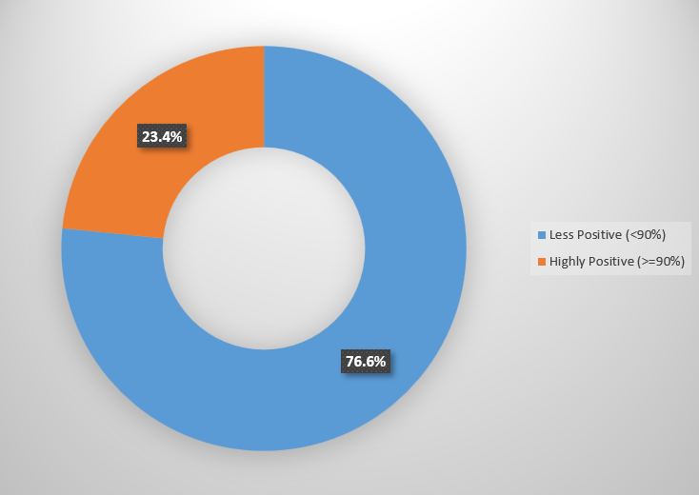

Fig. 3: Doughnut Chart Showing the Level of Perceptions Towards Food Hygiene among Urban Street Vendors in Abakaliki Metropolis
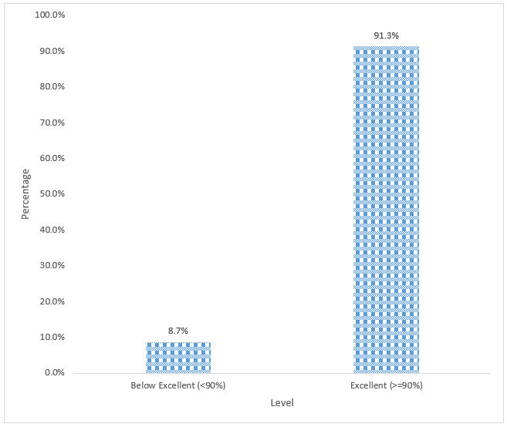

Fig. 4: Bar Chart Showing the Level of Hygiene Practices Towards Food Hygiene among Urban Street Vendors in Abakaliki Metropolis

Associations between socio-demographic characteristics and hygiene outcomes
Associations between socio demographic characteristics and hygiene outcomes revealed several significant relationships, as shown in the tables. Age was significantly associated with knowledge (Table 5; χ²=8.279, p=0.041), with vendors aged 41 years and above recording the highest proportion of excellent knowledge, while those aged 31–40 years had the highest proportion of below excellent knowledge. Sex also showed a significant association with knowledge (Table 5; χ²=8.925, p=0.003), as female vendors were more likely to demonstrate excellent knowledge compared to males, who had a higher proportion of below excellent knowledge. Marital status was strongly associated with both knowledge and practices, with knowledge showing a highly significant relationship (Table 5; χ²=23.225, p<0.001), where married vendors had the highest proportion of excellent knowledge, while divorced or separated vendors had the highest proportion of below excellent knowledge, and practices also showing significance (Table 7; χ²=9.587, p=0.022), with married vendors demonstrating stronger adherence compared to singles who showed weaker practices. Education was another strong predictor of knowledge (Table 5; χ²=18.777, p<0.001), as vendors with secondary and tertiary education were significantly more likely to demonstrate excellent knowledge compared to those with no formal education, who had the highest proportion of below excellent knowledge. In contrast, years of experience did not show any significant association with knowledge (Table 5; χ²=1.791, p=0.617) or hygiene practices (Table 7; χ²=7.283, p=0.063), indicating that both new entrants and long term vendors demonstrated similar levels of knowledge and practice.

Table 5: Association of Sociodemographic Characteristics and Level of Knowledge of Food Hygiene among Urban Street Vendors in Abakaliki Metropolis
 | Level of knowledge
Characteristics | Below Excellent (<90)  n (%) | Excellent (>=90)  n (%) | Total  n (%) | ꭕ² | P Value
Age (Years)
<=20yrs | 4 (10.5) | 9 (2.8) | 13 (3.7) | 8.279 | 0.041*
21-30yrs | 8 (21.1) | 93 (29.3) | 101 (28.5)
31-40yrs | 16 (42.1) | 101 (31.9) | 117 (33)
41 & above | 10 (26.3) | 114 (36) | 124 (34.9)
Sex
Male | 15 (39.5) | 59 (18.6) | 74 (20.8) | 8.925 | 0.003*
Female | 23 (60.5) | 258 (81.4) | 281 (79.2)
Marital status
Single | 15 (39.5) | 104 (32.8) | 119 (33.5) | 23.225 | <0.001*
Married | 15 (39.5) | 173 (54.6) | 188 (53)
Divorced/Separated | 8 (21.1) | 12 (3.8) | 20 (5.6)
Widowed | 0 (0) | 28 (8.8) | 28 (7.9)
Highest level of education
No formal education | 10 (26.3) | 19 (6) | 29 (8.2) | 18.777 | <0.001*
Primary | 4 (10.5) | 36 (11.4) | 40 (11.3)
Secondary | 12 (31.6) | 130 (41) | 142 (40)
Tertiary | 12 (31.6) | 132 (41.6) | 144 (40.6)
Years of experience in street food vending
<1 | 2 (5.3) | 17 (5.4) | 19 (5.4) | 1.791 | 0.617
1-5 | 18 (47.4) | 174 (54.9) | 192 (54.1)
6-10 | 13 (34.2) | 77 (24.3) | 90 (25.4)
>10 | 5 (13.2) | 49 (15.5) | 54 (15.2)
* Significant at P-Value < 0.05

Table 6: Association of Sociodemographic Characteristics and Level of Perception towards Food Hygiene among Urban Street Vendors in Abakaliki Metropolis
 | Level of knowledge
Characteristics | Less Positive (<90%)  n (%) | Highly Positive (>=90%)  n (%) | Total  n (%) | ꭕ² | P Value
Age (Years)
<=20yrs | 7(2.6) | 6(7.2) | 13(3.7) | 9.588 | 0.022*
21-30yrs | 72(26.5) | 29(34.9) | 101(28.5)
31-40yrs | 99(36.4) | 18(21.7) | 117(33)
41 & above | 94(34.6) | 30(36.1) | 124(34.9)
Sex
Male | 50(18.4) | 24(28.9) | 74(20.8) | 4.264 | 0.039*
Female | 222(81.6) | 59(71.1) | 281(79.2)
Marital status
Single | 97(35.7) | 22(26.5) | 119(33.5) | 11.070 | 0.011*
Married | 141(51.8) | 47(56.6) | 188(53)
Divorced/Separated | 10(3.7) | 10(12) | 20(5.6)
Widowed | 24(8.8) | 4(4.8) | 28(7.9)
Highest level of education
No formal education | 16(5.9) | 13(15.7) | 29(8.2) | 13.863 | 0.003*
Primary | 33(12.1) | 7(8.4) | 40(11.3)
Secondary | 119(43.8) | 23(27.7) | 142(40)
Tertiary | 104(38.2) | 40(48.2) | 144(40.6)
Years of experience in street food vending
<1 | 18(6.6) | 1(1.2) | 19(5.4) | 3.889 | 0.274
1-5 | 145(53.3) | 47(56.6) | 192(54.1)
6-10 | 67(24.6) | 23(27.7) | 90(25.4)
>10 | 42(15.4) | 12(14.5) | 54(15.2)
* Significant at P-Value < 0.05

Table 7: Association of Sociodemographic Characteristics and Level of Practices towards Food Hygiene among Urban Street Vendors in Abakaliki Metropolis
 | Level of knowledge
Characteristics | Less Positive (<90%)  n (%) | Highly Positive (>=90%)  n (%) | Total  n (%) | ꭕ² | P Value
Age (Years)
<=20yrs | 3(9.7) | 10(3.1) | 13(3.7) | 3.704a | 0.295
21-30yrs | 9(29) | 92(28.4) | 101(28.5)
31-40yrs | 10(32.3) | 107(33) | 117(33)
41 & above | 9(29) | 115(35.5) | 124(34.9)
Sex
Male | 10(32.3) | 64(19.8) | 74(20.8) | 2.681a | 0.102
Female | 21(67.7) | 260(80.2) | 281(79.2)
Marital status
Single | 17(54.8) | 102(31.5) | 119(33.5) | 9.587a | 0.022*
Married | 14(45.2) | 174(53.7) | 188(53)
Divorced/Separated | 0(0) | 20(6.2) | 20(5.6)
Widowed | 0(0) | 28(8.6) | 28(7.9)
Highest level of education
No formal education | 2(6.5) | 27(8.3) | 29(8.2) | 3.568a | 0.312
Primary | 5(16.1) | 35(10.8) | 40(11.3)
Secondary | 8(25.8) | 134(41.4) | 142(40)
Tertiary | 16(51.6) | 128(39.5) | 144(40.6)
Years of experience in street food vending
<1 | 0(0) | 19(5.9) | 19(5.4) | 7.283a | 0.063
1-5 | 22(71) | 170(52.5) | 192(54.1)
6-10 | 3(9.7) | 87(26.9) | 90(25.4)
>10 | 6(19.4) | 48(14.8) | 54(15.2)
* Significant at P-Value < 0.05

Predictors Analysis of the Food Hygiene Outcomes among Urban Street Vendors in Abakaliki Metropolis
Predictor analysis further confirmed the associations between socio‑demographic characteristics and hygiene outcomes. Vendors aged 41 years and above were significantly more likely to have excellent knowledge compared to those aged ≤20 years, with an adjusted odds ratio (aOR) of 8.35 and a 95% confidence interval (CI) of 1.658–42.055 (Table 8). Sex was also a significant predictor, as female vendors were more likely than males to demonstrate excellent knowledge, with an aOR of 3.74 and a 95% CI of 1.717–8.157. Education emerged as a consistent and strong predictor, with vendors who had primary education being nearly four times more likely to have excellent knowledge compared to those with no formal education (aOR=3.93, 95% CI: 1.015–15.237), those with secondary education seven times more likely (aOR=7.06, 95% CI: 2.465–20.218), and those with tertiary education almost nine times more likely (aOR=8.72, 95% CI: 2.911–26.098). For perceptions, marital status was significant (Table 9), with married vendors more likely to hold highly positive perceptions compared to singles (aOR=2.83, 95% CI: 1.261–6.359), and divorced/separated vendors showing even stronger odds (aOR=7.43, 95% CI: 2.082–26.499). Female vendors, however, were less likely than males to demonstrate highly positive perceptions (aOR=0.41, 95% CI: 0.21–0.81). Predictors of hygiene practices were less clear (Table 10), as age, sex, and education did not show statistically significant associations, although younger vendors and females tended to report better practices.

Table 8: Predictors of Level of Perception of Food Hygiene among Urban Street Vendors in Abakaliki Metropolis
 |  |  | 95% C. I. for aOR
Characteristics | aOR | P-Value | Lower | Upper
Age (Years)
<=20yrs | 1 (Ref)
21-30yrs | 0.667 | 0.581 | 0.158 | 2.815
31-40yrs | 0.192 | 0.036* | 0.041 | 0.895
41 & above | 0.232 | 0.079 | 0.046 | 1.181
Sex
Male | 1 (Ref)
Female | 0.412 | 0.010* | 0.21 | 0.808
Marital status
Single | 1 (Ref)
Married | 2.832 | 0.012* | 1.261 | 6.359
Divorced/Separated | 7.429 | 0.002* | 2.082 | 26.499
Widowed | 0.905 | 0.907* | 0.173 | 4.751
Highest level of education
No formal education | 1 (Ref)
Primary | 0.141 | 0.003* | 0.038 | 0.52
Secondary | 0.149 | <0.001* | 0.055 | 0.408
Tertiary | 0.309 | 0.017* | 0.118 | 0.811
Years of experience in street food vending
<1 | 1 (Ref)
1-5 | 4.18 | 0.186 | 0.501 | 34.856
6-10 | 4.129 | 0.209 | 0.453 | 37.63
>10 | 5.289 | 0.155 | 0.532 | 52.62
aOR = Adjusted Odd Ratio; 95% C.I. = 95% Confidence interval; Ref = Reference value; * Significant at P-Value < 0.05

Table 9: Predictors of Level of Knowledge of Food Hygiene among Urban Street Vendors in Abakaliki Metropolis
 |  |  | 95% C. I. for aOR
Characteristics | aOR | P-Value | Lower | Upper
Age (Years)
<=20yrs | 1 (Ref)
21-30yrs | 4.123 | 0.064 | 0.923 | 18.417
31-40yrs | 2.901 | 0.143 | 0.698 | 12.059
41 & above | 8.35 | 0.010* | 1.658 | 42.055
Sex
Male | 1 (Ref)
Female | 3.742 | 0.001* | 1.717 | 8.157
Highest level of education
No formal education | 1 (Ref)
Primary | 3.932 | 0.048* | 1.015 | 15.237
Secondary | 7.06 | <0.001* | 2.465 | 20.218
Tertiary | 8.716 | <0.001* | 2.911 | 26.098
Years of experience in street food vending
<1 | 1 (Ref)
1-5 | 1.077 | 0.928 | 0.217 | 5.352
6-10 | 0.54 | 0.482 | 0.097 | 3.01
>10 | 0.713 | 0.739 | 0.098 | 5.201
aOR = Adjusted Odd Ratio; 95% C.I. = 95% Confidence interval; Ref = Reference value; * Significant at P-Value < 0.05

Table 10: Predictors of Level of Perception of Food Hygiene among Urban Street Vendors in Abakaliki Metropolis
 |  |  | 95% C. I. for aOR
Characteristics | aOR | P-Value | Lower | Upper
Age (Years)
<=20yrs | 1 (Ref)
21-30yrs | 0.667 | 0.581 | 0.158 | 2.815
31-40yrs | 0.192 | 0.036* | 0.041 | 0.895
41 & above | 0.232 | 0.079 | 0.046 | 1.181
Sex
Male | 1 (Ref)
Female | 0.412 | 0.010* | 0.21 | 0.808
Marital status
Single | 1 (Ref)
Married | 2.832 | 0.012* | 1.261 | 6.359
Divorced/Separated | 7.429 | 0.002* | 2.082 | 26.499
Widowed | 0.905 | 0.907* | 0.173 | 4.751
Highest level of education
No formal education | 1 (Ref)
Primary | 0.141 | 0.003* | 0.038 | 0.52
Secondary | 0.149 | <0.001* | 0.055 | 0.408
Tertiary | 0.309 | 0.017* | 0.118 | 0.811
Years of experience in street food vending
<1 | 1 (Ref)
1-5 | 4.18 | 0.186 | 0.501 | 34.856
6-10 | 4.129 | 0.209 | 0.453 | 37.63
>10 | 5.289 | 0.155 | 0.532 | 52.62
aOR = Adjusted Odd Ratio; 95% C.I. = 95% Confidence interval; Ref = Reference value; * Significant at P-Value < 0.05

Discussion of Findings
This study examined the predictors of knowledge, perception, and practices towards food hygiene among urban street food vendors in Abakaliki metropolis, situating the findings within broader empirical evidence from Nigeria and other countries. The results revealed that vendors generally demonstrated excellent knowledge of food hygiene, with 89.3% scoring at or above 90%. Almost all respondents recognized contamination risks from dirty hands, the importance of handwashing, and the need for clean utensils, protective clothing, and proper food storage. These findings align with Aljasir (2023), who emphasized that training and education significantly improve food safety knowledge, and with Adane et al. (2018), who found protective clothing and medical checks significantly associated with better hygiene practices. However, medical examination practices were relatively weaker, with only 79.4% of vendors acknowledging the need for regular checks, echoing Okojie & Isah (2019) in Benin City and Aluh & Aluh (2017) in Imo State, who both reported commendable knowledge but weaker compliance with health monitoring.
Perceptions of food hygiene were generally positive, with vendors strongly agreeing that hygiene protects customer health and improves trust and sales. The grand mean score of 3.42±0.23 confirmed this, though 76.6% had less positive perceptions compared to 23.4% with highly positive perceptions. Vendors’ narratives reinforced these findings, linking neatness and cleanliness directly to customer satisfaction and repeat patronage. These results mirror Hassan et al. (2020) in Zanzibar, who found that despite infrastructural limitations, customer sensitivity to hygiene was evident, and Czarniecka‑Skubina et al. (2018) in Kenya, who emphasized that customer expectations of cleanliness drive compliance. Similarly, Aluh & Aluh (2017) observed commendable knowledge but weaker attitudes, highlighting the persistent gap between awareness and consistent compliance.
Practices among vendors were strong, with high adherence to fundamental hygiene standards such as using clean water, clean utensils, covering food, and handwashing. The lowest compliance was observed in medical check‑ups, consistent with Adane et al. (2018) in Ethiopia and Okojie & Isah (2019) in Nigeria, who both reported weaker adherence to health monitoring despite strong awareness. Czarniecka‑Skubina et al. (2018) in Kenya documented widespread poor practices such as handling food with bare hands and inadequate storage, contrasting with the stronger compliance observed in Abakaliki. These findings suggest that Nigerian vendors may demonstrate relatively higher adherence to basic hygiene standards, though infrastructural gaps remain.
Predictor analysis highlighted significant socio‑demographic influences. Vendors aged 41 years and above were 8.35 times more likely to have excellent knowledge compared to those aged ≤20 years (aOR=8.35, 95% CI: 1.658–42.055), while female vendors were 3.74 times more likely than males (aOR=3.742, 95% CI: 1.717–8.157). Education was the strongest predictor, with tertiary‑educated vendors almost nine times more likely to have excellent knowledge compared to those without formal education (aOR=8.716, 95% CI: 2.911–26.098). These findings reinforce Adane et al. (2018) and Aljasir (2023), who both emphasized the role of education and training in improving food safety outcomes. Perceptions were influenced differently: vendors aged 31–40 years were less likely to have highly positive perceptions (aOR=0.192, 95% CI: 0.041–0.895), and female vendors were also less likely than males (aOR=0.412, 95% CI: 0.21–0.808). Marital status was significant, with married vendors more likely to hold highly positive perceptions (aOR=2.832, 95% CI: 1.261–6.359) and divorced/separated vendors showing even stronger odds (aOR=7.429, 95% CI: 2.082–26.499). Interestingly, education showed an inverse relationship with perception, as vendors with primary, secondary, and tertiary education were significantly less likely to have highly positive perceptions compared to those with no formal education. This resonates with Aluh & Aluh (2017), who found commendable knowledge but weaker attitudes, suggesting that higher education may heighten awareness of infrastructural limitations, thereby dampening perceptions. Predictors of hygiene practices were less clear, with age, sex, and education showing no statistically significant associations, though younger vendors and females tended to report better practices. This finding mirrors Okojie & Isah (2019) and Ibrahim et al. (2024), who observed high awareness but weaker adoption of practices.

Conclusion
This study demonstrated that urban street food vendors in Abakaliki metropolis possess excellent knowledge of food hygiene, with nearly nine out of ten scoring at or above 90%. Vendors consistently recognized contamination risks from dirty hands, the importance of handwashing, and the need for clean utensils, protective clothing, and proper food storage. Despite this, medical examination practices were relatively weak, reflecting a gap between awareness and consistent compliance. Perceptions of hygiene were generally positive, as vendors acknowledged its role in protecting customer health and improving trust, yet a majority held less positive perceptions, suggesting that structural barriers and heightened awareness of infrastructural limitations may temper attitudes. Hygiene practices were commendably strong, with over 91% demonstrating excellent compliance in handwashing, food covering, and use of clean water, though medical monitoring remained the weakest practice. Predictor analysis revealed that age, sex, and education significantly influenced knowledge, with older vendors, females, and those with higher education more likely to demonstrate excellent knowledge. Perceptions were shaped by marital status and sex, with married and divorced/separated vendors more likely to hold highly positive perceptions, while female vendors and those with higher education were less likely. Hygiene practices showed no statistically significant predictors, though younger vendors and females tended to report better practices.

References
Adane, M., Teka, B., Gismu, Y., Halefom, G., & Ademe, M. (2018). Food hygiene and safety measures among food handlers in street food shops and food establishments of Dessie town, Ethiopia: A community-based cross-sectional study. PLoS ONE, 13(5). https://doi.org/10.1371/JOURNAL.PONE.0196919
Ajzen, I. (2021). A Study on Attitude of Women Investors Towards Stock Market Investment in Kerala. Organizational Behavior and Human Decision Processes, 50(2), 179–211. https://doi.org/10.1016/0749-5978(91)90020-T
Aljasir, S. F. (2023). Food safety knowledge and practices among food handlers and consumers in Gulf countries: An integrative review. Global Public Health, 18(1). https://doi.org/10.1080/17441692.2023.2287584
Aluh, F. O., & Aluh, D. O. (2017). Knowledge, attitudes and practices of food hygiene among mobile food vendors in a Nigerian rural settlement. International Journal Of Community Medicine And Public Health, 4(11), 4025–4030. https://doi.org/10.18203/2394-6040.IJCMPH20174812
Asefa, A., Midaksa, G., Qanche, Q., Wondimu, W., Nigussie, T., Bogale, B., Birhanu, F., Asaye, Z., Mohammed, N., & Yosef, T. (2022). Does the perception of HIV risk among Female sex workers affect HIV prevention behavior? application of the Health Belief Model (HBM). BMC Public Health, 22(1), 1646. https://doi.org/10.1186/S12889-022-14046-3/TABLES/5
Chukuezi, C. O. (2010). Food safety and hyienic practices of street food vendors in Owerri, Nigeria. Studies in sociology of science, 1(1), 50.
Czarniecka-Skubina, E., Trafiałek, J., Wiatrowski, M., & Głuchowski, A. (2018). An evaluation of the hygiene practices of European street food vendors and a preliminary estimation of food safety for consumers, conducted in Paris. Journal of Food Protection, 81(10), 1614–1621. https://doi.org/10.4315/0362-028X.JFP-18-165
Hassan, J., EFood, L. F.-, & 2020, undefined. (2020). Food hygienic practices and safety measures among street food vendors in Zanzibar Urban District. SpringerJK Hassan, LWT FwejaEFood, 2020•Springer, 1(4), 332–338. https://doi.org/10.2991/efood.k.200619.001
Ibrahim, H., and, S. A.-F. J. of A., & 2024, undefined. (2024). Assessing Food Safety Awareness and Practices Among Street Food Vendors in Katsina State, North Western Nigeria. Jaat.Fudutsinma.Edu.NgHY Ibrahim, SS AdeolaFUDMA Journal of Agriculture and Agricultural Technology, 2024•jaat.Fudutsinma.Edu.Ng, 10(2), 9–14. https://doi.org/10.33003/jaat.2024.1002.02
Johnson, M., Samuel, I., Irene, O., & Paul, K. (2020a). Food safety knowledge and practices of street food vendors in selected locations within Kiambu County, Kenya. African Journal of Food Science, 14(6), 174–185. https://doi.org/10.5897/AJFS2020.1929
Okojie, P. W., & Isah, E. C. (2019). Food hygiene knowledge and practices of street food vendors in Benin City, Nigeria. International Journal of Consumer Studies, 43(6), 528–535. https://doi.org/10.1111/IJCS.12538
Osman, N., Moges1, D., & Ayanaw1, T. (2025). Food Safety Knowledge, Attitudes, and Practices of Street Food Vendors and Microbiological Quality of Selected Street Foods in Bahir Dar City, Ethiopia. https://doi.org/10.21203/RS.3.RS-7958922/V1
Salamandane, A., Malfeito-Ferreira, M., & Brito, L. (2023a). The Socioeconomic Factors of Street Food Vending in Developing Countries and Its Implications for Public Health: A Systematic Review. Foods 2023, Vol. 12, Page 3774, 12(20), 3774. https://doi.org/10.3390/FOODS12203774
WHO. (2025). WHO global strategy for food safety 2022-2030: towards stronger food safety ... - World Health Organization - Google Books. https://books.google.com.ng/books?hl=en&lr=&id=vsanEAAAQBAJ&oi=fnd&pg=PR3&dq=World+Health+Organization.+(2006).+Five+keys+to+safer+food+manual.+WHO+Press&ots=4k8F9F_EnN&sig=vKrWG2rxgb5aYCf0lUQU1MaiEkA&redir_esc=y#v=onepage&q&f=false

