Unsteady Radiative MHD Flow of Jeffrey Fluid through a Porous Medium with Hall and Soret Effects in the presence of Convective Boundary Condition

ABSTRACT
This study investigates the combined effects of Hall current and Soret diffusion on unsteady natural convection magnetohydrodynamic (MHD) flow of a viscous, incompressible, electrically conducting Jeffrey fluid through a porous medium, in the presence of thermal radiation and chemical reaction. The dimensionless governing equations are solved numerically using the Sixth-order Runge–Kutta method together with the shooting technique, and the resulting velocity, temperature, and concentration profiles are presented graphically and discussed for various governing parameters. The findings have potential applications in solar physics, including solar cycle dynamics, sunspot development, and the structure of rotating magnetic stars, as well as in MHD sensors and rotating MHD induction machine energy generators. The analysis reveals that increasing the Hall parameter enhances the velocity profiles, while the reverse trend is observed with increasing viscosity ratio and chemical reaction parameter. Thermal radiation elevates the temperature profiles, whereas an increase in the frequency of oscillations suppresses them. Furthermore, the concentration decreases with increasing Schmidt number but increases with increasing chemical reaction parameter.
KEYWORDS;- Soret and chemical reaction, Unsteady MHD flow, Hall current, Thermal radiation, Jeffrey fluid.

.
- INTRODUCTION
Natural convection flow induced by combined thermal and solutal buoyancy forces in a porous medium is critical to understanding many natural phenomena and industrial processes. Pure fluids are rarely attainable due to the ubiquitous presence of foreign particulates in atmospheric flows. Key processes such as waste dispersion, fog evaporation, photosynthesis, transpiration, sea breeze formation, and ocean currents are driven by these buoyancy forces arising from temperature and concentration gradients. Industrial applications include molten metal cooling, heat exchangers, petroleum reservoirs, insulation systems, filtration, nuclear waste management, catalytic reactors, desert coolers, frost formation, and wet-bulb thermometry.
The study of unsteady magnetohydrodynamic (MHD) flow of non-Newtonian fluids through porous media has gained considerable attention due to its wide range of applications in engineering and industrial processes, including geothermal systems, petroleum recovery, cooling technologies, and energy generation. The interaction between magnetic fields and electrically conducting fluids provides an effective mechanism for controlling flow behavior and heat transfer characteristics in such systems.
Among non-Newtonian models, the Jeffrey fluid has received significant interest because of its ability to capture both relaxation and retardation effects, making it more suitable for describing viscoelastic fluids encountered in practical applications. For instance, [1] investigated the thermal and diffusion effects on MHD Jeffrey fluid flow and reported that viscoelastic parameters significantly influence velocity and temperature distributions in boundary layer flows.
Hall current effect arises directly from the Lorentz force, which governs the behavior of charged particles in a magnetic field. This force is responsible for the deflection of electron beams in magnetically deflected cathode ray tubes and the rotation of electric motor armatures. Early applications of the Hall effect were limited to laboratory settings because the output voltage from the materials available at the time was too low for practical use. However, the ad vent of semiconductors introduced new materials with high charge mobilities, making it possible to manufacture commercially feasible Hall devices. Hall current refers to the voltage difference that develops across an electrical conductor, transverse to both the flow of electric current and a magnetic field applied normal to that current. When the magnetic field strength is very high, the influence of the Hall current becomes critically important. To enhance the electrical conductivity of a fluid, it is necessary to induce a current along a channel perpendicular to both the x and y directions that is, in the z-direction. This induced current is known as the Hall current. A strong magnetic field actually reduces the electrical conductivity of a fluid. [2], Investigates how Hall current, alongside Joule heating, contributes to an increased temperature field within the fluid, which is relevant to heat and mass movement indicators like the Nusselt and Sherwood numbers. [3] focuses on the application of the Hall effect in the flow field of an electrically conductive fluid with low density or a high magnetized field, noting that this phenomenon causes the flow field to experience secondary flow. [4] examines the impact of fluid flow characteristics on convective heat transfer using the magnetohydrodynamic (MHD) non-Newtonian fluid model with Hall current. [6] shows that Hall current, permeability of the porous media, radiation absorption, and diffusion thermo parameter tend to accelerate fluid flow in both primary and secondary flow directions.
Engineering science and applied mathematics researchers continue to be interested in the study of electrically conducting fluid (MHD). This is due to the broad applications of such flows in aero dynamics, engineering, geophysics, and aeronautics. The Soret effect is one of the processes at play in the transport phenomenon, which sees molecules being moved across a combination of many components due to a temperature gradient. Because of its applicability in various fields, such as geophysical, solar power collectors, cooling of electronic systems, and chemical catalytic reactors, convective heat and mass transfer in porous media has also been a matter of concern over the last several decades. This has contributed to the growing body of research on this topic. [7] examined MHD convective unsteady flow of a Jeffrey fluid past an inclined vertical porous plate with thermal diffusion Soret and Aligned magnetic field. [8] analyzed Unsteady magneto-hydro-dynamics flow of Jeffrey fluid through porous media with thermal radiation, Hall current and Soret effects. [9] explored Stability of Jeffrey fluids in anisotropic porous media: incorporating Soret effects and microbial systems. [10] have discussed Jeffrey fluid flow in a sloping channel with Hall current, thermal radiation, and inclined magnetic field effects. [11] Examines the Soret effect within the context of magnetohydrodynamic (MHD) Jeffrey nanofluid flow, focusing on heat and mass transfer over an inclined plate. [12] have studied the Soret effect within the context of unsteady Magnetohydrodynamic (MHD) free convection heat and mass transfer flow of an electrically conducting fluid past a vertical plate in a porous medium, considering thermal radiation and chemical reactions. The impact of Soret Dufour and radiation on the laminar flow of a rotating liquid past a porous plate via chemical reaction have been investigated by [13]. The Soret effect on MHD flow have been studied by [14] in the presence of hall current and induced magnetic field. Instability of Jeffrey fluid through flow in a porous layer induced by heat source and soret effect was stated by [15]. [16] analyzed Chemical reaction and activation energy on heat and mass transfer for convective flow along an inclined surface in Darcy porous medium with Soret and Dufour effects.
The interplay between thermal radiation and hydromagnetic natural convection significantly impacts heat and mass transfer characteristics in manufacturing environments. Processes such as steel rolling, glass fabrication, casting, and furnace design rely heavily on these dynamics. Because modern technical processes increasingly operate at ultra-high temperatures, accurately modeling radiative transport is a critical prerequisite for engineering reliable thermal systems. [5] were the first researchers to examine the effects of thermal radiation on temperature distribution and heat transfer in a medium flowing over a wedge. Utilizes the Rosseland approximation for the radiant heat flux vector to simplify the complex energy equation, as a general solution for the governing equations is not possible. [17] have studied MHD Marangoni boundary layer problem for hybrid nanofluids with thermal radiation. [18] have analyzed Impact of CNTs on an MHD Casson Marangoni boundary layer flow over a porous medium with suction/injection and thermal radiation. [19] have expressed the Effect of thermal radiation on convective heat transfer in MHD boundary layer Carreau fluid with chemical reaction. [20] studied Effect of MHD fluid flow heat transfer using CNTs with thermal radiation and heat source/sink across a stretching/shrinking sheet. [21] have examined Numerical simulations of MHD generalized Newtonian fluid flow effects on a stretching sheet in the presence of permeable media.
Investigating chemically reactive heat and mass transfer flows has become increasingly important across diverse chemical engineering applications. This class of transport phenomena serves as the foundational model for diverse environmental and industrial systems, ranging from cooling tower dynamics and thermal regulation to atmospheric haze dispersal and agricultural frost protection. Additional applications are found in agricultural environments and forest ecosystems containing fruit-bearing trees, where coupled heat and mass transfer with chemical reactions play an important role in environmental and biological processes. [22] examined the Impact of Binary Chemical Reaction and Activation Energy on Heat and Mass Transfer of Marangoni Driven Boundary Layer Flow of a Non-Newtonian Nanofluid. [23] have analyzed Numerical treatment of time dependent magneto hydrodynamic nanofluid flow of mass and heat transport subject to chemical reaction and heat source. The impact of a chemical reaction on the heat and mass transfer mechanisms in a dissipative and radiative nanofluid flow over a nonlinear stretching sheet was examined by [24]. [25] investigated Numerical simulation of magneto-hydrodynamic fluid flow with heat sink, chemical diffusion and Powell Eyring fluid behavior using Cattaneo–Christov source term. [26] analyzed Computational role of homogeneous–heterogeneous chemical reactions and a mixed convective ternary hybrid nanofluid in a vertical porous microchannel. [27] have explored Aspects of motile microorganism and thermophoretic particle deposition in the binary chemical reactive ternary hybrid nanofluid past a porous microchannel. Variable thermophysical properties of magnetohydrodynamic cross fluid model with effect of energy dissipation and chemical reaction was discussed by [28]. [29] examined Bio-Marangoni convection flow of Casson nanoliquid through a porous medium in the presence of chemically reactive activation energy. [30] have possessed Dynamics of unsteady reactive flow of viscous nanomaterial subject to Ohmic heating, heat source and viscous dissipation. [31], [32] and [33] explored the impact of dissipative Heat and mass with Richardson Number for the MHD convection Maxwell nanofluid flow. [34] and [35] explored stretching sheet, heat transfer parameters on nanomaterials.
The present work examines the influence of Hall current and Soret effect on unsteady free convective magnetohydrodynamic flow of a Jeffrey fluid past an impulsively moving vertical plate situated within a porous medium. The fluid is assumed to be viscous, incompressible, and electrically conducting, while the effects of thermal radiation and chemical reaction are incorporated into the mathematical model. The governing nonlinear equations are rendered dimensionless through suitable transformations and solved using the Sixth-Order Runge–Kutta scheme coupled with a Shooting numerical algorithm. The impacts of key dimension less parameters, namely the magnetic parameter, Hall parameter, Prandtl number, Schmidt number, thermal and mass Grashof numbers, radiation parameter, chemical reaction parameter, and Soret number, on the velocity, temperature, and concentration fields are analyzed. The findings provide valuable insight into the coupled heat and mass transfer mechanisms associated with MHD transport phenomena in porous media.

- FORMULATION OF THE PROBLEM
A Cartesian coordinate system is adopted, with the $x$-axis oriented vertically upward along the plate and the $y$-axis normal to the plate surface. A uniform transverse magnetic field of strength $B_{0}$ is applied perpendicular to the y-axis. The species concentration at the plate surface and within the fluid is maintained at a constant value $C$ throughout the process. The free stream temperature is denoted by $T_{∞}$, while the plate surface is raised to and maintained at a uniform target temperature. Likewise, the species’ concentration at the plate surface is raised to and maintained at a uniform target concentration. Fig.1 demonstrates the issue in terms of its geometry. Owing to the infinite extent of the plate in the $x$ and $z$ directions, all flow variables are assumed to be functions of the transverse coordinate $y$ and time $t$ only, except for the pressure field. The plate is considered electrically non-conducting, thereby preventing the flow of electric current through its surface. Furthermore, in the absence of externally applied electric fields and induced polarization effects, the influence of fluid polarization is neglected. Consequently, no electrical energy is supplied to or extracted from the fluid, and the electromagnetic interaction arises solely from the imposed magnetic field. Presumably, the induced magnetic field produced by the velocity of the fluid is insignificant in contrast to the magnetic field being applied. This presumption is reasonable because the magnetic Reynolds number is relatively low for partly ionized fluids and liquid metals, often used in various industrial applications.
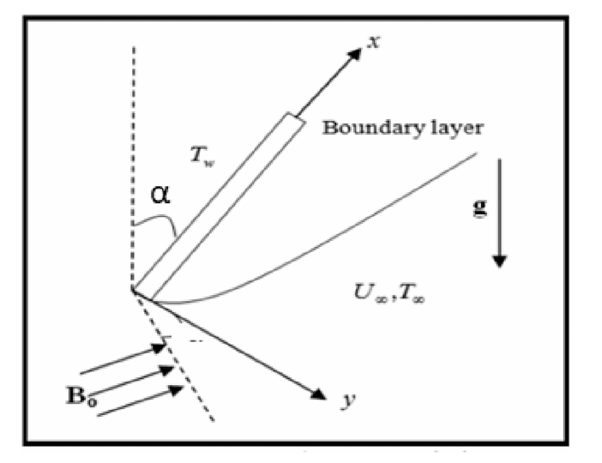
Fig. 1. The geometry of the problem
Considering the assumptions aforementioned, the governing equations for natural convection flow with heat and mass transfer of an electrically conducting, viscous, incompressible fluid past an infinite vertical plate embedded in a uniform porous medium in a rotating system are given by. These equations take into account the Hall current and the Soret effect followed by [36] and [37].
 | $$\frac{∂u}{∂x}+\frac{∂u}{∂y}=0$$ | (1)
 | $$\frac{∂u}{∂t}+w\frac{∂u}{∂z}=-\frac{1}{ρ}\frac{∂p}{∂x}+ϑ\left(\frac{1}{1+β}\right) \frac{∂^{2}u}{∂z^{2}}+\frac{σB_{0}}{ρ\left(1+H^{2}\right)} \left(Hv-u\right)+gβ_{T}\left(T-T_{∞}\right) Cosα+gβ_{C}\left(C-C_{∞}\right)Cosα-\left(\frac{1}{1+β}\right)\frac{ϑ}{k^{*}}u+\frac{∂^{2}u}{∂z^{2}} w\frac{∂u}{∂z}$$ | (2)
 | $\frac{∂v}{∂t}+w\frac{∂v}{∂z}=$ $-\frac{1}{ρ}\frac{∂p}{∂y}+ϑ\left(\frac{1}{1+β}\right) \frac{∂^{2}v}{∂z^{2}}-\frac{σB_{0}}{ρ\left(1+H^{2}\right)}\left(Hu+v\right)-\left(\frac{1}{1+β}\right)\frac{ϑ}{k^{*}}v+\left(Hu+v\right)\frac{∂^{2}u}{∂z^{2}}$ | (3)
 | $$\frac{∂T}{∂t}+w\frac{∂T}{∂z}=\frac{k_{1}}{ρC_{p}}\frac{∂^{2}T}{∂z^{2}}-\frac{Q_{0}}{ρC_{p}}\left(T-T_{∞}\right)-\frac{1}{ρC_{p}}\frac{∂q_{r}}{∂z}$$ | (4)
 | $$\frac{∂C}{∂t}+w\frac{∂C}{∂z}=D\frac{∂^{2}C}{∂z^{2}}-K\left(C-C_{∞}\right)+D_{1}\frac{∂^{2}T}{∂z^{2}}$$ | (5)

The boundary conditions are provided under the presumptions in the case of velocity distributions, thermodynamics and intensity
 | $$u^{*}=U_{0}, v=0, T=T_{w}+ε\left(T_{w}-T_{∞}\right)e^{iwt}, C=C_{w}+ε\left(C_{w}-C_{∞}\right)e^{iwt} at z=0$$ | (6)
 | $$u→U_{∞}, v→0, T→T_{∞} C→C_{∞} as z→∞$$ | (7)

We take into account a formulation in mathematics for an limit for optically thin grey gas that is close to equilibrium in the specified form by [36], [37].
 | $$\frac{∂q_{r}^{*}}{∂y^{*}}=4\left(T^{*}-T_{w}^{*}\right)I$$ | (8)
“Where $I=\int_{0}^{∞}{K_{λω}{\left(\frac{∂_{ebλ}}{∂T} \right)}_{ω}dλ}$, the absorbance factor at the wall in addition to $ebλ$ is Planck’s function “We suppose that since the equation for continuity shows that $wi$ was either a constant or a timerelated function.”
 | $$w=-w_{0}(1+Aεe^{nt})$$ | (9)

“Where $A$ is a constant that is actually positive., $ε$and $Aε$ are small less than unity, $w_{0}$balance of the suction velocity with a non-zero positive constant.”
Let $q=u+iv$ and $ξ=x-iy$ , and combining equations (15) and (16), we obtain
 | $$\frac{∂q}{∂t}-w\left(1+εAe^{nt}\right)\frac{∂q}{∂z}= -\frac{1}{ρ}\frac{∂p}{∂ξ}+v\left(\frac{1}{1+β}\right)\frac{∂^{2}q}{∂z^{2}}-\frac{σB_{0}}{ρ\left(1-iH\right)}q+gβ\left(T-T_{∞}\right)Cosα +gβ^{*}\left(C-C_{∞}\right)Cosα-\left(\frac{1}{1+β}\right)\frac{1}{k^{*}}q$$ | (10)
Outside the boundary layer, Equation (10) becomes
 | $$-\frac{1}{ρ}\frac{∂p}{∂ξ}=\frac{∂U_{∞}}{∂t}+\frac{v}{k} U_{∞}+\frac{σB_{0}^{2}}{ρ}U_{∞}$$ | (11)
To systematically express the physical problem in dimensionless form enabling a clear identification of the governing parameters, the following non-dimensional variables and parameters are introduced.
 | $$q^{*}=\frac{q}{w_{0}}, w^{*}=\frac{w}{w_{0}}, { z}^{*}=\frac{w_{0}z}{ϑ}, U_{0}^{*}=\frac{U_{∞}}{w_{0}}, t^{*}=\frac{tw_{0}^{2}}{ϑ}, θ=\frac{T-T_{∞}}{T_{w}-T_{∞}}, φ=\frac{C-C_{∞}}{C_{w}-C_{∞}}, M^{2}=\frac{σB_{0}^{2}ϑ}{ρw_{0}^{2}}, Pr=\frac{ϑρC_{p}}{k_{1}}=\frac{ϑ}{α}, Sc=\frac{ϑ}{D}, Gr=\frac{ϑgβ_{T}\left(T_{w}-T_{∞}\right)}{w_{0}^{3}}, Gm=\frac{ϑgβ_{c}\left(C_{w}-C_{∞} \right)}{w_{0}^{3}}, k^{*}=\frac{w_{0}^{2}k}{ϑ^{2}}, Q=\frac{ϑQ_{0}}{ρC_{p}w_{0}^{2}}, S=\frac{w_{0}^{2}α_{1}}{ρϑ^{2}}, K=\frac{K_{c}ϑ}{w_{0}^{2}}, S_{0}=\frac{D_{1}\left(T_{w}-T_{∞}\right)}{w_{0}(C_{w}-C_{∞})}, R=\frac{4I_{1}ϑ}{ρC_{p}w_{0}^{2}}$$ | (12)
"Using the dimensionless variables defined above, the governing equations (2)-(5) reduce to the following non-dimensional form:"
 | $$\frac{∂q}{∂t}-\left(1+Aεe^{nt}\right)\frac{∂q}{∂z}=\frac{∂U_{∞}}{∂t}+\left(\frac{1}{1+β}\right)\frac{∂^{2}q}{∂z^{2}}-\left(\frac{M^{2}}{1-iH}+\left(\frac{1}{1+β}\right)\frac{1}{k}\right)q+GrθCosα+GmφCosα$$ | (13)

 | $$\frac{∂θ}{∂t}-\left(1+Aεe^{nt}\right)\frac{∂θ}{∂z}=\frac{1}{P_{r}}\frac{∂^{2}θ}{∂z^{2}}-\left(Q-R\right)θ$$ | (14)

 | $$\frac{∂θ}{∂t}-\left(1+Aεe^{nt}\right)\frac{∂ϑ}{∂z}=\frac{1}{Sc}\frac{∂^{2}φ}{∂z^{2}}-K_{c}φ+S_{0}\frac{∂^{2}θ}{∂z^{2}}$$ | (15)

"The transformed system is subject to the following boundary conditions:"
 | $$q=U_{0}, θ=1+εe^{nt}, φ=1+εe^{nt} at z=0$$ | (16)
 | $$q=0, θ=0, φ=0 as z→∞$$ | (17)

Velocity, temperature and concentration can be represented as follows:
 | $$q=q_{0}\left(z\right)+εe^{nt}q_{1}\left(z\right)+Ο(ε^{2})$$ | (18)

 | $$θ=θ_{0}\left(z\right)+εe^{nt}θ_{1}\left(z\right)+Ο(ε^{2})$$ | (19)

 | $$ϕ=ϕ_{0}\left(z\right)+εe^{nt}ϕ_{1}\left(z\right)+Ο(ε^{2})$$ | (20)

Equations (18), (19) and (20) are replaced into equations (13), (14) and (15), combining harmonic and nonharmonic terms, and ignoring higher order terms of $Ο(ε^{2})$, one as a result, the following pair of equations are obtained $(q_{0}, 0_{0}, ϕ_{0})$ and ${(q}_{1}, θ_{1}, ϕ_{1})$.
 | $$\left(\frac{1}{1+β}\right) q_{0}^{''}+q_{0}^{'}-\left[\frac{M^{2}}{1-iH}+\left(\frac{1}{1+β}\right)\frac{1}{k}\right] q_{0}=-Gr θ_{0}Cosα-Gm φ_{o}Cosα$$ | (21)

 | $$\left(\frac{1}{1+β}\right) q_{1}^{''}+q_{1}^{'}-\left[\frac{M^{2}}{1-iH}+\left(\frac{1}{1+β}\right)\frac{1}{k}+n\right] q_{1}= =-Grθ_{1}Cosα-Gm φ_{1}Cosα-A{ q}_{0}^{'}$$ | (22)

 | $$θ_{0}^{''}+Pr θ_{0}^{'}-\left(Q-R\right)Pr{ θ}_{0}=0$$ | (23)

 | $$θ_{1}^{''}+Prθ_{1}^{'}-\left(Q-R+n\right)Pr{ θ}_{1}=-A Pr θ_{0}^{'}$$ | (24)

 | $$φ_{0}^{''}+Sc φ_{0}^{'}-Sc K_{c}{ φ}_{0}=Sc So{ θ}_{0}^{''}$$ | (25)

 | $$φ_{1}^{''}+Sc φ_{1}^{'}-\left(n+K_{c}\right)Sc{ φ}_{1}=-(A φ_{0}^{'}+So θ_{0}^{''})Sc$$ | (26)

The corresponding boundary conditions are as follows:
 | $$q_{0}=U_{0}, { q}_{1}=0, θ_{0}=1, θ_{1}=1, φ_{0}=1, φ_{1}=0 at z=0$$  $$q_{0}=0, q_{1}=0, { θ}_{0}=0, θ_{1}=0, φ_{0}=0, φ_{1}=0 as z→∞$$ | (27)

- NUMERICAL PROCEDURE
The non-linear differential equations (21) – (26) with the boundary conditions (27) have been solved numerically utilizing Sixth-order Runge-Kutta method together with shooting technique [38]. This technique is explained as follows:

- The higher-order, non-linear differential equations are transformed into a system of first order simultaneous differential equations.
- The resulting IVP (Initial Value Problem) is solved by utilizing a Sixth-order Runge-Kutta scheme [39], [40].
- Suitable arbitrary values are obtained by using the Newton Raphson method.
- The calculations have been performed via Maple.
The iteration process is repeated until the boundary conditions are satisfied.
- RESULTS AND DISCUSSION
The effect of the Grashof number Gr on the primary (u) and secondary (v) speed profiles is shown in Fig. 2. The Gr, defined as the ratio of thermal buoyancy forces to viscous forces, characterizes the relative importance of natural convection in the flow. An increase in the Gr, whether due to enhanced buoyancy or reduced viscosity, promotes fluid acceleration by diminishing the retarding influence of viscous stresses. Consequently, higher Gr are associated with augmented velocity profiles within the boundary layer. The result of the adjusted Solutal Grashof number Gm on both velocity distributions is seen in Fig. 3.

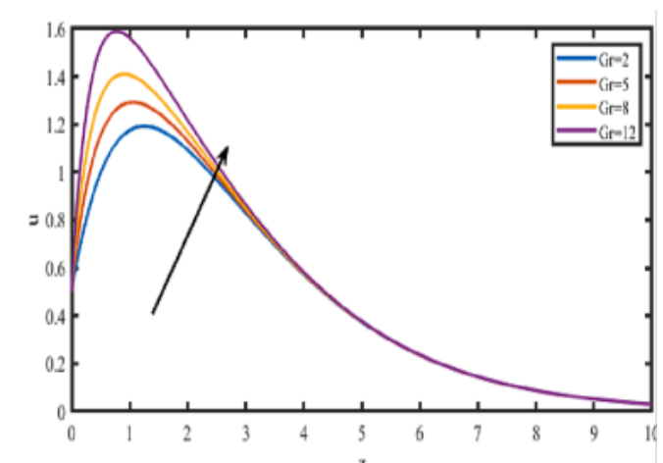 | 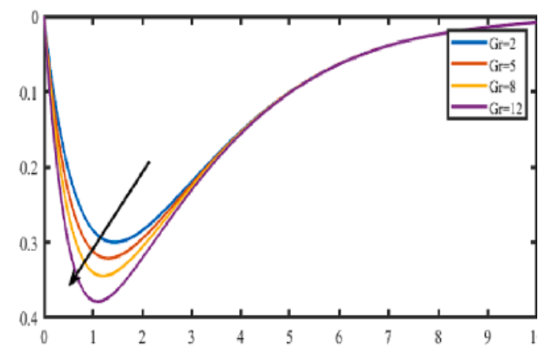

Fig. 2. The velocity profiles for u and v against Gr with M = 2, k = 0.5, So = 1, Gm = 3, H = 0.2, Pr = 0.71, Q = 1, Sc = 0.22, Kc = 1, n = 0.5, t = 0.5, R = 1, β = 1.0.
The solutal Grashof number (Gm) characterizes the relative influence of solutal buoyancy forces to viscous forces in the flow. An increase in Gm indicates a stronger solutal buoyancy effect relative to viscous resistance, which generally enhances the fluid motion and, consequently, increases the velocity within the boundary layer. Fig. 4 explains the significance of the Hartmann number M on the various velocity components. An increase in the Hartmann number M leads to a reduction in the primary velocity (u) component, while the secondary velocity (v) component increases due to the influence of the Hall current. The enhancement in the secondary velocity is attributed to the Hall effect, which modifies the electromagnetic response of the electrically conducting fluid and promotes motion in the transverse direction. Conversely, increasing suppresses the overall fluid motion, resulting in a decrease in the resultant velocity. This behavior is consistent with the action of the Lorentz force, which acts against the motion of the electrically conducting fluid and consequently enhances the resistance to flow. As the magnetic field strength increases, the opposing Lorentz force becomes more pronounced, leading to a reduction in the fluid velocity and, consequently, a thinner momentum boundary layer.
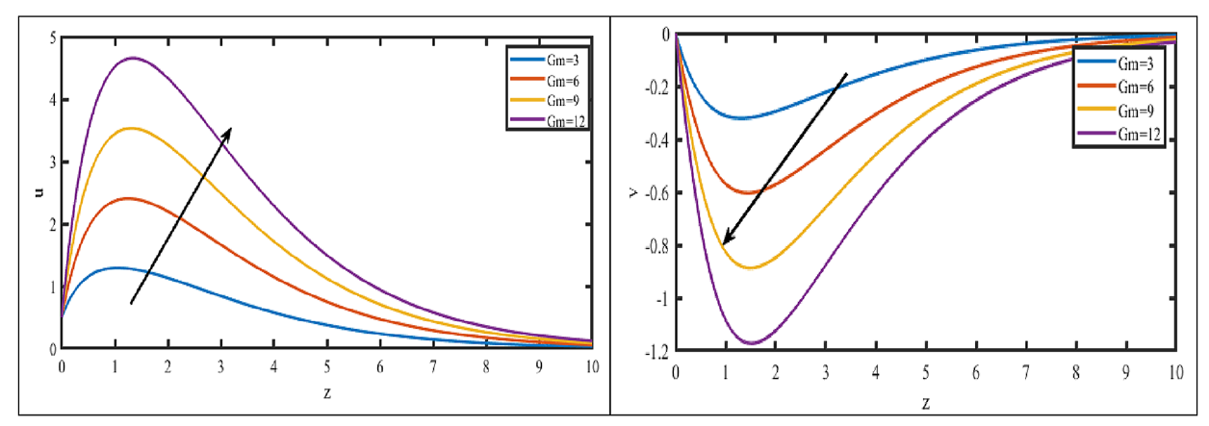
Fig. 3. The velocity profiles for u and v against Gm with M = 2, k = 0.5, R = 1, So = 1, Gr = 5, Gm = 3, H = 0.2, Pr = 0.71, Q = 1, Sc = 0.22, Kc = 1, n = 0.5, t = 0.5, β = 1.0.

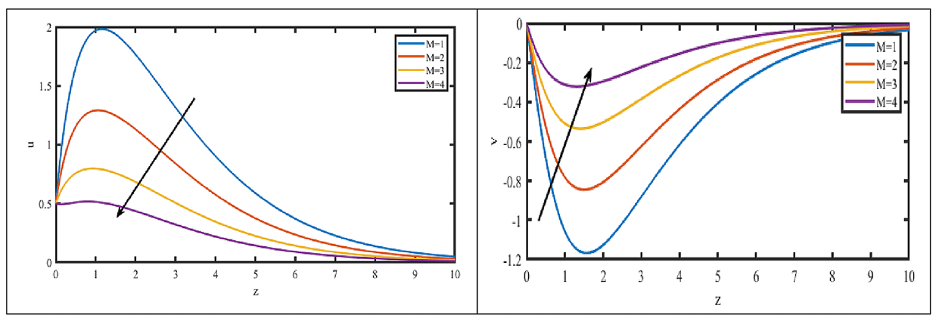
Fig. 4. The velocity profiles for u and v against M with k = 0.5, R = 1, Gr = 5, So = 1, Gm = 3, H = 0.2, Pr = 0.71, Q = 1, Sc = 0.22, Kc = 1, n = 0.5, t = 0.5, β = 1.0.
The effect of the Hall parameter $m$ on the velocity field is presented in Fig. 5. illustrates the influence of the Hall parameter m on the velocity profiles. As the Hall parameter increases, both the primary and secondary velocity components increase throughout the fluid domain. This enhancement is attributed to the Hall effect, which modifies the electromagnetic force distribution and promotes fluid motion in both the streamwise and transverse directions. Consequently, the resultant velocity increases with increasing Hall parameter, accompanied by a corresponding thickening of the momentum boundary layer. Fig. 6 and Fig. 7 exhibit the effect of angle of inclination (α) and Jeffrey fluid parameter (β). The primary velocity u diminishes with increasing inclination angle and aligned magnetic field parameter, whereas it reduced secondary velocity v.

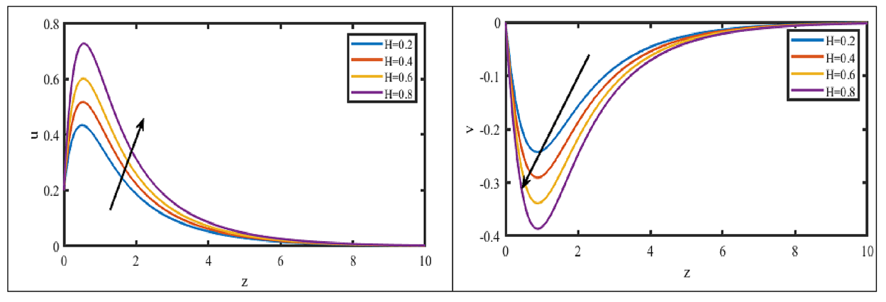
Fig. 5. The velocity profiles for u and v against H with M = 2, k = 0.5, Gr = 5, So = 1, Gm = 3, R = 1, Pr = 0.71, Q = 1, Sc = 0.22, Kc = 1, n = 0.5, t = 0.5, β = 1.0.
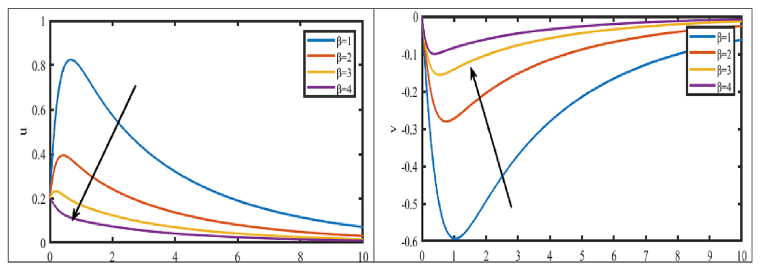
Fig. 6. The velocity profiles for both u and v plotted versus Jeffrey parameter (β) with M = 2, k = 0.5, Gr = 5, So = 1, Gm = 3, R = 1, Pr = 0.71, Q = 1, Sc = 0.22, Kc = 1, n = 0.5, t = 0.5
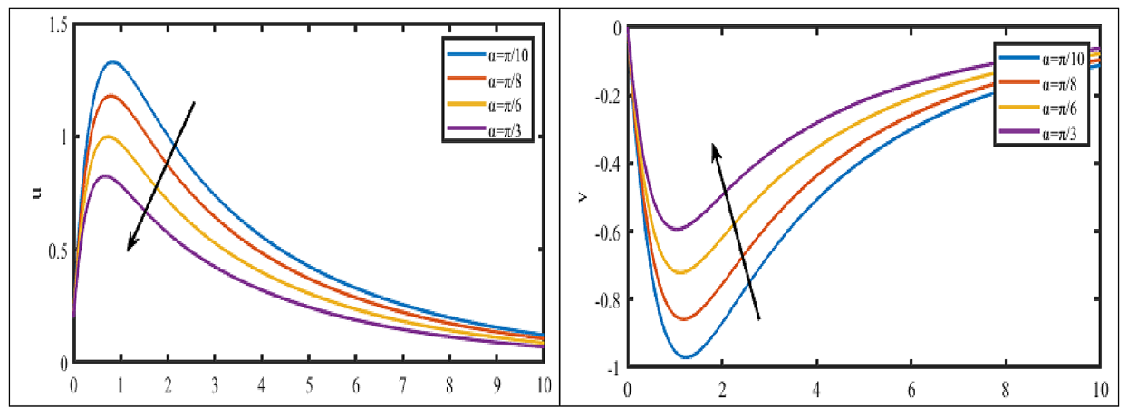
Fig. 7. The velocity profiles for both u and v plotted versus inclined parameter (α) with M = 2, k = 0.5, Gr = 5, So = 1, Gm = 3, R = 1, Pr = 0.71, Q = 1, Sc = 0.22, Kc = 1, n = 0.5, t = 0.5, β = 1.0
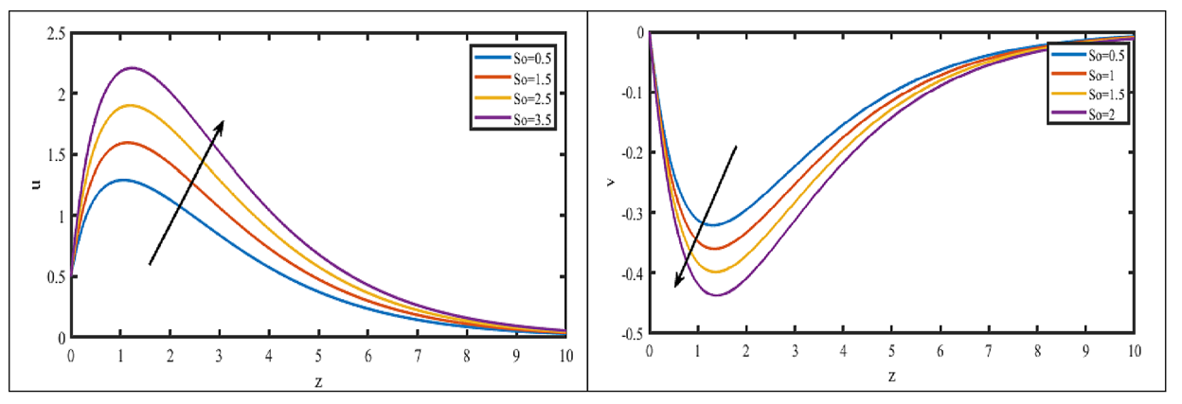
Fig. 8. The velocity profiles for u and v against So with M = 2, k = 0.5, Gr = 5, So = 1, Gm = 3, R = 1, Pr = 0.71, Q = 1, Sc = 0.22, Kc = 1, n = 0.5, t = 0.5, β = 1.0.
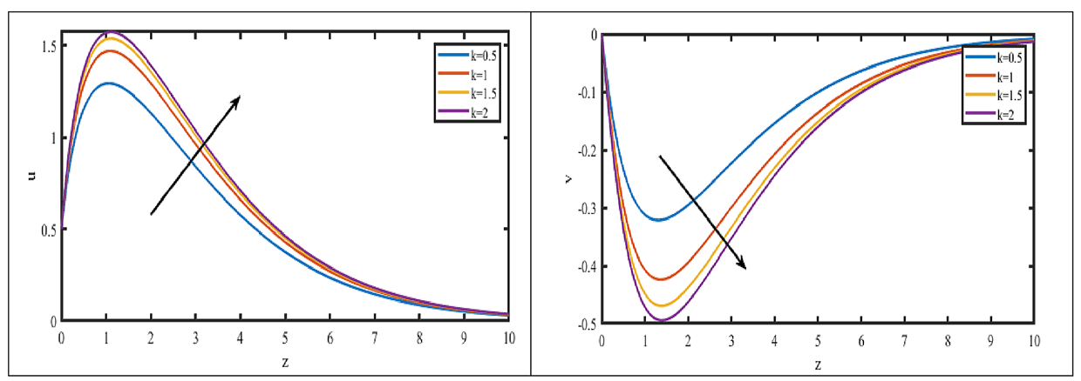
Fig. 9 The velocity profiles for u and v against k with M = 2, R = 1, Gr = 5, So = 1, Gm = 3, H = 0.2, Pr = 0.71, Sc = 0.22, Kc = 1, n = 0.5, t = 0.5, Q = 1, β = 1.0.
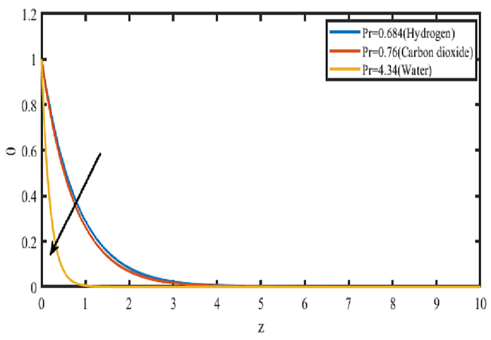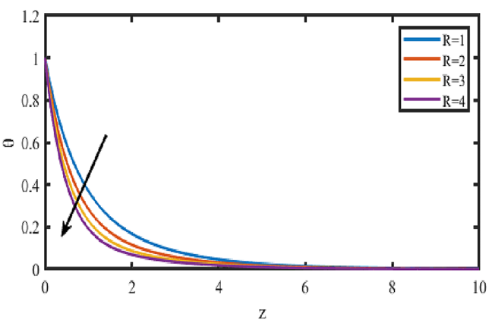
Fig. 10. Effect of Prandtl number parameter Pr on Temperature profiles. | Fig.11. Effect of Radiation parameter R on Temperature profiles.

Fig. 8. depicts the influence of the Soret number $So$ on the primary velocity $u$, secondary velocity $v$, and concentration field. Increasing $So$ enhances the primary velocity while diminishing the secondary velocity. Physically, an elevation in $Sr$ corresponds to a reduction in the effective viscosity of the nanofluid, which weakens viscous resistance and amplifies inertial effects, thereby accelerating the primary flow within the boundary layer.
The influence of the permeability parameter $K$ on the velocity field is presented in Fig. 9. Increasing $k$ suppresses the secondary velocity component $v$ while enhancing the primary component $u$. The enhancement of $u$ is further amplified by the Hall current effect, which influences the entire fluid domain. Consequently, the resultant velocity increases with $k$, accompanied by a corresponding thickening of the momentum boundary layer. Conversely, lower permeability impedes fluid motion, resulting in reduced velocity magnitudes throughout the flow field.
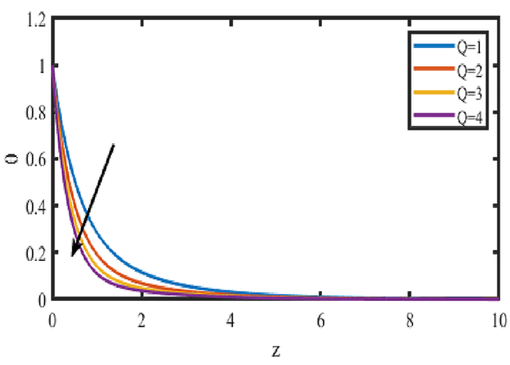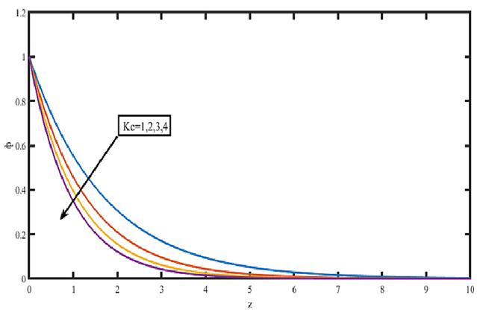
Fig. 12. Effect of Heat source parameter Q on Temperature profiles. | Fig. 13. Effect of Chemical reaction parameter Kr on Concentration profiles.

Figs. 10–12 illustrate the effects of the Prandtl number Pr, thermal radiation parameter R, and heat source parameter Q on the temperature profiles, respectively. The Prandtl number represents the ratio of momentum diffusivity to thermal diffusivity. An increase in corresponds to a reduction in thermal diffusivity, thereby limiting the rate at which thermal energy is transported through the fluid. Consequently, the temperature profile decreases as increases, indicating a reduction in the thermal boundary-layer thickness. A similar decreasing trend in the temperature profile is observed with increasing thermal radiation and heat source parameters, as depicted in Figs.11 and 12, respectively.
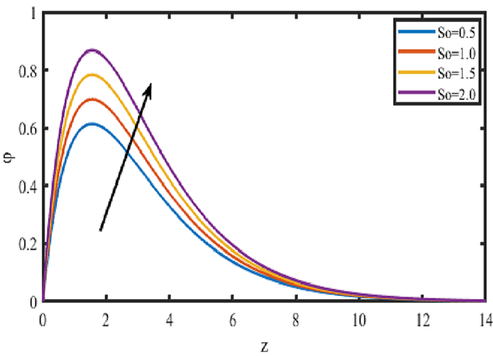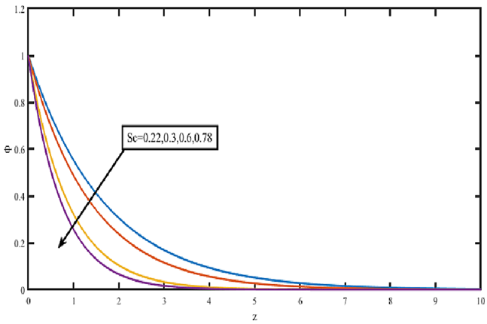
Fig. 14. Effect of Soret parameter So on Concentration profiles. | Fig. 15. Effect of Schmidt number parameter Sc on Concentration profiles.

Figs. 13–15 illustrate the respective effects of the chemical reaction parameter $Kr$, Soret number $Sr$, and Schmidt number $Sc$ on the concentration profiles. Fig. 13 depicts the influence of a destructive chemical reaction ($Kr>0$) on the concentration field. Increasing $Kr$ leads to a monotonic decrease in the concentration distribution, as the enhanced molecular disturbances intensify mass transport and accelerate species depletion. Fig. 14 demonstrates that the concentration profile increases with the Soret number $So$. This behavior is attributed to the enhanced thermophoretic migration of nanoparticles under stronger thermal gradients, which augments the species concentration within the boundary layer. The effect of the Schmidt number $Sc$ on the concentration profiles is presented in Fig. 15. The Schmidt number, defined as the ratio of kinematic viscosity to mass diffusivity, quantifies the relative effectiveness of momentum and mass transport. Higher $Sc$ values correspond to reduced mass diffusivity, which restricts species penetration into the boundary layer and consequently suppresses the concentration profiles.
- CONCLUSIONS
This study numerically investigated the influence of Hall current and Soret effects on the unsteady magnetohydrodynamic (MHD) natural convection flow of a viscous, incompressible, and electrically conducting fluid. The transport phenomena were evaluated past an infinite vertical plate embedded in a fluid-saturated porous medium in the presence of thermal radiation and chemical reaction. The non-linear governing partial differential equations were converted into a system of ordinary differential equations and solved using the Sixth-Order Runge–Kutta scheme coupled with a Shooting numerical algorithm. Comprehensive graphical analyses were conducted to evaluate velocity, temperature, and species concentration distributions across various dimensionless flow parameters. The principal findings are summarized as follows:
- Hall Current Influence: An increase in the Hall current parameter accelerates the secondary velocity profile (v) within the momentum boundary layer while exerting a retarding effect on the primary velocity profile.
- Thermo-diffusive (Soret) Effect: Higher Soret numbers enhance both the primary and secondary velocity distributions across the boundary layer due to temperature gradient-driven mass transport.
- Thermal Buoyancy Response: Stronger thermal buoyancy forces accelerate the primary flow near the plate surface while attenuating the secondary velocity across the momentum boundary layer. Farther from the plate, the primary flow experiences a reversal in momentum behavior.
- Concentration buoyancy: An increase in the concentration buoyancy force enhances both the primary and secondary velocity components, whereas mass diffusion produces an opposing effect on the velocity field.
- Porous Medium Permeability: Increasing the permeability parameter enhances the secondary flow speed by reducing matrix drag, whereas it decreases the primary velocity component within the boundary layer.
- Temperature field: Thermal diffusion and thermal radiation suppress the temperature distribution, whereas an increase in time enhances the temperature within the boundary layer.
- Species Concentration Distributions: Species concentration is suppressed by thermal and mass diffusion effects, but is significantly enhanced by increasing the Soret number and progression of time.

DECLARATION OF COMPETING INTEREST
The authors declare that they have no known competing financial interests or personal relationships that could have appeared to influence the work reported in this paper.
DATA AVAILABILITY
No data was used for the research described in the article.

Declaration of AI Use

This manuscript was prepared through the combined contributions of all author(s), including contributions to the study design, data, content development, results, interpretation, and related scholarly work. The author(s) acknowledge the use of Grammarly and ChatGPT to assist with grammar checking, language refinement, reference formatting. These AI-assisted tools were not used as authors and did not replace the intellectual contributions or scholarly judgment of the author(s). All AI-assisted outputs, including content, references, and interpretations, were carefully reviewed, revised, verified, and approved by the author(s). The author(s) accept full responsibility for the accuracy, integrity, and final content of the manuscript.

References

[1] | R. M. Kumara, R. S. Rajub, M. A. Kumar and B. Venkateswarlu, "A numerical study of thermal and diffusion effects on MHD Jeffrey fluid flow over a porous stretching sheet with activation energy," An International Journal of Computation and Methodology, vol. 86, no. 13, pp. 4423-4444,, 2025.
[2] | H. Vaidya, D. Tripathi, S. Saadaoui, C. Rajashekhar, M. Rafiq, Abdullaeva, B.S,, Alanazi, M. M. and K. V. Prasad, "Enhanced understanding of peristaltic flow in a uniform channel with Hall current and Joule heating: A study on the effects of a mixed convective Jeffrey fluid," Case Studies in Thermal Engineering, vol. 68, p. 105917, 2025.
[3] | S. Abbas and Mudassar Nazar, "Fractional analysis of unsteady magnetohydrodynamics Jeffrey flow over an infinite vertical plate in the presence of Hall current," Mathematical Methods in the Applied Sciences., vol. 48, no. 1, pp. 253-272, 2024.
[4] | S. M. Venthan, P. S. Kumar, S. S. Kumar, S. Sudarsan and G. Rangasamy, "A computational study of the impact of fluid flow characteristics on convective heat transfer with Hall current using the MHD non-Newtonian fluid model," Chemical Engineering Research and Design, vol. 1, no. 203, pp. 789-799, 2024.
[5] | H. B. Kommaddi, R. Kodi, C. Ganteda and G. Lorenzini, "Heat and Mass Transfer on Unsteady MHD Chemically Reacting Rotating Flow of Jeffrey Fluid Past an Inclined Plates under the Impact of Hall Current, Diffusion Thermo and Radiation Absorption," Journal of Advanced Research in Fluid Mechanics and Thermal Sciences, vol. 111, no. 2, pp. 225-241, 2023.
[6] | R. Kodi and V. Konduru , "Heat and mass transfer on MHD convective unsteady flow of a Jeffrey fluid past an inclined vertical porous plate with thermal diffusion Soret and Aligned magnetic field," Published by Elsevier Ltd., vol. 50, no. 5, pp. 2128-2134, 2022.
[7] | R. Kodi, R. R. Vaddemani, M. I. Khan , S. S. Abdullaev, A. Habibullah, M. Boudjemline, , M. Boujelbene and Y. Bouazzi , "Unsteady magneto-hydro-dynamics flow of Jeffrey fluid through porous media with thermal radiation, Hall current and Soret effects}," Journal of Magnetism and Magnetic Materials, vol. 582, p. 171033, 2023.
[8] | S. S. a. M. Muthtamilselvan, "Exploring stability of Jeffrey fluids in anisotropic porous media: incorporating Soret effects and microbial systems," International Journal of Numerical Methods for Heat and Fluid Flow, vol. 1, no. 35, pp. 66-86, 2025.
[9] | R. M. a. K. Kaladhar, "Irreversibility analysis of Jeffrey fluid flow in a sloping channel with Hall current, thermal radiation, and inclined magnetic field effects," Journal of Thermal Analysis and Calorimetry, vol. 149, p. 7705–7716, 2024.
[10] | A. Haritha, B. Vishali and C. V. Lakshmi, "Heat and mass transfer of MHD Jeffrey nanofluid flow through a porous media past an inclined plate with chemical reaction, radiation, and Soret effects," Wiley Online Library, vol. 52, no. 2, pp. 1178-1197, 2023.
[11] | O. T. Bafakeeh, K. Raghunath, F. Ali, M. Khalid, E. S. M. Tag-ElDin, M. Oreijah, K. Guedri, N. B. Khedher and M. Ijaz Khan , "Hall Current and Soret Effects on Unsteady MHD Rotating Flow of Second-Grade Fluid through Porous Media under the Influences of Thermal Radiation and Chemical Reactions," MDPI- Catalyst, vol. 12, no. 10, p. 1233, 2022.
[12] | M. A. Kumar, F. Mebarek-Oudina, P. Mangathai, N. A. Shah, . C. Vijayabhaskar, N. Venkatesh and Y. Fouad , "The impact of Soret Dufour and radiation on the laminar flow of a rotating liquid past a porous plate via chemical reaction," World Scientific, vol. 39, no. 10, p. 2450458, 2025.
[13] | A. A. a. J. P. Panda, "The Soret effect on MHD flow with Hall current and induced magnetic field," International Journal of Ambient Energy, vol. 44, no. 1, pp. 450-462, 2022.
[14] | R. Sen, Subrata Roy, P. A. L. Narayana and R. Raj Kairi, "Instability of Jeffrey Fluid Throughflow in a Porous Layer Induced by Heat Source and Soret Effect," ASME Journal of Heat and Mass Transfer, vol. 147, no. 7, p. 072702, 2024.
[15] | J. S. Huang, "Chemical reaction and activation energy on heat and mass transfer for convective flow along an inclined surface in Darcy porous medium with Soret and Dufour effects," Journal of Mechanics, vol. 39, p. 88–104, 2023.
[16] | R. Viskanta and R. J. Grosh, "Boundary layer in thermal radiation absorbing and emitting media," International Journal of Heat and Mass Transfer, vol. 5, no. 9, pp. 795-806, 1962.
[17] | E. H. A. a. A. Ebaid, " MHD Marangoni boundary layer problem for hybrid nanofluids with thermal radiation," International Journal of Numerical Methods for Heat and Fluid Flow., vol. 31, no. 3, p. 897–913, 2021.
[18] | R. Mahesh, U. S. Mahabaleshwar, E. H. Aly and O. Manca , "An impact of CNTs on an MHD Casson Marangoni boundary layer flow over a porous medium with suction/injection and thermal radiation," International Communications in Heat and Mass Transfer, vol. 141, p. 106561, 2023.
[19] | S. A. G. A. Shah, A. Hassan, H. Karamti, A. Alhushaybari, S. M. Eldin and A. M. Galal, "Effect of thermal radiation on convective heat transfer in MHD boundary layer Carreau fluid with chemical reaction," www.nature.com/scientificreports, vol. 13, p. 4117, 2023.
[20] | U. Mahabaleshwar, K. N. Sneha, A. Chan and Dia Zeidan , "An effect of MHD fluid flow heat transfer using CNTs with thermal radiation and heat source/sink across a stretching/shrinking sheet," International Communications in Heat and Mass Transfer, vol. 135, p. 106080, 2022.
[21] | S. Irshad, A. H. Majeed, S. Jahan, A. Ria, S. M. Eldin and H. Shahzad, "Numerical simulations of MHD generalized Newtonian fluid flow effects on a stretching sheet in the presence of permeable media: A finite difference-based study," Frontiers in Physics Statistical and Computational Physics., vol. 11, 2023.
[22] | R. J. P. Gowda, R. V. Kumar, A. M. Jyothi, B. C. Prasannakumara and I. E. Sarris, "Impact of Binary Chemical Reaction and Activation Energy on Heat and Mass Transfer of Marangoni Driven Boundary Layer Flow of a Non-Newtonian Nanofluid," MDPI, vol. 9, no. 4, p. 702, 2021.
[23] | Y.-X. Li, S. R. Mishra, P. K. Pattnaik, S. Baag, Yong-Min Li, M. Ijaz Khan, N. B. Khan, M. Kbiri Alaoui and S. U. Khan, "Numerical treatment of time dependent magnetohydrodynamic nanofluid flow of mass and heat transport subject to chemical reaction and heat source," Alexandria Engineering Journal, vol. 61, no. 3, pp. 2484-2491, 2021.
[24] | W. Abbas, Ahmed M. Megahed and Eman Fares , "The impact of a chemical reaction on the heat and mass transfer mechanisms in a dissipative and radiative nanofluid flow over a nonlinear stretching sheet," Science report , vol. 14, no. 3, p. 7712, 2024.
[25] | S. Karthik, D. Iranian and Qasem M. Al-Mdallal, "Numerical simulation of magneto-hydrodynamic fluid flow with heat sink, chemical diffusion and Powell Eyring fluid behavior using Cattaneo–Christov source term," International Journal of Thermofluids., vol. 24, p. 100616, 2022.
[26] | A. Roja, R. Saadeh, J. K. Madhukesh, MD. Shamshuddin, K. V. Prasad, U. Khan, C. Prakash and S. M. Hussain, "Computational role of homogeneous–heterogeneous chemical reactions and a mixed convective ternary hybrid nanofluid in a vertical porous microchannel," journal High Temperature Materials and Processes, vol. 43, no. 1, p. 20240057, 2024.
[27] | A. Roja, Umair Khan, T. Ramachandran, Ankur Kulshreshta, N. Neelima, Chander Prakash, . E.-S. M. Sherif and P. Ioan , "Aspects of motile microorganism and thermophoretic particle deposition in the binary chemical reactive ternary hybrid nanofluid past a porous microchannel," Wiley Online Library, vol. 105, no. 5, 2025.
[28] | M. Awais and T. Salahuddin, "Variable thermophysical properties of magnetohydrodynamic cross fluid model with effect of energy dissipation and chemical reaction," International Journal of Modern Physics B, vol. 38, no. 16, p. 2450197, 2024.
[29] | J. K. Madhukesh, G. K. Ramesh, B. C. Prasannakumara, S. A. Shehzad and F. M. Abbasi, "Bio-Marangoni convection flow of Casson nanoliquid through a porous medium in the presence of chemically reactive activation energy," Journal of Thermal Analysis and Calorimetry, vol. 42, p. 1191–1204, 2021.
[30] | W.-F. Xia, M. Ijaz Khan, Sami Ullah Khan, Faisal Shah and M. Imran Khan, "Dynamics of unsteady reactive flow of viscous nanomaterial subject to Ohmic heating, heat source and viscous dissipation," Ain Shams Engineering Journal, vol. 12, no. 4, pp. 3997-4005, 2021.
[31] | B. Nayak, S. Acharya and S. R. Mishra , " Impact of Dissipative Heat and Thermal Radiation on the Steady Magnetohydrodynamic Nanofluid Flow with an Interaction of Brownian Motion and Chemical Reaction," International Journal of Applied and Computational Mathematics, vol. 8, p. 144, 2022.
[32] | A. Ahmed, K. Masood , I. Muhammad and A. Jawad , "Transient MHD flow of Maxwell nanofluid subject to non-linear thermal radiation and convective heat transport," Applied Nanoscience, vol. 10, p. 5361–5373, 2020.
[33] | P. K. Ratha, R. S. Tripathy and S. R. Mishra , "On the Impact of Temperature and Space Dependent Heat Source/Sink with Richardson Number for the MHD Convection Flow of Nanofluid," International Journal of Applied and Computational Mathematics, vol. 10, p. 166, 2024.
[34] | A. Razaq, T. Hayat, S. A. Khan and S. Momani , " ATSS model based upon applications of Cattaneo-Christov thermal analysis for entropy optimized ternary nanomaterial flow with homogeneous-heterogeneous chemical reactions," Alexandria Engineering Journal, vol. 79, pp. 390-401, 2023.
[35] | K. Madhura and Babitha, "Numerical study on magnetohydrodynamics micropolar Carreau nanofluid with Brownian motion and thermophoresis effect," International Journal of Modelling and Simulation, vol. 45, pp. 651-664, 2023.
[36] | L. Zeng, T. Lv, T. Ma, Z. Fang and J. Shi, "Flow accelerated corrosion of X65 steel gradual contraction pipe in high CO2 partial pressure environments," Arabian Journal of Chemistry, vol. 16, p. 104935, 2023.
[37] | V. V. L. Deepthi, M. M. A. Lashin, N. R. Kumar , K. Raghunath, M. Oreijah, K. Guedri, E. S. M. Tag-ElDin, F. Ali, M. I. Khan and A. M. Galal, "Recent Development of Heat and Mass Transport in the Presence of Hall, Ion Slip and Thermo Diffusion in Radiative Second Grade Material: Application of Micromachines," Micromachines, vol. 13, no. 10, p. 1566, 2022.
[38] | P. Nachtsheim and P. Swigert, Satisfaction of the asymptotic boundary conditions in the numerical solution of the system of nonlinear equations of boundary layer type, Washington : NASA, 1965.
[39] | M. Jain, Numerical methods for scientific and engineering computation., New Age International., 2003.
[40] | F. E., Low-order Classical Runge-Kutta Formulas with Step Size Control and their Application to Some Heat Transfer Problems, Washington : NASA Technical Report 315, 1969.

