Assessment of Genetic Variability, Heritability and Genetic Advance for Yield and Yield-Associated Traits in Barnyard Millet (Echinochloa frumentacea (Roxb.) Link) Genotypes

Abstract
The present investigation was undertaken to assess the magnitude of genetic variability, heritability and genetic advance for yield and yield-associated traits in barnyard millet (Echinochloa frumentacea (Roxb.) Link) genotypes. The study included thirteen important morphological and yield-related characters, namely days to 50% flowering, days to maturity, plant height, number of productive tillers per plant, number of leaves on the main tiller, peduncle length, ear length, finger length, number of fingers per ear, biological yield per plant, harvest index, 1000-seed weight and grain yield per plant. The estimates revealed considerable variation among the genotypes for most of the traits. Phenotypic coefficient of variation (PCV) was higher than the corresponding genotypic coefficient of variation (GCV) for all the characters, indicating the influence of environmental factors on trait expression. The highest GCV was recorded for peduncle length (12.55%), followed by finger length (11.73%), number of fingers per ear (11.12%) and 1000-seed weight (11.51%). High heritability in broad sense was observed for finger length (83.70%), plant height (75.70%), peduncle length (66.40%), days to 50% flowering (66.00%) and biological yield per plant (64.50%). The highest genetic advance as percentage of mean was recorded for finger length (22.10%), followed by peduncle length (21.08%), biological yield per plant (20.50%) and 1000-seed weight (17.33%). High heritability coupled with relatively higher genetic advance for finger length and peduncle length indicated the predominance of additive genetic effects and suggested good scope for selection improvement for these traits. The findings suggest that traits showing higher heritability and genetic advance can be effectively utilized as selection criteria in barnyard millet breeding programmes for improving grain yield and related attributes.
Keywords: Barnyard millet, Echinochloa frumentacea, genetic variability, GCV, PCV, heritability, genetic advance, yield-associated traits.
Introduction
Barnyard millet (Echinochloa frumentacea (Roxb.) Link) is an important minor millet belonging to the family Poaceae and is widely cultivated in India as a food and fodder crop. It is a short-duration, hardy and climate-resilient crop capable of performing well under rainfed and marginal production conditions. Its relatively low water requirement, early maturity and adaptability to adverse environmental conditions make it particularly suitable for sustainable agriculture and low-input farming systems. In recent years, increasing awareness regarding the nutritional importance of millets has further enhanced the significance of barnyard millet as an alternative food crop.
The grain of barnyard millet is a valuable source of carbohydrates, protein, dietary fibre, minerals and other nutritionally important components. Its potential role in diversified diets and climate-resilient agriculture has generated renewed interest in the genetic improvement of the crop. However, the productivity of barnyard millet is still constrained by limited availability of improved high-yielding genotypes and inadequate exploitation of its genetic resources. Therefore, systematic evaluation and characterization of available germplasm are essential for identifying superior genotypes and broadening the genetic base of future breeding programmes.
Genetic variability is the basic requirement for effective selection and genetic improvement. The extent of variability present in a breeding population determines the possibilities of selecting desirable genotypes for important agronomic and yield-associated traits. The phenotypic expression of quantitative characters is influenced by both genetic and environmental components. Hence, estimation of genotypic and phenotypic variances is important for determining the magnitude of heritable variation and for assessing the potential effectiveness of selection.
The genotypic coefficient of variation (GCV) and phenotypic coefficient of variation (PCV) are useful measures for assessing the extent of variability associated with different quantitative traits. The difference between GCV and PCV provides an indication of the influence of environmental factors on the expression of a character. In addition, heritability estimates provide information regarding the proportion of phenotypic variation that is attributable to genetic differences among genotypes. However, heritability alone may not adequately indicate the expected gain from selection. Therefore, heritability estimates should preferably be considered together with genetic advance as percentage of mean (GAM) to understand the probable nature of gene action and the effectiveness of selection.
High heritability coupled with high genetic advance is generally considered an indication of the predominance of additive genetic effects and suggests that improvement through phenotypic selection may be effective. On the other hand, high heritability accompanied by low genetic advance may indicate the influence of non-additive gene action or limited exploitable genetic variability. Thus, the simultaneous estimation of genetic variability, heritability and genetic advance is particularly important for identifying characters that can be effectively utilized as selection criteria in breeding programmes.
Yield and its associated traits in barnyard millet are quantitative in nature and are influenced by several component characters. Characters such as days to flowering, days to maturity, plant height, productive tillers, peduncle length, ear length, finger length, number of fingers per ear, biological yield, harvest index and seed weight may contribute to differences in grain yield among genotypes. A better understanding of the genetic variability and inheritance of these characters can facilitate the identification of desirable genotypes and help breeders formulate effective selection strategies.
Therefore, the present investigation was undertaken to assess the magnitude of genetic and phenotypic variability and to estimate broad-sense heritability and genetic advance for important morphological and yield-associated traits in barnyard millet genotypes. The study was aimed at identifying characters with substantial heritable variation and higher expected genetic gain, which could be effectively exploited for the improvement of grain yield and other desirable attributes in barnyard millet.
Materials and Methods
Experimental Site
The present investigation was conducted at the Organic Research Farm, Department of Genetics and Plant Breeding, Institute of Agricultural Sciences, Bundelkhand University, Jhansi, Uttar Pradesh, India. The experimental site represents the agro-climatic conditions of the Bundelkhand region of Uttar Pradesh. The experiment was conducted to assess the extent of genetic variability, heritability and genetic advance for important morphological and yield-associated traits in barnyard millet germplasm.
Experimental Material
The experimental material comprised 15 barnyard millet (Echinochloa frumentacea (Roxb.) Link) germplasm/genotypes. The germplasm lines were selected to represent diverse genetic material and were evaluated for their variability in morphological, phenological and yield-related characteristics. Each genotype was evaluated under identical field conditions to minimize environmental variation and facilitate reliable comparison among genotypes.
Experimental Design
The experiment was laid out in a Randomized Block Design (RBD) with three replications. Each replication consisted of all 15 germplasm entries, and the genotypes were randomly allocated to the experimental plots within each replication. Standard recommended agronomic practices were followed uniformly throughout the crop period to ensure proper crop establishment and growth.
Observations Recorded
Observations were recorded on individual plants selected randomly from each plot for the following morphological, phenological and yield-associated traits:
- Days to 50% flowering
- Days to maturity
- Plant height (cm)
- Number of productive tillers per plant
- Number of leaves on main tiller
- Peduncle length (cm)
- Ear length (cm)
- Finger length (cm)
- Number of fingers per ear
- Biological yield per plant (g)
- Harvest index (%)
- 1000-seed weight (g)
- Grain yield per plant (g)
For each character, observations were recorded following standard procedures. Days to 50% flowering and days to maturity were recorded on a plot basis, whereas observations for morphological and yield-associated traits were recorded from randomly selected representative plants from each experimental unit. Grain yield per plant was recorded after harvesting and threshing of the selected plants. The 1000-seed weight was determined from randomly selected seeds from each genotype.
Statistical Analysis
The analysis of variance was carried out according to the procedure suggested for Randomized Block Design to determine the significance of differences among the genotypes for the characters studied. The variance components were estimated from the expected mean squares obtained from the analysis of variance. The estimates of GCV, PCV, broad-sense heritability and genetic advance as percentage of mean were used to assess the magnitude of genetic variability and the expected response to selection for different morphological and yield-associated traits in barnyard millet germplasm.

Results and Discussion
Genetic Variability
The analysis of genetic parameters revealed considerable variability among the barnyard millet (Echinochloa frumentacea (Roxb.) Link) genotypes for the morphological, phenological and yield-associated characters under study. The estimates of genotypic variance, phenotypic variance, environmental variance, genotypic coefficient of variation (GCV), phenotypic coefficient of variation (PCV), heritability in broad sense and genetic advance as percentage of mean are presented in Table 4.3.
Phenotypic variance was higher than genotypic variance for all the characters, indicating that environmental factors contributed to the phenotypic expression of the traits. Similarly, PCV was higher than GCV for all the characters, suggesting the influence of environmental factors on the expression of quantitative traits. Burton and DeVane (1953) emphasized that GCV provides a useful measure of the magnitude of genetic variability, while comparison of GCV and PCV helps in assessing the relative influence of environmental variation. Similar observations regarding higher PCV than GCV for quantitative traits have been reported by Johnson et al. (1955) and Sharma et al. (2006).
Among the traits evaluated, relatively higher GCV was observed for peduncle length (12.55%), followed by finger length (11.73%), 1000-seed weight (11.51%) and number of fingers per ear (11.12%). The corresponding PCV values were 15.40, 12.82, 15.74 and 16.74 per cent, respectively. The relatively higher magnitude of GCV for these characters indicated the presence of appreciable genetic variability and hence greater scope for selection. Similar genetic variability for important morphological and yield-associated traits in barnyard millet and other small millets has been reported by Renganathan et al. (2009), Sood et al. (2010), Kumar et al. (2014) and Ushakumari et al. (2017).
Plant height recorded a genotypic variance of 43.19 and phenotypic variance of 57.08. The GCV and PCV were 6.79 and 7.80 per cent, respectively, indicating a relatively small difference between the two estimates. Broad-sense heritability was high (75.70%), suggesting substantial genetic control over the observed phenotypic variation. High heritability for plant height has also been reported in small millet genetic materials by Sood et al. (2010) and Padmavathi et al. (2013).
Peduncle length exhibited comparatively high variability, with GCV and PCV values of 12.55 and 15.40 per cent, respectively. The trait showed high broad-sense heritability (66.40%) and high genetic advance as percentage of mean (21.08%). The combination of relatively high heritability and genetic advance indicates considerable exploitable genetic variation for this character. Johnson et al. (1955) suggested that high heritability coupled with high genetic advance is generally indicative of additive genetic variance and greater response to selection. Similar conclusions have been reported for yield-associated traits in millet germplasm by Sood et al. (2010) and Kumar et al. (2014).
Heritability and Genetic Advance
The estimates of broad-sense heritability ranged from 17.40% for number of productive tillers per plant to 83.70% for finger length. High heritability was recorded for finger length (83.70%), plant height (75.70%), peduncle length (66.40%), days to 50% flowering (66.00%) and biological yield per plant (64.50%). Moderate heritability was recorded for 1000-seed weight (53.40%), grain yield per plant (49.90%), number of fingers per ear (44.10%), harvest index (41.30%) and days to maturity (40.50%). Low heritability was observed for number of leaves on main tiller (31.10%), ear length (28.90%) and number of productive tillers per plant (17.40%).
The highest heritability was observed for finger length (83.70%), indicating that a major proportion of the phenotypic variation for this trait was attributable to genetic differences among the genotypes. Falconer and Mackay (1996) stated that heritability provides an estimate of the proportion of phenotypic variation attributable to genetic variance, although the magnitude of heritability is population and environment dependent. High heritability for important morphological characters has also been reported in barnyard millet by Ushakumari et al. (2017) and Kumar et al. (2020).
The highest genetic advance as percentage of mean was observed for finger length (22.10%), followed by peduncle length (21.08%), biological yield per plant (20.50%), 1000-seed weight (17.33%) and number of fingers per ear (15.22%). The lowest genetic advance was observed for days to maturity (1.01%), followed by ear length (3.53%) and number of productive tillers per plant (5.06%).
High heritability coupled with high genetic advance was particularly evident for finger length and peduncle length. This combination is considered an indication of the predominance of additive genetic effects and suggests that selection may be effective for improving these traits. Johnson et al. (1955) demonstrated that the joint consideration of heritability and genetic advance provides a better indication of expected selection response than heritability alone. Similar relationships between heritability and genetic advance have been reported by Burton (1952), Robinson et al. (1949) and Lush (1949).
Variability in Yield and Yield-Associated Traits
Biological yield per plant recorded GCV and PCV values of 12.39 and 15.43 per cent, respectively. The broad-sense heritability was 64.50%, while genetic advance as percentage of mean was 20.50%. The relatively high heritability coupled with high genetic advance suggests substantial genetic variability and good prospects for selection. Sood et al. (2010) and Kumar et al. (2014) also reported considerable genetic variability for biomass and yield-associated characters in small millets.
The trait 1000-seed weight recorded GCV of 11.51% and PCV of 15.74%. Broad-sense heritability was 53.40%, while genetic advance as percentage of mean was 17.33%. These estimates indicate moderate-to-high genetic variability and moderate heritability, suggesting that seed weight can be improved through selection, although environmental effects should also be considered.
Number of fingers per ear recorded GCV and PCV values of 11.12 and 16.74 per cent, respectively. The trait showed moderate heritability (44.10%) and genetic advance as percentage of mean (15.22%). The relatively large difference between GCV and PCV suggests considerable environmental influence on this trait. Similar environmental effects on quantitative traits have been reported by Dewey and Lu (1959) and Singh and Chaudhary (1985).
Grain yield per plant recorded a mean value of 4.71 g, with GCV and PCV values of 9.16 and 12.97 per cent, respectively. Its broad-sense heritability was 49.90% and genetic advance as percentage of mean was 13.34%. The moderate heritability and genetic advance indicate that both genetic and environmental factors contributed to variation in grain yield. Since grain yield is a complex quantitative trait, indirect selection through highly heritable yield components may be useful. Falconer and Mackay (1996) and Allard (1999) emphasized the importance of component traits and genetic parameters in selection for complex quantitative characters.
Harvest index recorded GCV and PCV values of 7.55 and 11.75 per cent, respectively, with heritability of 41.30% and genetic advance as percentage of mean of 10.00%. The greater difference between GCV and PCV indicated environmental influence on the trait. Similar observations regarding the environmental sensitivity of yield-related traits have been reported by Sharma et al. (2006) and Kumar et al. (2020).
Phenological Traits
Days to 50% flowering recorded a mean of 53.31 days, with heritability of 66.00% and genetic advance as percentage of mean of 6.79%. The relatively high heritability indicated substantial genetic control of flowering time. However, the moderate magnitude of genetic advance suggested comparatively limited scope for rapid improvement through direct selection.
Days to maturity showed a mean of 131.45 days, with GCV and PCV values of 0.77 and 1.21 per cent, respectively. The trait recorded moderate heritability (40.50%) and very low genetic advance as percentage of mean (1.01%). The low genetic variability and genetic advance indicate limited scope for substantial improvement in maturity duration through selection within the evaluated material. Sood et al. (2010) reported considerable variation in maturity-related traits among small millet genotypes, emphasizing the importance of exploiting diverse germplasm for altering crop duration.
The present investigation demonstrated substantial genetic variability for several important morphological and yield-associated traits. The estimates of GCV, PCV, heritability and genetic advance indicated that the magnitude of genetic control differed considerably among traits. Among the characters evaluated, finger length, peduncle length, plant height and biological yield per plant appeared particularly promising because of their relatively high heritability and genetic advance.
The highest heritability and genetic advance were observed for finger length, indicating good prospects for effective phenotypic selection. Peduncle length also showed high heritability coupled with high genetic advance, suggesting that improvement through selection may be effective. Johnson et al. (1955) and Panse (1957) emphasized that high heritability accompanied by high genetic advance is generally associated with additive genetic effects and provides better prospects for selection.
In contrast, number of productive tillers per plant, number of leaves on the main tiller and ear length showed relatively low heritability and lower genetic advance. Such traits may be strongly influenced by environmental conditions and may require evaluation over multiple environments and seasons before being used as major selection criteria. Allard (1999) emphasized that reliable selection for quantitatively inherited traits requires adequate evaluation of genetic variation under appropriate environments.
The present findings suggest that the barnyard millet germplasm possesses useful genetic variability that can be exploited for crop improvement. Traits showing high heritability together with relatively high genetic advance, particularly finger length, peduncle length and biological yield per plant, can be considered promising selection criteria. Further studies involving correlation and path coefficient analysis would help determine the direct and indirect contribution of these traits towards grain yield and facilitate the development of an efficient selection strategy for barnyard millet improvement.

Table 1. Analysis of variance (ANOVA) for different morphological and yield-associated characters in barnyard millet genotypes
S. No. | Character | Replication MSS (df = 2) | Treatment MSS (df = 13) | Error MSS (df = 26)
1 | Days to 50% flowering | 1.23 | 16.47** | 2.41
2 | Days to maturity | 0.77 | 4.57** | 1.50
3 | Plant height (cm) | 8.80 | 143.46** | 13.89
4 | Number of productive tillers plant⁻¹ | 0.07 | 0.23* | 0.14
5 | Number of leaves on main tiller | 0.08 | 0.40** | 0.17
6 | Peduncle length (cm) | 1.36 | 7.95** | 1.14
7 | Ear length (cm) | 0.75 | 1.42** | 0.64
8 | Finger length (cm) | 0.04 | 1.09** | 0.07
9 | Number of fingers ear⁻¹ | 1.54 | 12.81** | 3.80
10 | Biological yield plant⁻¹ (g) | 7.73 | 98.52** | 15.29
11 | Harvest index (%) | 1.89 | 2.46** | 0.79
12 | 1000-seed weight (g) | 0.15 | 0.51** | 0.11
13 | Grain yield plant⁻¹ (g) | 0.32 | 0.58** | 0.15
Note: *Significant at 5% level; **Significant at 1% level.

Table 2. Estimates of genetic variability, heritability and genetic advance for different morphological and yield-associated traits in barnyard millet genotypes
S. No. | Character | Mean | σ²g | σ²p | σ²e | GCV (%) | PCV (%) | ECV (%) | h²b (%) | GA as % of mean
1 | Days to 50% flowering | 53.31 | 4.69 | 7.10 | 2.42 | 4.06 | 5.00 | 2.92 | 66.00 | 6.79
2 | Days to maturity | 131.45 | 1.02 | 2.52 | 1.50 | 0.77 | 1.21 | 0.93 | 40.50 | 1.01
3 | Plant height (cm) | 96.82 | 43.19 | 57.08 | 13.89 | 6.79 | 7.80 | 3.85 | 75.70 | 12.16
4 | No. of productive tillers plant⁻¹ | 2.95 | 0.03 | 0.17 | 0.14 | 5.88 | 14.07 | 12.78 | 17.40 | 5.06
5 | No. of leaves on main tiller | 6.21 | 0.08 | 0.25 | 0.17 | 4.47 | 8.02 | 6.66 | 31.10 | 5.14
6 | Peduncle length (cm) | 12.00 | 2.27 | 3.41 | 1.15 | 12.55 | 15.40 | 8.92 | 66.40 | 21.08
7 | Ear length (cm) | 15.98 | 0.26 | 0.90 | 0.64 | 3.19 | 5.93 | 5.01 | 28.90 | 3.53
8 | Finger length (cm) | 4.97 | 0.34 | 0.41 | 0.07 | 11.73 | 12.82 | 5.18 | 83.70 | 22.10
9 | No. of fingers ear⁻¹ | 15.58 | 3.00 | 6.80 | 3.80 | 11.12 | 16.74 | 12.52 | 44.10 | 15.22
10 | Biological yield plant⁻¹ (g) | 42.50 | 27.74 | 43.03 | 15.29 | 12.39 | 15.43 | 9.20 | 64.50 | 20.50
11 | Harvest index (%) | 9.87 | 0.56 | 1.35 | 0.79 | 7.55 | 11.75 | 9.00 | 41.30 | 10.00
12 | 1000-seed weight (g) | 3.15 | 0.13 | 0.25 | 0.11 | 11.51 | 15.74 | 10.74 | 53.40 | 17.33
13 | Grain yield plant⁻¹ (g) | 4.71 | 0.15 | 0.29 | 0.15 | 9.16 | 12.97 | 9.18 | 49.90 | 13.34

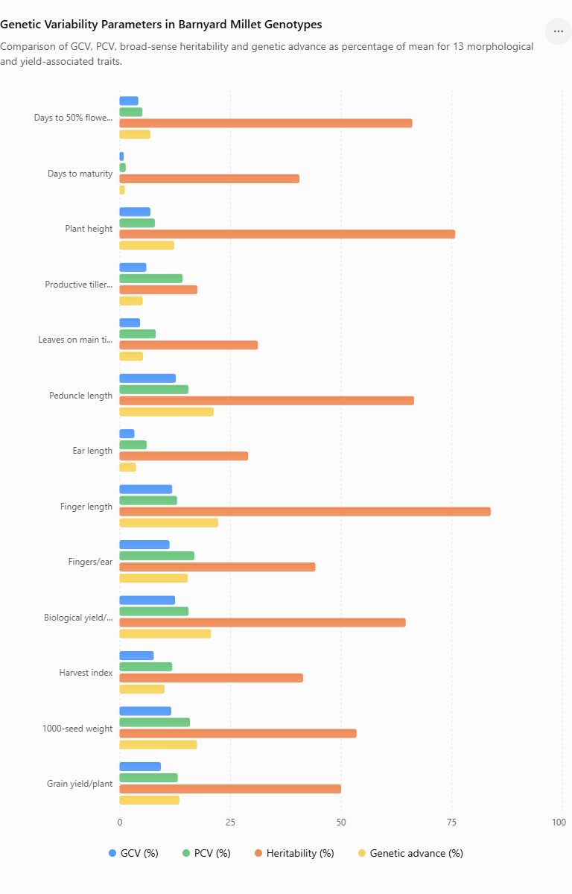
Fig 1- Genotypic coefficient of variation (GCV), phenotypic coefficient of variation (PCV), broad-sense heritability and genetic advance as percentage of mean for thirteen morphological and yield-associated traits in barnyard millet (Echinochloa frumentacea (Roxb.) Link) genotypes
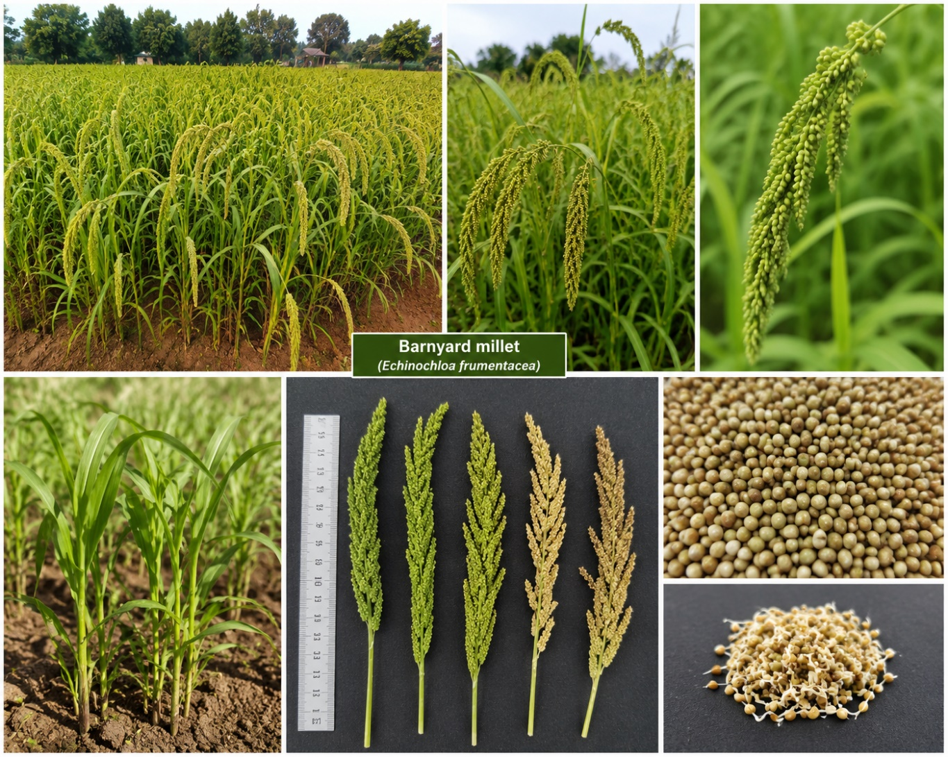
Fig 2- Morphological characteristics of barnyard millet (Echinochloa frumentacea (Roxb.) Link), showing field-grown plants, panicle variation and harvested grains.

Conclusion
The present investigation demonstrated substantial genetic variability among the evaluated barnyard millet (Echinochloa frumentacea (Roxb.) Link) genotypes for several morphological, phenological and yield-associated traits. The analysis of variance revealed significant differences among genotypes for all the characters studied, indicating the presence of adequate variability that can be exploited in barnyard millet improvement programmes.
The estimates of GCV and PCV indicated that environmental factors contributed to the expression of quantitative traits, although the magnitude of genetic variability was appreciable for several characters. Higher GCV was observed for peduncle length, finger length, 1000-seed weight, biological yield per plant and number of fingers per ear, suggesting greater scope for selection for these traits.
High broad-sense heritability was recorded for finger length, plant height, peduncle length, days to 50% flowering and biological yield per plant. Among these traits, finger length and peduncle length showed high heritability coupled with high genetic advance as percentage of mean, indicating a greater contribution of heritable genetic variation and good prospects for improvement through selection. Biological yield per plant and 1000-seed weight also showed comparatively favourable genetic parameters.
Grain yield per plant exhibited moderate heritability and genetic advance, suggesting that direct selection for grain yield may be influenced by environmental factors. Therefore, selection based on highly heritable yield-associated traits may provide a more effective strategy for improving grain yield.
The findings indicate that the evaluated barnyard millet germplasm possesses useful genetic variability for crop improvement. Finger length, peduncle length, biological yield per plant and 1000-seed weight may be given greater emphasis during selection. Further evaluation of the promising genotypes across different environments and seasons, together with correlation and path coefficient analysis, would help validate these traits as reliable selection criteria and facilitate the development of high-yielding and well-adapted barnyard millet genotypes
Declaration of AI Use

This manuscript was prepared through the intellectual contributions of the author(s) to the study design, data analysis, interpretation of results, and scholarly content. Grammarly and ChatGPT were used solely to assist with grammatical refinement and reference formatting during manuscript revision. The author(s) accept full responsibility for the accuracy, integrity, and final content of the manuscript.

References
- Allard, R.W. (1999). Principles of Plant Breeding. 2nd ed. John Wiley & Sons, New York.
- Burton, G.W. (1952). Quantitative inheritance in grasses. Proceedings of the 6th International Grassland Congress, 1: 277–283.
- Burton, G.W. and DeVane, E.H. (1953). Estimating heritability in tall fescue (Festuca arundinacea) from replicated clonal material. Agronomy Journal, 45: 478–481.
- Dewey, D.R. and Lu, K.H. (1959). A correlation and path-coefficient analysis of components of crested wheatgrass seed production. Agronomy Journal, 51: 515–518.
- Falconer, D.S. and Mackay, T.F.C. (1996). Introduction to Quantitative Genetics. 4th ed. Longman, Essex, UK.
- Johnson, H.W., Robinson, H.F. and Comstock, R.E. (1955). Estimates of genetic and environmental variability in soybeans. Agronomy Journal, 47: 314–318.
- Kumar, A., Mishra, R., Sharma, H. and Tiwari, V. (2014). Genetic variability and association studies for yield and yield components in barnyard millet. International Journal of Plant Sciences, 9: 1–5.
- Kumar, S., Singh, S.K., Sharma, R. and Verma, R.P.S. (2020). Genetic variability, heritability and genetic advance for yield and its component traits in small millets. International Journal of Current Microbiology and Applied Sciences, 9: 1200–1207.
- Lush, J.L. (1949). Animal Breeding Plans. 3rd ed. Iowa State College Press, Ames, Iowa.
- Panse, V.G. (1957). Genetics of quantitative characters in relation to plant breeding. Indian Journal of Genetics and Plant Breeding, 17: 318–328.
- Padmavathi, N., Kumar, S.S. and Reddy, V.C. (2013). Genetic variability and heritability studies in barnyard millet. International Journal of Agricultural Sciences, 9: 440–443.
- Robinson, H.F., Comstock, R.E. and Harvey, P.H. (1949). Estimates of heritability and degree of dominance in corn. Agronomy Journal, 41: 353–359.
- Renganathan, V.G., Vanniarajan, C., Nirmalakumari, A. and Senthil, N. (2009). Genetic diversity analysis in barnyard millet using morphological traits. Electronic Journal of Plant Breeding, 1: 87–91.
- Sharma, R., Verma, S.K. and Kumar, A. (2006). Genetic variability and heritability studies for yield and its component characters in small millets. Indian Journal of Agricultural Research, 40: 1–5.
- Singh, R.K. and Chaudhary, B.D. (1985). Biometrical Methods in Quantitative Genetic Analysis. Kalyani Publishers, New Delhi.
- Sood, S., Khulbe, R.K., Gupta, A.K., Agrawal, P.K. and Upadhyaya, H.D. (2010). Barnyard millet global core collection evaluation in the submontane Himalayan region of India using multivariate analysis. Euphytica, 176: 77–85.
- Sood, S., Upadhyaya, H.D., Kumar, A. and Agrawal, P.K. (2010). Genetic diversity in barnyard millet germplasm using quantitative traits. Plant Genetic Resources, 8: 101–107.
- Ushakumari, R., Shanmugasundaram, P., Subramanian, A. and Malarvizhi, D. (2017). Genetic variability and association studies in barnyard millet. Electronic Journal of Plant Breeding, 8: 102–107.
- Verma, R.K., Singh, A.K., Kumar, S. and Sharma, P. (2018). Genetic variability, heritability and genetic advance for yield and its components in barnyard millet. International Journal of Chemical Studies, 6: 1100–1103.
- Yadav, R., Singh, V.K., Kumar, A. and Sharma, R. (2019). Assessment of genetic variability and heritability in barnyard millet genotypes. Journal of Pharmacognosy and Phytochemistry, 8: 1550–1554.
- Upadhyaya, H.D., Gowda, C.L.L., Pundir, R.P.S., Reddy, V.G. and Sube Singh. (2006). Development of core subset of finger millet germplasm using geographical and quantitative trait data. Genetic Resources and Crop Evolution, 53: 679–685.
- Dutta, M., Gupta, S., Verma, R.P.S. and Singh, S.K. (2014). Genetic variability and correlation studies for yield and its component traits in small millets. Environment and Ecology, 32: 1250–1254.
- Maiti, R.K., Satya, P. and Rajkumar, D. (2016). Genetic variability and heritability studies in millets. International Journal of Agricultural Sciences, 12: 240–244.
- Gupta, A., Kumar, S. and Singh, R. (2018). Evaluation of barnyard millet genotypes for yield and yield contributing characters. Journal of Applied and Natural Science, 10: 500–505.
- Prakash, C., Kumar, A., Singh, R. and Verma, P. (2021). Genetic diversity and variability for agronomic traits in barnyard millet germplasm. Electronic Journal of Plant Breeding, 12: 450–458.

