Case report

Therapeutic synergy: triple regimen with calcipotriol, clobetasol propionate, and phototherapy in generalized lichen planus in an adolescent

ABSTRACT

Objective: To highlight the synergistic efficacy of high-potency topical corticosteroids, vitamin D analogs, and narrow-band UVB (NB-UVB) phototherapy in achieving rapid clinical remission of pruritus and lesions, while minimizing the morbidity and adverse effects associated with conventional systemic therapies in pediatric patients.
Case report: A 14-year-old male adolescent presented with a generalized, bilateral, and symmetrical dermatosis of three months' evolution, characterized by purpuric papules that coalesce to form plaques with fine scales and pruritus. Dermoscopy revealed Wickham striae, and onychoscopy showed leukonychia on the third and fourth fingers of the right hand. Following suspicion of psoriasis vulgaris or eruptive LP, the skin biopsy confirmed LP. A combination therapy was initiated, consisting of topical clobetasol propionate 0.05% at night (21 days), calcipotriol 0.005% in the morning (two months), and narrow-band UVB phototherapy twice a week (two months). The patient evolved satisfactorily, with remission of pruritus and resolution of lesions leaving residual post-inflammatory hyperpigmentation.
Conclusion: The combination of high-potency corticosteroids, topical calcipotriol, and phototherapy represents an effective and safe alternative for generalized lichen planus in pediatrics. This regimen offers a potent synergism that accelerates clinical remission and minimizes long-term adverse effects.

Keywords: Clobetasol; Lichen Planus; Pediatrics; Phototherapy.

- INTRODUCTION
Lichen planus (LP) is defined as a chronic inflammatory dermatosis of unknown etiology that affects the skin, mucous membranes, and skin appendages.¹ Globally, its prevalence in adults ranges from 0.2 to 1%, with a marked female predominance and a peak incidence between the third and sixth decades of life; in contrast, its presentation in the pediatric age group is uncommon, accounting for only 1 to 4% of cases.² Although the exact etiopathogenesis remains unclear, numerous studies support an immunological basis. In this process, T lymphocytes, activated by Langerhans cells, attack the basement membrane, while epidermal keratinocytes produce proinflammatory cytokines such as interleukin (IL)-1β, IL-4, IL-6, and tumor necrosis factor-alpha (TNF-α). These mediators activate tissue macrophages and mononuclear cells, triggering antigen-specific and non-specific inflammatory mechanisms that lead to the accumulation and migration of CD8+ T cells, with the subsequent apoptosis of keratinocytes.³
Conventional treatments for LP typically include topical corticosteroids as first-line therapy, reserving systemic corticosteroids, phototherapy, retinoids, immunosuppressants such as cyclosporine, or disease-modifying antirheumatic drugs (DMARDs) such as methotrexate for more severe or generalized cases.⁴
In the search for effective therapeutic alternatives with a favorable long-term safety profile, the role of vitamin D analogs has been evaluated. Calcipotriol is a synthetic derivative of vitamin D3, initially approved by the FDA in 1993 for the management of psoriasis.⁵ This drug exerts potent immunosuppressive and anti-inflammatory functions by stimulating cellular differentiation and inhibiting the proliferation of keratinocytes and lymphocytes. These biological actions are mediated by the vitamin D receptor (VDR), a steroid receptor located on T lymphocytes.⁵ Furthermore, calcipotriol is an effective inhibitor of the production of proinflammatory cytokines such as IL-1, IL-2, and IL-8, while increasing the levels of IL-10, a cytokine with immunosuppressive properties.³
Based on this pathogenic rationale, Bayramgürler and cols. conducted a prospective study in which they analyzed 16 patients with histopathologically confirmed LP treated with topical calcipotriol twice daily for three months. The authors reported an overall clinical response in 56.3% of the cases, broken down into partial improvement in 25% and complete resolution with residual post-inflammatory hyperpigmentation in 31.3%; conversely, 43.7% showed no response to treatment.⁶ For their part, Theng and cols compared the efficacy of calcipotriol against 0.1% betamethasone valerate for 12 weeks in 31 patients with cutaneous lichen planus (15 received calcipotriol and 16 betamethasone). Flattening of the lesions was observed in 46.7% of the calcipotriol group and in 50.0% of the betamethasone group. Complete resolution was achieved in only one patient in the calcipotriol group.⁵
Because the management of cutaneous LP represents an ongoing therapeutic challenge, the combination of a high-potency corticosteroid such as clobetasol propionate with calcipotriol emerges as a promising alternative based on their potential immunomodulatory and anti-inflammatory synergism. The objective of this report is to describe the clinical evolution, efficacy, and tolerability of this combined therapy in a patient with cutaneous LP, providing scientific evidence on the use of joint therapeutic regimens, while discussing their probable biological mechanisms of synergy and safety considerations.

- CASE PRESENTATION
The study presents the case of a 14-year-old male, born and residing in Valencia, Carabobo State, Venezuela, the product of a seventh controlled pregnancy and simple eutocic deliver .No relevant personal or family history is reported. The patient reported a 3-month history of the current illness, which began with purpuric flat-topped papules on the lateral aspect of the right leg. These lesions coalesced to form plaques and subsequently became generalized. Consequently, he visited the nearest outpatient center in January 2026, where a topical treatment with betamethasone, clotrimazole, and gentamicin cream was prescribed. He applied this for two weeks without clinical improvement. For this reason, he presented to the pediatric dermatology service of the Ciudad Hospitalaria "Dr. Enrique Tejera" on March 9, 2026.
Physical examination: Fitzpatrick skin phototype IV/VI. He presented a generalized, bilateral, and symmetrical dermatosis characterized by purpuric flat-topped papules that coalesced into plaques with poorly defined regular borders, variable in shape and size, with the presence of fine scales on their surface. Excoriations with hematic crusts and areas of lichenification were also observed (Fig 1).
Dermoscopic examination revealed an erythematous-violaceous background with fine surface scales was visualized, along with the presence of Wickham striae. (Fig 2).
Onychoscopy: Leukonychia was observed on the 3rd and 4th fingernails of the right hand. The rest of the nail plates were unaffected.

Given the clinical findings, the following differential diagnoses were considered: generalized lichen planus, acute eruptive lichen planus, and psoriasis vulgaris.
Laboratory tests were ordered, which reported non-reactive serology for HIV and VDRL.
The histopathological study showed hyperkeratosis, parakeratosis, irregular acanthosis, and a band-like lymphocytic inflammatory infiltrate in the papillary dermis, along with Civatte bodies (Fig 3).
A combined therapeutic regimen was initiated based on the topical application of 0.05% clobetasol propionate cream at night for 21 days, associated with 0.005% calcipotriol ointment in the mornings for two months. Additionally, a narrow-band UVB (NB-UVB) phototherapy protocol was integrated and administered at a frequency of two sessions per week for two months. After completing the therapeutic regimen, the patient showed a satisfactory clinical response, characterized by the significant resolution of the skin lesions with residual post-inflammatory hyperpigmentation and the complete remission of pruritus.

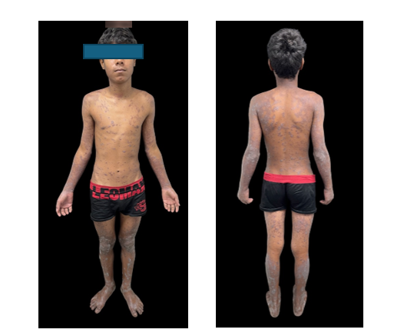

Fig 1. Purpuric flat-topped papules that coalesced into plaques with poorly defined regular borders, variable in shape and size, with the presence of fine scales on their surface. Excoriations with hematic crusts and areas of lichenification were also observed.

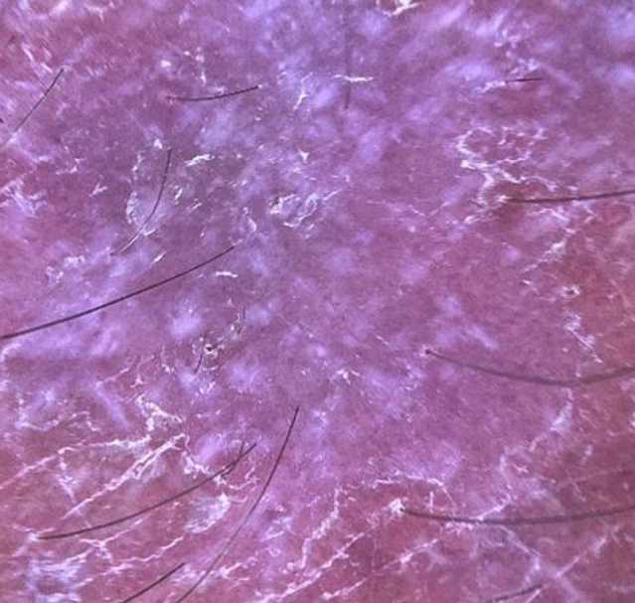

Fig 2. Dermoscopic examination revealed an erythematous-violaceous background with fine surface scales was visualized, along with the presence of Wickham striae

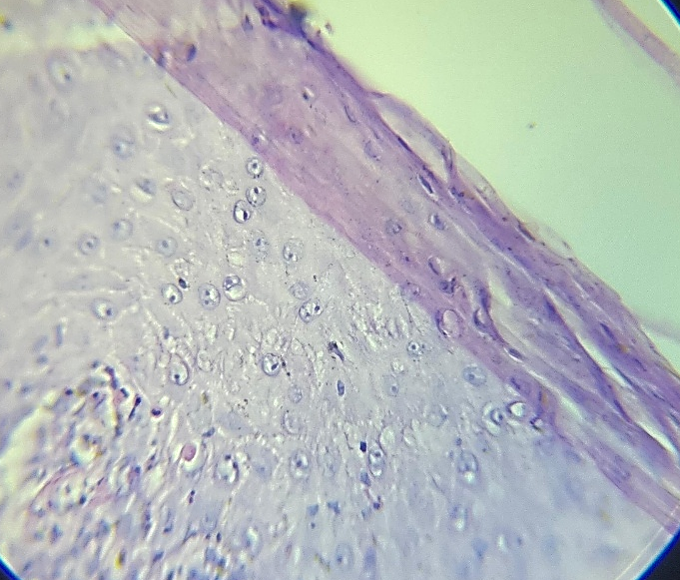

Fig 3. The histopathological study showed hyperkeratosis, parakeratosis, irregular acanthosis, and a band-like lymphocytic inflammatory infiltrate in the papillary dermis, along with Civatte (H&E, 40x).

- DISCUSSION

The therapeutic approach to cutaneous lichen planus is primarily determined by the location of the lesions and clinical severity, with topical corticosteroids being the first-line treatment of choice. As second-line therapies, various alternatives are available, such as topical calcineurin inhibitors, retinoids, systemic steroids, cyclosporine, metronidazole, and griseofulvin;⁷ in extensive forms, escalating to systemic therapies and complementary modalities such as phototherapy is considered.⁸

With the aim of optimizing the resolution of cutaneous lesions and limiting the need for prolonged systemic corticosteroid therapy, a synergistic topical approach was chosen as the initial strategy in this case. The mechanism of action of topical corticosteroids is based on the inhibition of T-lymphocyte proliferation and the suppression of inflammatory immune mediators;⁹ however, their continued use, especially of very high-potency formulations such as clobetasol, carries significant limitations: cutaneous atrophy, characterized by a reduction in skin thickness and elasticity, telangiectasias, and purpura, as well as local effects that can compromise tissue integrity.¹⁰ In this context, combined therapy with vitamin D analogs emerges as a promising alternative due to complementary mechanisms of action.

Calcipotriol induces terminal differentiation and inhibits keratinocyte proliferation, in addition to suppressing the lymphocyte response by decreasing interleukins (IL) 1 and 8.³ Although the anti-inflammatory properties of calcipotriol alone are inferior to those of corticosteroids, comparative clinical trials, such as those conducted by Guenther et al., have documented a robust synergistic effect when used in combination, achieving greater efficacy. Furthermore, randomized clinical trials, such as the one by Katoh et al., have validated the use of premixed ointments of calcipotriol and clobetasol propionate, demonstrating that this topical formulation drastically reduces clinical symptoms in psoriasis within a few weeks of initiation compared to individual monotherapies.⁵

It is important to highlight that although calcipotriol is formally approved by regulatory agencies exclusively for the management of psoriasis vulgaris, its biological properties pathophysiologically support its off-label use in lichen planus. A crucial point justifying the regimen used in this case is the ability of calcipotriol to counteract the side effects of corticosteroids. In the landmark experimental study conducted by Norsgaard et al., it was demonstrated that, through the modulation of key extracellular matrix components, calcipotriol reduces the early signs of cutaneous atrophy by restoring hyaluronic acid synthesis in keratinocytes and preventing epidermal thinning.¹⁰ It should be noted that although this study was conducted using betamethasone, the biological principle of tissue preservation is perfectly extrapolable to other very high-potency corticosteroids such as clobetasol.

As a complementary pillar in scenarios of generalized and disseminated involvement, phototherapy using narrow-band ultraviolet B (NB-UVB) radiation has demonstrated high therapeutic efficiency. Clinical studies, such as the prospective trial by Dawood et al., have validated the high efficacy of NB-UVB in disseminated lichen planus, reporting excellent rates of complete lesion clearance and prolonged periods of remission.¹¹ This modality exerts anti-inflammatory and immunosuppressive biological effects by penetrating the epidermis and superficial dermis, where it alters antigen presentation in Langerhans cells. Additionally, it is recognized that phototherapy induces the synthesis of regulatory cytokines such as interleukins (IL) 6, 8, 10, 12, and 15, granulocyte colony-stimulating factor, and IL-1 receptor antagonist, while decreasing the synthesis of IL-2.⁸

Regarding its use in the pediatric population, Magdaleno-Tapial et al. demonstrated that NB-UVB phototherapy has an excellent safety and efficacy profile in children, comparable to that observed in adults, with reported adverse effects of only 16%, among which mild erythema and transient xerotic pruritus are the most frequent, with no long-term systemic complications registered.¹²

In this case, the joint implementation of this multidisciplinary regimen (dual topical regimen combined with NB-UVB phototherapy) demonstrated notable clinical efficacy, evidencing marked improvement and flattening of the disseminated lesions two months after initiating treatment. During this period, no manifestations of cutaneous atrophy, capillary fragility, or persistent local adverse reactions were observed.

Following the resolution of the active inflammatory phase, the patient developed residual post-inflammatory hyperpigmentation. This phenomenon is an expected and characteristic clinical finding in the evolution of lichen planus, resulting from pigmentary incontinence with the consequent phagocytosis of melanin by dermal melanophages. Therefore, this benign evolutionary course does not represent a therapeutic failure, but rather the macroscopic footprint of the biological healing process typical of interface dermatoses.

- CONCLUSION

This report provides relevant clinical evidence on the utility of combined approaches and multimodal therapy in the treatment of disseminated cutaneous lichen planus in the adolescent population. The favorable evolution of the patient, characterized by a rapid remission of the active inflammatory phase without signs of cutaneous atrophy or local side effects, suggests that the combination of clobetasol, calcipotriol, and NB-UVB phototherapy constitutes a promising alternative that optimizes clinical outcomes and reduces the need for aggressive systemic treatments. These observations are promising but limited by the single-case design; therefore, it is essential to conduct prospective, controlled studies with larger cohorts to standardize the therapeutic regimen and confirm its safety and efficacy profile in routine clinical practice.

Consent

As per international standards, parental written consent has been collected and preserved by the author(s).

Ethical Approval

As per international standards or university standards written ethical approval has been collected and preserved by the author(s).Competing InterestsAuthors have declared that no competing interests exist.

Declaration of AI Use

This manuscript was prepared through the combined contributions of all author(s), including contributions to the study design, data, content development, results, interpretation, and related scholarly work. The author(s) acknowledge the use of Grammarly and ChatGPT to assist with grammar checking, language refinement, reference formatting. These AI-assisted tools were not used as authors and did not replace the intellectual contributions or scholarly judgment of the author(s). All AI-assisted outputs, including content, references, and interpretations, were carefully reviewed, revised, verified, and approved by the author(s). The author(s) accept full responsibility for the accuracy, integrity, and final content of the manuscript.

References

- Pertuz Suárez, M. J., Buján, M. M., Centeno, M. V., y Cervini, A. B. (2021). Liquen plano, estudio retrospectivo en un hospital pediátrico.( Lichen planus: a retrospective study at a pediatric hospital) Dermatol Argent, 27(2), 64-68.
- Bolognia, J. L., Schaffer, J. V., y Cerroni, L. (2018). Dermatology (4a ed.). Madrid: Elsevier.
- De Paola, M., Fimiani, M., Batsikosta, A., Pisani, C., y Bilenchi, C. (2014). Unilateral hypertrophic lichen planus successfully treated with topical calcipotriol. G Ital Dermatol Venereol, 149(2), 1-2.
- Gregory, M., Esfandiari, N., y Daveluy, S. (2026). Off-Label Use of Upadacitinib for Treatment of Lichen Planus: A Narrative Review. Dermatol Pract Concept, 16(2), 6449. https://doi.org/10.5826/dpc.1602a6449
- Patel, R. T., Gay, J. J., Fagan, K. K., y Eikenberg, J. D. (2023). Non-psoriatic uses of calcipotriol: a concise updated review. Dermatol Online J, 29(3), 1. https://doi.org/10.5070/D329361422
- Bayramgürler, D., Apaydın, R., y Bilen, N. (2009). Limited benefit of topical calcipotriol in lichen planus treatment: a preliminary study. J Dermatolog Treat, 13(3), 129-132. https://doi.org/10.1080/09546630260199497
- Bermúdez-Barrios, N., Hernández-Pérez, D. M., y Vivas-Toro, S. C. (2023). Manifestación clásica del liquen plano simple(Classic presentation of lichen planus simplex). Dermatol Rev Mex, 67(5), 770-773.
- Estrella-Tejeda, L. B., Aguilar-Pérez, J. C., Jiménez-Peña, D. V., Peña-Alonso, R. C., y Rodríguez-Castellanos, M. A. (2025). Liquen plano eruptivo tratado con fototerapia (Eruptive lichen planus treated with phototherapy). Dermatol Rev Mex, 69(1), 82-88. https://doi.org/10.24245/dermatolrevmex.v69i1.10316
- Nair, A. B., Kumar, S., Dalal, P., Nagalli, S., Al-Dhubiab, B. E., Al-Mhanna, O. H., et al. (2022). Novel Dermal Delivery Cargos of Clobetasol Propionate: An Update. Pharmaceutics, 14(2), 383. https://doi.org/10.3390/pharmaceutics14020383
- Norsgaard, H., Kurdykowski, S., Descargues, P., González, T., et al. (2014). Calcipotriol counteracts betamethasone-induced decrease in extracellular matrix components related to skin atrophy. Arch Dermatol Res, 306(8), 719-729. https://doi.org/10.1007/s00403-014-1485-3
- Dawood, M., Sizopoulou, C., Greenberger, S., Barzilai, A., y Pavlotsky, F. (2022). Narrowband ultraviolet B radiation for lichen planus: long-term follow-up of 192 patients. J Clin Aesthet Dermatol, 15(4), 31-35. PMID: 35465030
- Magdaleno-Tapial, J., Ortiz-Salvador, J. M., Valenzuela-Oñate, C., Marí-Cornejo, P., Esteve-Martínez, A., y Pérez-Ferriols, A. (2019). Experiencia en el uso de fototerapia en pacientes pediátricos y comparación de esta técnica frente a pacientes adultos(Experience with the use of phototherapy in pediatric patients and comparison of this technique with adult patients). Actas Dermosifiliogr, 110(9), 731-737. https://doi.org/10.1016/j.ad.2019.03.007
- Dutra, T. T. B., Bezerra, T. M. M., Chaves, F. N., Feitosa, S. G., et al. (2021). Therapeutic alternative for oral lichen planus treatment in an unusual location: case report. Arch Health Invest, 10(5), 734-739. http://dx.doi.org/10.21270/archi.v10i5.4970
- Austad, J., Bjerke, J. R., Gjertsen, B. T., Helland, S., Livden, J. K., Morken, T., et al. (1998). Clobetasol propionate followed by calcipotriol is superior to calcipotriol alone in the topical treatment of psoriasis. J Eur Acad Dermatol Venereol, 11(1), 19-24. https://doi.org/10.1111/j.1468-3083.1998.tb00742.x PMID: 9731961
- Mahajan, H., Deshmukh, G., Dhoot, D., Mamadi, R., y Barkate, H. (2020). Evaluación clínica comparativa de la eficacia y seguridad del calcitriol y el calcipotriol en la psoriasis en placas leve (Comparative clinical evaluation of the efficacy and safety of calcitriol and calcipotriol in mild plaque psoriasis.). Rev Int Dermatol Clín, 3(2), 28-31. https://doi.org/10.11648/j.ijcd.20200302.13

