Case report

ARTERIOVENOUS MALFORMATION MIMICKING INFLAMMATORY POLYP: UNUSUAL CASE PRESENTATION

ABSTRACT
Nasal arteriovenous malformation(AVM) in nasal cavity an exceptionally rare vascular tumour and may resemble other benign nasal lesion which predominantly unilateral. It is usually present at birth and undergo transformation and progression later in life. Careful evaluation need to differentiate AVMs from any other benign nasal mass pathology as it required different modality and intervention in their management. We present the case of nasal AVM of inferior turbinate in 55 years old male that presented with nasal block and was treated via surgical intervention.
KEYWORDS
arteriovenous malformation (AVM), nasal mass pathology
INTRODUCTION
Vascular anomalies of the head and neck comprise a heterogeneous group of vascular tumours and vascular malformations. Accurate classification is important because the biological behaviour, diagnostic assessment, and management of these lesions differ. Arteriovenous malformations are fast-flow lesions characterised by direct communication between arterial and venous channels without an intervening normal capillary bed, and their clinical presentation varies with anatomical location and lesion extent (8-11).
Within the nasal cavity, a vascular lesion may present as a non-specific polypoidal mass; consequently, endoscopic appearance alone may not establish the diagnosis. A detailed history, careful examination, and appropriate vascular imaging can help determine lesion flow, anatomical extent, and the relationship to adjacent structures before intervention (12-15).
Management of symptomatic extracranial arteriovenous malformations is individualised and commonly requires multidisciplinary assessment. Embolisation, sclerotherapy, surgical excision, or a staged combination of modalities may be considered according to lesion characteristics; however, incomplete treatment can be followed by persistence or recurrence, supporting the need for structured follow-up (16-19).
Recent case literature on oral vascular malformations also indicates that benign-appearing lesions may be misclassified without clinicoradiological correlation and that treatment selection should reflect lesion flow and anatomy (20,21). The diagnostic gap addressed in this report is the difficulty of recognising an arteriovenous malformation when an inferior turbinate mass has the endoscopic and initial histopathological appearance of an inflammatory polyp.
Therefore, this report aims to describe an arteriovenous malformation of the bilateral inferior turbinates presenting clinically as a unilateral nasal mass and to emphasise the diagnostic and management considerations arising from this unusual presentation.
CASE PRESENTATION
A 55 years old male with underlying bronchial asthma presented with unilateral nasal block for few months. He has no epistaxis, cacosmia, facial pain, neck swelling and nasal congestion. Patient denies any sinusitis symptom, vision changes, constitutional symptoms, fever, headache, and ear symptoms. There is no history of recent trauma and his review of other systemics were negative. On examination, patient was alert, comfortable and not in acute distress. All examination were unremarkable except from the rigid nasoendoscope revealed papillomatous nasal mass arising from right posterior end of inferior turbinate (Figure 1). Biopsy done bedside and histopathology examination (HPE) come back only as inflammatory polyp. Thus, radio imaging CT Paranasal sinus (CT PNS) was arranged and only revealed presence of right inferior turbinate mass over posterior aspect measured about 1.9x1.0x1.2cm with mucosal thickening over bilateral aspect of maxillary as well as ethmoid sinuses and there was no evidence of bony erosion, hyperostosis and widened bony foramina.
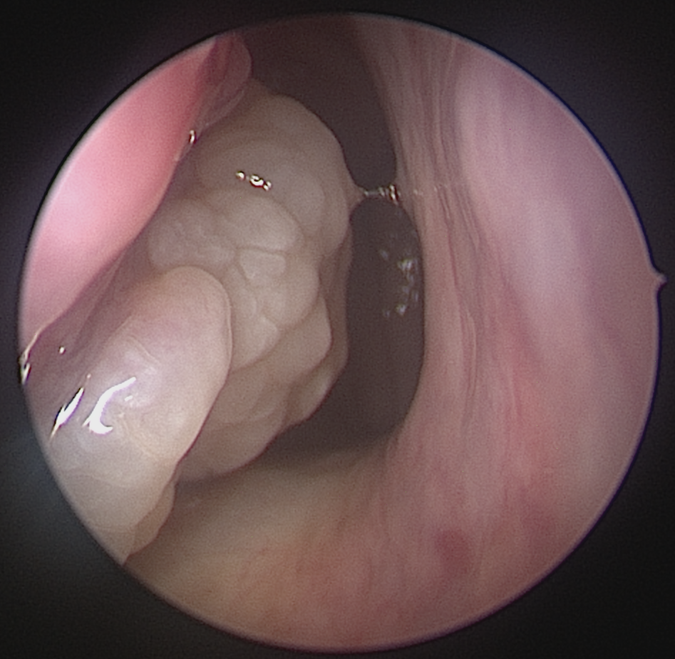
Figure 1:Bedside nasal endoscope showed papillomatous right nasal mass from inferior turbinate
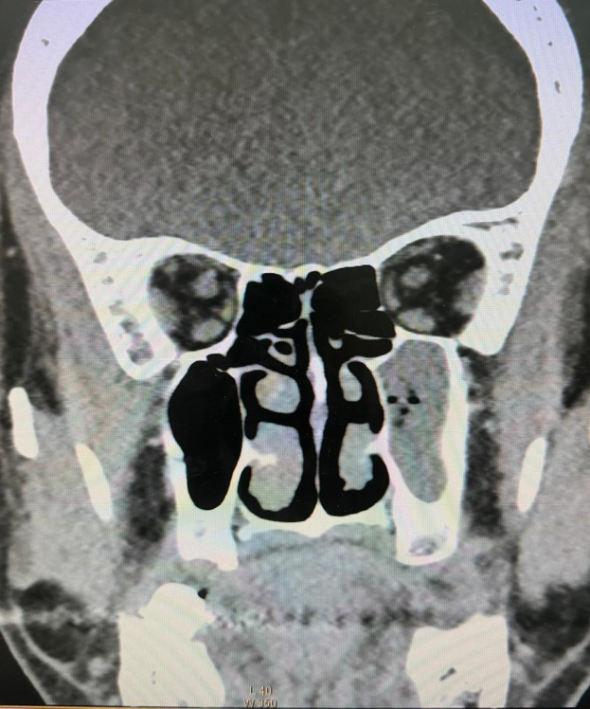
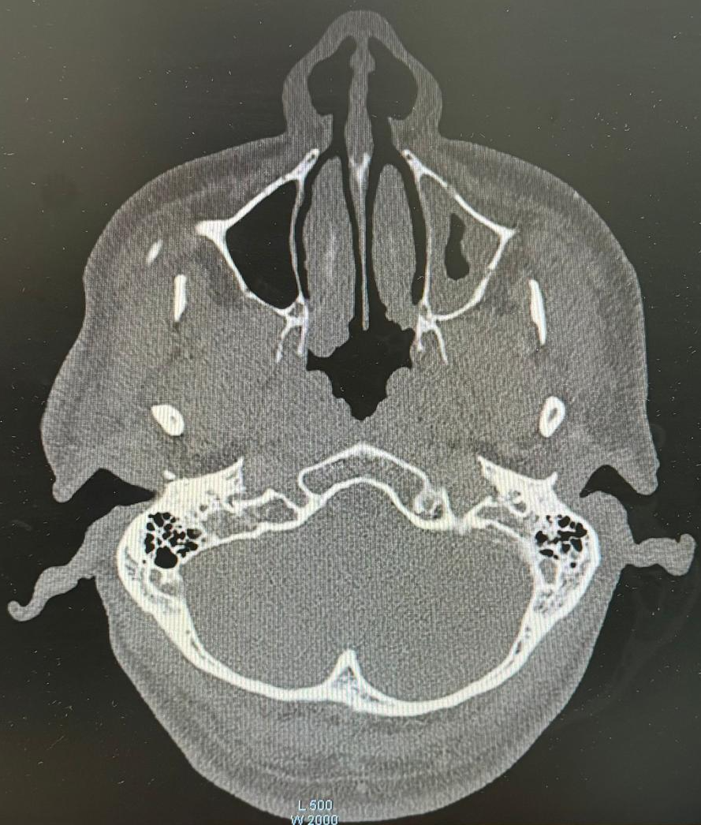

Figure 2: CT PNS showed homogenousity lesion over the right inferior turbinate and no bony erosion.

Patient underwent functional endoscopic sinus surgery and turbinectomy. Intraoperative finding showed presence of polypoidal nasal mass over the bilateral inferior turbinate and we proceeded with bilaterally turbinectomy for this patient and sample was sent for HPE. Sample result surprisingly comes back as arteriovenous malformation(AVM) of bilateral inferior turbinate. Post operatively patient was well. There was no more nasal blockage and post operative site well healed and no recurrence mass seen.
DISCUSSION
AVMS of nasal cavity defined as anomaly of vascular normal capillary bed where there is abnormal communication between the venous plexus and arterial systems. This vascular lesion is commonly present in head and neck region, but its location over the nose and paranasal sinuses are extremely rare and representing 1 % of AVMs case (1). They are usually present at birth and clinically silent until later in life as the lesion progress. The mean age of diagnosis of AVMs usually in mean age 20s (1,2). Patient with nasal AVMs usually asymptomatic and as the lesion progress it may cause compression to surrounding structures causing nasal blockage and risk of bleeding. AVMs are usually treated conservatively if patient asymptomatic but treatment and intervention recommended when lesion give symptoms to patient like in this case. Careful evaluation of nasal lesion bedside are necessary to help as their appearance may resembles other nasal pathology like in this case which did look like nasal papilloma. Biopsy should be avoided in nasal AVMs as it can cause profuse bleeding. Thus, it is crucial to differentiate AVMs from other vascular lesion and nasal pathology to avoid life threatening complication and for safe management toward patient. Radio-imaging are necessary to be done as it help to direct and guide our management by providing information regarding the extension of the lesion. MRI remain as the investigation of choice in managing this lesion (3,4). They provide soft tissue extension and able to differentiate it with others vascular lesion. Like in this case, we only did the CT scan and CT scan did give limitation as it only help to us evaluate potential bony involvement caused by the expansion of nasal lesion.
In term of management, AVMs required a multidisciplinary approach which involve radiologist, ENT surgeon, and anesthetist. The goal of treatment for surgical intervention in AVMs primarily aiming for complete removal of the nidus and usually require pre-operative embolization prior to surgical excision within 24hours to 72hours (5). The aims for this are to delineate the lesion’s margin and reduce intraoperative blood loss. Other alternative therapy is via medical treatment using sclerotherapy which successfully known treatment for AVMs.
Complication procedure risk of AVMs is high as it can potentially cause profuse bleeding and risk of embolization can cause stroke, blindness, and cranial nerve palsy (1,6). Thus, thorough evaluation prior to surgery important to reduce the risk intraoperative and postoperative complications. There is no intraoperative and post operative complications occurs in our case and estimated blood loss is minimal.
Recurrence risk of AVMs are high, and some studies did report recurrence rates as high as 81% after surgery and 98% after embolization (7). It is due to residual portion of nidus that can expand over time due to other proangiogenic factor like inflammation and hypoxia that driven the lesion to recur back. Thus, there is a need for long term follow up and mandatory because some study reported relapses can occur up until 10 years after treatment (7).
CONCLUSION
As conclusion, patient who come with unilateral nasal mass, AVMs also need to be considerate as one of differential diagnosis even though is rare. Proper biopsy and detail evaluation with imaging may guide and essential for diagnosis with surgical planning. Surgical intervention did play a role as one of mainstay treatment for AVMs in nasal cavity and proper follow up is mandatory because risk of relapse may happen up until 10years after treatment.

Declaration of AI Use

This manuscript was prepared through the combined contributions of all author(s), including contributions to the study design, data, content development, results, interpretation, and related scholarly work. The author(s) acknowledge the use of Grammarly and ChatGPT to assist with grammar checking, language refinement, reference formatting. These AI-assisted tools were not used as authors and did not replace the intellectual contributions or scholarly judgment of the author(s). All AI-assisted outputs, including content, references, and interpretations, were carefully reviewed, revised, verified, and approved by the author(s). The author(s) accept full responsibility for the accuracy, integrity, and final content of the manuscript.

REFERENCES
- Tanoue S, Tanaka N, Koganemaru M, Kuhara A, Kugiyama T, Sawano M, et al. Head and Neck Arteriovenous Malformations: Clinical Manifestations and Endovascular Treatments. Interventional Radiology. 2023 Jul 1;8(2):23– 35.
- Kim D, Choi KU, Kim HJ, Cho KS. Arteriovenous malformation of the maxillary sinus: a rare clinical entity. Braz J Otorhinolaryngol. 2020 Nov-Dec;86(6):820-823.. Epub 2016 Aug 23.

- Ethunandan M, Mellor TK. Haemangiomas and vascular malformations of the maxillofacial region-a review. Br J Oral Maxillofac Surg. 2006;44:263-72.
- Chen W, Wang J, Li J, Xu L. Comprehensive treatment of arteriovenous malformations in the oral and maxillofacial region. J Oral Maxillofac Surg. 2005;63:1484-8.
- Noh Y, Ryu G, Kim HY. A case of arteriovenous malformation of the nasal tip. Korean J Otorhinolaryngol-Head Neck Surg 2020;63:123-8.
- Bittles MA, Sidhu MK, Sze RW, Finn LS, Ghioni V, Perkins JA. Multidetector CT angiography of pediatric vascular malformations and hemangiomas: utility of 3-D reformatting in differential diagnosis. Pediatr Radiol. 2005;35:1100-6.
- Fernández-Alvarez V, Suárez C, de Bree R, Nixon IJ, Mäkitie AA, Rinaldo A, et al. Management of extracranial arteriovenous malformations of the head and neck. Auris Nasus Larynx. 2020 Apr;47(2):181–90.
- Gallant SC, Chewning RH, Orbach DB, Trenor CC 3rd, Cunningham MJ. Contemporary management of vascular anomalies of the head and neck-Part 1: Vascular malformations: A review. JAMA Otolaryngol Head Neck Surg. 2021;147(2):197-206. https://doi.org/10.1001/jamaoto.2020.4353
- Oomen KPQ, Wreesmann VB. Current classification of vascular anomalies of the head and neck. J Oral Pathol Med. 2022;51(10):830-836. https://doi.org/10.1111/jop.13353
- Rosenberg TL, Phillips JD. Update on vascular anomalies of the head and neck. Otolaryngol Clin North Am. 2022;55(6):1215-1231. https://doi.org/10.1016/j.otc.2022.07.019
- Schmidt VF, Masthoff M, Czihal M, Cucuruz B, Häberle B, Brill R, et al. Imaging of peripheral vascular malformations-current concepts and future perspectives. Mol Cell Pediatr. 2021;8(1):19. https://doi.org/10.1186/s40348-021-00132-w
- Dorrity J, Mack J, Wong K, Richter GT. Multimodality treatment of vascular anomalies of the head and neck. J Oral Pathol Med. 2022;51(10):860-871. https://doi.org/10.1111/jop.13322
- Léauté-Labrèze C. Medical management of vascular anomalies of the head and neck. J Oral Pathol Med. 2022;51(10):837-843. https://doi.org/10.1111/jop.13324
- Leyman B, Govaerts D, Dormaar JT, Meeus J, Bila M, Coropciuc R, et al. A 16-year retrospective study of vascular anomalies in the head and neck region. Head Face Med. 2023;19(1):32. https://doi.org/10.1186/s13005-023-00376-z
- Pampín Martínez MM, Rodríguez-Laguna L, Gómez García E, Cebrián Carretero JL, González Otero T, López Gutiérrez JC. Genetic profile of arteriovenous anomalies of the head and neck: Implications in progression and therapeutic approaches. J Pediatr Surg. 2023;58(10):2043-2049. https://doi.org/10.1016/j.jpedsurg.2023.01.047
- Lilje D, Wiesmann M, Hasan D, Riabikin A, Ridwan H, Hölzle F, et al. Interventional therapy of extracranial arteriovenous malformations of the head and neck-A systematic review. PLoS One. 2022;17(7):e0268809. https://doi.org/10.1371/journal.pone.0268809
- Malik MH, Jabal MS, Kobeissi H, Gupta R, Bilgin C, Brinjikji W. Embolization of arteriovenous malformations of head and neck: A systematic review. Interv Neuroradiol. 2025;31(6):852-858. https://doi.org/10.1177/15910199231219823
- Werba N, Ludwig J, Weiss C, Struebing F, Schoenberg S, Sadick M. Extracranial arteriovenous malformations: A 10-year experience at a German vascular anomaly center and evaluation of diagnostic imaging for endovascular therapy assessment. Front Med (Lausanne). 2024;11:1473685. https://doi.org/10.3389/fmed.2024.1473685
- Shiraishi M, Narushima M, Banda CH, Moriwaki Y, Fujisawa K, Nakajima M, et al. Treatment effectiveness and recurrence of extracranial arteriovenous malformations following surgical operations: A 15-year retrospective cohort study. Ann Plast Surg. 2024;92(6):688-693. https://doi.org/10.1097/SAP.0000000000003924
- Chhuju S, Prasad V, Rai AK, Pun H, Karki B, Shivhare P. A slow flow oral vascular malformation managed by sclerotherapy (3% sodium tetradecyl sulfate) and diode laser (980 nm): A case report. Int J Res Rep Dent. 2025;8(1):9-15. https://doi.org/10.9734/ijrrd/2025/v8i1202
- Ishali D, Trupti G, Mahesh C. Venous malformation of the buccal mucosa in a 65-year-old female: A case report. J Case Rep Med Sci. 2026;12(1):14-19. https://doi.org/10.56557/jocrims/2026/v12i110343

