Revision Stapes Surgery for Otosclerosis: Causes of Functional Failure and Hearing Outcomes

ABSTRACT
Introduction: Stapes surgery is among the most dependable procedures in otology, yet a minority of ears never achieve the expected closure of the air-bone gap, or lose it after an initially satisfactory result. Revision surgery in these ears is technically demanding and its outcome is far less predictable than that of the primary operation. The purpose of this work was to identify the causes of functional failure encountered at re-exploration and to quantify the hearing benefit that revision surgery actually delivers.
Materials and Methods: We conducted a retrospective descriptive study over a twelve-year period in a single tertiary department, with all procedures performed by the same surgeon. Patients who underwent revision after a primary operation for otosclerosis carried out in our unit were included; incomplete files, patients lost to follow-up and ears with total deafness were excluded. Air- and bone-conduction thresholds were averaged over 500, 1000, 2000 and 4000 Hz, and the air-bone gap was derived from the difference. High-resolution temporal bone computed tomography was obtained in every case before re-exploration. Outcomes were assessed against the criteria of the American Academy of Otolaryngology-Head and Neck Surgery.
Results: One hundred and sixty-four primary stapedotomies were performed during the study period. Eleven ears (6.7%) developed functional failure and eight were analysable. The mean age at revision was 41.5 years, with a female predominance of seven to one. Failure was recognised within the first month in three patients and beyond three years in one, with a mean interval of 1.4 years. Computed tomography suggested prosthesis dislocation in four ears. At exploration, a prosthesis-related problem was found in six of the eight ears, dislocation being the single commonest finding. The mean pure-tone average improved from 63.4 dB to 47.5 dB and the mean air-bone gap narrowed from 39.4 dB to 26.3 dB. A residual gap of 20 dB or less was obtained in six ears (75%) and closure of at least 10 dB in six ears (75%). Bone conduction deteriorated slightly, by roughly 2.6 dB, and no patient developed total deafness.
Discussion: Prosthesis displacement dominated our series, as it does in most published cohorts, and this is reassuring because it is also the most correctable of the failure mechanisms. Our functional results sit within the range reported in the literature for the 20 dB endpoint but fall short at the 10 dB endpoint, which we attribute to the small sample, the absence of laser assistance and the severity of the preoperative gaps. Careful preoperative counselling remains essential: roughly six patients in ten can expect a meaningful improvement, and the possibility of an unchanged or poorer result must be stated plainly.
Keywords
Otosclerosis, Revision stapes surgery, Stapedotomy, Air-bone gap, Prosthesis dislocation, Conductive hearing loss.
Introduction
Otosclerosis is a primary osteodystrophy confined to the otic capsule, in which alternating waves of bone resorption and disorganised remodelling produce spongiotic foci that eventually immobilise the stapes footplate. The condition affects roughly three to four adults per thousand, is bilateral in seventy to eighty per cent of cases, and characteristically declares itself in young adults between the second and fifth decades with a slowly progressive conductive hearing loss behind an entirely normal eardrum [1]. Women are affected somewhat more often than men, and a family history is found in a substantial minority of patients.
Surgical treatment of the fixed stapes is one of the great successes of modern otology. Since Shea reintroduced stapedectomy in the mid-1950s, and still more since the shift towards small-fenestra stapedotomy, the operation has become a reliable and highly reproducible way of restoring the columellar effect. Contemporary series report closure of the air-bone gap to within 10 dB in eighty to ninety per cent of primary cases, and the risk of severe sensorineural injury has fallen below one per cent in experienced hands [2,3].
Reliable, however, is not the same as infallible. A proportion of patients, variously estimated between three and ten per cent depending on the length of follow-up and on how failure is defined, will present again with a conductive loss that has either never resolved or has returned after an initially good result [4,5]. Some of these patients also complain of vertigo or of tinnitus, and a few report a sudden deterioration triggered by a trivial event such as sneezing, straining or a slap to the ear. In this situation the surgeon is faced with a question that cannot be answered from the outside: is the problem mechanical and therefore correctable, or does it reflect cochlear deterioration that surgery can only worsen?
Revision stapes surgery is undertaken to answer that question and, where possible, to correct what is found. It is a different operation from the primary procedure. The anatomical landmarks are obscured by fibrosis, the oval window niche may be occupied by scar tissue or by a re-proliferating otosclerotic focus, and the long process of the incus is frequently eroded around the crimped prosthesis. The margin for error is narrow, and the risk of labyrinthine injury is generally held to be higher than in virgin ears, although several authors have disputed this [6,7]. Published hearing results are correspondingly more modest and considerably more variable than those of primary surgery [8,9].
Data from North African and Moroccan centres remain sparse. We therefore reviewed the revision cases performed in our department over twelve years, all by a single surgeon and all following a primary operation carried out in the same unit, in order to describe the mechanisms of failure encountered at re-exploration and to measure the audiometric benefit obtained.
Materials and Methods
This was a retrospective descriptive study conducted in the Department of Otorhinolaryngology and Head and Neck Surgery of the 20 August Hospital, Ibn Rochd University Hospital Centre in Casablanca, covering the twelve-year period from 1 January 2012 to 7 April 2024. The study was carried out in accordance with the ethical principles of the Declaration of Helsinki, and the anonymity of the records was preserved throughout.
All patients operated on for otosclerosis during that period were screened. Cases were included when a revision procedure had been performed after a primary stapes operation carried out in our department by the same surgeon. Files that were incomplete or unusable, ears with total deafness, patients whose clinical or radiological data were unavailable, patients lost to follow-up or with unsatisfactory postoperative surveillance, and revisions whose primary operation had been performed elsewhere or outside the study window were all excluded. Eleven patients met the definition of functional failure, understood as persistence of a residual air-bone gap after the first operation, worsening of symptoms, or the appearance of labyrinthine signs. Three of these were excluded because the revision file could not be retrieved, leaving eight patients for analysis.
For each patient we recorded the sociodemographic profile, the personal and family history, the presenting symptoms and their laterality, the findings of microscopic otoscopy and tuning-fork testing, and the results of pure-tone and impedance audiometry. Data from the first operation were retrieved from the original operative notes: the type of anaesthesia, the approach, the state of the mucosa and of the ossicular chain, the calibre of the platinotomy, and the material, diameter and length of the prosthesis. For the revision itself we recorded the interval between the two procedures, any triggering event reported by the patient, the radiological findings, the intraoperative appearances, the cause of failure identified, the corrective gesture performed and the postoperative course.
Pure-tone audiometry was performed in a sound-treated booth with a calibrated audiometer. Air-conduction thresholds were obtained at 250, 500, 1000, 2000 and 4000 Hz and bone-conduction thresholds over the same range. The pure-tone average was calculated as the arithmetic mean of the thresholds at 500, 1000, 2000 and 4000 Hz, and the air-bone gap as the difference between the air- and bone-conduction averages at the same four frequencies, in line with the recommendations of the American Academy of Otolaryngology-Head and Neck Surgery [10]. Tympanometry and stapedial reflex testing completed the assessment. High-resolution computed tomography of the temporal bones was obtained in every patient, both before the primary operation, where it was staged according to the Veillon classification [11], and before revision, where it was read specifically for prosthesis position and length, oval window opacity and cochlear involvement.
All operations, primary and revision, were performed under deep general anaesthesia with controlled hypotension, systolic pressure being kept below 100 mmHg and diastolic above 50 mmHg. Revisions used the minimal endaural Shambaugh approach, which leaves both hands free and gives a wider view of the oval window niche. After elevation of the tympanomeatal flap, the ossicular chain was palpated and inspected, peri-prosthetic fibrosis was divided, the prosthesis was assessed in situ and then removed with great care, the platinotomy was re-explored with a trephine and a new fluoroplastic piston was inserted. Prosthesis length was checked visually and with a measuring rod. A temporalis fascia graft was placed over the platinotomy when the surgeon judged the seal insufficient.
Data were collected from the departmental archive and completed by telephone contact with the patients, entered into a spreadsheet and analysed with JAMOVI. Given the sample size, the analysis was descriptive; results are expressed as means with ranges and as absolute numbers with percentages.
Results
One hundred and sixty-four patients underwent primary stapes surgery for otosclerosis during the twelve-year period. Functional failure occurred in eleven, giving a revision rate of 6.7%, or approximately 0.6 cases per year. Eight ears in eight patients formed the study population.
At the time of the first operation the mean age was 38.5 years (range 29-52). Seven patients were women and one was a man, a sex ratio of 0.14. Five patients reported a history of measles and two had a first-degree relative with otosclerosis. All eight presented with progressive hearing loss, associated with tinnitus in two and with paracusis of Willis in one; the eardrum was normal in every case and the stapedial reflex was absent as expected. The mean preoperative pure-tone average was 55.4 dB with a mean air-bone gap of 30.9 dB, and six of the eight ears had a purely conductive loss. Computed tomography showed bilateral disease in five patients; three ears were staged 1b and five stage 2 on the Veillon classification. All were operated through a speculum approach under general anaesthesia, with a calibrated platinotomy of 0.4 mm in seven and 0.6 mm in one, and a fluoroplastic piston in every case. The facial nerve was dehiscent and overhanging in two ears. After the primary operation the mean pure-tone average was 45 dB and the mean air-bone gap 28.3 dB, so that the average gain was modest at 10.4 dB and the gap narrowed by only 2.6 dB.
The mean age at revision was 41.5 years (range 30-56). Every patient again complained of hearing loss, three of tinnitus, one of paracusis and one of vertigo. The mean interval between the first operation and recognition of failure was 508 days, that is roughly 1.4 years, with a maximum of seven years. Two patients had never improved at all after the primary procedure. Three failures were recognised within the first month, two between one and three months, two between three and thirty-six months and one after three years (Figure 1). One patient attributed the deterioration to a bout of coughing during a cold and another to a slap on the ear; in the remaining six the history was unrevealing. Weber lateralised to the poorer ear in three patients, to the better ear in three and was central in two, an atypical pattern in more than half the series.
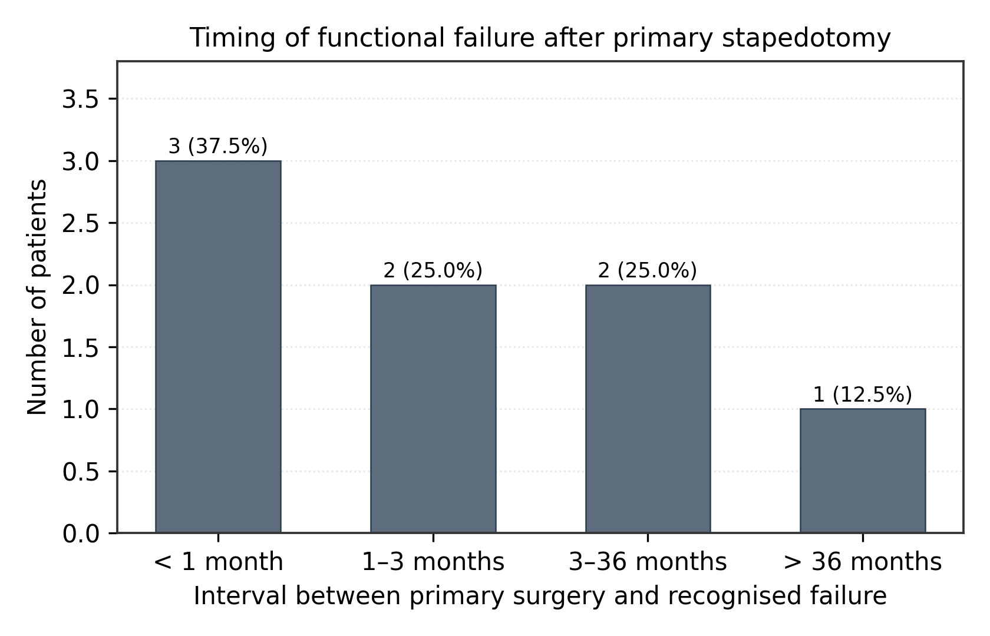
Figure 1: Timing of functional failure after primary stapedotomy.
Before revision the mean pure-tone average had deteriorated to 63.4 dB and the mean air-bone gap to 39.4 dB. Six patients had lost ground since the first operation, by between 10 and 41 dB, while two were unchanged. Four ears had a gap wider than 40 dB. Two patients had a mixed loss and six a purely conductive one. Tympanometry remained normal in all.
Computed tomography before revision suggested a dislocated prosthesis in four ears (50%), a prosthesis that was too short in one and a displaced prosthesis in one, while in two ears no cause could be identified. One patient had an otosclerotic focus in contact with the cochlear lumen. Representative images are shown in Figures 2 and 3.
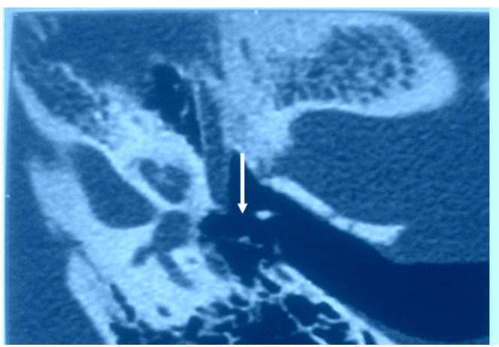
Figure 2: Axial CT of a left temporal bone showing a dislocated piston (arrow).
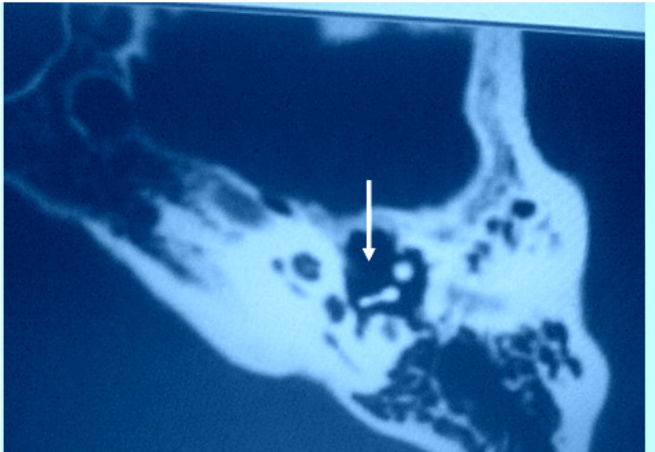
Figure 3: Axial CT of a right temporal bone showing a prosthesis that is too short and does not enter the platinotomy (arrow).
At exploration the mucosa was normal in seven ears and inflammatory in one. The chorda tympani was preserved in seven and sacrificed in one where it was embedded in bone. The prosthesis was found dislocated in four ears, displaced in one and too short in one; the long process of the incus was eroded in one, requiring excision; and in one ear no abnormality was found at all, in a patient in whom an associated sensorineural component had been suspected (Figure 4). One patient had both a dislocated piston and an eroded incus. A new fluoroplastic piston of 4.5 mm was placed in seven ears and 4.75 mm in one, through a platinotomy of 0.4 mm in seven and 0.6 mm in one, and a fascia graft was added in three ears. No intraoperative complication occurred.
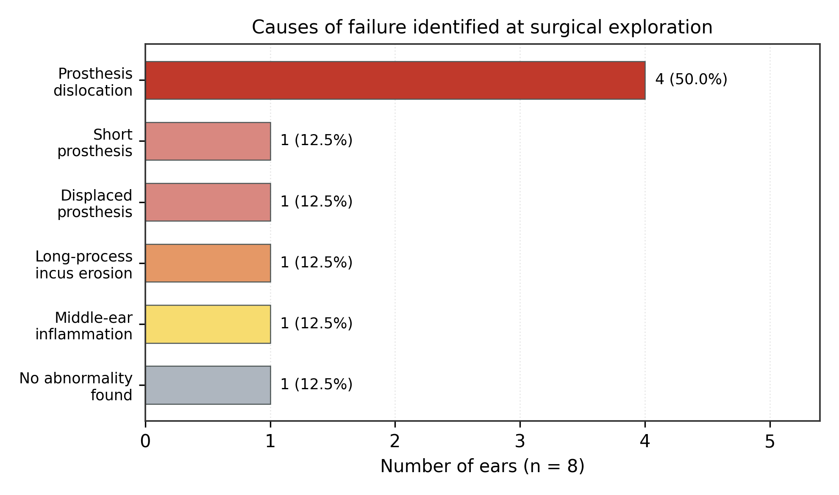
Figure 4: Causes of failure identified at surgical exploration (n = 8 ears).
After revision the mean pure-tone average was 47.5 dB, against 63.4 dB before surgery, a mean gain of 15.9 dB with a maximum of 46 dB; two patients gained nothing. The mean air-bone gap fell from 39.4 dB to 26.3 dB, a mean closure of 13.1 dB with a maximum of 35 dB. A residual gap of 20 dB or less was achieved in six of the eight ears (75%), and a closure of 10 dB or more in six ears (75%); no ear reached a gap of 10 dB or less. Individual results are detailed in Table 1 and Figure 5. Frequency by frequency, the improvement was distributed fairly evenly across the audiogram, the largest gain being at 500 and 1000 Hz where the gap narrowed by 23.1 dB (Table 2, Figures 6 and 7). Bone-conduction thresholds rose slightly, from a mean of 19.5 dB to 22.1 dB, an average deterioration of 2.6 dB that was most marked at 4000 Hz.
Table 1: Individual audiometric outcomes of revision stapes surgery (dB).
Ear | Pre-rev. PTA (dB) | Pre-rev. ABG (dB) | Post-rev. PTA (dB) | Post-rev. ABG (dB) | PTA gain (dB) | ABG closure (dB)
A | 60 | 50 | 60 | 50 | 0 | 0
B | 53 | 35 | 35 | 18 | 18 | 17
C | 91 | 55 | 45 | 20 | 46 | 35
D | 67 | 44 | 41 | 19 | 26 | 20
E | 52 | 24 | 52 | 20 | 0 | 1
F | 76 | 30 | 65 | 18 | 11 | 10
G | 58 | 45 | 45 | 35 | 13 | 10
H | 50 | 32 | 37 | 20 | 13 | 12
Mean | 63.4 | 39.4 | 47.5 | 26.3 | 15.9 | 13.1
PTA: pure-tone average (0.5-4 kHz); ABG: air-bone gap.
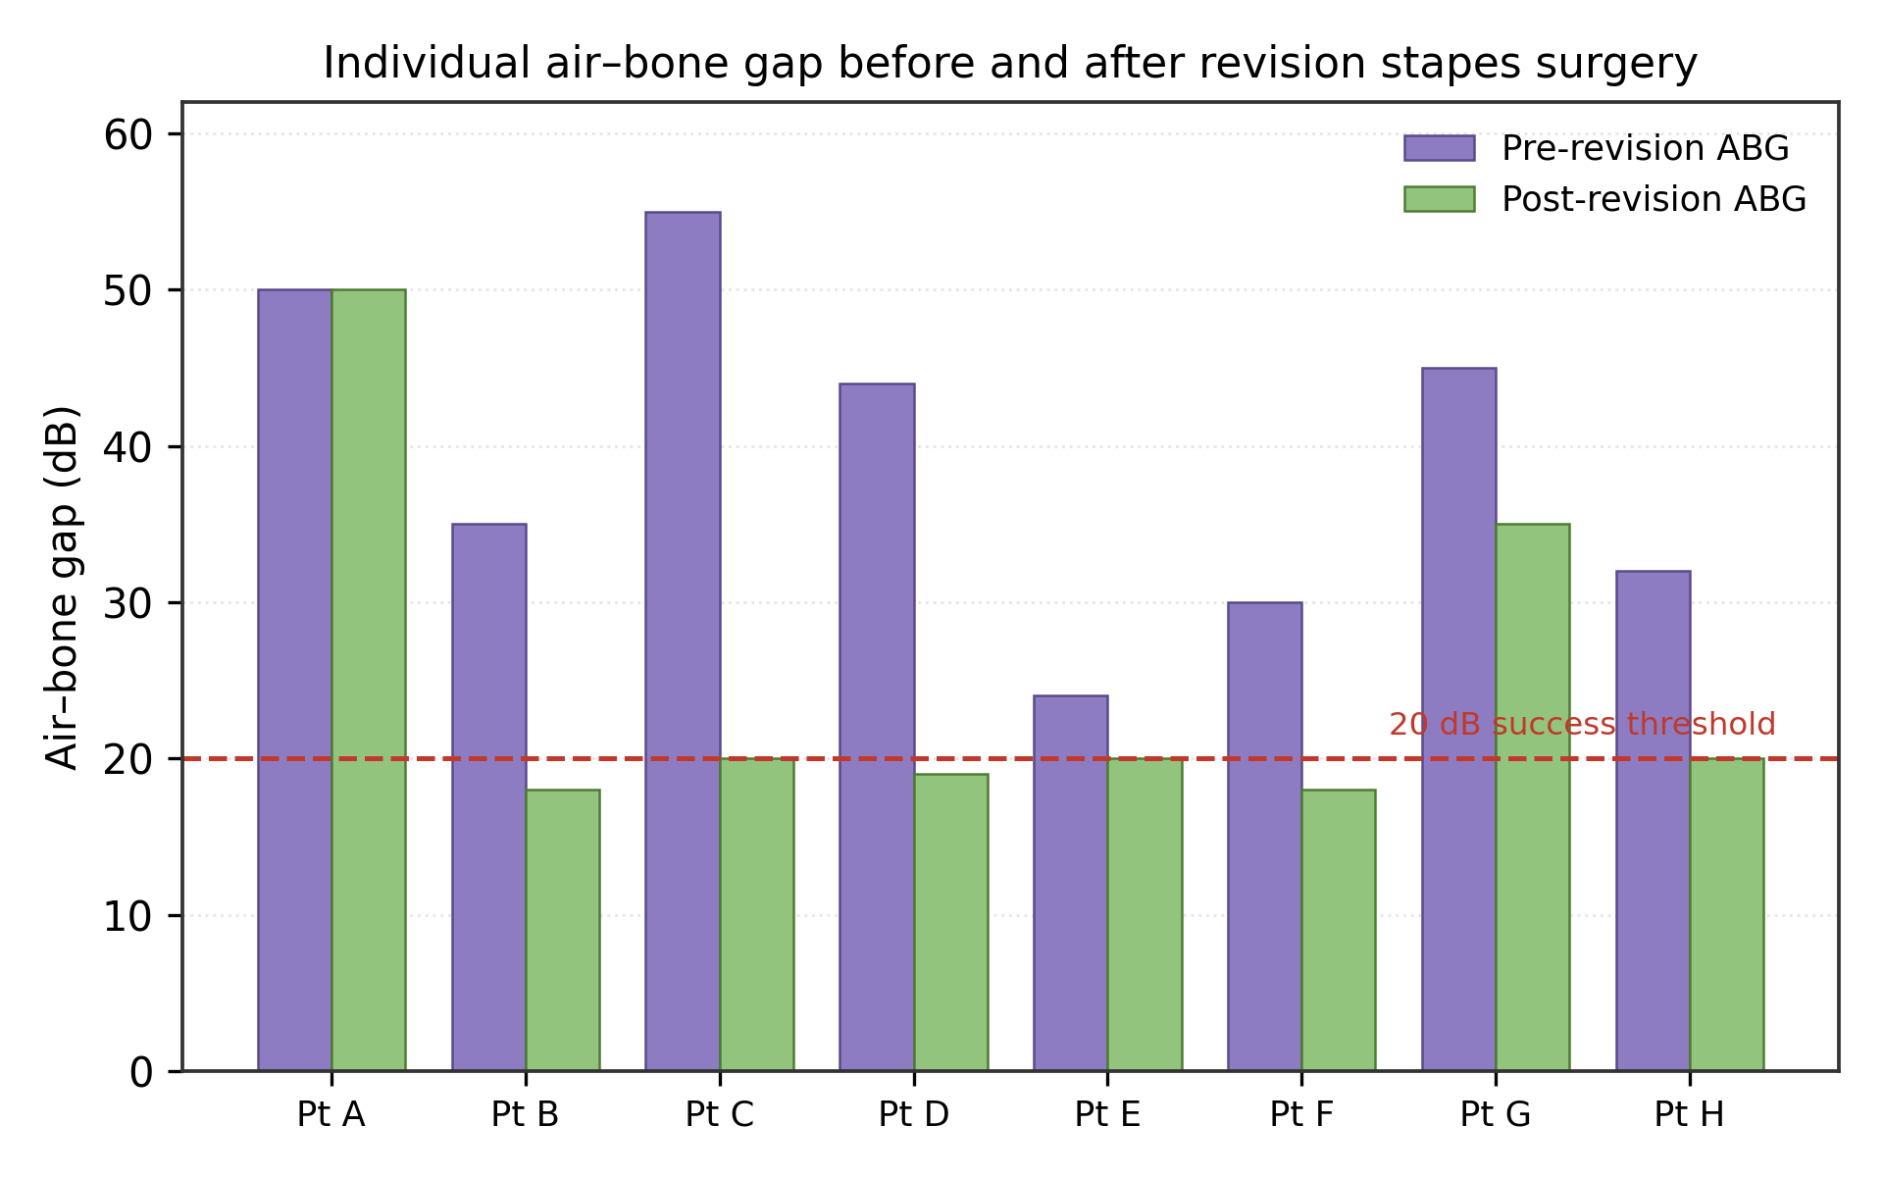
Figure 5: Individual air-bone gap before and after revision stapes surgery.
Table 2: Mean audiometric thresholds by frequency, before and after revision surgery.
Parameter (mean, dB) | 250 Hz | 500 Hz | 1000 Hz | 2000 Hz | 4000 Hz | Mean
Air conduction, pre-revision | 63.8 | 63.8 | 66.3 | 62.5 | 66.9 | 64.6
Bone conduction, pre-revision | 10.0 | 13.1 | 20.6 | 25.6 | 28.1 | 19.5
Air-bone gap, pre-revision | 53.8 | 50.6 | 45.6 | 36.9 | 38.8 | 45.1
Air conduction, post-revision | 46.9 | 44.4 | 43.8 | 44.4 | 49.4 | 45.8
Bone conduction, post-revision | 12.5 | 16.9 | 21.3 | 27.5 | 32.5 | 22.1
Air-bone gap, post-revision | 34.4 | 27.5 | 22.5 | 16.9 | 16.9 | 23.6
Air-bone gap closure | 19.4 | 23.1 | 23.1 | 20.0 | 21.9 | 21.5
Means are calculated over 250-4000 Hz.
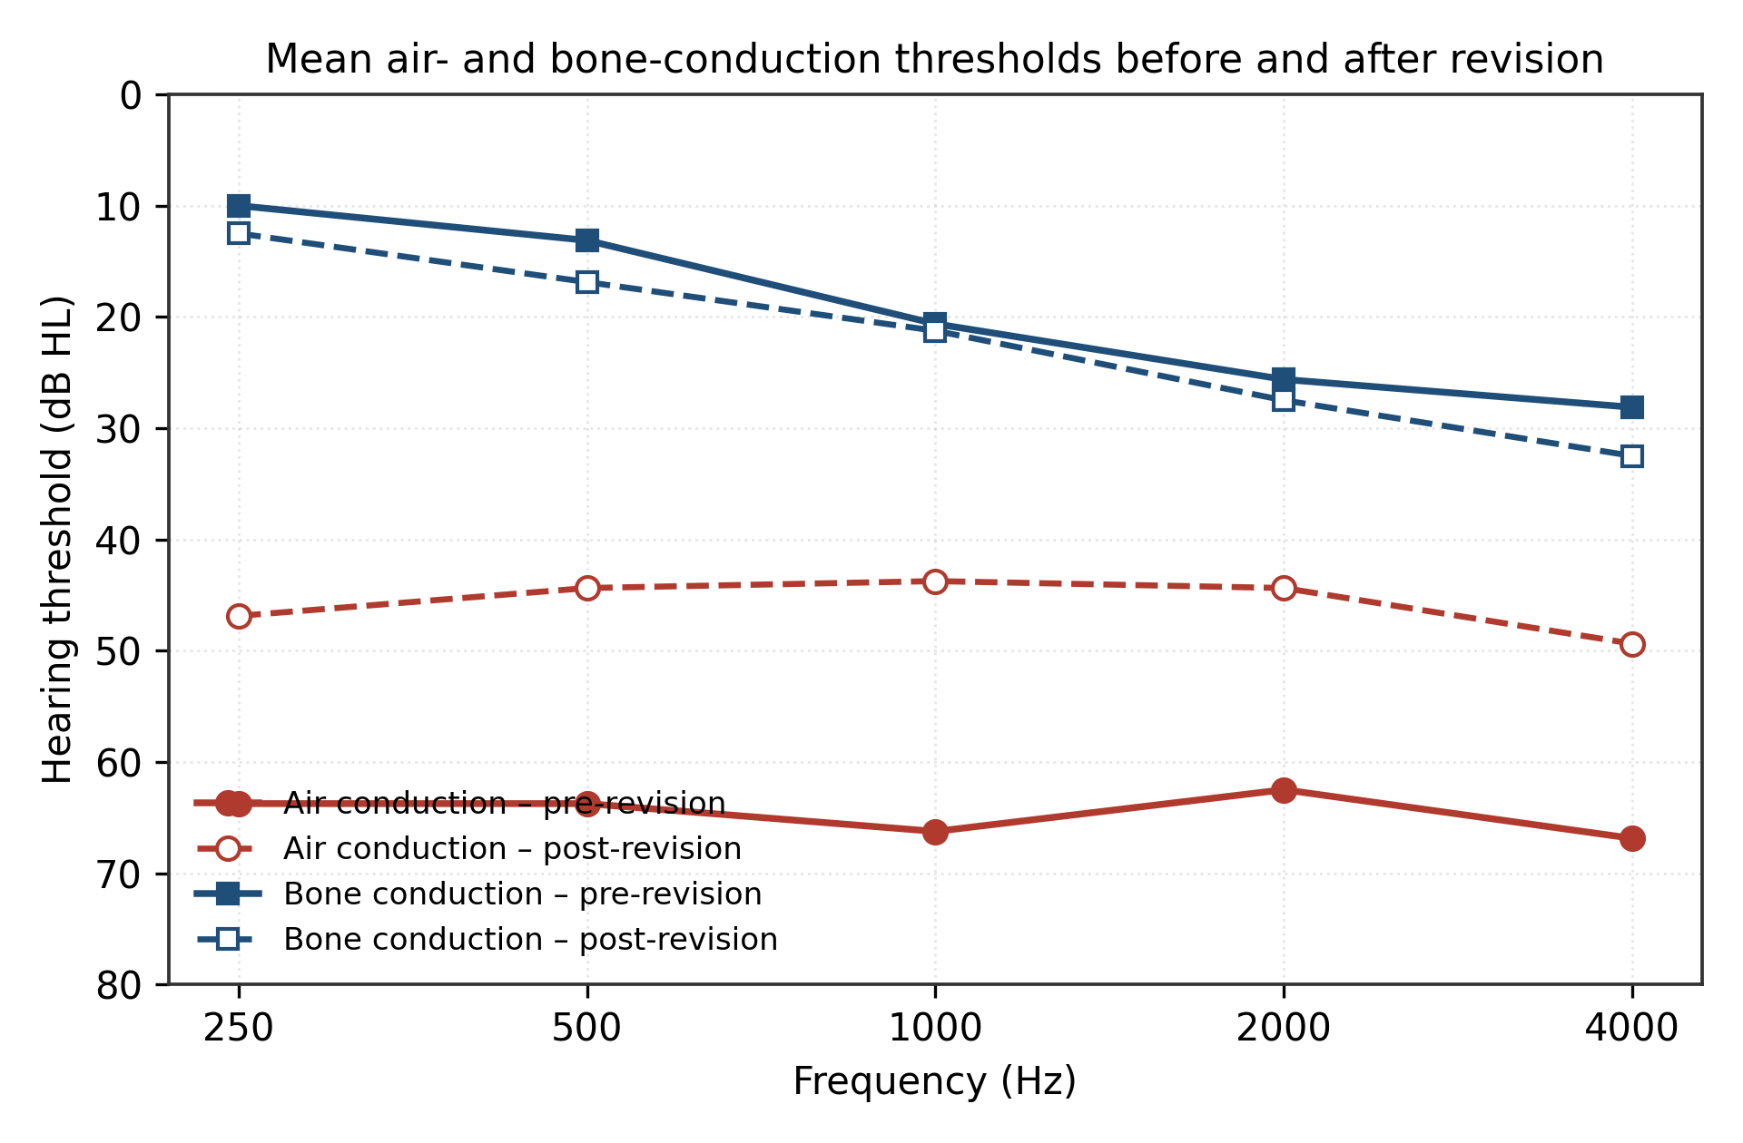
Figure 6: Mean air- and bone-conduction thresholds before and after revision surgery.
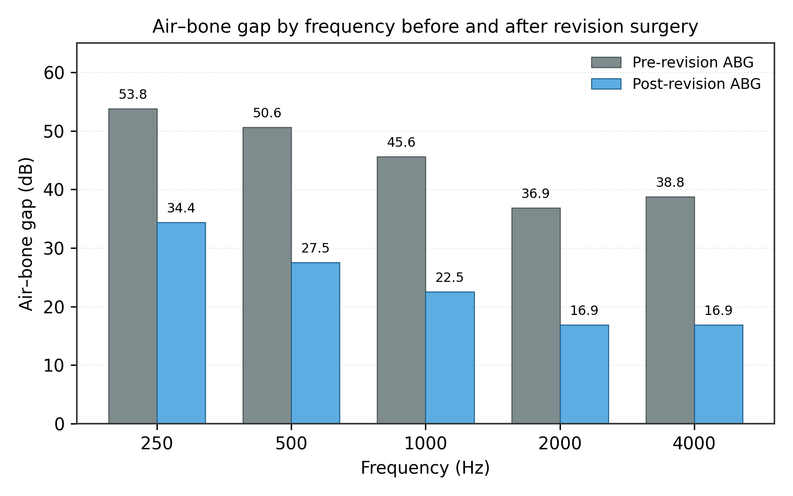
Figure 7: Air-bone gap by frequency before and after revision surgery.
Seven of the eight patients reported a clear subjective improvement in hearing; the eighth, in whom no mechanical cause had been found, felt no better. No patient developed total deafness, facial palsy or persistent vertigo.
Discussion
Our revision rate of 6.7% falls between the three to four per cent quoted by most authors and the 8.9% reported by Ayache [12], and is close to the 8.3% found by Szyfter in a cohort of more than a thousand patients followed for up to two decades [4]. A thesis from Marrakech reported 9.8%. The figure depends heavily on how long patients are followed and on how readily a surgeon offers re-exploration, and comparisons between series should be made with that in mind. Meyer and Lambert estimated that ten to twenty per cent of stapedectomised ears would eventually need revision over six to twenty years [13], which suggests that most published rates, including ours, are underestimates.
The demographic profile of our patients is unremarkable. A mean age at revision of 41.5 years is slightly younger than the 44 to 48 years reported by Somers, Bakhos and Gros [6,8,14], and our female predominance of seven to one is more marked than the roughly three to two usually described, almost certainly an artefact of the small sample. No study has convincingly linked age to the risk of functional failure.
The mechanisms of failure we encountered are the classical ones. A prosthesis-related problem accounted for six of our eight ears, with dislocation alone responsible for half the series. That proportion matches the 45% reported in some cohorts and the 48.2% of Lundman [9], and is higher than Ayache's 20.8% [12]. Erosion of the long process of the incus, present in one of our ears, is a well-recognised late complication of crimping and tends to carry a poorer prognosis [15]. The single ear in which nothing abnormal was found deserves comment: re-exploration that reveals a correctly placed and mobile prosthesis usually means that the residual gap was never conductive in origin, and this patient was the only one who reported no subjective benefit. Preoperative recognition of such cases would spare a difficult operation, but neither imaging nor audiometry currently allows it with confidence.
Computed tomography proved useful but not decisive. It correctly predicted the mechanical cause in six of eight ears, which is comparable to the fifty per cent detection rate reported by Ayache and by others [12,16], and it failed in the two ears where the abnormality was either subtle or absent. A short prosthesis and a dislocated one are the two findings that imaging identifies most reliably; fibrosis and early re-proliferation of an otosclerotic focus are largely invisible. The scan is nonetheless worth obtaining, if only because it may reveal a focus in contact with the cochlea, an obliterative pattern, or an unexpected anatomical hazard [17].
Judged against the AAO-HNS criteria, our results are mixed. A postoperative gap of 20 dB or less was obtained in 75% of ears, which sits comfortably within the 60 to 96% range of the published series, and closure of more than 10 dB was achieved in 75%, against 54 to 81% in the literature [5,18,19]. No ear, however, reached a gap of 10 dB or less, whereas most series report between 35 and 71%. Three factors probably contribute. The gaps we were starting from were wide, averaging 39 dB; our department has no laser, and Ayache's group demonstrated a clear advantage for laser-assisted revision, with 61.5% success against 49% without [20]; and eight ears is simply too small a denominator for a demanding endpoint. Bone conduction deteriorated by 2.6 dB on average, in keeping with the one to three decibel shifts reported by Bakhos, Gros and Lundman [8,9,14], and no ear was lost, which is the outcome that matters most.
The wider lesson is one of expectation management. Hearing results after revision are governed less by surgical technique than by what is found once the middle ear is opened. A short or dislocated prosthesis in an otherwise healthy oval window is the best of the scenarios and usually does well; dense fibrosis, adhesions and erosion of the incus do considerably worse; and re-proliferation of an obliterative focus gives results that vary unpredictably between series [17,21]. Pedersen recorded deterioration in 17% of 186 revisions and Palva in 23% of 76, figures that justify a frank preoperative conversation [22]. Telling a patient that there is roughly a sixty per cent chance of improvement, that the hearing may equally remain unchanged, and that it may occasionally become worse, is both honest and supported by the data. It is also worth remembering that the benefit tends to erode with time: Lippy observed that a gap closure rate of 72% had fallen to 50% at ten years, and that results deteriorate further with each successive revision [18].
The limitations of this work are those of any small retrospective series from a single centre. Eight ears do not permit inferential statistics, follow-up was limited to the early postoperative period, and the absence of a validated quality-of-life instrument means that subjective benefit was captured only informally. Against this, the cohort is homogeneous in a way that larger series rarely are: one surgeon, one technique, one department, and complete access to the notes of the primary operation, which is precisely the information most often missing when a patient is referred for revision from elsewhere.
Conclusion
Failure after stapes surgery is uncommon but not rare, and in the great majority of cases it is mechanical and therefore correctable. In our twelve-year experience, prosthesis dislocation accounted for half of all failures and a prosthesis-related problem for three-quarters. Revision surgery closed the air-bone gap to within 20 dB in three ears out of four and produced subjective improvement in seven patients out of eight, without cochlear loss. These results are respectable but consistently below those of primary surgery, and they argue for two things: meticulous technique at the first operation, particularly in seating and crimping the prosthesis, and an honest, specific discussion with the patient before any re-exploration is undertaken.

Declaration of AI Use

This manuscript was prepared through the combined contributions of all author(s), including contributions to the study design, data, content development, results, interpretation, and related scholarly work. The author(s) acknowledge the use of Grammarly and ChatGPT to assist with grammar checking, language refinement, reference formatting. These AI-assisted tools were not used as authors and did not replace the intellectual contributions or scholarly judgment of the author(s). All AI-assisted outputs, including content, references, and interpretations, were carefully reviewed, revised, verified, and approved by the author(s). The author(s) accept full responsibility for the accuracy, integrity, and final content of the manuscript.

References
1. Sakano H, Harris JP. Revision stapes surgery. Curr Otorhinolaryngol Rep. 2022; 10: 1-8.
2. Shea JJ. Stapedectomy - a long-term report. Ann Otol Rhinol Laryngol. 1982; 91: 516-520.
3. De la Cruz A, Fayad JN. Revision stapedectomy. Otolaryngol Head Neck Surg. 2000; 123: 728-732.
4. Szyfter W, Gawecki W, Bartochowska A, et al. Conductive hearing loss after surgical treatment of otosclerosis - long-term observations. Otolaryngol Pol. 2020; 74: 1-6.
5. Sheehy JL, Nelson RA, House HP. Revision stapedectomy: a review of 258 cases. Laryngoscope. 1981; 91: 43-51.
6. Somers T, Govaerts P, Janssens de Varebeke S, et al. Revision stapes surgery. J Laryngol Otol. 1997; 111: 233-239.
7. Hammerschlag PE, Fishman A, Scheer AA. A review of 308 cases of revision stapedectomy. Laryngoscope. 1998; 108: 1794-1800.
8. Bakhos D, Lescanne E, Charretier C, et al. A review of 89 revision stapes surgeries for otosclerosis. Eur Ann Otorhinolaryngol Head Neck Dis. 2010; 127: 177-182.
9. Lundman L, Stromback K, Bjorsne A, et al. Otosclerosis revision surgery in Sweden: hearing outcome, predictive factors and complications. Eur Arch Otorhinolaryngol. 2020; 277: 19-29.
10. Committee on Hearing and Equilibrium guidelines for the evaluation of results of treatment of conductive hearing loss. American Academy of Otolaryngology-Head and Neck Surgery. Otolaryngol Head Neck Surg. 1995; 113: 186-187.
11. Veillon F, Riehm S, Emachescu B, et al. Imaging of the windows of the temporal bone. Semin Ultrasound CT MR. 2001; 22: 271-280.
12. Ayache D, El Kihel M, Betsch C, et al. Les reinterventions dans la chirurgie de l'otospongiose: a propos de 26 cas. Ann Otolaryngol Chir Cervicofac. 2000; 117: 281-290.
13. Meyer TA, Lambert PR. Primary and revision stapedectomy in elderly patients. Curr Opin Otolaryngol Head Neck Surg. 2004; 12: 387-392.
14. Gros A, Vatovec J, Zargi M, et al. Success rate in revision stapes surgery for otosclerosis. Otol Neurotol. 2005; 26: 1143-1148.
15. Derlacki EL. Revision stapes surgery: problems with some solutions. Laryngoscope. 1985; 95: 1047-1053.
16. Naggara O, Williams M, Ayache D, et al. Imagerie des echecs et complications de la chirurgie de l'otospongiose. J Radiol. 2005; 86: 1749-1761.
17. Ayache D, Sleiman J, Plouin-Gaudon I, et al. Obliterative otosclerosis. J Laryngol Otol. 1999; 113: 512-514.
18. Lippy WH, Battista RA, Berenholz L, et al. Twenty-year review of revision stapedectomy. Otol Neurotol. 2003; 24: 560-566.
19. Puxeddu R, Ledda GP, Pelagatti CL, et al. Revision stapes surgery for recurrent transmissional hearing loss after stapedectomy and stapedotomy for otosclerosis. Acta Otorhinolaryngol Ital. 2005; 25: 347-352.
20. Betsch C, Ayache D, Decat M, et al. Les reinterventions dans la chirurgie de l'otospongiose: interet du laser. Ann Otolaryngol Chir Cervicofac. 2003; 120: 79-85.
21. Martin C, Messary A, Bertholon P, et al. Echecs fonctionnels dans la chirurgie de l'otospongiose: causes, diagnostic et traitement. Rev Laryngol Otol Rhinol. 2003; 124: 23-29.
22. Pedersen CB. Revision surgery in otosclerosis - an investigation of the factors which influence the hearing result. Clin Otolaryngol Allied Sci. 1996; 21: 385-388.

