Original Research Article

The Artificial Intelligence Verification Premium: A Dynamic Model of Automation Opacity, Borrowing Costs, and Firm Value

ABSTRACT
Aims: This study develops the artificial intelligence verification premium, defined as the incremental borrowing cost generated when automation creates operational risk that is insufficiently verified, understood, or governed. The objective is to connect artificial intelligence productivity choices to corporate financing costs and firm value.
Study design: Analytical model development with longitudinal Monte Carlo simulation, paired policy comparisons, policy-space search, and structural sensitivity analysis.
Place and Duration of Study: Singapore; model development, computational experiments, audit, and revision were conducted in August 2026.
Methodology: A dynamic firm model links automation intensity, verification intensity, verification debt, retained human oversight capability, stochastic uncertainty, incident risk, debt pricing, and discounted firm value. Competitive lenders price one-period debt using a zero-profit condition with loss-given-default. Five stylised management regimes were simulated for 20,000 synthetic firms over 48 quarters using common random numbers. A 324-policy grid was evaluated with 4,000 trajectories per policy, followed by sensitivity searches under alternative leverage, loss severity, artificial intelligence productivity, and model-risk assumptions.
Results: Acceleration-first adoption produced a mean borrowing premium of 130.56 basis points per quarter, versus 9.99 under balanced assurance and 11.31 under assurance-scaled automation. Mean discounted firm value was 356.82 for acceleration-first, 408.01 for balanced assurance, and 416.69 for assurance-scaled automation. The highest evaluated grid policy was automation 0.80 and verification 0.55, with mean value 417.51. The analytical direct-risk threshold was verification 0.538, placing the numerical optimum just above the level at which additional automation ceases to increase contemporaneous failure probability.
Conclusion: Artificial intelligence can create a financing externality inside the firm: productivity gains may be partly offset by a verification-sensitive borrowing premium. Efficient adoption therefore requires joint optimisation of automation and assurance rather than automation maximisation or blanket control intensity.
Keywords: artificial intelligence; cost of debt; verification; firm value; model risk; corporate finance; automation; information asymmetry
JEL Classification: G32; G33; O33; M15

1. INTRODUCTION
Generative and agentic artificial intelligence are increasingly treated as productivity technologies, but corporate adoption decisions are ultimately financed decisions. A firm that automates more work may reduce task completion time, expand output, and improve the scalability of knowledge-intensive processes. At the same time, it may create new forms of model error, opaque dependency, correlated failure, weakly understood decision logic, and deferred human checking. Experimental and field evidence shows that generative artificial intelligence can improve productivity in selected knowledge tasks, although gains are heterogeneous across workers and task types (Noy & Zhang, 2023; Brynjolfsson et al., 2025). At the macroeconomic level, the aggregate effect of artificial intelligence depends not only on task-level gains but also on which tasks can be reliably improved and on the costs of deployment, adaptation, and complementarity (Acemoglu, 2025).
A separate literature in finance establishes that information quality, opacity, and perceived default risk affect the price and availability of capital. Information asymmetry can raise required returns because uninformed capital providers face an informational disadvantage (Easley & O’Hara, 2004). Higher-quality disclosure can lower the cost of capital under identifiable conditions (Lambert et al., 2007), and greater bond-market transparency can reduce corporate bond issuing costs (Brugler et al., 2022). Corporate debt pricing is also fundamentally linked to the probability and severity of adverse states (Merton, 1974). These two literatures, artificial intelligence productivity and financing under imperfect information, have largely developed separately.
This separation creates an important missing mechanism. If artificial intelligence adoption changes the probability distribution of operational losses, and if lenders or other capital providers price those losses, then verification quality should become a financing variable. Artificial intelligence assurance is not merely a compliance cost. It can alter the firm’s risk distribution and therefore the price at which external capital is supplied. This possibility is increasingly relevant because financial authorities have highlighted model risk, data quality, governance weaknesses, third-party dependence, and correlated artificial intelligence use as potential sources of financial vulnerability (Financial Stability Board, 2024; Crisanto et al., 2024). Existing model-risk guidance likewise emphasises independent validation and effective challenge when model outputs materially affect financial decisions (Board of Governors of the Federal Reserve System & Office of the Comptroller of the Currency, 2011). The National Institute of Standards and Technology similarly treats governance, measurement, and management as interdependent components of artificial intelligence risk management (National Institute of Standards and Technology, 2023).
The present paper develops a formal bridge between these domains through the concept of the artificial intelligence verification premium. The premium is the incremental borrowing spread generated by artificial-intelligence-related failure probability when automation exceeds the organisation’s capacity to verify outputs, preserve human oversight competence, and prevent unresolved assurance obligations from accumulating. The mechanism extends the concept of verification debt, previously modelled as an internal organisational stock that can accumulate when artificial intelligence outputs are insufficiently checked (Tan, 2026). The earlier framework focused on productivity, resilience, and internal organisational value. The present study is different in both object and mechanism: it endogenises the price of debt and asks when internal assurance choices are transmitted into external financing costs.
The paper makes five contributions. First, it derives a closed-form borrowing spread from a competitive lender zero-profit condition, allowing artificial intelligence risk to enter financing cost without assuming an arbitrary risk-premium function. Second, it models verification debt and human oversight capability as dynamic state variables, so financing costs depend on the history of adoption rather than only current automation. Third, it derives two verification thresholds: a direct-risk threshold above which additional automation no longer increases contemporaneous failure probability, and a debt non-accumulation threshold that prevents new verification debt from being created from a zero-debt state. Fourth, it evaluates the model through Monte Carlo simulation, common-random-number paired comparisons, and a full two-dimensional policy search. Fifth, it tests whether the preferred automation-verification region changes under alternative leverage, loss-given-default, artificial intelligence productivity, and unmanaged-risk sensitivity.
The central argument is not that artificial intelligence necessarily increases borrowing costs. Rather, the sign is conditional. When verification is weak, higher automation can increase unresolved exposure and raise the priced probability of adverse outcomes. When verification is sufficiently strong, automation can coexist with low risk and high value. Excessively intensive assurance can also destroy value if its direct cost exceeds the reduction in expected loss and financing premium. The economically relevant decision is therefore joint optimisation, not a binary choice between adoption and non-adoption.

2. THEORETICAL BACKGROUND AND HYPOTHESIS DEVELOPMENT
2.1 Artificial intelligence productivity and the problem of incomplete valuation
Early evidence on generative artificial intelligence supports meaningful task-level productivity effects. Noy and Zhang (2023) found faster completion and higher average quality in professional writing tasks. Brynjolfsson et al. (2025), using a large-scale workplace deployment, found productivity gains that were concentrated among less experienced and lower-skilled workers. These findings support the idea that artificial intelligence can act as a complement to labour and as a mechanism for diffusing high-performer practices. They do not, however, imply that all automation produces equal firm value. Acemoglu (2025) stresses that task-level gains must be aggregated carefully and that the learnability and context-dependence of tasks constrain economy-wide effects.
Management decisions can therefore be mis-specified if they treat task throughput as the complete payoff. Artificial intelligence systems may generate outputs cheaply while simultaneously increasing the burden of checking, exception handling, governance, audit, remediation, and incident response. Gans (2025) formalises the more general point that learning about harms can affect the optimal rate of artificial intelligence adoption. In organisational settings, Tan (2026) proposes verification debt as an accumulated stock of unverified assumptions, weak review, concealed dependencies, and deferred validation that can convert early productivity gains into later fragility.
The present model preserves this dynamic logic but moves the outcome variable into corporate finance. The key addition is that unresolved verification exposure affects a hazard probability that lenders price. This creates a channel through which an internal technology-management decision becomes an external financing cost.
2.2 Information quality, opacity, and the cost of debt
Corporate finance has long recognised that financing prices reflect more than physical asset risk. Easley and O’Hara (2004) show that the composition and quality of information can influence firms’ cost of capital because uninformed investors require compensation when better-informed investors possess an advantage. Lambert et al. (2007) show that accounting information and disclosure can affect the cost of capital both directly, through assessed covariance, and indirectly, through firms’ real decisions. In debt markets, greater transparency can reduce issuing costs by reducing information asymmetry (Brugler et al., 2022), while differences between public and private credit information can affect access to bond financing (Iannamorelli et al., 2024).
The mechanism also fits foundational theories of financial contracting. Agency conflicts can make externally financed activity costly when managers and capital providers do not share the same information or incentives (Jensen & Meckling, 1976). Delegated monitoring reduces information-production costs in lending (Diamond, 1984), while financial intermediation and firms’ financing capacity can constrain real investment (Holmström & Tirole, 1997). Debt overhang and information asymmetry can distort investment and financing choices even when projects are technologically attractive (Myers, 1977; Myers & Majluf, 1984). In the artificial intelligence setting, these frictions can be amplified by concentration in upstream model and infrastructure markets, which can create common dependencies that are not obvious from conventional operating metrics (Korinek & Vipra, 2025).
Artificial intelligence can intensify this problem because important operational processes may become more difficult to understand from conventional financial statements. A firm may report lower labour cost or faster output while outside financiers cannot directly observe how much of that output rests on unverified model behaviour, concentrated third-party services, weak human fallback capability, or brittle automated workflows. Regulators have explicitly identified model risk, data quality, governance, cyber vulnerability, and third-party concentration among important artificial intelligence-related financial risks (Financial Stability Board, 2024; Crisanto et al., 2024). This suggests that the quality of assurance around artificial intelligence may eventually function similarly to other forms of risk-relevant disclosure and control quality.
The model does not assume that lenders can perfectly observe every internal variable. Instead, it treats the priced failure probability as the lender’s equilibrium risk assessment given the firm’s observable or credibly inferable assurance condition. This is a reduced-form representation of underwriting, covenant monitoring, audit evidence, technology due diligence, and other information channels. The objective is to isolate the economic mechanism rather than reproduce a particular credit-rating process.
2.3 Verification as productive assurance rather than pure overhead
Verification has two economically opposed effects. First, it is costly. Review time, independent validation, testing, documentation, red-team exercises, audit trails, human escalation, and control infrastructure consume resources. Second, verification can be productive because it reduces expected loss, preserves organisational knowledge, and can make higher levels of automation safely scalable. Model-risk guidance has long emphasised that effective challenge requires competence, independence, and influence rather than mechanical approval (Board of Governors of the Federal Reserve System & Office of the Comptroller of the Currency, 2011). The NIST framework similarly treats governance, mapping, measurement, and management as a connected cycle rather than a one-time compliance action (National Institute of Standards and Technology, 2023).
This dual role implies a non-monotonic value relationship. Very low verification can allow risk and verification debt to accumulate. Very high verification can suppress risk but impose excessive cost and slow the exploitation of productive automation. The value-maximising region should therefore be interior under plausible parameterisations.
2.4 Research propositions
The analytical model develops four propositions.
Proposition 1, convex financing response. Holding the risk-free rate and loss-given-default constant, the artificial intelligence verification premium is increasing and convex in the priced failure probability.
Proposition 2, direct-risk verification threshold. Holding the state variables constant, the contemporaneous marginal effect of automation on failure probability changes sign at a verification intensity equal to the ratio of the direct automation-risk coefficient to the automation-verification interaction coefficient.
Proposition 3, verification-debt non-accumulation threshold. Starting from zero verification debt, there exists a minimum verification intensity that prevents new debt from being created. This threshold increases with automation and environmental uncertainty and decreases with human oversight capability and verification effectiveness.
Proposition 4, joint optimisation. Because automation generates productivity benefits and convex scaling costs while verification generates assurance benefits and direct costs, the value-maximising policy need not maximise either control individually. An interior region can dominate both acceleration-first and assurance-heavy policies.

3. METHODOLOGY
3.1 Research design
The study is a theoretical-computational original research design. No human participants, proprietary firm records, or externally collected observations are used. The numerical findings are generated from a fully specified stochastic model and are intended to evaluate internal consistency, comparative statics, dynamic mechanisms, and policy trade-offs. They should not be interpreted as empirical estimates of actual corporate borrowing spreads.
The simulated horizon is 48 quarters. The principal regime comparison uses 20,000 synthetic firm trajectories per policy. The policy-space search evaluates 18 automation levels and 18 verification levels, producing 324 fixed policies, with 4,000 trajectories per policy. Sensitivity searches use 1,200 trajectories per policy. Common random numbers are used across policies within each experiment so that differences are driven primarily by policy rather than independent simulation noise.
3.2 Controls, states, and uncertainty
Let automation intensity be $a∈\left[0,1\right]$ and verification intensity be $v∈\left[0,1\right]$. Policies are fixed over the baseline horizon to isolate long-run consequences of stable management choices. The two endogenous state variables are verification debt $q_{t}≥0$ and retained human oversight capability $h_{t}∈\left[0,1\right]$.
Environmental uncertainty is generated from a latent autoregressive process:
$x_{t}=ρ_{x}x_{t-1}+σ_{x}ζ_{t}, ζ_{t}∼N\left(0,1\right), u_{t}=max\left(0,x_{t}\right).$ (1)
The non-negative transformation $u_{t}$ represents adverse uncertainty pressure. It can be interpreted as model drift, changing business context, unusual data conditions, regulatory change, or other factors that make automated outputs harder to validate.
3.3 Operating surplus
Before financing cost and incident loss, the firm’s period operating surplus is:
$Y_{t}=μ_{0}+αa+βah_{t}+γav-\frac{κ_{a}}{2}a^{2}-\frac{κ_{v}}{2}v^{2}-c_{q}q_{t}-c_{x}av+ε_{t}, ε_{t}∼N\left(0,σ_{ε}^{2}\right).$ (2)
The term $αa$ captures direct automation productivity. The complementarity term $βah_{t}$ rewards automation that remains supported by human oversight competence. The term $γav$ represents assurance-enabled scalability, in which verified systems can be used more confidently in consequential workflows. Convex terms penalise excessive automation and verification intensity. Verification debt creates rework and coordination costs through $c_{q}q_{t}$, and $c_{x}av$ captures the workload of verifying a larger automated surface.
3.4 Verification debt dynamics
Verification debt evolves as:
$q_{t+1}=max\left\{0,\left(1-δ_{q}\right)q_{t}+ϕa\left(1-v\right)\left(1+u_{t}\right)-ψvh_{t}\right\}.$ (3)
Debt partially decays at rate $δ_{q}$. New debt is created when automation is high, verification is incomplete, and uncertainty is elevated. Verification supported by human capability clears debt at rate $ψvh_{t}$. This formulation makes verification quality productive only when the organisation retains sufficient competence to conduct meaningful challenge.
3.5 Human oversight capability
Human oversight capability evolves according to:
$h_{t+1}=min\left\{1,max\left[0,h_{t}+ρ_{v}v\left(1-h_{t}\right)-ρ_{a}a\left(1-v\right)h_{t}\right]\right\}.$ (4)
Verification sustains capability by keeping humans engaged with system logic, edge cases, and review. High automation with weak verification erodes capability because fewer consequential tasks are actively examined. This state variable makes risk path-dependent: a firm that allows oversight competence to decay cannot instantaneously restore high-quality verification merely by changing policy later.
3.6 Failure probability
The period probability of a financing-relevant adverse artificial-intelligence-related state is logistic. The state can represent a sufficiently material operating incident, control failure, or model-driven loss event to affect creditor recovery or refinancing assessment:
$p_{t}=\frac{1}{1+exp\left(-z_{t}\right)},$ (5)
where
$z_{t}=θ_{0}+θ_{q}q_{t}+θ_{u}u_{t}+θ_{a}a-θ_{av}av-θ_{h}h_{t}.$ (6)
Verification debt, uncertainty, and automation raise risk, while the interaction between automation and verification reduces risk when assurance scales with deployment. Human oversight capability also lowers risk. The logistic specification keeps probabilities in the unit interval and allows nonlinear amplification as the risk index rises. The variable $p_{t}$ is therefore not the probability of any minor artificial intelligence error. It is the model’s priced probability of an adverse state that is material to both operating cash flow and creditor recovery.
3.7 Competitive debt pricing and the artificial intelligence verification premium
The financing mechanism is derived from a one-period competitive lender condition. Let $B$ be debt principal, $r_{f}$ the risk-free return, $r_{D,t}$ the contractual debt rate, and $λ∈\left(0,1\right)$ the creditor loss fraction conditional on the priced adverse state. The baseline uses $B=\overset{‾}{B}ω$, where $\overset{‾}{B}$ is a debt-scale parameter and $ω$ is financing intensity. If the adverse state occurs with probability $p_{t}$, lenders receive a fraction $1-λ$ of promised repayment. Zero expected excess profit requires:
$\left(1+r_{f}\right)B=\left[\left(1-p_{t}\right)+p_{t}\left(1-λ\right)\right]\left(1+r_{D,t}\right)B.$ (7)
Therefore:
$r_{D,t}=\frac{1+r_{f}}{1-λp_{t}}-1.$ (8)
Define the artificial intelligence verification premium $s_{t}$ as the spread above the risk-free rate attributable to the priced failure probability:
$s_{t}=r_{D,t}-r_{f}=\left(1+r_{f}\right)\frac{λp_{t}}{1-λp_{t}}.$ (9)
Differentiating gives:
$\frac{∂s_{t}}{∂p_{t}}=\frac{\left(1+r_{f}\right)λ}{{\left(1-λp_{t}\right)}^{2}}>0, \frac{∂^{2}s_{t}}{∂p_{t}^{2}}=\frac{2\left(1+r_{f}\right)λ^{2}}{{\left(1-λp_{t}\right)}^{3}}>0.$ (10)
Equation (10) proves Proposition 1. The financing penalty accelerates as risk rises.
3.8 Verification thresholds
From Equations (5) and (6), holding $q_{t}$, $u_{t}$, and $h_{t}$ constant:
$\frac{∂p_{t}}{∂a}=p_{t}\left(1-p_{t}\right)\left(θ_{a}-θ_{av}v\right).$ (11)
Hence the direct-risk threshold is:
$v_{p}^{crit}=\frac{θ_{a}}{θ_{av}}.$ (12)
When $v>v_{p}^{crit}$, an incremental increase in automation reduces contemporaneous risk in the model because assurance-enabled deployment more than offsets the direct automation-risk term. Under the baseline coefficients, $v_{p}^{crit}=1.40/2.60=0.538$.
A separate condition controls new verification-debt creation. At $q_{t}=0$, Equation (3) produces no new debt when:
$ϕa\left(1-v\right)\left(1+u_{t}\right)≤ψvh_{t}.$ (13)
Solving for verification yields:
$v_{q}^{crit}\left(a,h_{t},u_{t}\right)=\frac{ϕa\left(1+u_{t}\right)}{ψh_{t}+ϕa\left(1+u_{t}\right)}.$ (14)
A sufficient contemporaneous assurance condition is therefore:
$v≥v_{A}^{crit}=max\left\{v_{p}^{crit},v_{q}^{crit}\left(a,h_{t},u_{t}\right)\right\}.$ (15)
This combined threshold does not guarantee global optimality because verification has direct cost and the state variables evolve. It identifies a local region in which automation does not directly raise priced risk and does not create new verification debt from a zero-debt state.
3.9 Incident losses and firm value
An incident indicator $I_{t}$ is drawn from a Bernoulli distribution with probability $p_{t}$. Conditional severity is lognormal and increases with verification debt:
$L_{t}=I_{t}l_{0}\left(1+ξq_{t}\right)exp\left(σ_{l}Z_{t}-\frac{σ_{l}^{2}}{2}\right), Z_{t}∼N\left(0,1\right).$ (16)
The exponential adjustment preserves the conditional mean scaling term. Period net cash flow is:
$CF_{t}=Y_{t}-L_{t}-Br_{D,t}.$ (17)
The discounted firm-value index over $T$ periods is:
$V=\sum_{t=0}^{T-1}{\frac{CF_{t}}{{\left(1+r_{f}\right)}^{t}}}.$ (18)
This is a model value index rather than a currency valuation. It permits internally consistent comparisons across policies without claiming calibration to a particular firm or national credit market. The two risk-related deductions in Equation (17) represent different cash-flow objects. $L_{t}$ is a realised operating loss borne by the firm when the adverse state occurs, whereas $Br_{D,t}$ is the ex ante contractual financing charge required by lenders for bearing creditor exposure. Including both therefore captures an operating-loss channel and a financing-price channel rather than charging the same item twice. The index should be read as residual discounted cash flow under a rolling-debt convention, not as an enterprise-value identity.
3.10 Baseline parameters and management regimes
Table 1 lists the complete baseline parameters. Values are deliberately stylised. They are selected to create economically interpretable trade-offs rather than to reproduce a particular observed data set. The audit criterion is therefore structural: whether propositions, comparative statics, and simulation outcomes are consistent with the stated equations.
Table 1. Baseline model parameters
Parameter | Value | Interpretation
T | 48 | Quarterly horizon
q₀ | 0.25 | Initial verification debt
h₀ | 0.85 | Initial human oversight capability
μ₀ | 8.00 | Baseline operating surplus
α | 5.00 | Direct automation productivity
β | 3.00 | Automation-human complementarity
γ | 1.70 | Assurance-enabled scalability
κ_{a} | 9.00 | Convex automation cost
κ_{v} | 5.20 | Convex verification cost
c_{q} | 0.55 | Operating cost of verification debt
c_{x} | 0.70 | Cost of verifying automated surface
φ | 0.42 | Verification-debt creation rate
ψ | 0.48 | Verification-debt clearance rate
δ_{q} | 0.18 | Passive debt decay rate
ρ_{v} | 0.10 | Verification-supported capability renewal
ρ_{a} | 0.07 | Capability erosion under weakly verified automation
θ₀ | -5.60 | Baseline logit intercept
θ_{q} | 0.75 | Verification-debt risk coefficient
θ_{u} | 0.55 | Uncertainty-risk coefficient
θ_{a} | 1.40 | Direct automation-risk coefficient
θ_{av} | 2.60 | Automation-verification risk offset
θ_{h} | 0.90 | Human capability risk reduction
ρ_{x} | 0.65 | Uncertainty persistence
σ_{x} | 0.35 | Uncertainty innovation scale
σ_{ε} | 0.70 | Operating-surplus shock scale
r_{f} | 0.008 | Quarterly risk-free rate
λ | 0.60 | Creditor loss fraction in priced adverse state
B̄ | 12.00 | Debt-scale parameter
ω | 0.55 | Baseline financing intensity, so B = B̄ω
ℓ₀ | 8.00 | Mean baseline incident severity
ξ | 0.45 | Verification-debt severity multiplier
σ_{ℓ} | 0.35 | Lognormal incident-severity volatility
Five stylised fixed policies are compared. Conventional controls use low automation and moderate verification $\left(a=0.20,v=0.45\right)$. Acceleration-first uses high automation with weak verification $\left(0.90,0.20\right)$. Balanced assurance uses moderate-high automation and verification $\left(0.65,0.65\right)$. Assurance-scaled automation uses high automation with verification near the analytically relevant threshold $\left(0.85,0.60\right)$. Assurance-heavy uses moderate automation and very high verification $\left(0.45,0.95\right)$.
3.11 Computational implementation, reproducibility, and generative artificial intelligence use
The simulation was implemented in Python using NumPy for random-number generation and vectorised state updates, pandas for result tabulation, and Matplotlib for figures. The master random seed was 20260810. The complete baseline parameter set is reported in Table 1 and the equations above; the policy grid spans 0.10 to 0.95 in increments of 0.05 for both $a$ and $v$. Common random numbers were used for paired policy comparisons and grid evaluations.
OpenAI ChatGPT (GPT-5.6 Sol model/version, provided by OpenAI; accessed August 2026) was used as a drafting, coding, language-editing, and formatting assistant during manuscript preparation. It did not provide external empirical observations. Simulation outputs reported in the article were generated from the explicit model and checked against the analytical equations, parameter bounds, convergence behaviour, and independent recomputation of summary statistics. The author retains responsibility for the final submitted manuscript, consistent with the journal’s artificial intelligence policy.

4. RESULTS AND DISCUSSION
4.1 Regime comparison
The five-regime experiment produces a clear distinction between task acceleration and financing-adjusted value. Table 2 reports mean discounted firm value with its Monte Carlo standard error in parentheses, average quarterly borrowing premium, mean probability of the priced adverse state, terminal verification debt, and terminal human capability.
Table 2. Outcomes for five stylised management regimes
Regime | Policy (a, v) | Mean value (MCSE) | Borrowing premium (bp) | Priced adverse-state probability (%) | End q | End h
Conventional controls | (0.20, 0.45) | 352.97 (0.03) | 12.21 | 0.202 | 0.000 | 0.854
Acceleration-first | (0.90, 0.20) | 356.82 (0.10) | 130.56 | 2.125 | 1.821 | 0.301
Balanced assurance | (0.65, 0.65) | 408.01 (0.03) | 9.99 | 0.165 | 0.000 | 0.804
Assurance-scaled automation | (0.85, 0.60) | 416.69 (0.03) | 11.31 | 0.187 | 0.015 | 0.718
Assurance-heavy | (0.45, 0.95) | 345.84 (0.03) | 6.57 | 0.109 | 0.000 | 0.983
The acceleration-first policy illustrates the artificial intelligence verification premium most strongly. Its mean quarterly borrowing premium is 130.56 basis points, roughly eleven times the conventional-control premium and more than thirteen times the balanced-assurance premium. This outcome is not imposed directly. It emerges because high automation combined with low verification increases verification debt, erodes human oversight capability, raises the logistic incident probability, and then feeds into the lender zero-profit pricing condition. The same regime averages 1.013 priced adverse states over 48 quarters, compared with 0.080 under balanced assurance and 0.091 under assurance-scaled automation.
The high spread is economically consequential in the model even though acceleration-first initially produces substantial operating gains. Mean discounted value under acceleration-first is 356.82, only slightly above conventional controls at 352.97 and well below balanced assurance at 408.01. Using common random numbers, balanced assurance exceeds acceleration-first by 51.20 value units with a 95% Monte Carlo interval for the mean difference of [51.02, 51.38]. Assurance-scaled automation exceeds acceleration-first by 59.88 units, with interval [59.70, 60.05]. These are simulation-precision intervals, not empirical confidence intervals about real firms.
Assurance-heavy has the lowest borrowing premium, 6.57 basis points, and the highest terminal human capability, 0.983. Yet its mean firm value is only 345.84 because the direct and convex costs of verification outweigh the incremental risk reduction at its lower automation level. This result supports Proposition 4: risk minimisation is not value maximisation.
Figure 1 shows the time path of the mean borrowing premium. The premium under acceleration-first separates progressively as verification debt accumulates and human capability erodes. The remaining regimes stay in a comparatively low-premium region.
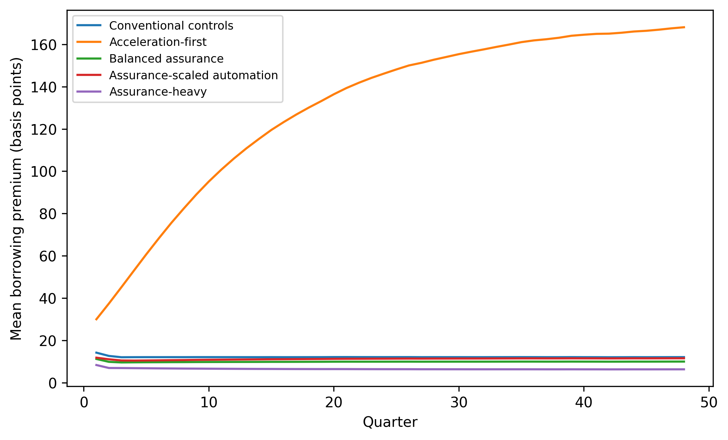
Fig. 1. Mean borrowing premium by management regime over 48 quarters. Values are basis points above the quarterly risk-free rate.
4.2 Policy-space search and the value ridge
The 324-policy search confirms that the preferred policy is interior in verification and close to interior in automation. The highest evaluated point is $a=0.80$ and $v=0.55$, with mean discounted value 417.51 and an average quarterly borrowing premium of 13.20 basis points. The next-best policy, $a=0.75$ and $v=0.55$, produces 417.32. Several nearby combinations differ by less than one value unit, indicating a relatively flat value ridge rather than a knife-edge optimum.
This flatness is important. The model should not be interpreted as recommending the exact numerical pair $\left(0.80,0.55\right)$. Instead, it identifies a region in which automation is high enough to exploit productivity gains while verification is sufficient to prevent the financing penalty from becoming dominant. Small deviations inside this region have modest value effects, whereas moving toward high automation and very weak verification produces sharp deterioration.
Figure 2 displays the full value surface. Low automation limits the productivity contribution even when verification is strong. High automation combined with very low verification creates a steep penalty through verification debt, capability erosion, incidents, and borrowing costs. Very high verification also reduces value because assurance itself is costly. The resulting surface provides the computational counterpart to Proposition 4.
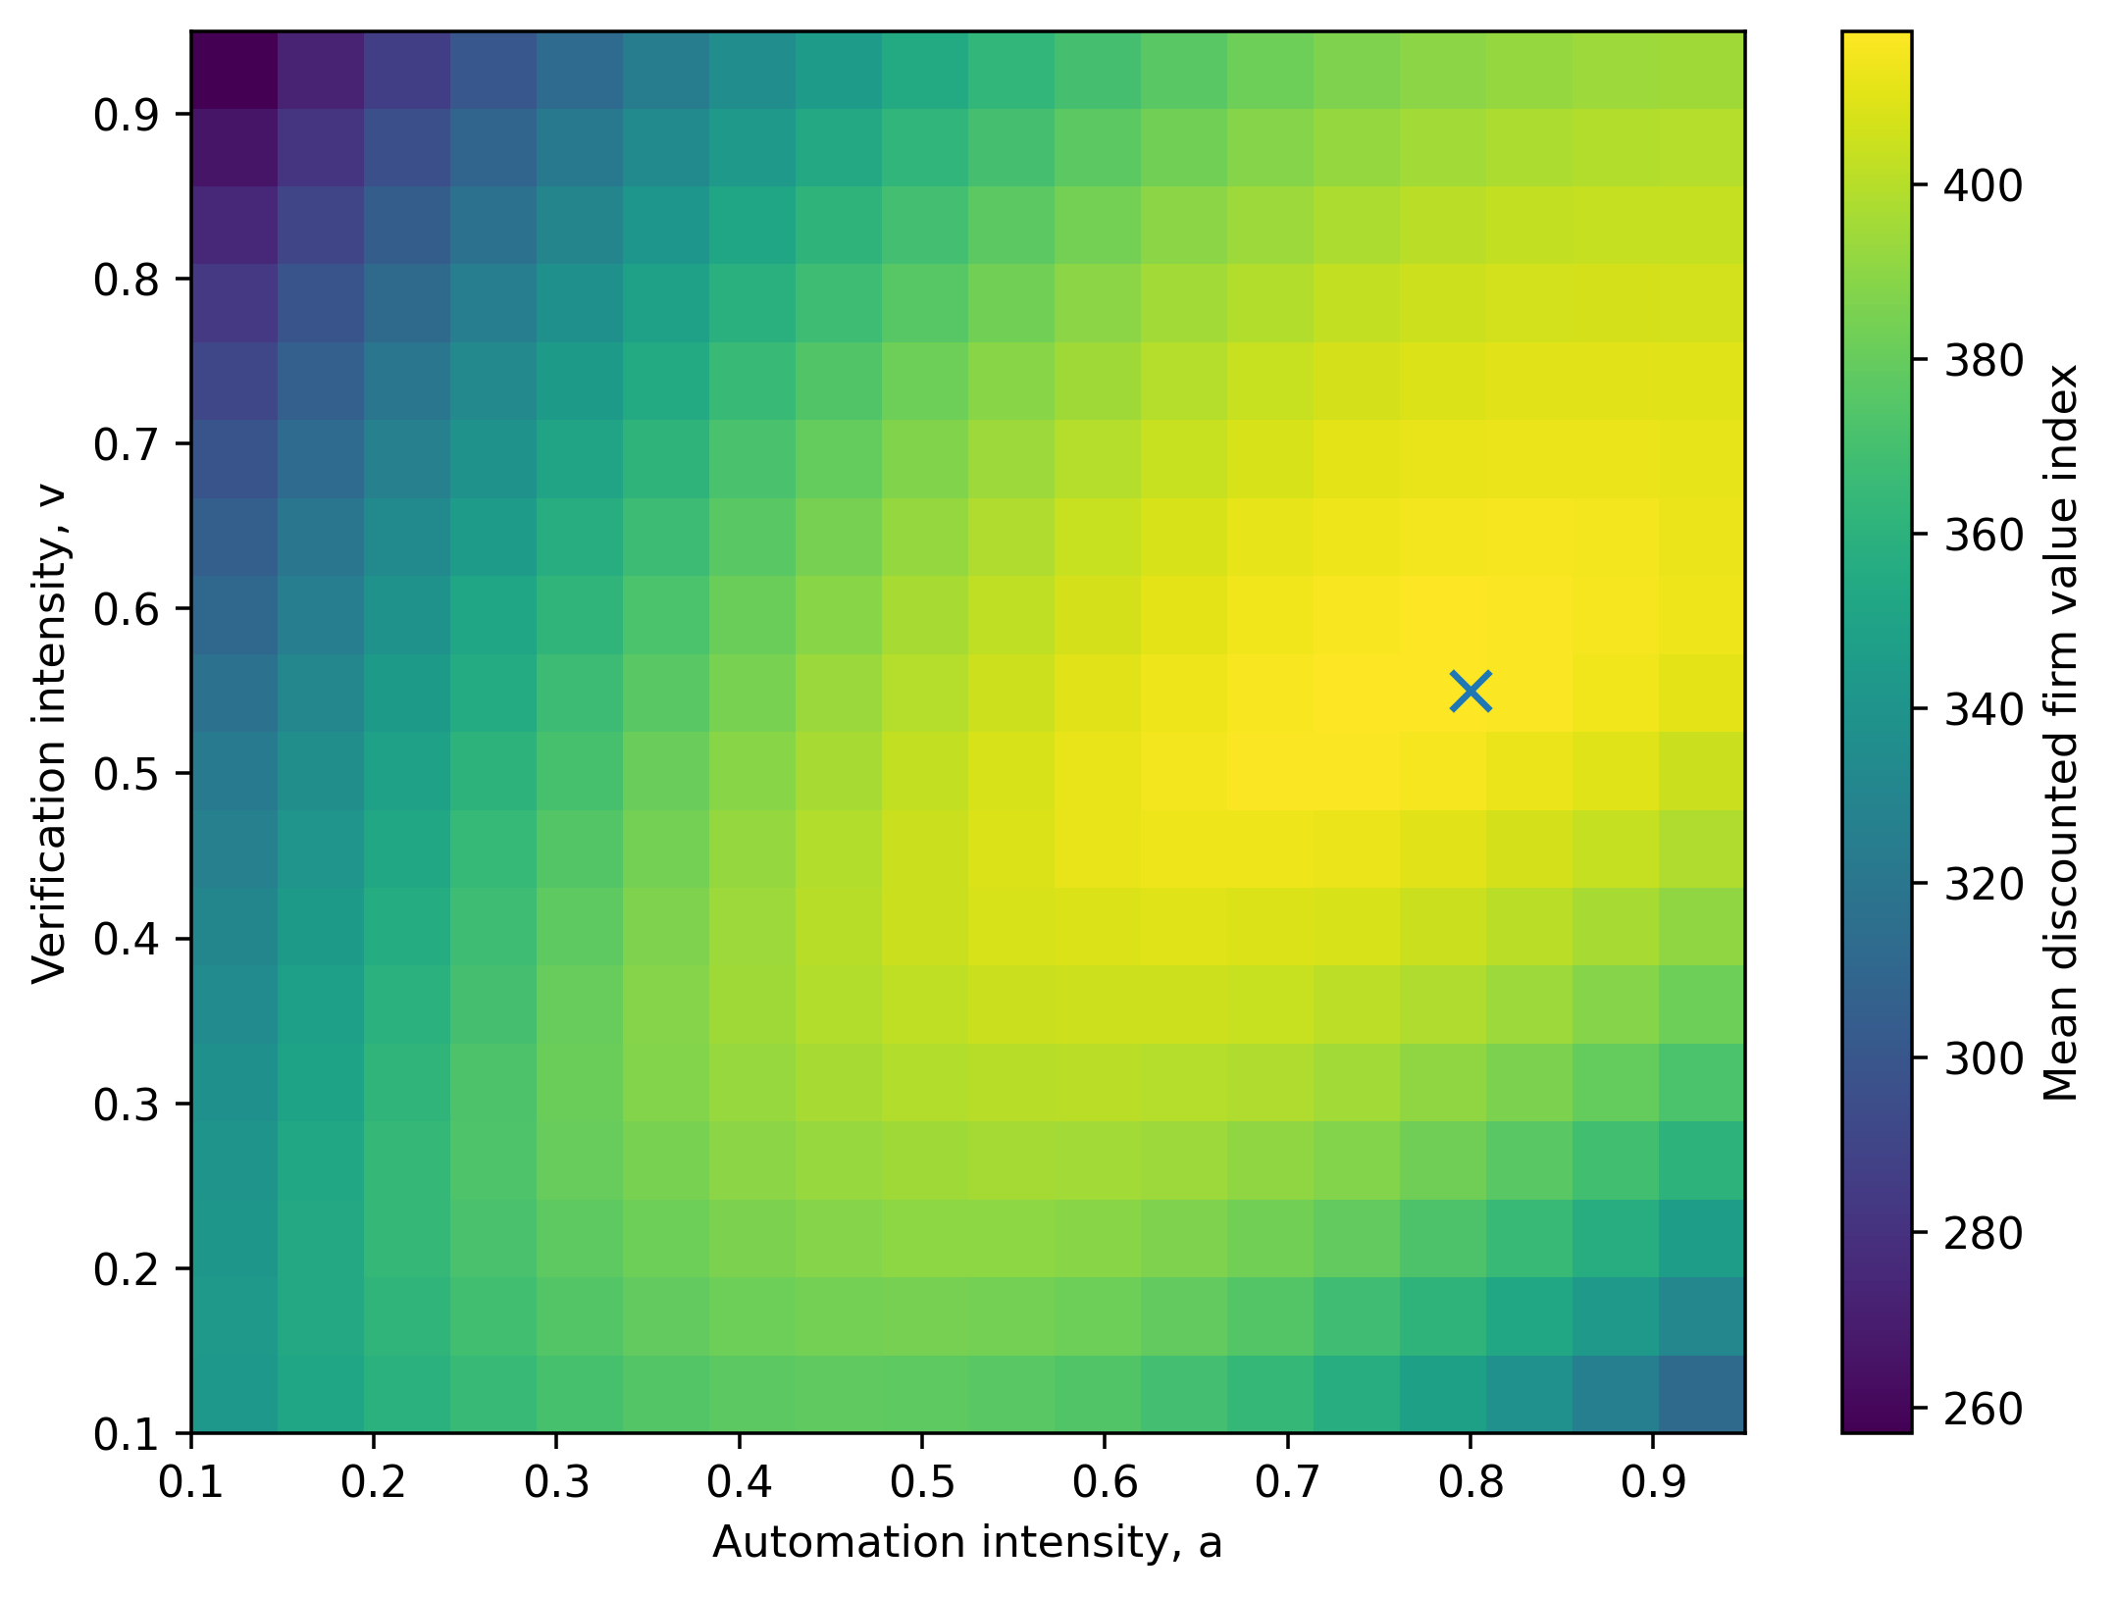
Fig. 2. Mean discounted firm value across the 324-policy automation-verification grid. The cross marks the highest evaluated policy, $a=0.80$, $v=0.55$.
4.3 Analytical threshold and numerical optimum
The baseline direct-risk threshold from Equation (12) is $v_{p}^{crit}=0.538$. The value-maximising grid point uses $v=0.55$, immediately above that threshold. This alignment is not a mathematical necessity because the value function also includes direct verification cost, verification-debt dynamics, human capability, incident severity, and debt service. It nevertheless provides a useful structural check: the numerical search places the optimum close to the point at which verification becomes strong enough for additional automation to stop raising contemporaneous risk.
At the baseline initial state with $a=0.80$, $h_{0}=0.85$, and $u_{0}=0$, Equation (14) gives $v_{q}^{crit}≈0.452$. The combined initial assurance threshold is therefore $v_{A}^{crit}=max\left(0.538,0.452\right)=0.538$. Environmental uncertainty can raise the debt non-accumulation threshold over time, while human capability can fall if automation remains insufficiently verified. The dynamic system therefore rewards some buffer above the initial threshold.
Figure 3 isolates verification intensity at $a=0.80$. Value rises steeply from weak verification, reaches a maximum around 0.55, then declines as the marginal assurance benefit is overtaken by verification cost. This is the central economic trade-off of the paper.
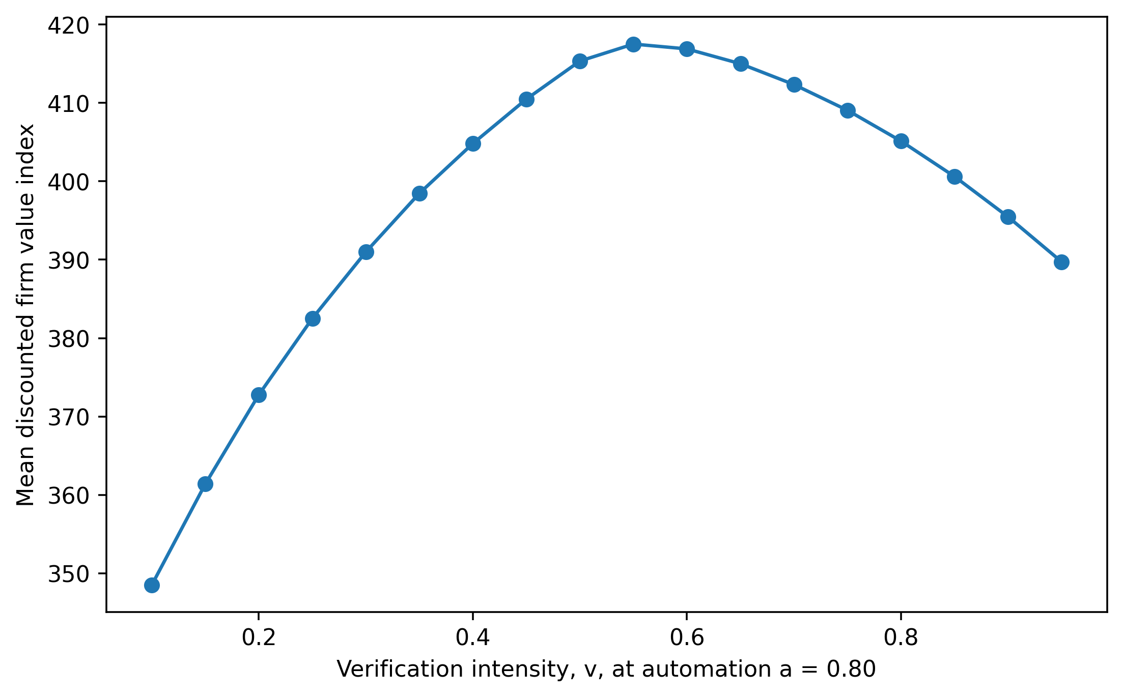
Fig. 3. Verification sweep at automation intensity $a=0.80$. Mean discounted firm value peaks near the analytical direct-risk threshold.
4.4 Sensitivity analysis
Table 3 reports the best policy found in repeated grid searches under alternative structural assumptions. The base optimum is stable to moderate changes in leverage and loss-given-default, although the borrowing premium changes mechanically with loss severity. More importantly, the preferred policy shifts in the expected direction when the productivity return to automation changes.
Table 3. Policy-search sensitivity results
Scenario | Best a | Best v | Mean value | Borrowing premium (bp) | End q | End h
Baseline | 0.80 | 0.55 | 417.53 | 13.19 | 0.054 | 0.689
Low leverage (0.30) | 0.80 | 0.55 | 418.65 | 13.19 | 0.054 | 0.689
High leverage (0.75) | 0.80 | 0.55 | 416.63 | 13.19 | 0.054 | 0.689
Low creditor loss fraction (0.40) | 0.80 | 0.55 | 417.64 | 8.79 | 0.054 | 0.689
High creditor loss fraction (0.80) | 0.80 | 0.55 | 417.41 | 17.60 | 0.054 | 0.689
Lower artificial intelligence productivity (-20%) | 0.65 | 0.50 | 388.77 | 14.28 | 0.045 | 0.692
Higher artificial intelligence productivity (+20%) | 0.90 | 0.60 | 451.57 | 11.38 | 0.028 | 0.706
Higher unmanaged-risk sensitivity (+20%) | 0.80 | 0.55 | 417.20 | 17.09 | 0.054 | 0.689
The leverage results require careful interpretation. Leverage changes the level of value because more debt is exposed to the priced rate, but it does not change the best grid coordinates in this baseline range. This is a feature of the chosen parameterisation, not a general theorem. A stronger financing-cost coefficient, tighter liquidity constraint, or endogenous debt quantity could make the optimal technology policy more leverage-sensitive.
Changing the creditor loss fraction from 0.40 to 0.80 shifts the mean borrowing premium at the best policy from 8.79 to 17.60 basis points, exactly reflecting the lender pricing channel in Equation (9). The optimal grid coordinates remain unchanged because the operating productivity and verification-cost terms are still dominant around the value ridge.
The artificial intelligence productivity scenarios generate larger policy changes. When the direct productivity coefficient falls by 20%, the best grid point moves to lower automation $\left(0.65\right)$ and slightly lower verification $\left(0.50\right)$. When productivity rises by 20%, the best policy moves to $a=0.90$ and $v=0.60$. The verification requirement therefore scales with the economically justified automation level. This result is consistent with the paper’s central claim: assurance should be proportional to deployment rather than treated as a fixed overhead.
Increasing the coefficients on unmanaged risk by 20% raises the borrowing premium at the preferred policy from 13.19 to 17.09 basis points while leaving the discrete grid optimum unchanged. The result again indicates local flatness. A finer continuous optimisation could shift the exact coordinates, but the economically relevant conclusion is the persistence of a moderate-high verification region.
4.5 Interpretation for corporate finance
The model creates a new corporate-finance interpretation of artificial intelligence governance. Verification spending can be viewed as a form of risk-reducing intangible investment. Like internal control, disclosure quality, audit quality, cybersecurity investment, or covenant compliance, it can affect the distribution of future cash flows and the information set of capital providers. The difference is that artificial intelligence assurance is tightly coupled to the scale of automation. A fixed verification architecture can become insufficient as automated decision scope expands.
This relationship is especially relevant to firms whose intangible processes are difficult for lenders to inspect directly. Outside financiers may observe revenue growth, margins, headcount reduction, or capital expenditure while lacking direct visibility into model dependency, exception handling, human fallback, or verification backlog. Under such conditions, credible evidence of testing and governance can have financial value because it reduces uncertainty about adverse states. This interpretation parallels the broader evidence that transparency and information quality can affect financing costs (Easley & O’Hara, 2004; Lambert et al., 2007; Brugler et al., 2022).
The artificial intelligence verification premium also suggests a role for debt covenants and technology-risk disclosure. Lenders could condition pricing not on a generic statement that a borrower “uses artificial intelligence” but on measurable assurance indicators, such as independent validation coverage, incident rates, unresolved high-severity findings, model inventory completeness, concentration in external model providers, fallback capacity, and the share of consequential automated decisions subject to effective human challenge. The model does not estimate the market price of these indicators, but it provides a theoretical rationale for why such a price can exist.
4.6 Interpretation for management
For managers, the main implication is that productivity dashboards can be incomplete. A policy that raises throughput while increasing verification debt may appear successful before financing and tail-risk effects are visible. The acceleration-first simulation captures this possibility: value from automation is real, but the borrowing premium rises enough to erode a substantial part of the advantage.
A second implication is that more assurance is not always better. Assurance-heavy policy delivers the lowest spread and incident frequency but the lowest value among the three strongly controlled regimes. Governance quality should therefore be assessed in relation to materiality and deployment scope. This is consistent with model-risk practice, which generally scales validation requirements to model materiality and potential impact rather than demanding the maximum control burden for every use (Board of Governors of the Federal Reserve System & Office of the Comptroller of the Currency, 2011).
A third implication is that preserving human capability has option value. Equation (4) makes expertise an endogenous stock. When weakly verified automation displaces active review, human capability erodes and future verification becomes less effective. This creates hysteresis: after a long period of unchecked automation, increasing the verification budget may not immediately restore risk control. Training, rotation, manual fallback exercises, and deliberate retention of domain expertise can therefore be interpreted as financing-relevant resilience investments.
4.7 Relationship to the verification-debt literature
The study is conceptually related to the verification-debt framework developed by Tan (2026), but the contribution is not a replication. The earlier model explains how artificial intelligence-enabled productivity can coexist with internal organisational fragility and shows that extensive automation can remain valuable when verification is strong. The present paper adds an external price mechanism. Verification debt enters a probabilistic loss function, lenders price that probability through a zero-profit condition, and the resulting spread feeds back into firm value. This transforms verification debt from an internal management stock into a potential capital-market variable.
The distinction matters because a firm can remain operationally productive while experiencing a deterioration in financing terms. Conversely, a firm that invests in credible assurance may receive a financing benefit even when the assurance activity appears to reduce short-run operating efficiency. The artificial intelligence verification premium therefore provides a mechanism for reconciling technology governance with shareholder-value and creditor-value perspectives.
4.8 Limitations and directions for empirical testing
The model has six important limitations. First, parameter values are stylised rather than estimated from corporate loan or bond data. The numerical spread levels should not be interpreted as forecasts. Second, lenders are represented by a competitive one-period pricing condition with exogenous loss-given-default. Real credit markets include maturity structure, collateral, covenants, ratings, taxes, liquidity premia, relationship banking, and strategic renegotiation. Third, the firm uses fixed automation and verification policies in the main experiments. Endogenous adaptive control would allow managers to respond to realised debt, incidents, or financing conditions.
Fourth, the model treats the priced failure probability as if lenders can form an adequate risk estimate. In practice, artificial intelligence opacity may itself create estimation error. A richer model could separate true risk from observed assurance signals and study signalling equilibria, adverse selection, or rating disagreement. Fifth, the model contains a single representative class of automation. Actual firms use heterogeneous systems across low-stakes and high-stakes tasks, with different failure correlations and verification requirements. Sixth, human capability is represented by one bounded stock, whereas real organisations contain multiple forms of technical, domain, legal, and managerial expertise.
These limitations define an empirical research agenda. Future studies could test whether firms with more extensive artificial intelligence exposure face different loan spreads, bond yields, covenant intensity, insurance pricing, or rating outlooks after controlling for conventional risk. The central identification challenge would be measurement of assurance quality. Potential measures include model validation coverage, internal-audit findings, disclosed artificial intelligence incidents, governance committee structure, third-party concentration, assurance expenditure, and verification backlog. Natural experiments created by new disclosure rules or supervisory guidance could help establish causality.
A second empirical strategy would focus on within-firm project financing. If two business units have similar conventional financial characteristics but differ in the materiality and verification quality of automated decision systems, internal hurdle rates, capital allocations, or insurance costs may reveal a shadow artificial intelligence verification premium before external markets price it directly.

5. CONCLUSION
This study develops the artificial intelligence verification premium as a bridge between artificial intelligence management and corporate finance. The model begins from a simple proposition: if weakly verified automation changes the probability of adverse operating outcomes, competitive lenders should price that change. Once verification debt and human oversight capability are allowed to evolve dynamically, the cost of debt becomes path-dependent rather than a static function of automation intensity.
The analytical results show that the borrowing premium is increasing and convex in priced failure probability. They also identify a direct-risk verification threshold and a verification-debt non-accumulation threshold. The computational experiments reinforce these mechanisms. Acceleration-first automation generates a mean borrowing premium of 130.56 basis points per quarter and a discounted value of 356.82, while balanced assurance and assurance-scaled automation keep premiums near 10 to 11 basis points and produce materially higher value. A full policy search identifies a broad value ridge around high but not maximal automation and moderate-high verification. The best evaluated point, automation 0.80 and verification 0.55, lies just above the analytical direct-risk threshold of 0.538.
The main implication is conditional rather than anti-technology. Artificial intelligence can improve firm value, including at high automation intensity, when assurance scales with deployment. Weak verification can convert some of the productivity gain into an endogenous financing penalty, while excessive verification can destroy value through its direct cost. Corporate artificial intelligence strategy should therefore optimise productivity, assurance, human capability, and financing jointly.
For finance research, the framework suggests that artificial intelligence governance may become a priced intangible characteristic of the firm. For managers, it implies that verification is not merely a technical control or compliance expense. Under plausible financing conditions, it can be part of the firm’s cost-of-capital architecture.

COMPETING INTERESTS
The author declares that no competing interests exist.

ETHICAL APPROVAL
Not applicable. The study is theoretical and computational and uses no human participants, personal data, patient information, animal subjects, or proprietary organisational data.

DATA AND CODE AVAILABILITY
No external empirical dataset was used. All reported numerical results are generated from the equations and parameter values stated in the manuscript using the master random seed 20260810. The Python simulation code used to generate the tables and figures is available from the corresponding author and can be supplied as supplementary material.
Declaration of AI Use

This manuscript was prepared through the combined contributions of all author(s), including contributions to the study design, data, content development, results, interpretation, and related scholarly work. The author(s) acknowledge the use of Grammarly and ChatGPT to assist with grammar checking, language refinement, reference formatting. These AI-assisted tools were not used as authors and did not replace the intellectual contributions or scholarly judgment of the author(s). All AI-assisted outputs, including content, references, and interpretations, were carefully reviewed, revised, verified, and approved by the author(s). The author(s) accept full responsibility for the accuracy, integrity, and final content of the manuscript.

REFERENCES
Acemoglu, D. (2025). The simple macroeconomics of AI. Economic Policy, 40(121), 13-58. https://doi.org/10.1093/epolic/eiae042
Board of Governors of the Federal Reserve System, & Office of the Comptroller of the Currency. (2011). Supervisory guidance on model risk management (SR 11-7 / OCC 2011-12). https://www.federalreserve.gov/supervisionreg/srletters/sr1107.htm
Brugler, J., Comerton-Forde, C., & Martin, J. S. (2022). Secondary market transparency and corporate bond issuing costs. Review of Finance, 26(1), 43-77. https://doi.org/10.1093/rof/rfab017
Brynjolfsson, E., Li, D., & Raymond, L. (2025). Generative AI at work. The Quarterly Journal of Economics, 140(2), 889-942. https://doi.org/10.1093/qje/qjae044
Crisanto, J. C., Leuterio, C. B., Prenio, J., & Yong, J. (2024). Regulating AI in the financial sector: Recent developments and main challenges (FSI Insights on Policy Implementation No. 63). Bank for International Settlements. https://www.bis.org/fsi/publ/insights63.htm
Diamond, D. W. (1984). Financial intermediation and delegated monitoring. The Review of Economic Studies, 51(3), 393-414. https://doi.org/10.2307/2297430
Easley, D., & O’Hara, M. (2004). Information and the cost of capital. The Journal of Finance, 59(4), 1553-1583. https://doi.org/10.1111/j.1540-6261.2004.00672.x
Financial Stability Board. (2024). The financial stability implications of artificial intelligence. https://www.fsb.org/2024/11/the-financial-stability-implications-of-artificial-intelligence/
Gans, J. S. (2025). How learning about harms impacts the optimal rate of artificial intelligence adoption. Economic Policy, 40(121), 199-219. https://doi.org/10.1093/epolic/eiae053
Holmström, B., & Tirole, J. (1997). Financial intermediation, loanable funds, and the real sector. The Quarterly Journal of Economics, 112(3), 663-691. https://doi.org/10.1162/003355397555316
Iannamorelli, A., Nobili, S., Scalia, A., & Zaccaria, L. (2024). Asymmetric information and corporate lending: Evidence from SME bond markets. Review of Finance, 28(1), 163-201. https://doi.org/10.1093/rof/rfad024
Jensen, M. C., & Meckling, W. H. (1976). Theory of the firm: Managerial behavior, agency costs and ownership structure. Journal of Financial Economics, 3(4), 305-360. https://doi.org/10.1016/0304-405X(76)90026-X
Korinek, A., & Vipra, J. (2025). Concentrating intelligence: Scaling and market structure in artificial intelligence. Economic Policy, 40(121), 225-256. https://doi.org/10.1093/epolic/eiae057
Lambert, R., Leuz, C., & Verrecchia, R. E. (2007). Accounting information, disclosure, and the cost of capital. Journal of Accounting Research, 45(2), 385-420. https://doi.org/10.1111/j.1475-679X.2007.00238.x
Merton, R. C. (1974). On the pricing of corporate debt: The risk structure of interest rates. The Journal of Finance, 29(2), 449-470. https://doi.org/10.1111/j.1540-6261.1974.tb03058.x
Myers, S. C. (1977). Determinants of corporate borrowing. Journal of Financial Economics, 5(2), 147-175. https://doi.org/10.1016/0304-405X(77)90015-0
Myers, S. C., & Majluf, N. S. (1984). Corporate financing and investment decisions when firms have information that investors do not have. Journal of Financial Economics, 13(2), 187-221. https://doi.org/10.1016/0304-405X(84)90023-0
National Institute of Standards and Technology. (2023). Artificial intelligence risk management framework (AI RMF 1.0) (NIST AI 100-1). https://doi.org/10.6028/NIST.AI.100-1
Noy, S., & Zhang, W. (2023). Experimental evidence on the productivity effects of generative artificial intelligence. Science, 381(6654), 187-192. https://doi.org/10.1126/science.adh2586
Tan, K. H. (2026). The coordination compression trap: A dynamic model of AI-enabled productivity, verification debt, and organisational resilience in global knowledge firms. Journal of Global Economics, Management and Business Research, 18(3), 256-278. https://doi.org/10.56557/jgembr/2026/v18i310956

