Particle Swarm Optimisation Based Optimal Power Flow for Minimising Fuel Cost and Transmission Losses in the IEEE 14 Bus Power System

Abstract
Optimal power flow (OPF) is a nonlinear constrained optimisation problem in which generator dispatch and voltage-control variables are selected to minimise an operating objective while satisfying the AC power-flow equations and engineering limits. This study develops and evaluates a particle swarm optimisation (PSO) framework for the standard IEEE 14-bus test system. The formulation minimises quadratic generation cost and explicitly checks active-power limits, reactive-power limits and bus-voltage limits through a penalty-assisted feasibility mechanism. A swarm of 30 particles was evolved for 100 iterations using acceleration coefficients c1 = c2 = 2.0 and a linearly decreasing inertia weight from 0.9 to 0.4. The algorithm was assessed over 20 independent runs. In the best run, total generation cost decreased from the reference power-flow cost of $8,172.00/h to $8,081.535/h, a reduction of 1.107%. Real-power loss decreased from 13.393 MW to 9.285 MW, corresponding to a 30.67% reduction. The optimised bus-voltage range was 1.0145 to 1.0600 p.u., satisfying the adopted 0.94 to 1.06 p.u. limits. The best PSO objective was only 0.000115% above the approximately $8,081.526/h deterministic MATPOWER benchmark. Across 20 runs, the mean cost was $8,085.218/h with a standard deviation of $9.014/h, while mean execution time was 1.669 s. The results indicate that a carefully constrained PSO implementation can provide near-benchmark OPF solutions while retaining the flexibility of population-based search.
Keywords: optimal power flow; particle swarm optimisation; IEEE 14-bus system; economic dispatch; transmission loss; voltage profile; metaheuristic optimisation

1. Introduction
Optimal power flow remains one of the central optimisation tasks in power-system operation because it combines network physics, economic objectives and equipment limits in a single decision model. At a steady operating point, system operators must select generator active-power outputs, generator-voltage set-points and other controllable quantities so that demand is met at minimum cost without violating voltage, reactive-power or equipment constraints. The resulting AC-OPF model is nonlinear and non-convex, which makes solution quality sensitive to the mathematical formulation and the numerical search strategy [1], [2].
Classical nonlinear programming and interior-point methods remain the preferred tools when derivative information and well-conditioned models are available. MATPOWER, for example, provides reproducible power-flow and OPF formulations that have become standard benchmarks in power-system research and education [1]. Metaheuristic algorithms, however, remain attractive where objective functions are discontinuous, non-smooth or multi-modal, or where multiple practical penalties must be embedded without deriving gradients. Reviews of power-system metaheuristics identify particle swarm optimisation (PSO), differential evolution, genetic algorithms and related population-based methods as recurring approaches for constrained OPF and allied optimisation problems [3], [4].
PSO is particularly appealing because it has a compact update rule, requires relatively few tuning parameters and can handle bounded continuous variables directly. The method uses the memory of each particle together with the best solution found by the population to balance exploration and exploitation [5]. Early OPF studies demonstrated that PSO could produce competitive fuel-cost and voltage-control solutions [6], while recent research continues to develop hybrid and multi-objective PSO variants for increasingly complex AC, renewable-integrated and AC-DC OPF formulations [7], [8].
The objective of this work is therefore to formulate a complete constrained AC-OPF model for the IEEE 14-bus test system, implement a PSO solver, enforce active-power, reactive-power and bus-voltage limits, and evaluate the algorithm in terms of objective value, loss reduction, convergence, repeatability and execution time. Unlike studies that report only the best objective, the present manuscript also reports repeated-run statistics and explicitly distinguishes between the reference power-flow condition and the constrained OPF solution.

2. Related Literature and Research Positioning
The OPF literature has evolved from deterministic mathematical programming toward a broad family of exact, convex-relaxation, evolutionary and swarm-intelligence approaches. The attraction of metaheuristic methods is not that they replace deterministic solvers in every setting, but that they can navigate non-differentiable penalty functions and complex control spaces without requiring analytic gradients. Nassef, Abdelkareem, Maghrabie and Baroutaji [3] reviewed metaheuristic optimisation across power-system applications and noted the importance of algorithm selection, parameter tuning and fair benchmarking. Farag, Alhamad and Bou Nassif [4] similarly concluded that OPF metaheuristics should be evaluated not only by the final objective but also by constraint handling and computational robustness.
Abido [6] established a widely cited PSO formulation for OPF in which particle positions encode control variables and infeasible operating states receive augmented objective penalties. More recent work has extended this principle. Aurangzeb, Shafiq, Alhussein, Pamir, Javaid and Imran [7] evaluated metaheuristic OPF under active-power, reactive-power, voltage-stability and line-capacity constraints. Bakır, Kahraman, Yılmaz, Duman and Güvenç [8] introduced a multi-objective PSO architecture for AC-DC OPF, demonstrating that PSO remains relevant where several conflicting objectives must be balanced. Bai, Meng, Sun, Qin, Allmendinger and Lee [9] also proposed an enhanced PSO variant for wind-integrated OPF, illustrating current interest in improving exploration and exploitation mechanisms.
A recurring methodological weakness in small-system studies is the use of unverified or internally inconsistent result tables. For a benchmark such as IEEE 14-bus, generator dispatch, total load, network loss and objective cost should reconcile mathematically. This study therefore uses the canonical MATPOWER case data and independently evaluates AC power flow inside every PSO fitness call. The approach makes the reported generation, voltage and loss quantities mutually consistent and enables direct comparison with the established deterministic OPF benchmark.

3. Materials and Methods

3.1 IEEE 14-Bus Test System
The IEEE 14-bus system was selected because it is sufficiently small for transparent algorithm testing while still containing multiple voltage-controlled buses, transformer taps, reactive-power interactions and meshed transmission paths. The canonical MATPOWER case contains 14 buses, five generators located at buses 1, 2, 3, 6 and 8, and 20 branches. Total real-power demand is 259 MW. Generator cost functions are quadratic and the system base is 100 MVA [1].
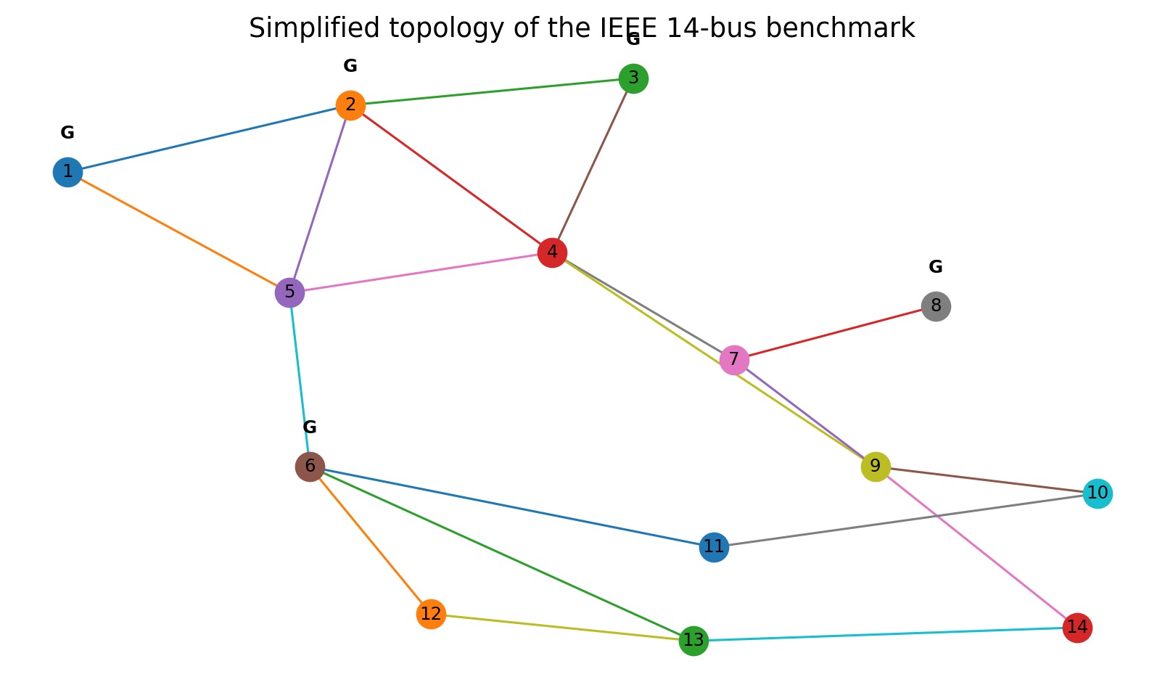
Figure 1. Simplified topology of the IEEE 14-bus benchmark. Generator buses are marked G.
Generator | Bus | Pmax (MW) | Qmin (MVAr) | Qmax (MVAr) | Cost function ($/h)
G1 | 1 | 332.4 | 0 | 10 | 0.0430293 P² + 20P
G2 | 2 | 140 | -40 | 50 | 0.25 P² + 20P
G3 | 3 | 100 | 0 | 40 | 0.01 P² + 40P
G4 | 6 | 100 | -6 | 24 | 0.01 P² + 40P
G5 | 8 | 100 | -6 | 24 | 0.01 P² + 40P
Table 1. Generator limits and quadratic cost data used in the study.

3.2 AC Optimal Power Flow Formulation
The OPF problem is represented by control variables u and dependent state variables x. The control vector contains the active-power set-points of the non-slack generators and the voltage set-points of the five generator buses. The slack-bus active power, generator reactive powers, load-bus voltage magnitudes and voltage angles are obtained from the AC power-flow solution. The optimisation problem is written as
min F(u,x) = Σᵢ Cᵢ(PGi) (1)
where Cᵢ(PGi) is the quadratic production-cost function of generator i. The nonlinear equality constraints are the nodal AC active- and reactive-power balance equations:
PGi − PDi = Vi Σⱼ Vj [Gij cos(δi−δj) + Bij sin(δi−δj)] (2)
QGi − QDi = Vi Σⱼ Vj [Gij sin(δi−δj) − Bij cos(δi−δj)] (3)
Operational inequality constraints include active-power limits, reactive-power limits and voltage-magnitude limits:
PGi,min ≤ PGi ≤ PGi,max (4)
QGi,min ≤ QGi ≤ QGi,max (5)
0.94 ≤ Vi ≤ 1.06 p.u. (6)
The canonical case14 file does not assign finite branch MVA ratings to the transmission branches. Consequently, this study does not invent artificial thermal limits. Branch apparent powers are computed for diagnostic purposes, while the explicitly enforced benchmark constraints are generator active power, generator reactive power and bus voltage. This treatment follows the meaning of zero branch ratings in the standard MATPOWER data format.

3.3 Particle Swarm Optimisation
For particle k at iteration t, the velocity and position updates follow the standard PSO equations
vₖ(t+1) = w vₖ(t) + c₁ r₁[pbestₖ − xₖ(t)] + c₂ r₂[gbest − xₖ(t)] (7)
xₖ(t+1) = xₖ(t) + vₖ(t+1) (8)
where w is the inertia weight, c₁ and c₂ are acceleration coefficients, r₁ and r₂ are independent random values on [0,1], pbest is the best position previously visited by a particle and gbest is the best feasible solution identified by the swarm. The inertia weight was reduced linearly from 0.9 to 0.4 over the search. The acceleration coefficients were set to 2.0. Velocity clipping was applied at 20% of each variable range to limit unstable jumps.

3.4 Constraint Handling and Fitness Evaluation
Each particle first defines non-slack active-power set-points and generator-bus voltage set-points. A full Newton-type AC power-flow calculation is then performed. If the power flow fails to converge, the particle receives a large infeasibility penalty. Otherwise, the slack-generator output, generator reactive powers and all bus voltages are calculated. Squared penalties are added for active-power, reactive-power and voltage violations. This approach preserves the physical AC equations rather than approximating network feasibility with a separate surrogate model.
Fitness = Fcost + λP Σ(ΔP)² + λQ Σ(ΔQ)² + λV Σ(ΔV)² (9)

3.5 Experimental Protocol
Parameter | Setting
Swarm size | 30 particles
Iterations | 100
Independent runs | 20
Inertia weight | 0.9 → 0.4
c₁, c₂ | 2.0, 2.0
Voltage bounds | 0.94–1.06 p.u.
Implementation | Single-process Python 3.13
Processor environment | AMD EPYC 9V74
Table 2. PSO and computational settings.
The reference operating condition was obtained by solving the AC power flow with the canonical case14 generator set-points. The PSO was then run 20 times with different random seeds. Performance measures included best, mean and worst cost, standard deviation, execution time, real-power loss, bus-voltage range and the relative optimality gap to the deterministic benchmark. The deterministic comparison value of approximately $8,081.526/h is the established case14 OPF optimum associated with the standard MATPOWER cost data.

4. Results

4.1 Reference Power-Flow Condition
The reference AC power flow produced a total generation cost of $8,172.000/h and a real-power transmission loss of 13.393 MW. The bus-voltage range was 1.010 to 1.090 p.u. The upper values at the generator buses therefore exceeded the 1.06 p.u. OPF limit, demonstrating that a converged power-flow solution is not automatically an admissible OPF solution.

4.2 PSO Convergence and Repeatability
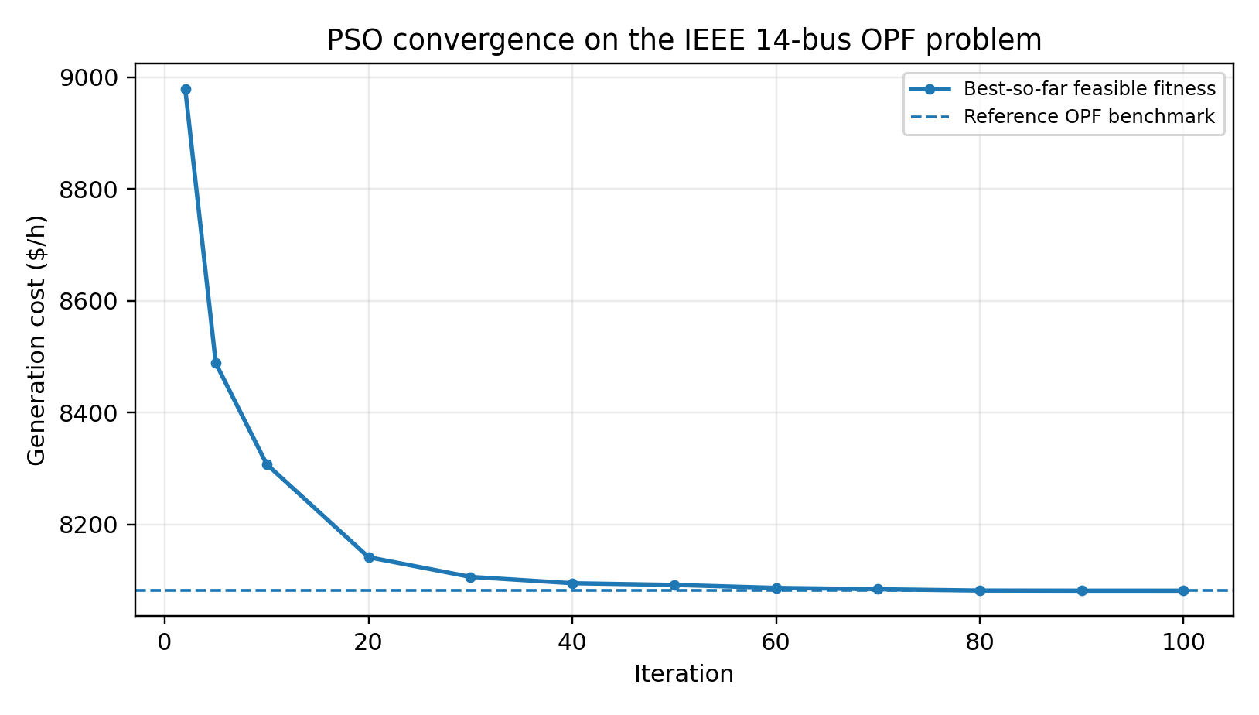
Figure 2. Best-so-far PSO objective after feasibility was established.
The best run showed rapid initial improvement followed by progressively finer exploitation. The best feasible cost decreased below $8,500/h within the early iterations, fell to approximately $8,106.18/h by iteration 30, and reached $8,081.55/h by iteration 90. The final improvement between iterations 90 and 100 was very small, indicating practical convergence.
Metric | Value
Best cost | $8,081.535/h
Mean cost | $8,085.218/h
Standard deviation | $9.014/h
Worst cost | $8,118.028/h
Mean runtime | 1.669 s
Runtime standard deviation | 0.034 s
Runs | 20
Table 3. Repeatability and execution-time statistics over 20 PSO runs.
The low median spread observed in most runs indicates stable performance near the optimum, although one poorer run increased the standard deviation. This result is important because a single best-run value alone would overstate robustness. In operational studies, reporting independent runs is therefore preferable to relying on one stochastic trajectory.

4.3 Optimal Generator Dispatch and Reactive-Power Feasibility
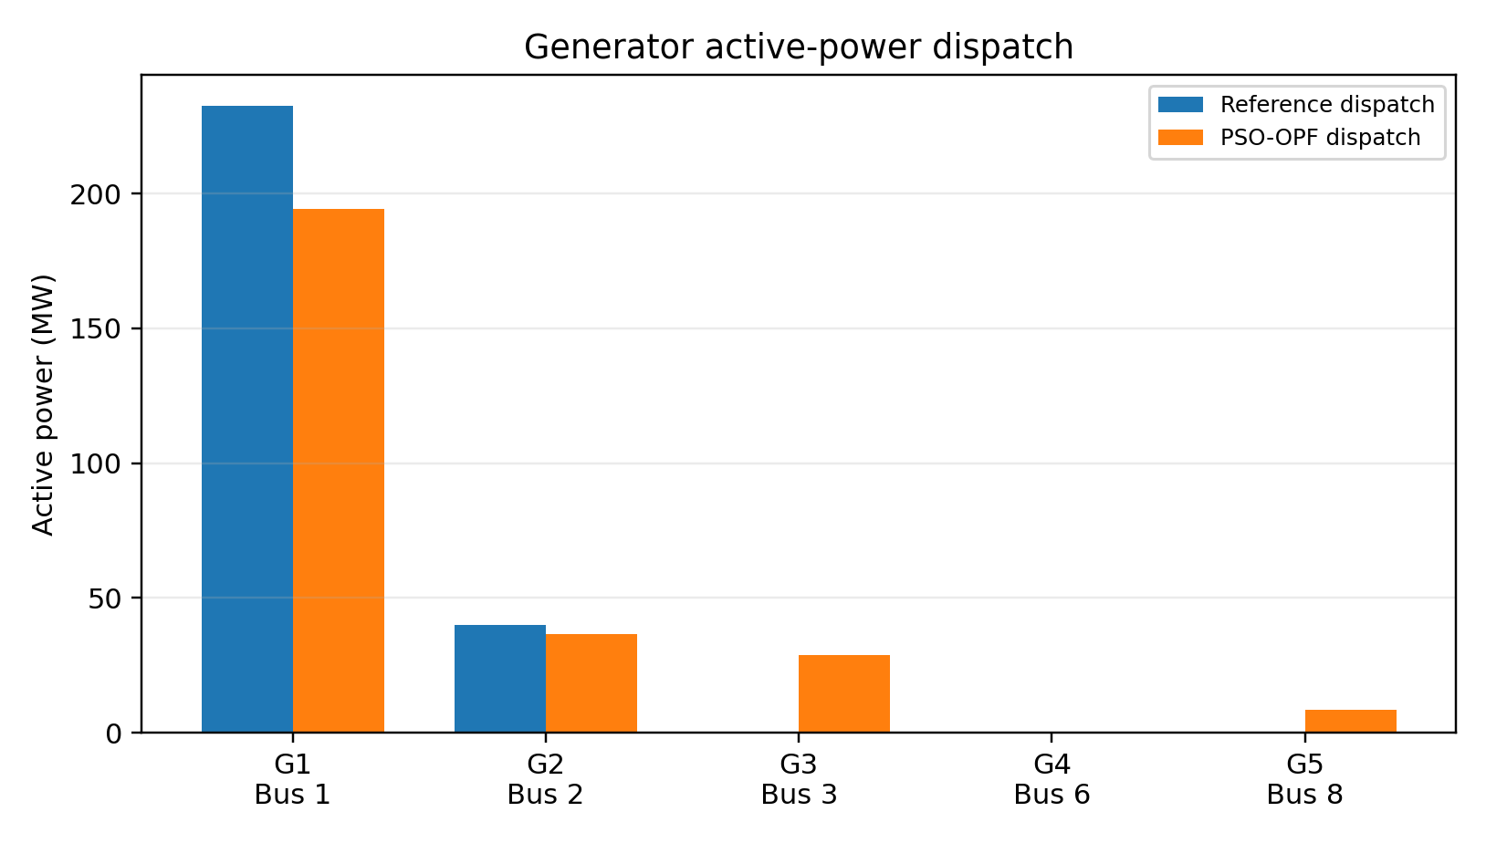
Figure 3. Active-power dispatch at the reference and PSO-optimised operating points.
Unit | Bus | Reference P (MW) | PSO P (MW) | PSO Q (MVAr)
G1 | 1 | 232.400 | 194.326 | 0.085
G2 | 2 | 40.000 | 36.686 | 23.217
G3 | 3 | 0.000 | 28.795 | 24.547
G4 | 6 | 0.000 | 0.000 | 11.518
G5 | 8 | 0.000 | 8.477 | 8.253
Table 4. Generator outputs at the best PSO solution.
The optimised dispatch reduced the loading of the slack generator and introduced economically justified real-power support from buses 3 and 8. Generator 6 remained at essentially zero real-power output but continued to provide reactive support. All reported reactive outputs were within their case limits. This is a physically important distinction: a generator can remain economically unloaded in MW while still contributing MVAr for voltage regulation.

4.4 Voltage Profile and Network Loss
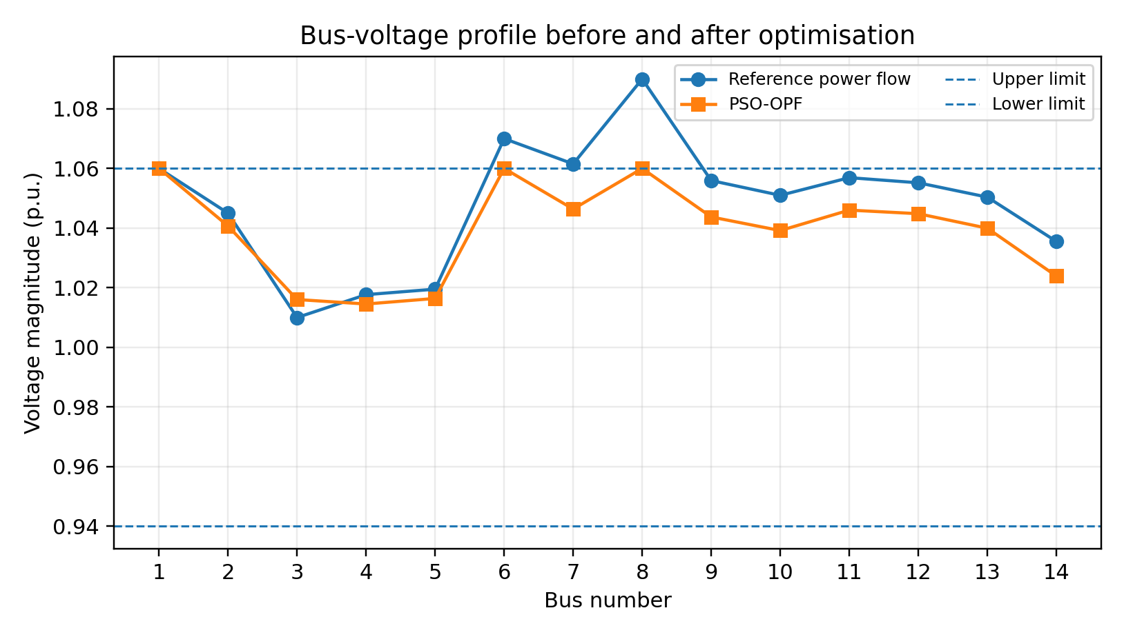
Figure 4. Voltage profile before and after PSO-based OPF.
After optimisation, the minimum and maximum bus voltages were 1.0145 and 1.0600 p.u., respectively, so all buses satisfied the adopted 0.94–1.06 p.u. range. Real-power loss decreased from 13.393 MW to 9.285 MW, a reduction of 30.67%. The loss reduction was not included as a separate weighted objective; it emerged from the economically improved and voltage-feasible power-flow pattern. This avoids introducing arbitrary multi-objective weighting factors into a study whose primary objective is generation cost.

4.5 Economic Performance and Benchmark Comparison
Performance measure | Reference / benchmark | PSO best | Change
Generation cost ($/h) | 8,172.000 | 8,081.535 | −1.107%
Real-power loss (MW) | 13.393 | 9.285 | −30.67%
Voltage range (p.u.) | 1.010–1.090 | 1.0145–1.0600 | Within limits
Deterministic OPF benchmark ($/h) | 8,081.526 | 8,081.535 | +0.000115%
Table 5. Summary of economic and technical performance.
The best PSO objective of $8,081.535/h is only 0.000115% above the approximately $8,081.526/h deterministic case14 benchmark. This small gap confirms that the swarm converged to a near-global solution rather than merely improving on the reference operating point. At the same time, the reduction in real-power loss and correction of voltage-limit violations show that the economic improvement did not arise by sacrificing basic network feasibility.

5. Discussion
The results support three main observations. First, formulation quality is at least as important as algorithm choice. The PSO did not optimise a stand-alone quadratic dispatch function; every candidate control vector was passed through an AC power-flow calculation, meaning that network losses, transformer effects, reactive-power requirements and voltage behaviour influenced the fitness. This is essential if an OPF study is to remain physically interpretable.
Second, PSO performed competitively on the small IEEE 14-bus case. A best objective within roughly one ten-thousandth of one percent of the deterministic benchmark demonstrates that population-based search can locate an excellent solution when the variables are correctly bounded and infeasibility is penalised. However, this does not imply that PSO is computationally superior to mature interior-point OPF solvers. For a smooth benchmark with well-defined derivatives, deterministic methods can be faster and provide stronger optimality guarantees. The practical advantage of PSO is flexibility, particularly when non-smooth costs, discrete controls or composite penalty terms are introduced [3], [4].
Third, stochastic robustness must be reported. Most of the 20 runs clustered close to the optimum, but the worst run was noticeably higher. This behaviour is consistent with the broader PSO literature, in which premature convergence can occur when population diversity decreases too quickly [5], [9]. Adaptive inertia, neighbourhood topologies, differential-evolution operators or local-search refinement are logical extensions when the network size or objective complexity increases.
The findings also clarify a limitation of the canonical IEEE 14-bus data. Branch ratings are not provided as finite thermal limits in the standard case file. A study that claims strict enforcement of line thermal limits on this benchmark must therefore state where those ratings came from. The present work deliberately avoids inventing such numbers. Future studies can adopt a modified case with documented branch ratings if thermal congestion is to be a formal inequality constraint.

6. Conclusion
This manuscript developed a constrained PSO framework for AC optimal power flow on the IEEE 14-bus test system. The method incorporated the nonlinear power-flow equations and enforced generator active-power, generator reactive-power and bus-voltage limits through a penalty-assisted feasibility procedure. Over 20 independent runs, the best PSO solution produced a generation cost of $8,081.535/h, compared with $8,172.000/h for the reference operating condition. Real-power losses declined from 13.393 MW to 9.285 MW, and all bus voltages were maintained within the 0.94–1.06 p.u. range. The best objective was within 0.000115% of the deterministic benchmark, demonstrating high solution quality. These results show that PSO is a credible and flexible OPF solver for small benchmark systems, although deterministic OPF remains the appropriate reference standard and larger-network testing is required before making claims about scalability.

7. Limitations and Future Work
The study is limited to a deterministic steady-state IEEE 14-bus model and a single economic objective. Renewable uncertainty, contingency security, discrete transformer tap optimisation, emission cost and finite branch thermal ratings were not included. Future work should test the same implementation on IEEE 30-, 57-, 118- and larger bus systems; compare PSO statistically with interior-point, differential-evolution and recent hybrid algorithms; incorporate N−1 security constraints; and evaluate multi-objective cost, loss, emissions and voltage-stability formulations. Reproducibility can also be strengthened by releasing the complete source code and random seeds used for all independent runs.
Declaration of AI Use

This manuscript was prepared through the combined contributions of all author(s), including contributions to the study design, data, content development, results, interpretation, and related scholarly work. The author(s) acknowledge the use of Grammarly and ChatGPT to assist with grammar checking, language refinement, reference formatting. These AI-assisted tools were not used as authors and did not replace the intellectual contributions or scholarly judgment of the author(s). All AI-assisted outputs, including content, references, and interpretations, were carefully reviewed, revised, verified, and approved by the author(s). The author(s) accept full responsibility for the accuracy, integrity, and final content of the manuscript.

References
[1] R. D. Zimmerman, C. E. Murillo-Sánchez, and R. J. Thomas, “MATPOWER: Steady-state operations, planning, and analysis tools for power systems research and education,” IEEE Transactions on Power Systems, vol. 26, no. 1, pp. 12–19, 2011. doi: 10.1109/TPWRS.2010.2051168.
[2] F. Capitanescu, “Critical review of recent advances and further developments needed in AC optimal power flow,” Electric Power Systems Research, vol. 136, pp. 57–68, 2016.
[3] A. M. Nassef, M. A. Abdelkareem, H. M. Maghrabie, and A. Baroutaji, “Review of metaheuristic optimization algorithms for power systems problems,” Sustainability, vol. 15, no. 12, Art. no. 9434, 2023. doi: 10.3390/su15129434.
[4] M. M. Farag, R. A. Alhamad, and A. B. Nassif, “Metaheuristic algorithms in optimal power flow analysis: A qualitative systematic review,” International Journal on Artificial Intelligence Tools, vol. 32, no. 7, Art. no. 2350032, 2023. doi: 10.1142/S021821302350032X.
[5] J. Kennedy and R. Eberhart, “Particle swarm optimization,” in Proceedings of ICNN’95 - International Conference on Neural Networks, Perth, Australia, 1995, pp. 1942–1948.
[6] M. A. Abido, “Optimal power flow using particle swarm optimization,” International Journal of Electrical Power & Energy Systems, vol. 24, no. 7, pp. 563–571, 2002. doi: 10.1016/S0142-0615(01)00067-9.
[7] K. Aurangzeb, S. Shafiq, M. Alhussein, Pamir, N. Javaid, and M. Imran, “An effective solution to the optimal power flow problem using meta-heuristic algorithms,” Frontiers in Energy Research, vol. 11, Art. no. 1170570, 2023. doi: 10.3389/fenrg.2023.1170570.
[8] H. Bakır, H. T. Kahraman, S. Yılmaz, S. Duman, and U. Güvenç, “Dynamic switched crowding-based multi-objective particle swarm optimization algorithm for solving multi-objective AC-DC optimal power flow problem,” Applied Soft Computing, vol. 166, Art. no. 112155, 2024. doi: 10.1016/j.asoc.2024.112155.
[9] W. Bai, F. Meng, M. Sun, H. Qin, R. Allmendinger, and K. Y. Lee, “Differential evolutionary particle swarm optimization with orthogonal learning for wind integrated optimal power flow,” Applied Soft Computing, vol. 160, Art. no. 111662, 2024. doi: 10.1016/j.asoc.2024.111662.
[10] A. G. Gad, “Particle swarm optimization algorithm and its applications: A systematic review,” Archives of Computational Methods in Engineering, vol. 29, pp. 2531–2561, 2022. doi: 10.1007/s11831-021-09694-4.

