Comparative Statistical Characterization of Normal and Millisecond Pulsars from the ATNF Pulsar Catalogue

Abstract
This study presents a comparative statistical analysis of 2,891 normal pulsars (NPs) and 550 millisecond pulsars (MPs) using data from the ATNF Pulsar Catalogue. Twenty rotational, spatial, and derived parameters were analysed using descriptive statistics, distribution analysis, skewness, kurtosis, and Pearson correlation coefficients. The results reveal stark population contrasts. MPs exhibit median periods of 3.87 ms compared to 0.61 s for NPs, with corresponding frequencies of 258 Hz versus 1.63 Hz. The period derivative differs by five orders of magnitude (1.12×10⁻²⁰ for MPs versus 1.96×10⁻¹⁵ for NPs), confirming the exceptional rotational stability of recycled pulsars. Surface magnetic fields show median values of 2.17×10⁸ G for MPs and 1.10×10¹² G for NPs, while characteristic ages differ substantially (4.94×10⁹ yr versus 6.00×10⁶ yr). Spatial distributions indicate MPs are slightly farther from the Galactic plane (median Z = 0.05 kpc) than NPs (Z = 0.01 kpc), consistent with their older ages and prolonged dynamical evolution. Distribution analysis reveals MP parameters are highly skewed and leptokurtic, reflecting a homogeneous population clustered around narrow parameter ranges, whereas NPs exhibit broader, more symmetric distributions. Correlation analysis demonstrates generally weak relationships between period and most parameters, with the strongest physically meaningful correlation occurring between period and surface magnetic field in MPs (r = 0.53). The inverse relationship between period and frequency (r = -0.78 for MPs) reflects their inherent mathematical dependence. These findings quantitatively confirm that normal and millisecond pulsars constitute statistically distinct populations with contrasting rotational, magnetic, energetic, and spatial properties, providing strong empirical support for the standard pulsar recycling model and contributing to broader understanding of neutron-star evolution.
Keywords: Millisecond pulsars; Normal pulsars; ATNF Pulsar Catalogue; Neutron star evolution; Statistical analysis
1. INTRODUCTION
Pulsars are rapidly rotating, highly magnetized neutron stars formed during the gravitational collapse of massive stars following core-collapse supernovae. Since their discovery by Hewish et al. (1968), pulsars have become fundamental astrophysical laboratories for investigating matter at supranuclear densities, strong magnetic fields, relativistic plasma physics, and gravitational phenomena (Hewish et al., 1968; Lorimer & Kramer, 2005). Their highly stable periodic emission, observed from radio wavelengths to X-rays and gamma rays, has enabled precise studies of neutron star interiors, the interstellar medium, tests of general relativity, and the detection of nanohertz gravitational waves through pulsar timing arrays (Lorimer & Kramer, 2005; Kramer et al., 2006; Hobbs et al., 2010).

Pulsed emission arises because the magnetic axis of a neutron star is generally inclined to its rotational axis. As the star rotates, beams of electromagnetic radiation sweep across the sky, producing periodic pulses whenever the emission beam intersects the observer's line of sight (Lyne & Graham-Smith, 2012). Pulsars typically contain about 1.4 solar masses compressed into radii of approximately 10–15 km, possess surface magnetic fields ranging from about 10⁸ to 10¹³ G, and exhibit rotation periods spanning milliseconds to several seconds (Lorimer & Kramer, 2005). These extreme physical conditions make pulsars ideal natural laboratories for studying dense matter, relativistic electrodynamics, and stellar evolution.

Based on their rotational and evolutionary characteristics, pulsars are broadly classified as normal pulsars (NPs) and millisecond pulsars (MPs). Normal pulsars generally have rotation periods between approximately 0.1 s and several seconds, strong magnetic fields (10¹¹–10¹³ G), and relatively young characteristic ages. Their rotational energy gradually decreases through magnetic dipole braking, producing measurable spin-down over time (Lyne & Graham-Smith, 2012). In contrast, millisecond pulsars rotate with periods typically shorter than 30 ms and possess comparatively weak magnetic fields (10⁸–10¹⁰ G). They are widely believed to have formed through the recycling process, in which prolonged accretion of mass and angular momentum from a binary companion spins the neutron star up to very high rotational frequencies while substantially reducing its surface magnetic field (Alpar et al., 1982; Bhattacharya & van den Heuvel, 1991). As a result, millisecond pulsars are among the most stable natural clocks known and are indispensable for precision timing experiments and gravitational-wave detection.

The contrasting evolutionary pathways of NPs and MPs produce distinct observational characteristics. Normal pulsars generally exhibit stronger magnetic braking, larger period derivatives, higher magnetic fields, and characteristic ages ranging from thousands to millions of years. Conversely, millisecond pulsars possess extremely small period derivatives, exceptional rotational stability, weaker magnetic fields, and characteristic ages extending to several billion years (Bhattacharya & van den Heuvel, 1991; Lyne & Graham-Smith, 2012). These differences provide valuable insight into neutron star formation, magnetic field evolution, spin-down mechanisms, and binary stellar evolution.

The rapid growth of pulsar surveys over the past two decades has transformed pulsar astronomy from studies of individual objects to investigations of entire pulsar populations. Central to this development is the Australia Telescope National Facility (ATNF) Pulsar Catalogue, which provides one of the most comprehensive compilations of pulsar observational and derived parameters, including spin period, period derivative, dispersion measure, magnetic field strength, characteristic age, spin-down luminosity, luminosity, binary properties, and Galactic position (Manchester et al., 2005). The availability of such extensive datasets enables large-scale statistical investigations capable of revealing systematic trends and population characteristics that cannot be identified from individual pulsars alone.

Previous studies have primarily focused on specific aspects of pulsar physics, including magnetic field evolution, pulsar timing, binary interactions, emission mechanisms, spin evolution, and tests of relativistic gravity (Bhattacharya & van den Heuvel, 1991; Kramer et al., 2006; Tauris & van den Heuvel, 2006; Lorimer, 2008). Although these investigations have substantially advanced our understanding of neutron-star physics, relatively few studies have undertaken a comprehensive statistical comparison of the principal observational and derived parameters of normal and millisecond pulsars using a single, homogeneous database and a consistent statistical framework. Consequently, important differences in the statistical behaviour, distribution, and interrelationships of key pulsar parameters remain insufficiently quantified.

Comparative statistical analyses provide an objective means of identifying similarities and differences between pulsar populations. Descriptive statistics, distribution analysis, skewness, kurtosis, and correlation analysis enable the characterization of parameter distributions, the identification of systematic trends, and the evaluation of relationships among physical quantities. Such analyses improve our understanding of pulsar demographics and provide observational constraints on models of neutron-star evolution, magnetic field decay, rotational evolution, and binary recycling (Lorimer, 2008; Tauris & van den Heuvel, 2006).

This study addresses the existing gap by conducting a comprehensive statistical comparison of twenty observational and derived parameters of normal and millisecond pulsars using data obtained from the ATNF Pulsar Catalogue. Specifically, the study aims to (i) compare the physical characteristics of normal and millisecond pulsars, (ii) characterize the statistical distributions of the selected parameters using descriptive statistics, skewness, and kurtosis, (iii) investigate relationships between rotational period and selected physical parameters through correlation analysis, and (iv) interpret the observed differences within the framework of pulsar evolution. The results provide quantitative evidence of the similarities and differences between the two pulsar populations and contribute to a broader understanding of neutron-star evolution, magnetic field evolution, and the long-term effects of binary recycling.

2. Method of Data Analysis
The data used in this study were obtained from the Australia Telescope National Facility (ATNF) Pulsar Catalogue, which provides comprehensive measurements of pulsar physical and observational properties, and the Jodrell Bank Glitch Catalogue, which contains records of pulsar rotational glitches (Manchester et al., 2005; Basu et al., 2022). The dataset consists of 3,441 pulsars, comprising 2,891 normal pulsars (NPs) and 550 millisecond pulsars (MPs). Pulsars were classified according to their rotational periods and evolutionary characteristics, with NPs representing young, strongly magnetized neutron stars and MPs representing recycled neutron stars spun up through binary accretion. Additional classifications describing emission properties and neutron star subtypes were retained where available to provide a broader characterization of the pulsar populations.
A total of 20 physical and derived parameters were analyzed. These include rotational and timing parameters (spin period, period derivative, rotation frequency, frequency derivative, dispersion measure, and rotation measure); Galactic position and distance parameters (distance, YMW16 distance estimate, Galactic coordinates, and height above the Galactic plane); derived physical quantities (radio luminosity, characteristic age, surface magnetic field, spin-down luminosity, energy flux, proper motion, transverse velocity, Shklovskii-corrected period derivative and age, and magnetic field at the light cylinder); and the number of observed glitches, which provides information on sudden rotational irregularities associated with neutron star interior dynamics.
Distances were estimated using the YMW16 Galactic electron-density model, which converts dispersion measures into pulsar distances by modelling the distribution of free electrons throughout the Milky Way (Yao et al., 2017). Compared with earlier models, YMW16 incorporates updated Galactic structures and electron-density distributions, thereby providing improved distance estimates essential for determining intrinsic pulsar properties, spatial distributions, and timing corrections.
The statistical analysis comprised descriptive, distributional, and inferential techniques to compare the physical characteristics of normal and millisecond pulsars. Histograms were used to visualize parameter distributions, identify outliers, assess variability, and evaluate departures from normality. Distributional characteristics were further quantified using skewness and kurtosis, which measure distribution asymmetry and peakedness, respectively. Positive or negative skewness indicates the direction of asymmetry, while kurtosis describes whether a distribution is more peaked or flatter than a normal distribution (Westfall et al., 2014).
Relationships among pulsar parameters were investigated using Pearson's product-moment correlation analysis, which quantifies the strength and direction of linear associations between variables (Fisher, 1915). Correlation coefficients were interpreted according to standard statistical conventions to distinguish weak, moderate, and strong positive or negative relationships. In addition, linear regression analysis was performed to model the dependence of selected parameters and to determine the best-fit relationships between variables. Regression equations, slopes, intercepts, and associated uncertainties were used to evaluate trends and provide quantitative insight into the physical relationships governing pulsar evolution. Collectively, these statistical techniques provide a robust framework for identifying similarities and differences between normal and millisecond pulsars and for investigating the underlying physical processes responsible for their observed characteristics.

3. RESULTS AND DISCUSSIONS
We present the average values of the studied parameters (mean with the standard error, median, and values for NPs and MPs. They are given in Table 1

Table 1. Estimated Average Values (Median and Mean with Average Deviation) of Pulsar Parameters
 | Parameter | Median | Median | Mean | Mean
 |  | NP | MP | NP | MP
1 | P (Period) (s) | 0.61 | 3.87E-03 | 0.99±0.74 | 4.44±1.70E-03
2 | $\dot{P}$(Period Derivative) | 1.96E-15 | 1.12E-20 | 4.60±8.79E-13 | 3.23±7.34E-20
3 | F Frequency (Hz) | 1.63 | 2.58E+2 | 3.53±3.32 | 2.80±1.01E+2
4 | $\dot{F}$ (s⁻²) | -3.17E-15 | -6.47E-16 | -9.17±16.51E-12 | -2.45±4.29E-15
5 | DM (Dispersion Measure) (cm⁻³pc) | 1.59E+2 | 51.93 | 2.27±1.66E+2 | 85.47±67.78
6 | RM (Rotation Measure) (rad m⁻²) | 9.15 | 8.91 | -1.59±2.5E+2 | 28.82±66.12
7 | DIST (YMW16 DM) (kpc) | 4.57 | 4.09 | 6.31±4.17 | 4.90±3.17
8 | ${DIST}_{DM}$ (Distance based on the YMW16 electron density model) (kpc) | 4.62 | 3.04 | 6.40±4.23 | 4.48±3.19
9 | ZZ (Distance from the Galactic plane) (kpc) | 0.01 | 0.05 | -0.28±1.27 | 0.25±1.52
10 | XX (X-Distance in X-Y-Z Galactic coordinate system ) (kpc) | 0.68 | 0.44 | 0.56±3.53 | 0.75±2.05
11 | YY (Y-Distance in X-Y-Z Galactic coordinate system ) (kpc) | 5.15 | 6.62 | 4.84±3.02 | 6.10±2.45
12 | $R_{LUM14}$ (Radio luminosity at 1400 MHz) (mJy kpc²) | 8.55 | 1.45 | 4.43±5.73E+01 | 2.16±3.59E+01
13 | AGE (Spin down age) (yr) | 6.00E+06 | 4.94E+09 | 2.29±3.82E+08 | 1.33±1.51E+10
14 | $B_{SURF}$ (Spin down age) (G) | 1.10E+12 | 2.17E+08 | 5.72±7.98E+12 | 3.50±2.44E+08
15 | $\dot{E}$ (Spin down energy loss rate) (ergs/s) | 2.30E+32 | 8.75E+33 | 0.77±1.46E+36 | 4.80±6.07E+34
16 | $\ddot{E}$ (Energy flux at the Sun) (ergs/kpc²/s) | 1.30E+31 | 2.85E+33 | 1.13±2.17E+35 | 1.30±1.63E+34
17 | PMTOT (Total proper motion) (mas/yr) | 1.73E-15 | 2.24E-21 | 2.16±4.19E-12 | 1.79±7.30E-20
18 | $V_{TRANS}$ (Transverse velocity - based on DIST) (km/s) | 5.65E+06 | 8.29E+09 | 2.61±4.60E+09 | 4.80±6.54E+10
19 | ${\dot{P}}_{i}$(Period derivative corrected for Shklovskii) | 17.11 | 6.1 | 30.11±24.41 | 10.83±7.59
20 | ${AGE}_{i}$ (Spin down age from TRANS) (yr) | 204.29 | 129.07 | 2.97.±2.15E+2 | 1.92±1.25E+2
21 | $B_{LC}$ (Magnetic field at light cylinder) (G) | 387.11 | 3.84E+4 | 3.69±6.54E+3 | 7.78±6.86E+4

Table 1 presents the median and mean values (± average deviation) of the selected physical parameters for normal pulsars (NPs) and millisecond pulsars (MPs). Because several parameters exhibit large dispersions, as reflected by the substantial deviations in the mean values, the median values provide a more robust measure of central tendency and are therefore used for comparison.
The most striking distinction between the two pulsar populations is their rotational properties. Normal pulsars have a median spin period of 0.61 s, whereas millisecond pulsars have a median period of 3.87 × 10⁻³ s, confirming that MPs rotate approximately two orders of magnitude faster than NPs. Correspondingly, the median spin frequency (F0) of MPs (258 Hz) is about 160 times higher than that of NPs (1.63 Hz). Furthermore, the median period derivative (P1) of NPs (1.96 × 10⁻¹⁵) exceeds that of MPs (1.12 × 10⁻²⁰) by approximately five orders of magnitude, while the magnitude of the frequency derivative (F1) is also considerably larger for NPs. These findings demonstrate that normal pulsars lose rotational energy much more rapidly than millisecond pulsars, whereas the extremely small spin-down rates of MPs reflect their exceptional rotational stability after recycling through binary accretion. These results are consistent with previous studies that identify millisecond pulsars as highly stable astrophysical clocks suitable for precision timing experiments (Mingarelli et al., 2020; Cognard et al., 2021; Kramer et al., 2021; Maan & Desai, 2023; Liu et al., 2023).
The interstellar propagation parameters also exhibit notable differences. The median dispersion measure (DM) of NPs (159 cm⁻³ pc) is approximately three times greater than that of MPs (51.93 cm⁻³ pc), suggesting that, on average, normal pulsars are observed through denser columns of free electrons in the interstellar medium. In contrast, the median rotation measures (RM) are nearly identical for both populations (9.15 and 8.91 rad m⁻²), implying comparable average magnetic field contributions along the line of sight despite differences in electron density. The median distances estimated using the YMW16 model indicate that both populations occupy similar Galactic distances, although NPs are, on average, slightly farther from the Sun than MPs. Likewise, both populations are concentrated near the Galactic plane, but MPs exhibit a somewhat larger median vertical distance.

Skewness and Kurtosis of Normal and Millisecond Pulsars
The dichotomy between NPs and MPs represents a cornerstone of neutron star evolution. NPs are young (characteristic ages $τ∼{10}^{4}-{10}^{7}$ yr), born in supernovae with high magnetic fields ($B∼{10}^{12}$ G) and slow rotation ($P∼0.1-10$ s). In stark contrast, MPs are ancient, recycled objects spun up to millisecond periods ($P∼1-30$ ms) via mass accretion from a binary companion - a process that buries their magnetic fields ($B∼{10}^{8}-10^{9}$ G) and results in exceptionally low period derivatives (Alpar et al., 1982; Bhattacharya & van den Heuvel, 1991).
To quantify the morphological differences between these populations, we employ skewness and kurtosis The statistics in Table 2 (computed on logarithmic scales) provide a powerful lens into their underlying physical mechanisms.

Table 2: The Value of the Skewness and Kurtosis of the Distribution of the Studied Parameters of the MPs and the NPs
 | Parameter | NP | MP | NP | MP
 |  | skewness | skewness | kurtosis | kurtosis
1 | P (Period) (s) | -0.48 | 2.63 | 0.94 | 25.76
2 | $\dot{P}$(Period Derivative) | -0.63 | 1.42 | 2.20 | 17.96
3 | F Frequency (Hz) | 0.48 | -1.96 | 0.94 | 1.63
4 | $\dot{F}$ (s⁻²) | 0.61 | 8.49 | 0.36 | 12.18
5 | DM (Dispersion Measure) (cm⁻³pc) | -0.51 | -0.70 | -0.10 | 0.44
6 | RM (Rotation Measure) (rad m⁻²) | -0.39 | -0.84 | 1.23 | 1.21
7 | DIST (YMW16 DM) (kpc) | -0.56 | -0.55 | 1.30 | 0.40
8 | ${DIST}_{DM}$ (Distance based on the YMW16 electron density model) (kpc) | -0.51 | -0.15 | 1.30 | 0.77
9 | ZZ (Distance from the Galactic plane) (kpc) | 0.14 | -0.06 | 0.50 | -0.31
10 | XX (X-Distance in X-Y-Z Galactic coordinate system ) (kpc) | -1.01 | -1.03 | 2.17 | 2.57
11 | YY (Y-Distance in X-Y-Z Galactic coordinate system ) (kpc) | -2.42 | -2.14 | 10.02 | 5.76
12 | $R_{LUM14}$ (Radio luminosity at 1400 MHz) (mJy kpc²) | -0.36 | 0.55 | 0.59 | 3.67
13 | AGE (Spin down age $τ$) (yr) | -0.07 | -4.70 | 0.57 | 5.27
14 | $B_{SURF}$ (Spin down age) (G) | -0.88 | -8.59 | 3.86 | 12.15
15 | $\dot{E}$ (Spin down energy loss rate) (ergs/s) | 0.75 | -13.89 | 0.72 | 22.47
16 | $\ddot{E}$ (Energy flux at the Sun) (ergs/kpc²/s) | 0.63 | -11.83 | 0.54 | 17.85
17 | ${PM}_{TOT}$ (Total proper motion) (mas/yr) | -0.79 | 9.42 | 0.80 | 13.85
18 | $V_{TRANS}$ (Transverse velocity - based on DIST) (km/s) | 0.33 | 18.78 | 0.45 | 35.29
19 | ${\dot{P}}_{i}$(Period derivative corrected for Shklovskii) | -0.03 | 0.45 | 0.28 | 2.39
20 | ${AGE}_{i}$ ( $τ_{i}$Spin down age from TRANS) (yr) | -0.54 | -0.20 | 0.82 | 5.83
21 | $B_{LC}$ (Magnetic field at light cylinder) (G) | 0.59 | -1.27 | 0.56 | 8.07

Rotational Parameters (P, F, $\dot{P}$, $\dot{F}$​)
The rotational period (P) distributions are fundamentally distinct. NPs exhibit a mild negative skew (-0.48) and low kurtosis (0.94), indicating a relatively broad continuum of spin periods with a slight surplus of faster rotators. MPs, however, display a strong positive skew (2.63) and extreme kurtosis (25.76). This signifies that the vast majority of MPs are incredibly tightly clustered at very short periods (~2–5 ms), but a long tail stretches towards slower periods (e.g., 30–50 ms). This ultra-peaked distribution is a direct consequence of the narrow spin-period range imposed by the recycling process (Lorimer & Kramer, 2005), whereas the broader NP distribution reflects continuous magnetic braking over diverse lifetimes. The frequency (F​) mirrors this exactly: NP is mildly right-skewed (0.48), while MP is strongly left-skewed (-1.96), confirming the bulk of MPs reside at the high-frequency extreme.
For the period derivative ($\dot{P}$​) and frequency derivative ($\dot{F}$​), NPs show moderate negative skew (-0.63 and 0.61, respectively), pointing to a tail of intrinsically weaker-field or older objects. MPs are characterized by extreme positive skewness (1.42 for $\dot{P}$​; 8.49 for $\dot{F}$​) and massive kurtosis (~18 and ~12). While most MSPs possess extraordinarily tiny spin-down rates, this heavy right tail pinpoints a distinct subclass of outliers with unusually high P˙P˙. These are typically "spider" pulsars (black widows/redbacks) subject to intense orbital acceleration, or systems with slightly higher-than-average buried fields, demonstrating that kinematic and intrinsic variability uniquely distort the MP rotational distribution.

Magnetic Fields and Spin-Down Energy ($B_{SURF}$,$B_{LC}$ ,$\dot{ E}$​)
The surface magnetic field ($B_{SURF}$​) exhibits the starkest contrast. NPs are negatively skewed (-0.88)—a tail toward older, weaker-field objects. MPs, however, show a catastrophic negative skew (-8.59) with massive kurtosis (12.15). The MP magnetic field is incredibly concentrated at the ultra-low end ($\sim {10}^{8}$ G). The long-left tail extends toward higher values (e.g., $\sim {10}^{10}$ G), representing incompletely recycled pulsars. Because the core is so sharp, even a few of these high-field interlopers become extreme statistical outliers, dragging the mean field higher than the median. The light-cylinder field ($B_{LC}$​) reverses this: NP is mildly positive (0.59), while MP is negative (-1.27), as their extreme spin rates push the light cylinder outward, creating a tail of MPs with exceptionally low BLCBLC​.
The spin-down energy loss ($\dot{E}$​) is pivotal. NPs are right-skewed (0.75), dominated by a high-energy tail of extremely energetic young pulsars (e.g., the Crab). MPs are extremely left-skewed (-13.89) with staggering kurtosis (22.47). Physically, most MSPs spin fast, giving them a core of relatively high $\dot{E}$ ($\sim {10}^{34}$ erg/s). However, a long, thin tail of elderly, dying MSPs—slowly spinning, low-$\dot{P}$ systems—populates the extreme left tail, pulling the mean $\dot{E}$ far below the median. This perfectly distinguishes the populations: NP has a bright high-energy tail; MP has a dim, low-energy dying tail.

Aging and Kinematics (AGE, ${PM}_{TOT},V_{TRANS​}$)
Characteristic age ($τ$) for NPs is virtually symmetric (-0.07), reflecting a smooth, steady decline in population numbers over time. MPs are massively left-skewed (-4.70). The bulk of MSPs cluster at extraordinarily ancient ages $(\sim {10}^{9}-{10}^{10}$ yr), while the left tail consists of younger recycled pulsars ($\sim {10}^{8}$ yr) that have just recently ceased accretion. The extreme kurtosis indicates a sharp cutoff at the high-age end, with rare younger interlopers.
The kinematic parameters—Total Proper Motion (${PM}_{TOT}$) and Transverse Velocity ($V_{TRANS​}$)—show the most dramatic divergence. NPs have mild negative skew (-0.79) and near-symmetric velocity distributions (0.33). MPs possess absurdly positive skewness (9.42 for ${PM}_{TOT}$, 18.78 for $V_{TRANS​}$) and extreme kurtosis (~14 and ~35). While most MPs have moderate transverse motions, a rare but significant hyper-velocity tail (>500>500 km/s) emerges. These result from asymmetric supernova kicks that disrupted their binary progenitors or from asymmetric companion evaporation (Lyne & Graham-Smith, 2012). This extreme right-tail reveals that MPs are dynamically hotter and have undergone a far more violent kinematic history than the relatively quiescent, Gaussian-like velocity distribution of NPs.

Luminosity and Propagation ($R_{LUM14}$, RM)
Radio luminosity ($R_{LUM14}$​) differs noticeably: NPs are mildly left-skewed (-0.36), implying a slight surplus of high-luminosity objects. MPs are positively skewed (0.55) with high kurtosis (3.67), indicating a sharp core of intrinsically faint objects punctuated by a distinct tail of extremely bright MSPs (often spider pulsars with high spin-down power efficiently converted to radio emission). The Rotation Measure (RM) is negatively skewed for both, but more so for MPs (-0.84 vs -0.39). While most lines-of-sight yield low RM, the MP population—owing to larger average distances—encounters more extreme magnetized regions, widening the negative tail.

The Corrected Intrinsic Parameters ($P_{i}, τ_{i}$)
Correcting for the Shklovskii effect (kinematic acceleration) and Galactic acceleration fundamentally alters the interpretation. For NPs, the $P_{i}$ skewness is nearly zero (-0.03), confirming their measured$\dot{ P}$is intrinsically genuine. For MPs, raw $P_{i}$ skewness drops from 1.42 to 0.45—the high skewness is partially driven by kinematic biases, but a positive skew persists, confirming some MSPs genuinely possess higher intrinsic spin-down rates due to their physics.
Most remarkably, the extreme left-skewness of raw MP AGE (-4.70) moderates dramatically to -0.20 for $τ_{i}$​. This is may indicate that the apparent young MSP tail in the characteristic age is almost entirely an artifact of kinematic acceleration. Once corrected, the intrinsic age distribution of MSPs becomes nearly symmetric and log-normal, proving that the recycling process produces an extremely homogeneous population of uniformly ancient objects, as predicted by binary evolution models (Bhattacharya & van den Heuvel, 1991).

In conclusion, synthesizing these statistical signatures paints a crystal-clear evolutionary contrast:
- NP represent a stochastic, short-lived, disk-bound population. Their distributions are moderate, with small tails. They follow simple, steady-state evolution where magnetic fields decay and periods increase, yielding smooth, near-Gaussian (or moderate-skew) log-distributions. Their high kurtosis in YY confirms they are dynamically tied to the thin Galactic disk.
- MP represent a recycled, highly evolved, and outlier-dominated population. Their distributions are defined by extreme kurtosis and polarizing skewness. They feature an incredibly tight core (ultra-fast spins, ultra-low B-fields, ultra-old ages) punctuated by rare but physically critical outlier classes:
  - The high-B tail (left skew in $B_{SURF}$​, right skew in $\dot{P}$): MPs that failed to fully recycle.
  - The hyper-velocity tail (extreme right skew in ${PM}_{TOT }$and $V_{TRANS}$​): disruptors from binary-supernova kicks.
  - The low-$\dot{E}$ tail (left skew in $E$): dying, slow-recycled pulsars at the end of their evolutionary life.
Ultimately, the extreme kurtosis in MP parameters (often >10) is a definitive statistical fingerprint of a population shaped by discrete, rare, and energetic events—accretion cessation, asymmetric kicks, and binary evaporation. This contrasts starkly with the smooth, continuous aging of NPs, unifying their observed statistical distributions with the underlying astrophysical theory of neutron star recycling.

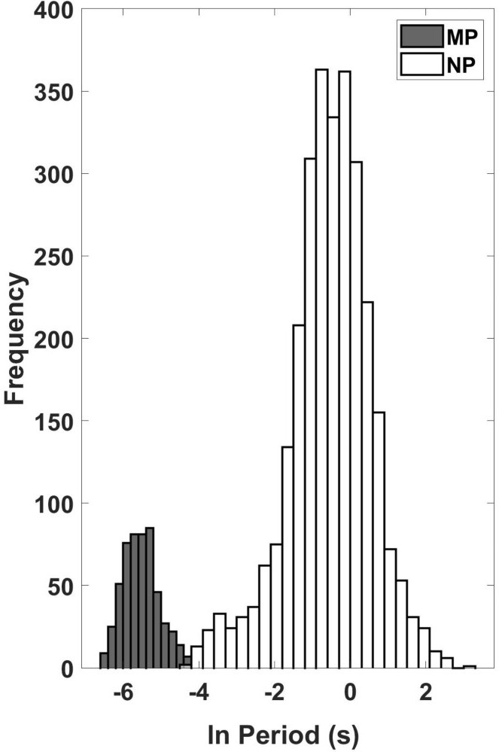
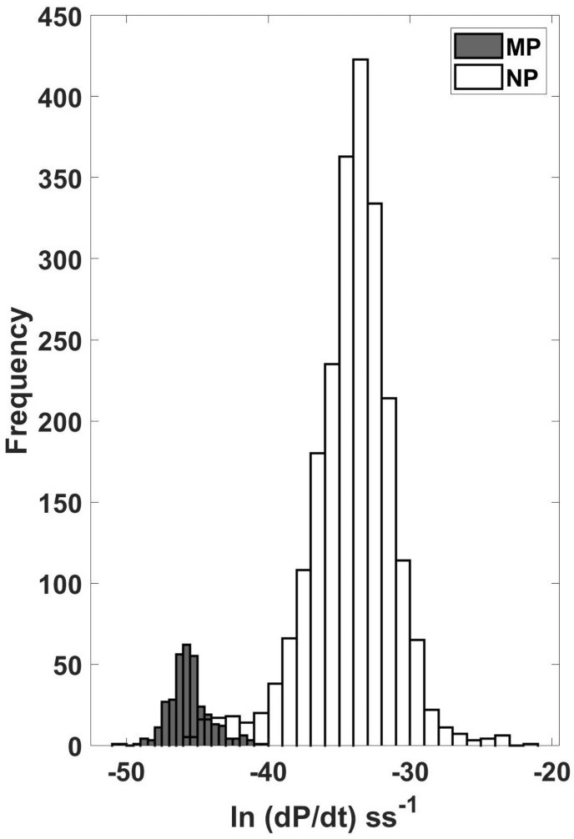

Figure 1. The Distribution Plot of the Natural Logarithm of Values Rotational Period (s) and First-Time Derivative of Period (ss-1) of NPs and MPs .

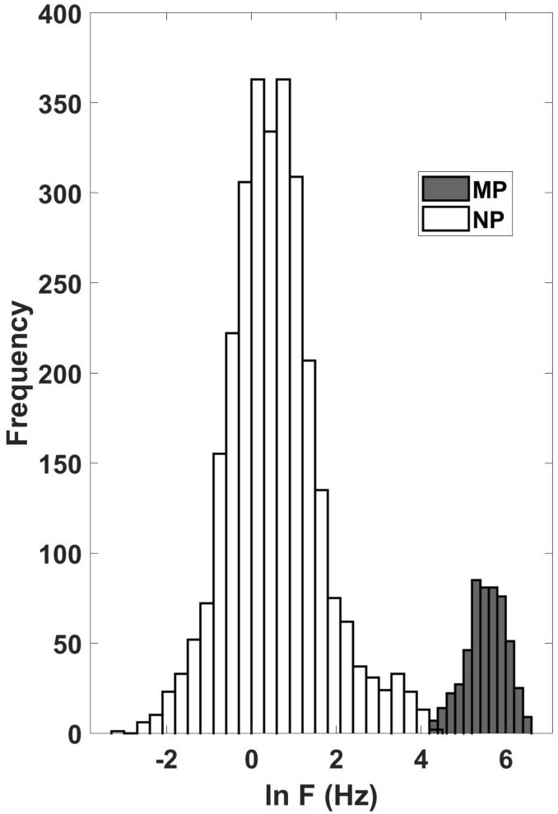
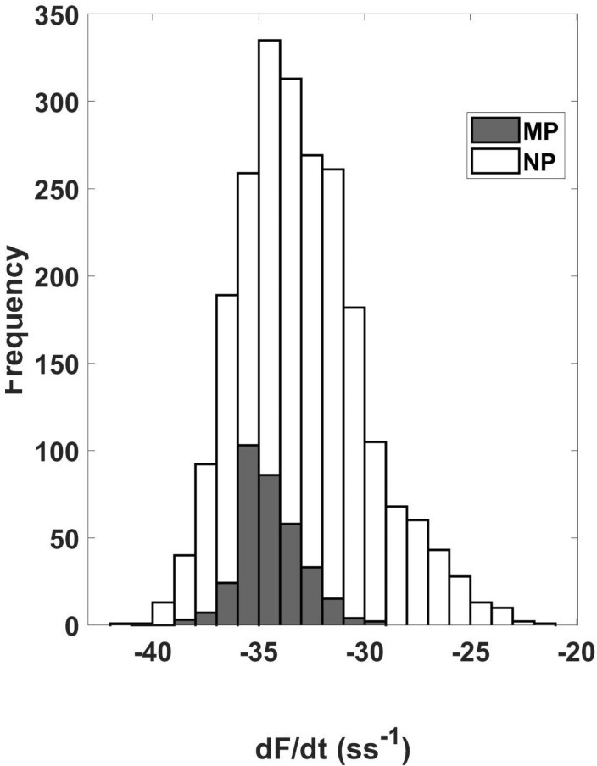

Fist-Time Derivative Frequency of Rotation (ss-1)

Figure 2: The Distribution Plot of the Natural Logarithm of Values of Rotation Frequency (Hz) of and First-Time Derivative Frequency of Rotation (s-2) of NPs and MPs.
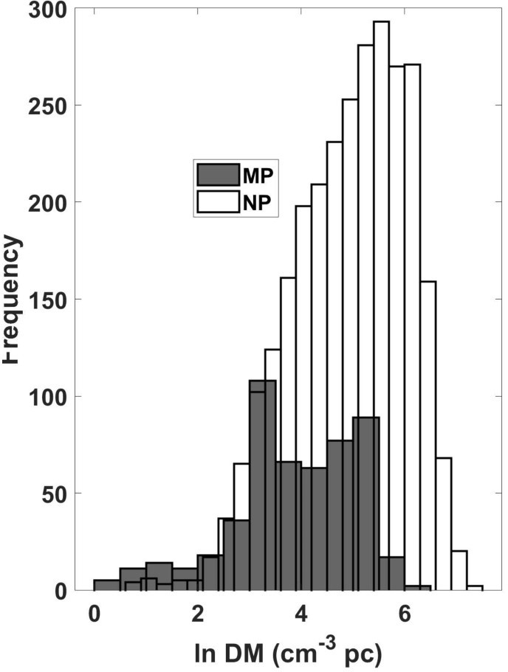
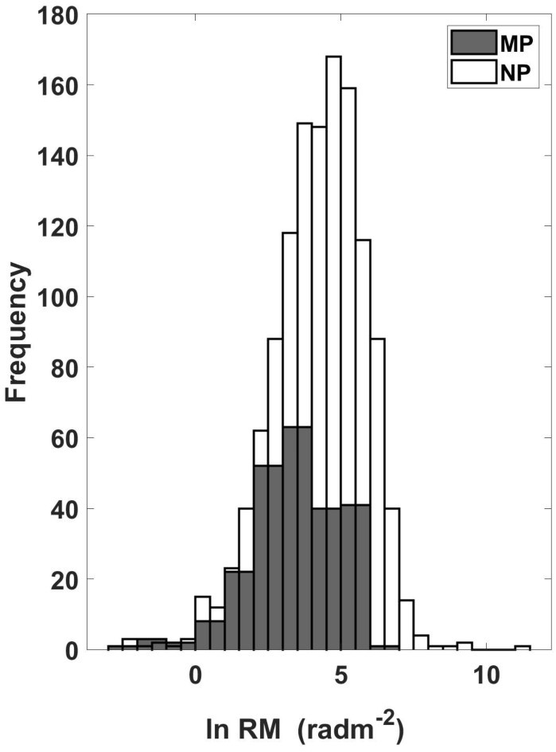

Figure 3:.The Distribution Plot of the Natural Logarithm of Values of the Dispersion Measure and Rotation Measure of NPs and MPs of NPs and MPs Distribution
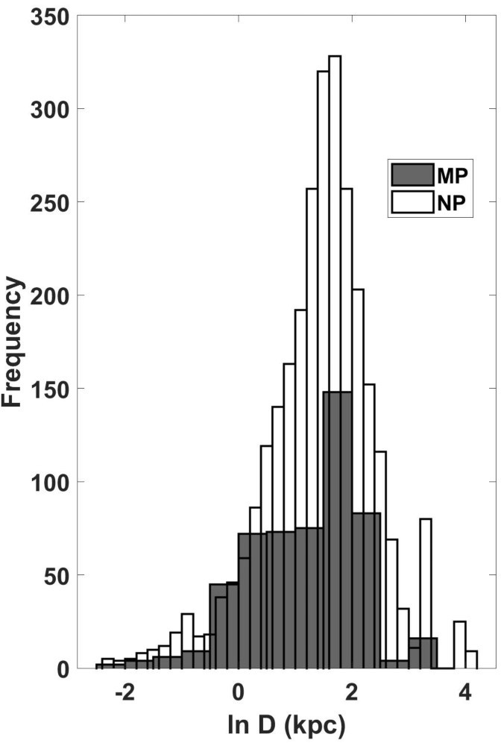
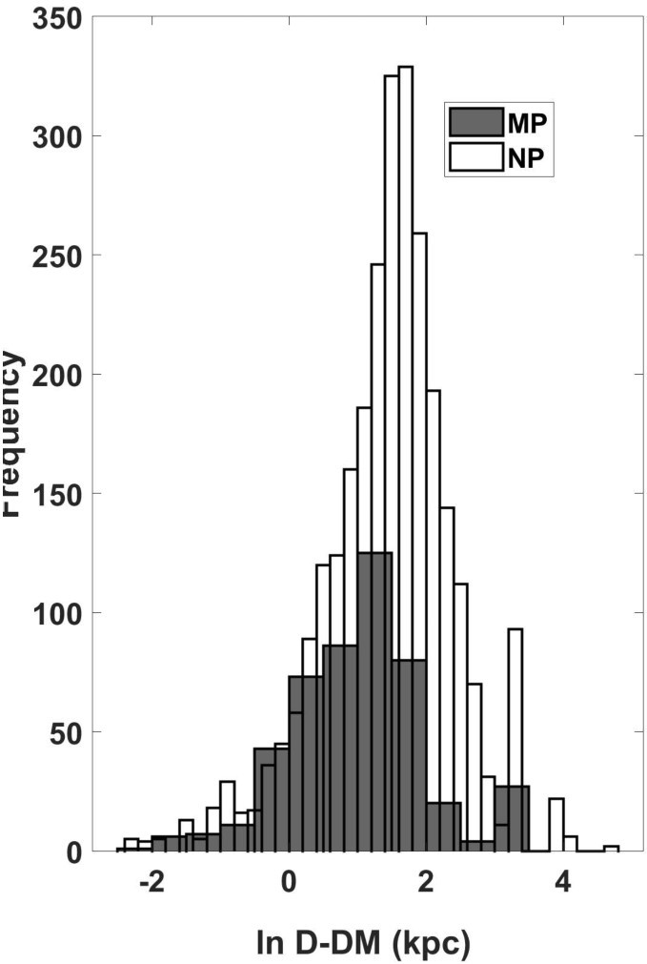
Figure 4: The Distribution Plot of the Natural Logarithm of Values of the Distance and the Distance (YMW16 model) of NPs and MPs

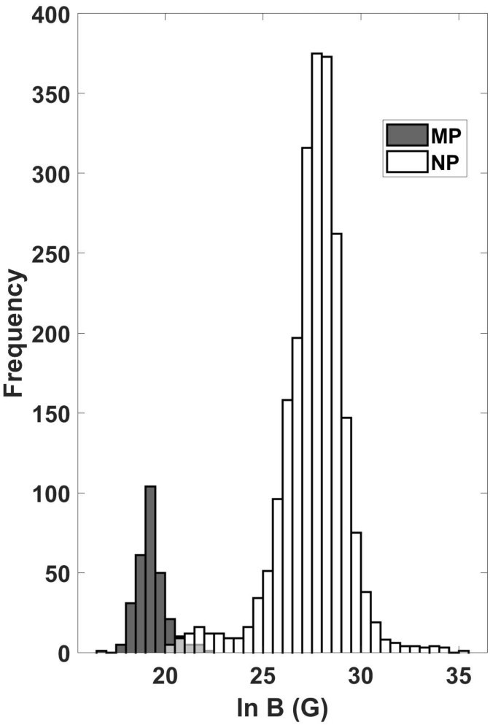
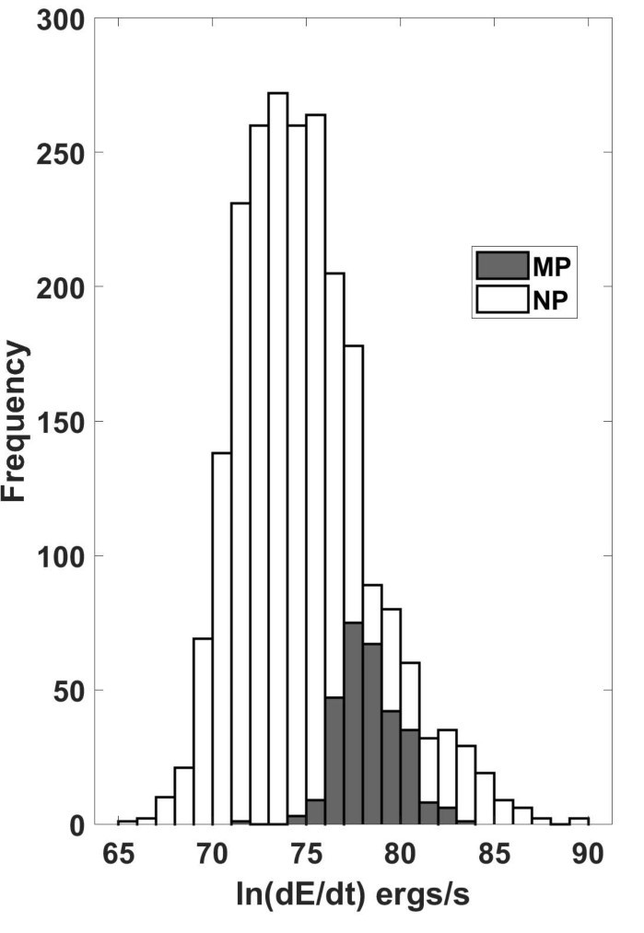

Figure 5: The Distribution Plot of the Natural Logarithm of Values of the Luminosity at 1400 MHz and Age of NPs and MPs
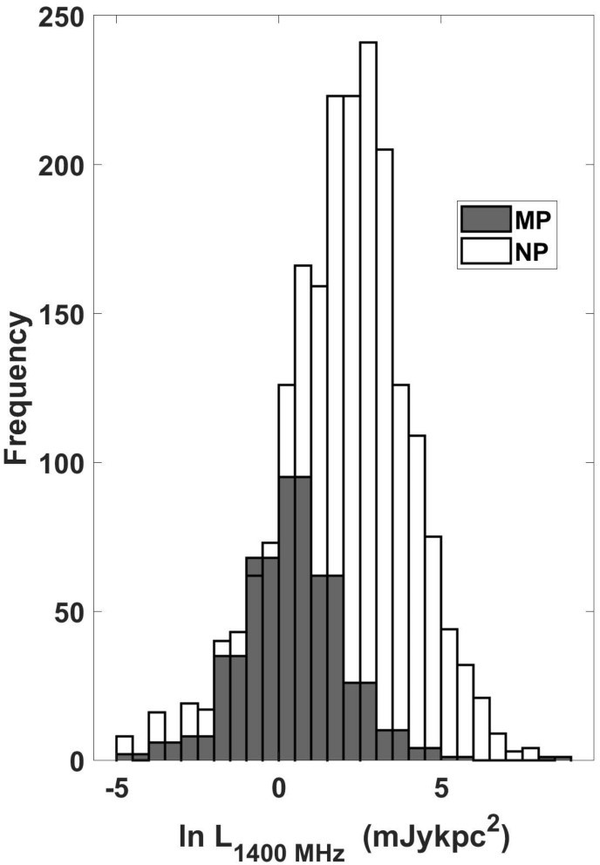
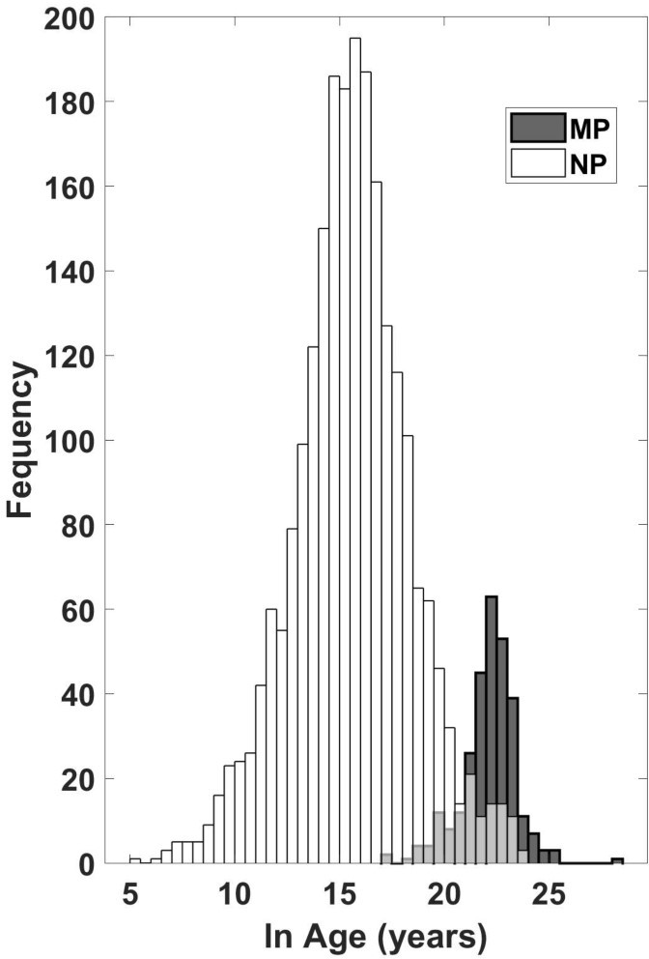
Figure 6: The Distribution Plot of the Natural Logarithm of Values of Magnetic Field and Spin Down Energy Loss Rate of NPs and MPs
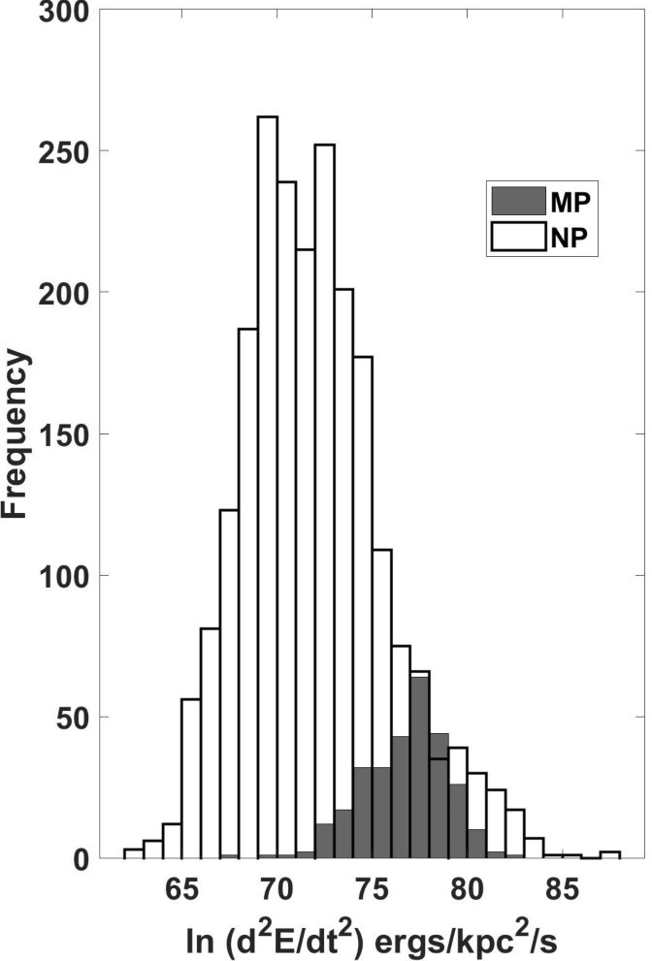
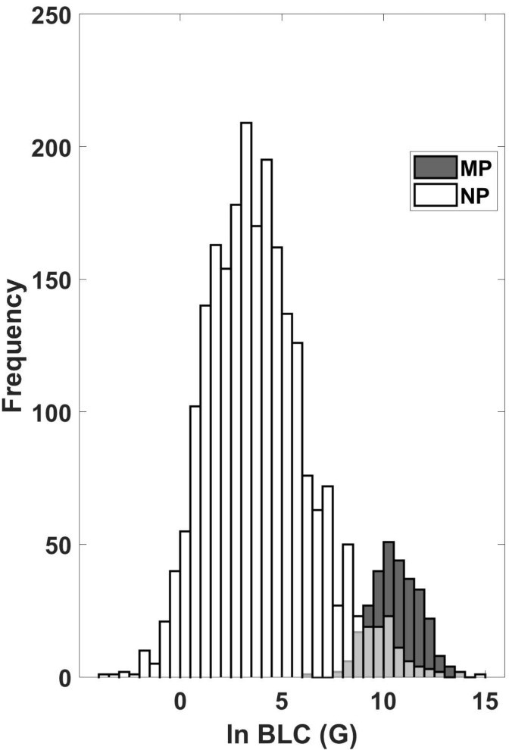
Figure 7: The Distribution Plot of the Natural Logarithm of Values of Energy flux at the Sun (ergs/kpc2/s) Magnetic Field at Light Cylinder of NPs and MPs
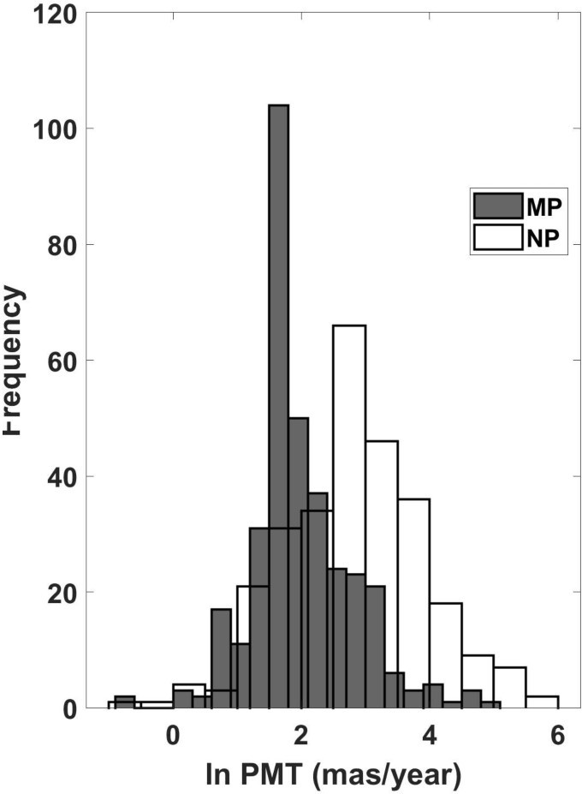
.

Figure 8: The Distribution Plot of the Natural Logarithm of Values of Total Proper Motion of NPs and MPs
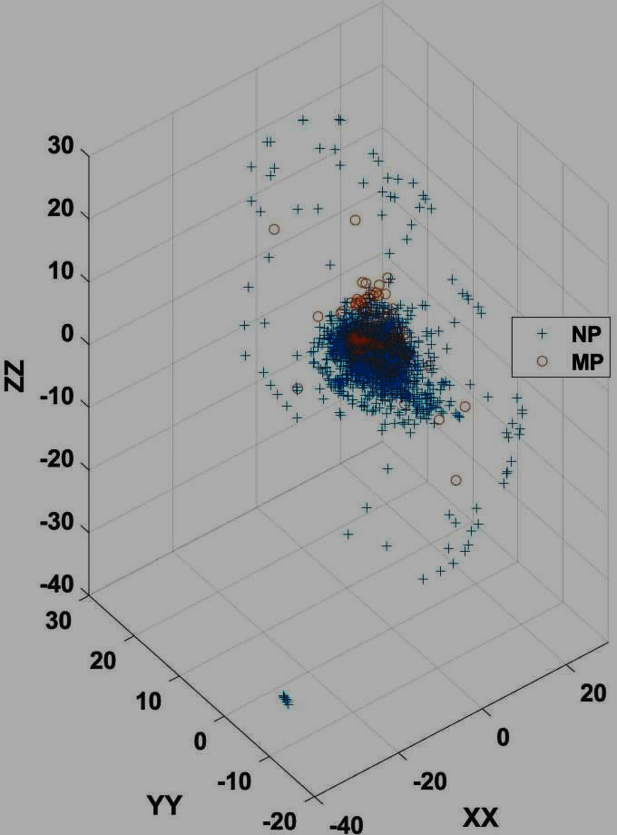

Figure 9: The 3-dimensional Plot of ZZ-YY-YY distances in (kpc) from the Galactic Plane (where ZZ is Distance from the Galactic plane, XX is X-Distance in X-Y-Z Galactic coordinate system and YY is Y-Distance in X-Y-Z Galactic coordinate system)

Figures 1 – 8 show the distribution plots described. In Figure 9, we present the XX-YY-ZZ plot of the distances of the pulsars with respect to the Galactic plane. We present an analysis of the median spatial coordinates of normal pulsars (NPs) and millisecond pulsars (MPs) within the Galactic Cartesian frame, where ZZ denotes the vertical displacement from the Galactic mid-plane, and X and Y represent orthogonal in-plane distances. The derived median values are Z=0.01 kpc, X=0.68 kpc, Y=5.15 kpc for NPs, and Z=0.05 kpc, X=0.44, Y=6.62 kpc for MPs, as illustrated by the three-dimensional scatter plot in Figure 9. With respect to height above the plane, NPrs exhibit a median Z of just 0.01 kpc (10 pc), placing them extremely close to the Galactic mid-plane. This confinement is a direct consequence of their youth and their origin in core-collapse supernovae, which occur predominantly within the thin disk where active star formation is concentrated. MPs, by contrast, display a median Z of 0.05 kpc (50 pc), indicating a modest but distinct vertical dispersion. Their slightly larger offset can be attributed to their advanced ages and the cumulative effects of dynamical processes, including prolonged evolution in binary systems and the influence of natal kicks.
In the X coordinate, NPs have a median distance of 0.68 kpc, whereas MPs are found at a slightly smaller median X of 0.44 kpc. Both populations therefore reside relatively near the Galactic centre in this direction, with MPs appearing marginally more centrally concentrated; this may reflect differences in their birth sites and subsequent radial migration within the disk. The Y coordinate reveals a more pronounced contrast: the median Y for NPs is 5.15 kpc, while for MPs it extends to 6.62 kpc. The larger median Y of the millisecond population signifies a greater spread along the tangential direction of the Galactic plane, a pattern that can be understood by their older characteristic ages, which allow more time for orbital diffusion and drift within the Galactic potential. NPs, being younger, remain more closely associated with the spiral arm features where their massive progenitors were born, resulting in the more limited Y extent observed.
Taken together, the spatial distributions of the two pulsar classes encode their distinct evolutionary histories. NPs are tightly bound to the Galactic plane and the star-forming thin disk, consistent with a young stellar population that has undergone little dynamical relaxation. MPs exhibit a broader distribution both in vertical height and in the in-plane Y coordinate, a signature of their great age and the protracted dynamical evolution that includes binary recycling and long-term interactions with the Galactic gravitational field. These contrasting median coordinates thus provide a quantitative illustration of how age and formation pathways shape the present-day architecture of the Galactic pulsar population.

Discussion of the Correlation Between Period and Other Pulsar Parameters
The correlation coefficients are presented in Table 3
 | NPs | MPs
Parameters | r | r
$$P/\dot{P}$$ | 0.17 | 0.18
$$P/F$$ | -0.27 | -0.78
$$P/\dot{F}$$ | 0.05 | 0.14
$$P/DM$$ | -0.06 | 0.20
$$P/RM$$ | -0.09 | 0.13
$$P/D$$ | -0.01 | 0.15
$$P/{Dist}_{DM}$$ | -0.03 | 0.08
$$P/R_{LUM14}$$ | -0.02 | 0.12
$$P/AGE$$ | -0.10 | 0.22
$$P/B_{SURF}$$ | 0.33 | 0.53
$$P/\dot{E}$$ | -0.04 | 0.01
$$P/\ddot{E}$$ | -0.03 | 0.06
$$P/{\dot{P}}_{i}$$ | 0.33 | 0.18
$$P/{AGE}_{i}$$ | -0.01 | 0.15
$$P/{PM}_{TOT}$$ | 0.25 | 0.07
$$P/V_{TRANS}$$ | -0.04 | 0.13
$$P/B_{LC}$$ | -0.05 | -0.28

The correlation coefficients are presented in Table 3 indicate that the rotational period exhibits generally weak relationships with most physical parameters in both NPs and MPs. For the NP population, almost all correlation coefficients fall within ±0.10, indicating negligible linear relationships between period and the majority of the measured parameters. Slightly stronger correlations are observed only with the surface magnetic field (r = 0.33), the Shklovskii-corrected period derivative (r = 0.33), and total proper motion (r = 0.25). These results suggest that the spin period of normal pulsars is largely independent of most observational and derived properties, reflecting the diverse evolutionary stages and initial conditions of the NP population.
MPs exhibit a somewhat different correlation pattern. Although most relationships remain weak, the correlation between period and surface magnetic field increases to r = 0.53, indicating a moderate positive association. Weak positive correlations are also observed between period and characteristic age (r = 0.22), dispersion measure (r = 0.20), corrected period derivative (r = 0.18), and distance (r = 0.15). These results suggest that the rotational period of MPs retains a modest evolutionary signature, reflecting the relatively homogeneous nature of recycled pulsars compared with the much broader evolutionary diversity of normal pulsars.
The strongest correlation in the entire analysis is the negative relationship between period (P) and rotation frequency (F) for millisecond pulsars (r = –0.78), compared with a much weaker correlation for normal pulsars (r = –0.27). This relationship is expected because rotational frequency is mathematically defined as the reciprocal of the spin period ($F =\frac{1}{P}$). Consequently, pulsars with shorter periods necessarily possess higher rotation frequencies. The stronger correlation observed among millisecond pulsars reflects the narrow range of spin periods characteristic of recycled pulsars, whereas the broader period distribution of normal pulsars weakens the linear relationship.
The moderate positive correlation between period and the surface magnetic field ($B_{SURF}$) in MPs (r = 0.53) is consistent with the standard recycling scenario. During prolonged accretion in a binary system, neutron stars are spun up to millisecond periods while their magnetic fields are substantially reduced through accretion-induced magnetic field burial or decay (Alpar et al., 1982; Bhattacharya & van den Heuvel, 1991). Consequently, MPs with relatively longer periods tend to retain somewhat stronger magnetic fields, producing the observed positive correlation. In contrast, the weaker relationship observed for NPs (r = 0.33) indicates that although magnetic braking governs rotational evolution, the magnetic field alone does not determine the spin period because pulsar birth periods, ages, and individual evolutionary histories introduce substantial scatter.
The remaining correlations involving dispersion measure, distance, luminosity, spin-down energy loss rate, energy flux, proper motion, transverse velocity, and light-cylinder magnetic field are all weak (|r| < 0.30) for both pulsar populations. These results indicate that the rotational period is not a strong predictor of these physical quantities. In particular, the weak positive correlations between period and dispersion measure or distance in MPs are insufficient to establish a direct physical relationship and are more likely to reflect observational selection effects and the spatial distribution of the known pulsar population rather than intrinsic evolutionary processes.
Overall, the correlation analysis demonstrates that spin period alone explains only a small fraction of the variability in most pulsar parameters. The principal exceptions are the moderate association between period and surface magnetic field in MPs and the expected inverse relationship between period and rotation frequency. These findings support the current understanding that pulsar evolution is governed by multiple interacting physical processes—including magnetic braking, binary evolution, accretion history, and environmental influences—rather than by rotational period alone.

4. Conclusions
The comparative analysis indicates that normal pulsars and millisecond pulsars show distinct statistical properties in their rotational, magnetic, age-related, and spatial parameters. Normal pulsars are characterized by longer spin periods, larger period derivatives, stronger surface magnetic fields, and younger characteristic ages. In contrast, millisecond pulsars show shorter spin periods, higher rotational frequencies, lower spin-down rates, weaker magnetic fields, and older characteristic ages. These trends are consistent with the interpretation that millisecond pulsars are recycled neutron stars that have been spun up through binary accretion. The spatial results suggest that both populations remain broadly associated with the Galactic disk, although millisecond pulsars show a slightly wider vertical distribution, consistent with their older evolutionary history. Correlation analysis indicates that spin period alone does not strongly predict most pulsar properties, except where mathematical or physically expected relationships exist. Overall, the study provides a descriptive statistical comparison of the two pulsar populations, but the results require careful verification of parameter labels, units, and derived values before final publication.

Limitations
This study is limited by its reliance on catalogue data, which may contain missing values, heterogeneous measurement uncertainties, and selection effects from different pulsar surveys. The classification criteria for normal and millisecond pulsars require clearer definition, and the analysis does not fully account for observational bias, binary status, or pulsar subtype. Some derived quantities and units require verification, particularly values related to proper motion and transverse velocity. The study is mainly descriptive and does not provide uncertainty propagation or formal population modeling. Future work should include reproducible data extraction, corrected parameter definitions, uncertainty analysis, and code-supported statistical validation.
Declaration of AI Use

This manuscript was prepared through the combined contributions of all author(s), including contributions to the study design, data, content development, results, interpretation, and related scholarly work. The author(s) acknowledge the use of Grammarly and ChatGPT to assist with grammar checking, language refinement, reference formatting. These AI-assisted tools were not used as authors and did not replace the intellectual contributions or scholarly judgment of the author(s). All AI-assisted outputs, including content, references, and interpretations, were carefully reviewed, revised, verified, and approved by the author(s). The author(s) accept full responsibility for the accuracy, integrity, and final content of the manuscript.

Declaration:
The authors declare that no funds, grants, or other support were received during the preparation of this manuscript.

References

Abbott, B. P., Abbott, R., Abbott, T. D., et al. (2017). GW170817: Observation of gravitational waves from a binary neutron star inspiral. Physical Review Letters, 119(16), 161101. https://doi.org/10.1103/PhysRevLett.119.161101
Alpar, M. A., Cheng, A. F., Ruderman, M. A., & Shaham, J. (1982). A new class of radio pulsars. Nature, 300(5894), 728–730. https://doi.org/10.1038/300728a0
Basu, A., Char, P., & Mitra, D. (2022). The Jodrell Bank glitch catalogue. Monthly Notices of the Royal Astronomical Society, 515(3), 4232–4243.
Bhattacharya, D., & van den Heuvel, E. P. J. (1991). Formation and evolution of binary and millisecond radio pulsars. Physics Reports, 203(1–2), 1–124. https://doi.org/10.1016/0370-1573(91)90064-S
Fisher, R. A. (1915). Frequency distribution of the values of the correlation coefficient in samples from an indefinitely large population. Biometrika, 10(4), 507–521.
Hewish, A., Bell, S. J., Pilkington, J. D. H., Scott, P. F., & Collins, R. A. (1968). Observation of a rapidly pulsating radio source. Nature, 217(5130), 709–713. https://doi.org/10.1038/217709a0
Hobbs, G., Archibald, A., Arzoumanian, Z., et al. (2010). The International Pulsar Timing Array project: Using pulsars as a gravitational wave detector. Classical and Quantum Gravity, 27(8), 084013. https://doi.org/10.1088/0264-9381/27/8/084013
Kramer, M., Stairs, I. H., Manchester, R. N., et al. (2006). Tests of general relativity from timing the double pulsar. Science, 314(5796), 97–102. https://doi.org/10.1126/science.1132305
Lorimer, D. R. (2008). Binary and millisecond pulsars. Living Reviews in Relativity, 11, 8. https://doi.org/10.12942/lrr-2008-8
Lorimer, D. R., & Kramer, M. (2005). Handbook of Pulsar Astronomy. Cambridge University Press.
Lyne, A. G., & Graham-Smith, F. (2012). Pulsar Astronomy (4th ed.). Cambridge University Press.
Manchester, R. N., Hobbs, G. B., Teoh, A., & Hobbs, M. (2005). The Australia Telescope National Facility pulsar catalogue. The Astronomical Journal, 129(4), 1993–2006.
Tauris, T. M., & van den Heuvel, E. P. J. (2006). Formation and evolution of compact stellar X-ray sources. In W. H. G. Lewin & M. van der Klis (Eds.), Compact Stellar X-ray Sources (pp. 623–665). Cambridge University Press.
Westfall, P. H., Henning, K. S. S., & Zhang, Y. (2014). Understanding Advanced Statistical Methods. CRC Press.
Yao, J. M., Manchester, R. N., & Wang, N. (2017). A new electron-density model for estimation of pulsar and FRB distances. The Astrophysical Journal, 835(1), 29.

