Integrating Improved Poultry Production with School Feeding in the Sidama Region, Ethiopia: A Field Demonstration of the “One Egg for a Child” Initiative

Abstract
Malnutrition among school-age children remains a major public health challenge in Ethiopia, affecting physical growth, cognitive development and educational performance. This descriptive field demonstration documented the implementation and early operational performance of improved poultry production integrated with a Home-Grown School Feeding Programme through the “One Egg for a Child” initiative at Murancho Qutala Elementary School, Hawella Woreda, Sidama Region, Ethiopia, under the SAPLING Project of the Tropical Poultry Genetic Solutions Platform. Poultry-production and enterprise records were compiled from January to April 2024, while egg distribution to participating schoolchildren was documented separately following initiation of the school-feeding component. A poultry demonstration centre using Bovans Brown layer chickens was established and managed under improved husbandry practices. A total of 1,200 two-month-old pullets were stocked. During the recorded production period, more than 61,000 eggs were produced, and surplus egg sales generated approximately ETB 500,000 in gross revenue. A total of 4,250 eggs were distributed to 100 nutritionally vulnerable schoolchildren, with each participating child receiving one boiled egg on designated school-feeding days. Gross revenue from surplus egg sales contributed to the purchase of poultry feed during the observation period, while the initiative directly engaged five staff members in poultry management and school-feeding activities. Awareness meetings, demonstration visits and experience-sharing activities were conducted for students, teachers, parents and community representatives, covering improved poultry management, egg consumption and local marketing practices. As the demonstration did not include a control group, baseline measurements or direct assessment of nutritional and educational outcomes, the findings primarily describe implementation processes and early operational outputs rather than intervention effectiveness. The findings demonstrate the short-term operational feasibility of linking a school-based poultry enterprise with egg provision for selected schoolchildren and provide a basis for longer-term evaluations of its nutritional, educational and economic effects.
Keywords: Egg supplementation; Home-Grown School Feeding; improved poultry production; school-age children; Bovans Brown; Ethiopia; nutrition-sensitive agriculture; poultry enterprise; community engagement.

1. Introduction
Malnutrition remains a major public health challenge in low- and middle-income countries, with profound consequences for children's physical growth, cognitive development, educational achievement and future productivity. Poor nutrition during childhood is strongly associated with reduced school attendance, impaired concentration, lower academic performance and increased susceptibility to illness, ultimately limiting human capital development (Bisset et al., 2013; Victora et al., 2021; Alderman & Headey, 2017). School-age children are an important target group for nutritional interventions because this stage provides an opportunity to address nutritional deficiencies while supporting continued growth and learning. Nutritional status during the school-age period affects health and cognition, with implications for educational achievement (Saavedra & Prentice, 2023).
In Ethiopia, childhood malnutrition remains a critical concern. According to the 2024-25 Ethiopia Demographic and Health Survey, 40% of children under five years of age are stunted, 5% are wasted and 18% are underweight, indicating that child undernutrition remains a major public health challenge in the country (Ethiopian Statistical Service [ESS] & ICF, 2026). These national indicators concern children younger than five years and should therefore be interpreted as evidence of Ethiopia’s broader undernutrition burden rather than as a direct estimate for the 6–11-year-old pupils targeted by the present initiative. Nevertheless, the school-age period remains nutritionally important because continued physical growth and neurocognitive development may be constrained by inadequate dietary quality and persistent nutrient deficiencies (Saavedra & Prentice, 2023). Among school-age children, undernutrition and micronutrient deficiencies remain widespread, largely driven by inadequate dietary diversity, food insecurity, poverty, poor sanitation and limited access to health services (United Nations Children's Fund [UNICEF], 2019). Addressing these challenges requires integrated, multisectoral approaches that link nutrition, education and agriculture. Because the present intervention targets school-age children rather than infants receiving complementary foods, its rationale should be grounded primarily in evidence from school nutrition and school-feeding research. School-based food provision is especially relevant where limited dietary diversity and household food insecurity persist into middle childhood, although the magnitude of benefit depends on meal composition, programme duration and the outcomes evaluated (Saavedra & Prentice, 2023; Wang et al., 2021).
School Feeding Programmes (SFPs) have been widely recognised as effective interventions for improving child nutrition, school attendance, learning outcomes and social equity. A systematic review and meta-analysis of controlled studies conducted in low- and middle-income countries found that school feeding produced modest improvements in child growth and school attendance, although the magnitude and consistency of these effects varied across programme designs, settings and outcome measures (Wang et al., 2021). These findings support the use of schools as food-delivery platforms while also demonstrating that nutritional and educational benefits should be measured directly rather than inferred solely from the number of meals or food items distributed. Globally, more than 368 million children benefit from school feeding initiatives, which have consistently demonstrated positive effects on nutrition and educational performance (Food and Agriculture Organization of the United Nations [FAO] & World Food Programme [WFP], 2018; Drake et al., 2020). Recent Ethiopian evidence also indicates that school feeding was negatively associated with school absenteeism among primary school adolescents in Addis Ababa, supporting continued evaluation of school feeding models in local settings (Mohammed et al., 2023). This evidence is particularly relevant because it demonstrates a locally observed educational association; however, reduced absenteeism should not be interpreted as direct evidence of improved nutritional status. Nutritional, educational and operational outcomes should therefore be treated as related but distinct dimensions of school-feeding performance, each requiring appropriate indicators and study designs. A recent review of African school feeding programmes emphasised that long-term sustainability depends on context-specific design, local resources, community involvement and operational planning (Mainje et al., 2024). The School Feeding Programme was officially launched in Ethiopia in 1994 as a pilot initiative in collaboration with the Ministry of Education and the World Food Programme. The programme initially covered 40 primary schools in Tigray, Amhara, Afar and Oromia, benefiting approximately 25,000 children (Federal Democratic Republic of Ethiopia [FDRE], 2024).
Home-Grown School Feeding (HGSF) strengthens the linkage between agriculture and nutrition by sourcing food locally, supporting smallholder farmers, improving children's access to nutritious foods and stimulating rural economies (Food and Agriculture Organization of the United Nations [FAO], 2018; Gelli, 2015). Recent African evidence further suggests that local sourcing alone does not ensure programme continuity; stable financing, reliable procurement, institutional coordination, community participation and routine monitoring are also central to long-term sustainability (Mainje et al., 2024). Within this framework, a school-based poultry unit may function both as a source of locally produced animal-source food and as an enterprise intended to contribute to the programme’s recurrent operating requirements. Poultry production is particularly suitable for this approach because it requires relatively low investment while providing nutrient-rich eggs and income for rural households (Alders et al., 2018). For a school-linked poultry enterprise, reliable egg supply depends not only on the genetic potential of the birds but also on adequate feeding, flock-health management, biosecurity, labour, infrastructure and access to a functioning market. These operational components must work together because disruption in any one of them may reduce egg availability and limit the revenue available for purchasing recurrent production inputs (Alders et al., 2018; Mainje et al., 2024).
Eggs are among the most nutrient-dense foods, providing high-quality protein, essential vitamins and minerals, choline and other nutrients that are important for growth and cognitive development (Iannotti et al., 2014; Lutter and Morris, 2018; FAO, 2015). Their high nutrient bioavailability and relative affordability make them a practical food-based option for addressing childhood undernutrition. Evidence from early-childhood trials demonstrates the nutritional potential of eggs, but findings from infants and preschool-aged children should not be transferred uncritically to school-age populations because age, background diet and intervention duration may influence the response. More directly, a quasi-experimental school-based study reported improvements in selected anthropometric indicators among disadvantaged school-age children receiving one egg per school day; however, contextual differences and the non-randomised design limit direct extrapolation of those findings to rural Ethiopia (Chen & Jin, 2023).
Against this background, the "One Egg for One Child" initiative was established at Murancho Qutala Elementary School in the Sidama Region, Ethiopia, under the Sustainable Animal Productivity for Livelihoods, Nutrition and Gender Inclusion (SAPLING) Project of the Tropical Poultry Genetic Solutions (TPGS) Platform. The initiative integrates improved poultry production with a Home-Grown School Feeding Programme by establishing a poultry demonstration centre that provides one egg per child on each school day. Beyond supporting child nutrition, the initiative aims to strengthen local poultry production, promote improved management practices, create income-generating opportunities and generate evidence for scaling integrated poultry-based school feeding models in Ethiopia. Although school feeding, HGSF and poultry-based nutrition interventions have been discussed in different settings, limited field-based evidence is available on how a school-centred improved poultry enterprise can simultaneously supply eggs for schoolchildren, generate operating income and build community awareness under rural Ethiopian conditions. Accordingly, the principal contribution of the present study is operational rather than clinical. It documents whether a school-centred layer enterprise could maintain egg production, allocate part of its output to selected pupils, generate gross revenue from surplus egg sales and establish a local implementation and stakeholder-engagement structure; it was not designed to determine causal effects on nutritional status, school attendance or academic performance. Therefore, documenting the implementation and early performance of this model is important for informing context-specific planning and future evaluation.

2. Objective
To document the establishment and early operational performance of a school-based improved poultry enterprise integrated with a Home-Grown School Feeding Programme, focusing on poultry production, egg allocation, gross sales revenue, employment and stakeholder-engagement activities.

3. Materials and Methods

3.1. Study Area and Project Period
The study was conducted at Murancho Qutala Elementary School in Hawella Woreda, Sidama Region, Ethiopia. The school is located approximately 25 kilometres south of Hawassa City, the regional capital of Sidama Region.

3.2. Project Implementation Procedures

3.2.1. Site Selection
A suitable school was selected based on predefined criteria developed to maximise the potential for project success and sustainability. These criteria included the availability of adequate land for poultry house construction, access to clean water and electricity, ease of accessibility for regular monitoring and follow-up activities, demonstrated community interest and support, and commitment from the school administration to actively participate in and sustain the intervention. Based on these criteria, a comprehensive assessment of potential schools in the region was conducted, leading to the selection of Murancho Qutala Elementary School as the intervention site. This school met all selection criteria and demonstrated strong community support and commitment to the project objectives.

3.2.2. Stakeholder Awareness Creation and Community Mobilization
Awareness-creation meetings were conducted with district officials, school administrators, teachers, parents and community representatives to introduce the objectives and expected outcomes of the project. These meetings were essential for building understanding, generating support and mobilising community participation in the initiative. They provided opportunities for stakeholders to ask questions, express concerns and contribute ideas for project implementation. Through these processes, community members gained an understanding of the nutritional importance of eggs for child development, the potential of improved poultry production for livelihood enhancement and the mutual benefits of linking school feeding with local agricultural production. The school community actively contributed to the implementation process by providing land and locally available construction materials required for the poultry facility, demonstrating strong ownership and commitment to the project.

3.2.3. Establishment of Monitoring and Follow-up Team
A multidisciplinary monitoring and follow-up committee was established to provide oversight and technical guidance for project implementation. The committee comprised school working groups involving students, parents and teachers, the district education and livestock offices, the Hawassa Agricultural Research Centre and community representatives. This multi-stakeholder composition ensured that diverse perspectives and expertise informed project implementation, while also facilitating coordination across sectors and administrative levels. The team was responsible for overseeing project implementation, monitoring poultry production activities, coordinating the school feeding intervention and addressing challenges that arose during implementation. Regular meetings were held to review progress, share information and plan subsequent activities.

3.2.4. Recruitment of Personnel
To ensure effective management of the poultry enterprise, a dedicated team of personnel was recruited with the participation of the school community and relevant stakeholders. This team comprised two poultry keepers, two attendants and one technical expert. The recruitment process emphasised the selection of individuals with demonstrated commitment, reliability and willingness to learn, even if they did not have prior formal training in poultry management.

3.3. Establishment of the Poultry Demonstration Center

3.3.1. Construction of Poultry Facilities
The main poultry layer house was constructed with dimensions of 16 metres by 10 metres, providing adequate space for housing and managing a commercial layer flock (Fig. 1). This facility was designed following best practices for commercial poultry housing, incorporating features such as adequate ventilation, appropriate lighting, and protection from predators and adverse weather conditions.
In addition to the main poultry house, a 9-metre by 3-metre feed storage and office block was constructed to facilitate daily operations and secure storage of feed and equipment. This facility provided space for feed storage, record keeping and general administrative functions related to the poultry enterprise and feeding programme.
The construction of these facilities was supported by TPGS funding and materials procured through the Hawassa Agricultural Research Centre, with substantial community involvement in the construction process. School community representatives contributed local building materials, such as wood and stone, provided diligent on-site supervision and contributed labour for construction activities. Project funds were reserved for industrial supplies, such as cement, sheeting and nails, ensuring that the facilities met appropriate standards for commercial poultry production. The success of this initiative is largely attributable to this effective public-community partnership, which created a sense of collective ownership and responsibility for the project's success.
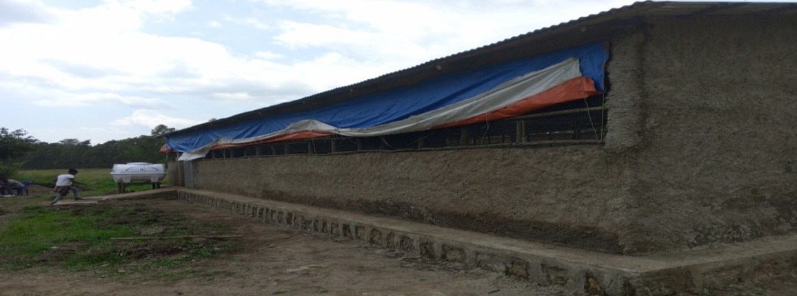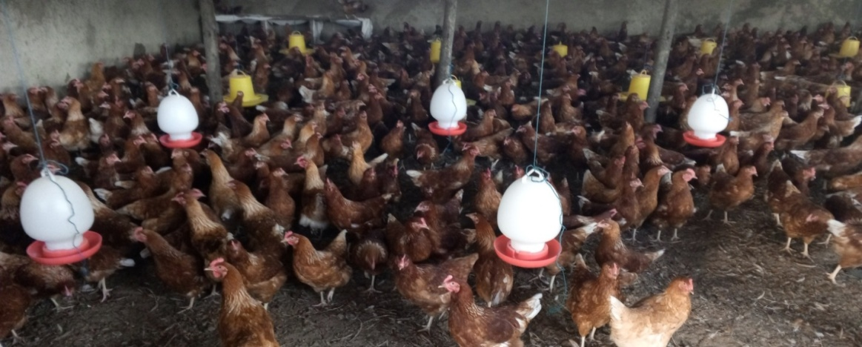

Fig. 1. Poultry house constructed with project support and active participation of the school community.

3.3.2. Installation of Utilities and Procurement of Equipment
To ensure smooth operations, the project installed critical infrastructure, including a potable water line with maintenance protocols, a water tanker and an electrical connection to ensure an uninterrupted water and power supply. These utilities were essential for maintaining appropriate husbandry conditions, supporting bird health and productivity, and ensuring that egg production could be sustained throughout the year.
Concurrently, all necessary production equipment and inputs were procured and made available for use. These included feeders and drinkers designed for commercial layer management, starter feed for the pullets and veterinary medicines for routine health management. The procurement process followed established procedures to ensure quality and cost-effectiveness, with inputs sourced from reputable suppliers.

3.3.3. Procurement and Stocking of Chickens
After completion of all preparatory activities, Bovans Brown pullets aged 60 days were purchased and stocked. The Bovans Brown breed was selected based on its demonstrated performance characteristics, including good egg production, adaptability to various management conditions and suitability for smallholder and commercial production contexts in tropical environments.

3.4. Poultry Management Practices
The poultry demonstration centre was managed using improved husbandry practices to optimise bird health and productivity. A total of 1,200 two-month-old pullets were stocked. Birds received balanced diets appropriate to their production stage, beginning with concentrate pullet feed and transitioning to commercial layer feed at the onset of egg production. Clean drinking water was provided ad libitum. Routine health management included regular monitoring, Newcastle disease vaccination every three months, vitamin supplementation as needed and strict biosecurity measures, including controlled access, footbaths, and routine cleaning and disinfection, to maintain flock health and prevent disease.

3.5. Ethical Approval and Consent to Participate
This study was conducted in accordance with the ethical principles outlined in the Declaration of Helsinki (World Medical Association, 2013). Ethical clearance was obtained from the Sidama Bureau of Health and the Ethiopian Public Health Institute. All activities involving participating children commenced only after the required ethical and administrative permissions had been obtained. All participants and their families were informed about the study objectives, procedures, potential benefits and voluntary nature of participation. Informed consent was obtained from the parents or legal guardians of participating children, and age-appropriate verbal assent was obtained from the children before their inclusion in the feeding and data-collection activities. Where consent was obtained verbally, the procedure was documented by the project team in accordance with the requirements approved by the relevant ethics committees. Before enrolment, parents or legal guardians were asked whether their children had a known history of egg allergy or another relevant dietary contraindication. Children with a reported egg allergy or other contraindication were excluded, and procedures were established to identify, document and manage any adverse reaction occurring during the feeding period. Participation was voluntary, and the children and their families were informed that they could decline participation or withdraw at any time without penalty or any effect on school enrolment, routine education or access to school services. All information collected was treated confidentially and used solely for the stated research purposes. Separate permission was obtained from parents or legal guardians for photographing participating children and for the use of approved images in project reports and academic publications. Images were anonymised where necessary to reduce the possibility of identifying individual participants.

3.5.1. Animal Welfare and Husbandry Compliance
The poultry component was implemented as a field demonstration under routine layer-management conditions and did not involve invasive experimental procedures. Birds were managed in accordance with applicable institutional and national animal-welfare and husbandry requirements, with appropriate housing, feed, clean water, preventive health care, biosecurity and veterinary oversight. Flock health was monitored regularly, and sick or injured birds were managed using appropriate veterinary and humane husbandry procedures.

3.6. School Feeding Intervention
The Home-Grown School Feeding Programme was officially launched on 30 March 2024 under the "One Egg for One Child" initiative (Fig. 2). A total of 100 nutritionally vulnerable students were enrolled in the feeding component. On each scheduled feeding day, every attending child was offered one boiled egg, and the number of eggs distributed therefore varied according to daily attendance. Daily attendance and egg distribution records were maintained to monitor implementation. Eggs were prepared and distributed under hygienic conditions as part of the school routine. Surplus eggs were sold locally, and a portion of the resulting gross revenue was used to purchase feed and pay poultry attendants during the observation period.

3.7. Data Collection and Descriptive Analysis
Daily records were maintained for flock size, egg production, egg distribution and egg sales throughout the observation period. Hen-day egg production was calculated as the number of eggs produced on a given day divided by the number of live hens present on that day, multiplied by 100. Egg-production and distribution records were summarised using totals, percentages and ranges. Gross sales revenue was calculated from recorded egg sales; however, net profit was not estimated because complete expenditure data were unavailable.

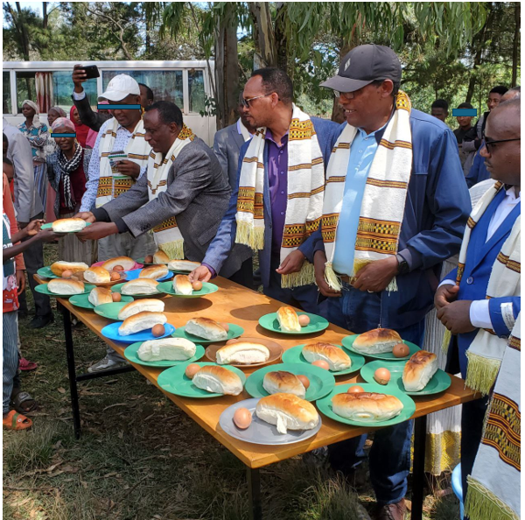

Fig. 2. Official launch of the "One Egg for One Child" initiative under the Home-Grown School Feeding Programme at Murancho Qutala Elementary School.

4. Results and Discussion

4.1. Poultry Production Performance
The Bovans Brown chickens exhibited good production performance under the improved management conditions implemented at the demonstration centre. The birds achieved body weights ranging from 1.2 to 1.6 kilograms, which was consistent with expected standards for the breed and age of the birds. This weight range indicated good growth and development, providing a foundation for subsequent productive performance.
Egg production commenced as expected and progressed through the typical production curve for commercial layers, gradually increasing to approximately 40% hen-day production during the early laying period. As the birds matured, hen-day egg production increased from approximately 40% during early lay to a range of 68–79% during the highest-producing period, representing good performance within the expected range for Bovans Brown layers under tropical conditions. The progressive increase from early lay to the reported peak is biologically compatible with flock maturation, although the magnitude and stability of laying performance may also have been influenced by feed and water intake, housing ventilation, flock health and ambient temperature. Heat stress can alter physiological homeostasis, feed consumption and productive performance in poultry; therefore, the observed production curve should be interpreted as the combined outcome of bird age, management and the local production environment rather than as a consequence of genetic potential alone (Oladokun & Adewole, 2022). Direct comparison with traditional village chickens should also be made cautiously because the systems differ substantially in genotype, formulated feeding, housing, veterinary support and production objectives.
Total egg production during the intervention period exceeded 61,000 eggs, demonstrating substantial productive capacity from the flock. This level of production was higher than would generally be expected under traditional village poultry management, highlighting the productivity gains achievable through improved genetics and management. Collected eggs were stored in a designated room before distribution through the school feeding programme, while surplus eggs were sold to generate income for the initiative (Fig. 3). The key production and economic indicators are summarised in Table 1.
Table 1. Performance and economic parameters of the study flock
Parameter | Performance
Initial egg production | ~40% hen-day production
Hen-day production during the highest-producing period | 68–79% hen-day production
Total eggs produced | >61,000 eggs
Revenue generated | ~ETB 500,000

The poultry enterprise generated approximately ETB 500,000 in gross sales revenue during the reported observation period. A portion of this revenue was used to purchase poultry feed; however, the absence of complete expenditure data prevents determination of net profit, full cost recovery or financial sustainability. Nevertheless, gross sales revenue should not be equated with net profit or full cost recovery, because feed, labour, veterinary inputs, utilities, equipment depreciation and externally financed infrastructure must all be considered in a complete economic assessment. Evidence from African school-meal programmes indicates that inadequate or unpredictable budgets, supply-chain constraints and logistical challenges can interrupt programme continuity even when local food procurement is incorporated. Accordingly, the longer-term financial viability of the present model should be evaluated using complete expenditure records and sensitivity analyses that account for changes in feed prices, egg prices, flock mortality and production levels (Wineman et al., 2022).

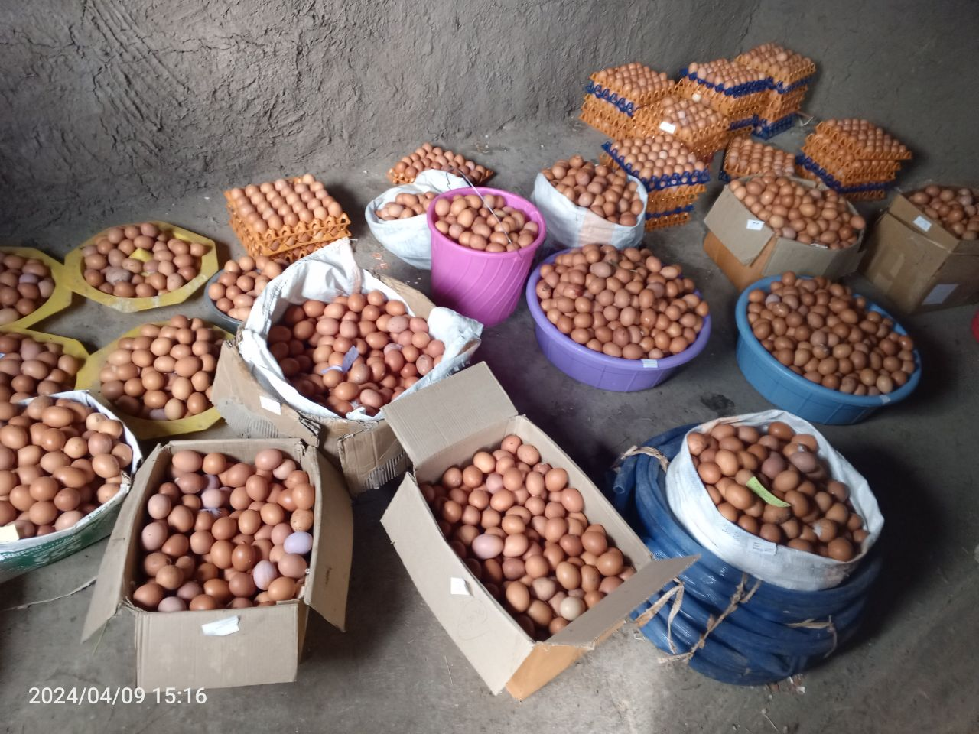
Fig. 3. Eggs collected from the poultry demonstration farm.

4.2. School Feeding Performance
A total of 100 students were enrolled in the feeding programme, and each child attending on a scheduled feeding day was offered one boiled egg. Before meals, students washed their hands at a handwashing facility installed near the dining area (Fig. 4). Figure 5 illustrates egg consumption during one of the scheduled feeding activities.
Regular egg provision increased access to a nutrient-dense animal-source food among the participating students; however, the available records demonstrate food delivery rather than improvement in total dietary intake, nutritional status, school attendance or learning performance. A systematic review and meta-analysis of school-feeding interventions in low- and middle-income countries reported modest improvements in selected growth and attendance outcomes, but the magnitude of these effects varied according to programme design, intervention duration and outcome measurement. Direct nutritional and educational benefits should therefore not be attributed to the present initiative without baseline and follow-up measurements and an appropriate comparison group (Wang et al., 2021).
The total number of eggs distributed through the school feeding programme during the intervention period was 4,250. This figure represents the cumulative number of egg servings recorded across scheduled feeding days rather than an equal cumulative number of eggs for every enrolled child, because daily attendance varied during implementation. The nutritional significance of this level of provision cannot be determined from the number of eggs distributed alone, because any measurable effect would also depend on the duration and regularity of consumption, the children’s baseline diets and whether the eggs supplemented rather than displaced foods that would otherwise have been consumed. A quasi-experimental egg-based programme among disadvantaged school-age children reported improvements in selected anthropometric indicators following structured egg provision; however, differences in setting and study design, together with the absence of comparable anthropometric measurements and a control group in the present demonstration, preclude direct extrapolation of those findings (Chen & Jin, 2023). This represented approximately 7% of total egg production, while most of the remaining eggs were sold to generate gross revenue for recurrent enterprise activities. The allocation of approximately 7% of production to direct feeding, with most of the remaining eggs made available for sale, illustrates the dual nutritional and enterprise objectives of the initiative. Future evaluation should determine whether this allocation remains sufficient to provide a meaningful and sustained dietary contribution while generating adequate net revenue for flock management.
Daily attendance and egg-distribution records indicated that the enrolled children participated in the feeding activities, although formal measures of acceptability, attendance change and educational outcomes were not collected. The integration of egg distribution into the school routine facilitated regular programme delivery. Informal observations suggested that the activities were generally well received, although student acceptability was not evaluated using a structured or validated assessment. These observations provide useful information about programme acceptability and implementation, but favourable participation does not by itself demonstrate improved school attendance, concentration or academic achievement. Experimental research on large-scale school feeding has evaluated educational effects through prespecified learning and cognitive measures, illustrating the importance of collecting comparable attendance and achievement data before educational benefits are attributed to the present initiative (Aurino et al., 2023).
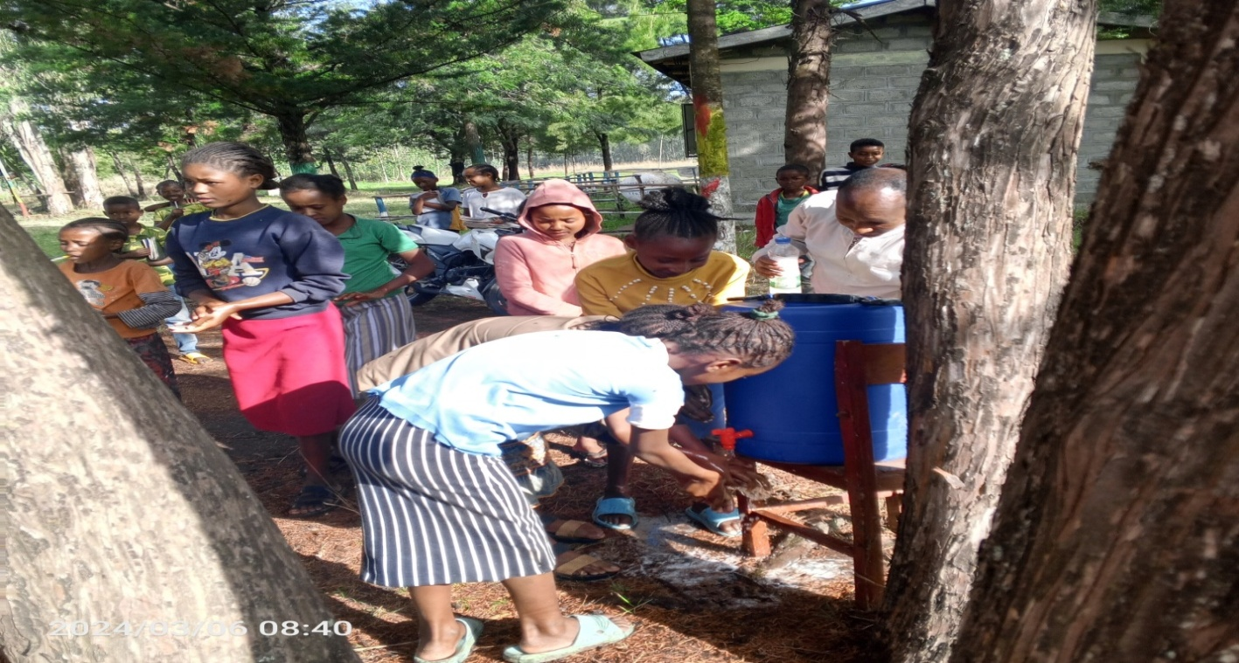
Fig. 4. Students washing their hands before consuming eggs provided through the "One Egg for One Child" school feeding initiative.

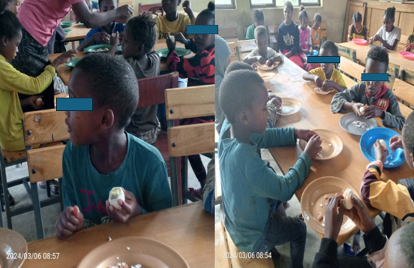

Fig. 5. Schoolchildren consuming eggs provided through the "One Egg for a Child" initiative under the Home-Grown School Feeding Programme.

4.3. Community Engagement and Capacity-Building Activities
The demonstration centre served as a practical platform for stakeholder engagement, demonstration activities and knowledge exchange beyond the immediate school community. Students, parents and community members participated in demonstration visits and discussions covering improved poultry production, nutrition and egg-marketing practices. The demonstration activities provided opportunities for participating stakeholders to observe improved poultry-management practices and discuss their potential application within the local context. Project-performance meetings and experience-sharing forums also addressed egg marketing, market linkages and the practical requirements for maintaining school-based poultry enterprises. Because stakeholder knowledge, adoption intentions and awareness were not assessed systematically, these activities should be interpreted as engagement outputs rather than demonstrated changes in knowledge or behaviour. Project implementation was continuously monitored in collaboration with key stakeholders. Strategies for scaling up these findings were discussed with elementary school principals and education office officials (Fig. 7).
Although this stakeholder platform may facilitate local ownership and knowledge exchange, successful replication will also depend on schools having adequate land, water, electricity, trained personnel, veterinary support and reliable markets for feed and eggs. African school-meal programmes vary considerably in their financing, procurement arrangements, institutional capacity and logistical infrastructure; consequently, the operational feasibility observed at this purposively selected and externally supported site should not be generalised to less-resourced schools without further implementation testing (Wineman et al., 2022).
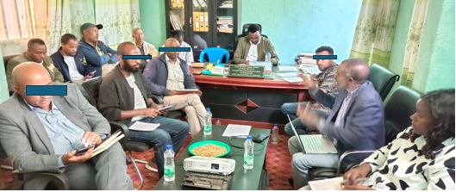
Fig. 6. Project performance evaluation meeting conducted with the participation of key stakeholders.

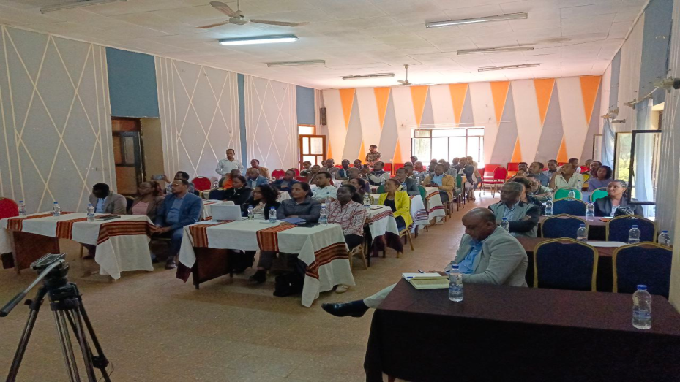
Fig. 7. Experience-sharing forum with 25 elementary school principals on the Murancho Qutala Home-Grown School Feeding Programme, organised to promote knowledge exchange and support scaling up of the initiative.
4.4. Employment Creation
The poultry enterprise directly engaged five staff members—two women and three men—in poultry-management and school-feeding activities. Feed supply, egg marketing and related services represent potential pathways for wider economic activity; however, indirect employment, household income and broader livelihood effects were not systematically assessed during the demonstration.
Overall, the demonstration showed that improved layer management could generate eggs for both school distribution and local sale within a supported school setting. During the highest-producing period, the flock recorded hen-day production levels ranging from 68% to 79%; however, comparison with traditional village systems should be interpreted cautiously because genotype, formulated feeding, housing, veterinary support and production objectives differed substantially. Egg distribution provided participating children with access to a nutrient-dense animal-source food, but nutritional and educational effects were not measured. Gross revenue from egg sales contributed to selected recurrent inputs, although profitability and financial sustainability could not be established without complete cost accounting. Stakeholder meetings, demonstration visits and experience-sharing activities indicated active participation, but changes in awareness, household adoption and livelihoods were not formally evaluated. The findings therefore support further testing of the model rather than definitive conclusions regarding nutritional effectiveness, socioeconomic benefit or scalability.

Conclusion
The “One Egg for One Child” initiative demonstrated the practical feasibility of linking improved poultry production with a Home-Grown School Feeding Programme in the Sidama Region of Ethiopia. The poultry demonstration centre produced a substantial number of eggs, supported regular egg distribution to 100 schoolchildren selected according to the programme’s eligibility procedures, and generated gross sales revenue that contributed to the purchase of poultry feed and continuation of enterprise activities during the observation period. These results demonstrate short-term operational feasibility, indicating that egg production, school-based distribution and local marketing could be implemented concurrently within the supported demonstration setting. The initiative also created five direct work opportunities and provided a practical platform through which students, teachers, parents and community representatives were exposed to improved poultry management, egg consumption and local marketing practices. However, the study did not measure changes in nutritional status, dietary intake, school attendance, academic performance, household income or community-level awareness; consequently, improvements in these outcomes cannot be inferred from the production and distribution records alone. The findings suggest that school-based poultry enterprises may contribute to local egg provision and generate revenue for selected recurrent inputs, although their financial sustainability cannot be established without complete information on feed, labour, veterinary care, utilities, depreciation and other operating costs. Overall, the model provides a practical basis for further testing in comparable rural school settings. Replication should initially be undertaken as a carefully monitored pilot because the present experience was limited to one purposively selected school that received external technical, infrastructural and material support. The evidence is descriptive and should therefore be interpreted as documentation of early implementation rather than proof of nutritional effectiveness, profitability or long-term sustainability. Future evaluations should include multiple schools, baseline and follow-up measurements, appropriate comparison groups, complete cost accounting, longer production monitoring and direct assessment of dietary, nutritional, educational and socioeconomic outcomes before conclusions are drawn regarding effectiveness or scalability.

Limitations and Future Research
This study was based on a single school-based intervention and did not include a control group or baseline and endline comparisons. The purposive selection of a school with available land, infrastructure and strong stakeholder support may also limit the transferability of the findings to less-resourced settings. Direct nutritional outcomes, anthropometric changes, dietary intake, school attendance, academic performance and household-level effects were not measured. Similarly, changes in community awareness and programme acceptability were inferred from participation and informal observations rather than assessed with validated instruments. The short intervention period limited evaluation of long-term flock productivity, mortality, seasonal variation, programme continuity and scalability. In addition, the economic assessment was based mainly on gross revenue and did not incorporate complete records of feed, labour, veterinary care, utilities, depreciation and other operating costs; therefore, profitability and full cost recovery could not be established. The findings should consequently be interpreted as evidence from a descriptive field demonstration rather than as conclusive proof of nutritional, educational or socioeconomic impact.
Future research should evaluate the model across multiple schools using longer follow-up periods, baseline and endline measurements, and appropriate comparison groups. Studies should combine detailed poultry-production and cost data with direct assessment of dietary intake, anthropometry, attendance, learning outcomes, adverse events and stakeholder acceptability. Process evaluations should also examine implementation fidelity, equity in beneficiary selection, dependence on external support and the contextual conditions required for sustainable scale-up.
Declaration of AI Use

This manuscript was prepared through the combined contributions of all author(s), including contributions to the study design, data, content development, results, interpretation and related scholarly work. The author(s) acknowledge the use of Grammarly and ChatGPT to assist with grammar checking, language refinement and reference formatting. These AI-assisted tools were not used as authors and did not replace the intellectual contributions or scholarly judgement of the author(s). All AI-assisted outputs, including content, references and interpretations, were carefully reviewed, revised, verified and approved by the author(s). The author(s) accept full responsibility for the accuracy, integrity and final content of the manuscript.

References
• Alderman, H., & Headey, D. D. (2017). How important is parental education for child nutrition? World Development, 94, 448–464. https://doi.org/10.1016/j.worlddev.2017.02.007
• Alders, R. G., Dumas, S. E., Rukambile, E., Magoke, G., Maulaga, W., Jong, J., & Costa, R. (2018). Family poultry: Multiple roles, systems, challenges, and options for sustainable contributions to household nutrition security through a planetary health lens. Maternal & Child Nutrition, 14(Suppl. 3), e12668. https://doi.org/10.1111/mcn.12668
• Bisset, S., Fournier, M., Pagani, L., & Janosz, M. (2013). Predicting academic and cognitive outcomes from weight status trajectories during childhood. International Journal of Obesity, 37(1), 154–159. https://doi.org/10.1038/ijo.2012.106
• Drake, L. J., Lazrak, N., Fernandes, M., Chu, K., Singh, S., Ryckembusch, D., Nourozi, S., Bundy, D. A. P., & Burbano, C. (2020). Establishing global school feeding programme targets: How many poor children globally should be prioritised, and what would be the cost of implementation? Frontiers in Public Health, 8, 530176. https://doi.org/10.3389/fpubh.2020.530176
• Ethiopian Statistical Service, & ICF. (2026). Ethiopia Demographic and Health Survey 2024–25: Key indicators report. Ethiopian Statistical Service and ICF. https://ess.gov.et/download/demographic-and-health-survey-2024-25/
• Federal Democratic Republic of Ethiopia. (2024). National school feeding programme policy framework and implementation strategy. Ministry of Education.
• Food and Agriculture Organization of the United Nations, World Food Programme, International Fund for Agricultural Development, New Partnership for Africa’s Development, Global Child Nutrition Foundation, & Partnership for Child Development. (2018). Home-grown school feeding: Resource framework—Synopsis. FAO and WFP. https://openknowledge.fao.org/handle/20.500.14283/ca0474en
• Food and Agriculture Organization of the United Nations. (2015). Egg facts [Infographic]. FAO. https://www.fao.org/assets/infographics/FAO-Infographic-egg-facts-en.pdf
• Food and Agriculture Organization of the United Nations. (2018). Eggs: Harnessing their power for the fight against hunger and malnutrition (FSN Forum Discussion No. 154). FAO. https://openknowledge.fao.org/handle/20.500.14283/ca2168en
• Gelli, A. (2015). School feeding and girls’ enrollment: The effects of alternative implementation modalities in low-income settings in Sub-Saharan Africa. Frontiers in Public Health, 3, 76. https://doi.org/10.3389/fpubh.2015.00076
• Lutter, C. K., & Morris, S. S. (2018). Eggs: A high potential food for improving maternal and child nutrition. Maternal & Child Nutrition, 14(Suppl. 3), e12666. https://doi.org/10.1111/mcn.12666
• Iannotti, L. L., Lutter, C. K., Bunn, D. A., & Stewart, C. P. (2014). Eggs: The uncracked potential for improving maternal and young child nutrition among the world’s poor. Nutrition Reviews, 72(6), 355–368. https://doi.org/10.1111/nure.12107
• Saavedra, J. M., & Prentice, A. M. (2023). Nutrition in school-age children: A rationale for revisiting priorities. Nutrition Reviews, 81(7), 823–843. https://doi.org/10.1093/nutrit/nuac089
• United Nations Children’s Fund. (2019). The State of the World’s Children 2019: Children, food and nutrition—Growing well in a changing world. UNICEF. https://www.unicef.org/reports/state-of-worlds-children-2019
• Victora, C. G., Christian, P., Vidaletti, L. P., Gatica-Dominguez, G., Menon, P., & Black, R. E. (2021). Revisiting maternal and child undernutrition in low-income and middle-income countries: Variable progress towards an unfinished agenda. The Lancet, 397(10282), 1388–1399. https://doi.org/10.1016/S0140-6736(21)00394-9
• World Medical Association. (2013). World Medical Association Declaration of Helsinki: Ethical principles for medical research involving human subjects. JAMA, 310(20), 2191–2194. https://doi.org/10.1001/jama.2013.281053

• Mohammed, B., Belachew, T., Kedir, S., & Abate, K. H. (2023). Effect of school feeding program on school absenteeism of primary school adolescents in Addis Ababa, Ethiopia: A prospective cohort study. Food and Nutrition Bulletin, 44(3), 162–171. https://doi.org/10.1177/03795721231179264
• Mainje, M. M., Matumba, L. M., Harvey, J. J. W., Phiri, H., Gama, A. P., Phiri, A., Phangaphanga, I., Chizimba, R., Wamey, B., Gallagher, P., Rutto, E., & Leslie, J. F. (2024). Long-term sustainability of African school feeding programs, a review. Frontiers in Sustainable Food Systems, 8, 1424354. https://doi.org/10.3389/fsufs.2024.1424354
Chen, J.-H., & Jin, M. (2023). The effectiveness of an egg-based intervention on improving the nutrition of poor school-age children in China: A quasi-experimental assessment. Nutrition, 109, 111994. https://doi.org/10.1016/j.nut.2023.111994
Wang, D., Shinde, S., Young, T., & Fawzi, W. W. (2021). Impacts of school feeding on educational and health outcomes of school-age children and adolescents in low- and middle-income countries: A systematic review and meta-analysis. Journal of Global Health, 11, 04051. https://doi.org/10.7189/jogh.11.04051
Aurino, E., Gelli, A., Adamba, C., Osei-Akoto, I., & Alderman, H. (2023). Food for thought?: Experimental evidence on the learning impacts of a large-scale school feeding program. Journal of Human Resources, 58(1), 74–111. https://doi.org/10.3368/jhr.58.3.1019-10515R1
Oladokun, S., & Adewole, D. I. (2022). Biomarkers of heat stress and mechanism of heat stress response in avian species: Current insights and future perspectives from poultry science. Journal of Thermal Biology, 110, 103332. https://doi.org/10.1016/j.jtherbio.2022.103332
Wineman, A., Ekwueme, M. C., Bigayimpunzi, L., Martin-Daihirou, A., de Gois V. N. Rodrigues, E. L., Etuge, P., Warner, Y., Kessler, H., & Mitchell, A. (2022). School meal programs in Africa: Regional results from the 2019 Global Survey of School Meal Programs. Frontiers in Public Health, 10, 871866. https://doi.org/10.3389/fpubh.2022.871866

