Home-Grown School Feeding Program: Integrating Improved Poultry Production with the ‘One Egg for One Child’ Initiative in Sidama Region, Ethiopia

Abstract
Malnutrition among school-age children remains a major public health challenge in Ethiopia, adversely affecting physical growth, cognitive development, and educational performance. This study evaluated the integration of improved poultry production with a Home-Grown School Feeding Program through the “One Egg for One Child” initiative at Hawela Murancho Qutala Elementary School, Sidama Region, Ethiopia, under the SAPLING Project of the Tropical Poultry Genetic Solutions (TPGS) Platform. A poultry demonstration center using Bovans Brown layer chickens was established and managed under improved husbandry practices. Eggs produced were supplied to schoolchildren through a daily egg-feeding program, while production and community engagement data were collected from January to April 2024. During the intervention period, more than 61,000 eggs were produced, generating approximately ETB 500,000 in revenue. A total of 4,250 eggs were distributed, providing one egg per school day to about 100 children. The enterprise also generated sufficient income to purchase poultry feed valued at ETB 81,000 and created employment opportunities for five staff members. In addition, the intervention improved awareness of poultry production, nutrition, and marketing practices among students, teachers, parents, and community members. The findings demonstrate that integrating improved poultry production with Home-Grown School Feeding Programs can enhance child nutrition, generate income, create employment, and strengthen local food systems in rural Ethiopia.
Keywords: Home-Grown School Feeding, Poultry Production, School Nutrition, Bovans Brown, SAPLING, TPGS, Ethiopia.

1. Introduction
Malnutrition remains a major public health challenge in low- and middle-income countries, with profound consequences for children's physical growth, cognitive development, educational achievement, and future productivity. Poor nutrition during childhood is strongly associated with reduced school attendance, impaired concentration, lower academic performance, and increased susceptibility to illness, ultimately limiting human capital development (Bisset et al., 2013; Victora et al., 2021; Alderman et al., 2017). School-age children represent an important target for nutritional interventions because this stage offers an opportunity to address nutritional deficiencies while supporting continued growth and learning (Prentice, 2005; Singh et al., 2020).
In Ethiopia, childhood malnutrition remains a critical concern. According to the Ethiopia Demographic and Health Survey, 37% of children under five are stunted, while wasting and underweight affect 7% and 22%, respectively (EDHS, 2016). Among school-age children, undernutrition and micronutrient deficiencies remain widespread, largely driven by inadequate dietary diversity, food insecurity, poverty, poor sanitation, and limited access to health services ( UNICEF, 2019). Addressing these challenges requires integrated, multisectoral approaches that link nutrition, education, and agriculture.
School Feeding Programs (SFPs) have been widely recognized as effective interventions for improving child nutrition, school attendance, learning outcomes, and social equity. Globally, more than 368 million children benefit from school feeding initiatives, which have consistently demonstrated positive effects on nutrition and educational performance (FAO & WFP, 2018; Drake et al., 2020). Ethiopia has implemented school feeding programs since the 1990s, and in 2023 launched the National Home-Grown School Feeding Program (NHGSFP), which combines school nutrition with local agricultural development through procurement from local producers (EPHI, 2025).
Home-Grown School Feeding (HGSF) strengthens the linkage between agriculture and nutrition by sourcing food locally, supporting smallholder farmers, improving children's access to nutritious foods, and stimulating rural economies (FAO, 2018; Gelli et al., 2015). Poultry production is particularly suitable for this approach because it requires relatively low investment while providing nutrient-rich eggs and income for rural households (Alders et al., 2018).
Eggs are among the most nutrient-dense foods, providing high-quality protein, essential vitamins and minerals, choline, and other nutrients critical for growth and cognitive development (Iannotti et al., 2014; FAO, 2015). Their high nutrient bioavailability and affordability make them an effective intervention against childhood undernutrition. Studies have shown that regular egg consumption improves child growth and nutritional status, while integration into school feeding programs can simultaneously stimulate local poultry production and community livelihoods (Iannotti et al., 2017; FAO, 2018).
Against this background, the "One Egg for One Child" initiative was established at Murancho Qutala Elementary School in the Sidama Region, Ethiopia, under the Sustainable Animal Productivity for Livelihoods, Nutrition and Gender Inclusion (SAPLING) Project of the Tropical Poultry Genetic Solutions (TPGS) Platform. The initiative integrates improved poultry production with a Home-Grown School Feeding Program by establishing a poultry demonstration center that provides one egg per child on each school day. Beyond improving child nutrition, the initiative aims to strengthen local poultry production, promote improved management practices, create income-generating opportunities, and generate evidence for scaling integrated poultry-based school feeding models in Ethiopia.

2. Objectives
To demonstrate the integration of improved poultry production with a Home-Grown School Feeding Program through the "One Egg for One Child" initiative and assess its contribution to school nutrition, community awareness, and livelihood improvement.

3. Materials and Methods

3.1. Study Area and Project Period
The study was conducted at Murancho Qutala Elementary School in Hawella Woreda, Sidama Region, Ethiopia. The school is located approximately 25 kilometers south of Hawassa City, the regional capital of Sidama Region.

3.2. Project Implementation Procedures

3.2.1. Site Selection
A suitable school was selected based on predefined criteria that were developed to maximize the potential for project success and sustainability. These criteria included: availability of adequate land for poultry house construction, access to clean water and electricity, ease of accessibility for regular monitoring and follow-up activities, demonstrated community interest and support, and commitment from school administration to actively participate in and sustain the intervention. Based on these criteria, a comprehensive assessment was conducted of potential schools in the region, leading to the selection of Murancho Qutala Elementary School as the intervention site. This school met all selection criteria and demonstrated strong community support and commitment to the project objectives.

3.2.2. Stakeholder Awareness Creation and Community Mobilization
Awareness-creation meetings were conducted with district officials, school administrators, teachers, parents, and community representatives to introduce the objectives and expected outcomes of the project. These meetings were essential for building understanding, generating support, and mobilizing community participation in the initiative. The meetings provided opportunities for stakeholders to ask questions, express concerns, and contribute ideas for project implementation. Through these processes, community members gained an understanding of the nutritional importance of eggs for child development, the potential of improved poultry production for livelihood enhancement, and the mutual benefits of linking school feeding with local agricultural production. The school community actively contributed to the implementation process through the provision of land and locally available construction materials required for the poultry facility, demonstrating strong ownership and commitment to the project.

3.2.3. Establishment of Monitoring and Follow-up Team
A multidisciplinary monitoring and follow-up committee was established to provide oversight and technical guidance for project implementation. The committee comprised representatives from the school administration (“WOMEH”a team including parents and teachers), the district education and livestock offices, the Hawassa Agricultural Research Center, and community representatives. This multi-stakeholder composition ensured that diverse perspectives and expertise were brought to bear on project implementation, while also facilitating coordination across different sectors and administrative levels. The team was responsible for overseeing project implementation, monitoring poultry production activities, coordinating the school feeding intervention, and addressing any challenges that arose during implementation. Regular meetings were held to review progress, share information, and plan next steps.

3.2.4. Recruitment of Personnel
To ensure effective management of the poultry enterprise, a dedicated team of personnel was recruited with the participation of the school community and relevant stakeholders. This team comprised two poultry keepers, two attendants, and one technical expert. The recruitment process emphasized selection of individuals with demonstrated commitment, reliability, and willingness to learn, even if they did not have prior formal training in poultry management.

3.3. Establishment of the Poultry Demonstration Center

3.3.1. Construction of Poultry Facilities
The main poultry layer house was constructed to dimensions of 16 meters by 10 meters, providing adequate space for the housing and management of a commercial layer flock. This facility was designed following best practices for commercial poultry housing, incorporating features such as adequate ventilation, appropriate lighting, and protection from predators and adverse weather conditions.
In addition to the main poultry house, a 9meter by 3meter feed storage and office block was constructed to facilitate daily operations and secure storage of feed and equipment. This facility provided space for feed storage, record keeping, and general administrative functions related to the poultry enterprise and feeding program.
The construction of these facilities was supported by TPGS funding and materials procured through the Hawassa Agricultural Research Center, with substantial community involvement in the construction process. School community representatives, contributed local building materials such as wood and stone, provided diligent on-site supervision, and contributed labor for construction activities. Project funds were reserved for industrial supplies like cement, sheeting, and nails, ensuring that the facilities met appropriate standards for commercial poultry production. The success of this initiative is largely attributable to this effective public-community partnership, which created a sense of collective ownership and responsibility for the project's success.
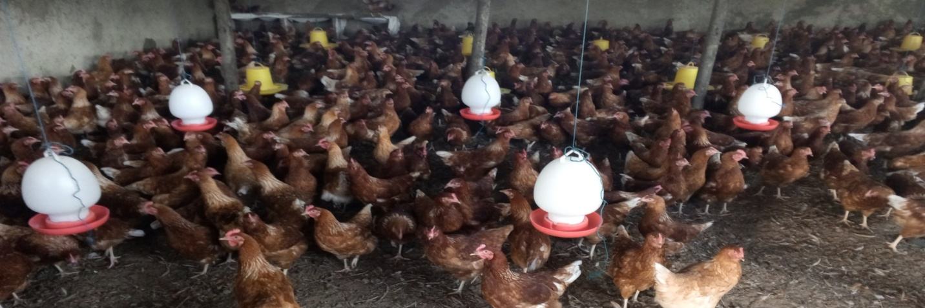
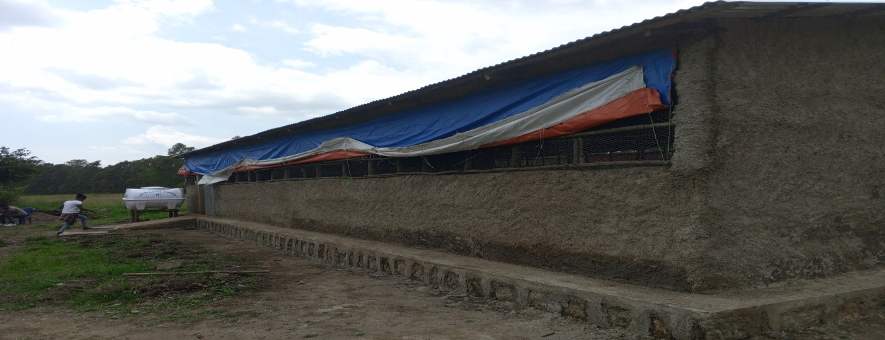

Fig. 1. Poultry house constructed with project support and active participation of the school community.

3.3.2. Installation of Utilities and Procurement of Equipment
To guarantee seamless operations, the project installed critical infrastructure including a potable water line with maintenance protocols, a water tanker, and an electrical connection to ensure uninterrupted water and power supply. These utilities were essential for maintaining appropriate husbandry conditions, supporting the health and productivity of the birds, and ensuring that egg production could be sustained throughout the year.
Concurrently, all necessary production equipment and inputs were procured and made available for use. This included feeders and drinkers designed for commercial layer management, starter feed for the pullets, and veterinary medicines for routine health management. The procurement process followed established procedures to ensure quality and cost-effectiveness, with inputs sourced from reputable suppliers.

3.3.3. Procurement and Stocking of Chickens
After completion of all preparatory activities, Bovans Brown pullets aged 60 days were purchased & stocked. The Bovans Brown breed was selected based on its demonstrated performance characteristics, including good egg production, adaptability to various management conditions, and suitability for smallholder and commercial production contexts in tropical environments.

3.4. Poultry Management Practices
The poultry demonstration center was managed using improved husbandry practices to optimize bird health and productivity. Birds received balanced diets appropriate to their production stage, beginning with concentrate pullet feed and transitioning to commercial layer feed at the onset of egg production. Clean drinking water was provided ad libitum. Routine health management included regular monitoring, Newcastle disease vaccination every three months, vitamin supplementation as needed, and strict biosecurity measures, including controlled access, footbaths, and routine cleaning and disinfection, to maintain flock health and prevent disease.

3.5. School Feeding Intervention
The Home-Grown School Feeding Program was officially launched on 30 March 2024 under the "One Egg for One Child" initiative. Approximately 100 nutritionally vulnerable students, identified in consultation with teachers, school administrators, and school community representatives, received one boiled egg per school day, five days per week. Daily attendance and egg distribution records were maintained to monitor implementation. Eggs were prepared and distributed under hygienic conditions as part of the school routine. Surplus eggs were sold locally, improving community access to nutritious food while generating revenue to purchase feed and pay poultry attendants, thereby supporting the program's long-term sustainability.

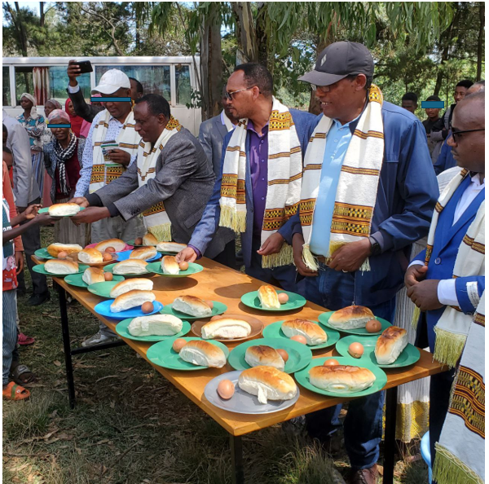

Fig.2. Official launch of the “One Egg for One Child” initiative under the Home-Grown School Feeding Program at Murancho Qutala Elementary School.

4. Results and dicsussion

4.1. Poultry Production Performance
The Bovans Brown chickens exhibited good production performance under the improved management conditions implemented at the demonstration center. The birds achieved body weights ranging from 1.2 to 1.6 kilograms, consistent with expected standards for the breed and age of the birds. This weight range indicated good growth and development, providing a foundation for subsequent productive performance.
Egg production commenced as expected and progressed through the typical production curve for commercial layers. Initial egg production was approximately 40% hen-day production, indicating the onset of lay and the transition to full production. As the birds matured production increased to a peak of 68-79% hen-day production, which represents strong performance within the expected range for Bovans Brown layers under tropical conditions.
Total egg production during the reporting period exceeded 61,000 eggs, demonstrating substantial productive capacity from the relatively small flock. This level of production significantly exceeded what would be achievable under traditional village poultry management, highlighting the productivity gains achievable through improved genetics and management.
The economic performance of the poultry enterprise was equally encouraging. Total revenue generated from egg sales and related activities was approximately ETB 500,000 (approximately USD 9,000 at prevailing exchange rates), demonstrating the income-generating potential of improved poultry production. From this revenue, the school community was able to purchase poultry feed, ensuring the continued operation of the enterprise and its feeding program. The generation of sufficient revenue to cover operating costs, particularly feed costs which represent the largest recurring expense in poultry production, is essential for the long-term sustainability of the enterprise.

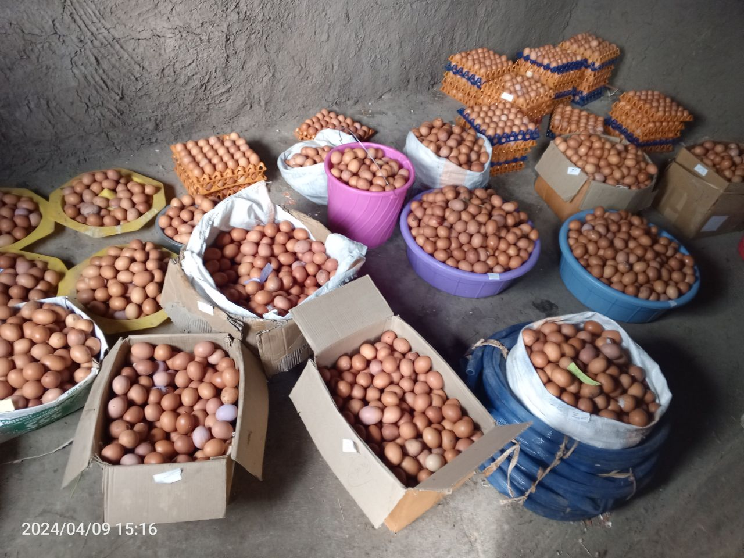
Fig. 3. Eggs collected from the poultry demonstration farm.

4.2. School Feeding Performance
The school feeding component of the intervention reached its intended beneficiaries effectively, with consistent participation throughout the implementation period. A total of 100 students were reached through the feeding program, with each participating student receiving one boiled egg per school day. This consistent daily provision ensured that students benefited from the nutritional value of eggs on a regular basis, potentially supporting their health, growth, and educational outcomes.
The total number of eggs distributed through the school feeding program during the intervention period was 4,250. This represented approximately 7% of total egg production, with the remainder sold to generate revenue for enterprise sustainability. The proportion of production allocated to the feeding program represented a balanced approach that achieved program objectives while ensuring financial viability.
Monitoring of daily attendance and consumption records indicated consistent participation among enrolled students, with limited absenteeism affecting program reach. The regular integration of egg distribution into the school day facilitated consistent consumption and contributed to students' positive perception of the program. Staff and community members involved in egg preparation and distribution reported that students were enthusiastic about the program and that egg consumption had become a positive aspect of the school day.

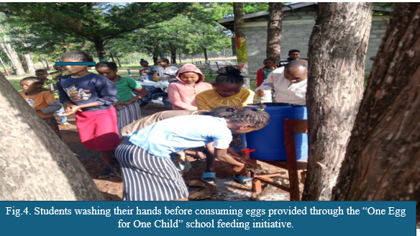
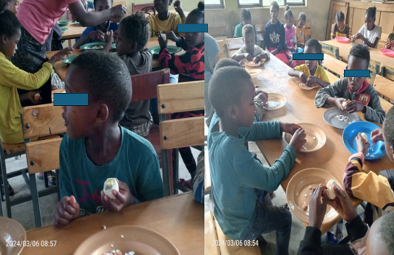

Fig.5. School children consuming eggs provided through the “One Egg for One Child” initiative under the Home-Grown School Feeding Program.4.3. Community Awareness and Capacity Building
The demonstration center served as a practical training and learning platform for diverse stakeholders, contributing to awareness and capacity building beyond the immediate school community. Students gained exposure to improved poultry production practices, developing understanding of animal husbandry, nutrition, and agricultural enterprise management.
Parents and community members visited the demonstration center, observing improved poultry management practices and learning about the potential for income generation through poultry production. The center's visible success created interest in adopting similar practices at the household level, potentially leading to broader impacts on community poultry production and nutrition. Community members expressed particular interest in the productivity gains achievable through improved genetics and management, and in the economic viability of poultry production as a livelihood enterprise.
The project also enhanced awareness of poultry marketing opportunities, demonstrating the potential for local egg sales and the importance of market linkages for sustainable poultry production. This awareness is essential for creating an enabling environment for poultry development, as production improvements alone are insufficient without viable markets for products.
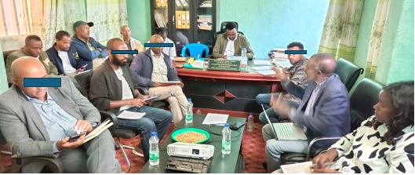
Fig.6. Project performance evaluation meeting conducted with the participation of key stakeholders

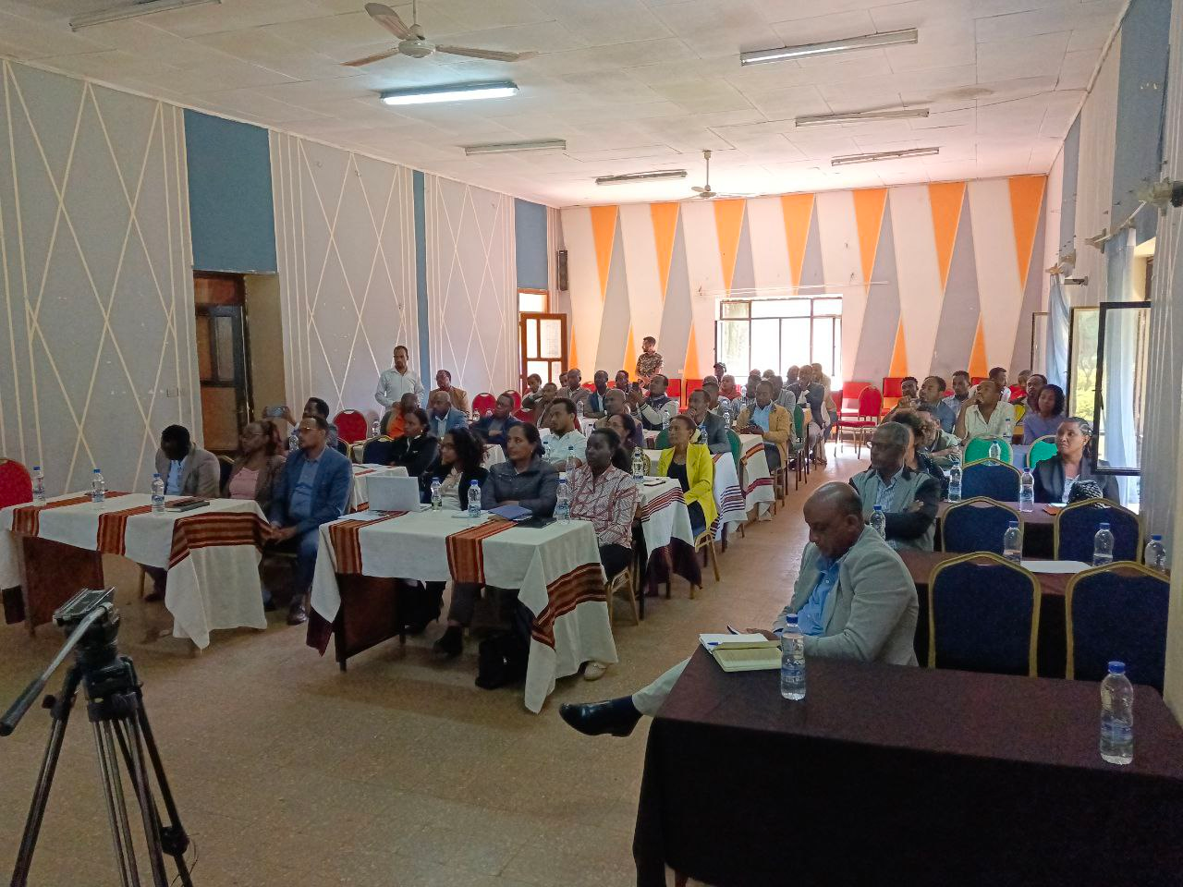
Fig.7. Forum for sharing experiences on the Murancho Qutala home-grown school feeding program, held with 25 school directors to support scaling up.

4.4. Employment Creation
The poultry enterprise created direct employment for five staff members (two females and three males) responsible for poultry management and school feeding, improving livelihoods and promoting gender inclusion. It also generated indirect employment and income opportunities through feed supply, egg marketing, and related activities, extending economic benefits to the wider community.
The findings demonstrate that integrating improved poultry production with Home-Grown School Feeding Programs is both feasible and beneficial. Bovans Brown chickens achieved peak egg production of 68–79%, substantially exceeding the 20–40% typically reported under traditional village systems (Mtileni et al., 2009), highlighting the advantages of improved genetics and management. Providing one egg daily supplied high-quality protein and essential micronutrients that are often lacking in the diets of rural Ethiopian schoolchildren, contributing to improved nutrition through the high bioavailability of egg nutrients (Adesogan et al., 2019; Gibson et al., 2018). Revenue generated from egg sales covered operational costs, demonstrating the financial sustainability of the enterprise. The intervention also increased community awareness of improved poultry production and promoted school-based agricultural enterprises as learning platforms. By linking local production with school feeding, the initiative ensured a reliable supply of fresh, nutritious food while strengthening local markets, consistent with the principles of Home-Grown School Feeding and nutrition-sensitive agriculture.

Conclusions
The “One Egg for One Child” initiative demonstrated the practical feasibility of linking improved poultry production with a Home-Grown School Feeding Program in the Sidama Region of Ethiopia. The poultry demonstration center produced a substantial number of eggs, supported regular egg distribution to selected schoolchildren, and generated income that contributed to feed purchase and enterprise operation. The intervention also created employment opportunities and served as a learning platform for students, teachers, parents, and community members on improved poultry management, nutrition, and egg marketing. These findings suggest that school-based poultry enterprises can contribute to local food provision and may support the sustainability of school feeding activities when properly managed. However, the evidence presented is mainly descriptive and should be interpreted cautiously. Further implementation with stronger monitoring, cost analysis, and nutrition-related outcome measurement would help determine the broader effectiveness and scalability of this model.

Limitations
This study was based on a single school-based intervention and did not include a control group or baseline and endline comparison. The results are mainly descriptive and focused on production, egg distribution, revenue generation, and community engagement. Direct nutritional outcomes, anthropometric changes, school attendance, academic performance, and household-level impacts were not measured. The short reporting period also limits assessment of long-term sustainability, flock productivity, cost recovery, and scalability. Therefore, the findings should be interpreted as evidence from a field demonstration rather than as conclusive proof of nutritional or educational impact.
Declaration of AI Use

This manuscript was prepared through the combined contributions of all author(s), including contributions to the study design, data, content development, results, interpretation, and related scholarly work. The author(s) acknowledge the use of Grammarly and ChatGPT to assist with grammar checking, language refinement, reference formatting. These AI-assisted tools were not used as authors and did not replace the intellectual contributions or scholarly judgment of the author(s). All AI-assisted outputs, including content, references, and interpretations, were carefully reviewed, revised, verified, and approved by the author(s). The author(s) accept full responsibility for the accuracy, integrity, and final content of the manuscript.

References
- Adesogan A, T,, A.H. Havelaar, S.L. McKune, M. Eilitta, G.E. Dahl. Animal source foods: sustainability problem or malnutrition and sustainability solution? Perspective matters. Global
- Alderman, Harold & Headey, Derek D., 2017. "How Important is Parental Education for Child Nutrition?," World Development, Elsevier, vol. 94(C), pages 448-464.
- Alders R., Dumas S., Rukambile E.et.al., 2018. Family poultry: Multiple roles, systems, challenges, and options for sustainable contributions to household nutrition security through a planetary health lens
- Bisset S, Fournier M, Pagani L, Janosz M. Predicting academic and cognitive outcomes from weight status trajectories during childhood. Int J Obes. 2013;37(1):154–9. https://doi.org/10.1038/ijo.2012.106.
- Drake L, Lazrak N, Fernandes M, et al. Establishing global school feeding program targets: how many poor children globally should be prioritized, and what would be the cost of implementation? Front Public Health. 2020; 8:530176
- Ethiopia Demographic and Health Survey(EDH) 2016. Addis Ababa, Ethiopia, and Rockville, Maryland, USA: CSA and ICF.
- Ethiopian Public Health Institute (EPH). 2025. A Guide to School Feeding Menus for Addis Ababa.
- FAO & WFP. 2018. Home-Grown School Feeding. Resource Framework. Synopsis. Rome, 36 pp.
- FAO. 2015. Egg facts. Rome. www.fao.org/assets/infographics/FAO-Infographic-egg-facts-en.pdf
- Food and Agriculture Organization. Eggs: harnessing their power for the fight against hunger and malnutrition available at, Global Forum on Food Security and Nutrition, No 154 (2018).
- Gelli A.2015. School Feeding and Girls' Enrollment: The Effects of Alternative Implementation Modalities in Low-Income Settings in Sub-Saharan Africa. Front Public Health.
- Iannotti LL, Lutter CK, Bunn DA, Stewart CP. 2014. Eggs: the uncracked potential for improving maternal and young child nutrition among the world's poor.
- Iannotti, L. L. , Lutter, C. K. , Stewart, C. P. , Gallegos Riofrío, C. A. , Malo, C. , Reinhart, G. , Palacios, A. , Karp, C. , Chapnick, M. , Cox, K. , & Waters, W. F. (2017). Eggs in early complementary feeding and child growth
- Prentice AM. The emerging epidemic of obesity in developing countries. Int J Epidemiol. 2005;35(1):93–9. https://doi.org/10.1093/ije/dyi272
- Singh, A.; Sharma, J.; Paichha, M.; Chakrabarti, R., 2020. Achyranthes aspera (prickly chaff flower) leaves- and seeds-supplemented diets regulate growth, innate immunity, and oxidative stress in Aeromonas hydrophila-challenged Labeo rohita. J. Appl. Aquacult., 32 (3): 250-267
- UNICEF (2019). The State of the World’s Children 2019. Children, Food and Nutrition: Growing well in a changing world. New York: UNICEF.
- Victora CG, Christian P, Vidaletti LP, Gatica-Domínguez G, Menon P, Black RE.2021. Revisiting maternal and child under nutrition in low-income and middle-income countries.

