Review Article

Quantifying the AMR Burden Attributable to Vaccine-Preventable Livestock Diseases in LMICs: A One Health Modelling Approach

Abstract

Background: Antimicrobial resistance (AMR) constitutes one of the most formidable public health threats of the 21st century, with low- and middle-income countries (LMICs) bearing a disproportionate burden. Livestock systems in these settings are both major consumers of antimicrobials and critical reservoirs for resistant pathogens, yet the quantitative contribution of vaccine-preventable livestock diseases to AMR burden remains poorly characterised within a One Health framework.
Objectives: This review synthesises available evidence on the burden of AMR attributable to vaccine-preventable livestock diseases in LMICs, evaluates existing modelling methodologies and their limitations, identifies critical data gaps, and proposes an integrated One Health modelling framework to guide future research and policy.
Methods: A narrative synthesis was conducted using evidence from PubMed, Scopus, Web of Science, and grey literature (WHO, FAO, WOAH, GRAM) published from 2015 to 2025. Studies examining AMR burden quantification, veterinary antimicrobial use (AMU), livestock vaccination, and One Health modelling approaches were included, with priority given to LMIC-focused evidence.
Results: Global AMU in food-producing animals was estimated at approximately 99,502 tonnes in 2020, projected to rise by 8% by 2030, with Asia and emerging economies disproportionately driving this trend. Vaccine-preventable diseases- including Foot-and-Mouth Disease, Newcastle Disease, Contagious Bovine Pleuropneumonia, and Brucellosis- collectively drive substantial antibiotic prophylaxis in LMICs. However, only 10% of LMICs systematically track AMR in animals, and no validated cross-sectoral modelling framework currently quantifies the AMR burden averted by livestock vaccination programmes. Existing approaches utilising Disability-Adjusted Life Years (DALYs), the Animal Health Loss Envelope (AHLE), and compartmental transmission models reveal significant methodological gaps.
Conclusions: A robust, LMIC-adapted One Health modelling framework integrating animal AMU data, zoonotic spillover pathways, vaccination coverage metrics, and human AMR outcomes is urgently needed. Addressing surveillance fragmentation, cold-chain barriers, and data harmonisation will be pivotal to realising the full potential of livestock vaccination as a cost-effective AMR mitigation strategy.

Keywords: Antimicrobial resistance; livestock vaccines; LMICs; One Health; disease burden modelling; vaccine-preventable diseases

1. Introduction

Antimicrobial resistance (AMR) has emerged as a defining global health crisis, threatening to unravel decades of progress in infectious disease management (WHO, 2023). The Global Research on Antimicrobial Resistance (GRAM) project estimated that in 2019 alone, 1.27 million deaths were directly attributable to bacterial AMR, with a further 4.95 million deaths associated with resistant infections (Murray et al., 2022). Modelling projections paint an even grimmer future: without concerted action, AMR could cause 38.5 million cumulative human deaths between 2025 and 2050, with the heaviest burden concentrated in South Asia, Sub-Saharan Africa, and Southeast Asia- regions broadly constituting low- and middle-income countries (LMICs) (WOAH, 2024).

The livestock sector occupies a paradoxical position in this crisis. On one hand, food-producing animals represent the largest single reservoir of antimicrobial consumption globally, accounting for the majority of total antibiotic production in many nations (Van Boeckel et al., 2015; Mulchandani et al., 2023). On the other hand, healthy livestock are foundational to food security, livelihoods, and economic stability in LMICs, where smallholder farming systems often lack the biosecurity infrastructure and veterinary capacity that make routine antibiotic use seem indispensable to farmers (Coyne et al., 2019). This tension- between the necessity of animal productivity and the imperative to reduce AMU- defines one of the most urgent implementation challenges at the human-animal-environment interface.

Vaccination of livestock offers a compelling dual solution: it prevents disease, thereby directly reducing the infections that drive antibiotic prescribing, and it reduces resistant pathogen reservoirs that can spill over into human populations (Lhermie et al., 2017; Yugueros-Marcos and Etienne, 2026). Despite this theoretical elegance, the quantitative evidence linking livestock vaccination to measurable reductions in AMR burden- particularly in LMICs- remains fragmented, methodologically inconsistent, and largely absent from integrated One Health modelling frameworks (Martins et al., 2024; Venkateswaran et al., 2024).

This review addresses this gap directly. We synthesise global evidence on antimicrobial use patterns in livestock, identify the principal vaccine-preventable diseases driving antibiotic dependency in LMICs, evaluate the state of One Health modelling for quantifying vaccine-attributable AMR burden reduction, and propose a conceptual framework for future research. The paper is structured to serve both scientific and policy audiences, with particular relevance to the WOAH/FAO/WHO Quadripartite's One Health Joint Plan of Action (2022–2026).

2. Scope and Methodology

This narrative review was conducted following the broad principles of systematic evidence synthesis. Literature was identified through PubMed, Scopus, Web of Science, and Google Scholar, supplemented by grey literature from WHO, FAO, WOAH, the GRAM project, the Global Burden of Animal Diseases (GBADs) programme, and IFPMA. Search terms included combinations of: 'antimicrobial resistance', 'livestock', 'vaccines', 'LMICs', 'One Health', 'modelling', 'DALY', 'burden of disease', 'antibiotic use', 'zoonosis', 'vaccine-preventable', and relevant disease names (FMD, Newcastle disease, CBPP, Brucellosis, HPAI). Studies published between 2015 and 2025 were considered, with priority given to empirical studies, systematic reviews, and modelling papers published after 2019.
Inclusion criteria encompassed: (i) studies quantifying AMU or AMR burden in livestock; (ii) studies evaluating vaccine impact on antibiotic use or AMR; (iii) One Health modelling frameworks applicable to LMICs; and (iv) epidemiological or economic analyses of vaccine-preventable livestock diseases. Studies limited exclusively to high-income country settings with no transferable methodology were excluded. Data on AMU projections, DALY estimates, and vaccine coverage were extracted and cross-referenced across multiple primary sources.
Table 1. Summary of key vaccine-preventable livestock diseases driving AMU in LMICs and their AMR relevance
Disease | Pathogen | Species Affected | LMIC Burden | Antibiotics Used | Vaccine Availability
Foot-and-Mouth Disease (FMD) | FMDV (Picornavirus) | Cattle, pigs, sheep, goats | Endemic Asia, Africa, Middle East | Broad-spectrum prophylaxis | Available; coverage gaps in LMICs
Newcastle Disease (ND) | Avulavirus (NDV) | Poultry | Major smallholder poultry losses Sub-Saharan Africa, Asia | Tetracyclines, fluoroquinolones | Thermostable (I-2 strain) available; widely used
Contagious Bovine Pleuropneumonia (CBPP) | Mycoplasma mycoides | Cattle | Sub-Saharan Africa- major cattle-keeping regions | Oxytetracycline (widespread) | Available; short duration of immunity; gaps remain
Brucellosis | Brucella abortus / melitensis | Cattle, sheep, goats | Africa, South/Central Asia, Middle East | Doxycycline, rifampicin | Rev-1, S19, RB51 vaccines available; underutilised
Highly Pathogenic Avian Influenza (HPAI) | Influenza A (H5N1/H5N6) | Poultry, waterfowl | Recurrent outbreaks Asia, Africa | Antivirals + broad-spectrum ABs for secondary infections | Used in some countries (China, Egypt); limited LMIC deployment
Mycoplasma infections (poultry) | Mycoplasma gallisepticum / synoviae | Poultry | South/Southeast Asia- major driver of AMU | Macrolides, tetracyclines- extensive use | Live vaccines now used to reduce antibiotic dependency
Source: Compiled by authors from Morrow (2024), Martins et al. (2024), and Jacobsen et al. (2025).

3. Antimicrobial Use in Livestock: Global and LMIC Patterns

3.1 Magnitude and Trajectory of Global AMU

The scale of antimicrobial use (AMU) in food-producing animals is formidable. Van Boeckel et al. (2015) estimated total livestock antibiotic consumption at 63,151 tonnes in 2010, with projections of a 67% rise by 2030 driven by intensification of production systems in middle-income countries. Subsequent modelling by Mulchandani et al. (2023), using updated data from 42 countries, estimated global AMU at approximately 99,502 tonnes (95% CI: 68,535–198,052) in 2020, with a projected 8% increase by 2030 to 107,472 tonnes. Notably, Asia accounts for approximately 67% of global hotspots for AMU intensity, while Africa contributes less than 1% in absolute tonnage terms- yet represents the most rapidly expanding trajectory given projected intensification of livestock systems (Mulchandani et al., 2023).

The per-species perspective is instructive. Tiseo et al. (2020) found that global average antimicrobial consumption was highest in poultry (148 mg/kg), followed by swine (172 mg/kg), and lowest in cattle (45 mg/kg). This pattern is particularly relevant for LMICs, where poultry and swine systems are expanding rapidly to meet urban protein demand, often with minimal veterinary oversight (Coyne et al., 2019). In Bangladesh, for instance, approximately 94.16% of poultry farmers report using antimicrobials in their flocks, primarily tetracyclines, fluoroquinolones, and macrolides- many of which are critically important antimicrobials (CIA) designated by WHO (Al Asad and Katha, 2024).
3.2 AMU Drivers in LMIC Livestock Systems

The structural drivers of high AMU in LMIC livestock systems are well documented and deeply intertwined with the absence of effective vaccination programmes. First, vaccine-preventable respiratory and enteric diseases- including Newcastle Disease, CBPP, and Mycoplasma infections- create chronic cycles of morbidity that farmers manage almost exclusively through antibiotic administration, often without veterinary prescription (Morrow, 2024; Jacobsen et al., 2025). Second, inadequate biosecurity infrastructure in smallholder systems means that herd-level disease containment depends on metaphylactic antibiotic use rather than prevention (Coyne et al., 2019). Third, the absence of functioning regulatory frameworks in many LMICs permits over-the-counter antibiotic sales, growth promotion use, and sub-therapeutic administration without oversight (Al Asad and Katha, 2024).
AMU projections for emerging economies are particularly concerning. Mulchandani et al. (2023) project that AMU intensity will rise substantially by 2030 in countries such as Myanmar (205%), Indonesia (202%), Nigeria (163%), Peru (160%), and Vietnam (157%), driven by expansion of intensive production systems. These projections underscore the urgent need for preventive alternatives- including vaccination- to be integrated into national AMR action plans before consumption spirals further.

4. The One Health Nexus: Livestock AMR and Human Health Burden

4.1 Pathways of AMR Transmission from Livestock to Humans

The One Health framework posits that human, animal, and environmental health are inextricably linked- a premise particularly well-evidenced in the context of AMR (WHO/FAO/WOAH, 2022). Resistant bacteria and antimicrobial resistance genes (ARGs) generated within livestock systems reach human populations through multiple interconnected pathways: direct zoonotic transmission through occupational exposure; indirect transmission through contaminated food products and the food chain; environmental dissemination through agricultural runoff, soil, and water systems; and airborne spread in regions of dense livestock-human cohabitation (Elbehiry and Marzouk, 2025; Al-Khalaifah et al., 2025).
The epidemiological consequences of these pathways are substantial. In sub-Saharan Africa, the highest rate of human deaths attributed to AMR globally- 23.7 per 100,000- has been documented, approximately 50% above the global average of 16.4 per 100,000 (Jacobsen et al., 2025). WOAH (2024) projects that the spread of resistant pathogens from livestock to humans could cost $77–384 billion per year in GDP losses, depending on spillover severity, with the heaviest mortality burden falling on South Asia (630,000 annual deaths) and Sub-Saharan Africa (320,000 annual deaths)- the very regions where livestock vaccination coverage is lowest and AMU regulation weakest.
4.2 Multidrug Resistance in Livestock Pathogens of Zoonotic Concern

Multi-drug resistant (MDR) bacteria circulating in livestock systems of LMICs represent a direct public health threat. In LMICs' poultry and swine sectors, MDR Escherichia coli prevalence already exceeds 50% of isolates in some settings (Mulchandani et al., 2023; Elbehiry and Marzouk, 2025). Salmonella serovars with resistance to third-generation cephalosporins and fluoroquinolones have been extensively documented in poultry slaughter chains across South and Southeast Asia (Sana et al., 2025). Campylobacter jejuni isolates with ciprofloxacin resistance rates exceeding 80% have been reported in poultry farms in sub-Saharan Africa, where vaccination and biosecurity programmes are largely absent (Jacobsen et al., 2025).
The mechanistic link between vaccine-preventable diseases and zoonotic AMR emergence is particularly clear for Mycoplasma infections. Morrow (2024) demonstrated that routine antibiotic administration in laying flocks- primarily driven by uncontrolled Mycoplasma gallisepticum infections- exerts significant selective pressure on commensal E. coli and Salmonella in the chicken microbiota, generating the resistance profiles subsequently detected in processed poultry products and human clinical isolates. Vaccination of Mycoplasma-negative flocks with live Mycoplasma vaccines has been shown to reduce antibiotic dependence in lay, directly interrupting this resistance amplification cycle.

Table 2. Projected AMR-attributable human mortality and economic burden from livestock spillover in LMICs by 2050
Region | Annual Deaths (2050 Projection) | GDP Loss Estimate (USD billion/year) | Key Livestock-Related Pathogen Concern
South Asia | 630,000 | 77–384 (combined spillover) | MDR E. coli, Salmonella, HPAI H5N1
Sub-Saharan Africa | 320,000 | High (data incomplete) | MDR Salmonella, CBPP-driven oxytetracycline AMR, Brucella
Southeast Asia / East Asia / Oceania | 390,000 | High | MDR Campylobacter, ESBL E. coli (poultry)
Latin America | Moderate (data gaps) | Moderate | MDR E. coli (swine), Salmonella (poultry)
Global (all LMICs combined) | ~10 million (AMR total by 2050) | 2–3.5% GDP loss | Cross-sectoral- livestock contribution unquantified
Source: WOAH (2024); Murray et al. (2022); Mulchandani et al. (2023); Jacobsen et al. (2025). Note: Livestock-specific proportions of projected mortality remain unquantified- representing a key research gap.

5. Livestock Vaccines as AMR Mitigation: Evidence and Mechanisms

5.1 Direct and Indirect Mechanisms of AMR Reduction

Vaccines reduce AMR burden through at least four mechanistic pathways. First, by preventing primary infection, vaccines eliminate the immediate therapeutic indication for antibiotic administration. Second, by preventing viral infections that predispose animals to secondary bacterial infections, vaccines reduce the frequency of infections that require antibiotic treatment. Third, by reducing the overall prevalence of pathogenic bacteria in livestock populations, vaccines reduce the density of bacterial populations on which selective antibiotic pressure can operate. Fourth, by reducing zoonotic spillover of resistant pathogens, effective livestock vaccination programmes protect human populations from acquiring AMR infections through animal contact or the food chain (Lhermie et al., 2017).
The evidence base for these mechanisms is growing, though predominantly generated in high-income country settings. In the aquaculture industry, widespread vaccination of salmonids in Norway contributed to a greater than 99% reduction in antibiotic use between 1987 and 2012, providing perhaps the strongest demonstration of vaccination's transformative potential for AMU reduction (Schar et al., 2020). For terrestrial livestock, a survey of poultry farmers in Senegal demonstrated that farmers with higher AMR awareness and greater vaccination uptake were significantly less likely to use antibiotics in healthy birds, and farms with better vaccination protocols showed reduced AMU alongside maintained productivity (Van Boeckel et al., 2015).

5.2 Disease-Specific Evidence: Key Vaccine-Preventable Diseases
5.2.1 Newcastle Disease

Newcastle Disease (ND) is arguably the most important vaccine-preventable cause of antibiotic overuse in smallholder poultry systems across Sub-Saharan Africa and South Asia. NDV outbreaks trigger immediate antibiotic prophylaxis of entire flocks- a pattern driven by farmer behaviour, lack of diagnostics to differentiate viral from bacterial aetiology, and the inability to afford flock losses (Morrow, 2024; Sana et al., 2025). The thermostable I-2 strain NDV vaccine, developed specifically for LMIC settings, has demonstrated strong efficacy under ambient temperature conditions, making it a critical tool for reducing AMU-driven AMR in smallholder systems. Marzouk and Alajaji (2025) documented that thermostable NDV vaccines in tablet and ocular formats have reduced outbreak frequency in LMIC poultry systems, though quantitative linkage to AMU reduction in these settings remains poorly documented.
5.2.2 Brucellosis

Brucellosis in cattle and small ruminants drives substantial doxycycline and oxytetracycline use in LMICs, particularly in Africa and Central/South Asia- both critically important antimicrobials (CIAs) in human medicine. Targeted Rev-1 vaccination of small ruminants against Brucella melitensis has been associated with measurable declines in human brucellosis incidence, and programme lapses have consistently coincided with rebounds in both animal and human disease (Marzouk and Alajaji, 2025). Despite this evidence, Brucella vaccination coverage in LMICs remains low due to cold-chain requirements, livestock movement constraints, and the need for trained personnel for vaccine administration.
5.2.3 Contagious Bovine Pleuropneumonia (CBPP)

CBPP, caused by Mycoplasma mycoides subsp. mycoides, remains endemic across sub-Saharan Africa and drives extensive oxytetracycline use. Paradoxically, the selective pressure of oxytetracycline on commensal bacteria in treated cattle is generating resistance profiles relevant to both animal and human pathogens (Jacobsen et al., 2025). The available CBPP vaccine provides only short-duration immunity (approximately six months), necessitating frequent revaccination that is logistically challenging in pastoral systems- a gap that next-generation vaccine platforms could potentially address.
5.3 Quantitative Evidence Gaps

Despite the theoretical and mechanistic evidence, robust quantitative evidence directly linking livestock vaccination programmes to measurable reductions in AMR burden- expressed in standardised units such as DALYs, antibiotic consumption per population correction unit (PCU), or resistance gene prevalence indices- is remarkably sparse in LMIC contexts. Venkateswaran et al. (2024), conducting a systematic mapping exercise within the GBADs programme, identified AMU measurement gaps in livestock AMR surveillance as a critical bottleneck for burden estimation. Critically, only 10% of LMICs report tracking AMR in animals in any standardised format (Al Asad and Katha, 2024). The IFPMA (2023) value framework for vaccine-mediated AMR reduction- which includes 'vaccine-averted AMR health burden' as a first criterion- explicitly acknowledges insufficient data to populate this metric in LMIC livestock contexts.

6. Existing Modelling Frameworks for AMR Burden Quantification

6.1 Disability-Adjusted Life Years (DALYs) and Burden of Disease Modelling

The Disability-Adjusted Life Year (DALY) is the primary standardised metric for comparing AMR burden across diseases and regions in human health. The GRAM project's 2022 landmark study computed age-specific deaths and DALYs attributable to and associated with bacterial AMR across 23 pathogens and 88 pathogen-drug combinations for 204 countries, estimating 47.9 million DALYs attributable to AMR globally in 2019 (Murray et al., 2022). A subsequent modelling study evaluated the proportion of this AMR burden that could theoretically be averted through vaccination, providing estimates for existing vaccine platforms (PCV, TCV, rotavirus, influenza) but notably excluding livestock-related pathogens in LMIC-relevant modelling scenarios (Kim et al., 2023).
The absence of livestock-origin AMR from DALY-based modelling reflects a fundamental data gap: the GRAM methodology required country-level antimicrobial susceptibility testing data and clinical surveillance data that virtually no LMIC routinely generates for animal sources (Venkateswaran et al., 2024). Cross-sectoral One Health modelling of DALYs- attributing a proportion of human AMR DALYs to animal-origin resistant pathogens- has been identified as a priority by the Naylor et al. (2020) scoping review, which found that quantitative One Health evaluation frameworks for AMR remain underdeveloped, particularly for the animal-human transmission interface in resource-limited settings.
6.2 The Global Burden of Animal Diseases (GBADs) Framework

The GBADs programme, hosted at the University of Liverpool, has pioneered a conceptual framework for quantifying the social and economic burden of AMU and AMR in livestock using the Animal Health Loss Envelope (AHLE) as the central metric (Martins et al., 2024). The AHLE defines the boundary for overall losses from health hazards in livestock, enabling AMU to be positioned as both a cost incurred to reduce infection-associated losses and a generator of negative externalities in the form of AMR. Three distinct pathways through which AMR contributes to the AHLE are identified: (i) increased mortality and morbidity from resistant infections; (ii) direct expenditure on second-line antimicrobials; and (iii) spillover to human health, creating costs outside the livestock sector (Martins et al., 2024).
While the GBADs AHLE framework represents the most methodologically sophisticated approach to livestock AMR burden quantification available, Martins et al. (2024) explicitly acknowledge that the framework remains conceptual, with critical data gaps preventing operationalization- particularly for LMICs. Standardised methodologies for AMU measurement in livestock are absent in most LMIC settings, making baseline data for AHLE calculations essentially unavailable. This renders the vaccine-averted burden component of the framework currently inestimable in a quantitative sense.
6.3 Epidemiological Transmission Models

Compartmental transmission models (SIR/SIS/SEIR) and agent-based models (ABMs) have been applied to simulate AMR dynamics in livestock populations, though typically in isolation from human health outcomes. Naylor et al. (2020), in a scoping review of quantitative One Health evaluation frameworks, identified that models integrating human and animal AMR dynamics- and capable of generating cross-sectoral impact estimates- were extremely rare, particularly for LMIC contexts. Where such models exist, they commonly omit vaccination as an intervention parameter, focusing instead on antibiotic restriction policies as the primary lever for AMR reduction.
The absence of validated cross-sectoral transmission models capable of quantifying the AMR burden averted by livestock vaccination represents perhaps the most consequential methodological gap in this field. Such models would need to integrate: (i) vaccine coverage and efficacy data by disease and livestock species; (ii) AMU reduction coefficients linked to vaccination status; (iii) resistant pathogen prevalence in livestock populations; (iv) transmission probabilities across the livestock-human interface; and (v) human clinical outcomes expressed in DALYs. None of the models reviewed in this synthesis met all five criteria for LMIC settings.
Table 3. Comparison of existing modelling frameworks for AMR burden quantification: applicability and limitations in LMIC livestock contexts
Framework | Primary Metric | Livestock-Human Integration | Vaccine Parameter Included? | LMIC Applicability
GRAM / Murray et al. (2022) | DALYs; deaths attributable/associated with AMR | No- human clinical data only | No | Limited- requires surveillance data absent in most LMICs
GBADs / AHLE (Martins et al., 2024) | Animal Health Loss Envelope (monetary) | Conceptually yes; operationally no | Partially (as prevention cost) | Moderate- framework designed for LMICs but data gaps critical
Naylor et al. (2020)- One Health DALY | DALYs with cross-sectoral attribution | Yes- scoping framework | Not operationalised | Low- theoretical only; no LMIC empirical application
IFPMA / WHO Vaccine Value Framework (2023) | 5-criterion vaccine value index incl. AMR | Partially- focuses on human vaccines | Yes- core criterion | Low for livestock- data explicitly insufficient
Compartmental SIR/SEIR Models | Prevalence; resistance frequency | Rarely | Rarely | Variable; requires parameterisation data absent in LMICs
Source: Authors' synthesis. GRAM= Global Research on Antimicrobial Resistance; GBADs= Global Burden of Animal Diseases; AHLE= Animal Health Loss Envelope; IFPMA= International Federation of Pharmaceutical Manufacturers & Associations.

7. Proposed One Health Modelling Framework

7.1 Conceptual Structure

Based on the evidence synthesised above, we propose an integrated One Health modelling framework for quantifying the AMR burden attributable to vaccine-preventable livestock diseases in LMICs. The framework draws on the complementary strengths of the GRAM DALY methodology, the GBADs AHLE approach, and compartmental transmission modelling, structured around four interacting modules: (i) Livestock Disease Burden and AMU Module; (ii) AMR Generation and Resistance Gene Spread Module; (iii) Cross-Sectoral Transmission and Spillover Module; and (iv) Human Health Outcome and DALY Attribution Module.
The Livestock Disease Burden and AMU Module estimates, for each target vaccine-preventable disease (FMD, ND, CBPP, Brucellosis, HPAI), the species-specific infection incidence, associated AMU volumes (expressed in mg/PCU), and the counterfactual AMU that would be averted under defined vaccination coverage scenarios. Vaccination coverage is modelled as a continuous variable, enabling the generation of dose-response curves linking coverage rates to AMU reduction.
The AMR Generation Module translates AMU volumes into resistant pathogen prevalence estimates for the indicator organisms most relevant to human health (E. coli, Salmonella, Campylobacter) using published AMU-resistance relationships. This module incorporates horizontal gene transfer probability estimates for mobile genetic elements carrying clinically relevant resistance genes (e.g., blaCTX-M, mcr-1, tet genes).
The Cross-Sectoral Transmission Module applies region-specific transmission probability matrices for the livestock-human interface, drawing on zoonotic spillover modelling approaches and contextualised to LMIC production systems (smallholder vs. intensive). Finally, the Human Health Outcome Module converts estimated human AMR infection events into DALYs using GRAM disability weights and age-specific mortality data, enabling direct comparison with existing human AMR burden estimates and the calculation of vaccine-averted DALYs.
7.2 Data Requirements and Sources

Operationalisation of this framework in LMIC settings will require harmonised data across four domains: (1) animal health data- disease incidence by species and region, AMU volumes stratified by disease indication, and vaccination coverage rates, ideally drawn from WOAH WAHIS, FAO EMPRES, and national veterinary authorities; (2) AMR surveillance data- resistance prevalence in livestock indicator organisms, drawn from WHO GLASS (where animal modules exist), WOAH AMR surveillance, and academic literature; (3) cross-sectoral transmission data- livestock-human contact rates, food chain contamination data, and environmental AMR prevalence; and (4) human health data- AMR infection incidence, mortality, and DALY weights, aligned with GRAM estimates.
8. Barriers to Implementation of Livestock Vaccination in LMICs

8.1 Cold-Chain and Delivery Infrastructure

The most fundamental implementation barrier is cold-chain dependence of conventional vaccines. Most veterinary vaccines require storage between 2°C and 8°C to maintain potency; however, infrastructure limitations and frequent power outages in remote LMIC settings routinely compromise cold-chain integrity, leading to vaccine spoilage and loss of efficacy (Raut et al., 2025). Economic constraints in LMICs further impede investment in cold-chain infrastructure, creating a structural disadvantage precisely in the regions where vaccination is most urgently needed (Acharya and Phuyal, 2025). Novel thermostable formulations- utilising lyophilisation, spray drying, and vacuum foam drying- offer potential solutions, but manufacturing complexity and cost remain significant barriers to scale-up (Marzouk and Alajaji, 2025).
8.2 Surveillance Fragmentation and Data Availability

Effective vaccination programme planning and AMR burden monitoring both depend on functional surveillance infrastructure that is largely absent in LMIC livestock sectors. Fragmented AMR surveillance systems, weak laboratory infrastructure, and inconsistent policy enforcement collectively undermine the capacity to measure baseline AMR burden, evaluate vaccination impact, or make evidence-based investment decisions (Elbehiry and Marzouk, 2025; Al-Khalaifah et al., 2025). The introduction of genomic tools- whole-genome sequencing, metagenomics, and CRISPR-based diagnostics- offers transformative potential for AMR surveillance, but significant barriers related to limited bioinformatics capacity, economic constraints, and fragmented governance impede their adoption in LMICs (Dougan and Hugo-Webb, 2025).
8.3 Regulatory and Governance Gaps

Novel vaccine platforms- including mRNA vaccines, nanovaccine formulations, and vector-based technologies- face significant regulatory barriers in LMIC settings that differ substantially from high-income country regulatory environments. While the EU's 2018 ECJ ruling and EFSA's 2025 opinion have clarified governance for novel biotechnologies in Europe, many LMICs lack equivalent regulatory capacity or precedent for genome-edited or novel platform vaccines for livestock (Marzouk and Alajaji, 2025). Kenya's 2022 and 2025 genome-editing guidelines represent a notable exception, demonstrating that LMIC regulatory frameworks can adapt when provided with appropriate technical support and stakeholder engagement.
8.4 Economic and Political Barriers

Livestock vaccination programmes in LMICs face structural economic disincentives. The short-term cost of vaccines- even when subsidized- may exceed the immediate economic horizon of smallholder farmers operating with thin margins and minimal animal health insurance. Political will for sustained vaccination programmes is often insufficient in contexts where competing health priorities dominate national AMR action plans. Moreover, IFPMA (2023) and WHO (2024) mRNA Technology Transfer initiatives highlight that even where technical knowledge exists, the capital costs of vaccine manufacturing infrastructure- fill-finish capacity, GMP utilities, trained personnel- remain prohibitive for most LMICs, creating sustained dependency on imported vaccine products that are not tailored to local pathogen strains (Marzouk and Alajaji, 2025).
Table 4. Key research gaps and priority actions for quantifying vaccine-attributable AMR burden in LMIC livestock systems
# | Research Gap | Current Limitation | Priority Action | Relevant Stakeholders
1 | Absence of LMIC-specific AMU data linked to vaccine-preventable disease cycles | Only 10% of LMICs track AMR in animals; no standardised AMU metric by disease indication | Develop disease-specific AMU sentinels in pilot countries; integrate into WOAH WAHIS reporting | WOAH, FAO, national veterinary authorities
2 | No validated cross-sectoral modelling framework linking livestock vaccination to human AMR DALYs | Existing models (GRAM, GBADs) are siloed; none integrate vaccination as a parameter in LMIC livestock contexts | Develop and validate integrated One Health modelling framework (as proposed in Section 7); pilot in 3–5 LMIC countries | WHO, GBADs consortium, academic institutions
3 | Thermostable vaccine platforms underutilised; AMR impact of cold-chain failure not quantified | Cold-chain failure rates in LMICs are underdocumented; spoilage-related AMR consequences unmodelled | Conduct cold-chain integrity studies in LMIC pilot settings; model AMR implications of vaccine potency loss | GAVI, Wellcome Trust, Ministries of Agriculture
4 | Zoonotic transmission coefficients for AMR from LMIC livestock systems are poorly defined | Transmission probability matrices lack LMIC-specific parameterisation for livestock-human interfaces | Conduct systematic cross-sectional studies of AMR prevalence at livestock-human interfaces in priority LMIC regions | ILRI, LSHTM, national public health institutes
5 | Economic cost-effectiveness of livestock vaccination as an AMR intervention remains unquantified in LMICs | No LMIC cost-benefit analyses integrating human health externalities of livestock AMR averted by vaccination | Develop LMIC-adapted health economic models incorporating full One Health AMR externalities of livestock vaccination | World Bank, IMF, IFPMA, WHO
Source: Authors' synthesis from Martins et al. (2024), Venkateswaran et al. (2024), WOAH (2024), and Jacobsen et al. (2025).

9. Policy Implications and Recommendations

9.1 Integration into National AMR Action Plans

The evidence presented in this review demonstrates that livestock vaccination is a systematically underutilised component of national AMR action plans (NAPs) in LMICs. The WOAH/FAO/WHO One Health Joint Plan of Action (2022–2026) provides a global governance framework, but success requires national adaptation, sustainable financing, and accountability mechanisms that explicitly integrate veterinary vaccination targets alongside antimicrobial stewardship goals (Marzouk and Alajaji, 2025). We recommend that all LMICs with significant livestock sectors establish formal vaccination coverage targets for priority vaccine-preventable diseases- FMD, ND, CBPP, and Brucellosis at minimum- as integral components of their NAPs, with dedicated monitoring frameworks linked to WOAH reporting.

9.2 Investment in LMIC-Adapted Vaccine Technologies
The thermostable vaccine platform represents the most immediately actionable technological investment for expanding livestock vaccination in LMIC settings. Newcastle Disease thermostable vaccines (I-2 strain) already demonstrate proof-of-concept, and recent innovations in vacuum foam drying have further extended NDV shelf-life at ambient temperatures (Marzouk and Alajaji, 2025). Prioritising manufacturing technology transfer for thermostable formulations of CBPP and FMD vaccines- diseases for which cold-chain-independent vaccines are not yet commercially available- should become a funding priority for GAVI, the Wellcome Trust, and CEPI livestock health programmes.

9.3 One Health Surveillance Investment
Effective surveillance is the foundational requirement for all the policy interventions identified in this review. Cross-sector dashboards that report human outcomes alongside animal and environmental AMR indicators- tracking AMU, resistance prevalence, time-to-detection, DALYs averted, and antibiotic-use context- are needed to make One Health accountability operational rather than aspirational (Marzouk and Alajaji, 2025). Standardised AMR/AMU indicators aligned with WHO's GLASS, WOAH's WAHIS, and the IHR/Joint External Evaluation framework would enable cross-country comparison and adaptive policy design.

10. Conclusions

This review indicates that vaccine-preventable livestock diseases may contribute substantially to antimicrobial use in LMIC livestock systems, but the magnitude of their contribution to AMR burden remains insufficiently quantified. Livestock vaccination has a plausible role in reducing antimicrobial demand by preventing primary infections, limiting secondary bacterial complications, and decreasing disease-related prophylactic treatment. Nevertheless, current evidence is fragmented, and few available studies directly connect vaccination coverage with measurable reductions in antimicrobial use, resistant pathogen prevalence, or human AMR outcomes. Existing burden estimation approaches offer important methodological foundations, but they remain limited by incomplete animal health surveillance, scarce disease-specific antimicrobial use data, and weak integration between livestock, environmental, and human health information. A practical One Health modelling framework should therefore combine livestock disease incidence, vaccination coverage, antimicrobial use, resistance emergence, transmission pathways, and human health impact measures. Such a framework would help policymakers estimate the potential value of livestock vaccination as part of national AMR action plans. Future work should prioritize reliable surveillance, standardised data collection, validation of model parameters in LMIC settings, and assessment of the economic and health benefits of vaccination-based AMR mitigation.
Limitations
This review is limited by the availability and quality of existing evidence on livestock vaccination, antimicrobial use, and AMR outcomes in LMICs. Much of the available literature is indirect, and few studies provide disease-specific estimates linking vaccination to reduced antimicrobial consumption or measurable changes in resistant pathogen prevalence. Several modelling frameworks discussed in the manuscript remain conceptual or are based primarily on human health data, which limits their direct application to livestock-origin AMR. Surveillance gaps in many LMICs also restrict the reliability of burden estimates and make cross-country comparisons difficult. The review did not present a formal systematic review process, risk-of-bias assessment, or meta-analysis, and therefore the findings should be interpreted as a narrative synthesis rather than a quantitative estimate of vaccine-attributable AMR reduction. Further empirical studies and validated One Health models are needed to support stronger conclusions.

Declaration of AI Use

This manuscript was prepared through the combined contributions of all author(s), including contributions to the study design, data, content development, results, interpretation, and related scholarly work. The author(s) acknowledge the use of Grammarly and ChatGPT to assist with grammar checking, language refinement, reference formatting. These AI-assisted tools were not used as authors and did not replace the intellectual contributions or scholarly judgment of the author(s). All AI-assisted outputs, including content, references, and interpretations, were carefully reviewed, revised, verified, and approved by the author(s). The author(s) accept full responsibility for the accuracy, integrity, and final content of the manuscript.

Conflict of Interest: The authors declare no conflict of interest.
Ethics Statement: No human participants or animals were involved in this review.
References
Acharya, K.P. and Phuyal, S., 2025. The unsung virtue of thermostable anti-rabies vaccine. Open Veterinary Journal, 15(5), p.1864.
Al Asad, M. and Katha, Z.S., 2024. Antimicrobial resistance in livestock-human interaction: A critical public health issue. JSM Microbiology, 10(1), p.1062. https://doi.org/10.47739/2333-6455/1062
Al-Khalaifah, H., Rahman, M.H., Al-Surrayai, T., Al-Dhumair, A. and Al-Hasan, M., 2025. A One-Health perspective of antimicrobial resistance (AMR): Human, animals and environmental health. Life, 15(10), p.1598.
Coyne, L., Latham, S.M., Dawson, S., Donald, I.J., Pearson, R.B., Smith, R.F., Williams, D.J. and Pinchbeck, G.L., 2019. Understanding antimicrobial use in livestock in low-and middle-income countries: A systematic review of knowledge, attitudes and practices. Frontiers in Veterinary Science, 6, p.129.
Dougan, G. and Hugo-Webb, E., 2025. Impact of vaccines on antimicrobial resistance. Journal of Medical Microbiology, 74(8), p.002050.
Elbehiry, A. and Marzouk, E., 2025. From Farm to Fork: Antimicrobial-resistant bacterial pathogens in livestock production and the food chain. Veterinary Sciences, 12(9), p.862.
IFPMA, 2023. The value of vaccines to mitigate antimicrobial resistance. Geneva: International Federation of Pharmaceutical Manufacturers & Associations.
Jacobsen, A.B., Ogden, J. and Ekiri, A.B., 2025. Interventions for reducing antimicrobial resistance in livestock in sub Saharan Africa: systematic review. Frontiers in Veterinary Science, 12, p.1702427.
Kim, C., Holm, M., Frost, I., Hasso-Agopsowicz, M. and Abbas, K., 2023. Global and regional burden of attributable and associated bacterial antimicrobial resistance avertable by vaccination: modelling study. BMJ Global Health, 8(7).
Lhermie, G., Gröhn, Y.T. and Raboisson, D., 2017. Addressing antimicrobial resistance: an overview of priority actions to prevent suboptimal antimicrobial use in food-animal production. Frontiers in Microbiology, 7, p.2114.
Martins, S.B., Afonso, J.S., Fastl, C., Huntington, B. and Rushton, J., 2024. The burden of antimicrobial resistance in livestock: A framework to estimate its impact within the Global Burden of Animal Diseases programme. One Health, 19, p.100917.
Marzouk, E. and Alajaji, A.I., 2025. Preventive Immunology for Livestock and Zoonotic Infectious Diseases in the One Health Era: From Mechanistic Insights to Innovative Interventions. Veterinary Sciences, 12(10), p.1014.
Morrow, C.J., 2024. Antimicrobial resistance (AMR): An important one health issue for layer and meat poultry industries worldwide. Poultry Science, 103(7), p.103690.
Mulchandani, R., Wang, Y., Gilbert, M. and Van Boeckel, T.P., 2023. Global trends in antimicrobial use in food-producing animals: 2020 to 2030. PLOS global public health, 3(2), p.e0001305.
Murray, C.J.L., Ikuta, K.S., Sharara, F., Swetschinski, L., Robles Aguilar, G., Gray, A., Han, C., Bisignano, C., Rao, P., Wool, E. and Johnson, S.C. et al., 2022. Global burden of bacterial antimicrobial resistance in 2019: a systematic analysis. The Lancet, 399(10325), pp.629–655.
Naylor, N.R., Lines, J., Waage, J., Wieland, B. and Knight, G.M., 2020. Quantitatively evaluating the cross-sectoral and One Health impact of interventions: A scoping review and case study of antimicrobial resistance. One Health, 11, p.100194.
Raut, R., Shrestha, R., Adhikari, A., Fatima, A. and Naeem, M., 2025. Revolutionizing Veterinary Vaccines: Overcoming Cold-Chain Barriers Through Thermostable and Novel Delivery Technologies. Applied Microbiology, 5(3), p.83.
Sana, S.S., Atuahene, D., Nagy, V., Shaikh, A.M. and Knop, R., 2025. The Rising Threat of Antibiotic Resistance in Poultry: Veterinary and One Health Perspectives. Veterinary Sciences, 12(11), p.1059.
Schar, D., Klein, E.Y., Laxminarayan, R., Gilbert, M. and Van Boeckel, T.P., 2020. Global trends in antimicrobial use in aquaculture. Scientific reports, 10(1), p.21878.
Tiseo, K., Huber, L., Gilbert, M., Robinson, T.P. and Van Boeckel, T.P., 2020. Global trends in antimicrobial use in food animals from 2017 to 2030. Antibiotics, 9(12), p.918.
Van Boeckel, T.P., Brower, C., Gilbert, M., Grenfell, B.T., Levin, S.A., Robinson, T.P., Teillant, A. and Laxminarayan, R., 2015. Global trends in antimicrobial use in food animals. Proceedings of the National Academy of Sciences, 112(18), pp.5649-5654.
Venkateswaran, N., Swetschinski, L.R., Fastl, C., Bari, C.D., Criscuolo, N.G., Mulchandani, R., Zhao, C., Meštrović, T., Ikuta, K.S., Martins, S.B. and Coyne, L.A., 2024. Using priorities between human and livestock bacterial antimicrobial resistance (AMR) to identify data gaps in livestock AMR surveillance. BMC Infectious Diseases, 24(1), p.1027.
World Health Organization (WHO), 2023. Global Antimicrobial Resistance and Use Surveillance System (GLASS) Report 2022. Geneva: World Health Organization.
World Health Organization, Food and Agriculture Organization and World Organisation for Animal Health (WHO/FAO/WOAH), 2022. One Health Joint Plan of Action (2022–2026): working together for the health of humans, animals, plants and the environment. Geneva: World Health Organization.
World Organisation for Animal Health (WOAH), 2024. Forecasting the fallout from AMR: averting the health and economic consequences. Paris: World Organisation for Animal Health.
World Health Organization (WHO), 2024. Leveraging Vaccines to Reduce Antibiotic Use and Prevent Antimicrobial Resistance: An Action Framework for Livestock and Human Health Sectors. Geneva: World Health Organization.

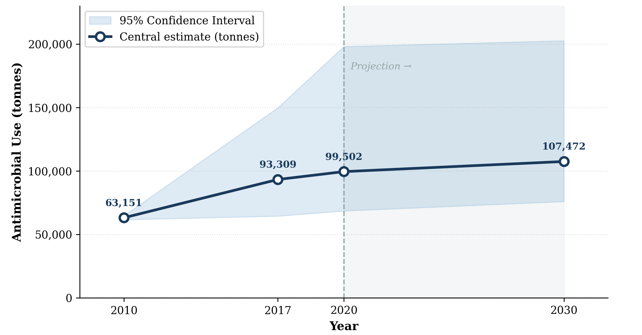

Figure 1. Global Antimicrobial Use (AMU) in Food-Producing Animals: Observed Trend (2010–2020) and Projected Increase to 2030 (Van Boeckel et al., 2015; Tiseo et al., 2020; Mulchandani et al., 2023).

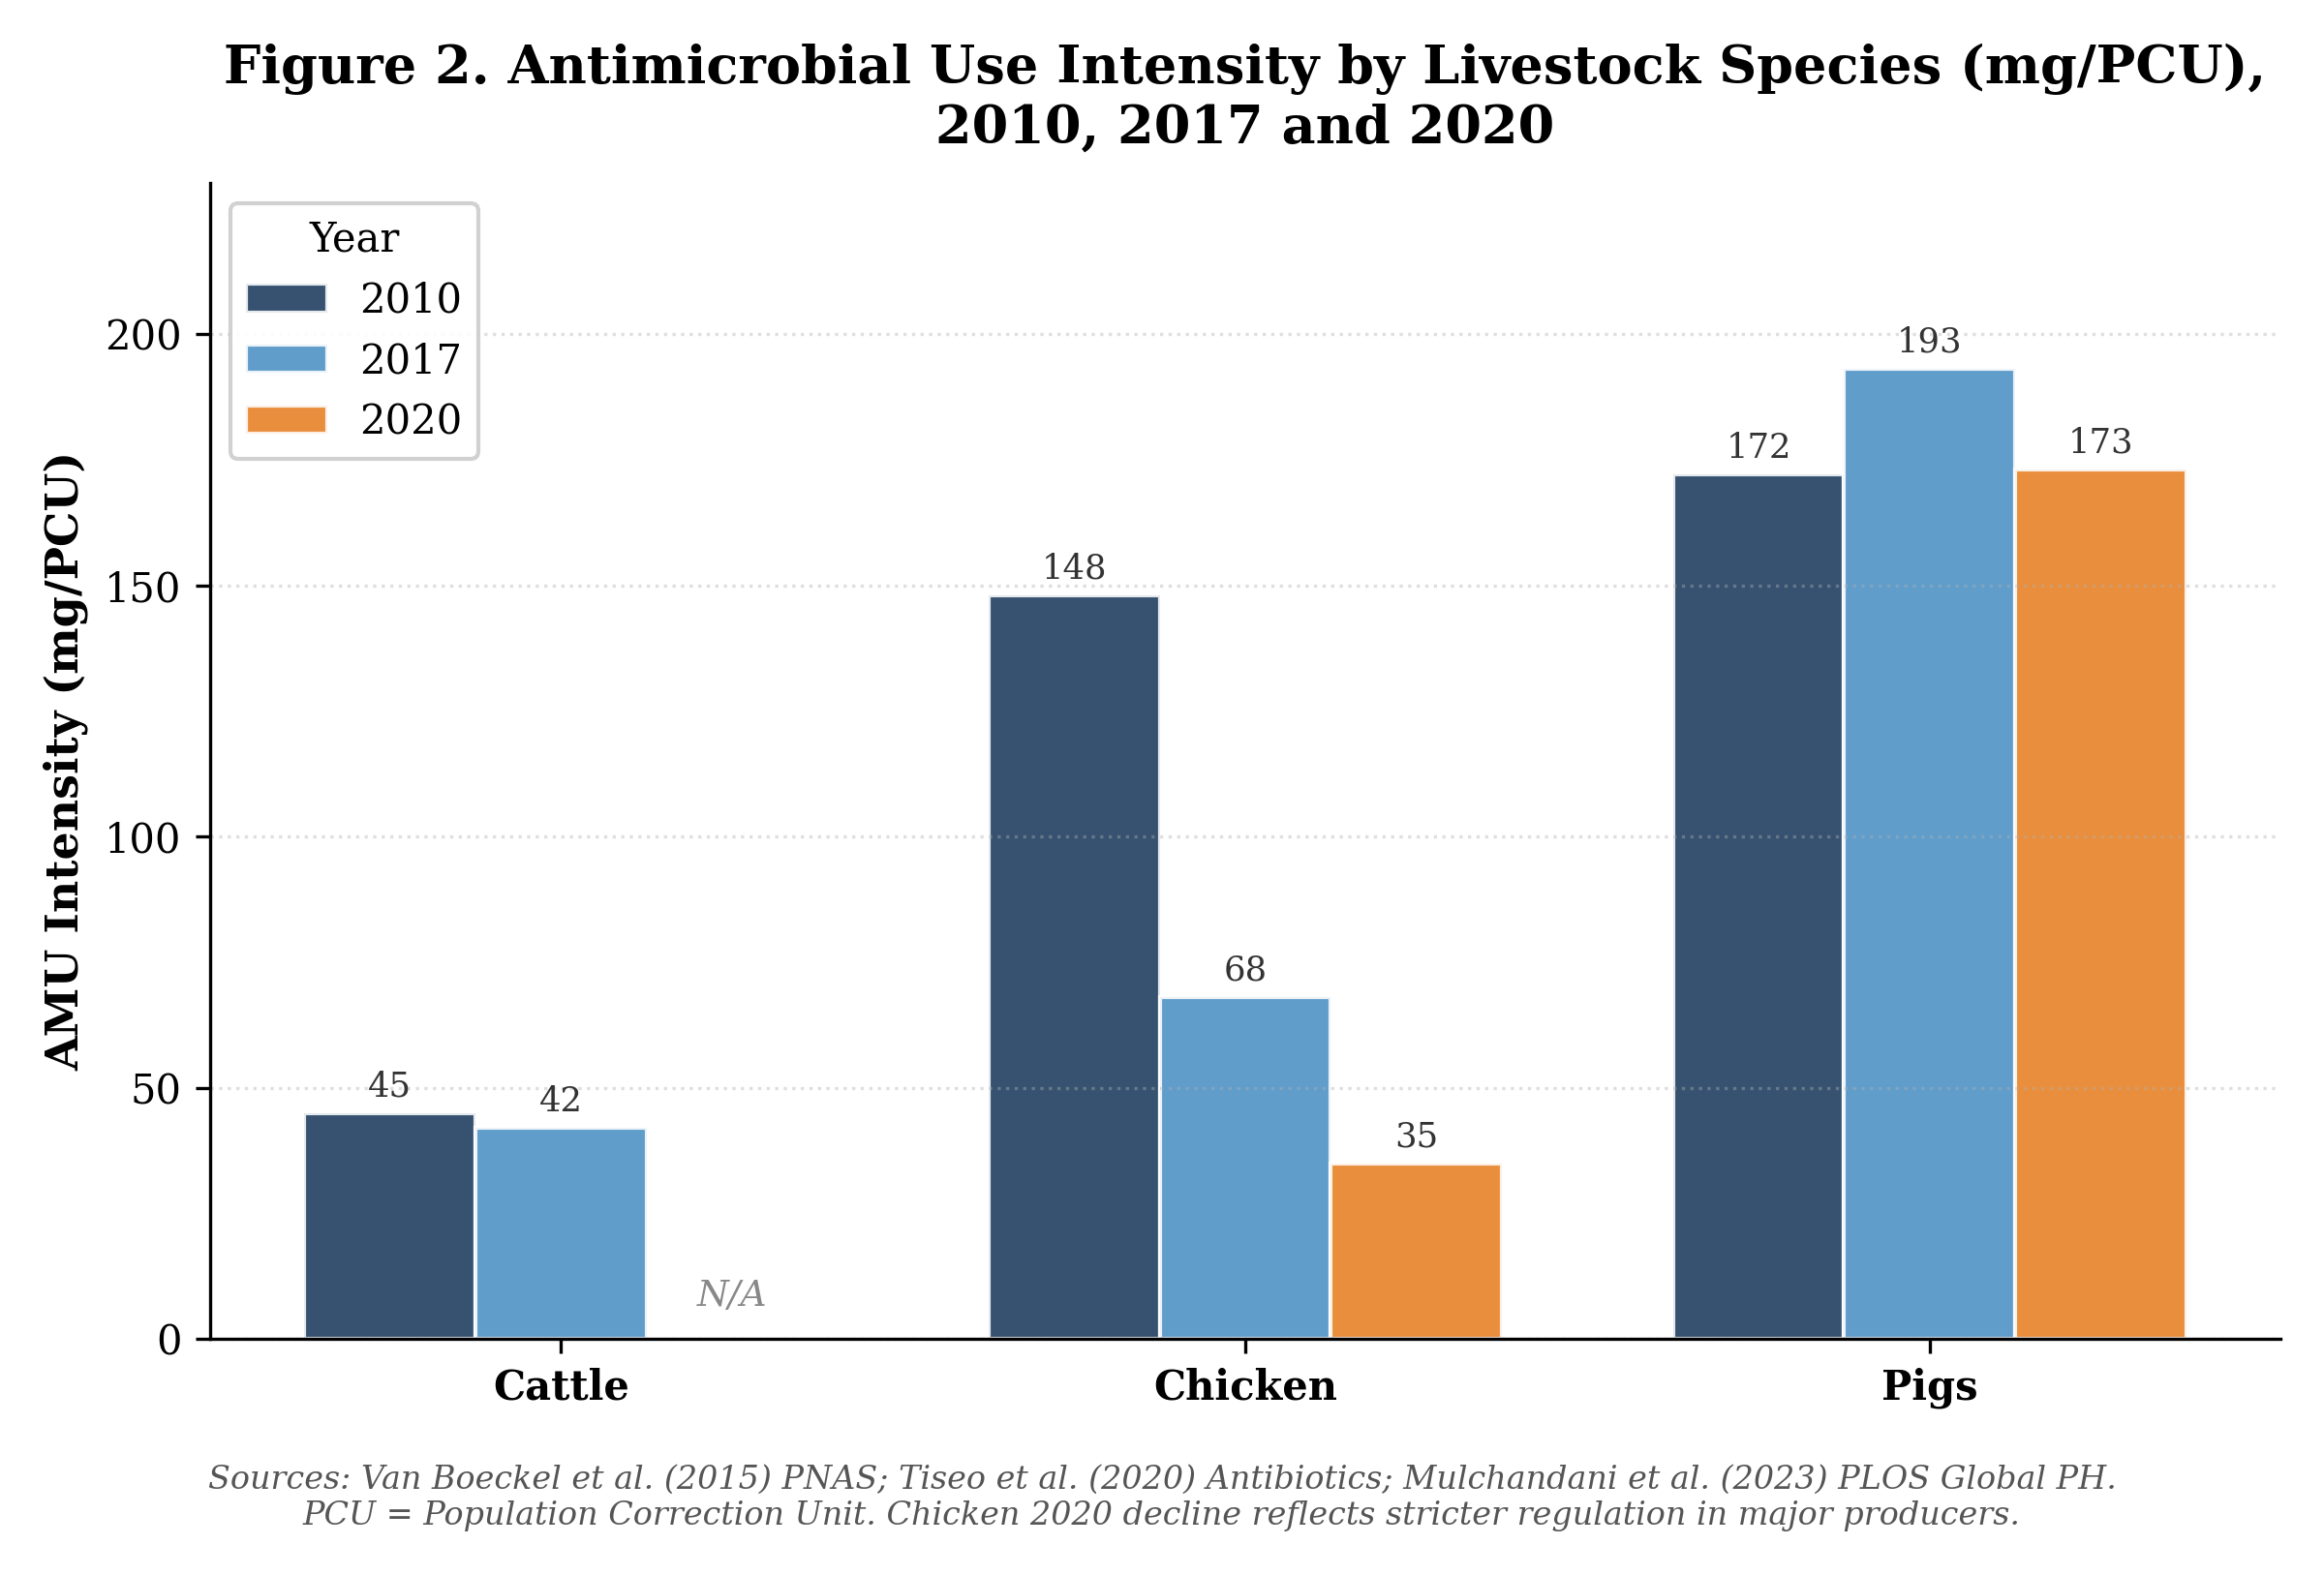
Figure 2. Antimicrobial Use Intensity by Livestock Species (mg/PCU) at Three Time Points: 2010, 2017, and 2020 (Van Boeckel et al., 2015; Tiseo et al., 2020; Mulchandani et al., 2023).

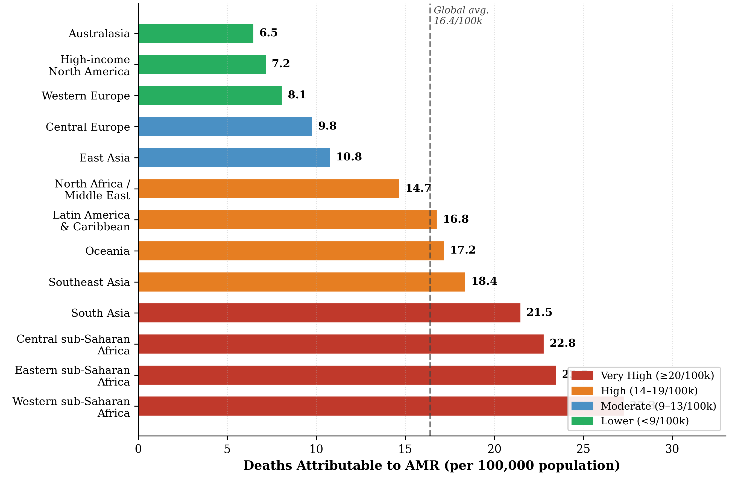
Figure 3. All-Age AMR-Attributable Death Rate per 100,000 Population by GBD Region, 2019. Global average = 16.4 per 100,000 (dashed line) (Murray et al., 2022).

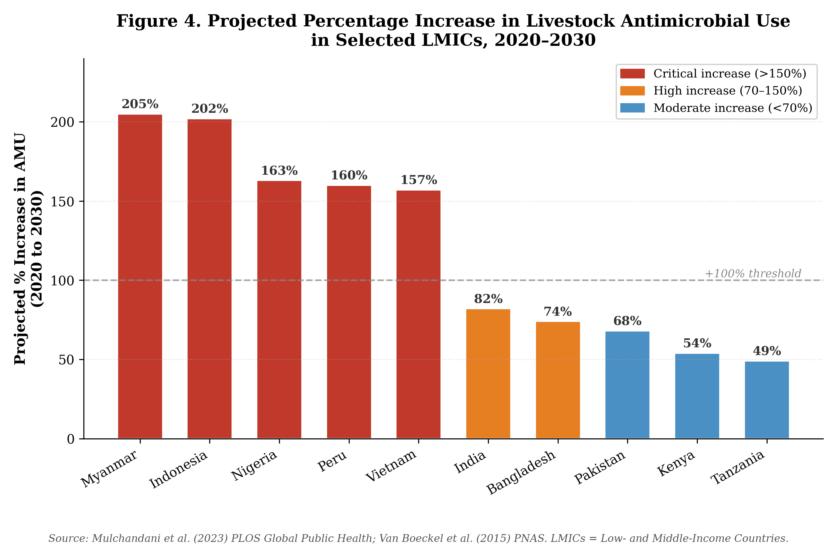
Figure 4. Projected Percentage Increase in Livestock Antimicrobial Use in Selected Low- and Middle-Income Countries, 2020–2030 (Mulchandani et al., 2023; Van Boeckel et al., 2015).

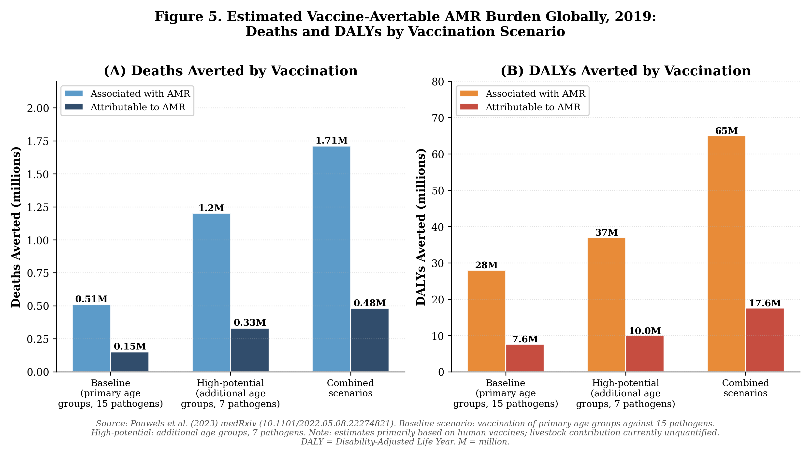

Figure 5. Estimated Globally Vaccine-Avertable AMR Burden (2019): (A) Deaths Averted (millions) and (B) DALYs Averted (millions) under Baseline and High-Potential Vaccination Scenarios (Kim et al., 2023; Murray et al., 2022)

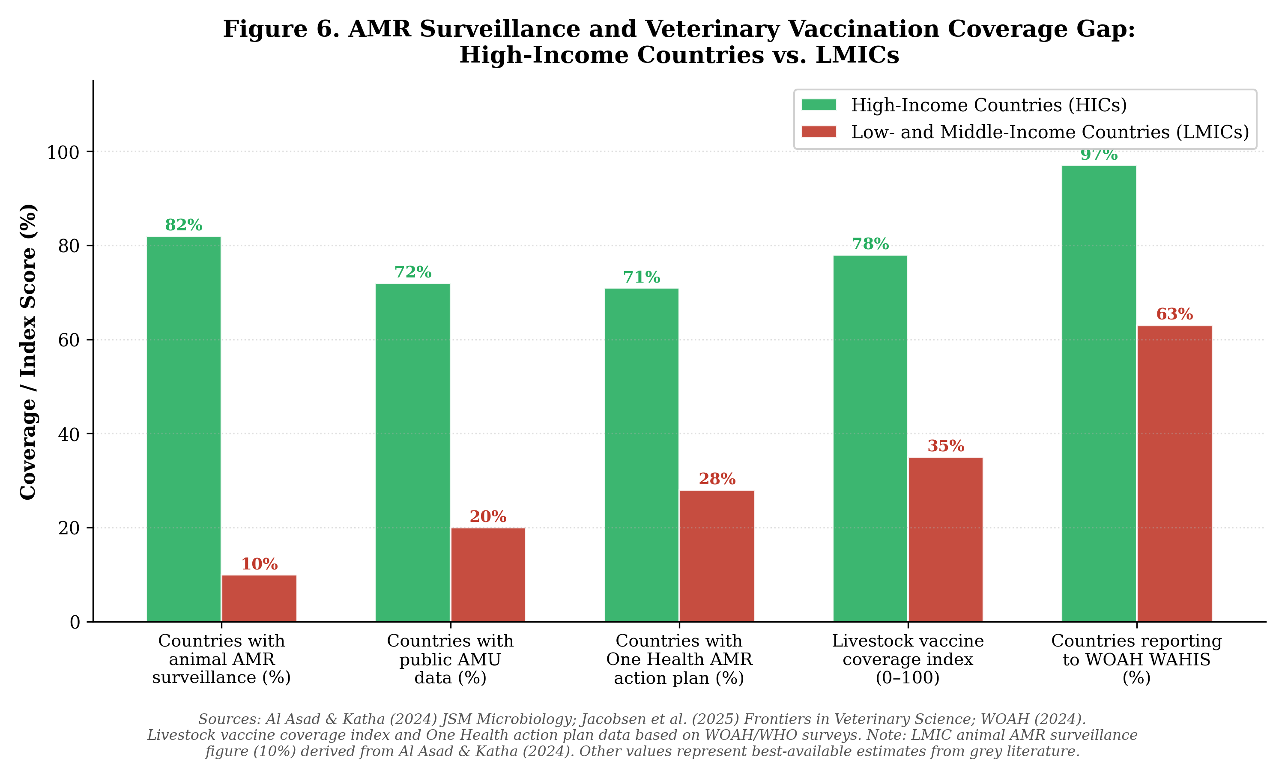

Figure 6. AMR Surveillance and Veterinary Vaccination Coverage Gap Between High-Income Countries (HICs) and Low- and Middle-Income Countries (LMICs) Across Five Governance Indicators (Al Asad & Katha., 2024; Jacobsen et al., 2025; WOAH, 2024; WHO/FAO/WOAH, 2022).

