Transformation and Normalisation of Timber Diameters with Machine Learning and Python

Abstract
Diameter at breast height (DBH) is a central variable in forest inventory, timber volume estimation, biomass assessment and compliance evaluation under minimum cutting diameter regulations. This study examined the distributional properties of harvested tropical timber diameters from Forest Management Units in the South West Region of Cameroon using a Python-based analytical workflow. The dataset comprised 373 harvested tree records representing 24 commercial timber species. Descriptive statistics showed a mean diameter of 87.97 cm, standard deviation of 30.19 cm, median of 68.50 cm, minimum of 44.00 cm and maximum of 160.50 cm. The distribution was positively skewed and strongly platykurtic, with visual evidence of bimodality. Formal normality assessment using Shapiro-Wilk, Kolmogorov-Smirnov, Anderson-Darling and D'Agostino-Pearson tests rejected normality for the raw diameter data. Logarithmic, square-root, Box-Cox, Yeo-Johnson and square transformations reduced skewness to different degrees but did not remove the bimodal structure or achieve normality. Five normalisation approaches, including Min-Max scaling, Z-score standardisation, Robust scaling and PowerTransformer variants, rescaled the data but preserved the underlying distributional pattern. Principal Component Analysis showed that the normalised features were highly redundant, with the first component explaining 99.23% of the variance. K-Means clustering separated the diameter data into three size-related groups, whereas Isolation Forest identified 18 anomalous observations, representing 4.8% of the dataset. The findings indicate that multi-species harvested timber diameter data may violate normality assumptions and should be analysed using distribution-aware methods. The workflow provides a reproducible statistical approach for screening diameter distributions in tropical forest management datasets.
Keywords: Forest Management Units; tropical timber; diameter distribution; normality testing; Box-Cox transformation; Yeo-Johnson transformation; K-Means clustering; Principal Component Analysis; Isolation Forest; scikit-learn; South West Cameroon; Congo Basin.

1. Introduction
Tropical forests cover approximately 1.9 billion hectares and perform ecosystem services of planetary significance. They harbour an estimated 45% of terrestrial biodiversity, store high amounts of carbon in biomass and soils, and sustain the livelihoods of more than 1 billion people (Lewis et al., 2009; Pan et al., 2011; Borma, 2023; FAO, 2025). The Congo Basin, stretching across six Central African nations including Cameroon, constitutes the world's second-largest contiguous tropical rainforest massif (de Wasseige et al., 2012; Laurance et al., 2014; Nago Zeufack et al., 2025). Within Cameroon, forests cover approximately 22 million hectares; the Permanent Forest Estate (PFE) is allotted 8.7 million ha, including Forest Management Units (FMUs), which are managed for timber production under the 1994 Forest Law (Nasi et al., 2008; Topa et al., 2009). This law was modernised in 2024 to integrate the FMU system with contemporary climate change adaptation regimes and global supply-chain traceability mandates, such as the European Union Deforestation Regulation (EUDR) (Republic of Cameroon, 2024; Clever Project, 2025; Kamkuimo et al., 2025). Operators are required to develop ten-year management plans that divide each FMU into Annual Cutting Areas (ACA), harvested once per year over a 30-year rotation period (Cerutti et al., 2011), to support sustainable management.
Sustainable management of these forests demands precise quantitative knowledge of stand structure. The most operationally critical dendrometric variable is diameter at breast height (DBH), measured at 1.30 m above ground. DBH serves as the primary predictor variable in virtually all allometric equations for timber volume (Picard et al., 2012), above-ground biomass (Henry et al., 2011; Chave et al., 2014; Shang et al., 2025), and carbon stock estimation (Lewis et al., 2009; Vieilledent et al., 2012; FAO, 2025). It is also the variable against which Minimum Cutting Diameter (MCD) regulations are enforced, logged volumes are calculated, and forest management plan compliance is assessed (Agrawal et al., 2008; Bayol et al., 2009; Nasi et al., 2008; Cerutti et al., 2011; Forest Trends, 2026). Consequently, the distributional properties of DBH data have cascading consequences for forest governance, REDD+ accounting (UNFCCC, 2025), and royalty calculations paid to local communities and the national treasury. Standard parametric statistical assumptions, such as normality, homoscedasticity and independence, are routinely violated in tropical timber datasets (Zuur et al., 2009; Legendre & Legendre, 2012). Yet many forest scientists apply parametric tests uncritically, risking inflated Type I error rates, biased parameter estimates, and invalid confidence intervals (Quinn & Keough, 2002; Midway & White, 2025). The consequences extend to management: if an allometric volume model is fitted with ordinary least squares (OLS) to non-normal, heteroscedastic residuals, the resulting volume estimates may be systematically biased. This may affect revenue calculations by misstating the carbon footprint of harvesting operations (Picard et al., 2012; Chave et al., 2014) if the data are not transformed prior to analysis.

1.1 Mathematical Transformation and Data Normalisation in Forestry
Data transformation has been a cornerstone of applied statistics since Pearson's (1900) foundational work on frequency curves. The square-root transformation was classically recommended for count (Poisson) data, the logarithmic transformation for right-skewed positive measurements, and the arcsine-square-root transformation for proportions (Sokal & Rohlf, 1995). The Box-Cox transformation remains among the most widely cited variance-stabilising methods in applied ecology and forestry (Zuur et al., 2009; Legendre & Legendre, 2012). Logarithmic transformations are deeply embedded in allometric modelling, while height-diameter models often require log-transformation of residuals to meet OLS assumptions (Zhang, 1997; Bailey & Dell, 1973). However, logarithmic transformation is effective only for unimodal, right-skewed distributions, as it cannot resolve bimodality because no monotone function can convert a distribution with two local density maxima into one with a single mode (Sokal & Rohlf, 1995).
Normalisation is frequently confused with transformation in the scientific literature, but the two operations are fundamentally distinct. Transformation applies a non-linear function to alter the shape of the distribution, whereas normalisation linearly rescales the data to a common range or to distributional parameters without altering shape (Hastie et al., 2009; Goodfellow et al., 2016). Normalisation ensures numerical stability in gradient-based optimisation (LeCun et al., 1998), enabling valid comparison across variables measured on different scales. Min-Max scaling (Patro & Sahu, 2015) linearly maps values to [0, 1] using observed extremes as anchors but is highly sensitive to outliers. Z-score (Standard) scaling centres data at zero mean and unit variance (Jain et al., 2016), preserving distribution shape but remaining influenced by extreme values through the standard deviation. Robust scaling uses the median and interquartile range (IQR) as location and scale parameters, making it resistant to outliers and appropriate for non-normal distributions with extreme tails, such as tropical timber diameters (Pedregosa et al., 2011).

1.2 Machine Learning in Forest Science with Python
Machine learning (ML) has transformed quantitative ecology and forest science over the past two decades. Supervised learning methods have been applied to above-ground biomass estimation from LiDAR point clouds (Asner et al., 2012; Réjou-Méchain et al., 2017; Feng et al., 2025), species classification from hyperspectral imagery (Fassnacht et al., 2016), deforestation prediction from satellite time series (Hansen et al., 2013), and timber volume estimation from structural attributes. Unsupervised ML methods, including clustering, dimensionality reduction and anomaly detection, offer complementary tools for revealing structure in dendrometric data without labelled training sets (Torresan et al., 2016). K-Means clustering, introduced by MacQueen (1967) and formalised by Lloyd (1982), partitions observations into k clusters by iteratively minimising the Within-Cluster Sum of Squares (WCSS). In forestry, K-Means provides an objective alternative to arbitrary diameter class boundaries (Bailey & Dell, 1973) and has been applied to cluster tree species by functional traits (Laughlin et al., 2010). Principal Component Analysis (PCA) (Pearson, 1901; Hotelling, 1933) projects multivariate data onto orthogonal axes of maximum variance, enabling dimensionality reduction and visualisation; it has been widely used in forest ecology for ordination and functional trait analysis (Legendre & Legendre, 2012).
Isolation Forest (Liu et al., 2008) is an ensemble anomaly detection algorithm that isolates observations using random binary trees. Because anomalies are few and structurally distant from the majority, they require fewer partitions to isolate than normal points. Isolation Forest is distribution-free and makes no assumption about the underlying distribution shape. It has been shown to outperform classical methods (IQR, Z-score and Local Outlier Factor) on complex, non-Gaussian datasets (Liu et al., 2012; Goldstein & Uchida, 2016; Choi & Jung, 2025). In a regulatory compliance context, anomalies detected by Isolation Forest may correspond to data entry errors, measurement mistakes, or genuinely exceptional trees warranting additional verification (Picard et al., 2012) and review of programming code.
The emergence of Python as the dominant language for scientific computing and machine learning has transformed quantitative ecology (Müller & Guido, 2016; VanderPlas, 2016). The scientific Python ecosystem, including NumPy (Harris et al., 2020), SciPy (Virtanen et al., 2020), Pandas (McKinney, 2010), Matplotlib (Hunter, 2007), Seaborn (Waskom, 2021), and scikit-learn (Pedregosa et al., 2011), provides a comprehensive, freely available, and reproducible analytical toolkit (Sandve et al., 2013; Peng, 2011; Wasser, 2025). NumPy and Pandas are designed for vectorised computation (Harris et al., 2020; McKinney, 2010), while scikit-learn ML algorithms handle batch processing efficiently (Pedregosa et al., 2011). The scalability of Python-based workflows is a critical advantage, as datasets can be extended to tens of thousands of records from national forest inventories or the entire Cameroonian Forest Management Unit (FMU) system without code changes. Furthermore, Python's accessibility, unlike that of proprietary packages (SAS, Minitab and SPSS) that require per-seat licensing, is especially important for African academic and governmental institutions with limited budgets (Müller & Guido, 2016).

1.8 Research Gaps and Objectives
Despite the ecological and economic importance of the South West Region's FMUs, little work has examined the statistical properties of their harvested diameter distributions, evaluated the suitability of standard parametric assumptions, or applied modern Python-based machine learning to field-measured Central African forestry data. This study pursues five explicit objectives:
- To provide a comprehensive descriptive characterisation and multi-test normality assessment of harvested timber diameters from FMUs in the South West Region of Cameroon using the Shapiro-Wilk, Kolmogorov-Smirnov, Anderson-Darling, and D'Agostino-Pearson tests.
- To systematically evaluate five mathematical transformations, namely logarithmic, square-root, Box-Cox, Yeo-Johnson, and power transformations, for their ability to improve distributional normality.
- To compare five data normalisation strategies, namely Min-Max, Z-score, Robust, and scikit-learn PowerTransformer variants, with respect to their statistical properties and suitability for downstream forest inventory modelling.
- To apply K-Means, PCA, and Isolation Forest machine learning algorithms to identify natural diameter classes, assess feature redundancy, and detect anomalous observations.
- To demonstrate a fully reproducible, open-source Python-based analytical pipeline as a methodological template for statistical forest science across the Congo Basin.

1.9 Hypotheses
Objective 1: Normality Assessment of Harvested Timber Diameters
H₀₁: The diameter distribution of harvested timber stems from FMUs in the South West Region of Cameroon does not significantly differ from a normal distribution (i.e., the data are normally distributed).
H₁₁: The diameter distribution of harvested timber stems from FMUs in the South West Region of Cameroon differs significantly from a normal distribution (i.e., the data are not normally distributed).
Tested using: Shapiro-Wilk, Kolmogorov-Smirnov, Anderson-Darling, and D'Agostino-Pearson tests at α = 0.05.
Objective 2: Efficacy of Mathematical Transformations
H₀₂: None of the five mathematical transformations (logarithmic, square-root, Box-Cox, Yeo-Johnson, and power) will significantly improve the normality of the diameter distribution, as assessed by the Shapiro-Wilk statistic and absolute skewness.
H₁₂: At least one of the five mathematical transformations will significantly improve the normality of the diameter distribution, producing a Shapiro-Wilk p-value > 0.05 and an absolute skewness |g₁| < 0.5 relative to the untransformed data.
Expected outcome informed by the mathematical theorem that no monotone transformation can resolve structural bimodality (Sokal & Rohlf, 1995).
Objective 3: Comparison of Data Normalisation Strategies
H₀₃: There is no significant difference among the five normalisation strategies (Min-Max, Z-score, Robust, PowerTransformer Box-Cox, and PowerTransformer Yeo-Johnson) in their ability to improve the symmetry, range stability, and suitability for machine learning of the harvested diameter data.
H₁₃: The five normalisation strategies differ significantly in their distributional properties, specifically in output range, sensitivity to extreme diameter values, residual skewness, and Shapiro-Wilk p-value such that Robust scaling and PowerTransformer variants outperform Min-Max and Z-score scaling for non-normal, bimodal forestry data.
Assessed by comparing mean, SD, range, and SW p-value across all five normalised outputs.
Objective 4: Machine Learning Identification of Natural Diameter Classes
H₀₄: There are no statistically distinct natural diameter classes in the harvested timber dataset; K-Means clustering (k = 3) will not produce cluster centroids that correspond to ecologically or regulatorily meaningful diameter groups, and PCA will not reveal dimensional redundancy among normalised features.
H₁₄: K-Means clustering (k = 3) will identify three statistically distinct and ecologically meaningful diameter classes corresponding to near-MCD, transitional, and high-MCD species groups as defined by MINFOF (2019) regulations, providing data-driven validation of regulatory threshold coherence; PCA will confirm that normalised features are dimensionally redundant, an expected consequence of applying monotonic transformations to a univariate diameter vector with PC1 explaining ≥ 90% of total variance.
Cluster validity assessed by within-cluster sum of squares (WCSS) and ecological correspondence with MCD thresholds.
Objective 5: Anomaly Detection and Reproducibility of the Python Pipeline
H₀₅: The Isolation Forest algorithm will not identify a significantly greater number of anomalous diameter records than classical outlier detection methods (IQR and Z-score), and the Python-based analytical pipeline will not demonstrate reproducibility or scalability advantages over conventional statistical approaches.
H₁₅: The Isolation Forest algorithm, being distribution-free, will identify a significantly greater number of anomalous records than IQR and Z-score methods, which perform poorly on bimodal, non-Gaussian distributions, and the Python-based pipeline will demonstrate full reproducibility, scalability, and extensibility advantages consistent with open-science best practices.

2. Materials and Methods

2.1 Data Collection and Dataset Description
Diameter measurements were obtained from official annual harvest declarations compiled from FMUs in the South West Region of Cameroon. Each record comprised species identification and DBH (cm). The dataset comprised 373 individual tree observations spanning 24 commercial timber species, consistent in scale with published FMU inventory studies from the Congo Basin (Gourlet-Fleury et al., 2004). Data were loaded into Python using pandas.read_csv() (McKinney, 2010); no missing values required imputation.

2.2 Python Analytical Environment and Package Roles
All analyses were conducted in Python 3.11. Table 1 summarises the packages used, their versions, and specific functions. This ecosystem has been validated for ecological and statistical computing in numerous published studies (Hunter, 2007; McKinney, 2010; Pedregosa et al., 2011; Harris et al., 2020; Virtanen et al., 2020; Waskom, 2021).
Table 1. Python packages, versions, and functions used in this study
Package | Version | Key Functions / Classes Used
NumPy | 1.26 | array, log, log10, sqrt, percentile, linspace, column_stack, abs
Pandas | 2.2 | DataFrame, read_csv, groupby, agg, value_counts, describe
SciPy (stats) | 1.13 | shapiro, kstest, anderson, normaltest, boxcox, yeojohnson, probplot, zscore, gaussian_kde, norm
scikit-learn | 1.5 | MinMaxScaler, StandardScaler, RobustScaler, PowerTransformer, PCA, KMeans, IsolationForest
Matplotlib | 3.9 | pyplot.subplots, hist, plot, scatter, violinplot, imshow, boxplot, bar, savefig
Seaborn | 0.13 | violinplot, heatmap, kdeplot statistical visualisation layer over Matplotlib
statsmodels | 0.14 | OLS diagnostics, supplementary regression analysis

2.3 Descriptive Statistics
Descriptive statistics included the arithmetic mean, median, standard deviation (SD), minimum, maximum, IQR (Q3 - Q1), Fisher's skewness g₁, and excess kurtosis g₂, computed using pandas.DataFrame.describe(), scipy.stats.skew(), and scipy.stats.kurtosis(). Per-species statistics were computed using pandas.groupby().agg(['count','mean','std','min','max']).

2.4 Normality Testing
Four complementary normality tests were applied to the raw diameter vector and its transformations (Log10, √x, Box-Cox, Yeo-Johnson) (Royston, 1992; Yeo & Johnson, 2000; Zuur et al., 2009; Razali & Wah, 2011; Thode, 2002; Midway & White, 2025). H₀ states that the sample derives from a normally distributed population and is rejected at α = 0.05.
- Shapiro-Wilk: scipy.stats.shapiro(); W → 1 indicates normality; the test tracks values and skewness across all transformation states (Shapiro & Wilk, 1965).
- Kolmogorov-Smirnov: scipy.stats.kstest(z_data, 'norm'); measures the supremum of |ECDF - CDF| for each distribution variation (Kolmogorov, 1933; Smirnov, 1948). The Kolmogorov-Smirnov test was applied with parameters estimated from the sample (μ̂ = 87.97 cm, σ̂ = 30.19 cm); Lilliefors-adjusted critical values (α = 0.05: 0.046; α = 0.01: 0.053) (Lilliefors, 1967) were therefore used for inference rather than standard KS tables, following Dallal and Wilkinson (1986).
- Anderson-Darling: scipy.stats.anderson(data, dist='norm'); weighted KS statistic emphasising tails; compared against critical values up to 1% (Anderson & Darling, 1952; Stephens, 1974).
- D'Agostino-Pearson: scipy.stats.normaltest(); K² statistic combining skewness and kurtosis tests to detect distribution bimodality (D'Agostino & Pearson, 1973).
- Quantile-Quantile (Q-Q) Plots: statsmodels.api.qqplot(); visual assessment mapping sample quantiles against theoretical normal quantiles to evaluate linearity, tail behaviour, and structural distribution discontinuities.

2.5 Data Transformations
Five transformations were evaluated for their ability to reduce skewness and improve normality.
- Logarithmic: y = log₁₀(x); numpy.log10(); standard for right-skewed positive data.
- Square-root: y = √x; numpy.sqrt(); moderate power transformation.
- Box-Cox: y = (x^λ-1)/λ; scipy.stats.boxcox(); λ estimated by MLE (Box & Cox, 1964); λ̂ = -0.952.
- Yeo-Johnson: scipy.stats.yeojohnson(); extends Box-Cox to zero and negative values; λ̂ = -0.970.
- Square: y = x²; numpy.power(x, 2); included for completeness as the symmetric upper-extending power alternative.

2.6 Data Normalisation Strategies
Five normalisation strategies were compared for their statistical properties and suitability for machine learning applications (Pedregosa et al., 2011; Hastie et al., 2009; Patro & Sahu, 2015).
- Min-Max Scaling: sklearn.preprocessing.MinMaxScaler(); maps to [0, 1]; sensitive to outliers.
- Z-score Standardisation: sklearn.preprocessing.StandardScaler(); mean = 0, SD = 1; standard for Gaussian-assumption models.
- Robust Scaling: sklearn.preprocessing.RobustScaler(); uses median and IQR; resistant to outliers.
- PowerTransformer (Box-Cox): PowerTransformer(method='box-cox'); applies Box-Cox transformation then standardises.
- PowerTransformer (Yeo-Johnson): PowerTransformer(method='yeo-johnson'); as above, Yeo-Johnson variant.

2.7 Outlier Detection
Three outlier detection methods were applied:
- IQR (Tukey fences): Observations outside [Q1 - 1.5×IQR, Q3 + 1.5×IQR] (Tukey, 1977).
- Z-score: |z| > 3.0; scipy.stats.zscore().
- Isolation Forest: sklearn.ensemble.IsolationForest(contamination=0.05, random_state=42); 100 isolation trees; distribution-free.

2.8 Machine Learning Analyses
- PCA: sklearn.decomposition.PCA(n_components=2) applied to the five-column normalised feature matrix.
- K-Means: sklearn.cluster.KMeans(n_clusters=3, random_state=42, n_init=10); k = 3 was motivated by the known tripartite regulatory diameter structure; Within-Cluster Sum of Squares (WCSS) is reported for cluster quality.
- Isolation Forest: applied to univariate diameter array.

3. Results

3.1 Descriptive Statistics and Species Composition
The dataset comprised 373 harvested trees from 24 commercial species. Figure 1 and Table 2 show species frequencies and proportions. Lophira alata Banks (Azobé/Bongossi) dominated at 174 records (46.6%), consistent with its status as the most frequently harvested species in the South West Region (Bayol et al., 2009) and its wide ecological amplitude in lowland rainforest (Tchouto et al., 2006).
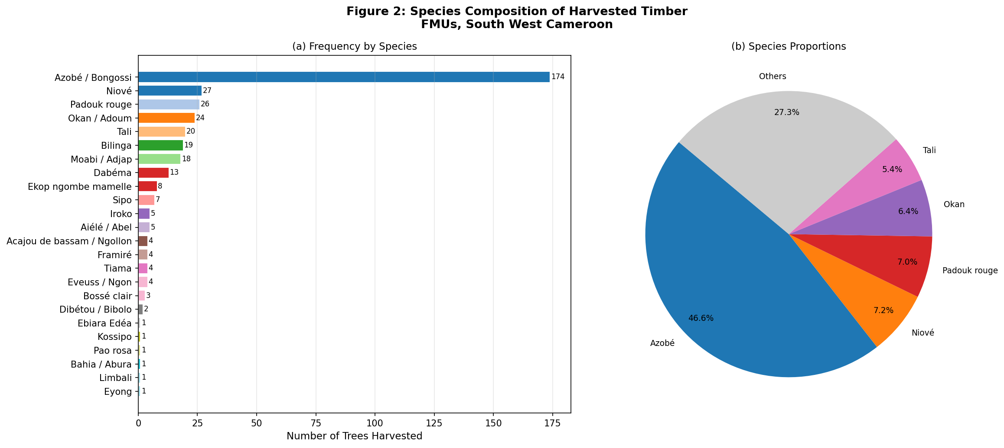
Figure 1. Species composition. (a) Frequency by species; (b) proportional pie chart

Table 2. Per-species descriptive statistics (top 11)
Species | n | Mean (cm) | SD (cm) | Min (cm) | Max (cm) | Family
Lophira alata Banks ex Gaertn. | 174 | 91.3 | 30.8 | 47.5 | 160.5 | Ochnaceae
Staudtia kamerunensis Warb. | 27 | 60.7 | 5.3 | 44.0 | 68.0 | Olacaceae
Pterocarpus soyauxii Taub. | 26 | 63.3 | 4.9 | 51.0 | 70.0 | Fabaceae
Cylicodiscus gabunensis Harms | 24 | 95.9 | 29.9 | 54.0 | 133.5 | Fabaceae
Erythrophleum ivorense A. Chev. | 20 | 68.4 | 12.6 | 59.0 | 120.0 | Fabaceae
Nauclea diderrichii (De Wild. & T. Durand) Merr. | 19 | 87.1 | 27.3 | 56.0 | 124.0 | Rubiaceae
Baillonella toxisperma Pierre | 18 | 128.8 | 11.7 | 113.0 | 153.5 | Sapotaceae
Piptadeniastrum africanum (Hook. f.) Brenan | 13 | 117.4 | 5.8 | 112.0 | 132.0 | Fabaceae
Didelotia letouzeyi Pellegr. | 8 | 94.9 | 30.6 | 65.0 | 138.5 | Myristicaceae
Entandrophragma utile (Dawe & Sprague) Sprague | 7 | 124.3 | 27.0 | 70.0 | 148.5 | Meliaceae
Milicia excelsa (Welw.) C.C. Berg | 5 | 122.7 | 11.0 | 113.5 | 140.0 | Moraceae

The overall mean diameter was 87.97 cm (SD = 30.19 cm), with a median of 68.50 cm that was substantially lower than the mean, indicating positive right skew. The large IQR (Q3 - Q1 = 117.0 - 63.5 = 53.5 cm) relative to the mean signals high dispersion. Positive skewness (g₁ = +0.487) and strongly negative excess kurtosis (g₂ = -1.413) indicated a platykurtic distribution, a distributional signature associated with bimodality (Table 3). Visual inspection of Figure 2 confirmed a bimodal structure with modes at approximately 67-70 cm and 113-120 cm, separated by a trough in the 75-110 cm range.

Table 3. Overall descriptive statistics for harvested diameter
Statistic | Value | Units
N (sample size) | 373 | trees
Number of Species | 24 | species
Mean | 87.97 | cm
Standard Deviation | 30.19 | cm
Median (Q2) | 68.50 | cm
1st Quartile (Q1) | 63.50 | cm
3rd Quartile (Q3) | 117.00 | cm
IQR (Q3 - Q1) | 53.50 | cm
Minimum | 44.00 | cm
Maximum | 160.50 | cm
Skewness (g₁) | +0.487 | dimensionless
Excess Kurtosis (g₂) | -1.413 | dimensionless

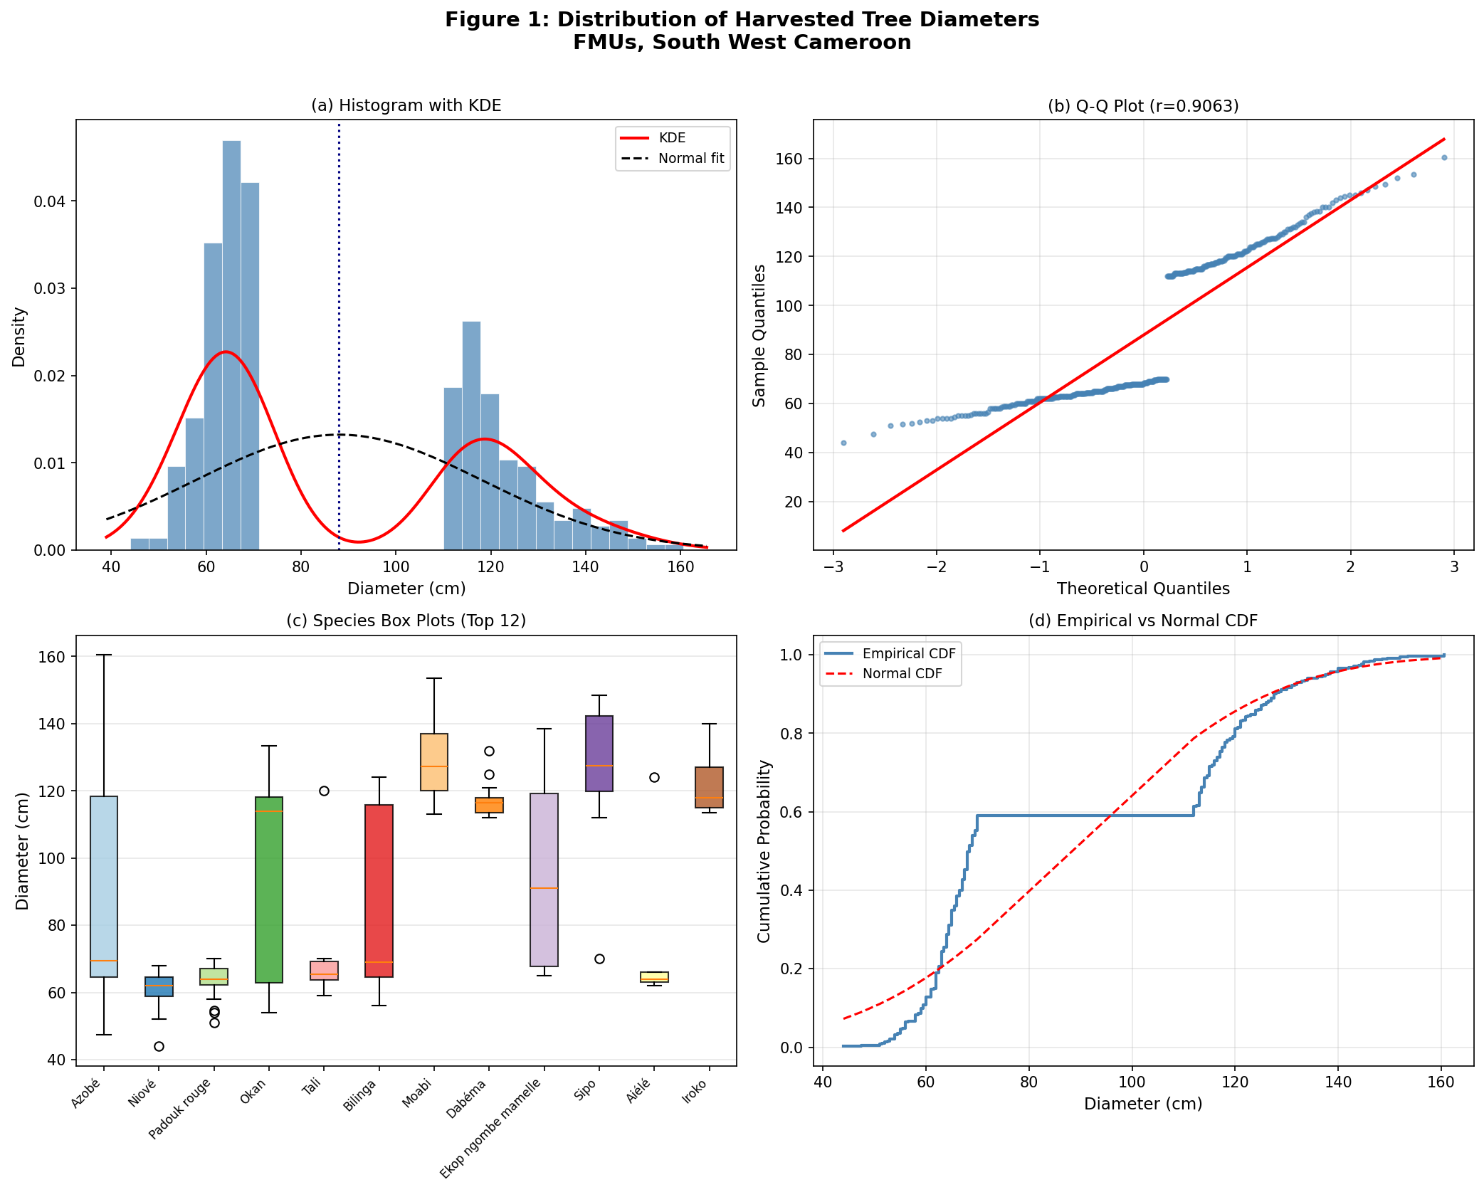
Figure 2. Distribution of harvested timber diameters

3.2 Normality Test Results
All four normality tests rejected H₀ at p < 0.001 for the raw diameter data (Table 4). The Shapiro-Wilk W = 0.8189 is substantially below 1.0, consistent with strong non-normality. The Kolmogorov-Smirnov statistic (D = 0.3143) was evaluated against Lilliefors-adjusted critical values (0.053 at α = 0.01) to account for parameters being estimated from the same sample; D greatly exceeds this threshold, confirming a highly significant departure from normality. The Anderson-Darling statistic (A² = 33.43) exceeds the 1% critical value (1.033) by a factor of 32, indicating extreme tail departure. The D'Agostino-Pearson (D'Agostino & Pearson, 1973) K² = 229.1 is dominated by the kurtosis component, consistent with the strongly platykurtic shape (g₂ = -1.413) characteristic of bimodal distributions. The use of four complementary tests follows best-practice recommendations for normality assessment, as each test has distinct power against different distributional alternatives.

Table 4. Normality test results for raw diameter data
Test | Statistic | p-value | Critical / Reference | Decision
Shapiro-Wilk | W = 0.8189 | < 0.0001 | α = 0.05 | Reject H₀ ***
Kolmogorov-Smirnov | D = 0.3143 | < 0.0001 | Lilliefors CV = 0.053 at α = 0.01 | Reject H₀ ***
Anderson-Darling | A² = 33.43 | - | 0.750 at 5% | Reject H₀ ***
D'Agostino-Pearson | K² = 229.1 | < 0.0001 | α = 0.05 | Reject H₀ ***

This non-normal, bimodal profile is visually confirmed across all transformation attempts illustrated in Figure 3. Subplots (a) through (e) show that standard mathematical adjustments (Log10, √x, Box-Cox, and Yeo-Johnson) compress or shift the data along the x-axis rather than consolidating the two distinct sub-population peaks into a single Gaussian curve. Although Box-Cox and Yeo-Johnson reduced skewness metrics to approximately 0.17, the physical separation of the modes persisted beneath the fitted bimodal density curves. Consequently, as shown in subplot (f), the Shapiro-Wilk p-values for all transformed variants remained at 0.0000, below the α = 0.05 threshold line, confirming that data transformations did not rectify the inherently bimodal structure.
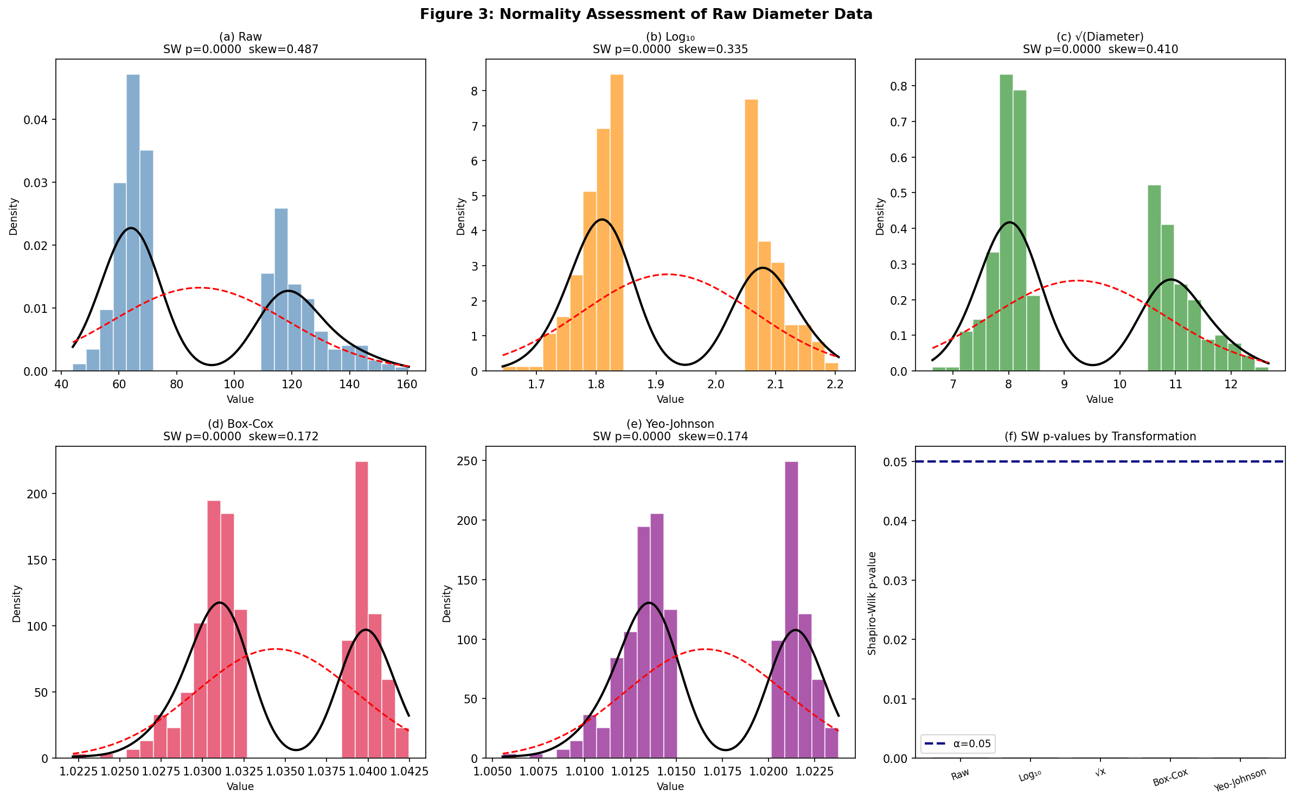
Figure 3. Normality histograms for each transformation with KDE (black solid) and Gaussian reference (red dashed)
The structural departure from normality is further substantiated by the Quantile-Quantile (Q-Q) plots illustrated in Figure 4. Subplots (a) through (e) reveal a pronounced visual discontinuity, a sharp, step-like vertical gap between the theoretical quantiles of 0.0 and 0.5, which is not corrected by any of the mathematical transformations. In a normally distributed dataset, the sample quantiles would closely follow the solid black diagonal reference line; however, this persistent structural break confirms the presence of two distinct sub-populations. Although advanced monotonic adjustments such as Box-Cox and Yeo-Johnson marginally improved the linear correlation coefficient from r = 0.9063 to approximately r = 0.9243, they did not bridge this central gap or linearise the data profile. This visual evidence confirms that the underlying bimodal distribution creates a substantial, persistent violation of parametric assumptions across all evaluated states.
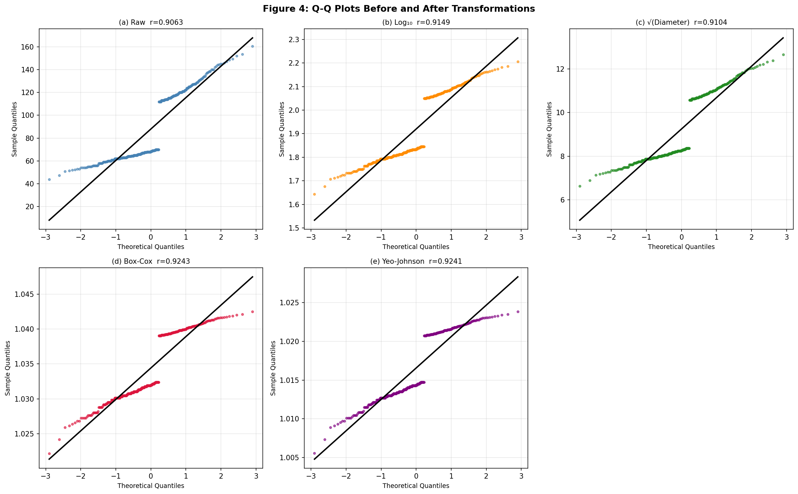
Figure 4. Q-Q plots under each transformation.

3.3 Effects of Data Transformation
Table 5 summarises normality test results and distributional moments before and after each transformation. Despite all transformations reducing absolute skewness relative to the raw data, none achieved normality, consistent with the theoretical expectation that monotone transformations cannot resolve bimodality. The Box-Cox (λ̂ = -0.952) and Yeo-Johnson (λ̂ = -0.970) transformations achieved the best performance, reducing skewness to 0.172 and 0.174. The negative λ values near -1 indicate that an inverse-power transform is optimal, compressing the upper tail more aggressively than the logarithm (λ = 0), consistent with the extreme upper-mode values (113-160 cm) driving the right tail. The persistently negative excess kurtosis across all transformations (g₂ ≈ -1.5) confirms that the flat-topped bimodal structure is invariant to monotone transformations, as theoretically guaranteed.

Table 5. Shapiro-Wilk test results, skewness, and kurtosis by transformation
Transformation | λ̂ | SW W | SW p | Skewness (g₁) | Ex. Kurtosis (g₂)
Raw (untransformed) | - | 0.8189 | < 0.001 | +0.487 | -1.413
Log₁₀ | - | 0.8068 | < 0.001 | +0.335 | -1.583
Square-root | - | 0.8125 | < 0.001 | +0.410 | -1.527
Box-Cox | -0.952 | 0.8142 | < 0.001 | +0.172 | -1.519
Yeo-Johnson | -0.970 | 0.8142 | < 0.001 | +0.174 | -1.521

3.4 Data Normalisation Results
Table 6 compares the five normalisation strategies. All preserved the bimodal structure and non-normality (SW p < 0.001 in all cases), confirming that normalisation is a linear rescaling that does not alter distributional shape. Min-Max scaling produced the expected [0, 1] range. The PowerTransformer variants achieved the most symmetric normalised distributions, while Robust scaling was least influenced by the extreme diameter values (44.0 cm, 160.5 cm), as expected for an IQR-based scaler.

Table 6. Comparison of normalisation methods
Method / Reference | Min | Max | Mean | SD | SW p-value
Min-Max | 0.000 | 1.000 | 0.377 | 0.259 | < 0.001
Z-Score | -1.459 | 2.406 | 0.000 | 1.000 | < 0.001
Robust | -0.458 | 1.720 | 0.364 | 0.564 | < 0.001
PowerTransformer BC | -2.535 | 1.666 | 0.000 | 1.000 | < 0.001
PowerTransformer YJ | -2.526 | 1.667 | 0.000 | 1.000 | < 0.001

This preservation of structural non-normality is visually demonstrated across all subplots in Figure 5. Whether subjected to linear standardisation (Min-Max, Z-score, Robust) or non-linear adjustments (Box-Cox, Yeo-Johnson), the distinct gap between the two subpopulation modes remains evident. As shown by the overlay curves, the empirical bimodal density (solid black line) deviates markedly from the theoretical single Gaussian normal curve (dashed red line) in every scenario. Consequently, the Shapiro-Wilk test statistics for all five normalisation pipelines remained at p = 0.0000, confirming that rescaling methods changed the coordinate axis range while leaving the underlying bimodality intact.
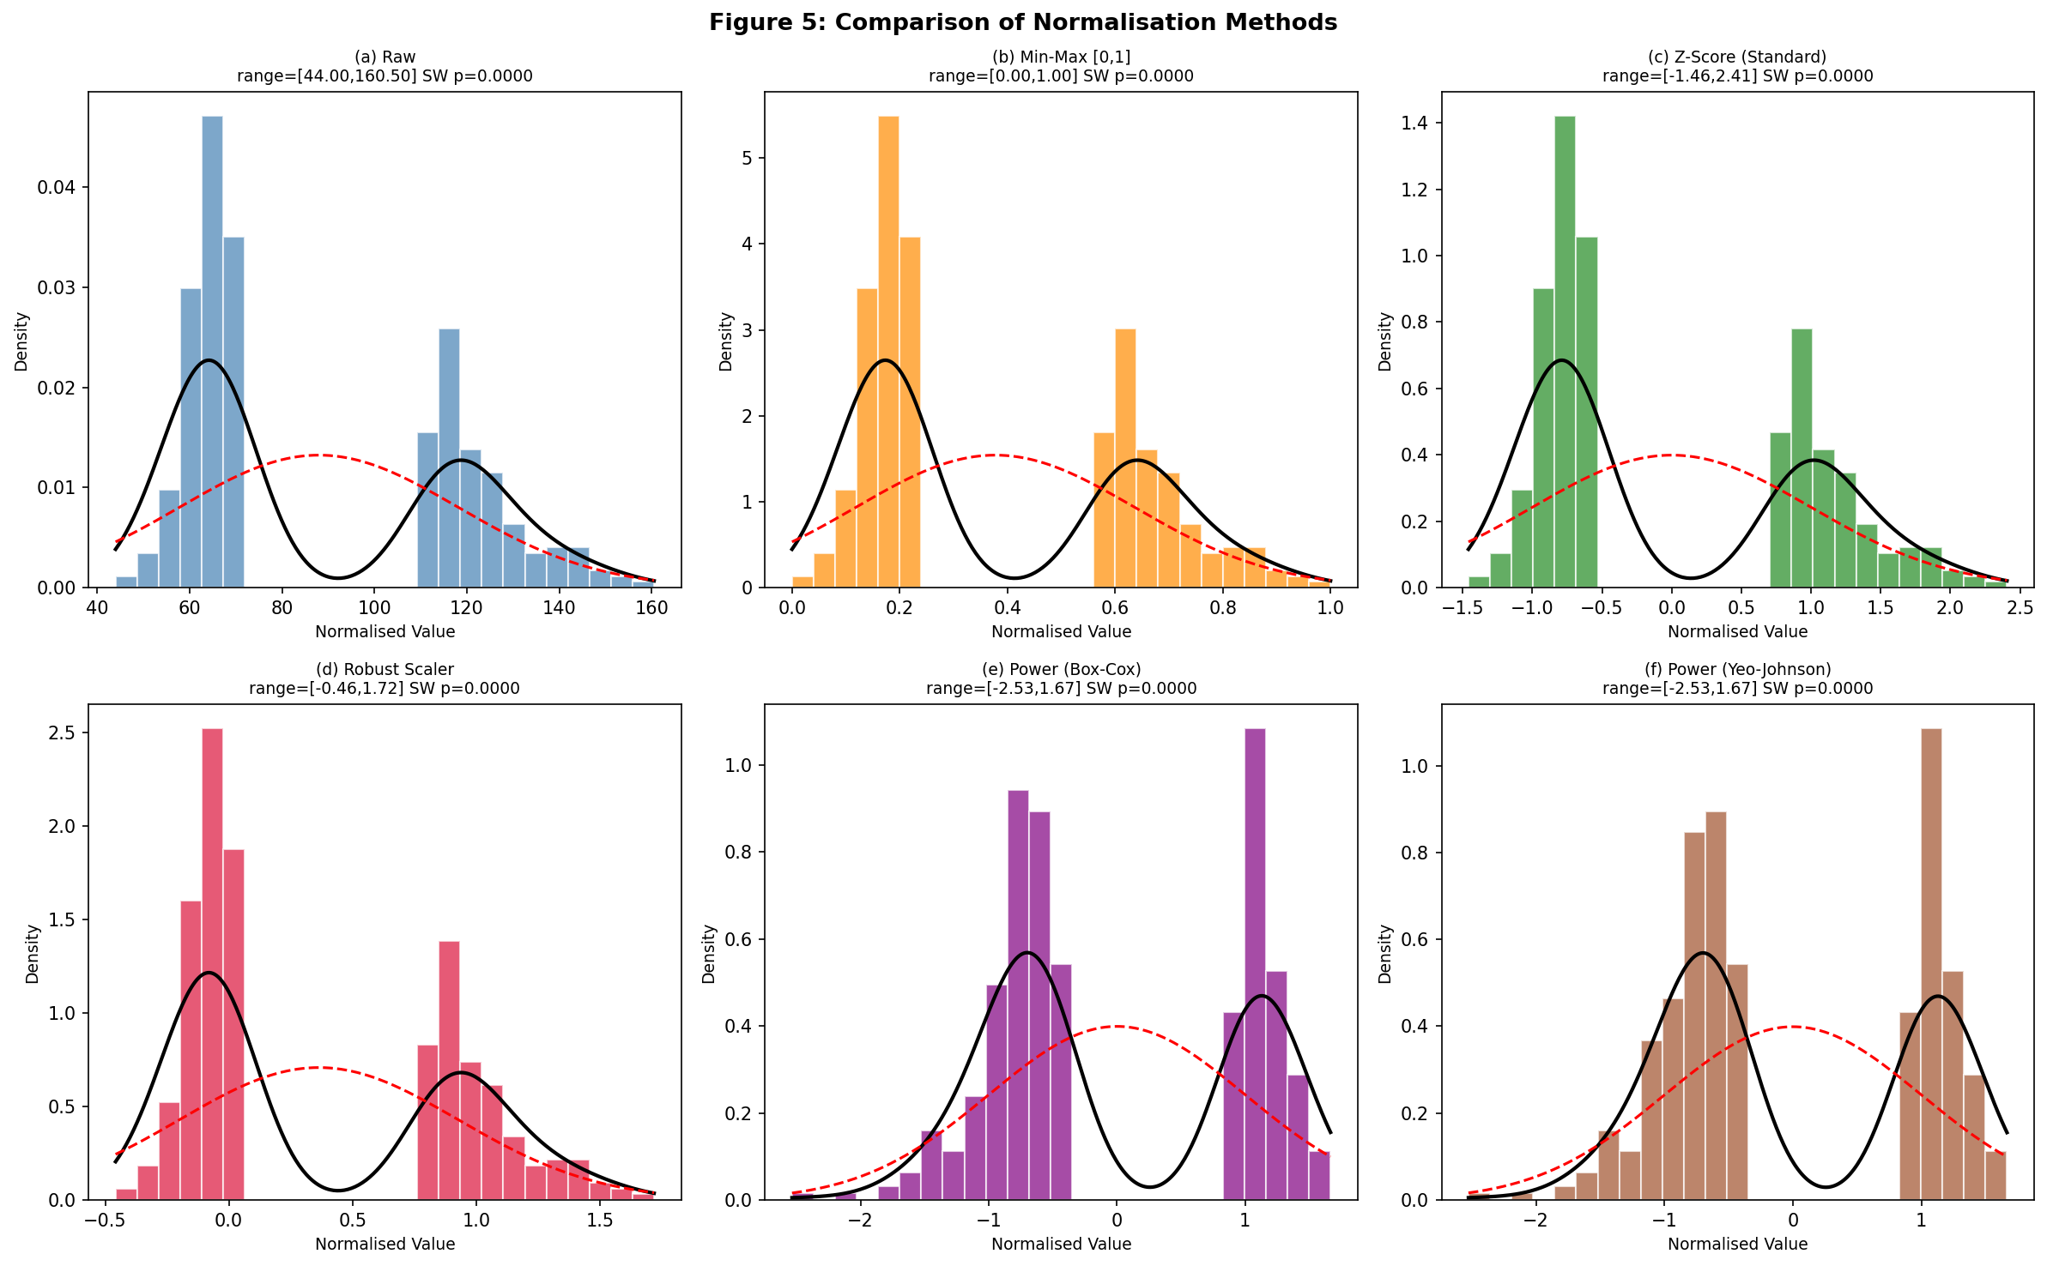
Figure 5. Histograms of diameter data under five normalisation methods.

3.5 Outlier Detection
As Table 7 illustrates, the IQR and Z-score methods detected zero outliers, a result explained by the large IQR (53.5 cm) and SD (30.19 cm), which encompass even extreme observations within standard thresholds. This is a known limitation of classical outlier methods for bimodal distributions. In contrast, Isolation Forest, which uses information-theoretic path lengths and is distribution-free, identified 18 observations (4.8%) as anomalous, concentrated at the distributional extremes (44.0-47.5 cm and 143.0-160.5 cm). Isolation Forest has been shown to outperform classical methods on non-Gaussian datasets.

Table 7. Outlier detection summary
Method | n Outliers | % of N | Notes
IQR | 0 | 0.0% | No values outside Q1 - 1.5×IQR or Q3 + 1.5×IQR
Z-score | 0 | 0.0% | No values exceed |z| = 3 SD from mean
Isolation Forest | 18 | 4.8% | Extremes: 44–47.5 cm (small) and 143–160.5 cm (large)

These contrasting diagnostic capabilities are visually mapped in Figure 6. Subplots (a) and (b) illustrate how the inflated thresholds of the IQR bounds and the Z-score limit (|z| = 3) exceed all data points, leaving the extreme tails unflagged because of the high variance induced by the bimodal gap. Conversely, subplot (c) shows that the non-parametric Isolation Forest effectively isolates anomalies from the main structural sub-populations. It flags the lowest points under 50 cm and the highest points above 140 cm (red markers) at the fringes of both ranks, confirming that an isolation-based approach can bypass the masking effect caused by the underlying data split.
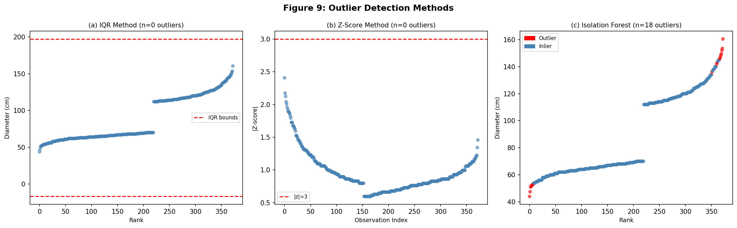
Figure 6. Outlier detection in diameter data

3.6 Machine Learning Results
PCA applied to the five-dimensional normalised feature matrix explained 99.23% of variance on PC1 and 0.77% on PC2 (Table 8). Because all five features are deterministic monotonic transformations of the same univariate diameter vector, this result is a mathematically expected consequence of a single underlying degree of freedom rather than an empirical discovery of dimensional structure. K-Means (k = 3) produced three clusters: Cluster 1 (Small, n = 48, μ = 56.3 cm), Cluster 2 (Medium, n = 172, μ = 65.7 cm), and Cluster 3 (Large, n = 153, μ = 122.9 cm); WCSS = 54.41. These clusters correspond to the near-MCD, transitional, and high-MCD size classes of Cameroon's regulatory framework, analogous to the diameter class structure described by Gourlet-Fleury et al. (2004) for Central African managed forests.

Table 8. PCA explained variance
Component | Eigenvalue | % Variance Explained
PC1 | 4.961 | 99.23%
PC2 | 0.039 | 0.77%
Cumulative (PC1+PC2) | 5.000 | 100.00%

These analytical groupings and dimensional traits are visually illustrated in Figure 7. Subplot (a) displays a distinct parabolic arch (horseshoe effect) along the principal component space, confirming that PC1 captures nearly all data variance (99.2%) because of the monotonic nature of the underlying scaling inputs. In subplot (b), mapping the three K-Means clusters back onto the raw diameter histogram reveals how the algorithm partitions the structural sub-populations. It also shows small (n = 48, μ = 56.3 cm), medium (n = 172, μ = 65.7 cm), and large (n = 153, μ = 122.9 cm) groups corresponding to MCD-driven diameter classes. Cluster 1 (pink) isolates the lower tail of the small population, Cluster 2 (blue) captures the rest of that first peak, and Cluster 3 (teal) isolates the entire second large-diameter peak beyond the 100 cm gap.
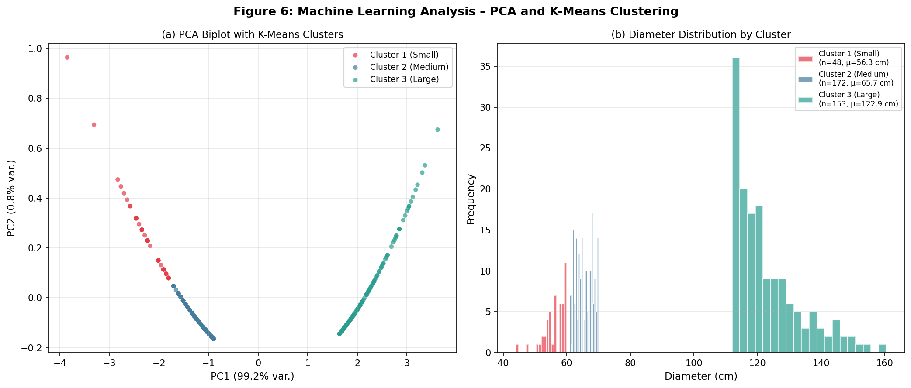
Figure 7. Machine learning results with PCA and diameter distributions by cluster
These species-specific structural differences are visually resolved using the violin plots illustrated in Figure 8. The breakdown demonstrates that the overall dataset's bimodality is driven by the pooling of distinct timber species with contrasting ecological profiles and size classes. Species such as Entandrophragma utile (Hook. f.) Sprague, Baillonella toxisperma Pierre, and Piptadeniastrum africanum (Hook. f.) Brenan are heavily skewed toward large-diameter classes and are situated almost entirely above the overall median line of 68.5 cm. In contrast, Pterocarpus soyauxii Taub. and Staudtia kamerunensis Warb. are tightly clustered as smaller-diameter cohorts below the median. Major commercial species, such as Cylicodiscus gabunensis Harms, Didelotia letouzeyi Pellegr., Nauclea diderrichii (De Wild. & T. Durand) Merr., and especially Lophira alata Banks ex Gaertn., exhibit prominent internal bimodality or elongated dumbbell shapes that span the entire diameter spectrum, confirming that specific canopy-dominant species contain multiple internal age or management size classes within these FMUs.
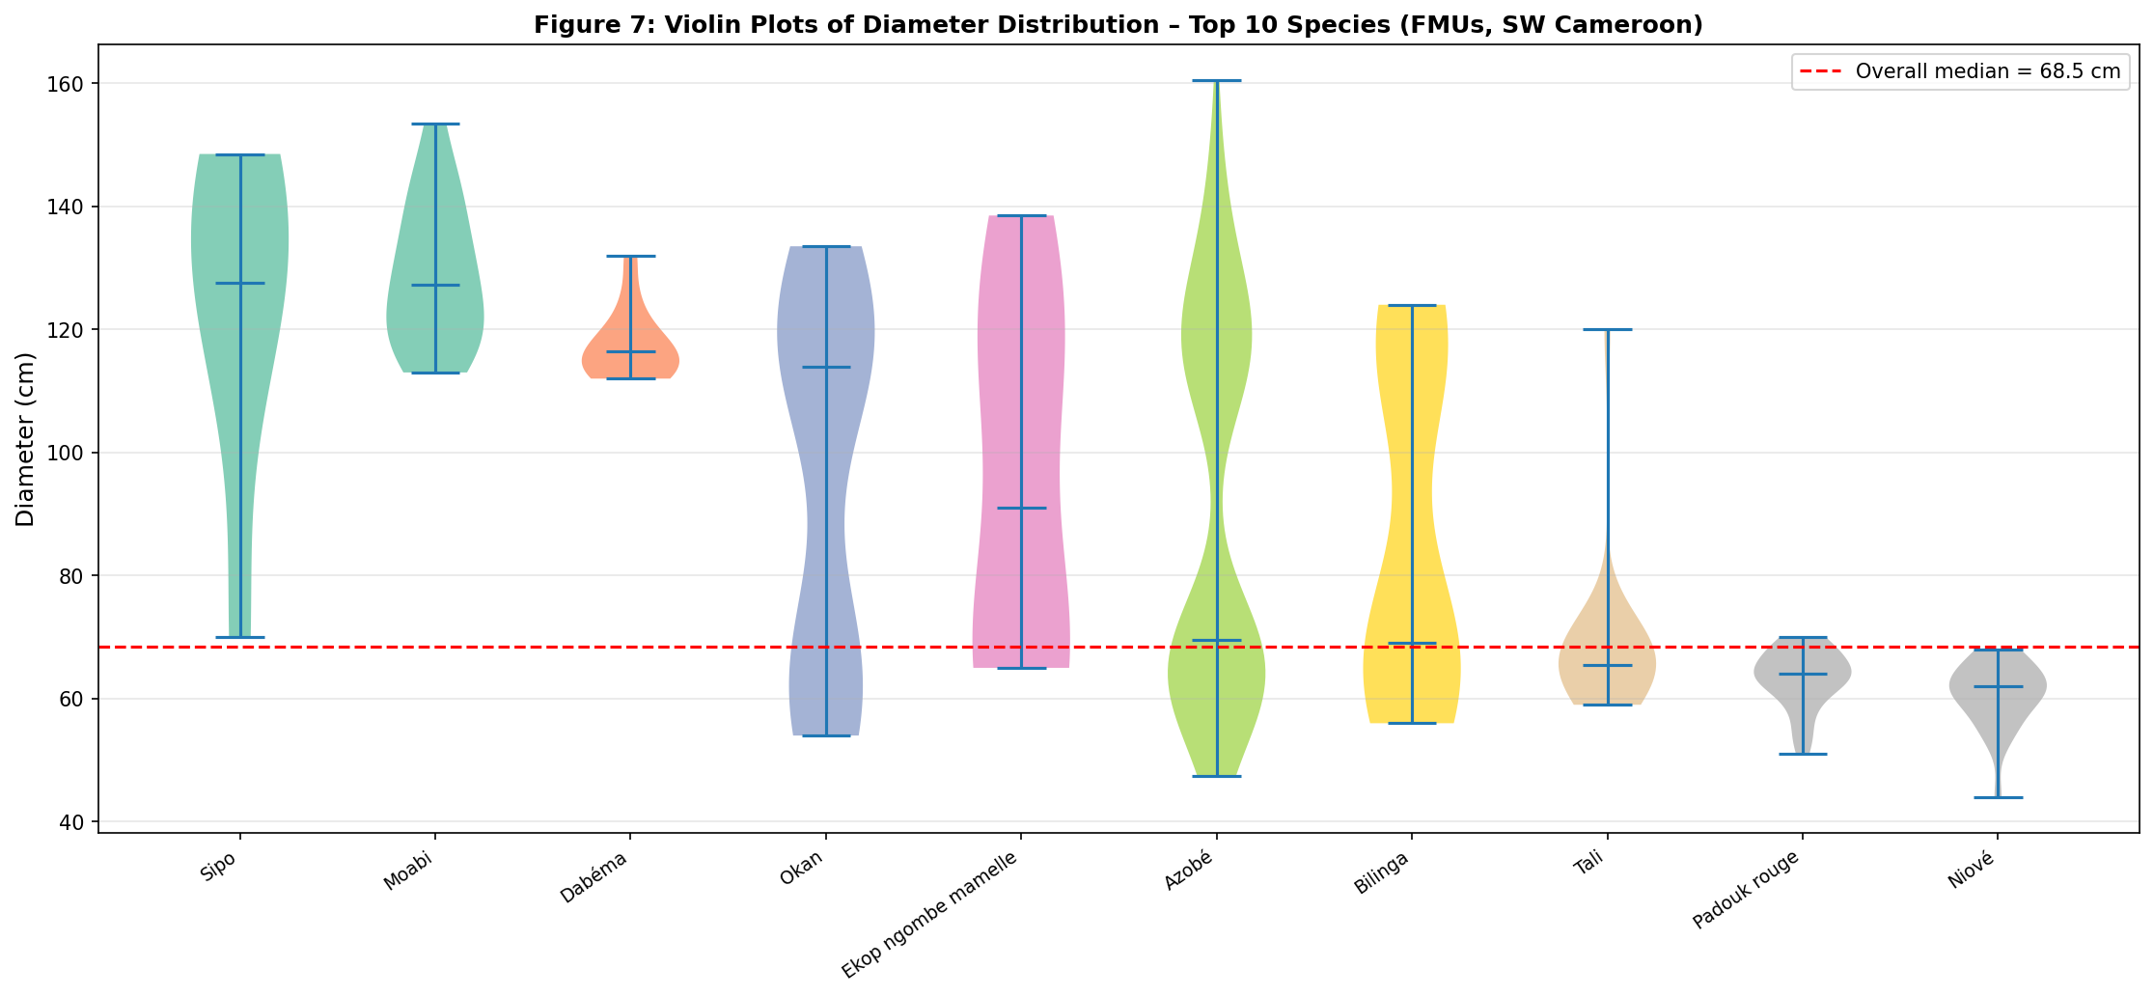
Figure 8. Violin plots for the ten most frequently harvested species ordered by median diameter.
These redundant feature relationships are visually quantified by the correlation matrix heatmap illustrated in Figure 9. The matrix demonstrates near-perfect linear relationships across all evaluated processing steps, with Pearson correlation coefficients (r) remaining between 0.98 and 1.00. Linear rescalings (Min-Max, Z-score, and Robust) preserve perfect collinearity (r = 1.00) with the raw data vector because they do not alter relative sample positions. Monotonic mathematical transformations, such as logarithmic, square-root, Box-Cox, and Yeo-Johnson transformations, exhibit negligible deviations (dropping only to 0.98 or 0.99) because of slight non-linear scaling bends. This uniform heatmap confirms that all transformed and normalised features retain the same underlying rank information, directly explaining the large variance concentration observed on the first principal component during dimensional analysis.
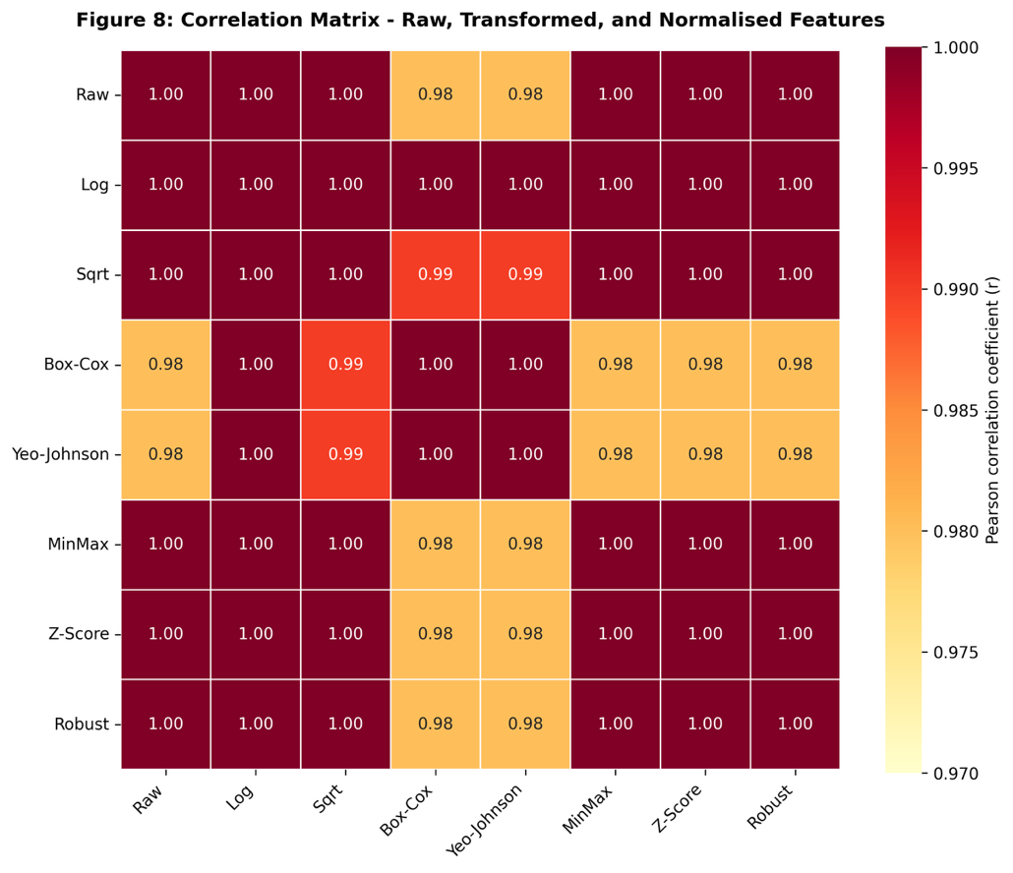
Figure 9. Pearson correlation matrix of raw, transformed, and normalised features
4. Discussion
4.1 The Bimodal Diameter Distribution as a Structural Property of Multi-Species Harvesting
The unanimous rejection of normality by all four complementary tests and the visual confirmation of a bimodal distribution with modes at approximately 67-70 cm and 113-120 cm are the central empirical findings of this study. This structural signature was not an artefact of measurement error or sampling bias; rather, it is an ecologically coherent consequence of harvesting a taxonomically heterogeneous assemblage under a species-specific Minimum Cutting Diameter (MCD) regulatory framework. The pooling of species with low MCDs (40-70 cm), exemplified by Pterocarpus soyauxii Taub. and Staudtia kamerunensis Warb., with high-MCD, large-stature species such as Baillonella toxisperma Pierre (MCD 100 cm) and Piptadeniastrum africanum (Hook. f.) Brenan (MCD 100 cm) inevitably produces a compound distribution. This is analogous to the mixture distributions documented in multi-cohort temperate forests (Gourlet-Fleury et al., 2004) and represents a structural property of Central African FMU harvest data rather than a methodological anomaly. The strongly negative excess kurtosis (g₂ = −1.413) is a reliable diagnostic signature of this bimodal architecture, consistent with the platykurtic profiles observed in other Congo Basin mixed-species inventories (de Wasseige et al., 2012).

This finding has immediate governance implications. The persistent application of parametric statistical frameworks assuming normality, including ordinary least squares volume models, parametric confidence intervals for carbon stock estimates, and z-score-based outlier screening in compliance auditing, is demonstrably inappropriate for this class of data. Because DBH is the primary predictor in virtually all allometric equations for above-ground biomass and timber volume (Picard et al., 2012; Chave et al., 2014), systematically biased distributional assumptions may propagate into biomass and volume estimates that feed REDD+ accounting frameworks and royalty calculations, although quantifying such propagation would require species-specific allometric validation beyond the scope of this study (Nasi et al., 2008; Cerutti et al., 2011).

4.2 The Theoretical Limits of Transformation and Their Practical Consequences
The failure of all five mathematical transformations to achieve normality is not a weakness of the analytical approach; it confirms a mathematical theorem with practical implications. Because no strictly monotone function can convert a distribution with two local density maxima into a unimodal distribution (Sokal & Rohlf, 1995), the persistence of bimodality across logarithmic, square-root, Box-Cox, and Yeo-Johnson transformations was theoretically expected. The Box-Cox (λ̂ = -0.952) and Yeo-Johnson (λ̂ = -0.970) transformations achieved the most favourable skewness reduction (g₁ ≈ 0.17), yet all Shapiro-Wilk p-values remained at p < 0.001 and excess kurtosis remained persistently negative (g₂ ≈ -1.5). The Q-Q plots provided strong visual evidence: the sharp, step-like vertical discontinuity between theoretical quantiles 0.0 and 0.5, unmitigated by any transformation, is the geometric signature of two structurally isolated sub-populations.

This result challenges a widespread but uncritical convention in applied forestry statistics. The logarithmic transformation is deeply embedded in allometric modelling practice because diameter-volume and diameter-biomass relationships are approximately log-linear for individual species (Henry et al., 2011; Picard et al., 2012). However, its application to multi-species harvest datasets conflates within-species allometric linearisation with between-species distributional normalisation, two categorically distinct statistical problems. Practitioners and regulatory auditors should recognise that transformation can improve model residual symmetry without resolving the dataset-level distributional structure. Failure to make this distinction risks producing statistically invalid confidence intervals for forest management plan compliance assessments, precisely the context where inferential validity is most consequential.

4.3 Normalisation Strategies and Their Suitability for Machine Learning Pipelines
The comparison of five normalisation strategies revealed that all are mathematically appropriate for rescaling purposes but differ substantially in their resistance to the extreme diameter values that characterise this dataset. Min-Max scaling, producing the expected [0, 1] range, is maximally sensitive to the observed extremes (44.0 cm and 160.5 cm) and may be severely distorted if new harvest declarations contain even slightly more extreme values. This is a realistic scenario as FMU rotation areas expand under Cameroon's 30-year management plan framework. Z-score standardisation preserves distributional shape while remaining influenced by the large standard deviation (30.19 cm) inflated by bimodality. Robust scaling, anchored to the median and IQR, is most appropriate for the non-Gaussian, heavy-tailed diameter distribution encountered here, consistent with the practical guidance of Hastie et al. (2009) and the theoretical recommendation of Pedregosa et al. (2011) for skewed ecological data.

The PowerTransformer variants achieved the most symmetric normalised output (lowest residual |g₁|) by combining power transformation with Z-score standardisation. The near-perfect Pearson correlations (r = 0.98-1.00) among all transformed and normalised features confirm that they are dimensionally redundant representations of the same univariate diameter rank. This finding is not merely a statistical curiosity; it directly explains the PCA result (PC1 = 99.23% of variance) and has a practical implication: in machine learning pipelines applied to univariate diameter data, feature engineering through transformation and normalisation adds no independent information. The choice of normalisation should therefore be driven by downstream algorithm requirements, including distance sensitivity for K-Means and K-Nearest Neighbours and numerical stability for gradient-based methods, rather than by the expectation of distributional normalisation.

4.4 Isolation Forest as a Superior Anomaly Detection Framework for Non-Gaussian Forestry Data
The complete failure of IQR and Z-score methods to detect any anomalies despite the dataset containing values as extreme as 44.0 cm (near the absolute MCD floor for the most common species) and 160.5 cm (substantially exceeding published diameter records for several of the species present) is a practically significant finding for forest compliance monitoring. Both classical methods are calibrated by the standard deviation and IQR, respectively, both of which are inflated by the 53.5 cm interquartile span of a bimodal distribution. This variance-masking effect is an instance of the general phenomenon whereby classical outlier detectors exhibit reduced sensitivity in multimodal datasets (Liu et al., 2012; Goldstein & Uchida, 2016), sometimes termed the masking effect in statistical literature (Barnett & Lewis, 1994).

Isolation Forest, being distribution-free and operating on information-theoretic path lengths rather than moment-based thresholds, successfully identified 18 anomalous records (4.8%) concentrated at the distributional extremes. In a regulatory compliance context, the two categories of anomalies have distinct interpretations. The lower-tail flags (44.0-47.5 cm) may represent sub-MCD harvest violations warranting immediate verification by Independent Forest Monitors, measurement recording errors, or genuinely small-diameter individuals of high-MCD species requiring botanical confirmation. The upper-tail flags (143.0-160.5 cm) may indicate exceptional old-growth individuals of conservation significance or measurement or transcription errors in harvest declarations. The distinction between these interpretations requires field verification, but the critical point is that Isolation Forest surfaces these cases for scrutiny while classical methods do not. This capability could support compliance screening workflows in contexts where legality verification frameworks such as Cameroon's Forest Law and EUDR traceability requirements demand documented evidence of harvest regularity, although direct integration would require further methodological development (Republic of Cameroon, 2024; Clever Project, 2025).

4.5 Machine Learning Reveals Ecologically and Regulatorily Meaningful Diameter Structure
K-Means clustering (k = 3, WCSS = 54.41) was applied to the normalised diameter feature space as a data-driven validation exercise rather than a multivariate discovery tool. Because all features are monotonic transformations of a single variable, the PCA result (PC1 = 99.23%) is an expected mathematical consequence rather than an empirical finding; it confirms that diameter alone is the structurally dominant axis in this dataset. The clustering outcome nonetheless constitutes independent algorithmic corroboration that Cameroon's MINFOF regulatory thresholds reflect genuine discontinuities in the empirical distribution: a small near-MCD class (Cluster 1, μ = 56.3 cm, n = 48), a transitional class (Cluster 2, μ = 65.7 cm, n = 172), and a large-diameter class (Cluster 3, μ = 122.9 cm, n = 153), rather than arbitrary policy choices. This correspondence between a purely data-driven algorithm and a regulatory classification is consistent with the size-class ecology reviewed by Clark and Clark (1999) and with the functional trait-based diameter class structures identified in Central African managed forests by Gourlet-Fleury et al. (2004). Future work incorporating multivariate dendrometric features (crown diameter, height, wood density) would enable genuinely multivariate ML inference.

The violin plot analysis adds ecological depth to this structural interpretation. The intraspecific bimodality visible in Lophira alata Banks ex Gaertn., Cylicodiscus gabunensis Harms, Nauclea diderrichii (De Wild. & T. Durand) Merr., and Didelotia letouzeyi Pellegr., spanning the full diameter spectrum, is consistent with the known ecological plasticity of Guineo-Congolian canopy dominants across successional stages and topographic gradients (Tchouto et al., 2006). Lophira alata Banks ex Gaertn., which dominated the dataset at 46.6% of records, is a light-demanding pioneer whose diameter distribution within a single FMU can span 40-160 cm or above, depending on the rotation history of the ACA. This intraspecific diameter variance represents both an ecological phenomenon and a statistical challenge: volume and biomass models for this species, calibrated without accounting for the multimodal diameter structure, may produce systematically biased predictions at both ends of the diameter range.

4.6 The Open-Source Python Pipeline as a Methodological Contribution
The fully reproducible Python pipeline demonstrated here addresses a structural gap in applied forest governance science in Central Africa. The Cameroonian forest statistical apparatus, including annual harvest declarations, FMU management plan compliance reporting, and REDD+ Monitoring, Reporting, and Verification (MRV) systems, currently relies heavily on proprietary software and external consultant expertise (Nasi et al., 2008). The demonstrated pipeline, executable with freely available packages across any operating system, provides a replicable analytical template that can be extended to the full Cameroonian FMU portfolio without code modification. The vectorised NumPy and Pandas architecture scales from 373 records to national inventory datasets of hundreds of thousands of observations without performance degradation. This scalability makes the pipeline a candidate for extension to national inventory datasets, and its reproducibility is consistent with the growing demand for standardised statistical workflows in tropical forest governance contexts.

4.7 Limitations and Future Directions
Several limitations bound the scope of the present findings. The 373-record dataset, while consistent in scale with published FMU inventory studies from the Congo Basin, represents a single snapshot of harvest declarations from one sub-region and one rotation cycle. Temporal dynamics, including diameter increment rates, harvesting intensity effects on population structure, and climate-driven growth variability, cannot be inferred from cross-sectional harvest data alone. The Isolation Forest contamination parameter (0.05) was set a priori; sensitivity analysis across contamination values of 0.02-0.10 would strengthen the anomaly detection conclusions. The K-Means algorithm assumes spherical cluster geometry, which may not fully capture the asymmetric diameter distributions within each regulatory class; Gaussian Mixture Models or hierarchical clustering offer promising alternatives for future analyses. Finally, the absence of spatial coordinates, tree height measurements, and wood density data precluded the fitting of full allometric biomass models, which would constitute a natural extension of this work and would directly support REDD+ carbon stock verification in Cameroon's FMUs and beyond.

5. Conclusion
This study assessed the statistical behaviour of harvested tropical timber diameter data from Forest Management Units in the South West Region of Cameroon. The results showed that the dataset was structurally non-normal and bimodal, reflecting the pooling of multiple commercial species with different diameter ranges. All formal normality tests rejected the assumption of normality, and the observed bimodality remained after the application of logarithmic, square-root, Box-Cox, Yeo-Johnson, and square transformations. Normalisation methods changed the scale of the data but did not alter the underlying distributional structure. The high variance explained by the first principal component confirmed that the transformed and normalised variables retained largely the same information as the original diameter vector. K-Means clustering identified three diameter-related groups, while Isolation Forest detected anomalous observations at the lower and upper extremes of the distribution. These findings suggest that conventional parametric assumptions and classical outlier methods may be unsuitable for pooled multi-species timber diameter data. Distribution-aware analysis, careful visual inspection, and reproducible computational workflows are therefore important for the reliable interpretation of harvested timber diameter datasets.

6. Limitations
This study was based on 373 harvested tree records from Forest Management Units in one region of Cameroon, and the findings should therefore be interpreted within this geographic and sampling context. The dataset represented a cross-sectional harvest record and did not include repeated measurements, growth history, or temporal information on harvesting cycles. Spatial coordinates, tree height, wood density, and stand-level variables were not available, limiting the possibility of extending the analysis to full biomass or volume modelling. The study also relied on a fixed Isolation Forest contamination value of 0.05, and alternative parameter settings were not tested. K-Means clustering was applied with a predefined number of clusters, which may influence the resulting group structure. In addition, the analysis used only diameter and species information; therefore, ecological interpretation of the detected clusters and anomalies requires further field verification.

Declaration of AI Use

This manuscript was prepared through the combined contributions of all author(s), including contributions to the study design, data, content development, results, interpretation, and related scholarly work. The author(s) acknowledge the use of Grammarly and ChatGPT to assist with grammar checking, language refinement, reference formatting. These AI-assisted tools were not used as authors and did not replace the intellectual contributions or scholarly judgment of the author(s). All AI-assisted outputs, including content, references, and interpretations, were carefully reviewed, revised, verified, and approved by the author(s). The author(s) accept full responsibility for the accuracy, integrity, and final content of the manuscript.

7. References
Agrawal, A., Chhatre, A., & Hardin, R. (2008). Changing governance of the world’s forests. Science, 320(5882), 1460–1462. https://doi.org/10.1126/science.1155369
Anderson, T. W., & Darling, D. A. (1952). Asymptotic theory of certain goodness-of-fit criteria based on stochastic processes. The Annals of Mathematical Statistics, 23(2), 193–212. https://doi.org/10.1214/aoms/1177729437
Asner, G. P., Mascaro, J., Muller-Landau, H. C., Vieilledent, G., Vaudry, R., Rasamoelina, M., Hall, J. S., & van Breugel, M. (2012). A universal airborne LiDAR approach for tropical forest carbon mapping. Oecologia, 168, 1147–1160. https://doi.org/10.1007/s00442-011-2165-z
Bayol, N., & Eba’a Atyi, R. (2009). The forests of Congo in 2008. In C. de Wasseige, D. Devers, P. de Marcken, R. Eba’a Atyi, R. Nasi, & P. Mayaux (Eds.), The forests of the Congo Basin: State of the forests 2008 (pp. 97–109). Publications Office of the European Union. https://doi.org/10.2788/32259
Bailey, R. L., & Dell, T. R. (1973). Quantifying diameter distributions with the Weibull function. Forest Science, 19(2), 97–104. https://doi.org/10.1093/forestscience/19.2.97
Barnett, V., & Lewis, T. (1994). Outliers in statistical data (3rd ed.). Wiley. https://www.wiley.com/en-us/shop/general-introductory-statistics/outliers-in-statistical-data-3rd-edition-p-9780471930945
Borma, L. (2023). Why tropical forests are important for our well-being. Eos, 104. https://doi.org/10.1029/2023EO235005
Box, G. E. P., & Cox, D. R. (1964). An analysis of transformations. Journal of the Royal Statistical Society: Series B, 26(2), 211–243. https://doi.org/10.1111/j.2517-6161.1964.tb00553.x
Cerutti, P. O., Tacconi, L., Nasi, R., & Lescuyer, G. (2011). Legal vs. certified timber: Preliminary impacts of forest certification in Cameroon. Forest Policy and Economics, 13(3), 184–190. https://doi.org/10.1016/j.forpol.2010.11.005
Chave, J., Réjou-Méchain, M., Búrquez, A., Chidumayo, E., Colgan, M. S., Delitti, W. B. C., Duque, A., Eid, T., Fearnside, P. M., Goodman, R. C., Henry, M., Martínez-Yrízar, A., Mugasha, W. A., Muller-Landau, H. C., Mencuccini, M., Nelson, B. W., Ngomanda, A., Nogueira, E. M., Ortiz-Malavassi, E., … Vieilledent, G. (2014). Improved allometric models to estimate the aboveground biomass of tropical trees. Global Change Biology, 20(10), 3177–3190. https://doi.org/10.1111/gcb.12629
Choi, H., & Jung, K. (2025). Impact of data distribution and bootstrap setting on anomaly detection using isolation forest in process quality control. Entropy, 27(7), Article 761. https://doi.org/10.3390/e27070761
Clark, D. A., & Clark, D. B. (1999). Assessing the growth of tropical rain forest trees: Issues for forest modeling and management. Ecological Applications, 9(3), 981–997. https://doi.org/10.2307/2641344
Clever Project. (2025). Losing forests by the minute: New laws in Cameroon and the EU’s global push. Clever Consortium / Horizon Europe. https://clever-project.eu/losing-forests-by-the-minute-new-laws-in-cameroon-and-the-eus-global-push/
Dallal, G. E., & Wilkinson, L. (1986). An analytic approximation to the distribution of Lilliefors’s test statistic for normality. The American Statistician, 40(4), 294–296. https://doi.org/10.1080/00031305.1986.10475419
D’Agostino, R. B., & Pearson, E. S. (1973). Tests for departure from normality: Empirical results for the distributions of b2 and √b1. Biometrika, 60(3), 613–622. https://doi.org/10.1093/biomet/60.3.613
de Wasseige, C., de Marcken, P., Bayol, N., Hiol Hiol, F., Mayaux, P., Desclée, B., Nasi, R., Billand, A., Defourny, P., & Eba’a Atyi, R. (Eds.). (2012). The forests of the Congo Basin: State of the forest 2010. Publications Office of the European Union. https://doi.org/10.2788/47210
Food and Agriculture Organization of the United Nations. (2025). Global forest resources assessment 2025: Main report. https://doi.org/10.4060/cd6709en
Feng, Y., Liu, J., Hu, H., Cui, P., Zhou, H., Ma, B., Liu, Z., & Chen, D. (2025). Global patterns in forest carbon storage estimation: Bibliometric analysis of technological evolution, accuracy gains and scaling challenges. Frontiers in Forests and Global Change, 8, Article 1649356. https://doi.org/10.3389/ffgc.2025.1649356
Fassnacht, F. E., Latifi, H., Stereńczak, K., Modzelewska, A., Lefsky, M., Waser, L. T., Straub, C., & Ghosh, A. (2016). Review of studies on tree species classification from remotely sensed data. Remote Sensing of Environment, 186, 64–87. https://doi.org/10.1016/j.rse.2016.08.013
Forest Trends. (2026). Illegal deforestation and associated trade (IDAT) risk: Cameroon. https://www.forest-trends.org/idat_countries/cameroon/
Goldstein, M., & Uchida, S. (2016). A comparative evaluation of unsupervised anomaly detection algorithms for multivariate data. PLOS ONE, 11(4), Article e0152173. https://doi.org/10.1371/journal.pone.0152173
Goodfellow, I., Bengio, Y., & Courville, A. (2016). Deep learning. MIT Press. http://www.deeplearningbook.org
Gourlet-Fleury, S., Favrichon, V., Schmitt, L., & Petronelli, P. (2004). Consequences of silvicultural treatments on stand dynamics at Paracou. In S. Gourlet-Fleury, J.-M. Guehl, & O. Laroussinie (Eds.), Ecology and management of a neotropical rainforest: Lessons drawn from Paracou, a long-term experimental research site in French Guiana (pp. 254–280). Elsevier.
Hansen, M. C., Potapov, P. V., Moore, R., Hancher, M., Turubanova, S. A., Tyukavina, A., Thau, D., Stehman, S. V., Goetz, S. J., Loveland, T. R., Kommareddy, A., Egorov, A., Chini, L., Justice, C. O., & Townshend, J. R. G. (2013). High-resolution global maps of 21st-century forest cover change. Science, 342(6160), 850–853. https://doi.org/10.1126/science.1244693
Harris, C. R., Millman, K. J., van der Walt, S. J., Gommers, R., Virtanen, P., Cournapeau, D., Wieser, E., Taylor, J., Berg, S., Smith, N. J., Kern, R., Picus, M., Hoyer, S., van Kerkwijk, M. H., Brett, M., Haldane, A., del Río, J. F., Wiebe, M., Peterson, P., Gérard-Marchant, P., Sheppard, K., Reddy, T., Weckesser, W., Abbasi, H., Gohlke, C., & Oliphant, T. E. (2020). Array programming with NumPy. Nature, 585, 357–362. https://doi.org/10.1038/s41586-020-2649-2
Hastie, T., Tibshirani, R., & Friedman, J. (2009). The elements of statistical learning: Data mining, inference, and prediction (2nd ed.). Springer. https://doi.org/10.1007/978-0-387-84858-7
Henry, M., Picard, N., Trotta, C., Manlay, R. J., Valentini, R., Bernoux, M., & Saint-André, L. (2011). Estimating tree biomass of sub-Saharan African forests: A review of available allometric equations. Silva Fennica, 45(3B), 477–569. https://doi.org/10.14214/sf.38
Hotelling, H. (1933). Analysis of a complex of statistical variables into principal components. Journal of Educational Psychology, 24(6), 417–441. https://doi.org/10.1037/h0071325
Hunter, J. D. (2007). Matplotlib: A 2D graphics environment. Computing in Science & Engineering, 9(3), 90–95. https://doi.org/10.1109/MCSE.2007.55
Jain, P., Gyanchandani, M., & Khare, N. (2016). Big data privacy: A technological perspective and review. Journal of Big Data, 3, Article 25. https://doi.org/10.1186/s40537-016-0059-y
Kolmogorov, A. N. (1933). Sulla determinazione empirica di una legge di distribuzione. Giornale dell’Istituto Italiano degli Attuari, 4, 83–91. https://digitale.bnc.roma.sbn.it/tecadigitale/giornale/CFI0353791/1933/unico
Laughlin, D. C., Leppert, J. J., Moore, M. M., & Sieg, C. H. (2010). A multi-trait test of the leaf-height-seed plant strategy scheme with 133 species from a pine forest flora. Functional Ecology, 24(3), 493–501. https://doi.org/10.1111/j.1365-2435.2009.01672.x
Laurance, W. F., Sayer, J., & Cassman, K. G. (2014). Agricultural expansion and its impacts on tropical nature. Trends in Ecology & Evolution, 29(2), 107–116. https://doi.org/10.1016/j.tree.2013.12.001
LeCun, Y., Bottou, L., Orr, G. B., & Müller, K.-R. (1998). Efficient backprop. In G. B. Orr & K.-R. Müller (Eds.), Neural networks: Tricks of the trade (Lecture Notes in Computer Science, Vol. 1524, pp. 9–50). Springer. https://doi.org/10.1007/3-540-49430-8_2
Legendre, P., & Legendre, L. (2012). Numerical ecology (3rd English ed.). Elsevier. https://www.sciencedirect.com/bookseries/developments-in-environmental-modelling/vol/24/suppl/C
Lewis, S. L., Lopez-Gonzalez, G., Sonké, B., Affum-Baffoe, K., Baker, T. R., Ojo, L. O., Phillips, O. L., Reitsma, J. M., White, L., Comiskey, J. A., Djuikouo, M.-N. K., Ewango, C. E. N., Feldpausch, T. R., Hamilton, A. C., Gloor, M., Hart, T., Hladik, A., Lloyd, J., Lovett, J. C., … Wöll, H. (2009). Increasing carbon storage in intact African tropical forests. Nature, 457(7232), 1003–1006. https://doi.org/10.1038/nature07771
Lilliefors, H. W. (1967). On the Kolmogorov–Smirnov test for normality with mean and variance unknown. Journal of the American Statistical Association, 62(318), 399–402. https://doi.org/10.2307/2283970
Liu, F. T., Ting, K. M., & Zhou, Z.-H. (2008). Isolation forest. In 2008 IEEE International Conference on Data Mining (pp. 413–422). IEEE. https://doi.org/10.1109/ICDM.2008.17
Liu, F. T., Ting, K. M., & Zhou, Z.-H. (2012). Isolation-based anomaly detection. ACM Transactions on Knowledge Discovery from Data, 6(1), Article 3. https://doi.org/10.1145/2133360.2133363
Lloyd, S. P. (1982). Least squares quantization in PCM. IEEE Transactions on Information Theory, 28(2), 129–137. https://doi.org/10.1109/TIT.1982.1056489
MacQueen, J. B. (1967). Some methods for classification and analysis of multivariate observations. In L. M. Le Cam & J. Neyman (Eds.), Proceedings of the Fifth Berkeley Symposium on Mathematical Statistics and Probability, Volume 1: Statistics (pp. 281–297). University of California Press. https://projecteuclid.org/euclid.bsmsp/1200512992
McKinney, W. (2010). Data structures for statistical computing in Python. In S. van der Walt & J. Millman (Eds.), Proceedings of the 9th Python in Science Conference (pp. 56–61). https://doi.org/10.25080/Majora-92bf1922-00a
Midway, S., & White, J. W. (2025). Testing for normality in regression models: Mistakes abound (but may not matter). Royal Society Open Science, 12(4), Article 241904. https://doi.org/10.1098/rsos.241904
MINFOF. (2019). Forest management plan standards for forest management units in Cameroon: Technical Guide No. 7/Rapport sur l’état des forêts du Cameroun. Ministère des Forêts et de la Faune.
Müller, A. C., & Guido, S. (2016). Introduction to machine learning with Python: A guide for data scientists. O’Reilly Media. https://www.oreilly.com/library/view/introduction-to-machine/9781449369880/
Nago Zeufack, M., Ward, B., Pokem, D., & Rigaud, K. K. (2025). A fair deal for the sustainable development of Congo Basin countries and the protection of the rainforest. Grantham Research Institute on Climate Change and the Environment, London School of Economics and Political Science. https://www.lse.ac.uk/granthaminstitute/publication/a-fair-deal-for-the-sustainable-development-of-the-congo-basin-countries-and-the-protection-of-the-rainforest/
Nasi, R., Brown, D., Wilkie, D., Bennett, E., Tutin, C., van Tol, G., & Christophersen, T. (2008). Conservation and use of wildlife-based resources: The bushmeat crisis (CBD Technical Series No. 33). Secretariat of the Convention on Biological Diversity and Center for International Forestry Research. https://www.cbd.int/doc/publications/cbd-ts-33-en.pdf
Pan, Y., Birdsey, R. A., Fang, J., Houghton, R., Kauppi, P. E., Kurz, W. A., Phillips, O. L., Shvidenko, A., Lewis, S. L., Canadell, J. G., Ciais, P., Jackson, R. B., Pacala, S. W., McGuire, A. D., Piao, S., Rautiainen, A., Sitch, S., & Hayes, D. (2011). A large and persistent carbon sink in the world’s forests. Science, 333(6045), 988–993. https://doi.org/10.1126/science.1201609
Patro, S. G. K., & Sahu, K. K. (2015). Normalization: A preprocessing stage. International Advanced Research Journal in Science, Engineering and Technology, 2(3), 20–22. https://iarjset.com/wp-content/uploads/2015/march-15/IARJSET%205.pdf
Pearson, K. (1900). On the criterion that a given system of deviations from the probable in the case of a correlated system of variables is such that it can be reasonably supposed to have arisen from random sampling. The London, Edinburgh, and Dublin Philosophical Magazine and Journal of Science, Series 5, 50(302), 157–175. https://doi.org/10.1080/14786440009463897
Pearson, K. (1901). On lines and planes of closest fit to systems of points in space. The London, Edinburgh, and Dublin Philosophical Magazine and Journal of Science, 2(11), 559–572. https://doi.org/10.1080/14786440109462720
Pedregosa, F., Varoquaux, G., Gramfort, A., Michel, V., Thirion, B., Grisel, O., Blondel, M., Prettenhofer, P., Weiss, R., Dubourg, V., Vanderplas, J., Passos, A., Cournapeau, D., Brucher, M., Perrot, M., & Duchesnay, É. (2011). Scikit-learn: Machine learning in Python. Journal of Machine Learning Research, 12(85), 2825–2830. https://jmlr.org/papers/v12/pedregosa11a.html
Peng, R. D. (2011). Reproducible research in computational science. Science, 334(6060), 1226–1227. https://doi.org/10.1126/science.1213847
Picard, N., Saint-André, L., & Henry, M. (2012). Manual for building tree volume and biomass allometric equations: From field measurement to prediction. Food and Agriculture Organization of the United Nations and Centre de Coopération Internationale en Recherche Agronomique pour le Développement. https://www.fao.org/4/i3058e/i3058e.pdf
Quinn, G. P., & Keough, M. J. (2002). Experimental design and data analysis for biologists. Cambridge University Press. https://doi.org/10.1017/CBO9780511806384
Razali, N. M., & Wah, Y. B. (2011). Power comparisons of Shapiro–Wilk, Kolmogorov–Smirnov, Lilliefors, and Anderson–Darling tests. Journal of Statistical Modeling and Analytics, 2(1), 21–33. https://www.academia.edu/105326283/Power_comparisons_of_Shapiro_Wilk_Kolmogorov_Smirnov_Lilliefors_and_Anderson_Darling_test
Réjou-Méchain, M., Tanguy, A., Piponiot, C., Chave, J., & Hérault, B. (2017). BIOMASS: An R package for estimating above-ground biomass and its uncertainty in tropical forests. Methods in Ecology and Evolution, 8(9), 1163–1167. https://doi.org/10.1111/2041-210X.12753
Republic of Cameroon. (2024). Law No. 2024/008 of 24 July 2024 to lay down forestry and wildlife regulations. Presidency of the Republic of Cameroon. https://www.prc.cm/en/news/the-acts/laws/7310-law-no-2024-008-of-24-july-2024-to-lay-down-forestry-and-wildlife-regulations
Royston, P. (1992). Approximating the Shapiro–Wilk W-test for non-normality. Statistics and Computing, 2, 117–119. https://doi.org/10.1007/BF01891203
Sandve, G. K., Nekrutenko, A., Taylor, J., & Hovig, E. (2013). Ten simple rules for reproducible computational research. PLOS Computational Biology, 9(10), Article e1003285. https://doi.org/10.1371/journal.pcbi.1003285
Shang, Y., Xia, Y., Ran, X., Zheng, X., Ding, H., & Fang, Y. (2025). Allometric equations for aboveground biomass estimation in natural forest trees: Generalized or species-specific? Diversity, 17(7), Article 493. https://doi.org/10.3390/d17070493
Shapiro, S. S., & Wilk, M. B. (1965). An analysis of variance test for normality: Complete samples. Biometrika, 52(3/4), 591–611. https://doi.org/10.1093/biomet/52.3-4.591
Smirnov, N. (1948). Table for estimating the goodness of fit of empirical distributions. The Annals of Mathematical Statistics, 19(2), 279–281. https://doi.org/10.1214/aoms/1177730256
Sokal, R. R., & Rohlf, F. J. (1995). Biometry: The principles and practice of statistics in biological research (3rd ed.). W. H. Freeman. https://openlibrary.org/books/OL1087142M/Biometry
Stephens, M. A. (1974). EDF statistics for goodness of fit and some comparisons. Journal of the American Statistical Association, 69(347), 730–737. https://doi.org/10.2307/2286009
Tchouto, M. G. P., de Boer, W. F., de Wilde, J. J. F. E., & van der Maesen, L. J. G. (2006). Diversity patterns in the flora of the Campo-Ma’an rain forest, Cameroon: Do tree species tell it all? Biodiversity and Conservation, 15, 1353–1374. https://doi.org/10.1007/s10531-005-5394-9
Thode, H. J. (2002). Testing for normality. Marcel Dekker. https://doi.org/10.1201/9780203910894
Topa, G., Karsenty, A., Megevand, C., & Debroux, L. (2009). The rainforests of Cameroon: Experience and evidence from a decade of reform. World Bank. https://doi.org/10.1596/978-0-8213-7878-6
Torresan, C., Corona, P., Scrinzi, G., & Marsal, J. V. (2016). Using classification trees to predict forest structure types from LiDAR data. Annals of Forest Research, 59(2), 281–298. https://doi.org/10.15287/afr.2016.423
Kamkuimo, P., Guiny, J., Kamga, J., & Modjo, A. (2025). A guide to verify the legality of timber imported from Cameroon: Documentary analysis for EUTR/EUDR authorities to carry out due diligence. TRAFFIC International & Forêts et Développement Rural. https://www.traffic.org/site/assets/files/28083/vf3_traffic-foder-guide-to-verify-legality-of-timber-from-cameroon_feb2025-final-repris.pdf
Tukey, J. W. (1977). Exploratory data analysis. Addison-Wesley. https://archive.org/details/exploratorydataa0000tuke_7616
United Nations Framework Convention on Climate Change. (2025). What is REDD+? https://unfccc.int/topics/land-use/workstreams/redd/what-is-redd
VanderPlas, J. (2016). Python data science handbook: Essential tools for working with data. O’Reilly Media. https://jakevdp.github.io/PythonDataScienceHandbook/
Vieilledent, G., Vaudry, R., Andriamanohisoa, S. F. D., Rakotonarivo, O. S., Randrianasolo, H. Z., Razafindrabe, H. N., Rakotoarivony, C. B., Ebeling, J., & Rasamoelina, M. (2012). A universal approach to estimate biomass and carbon stock in tropical forests using generic allometric models. Ecological Applications, 22(2), 572–583. https://doi.org/10.1890/11-0039.1
Virtanen, P., Gommers, R., Oliphant, T. E., Haberland, M., Reddy, T., Cournapeau, D., Burovski, E., Peterson, P., Weckesser, W., Bright, J., van der Walt, S. J., Brett, M., Wilson, J., Millman, K. J., Mayorov, N., Nelson, A. R. J., Jones, E., Kern, R., Larson, E., Carey, C. J., Polat, İ., Feng, Y., Moore, E. W., VanderPlas, J., Laxalde, D., Perktold, J., Cimrman, R., Henriksen, I., Quintero, E. A., Harris, C. R., Archibald, A. M., Ribeiro, A. H., Pedregosa, F., & van Mulbregt, P. (2020). SciPy 1.0: Fundamental algorithms for scientific computing in Python. Nature Methods, 17, 261–272. https://doi.org/10.1038/s41592-019-0686-2
Waskom, M. L. (2021). Seaborn: Statistical data visualization. Journal of Open Source Software, 6(60), Article 3021. https://doi.org/10.21105/joss.03021
Wasser, L. (2025, September 15). Python’s reproducibility crisis: And how we fixed it for open science education. https://www.leahwasser.com/blog/2025/2025-09-15-reproducibility-python-environments/
Yeo, I.-K., & Johnson, R. A. (2000). A new family of power transformations to improve normality or symmetry. Biometrika, 87(4), 954–959. https://doi.org/10.1093/biomet/87.4.954
Zhang, L. (1997). Cross-validation of non-linear growth functions for modelling tree height–diameter relationships. Annals of Botany, 79(3), 251–257. https://doi.org/10.1006/anbo.1996.0334
Zuur, A. F., Ieno, E. N., Walker, N. J., Saveliev, A. A., & Smith, G. M. (2009). Mixed effects models and extensions in ecology with R. Springer. https://doi.org/10.1007/978-0-387-87458-6

