Forecasting Annual Electricity Consumption in Myanmar: A Comparative Time Series Analysis for Strategic Energy Planning

ABSTRACT
Electricity demand forecasting is essential for effective energy planning resource allocation, and policy formulation. This study analyzed comprehensive historical time series data spanning 63 years, from the 1961–1962 to the 2023–2024 fiscal years. The research extensively utilizes secondary time series data on annual electricity consumption sourced from the Myanmar Statistical Yearbooks, published by the Central Statistical Organization (CSO) under the Ministry of Planning and Finance. The Augmented Dickey-Fuller (ADF) unit root test was applied to determine the stationary of the data series. Three distinct univariate forecasting techniques the Box-Jenkins Autoregressive Integrated Moving Average (ARIMA) model, Brown’s Double Exponential Smoothing model, and Holt’s Double Exponential Smoothing mode were implemented to capture modeling trends. The best-performing forecasting model was determined through a comparative evaluation of standard residual fit statistics, specifically the Root Mean Square Error (RMSE), Mean Absolute Percentage Error (MAPE), and the Bayesian Information Criterion (BIC). The initial ADF test for stationary yielded a value of 3.68 with a p-value of 1.00, confirming that the original series was non-stationary and required a first-differencing transformation. Ljung-Box Q-statistic of 18.74 (df = 18, sig = 0.82) indicated no significant residual autocorrelation. In comparison, Holt’s model produced error accuracy values of 1285.32 (RMSE), 7.03% (MAPE), and 14.45 (BIC). Brown’s Double Exponential Smoothing model achieved an RMSE of 1277.84, a MAPE of 7.53%, and a BIC of 14.37. Based on the superior fitness parameters of the ARIMA model, the 95% confidence interval forecast estimates for electricity consumption (in kWh) are 33,977.3 for 2024–2025, 36,809.3 for 2025–2026, 39,877.3 for 2026–2027, and 43,201.0 for 2027–2028. Identifying precise time-series frameworks such as the ARIMA model provides highly accurate forecasts capable of capturing short-term fluctuations and data shifts within the temporal series. Regular implementation and monitoring of these refined statistical models, using continuous secondary updates, allow for the stable identification of long-term electricity demands. Consequently, these quantitative forecasting insights strategically empower energy planners and government policymakers to balance industrial expansion and economic growth with the long-term sustainability of the national grid infrastructure.
Keywords: annual electricity consumption; Myanmar; time-series forecasting; ARIMA model; Brown’s Double Exponential Smoothing; Holt’s Double Exponential Smoothing; Augmented Dickey–Fuller test; energy planning; forecasting accuracy; national grid planning

1. INTRODUCTION
Myanmar's electricity sector has undergone significant changes over time. The country has relied heavily on hydropower for electricity generation by harnessing the energy potential of its numerous rivers (Economic Research Institute for ASEAN and East Asia, 2020). However, increasing urbanisation, industrialisation, and population growth have created demand for more diversified and reliable energy sources (Dapice, 2012). At present, Myanmar's electricity sector is characterised by a mixture of conventional and renewable energy sources (United Nations Economic and Social Council, 2016). Hydropower continues to be a major contributor, supplemented by thermal power plants (Total Myanmar, 2015). In recent years, increasing emphasis has been placed on incorporating renewable energy, particularly solar and wind power, in line with global trends towards sustainable and cleaner energy solutions (Ritchie, Roser, & Rosado, 2020). Despite this progress, Myanmar's electricity sector faces challenges such as infrastructure constraints, grid limitations, and the need for policy reform (Vakulchuk et al., 2017). These challenges also present opportunities for innovation, investment, and the adoption of modern technologies to improve the energy landscape (Rodriguez, Vasquez, & Dayupay, 2020). Myanmar has abundant renewable energy resources, including substantial solar potential and untapped wind resources (United Nations Economic and Social Council, 2016). Recognising the importance of sustainable practices, the country is exploring ways to harness these resources to meet increasing energy demand while minimising environmental impact (Liu & Noor, 2020). The Government of Myanmar has been proactive in addressing the evolving energy landscape. Policy frameworks are being developed to promote private-sector participation, encourage foreign investment, and establish a conducive environment for integrating new technologies into the electricity grid (Asian Development Bank, 2015). As Myanmar moves towards a more electrified future, the focus is on balancing economic development with environmental sustainability (World Energy Council, 2016). Forecasts suggest a shift towards a more diversified and resilient energy mix, with a greater share of renewable sources contributing to overall electricity generation. This strategic approach positions Myanmar on a path towards a more sustainable and prosperous energy future (Economic Research Institute for ASEAN and East Asia, 2020).
1.1 Rationale of the Study
Myanmar is at a pivotal stage in its economic trajectory, with rapid urbanisation, industrial expansion, and population growth. The interaction of these factors requires a comprehensive understanding of the dynamics within the country's electricity sector. Myanmar's economic development is closely linked to its ability to meet the increasing demand for electricity. As industries expand and urban centres grow, there is a clear need to forecast, plan, and optimise electricity supply to support sustained economic growth. With the global emphasis on sustainable development and climate change mitigation, Myanmar seeks to align its energy sector with environmentally conscious practices. A study of electricity consumption and demand is therefore important for identifying pathways to integrate renewable energy sources, reduce carbon emissions, and foster a sustainable energy ecosystem. The existing electricity infrastructure in Myanmar faces challenges related to capacity, reliability, and distribution. A comprehensive study can identify these bottlenecks and provide insights into the upgrades and expansions needed to ensure a resilient and efficient energy grid.
The Government of Myanmar is actively formulating policies and regulatory frameworks to attract investment, encourage private-sector participation, and promote innovation in the energy sector. Evaluating the effectiveness of existing policies can support recommendations for strengthening the regulatory environment. A reliable and accessible electricity supply is fundamental to fostering social inclusiveness and improving quality of life. This study examines ways to ensure equitable access to electricity, particularly in rural areas, and considers the socio-economic implications of improved energy access. The global energy landscape is evolving rapidly through technological advancement and a growing focus on sustainable energy solutions. A study of Myanmar's electricity sector positions the country within these global trends and supports the adoption of good practices and innovative technologies.
Understanding the trajectory of electricity demand and generation is crucial for attracting investment in the energy sector. This study provides insights into potential investment opportunities and supports the development of a robust and economically resilient electricity infrastructure. It also contributes to a shared understanding of the challenges and opportunities, thereby supporting initiatives that contribute to the overall well-being of the nation.
The primary sources of energy consumption in Myanmar comprise electricity, natural gas, coal, petrol, propane, wood chips, rice husks, sawdust, charcoal, and ammonia. Total electricity consumption in the country was estimated at 8.71 terawatt-hours (TWh). Biomass accounts for approximately 65% of the total primary energy supply and is utilised predominantly within the residential sector, which consumes around 97% of the biomass energy produced. Myanmar records one of the lowest levels of per capita energy consumption in Southeast Asia, largely attributable to low electrification rates and widespread poverty. It is estimated that approximately 65% of the population remains unconnected to the national electricity grid. Furthermore, the country's electricity infrastructure remains underdeveloped, with limited grid coverage and a lack of substantial privately owned power generation facilities. Despite these constraints, energy demand has increased steadily, with average annual growth in energy consumption reaching 3.3% between 2000 and 2007 (World Energy Council, 2016).

The principal objective of Myanmar's energy policy is to achieve energy independence through the expansion of domestic production from available primary energy resources. This objective is pursued through intensified exploration and development activities, together with initiatives promoting energy efficiency, energy conservation, and the adoption of renewable energy technologies. Recognising electricity as a critical driver of economic development, the Government has prioritised measures to increase power-generation capacity and improve the reliability, density, and volume of electricity distribution throughout the country (Asian Development Bank, 2015).

As Myanmar's economy continues to develop, electricity demand is expected to rise correspondingly. The role of electricity consumption as a catalyst for economic growth has long been recognised in the economic development literature. Sustained economic growth contributes to improvements in living standards and increases in gross domestic product (GDP) per capita. As living standards improve, energy consumption typically expands in response to growing household and industrial demand. In this context, the present study forecasts future electricity consumption in Myanmar using several time-series forecasting techniques, including the Autoregressive Integrated Moving Average (ARIMA) model, Double Exponential Smoothing, and Holt-Winters smoothing methods.
1.2 Method of Study
The research methodology is anchored in the model-building framework proposed by Box and Jenkins (Box et al., 1994), and the Augmented Dickey-Fuller (ADF) unit-root test is used to determine whether the series is stationary. The study employs three forecasting models: the ARIMA model, Brown's Double Exponential Smoothing model, and Holt's Double Exponential Smoothing model. These models are used to analyse and forecast electricity consumption in Myanmar. The most appropriate model for predicting electricity consumption in Myanmar is determined through a comparative evaluation of these models.

1.3 Scope of the Study
The annual time-series data on electricity generation and consumption in Myanmar spanning 1961-1962 to 2023-2024 (63 years) are utilised in this study. The secondary data were collected from the Myanmar Statistical Year Books published by the Central Statistical Organization (CSO), Ministry of Planning and Finance.
1.4 Organization of the Study
This study is structured into five chapters. Chapter 1 presents the introduction and includes the rationale of the study, objectives, method, scope and limitations, and organisation of the study. Chapter 2 presents the literature review, including background information and related empirical studies. Chapter 3 reviews the theoretical concepts related to the models employed in this study. Chapter 4 focuses on the modelling and forecasting of electricity generation and consumption in Myanmar and the implementation of AMI in Myanmar. Finally, Chapter 5 presents the findings, suggestions, recommendations, and avenues for further study.
1.5 Research Gap of the Study
Recent electricity-demand forecasting literature continues to emphasise the use of statistical, machine-learning, and hybrid approaches for planning-oriented prediction, while noting that model selection should be guided by data structure, validation criteria, and the intended forecasting horizon (Chen et al., 2024; Ugbehe et al., 2025). In regional electricity-demand studies, ARIMA-based modelling has also been evaluated using error measures such as RMSE and MAPE and has been found suitable in several country-level contexts (Semekonawo & Kam, 2022). At the same time, recent applied work shows that demand-estimation performance may depend on the availability of supporting explanatory data, whereas this manuscript relies on the official annual national consumption series for Myanmar (Peplinski et al., 2024). Therefore, a context-specific research gap remains in evaluating parsimonious univariate forecasting models for Myanmar's official long-run annual electricity-consumption series up to the 2023-2024 fiscal year, particularly for evidence that can support national grid-planning decisions using the data currently available in this manuscript.
1.6 Objectives of the Study
The study aims to achieve the following objectives:
(i) to identify and evaluate the most suitable time-series forecasting model for predicting annual electricity consumption in Myanmar
(ii) to forecast future electricity consumption trends in Myanmar using the selected optimal forecasting model
2. Literature Review
This chapter presents Myanmar's electricity-consumption landscape and reflects the complexities of balancing economic development with environmental sustainability. As the country navigates these challenges and opportunities, a nuanced understanding of electricity-consumption dynamics is essential for shaping policies, fostering innovation, and building resilient energy infrastructure. The exploration of global electricity consumption, electricity development in Southeast Asia, and the patterns of electricity production and consumption in Myanmar stands at the forefront of contemporary energy research. As the world faces increasing energy demand and evolving environmental considerations, a comprehensive understanding of these interrelated aspects becomes important. This study aims to contribute valuable insights to the discourse on energy policy, sustainability, and the evolving global and regional electricity landscape.
2.1 Global Electricity Consumption
Global electricity consumption has steadily increased over time, driven by population growth, industrialisation, urbanisation, and technological advancement. Electricity demand is a key indicator of economic development and quality of life. There are significant disparities in electricity consumption among regions. Developed countries generally have higher per capita electricity consumption because of advanced industrial infrastructure and higher standards of living. Developing regions may still have lower overall consumption, but they are often characterised by faster growth rates. The industrial sector is a major consumer of electricity, using it for manufacturing, processing, and various industrial activities. The residential sector also contributes significantly, particularly in developed countries where households rely heavily on electrical appliances and heating or cooling systems. There is a global trend towards increasing the share of renewable energy in the electricity mix. Countries are investing in wind, solar, hydroelectric, and other renewable sources to diversify their energy portfolios, reduce carbon emissions, and enhance sustainability. Technological advances in energy-efficient appliances, smart grids, and energy-storage solutions are influencing how electricity is consumed and managed. These innovations contribute to reducing overall energy consumption and optimising the use of electricity in different sectors.
Many countries are adopting policies to promote energy efficiency, reduce carbon emissions, and transition to cleaner energy sources. These initiatives are often aligned with global climate goals, such as those outlined in the Paris Agreement. Challenges related to meeting growing electricity demand include the need for significant infrastructure investment, grid modernisation, and the reduction of energy poverty in some regions. Opportunities lie in the development and implementation of sustainable and resilient energy systems. The electrification of transportation, including electric vehicles, is a notable trend affecting global electricity consumption. As more countries aim to shift away from fossil fuels, the demand for electricity in the transport sector is expected to rise. The increasing reliance on digital technologies and the growth of data centres also contribute to higher electricity consumption in the information-technology sector. Data centres, in particular, require substantial energy for operation and cooling.
Since the Industrial Revolution, global energy systems have undergone profound transformations, accompanied by a substantial increase in energy demand across many countries. This growth has been driven primarily by economic development, rising levels of wealth, and rapid population expansion. As populations continue to increase, the demand for electricity has intensified, often exceeding the capacity of existing energy infrastructure. Consequently, global energy consumption has continued to rise steadily over time, creating significant challenges for the sustainable transition of energy systems.
Variations in total energy consumption among countries are largely influenced by differences in population size and levels of economic development (Ritchie et al., 2020). Countries with the highest levels of energy consumption include Iceland, Norway, Canada, and the United States, as well as affluent Middle Eastern nations such as Oman, Saudi Arabia, and Qatar. Per capita energy consumption in these countries can be up to one hundred times greater than that observed in some of the world’s poorest nations (Ritchie et al., 2020).
Global electricity consumption has exhibited sustained growth over the past five decades, reaching approximately 23,900 terawatt-hours (TWh) in 2019. Between 1980 and 2019, worldwide electricity consumption more than tripled, whereas the global population increased by approximately 75%. This substantial rise in electricity demand has been driven by ongoing industrialisation, economic expansion, and improved access to electricity across both developed and developing regions of the world (Alves, 2022).
2.2 Electricity Production in Myanmar
As of January 2023, Myanmar's electricity production was primarily characterised by a combination of conventional and renewable energy sources. The energy landscape can evolve over time; therefore, recent reports and official sources should be consulted for the most current information. A general overview is provided below:
i. Hydropower: Hydropower has historically been the dominant source of electricity production in Myanmar. The country is endowed with abundant rivers and water resources, providing significant hydropower potential. Large hydropower projects, such as the Ayeyarwady and Chindwin River projects, contribute significantly to the nation's electricity grid.
ii. Natural Gas: Natural gas plays a crucial role in Myanmar's energy mix. The country has natural gas reserves, and gas-fired power plants are an essential component of electricity production. Myanmar has sought to develop and expand its natural gas infrastructure to meet growing energy demands.
iii. Renewable Energy: There is a growing emphasis on integrating renewable energy sources into Myanmar's electricity production. Solar and wind energy projects have gained traction as the Government aims to diversify the energy mix and promote sustainable practices. Small-scale solar installations are particularly important in rural electrification efforts.
iv. Coal: Although Myanmar has some coal reserves, coal has historically made a limited contribution to electricity production compared with other sources. However, the development of coal-fired power plants has been discussed as a means of meeting increasing energy demand.
v. Biomass and Bioenergy: Biomass, including agricultural residues and organic waste, contributes to electricity generation, especially in rural areas. Bioenergy projects aim to utilize organic materials for power generation, promoting both energy access and waste utilization.
The major source of electricity production (74.7%) is hydroelectric power stations, and the remaining energy supply is obtained from fossil fuels, with gas serving as the primary fuel (20.5%), followed by coal and oil. As of 2017, the installed electricity-generation capacity in Myanmar was approximately 5 gigawatts (GW), with ongoing efforts aimed at achieving the country's plan for 100% electrification by 2030. The target for 2025 is to generate 12% of all electricity from renewable sources in Myanmar. In rural areas, wood and biomass continue to be used as primary energy sources, particularly in regions with low electrification rates. Despite the abundance of energy resources in Myanmar, major sources, particularly hydropower and natural gas, play significant roles. In 2013, Myanmar exported 8561 kilotons of oil equivalent (KTOE) of natural gas and 144 KTOE of crude oil. Myanmar ranks among the five major energy exporters in the region and is the second-largest exporter of natural gas in the Asia-Pacific region, after Indonesia. Gas reserves in Myanmar, as estimated by the World Energy Council, stand at 244 million megatons of oil equivalent (MTOE), with oil and coal playing smaller roles and reserves estimated at 7 MTOE and 1 MTOE, respectively. Recognising the energy sector as a strategic industry, the Myanmar Government considers it an important recipient of foreign direct investment, contributing to foreign-currency inflows, particularly in the petroleum sector.
2.3 Electricity Consumption in Myanmar
As of January 2023, Myanmar's electricity consumption had been influenced by various factors, including economic growth, industrialisation, urbanisation, and government initiatives to improve energy access. Data may have changed since then; therefore, recent reports and official sources should be consulted for the most current information.
i. Growing Demand: Myanmar has experienced a growing demand for electricity, driven by the country's economic development and population growth. As industries expand, urban areas develop, and living standards improve, the need for electricity has increased significantly.
ii. Industrial and Commercial Sectors: The industrial and commercial sectors are major consumers of electricity in Myanmar. With the country's efforts to attract investments and promote industrialization, there has been a notable increase in electricity demand from factories, businesses, and other industrial activities.
iii. Urbanization: The process of urbanization, with more people moving to urban areas, has contributed to increased electricity consumption. Urban centers tend to have higher concentrations of businesses, residential complexes, and infrastructure that rely on electricity.
iv. Rural Electrification Efforts: Myanmar faces challenges in ensuring electricity access in rural and remote areas. Government initiatives and international collaborations have been implemented to expand the electricity grid and provide off-grid solutions, aiming to improve energy access in rural regions.
v. Government Initiatives: The government of Myanmar has been implementing various initiatives to address the challenges and opportunities in the electricity sector. Policies have been developed to attract private investment, encourage foreign partnerships, and promote sustainable energy practices.
vi. Rural Electrification: Myanmar faces challenges in ensuring electricity access in remote and rural areas. Efforts to expand the electricity grid and implement off-grid solutions, including renewable energy technologies, are part of initiatives to enhance rural electrification.
vii. Cross-Border Energy Trade: Myanmar has engaged in discussions and projects related to cross-border energy trade. Collaborative efforts with neighboring countries aim to optimize energy resources and promote regional energy security. It's crucial to verify the latest developments from official sources or recent reports to gain a more accurate and up-to-date understanding of Myanmar's electricity production landscape. The country's energy sector is dynamic, and ongoing efforts are made to balance the growing demand for electricity with sustainability goals and technological advancements.
For the latest and most accurate information on electricity consumption in Myanmar, official reports from government agencies, international organisations, and energy-related institutions should be consulted. Biomass is expected to reduce the growth rate of total final energy consumption (TFEC) (Oil and Gas Planning Department & Economic Research Institute for ASEAN and East Asia, 2019). TFEC, which consists of industry, transport, commercial buildings, and residences, is projected to increase by 3.0% per year by 2040, which is lower than GDP growth. Oil consumption is projected to increase by 4.9% per year, and electricity consumption by 7.0% by 2040. Biomass is projected to rise by only 0.3% and remain almost flat until 2040 (International Energy Agency, 2022).
2.4 Electricity Demand and Supply in Myanmar
Myanmar has experienced a significant increase in electricity demand, driven by economic growth, industrialisation, and urbanisation. Demand is expected to continue rising as various sectors, including manufacturing and services, expand. The industrial and commercial sectors are major contributors to electricity demand in Myanmar. The Government's efforts to attract foreign investment and promote industrialisation have increased the need for reliable and affordable electricity in these sectors. Urbanisation has also increased residential electricity demand as more people move to urban areas. Improved living standards, greater use of electrical appliances, and a growing urban population contribute to overall residential electricity consumption.
i. Hydropower Dominance: Historically, hydropower has been the dominant source of electricity in Myanmar. Large hydropower projects, such as those on the Ayeyarwady River, have played a crucial role in meeting the country's electricity needs. However, this dominance has also posed challenges during periods of low rainfall.
ii. Natural Gas Contribution: Natural gas-fired power plants have been significant contributors to electricity supply. Myanmar has natural gas reserves, and gas-fired generation facilities help provide a stable and flexible source of electricity.
iii. Renewable Energy Integration: Myanmar has been making efforts to diversify its energy mix by integrating renewable energy sources. Solar and wind energy projects have been developed to harness the country's abundant renewable resources, contributing to sustainability goals.
iv. Infrastructure Challenges: Myanmar faces challenges in electricity infrastructure, including limitations in transmission and distribution networks. These challenges can result in inefficiencies, grid instability, and difficulties in meeting the increasing demand.
v. Government Initiatives: The government of Myanmar has implemented various initiatives to address the demand-supply gap. This includes policies to attract investments, improve infrastructure, and promote the use of renewable energy sources. Regulatory reforms have also been introduced to facilitate private sector participation.
vi. Government Policies and Initiatives: The government of Myanmar has implemented policies and initiatives to address electricity demand, enhance energy efficiency, and attract investments in the energy sector. These include regulatory reforms and efforts to create a more conducive environment for private sector participation.
vii. Electrification of Remote Areas: Rural electrification efforts have been ongoing to ensure energy access in remote areas. Off-grid solutions, including renewable energy technologies, have been deployed to improve electrification rates in underserved regions.
For the latest and most accurate information on electricity demand and supply in Myanmar, it is recommended to refer to official reports from government agencies, international organizations, or energy-related institutions. To address immediate electricity supply constraints, several short-term measures have been proposed to increase power generation capacity. These include expanding electricity purchases from the Shweli-1 Hydropower Plant, comprising an additional 100 MW alongside its existing 200 MW capacity, as well as upgrading a number of gas turbine facilities to provide an additional 110 MW of generation capacity. In terms of electricity output, the expanded 200 MW capacity from Shweli-1 is expected to generate approximately 1,340 million kWh annually, while the upgraded gas turbines are projected to contribute a further 800 million kWh. Collectively, these initiatives would add around 2,140 million kWh to the national electricity supply. However, given that the electricity deficit was estimated at 5,200 million kWh in 2013–2014, a supply gap of approximately 3,000 million kWh would still remain in the subsequent year. Where feasible, part of this deficit is expected to be compensated through the use of diesel-powered generators, although these incur relatively high generation costs, estimated at between US$0.30 and US$0.40 per kWh (Vakulchuk et al., 2017).

Over the longer term, plans have been formulated to expand gas-fired electricity generation capacity by 450 MW, effectively doubling the firm gas-fired generation capacity. Nevertheless, securing an adequate and reliable supply of natural gas to support this expansion presents a significant challenge. The Southeast gas pipeline, which transports gas from offshore fields through Mon State to Yangon, has reportedly experienced corrosion-related issues that have reduced its operational capacity well below its design specifications. Although repair works have been initiated, the completion timeline remains uncertain. Furthermore, other pipelines supplying gas directly from offshore fields to Yangon are operating close to their maximum capacity. Consequently, reconstruction and capacity enhancement of the Southeast pipeline may represent the most viable long-term solution, although upgrading the Yetagun pipeline remains a possible alternative. Regardless of the approach adopted, increasing gas-fired electricity generation in Yangon is considered essential, as most hydropower resources are located in remote areas and involve comparatively high transmission and utilisation costs (Vakulchuk et al., 2017).

Beyond issues of fuel availability and infrastructure capacity, the economic viability of gas-fired electricity generation is also influenced by the prevailing electricity tariff structure. Existing gas turbine technologies are considerably less efficient than modern gas turbines and combined-cycle generation systems, consuming approximately two to three times more fuel to produce the same amount of electricity. This inefficiency substantially increases generation costs and limits the financial sustainability of electricity production under current pricing arrangements. The adoption of modern generation technologies, particularly combined-cycle gas turbine systems, would significantly improve efficiency and could enable profitable electricity generation at an estimated cost of approximately US$0.10 per kWh (Vakulchuk et al., 2017).
2.5 Other Energy Development Policies
In addition to specific energy-supply policies, Myanmar has been working on broader energy-development policies to address various aspects of the energy sector. These policies aim to foster sustainability, improve energy access, and support the country's overall economic development. Recent reports and official sources should be consulted for the most current information. Key areas of energy-development policy in Myanmar include the following:
i. Energy Access and Electrification: Myanmar's policies aim to improve energy access, particularly in rural and remote areas. Strategies for rural electrification include the extension of the electricity grid, deployment of off-grid solutions, and the use of renewable energy sources to ensure a more inclusive and widespread access to electricity.
ii. Capacity Building and Workforce Development: Policies emphasize capacity building and workforce development to enhance the skills and capabilities of professionals in the energy sector. This includes training programs, educational initiatives, and collaborations with institutions to build a skilled workforce capable of contributing to the sustainable development of the energy industry.
iii. Technology Adoption and Innovation: Myanmar is focused on adopting new technologies and fostering innovation in the energy sector. Policies support the research, development, and deployment of advanced technologies to improve energy efficiency, reduce environmental impact, and enhance the overall resilience of the energy infrastructure.
iv. Energy Efficiency and Conservation: Policies promote energy efficiency and conservation measures across various sectors, including industries, transportation, and households. Initiatives may include the implementation of energy-efficient practices, standards, and the promotion of technologies that reduce energy consumption.
v. Regulatory Frameworks and Market Development: There is a continuous effort to refine and strengthen regulatory frameworks in the energy sector. This includes creating transparent and predictable regulatory environments to attract investments, foster competition, and ensure the efficient functioning of energy markets.
vi. Environmental Sustainability and Climate Mitigation: Myanmar's energy development policies align with environmental sustainability goals and climate change mitigation. The country may adopt policies to reduce greenhouse gas emissions, promote the use of renewable energy sources, and integrate climate considerations into energy planning.
2.6 Reviews on Related Studies
Taylor (2003) examined forecasting lead times ranging from a half-hour ahead to a day-ahead forecast. The study used the Double Seasonal Holt-Winters method and the ARIMA model to forecast electricity demand. A key finding was that half-hourly intervals contain more than one seasonal pattern. This finding challenged conventional assumptions and highlighted the need for forecasting models capable of capturing the multiple seasonal dynamics inherent in electricity-demand fluctuations. Taylor's findings advanced the discussion of univariate online electricity-demand forecasting and provided a basis for refining methods to address complex temporal patterns in energy-consumption prediction.
Landolsi and Ben Rejeb (2011) focused on forecasting energy consumption in Tunisia from 1979 to 2008. Based on the Box-Jenkins approach, the study used the Autoregressive Integrated Moving Average (ARIMA) methodology to identify patterns in energy-consumption data provided by the National Institute of Statistics. The analysis showed that the energy-consumption data were non-stationary, requiring differencing to make the series stationary. Examination of the autocorrelation function (ACF) and partial autocorrelation function (PACF) of the first difference led to the identification of potential models, including MA(1), AR(1), and ARIMA(1,1,1). Through analysis of the error terms, the residuals were found to exhibit white-noise and homoscedastic characteristics. The model-selection process ultimately identified ARIMA(1,1,0), guided by the minimisation of the Akaike Information Criterion (AIC) and Schwarz Criterion (SC). After establishing the most appropriate model, the study projected energy consumption for 2009 to 2020. The findings suggested an expected increase in energy demand of 17.14% from 2008 to 2020.
Al-Hafid and Al-Maamary (2012) studied short-term electrical load forecasting in Iraq. The study forecast the daily peak demand for electricity using the seasonal Holt-Winters method with a time-series model. The method was evaluated using forecasting-accuracy criteria, namely the absolute percentage error and the mean absolute percentage error. The results indicated a MAPE of 3.94% for one-step-ahead forecasting and 4.49% for seven-step-ahead forecasting.
Abd Jalil et al. (2013) examined electricity load-demand forecasting using data from 1 September 2005 to 31 August 2006. Five exponential smoothing methods were considered for lead times ranging from a half-hour ahead to a year ahead. The study found that time series of demand recorded at half-hourly intervals contain more than one seasonal pattern, and the HWT exponential smoothing method was identified as the best-performing approach.
Wiah et al. (2012) conducted a time-series analysis of electricity demand in Tamale, Ghana, using secondary data from 1992 to 2013. ARIMA models were selected to forecast domestic, commercial, and industrial electricity demand, showing that domestic and commercial demand increased more rapidly than industrial demand.
Fernando et al. (2017) examined electricity production and consumption in Sri Lanka from 1972 to 2014, applying the Box-Jenkins method to fit ARIMA models for forecasting gross electricity generation and total electricity use.
Mahia et al. (2019) analysed electricity-consumption forecasting for industries in Guangdong Province, China, using three ARIMA models. The experimental results indicated that ARIMA (1,1,1) had high precision, produced stable predictions, and was suitable for predicting electricity consumption.
Rodriguez et al. (2020) examined the use of double exponential smoothing in energy-consumption forecasting for the Puerto Princesa distribution system. Load forecasting from 2019 to 2028 was conducted, and the results demonstrated that energy consumption could be estimated using smoothing parameters alpha = 0.1 and beta = 0.1.
Ahmad and Mohamad (2020) analysed electricity consumption at Universiti Tun Hussein Onn Malaysia (UTHM). Electricity data from January 2009 to December 2017 were used to model the consumption pattern and forecast electricity consumption from January 2018 to December 2018. The study compared the performance of Holt's Linear Trend method and the Holt-Winters method in long-term forecasting. The results showed that both methods performed well, with the Holt-Winters method producing lower error values than Holt's Linear Trend method.
Omer et al. (2021) studied the generation of electrical energy in the Kurdistan Region from 2010 to 2020 using Brown's and Holt's Double Exponential Smoothing models. The results indicated similar outcomes for both models, with Holt's DES model considered the main prediction model based on the lower MAPE value.
3. METHODOLOGY
3.1 Data Source and Description
This study utilizes secondary time series data on annual electricity consumption in Myanmar, covering a comprehensive historical duration of 63 fiscal years from 1961–1962 to 2023–2024. The data were officially sourced from the Myanmar Statistical Year Books published by the Central Statistical Organization (CSO) under the Ministry of Planning and Finance. The baseline data represent total national consumption measured in kilowatt-hours (kWh).
3.2 Stationary Test (Augmented Dickey-Fuller Test)
To ensure statistical validity in time-series forecasting, the data must be stationary to avoid spurious regression results. The Augmented Dickey-Fuller (ADF) unit-root test is conducted to assess the stationarity of the series. The null hypothesis (H0) states that the time series has a unit root and is non-stationary, whereas the alternative hypothesis (H1) states that the series is stationary. If the original data series is non-stationary, a first-differencing transformation is applied as defined below:

ΔY_{t}=Y_{t} –Y_{t-1}

3.3 Time Series Forecasting Models
Exponential Smoothing
The Exponential Smoothing Methods apply unequal weights to past data. These weights decay exponentially from the most recent data value to the most distant value. The basic notion underlying exponential smoothing is that there is an underlying pattern in the values of the variables to be forecast and that the historical observations of each variable represent both this underlying pattern and random fluctuations. The goal of these forecasting methods is to distinguish between random fluctuations and the basic underlying pattern by smoothing the historical values. This process reduces the randomness in the historical sequence and bases a forecast on the smoothed pattern of the data (Delurgio, 1998).
Brown's Double Exponential Smoothing (DES) Model: Double exponential smoothing is a method that is very similar to double moving averages. This method accounts for trend and retains the advantage of requiring less data than moving averages, an attribute of all exponential smoothing methods (Delurgio, 1998). Brown's double exponential smoothing uses a single coefficient, alpha, for both smoothing operations. As in double moving averages, this method computes the difference between single and double smoothed values as a measure of trend. It then adds this value to the single smoothed value, together with an adjustment for the current trend.
Holt's Double Exponential Smoothing Model: Holt's two-parameter model, also known as linear exponential smoothing, is a popular smoothing model for forecasting data with trend. Holt's model has three separate equations that work together to generate a final forecast. The first is a basic smoothing equation that directly adjusts the last smoothed value for the previous period's trend. The trend itself is updated over time through the second equation, in which the trend is expressed as the difference between the last two smoothed values. Finally, the third equation is used to generate the forecast. Holt's model uses two parameters, one for the overall smoothing equation and the other for the trend-smoothing equation. The method is also called double exponential smoothing or trend-enhanced exponential smoothing (Delurgio, 1998).
Box-Jenkins ARIMA Model: In time-series analysis, two useful representations can be used to express a time-series process: the autoregressive representation and the moving-average representation. In 1970, George Box and Gwilym Jenkins popularised time-series analysis and forecasting. The forecasting technique they described is known as the Autoregressive Integrated Moving Average (ARIMA) model or the Box-Jenkins model. Several approaches can be used to forecast a time series, such as exponential smoothing, decomposition into trend, seasonal and irregular components, regression models, and ARIMA models, including Autoregressive Integrated Moving Average with Explanatory Variables (ARIMAX). These approaches can be classified into univariate and multivariate analyses (Wei, 2006).
3.4 Model Selection Criteria
In time-series analysis, several models may adequately represent a given dataset. Sometimes the best choice is clear; at other times, model selection can be difficult. For these reasons, model-selection criteria based on residuals are used. These criteria are as follows:
- Root Mean Square Error (RMSE)
- Mean Absolute Percentage Error (MAPE)
- Bayesian Information Criterion (BIC)

Root Mean Square Error (RMSE): Measures the standard deviation of the residuals (prediction errors).
RMSE = $\sqrt{MSE}$

where MSE is the mean square error.
Mean Absolute Percentage Error (MAPE): Expresses accuracy as a percentage of error, providing an easily interpretable relative scale.
$$MAPE=100\frac{1}{n }\sum_{t=1}^{n}{\left|\left.\frac{At-Ft}{At}\right|\right.}$$
Where:
n is the total number of data points or forecast periods.
At represents the actual observed value at time t.
Ft represents the forecasted value at time t.
Bayesian Information Criterion (BIC): Evaluates goodness of fit while penalising model complexity to prevent overfitting.
$BIC\left(M\right)=\ln{{\hat{σ}}_{a}^{2}}-\left(n-M\right)ln\left(1-\frac{M}{n}\right)+M\ln{n+M ln } \left[\left(\frac{{\hat{σ}}_{z}^{2}}{{\hat{σ}}_{a}^{2}}-1\right)/M\right]$
${\hat{σ}}_{a}^{2}σ_{a}^{2}$where the term represents the maximum likelihood estimate, M is the number of parameters,
${\hat{σ}}_{z}^{2}$and the final term is the sample variance of the series.
3.5 Forecasting
One of the most important objectives in time-series analysis is to forecast future values. Even when the final purpose of time-series modelling is system control, its operation is usually based on forecasting. In forecasting, the main objective is to produce an optimal forecast that has no error or as little error as possible. In this situation, the minimum mean square error forecast is suitable (Wei, 2006).
Consider the general nonstationary ARIMA (p, d, q) model with $d≠0$.
That is, $∅(B)(1-B)^{d}Z_{t}=θ\left(B\right)a_{t}$
where, $∅\left(B\right)=\left(1-∅_{1}B-…-∅_{p}B^{p}\right)$ is a stationary AR operator and
$where,θ\left(B\right)=\left(1-θ_{1}B-…-θ_{q}B^{q}\right)$ is an invertible MA operator, respectively.
For the general ARIMA model, the model can be rewritten at time t+l in an AR representation because the model is invertible. Therefore,
$π\left(B\right)Z_{t+l} = a_{t+l}$
$Z_{t+l} = {\sum_{j=1}^{∞}{π_{j}Z_{t+l-j}}a}_{t+l}$
By applying the operator
$$\left(B\right)=\frac{{1-θ}_{q}\left(B\right)}{{1-θ}_{p}\left(B\right)}a_{t}=\left(1+{}_{1}B+{}_{2}B^{2}+…\right)$$
Choosing weights,
$\sum_{i=0}^{m}{π_{m-i}{}_{i}=0}$, for m = 1, 3,…,l-1.
For a normal process, the (1-a) 100% forecast limits are
$${\hat{Z}}_{n}\left(l\right)±N_{a/2}{\left[1+\sum_{J=0}^{L-1}{{}_{J}^{2}}\right]}^{\frac{1}{2}}σ_{a}$$
$\left({N>N}_{a/2}\right)=α/2$where Na is the standard normal deviate such that P holds.
4. RESULTS AND DISCUSSION
4.1 Time Series Plot for Electricity Consumption in Myanmar
The electricity consumption (kWh) in Myanmar over the period from 1961-1962 to 2023-2024 (63 years) is illustrated in Figure (1).
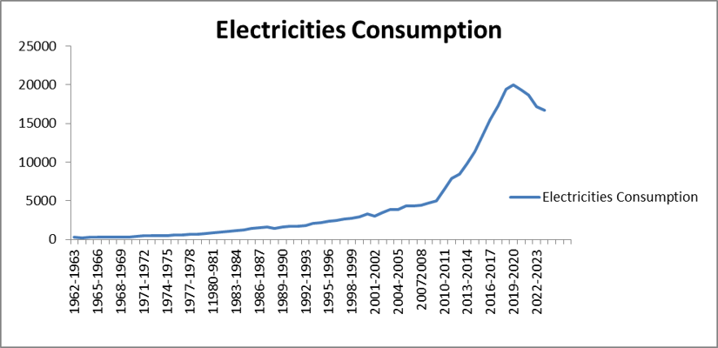
Source: Statistical Year Books (1961-62 to 2023-24)
Figure 1 Time Series Plot of Electricity Consumption (kWh) in Myanmar.
According to Figure (1), the original series of electricity consumption in Myanmar exhibits a distinct upward, non-linear trend. This pattern indicates that the mean level is time-dependent (non-stationary), with variance expanding alongside the increasing mean. Consequently, a formal statistical test was conducted to analyse the trend of the original series. Historically, Myanmar's electricity consumption grew at a modest pace from 1961-1962 through 1989-1990. Structurally, the timeline can be understood in three main phases: 1961-1962 to 1981-1982, a period of steady and gradual growth; 1982-1983 to 2009-2010, a phase characterised by a relatively stable and consistent rate of consumption; and 2009-2010 to 2019-2020, a decade of sharp acceleration, culminating in a historic peak in 2019-2020 as a result of expanding socio-economic activities. Conversely, a noticeable decline in consumption was observed during 2020-2021, 2021-2022, and 2023-2024, which can be attributed to temporary domestic transitions and socio-economic adjustments that altered industrial and public energy demand. Following this brief contraction, the series shows a subtle shift towards recovery as situational stabilisation began to take effect.
4.2 Stationary Test
The sample ACF and PACF are widely used in identifying ARIMA models and play an important role in the identification phase of the Box-Jenkins methodology for forecasting and control applications. The graphical stationarity test using the sample ACF and PACF of electricity consumption in Myanmar is described in Figure (2).
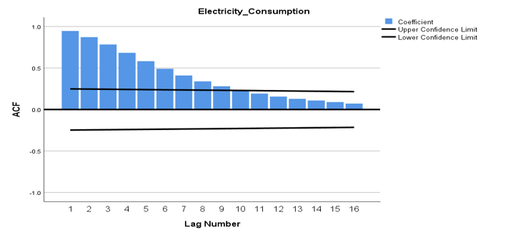
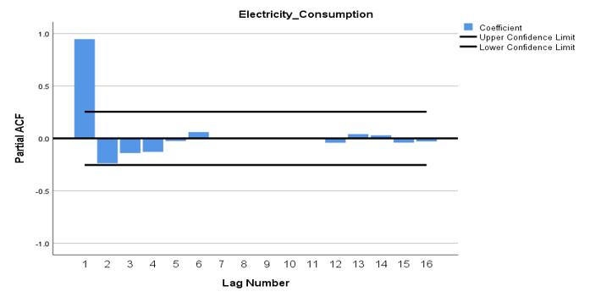
Source: Own computation
Figure 2 Sample ACF and PACF of Electricity Consumption in Myanmar.
According to Figure 2, the ACF displays an exponential decay pattern that slowly dies out rather than approaching zero quickly, with the spikes also alternating in sign and producing a wave-like form, which is typical of a non-stationary series. The PACF for the electricity-consumption series is similar to the ACF, as shown in Figure 2, indicating a series that may be non-stationary in the mean and possibly in the variance and therefore requires differencing or transformation. It can be seen that the original series is not stationary. The sample ACF decays exponentially, and the sample PACF cuts off after lag 1. Therefore, the tentative model for electricity consumption in Myanmar is an AR model.
4.3 Test of Stationary for Electricity Consumption in Myanmar
One of the requirements for using the ARIMA method is that the time-series data must be stationary. The term stationary refers to the absence of a trend involving data growth or decline. If the data are not stationary, a differencing process can be used. Several methods can be used to determine whether a time-series dataset is stationary, including summary statistics and statistical tests. The average and variance of time-series data are used to determine whether there is a significant change in these values within a given time range. The Augmented Dickey-Fuller test is a statistical test frequently used to determine stationarity. To examine whether the series is stationary, the Augmented Dickey-Fuller (ADF) test is carried out with the null hypothesis that the data are non-stationary, before differencing the series to obtain an improved result from the Box-Jenkins ARIMA model. The null hypothesis (H0) in the test is that the time-series data are non-stationary, whereas the alternative hypothesis (Ha) is that the series is stationary. The hypothesis is then tested by applying appropriate differencing of the data in order d and applying the ADF test to the differenced time-series data.
Table (1) Result of Augmented Dickey – Fuller Test for First Difference

 |  | t-statistic | P-value
Augmented Dickey-Fuller test Statistics |  | 3.679 | 0.932
Test critical values | 1% level | -3.565
Test critical values | 5% level | -2.920
Test critical values | 10% level | -2.598
Level |  | 5%
First Difference |  | -2.920 | 0.000
Source: Own Computation
The null hypothesis in this context is that the time series has a unit root and is non-stationary. Since the p-value is 0.932, which is higher than 0.05, there is insufficient evidence to reject the null hypothesis. Therefore, based on the ADF test, the time series is likely to be non-stationary in the mean. Since the original series is not stationary, it must be transformed by differencing to produce a stationary series. According to the result, first differencing was applied and the test was repeated. The calculated ADF test result for the first-difference series is -2.921, with a p-value of 0.000. Therefore, H0 is rejected, and it can be concluded that the alternative hypothesis is supported; that is, the series is stationary in its mean and variance. The ACF and PACF of the first-difference series of electricity consumption are shown in Figure 3.
Table (2)Estimated Autocorrelation and Partial Autocorrelation Function for First Difference Series of Electricity Consumption in Myanmar
(𝑎) 𝜌̂_{𝑘} 𝑓𝑜𝑟 {𝑊_{𝑡} = (1 − 𝐵)} – 𝑊̅ = -0.0435 𝑆_{𝑤} = -0.009 𝑛 = 63
Lag k | 1 | 2 | 3 | 4 | 5 | 6 | 7 | 8 | 9 | 10 | 11 | 12
ACF | .263 | .050 | .054 | -.168 | .089 | -.192 | -.114 | .060 | -.145 | .004 | -.167 | -.178
SE | .128 | .128 | .128 | .128 | .128 | .128 | .128 | .128 | .128 | .128 | .128 | .128
Lag k | 13 | 14 | 15 | 16 | 17 | 18 | 19 | 20 | 21 | 22 | 23 | 24
ACF | .225 | -.020 | -.065 | -.161 | -.056 | -.014 | -.137 | .021 | .006 | -.174 | -.074 | -.046
SE | .128 | .128 | .128 | .128 | .128 | .128 | .128 | .128 | .128 | .128 | .128 | .128
(𝑏) ∅̂ 𝑘𝑘 𝑓𝑜𝑟 {𝑊_{𝑡} = (1 − 𝐵)} 𝑊̅ = -0.0435 𝑆_{𝑤} = -0.009 𝑛 = 63
Lag k | 1 | 2 | 3 | 4 | 5 | 6 | 7 | 8 | 9 | 10 | 11 | 12
PACF | .955 | -.023 | -.023 | -.023 | -.023 | -.023 | -.023 | -.023 | -.023 | -.023 | -.023 | -.023
SE | .123 | .123 | .123 | .123 | .123 | .123 | .123 | .123 | .123 | .123 | .123 | .123
Lag k | 13 | 14 | 15 | 16 | 17 | 18 | 19 | 20 | 21 | 22 | 23 | 24
PACF | -.023 | -.023 | -.023 | -.024 | -.024 | -.024 | -.024 | -.024 | -.023 | -.023 | -.023 | -.023
SE | .123 | .123 | .123 | .123 | .123 | .123 | .123 | .123 | .123 | .123 | .123 | .123
Source: Own Computation
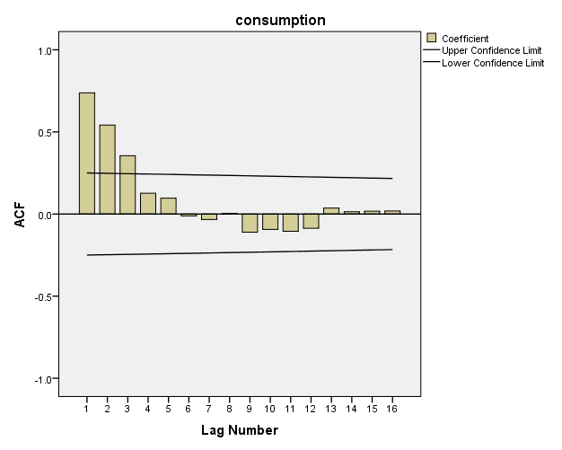
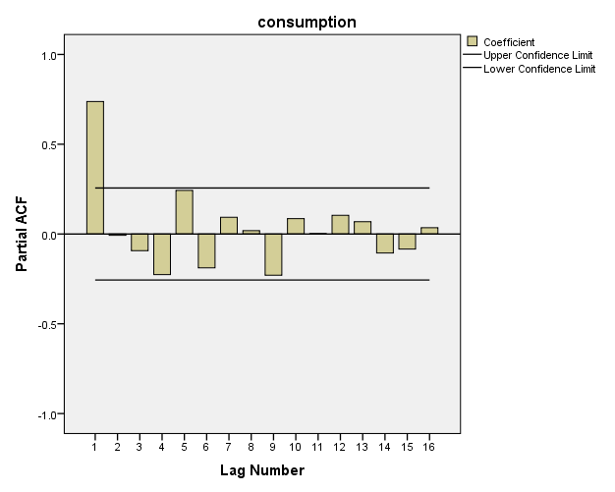

Figure 3 Sample ACF and PACF of First Difference Series of Electricity Consumption in Myanmar.

4.4 Model Identification for Electricity Consumption in Myanmar
To select the most suitable forecasting model among the possible tentative models, RMSE (Root Mean Square Error), MAPE (Mean Absolute Percentage Error), and the lowest BIC (Bayesian Information Criterion) values were considered. Table (3) summarises the calculated results for each fitted ARIMA model for electricity consumption in Myanmar.
Table (3)RMSE, MAPE and BIC Values of ARIMA Models for Electricity Consumption

ARIMA Model | RMSE | MAPE (%) | BIC
(0, 1, 0) | 1239.33 | 5.86 | 14.31
(0, 1, 1) | 1306.29 | 11.83 | 14.48
(0, 1, 2) | 1319.82 | 11.09 | 14.57
(1, 1, 0) | 1308.39 | 11.64 | 14.48
(1, 1, 1) | 1305.58 | 9.66 | 14.54
(1, 1, 2) | 1313.99 | 9.58 | 14.63
(2, 1, 0) | 1319.47 | 11.39 | 14.57
(2, 1, 1) | 1314.38 | 9.48 | 14.63
(2, 1, 2) | 1329.41 | 9.70 | 14.72

Source: Own Computation
In Table 3, based on the tentative order analysis, the selected ARIMA model for electricity consumption is ARIMA (0,1,0). In this case, the ARIMA (0,1,0) model has an RMSE of 1239.33, indicating that, on average, the model's predictions deviate by approximately 1239.33 units from the actual values. MAPE is a percentage-based measure of model accuracy. The ARIMA (0,1,0) model has a MAPE of 5.86%, suggesting that, on average, the model's predictions deviate by around 5.86% from the actual values. BIC is a measure of goodness of fit for a statistical model, and lower BIC values are generally preferred. The ARIMA (0,1,0) model has a BIC of 14.31, indicating a relatively good fit. According to the calculated results, this model can be considered a suitable forecasting model for electricity consumption in Myanmar.
4.5 Estimation of Parameters for Electricity Consumption
After identifying the best-fitted ARIMA model for electricity consumption in Myanmar, the calculated results are shown in Table 4.
Table 4. Parameter Estimates of the Fitted Model for the Electricity Consumption
ARIMA Model | Coefficient Δ1 (SE)
(0, 1, 0) | 0.048
Source: Owned Computation
According to the estimated model, the forecast value at time t for electricity consumption depends on the first previous value at time t-1. Its value at time t-1 is combined with a positive coefficient of 0.048 for the random error at time t-1. Model diagnostic checking of the fitted models was performed through residual analysis to determine the adequacy of the model and to identify potential improvements. Diagnostic checking is a procedure used to check residuals.
The residual plots of ACF and PACF against lags are presented in Figure 4. These figures show that the residuals from the ARIMA (0,1,0) fitted model for electricity consumption in Myanmar are close to zero.

4.6 Diagnostic Checking
The residual ACF and PACF are shown in Figure 4, which presents the estimated Autocorrelation Function and Partial Autocorrelation Function of residuals for the ARIMA (0,1,0) model of electricity consumption in Myanmar.
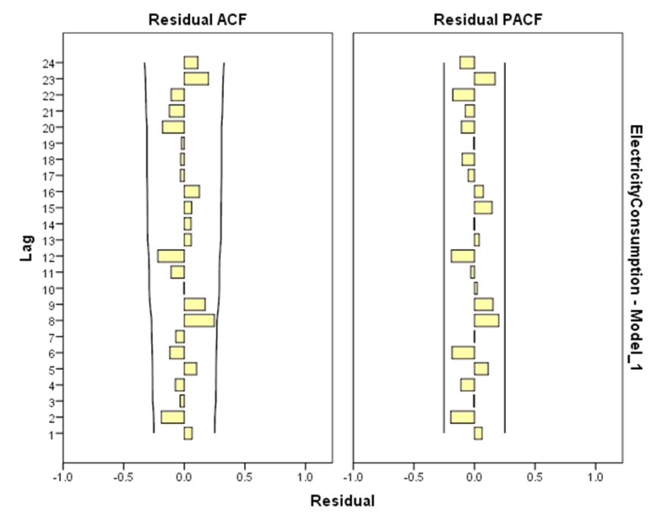

Source:SPSS Output
Figure (4) Autocorrelation and Partial Autocorrelation Function of Residual Values for ARIMA ( 0,1,0 ).
According to Figure (4), the residual values of the Autocorrelation Function (ACF) and Partial Autocorrelation Function (PACF) for electricity consumption in Myanmar are small and fall within the two standard-error limits. Consequently, the residual series represents a white-noise process. This implies that the ARIMA (0,1,0) model is an adequate model for the log-transformed data series of electricity consumption in Myanmar. Subsequently, autocorrelation among residuals is assessed using the test statistic (Q).
Null Hypothesis: H0: ρ₁=ρ₂=…= ρ_{k} = 0ρ₁​ = ρ₂​ =…= ρ_{k}​ = 0 There is no autocorrelation among residuals.
Alternative Hypothesis: H1: At least ρ_{k} ρ_{k​} are not equal to zero. There is auto correlation among residuals.
The residual values for the ARIMA (0,1,0) model for consumption are presented in Table (5).

Table (5) Model Statistics of ARIMA(0,1,0) model for Electricity Consumption in Myanmar
Model | Ljung-Box Q |  |  | RMSE | MAPE | BIC
Model | Statistics | Df | sig | RMSE | MAPE | BIC
ARIMA(0,1,0) | 12.464 | 18 | 0.822 | 1239.33 | 5.86 | 14.31
Source: SPSS output
As shown in Table (5), the observed value of Q is 12.464 and is not significant. This indicates that there is no autocorrelation among the residuals. Thus, the ARIMA (0,1,0) model is adequate for fitting the data series of electricity consumption in Myanmar.
4.7 Comparative Evaluation of Competitive Forecast Systems
To ensure the selection of a high-precision framework, the selected ARIMA (0,1,0) model was evaluated alongside univariate exponential smoothing models, specifically Brown’s Double Exponential Smoothing (DES) and Holt’s Linear Exponential Smoothing.
Table 6 Structural performance matrix across distinct forecasting models
Model | RMSE | MAPE(%) | BIC
ARIMA (0,1,0) | 1239.33 | 5.86 | 14.31
Brown’s Double Exponential Smoothing | 1277.84 | 7.53 | 14.37
Holt’s Double Exponential Smoothing | 1285.31 | 7.03 | 14.45
Source: Own Computation
The ARIMA (0,1,0) model performs well in terms of both MAPE and BIC, suggesting accurate forecasting with low prediction errors. The BIC value is also relatively low, supporting the model's goodness of fit. However, other factors, such as the nature of the data, model simplicity, and interpretability, should also be considered when selecting the best forecasting model. Therefore, the ARIMA (0,1,0) model is suitable for forecasting electricity consumption in Myanmar for the next five years. The ARIMA (0,1,0) framework provides calibrated projections that can support energy policymakers and national planners in developing infrastructure and power-distribution strategies.
4.8 National Electricity Consumption Projections
Using the parameters from the selected ARIMA (0,1,0) model, mathematical projections for annual electricity consumption in Myanmar were calculated with a 95% confidence threshold.
Table 7 . Proportional forecast matrix for annual electricity consumption (kWh)

Fiscal Year (FY) | Forecast Values (kWh) | Values (kWh)
Fiscal Year (FY) | Forecast Values (kWh) | UCL | LCL
2024-2025 | 31363.3 | 39369.3 | 24644.9
2025-2026 | 33977.3 | 44802 | 25243.2
2026-2027 | 36809.3 | 50564.7 | 26070.6
2027-2028 | 39877.3 | 56768.2 | 27067.7
2028-2029 | 43201.0 | 63494.2 | 28208.5
Source: SPSS output
From Table (7), the predictive baseline demonstrates an upward trend in annual electricity consumption, increasing from 31363.3 kWh in FY 2024-2025 to an estimated 43201.0 kWh by FY 2028-2029. This escalation reflects structural growth drivers, including urbanisation and industrial diversification within the economy. The broadening band between the Upper Confidence Limit (UCL) and Lower Confidence Limit (LCL) over the forecast horizon is a standard characteristic of multi-step-ahead time-series models because it accounts for cumulative variance over time. By FY 2028-2029, the maximum potential demand could reach 63494.2 kWh under high-demand conditions, whereas the lower bound is 28208.5 kWh. These empirical configurations are consistent with the international literature regarding infrastructure pressures and production vulnerabilities in emerging economies experiencing volatile macroeconomic demand (e.g., Taylor, 2003; Ahmad & Mohamad, 2020). From a strategic-planning perspective, continuously updating and monitoring these univariate models will provide the data required to align centralised grid expansion with national sustainable-energy policies.
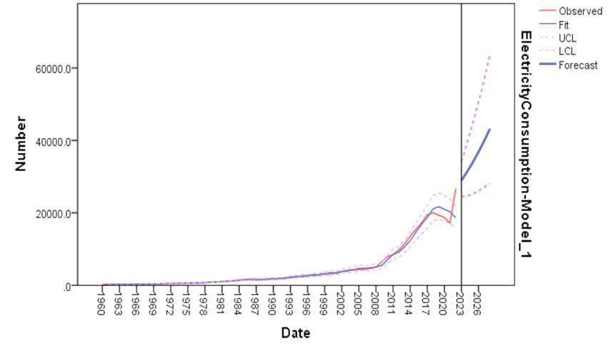
Figure 5. Historical and Forecasted Annual Electricity Consumption (kWh) in Myanmar
Year

Source: SPSS Output
(Note for Publication: The horizontal axis represents years, spanning from historical data to the 2028-2029 forecast horizon, and the vertical axis represents annual electricity consumption (kWh). The solid centre line illustrates the ARIMA (0,1,0) forecast values, while the outer boundary lines define the 95% confidence interval limits (UCL and LCL). The image resolution should be exported at a minimum of 300 DPI for visual clarity.)
5. CONCLUSION
The empirical results demonstrate that the ARIMA (0, 1, 0) model comprehensively outperforms the alternative configurations. It achieved the highest predictive accuracy, yielding the lowest statistical residual error metrics with a Root Mean Square Error (RMSE) of 1239.33, a Mean Absolute Percentage Error (MAPE) of 5.86%, and a Bayesian Information Criterion (BIC) of 14.31. The statistical projections generated by the selected ARIMA model indicate a continuous, stable long-term upward trend in Myanmar’s national electricity demand over the upcoming fiscal years. These quantitative findings provide a highly reliable statistical baseline for national energy infrastructure development. By accurately identifying long-term consumption trajectories, this research serves as a valuable decision-making tool for energy planners and government policymakers to balance supply-side expansion, optimize grid investments, and mitigate power shortages, thereby supporting the sustainable economic growth and urbanization of Myanmar. This chapter presents a comprehensive summary of the findings derived from the analysis of electricity consumption in Myanmar spanning the period from 1961-1962 to 2023-2024, covering a span of 63 years. The data utilized for this study was sourced from the Myanmar Statistical Year Books published by the Central Statistical Organization, Ministry of Planning and Finance. The predictive models employed in forecasting yearly electricity consumption included the Box-Jenkins ARIMA Model, Brown's Double Exponential Smoothing Model, and Holt's Double Exponential Smoothing Model. Additionally, the study employed Double Exponential Smoothing Models, specifically Brown's Double Exponential Smoothing and Holt's Double Exponential Smoothing Model for forecasting of electricity consumption in Myanmar. Brown's model, utilizing a single coefficient (alpha) for both trend smoothing operations, yielded accuracy values of 405.148 (RMSE), 5.597(MAPE)and 12.075(BIC). Holt's model, an extension accommodating the trend component, produced accuracy values of 408.528 (RMSE), 5.603(MAPE) and 12.158(BIC). When comparing the three models, it becomes evident that Brown's Double Exponential Smoothing Model displaying smaller values for both MAPE and BIC. This establishes the model's suitability for effectively fitting and forecasting electricity consumption in Myanmar, particularly during periods of decline after Covid-19. The 95% limit forecast values for electricity consumption in kilowatt-hours (KWh) are 16293.9 in 2023-2024,15852.8 in 2024-2025, 15415.8 in 2025-2026, and 14982.6 in 2026-2027.
5.1 Suggestions and Recommendations
The forecasting models, specifically the Box-Jenkins ARIMA model, Brown's Double Exponential Smoothing model, and Holt's Exponential Smoothing model, provide a comparative analysis of electricity-consumption trends in Myanmar over 63 years. More detailed explanations of each model's mechanisms, assumptions, and procedures would help readers understand the methodology more clearly. A sensitivity analysis could also be conducted to assess how changes in model parameters might influence forecasting outcomes. Exploring potential external factors, such as socio-economic developments or policy changes that may affect electricity-consumption trends, could add depth to future studies and improve forecasting accuracy. Such analysis could enhance the robustness of the selected model.
It is recommended that forecasting models be validated against external datasets or events to assess their performance in different scenarios and ensure their generalisability beyond the studied time frame. A more detailed discussion of diagnostic checks, such as ACF and PACF analyses, would provide additional insights into model reliability and potential areas for improvement. The practical implications of the forecasting results for policymakers, utility planners, and stakeholders in Myanmar's energy sector should also be emphasised. The limitations of each forecasting model should be acknowledged and discussed to ensure a nuanced interpretation of the findings. Collaboration with relevant stakeholders in Myanmar's energy sector is recommended to obtain a more comprehensive understanding of local dynamics and potential influencing factors. Regular monitoring and updating of the forecasting models as new data become available should also be encouraged. This iterative process can help maintain the relevance and accuracy of the predictions.
5.3 Needs for Further Studies
To enhance the depth and breadth of understanding of electricity consumption in Myanmar, future studies could incorporate additional economic indicators beyond the annual time-series data analysed in this study. The primary dataset used for this analysis was sourced from the Myanmar Statistical Year Books published by the Central Statistical Organization under the Ministry of Planning and Finance. Future studies should extend the temporal scope as new data become available to capture evolving trends and ensure the continued relevance of forecasting models. Additional variables, such as economic indicators, climate patterns, and policy changes that may affect electricity consumption, should also be explored. This would improve the models' adaptability to dynamic external influences. Regional variations in electricity-consumption patterns within Myanmar should also be investigated. Understanding localised trends can contribute to more targeted and effective energy-management strategies. Future studies could also incorporate advances in forecasting techniques or integrate artificial intelligence and machine-learning algorithms to improve prediction accuracy and efficiency. Further analysis of socio-economic factors influencing electricity demand, including population growth, urbanisation, and income levels, is also recommended. The impact of renewable-energy initiatives on electricity-consumption trends should be assessed to guide environmentally conscious energy planning. The effectiveness of demand-side management strategies, including consumer behaviour, awareness campaigns, and incentive programmes, should also be investigated. Collaboration with key stakeholders, such as government agencies, energy providers, and environmental organisations, can provide more comprehensive insights and practical solutions. Existing energy policies in Myanmar should be evaluated to ensure alignment with current consumption trends and future sustainability goals. Continuous validation against real-time data is important for maintaining the reliability of forecasting models in a changing energy landscape. Future studies should also consider the influence of climate variability on electricity consumption, including weather patterns and temperature changes. Interdisciplinary collaboration involving economics, environmental science, and technology can provide a more holistic understanding of the factors shaping electricity consumption. By addressing these areas, future studies can contribute to a more nuanced understanding of Myanmar's electricity-consumption landscape and provide useful insights for sustainable energy planning and policy formulation.
Limitation
This study is limited to annual secondary data published in Myanmar Statistical Year Books and applies univariate forecasting models only. The analysis does not include explanatory variables such as population, industrial output, tariffs, weather conditions, policy changes, or regional consumption patterns. Consequently, the forecasts should be interpreted as statistical projections based on historical consumption behaviour rather than causal estimates of electricity demand.
Competing interests

The authors have declared that no competing interests exist. This research was conducted in an independent academic environment as part of a PhD degree programme and there are no financial, personal, or institutional relationships with other individuals or organizations that could inappropriately influence, bias, or conflict with the integrity of this work.

dECLARATION

The study does not involve any human subjects, clinical trials, or live animal experiments. The empirical analysis is based entirely on aggregated historical secondary data officially published in the Myanmar Statistical Year Books by the Central Statistical Organization (CSO). Therefore, institutional ethical approval or review board clearance is not applicable to this manuscript.

LIST OFABBREVIATIONS

AR – Autoregressive

ARIMA – Autoregressive Integrated Moving Average

ARIMA(0,1,0) – Autoregressive Integrated Moving Average (with 0 Autoregressive term, 1 Degree of Differencing, and 0 Moving Average term)

ARMA – Autoregressive Moving Average

ASEAN – Association of Southeast Asian Nations

BIC – Bayesian Information Criterion

CSO – Central Statistical Organization

DES – Double Exponential Smoothing

DF – Degrees of Freedom

DPI – Dots Per Inch (Image Resolution standard)

FY – Fiscal Year

kWh – Kilowatt-hour

LCL – Lower Confidence Limit

MAE – Mean Absolute Error

MAPE – Mean Absolute Percentage Error

MSE – Mean Square Error

MTOE – Million Tons of Oil Equivalent

PACF – Partial Autocorrelation Function

RMSE – Root Mean Square Error

SPSS – Statistical Package for the Social Sciences

TWh – Terawatt-hour

UCL–Upper Confidence Limit

DISCLAIMER (ARTIFICIAL INTELLIGENCE)

The author(s) declare that generative AI technologies, specifically Large Language Models (such as Google Gemini), were utilized solely for improving the language, grammar, and readability of this manuscript during the editing process. The AI was not used to create, alter, or interpret any research data, results, or conclusions. The author(s) take full responsibility for the final content and accuracy of the manuscript.

ACF – Autocorrelation Function

ADF – Augmented Dickey-Fuller Test

REFERENCES
Ahmad, M. S., & Mohamad Nor, A. F. (2020). Forecasting of Universiti Tun Hussein Onn Malaysia’s electrical load by using Holt’s linear trend and Holt-Winters techniques. ARPN Journal of Engineering and Applied Sciences, 15(12), 1398–1402. https://www.arpnjournals.org/jeas/research_papers/rp_2020/jeas_0620_8243.pdf
Al-Hafid, M. S., & Al-Maamary, G. H. (2012). Short-term electrical load forecasting using Holt-Winters method. Al-Rafidain Engineering Journal, 20(6), 15–22. https://doi.org/10.33899/rengj.2012.63377
Alves, B. (2022). Global electricity consumption 1980–2019. Statista. https://www.statista.com/statistics/280704/world-power-consumption/
Asian Development Bank. (2015). TA 8356-MYA final report: Myanmar Energy Master Plan. https://www.adb.org/projects/documents/mya-46389-001-tacr-2
Box, G. E. P., Jenkins, G. M., & Reinsel, G. C. (1994). Time series analysis: Forecasting and control (3rd ed.). Prentice Hall.
Chen, J., Chen, T., Wang, Y., & Wang, L. (2024). A survey of time series data forecasting methods based on deep learning. Journal of Basic and Applied Research International, 30(6), 140–157. https://doi.org/10.56557/jobari/2024/v30i69014
Dapice, D. (2012). Electricity demand and supply in Myanmar. Proximity Designs. https://ash.harvard.edu/wp-content/uploads/2024/02/electricitydemand.pdf
DeLurgio, S. A. (1998). Forecasting principles and applications (1st ed.). Irwin/McGraw-Hill.
United Nations Economic and Social Council. (2016). Energy scene and trends in Asia and the Pacific: Note by the secretariat (E/ESCAP/CE(1)/1). United Nations Economic and Social Commission for Asia and the Pacific. https://www.unescap.org/official-documents/document/14198
Economic Research Institute for ASEAN and East Asia. (2020). Myanmar Energy Outlook 2020. ERIA. https://www.eria.org/publications/myanmar-energy-outlook-2020
Fernando, J. L. L. S., Gunawardana, J. R. N. A., Perera, K. A. I. T., Perera, M. L. D. M., Shashikala, M. A. G., Jayasundara, D. D. M., & Rathnayaka, R. M. K. T. (2017). Time series modelling approach for forecasting electricity demand in Sri Lanka. General Sir John Kotelawala Defence University Repository. http://ir.kdu.ac.lk/handle/345/1759
International Energy Agency. (2022). World Energy Outlook 2022. IEA. https://www.iea.org/reports/world-energy-outlook-2022
Abd Jalil, N. A., Ahmad, M. H., & Mohamed, N. (2013). Electricity load demand forecasting using exponential smoothing methods. World Applied Sciences Journal, 22(11), 1540–1543. https://doi.org/10.5829/idosi.wasj.2013.22.11.2891
Wiah, E. N., Buabeng, A., & Agyarko, K. (2022). Statistical model for the forecast of electricity power generation in Ghana. Open Journal of Statistics, 12(3), 373–384. https://doi.org/10.4236/ojs.2022.123024
Landolsi, M., & Ben Rejeb, J. (2011). ARIMA forecasting of energy consumption in Tunisia. Advances and Applications in Statistics, 25(2), 153–164.
Liu, Y., & Noor, R. (2020). Energy efficiency in ASEAN: Trends and financing schemes (ADBI Working Paper No. 1196). Asian Development Bank Institute. https://www.adb.org/publications/energy-efficiency-asean-trends-financing-schemes
Mahia, F., Dey, A. R., Masud, M. A., & Mahmud, M. S. (2019). Forecasting electricity consumption using ARIMA model. In 2019 International Conference on Sustainable Technologies for Industry 4.0 (STI) (pp. 1–6). IEEE. https://doi.org/10.1109/STI47673.2019.9068076
Oil and Gas Planning Department, Ministry of Electricity and Energy of Myanmar, & Economic Research Institute for ASEAN and East Asia. (2019). Myanmar Energy Statistics 2019. ERIA. https://www.eria.org/publications/myanmar-energy-statistics-2019
Omer, A. W., Blbas, H. T. A., & Kadir, D. H. (2021). A comparison between Brown’s and Holt’s double exponential smoothing for forecasting applied generation electrical energies in Kurdistan Region. Cihan University-Erbil Scientific Journal, 5(2), 56–63. https://doi.org/10.24086/cuesj.v5n2y2021.pp56-63
Peplinski, M., Dilkina, B., Chen, M., Silva, S. J., Ban-Weiss, G. A., & Sanders, K. T. (2024). A machine learning framework to estimate residential electricity demand based on smart meter electricity, climate, building characteristics, and socioeconomic datasets. Applied Energy, 357, Article 122413. https://doi.org/10.1016/j.apenergy.2023.122413
Ritchie, H., Roser, M., & Rosado, P. (2020). Energy. Our World in Data. https://ourworldindata.org/energy
Rodriguez, M. E. F., Vasquez, A. R. G., & Dayupay, R. C. (2020). Utilization of double exponential smoothing in energy consumption forecasting for Puerto Princesa Distribution System. International Journal of Scientific & Engineering Research, 11(11), 807–810.
Semekonawo, K. P., & Kam, S. (2022). Linear regression and ARIMA models for electricity demand forecasting in West Africa. Journal of Energy Research and Reviews, 12(2), 26–36. https://doi.org/10.9734/jenrr/2022/v12i230296
Taylor, J. W. (2003). Short-term electricity demand forecasting using double seasonal exponential smoothing. Journal of the Operational Research Society, 54(8), 799–805. https://doi.org/10.1057/palgrave.jors.2601589
Total Myanmar. (2015). Oil and gas in Myanmar.
Ugbehe, P. O., Diemuodeke, O. E., & Aikhuele, D. O. (2025). Electricity demand forecasting methodologies and applications: A review. Sustainable Energy Research, 12, Article 19. https://doi.org/10.1186/s40807-025-00149-z
Vakulchuk, R., Hlaing, K. K., Naing, E. Z., Overland, I., Suryadi, B., & Velautham, S. (2017). Myanmar’s attractiveness for investment in the energy sector: A comparative international perspective. Norwegian Institute of International Affairs and Myanmar Institute of Strategic and International Studies. https://www.nupi.no/en/publications/cristin-pub/myanmars-attractiveness-for-investment-in-the-energy-sector-a-comparative-international-perspective
Wei, W. W. S. (2006). Time series analysis: Univariate and multivariate methods (2nd ed.). Pearson Addison Wesley.
World Energy Council. (2016). World energy resources 2016. https://www.worldenergy.org/publications/entry/world-energy-resources-2016

APPENDIX
List 1: Electricity Consumption (Kwh) in Myanmar 1961-62 to 2022-23 (63 years)
Year Electricity Consumption Year Electricity Consumption
1961-62 231 1992-93 1831
1962-63 266 1993-94 2059
1963-64 255 1994-95 2218
1964-65 270 1995-96 2325
1965-66 265 1996-97 2434
1966-67 277 1997-98 2676
1967-68 293 1998-99 2716
1968-69 311 1999-00 2910
1969-70 340 2000-01 3268
1970-71 397 2001-02 3041

Year Electricity Consumption Year Electricity Consumption

1971-72 464 2002-03 3484
1972-73 492 2003-04 3850
1973-74 508 2004-05 3909
1974-75 508 2005-06 4353
1975-76 556 2006-07 4355
1976-77 628 2007-08 4438
1977-78 678 2008-09 4701
1978-79 690 2009-10 4993
1979-80 763 2010-11 6467
1980-81 853 2011-12 7877
1981-82 950 2012-13 8441
1982-83 1050 2013-14 9795
1983-84 1122 2014-15 11407
1984-85 1264 2015-16 13551
1985-86 1460 2016-17 15482
1986-87 1543 2017-18 17252
1987-88 1580 2018-19 19478
1988-89 1428 2019-20 20044
1989-90 1593 2020-2021 19370
1990-91 1675 2021-2022 18708
1991-92 1677 2022-2023 17184
2023-2024 26723
Source: Statistical Year Book (1961-62 to 2023-24)

Model Statistics of Best-Fitting Models according to MaxAPE (smaller values indicate better fit).
Model ARIMA(0,1,0) |  | Number of Predictors |  | Model Fit statistics |  |  |  |  |  |  |  | Ljung-Box Q(18) |  |  |  |  |  | Number of Outliers
 |  |  |  | Stationary R-squared |  | RMSE |  | MAPE |  | Normalized BIC |  | Statistics |  | DF |  | Sig.
Electricity Consumption-Model_1 |  | 0 |  | 1.554E-15 |  | 1239.328 |  | 5.865 |  | 14.311 |  | 12.464 |  | 18 |  | .822 |  | 0
Model Statistics of Best-Fitting Models according to Stationary R-squared (larger values indicate better fit).
Model Brown Exponential Smoothing | Number of Predictors |  | Model Fit statistics |  |  |  |  |  |  |  |  |  | Ljung-Box Q(18) |  |  |  |  |  | Number of Outliers
Model Brown Exponential Smoothing |  |  | Stationary R-squared |  | RMSE |  | MAPE |  | MAE |  | Normalized BIC |  | Statistics |  | DF |  | Sig.
Electricity Consumption-Model_1 | 0 |  | .227 |  | 1277.844 |  | 7.532 |  | 528.504 |  | 14.372 |  | 4.251 |  | 17 |  | .999 |  | 0

Model Statistics of Worst-Fitting Models according to Stationary R-squared (larger values indicate better fit).
Model Holt | Number of Predictors |  | Model Fit statistics |  |  |  |  |  |  |  |  |  |  |  | Ljung-Box Q(18) |  |  | Number of Outliers
Model Holt |  |  | Stationary R-squared |  |  | RMSE |  |  | MAPE |  | MAE |  | Normalized BIC |  | Statistics | DF | Sig. | Number of Outliers
Electricity Consumption-Model_1 | 0 |  | .230 |  |  | 1285.313 |  |  | 7.039 |  | 512.183 |  | 14.449 |  | 4.064 | 16 | .999 | 0
Forecast of Best-Fitting Models according to Stationary R-squared (larger values indicate better fit).

Model ARIMA(0,1,0) |  |  |  |  | 2024 |  | 2025 | 2026 |  | 2027 |  | 2028
Electricity Consumption-Model_1 |  | Forecast |  |  | 31363.3 |  | 33977.3 | 36809.3 |  | 39877.3 |  | 43201.0
 |  | UCL |  |  | 39369.3 |  | 44802.0 | 50564.7 |  | 56768.2 |  | 63494.2
 |  | LCL |  |  | 24644.9 |  | 25243.2 | 26070.6 |  | 27067.7 |  | 28208.5
Note : For each model, forecasts start after the last non-missing in the range of the requested estimation period, and end at the last period for which non-missing values of all the predictors are available or at the end date of the requested forecast period, whichever is earlier.

