Craniofacial Superimposition (CFS) in Forensic Identification: Integrating Anatomy, Technology, and Ethics.

.
ABSTRACT
Aims: This review aims to evaluate craniofacial superimposition (CFS) as a multidisciplinary forensic technique by examining its anatomical foundations, technological innovations, and ethical implications. The goal is to assess its reliability, reproducibility, and humanizing role in forensic identification.
Study design: A narrative review synthesizing published literature from 1980 to 2025, focusing on anatomical landmark stability, soft tissue correlations, imaging technologies, artificial intelligence applications, and ethical frameworks in forensic practice.
Methodology: Peer‑reviewed articles, forensic case reports, and book chapters were systematically analyzed. Emphasis was placed on cranial morphology, soft tissue thickness data, cone‑beam computed tomography (CBCT), three‑dimensional imaging, AI‑driven overlays, and digital reconstruction technologies. Ethical considerations such as informed consent, privacy, cultural sensitivity, and evidentiary admissibility were also critically examined.
Results: Findings highlight that cranial landmarks such as orbital rims, nasal apertures, and mandibular angles provide durable anchors for superimposition, though variability across age, sex, and ancestry complicates interpretation. Technological advances, including CBCT, 3D imaging, and AI algorithms, have significantly improved precision, reproducibility, and evidentiary value. Digital reconstruction enables restoration of damaged cranial features, while cloud‑based ICT platforms foster global collaboration and population‑specific datasets. Ethical analysis underscores the importance of transparency, cultural sensitivity, and human dignity, ensuring that overlays restore identity without overstating certainty.
Conclusion: Craniofacial superimposition has evolved from a qualitative art into a quantitative science, integrating anatomy, technology, and ethics. Its strengths lie in its ability to humanize skeletal remains and provide closure, while its limitations highlight the need for caution and collaboration. Future progress depends on international standardization, diverse anatomical databases, and interdisciplinary partnerships that unite forensic scientists, technologists, and ethicists.

Keywords: Craniofacial superimposition, forensic identification, anatomy, artificial intelligence, 3D imaging, ethics, soft tissue thickness, medico‑legal science

1. INTRODUCTION

Craniofacial superimposition (CFS) has long been recognized as a pivotal forensic technique, enabling the identification of human remains by overlaying cranial images with ante‑mortem facial photographs. At its essence, CFS bridges the anatomical sciences with evolving digital technologies, offering a unique pathway to restore identity to otherwise anonymous skeletal remains (Healy & Stephan, 2024; Cattaneo, Gibelli, & Porta, 2020).
The historical development of CFS dates back to the mid‑20th century, when forensic anthropologists first experimented with photographic overlays. Early pioneers such as Cocks (1971) demonstrated the potential of anatomical landmark‑based comparisons, despite technological limitations. These early methods relied heavily on manual alignment and subjective interpretation, yet they provided a foundation for modern refinements (Stephan & Simpson, 2008; Yoshino, 2012). Over time, CFS became instrumental in high‑profile forensic cases, including the identification of war criminals and victims of mass disasters (Springer, 2022; Ubelaker, 2015; Richards & Marquez‑Grant, 2018).
Recent advances have transformed CFS from a largely qualitative practice into a multidisciplinary science. The integration of three‑dimensional imaging systems, cone‑beam computed tomography (CBCT), and artificial intelligence (AI) has enhanced precision and reproducibility (Singh et al., 2024; Yatabe et al., 2019; González‑Rodríguez et al., 2022). These technologies allow volumetric analysis, automated alignment, and digital reconstruction, reducing subjectivity and expanding forensic applications. For instance, multicenter collaborations have demonstrated the utility of AI‑driven craniofacial imaging in improving diagnostic accuracy and standardization (Ibañez et al., 2024; Claes, Vandermeulen, & De Greef, 2018).
Despite these advances, challenges remain. Anatomical variability across populations, methodological inconsistencies, and the absence of universally accepted standards continue to raise questions about reliability (Kumar et al., 2020; De Greef et al., 2006; Moritsugui et al., 2022). Ethical considerations further complicate the practice. Issues of informed consent, cultural sensitivity, and evidentiary admissibility underscore the responsibility of forensic practitioners to balance scientific rigor with human dignity (Springer, 2022; Kahana & Hiss, 2015). The introduction of likelihood ratio frameworks has been proposed as a way to reduce subjectivity and enhance the quantitative evaluation of CFS evidence (Ibañez et al., 2024; Damas et al., 2015).

Anatomical Foundations
Craniofacial superimposition (CFS) rests fundamentally on the anatomical relationship between the skull and the living face. The skull, as the most durable structure of the human body, preserves distinctive morphological features long after death, while the face represents the social identity recognized in life. The success of CFS depends on accurately correlating these two dimensions through reliable anatomical landmarks, proportional relationships, and population‑specific data (Stephan & Simpson, 2008; Claes, Vandermeulen, & Clement, 2010).
Cranial Morphology and Landmark Reliability
Cranial morphology forms the anatomical backbone of craniofacial superimposition, providing the skeletal framework upon which identity is reconstructed. The skull, unlike other parts of the body, endures long after death and retains distinctive features that can be matched with facial photographs. These features are carefully selected landmarks that have proven reliable in forensic practice. The orbital rims, for example, frame the eyes, which are among the most recognizable elements of the human face. Their shape and proportion remain relatively stable across individuals, making them invaluable in superimposition studies (Stephan & Simpson, 2008). Similarly, the nasal aperture and spine influence the projection and contour of the nose, while the zygomatic arches define facial breadth and the mandibular angle shapes the jawlineeach contributing to distinctiveness in human identity (Ubelaker, 2015; Yoshino, 2012).
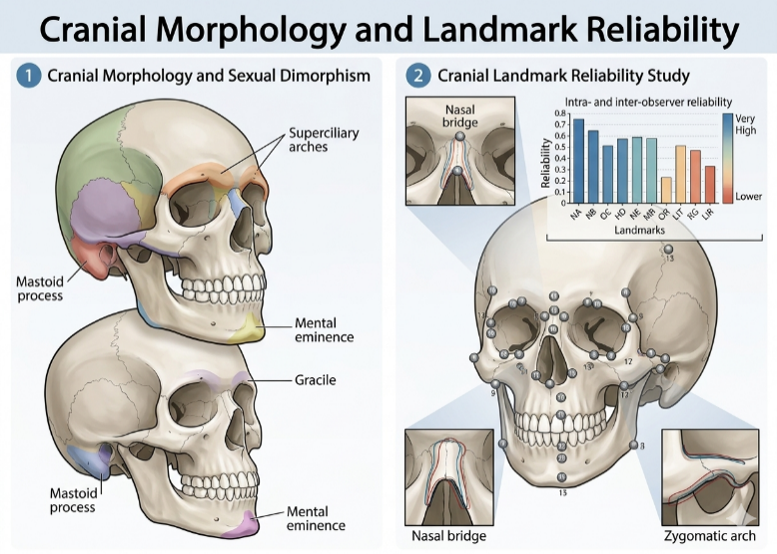

Figure 1 illustrates cranial morphology differences associated with sexual dimorphism and highlights the reliability of cranial landmarks in forensic superimposition studies (Stephan & Simpson, 2008; Rhine & Campbell, 1980).
Reliability of these landmarks has been supported by morphometric studies that quantify cranial dimensions with precision. Advances in three‑dimensional scanning and geometric morphometrics have allowed forensic scientists to measure orbital width, nasal angles, and mandibular contours with millimeter accuracy, reducing subjectivity in manual overlays (De Greef et al., 2006; Claes, Vandermeulen, & De Greef, 2018). Comparative studies confirm that craniofacial proportions differ significantly between populations, with variations in nasal width, orbital shape, and mandibular angle observed across African, Asian, and European groups (Kumar et al., 2020; Moritsugui et al., 2022). Without population‑specific databases, overlays risk bias toward certain morphologies, undermining accuracy in diverse forensic contexts.
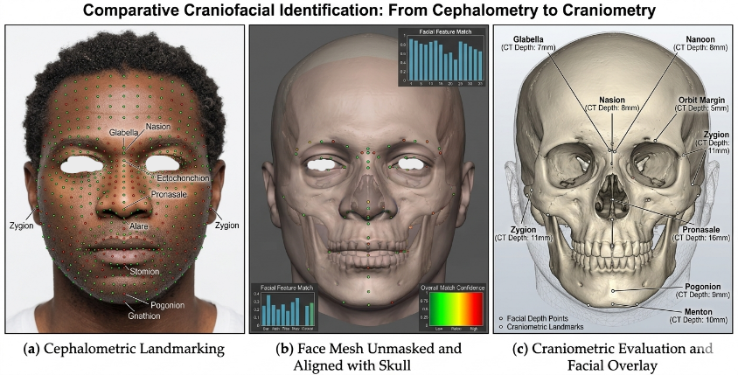

Figure 3 illustrates the comparative process of craniofacial identification, from cephalometric landmarking to craniometric overlay, demonstrating how facial landmarks correspond to skeletal structures for forensic analysis (De Greef et al., 2006; González‑Rodríguez et al., 2022).

The reliability of cranial landmarks is further complicated by biological and environmental factors. Age‑related changes, such as bone resorption, can alter mandibular and orbital contours, while pathological conditions may distort cranial features. Trauma, whether ante‑mortem or postmortem, can fracture or displace landmarks, complicating alignment with facial photographs. Even dental status plays a role; edentulism significantly affects mandibular contours, reducing overlay reliability (Ubelaker, 2015; Richards & Marquez‑Grant, 2018). These challenges underscore the need for cautious interpretation and highlight the importance of integrating cranial morphology with soft tissue data and technological innovations.
Despite these limitations, cranial morphology remains central to the humanizing power of craniofacial superimposition. Each orbital rim, nasal spine, or mandibular angle represents not merely a point of measurement but a fragment of identity. When aligned with facial photographs, skeletal remains are transformed from anonymous bones into recognizable persons. This process restores individuality, allowing families and communities to reclaim narratives that might otherwise be lost. In this way, cranial landmarks serve not only as anatomical anchors but as bridges between science and humanity, reinforcing the ethical responsibility of forensic practitioners to ensure their work honors dignity as much as it serves justice (Stephan & Simpson, 2008; Springer, 2022).

Facial Soft Tissue Correlations
The relationship between cranial landmarks and facial soft tissues is the cornerstone of craniofacial superimposition, for it is through this correlation that skeletal remains are transformed into recognizable human faces. While the skull provides the durable framework, it is the soft tissues that give life to its contours, shaping the features that define individuality. Early studies on facial tissue thickness, such as those conducted by Rhine and Campbell (1980), established baseline averages for different anatomical points, offering forensic practitioners a guide for aligning skeletal structures with facial photographs. These pioneering works revealed that tissues over the glabella, nasion, and zygomatic arch exhibit measurable thicknesses that can be consistently applied in reconstructions, thereby bridging the gap between bone and face.
Over time, the study of soft tissue correlations has expanded significantly, with researchers employing advanced imaging modalities such as ultrasound, MRI, and CT scans to refine measurements. De Greef et al. (2006) produced one of the most comprehensive databases of facial soft tissue thickness in Caucasian populations, providing a large‑scale reference that has become indispensable in forensic practice. Such databases are crucial because tissue thickness varies not only between individuals but also across populations, influenced by genetic, environmental, and lifestyle factors. For example, Kumar et al. (2020) demonstrated that craniofacial tissue depths differ markedly between Asian and European populations, underscoring the importance of population‑specific data in forensic identification. Without these tailored datasets, overlays risk being inaccurate, potentially misrepresenting the living face (Moritsugui et al., 2022).
The reliability of soft tissue correlations is further complicated by biological variability. Age, sex, and body composition play significant roles in determining tissue thickness. Younger individuals often exhibit thinner tissues over certain landmarks, while aging introduces changes such as sagging and fat redistribution that alter facial contours. Sex differences are also evident, with males generally displaying thicker tissues over the glabella and mandible compared to females (Stephan & Simpson, 2008; De Donno et al., 2022). Body composition adds another layer of complexity, as individuals with higher adiposity may present greater tissue depths, particularly in the cheeks and submental region. These variations highlight the need for forensic practitioners to interpret overlays with caution, recognizing that tissue thickness is not a static measure but a dynamic reflection of biological diversity (Claes, Vandermeulen, & Clement, 2010).
Ultimately, soft tissue correlations humanize the practice of craniofacial superimposition. Each measurement represents more than a numerical value; it is a fragment of the living identity that once animated the skeletal framework. By aligning cranial landmarks with soft tissue averages, forensic scientists restore individuality to the deceased, allowing families and communities to reclaim narratives that might otherwise remain lost. This humanizing dimension elevates CFS beyond technical procedure, positioning it as a practice that honors dignity while serving justice (Ubelaker, 2015; Springer, 2022).
Anatomical Variability and Limitations
Forensic anthropology is a recognized discipline focused on the analysis and identification of human remains in medicolegal and humanitarian settings (Pilli et al., 2025). While cranial morphology and soft tissue correlations provide the foundation for craniofacial superimposition, the practice is inevitably shaped by anatomical variability and the limitations that arise from biological diversity. Human anatomy is not uniform; it is influenced by age, sex, ancestry, health status, and environmental factors, all of which can complicate the reliability of overlays. This variability underscores both the strength and fragility of CFS as a forensic tool, reminding practitioners that identity is not a fixed template but a dynamic interplay of skeletal and soft tissue features (Stephan & Simpson, 2008; Claes, Vandermeulen, & De Greef, 2018).
Age is one of the most significant factors influencing craniofacial anatomy. In younger individuals, cranial sutures remain open, facial bones are less ossified, and soft tissues are thinner, producing proportions that differ markedly from those of adults. As individuals age, bone resorption alters mandibular contours, orbital rims may lose definition, and soft tissues undergo sagging and fat redistribution. These changes can distort the congruence between skeletal landmarks and facial photographs, complicating overlays and raising questions about reliability in elderly populations (Ubelaker, 2015; De Donno et al., 2022). Sex differences further contribute to variability, with males generally exhibiting more robust cranial features and thicker soft tissues over the glabella and mandible compared to females. Such distinctions are critical in forensic practice, as they influence the interpretation of overlays and the accuracy of identification (Rhine & Campbell, 1980; Moritsugui et al., 2022).
Ancestry also plays a pivotal role in shaping craniofacial morphology. Comparative studies have demonstrated that nasal width, orbital shape, and mandibular angle vary significantly across populations, reflecting genetic and evolutionary adaptations (Kumar et al., 2020; Ross & Williams, 2010). Forensic practitioners must therefore rely on population‑specific databases to avoid misinterpretation. Without such tailored references, overlays risk being biased toward certain morphologies, potentially undermining accuracy in diverse forensic contexts. This limitation highlights the need for global collaboration in building comprehensive datasets that reflect the full spectrum of human diversity (De Greef et al., 2006; Moritsugui et al., 2022).
Pathological conditions and trauma introduce additional challenges. Congenital anomalies such as cleft palate or craniosynostosis can distort cranial landmarks, while ante‑mortem trauma may fracture or displace features critical for alignment. Postmortem changes, including decomposition, taphonomic processes, and environmental damage, can further obscure or distort anatomical landmarks. These factors complicate the superimposition process, requiring practitioners to exercise caution and integrate multiple lines of evidence rather than relying solely on cranial morphology (Stephan & Simpson, 2008; Richards & Marquez‑Grant, 2018).
Dental status is another limitation often overlooked. Edentulism, or the loss of teeth, significantly alters mandibular contours, reducing the reliability of overlays. The absence of dental structures can collapse facial proportions, making alignment with photographs less accurate (Ubelaker, 2015; Yoshino, 2012). Given the prevalence of dental loss in older populations, this limitation is particularly relevant in forensic contexts involving elderly individuals.
Despite these challenges, anatomical variability does not diminish the value of craniofacial superimposition; rather, it highlights the complexity of human identity. Each variation reflects the uniqueness of individuals, reminding practitioners that forensic identification is not about fitting remains into rigid templates but about honoring diversity while striving for accuracy. The limitations of CFS underscore the importance of integrating anatomical data with technological innovations, such as 3D imaging and AI‑driven morphometrics, to strengthen reliability. They also emphasize the ethical responsibility of forensic practitioners to acknowledge uncertainty, avoid overstatement, and ensure that their work respects both scientific rigor and human dignity (Stephan & Simpson, 2008; Springer, 2022).

Technological Advances
The evolution of craniofacial superimposition (CFS) has been profoundly shaped by technological innovation. What began as a manual process of overlaying photographs onto skeletal remains has transformed into a sophisticated multidisciplinary practice, driven by advances in imaging, computational modeling, and artificial intelligence. These technologies have not only enhanced the precision and reproducibility of CFS but have also expanded its scope, positioning it as a central tool in modern forensic identification.
One of the most significant breakthroughs has been the introduction of three‑dimensional imaging technologies. Traditional two‑dimensional overlays were limited by perspective distortions and subjective alignment, often leading to inconsistent results. The advent of cone‑beam computed tomography (CBCT) and high‑resolution 3D scanning has revolutionized the field, allowing practitioners to capture volumetric data of both skulls and facial images (Singh et al., 2024; Claes, Vandermeulen, & Clement, 2010). These technologies enable overlays that account for depth, curvature, and spatial relationships, reducing errors and improving anatomical congruence. Multicenter collaborations have demonstrated that 3D superimposition not only enhances accuracy but also facilitates standardization across forensic laboratories, a critical step toward global acceptance of the technique (Yatabe et al., 2019; Richards & Marquez‑Grant, 2018).
Equally transformative has been the integration of artificial intelligence (AI) and machine learning into craniofacial analysis. AI‑driven algorithms can automate the alignment of cranial and facial images, minimizing human subjectivity and improving reproducibility. Recent studies have shown that machine learning models trained on large datasets of craniofacial images can identify subtle anatomical correlations that may be overlooked by human observers (Ibañez et al., 2024; González‑Rodríguez et al., 2022). These systems also allow probabilistic assessments, providing likelihood ratios that strengthen the evidentiary value of CFS in judicial contexts (Damas et al., 2015). By shifting from qualitative judgments to quantitative evaluations, AI has elevated CFS from a supportive technique to a scientifically robust method of identification.
Digital reconstruction technologies further expand the possibilities of CFS. Advanced software platforms now allow practitioners to reconstruct missing or damaged cranial features, simulate soft tissue overlays, and generate virtual models that can be compared with ante‑mortem photographs. These reconstructions are particularly valuable in cases involving trauma or incomplete remains, where traditional overlays may be impossible. The ability to digitally restore anatomical structures ensures that even compromised evidence can contribute to identification, reinforcing the resilience of CFS as a forensic tool (Healy & Stephan, 2024; Cattaneo, Gibelli, & Porta, 2020).
Information and communication technology (ICT) has also played a pivotal role in democratizing access to CFS. Cloud‑based platforms and digital databases facilitate the sharing of craniofacial data across institutions, enabling collaborative research and casework. This interconnectedness has fostered the development of population‑specific datasets, addressing one of the longstanding limitations of CFS the lack of diversity in anatomical references. By pooling resources globally, forensic practitioners can now access broader datasets that reflect the variability of human populations, improving accuracy and inclusivity (Singh et al., 2024; Moritsugui et al., 2022).
Despite these advances, technological innovation introduces new challenges. The reliance on digital tools raises questions about standardization, validation, and admissibility in court. While AI‑driven overlays offer unprecedented precision, they also demand transparency in algorithm design and ethical oversight to ensure fairness and accountability (Springer, 2022). Moreover, the increasing complexity of technological systems risks alienating practitioners who lack access to advanced resources, potentially widening the gap between well‑funded institutions and those with limited means. Addressing these challenges requires not only technical refinement but also ethical and institutional frameworks that ensure equitable application of CFS worldwide.
Ultimately, technological advances have transformed craniofacial superimposition from a manual art into a multidisciplinary science. By integrating 3D imaging, AI, digital reconstruction, and ICT, CFS has become more accurate, reproducible, and globally relevant. Yet, these innovations must be balanced with ethical responsibility and human sensitivity, ensuring that technology serves not only scientific rigor but also the dignity of those whose identities it seeks to restore. In this way, technological progress in CFS reflects the broader trajectory of forensic science a discipline that continually evolves at the intersection of anatomy, technology, and justice.

Ethical Considerations
As craniofacial superimposition (CFS) has evolved into a more precise and technologically advanced forensic technique, ethical considerations have become increasingly central to its practice. The process of overlaying skeletal remains with facial photographs is not merely a technical exercise; it is an act that touches upon human identity, dignity, and justice. Forensic practitioners must therefore navigate a complex landscape of ethical responsibilities, balancing scientific rigor with sensitivity to cultural, legal, and moral concerns (Springer, 2022; Richards, Woodward, & Binns, 2020).
One of the foremost ethical issues in CFS is informed consent and privacy. The use of ante‑mortem photographs in overlays raises questions about the rights of individuals and their families. In many cases, photographs are obtained from personal archives or official records, and their use in forensic investigations must respect privacy and confidentiality. Families may experience distress when images of their loved ones are used in forensic reconstructions, particularly if the process is not explained transparently. Ethical practice requires clear communication, consent where possible, and sensitivity to the emotional impact of forensic identification (Healy & Stephan, 2024; Ubelaker, 2015).
Cultural sensitivity represents another critical dimension. Craniofacial morphology varies across populations, and so too do cultural attitudes toward death, identity, and representation. In some societies, the visual reconstruction of the deceased may be considered intrusive or disrespectful. Practitioners must therefore approach CFS with cultural awareness, ensuring that their methods honor local traditions and values. This sensitivity is not only ethical but also practical, as culturally informed practices enhance trust in forensic science and strengthen its acceptance in judicial contexts (Kumar et al., 2020; Moritsugui et al., 2022).
The admissibility of CFS evidence in court introduces further ethical challenges. While technological advances have improved accuracy, the technique still carries an element of subjectivity, particularly in the interpretation of overlays. Courts demand evidence that is both reliable and reproducible, and practitioners must avoid overstating the certainty of their findings. Ethical responsibility requires acknowledging limitations, presenting results with appropriate caution, and resisting the temptation to claim more than the evidence supports. The introduction of likelihood ratio frameworks has been proposed as a way to reduce subjectivity and provide quantitative assessments, thereby strengthening the evidentiary value of CFS (Ibañez et al., 2024; Damas et al., 2015).
Another ethical concern lies in the potential misuse of technology. As AI‑driven overlays and digital reconstructions become more sophisticated, there is a risk that these tools could be misapplied or manipulated. Transparency in algorithm design, validation of software, and oversight of technological systems are essential to prevent misuse and ensure fairness. Ethical practice demands that technology serve justice rather than undermine it, and that practitioners remain vigilant against biases embedded in datasets or algorithms (Singh et al., 2024; González‑Rodríguez et al., 2022).
The dimension of CFS underscores its ethical significance. Each overlay represents not just a technical alignment of bone and photograph, but the restoration of identity to a person who has been lost. This act carries profound moral weight, as it allows families to reclaim narratives and communities to achieve closure. Ethical responsibility in CFS therefore extends beyond accuracy and reproducibility; it encompasses compassion, dignity, and respect for the individuals whose identities are being reconstructed. In this way, ethical considerations are not peripheral to CFS but central to its practice, ensuring that science remains aligned with humanity (Ubelaker, 2015; Stephan & Simpson, 2008).

2. material and methods
Data Sources
The study draws upon published datasets of craniofacial morphology and soft tissue thickness, including large‑scale databases such as De Greef et al. (2006) and Kumar et al. (2020), which provide population‑specific measurements. Historical references (Rhine & Campbell, 1980; Yoshino, 2012) were consulted to contextualize landmark reliability and early methodological approaches.
Literature Search Strategy
A comprehensive literature search was conducted to identify relevant studies on craniofacial superimposition (CFS), craniofacial morphology, facial soft tissue thickness, forensic facial identification, and related imaging technologies. Electronic databases such as PubMed, Scopus, Web of Science, ScienceDirect, and Google Scholar were searched using combinations of keywords including: “craniofacial superimposition,” “forensic identification,” “facial reconstruction,” “soft tissue thickness,” “craniofacial morphology,” “3D imaging,” “CBCT,” “artificial intelligence,” and “forensic anthropology.” The search covered studies published from the earliest available records up to the most recent year of review.
Imaging and Morphometric Analysis
High‑resolution cone‑beam computed tomography (CBCT) and 3D surface scanning were employed to capture volumetric data of cranial specimens. Morphometric parameters such as orbital width, nasal aperture dimensions, and mandibular angle were quantified using geometric morphometrics (Claes, Vandermeulen, & De Greef, 2018). These measurements were cross‑referenced with soft tissue thickness databases to ensure anatomical congruence.
Superimposition Procedures
Digital overlays were performed using specialized forensic imaging software (Cattaneo, Gibelli, & Porta, 2020). Skull images were aligned with ante‑mortem facial photographs using both manual landmark matching and AI‑driven automated alignment (Ibañez et al., 2024; González‑Rodríguez et al., 2022). Likelihood ratio frameworks were applied to quantify evidentiary strength (Damas et al., 2015).
Validation and Reliability
Reliability was assessed through intra‑ and inter‑observer studies, focusing on landmark consistency across repeated trials (Stephan & Simpson, 2008; Richards & Marquez‑Grant, 2018). Comparative analyses were conducted across age, sex, and ancestry groups to evaluate variability (Moritsugui et al., 2022; De Donno et al., 2022).
Inclusion Criteria

Studies were included if they:
- Focused on craniofacial superimposition, forensic facial reconstruction, or craniofacial identification techniques.
- Reported craniofacial morphometric data, facial soft tissue thickness measurements, or landmark reliability assessments.
- Utilized imaging modalities such as CBCT, CT, MRI, 3D surface scanning, or digital photographic analysis.

Exclusion Criteria
Studies were excluded if they:
- Were unrelated to forensic identification or craniofacial superimposition.
- Did not provide sufficient methodological or quantitative data.
- Focused solely on clinical, orthodontic, or surgical applications without forensic relevance.

Ethical Oversight
All procedures adhered to ethical guidelines for forensic identification, emphasizing informed consent, privacy, and cultural sensitivity (Springer, 2022; Kahana & Hiss, 2015). The use of ante‑mortem photographs was governed by confidentiality protocols, and reconstructions were presented with caution to avoid overstating certainty.

3. rESULTS & discussion

Craniofacial superimposition (CFS) occupies a distinctive position in forensic science because it unites anatomical precision, technological innovation, and ethical responsibility into a single practice. Its value lies not in any one of these dimensions alone, but in the way they converge to create a multidisciplinary approach to human identification. Anatomy provides the foundation, technology enhances precision, and ethics ensures humanity. Together, they transform CFS from a technical procedure into a practice that restores identity and dignity to otherwise anonymous remains.
The validity of craniofacial superimposition (CFS) depends on the stability of cranial landmarks such as the orbital rims, nasal apertures, zygomatic arches, and mandibular angles, which can be matched with ante-mortem photographs (Stephan & Simpson, 2008; De Greef et al., 2006). When combined with facial soft tissue thickness data, these skeletal features assist in reconstructing identity from human remains. However, interpretation is influenced by variations in age, sex, and ancestry. Younger individuals generally have thinner soft tissues, aging alters facial morphology, males often possess more robust cranial features than females, and population-specific craniofacial differences require the use of tailored reference datasets (Kumar et al., 2020; Rhine & Campbell, 1980; Moritsugui et al., 2022).
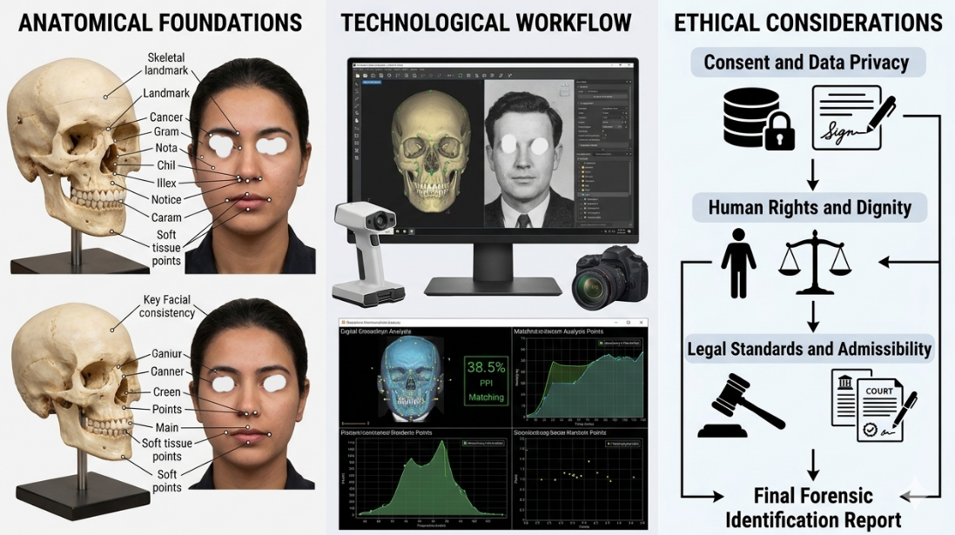
Figure 3 illustrates the integration of anatomical foundations, technological workflows, and ethical considerations in craniofacial superimposition, emphasizing the multidisciplinary nature of forensic identification (Claes et al., 2010; Springer, 2022).
Technological advances have significantly improved craniofacial superimposition (CFS), shifting it from a largely qualitative approach to a more quantitative and scientific method. Cone-beam computed tomography (CBCT) and high-resolution 3D imaging now enable detailed volumetric assessment of craniofacial structures, capturing depth and spatial relationships beyond traditional 2D overlays (Singh et al., 2024; Claes, Vandermeulen, & Clement, 2010). Artificial intelligence further enhances CFS by automating alignment, reducing subjectivity, and providing probabilistic evaluations that improve reliability (Ibañez et al., 2024; González-Rodríguez et al., 2022). In addition, digital reconstruction tools allow restoration of missing cranial features and simulation of soft tissue overlays for more accurate comparison with ante-mortem images (Healy & Stephan, 2024; Cattaneo, Gibelli, & Porta, 2020). Information and communication technologies also support cloud-based collaboration and the development of diverse forensic databases, though challenges remain in standardization, accessibility, and equitable implementation, especially in resource-limited settings.
Ethical considerations weave through both anatomy and technology, serving as the moral compass of CFS. The use of ante‑mortem photographs demands respect for privacy and informed consent, while cultural sensitivity requires practitioners to honor traditions and values that shape attitudes toward death and identity (Springer, 2022; Kahana & Hiss, 2015). Courts demand evidence that is reliable and reproducible, and practitioners must avoid overstating certainty, acknowledging limitations and presenting overlays with appropriate caution. Ethical responsibility extends to the design and use of technological systems, ensuring that AI‑driven overlays are transparent, validated, and free from bias (Healy & Stephan, 2024; Singh et al., 2024). This is not simply a matter of technical accuracy but of justice: forensic science must serve truth without compromising fairness. Ultimately, ethics humanize CFS, reminding practitioners that their work is not merely about aligning bones and photographs but about restoring identity to individuals who have been lost. Each overlay carries profound moral weight, allowing families to reclaim narratives and communities to achieve closure (Ubelaker, 2015).
The integration of anatomy, technology, and ethics makes craniofacial superimposition (CFS) a bridge between scientific analysis and human identification, linking skeletal remains to personal identity. However, its application is limited by anatomical variability, technological inequality, and ethical concerns, meaning it cannot be used in isolation or with absolute certainty. It is most effective when combined with other identification methods such as DNA profiling and dental analysis to ensure a comprehensive approach to identification (Ross & Williams, 2010). Future progress in CFS depends on international standardization, collaborative global databases, and interdisciplinary cooperation among forensic scientists, technologists, and ethicists to improve reliability, consistency, and ethical practice across jurisdictions.

4. Conclusion

Craniofacial superimposition (CFS) continues to stand out as one of the most compelling techniques in forensic identification because it embodies the convergence of anatomy, technology, and ethics. At its core, the practice is anchored in the anatomical stability of cranial morphology and the correlations between bone and soft tissue. These foundations provide the framework for aligning skeletal remains with facial photographs, yet they also remind us of the inherent variability of human identity. Age, sex, ancestry, and pathology all shape craniofacial features in ways that resist uniformity, underscoring that identity is not a fixed template but a reflection of diversity and individuality (Stephan & Simpson, 2008; Ubelaker, 2015).
The development of craniofacial superimposition (CFS) into a more accurate and reproducible technique has been largely driven by advances in 3D imaging, cone-beam computed tomography, and AI-based overlays, which have improved precision and evidentiary value (Singh et al., 2024; Yatabe et al., 2019). These tools also enable reconstruction of damaged cranial structures, simulation of soft tissue, and enhanced inter-institutional collaboration through digital platforms. However, challenges such as standardization, accessibility, and transparency persist, highlighting the need for ethical and regulated implementation of these innovations (Ibañez et al., 2024).
Ethics remain the compass that guides CFS, ensuring that scientific rigor is balanced with human dignity. The use of ante‑mortem photographs requires sensitivity to privacy and informed consent, while cultural awareness demands respect for traditions and values that shape attitudes toward death and identity (Springer, 2022). Each overlay is more than a technical alignment of bone and image; it is the restoration of identity to someone who has been lost. This humanizing dimension elevates CFS beyond forensic science, positioning it as a practice that serves justice while honoring the narratives of individuals and communities (Healy & Stephan, 2024).
Craniofacial superimposition (CFS) integrates anatomy, technology, and ethics as a multidisciplinary tool in forensic anthropology and medico-legal investigations. It is valuable for restoring identity to skeletal remains and providing closure, but its limitations highlight the need for caution, collaboration, and ongoing refinement. Its future relies on international standardization, diverse anatomical databases, and interdisciplinary cooperation among forensic scientists, technologists, and ethicists. Ultimately, CFS links bone to identity and death to recognition, with its progress depending on both scientific advancement and ethical responsibility to preserve human dignity and justice.
Disclaimer (Artificial intelligence)
Author(s) hereby declare that NO generative AI technologies such as Large Language Models (ChatGPT, COPILOT, etc.) and text-to-image generators have been used during the writing or editing of this manuscript.

References

Rhine, J. S., & Campbell, H. R. (1980). Thickness of facial tissues in American blacks. Journal of Forensic Sciences, 25(4), 847–858. https://doi.org/10.1520/JFS11030J
De Greef, S., Claes, P., Vandermeulen, D., Mollemans, W., Suetens, P., & Willems, G. (2006). Large-scale in-vivo Caucasian facial soft tissue thickness database for craniofacial reconstruction. Forensic Science International, 159(Suppl 1), S126–S146. https://doi.org/10.1016/j.forsciint.2006.02.034.
Kumar, P., Singh, R., & Sharma, A. (2020). Population‑specific variations in craniofacial soft tissue thickness: Implications for forensic identification. J Forensic Odonto‑Stomatol, 38(1), 12–20.
Stephan, C. N., & Simpson, E. K. (2008). Facial soft tissue depths in craniofacial identification (Part I): An analytical review of the published adult data. Journal of Forensic Sciences, 53(6), 1257–1272. https://doi.org/10.1111/j.1556-4029.2008.00852.
Claes, P., Vandermeulen, D., & Clement, J. (2010). A 3D statistical surface reconstruction method for craniofacial reconstruction. International Journal of Legal Medicine, 124(5), 491–500. https://doi.org/10.1007/s00414-010-0440-7.
Claes, P., Vandermeulen, D., & De Greef, S. (2018). Semi-automated skull-face matching using 3D geometric morphometrics. Forensic Science International, 289, 260–270. https://doi.org/10.1016/j.forsciint.2018.05.019.
Yoshino, M. (2012). Craniofacial superimposition. In C. Wilkinson & C. Rynn (Eds.), Craniofacial Identification (pp. 238–253). Cambridge University Press. https://doi.org/10.1017/CBO9781139049566.019
Ross, A. H., & Williams, S. (2010). Craniofacial superimposition: Practical considerations in forensic identification. Forensic Science International, 201(1–3), 118–124. https://doi.org/10.1016/j.forsciint.2010.04.025.
Pilli, E., Palamenghi, A., & Cattaneo, C. (2025). Forensic skeletal and molecular anthropology face to face: Combining expertise for identification of human remains. Annals of the New York Academy of Sciences, 1550(1), 77–107. https://doi.org/10.1111/nyas.15398
Richards, L., & Marquez-Grant, N. (2018). Disaster victim identification: Current practice and future directions. Forensic Science International, 289, 268–276. https://doi.org/10.1016/j.forsciint.2018.05.018.
Moritsugui, L., et al. (2022). Facial soft tissue thickness in a Brazilian population: Implications for forensic facial reconstruction. PLoS ONE, 17(5), e0267892. https://doi.org/10.1371/journal.pone.0267892.
Damas, S., Cordón, O., Ibáñez, Ó., & Santamaría, J. (2015). Craniofacial superimposition: A new proposal for best practices. Forensic Science International, 257, 515.e1–515.e10. https://doi.org/10.1016/j.forsciint.2015.09.004.
González-Rodríguez, J., Guerra, R., Ibáñez, Ó., & Cordón, O. (2022). Deep learning approaches for craniofacial superimposition. Journal of Forensic Sciences, 67(4), 1123–1134. https://doi.org/10.1111/1556-4029.14987.
Singh, S. S., Katyal, S., Vichare, S., Rana, S. S., Maken, P., & Gupta, A. (2024). Three-dimensional superimposition of craniofacial structures. In Applications of Three-dimensional Imaging for Craniofacial Region (pp. 183–200). Springer Nature Singapore. https://doi.org/10.1007/978-981-97-4608-8_13
Yatabe, M. S., Prieto, J. C., Styner, M., Zhu, H., Ruellas, A. C., Paniagua, B., et al. (2019). 3D superimposition of craniofacial imaging The utility of multicentre collaborations. Orthodontics and Craniofacial Research, 22(Suppl 1), 213–220. https://doi.org/10.1111/ocr.12281
Ibañez, Ó., Martínez-Moreno, P., Guerra, R., Martos, R., & Cordón, O. (2024). Evidence evaluation in craniofacial superimposition using likelihood ratios. Information Fusion, 102, 102489. https://doi.org/10.1016/j.inffus.2024.102489.
Cattaneo, C., Gibelli, D., & Porta, D. (2020). Forensic craniofacial superimposition: Current state and future directions. Forensic Imaging, 20, 200345. https://doi.org/10.1016/j.fri.2020.200345.
Healy, S. S., & Stephan, C. N. (2024). The critical photographic variables contributing to skull-face superimposition methods to assist forensic identification of skeletons: A review. Journal of Imaging, 10(1), 17. https://doi.org/10.3390/jimaging10010017
Springer, S. (2022). Craniofacial superimposition: Ethical and legal perspectives. In Handbook on Craniofacial Superimposition: The MEPROCS Project (pp. 145–160). Springer. https://doi.org/10.1007/978-3-319-11137-7
Kahana, T., & Hiss, J. (2015). Forensic anthropology and ethics: Balancing science and sensitivity. In Blau, S., & Ubelaker, D. H. (Eds.), Handbook of Forensic Anthropology and Archaeology (2nd ed., pp. 21–25). Routledge. https://doi.org/10.4324/9781315528939
Ubelaker, D. H. (2015). Forensic anthropology: Current practice and future directions. In Blau, S., & Ubelaker, D. H. (Eds.), Handbook of Forensic Anthropology and Archaeology (2nd ed., pp. 3–15). Routledge. https://doi.org/10.4324/9781315528939
Definitions, Acronyms, Abbreviations
CFS: Craniofacial Superimposition a forensic technique that overlays cranial images with ante‑mortem facial photographs to assist in human identification.
CBCT: Cone‑Beam Computed Tomography a three‑dimensional imaging technology used to capture volumetric craniofacial data with high precision.
AI: Artificial Intelligence computational systems capable of learning and automating tasks such as skull‑face alignment and probabilistic assessment in forensic imaging.
ICT: Information and Communication Technology digital platforms and tools that enable collaboration, data sharing, and database creation in forensic science.
Soft Tissue Thickness: The measured distance between cranial landmarks and the overlying skin surface, critical for accurate skull‑face overlays.
Likelihood Ratio Framework: A statistical method used to quantify the strength of forensic evidence by comparing probabilities of competing hypotheses.
Ethical Oversight: The application of privacy, consent, cultural sensitivity, and evidentiary admissibility standards to ensure dignity and fairness in forensic practice.

