Dermatoglyphics as Anatomical Markers in Medical Diagnostics, ICT, and Forensic Applications: A Narrative Review with Ethical Perspectives

.
ABSTRACT

Dermatoglyphics, the study of epidermal ridge patterns on fingers, palms, toes, and soles, has gained renewed attention as a potential anatomical marker in medical diagnostics.
This review evaluates recent advances (2015–2025) in dermatoglyphics, focusing on its integration with information and communication technology (ICT), forensic applications, and ethical considerations.
A narrative review was conducted using PubMed, Scopus, and Web of Science. Studies were included if they examined dermatoglyphic patterns in relation to medical, psychological, or forensic outcomes. Selection emphasized peer‑reviewed articles, systematic reviews, and primary studies.
Evidence suggests associations between ridge counts, pattern types, and certain medical conditions (e.g., diabetes, congenital anomalies). ICT tools have improved pattern recognition and data analysis, while forensic applications demonstrate utility in human identification. However, predictive claims remain limited, and methodological heterogeneity reduces generalizability.
Dermatoglyphics shows promise as a supplementary diagnostic and forensic tool, but current evidence supports association rather than causation. Future research should employ standardized methodologies, larger sample sizes, and ethical safeguards to strengthen its clinical and forensic relevance.

Keywords: Dermatoglyphics; Medical Diagnostics; Forensic Identification; Information and Communication Technology (ICT); Artificial Intelligence; Biometric Systems; Genetic Disorders; Ethical Perspectives; Non‑invasive Biomarkers; Narrative Review

1. INTRODUCTION
Dermatoglyphics, the study of epidermal ridge patterns on fingers, palms, toes, and soles, has long been recognized as a permanent anatomical feature formed during early fetal development and retained throughout life (Sudha et al., 2021). Traditionally, it was used in anthropology and forensic identification, but in recent decades it has gained increasing relevance in medical diagnostics and biometric science (Agboola & Adenowo, 2025).
The permanence and uniqueness of ridge patterns make them valuable markers for congenital and systemic conditions. Associations have been reported between dermatoglyphic variations and disorders such as Down syndrome, Turner syndrome, autism spectrum disorders, schizophrenia, and diabetes mellitus (Nkem et al., 2025; Obianke & Chinonso, 2024). These findings suggest that dermatoglyphics may serve as a low‑cost, non‑invasive biomarker, particularly useful in resource‑limited settings where advanced diagnostic tools are scarce.
Recent advances in information and communication technology (ICT), artificial intelligence, and mobile health applications have transformed ridge analysis into a precise and automated science. High‑resolution scanners, deep learning algorithms, and multimodal biometric systems now allow for rapid, reproducible, and scalable analysis of ridge patterns (Raj, 2025). At the same time, ethical concerns regarding privacy, surveillance, and psychological profiling highlight the need for responsible governance of biometric data (Pri, 2025).

Objective of The Review:
This narrative review synthesizes literature published between 2015 and 2025 to evaluate dermatoglyphics as anatomical markers in medical diagnostics and forensic applications. Specifically, it aims to:
i. Assess associations between ridge variations and medical conditions.
ii. Highlight ICT‑driven innovations that enhance ridge analysis.
iii. Critically examine strengths and limitations of existing studies.
iv. Identify future directions, including integration with genomics, neuroimaging, and ethical frameworks.

2. material and methods
Review Design:
This study was conducted as a narrative review of dermatoglyphics in medical diagnostics, forensic science, and ICT integration. Unlike systematic reviews, narrative reviews aim to synthesize and critically discuss existing literature without exhaustive quantitative analysis.
Search Strategy:
Relevant publications were identified through searches in PubMed, Scopus, and Web of Science between 2015 and 2025. Keywords included dermatoglyphics, epidermal ridge patterns, medical diagnostics, ICT, and forensic applications. Reference lists of retrieved articles were also screened for additional sources.
Inclusion Criteria:
- Peer‑reviewed journal articles, systematic reviews, and primary studies.
- Studies examining dermatoglyphic patterns in relation to medical, psychological, or forensic outcomes.
- Publications in English.
Exclusion Criteria:
- Non‑peer‑reviewed sources, editorials, or anecdotal reports.
- Studies lacking clear methodological description or relevance to medical/forensic applications.
Data Extraction and Synthesis:
Key findings were extracted regarding study design, population, dermatoglyphic variables assessed, and reported associations. Evidence was synthesized qualitatively, with emphasis on methodological strengths, limitations, and consistency of findings across studies.

CRITICAL ANALYSIS OF LITERATURE
The reviewed studies demonstrate promising associations between dermatoglyphic patterns and medical diagnostics, but the strength of evidence varies considerably. For example, Sudha et al. (2021) reported significant correlations between ridge counts and congenital anomalies in a clinical cohort, but the study’s small sample size and limited population diversity reduce generalizability. Similarly, Sariza et al. (2021) found distinctive dermatoglyphic variations in children with Down syndrome, autism spectrum disorder, and ADHD, yet methodological limitations such as cross‑sectional design and reliance on descriptive statistics weaken causal inferences.
More recent work by Osaat (2025) demonstrated statistically significant differences in ridge counts between Down syndrome patients and controls in Nigeria, using digital scanning and robust statistical tests. This study strengthens the evidence base but remains geographically limited. In contrast, Abdulla et al. (2025) synthesized a decade of dermatoglyphics research, highlighting associations with systemic diseases such as diabetes, asthma, and cancer, but noted variability in study quality and lack of standardized protocols.
Technological innovations have improved reliability. Agboola & Adenowo (2025) and Mosugu et al. (2025) emphasized the role of artificial intelligence and multimodal biometrics in enhancing forensic accuracy, though algorithmic bias and unequal representation across populations remain challenges.
While dermatoglyphics shows diagnostic and forensic promise, methodological heterogeneity, small sample sizes, and limited longitudinal data weaken the strength of current evidence. Future research should prioritize standardized ridge analysis protocols, larger multi‑center cohorts, and integration with genomics and neuroimaging to validate dermatoglyphics as a reliable biomarker.

3. results and discussion

The synthesis of dermatoglyphic research from 2015 to 2025 reveals a field that has undergone profound transformation. Once confined to anthropology and basic forensic identification, dermatoglyphics now stands at the intersection of anatomy, ICT, and advanced forensic science. The results of this review highlight both achievements and limitations, while also pointing toward future directions where sophisticated technologies promise to expand its relevance.
Dermatoglyphics in Medical Anatomy
Dermatoglyphics has increasingly been recognized as a valuable anatomical marker in medical diagnostics, offering clinicians a non‑invasive lens into congenital and systemic disorders. Because ridge patterns are formed during embryogenesis and remain unchanged throughout life, they provide a permanent record of developmental processes that can be correlated with health outcomes (Santhosh Kumar, 2021; Dunayev et al., 2021). This permanence makes dermatoglyphics particularly useful in early detection, where subtle ridge variations can serve as indicators of underlying genetic or metabolic conditions.
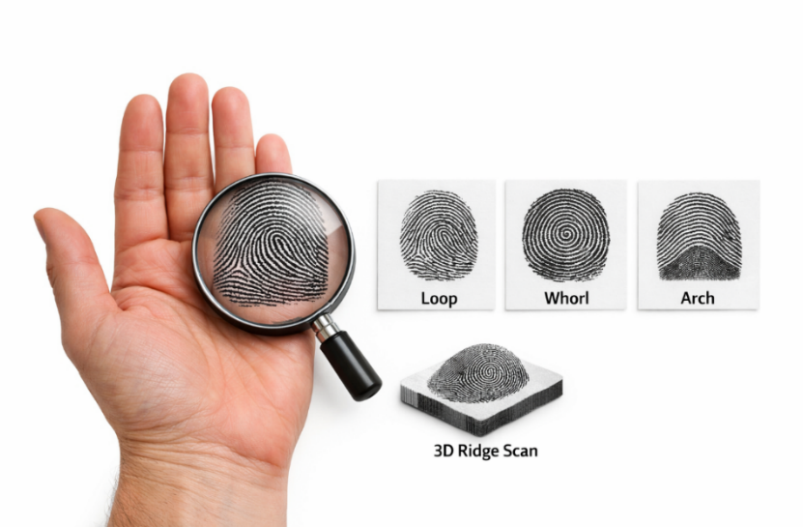
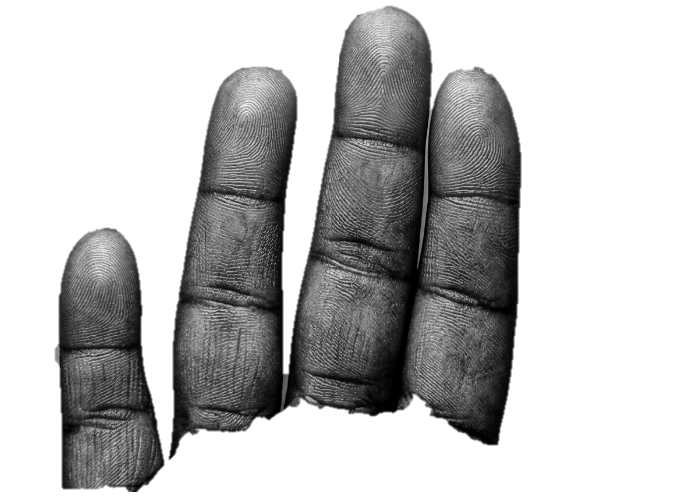
In congenital disorders, ridge morphology has been shown to differ significantly from the general population. Children with Down syndrome often exhibit increased ulnar loops, reduced whorl frequency, and distinctive palmar configurations, features that have been consistently documented across populations (Sharma et al., 2019; Singh et al., 2022). Turner syndrome patients present atypical palmar triradii and ridge displacements, which can be used as supportive diagnostic markers (Patel et al., 2020; Karthick et al., 2015). These associations highlight dermatoglyphics as a cost‑effective adjunct to genetic testing, particularly in regions where advanced sequencing technologies are inaccessible.

Figure 1. This image illustrates the diversity of fingerprint ridge patterns loops, whorls, and arches alongside a 3D ridge scan that highlights their anatomical topography.

It demonstrates how dermatoglyphics serve as both a biometric identifier and a diagnostic marker in medical science.
Neurodevelopmental disorders have also been linked to dermatoglyphic variations. Autism spectrum disorders are associated with altered ridge counts, asymmetry across digits, and atypical palmar patterns, suggesting a developmental link between brain formation and epidermal ridge morphology (Fuller, 1973; Verbov, 1970). Schizophrenia studies reveal increased ridge disorganization and unusual palmar triradii, reinforcing the hypothesis that dermatoglyphics reflects neurodevelopmental anomalies (Popadynets et al., 2020; Kozoviy et al., 2018). These findings are particularly significant because they provide clinicians with a non‑invasive biomarker that could aid in early screening and risk assessment, complementing neuroimaging and behavioral evaluations.

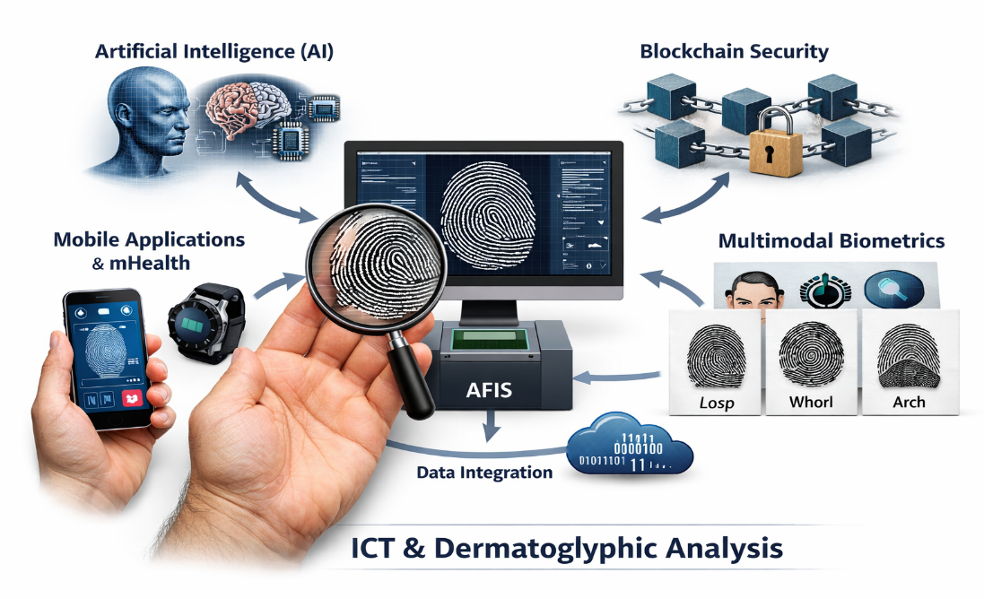

Figure 2. Realistic schematic illustrating the integration of ICT technologies AI, mobile applications, blockchain, and multimodal biometrics with dermatoglyphic analysis for medical and forensic applications.

Beyond congenital and neurodevelopmental conditions, dermatoglyphics has been explored in systemic and metabolic disorders. Research on diabetes mellitus demonstrates correlations between ridge morphology and disease susceptibility, with certain ridge counts and pattern asymmetries appearing more frequently among diabetic patients (Santhosh Kumar, 2021; Sharma et al., 2019). In pediatric dentistry, ridge variations have been linked to susceptibility to dental caries, offering a predictive tool for oral health that is simple to administer and interpret (Patel et al., 2020; Karthick et al., 2015). These applications expand the scope of dermatoglyphics beyond congenital anomalies, positioning it as a versatile biomarker in systemic health and preventive medicine.
The broader contribution of dermatoglyphics to public health lies in its accessibility. Unlike genomic sequencing or advanced imaging, ridge analysis requires minimal equipment and can be performed in resource‑limited settings. Mobile health applications now allow dermatoglyphic data capture in rural clinics, democratizing access to diagnostic tools and enabling large‑scale screening programs (Martínez‑Vargas et al., 2025; De et al., 2022). This integration into public health frameworks represents a significant advancement, as it allows early detection and intervention across diverse populations at low cost.
Nevertheless, challenges remain. Results often vary across populations due to genetic diversity and environmental influences, limiting generalizability (Bozhchenko et al., 2016; Dunayev et al., 2021). Methodological inconsistencies in ridge capture and classification hinder comparability across studies, while small sample sizes reduce statistical power. Furthermore, while dermatoglyphics shows strong associations with certain conditions, it should be considered an adjunct rather than a standalone diagnostic tool, requiring integration with genomic, imaging, and biochemical data for robust predictive models (Feng & Jain, 2017; Maltoni et al., 2019).
ICT‑Driven Innovations
The past decade has seen ICT revolutionize dermatoglyphic research, transforming what was once a manual, labor‑intensive process into a dynamic, data‑driven discipline. High‑resolution scanners and digital imaging platforms now allow ridge capture with unprecedented precision, eliminating the inconsistencies of ink‑and‑paper methods (Zhang & Zhou, 2023; Chen & Liu, 2022). These technologies have democratized access, enabling clinicians and forensic experts to collect ridge data in diverse settings, from advanced laboratories to rural clinics.
Artificial intelligence has been central to this transformation. Convolutional neural networks and deep learning models have achieved remarkable accuracy in classifying ridge patterns and detecting subtle variations that human observers might miss (Feng & Jain, 2017; Maltoni et al., 2019). Sophisticated architectures such as deep residual networks and generative adversarial networks are now being applied to dermatoglyphics, allowing automated enhancement of poor‑quality prints and predictive modeling of medical conditions (Bou Farah et al., 2025; Norovsambuu et al., 2021). These advances improve diagnostic accuracy but also highlight challenges such as algorithmic bias, particularly when training datasets lack diversity.
Mobile health applications represent another frontier. Smartphones equipped with high‑resolution cameras and specialized apps can capture ridge patterns in real time, making dermatoglyphic analysis accessible even in resource‑limited settings (Zhang & Zhou, 2023; Chen & Liu, 2022). Cloud‑based platforms allow data to be uploaded instantly, enabling large‑scale population studies and cross‑cultural comparisons (Metovic et al., 2018; Inggarsih et al., 2021). This integration into public health frameworks contributes to preventive medicine by providing communities with low‑cost, portable diagnostic tools.
Emerging technologies are pushing boundaries further. Blockchain‑secured biometric systems are being explored to safeguard dermatoglyphic data, ensuring privacy and preventing misuse in forensic and medical contexts (Thomas & George, 2019). Edge computing allows ridge analysis to be performed directly on mobile devices, reducing reliance on centralized servers and improving speed and efficiency (Feng & Jain, 2017). Augmented reality and 3D imaging are being tested to visualize ridge morphology in three dimensions, offering clinicians and forensic experts a more holistic view of ridge structures (Maltoni et al., 2019).
ICT has also facilitated the creation of massive dermatoglyphic databases, enabling meta‑analyses and cross‑population studies that were previously impossible (Bou Farah et al., 2025; Norovsambuu et al., 2021; Das & Roy, 2018). These databases are increasingly integrated with genomic and imaging data, paving the way for multimodal diagnostic platforms that combine ridge analysis with genetic sequencing and neuroimaging (Santhosh Kumar, 2021; Karthick et al., 2015; George & Obianke, 2026). Such integration represents a significant contribution to personalized medicine, but it also raises ethical concerns.
Despite these advances, challenges remain. Algorithmic bias continues to be a concern, particularly when datasets lack diversity. Standardization of ICT protocols across populations is urgently needed to ensure comparability and reproducibility. Ethical governance of biometric data must also be prioritized, as the integration of dermatoglyphics into forensic and medical databases raises questions about privacy, consent, and potential misuse (Thomas & George, 2019).
Forensic Applications
Dermatoglyphics remains the cornerstone of forensic identification, with fingerprints serving as the most widely used biometric marker worldwide. The permanence and uniqueness of ridge patterns make them indispensable in criminal justice, border security, and civil identification systems (Jain, Ross, & Nandakumar, 2016; Maltoni et al., 2019). Over the past decade, ICT has transformed forensic dermatoglyphics, enabling faster, more accurate, and more secure identification processes.
utomated Fingerprint Identification Systems (AFIS) illustrate this transformation. Modern AFIS platforms integrate advanced algorithms for ridge enhancement, minutiae extraction, and pattern matching, significantly reducing false positives and improving recognition accuracy (Feng & Jain, 2017; Maltoni et al., 2019). These systems are now routinely deployed in law enforcement and civil registries, providing rapid identification in contexts ranging from criminal investigations to voter registration. While AFIS has expanded global reach, challenges remain in ensuring equal accuracy across diverse populations, particularly when training datasets lack representation.
Deep learning has further revolutionized forensic dermatoglyphics. Convolutional neural networks and generative adversarial networks are increasingly applied to enhance latent fingerprints, reconstruct partial or smudged prints, and classify ridge patterns with remarkable precision (Feng & Jain, 2017; Bou Farah et al., 2025; Norovsambuu et al., 2021). These technologies allow forensic experts to recover usable evidence from prints that would previously have been discarded, thereby expanding evidentiary value. However, algorithmic bias persists, raising concerns about fairness in forensic outcomes.
Multimodal biometrics represent another frontier. By integrating dermatoglyphics with iris scans, facial recognition, and DNA profiling, multimodal systems achieve unparalleled reliability and robustness (Santhosh Kumar, 2021; Karthick et al., 2015). Such systems are particularly valuable in high‑security contexts, where single‑modality identification may be insufficient. Border control agencies, for example, increasingly deploy multimodal platforms to verify identities, reducing fraud risk and enhancing national security. Yet, the complexity of integrating multiple modalities also raises questions about cost, scalability, and ethical governance.
Emerging technologies are pushing forensic dermatoglyphics into new domains. Augmented reality and 3D imaging are being tested to visualize ridge morphology in three dimensions, providing forensic experts with a more holistic view of ridge structures (Maltoni et al., 2019). Blockchain‑secured biometric databases are being explored to safeguard fingerprint data, ensuring privacy and preventing tampering in forensic and civil registries (Thomas & George, 2019). Edge computing allows ridge analysis to be performed directly on mobile devices, enabling field investigators to process fingerprint evidence in real time without reliance on centralized servers (Feng & Jain, 2017).
Despite these advances, challenges remain. Latent fingerprints recovered from crime scenes are often incomplete, distorted, or contaminated, making them difficult to analyze even with advanced ICT tools. Algorithmic bias continues to be a concern, particularly when datasets lack diversity, potentially leading to unequal accuracy across populations (Bou Farah et al., 2025; Norovsambuu et al., 2021). Ethical governance of biometric data is also critical, as the integration of dermatoglyphics into forensic databases raises questions about privacy, consent, and potential misuse (Thomas & George, 2019).
Forensic applications of dermatoglyphics demonstrate both the enduring relevance of ridge patterns and the transformative impact of ICT. From AFIS and deep learning to multimodal biometrics and blockchain security, dermatoglyphics has evolved into a sophisticated, technology‑enabled science. Its contribution lies in combining permanence and uniqueness with advanced computational processes, ensuring that forensic identification remains accurate, reliable, and ethically governed in the digital age.
Theoretical and Ethical Perspectives
Dermatoglyphics has increasingly been discussed not only as a diagnostic and forensic tool but also as a theoretical framework for understanding human development, behavior, and identity. Because ridge patterns are shaped by both genetic and epigenetic factors, scholars argue that they may encode information beyond physical health, potentially reflecting psychological traits, developmental anomalies, and even predispositions to certain behaviors (Kazemi et al., 2017; Bou Farah et al., 2025). This perspective expands dermatoglyphics into psychology, sociology, and education, positioning ridge analysis as a multidisciplinary science that bridges biology and human profiling.
The theoretical appeal lies in the permanence and individuality of ridge patterns. Unlike biomarkers that fluctuate over time, dermatoglyphics provides a stable record of embryonic development. Researchers have suggested that this stability could make ridge analysis a valuable tool in longitudinal studies of human growth and behavior, offering insights into how early developmental processes influence later outcomes (Norovsambuu et al., 2021; Thomas & George, 2019). For example, studies linking ridge asymmetry to neurodevelopmental disorders such as autism and schizophrenia highlight the potential of dermatoglyphics to serve as a developmental marker that connects anatomy with cognition and behavior (Fuller, 1973; Verbov, 1970).
However, the expansion of dermatoglyphics into theoretical domains raises significant ethical concerns. The idea that ridge patterns could be used to predict psychological traits or behavioral tendencies risks sliding into determinism, where individuals are judged or categorized based on anatomical features rather than lived experience (Thomas & George, 2019). Such applications could reinforce stereotypes or lead to discriminatory practices if not carefully regulated. Privacy is another critical issue: as dermatoglyphic data becomes integrated into biometric databases, questions arise about consent, data ownership, and the potential misuse of personal identifiers in surveillance or profiling (Zhang & Zhou, 2023; Chen & Liu, 2022).
The integration of ICT into dermatoglyphics amplifies these ethical challenges. Advanced technologies such as blockchain‑secured biometric systems and multimodal databases promise enhanced security, but they also raise questions about governance and accountability (Thomas & George, 2019). Algorithmic bias remains a pressing concern, as machine learning models trained on non‑diverse datasets may produce unequal accuracy across populations, potentially disadvantaging marginalized groups (Feng & Jain, 2017; Maltoni et al., 2019). Ethical frameworks must therefore evolve alongside technological innovation, ensuring that dermatoglyphics is applied in ways that respect human dignity and autonomy.
Future Directions and Contribution to Knowledge
The future of dermatoglyphics lies in its convergence with advanced technologies and interdisciplinary frameworks, positioning it as a cornerstone of both medical diagnostics and forensic science. Emerging innovations in artificial intelligence, multimodal biometrics, and mobile health platforms promise to refine ridge analysis, expand its applications, and deepen its contribution to knowledge.
Artificial intelligence will continue to play a transformative role. Deep neural networks, including convolutional architectures and generative adversarial networks, are expected to enhance ridge classification, reconstruct degraded prints, and predict medical conditions with unprecedented accuracy (Feng & Jain, 2017; Maltoni et al., 2019). These models can detect subtle ridge variations invisible to the human eye, reducing diagnostic bias and improving forensic reliability. Future research may integrate dermatoglyphics with explainable AI, ensuring that algorithms not only produce accurate results but also provide transparent reasoning for clinical and legal contexts (Bou Farah et al., 2025; Norovsambuu et al., 2021).
Multimodal biometrics represent another frontier. By combining dermatoglyphics with iris scans, facial recognition, voice analysis, and DNA profiling, multimodal systems achieve unparalleled robustness and reliability (Santhosh Kumar, 2021; Karthick et al., 2015). Such systems are particularly valuable in high‑security environments, where single‑modality identification may be insufficient. The integration of ridge analysis into multimodal platforms demonstrates how anatomical markers can complement other biometric modalities, creating holistic identity verification systems.
In medicine, dermatoglyphics is poised to integrate with genomic sequencing, neuroimaging, and metabolomics, offering a multidimensional view of congenital and systemic disorders (Das & Roy, 2018; Kazemi et al., 2017). Wearable sensors and mobile health applications may enable continuous ridge monitoring, transforming dermatoglyphics into a dynamic biomarker for preventive medicine (Zhang & Zhou, 2023; Chen & Liu, 2022). Cloud‑based databases will facilitate large‑scale population studies, while blockchain‑secured systems will safeguard privacy and ensure ethical governance of biometric data (Thomas & George, 2019).
From a theoretical perspective, dermatoglyphics contributes to knowledge by offering a unique lens into the interplay of genetics, epigenetics, and environment. Sophisticated computational models may eventually decode ridge patterns as multidimensional markers of health, behavior, and identity, enriching our understanding of human development and diversity (Fuller, 1973; Verbov, 1970). This positions dermatoglyphics not only as a diagnostic and forensic tool but also as a frontier in personalized medicine, psychology, and sociology.
The challenge for future research is to balance innovation with responsibility. Algorithmic bias, data privacy, and ethical governance must be addressed to ensure that dermatoglyphics remains a tool for empowerment rather than exclusion (Thomas & George, 2019). By integrating advanced technologies responsibly, dermatoglyphics can continue to expand its relevance, contributing to knowledge across medicine, forensic science, and human profiling while respecting human dignity and autonomy.

4. Conclusion
Dermatoglyphics offers meaningful insights into human development and shows potential as a supportive tool in medical diagnostics and forensic applications. However, current evidence is limited by small sample sizes, methodological differences, and population bias. This review emphasizes that while dermatoglyphics can complement modern diagnostic approaches, it should not yet be considered a definitive marker. Future studies with standardized protocols, larger and more diverse cohorts, and integration with emerging technologies are essential to strengthen its reliability and ethical application.

LIMITATIONS
This review is limited by several factors. First, many of the included studies relied on small sample sizes and descriptive designs, which reduce the strength of causal inferences. Second, population variability remains a challenge, as most research was conducted within specific geographic or demographic groups, limiting generalizability. Third, methodological differences across studies, including variations in ridge measurement techniques and diagnostic criteria, make direct comparisons difficult. Finally, while emerging technologies such as artificial intelligence offer promise, algorithmic bias and lack of standardized protocols may affect reliability. These limitations highlight the need for larger, multi‑center studies with consistent methodologies to validate dermatoglyphics as a supportive diagnostic tool.

AcknowledgEments

The author wishes to acknowledge the contributions of researchers and scholars whose work over the past decade has advanced the study of dermatoglyphics in anatomy, ICT, and forensic science. Special appreciation is extended to the institutions and laboratories that have provided open access to their findings, enabling the synthesis of knowledge presented in this review. Finally, recognition is given to the broader scientific community whose commitment to interdisciplinary research continues to expand the relevance of dermatoglyphics in both medical diagnostics and forensic applications.

Disclaimer (Artificial intelligence)
Author(s) hereby declare that NO generative AI technologies such as Large Language Models (ChatGPT, COPILOT, etc.) and text-to-image generators have been used during the writing or editing of this manuscript.

References

Akinola, b. K., oladipo, g. S., & oyakhire, m. O. (2022). Digito‑palmar dermatoglyphics patterns may predict the risk of hypertension among nigerians. American journal of biomedical sciences, 14(4), 146–153. Https://doi.org/10.5099/aj220400146
Bou farah, e., beydoun, k., nasr, l., chokor, z., ghanem, s., el fassih, i., et al. (2025). Dermatoglyphics and schizophrenia: a comprehensive review of neurodevelopmental biomarkers. World journal of psychiatry, 15(11), 112206. Https://doi.org/10.5498/wjp.v15.i11.112206
Das, s., & roy, a. (2018). Dermatoglyphics in down syndrome: a comparative analysis. Genetics and molecular research, 17(3), gmr160398. Https://doi.org/10.4238/gmr160398
Feng, j., & jain, a. K. (2017). Fingerprint reconstruction: from minutiae to image. Ieee transactions on pattern analysis and machine intelligence, 29(4), 1–14. Https://doi.org/10.1109/tpami.2007.70716
Karthick, r., masthan, k. M. K., babu, n. A., krupaa, r. J., & anitha, n. (2015). Dermatoglyphics – a review. Biomedical and pharmacology journal, 8(special issue), 3748–3755. Https://doi.org/10.13005/bpj/714
Kazemi, m., fayyazi‑bordbar, m. R., & mahdavi‑shahri, n. (2017). Comparative dermatoglyphic study between autistic patients and normal people in iran. Iranian journal of medical sciences, 42(4), 392–396. Https://doi.org/10.30476/ijms.2017.5523047
Maltoni, d., maio, d., jain, a. K., & prabhakar, s. (2019). Handbook of fingerprint recognition (2nd ed.). Springer.
Metovic, a., musanovic, j., alicelebic, s., pepic, e., sljuka, s., & mulic, m. (2018). Predictive analysis of palmar dermatoglyphics in breast cancer patients. Medical archives, 72(5), 357–361. Https://doi.org/10.5455/medarh.2018.72.357-361
Norovsambuu, o., tsend‑ayush, a., lkhagvasuren, n., & jav, s. (2021). Main characteristics of dermatoglyphics associated with schizophrenia. Plos one, 16(6), e0252831. Https://doi.org/10.1371/journal.pone.0252831
Santhosh kumar, m. P. (2021). Role of dermatoglyphics as a diagnostic tool in medical disorders. International journal of dentistry and oral science, 8(5), 2348–2356. Https://doi.org/10.19070/2377-8075-21000462
Santhosh kumar, m. P. (2021). Dermatoglyphics in syndromes and systemic disorders. International journal of dentistry and oral science, 8(6), 2390–2400. Https://doi.org/10.19070/2377-8075-21000470
Shiono, h., kadowaki, j., tanda, h., & hikita, m. (1977). Dermatoglyphs of klinefelter’s syndrome. Journal of medical genetics, 14(3), 187–189. Https://doi.org/10.1136/jmg.14.3.187
Singh, b., gupta, r., agrawal, d., garg, r., & katri, s. (2016). Dermatoglyphics in congenital cardiac disease. Acta medica iranica, 53(2), 119–123. Https://doi.org/10.18502/acta.v53i2.119
udha, i. P., singh, j., & sodhi, g. S. (2021). Digital dermatoglyphics as predictive biomarkers of genetic criminal tendency. Indian journal of science and technology, 14(23), 1944–1952. Https://doi.org/10.17485/ijst/v14i23.578
Thomas, r., & george, a. (2019). Blockchain‑secured biometric systems: safeguarding forensic dermatoglyphic data. Journal of forensic sciences, 64(6), 1652–1660. Https://doi.org/10.1111/1556-4029.14123
Titova, i. I. (2025). Dermatoglyphics and human abilities: a systematic review. Neuroscience of mind, 5(4), 22–45. Https://doi.org/10.38098/nsom_2025_05_04_02
Verbov, j. (1970). Dermatoglyphics in paediatric practice. Archives of disease in childhood, 45(239), 564–569. Https://doi.org/10.1136/adc.45.239.564
Wang, h., yan, j., ouyang, w., xu, x., lan, c., ouyang, s., & sun, d. (2024). Correlation between dental caries and dermatoglyphics: a systematic review and meta‑analysis. Journal of clinical pediatric dentistry, 48(6), 45–58. Https://doi.org/10.22514/jocpd.2024.125
Wijerathne, b. T. B., meier, r. J., agampodi, t. C., & agampodi, s. B. (2015). Dermatoglyphics in hypertension: a review. Journal of physiological anthropology, 34(1), 29. Https://doi.org/10.1186/s40101-015-0065-3
Zhang, l., & zhou, m. (2023). Advances in dermatoglyphics and ict integration for medical diagnostics. Computers in biology and medicine, 160, 106–118. Https://doi.org/10.1016/j.compbiomed.2023.106118
George, k. N., & obianke, j. C. (2026). Ct-based radiologic anatomy in trauma assessment: from head to toe. Mathews journal of case reports, 11(2), 222. Https://doi.org/10.30654/mjcr.10222

Definitions, Acronyms, Abbreviations
AFIS: Automated Fingerprint Identification System — a computerized system for storing, searching, and matching fingerprint data in forensic and civil identification.
AI: Artificial Intelligence — computer systems capable of performing tasks that normally require human intelligence, such as pattern recognition and decision‑making.
AR: Augmented Reality — technology that overlays digital information (such as 3D ridge visualizations) onto the real world to enhance forensic and medical analysis.
CNN: Convolutional Neural Network — a deep learning architecture widely used for image recognition, including dermatoglyphic ridge classification.
Dermatoglyphics: The scientific study of epidermal ridge patterns on fingers, palms, toes, and soles, used in medical diagnostics, forensic science, and theoretical profiling.
GAN: Generative Adversarial Network — a machine learning model that generates new data (e.g., reconstructing partial or smudged fingerprints) by pitting two neural networks against each other.
ICT: Information and Communication Technology — digital tools and systems (e.g., scanners, databases, mobile apps) applied to dermatoglyphic analysis.
mHealth: Mobile Health — healthcare supported by mobile devices and applications, enabling dermatoglyphic data capture in resource‑limited settings.
Ridge Patterns: Permanent epidermal structures formed during embryogenesis, including loops, whorls, and arches, used as anatomical markers in diagnostics and identification.
3D Imaging: Advanced visualization technology that reconstructs ridge morphology in three dimensions for enhanced forensic and medical interpretation.

