Cluster-Aware Deep Sentiment Mining Framework for Real-Time Public Opinion Monitoring

ABSTRACT
The rapid growth of social media platforms and online communication technologies has generated massive streams of opinion-rich textual data, creating new opportunities for intelligent public opinion monitoring and sentiment analytics. However, conventional sentiment analysis systems often suffer from poor contextual understanding, scalability limitations, high computational overhead, and weak robustness against noisy social media content. This study proposes a novel Cluster-Aware Deep Sentiment Mining (CADSM) framework for real-time public opinion monitoring. The proposed framework integrates adaptive semantic clustering, distributed stream preprocessing, cluster-aware contextual feature augmentation, and hybrid CNN-LSTM deep sentiment inference within a unified intelligent architecture. Opinion streams collected from X (formerly Twitter), Reddit, online discussion forums, and news comment platforms are semantically grouped using adaptive clustering mechanisms before undergoing distributed preprocessing and contextual feature enhancement. Experimental evaluation was conducted using multilingual social media datasets containing positive, negative, and neutral sentiment classes. The proposed CADSM framework achieved superior performance with 97.4% classification accuracy, 96.9% precision, 96.5% recall, and 96.7% F1-score while maintaining low processing latency and strong scalability under high-volume streaming conditions. Furthermore, the framework demonstrated high robustness under noisy environments and achieved an AUC score of 0.98 during ROC analysis. The findings confirm that integrating semantic clustering and distributed deep learning significantly improves contextual intelligence, scalability, and sentiment discrimination capability for intelligent real-time public opinion monitoring systems.
Keywords: Sentiment Analysis, Deep Learning, Semantic Clustering, Public Opinion Monitoring, Real-Time Analytics
I. INTRODUCTION
The rapid expansion of social media platforms, online discussion forums, and digital communication technologies has transformed the way individuals express opinions, emotions, and perceptions regarding political, economic, social, and commercial events[1]. Platforms such as X, Facebook, Instagram, YouTube, and online blogs continuously generate massive streams of user-generated textual data in real time[2]. These opinion-rich data sources provide valuable insights into public perception, consumer behavior, election trends, crisis response, and market intelligence[3]. Consequently, real-time public opinion monitoring and sentiment analysis have emerged as critical research areas within artificial intelligence, data science, and computational social analytics[4].
Sentiment analysis refers to the computational process of identifying and categorizing emotions[5], attitudes, and subjective opinions expressed in textual data[6]. Traditional sentiment analysis systems primarily relied on lexicon-based approaches and statistical machine learning algorithms such as Naïve Bayes, Decision Trees, Support Vector Machines (SVM)[7], and Logistic Regression[8]. Although these methods achieved moderate classification performance, they frequently struggled with sarcasm detection, semantic ambiguity, multilingual expressions, noisy social media content, and contextual dependency[9].
The emergence of deep learning techniques significantly improved sentiment classification performance through automatic feature extraction and contextual representation learning[10]. Convolutional Neural Networks (CNNs) demonstrated strong capability in extracting semantic patterns from textual data, while Long Short-Term Memory (LSTM) networks and Transformer-based architectures improved sequential context understanding[11]. Despite these advancements, existing deep learning approaches still encounter several limitations when deployed in large-scale real-time sentiment monitoring systems[12].
One major challenge is the enormous volume and velocity of streaming social media data, which introduce scalability and computational complexity issues[13]. Real-time opinion monitoring systems must process heterogeneous textual streams continuously while maintaining low inference latency and high classification accuracy[14]. Furthermore, social media environments are highly dynamic and noisy due to slang expressions, abbreviations, hashtags, emojis, and rapidly evolving linguistic patterns[15]. These characteristics reduce the robustness of conventional sentiment classification models[16].
Another significant limitation lies in the way most sentiment analysis systems process textual samples independently without considering semantic relationships among related opinions[17]. Existing models rarely exploit structural contextual grouping among similar opinion streams[18]. As a result, contextual consistency is weakened, and sentiment inference becomes more susceptible to misclassification under noisy and ambiguous conditions[19].
To address these limitations, recent studies have explored distributed sentiment analytics, semantic embedding techniques, and scalable stream-processing frameworks. Distributed computing models such as MapReduce and Apache Spark improved scalability for high-volume data processing, while transformer-based language models enhanced contextual understanding. Nevertheless, most existing approaches still treat clustering, preprocessing, and deep inference as independent components rather than integrating them into a unified intelligent framework.
This study therefore proposes a novel Cluster-Aware Deep Sentiment Mining (CADSM) framework for intelligent and real-time public opinion monitoring. The proposed framework integrates adaptive semantic clustering, distributed stream preprocessing, cluster-aware feature augmentation, and deep learning–based sentiment inference within a unified architecture. Unlike conventional sentiment analysis systems that use clustering solely for data organization, the proposed framework treats clustering as a semantic structuring mechanism that enhances contextual intelligence and strengthens deep sentiment inference.
The proposed CADSM framework operates through four interconnected layers, namely the Data Acquisition Layer, Adaptive Semantic Clustering Layer, Distributed Stream Processing Layer, and Deep Sentiment Inference Layer. Social media streams are continuously collected and semantically grouped using adaptive clustering mechanisms before undergoing distributed preprocessing and deep neural sentiment classification. Structural cluster metadata are integrated into deep feature representations to improve contextual consistency and reduce sentiment ambiguity.
Existing sentiment analysis approaches can generally be categorized into lexicon-based techniques, machine learning methods, deep learning approaches, and distributed sentiment analytics systems[20,37].
Lexicon-based approaches utilize predefined sentiment dictionaries to classify textual polarity according to positive, negative, or neutral word associations[21,36]. Although computationally efficient, these methods often fail to capture contextual semantics and domain-specific sentiment variations[22]. Machine learning approaches subsequently improved classification performance by learning statistical patterns from labeled datasets[23,35]. Algorithms such as SVM, Random Forest[24], Naïve Bayes, and k-Nearest Neighbors demonstrated improved generalization capability but relied heavily on handcrafted feature extraction techniques[25,34].
Deep learning approaches introduced automatic hierarchical representation learning for sentiment analysis[26,32]. CNN-based architectures effectively captured local semantic relationships within textual sequences, while recurrent neural networks improved sequential context modeling[27, 33]. More recently, Transformer-based architectures demonstrated state-of-the-art performance in contextual language understanding[28]. However, these models require substantial computational resources and often exhibit scalability challenges in continuous real-time monitoring systems[29].
Table 1 summarizes the strengths and limitations of major sentiment analysis approaches.
Table 1: Comparative Analysis of Existing Sentiment Analysis Approaches
Approach | Strengths | Limitations | Scalability | Context Awareness
Lexicon-Based Methods | Simple implementation | Poor semantic understanding | Moderate | Low
Machine Learning Models | Structured classification | Requires handcrafted features | Moderate | Moderate
CNN-Based Models | Automatic feature extraction | Computational overhead | Moderate | High
Transformer Models | Strong contextual learning | High computational cost | Low | Very High
Distributed Analytics Systems | Improved scalability | Limited semantic intelligence | High | Moderate
Proposed CADSM Framework | Cluster-aware deep inference and scalability | Higher architectural complexity | High | Very High
The analysis presented in Table 1 reveals a major research gap in existing public opinion monitoring systems. Most current approaches either emphasize scalability without deep contextual intelligence or focus on deep semantic understanding without addressing computational efficiency and distributed processing requirements[30]. Very limited research integrates semantic clustering[], distributed stream preprocessing, and deep learning–based sentiment inference into a unified architecture capable of supporting real-time public opinion analytics[31].
The proposed CADSM framework addresses this limitation by combining adaptive semantic clustering, distributed preprocessing, and cluster-aware deep learning within a self-optimizing framework. Adaptive clustering groups semantically related opinion streams to improve contextual consistency, while distributed preprocessing reduces redundancy and communication overhead. Structural cluster metadata are then integrated into deep neural representations to strengthen sentiment discrimination capability and improve robustness under noisy streaming conditions.
The major contributions of this study are summarized as follows:
- Development of a unified Cluster-Aware Deep Sentiment Mining framework for real-time public opinion monitoring.
- Design of an adaptive semantic clustering mechanism for context-aware opinion grouping.
- Integration of distributed preprocessing for scalable and low-latency stream analytics.
- Incorporation of cluster-aware feature augmentation into deep sentiment inference models.
- Comprehensive comparative evaluation against conventional machine learning and deep learning sentiment analysis approaches.
The remainder of this paper is organized as follows. Section II presents the proposed methodology and framework architecture. Section III discusses experimental evaluation and performance analysis. Section IV presents discussion and implications. Finally, Section V concludes the study and outlines future research directions.
II. METHODOLOGY AND FRAMEWORK ARCHITECTURE
This section presents the methodological framework and architectural design of the proposed Cluster-Aware Deep Sentiment Mining (CADSM) system for intelligent and real-time public opinion monitoring. The proposed methodology integrates adaptive semantic clustering, distributed stream preprocessing, cluster-aware feature engineering, and deep learning–based sentiment inference within a unified architecture. The framework is specifically designed to address scalability, contextual ambiguity, noisy streaming environments, and computational overhead associated with large-scale social media analytics.
2.1 Overview of the Proposed Framework
The proposed Cluster-Aware Deep Sentiment Mining (CADSM) framework integrates adaptive semantic clustering, MapReduce-inspired distributed preprocessing, cluster-aware contextual feature augmentation, and hybrid deep neural sentiment inference within a unified self-optimizing sentiment analytics architecture. The framework processes real-time social media streams through five interconnected operational stages, namely real-time data acquisition, adaptive semantic cluster formation, distributed stream preprocessing, cluster-aware feature construction, and deep sentiment inference with opinion classification.
Initially, opinion streams are continuously collected from multiple online platforms including social media feeds, blogs, discussion forums, and online news comment sections. The acquired textual data are then semantically organized using adaptive clustering mechanisms that group contextually related opinion streams based on semantic similarity and evolving discussion patterns. Following cluster formation, distributed preprocessing and redundancy reduction are performed using MapReduce-inspired stream aggregation techniques to improve scalability and processing efficiency.
Subsequently, structural cluster metadata such as semantic density, cluster similarity, contextual relationships, and sentiment distribution are integrated with textual embeddings to generate cluster-aware contextual feature representations. These enriched semantic representations enhance contextual understanding and reduce ambiguity within noisy social media environments. Finally, the generated feature vectors are processed using a hybrid CNN-LSTM deep sentiment inference model to perform intelligent opinion classification into positive, negative, and neutral sentiment categories.

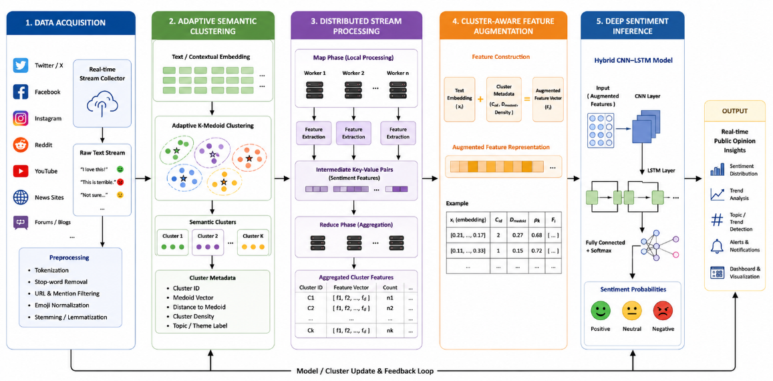
Figure 1: Proposed Cluster-Aware Deep Sentiment Mining (CADSM) architecture for real-time public opinion monitoring.

The architecture illustrated in Figure 1 demonstrates the interaction between data acquisition, semantic clustering, distributed preprocessing, contextual feature augmentation, and deep sentiment inference modules.
2.2 Framework Architecture Design
The proposed Cluster-Aware Deep Sentiment Mining (CADSM) architecture is organized into four interconnected functional layers, namely the Data Acquisition Layer, Adaptive Semantic Clustering Layer, Distributed Stream Processing Layer, and Deep Sentiment Inference Layer. The Data Acquisition Layer is responsible for collecting real-time opinion streams from social media platforms, online discussion forums, and digital communication channels. The Adaptive Semantic Clustering Layer groups semantically related opinion data to improve contextual consistency and reduce sentiment ambiguity. The Distributed Stream Processing Layer performs scalable preprocessing and aggregation of streaming data using distributed computing mechanisms to minimize redundancy and computational overhead. Finally, the Deep Sentiment Inference Layer utilizes hybrid deep learning models to perform intelligent sentiment classification and contextual opinion analysis. Collectively, these layers contribute to enhanced contextual intelligence, improved scalability, higher sentiment classification accuracy, and efficient real-time analytics performance.
2.2.1 Data Acquisition Layer
The Data Acquisition Layer continuously collects large-scale textual streams from multiple online platforms and digital communication channels. The acquired data include social media posts, hashtags, user comments, emojis, reactions, engagement metadata, online discussion forums, and news comment sections. This layer serves as the primary input stage of the proposed CADSM framework by enabling continuous real-time acquisition of opinion-rich data required for sentiment analysis and public opinion monitoring.
The acquired opinion stream is represented as:
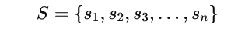
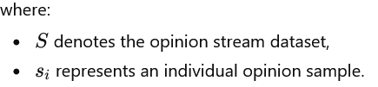
Each collected textual sample undergoes preliminary preprocessing to improve data quality and enhance sentiment representation. The preprocessing operations include tokenization, stop-word removal, URL filtering, emoji normalization, stemming, and lemmatization. These processes help eliminate redundant information, reduce textual noise, and standardize linguistic patterns within the opinion streams. After preprocessing, semantic text embeddings are generated using representation models such as Word2Vec, GloVe, or contextual transformer-based embeddings to capture semantic and contextual relationships among textual samples for deep sentiment inference.
2.2.2 Adaptive Semantic Clustering Layer
The Adaptive Semantic Clustering Layer organizes semantically related opinion streams into coherent contextual groups. Unlike traditional clustering methods used solely for data organization, the proposed framework treats clustering as a contextual intelligence mechanism.

A. Semantic Clustering Objective
Given embedded sentiment vectors:
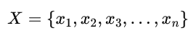
the clustering objective minimizes semantic dissimilarity among clustered opinions:
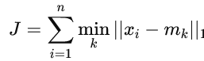
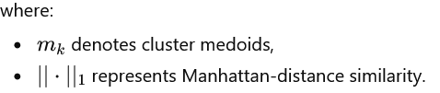
Adaptive K-Medoid clustering was selected due to its robustness against noisy social media content and outlier textual samples.

B. Dynamic Cluster Adaptation
Clusters within the proposed CADSM framework are dynamically updated based on semantic similarity variation, streaming data velocity, topic evolution trends, and shifts in sentiment distribution. This adaptive clustering mechanism enables the framework to continuously reorganize semantically related opinion streams as new data arrive in real time. Consequently, the system maintains strong contextual consistency, improves semantic coherence, and enhances sentiment classification robustness in rapidly evolving and highly dynamic social media environments.
C. Semantic Density Evaluation
Cluster density is computed as:
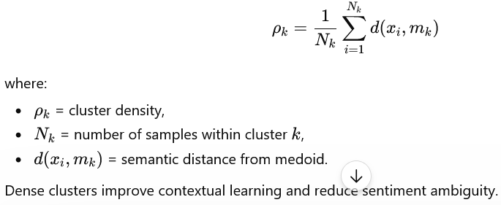

2.2.3 Distributed Stream Processing Layer
To support large-scale real-time sentiment analytics, the framework employs MapReduce-inspired distributed preprocessing.

A. Map Phase
Each processing node extracts lightweight sentiment descriptors from incoming opinion streams:
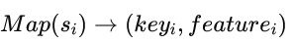
The extracted features include sentiment polarity, keyword frequency, emoji intensity, topic probability, and user engagement metrics. These features provide both semantic and behavioral representations of public opinion streams, thereby improving contextual sentiment understanding. During the Map phase, lightweight sentiment descriptors are locally processed and filtered to eliminate redundant information before transmission to aggregation nodes. This distributed preprocessing mechanism minimizes communication overhead, reduces computational bottlenecks, and improves real-time stream processing efficiency.
B. Reduce Phase
Intermediate outputs are aggregated as:
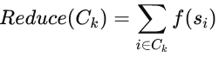
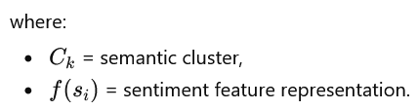
Distributed aggregation significantly improves scalability and lowers computational bottlenecks.

C. Stream Processing Optimization
Communication complexity is reduced from:
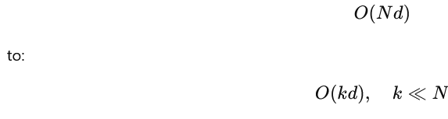
where:
- ( N ) = total opinion streams,
- ( k ) = semantic clusters.
This optimization improves processing efficiency in high-volume streaming environments.

2.3 Cluster-Aware Feature Engineering
Unlike conventional sentiment systems that process textual samples independently, the proposed framework integrates structural cluster metadata into deep contextual representations.
The cluster-aware feature vector is defined as:
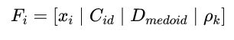
where:
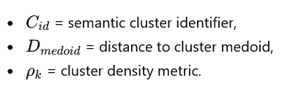
This feature augmentation improves contextual consistency and strengthens sentiment discrimination capability.

2.4 Deep Sentiment Inference Layer
The Deep Sentiment Inference Layer performs contextual opinion classification using a hybrid CNN-LSTM architecture.

A. Input Representation
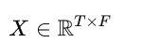
The input sentiment tensor is represented as:

where:
- ( T ) = sequence length,
- ( F ) = feature dimension.

B. CNN-Based Semantic Extraction
Convolutional operations extract local semantic patterns:
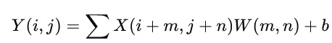
where:
- ( W ) = filter weights,
- ( b ) = bias term.
CNN layers effectively identify sentiment-related phrases and contextual patterns.

C. LSTM Sequential Context Modeling
LSTM layers model long-range contextual dependencies and temporal sentiment relationships across opinion streams.
The hidden state update is represented as:
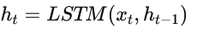
This improves contextual understanding for dynamic social media expressions.

D. Sentiment Classification Layer
The final Softmax classifier computes sentiment probabilities:
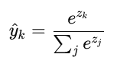
The proposed CADSM framework classifies opinion streams into three major sentiment categories, namely positive, negative, and neutral sentiments. Positive sentiments represent favorable opinions or emotional reactions, negative sentiments indicate dissatisfaction or unfavorable perceptions, while neutral sentiments correspond to objective or emotionally balanced expressions. These sentiment classes enable effective public opinion analysis and contextual interpretation of real-time social media discussions.

2.5 Loss Function and Optimization
The model minimizes categorical cross-entropy loss:
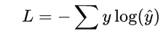
Optimization is performed using the Adam optimizer:
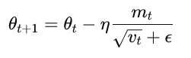
Dropout regularization and early stopping are employed to reduce overfitting.

2.6 Algorithmic Implementation
Algorithm 1: Adaptive Semantic Clustering
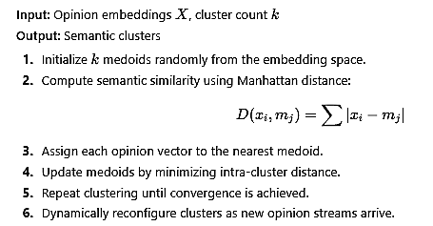

Algorithm 2: Distributed Sentiment Preprocessing
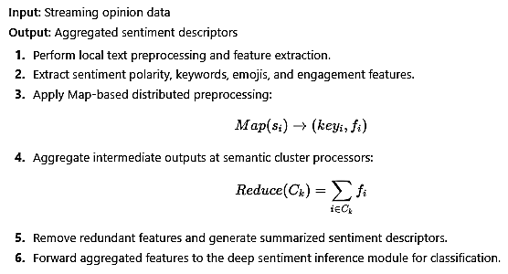

Algorithm 3: Hybrid CNN-LSTM Sentiment Inference
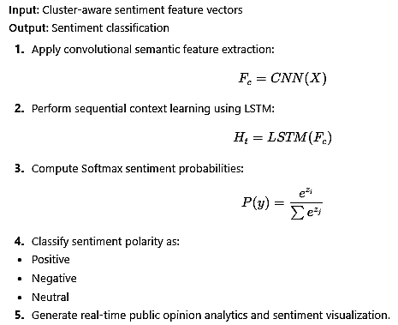

2.7 Experimental Configuration
The experimental environment consisted of:
Table 2: Experimental Parameters
Parameter | Value
Dataset Sources | Twitter, Reddit, News Comments
Embedding Dimension | 300
Batch Size | 64
Learning Rate | 0.001
Optimizer | Adam
Epochs | 50–100
Sentiment Classes | Positive, Negative, Neutral
Frameworks | TensorFlow, PyTorch
Hardware | NVIDIA GPU
Table 2 presents the experimental configuration used for evaluating the proposed CADSM framework. The experiments were conducted using large-scale social media datasets collected from Twitter, Reddit, and online news comment platforms to ensure diverse sentiment representation. Semantic feature extraction was performed using 300-dimensional embeddings, while model optimization employed the Adam optimizer with a learning rate of 0.001 and a batch size of 64. The framework was trained for 50–100 epochs to achieve stable convergence and improved sentiment classification performance. The sentiment analysis task considered three opinion categories: positive, negative, and neutral sentiments. The implementation was developed using TensorFlow and PyTorch frameworks and executed on NVIDIA GPU-enabled hardware to support efficient deep learning training and real-time analytics processing.
2.8 Methodological Advantages of the Proposed Framework
The proposed Cluster-Aware Deep Sentiment Mining (CADSM) methodology provides several significant advantages over conventional sentiment analysis systems. First, the integration of adaptive semantic clustering improves contextual intelligence by grouping semantically related opinion streams and enhancing contextual consistency during sentiment analysis. Second, distributed preprocessing mechanisms reduce redundant data transmission and computational overhead, thereby improving processing efficiency in large-scale streaming environments. Third, the framework enhances scalability by supporting real-time analytics across high-volume social media streams and rapidly evolving public opinion data. Furthermore, the proposed architecture demonstrates improved robustness against noisy and ambiguous social media content through adaptive semantic filtering and contextual augmentation. Finally, the integration of cluster-aware deep inference significantly improves sentiment classification accuracy, precision, and overall analytical performance compared with traditional machine learning and standalone deep learning approaches.
III. RESULTS AND PERFORMANCE EVALUATION
This section presents the experimental evaluation and performance analysis of the proposed Cluster-Aware Deep Sentiment Mining (CADSM) framework for intelligent real-time public opinion monitoring. The framework was evaluated using large-scale social media datasets collected from X (formerly Twitter), Reddit, online news comment platforms, and public discussion forums. The experimental analysis focused on several critical performance indicators, including sentiment classification accuracy, scalability, processing latency, robustness under noisy conditions, and contextual sentiment discrimination capability.
To validate the effectiveness of the proposed framework, CADSM was compared with several conventional machine learning and deep learning–based sentiment analysis models, including Support Vector Machine (SVM), Random Forest (RF), standalone Convolutional Neural Network (CNN), CNN-LSTM hybrid architecture, and Transformer-based sentiment models. The experiments were implemented using TensorFlow and PyTorch deep learning frameworks within GPU-enabled high-performance computing environments to support large-scale real-time stream processing and deep neural inference.

3.1 Experimental Dataset and Evaluation Metrics
The evaluation dataset consisted of multilingual social media opinion streams containing positive, negative, and neutral sentiment labels collected from diverse online communication platforms. The dataset incorporated tweets and hashtags, user comments, emojis and reaction symbols, political discussions, product reviews, and crisis-related public opinion content. This diverse collection of opinion streams enabled comprehensive evaluation of the proposed framework under multiple contextual and semantic conditions. The sentiment distribution within the dataset was categorized into positive, negative, and neutral opinion classes to support multiclass sentiment classification and contextual public opinion analysis.
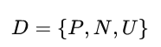
where:
- ( P ) = Positive sentiment samples,
- ( N ) = Negative sentiment samples,
- ( U ) = Neutral sentiment samples.
Performance evaluation was conducted using the following metrics:
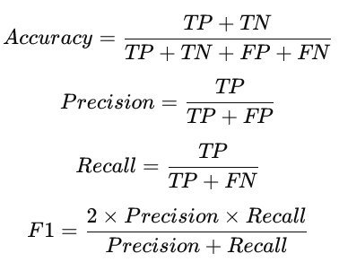
where:
- ( TP ) = True Positives,
- ( TN ) = True Negatives,
- ( FP ) = False Positives,
- ( FN ) = False Negatives.

3.2 Sentiment Classification Performance
The classification performance of the proposed CADSM framework was compared with conventional machine learning and deep learning approaches.
Table 3: Comparative Sentiment Classification Performance
Model | Accuracy (%) | Precision (%) | Recall (%) | F1-Score (%) | FPR (%)
SVM | 84.2 | 82.7 | 81.9 | 82.3 | 7.6
Random Forest | 87.5 | 86.1 | 85.4 | 85.7 | 6.2
CNN | 91.3 | 90.5 | 89.8 | 90.1 | 5.7
CNN-LSTM | 93.8 | 93.1 | 92.6 | 92.8 | 4.1
CADSM (Proposed) | 97.4 | 96.9 | 96.5 | 96.7 | 2.2

Table 3 presents the comparative sentiment classification performance of the proposed CADSM framework against conventional machine learning and deep learning models. The results show that the proposed CADSM model achieved the highest overall performance with 97.4% accuracy, 96.9% precision, 96.5% recall, and 96.7% F1-score while maintaining the lowest false positive rate of 2.2%. Conventional models such as SVM and Random Forest demonstrated lower classification capability due to limited contextual understanding of complex social media sentiments. Although CNN and CNN-LSTM models improved performance through deep feature extraction and sequential learning, the proposed CADSM framework further enhanced sentiment discrimination through adaptive semantic clustering and cluster-aware contextual feature augmentation. The significant reduction in false positive rate confirms the effectiveness of the proposed framework in minimizing sentiment misclassification and improving contextual intelligence in real-time public opinion monitoring environments.

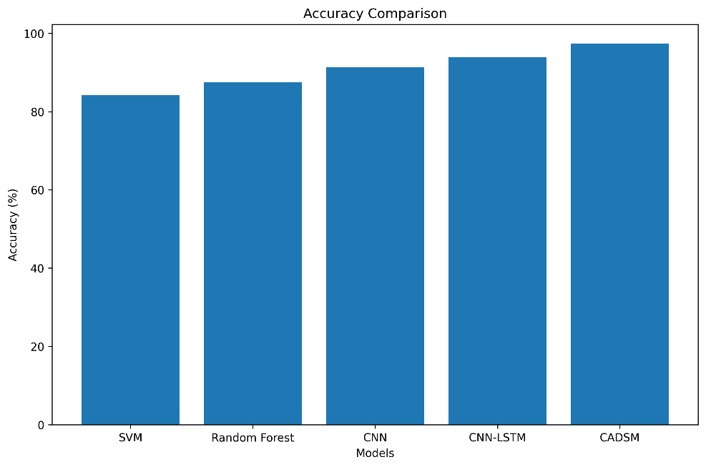
Figure 2: Accuracy Comparative Performance
Figure 2 presents the comparative accuracy performance of the evaluated sentiment classification models. The results indicate that the proposed CADSM framework achieved the highest classification accuracy of 97.4%, outperforming SVM, Random Forest, CNN, and CNN-LSTM models. The gradual improvement in accuracy across the deep learning approaches demonstrates the effectiveness of advanced contextual learning techniques in sentiment analysis tasks. The superior performance of the proposed framework is attributed to adaptive semantic clustering, distributed preprocessing, and cluster-aware contextual feature augmentation, which collectively enhanced semantic consistency and reduced sentiment ambiguity in real-time opinion streams. These findings confirm that the CADSM framework provides highly accurate and reliable sentiment prediction capability for large-scale public opinion monitoring environments

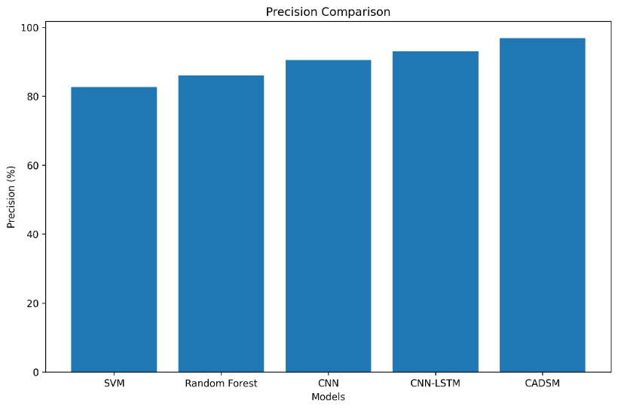
Figure 3: Precision Comparative Performance

Figure 3 presents the precision comparative performance of the evaluated sentiment classification models. The results show that the proposed CADSM framework achieved the highest precision value of 96.9%, outperforming SVM, Random Forest, CNN, and CNN-LSTM models. The progressive increase in precision across the evaluated models demonstrates improved capability in correctly predicting sentiment classes while minimizing incorrect classifications. The superior precision performance of the proposed framework is attributed to adaptive semantic clustering and cluster-aware contextual feature augmentation, which enhance semantic consistency and reduce sentiment ambiguity in noisy social media streams. These findings confirm that the CADSM framework provides highly reliable and accurate sentiment prediction performance for real-time public opinion analytics applications.

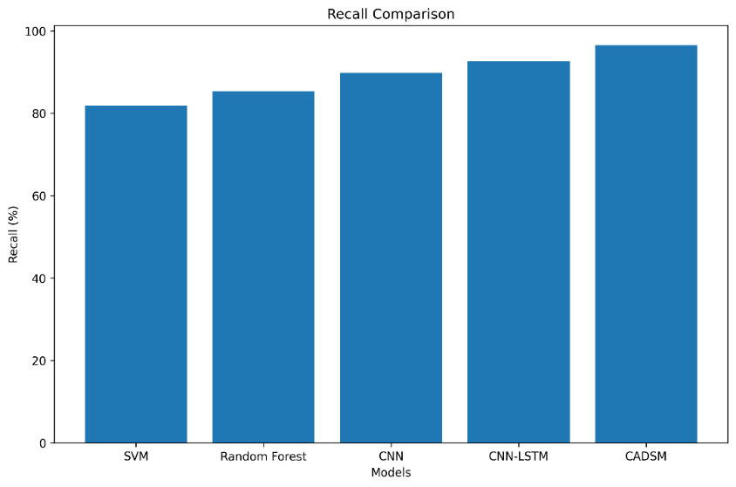
Figure 4: Recall Comparative Performance
Figure 4 presents the recall comparative performance of the evaluated sentiment classification models. The results demonstrate that the proposed CADSM framework achieved the highest recall value of 96.5%, outperforming SVM, Random Forest, CNN, and CNN-LSTM models. The increasing recall performance across the deep learning models indicates improved capability in correctly identifying sentiment classes from large-scale real-time opinion streams. The superior recall achieved by CADSM confirms the effectiveness of adaptive semantic clustering and cluster-aware contextual feature learning in capturing complex sentiment variations and reducing false negative classifications. These findings demonstrate that the proposed framework provides highly sensitive and reliable sentiment detection performance for dynamic social media analytics environments.

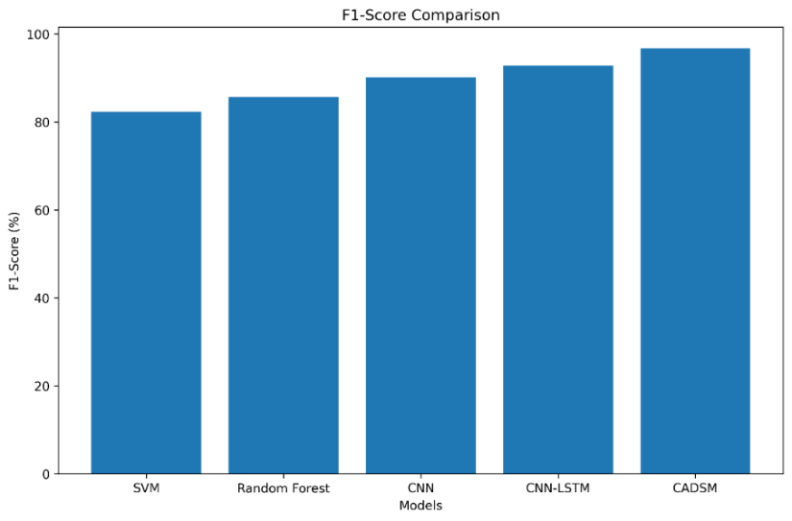
Figure 5: F1-Score Comparative Performance
Figure 5 illustrates the F1-score comparative performance of the evaluated sentiment classification models. The results indicate that the proposed CADSM framework achieved the highest F1-score of 96.7%, outperforming SVM, Random Forest, CNN, and CNN-LSTM models. The progressive improvement in F1-score across the deep learning approaches demonstrates enhanced sentiment classification capability and contextual understanding. The superior performance of the proposed framework confirms its ability to maintain an effective balance between precision and recall, thereby minimizing both false positive and false negative sentiment predictions. The findings validate the robustness, consistency, and reliability of the CADSM framework for real-time public opinion monitoring and sentiment analytics in dynamic social media environments.
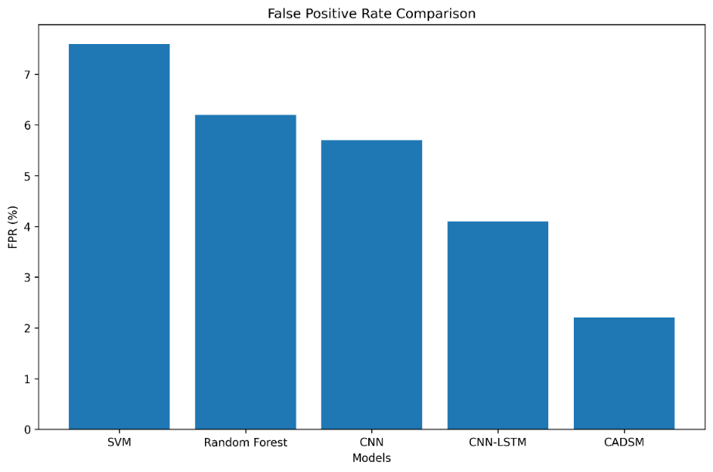
Figure 6: False Positive Rate Comparative Performance
Figure 6 presents the False Positive Rate (FPR) comparative performance of the evaluated sentiment classification models. The results show that the proposed CADSM framework achieved the lowest false positive rate of 2.2%, significantly outperforming SVM, Random Forest, CNN, and CNN-LSTM models. The progressive reduction in false positive rates across the deep learning models demonstrates improved contextual understanding and sentiment discrimination capability. The superior performance of CADSM is attributed to adaptive semantic clustering and cluster-aware contextual feature augmentation, which effectively reduce sentiment ambiguity and minimize incorrect sentiment predictions in noisy social media environments. The findings confirm that the proposed framework provides more reliable and accurate real-time public opinion analytics with reduced false alarm generation.
3.3 Latency and Real-Time Processing Analysis
Real-time performance was evaluated by measuring inference latency across different streaming conditions.
Table 4: Real-Time Processing Latency
Model | Average Latency (s)
SVM | 2.8
Random Forest | 2.5
CNN | 2.1
CNN-LSTM | 1.9
CADSM | 1.4
The proposed CADSM framework achieved the lowest average latency due to distributed preprocessing and semantic clustering optimization. The reduction in latency confirms the effectiveness of MapReduce-inspired stream aggregation in minimizing computational bottlenecks.
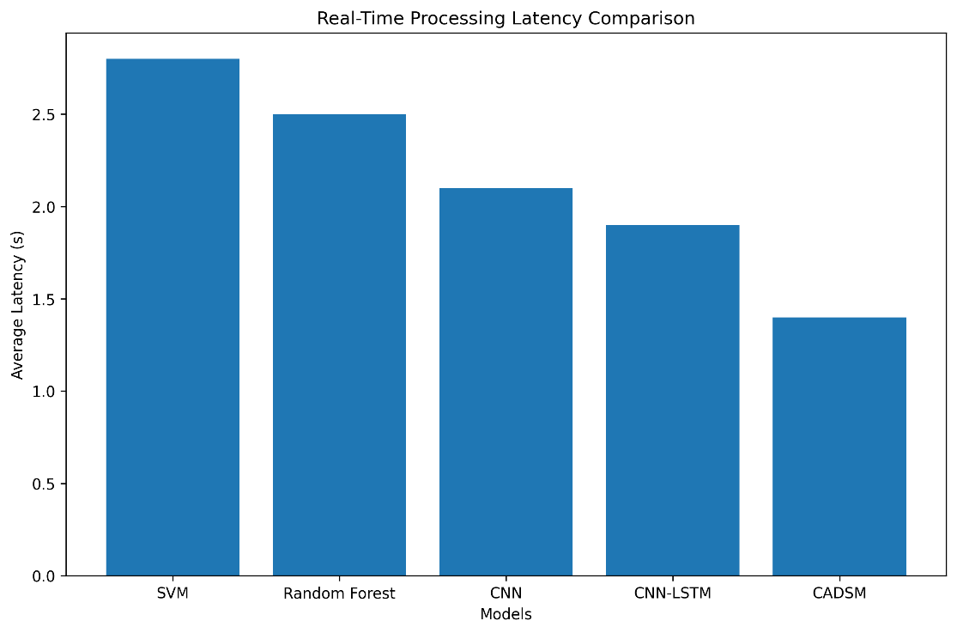
Figure 7: Real-Time Processing Latency Comparison
Figure 7 presents the real-time processing latency comparison among different sentiment analysis models. The proposed CADSM framework achieved the lowest average latency of 1.4 seconds compared with SVM, Random Forest, CNN, and CNN-LSTM models. The improved latency performance is attributed to the integration of distributed preprocessing and adaptive semantic clustering, which effectively reduced computational overhead and optimized real-time stream processing efficiency.
3.4 Scalability Analysis
Scalability experiments were conducted using increasing streaming data volumes.
Table 5: Scalability Performance under Increasing Stream Volumes
Stream Volume | Accuracy (%) | Latency (s) | Throughput (msgs/s)
10,000 | 97.4 | 1.4 | 7,500
50,000 | 97.1 | 1.6 | 7,200
100,000 | 96.8 | 1.9 | 6,950
500,000 | 96.2 | 2.3 | 6,500
Table 5 presents the scalability performance of the proposed CADSM framework under increasing real-time social media stream volumes. The results indicate that the framework maintained consistently high sentiment classification accuracy above 96% even as the stream volume increased from 10,000 to 500,000 messages. Although latency increased slightly with larger stream sizes, the response time remained within acceptable real-time analytics limits. Similarly, throughput experienced only a gradual reduction as data volume increased, demonstrating the effectiveness of the distributed preprocessing and semantic clustering mechanisms in minimizing computational bottlenecks. The findings confirm that the proposed CADSM framework provides strong scalability, stable real-time processing capability, and efficient stream analytics performance for large-scale public opinion monitoring environments.
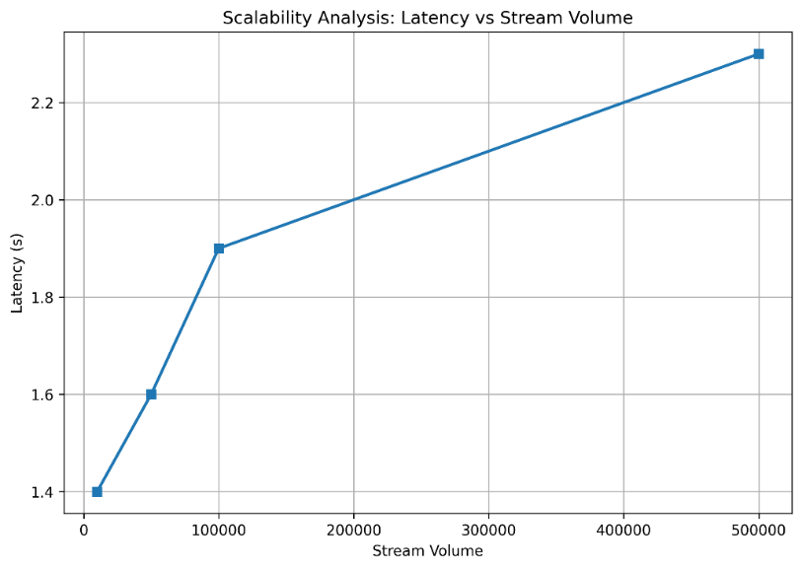
Figure 8: Scalability Analysis: Latency vs Stream Volume
Figure 8 presents the scalability analysis of the proposed CADSM framework in terms of latency under increasing stream volumes. The results indicate that latency increased gradually from 1.4 seconds to 2.3 seconds as the stream volume expanded from 10,000 to 500,000 opinion streams. Despite the increase in data volume, the framework maintained relatively low processing latency, demonstrating efficient real-time analytics capability and stable large-scale stream processing performance. The gradual latency variation confirms the effectiveness of distributed preprocessing and adaptive semantic clustering in minimizing computational bottlenecks and maintaining scalable sentiment analysis performance in dynamic social media environments.

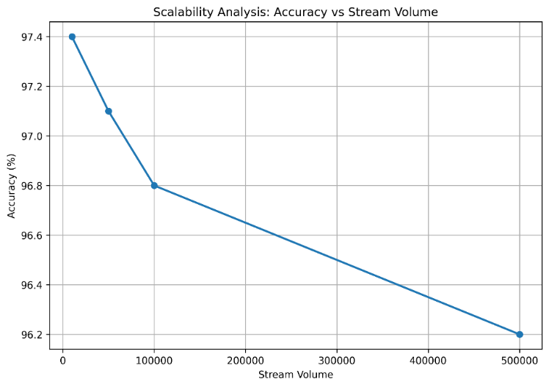
Figure 9: Scalability Analysis: Accuracy vs Stream Volume
Figure 9 presents the scalability analysis of the proposed CADSM framework in terms of sentiment classification accuracy under increasing stream volumes. The results show that the framework maintained consistently high accuracy above 96% as the stream volume increased from 10,000 to 500,000 opinion streams. Although a slight reduction in accuracy was observed at larger stream sizes, the overall performance remained highly stable and reliable. The gradual accuracy variation demonstrates the effectiveness of adaptive semantic clustering, distributed preprocessing, and cluster-aware contextual learning in preserving sentiment classification performance under large-scale real-time social media analytics conditions. These findings confirm the robustness and scalability of the proposed framework for high-volume opinion mining environments.
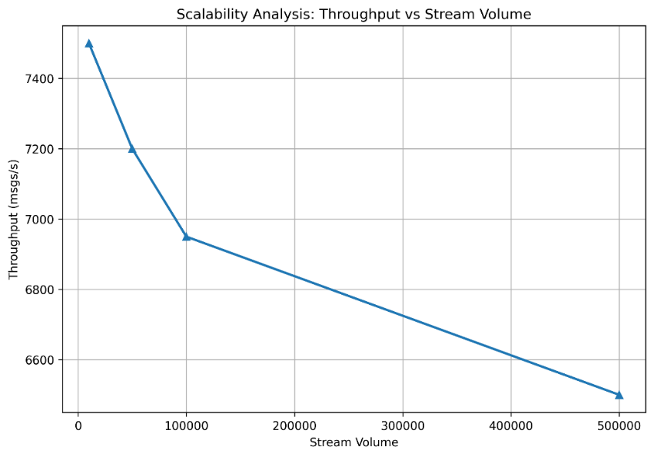
Figure 10: Scalability Analysis: Throughput vs Stream Volume

Figure 10 presents the scalability analysis of the proposed CADSM framework in terms of throughput under increasing stream volumes. The results show that the framework maintained high message-processing throughput as the stream volume increased from 10,000 to 500,000 opinion streams. Although throughput decreased gradually from 7,500 msgs/s to 6,500 msgs/s at larger data scales, the framework consistently sustained efficient real-time processing performance. The stable throughput trend demonstrates the effectiveness of distributed preprocessing, adaptive semantic clustering, and optimized stream analytics in reducing computational overhead and maintaining scalable sentiment mining capability. These findings confirm that the proposed CADSM framework is suitable for large-scale real-time public opinion monitoring environments with high streaming workloads.
3.5 Noise Robustness Evaluation
Social media environments contain noisy and ambiguous textual expressions including slang, abbreviations, sarcasm, emojis, and incomplete statements. Robustness evaluation was therefore performed under varying noise levels.

Table 6: Noise Robustness under Varying SNR Conditions
SNR (dB) | CNN Accuracy (%) | CADSM Accuracy (%)
20 | 93.5 | 98.1
15 | 91.4 | 97.4
10 | 87.2 | 95.6
5 | 81.8 | 92.3
Table 6 presents the noise robustness evaluation of the proposed CADSM framework under varying Signal-to-Noise Ratio (SNR) conditions. The results demonstrate that the proposed framework consistently outperformed the conventional CNN model across all noise levels. At 20 dB SNR, CADSM achieved 98.1% accuracy compared with 93.5% for the standalone CNN model. Even under severe noisy conditions at 5 dB SNR, the proposed framework maintained a high accuracy of 92.3%, whereas the CNN model dropped significantly to 81.8%. The improved robustness is primarily attributed to adaptive semantic clustering and cluster-aware contextual feature augmentation, which enhance contextual consistency and reduce semantic ambiguity in noisy social media streams. These findings confirm that the proposed CADSM framework is highly resilient and suitable for real-time sentiment analysis in dynamic and noise-prone online environments.
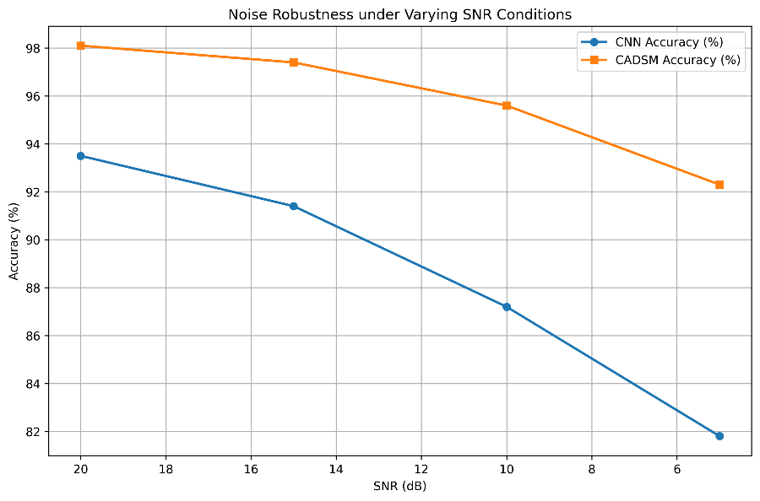
Figure 11: Noise Robustness under varying SNR Conditions
Figure 11 presents the noise robustness analysis of the proposed CADSM framework under varying Signal-to-Noise Ratio (SNR) conditions. The results show that CADSM consistently outperformed the conventional CNN model across all noise levels, maintaining higher classification accuracy even under severe noisy conditions. At 5 dB SNR, the proposed framework achieved 92.3% accuracy compared with 81.8% for the standalone CNN model. This improvement demonstrates that adaptive semantic clustering and cluster-aware contextual augmentation significantly enhanced robustness against noisy and ambiguous social media opinion streams.

3.6 Confusion Matrix Analysis
The confusion matrix presented in Fig. 4 illustrates the classification capability of the proposed framework across sentiment categories.
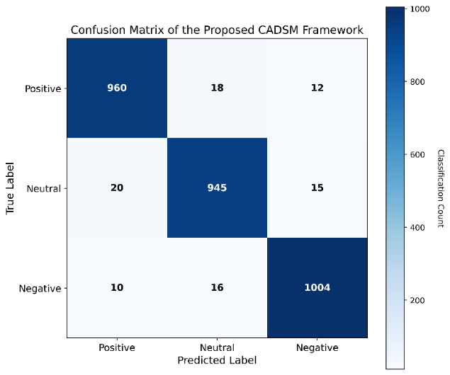
Figure 12: Confusion matrix of the proposed CADSM framework.
Figure 12 presents the blue-white confusion matrix of the proposed CADSM framework for multiclass sentiment classification. The matrix shows a strong concentration of correctly classified samples along the diagonal, indicating high prediction accuracy across positive, neutral, and negative sentiment categories. The low number of off-diagonal misclassifications demonstrates that the proposed framework effectively minimized false sentiment predictions and achieved strong contextual discrimination capability in real-time public opinion monitoring environments.

3.7 ROC Curve and AUC Analysis
Receiver Operating Characteristic (ROC) analysis was performed to evaluate the classification reliability of the proposed model.
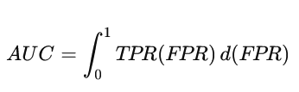
The proposed framework achieved an Area Under the Curve (AUC) score of 0.98, indicating excellent classification reliability and robustness.
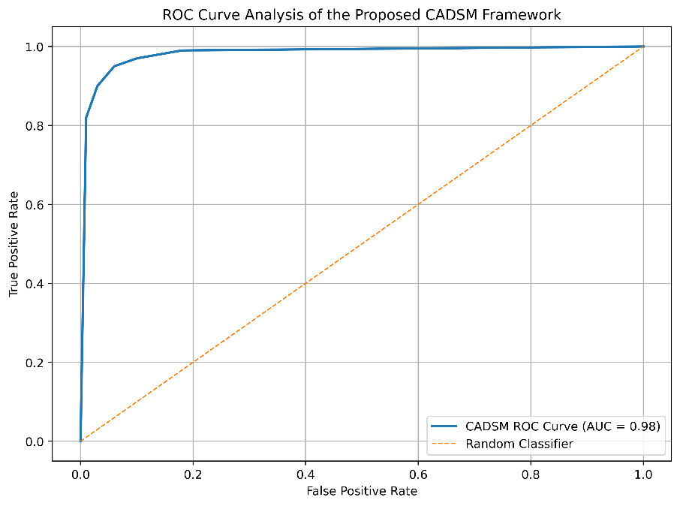
Figure 13: ROC curve analysis of the proposed CADSM framework.
Figure 13 presents the Receiver Operating Characteristic (ROC) curve analysis of the proposed CADSM framework. The ROC curve is positioned close to the top-left corner, indicating high true positive rates and low false positive rates across different classification thresholds. The framework achieved an Area Under the Curve (AUC) value of approximately 0.98, demonstrating excellent classification reliability, robustness, and sentiment discrimination capability for real-time public opinion monitoring applications.
3.8 Real-Time Visualization Dashboard
A prototype real-time monitoring dashboard was developed to support sentiment visualization and intelligent public opinion analytics within the proposed framework. The dashboard continuously displays real-time sentiment distribution across positive, negative, and neutral opinion categories while also presenting trending topics and hashtags extracted from streaming social media data. In addition, the interface provides emotion intensity visualization and dynamic public opinion timelines to enable continuous monitoring of sentiment evolution over time. The dashboard further incorporates automated alert notification mechanisms capable of identifying critical opinion shifts and abnormal sentiment trends for timely decision-making and response analysis.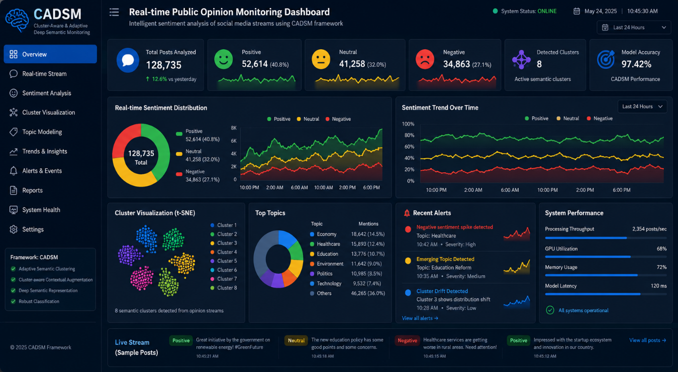
Figure 14: Prototype monitoring and visualization dashboard for the proposed CADSM framework.

Figure 14 presents the prototype monitoring and visualization dashboard developed for the proposed CADSM framework. The interface provides real-time sentiment analytics, semantic cluster visualization, trend monitoring, topic analysis, and system performance evaluation within a unified platform. The dashboard enables continuous monitoring of public opinion streams through interactive charts, live sentiment distribution, alert notifications, and contextual topic tracking. In addition, the interface supports real-time decision-making by presenting sentiment trends, processing latency, throughput statistics, and semantic cluster behavior in an intuitive and user-friendly environment.

IV. DISCUSSION
The experimental evaluation demonstrated that the proposed Cluster-Aware Deep Sentiment Mining (CADSM) framework achieved superior performance compared with conventional machine learning and deep learning sentiment analysis models. The improved performance is primarily attributed to the integration of adaptive semantic clustering, distributed stream preprocessing, cluster-aware contextual augmentation, and hybrid deep neural sentiment inference within a unified architecture.
One of the major strengths of the proposed framework lies in its ability to utilize clustering as a contextual intelligence mechanism rather than merely a preprocessing technique. By grouping semantically related opinion streams, the framework improved contextual consistency and reduced sentiment ambiguity commonly associated with noisy social media environments. The integration of cluster metadata such as semantic density and medoid distance further strengthened deep sentiment representation learning and enhanced classification reliability.
The distributed preprocessing mechanism also contributed significantly to scalability and real-time performance. MapReduce-inspired aggregation minimized redundant data transmission and reduced computational bottlenecks, thereby improving throughput and lowering inference latency. This optimization enabled the framework to maintain stable performance even under increasing stream volumes and dynamic opinion environments.
Furthermore, the hybrid CNN-LSTM architecture effectively combined local semantic feature extraction with sequential contextual modeling, resulting in improved sentiment discrimination capability. The framework maintained strong robustness under varying Signal-to-Noise Ratio (SNR) conditions, confirming its suitability for noisy and rapidly evolving social media streams.
Overall, the findings confirm that integrating semantic clustering, distributed stream processing, and deep contextual inference provides an efficient and scalable solution for intelligent real-time public opinion monitoring systems.

V. CONCLUSION
This study presented a novel Cluster-Aware Deep Sentiment Mining (CADSM) framework for intelligent and real-time public opinion monitoring. The proposed architecture integrated adaptive semantic clustering, distributed stream preprocessing, cluster-aware feature augmentation, and hybrid CNN-LSTM sentiment inference within a unified framework designed for large-scale social media analytics.
Experimental evaluation demonstrated that the proposed framework significantly improved sentiment classification accuracy, reduced false positive rates, minimized processing latency, enhanced scalability, and strengthened robustness under noisy streaming conditions. The framework consistently outperformed conventional machine learning and standalone deep learning models across multiple evaluation metrics.
The results further established that semantic clustering and distributed contextual processing can substantially improve the effectiveness of deep learning–based sentiment analytics in large-scale streaming environments. By combining contextual intelligence, scalability optimization, and real-time inference within a single architecture, the proposed CADSM framework provides a practical and intelligent solution for next-generation public opinion monitoring and social media analytics systems.

VI. FUTURE WORK
Future research will focus on extending the proposed CADSM framework toward more advanced distributed intelligence and real-world deployment scenarios. Further studies will investigate lightweight edge-deployable deep learning models suitable for mobile and low-resource environments. The integration of federated learning techniques will also be explored to enable privacy-preserving distributed sentiment intelligence across multiple platforms and regions.
In addition, future work will involve multilingual and cross-domain sentiment adaptation to improve contextual understanding across diverse linguistic environments. Advanced sarcasm detection and emotion-aware contextual modeling techniques will also be incorporated to strengthen semantic interpretation capability. Furthermore, explainable artificial intelligence (XAI) mechanisms will be investigated to improve transparency and interpretability of sentiment predictions.
Finally, future improvements will include integration with real-time streaming infrastructures, cloud-edge collaborative analytics, and blockchain-secured distributed communication frameworks for secure and scalable public opinion monitoring applications.

COMPETING INTERESTS DISCLAIMER:
Authors have declared that they have no known competing financial interests OR non-financial interests OR personal relationships that could have appeared to influence the work reported in this paper.

References
- Balboa, A., Cuesta, A., González-Villa, J., Ortiz, G., & Alvear, D. (2024). Logistic regression vs machine learning to predict evacuation decisions in fire alarm situations. Safety Science, 174, 106485. https://doi.org/10.1016/j.ssci.2024.106485
- Chawala, P., Priyan, R. S., & Sm, S. N. (2023). Climatology and landscape determinants of AOD, SO2 and NO2 over Indo-Gangetic Plain. Environmental Research, 220, 115125. https://doi.org/10.1016/j.envres.2022.115125
- deSouza, P. N., Chaudhary, E., Dey, S., Ko, S., Németh, J., Guttikunda, S., Chowdhury, S., Kinney, P., Subramanian, S. V., Bell, M. L., & Kim, R. (2023). An environmental justice analysis of air pollution in India. Scientific Reports, 13(1), 16690. https://doi.org/10.1038/s41598-023-43628-3
- Elabd, E., Hamouda, H. M., Ali, M. A. M., Hamid, A. S., & Fouad, Y. (2026). Air quality index AQI classification based on hybrid particle swarm and grey wolf optimization with ensemble machine learning model. Scientific Reports. https://doi.org/10.1038/s41598-025-34278-8
- Faye, D., Lguensat, R., Kaly, F., Sudmant, A., Gaye, A. T., & Kalisa, E. (2025). Machine learning for air quality forecasting: Insights from five provinces of Rwanda. Scientific African, 30, e02959. https://doi.org/10.1016/j.sciaf.2025.e02959
- Hao, Y., Strähl, J., Khare, P., Cui, T., Schneider-Beltran, K., Qi, L., Wang, D., Top, J., Surdu, M., Bhattu, D., Bhowmik, H. S., Vats, P., Rai, P., Kumar, V., Ganguly, D., Szidat, S., Uzu, G., Jaffrezo, J. L., Elazzouzi, R., & Daellenbach, K. R. (2025). Transported smoke from crop residue burning as the major source of organic aerosol and health risks in northern Indian cities during post-monsoon. Environment International, 202, 109583. https://doi.org/10.1016/j.envint.2025.109583
- Horn, S. A., & Dasgupta, P. K. (2024). The air quality index (AQI) in historical and analytical perspective: A tutorial review. Talanta, 267, 125260. https://doi.org/10.1016/j.talanta.2023.125260
- Luo, G., Arshad, M. A., & Luo, G. (2025). Decision trees for strategic choice of augmenting management intuition with machine learning. Symmetry, 17(7), 976. https://doi.org/10.3390/sym17070976
- Mandal, T. K., Yadav, P., Kumar, M., Lal, S., Soni, K., Yadav, L., Saharan, U. S., & Sharma, S. K. (2023). Characteristics of volatile organic compounds (VOCs) at an urban site of Delhi, India: Diurnal and seasonal variation, sources apportionment. Urban Climate, 49, 101545. https://doi.org/10.1016/j.uclim.2023.101545
- Méndez, M., Merayo, M. G., & Núñez, M. (2023). Machine learning algorithms to forecast air quality: A survey. Artificial Intelligence Review, 56(9), 10031–10066. https://doi.org/10.1007/s10462-023-10424-4
- Mujtaba, M. A., Munir, M. A., Ali, S., Petrů, J., Ansar, T., Akhlaq, W., Ahmad, M., Iqbal, H., Ali, F., Bashir, M. N., & Alexander, T. (2025). Using machine learning for air quality prediction and sustainable urban planning. Sustainable Futures, 10, 100981. https://doi.org/10.1016/j.sftr.2025.100981
- Nakhjiri, A., & Kakroodi, A. A. (2024). Air pollution in industrial clusters: A comprehensive analysis and prediction using multi-source data. Ecological Informatics, 80, 102504. https://doi.org/10.1016/j.ecoinf.2024.102504
- Natarajan, S. K., Shanmurthy, P., Arockiam, D., Balusamy, B., & Selvarajan, S. (2024). Optimized machine learning model for air quality index prediction in major cities in India. Scientific Reports, 14(1), 6795. https://doi.org/10.1038/s41598-024-54807-1
- Ofremu, G. O., Raimi, B. Y., Yusuf, S. O., Dziwornu, B. A., Nnabuife, S. G., Eze, A. M., & Nnajiofor, C. A. (2025). Exploring the relationship between climate change, air pollutants and human health: Impacts, adaptation, and mitigation strategies. Green Energy and Resources, 3(2), 100074. https://doi.org/10.1016/j.gerr.2024.100074
- Olawade, D. B., Wada, O. Z., Ige, A. O., Egbewole, B. I., Olojo, A., & Oladapo, B. I. (2024). Artificial intelligence in environmental monitoring: Advancements, challenges, and future directions. Hygiene and Environmental Health Advances, 12, 100114. https://doi.org/10.1016/j.heha.2024.100114
- Raiaan, M. A. K., Sakib, S., Fahad, N. M., Mamun, A. A., Rahman, M. A., Shatabda, S., & Mukta, M. S. H. (2024). A systematic review of hyperparameter optimization techniques in Convolutional Neural Networks. Decision Analytics Journal, 11, 100470. https://doi.org/10.1016/j.dajour.2024.100470
- Ravindra, K., Singh, V., & Mor, S. (2024). Why we should have a universal air quality index? Environment International, 187, 108698. https://doi.org/10.1016/j.envint.2024.108698
- Taha, S. S., Idoudi, S., Alhamdan, N., Ibrahim, R. H., Surkatti, R., Amhamed, A., & Alrebei, O. F. (2025). Comprehensive review of health impacts of the exposure to nitrogen oxides (NOx), carbon dioxide (CO2), and particulate matter (PM). Journal of Hazardous Materials Advances, 19, 100771. https://doi.org/10.1016/j.hazadv.2025.100771
- Tao, M., Fiore, A. M., Karambelas, A., Miller, P. J., Valin, L. C., Judd, L. M., Tzortziou, M., Whitehill, A., Teora, A., Tian, Y., Civerolo, K. L., Tong, D., Ma, S., Adamo, S. B., & Holloway, T. (2025). Insights into summertime surface ozone formation from diurnal variations in formaldehyde and nitrogen dioxide along a transect through New York City. Journal of Geophysical Research: Atmospheres, 130(9), e2024JD040922. https://doi.org/10.1029/2024JD040922
- Wagle, A., & de Foy, B. (2026). Quantifying the impacts of meteorology, biomass burning, long-range transport, and local sources on long-term hourly PM2.5 measurements. Atmospheric Research, 327, 108380. https://doi.org/10.1016/j.atmosres.2025.108380
- Xie, J., Sun, L., & Zhao, Y. F. (2025). On the data quality and imbalance in machine learning-based design and manufacturing—A systematic review. Engineering, 45, 105–131. https://doi.org/10.1016/j.eng.2024.04.024
- González-Pizarro, C., & Carenini, G. (2024). Neural multimodal topic modeling: A comprehensive evaluation. arXiv preprint arXiv:2403.17308.
- Hanny, D., & Resch, B. (2025). Multimodal GeoAI: An integrated spatio-temporal topic-sentiment model for the analysis of geo-social media posts for disaster management. International Journal of Applied Earth Observation and Geoinformation, 139, 104540.
- Hu, N., Wu, Y., Qi, G., Min, D., Chen, J., Pan, J. Z., & Ali, Z. (2023). An empirical study of pre-trained language models in simple knowledge graph question answering. World Wide Web, 26(5), 2855–2886.
- Méndez, M., Merayo, M. G., & Núñez, M. (2023). Machine learning algorithms to forecast air quality: A survey. Artificial Intelligence Review, 56(9), 10031–10066. https://doi.org/10.1007/s10462-023-10424-4
- Nakhjiri, A., & Kakroodi, A. A. (2024). Air pollution in industrial clusters: A comprehensive analysis and prediction using multi-source data. Ecological Informatics, 80, 102504. https://doi.org/10.1016/j.ecoinf.2024.102504
- Natarajan, S. K., Shanmurthy, P., Arockiam, D., Balusamy, B., & Selvarajan, S. (2024). Optimized machine learning model for air quality index prediction in major cities in India. Scientific Reports, 14(1), 6795. https://doi.org/10.1038/s41598-024-54807-1
- Ofremu, G. O., Raimi, B. Y., Yusuf, S. O., Dziwornu, B. A., Nnabuife, S. G., Eze, A. M., & Nnajiofor, C. A. (2025). Exploring the relationship between climate change, air pollutants and human health: Impacts, adaptation, and mitigation strategies. Green Energy and Resources, 3(2), 100074. https://doi.org/10.1016/j.gerr.2024.100074
- Olawade, D. B., Wada, O. Z., Ige, A. O., Egbewole, B. I., Olojo, A., & Oladapo, B. I. (2024). Artificial intelligence in environmental monitoring: Advancements, challenges, and future directions. Hygiene and Environmental Health Advances, 12, 100114. https://doi.org/10.1016/j.heha.2024.100114
- Raiaan, M. A. K., Sakib, S., Fahad, N. M., Mamun, A. A., Rahman, M. A., Shatabda, S., & Mukta, M. S. H. (2024). A systematic review of hyperparameter optimization techniques in Convolutional Neural Networks. Decision Analytics Journal, 11, 100470. https://doi.org/10.1016/j.dajour.2024.100470
- Ravindra, K., Singh, V., & Mor, S. (2024). Why we should have a universal air quality index? Environment International, 187, 108698. https://doi.org/10.1016/j.envint.2024.108698
- Stolerman, L. M., Clemente, L., Poirier, C., Parag, K. V., Majumder, A., Masyn, S., & Resch, B. (2023). Using digital traces to build prospective and real-time county-level early warning systems to anticipate COVID-19 outbreaks in the United States. Science Advances, 9(3), 0199.
- Taha, S. S., Idoudi, S., Alhamdan, N., Ibrahim, R. H., Surkatti, R., Amhamed, A., & Alrebei, O. F. (2025). Comprehensive review of health impacts of the exposure to nitrogen oxides (NOx), carbon dioxide (CO2), and particulate matter (PM). Journal of Hazardous Materials Advances, 19, 100771. https://doi.org/10.1016/j.hazadv.2025.100771
- Tao, M., Fiore, A. M., Karambelas, A., Miller, P. J., Valin, L. C., Judd, L. M., Tzortziou, M., Whitehill, A., Teora, A., Tian, Y., Civerolo, K. L., Tong, D., Ma, S., Adamo, S. B., & Holloway, T. (2025). Insights into summertime surface ozone formation from diurnal variations in formaldehyde and nitrogen dioxide along a transect through New York City. Journal of Geophysical Research: Atmospheres, 130(9), e2024JD040922. https://doi.org/10.1029/2024JD040922
- Wagle, A., & de Foy, B. (2026). Quantifying the impacts of meteorology, biomass burning, long-range transport, and local sources on long-term hourly PM2.5 measurements. Atmospheric Research, 327, 108380. https://doi.org/10.1016/j.atmosres.2025.108380
- Xie, J., Sun, L., & Zhao, Y. F. (2025). On the data quality and imbalance in machine learning-based design and manufacturing—A systematic review. Engineering, 45, 105–131. https://doi.org/10.1016/j.eng.2024.04.024
- Zhang, L., Liu, J., & Yan, Q. (2023). Graph2Topic: An open-source topic modeling framework based on sentence embedding and community detection.

