Original Research Article

Comparative Microscopic Study of Epidermal Characters in Blumea laciniata (Roxb.) DC. and Blumea obliqua (L.) Druce

Trichomes are found in a wide range of species and are essential to plant development. Trichomes are epidermal appendages that are frequently seen on the leaves, stems, and fruits of plants. There are two types of trichomes: glandular and non-glandular. Blumea species' immature leaves and stem, which were between one and three centimeters away from the stem tip, were divided into slices, peeled out of layers, and examined under a light microscope at X4, X10, X40 and X100. Results show that the most significant difference in the Blumeaobliqua(L.) Druce has biseriate glandular trichomes with multicellular foot while Blumealaciniata(Roxb.) DC. has biseriate glandular trichomes with multicellular head and anomocytic type of stomata observed in both species. With the use of a light microscope, authors performed a thorough investigation to categorize and characterize the trichomes present on the stem, as well as on the adaxial and abaxial surfaces of leaves of Blumeaobliqua(L.) Druce and Blumealaciniata(Roxb.) DC. Because it offers thorough comparative data on the trichome shape and stomatal traits of two prominent species of the genus Blumea, this publication is essential for the scientific community. The study provides important anatomical and taxonomic information that can help distinguish, identify, and classify closely related species. Additionally, characterising glandular and non-glandular trichomes advances our knowledge of plant adaptive traits and their potential pharmacological and ecological significance. Future study on plant anatomy, systematics, medicinal plants, and evolutionary biology will benefit from the discoveries.
Keywords: Blumea, Glandular, Non-glandular, Trichomes, Stomata

Abstract

INTRODUCTION
The largest family of angiosperms, the Asteraceae, contains over 1535 genera and 23,000 species that are dispersed throughout 17 tribes and subfamilies(Perveen et al.,2019)and in India the family represented by 1021 species, 27 subspecies, 117 varieties and 07 forma under 193 Genera(Karthikeyan et al.,2020).The family's members are mostly herbaceous, occasionally shrubby, and only a few trees.Two medicinal plants from the sunflower family, Blumeaobliqua(L.) DruceandBlumealaciniata(Roxb.) DC., are found in tropical and subtropical regions of Asia(Li et al., 2004). The medicinal plant Blumealaciniata (Roxb.) DC. has the ability to stop the growth of numerous disease-causing bacteria because of its essential oil(Dinde et al.,2018).
Characteristic aspects of stomatal development have been studied in detail in many plant groups, including both flowering and non-flowering plants(Rudall et al., 2013).Trichomes are unicellular or multicellular appendages that extend from a plant's above-ground epidermal cells(Johnson., 1975).These appendages are found in a wide range of species and are essential to the development of plants(Xiao et al.,2017).Trichomes serve as protective barriers against a variety of environmental dangers, including herbivores, UV radiation, disease attack, excessive transpiration, seed dissemination, and seed protection(Wang et al.,2012).Trichomes on the epidermis, along with the stomata, cutin, and wax, carried out a variety of protective activities by synthesizing, classifying, and secreting a variety of vital compounds(McDowellet al., 2011).Trichomes play a vital role against the response to the abiotic stress as well(Zhao and chen.,2016). Trichomes make the epidermis thicker and contain a larger percentage of long chain fatty acids than other epidermal cells, which helps to control temperature and lessen evaporation(Busta et al.,2017).It is obvious that a thorough analysis and characterization of trichome morphology can have a number of advantages, such as a trustworthy and non-contradictory nomenclature of trichomes and knowledge of the predominant trichome types present in Blumeaobliqua(L.) DruceandBlumealaciniata(Roxb.) DC.Comparative studies of epidermal features have the potential to be useful in identifying species and in figuring out how taxa are related.
MATERIALAND METHODS
Collection and identification of plant specimens:
During the plant exploration tour to arid and semi-arid areas of Barmer District (Rajasthan), the senior author collected some wild plants of family Asterceae and followed the proper herbarium methodology to prepare the voucher specimens(Jain and Rao,1975). While, going through the deep review of literature the specimens initially identified at generic level as BlumeaDC. using the "Flora of Rajasthan"(Shettyand Singh,1987). and “Flora of Indian Desert"(Bhandari,1995). At the species level, the identity of both taxa has been confirmed by theSrimanLalMeena,Scientist-E of the Botanical Survey of India, Arid Zone Regional Centre, Jodhpur (Rajasthan), as Blumeaoblique (L.) DruceandBlumealaciniata(Roxb.)DC.These plants have also been documented through photographs,andvoucher specimens of Blumealaciniata(Roxb.) DC. (HBSRKGCR73) and Blumeaoblique (L.)(HBSRKGCR06) have been deposited at the herbarium of Seth RanglalKothari Government College, Rajsamand (HBSRKGCR), Rajasthan, (India).In accordance with the IUCN Red List Categories and Criteria, the conservation status was evaluated(IUCN,2022).
MICROMORPHOLOGICAL STUDIES
For the purpose of micromorphological studies collected plant material of both species of Asteraceae family will be fixed in FAA solution for long time preservation for the study of stomata and trichomes.
Isolation of epidermis: Fresh leaves were immersed in water to prevent dehydration. The abaxial and adaxial epidermis of each specimen was separated with the help of razor, needles and forceps(Hameedet al.,2008) for the purpose of studies of stomata and trichomes.
Staining, mounting and microscopic examination: Epidermal peel of both abaxial and adaxial surfaces and stem were prepared by following a modified method of Johansen(1940) and Saas(1958). Pieces of the leaves and stem of each species were cut and soaked in Jeffery’s fluid (10% Nitric acid and 10% Chromic acid in 1:1) in well-covered petri-dishes, for about four to six hours (depend on sample) to macerate the mesophyll of leaf and upper layer of stem. The piece of leaves and stem were transferred into clean petri-dishes contain distilled water, and then the abaxial and adaxial surface of leaves were separated using a fine brush and forceps. The isolated epidermal layers then were rinsed and cleaned with distilled water to remove excess stain and transferred to a clean glass microscopic slide. The slides were observed under a light microscope with X4, X10, X40 and X100 magnifications. Photographs of the peels of leaves and stem were taken using Samsung SG-20 smartphone and images were processed with the help of software Coral draw and Adobe Photoshop. After observation permanent slides were prepared. The tissue were then undergone dehydration process, using 50%, 70%, 90% and 100% alcohol and 50% and 100% xylene solution, and mounted on slides using DPX, covered with coverslips before being kept in slide-box for future reference.
Determination of stomatal complex types: Stomatal complex types were examined on abaxial and adaxial epidermis of selected species. Terminology used in respect of stomatal types followed Prabhakar(2004)& Metcalfe and Chalk(1950).
Determination of trichome complexity and types: Terminology and nomenclature of trichomes was partly adopted after Metcalfeand Chalk(1979), Inamdar et al.(1983), Ullah et al.(2023).

RESULTS & DISCUSSION

Taxonomic description:
Blumeaobliqua(L.) Druce, Bot. Soc. Exch. Club Brit. Isles 4: 609. 1917, incl. (vars.). Kumar in Hajraetal., Fl. India 13: 137.f. 42. 1995. Erigeron obliquusL., Mant. Pl. 2: 573.1771 (as ‘obliquum’).BlumeaamplectensDC. in Wight, Contr. Bot. India: 13.1834, incl. (vars.). BlumeaarenariaDC. in Wight, Contr. Bot. India: 13.1834. BlumeapubifloraDC.Prodr. 5: 434.1836.
Annual, erect, suberect or diffuse herb with dichotomous branches, up to 50 cm high. Leaves 0.5–6.5 × 0.2–2.5 cm, elliptic-oblong to lanceolate,apiculate, with a serrate dentate edge and half amplexicaul to obtuse at base, scabrid to velutinous on both surfaces. Heads solitary, terminal or axillary, purplish. Involucral bracts hairy, linear–lanceolate. Receptacle slightly convex,aerolate, glabrous. Achene oblong-cuneate, pubescent,unribbed, dark-brown.Pappus 3–4 mm long, yellowish-white.
Fls. &Frts.: October – March.
Specimens examined: Barmer:Barmer rural area,Vimala, Herbarium of Seth Ranglal Kothari Govt College Rajsamand(HBSRKGCR06).
Blumealaciniata(Roxb.)DC.,Prodr. 5:436.1836; Hook.f., Fl. Brit. India 3: 264. 1881; Kumar in Hajraet al., Fl. India 13: 128. f. 39. 1995. ConyzalaciniataRoxb., Fl. Ind. 3:427.1832.
Annual, erect, glandular hairyherb. Lower leaves petioled. Lyrate-pinnatified; upper ones obovate, entire or coarsely toothed. Heads combined in to large leafy panicles, 5–7 mm in diam., yellow. Involucral-bracts linear-lanceolate, white hairy. Corolla-lobes of disc-florates hairy with collectors and unicellular hairs. Achenes ribbed, thinly hairy. Pappus-hairs white (Fig. 2a, 2b & 2c).
Fls. &Frts.: December - May.
Specimens examined: Barmer:Uttarlai, Vimala,Herbarium of Seth Ranglal Kothari Govt College Rajsamand(HBSRKGCR73).
Epidermal characters:
Our objectives included defining the specifics of each trichome type and its dimensions, as well as describing and documenting the trichome kinds in Blumeaobliqua(L.) DruceandBlumealaciniata(Roxb.) DC. We categorised the trichome kinds using photos that exhibited their most precise morphological traits, utilizing previous publications as a composite reference.BothBlumeaobliqua(L.) DruceandBlumealaciniata(Roxb.) DC.include epidermal trichomes, which include glandular and non-glandular hairs(Table 1,fig 1 & 2), B. oblique stem and leaves were covered with six different types of trichomes on both the abaxial and adaxial surfacesandB. Laciniatastemand leaves were covered with seven different types of trichomes on both the abaxial and adaxial surfaces.
In Blumea species, the stomatal apparatus is made up of two guard cells that surround a lenticular pore, which is oriented mostly parallel to the guard cells. Typical epidermal cells encircle this apparatus. The shape of epidermal cells is irregular and polygonal (Fig. 1d & 2d).In terms of nature, both species are amphistomaticand anomocytic types stomata were observed on both surfaces of leaves.
Table 1: Detailed morphological characterization of trichomes present on stem, adaxialandabaxial surfaces of leaves of two species of Blumea DC.
Trichomes position | Type of trichomes | Type of stomata
Blumealaciniata(Roxb.) DC.
Lower surface | - Non-glandular: Filiform multicellular trichomes, pointed tip (Fig. 1e) | Anomocytic;  Irregular epidermal cell (Fig. 1d)
Lower surface | - Non-glandular: Multicellular trichomes, blunt end, swollen base(Fig. 1g) | Anomocytic;  Irregular epidermal cell (Fig. 1d)
Lower surface | - Glandular: Biseriatetrichomes with simple base, multicellular head (Fig. 1f) | Anomocytic;  Irregular epidermal cell (Fig. 1d)
Stem | - Non-glandular: Multicellular trichomes with blunt end and simple base
Stem | - Non-glandular: Filiform, long trichome with pointed tip (Fig. 1h)
Stem | - Non-glandular: Aseptatetrichome with swollen base (Fig. 1i)
Stem | - Glandular: Biseriatetrichomes with multicellular head (Fig. 1g)
Blumeaobliqua(L.) Druce
Lower surface | - Non-glandular: Filiform, 1-2 celled simple filiform, swollen base whipshapedseptatetrichome (Fig. 2e) | Anomocytic;  Irregular epidermal cell (Fig. 2d)
Lower surface | - Non-glandular: Filiform, aseptatetrichome(Fig. 2f) | Anomocytic;  Irregular epidermal cell (Fig. 2d)
Lower surface | - Non-glandular: Multicellular, simple base, 4-celled (Fig. 2g) | Anomocytic;  Irregular epidermal cell (Fig. 2d)
Lower surface | - Glandular: Biseriatetrichome, foot 12-13 celled head uniseriate whip like (Fig. 2h) | Anomocytic;  Irregular epidermal cell (Fig. 2d)
Stem | - Non-glandular: Filiform; 3-4 celled simple, whip shaped head (Fig. 2i)
Stem | - Glandular: Multicellular, head capitate (Fig. 2j)

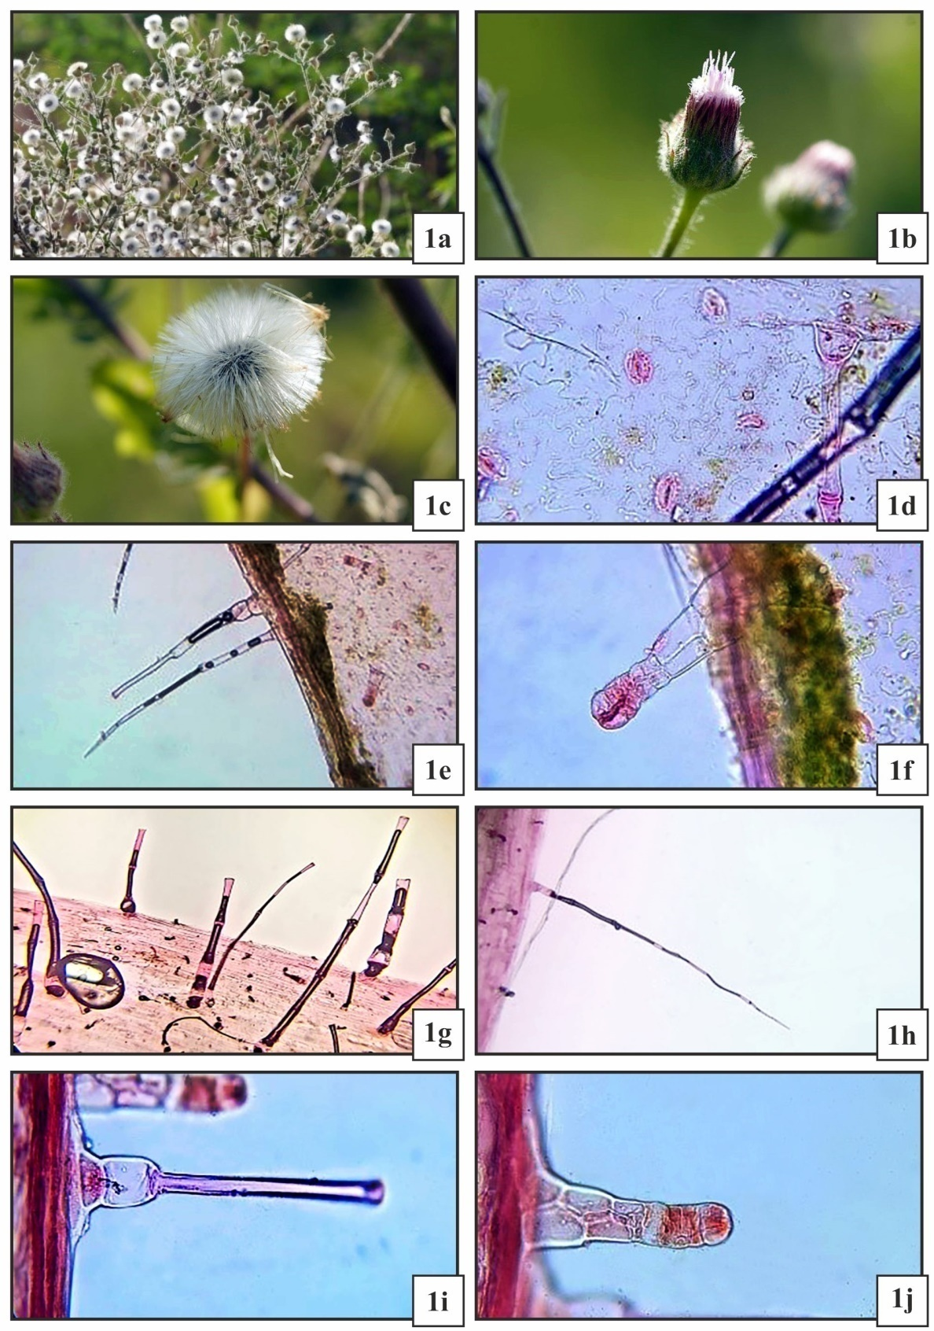
fig 1: Morphology and leaf epidermal features of Blumealaciniata(Roxb.) DC.
Fig.- 1a: Habitat; Fig.- 1b: Flower head;Fig.- 1c: Achene; Fig.- 1d: Anomocytic stomata; Fig.- 1e: Non-glandular trichome: Filiform, pointed tip; Fig.- 1f: Glandular biseriatetrichome; Fig.- 1g: Non-glandular trichome: blunt end; Fig.- 1h: Non-glandular trichome: long, filiform;Fig.- 1i: Non-glandular trichome: swollen base, aseptate;Fig.- 1j: Glandular trichome: multicellular head.
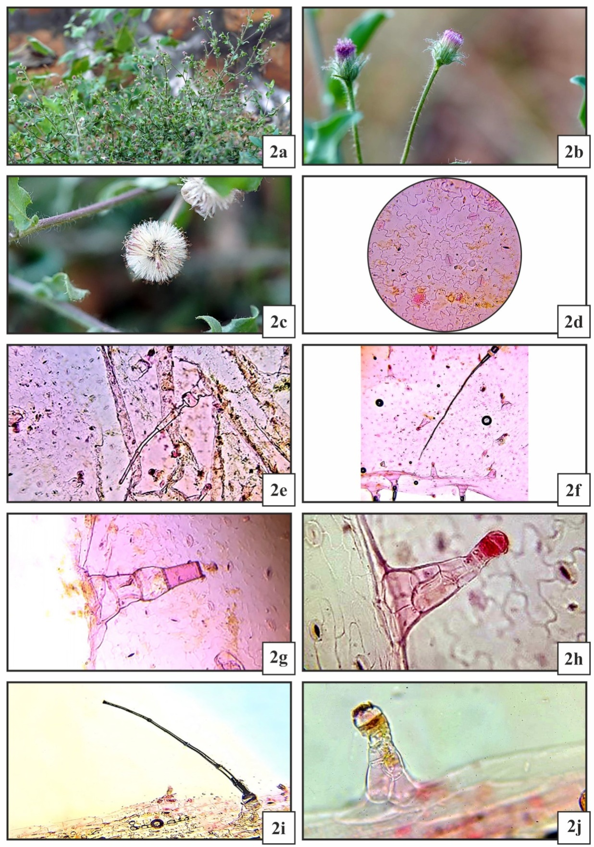
fig 2: Morphology and leaf epidermal features of Blumeaobliqua (L.) Druce
Fig.- 2a: Habitat; Fig.- 2b: Flower head;Fig.- 2c: Achene; Fig.- 2d: Anomocytic stomata; Fig.- 2e: Non-glandular trichome: filiform, swollenbase; Fig.- 2f: Non-glandular trichome: filiform,aseptate; Fig.- 2g:Non-glandular trichome: 4-celled; Fig.- 2h: Glandular trichome: biseriate; Fig.- 2i: Non-glandular trichome: filiform;Fig.-2j: Glandular trichome: capitate head.

Two plant species from the Asteraceae family had their trichome morphology examined in the current study. Trichomes, which are more significant, were formed by plants with hairs on their outside surfaces. They differ structurally and depend on the species. It is possible to categorize the species using these traits. According to Wagner (1991), the purpose of trichomes is to deter animals from grazing, direct pollination, or slow down the rate of photosynthesis by increasing reflection, which results in water loss and changes in leaf temperature.The primary purpose of both species' glandular and non-glandular trichomes, which are both present on the plant surface, may be to synthesize compounds that interact with pests or pollinators. A continuous layer of secretion that occurs on the plant surface is produced by glandular secreting trichomes. The layer might make light more reflective, which would lower leaf temperature (Dell and McComb, 1979).As a result of their ability to produce, store, and exude chemical compounds that aid in protecting plants from insect predation(Rangerand Hower,2001) glandular trichomes has drawn a lot of attention. Various trichome types with notable morphological structural differences have been reported in the current investigation. The identification of different Blumea species would benefit from study of the trichomes. The current study found considerable heterogeneity in the distribution and form of trichomes among the Asteraceae species under study. Trichomes are significant epidermal features that are essential to plant taxonomy, adaptability, and defence. In the identification and categorisation of plant species, their structural variety has been extensively employed as a trustworthy taxonomic characteristic. Both glandular and non-glandular trichomes were seen in the current study, demonstrating distinct variations in size, density, form, and distribution pattern among the species under investigation. Environmental factors and genetics may have an impact on these variances.
CONCLUSION
In conclusion, the new details on trichome shape can be used as additional data to aid in the Blumea species identification. The present study is therefore helped at identifying, describing and documenting the leaf and stem epidermal characters that diagnostic and taxonomically important in the family Asteraceae. Additionally, under harsh environmental circumstances, trichomes may help plants survive. A thick indumentum may lower leaf surface temperature, improve drought tolerance, and shield plants from UV rays. This adaptive significance implies that trichome shape has ecological significance in addition to taxonomic significance.
All things considered, the current study shows that trichome shape offers crucial micromorphological evidence for Blumea species identification. The functional and taxonomic importance of these epidermal structures may be further clarified by in-depth investigations employing scanning electron microscopy and phytochemical research.

CONFLICT OF INTEREST
The authors declare that the research was conducted in the absence of any commercial or financial relationship that could be construed as a potential conflict of interest.

Disclaimer (Artificial intelligence)

Author(s) hereby declare that NO generative AI technologies such as Large Language Models (ChatGPT, COPILOT, etc.) and text-to-image generators have been used during the writing or editing of this manuscript.

The authors hereby certify that this paper was not written, edited, or prepared using any generative AI methods, including text-to-image generators or Large Language Models (such ChatGPT, Copilot, etc.).

REFERENCES
Bhandari, M. M. (1995). Flora of the Indian desert. MPS. Reports, Jodhpur.
Busta, L., Hegebarth, D., Kroc, E. &Jetter, R. (2017). Changes in cuticular wax coverage and composition on developing Arabidopsis leaves are influenced by wax biosynthesis gene expression levels and trichome density. Planta, 245: 297-311.
Dell, B. &McComb, A.J. (1979). Plant resins—their formation, secretion and possible functions. In Advances in botanical research, Vol. 6, 277-316. Academic Press. https://doi.org/10.1016/S0065-2296(08)60332-8
Dinde, A.V., Lokhande, P.B. &Mujawar, H.A. (2018). Essential Oil Extraction, Characterization and Anti-microbial study of B. laciniata DC. fromKonkan Region, 11: 70–76.
Hameed, I., Hussain, F., &Dastagir, G. (2008). Stomatal studies of some selected medicinal plants of Polygonaceae. Pak. J. Bot, 40(6), 2273-2280.
Inamdar, J. A., Balakrishna, B., &Rao, T. V.(1983). "Structure, ontogeny, classification, and taxonomic significance of trichomes in Malvales." Journal of Plant Biology 26.3, 151-160
IUCN Standards and Petitions Committee (2022). Guidelines for Using the IUCN Red List Categories and Criteria. Version 15.1. Prepared by the Standards and Petitions Committee. https://www.iucnredlist.org/resources/redlistguidelines
Jain, S.K. &Rao, R.R. (1977).A Handbook of Field and Herbarium Methods. Today & Tomorrow’s Printers and publis., New Delhi, 1-157.
Johansen, D. (1940). A. Plant microtechnique., First Ed.
Johnson, H.B. (1975). Plant pubescence: an ecological perspective. The Botanical Review, 41:233-258.
Karthikeyan, S., Sanjappa, M., Moorthy, S., Bhattacharjee, B., Dash, S.S., Meena, S.L. &Mastakar, V.K. Asteraceae. Enydra: In: A.A. Mao & S.S. Dash(2020).Flowering Plants of India – An Annotated Checklist: Dicotyledons. Vol. 1. Botanical Survey of India, Kolkata, 751.
Li, Y., Ooi, L.S., Wang, H., But, P.P. &Ooi, V.E. (2004). Antiviral activities of medicinal herbs traditionally used in southern mainland China. Phytotherapy Research: An International Journal Devoted to Pharmacological and Toxicological Evaluation of Natural Product Derivatives, 18(9), 718-722. https://doi.org/10.1002/ptr.1518.
McDowell, E.T., Kapteyn, J., Schmidt, A., Li, C., Kang, J.H., Descour, A. A & Gang, D.R. (2011). Comparative functional genomic analysis of Solanum glandular trichome types. Plant Physiology, 155(1), 524-539. https://doi.org/10.1104/pp.110.167114 .
Metcalfe, C. R.& Chalk, L. (1950). "Anatomy of the dicotyledons, Vols. 1&2, Clarendon Press." Ramayya, N. Studies on the trichomes of some Compositae I. Generalstructure. Nelumbo,177-188 https://doi.org/10.20324/nelumbo/v4/1962/76550 (1962).
Perveen, A., Khan, M., Mansuri, S. &Tabassum, T. (2016). Morphological studies on trichome of family Asteraceae. International Journal of Biology and Biotechnology, 13(2), 177-182.
Prabhakar, M. (2004). Structure, delimitation, nomenclature and classification of stomata. Journal of Integrative Plant Biology, 46(2), 242
Ranger, C.M. &Hower, A.A. (2001). Glandular morphology from a perennial alfalfa clone resistant to the potato leaf hopper. Crop Science, 41(5), 1427-1434. https://doi.org/10.2135/cropsci2001.4151427x
Rudall, P.J., Hilton, J. & Bateman, R.M. (2013). Several developmental and morphogenetic factors govern the evolution of stomatal patterning in land plants. New Phytologist, 200(3), 598-614.
Saas, J. E. (1958). Botanical Microtechnique 3rd Ed. Oxford and IBH Publishing Co., Calcutta.
Shetty, B.V. & Singh, V. (1987).Flora of Rajasthan (Vol. 1). Calcutta: Botanical Survey of India, Howrah.
Ullah, S., Shakir, L., & Ullah, R. (2023). Morphological and phytochemical study of Cirsium arvense from district Mardan Pakistan. J. Bioinf. Biotechnol. Res, 1(1), 1-7.
Wagner, G.J. (1991). Secreting glandular trichomes: more than just hairs. Plant physiology, 96(3), 675-679. https://doi.org/10.1104/pp.96.3.675
Wang, X., Shen, C., Meng, P., Tan, G. &Lv, L. Analysis and review of trichomes in plants. BMC Plant Biology, 21(1), 1-11 (2021).
Xiao, K., Mao, X., Lin, Y., Xu, H., Zhu, Y., Cai, Q. & Zhang, J. (2017). Trichome, a functional diversity phenotype in plant. Mol. Biol., 6(1), 183.
Zhao, Q. & Chen, X.Y. (2016). Development: a new function of plant trichomes. Nature Plants, 2(7), 1-2.

