Original Research Article

Predicting Growth and Dry Matter Production of Tomato in Response to Exogenous Proline Application under Drought Stress

.
ABSTRACT

Aims: To evaluate the drought response of tomato under varying levels of proline application, to build a growth model for leaf area and shoot dry weight under drought and proline sprays, and to evaluate the model performance.
Study Design: Split-plot design: main factor (water supply: well-watered, drought-stressed), sub-factor (proline: 0, 20, 40, 60, 80 ppm) with four replications.
Place and Duration of Study: Polyhouse at the Department of Horticulture, Yezin Agricultural University (YAU), between October 2024 and May 2025.
Methodology: There were two pot experiments (Expt.): Expt. 1 for parameterization, Expt. 2 for model evaluation. Withholding of water and proline sprays was employed at five-leaf stage. Drought response of relative leaf expansion rate (RLER) to fraction of transpirable soil water (FTSW) was fitted by a linear–plateau regression (LPR) at each level of proline sprays and related parameters were generated for model simulation. Daily leaf expansion rate under well-watered condition (LER_{w}) was calculated from plant leaf area (PLA) estimated from measurements of individual leaf length and width. In model, LER under drought (LER_{d}) was described as the product of LER_{w} and RLER and PLA was the integral of LER. For each water regime, shoot dry weight (SDW) was the product of specific shoot mass and PLA.
Results: Moderate proline levels (20-40 ppm) delayed the drought response of RLER, exhibited by lower FTSW thresholds (0.49-0.5) compared to control (0.75). Predicted PLA under well-watered condition showed higher goodness of fit than droughted condition (R²=0.60 vs 0.55). Simulated SDW represented more under drought than the well-watered condition (R²=0.57 vs 0.42). Model performance across proline levels revealed RMSD ranges of 112-286 for PLA and 0.85-2.26 for SDW, with accuracies of 0.88-0.96.
Conclusion: Current growth model showed varying drought responses to proline sprays with some magnitudes of errors, which needed further calibration and validation.

Keywords: Model, Tomato, Drought, Proline, Leaf area, Dry matter production

1. INTRODUCTION

Tomato (Solanum lycopersicum L.) is a globally important horticultural crop and a widely used model species in plant physiological research (Arie et al., 2007; Khan et al., 2015). Tomato growth and productivity are highly sensitive to soil water availability, with water deficit adversely affecting physiological, biochemical, and morphological processes, ultimately reducing biomass accumulation and yield (Torres-Ruiz et al., 2015). Drought stress is one of the most critical environmental factors limiting crop productivity worldwide, particularly in arid and semi-arid regions, and climate change is expected to increase the frequency and severity of such events, further constraining agricultural production systems (Bray, 1997; Dai, 2012).
The plant performance under water-limited environments is evaluated on two fronts: the capacity for sustained productivity and the ability to survive (Myint, 2022). These two responses are not always compatible, and successful drought adaptation requires a balance between them (Myint, 2022). Because of its relatively simple canopy structure and well-defined growth stages, tomato is particularly well-suited for quantitative analysis and modeling of complex growth responses to environmental stress (Guoting et al., 2020).
Plants have evolved several adaptive strategies to cope with drought stress, broadly categorized into drought escape, drought resistance (comprising dehydration avoidance and dehydration tolerance), and drought recovery (Levitt, 1980; Ludlow & Muchow, 1990; Blum, 1999; Myint, 2022). Dehydration avoidance involves maintaining high plant water status through mechanisms such as reduced leaf area expansion and stomatal closure, while dehydration tolerance allows plants to function under low tissue water content through physiological and cellular adjustments (Morgan, 1984; Claeys & Inzé, 2013). A key mechanism underlying dehydration tolerance is osmotic adjustment, which involves the accumulation of compatible solutes to lower cellular osmotic potential, thereby facilitating water uptake and maintaining cell turgor even when soil water availability is limited (Morgan, 1984; Blum, 2017).
Among these compatible solutes, proline is one of the most widely reported. As the only proteinogenic secondary amino acid, proline accumulates in plants under water deficit and other abiotic stresses such as salinity, high temperature, and nutrient starvation (Sairam et al., 2002). Proline plays a multifaceted role in stress tolerance: it contributes to osmotic adjustment, stabilizes proteins and membranes, scavenges reactive oxygen species, and supports cellular redox balance under stress conditions (Boggess et al., 1976; Smirnoff & Cumbes, 1989).
Exogenous application of proline has been shown to enhance plant tolerance to abiotic stresses by improving water relations, photosynthetic capacity, and nutrient uptake (Ashraf & Foolad, 2007). Foliar-applied proline can reduce enzyme denaturation, protect membrane integrity, and regulate stress-responsive metabolic pathways (Iyer & Caplan, 1998). By enhancing osmotic adjustment, proline application helps maintain cell turgor and supports physiological functions under water-deficient conditions.
The effectiveness of exogenous proline is concentration-dependent. In controlled studies, proline is typically applied at 10–100 ppm, with optimal effects commonly observed at 10–50 ppm depending on stress conditions and cultivar. Kahlaoui et al. (2014) reported that 10–20 ppm proline significantly improved growth, leaf area, and fruit yield in salt-stressed tomato, while Elewa et al. (2017) and AlKahtani et al. (2021) demonstrated that 20–40 ppm enhanced plant height, leaf area, and dry matter production under drought stress. In contrast, higher concentrations such as 80 ppm are considerably above the optimal range reported for tomato (10–40 ppm). Heuer (2003) demonstrated that exogenous proline application can seriously inhibit tomato growth, attributed in part to a toxic effect of proline itself. This reduction at elevated concentrations may result from metabolic imbalance, where excessive proline accumulation exerts feedback inhibition on endogenous proline biosynthesis or disrupts cellular nitrogen metabolism and osmotic homeostasis (Ashraf & Foolad, 2007; Claussen, 2005).
Crop growth models provide valuable tools for understanding plant responses to environmental factors and for predicting growth under variable conditions (Marcelis et al., 2008; Soltani, 2012). Many models describe stress responses using soil water status, such as the fraction of transpirable soil water (FTSW). Physiological processes such as leaf expansion often exhibit a linear-plateau (two-segmented) response to declining FTSW (Sinclair & Ludlow, 1986; Ray & Sinclair, 1998). In this relationship, leaf expansion remains unaffected when soil water is above a critical threshold (the break point); once FTSW falls below this threshold, leaf expansion declines linearly with further water deficit (Sadras & Milroy, 1996; Soltani & Sinclair, 2012). This threshold-based response, which quantifies the point at which a process begins to decline, was successfully used by Myint (2022) to parameterize drought responses in tomato introgression lines. These parameters, the break point (FTSW threshold) and the slope (rate of decline), are not static; they can be modified by management practices such as proline application, which may alter the plant's sensitivity to soil water deficit.
Despite the documented benefits of proline, quantitative information on how its application modifies these linear-plateau response parameters and subsequently influences growth dynamics under varying drought stress remains limited. Incorporating such effects into crop growth models can improve their ability to simulate plant adaptive responses to drought (Boote et al., 2013).
Therefore, this study aimed to evaluate the drought response of tomato under varying levels of proline application, to build a growth model for leaf area and shoot dry weight under drought and proline sprays, and to evaluate the model performance.
.
2. Materials and Methods
2.1 Experimental conditions and treatments

Two pot experiments were conducted in the polyhouse of the Department of Horticulture at Yezin Agricultural University, Naypyitaw, Myanmar. Experiment 1 (October–December 2024) was conducted for parameterization, and Experiment 2 (March–May 2025) for model evaluation. A 2 × 5 split-plot design was employed with four replications. The main plot factor consisted of well-watered and drought-stressed treatments, and the subplot factor comprised five proline levels (0, 20, 40, 60, and 80 ppm). Each experimental unit consisted of two subunits, spaced 30 cm and 90 cm within and between rows.
The tomato variety used was 'NIRVANA-044', a semi-determinate, fast-growing hybrid, with unknown information regarding drought tolerance. Seeds were sown in plastic seedling trays, and thirteen-day-old seedlings were transplanted into 10-L plastic bags filled with a mixture of garden soil (loamy sand), well-decomposed cow dung, and burnt rice husk (11.5:1:1 v/v). At the five-leaf stage, drought imposition was started by withholding water, and proline treatments were applied. A 1% (w/v) stock solution was prepared by dissolving 1 g of proline in 100 ml of distilled water, and then separately diluted to obtain 400 ml of specific treatment solution. Each plant received 10 ml of the respective solution sprayed onto the leaves until runoff.

2.2 Data collection and parameterization
The environmental and plant data from Expt. 1 was collected and used for parameterization required to build the growth model describing the drought response under varying proline sprays.

2.2.1 Air temperature and growing degree days
Air temperature inside the polyhouse was hourly recorded by using a data logger. Minimum and maximum temperatures ranged from 22.4°C to 32.6°C in Experiment 1 and from 15.6°C to 31.4°C in Experiment 2. Growing degree days of i^{th} day (GDD_{i}, ºCd day⁻¹) was calculated as:
$${GDD}_{i}=\frac{T_{max}+T_{min}}{2}-T_{base}$$ | Eq. (1)

where T_{max} is the daily maximum air temperature (°C), T_{min}, the daily minimum air temperature (°C), and T_{base}, the base temperature (assumed as 10°C).
2.2.2 Soil water deprivation and daily transpiration determination

In order to prevent water loss through evaporation, the surface of each bag was covered with Styrofoam. The amount of soil water loss through transpiration was measured every two days by the gravimetric method and was replenished for well-watered treatments. The fraction of transpirable soil water (FTSW) under drought stress was calculated as:

$$FTSW=\frac{W_{t}-W_{f}}{W_{i}-W_{f}}$$ | Eq. (2)

where W_{t} is current bag weight, W_{f}, final bag weight (when stressed transpiration reached <10% of well-watered plants) and W_{i,} initial bag weight (at 100% WHC).

Daily transpiration rate (TR, kg plant⁻¹ day⁻¹) was calculated as the ratio of the change in plant weight between two consecutive measurements to the change in time (thermal time, t), multiplied by growing degree days of i^{th} day (Eq. 1):

$$TR \text{=}\frac{\text{W}\text{2 }-\text{W}\text{1}}{\text{t}\text{2 }-\text{t}\text{1}} × {GDD}_{i}$$ | Eq. (3)

where W₁ and W₂, bag weights (with plant) at time 1 and 2 (kg), t₂ and t₁, the corresponding thermal time at two time points, and GDD_{i}, growing degree days of i^{th} day.

2.2.3 Leaf length, leaf width, and leaf area

Leaf length (L) and width (L) of the leaf at rank five (representative leaf) were taken at two-day intervals from the time of treatment imposition until the drought-stressed plants showed 10% transpiration of the control. At harvest time, in addition to leaf length and leaf width, the leaf areas of all leaves were measured destructively by using ImageJ software. In parallel to the experiment, destructive measurements of leaf area (LA, cm² leaf⁻¹) and leaf dimensions (length and width) of all leaves were done at the onset of treatment using the reserved plants. The relationship between the length-width product and individual leaf areas was fitted by using a linear regression function (Figure 1) as follows:

$$LA=a_{l} (L×W)$$ | Eq. (4)

where parameter “a_{l}” is a regression coefficient.
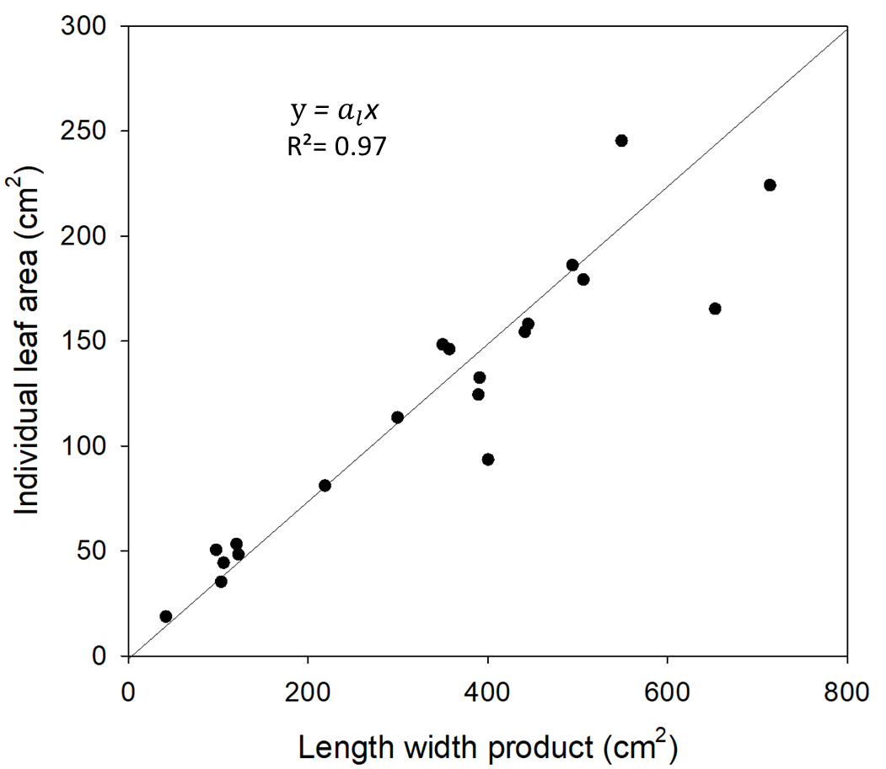
Figure 1. Relationship between length-width product and individual leaf area. a_{l} (0.342) is regression coefficient for single leaf area.

The relationship between the single leaf area (at rank 5) and plant leaf area was fitted with a modified hyperbola function, which allowed the generalization of plant leaf area (PLA, cm² plant⁻¹) (Figure 2) as follows:

$$PLA =a_{p}×\frac{LA}{(1+b_{p} LA)}$$ | Eq. (5)

where a_{p} and b_{p} are the regression constants.

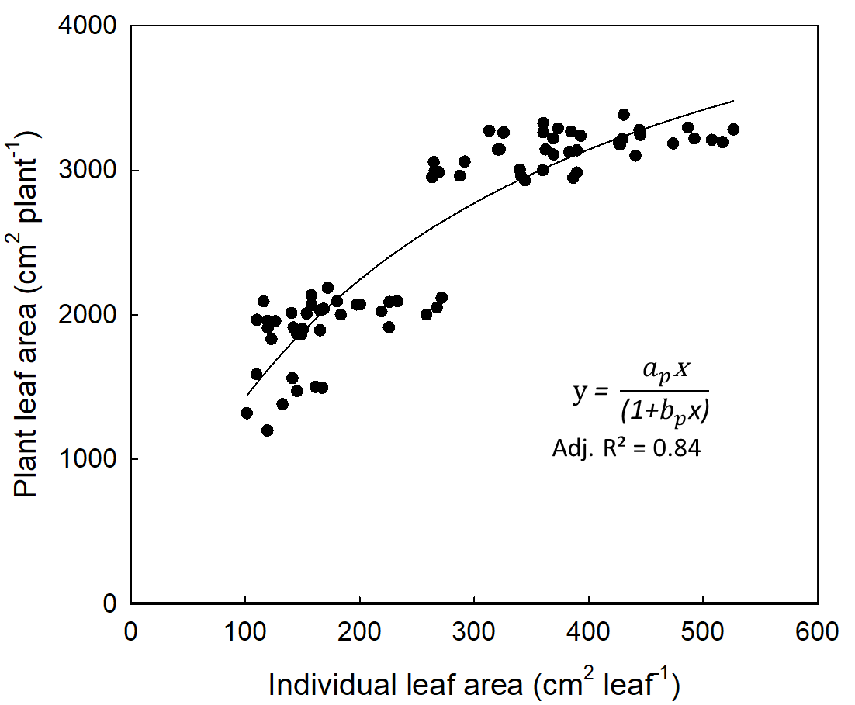
Figure 2. Relationship between individual leaf area and plant leaf area. a_{p} (19.57 cm² plant⁻¹) and b_{p} (0.0037) are regression constants of the modified hyperbola function.

2.2.4 Daily leaf expansion rate under well-watered conditions

Leaf expansion rate under well-watered conditions (LER_{w}, cm² plant⁻¹ day⁻¹) was calculated as:

$$LER_{w}=\frac{PLA_{2}-PLA_{1}}{t_{2}-t_{1}}× {GDD}_{i}$$ | Eq. (6)

where $PLA_{2}$and $PLA_{1}$are the plant leaf areas at two time points ($t_{2}$and $t_{1})$, expressed in degree days, and GDD_{i}, growing degree days of i^{th} day after treatment. LER followed a typical bell-shaped function (Figure 3).

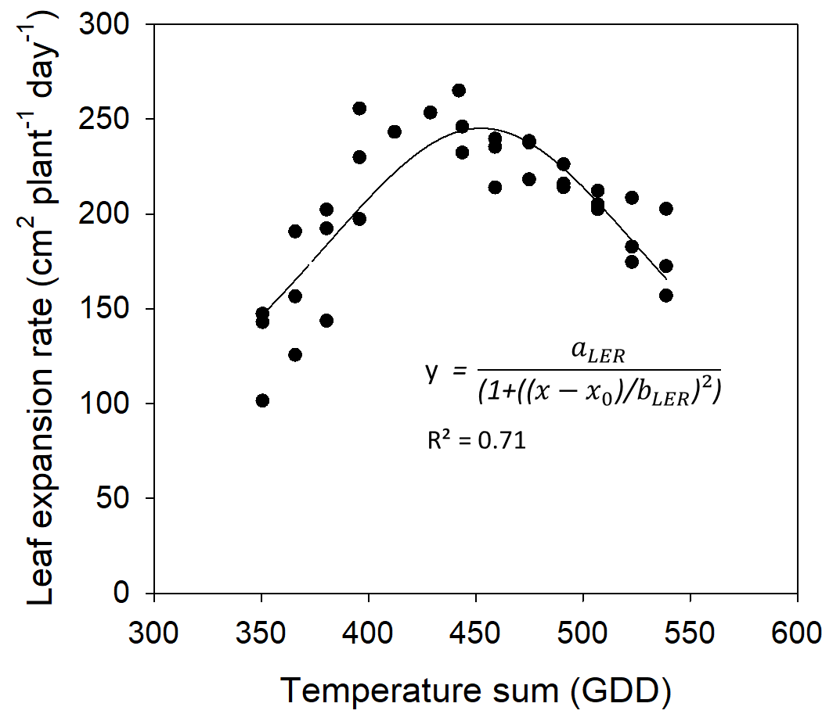
Figure 3. Leaf expansion rate of tomato over time under well-watered conditions
2.2.5 Relationship between shoot dry weight and plant leaf area

At harvest time, the plant samples were put into an oven at 70ºC until the constant weight was obtained, and the dry weight of shoots (leaves and stems) were recorded. The relationship between shoot dry weight and plant leaf area was fitted with linear regression separately for well-watered and drought-stressed plants (Figure 4).

Figure 4. Allometric relationship between plant leaf area (PLA) and shoot dry weight (SDW) of tomato under well-watered (A) and drought-stressed (B) conditions, respectively. a_{sw} (0.0078) and a_{sd} (0.0086) are specific shoot masses under well-watered and drought-stressed conditions.

2.5 Model description
The model was developed to simulate tomato growth and dry matter production under varying soil water availability and exogenous proline applications (Fig. 5). It is a plant-level ecophysiological model consisting of three main components: (i) leaf expansion dynamics, (ii) canopy development (Plant leaf area), and (iii) biomass accumulation (Shoot dry weight).
Model inputs consisted of leaf length and width of a representative leaf of well-watered conditions, GDD calculated from daily air temperature, soil water status (FTSW), and proline concentrations. There are two modeling pathways: Mw, the pathway for well watered condition, Md, the pathway for drought stress conditions. In M_{w}, plant leaf area (PLA) is generalized from single leaf area, which is described as a function of the length-width product. Leaf expansion rate (LER_{w}) is calculated back as a temperature-driven function of GDD. In M_{d}, relative leaf expansion rate (RLER) is described as a function of FTSW separately for each proline level. The effects of exogenous prolines on RLER are incorporated through the use of the drought response parameters (i.e., breakpoint and slope), thereby altering the sensitivity of leaf expansion rate to progressive soil drying. Leaf expansion rate under drought stress (LER_{d}) is obtained by multiplying LER_{w} with RLER. The model outputs are PLA and Shoot dry weight (SDW). PLA under drought stress (PLA_{d}) is then calculated by integrating LER_{d} over time from the onset of treatment, which is added to the initial leaf area. Finally, SDW is estimated as a linear allometric function of PLA, with separate parameters (specific shoot masses) for well-watered and drought-stressed conditions.

Figure 5: Flow chart of tomato growth model describing the input (leaf length and width, daily air temperature, proline level, soil water status), and output (plant leaf area, shoot dry weight). M_{w} and M_{d} are modeling pathways for well-watered and drought-stressed conditions, respectively. Model parameters involved in each sub-level are not shown.
2.5.1 Relative leaf expansion rate as a function of FTSW

Relative leaf expansion rate (RLER) is the ratio of LER_{d} to LER_{w} (unitless). The response of RLER to declining soil water availability was described using a (two-segmented) linear-plateau regression (LPR) model (Figure 6), which is commonly used to characterize plant physiological responses to soil drying (Sinclair & Ludlow, 1986; Ray & Sinclair, 1997). This model consists of two phases: an unresponsive phase, where RLER remains at its maximum when soil water is sufficient, and a responsive phase where RLER declines linearly as water deficit increases. The relationship is mathematically expressed as:

$$RLER= \left\{\begin{aligned}1, if FTSW≥c \\ a FTSW +b , else \end{aligned}\right.$$ | Eq. (7)

where RLER is the relative leaf expansion rate, FTSW is the fraction of transpirable soil water, c, breakpoint (FTSW threshold where leaf expansion starts to decline), a, slope of the linear decline, and b, intercept of the regression equation. The parameters, the breakpoint, slope, and intercept of the LPR model were generated from Expt. 1 and used as proline-specific drought response coefficients.
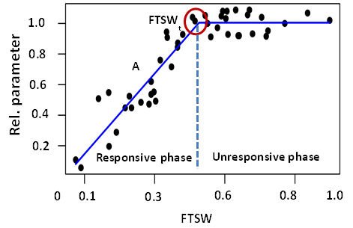
Figure 6. Linear-plateau regression model describing the response of the relative plant parameter to fraction of transpirable soil water (FTSW). FTSW_{t}, FTSW threshold; A, intensity of decline.

2.5.2 Leaf expansion rate under drought stress

Leaf expansion rate under drought stress (LER_{d}, cm² plant⁻¹ day⁻¹) was described as the product of LER_{w} (Eq. 6) and RLER (Eq. 7):

$$LER_{d}=LER_{w}×RLER$$ | Eq. (8)

2.5.3 Plant leaf area

For both of the water regimes, plant leaf area at time t (PLA) was described as the sum of initial leaf area (PLA_{t0}) and the integral of daily leaf expansion rate (LER) during the treatment period:
$$PLA (t)={PLA}_{t_{0}}+\int_{t_{0}}^{t_{i}}{LER}$$ | Eq. (9)
where t₀ is the onset of drought treatment, t_{i} is the current time post drought imposition.

2.5.4 Shoot dry weight

Shoot dry weight (SDW, g plant⁻¹) was described as a linear function of plant leaf area (PLA), separately for well-watered and drought-stressed conditions:

$${SDW}_{w} (t)=a_{sw} ×{ PLA}_{w}$$ | Eq. (10)
$${SDW}_{d} (t)=a_{sd} × {PLA}_{d}$$ | Eq. (11)
where a_{sw} and a_{sd} are the specific shoot masses (g cm⁻²) under well-watered and drought-stressed conditions parameterized from Expt. 1.

2.6 Simulation and model evaluation

Drought responses of the relative leaf expansion rate were first evaluated in Expt. 1 by fitting the data with a linear plateau regression (LPR) model under each level of proline sprays. After the LPR model was incorporated in the framework of the growth model, the model was run by using the parameters generated from Expt. 1 and experimental condition of Expt. 2 (e.g., air temperature, soil water, and individual leaf areas under well-watered conditions). Simulation was performed for the duration of a complete drought cycle (16 days) by daily time step. By using an independent dataset obtained at the end point of FTSW from Experiment 2, model performances were evaluated separately for plant leaf area and shoot dry weight by using statistical indicators, namely the coefficient of determination (R²), root mean squared deviation (RMSD), bias, and accuracy.

$$RMSD=\sqrt{\frac{1}{n}\sum_{i=1}^{n}{{(x_{i}-y_{i})}^{2}}}$$ | Eq. (12a)
$$Bias=\frac{1}{n}\sum_{i=1}^{n}{(x_{i}-y_{i})}$$ | Eq. (12b)
$$Accuracy=1-\frac{RMSD}{\frac{1}{n}\sum_{i=1}^{n}{(x_{i})}}$$ | Eq. (12c)

where, x_{i} and y_{i} are measured and simulated data, respectively (Kobayashi & Salam, 2000; Kahlen & Stützel, 2011). RMSD is the standard deviation of the residuals of the 1:1 line between simulated and observed values. Bias is a systematic difference between the mean values of simulated and observed data. Accuracy is the proportion of correctness of simulated values in comparison to observed values.

3. Results and Discussion
3.1 Varying drought responses of leaf expansion rate under proline sprays
In experiment one, the response of relative leaf expansion rate (RLER) was described as a function of fraction of transpirable soil water (FTSW) at each level of proline concentration (Figure 6). Fitting with an empirical model (linear-plateau regression) showed a high coefficient of determination (R² > 0.90) in the responsive phase. The fact that the drought response of RLER to FTSW strongly followed a linear fashion indicates that the decline of RLER was more dependent on soil water status than environmental heterogeneity once it commences the reaction. This threshold-type response is widely reported under progressive soil drying and reflects the regulation of growth processes under drought stress (Sinclair & Ludlow, 1986; Ray & Sinclair, 1997).

At 0 ppm (control) of proline concentration, RLER remained stable until FTSW declined to a break point of 0.75, then decreased linearly (slope = 0.98) to an end point of FTSW (intercept = 0.25) at which the transpiration of droughted plants reached less than 10% of the control (Figure 7A). The high value of the breakpoint indicates that RLER was highly sensitive to early soil moisture depletion as an adaptive (drought avoidance) response of the plant to reduce the plant's water loss through transpiration. This is in agreement with the reports that leaf expansion is among the earliest physiological processes inhibited under drought (Hsiao, 1973).
Application of 20 ppm proline reduced the break point to 0.50, with a steeper decline (slope=1.49) but with a similar intercept (0.25) (Figure 7B). A comparable response was observed at 40 ppm, with a break point of 0.49 and a slope of 1.50 (Figure 7C). These results indicate that moderate proline concentrations (20 - 40 ppm) delayed the onset of stress response, allowing leaf expansion to continue at lower soil moisture levels through increased osmotic adjustment and maintained cell turgor (Ashraf & Foolad, 2007; Szabados & Savoure, 2010).

At higher concentrations (60–80 ppm), the response pattern shifted toward a more gradual decline. Break points increased to 0.62–0.64, with moderate steepness of decline (slope = 1.18–1.20 (Figures 7D & 7E). Higher proline levels enhanced the plant's ability to adjust growth more progressively under drought, possibly through sustained osmotic regulation, membrane stabilization, and enhanced ROS scavenging (Szabados & Savouré, 2010; Verslues & Sharma, 2010). The possible reason for the high value of break points may be that high concentrations of exogenous proline sprays can cause the osmotic imbalance, metabolic disruption, and premature reduction of leaf expansion (Tesfaye et al., 2014; Li et al., 2024).
Across all treatments, break point values ranged from 0.49 to 0.75, indicating that proline altered the FTSW threshold at which leaf expansion began to decline under water deficit. Lower break point values at moderate proline levels (20–40 ppm) suggest that plants were able to maintain leaf expansion at lower soil moisture levels, likely due to improved osmotic adjustment and maintenance of cell turgor. This confirms that proline primarily influences the timing of growth reduction rather than preventing inhibition under extreme water deficit (Ashraf & Foolad, 2007).
Figure 7. Responses of relative leaf expansion rate (RLER) of tomato to fraction of transpirable soil water (FTSW) along the course of drought duration treated with specific levels of proline sprays: (A) 0 ppm (n = 64), (B) 20 ppm (n = 64), (C) 40 ppm (n = 64), (D) 60 ppm (n = 56), (E) 80 ppm (n = 56) derived from Experiment 1. Value above the plateau line in each figure indicates the break point (FTSW threshold).

3.2 Evaluation of model performance

The model for plant leaf area and shoot dry weight of tomato demonstrated a strong predictive performance across all proline treatments under both well-watered and drought-stressed conditions. The high accuracy values (0.907–0.971) and low RMSD values observed in this study are comparable to those reported in other crop modeling studies. For instance, similar accuracy ranges (0.89–0.95) were reported for tomato growth models under water deficit conditions (Guoting et al., 2020; Marcelis et al., 2008).

3.2.1 Plant leaf area
A moderate agreement was observed between the observed and simulated plant leaf area evaluated at harvest times. Under well-watered conditions, the trend of predicted values represented the 60% (R² = 0.60) of the observed total plant leaf area across all proline concentrations, regardless of the overestimated initial values (intercept = 585.25). According to linear regression, overall performance showed an underestimation by around 22% (regression coefficient = 0.78). The RMSD values ranged from 112.25 to 285.69 cm² plant⁻¹, the bias ranged from −47.61 to 207.23 cm² plant⁻¹, and the accuracy ranged from 0.90 to 0.96. The best performance was obtained at 60 ppm proline, with the lowest RMSD (112.25), relatively low bias (20.17), and the highest accuracy (0.96) (Figure 8). Overall underestimation, particularly observed in higher values, can be explained by the plateau nature of the hyperbolic model with saturation to generalize plant leaf area from a single leaf area. The model performance could be improved if the plant leaf area were described as the product of leaf number and representative leaf area, as modeled elsewhere.

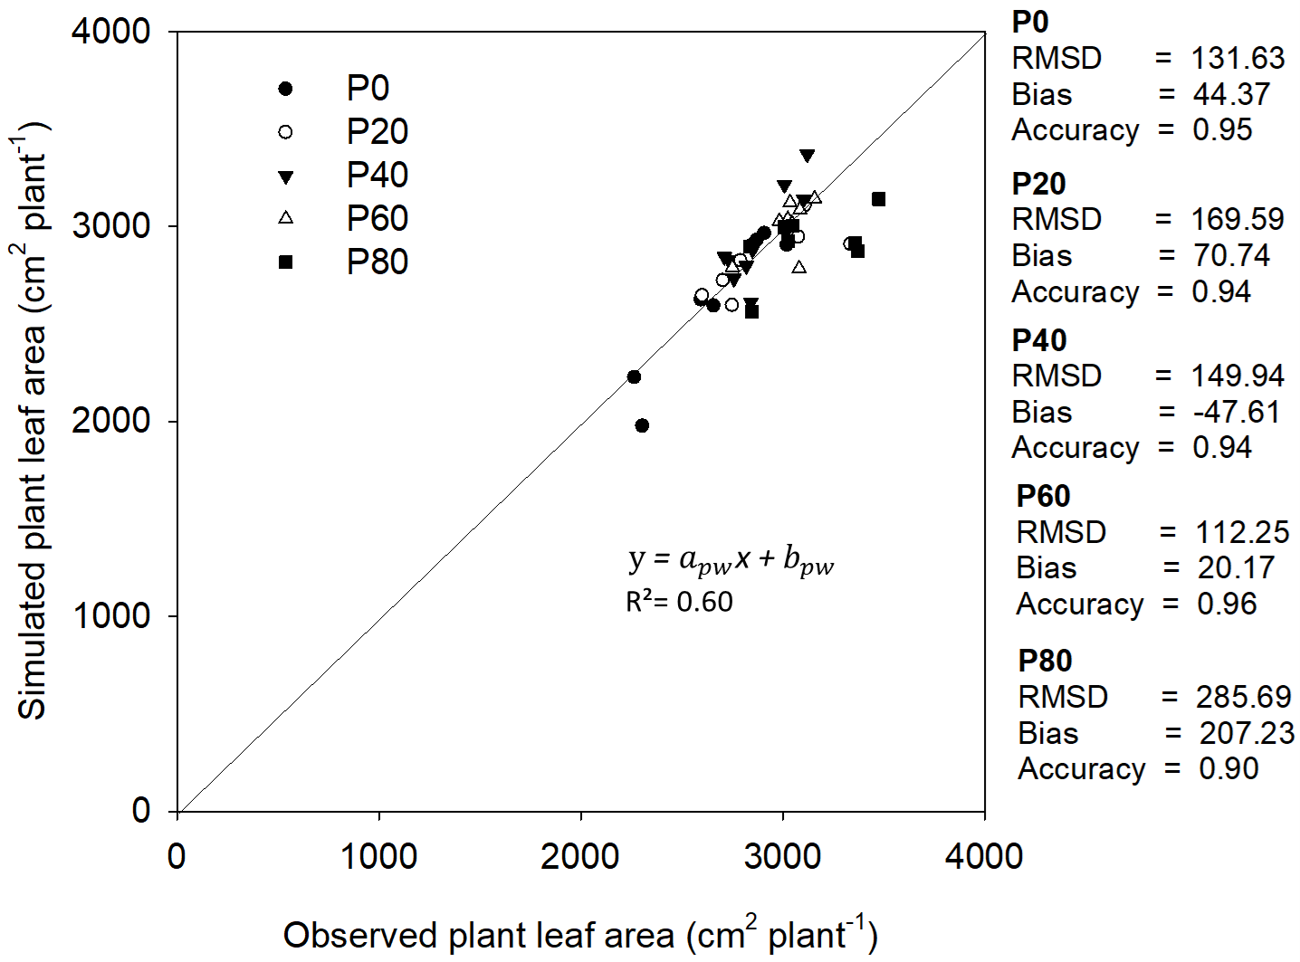
Figure 8. Observed and simulated plant leaf areas of tomato under well-watered conditions at different proline concentrations. The regression parameters a_{pw} (0.7796) and b_{pw} (585.25 cm² plant⁻¹) represent the slope and intercept, respectively, of the regression model for plant leaf area under well-watered conditions.

Under drought-stressed conditions, the model maintained a good predictive ability, although deviations were slightly higher than under well-watered conditions. This is consistent with the findings of Soltani and Sinclair (2012), who reported the reduced model performance under drought stress due to increased physiological complexity. RMSD values ranged from 151.04 to 216.10, bias from −147.99 to 106.00, and accuracy from 0.88 to 0.92. The best performance was observed at 40 ppm proline, with an RMSD of 151.04, a bias of −125.46, and an accuracy of 0.92 (Figure 9). Ashraf & Foolad (2007) observed that moderate proline levels enhance plant performance, which could be attributed to osmotic adjustment with a delayed response of leaf expansion rate to soil drying. In line with that, the current result indicates that the LPR model describing drought response works well for moderate levels of proline input.
The coefficients of determination (R²) were 0.60 under well-watered conditions and 0.55 under drought-stressed conditions, indicating a moderate agreement between observed and simulated leaf area. The lower R² value under drought conditions reflects increased variability in plant response under stress that the model did not take into account. Overall, the model performed better under well-watered conditions, as evidenced by lower RMSD and higher accuracy values. Nevertheless, the model maintained acceptable predictive performance under drought conditions, demonstrating its robustness across varying water availability levels. This reduction in model performance under drought may be attributed to uncertainties in estimating LPR parameter (e.g., break point, slope) of the LPR model to describe the relative leaf expansion rate (RLER) as a function of fraction of transpirable soil water (FTSW).

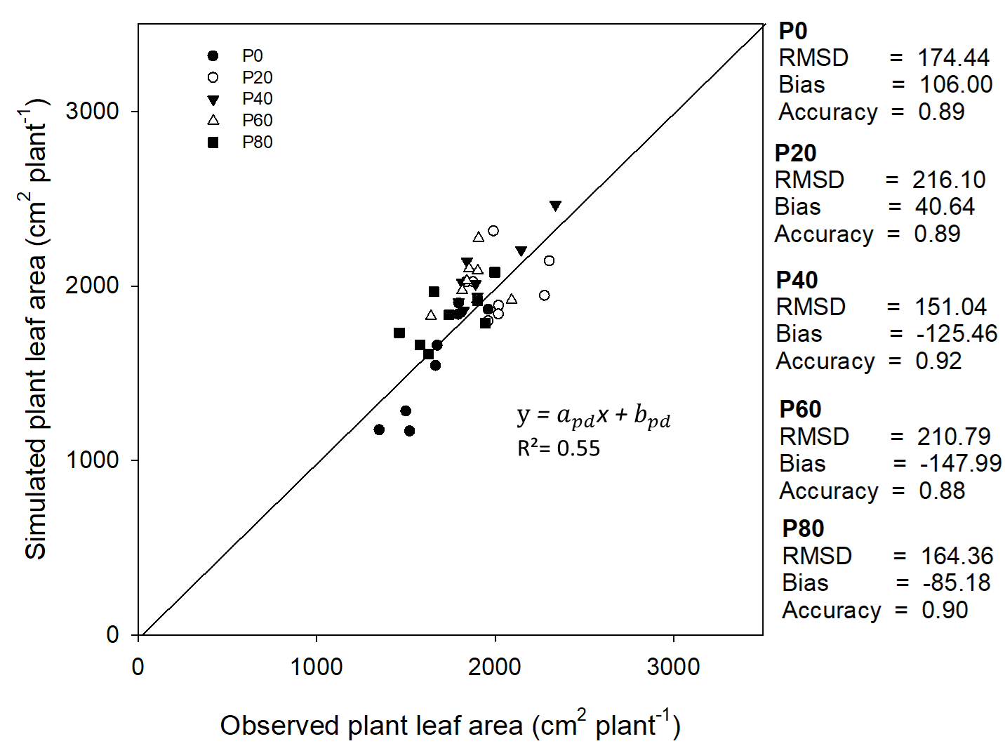
Figure 9. Observed and simulated plant leaf areas of tomato under drought-stressed conditions at different proline concentrations. The regression parameters a_{pd} (0.9274) and b_{pd} (176.59 cm² plant⁻¹) represent the slope and intercept, respectively, of the regression model for plant leaf area under drought stress.

3.2.2 Shoot dry weight
The agreement between observed and simulated shoot dry weight was evaluated against the 1:1 line (Figure 10). Under well-watered conditions, the model showed approximately19% of underestimation (regression coefficient = 0.81) with an overestimated initial value (intercept = 4.654), indicating a slight systematic bias at lower biomass values. The coefficient of determination was low (R² = 0.42), indicating a moderate level of agreement between observed and simulated values. This trend is in line with results observed for the plant leaf area, which also showed overall underestimation. There was only a marginal difference in the magnitude of errors in estimated shoot dry weight under well-watered conditions than drought conditions (RMSD = 1.60 vs 1.53, Bias = -0.44 vs 0.15). Lower goodness of fit (lower R² value) compared to plant leaf area may be attributed to more sources of errors, apart from uncertainty in simulated leaf area, in parameter estimation (here, specific shoot mass) of the allometric relationship generated from Experiment 1. Despite relatively low R² values (0.42 under well-watered conditions and 0.56 under drought-stressed conditions), the model adequately captured the overall trend of shoot dry weight variation across treatments. The improved performance under drought stress was reflected in a higher R² and reduced systematic bias compared to well-watered conditions. The observed variability in model performance indicates that uncertainties in biomass partitioning contributed more to prediction error than leaf area simulation.
The slope value of around 1 and the intercept values close to zero indicate an almost perfect alignment (1:1 line) of simulated values with observed ones. With separate evaluations for different proline levels under well-watered conditions, RMSD values ranged from 0.91 to 2.26, bias from −0.70 to 0.33, and accuracy from 0.89 to 0.96. The best performance was observed at 60 ppm proline, with the lowest RMSD (0.91) and highest accuracy (0.96) (Table 1).
Under drought-stressed conditions, the model maintained an acceptable predictive performance, with RMSD values ranging from 0.85 to 2.21, bias from −1.07 to 2.02, and accuracy from 0.85 to 0.94. The best performance was observed in the high proline level (80 ppm), with an RMSD of 0.85 and an accuracy of 0.94 (Table 1).
Overall, the model performed slightly better under drought-stressed conditions than under well-watered conditions in predicting shoot dry weight, as reflected by higher R² values, a perfect slope, and lower estimation errors. The relatively low coefficient of determination (R²) can be attributed to the combined analysis of data from both well-watered and drought-stressed conditions, which increased the overall variability in the dataset and reduced the strength of the global regression fit. In contrast, the evaluation metrics calculated at individual proline levels showed lower prediction errors (RMSD) and higher agreement between observed and simulated values, resulting in higher accuracy values. This indicates that while the overall model fit is moderate when all treatments are pooled, the model performs more consistently within specific proline concentration levels.

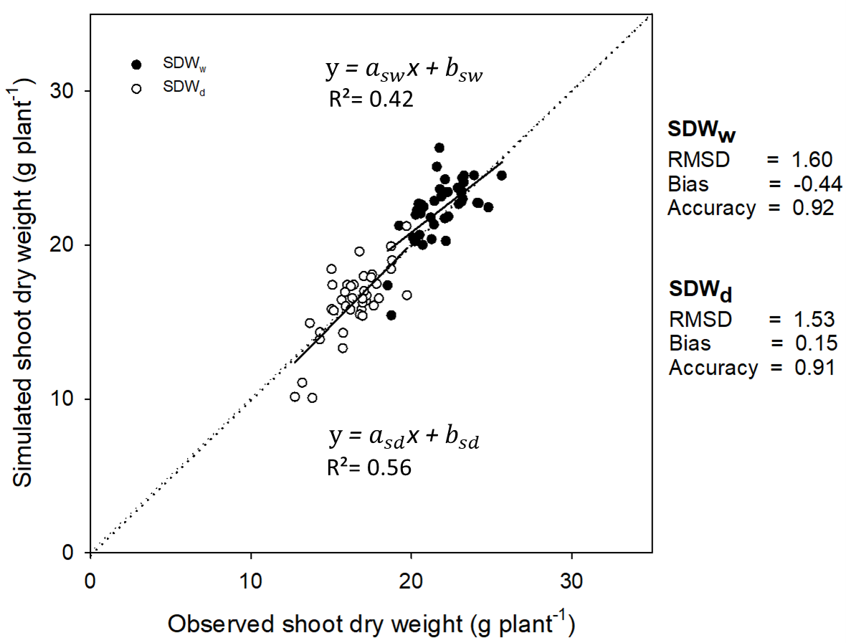
Figure 10. Model performance for shoot dry weight under well-watered and drought-stressed conditions. The regression parameters for well-watered conditions were a_{sw} 0.807 (slope) and b_{sw} 4.654 g plant⁻¹ (intercept), while those for drought-stressed conditions were a_{sd} 1.062 (slope) and b_{sd} -1.179 g plant⁻¹ (intercept)

Table 1. Evaluation of model performance for shoot dry weight of tomato at each level of proline concentration under well-watered and drought-stressed conditions
Proline  (ppm) | Shoot dry weight
Proline  (ppm) | Well – watered |  |  |  | Drought – stressed
Proline  (ppm) | RMSD | Bias | Accuracy |  | RMSD | Bias | Accuracy
0 | 1.72 | -0.28 | 0.91 |  | 2.21 | 2.02 | 0.85
20 | 1.44 | -0.19 | 0.93 |  | 0.42 | 0.15 | 0.91
40 | 2.26 | -1.39 | 0.89 |  | 1.61 | -1.07 | 0.90
60 | 0.91 | -0.70 | 0.96 |  | 1.19 | -0.36 | 0.92
80 | 1.36 | 0.33 | 0.94 |  | 0.85 | 0.04 | 0.94

5. Conclusion
This study evaluated the effects of proline application on drought response of leaf expansion rate, developed a growth model of tomato for varying levels of proline sprays under progressive soil drying conditions, and evaluated its predictive performance for leaf area and shoot dry weight. The linear–plateau regression model described quite well the drought response of relative leaf expansion rate to fraction of transpirable soil water at each level of proline sprays. Different levels of exogenous proline sprays influenced both the breakpoint and the intensity of decline in leaf expansion rate. Moderate proline concentrations (i.e. 20–40 ppm) reduced the breakpoint from 0.75 (control) to 0.49-0.50, bringing about the delayed onset of drought response, while higher concentrations (60–80 ppm) resulted in more gradual reductions in plant growth (i.e leaf expansion), as indicated by higher break point values (0.62- 0.64) and lower slope values (1.18–1.20).
Model validation demonstrated a good predictive performance of the model across all treatments. High prediction accuracy was exhibited by the ranges of 0.88 to 0.96 for plant leaf area and 0.85 to 0.95 for shoot dry weight. Separate evaluation for specific proline levels revealed that the model performed slightly better under well-watered conditions than under drought-stressed conditions, possibly attributed to the increased complexity of plant physiological responses and interaction between proline levels and drought adaptation mechanisms.
5. Recommendation
Overall, the model currently provides a framework for predicting tomato growth and dry matter production in response to drought stress under varying levels of proline application. To improve goodness-of-fit and prediction accuracy, further work on the calibration of parameters and structural adjustment (e.g., hyperbolic curve, effect of proline), inputs of additional ambient and soil factors influencing the rate of soil water decline and soil water threshold (e.g., vapour pressure deficit, soil water potential, osmotic potential) are needed.

Acknowledgments
The authors acknowledge the Department of Horticulture, Yezin Agricultural University, for research facilities, and the committee members for their valuable guidance and support.

Competing Interests
The authors declare that they have no competing interests.

Authors' Contributions

ZSTN and SSM conceived and designed the study. ZSTN conducted the experiments and collected the data. ZSTN and SSM analyzed the data, developed the model, and prepared the manuscript. WWL and PEEK reviewed and approved the final manuscript.

Disclaimer (Artificial intelligence)

Author(s) hereby declare that NO generative AI technologies such as Large Language Models (ChatGPT, COPILOT, etc.) and text-to-image generators have been used during the writing or editing of this manuscript.

6. References
Alkahtani, M. D., Attia, K. A., Hafez, Y. M., Khan, N., Eid, A. M., Ali, M. A., & Abdelaal, K. A. (2021). Chlorophyll fluorescence parameters and antioxidant defense system as indicators of drought tolerance in tomato (Solanum lycopersicum L.) under proline application. Saudi Journal of Biological Sciences, 28(12), 7036–7044.
Arie, T., Takahashi, H., Kodama, M., & Teraoka, T. (2007). Tomato as a model plant for plant-pathogen interactions. Plant Biotechnology, 24(1), 135–147.
Ashraf, M., & Foolad, M. R. (2007). Roles of glycine betaine and proline in improving plant abiotic stress resistance. Environmental and Experimental Botany, 59(2), 206–216.
Blum, A. (1999). Towards standard assays of drought resistance in crop plants. In J. M. Ribaut & D. Poland (Eds.), Molecular approaches for the genetic improvement of cereals for stable production in water-limited environments (pp. 29–34). CIMMYT.
Blum, A. (2017). Osmotic adjustment is a prime drought stress adaptive engine in support of plant production. Plant, Cell & Environment, 40(1), 4–10.
Boggess, S. F., Stewart, C. R., Aspinall, D., & Paleg, L. G. (1976). Effect of water stress on proline synthesis from radioactive precursors. Plant Physiology, 58(3), 398–401.
Boote, K. J., Jones, J. W., & Hoogenboom, G. (2013). Incorporating stress tolerance traits into crop models. Crop Science, 53(3), 1–15.
Bray, E. A. (1997). Plant responses to water deficit. Trends in Plant Science, 2(2), 48–54.
Claussen, W. (2005). Proline as a measure of stress in tomato plants. Plant Science, 168(4), 241-248.
Claeys, H., & Inzé, D. (2013). The agony of choice: How plants balance growth and survival under water-limiting conditions. Plant Physiology, 162(4), 1768–1779.
Dai, A. (2012). Increasing drought under global warming in observations and models. Nature Climate Change, 3(1), 52–58.
Elewa, T. A., Sadak, M. S., & Saad, A. M. (2017). Proline treatment improves physiological responses in quinoa plants under drought stress. Bioscience Research, 14(1), 21–33.
Guoting, L., Jie, L., & Jin, G. (2020). Effects of drought stress on photosynthetic and physiological parameters of tomato. Journal of the American Society for Horticultural Science, 145(1), 12–17.
Heuer, B. (2003). Influence of exogenous application of proline and glycinebetaine on growth of salt-stressed tomato plants. Plant Science, 165(4), 693–699.
Hsiao, T. C. (1973). Plant responses to water stress. Annual Review of Plant Physiology, 24, 519–570.
Iyer, S., & Caplan, A. (1998). Products of proline catabolism can induce osmotically regulated genes in rice. Plant Physiology, 116(1), 203–211.
Jones, H. G. (1981). Plants and microclimate: A quantitative approach to environmental plant physiology. Cambridge University Press.
Kahlen, K., & Stützel, H. (2011). Modelling photosynthesis of rosette plants: An individual leaf approach. Functional Plant Biology, 38(3), 187–196.
Kahlaoui, B., Hachicha, M., Rejeb, S., Rejeb, M. N., Hanchi, B., & Misle, E. (2014). Response of two tomato cultivars to field-applied proline under irrigation with saline water: Growth, chlorophyll fluorescence and nutritional aspects. Photosynthetica, 52(3), 421–429.
Khan, A., Khan, M. I., & Aslam, M. (2015). Tomato (Solanum lycopersicum L.) as a model crop in plant biology research. International Journal of Agriculture and Biology, 17(5), 857–864.
Kobayashi, K., & Salam, M. U. (2000). Comparing simulated and measured values using mean squared deviation and its components. Agronomy Journal, 92(2), 345–352.
Levitt, J. (1980). Responses of plants to environmental stresses, Volume II: Water, radiation, salt, and other stresses (2nd ed.). Academic Press.
Li, H., Liu, Y., Zhen, B., Lv, M., Zhou, X., Yong, B., Niu, Q., & Yang, S. (2024). Proline Spray Relieves the Adverse Effects of Drought on Wheat Flag Leaf Function. Plants, 13(7), 957. https://doi.org/10.3390/plants13070957
Ludlow, M. M., & Muchow, R. C. (1990). A critical evaluation of traits for improving crop yields in water-limited environments. Advances in Agronomy, 43, 107–153.
Marcelis, L. F. M., Heuvelink, E., & Goudriaan, J. (2008). Modelling biomass production and yield of horticultural crops: A review. Scientia Horticulturae, 74(1–2), 83–111.
Morgan, J. M. (1984). Osmoregulation and water stress in higher plants. Annual Review of Plant Physiology, 35(1), 299–319.
Myint, S. S., Moualeu-Ngangue, D. P., & Stützel, H. (2022). Modelling Morphological and Physiological Responses of Tomato Introgression Lines to Drought Stress [Doctoral dissertation, Leibniz Universität Hannover].
Ray, J. D., & Sinclair, T. R. (1997). Stomatal conductance of maize hybrids in response to drying soil. Crop Science, 37, 803–807.
Ray, J. D., & Sinclair, T. R. (1998). The effect of soil water status on plant water balance of four tropical grain legumes. Field Crops Research, 57(2), 155–163.
Sadras, V. O., & Milroy, S. P. (1996). Soil-water thresholds for the responses of leaf expansion and gas exchange: A review. Field Crops Research, 47(2–3), 253–266.
Sairam, R. K., Veerabhadra Rao, K., & Srivastava, G. C. (2002). Differential response of wheat genotypes to long term salinity stress in relation to oxidative stress, antioxidant activity and osmolyte concentration. Plant Science, 163(5), 1037–1046.
Sinclair, T. R., & Ludlow, M. M. (1986). Influence of soil water supply on the plant water balance of four tropical grain legumes. Australian Journal of Plant Physiology, 13(3), 329–341.
Smirnoff, N., & Cumbes, Q. J. (1989). Hydroxyl radical scavenging activity of compatible solutes. Phytochemistry, 28(4), 1057–1060.
Soltani, A. (2012). Mathematical modeling in plant biology. Springer.
Soltani, A., & Sinclair, T. R. (2012). Modeling physiology of crop development, growth and yield. CAB International.
Szabados, L., & Savouré, A. (2010). Proline: A multifunctional amino acid. Trends in Plant Science, 15(2), 89–97.
Tesfaye, S. G, Ismail, M. R., Ramlan, M. F., Marziah, M., Kausar, H. (2014). Effect of soil drying on rate of stress development, leaf gas exchange and proline accumulation in Robusta coffee (Coffea canephora pierre ex froehner) clones. Experimental Agriculture, 50(3):458-479 doi:10.1017/S001447971300063X
Torres-Ruiz, J. M., Díaz-Espejo, A., & Fernández, J. E. (2015). Role of hydraulic and chemical signals in leaves under drought stress. Journal of Experimental Botany, 66(10), 2939–2948.
Verslues, P. E., & Sharma, S. (2010). Proline metabolism and its implications for plant-environment interaction. The Arabidopsis Book, 8, e0140.

