Cluster-Based Demonstration of Potato variety (Belete),at Goriche woreda in Sidama Region, Ethiopia.

Abstract
Potato is one of the important root crops contributing to income, food security, and nutrient security for smallholder farmers in Ethiopia. But its production potential is hindered by inappropriate usage of the package, lack of improved tuber seed, and limited extension information. Hence, this study was implemented to demonstrate potato technologies, assess farmers’ feedback, and evaluate farmer tuber yield performance. From Goriche woreda purposively selected Moranicho Goriche kebele based on production potential, land availability (adjacent farmland up the planned 5.5 hectares), willingness of the farmers to implement full package of technology, sharing of input cost and sharing their knowledge to other farmers with collaboration of Woreda and Kebele agricultural experts.Total,25 host farmers were selected. Demonstration started with providing awareness-creation training for farmers and agricultural experts. Necessary inputs were accessed from Hawassa Agricultural Research Center and host farmers through cost-sharing. Specifically, 18000kg of potato tuber, 235kg of NPS, and 150kg of Urea fertilizer were used per hectare. Mancozeb was applied to treat late blight. At the maturity stage, a field day was conducted with media coverage. Data on farmers' feedback and tuber yield was collected. Data were analyzed through descriptive statistics and a qualitative method. Farmers positively perceived the demonstration results, particularly the outstanding traits of the variety 'Belete' and the effect of the package on tuber yield. The average tuber yield of the variety was 42.95 tons per hectare. The results implied that farmers were able to double their potato tuber yield by appropriately applying recommended packages with quality tuber seed. Hence, the demonstrated potato packages need to be scaled up within the demonstrated area and beyond, to similar agro-ecologies
Key words: Cluster, Demonstration, Farmer, full package, potato, Variety-belete.

- Background and justification
Potato (Solanum tuberosum L.) originated in the central highlands of the Andes in South America and arrived in Europe in the 16th century. It is the world’s fourth most widely grown food crop after wheat, rice, and maize (Milkias & Keba, 2021). Potatoes are grown at high elevations in tropical nations such Egypt, Sudan, Kenya, and Ethiopia (Chandio et al., 2022; Scott, 2021). Potato prefers altitudes of 1500-4200 meters and temperatures of 18-20°C for optimal growth and output (Aloo, 2021). Potatoes may grow in a deep, well-drained, friable environment with a pH range of 5 to 6.5 (Mugo et al., 2021).
The potato significantly supports global food security, nutrition, and healthy diets for millions of households and for creating diversified agri-food systems (Devaux et al., 2021; Wijesinha-Bettoni and Mouille, 2019). In many developing countries, including Ethiopia, where rapid population growth, shrinking arable land, and climate change are critical challenges to food security, potatoes emerge as a strategic crop. Potatoes are particularly valuable because they yield more food per unit of land compared to other staple crops (Mijena et al., 2022; Devaux et al., 2021).
Ethiopia has significant potential for potato farming. About 70 percent of its arable land, mainly highland areas above 1500 meters in altitude, is suitable for cultivation. This, along with its domestic consumption levels, positions the country as one of the major potato producers in Eastern Africa (Milkias & Keba, 2021). The crop commonly called as "hunger breaking crop" because it can be harvested when cereals are not yet ready or when other crops fail (Kolech et al., 2015).
The crop also has great potential for boosting food security, raising household income, and lowering poverty by offering essential nutrients (FAO, 2008). As a result, the Government of Ethiopia appreciates potatoes as a strategic commodity for food security (Milkias & Keba, 2021).
Although the Ethiopian government has begun to recognize the potential of potatoes and is placing more emphasis on its development through initiatives like the Agricultural Growth Program (AGP) and national seed system strategies meant to improve productivity and market access, Smallholder farmers continue to face major obstacles that keep them from fully benefiting from potato production (Haile et al., 2022).
Among them, suppressing challenges are lack of quality potato seed and susceptibility of landrace to pests and disease due to limited availability and unaffordability of certified seed (Abebe et al., 2022; Hirpa et al., 2010; Lemma & Bekele, 2023). The challenges are expressed by inadequate access to essential agricultural inputs such as fertilizers and pesticides, leading to nutrient deficiencies and increased pest and disease pressure (Tiruneh et al., 2024).On other hand low potato productivity emanated from factors such as inaccessibility of farmer training on basic agronomic practices of potato production (Hirpa et al., 2010; Lemma & Bekele, 2023). Resistance of farmers to adopting recommended agronomic practices, and packages are often due to limited access to timely and effective extension services (Haile et al., 2023; Tiruneh et al., 2024). These interconnected potato production challenges, combined with limited access to information on improved potato varieties and the application of inadequate technology packages, inhibit smallholders from achieving optimal potato tuber yields.
FSRP needs assessment survey in 2024 by Hawassa Agricultural Center revealed that while farmers in the Sidama region, particularly in Gorche woreda, widely produce potatoes but they face significant production problems. These include a shortage of improved potato seed, lack of specific agronomic practices training, inappropriate usage of the potato production package, and susceptibility of potato to pests and diseases. The overall effect of these production challenges has hindered the realization of potato's production potential for smallholder farmers. Therefore, this cluster-based demonstration of a potato production package was implemented to demonstrate and popularize potato production technology packages, assess farmers' feedback on these technologies, and evaluate on-farm potato yield performance.
- MATERIALS AND METHODS

2.1. Site and participating farmers’ selection
To implement the potato demonstration, Gorche Woreda was purposively selected based on previously identified community demand for potato technology to solve farmers’ production challenges. Before the selection of demonstration sites (kebeles), a discussion was held at the woreda level regarding the objectives, expected outputs, and potato technologies to be demonstrated. Then, the demonstration kebele (MuranchoGorche) was purposively selected, considering its potato production potential and accessibility (land and road).
Also, at the kebele level, further discussion was held to select the demonstration cluster. Then, in cooperation with development agents and woreda crop experts, and taking due consideration of representativeness and background experience in potato production, demonstration clusters were selected. Regarding the cluster implementation principle, farmers with adjacent land within the selected clusters were chosen as host farmers to achieve the planned land size for the demonstration. As a result, 25 farmers were selected to implement the potato demonstration on 5.5 hectares

2.2. Implementation procedures
Implementation of the demonstration started with an awareness-creation training attended by the selected cluster farmers, development agents from the selected Kebele, and supporting experts and coordinators from the Woreda gricultural office.
Also, Input access was facilitated through a cost-share approach. Accordingly, 100 quintals of the improved potato variety (Belete) seed rate 1800kg/ha and the awareness-creation training and Mancozeb were provided by the research center. Land preparation and fertilizer procurement were carried out by the host farmers.
Regarding agronomic practices, land preparation was repeated three times before planting. Planting was done in rows with split application of fertilizer. Fertilizer rate 235kg NPS and 150kg UREA per hectar, so that 235 kilograms of NPS and split application 50 kilograms of urea were applied at planting, and the remaining 100 kilograms of urea were applied after 35 days. Spacing:- 75*30cm b/n row and plant respectively.

2.3. Monitoring and Evaluation,
Responsibility for the demonstration was managed through a shared approach among researchers, farmers, and extension personnel at the woreda level. Accordingly, monitoring and supervision of the demonstration were done by multidisciplinary team of researchers from the research center every 15 days. Additionally, development agents and woreda extension collaborated weekly to monitor and supervise the demonstration field and provided feedback to farmers for field management.
  - Method of data collection and analysis

Data collection tasks employed both surveying households’ opinions and directly measuring sample potato root yield. Specifically, farmers’ feedback and perception data were collected from individual farmer interviews during field visits and from mass farmers and other stakeholders during field day sessions. Root yield data were collected from selected sample farmers’ fields by randomly selecting a 2x2 meter sample area twice from each potato field. Then attached soil was removed by washing, and the cleaned potato root yield was measured using a hand-held kilogram scale.

Data analysis was done using both qualitative and quantitative methods, depending on the nature of the collected data. Accordingly, analysis of farmers’ feedback was conducted quantitatively by summarizing and explaining it within separate themes. Root yield data were analyzed using descriptive statistics, particularly the mean, median, maximum, and minimum potato root yield.

3. RESULT AND DISCUSSION

3.1. Demonstration and Communications of Potato technology packages

3.1.1. Training of Beneficiary farmers and development agents
At the starting point of the demonstration's implementation, training was provided to selected farmers, Development Agents (DAs), and experts from the Woreda Agriculture and Natural Resource Development office. The training covered agronomic practices, objectives, and the importance of the full package and cluster-based demonstration approach. Researchers and other stakeholders (including administrative members) also participated in the training (table1).
Table-1 participant list of training
Location | Participant list in training
Gorche | Farmer |  |  | Agri- experts |  |  | Researchers |  |  |  | Other officers |  |  |  | Total
Gorche | M | F | Total | M | F | Total |  | M | F | Total |  | M | F | Total |  | M | F | Total
Gorche | 25 | - | 25 | 5 | - | 5 |  | 7 | 1 | 8 |  | 2 | 1 | 3 |  | 39 | 2 | 41
Source: field data (20250

3.1.2. Field day and field visit
To effectively popularize the technology, foster broader communication, and thereby enhance the adoption rate of the demonstrated potato technology, a field day was organized. The field day mainly targeted to facilitate the dissemination of information across a wider geographical area, identify future research directions, and smoothly transition (or hand over) the responsibility for expanding demonstration skills and knowledge to concerned stakeholders from the implementing research center.
To operationalize these objectives, the field day event engaged both direct participants (who visited the demonstration field) and indirect participants (who received information through media). The field day involved the inclusive participation of diverse stakeholders, ranging from regional-level officials to kebele-level representatives and researchers (Table 2), all of whom conducted direct visits to the demonstration fields.
Furthermore, to ensure information reached farmers and other stakeholders who were unable to participate in or directly visit the demonstration field, media coverage was employed, involving the Sidama Broadcast Corporation (SBC). For technologies to be widely adopted, initial awareness is paramount.
Table-2 participant list in field day
Location | Participant lists |  |  |  |  |  |  |  |  |  |  |  | Total
Gorche | Farmers |  |  | Agri-experts |  |  | Researchers |  |  | Other officers |  |  | Total
Gorche | M | F | Total | M | F | Total | M | F | Total | M | F | Total | Total
Gorche | 47 | 27 | 74 | 14 | 2 | 16 | 13 | 3 | 16 | 20 | 3 | 23 | 129
Source: field data (2025)
Fig_1: field day photo

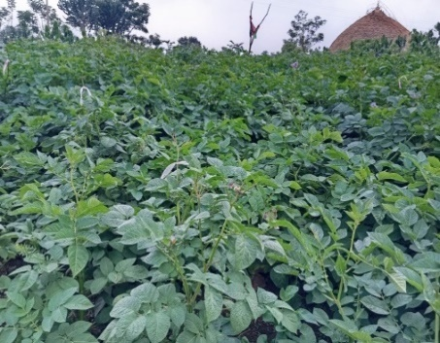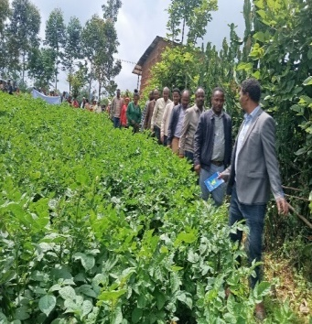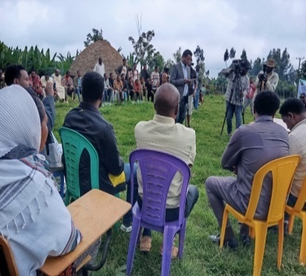 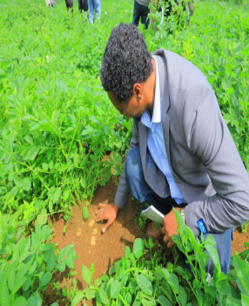
3.2. Evaluation of on farm tuber yield performance of potato Technologies
The demonstration of the Belete potato (variety) package showcased tuber yield performance in Gorche woreda Murachon Gorche kebele. The average yield recorded across the demonstration plots was 42.95 tons per hectare (t/ha), with estimable range from a minimum of 37.25 t/ha to a maximum of 44.75 t/ha (Table 3). The relatively low standard deviation of 4.2 t/ha indicates a consistent high performance across the different demonstration plots.
This performance could be resulted from the intensive technical support provided by researchers and extension personnel. Their intervention assisted the appropriate operationalization of recommended full packages, optimal agronomic practices, and careful input usage. Specifically, this included the use of quality seed tubers, balanced fertilizer (NPS and Urea) recommended application rate, timely land preparation, correct planting density, proper weeding, and effective pest and disease management (such as the use of Mancozeb to prevent late blight). Such integrated management, closely supervised and adapted to local conditions, allowed the Belete variety to express its full genetic potential, which is rarely achieved under typical smallholder conditions due to various constraints.
The findings emphasise the immense potential for significantly boosting potato productivity and, consequently, may contribute to enhancing food security and farmer income in the demonstration location and the Sidama region as a whole. It emphasizes that with targeted technical support, access to appropriate inputs, and appropriate application of improved agronomic practices, even well-yielding potato varieties like Belete can achieve yields comparable to research station levels on smallholder farmers' fields, thereby effectively bridging the existing tuber yield gap. In fact, Fantaw et al. (2019) reported that the released average tuber yield potential of the Belete variety was 47 and 33.8 tonnes per hectare on research fields and on farms, respectively. Additionally, the authors pointed out that the Belete variety has larger tuber size, which may be a good means to obtain better market value and returns for farmers, and it is comparably good in all other studied traits. Hence, it is recommended for the area and similar agro-ecologies. A finding by Seid and Tessema (2024) indicated that the average tuber yield performance of the Belete variety was 42.68 tons per hectare in research fields.
Table-3 yield performance
District | Kebele | variety | tuber yield in ton per hector
District | Kebele | variety | Mean | Std .dev. | Max | Min
Gorche | MuranchoGorche  (n=10) | Belete | 42.95 | 4.2 | 44.75 | 37.25
Source: field data (2025)
Fig 2: potato yield
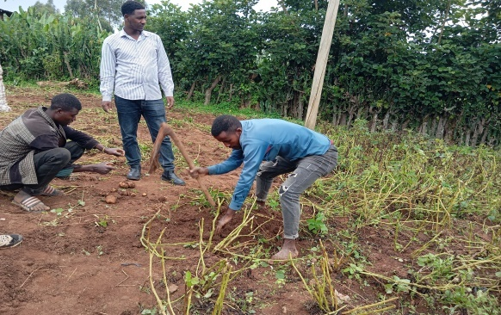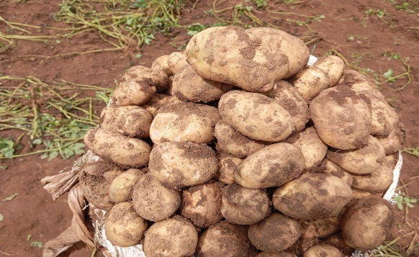

3.3. Stakeholder Feedback, Implementation Challenges and Lessons Learned on Potato Technologies and Cluster Approach

3.3.1. Feedback Given on potato Technologies

Farmers expressed that this demonstration of potato technologies and applied approaches was practically proven as a means of increasing production and productivity for smallholder farmers. They highlighted that operationalizing the full packages is what accounted for this showcase productivity in the same fields that were previously cultivated using usual agronomic practices. Besides they pointed that the outstanding field performance of potato resulted not only from the full package of agronomic practices used, but also from the demonstrated potato variety's good traits, including high tuber yielding potential, disease and pest resistance, and excellent adaptation to the demonstrated agro-ecologies.
Also, according to extension staff expression, this cluster-based demonstration opened the door for farmers to implement full-package applications to boost potato productivity. In addition, they suggested that the established FREG (Farmer Research Extension Group) model allowed for shared responsibility and provided feedback on any issues needing adjustment in the demonstration field. They added that to maintain these results and further raise agricultural output, careful consideration would be given to strengthening this link among research, farmers, and extension.

3.3.2. Challenges Faced During Demonstration Implementation
Implementation of the demonstration tasks in general, and particularly of cluster-based large-scale demonstrations, usually may face challenges due to the bulkiness of tasks required to cover wide areas and reach diverse stakeholders. Particularly, this cluster-based demonstration faced two main challenges before and during implementation. Firstly, there was a lack of access to quality potato seed from cooperatives or other formal organizations in and around the Sidama region. The second challenge was an outbreak of late blights in the demonstration fields; however, the activity supported by FSRP on other hand PIM did not allow chemical purchases from its budget.

3.3.3. Lesson learned for Future Demonstration Research
Although the aforementioned problems challenged the demonstration activity, outstanding performance was obtained by communicating with different research centers to acquire quality potato seed. Accordingly, Holeta Agricultural Research Center identified farmers’ cooperatives in its surrounding area that could supply quality seed. Also, purchase of the fungicide “Mancozeb” was made by strategically identifying alternative budget sources.
Thus, as a lesson for future demonstration activities, proactive partnership-building, pre-arranged seed sources, contingency financing, and integrated disease preparedness are essential to successfully achieve large-scale demonstration goals. Institutionalizing these measures will reduce vulnerability to supply and pest/disease shocks and help sustain large-scale demonstration performance on smallholder fields.

4. Conclusion and Recommendation
This cluster-based demonstration of potato was implemented to enhance the adoption rate of the full package of practices among smallholder potato producers in the Sidama region generally and at Gorche woreda particularly. To achieve this ultimate goal, strategies included awareness creation and showcasing its results to both direct and indirect participant farmers, utilizing case-dependent communication channels. Providing practical awareness creation training and creating communication platforms among farmers and concerned stakeholders via field visits and field days is an influential agricultural technology transfer tool, thereby improving the productivity of smallholder farmers.
Farmers in the demonstration area have been losing half of their possible potential potato tuber harvest volume due to their failure to operationalize recommended full packages and appropriate agronomic practices. However, smallholder farmers were able to produce a potential tuber yield of potato nearly comparable to the harvest volume from research fields by improving agronomic practices and appropriately applying recommended production packages. Regarding the cluster-based demonstration of potato technology packages, the improved total tuber yield harvested on-farm 42.9 t/hawhich wasreached nearly 91.4% of the 'Belete' variety's potential tuber yield as indicated at its release.
Therefore, agricultural extension personnel in Gorche Woreda and similar agro-ecologies in Sidama Region and beyond need to scale up the demonstration results by providing awareness training before activity implementation and by creating communication platforms for farmers to share experiences, thereby improve the potato tuber harvest volume of smallholder farmers within their existing land.
Seed enterprises should give due consideration to options for accessing quality potato seed to farmers. This can be achieved by establishing new potato-multiplying farmers’ cooperatives or by granting existing farmers’ cooperatives the mandate for potato tuber seed multiplication. Such measures would ensure that every potato producer in the region has access to quality potato tuber seed in their surroundings and in the required volume.
Disclaimer (Artificial intelligence)
Author(s) hereby declare that NO generative AI technologies such as Large Language Models (ChatGPT, COPILOT, etc.) and text-to-image generators have been used during the writing or editing of this manuscript.

References
- Aloo, B. (2021). Characterization of rhizobacteria and their formulation into biofertilizers for potato (solanum tuberosum l.) growth promotion in Tanzania (Doctoral dissertation, NM-AIST).
- Chandio, A. A., Gokmenoglu, K. K., Ahmad, M., & Jiang, Y. (2021). Towards sustainable rice production in Asia: the role of climatic factors. Earth Systems and Environment, 1-14.
- Devaux A, Goffart JP, Kromann P, et al.: The Potato of the Future: Opportunities and Challenges in Sustainable Agri-food Systems. Potato Res. 2021; 64: 681–720. PubMed Abstract|Publisher Full Text|Free Full Text
- Fantaw, S., Ayalew, A., Tadesse, D., G/Medhin, Z., & Agegnehu, E. (2019). Evaluation of potato (Solanum tuberosum L.) varieties for yield and yield components. Journal of Horticulture and Forestry, 11(3), 48-53.
- Haile, B., Ketema, T., &Mulualem, S. (2022). Government policies and their impact on potato value chain development in Ethiopia. Journal of Development and Agricultural Economics, × 14 ×(3), 134-148.
- Haile, B., Ketema, T., &Mulualem, S. (2023). Factors affecting potato productivity among smallholder farmers in Ethiopia. Journal of Agricultural Extension and Rural Development, × 15 ×(4), 345-354.
- Hirpa, A., Meuwissen, M. P. M., Tesfaye, A., Lommen, W. J. M., Oude Lansink, A., Tsegaye, A., & Struik, P. C. 2010. Analysis of seed potato systems in Ethiopia. American J. Potato Res. 87(6): 537-552.
- Lemma, T., & Bekele, A. (2023). Constraints and opportunities in potato seed system development in Ethiopia. African Journal of Agricultural Research, × 18 ×(17), 1609-1619.
- Milkias, D., & Keba, A. (2021). Potato Production and Marketing by Small Holder Farmers in Ethiopia፡ A Review Study. Journal of Natural Sciences Research, 12(16), 9-15.
- Mijena GM, Gedebo A, Beshir HM, et al.: Ensuring food security of smallholder farmers through improving productivity and nutrition of potato. J. Agric. Food Res. 2022; 10: 100400. Publisher Full Text
- Mugo, J. N., Karanja, N., Gachene, C., Dittert, K., & Schulte‐Geldermann, E. (2021). Response of potato to fertilizers applied on different soil types in Kenyan Highlands. Agronomy Journal, 113(6), 4793-4805.

- Scott, G. J. (2021). A review of root, tuber and banana crops in developing countries: past, present and future. International Journal of Food Science & Technology, 56(3), 1093-1114.
- Tiruneh, H., Wolde, Y., & Abebe, M. (2024). Determinants of potato yield among smallholder farmers in the central highlands of Ethiopia. African Crop Science Journal, × 32 ×(1),

