Attitude of Health Information Managers Towards Patients in Nigeria: Evidence from Three Selected Teaching Hospitals

Abstract
Background: Health Information Managers (HIMs) occupy a pivotal role in Nigeria's tertiary healthcare system, yet their attitudes towards patients remain understudied. This study assessed HIM attitudes and the factors shaping them across three major teaching hospitals.
Methods: A mixed-methods descriptive cross-sectional survey design was employed, integrating quantitative and qualitative data collection and analysis approaches. Data were collected from 300 HIMs across the University of Ilorin Teaching Hospital (UITH), Ahmadu Bello University Teaching Hospital (ABUTH), and Obafemi Awolowo University Teaching Hospital (OAUTH) using a validated structured questionnaire. Descriptive statistics, Pearson's correlation, multiple regression, Chi-square tests, and thematic analysis were applied.
Results: All 300 respondents (100%) self-reported positive attitudes; however, this finding should be interpreted cautiously given the well-documented potential for social desirability bias in self-report healthcare surveys. Technological resources were widely rated adequate and positively influenced attitudes. Training participation was moderate (mean frequency 2.50–2.80), yet 90–95% strongly believed that continuous professional development (CPD) improves attitude. A statistically significant association was found between communication practices and patient feedback frequency (χ² = 26.72, df = 16, p < 0.05). Qualitative analysis revealed three key themes: ethical breaches in confidentiality, systemic morale constraints, and aspirations for digital transformation.
Conclusion: Despite universally positive self-reported attitudes, underlying systemic, technological, and organisational challenges critically impair HIM service delivery. Integrated investment in ICT infrastructure, mandatory CPD, and patient-centred communication protocols is urgently recommended.

Keywords: Health Information Managers; Attitude; Patient-Centred Care; Nigeria; Teaching Hospitals; Electronic Health Records; Professional Development; Communication.

1. Introduction
Health Information Managers (HIMs) are fundamental custodians of patient data within healthcare institutions, responsible for the accurate acquisition, storage, retrieval, and protection of health records from creation through disposal. Their professional attitudes directly shape the quality, confidentiality, and accessibility of patient information variables that are inextricably linked to clinical decision-making and overall healthcare outcomes [1]. In Nigerian teaching hospitals, HIMs bridge administrative and clinical services, operating within particularly complex dual mandates of service delivery and clinical education.
Nigeria's three foremost teaching hospitals selected for this study the University of Ilorin Teaching Hospital (UITH) in Kwara State, Ahmadu Bello University Teaching Hospital (ABUTH) in Zaria, and Obafemi Awolowo University Teaching Hospital (OAUTH) in Ile-Ife represent the country's diverse regional healthcare landscape. These institutions collectively manage hundreds of thousands of patient records annually, making the attitudes of their HIM personnel a critical determinant of service quality [2, 3].
A growing body of literature identifies negative or indifferent HIM attitudes as a significant threat to healthcare quality. Such attitudes can compromise data confidentiality, delay information retrieval, and erode patient trust consequences that are acutely felt in low-resource settings where health systems are already strained [4]. Contributing factors include inadequate ICT infrastructure, insufficient continuous professional development (CPD), poor communication frameworks, high workloads, and limited managerial support [5, 6].
Despite these concerns, empirical studies specifically examining HIM attitudes within Nigerian tertiary hospitals remain scarce. Existing literature largely treats attitudes as secondary variables rather than primary research objects, leaving a critical gap in context-specific evidence for policy and intervention [7]. This study addresses that gap through a mixed-methods investigation of HIM attitudes across UITH, ABUTH, and OAUTH, guided by theoretical frameworks including the Theory of Planned Behaviour (TPB) [8], Social Cognitive Theory (SCT) [9], and the Technology Acceptance Model (TAM) [10].
The study aimed to:
- evaluate the level of professionalism and patient-centredness among HIMs;
- identify factors influencing their attitudes;
- examine the relationship between technological resources, training, communication practices, and HIM attitudes; and
- propose actionable recommendations for improved service delivery across Nigerian tertiary healthcare institutions.

2. Materials and Methods

2.1 Study Design and Setting
A descriptive cross-sectional survey design was employed to collect data from HIMs in three purposively selected Nigerian teaching hospitals: UITH (North-Central Nigeria), ABUTH (North-West Nigeria), and OAUTH (South-West Nigeria). These institutions were selected based on their status as major referral centres and the existence of documented challenges related to health information management. The study targeted HIMs directly involved in patient health record management across all professional cadres, from entry-level Records Officers to departmental heads.

2.2 Sample Size and Sampling
A multi-stage sampling approach was applied. Purposive sampling selected the three hospitals; stratified random sampling ensured representation across experience categories (0–5, 6–10, 11–15, >15 years) and professional cadres; and simple random sampling selected individuals within each stratum. A target sample of 100 HIMs per institution was set (300 total), consistent with typical staffing structures in large Nigerian teaching hospitals. All 300 questionnaires distributed were returned and analysed, yielding a 100% response rate.

2.3 Data Collection Instrument
A structured questionnaire titled 'Questionnaire for Health Information Professional/Personnel (HIP)' was developed and validated. It comprised six sections: Section A (demographics); Section B (overall attitude and attitudinal statements); Section C (professionalism and training); Section D (technological resources, training impact, communication, and ethics); Section E (impact on service delivery); and Section F (suggestions for improvement). Likert-scale items, dichotomous questions, and open-ended questions were included. Face and content validity were established by a panel of four experts (two HIM academics, one research methodologist, one senior clinician). Cronbach's Alpha reliability testing on a pilot sample (n=17) from a non-participating hospital yielded α > 0.70, confirming acceptable internal consistency.

2.4 Statistical Analysis
Quantitative data were analysed using SPSS version 26. Descriptive statistics (frequencies, percentages, means, standard deviations) summarised demographics and key variables. Pearson's Product-Moment Correlation tested Hypothesis 1 (H₀₁: technology and attitude). Multiple Regression Analysis examined Hypothesis 2 (H₀₂: training and attitude). Chi-square Test of Independence assessed Hypothesis 3 (H₀₃: communication and patient satisfaction). A p-value < 0.05 was the threshold for statistical significance. Qualitative open-ended responses underwent thematic content analysis following Braun and Clarke's framework [11], generating primary themes through iterative coding.

2.5 Ethical Considerations
Institutional ethical approvals were obtained from the Research and Ethics Committees of UITH, ABUTH, and OAUTH before data collection commenced. Participants were provided with an informed consent cover letter. Participation was voluntary and anonymous; no personally identifiable information was collected. All raw data were stored securely and will be retained for five years post-publication before secure disposal.

3. Results

3.1 Demographic Characteristics
Table 1 presents the demographic profile of the 100 UITH respondents, representative of the institutional sample structure. Across all three hospitals, the workforce was predominantly young: 63–73% fell within the 25–30 age bracket, and over 90% were aged 40 years or younger. Gender distribution was relatively balanced, with slight female majorities at UITH and ABUTH (62% and 60% female, respectively) and a male majority at OAUTH (60%). The most common educational qualification was a Bachelor's Degree (50–60% across hospitals). Experience was well-distributed, with a near-equal split between those with ≤10 years and those with >10 years of service.

Table 1: Demographic Profile of HIM Respondents at UITH (n=100)
S/N | Demographic Variable | Frequency (n=100) | Percentage (%)
 | Age Group
1 | 25–30 years | 73 | 73.0
2 | 31–35 years | 16 | 16.0
3 | 36–40 years | 8 | 8.0
4 | Above 40 years | 3 | 3.0
 | Gender
5 | Male | 38 | 38.0
6 | Female | 62 | 62.0
 | Highest Educational Qualification
7 | Diploma | 30 | 30.0
8 | Bachelor's Degree | 50 | 50.0
9 | Master's Degree | 15 | 15.0
10 | Doctorate | 5 | 5.0
 | Years of Experience
11 | 0–5 years | 15 | 15.0
12 | 6–10 years | 35 | 35.0
13 | 11–15 years | 20 | 20.0
14 | More than 15 years | 30 | 30.0

3.2 Self-Reported Attitudes Towards Patients
A striking and consistent finding emerged across all three institutions: 100% of respondents rated their overall attitude towards patients as positive. At UITH, 65% rated themselves 'Very Positive' (Mean=4.65, SD=0.48); ABUTH recorded 60% 'Very Positive' (Mean=4.60, SD=0.49); and OAUTH mirrored UITH at 65% 'Very Positive' (Mean=4.65, SD=0.48). Neutral or negative ratings were absent at all sites (Table 2). HIMs also strongly agreed with statements regarding treating patient information with respect and dignity, maintaining confidentiality, and feeling motivated to deliver timely information (combined mean range: 4.50–4.83).

Table 2: Overall Self-Reported Attitude Towards Patients Across All Three Hospitals
Attitude Rating | UITH (%) | ABUTH (%) | OAUTH (%)
Very Positive | 65.0 | 60.0 | 65.0
Positive | 35.0 | 40.0 | 35.0
Neutral | 0.0 | 0.0 | 0.0
Negative | 0.0 | 0.0 | 0.0
Very Negative | 0.0 | 0.0 | 0.0
Mean (SD) | 4.65 (0.48) | 4.60 (0.49) | 4.65 (0.48)

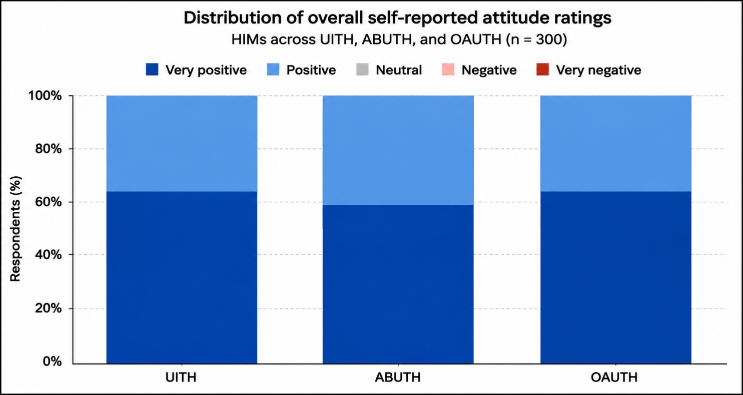
Figure 1. Distribution of Overall Self-Reported Attitude Ratings Among HIMs Across the Three Teaching Hospitals (n=300). All respondents reported positive attitudes.

3.3 Technological Resources and Influence on Attitude
At UITH, 90% of HIMs rated technological resources (EHR systems, computers, internet) as 'Adequate' (Mean=3.90, SD=0.30), with 100% reporting technology positively influenced their attitude towards patient information management (80% 'Positively', 20% 'Very Positively'; Mean=4.20). ABUTH showed a slightly lower adequacy rating (80% 'Adequate/Very Adequate'; Mean=3.80, SD=0.87), yet again 100% reported positive technological influence (Mean=4.28). At OAUTH, 85% rated technology adequate (Mean=3.85), and all respondents reported a positive influence (Mean=4.25). Despite these positive perceptions, qualitative responses at all three sites called for full Electronic Health Records (EHR) implementation, indicating that current infrastructure, while deemed functional, has not reached its optimal potential.

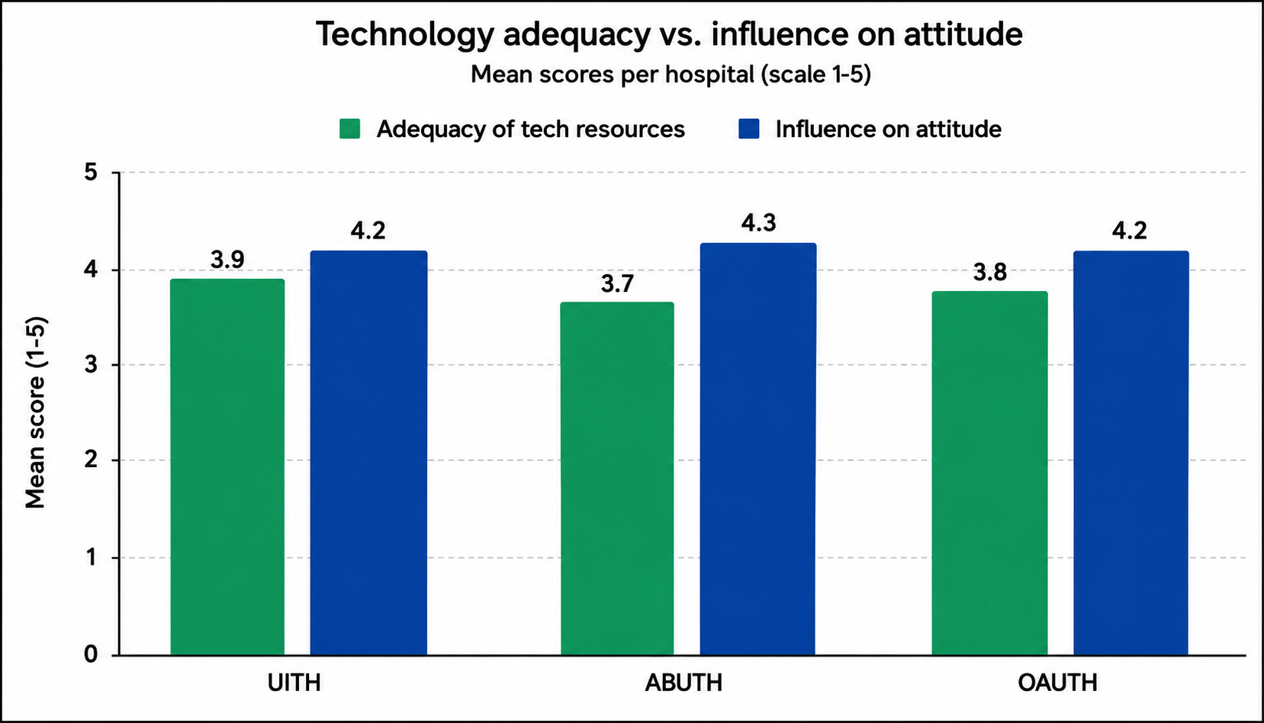
Figure 2. Comparison of Mean Adequacy Ratings of Technological Resources and Mean Scores for Influence of Technology on Attitude Across UITH, ABUTH, and OAUTH.

3.4 Training and Continuous Professional Development
While HIMs universally valued CPD, actual training participation was moderate. At UITH, 60% attended training 'Occasionally' (Mean=2.80); ABUTH reported 55% 'Occasionally' with 5% never attending (Mean=2.60); OAUTH had the lowest attendance, with 10% 'Never' and 30% 'Rarely' (Mean=2.50). Conversely, belief in the positive impact of CPD was overwhelming: 95% at UITH and OAUTH 'Strongly Agreed' that CPD improved their attitude (Mean=4.95), and 80% at ABUTH 'Strongly Agreed' (Mean=4.70). Table 3 summarises these training-related findings across all sites.

Table 3: Training Frequency and Belief in CPD Impact Across All Three Hospitals
Variable / Response | UITH (%) | ABUTH (%) | OAUTH (%)
Training Attendance Frequency
Never | 0.0 | 5.0 | 10.0
Rarely | 30.0 | 35.0 | 30.0
Occasionally | 60.0 | 55.0 | 60.0
Frequently | 10.0 | 5.0 | 0.0
Mean (SD) | 2.80 (0.63) | 2.60 (0.69) | 2.50 (0.70)
Belief that CPD Improves Attitude (%)
Strongly Agree | 95.0 | 80.0 | 95.0
Agree | 5.0 | 10.0 | 5.0
Neutral / Disagree | 0.0 | 10.0 | 0.0
Mean (SD) | 4.95 (0.22) | 4.70 (0.64) | 4.95 (0.22)

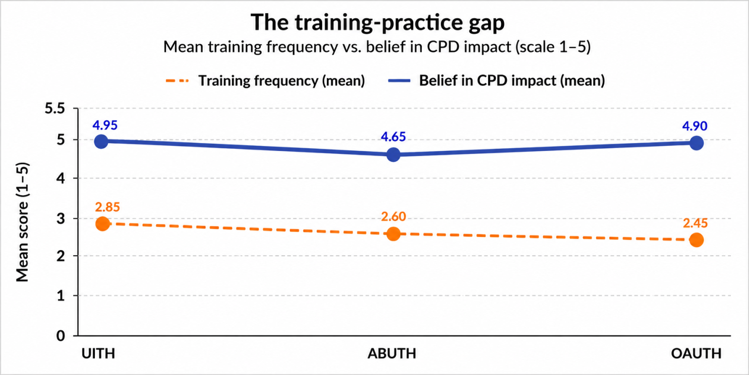
Figure 3. The Training-Practice Gap: Mean Training Frequency Compared with Mean Belief in the Positive Impact of Continuous Professional Development (CPD) Across the Three Teaching Hospitals.

3.5 Communication Practices and Patient Interaction
Direct patient communication was infrequent across all sites. At UITH, 60% of HIMs communicated with patients 'Rarely' and only 5% 'Often' (Mean=2.45); ABUTH showed 70% 'Rarely' (Mean=2.30); OAUTH reported 50% 'Rarely' (Mean=2.45). Despite this, communication effectiveness was rated highly 85–90% across institutions rated it 'Effective' or better. Patient feedback on health information management was similarly infrequent, with most respondents receiving it 'Rarely' to 'Sometimes' across all sites.

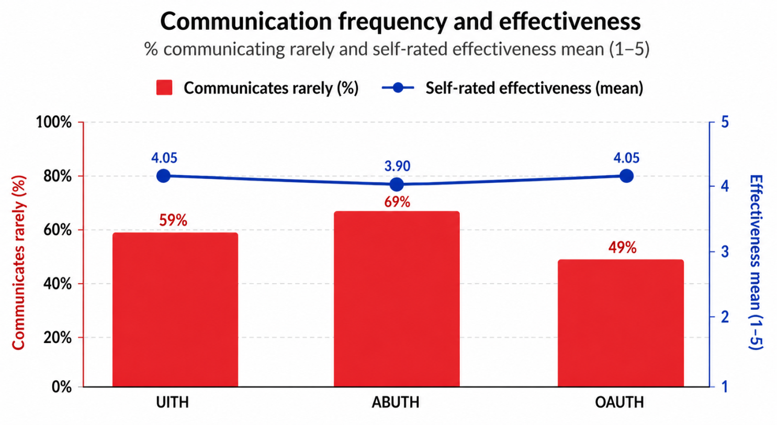
Figure 4. Direct Patient Communication Frequency (%) and Self-Rated Communication Effectiveness (Mean Score) Among HIMs at UITH, ABUTH, and OAUTH.

3.6 Ethical Considerations
Confidence in maintaining confidentiality was uniformly high: at UITH and OAUTH, 100% expressed confidence, with 50% and 25% respectively rating themselves 'Very Confident' (Mean=4.50). At ABUTH, 95% were confident (Mean=3.15, SD=0.56). Critically, a concrete ethical breach was reported at UITH disclosing a patient's genotype to a prospective spouse without her consent underscoring the gap between self-reported confidence and actual practice. At ABUTH and OAUTH, 100% of respondents reported no ethical dilemma encounters, though this may reflect under-reporting.

3.7 Hypothesis Testing
Table 4 summarises the results of all three hypothesis tests.

Table 4: Summary of Hypothesis Testing Results
Hypothesis | Statistical Test | Test Statistic | Critical Value | Decision
H₀₁: Technology & Attitude | Pearson Correlation (r) | r = −0.962; t = 3.522 | t-crit = 12.706 (df=1) | Fail to Reject H₀₁*
H₀₂: Training & Attitude | Multiple Regression Analysis | r(X₁Y) = −0.189; r(X₂Y) = 0.327 | r-crit = 0.997 (df=1) | Fail to Reject H₀₂*
H₀₃: Communication & Satisfaction | Chi-Square (χ²) | χ² = 26.7225 | χ²-crit = 26.296 (df=16) | Reject H₀₃ (p<0.05)
* Statistical failure to reject due to severely limited sample size (n = 3 hospitals for aggregated analysis). Descriptive and qualitative data indicate substantive practical relationships.

H₀₁ (technological resources and attitude) was not rejected (t-calc=3.522 < t-crit=12.706 at df=1), primarily because the analysis used aggregated hospital-level data (n=3), severely limiting statistical power. H₀₂ (training and attitude) similarly could not be rejected due to insufficient degrees of freedom in the regression model. However, H₀₃ (communication practices and patient satisfaction) was rejected (χ²=26.72 > χ²-crit=26.296, df=16, p<0.05), confirming a statistically significant association between communication frequency and patient feedback patterns across the 300 respondents.
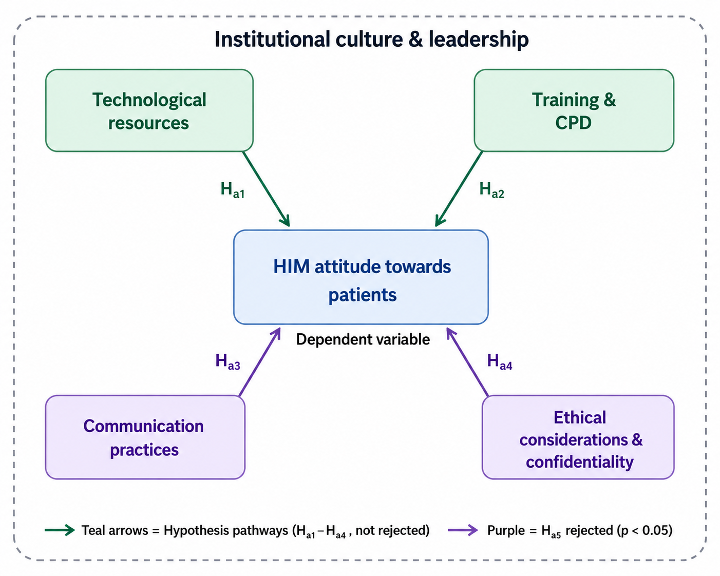

Figure 5. Conceptual Framework Illustrating the Relationships Between Independent Variables and the Attitude of Health Information Managers (HIMs) Towards Patients. H₀₁, H₀₂, and H₀₃ indicate hypothesis pathways tested in the study.

4. Discussion

4.1 The Paradox of Universal Positive Self-Perception
The most striking finding of this study is the paradox between universal positive self-reported attitudes and the evidence of systemic dysfunction revealed through qualitative and inferential analysis. A 100% positive attitude rate, consistent across 300 HIMs in three geographically distinct tertiary institutions, is unlikely to represent the full reality of practice. Social desirability bias the tendency for respondents to provide answers they believe are professionally expected is a recognised limitation of self-report surveys in healthcare settings [12]. The qualitative data, however, provides a critical corrective lens. The documented case of a confidentiality breach at UITH (disclosing a patient's genotype without consent) starkly contradicts high self-ratings on ethical conduct, exposing what may be termed 'professional blind spots.' These findings align with Rest's Ethical Decision-Making Model [13], which distinguishes between moral awareness, moral judgment, and actual moral action confidence does not guarantee competent ethical behaviour.

4.2 Technology as a Positive Enabler with Unmet Potential
Technological resources were widely perceived as adequate and positively influential on work attitudes. This is consistent with the Technology Acceptance Model (TAM) [10], which posits that perceived usefulness and ease of use drive technology adoption and positive attitudes. The convergence of high adequacy ratings (80–90% across sites) with 100% positive influence ratings confirms technology as a key pillar of HIM professional satisfaction. However, qualitative aspirations for full EHR implementation reveal that current technology meets only a baseline threshold. This 'plateau effect' suggests that attitude improvements achievable through technology have reached a ceiling under current infrastructure, and that leapfrogging to fully interoperable digital systems as demanded by the HIMs themselves is the next necessary investment [6]. This echoes Diffusion of Innovation Theory [14], which highlights that incomplete adoption of an innovation yields only partial benefits.

4.3 The Training-Practice Gap
The disconnect between the high value placed on CPD and the moderate actual frequency of training attendance is a defining finding. With mean training frequency scores of 2.50–2.80 (between 'Rarely' and 'Occasionally') coexisting with mean CPD belief scores of 4.70–4.95 (nearly maximum), a significant 'training-practice gap' is evident. This gap is explicable through Social Cognitive Theory [9], which emphasises that self-efficacy confidence in one's capability can be present even when the structural supports (time, funding, institutional prioritisation) for skill development are absent. The qualitative theme of systemic morale constraints, particularly the cited need for 'payment of arrears of leave bonus,' illustrates how administrative neglect can suppress engagement with professional development even where motivation exists [5]. This underscores the finding in the literature that training interventions in resource-constrained settings yield optimal results only when embedded within supportive institutional structures [15].

4.4 Communication as the Most Critical Modifiable Factor
The statistically significant association between communication frequency and patient feedback patterns (H₀₃ rejected, p<0.05) positions communication as the most evidentially robust intervention target in this study. Yet the data also reveal that direct patient communication remains infrequent most HIMs interact with patients ‘Rarely’ indicating that the HIM role in Nigerian teaching hospitals is predominantly back-office rather than patient-facing. This structural reality limits opportunities for patient-centred practice. Improving communication, both in frequency and in ethical quality, is critical. The grave ethical lapse at UITH illustrates that infrequent communication, when it does occur, can produce severe harm if not grounded in robust confidentiality protocols. These findings resonate with person-centred care literature emphasising that HIM interactions, though brief, have disproportionate impacts on patient trust and satisfaction [16, 18]. International evidence similarly demonstrates that communication quality and frequency are among the strongest modifiable predictors of patient experience in health information services, underscoring the urgency of structural reform in Nigerian teaching hospitals [19].

4.5 Implications for Policy and Practice
The findings collectively affirm that transforming HIM attitudes in Nigerian teaching hospitals requires a multi-level, systemic response. At the policy level, the Federal Ministry of Health should establish dedicated funding streams for HIM ICT infrastructure modernisation and mandate CPD inclusion in institutional operational plans. At the hospital management level, workload redistribution, transparent recognition schemes, and resolution of outstanding welfare obligations (such as unpaid leave allowances) are essential to restore morale and prevent the attitudinal erosion documented in this study. At the practice level, HIM departments should implement standardised, patient-centred communication charters and conduct regular internal ethics audits using real-world case studies such as those uncovered here as training tools. These recommendations are consistent with the theoretical frameworks underpinning this study, particularly the Theory of Planned Behaviour, which identifies subjective norms and perceived behavioural control as co-determinants of attitude-driven action [8].

4.6 Limitations of the Study
Several limitations must be acknowledged when interpreting the findings of this study. First, the reliance on self-reported data introduces a significant risk of social desirability bias, whereby respondents may have provided socially or professionally desirable responses rather than candid accounts of their actual attitudes and behaviour. This is particularly pertinent given that a universally positive attitude rate of 100% across all 300 respondents is statistically improbable in any real-world professional population and is likely inflated by this effect. Future studies should consider integrating observational methods, peer assessments, or patient feedback instruments as complementary data sources to validate self-reported attitudes.
Second, the hypothesis tests for H₀₁ (technology and attitude) and H₀₂ (training and attitude) were conducted using aggregated hospital-level data (n=3 data points), which severely restricted statistical power and degrees of freedom. The failure to reject these null hypotheses is therefore primarily a function of sample size at the institutional level rather than an absence of substantive relationships, which the descriptive and qualitative data do suggest. Individual-level regression analyses with the full 300-participant dataset would have yielded more robust inferential conclusions, and future replication studies should adopt this approach.
Third, although the three teaching hospitals represent distinct geopolitical zones of Nigeria, purposive selection of institutions limits the generalisability of findings to other tertiary, secondary, or primary healthcare settings in Nigeria and other low- and middle-income countries. Fourth, the cross-sectional design precludes causal inference; the associations identified between communication, technology, training, and attitudes reflect correlational patterns only. Longitudinal cohort designs would be needed to establish causal direction. Fifth, the thematic analysis of qualitative data, while grounded in Braun and Clarke’s framework, relied on the judgment of a single analyst, which may introduce interpretive bias; inter-rater reliability checks would strengthen future qualitative analyses. These limitations notwithstanding, the study represents a methodologically sound and contextually rich contribution to the evidence base on HIM attitudes in Nigerian tertiary healthcare.

5. Conclusion
This study provides the first empirical, cross-institutional evidence on the attitudes of Health Information Managers towards patients in three major Nigerian teaching hospitals. While HIMs universally self-report positive attitudes, a paradox of systemic dysfunction characterised by inconsistent training access, infrequent patient communication, and documented ethical lapses undermines service delivery quality. Communication practices were the only factor demonstrating a statistically significant association with patient satisfaction outcomes. The universally positive self-reported attitude finding must be interpreted cautiously in light of the well-documented social desirability bias in self-report instruments and the methodological limitation of conducting hypothesis tests at the hospital-aggregate level (n=3), which constrained statistical power for H₀₁ and H₀₂. The study concludes that attitudinal transformation among HIMs is contingent on integrated institutional reform: advanced ICT investment, mandatory and applied CPD, patient-centred communication protocols, and responsive welfare management. These conclusions are consistent with international comparative evidence on health information management workforce challenges in low- and middle-income healthcare systems [7, 17]. Longitudinal, multi-method studies incorporating patient-reported outcomes, observational assessments, and inter-rater validated qualitative analysis are recommended to further interrogate the causal pathways and cultural dimensions of HIM attitude formation in Nigeria’s evolving healthcare landscape.
Ethics Approval and Consent: Ethical approvals were obtained from the Research and Ethics Committees of UITH, ABUTH, and OAUTH. Written informed consent was implied by voluntary questionnaire completion.
Competing Interests: The author declares no competing interests.

Disclaimer (Artificial intelligence)

Author(s) hereby declare that NO generative AI technologies such as Large Language Models (ChatGPT, COPILOT, etc.) and text-to-image generators have been used during the writing or editing of this manuscript.

References
[1] Abosede OA, Longe OB. Health information management and patient care quality in Nigerian tertiary hospitals: A systematic review. J Health Inform Dev Ctries. 2021;15(1):1-18.
[2] Okafor MN, Ejikeme CL. Health information management challenges and patient data quality in Nigerian public hospitals. African J Health Sci. 2021;34(1):45-58.
[3] Onyegbule OA, Nwambam AS. Confidentiality, patient trust, and ethical practice in Nigerian healthcare institutions. J Health Ethics. 2022;18(2):112-126.
[4] Ajuwon GA, Rhine LD. Use of the internet for health information by physicians for patient care in a teaching hospital in Ibadan, Nigeria. Biomed Digit Libr. 2006;3(1):12. DOI: 10.1186/1742-5581-3-12.
[5] Alegbeleye BJ, Adepoju OE. Commitment of health information managers as predictors of service effectiveness in Nigerian tertiary hospitals. Eur J Med Health Sci. 2019;1(6):1-9. DOI: 10.24018/ejmed.2019.1.6.153.
[6] Umar FA. Knowledge of health information management professionals on digital health record systems at Ahmadu Bello University Teaching Hospital. Direct Res J Public Health Environ Technol. 2024;9(1):61-67.
[7] Faloudah A, Qasim R, Bahumayd M. Total quality management in healthcare. Int J Comput Appl. 2015;120(12):1-6. DOI: 10.5120/21261-4053.
[8] Ajzen I. The theory of planned behavior. Organ Behav Hum Decis Process. 1991;50:179-211. DOI: 10.1016/0749-5978(91)90020-T.
[9] Bandura A. Social Foundations of Thought and Action: A Social Cognitive Theory. Englewood Cliffs, NJ: Prentice-Hall; 1986.
[10] Davis FD. Perceived usefulness, perceived ease of use, and user acceptance of information technology. MIS Q. 1989;13(3):319-340. DOI: 10.2307/249008.
[11] Braun V, Clarke V. Using thematic analysis in psychology. Qual Res Psychol. 2006;3(2):77-101.
[12] Khalil C. The influence of social desirability on healthcare workers’ self-reported attitudes: A methodological review. Health Psychol Open. 2021;8(1):20551029211009866. DOI: 10.1177/20551029211009866.
[13] Rest JR. Development in Judging Moral Issues. Minneapolis, MN: University of Minnesota Press; 1979.
[14] Rogers EM. Diffusion of Innovations. 5th ed. New York: Free Press; 2003.
[15] Idowu KM, Ilesanmi OS. Exploring the challenges faced by health information professionals in delivering quality services in University of Ilorin Teaching Hospital. Direct Res J Public Health Environ Technol. 2024;9(2):176-182.
[16] McCormack B, McCance T. Person-Centred Practice in Nursing and Health Care: Theory and Practice. Oxford: Wiley-Blackwell; 2017. DOI: 10.1002/9781119099635.
[17] Adepoju EO, Opele JK. Technology application in health information management in Obafemi Awolowo University Teaching Hospitals Complex (OAUTHC) Ile-Ife, Osun State. Int J Res Publ. 2021;74(1):70-86. DOI: 10.47119/IJRP100741420211841.
[18] McCormack B, McCance T. Person-centred practice in nursing and health care: Theory and practice. Oxford: Wiley-Blackwell; 2017. DOI: 10.1002/9781119099635.
[19] Champion VL, Skinner CS. The health belief model. In: Glanz K, Rimer BK, Viswanath K, editors. Health Behavior and Health Education: Theory, Research, and Practice. 4th ed. San Francisco: Jossey-Bass; 2008. pp. 45-65.
[20] Schein EH, Schein PA. Organizational Culture and Leadership. 5th ed. San Francisco: Jossey-Bass; 2017. DOI: 10.1002/9781119212041.

