Case Report

Type 2 Torpedo Maculopathy with Distinct Multimodal Imaging Features: A Case Report

Abstract

Background: Torpedo maculopathy (TM) is a rare congenital retinal pigment epithelium (RPE) anomaly characterised by a torpedo-shaped lesion typically located temporal to the fovea. It is usually detected incidentally in asymptomatic individuals and can be classified into different subtypes based on optical coherence tomography (OCT) findings.

Case Presentation: A 45-year-old asymptomatic male underwent routine ophthalmic evaluation. Best-corrected visual acuity was 20/20 in both eyes. Fundus examination of the right eye revealed a well-defined torpedo-shaped hypopigmented lesion located approximately two disc diameters temporal to the fovea. Multimodal imaging demonstrated characteristic features of Type 2 torpedo maculopathy. Fundus autofluorescence showed predominantly hypoautofluorescence with a focal hyperautofluorescent temporal tip. OCT revealed preservation of the inner retinal layers, thinning of the outer nuclear layer, outer retinal cavitation, and increased choroidal transmission. OCT angiography showed no evidence of choroidal neovascularisation and demonstrated preserved choriocapillaris architecture surrounding the lesion. The left eye was normal.

Conclusion: This case highlights the diagnostic value of multimodal imaging in the identification and characterisation of Type 2 torpedo maculopathy. The presence of a hyperautofluorescent lesion tip, preserved inner retina with outer retinal cavitation, and intact surrounding choriocapillaris on OCTA provides additional imaging insights that may facilitate differentiation from other hypopigmented macular lesions. Although generally benign, periodic follow-up remains advisable to monitor for rare complications such as choroidal neovascularisation.

Keywords: Torpedo maculopathy, Type 2 torpedo maculopathy, multimodal imaging, optical coherence tomography, fundus autofluorescence, OCT angiography, retinal pigment epithelium.

Introduction
Torpedo maculopathy (TM) is a rare congenital anomaly of the retinal pigment epithelium (RPE), most often identified incidentally in asymptomatic individuals (1). It classically presents as a well-circumscribed, torpedo-shaped hypopigmented lesion located temporal to the fovea (1,2,23). Although typically solitary, satellite lesions and atypical torpedo-like lesions occurring outside the macula have also been reported, leading to the broader term “torpedo retinopathy” (3,4). These lesions are commonly oriented along the horizontal raphe within a kite-shaped distribution in the temporal macula, suggesting a possible relationship with retinal nerve fibre layer development (5). Most patients maintain normal visual acuity, although subtle functional abnormalities may occasionally be detected on detailed testing (6).

In classic fundus examination, TM manifests as an oval-shaped hypopigmented lesion resembling a bullet or torpedo with a wedge-shaped tail extending outward and pointing toward the foveola along the horizontal raphe. TM is likely underestimated because patients are typically asymptomatic, and these lesions are often detected during routine ophthalmologic examinations. Additionally, due to their nonprogressive and generally benign nature, no treatment is required (24-26).

Multimodal imaging plays a central role in the evaluation of TM. Optical coherence tomography (OCT) typically demonstrates thinning of the outer nuclear layer, attenuation or loss of the ellipsoid and interdigitation zones, and, in Type 2 TM, outer retinal cavitation with or without inner choroidal excavation (7). Fundus autofluorescence (FAF) commonly reveals hypoautofluorescence corresponding to areas of RPE alteration. These imaging modalities are also essential for differentiating TM from other pigmented and hypopigmented macular lesions, including congenital hypertrophy of the retinal pigment epithelium (CHRPE), choroidal nevus, and post-inflammatory scars (2,8).

The aim of this report is to describe an incidental case of Type 2 TM in an asymptomatic adult and to emphasise the diagnostic value of multimodal imaging in lesion characterisation, classification, and follow-up, with particular attention to imaging features that are not well documented in existing literature.

Case Presentation

A 45-year-old male presented for a routine ophthalmic examination with no visual complaints. Best-corrected visual acuity was 20/20 in both eyes. Anterior segment examination was unremarkable, and intraocular pressure was within normal limits bilaterally.

Fundus examination of the right eye revealed a solitary, well-circumscribed, torpedo-shaped hypopigmented lesion located approximately two disc diameters temporal to the fovea, with subtle hyperpigmentation at the temporal tip (Figure 1A). Fundus autofluorescence (FAF) demonstrated a predominantly hypoautofluorescent lesion with a focal hyperautofluorescent temporal tip, suggestive of localised retinal pigment epithelium (RPE) alteration (Figure 1B). Green and infrared reflectance imaging clearly delineated the lesion margins and highlighted subtle changes in outer retinal reflectivity (Figure 1C).

Spectral-domain optical coherence tomography (OCT) showed preservation of the inner retinal architecture with thinning of the outer nuclear layer, outer retinal cavitation, and increased choroidal signal transmission beneath the lesion (Figure 1D). These findings were consistent with the Type 2 subtype of torpedo maculopathy. Optical coherence tomography angiography (OCTA) demonstrated no evidence of choroidal neovascularisation and revealed preserved choriocapillaris perfusion surrounding the lesion, indicating stable vascular architecture (Figure 1E).

Examination of the left eye was entirely normal. Based on the characteristic funduscopic appearance and multimodal imaging findings, a diagnosis of unilateral Type 2 torpedo maculopathy was established. Given the absence of visual symptoms, preserved visual acuity, and lack of complications, the patient was advised to undergo periodic follow-up with multimodal imaging to monitor for any structural or vascular changes.

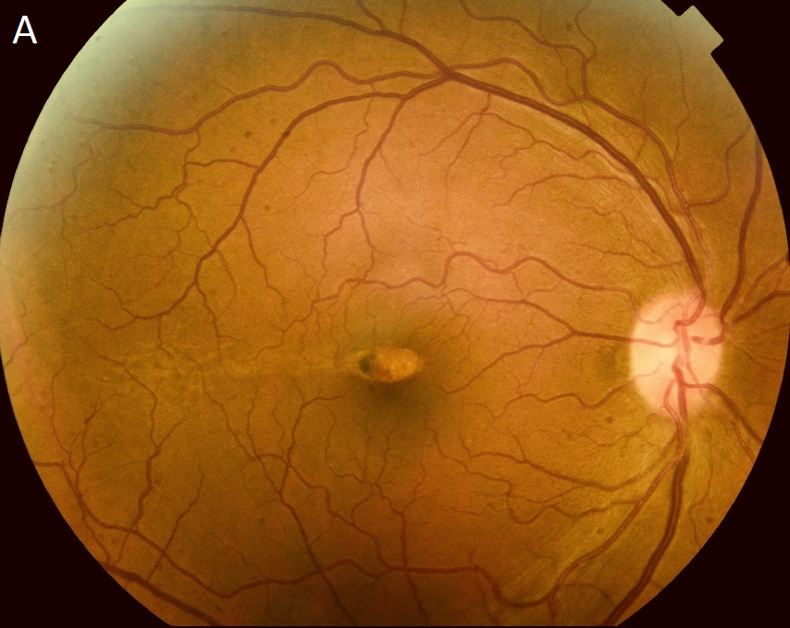
Figure 1A. Colour fundus photograph of the right eye showing a well-defined torpedo-shaped hypopigmented lesion located temporal to the fovea, with subtle hyperpigmentation at the temporal tip.

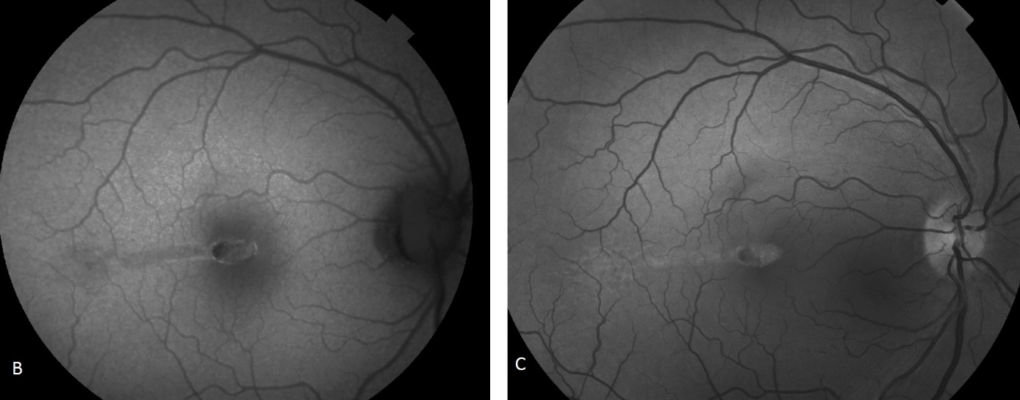
Figure 1B. Fundus autofluorescence image demonstrating a predominantly hypoautofluorescent lesion with focal hyperautofluorescence at the temporal tip.
Figure 1C. Green and infrared reflectance images delineating lesion margins and highlighting subtle alterations in outer retinal reflectivity.
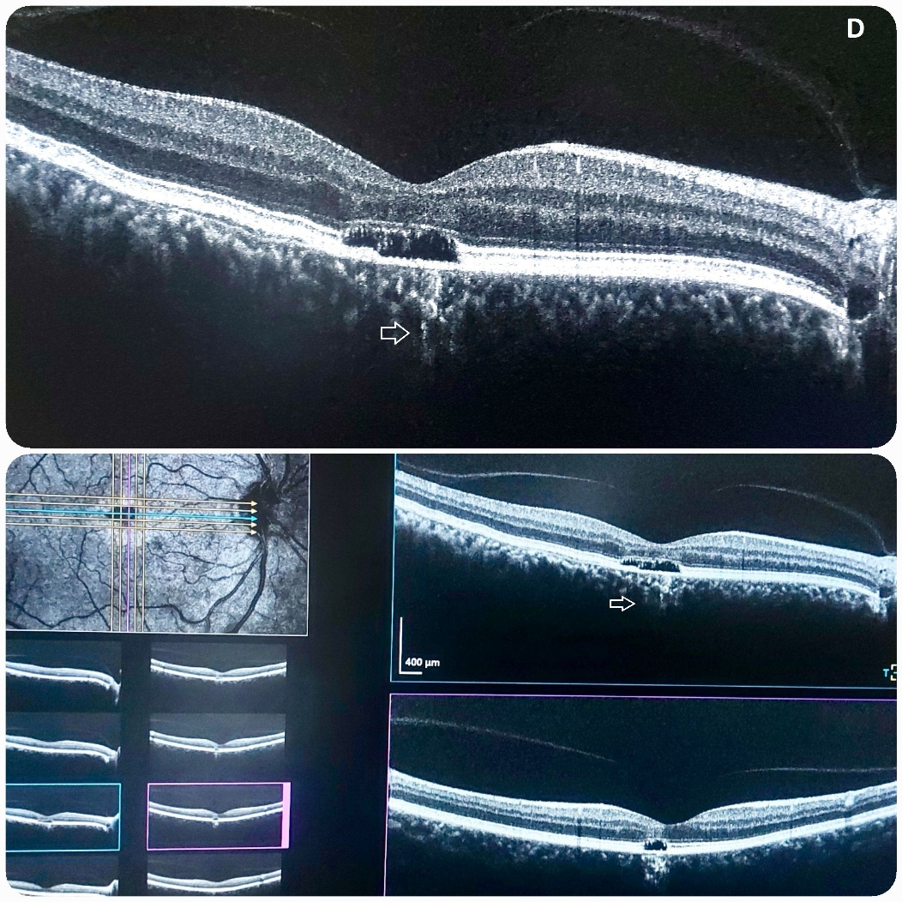

Figure 1D. Spectral-domain optical coherence tomography (OCT) B-scan showing preservation of the inner retinal layers, thinning of the outer nuclear layer, outer retinal cavitation, and increased choroidal signal transmission.

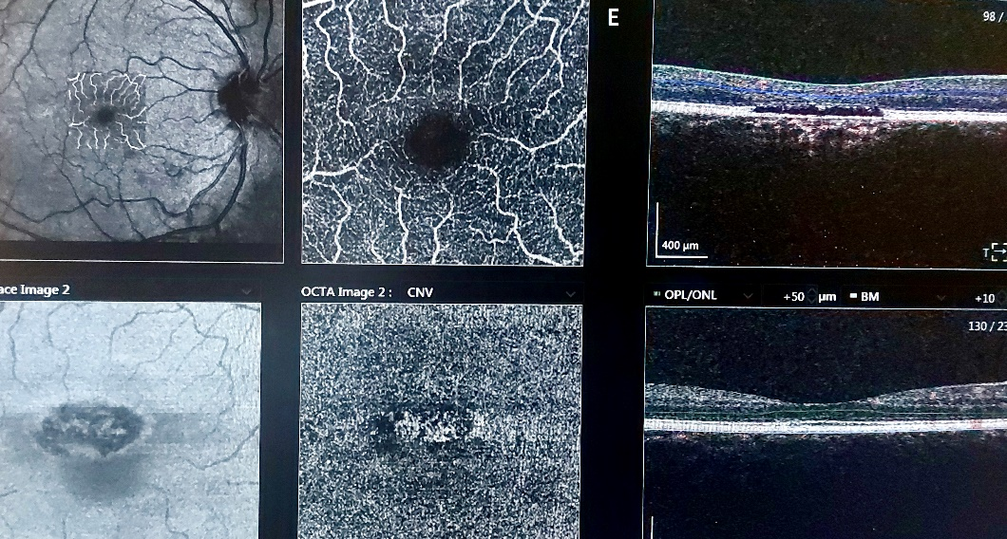

Figure 1E. Optical coherence tomography angiography (OCTA) demonstrating absence of choroidal neovascularisation and preserved choriocapillaris architecture surrounding the lesion.

Discussion
Torpedo maculopathy (TM) is a rare congenital anomaly of the retinal pigment epithelium (RPE), often discovered incidentally in asymptomatic patients (1). It is typically characterised by a well-circumscribed, torpedo-shaped hypopigmented lesion located temporal to the fovea. Although most lesions are solitary, satellite lesions may occur, and torpedo-like lesions outside the macula have been described, prompting the term “torpedo retinopathy” for such presentations (2,3). Distribution mapping analyses support a congenital aetiology, with lesions typically localising to a kite-shaped region of the temporal macula along the horizontal raphe, suggesting a correlation with retinal nerve fibre layer development (4).
Histopathologic studies and advanced imaging modalities have demonstrated that TM primarily affects the outer retina and RPE. Common OCT findings include thinning of the outer nuclear layer, attenuation or loss of the ellipsoid and interdigitation zones, and outer retinal cavitation, with or without inner choroidal excavation (5,6). Based on OCT morphology, Wong et al. classified TM into two types: Type 1 with outer retinal attenuation without cavitation, and Type 2 with outer retinal cavitation and degeneration, with or without inner choroidal excavation (6). Tripathy et al. proposed a Type 3 variant showing additional inner retinal and choroidal excavation alongside outer retinal degeneration (7). FAF typically shows hypoautofluorescence in the lesion, sometimes with hyperautofluorescent tips, reflecting RPE dysfunction and structural alterations (1,5).
Although TM is generally asymptomatic, functional testing such as microperimetry or perimetry can occasionally reveal scotomas or localised reductions in retinal sensitivity, though normal visual fields are frequently observed (8–10). Vision is usually preserved due to intact inner retinal layers. Some cases exhibit choroidal excavation on OCT, which may predispose to rare complications such as choroidal neovascularisation (CNV). CNV in TM has been reported in only a few cases, sometimes associated with focal choroidal excavation, emphasising the importance of long-term monitoring (11–13). OCT angiography can further assess choriocapillaris integrity and detect early neovascular changes (13).
The clinical spectrum of TM is broad. Lesions are generally oval-shaped, well-demarcated, and hypopigmented, but hyperpigmented variants exist and are rarely documented with long-term follow-up (14–16). TM lesions may present with variable features such as intraretinal clefts, fundus excavation, or visual field defects, highlighting the heterogeneity of presentation. The differential diagnosis includes congenital hypertrophy of the RPE (CHRPE), choroidal nevus, RPE hamartomas, inflammatory scars (e.g., toxoplasmosis), macular coloboma, and post-traumatic lesions (2,17–19). Accurate recognition of these atypical features is critical to avoid misdiagnosis and to guide appropriate follow-up.
Unique imaging perspective in the present case:
- Hyperautofluorescent tip on FAF
- OCTA showing intact choriocapillaris surrounding the lesion
- Preserved inner retina with outer cavitation
These features provide subtle but meaningful diagnostic markers not emphasised in prior reports, including Rickmann et al., 2024. They highlight the value of detailed multimodal imaging in differentiating TM from other hypopigmented macular lesions and emphasise the importance of systematic vascular evaluation, even in asymptomatic adults.
The pathophysiology of TM remains incompletely understood. Recent advances in ocular embryology using animal models and stem-cell-derived RPE suggest that pigmentation alone may not signify fully mature RPE, and polarity interactions between RPE and neural retinal cells continue during differentiation (20). The congenital nature of TM is further supported by lesion stability over long-term follow-up, typical location near the temporal macula, and presentation across a wide age range (4,20,21).
Multimodal imaging plays a pivotal role in the evaluation of TM. Colour fundus photography documents lesion morphology, FAF delineates areas of RPE dysfunction, OCT characterises outer retinal degeneration and cavitation, and OCT angiography assesses choroidal circulation and potential CNV development (1,5,6,13). Reflectance imaging can further delineate lesion margins and subtle structural changes. Periodic follow-up using these modalities allows early detection of complications and accurate monitoring of lesion evolution.
In summary, this case of incidental Type 2 TM illustrates the importance of multimodal imaging in characterising lesion morphology, classifying TM subtypes, and distinguishing TM from other macular lesions. Recognition of both classic hypopigmented and rare hyperpigmented variants is essential for accurate diagnosis and appropriate monitoring. Although generally benign and non-progressive, rare complications such as CNV may occur, especially in the presence of choroidal excavation, highlighting the need for long-term surveillance.

Conclusion

Type 2 torpedo maculopathy is an uncommon congenital retinal lesion that is frequently detected incidentally in asymptomatic individuals. This case emphasises the importance of multimodal imaging for accurate diagnosis and classification. The combination of a torpedo-shaped hypopigmented lesion, hyperautofluorescent temporal tip on fundus autofluorescence, outer retinal cavitation with preserved inner retinal layers on OCT, and intact surrounding choriocapillaris on OCTA supports the diagnosis and helps distinguish the lesion from other macular pathologies. Recognition of these imaging characteristics can improve diagnostic confidence and facilitate appropriate long-term monitoring for rare complications such as choroidal neovascularisation.

Consent
Written informed consent for publication of this case report and accompanying images was obtained from the patient.
Ethical Approval:
As per international standards or university standards, written ethical approval has been collected and preserved by the author(s).
Competing interests: None

Abbreviations
TM: Torpedo Maculopathy
RPE: Retinal Pigment Epithelium
OD: Oculus Dexter (Right Eye / Œil droit)
OS: Oculus Sinister (Left Eye / Œil gauche)
FAF: Fundus Autofluorescence
NIR-FAF: Near-Infrared Fundus Autofluorescence
OCT: Optical Coherence Tomography
OCTA: Optical Coherence Tomography Angiography
CNV: Choroidal Neovascularization
CHRPE: Congenital Hypertrophy of the Retinal Pigment Epithelium
BCVA: Best-Corrected Visual Acuity

Disclaimer (Artificial intelligence)

Author(s) hereby declare that NO generative AI technologies such as Large Language Models (ChatGPT, COPILOT, etc.) and text-to-image generators have been used during the writing or editing of this manuscript.

References
- Shields CL, Guzman JM, Shapiro MJ, Fogel LE, Shields JA. Torpedo maculopathy at the site of the fetal “bulge.” Arch Ophthalmol. 2010;128:499–501.
- Venkatesh R, Jain K, Pereira A, Thirumalesh YNK. Torpedo retinopathy. J Ophthalmic Vis Res. 2020;15:187–191.
- Rickmann A, Bodenbender JP, Gelisken F, Kühlewein L. Type 1 and Type 2 torpedo maculopathy. Clin Exp Ophthalmol. 2024;52:1805–1810.
- Williams PJ, Salek S, Prinzi RA, Bergstrom C, Hubbard GB. Distribution patterns of torpedo maculopathy: evidence of a congenital retinal nerve fiber layer-driven etiology. Saudi J Ophthalmol. 2019;33:260–267.
- Wong EN, Fraser-Bell S, Hunyor AP, Chen FK. Novel optical coherence tomography classification of torpedo maculopathy. Clin Exp Ophthalmol. 2015;43:342–348.
- Kerwat D, Jamall O, Antonakis S, Almeida GC. Torpedo maculopathy: a case series - insights into basic pathology. Eur J Ophthalmol. 2021;31:NP35–NP39.
- Tripathy K, Sarma B, Mazumdar S. Commentary: Inner retinal excavation in torpedo maculopathy and proposed type 3 lesions in optical coherence tomography. Indian J Ophthalmol. 2018;66:1213–1214.
- Buzzonetti L, Petroni S, Catena G, Iarossi G. Optical coherence tomography and electrophysiological findings in torpedo maculopathy. Doc Ophthalmol. 2015;130:65–70.
- Su Y, Gurwood AS. Neurosensory retinal detachment secondary to torpedo maculopathy. Optometry. 2010;81:405–407.
- Sanabria MR, Coco RM, Sanchidrian M. OCT findings in torpedo maculopathy. Retin Cases Brief Rep. 2008;2:109–111.
- Shirley K, O’Neill M, Gamble R, Ramsey A, McLoone E. Torpedo maculopathy: disease spectrum and associated choroidal neovascularisation in a paediatric population. Eye (Lond). 2018;32:1315–1320.
- Parodi MB, Romano F, Montagna M, Albertini GC, Pierro L, Arrigo A, Bandello F. Choroidal neovascularization in torpedo maculopathy assessed on OCT angiography. Ophthalmic Surg Lasers Imaging Retina. 2018;49:e210–e213.
- Banaee T, Doss M, Eller AW. Torpedo maculopathy complicated by choroidal neovascularization. Retina. 2018;38:e52–e55.
- Ranjith PC, Giridhar A. Hyperpigmented torpedo maculopathy. Indian J Ophthalmol. 2019;67:229–233.
- Golchet PR, Jampol LM, Mathura JR, Daily MJ. Torpedo maculopathy. Br J Ophthalmol. 2010;94:302–306.
- Roseman RL, Gass JD. Solitary hypopigmented nevus of the retinal pigment epithelium in the macula. Arch Ophthalmol. 1992;110:1358–1359.
- Pian D, Ferrucci S, Anderson SF, Wu C. Paramacular coloboma. Optom Vis Sci. 2003;80:556–563.
- Shields JA, Shields CL. Tumours and related lesions of the pigment epithelium. In: Intraocular Tumours: An Atlas and Textbook. 2nd ed. Philadelphia, PA: Lippincott Williams & Wilkins; 2008. p.431–480.
- Trevino R, Kiani S, Raveendranathan P. The expanding clinical spectrum of torpedo maculopathy. Optom Vis Sci. 2014;91:e18.
- Bennis A, Jacobs JG, Catsburg LAE, et al. Stem cell-derived retinal pigment epithelium: the role of pigmentation as maturation marker and gene expression profile comparison with human endogenous retinal pigment epithelium. Stem Cell Rev Rep. 2017;13:659–669.
- Shields CL, Mashayekhi A, Ho T, Cater J, Shields JA. Solitary congenital hypertrophy of the retinal pigment epithelium: clinical features and frequency of enlargement in 330 patients. Ophthalmology. 2003;110:1968–1971.
- Giannakaki-Zimmermann H, Wolf S, Fleckenstein M, et al. Choriocapillaris alterations in torpedo maculopathy: OCT-A insights. Graefes Arch Clin Exp Ophthalmol. 2021;259:1021–1029.
- Hartley, M., Kotagiri, A., & Gnanaraj, L. (2025). Torpedo maculopathy: A paediatric case series with multimodal imaging. BMJ Open Ophthalmology, 10(Suppl 4), A11.3. https://bmjophth.bmj.com/content/10/Suppl_4/A11.3
- Yuan, H., Dou, H., & Li, X. (2023). Multimodal imaging of choroidal structural in torpedo maculopathy. Frontiers in Medicine, 10, 1085457.
- Bodur, M. F., Özdemir, A., & Koçak, N. (2025). Torpedo Maculopathy in Multimodal Imaging: New Perspectives in Light of Diagnosis. Journal of Retina-Vitreous/Retina Vitreus, 34(4).
- Lopez, J. M., Miere, A., Rabinovic, M., Mehanna, C. J., Crincoli, E., Colantuono, D., & Souied, E. H. (2024). Torpedo maculopathy: multimodal and retromodal imaging. Canadian Journal of Ophthalmology, 59(1), e96-e99.

