BEYOND MARKET CO-MOVEMENT: A SEEMINGLY UNRELATED REGRESSION (SUR) BASED ANALYSIS OF HIDDEN SECTORAL CONNECTEDNESS IN INDIAN EQUITY INDICES

Abstract: Understanding sectoral interdependence in equity markets requires distinguishing between co-movement driven by common macro-financial factors and residual cross-sectoral linkages. This study examines conditional sectoral connectedness in the Indian equity market using a Seemingly Unrelated Regression (SUR) framework. Daily return data for eight major NIFTY sectoral indices over the period 2020–2026 are analyzed. Each sector’s return is modeled as a function of lagged own returns and lagged macro-financial variables, including the NIFTY 50 index, India VIX, USD/INR exchange rate, Brent crude oil prices, S&P 500 index, and gold prices, to mitigate simultaneity effects. The SUR–Feasible Generalized Least Squares (FGLS) approach enables efficient joint estimation while capturing contemporaneous correlations across sectoral residuals. The results indicate that global market movements, particularly the S&P 500, exert a strong and consistent influence across all sectors, highlighting the importance of international spillovers. Commodity-linked sectors such as Energy and Metals exhibit strong positive associations with oil price movements, while exchange-rate sensitivities vary significantly across sectors. Despite controlling for observed drivers, the residual covariance structure reveals a dense network of positive contemporaneous associations, suggesting the presence of latent shared influences across sectors. The strongest residual linkage is observed between Energy and Metals, indicating persistent commodity-cycle effects. Sensitivity analysis confirms that the connectedness network is robust to alternative correlation thresholds. Residual diagnostics indicate limited first-order serial dependence, although some higher-order dependence remains. Overall, the findings suggest that sectoral connectedness in Indian equity markets is conditional in nature, with both global and domestic factors playing a significant role, alongside latent cross-sectoral linkages not captured by observable variables.
Keywords - Seemingly unrelated regression; sectoral equity indices; systemic risk; market beta; volatility spillovers; financial connectedness

INTRODUCTION
Financial markets are inherently interconnected systems in which shocks rarely remain confined to a single asset or sector (1). In equity markets, sectoral indices often co-move not only due to shared exposure to aggregate market conditions, but also because of deeper structural linkages such as supply-chain dependencies, financial intermediation channels, and common macroeconomic risk factors. Understanding how shocks propagate across sectors is therefore central to asset pricing, portfolio diversification, and systemic risk assessment (2). This issue is particularly salient for emerging markets such as India, where sectoral heterogeneity is pronounced and market dynamics are frequently influenced by global uncertainty, capital flows, and commodity price fluctuations.
Existing empirical evidence on sectoral interdependence has largely relied on unconditional correlation measures or multivariate time-series frameworks such as vector autoregressions and volatility spillover indices (3). While these approaches provide useful descriptive insights, they often conflate common factor exposure with genuine cross-sector dependence (4). As a result, observed co-movements may simply reflect shared sensitivity to market-wide shocks rather than meaningful inter-sector transmission. This distinction is economically important: from a risk-management perspective, diversification benefits depend not on raw correlations, but on conditional dependence after controlling for systematic drivers.
The Indian equity market offers a compelling setting to revisit this issue. Sectoral indices such as Banking, Information Technology, Energy, and Metals differ markedly in their exposure to domestic demand, global trade, financial conditions, and commodity cycles. Moreover, periods of heightened uncertainty—captured by volatility indices, exchange-rate movements, and energy price shocks—can induce asymmetric and nonlinear responses across sectors. Despite this richness, most existing Indian studies continue to assess sectoral linkages using correlation-based or event-driven methods, leaving the structure of conditional contemporaneous dependence largely unexplored (1).
This study addresses this gap by adopting a system-based econometric framework that explicitly separates common factor effects from residual cross-sector dependence. We model daily returns of eight major NIFTY sectoral indices within a Seemingly Unrelated Regressions (SUR) system augmented with key macro-financial factors, including the NIFTY 50 market return, India VIX, USD/INR exchange rate, and Brent crude oil prices. By exploiting the contemporaneous correlation structure of equation-specific disturbances, the SUR framework enables efficient estimation and provides direct insight into latent inter-sector linkages that remain hidden in single-equation regressions.
The contribution of this paper is threefold. First, it provides a comprehensive system-level analysis of Indian sectoral returns that distinguishes between market-driven co-movement and residual connectedness. Second, it documents economically meaningful patterns of contemporaneous residual correlation across sectors, revealing both reinforcing and offsetting relationships that are not visible in raw return correlations. Third, by visualizing these residual dependencies as a network, the study offers an intuitive representation of sectoral connectedness with direct implications for diversification and systemic risk monitoring.
The remainder of the paper is structured as follows. Section 2 reviews the relevant literature on sectoral co-movement and system-based modeling approaches. Section 3 describes the data and econometric methodology. Section 4 presents and discusses the empirical results. Section 5 concludes and outlines directions for future research.
LITERATURE REVIEW
Research on equity market interdependence has a long tradition in financial economics, with early studies focusing on correlation structures and common factor models. In the context of sectoral analysis, correlations have been widely used to infer diversification benefits and co-movement patterns (5)(6)(7). However, unconditional correlations are known to be unstable over time and sensitive to market regimes, particularly during periods of financial stress when correlations tend to increase sharply (8).
To address these limitations, subsequent studies have employed multivariate time-series frameworks such as vector autoregressions (VAR), vector error-correction models, and volatility spillover indices. The connectedness framework proposed by Diebold and Yilmaz has been especially influential, allowing researchers to quantify directional spillovers in returns and volatility across assets and sectors (9). While powerful, these approaches often focus on dynamic transmission mechanisms and variance decompositions, rather than isolating contemporaneous dependence conditional on common explanatory variables (10) (11).
Within the Indian context, several studies have examined sectoral co-movement using correlation analysis, rolling-window techniques, or VAR-based spillover measures (12). These studies generally find strong integration among cyclical sectors such as Banking, Auto, and Realty, particularly during crisis periods (13). However, most of this literature does not explicitly control for shared exposure to macro-financial risk factors, raising concerns that reported spillovers may largely reflect common shocks rather than structural inter-sector linkages.
System regression techniques, such as Seemingly Unrelated Regressions, provide a natural framework to address this issue. Originally developed to improve efficiency when multiple equations are linked through correlated disturbances, SUR models have been applied in asset pricing, macroeconomics, and international finance to capture cross-equation dependence (14)(15)(16). By estimating the full covariance structure of residuals, SUR allows researchers to distinguish between explained co-movement and latent contemporaneous dependence (17)(18). Despite its suitability, SUR remains underutilized in empirical studies of equity sector connectedness, particularly in emerging markets.
Recent literature highlights the role of global supply chain disruptions in amplifying sectoral interdependence, particularly across manufacturing, energy, and commodity-linked sectors. Such disruptions create asymmetric shocks that propagate across industries, reinforcing the importance of modeling conditional connectedness.
This study builds on and extends the existing literature by applying a SUR–FGLS framework to Indian sectoral returns, explicitly modeling both systematic risk exposure and residual interdependence. In doing so, it bridges the gap between correlation-based connectedness analysis and system-level econometric modeling, offering a more nuanced view of how shocks propagate across equity sectors.
RESEARCH METHODOLOGY
3.1 Data and Variable Construction
The empirical analysis is conducted using daily closing price data for eight major sectoral indices of the Indian equity market: NIFTY IT, NIFTY FMCG, NIFTY PHARMA, NIFTY AUTO, NIFTY BANK, NIFTY ENERGY, NIFTY METAL, and NIFTY REALTY. The sample period extends from 1 January 2020 to 1 January 2026, based on data availability from Yahoo Finance. The sample period encompasses major economic disruptions including the COVID-19 pandemic, post-pandemic recovery, inflationary pressures, and global monetary tightening, which are expected to influence sectoral return dynamics. These indices collectively capture a broad cross-section of sectoral dynamics, including both cyclical and defensive segments of the economy. The analysis is implemented using Python libraries such as pandas and NumPy for data processing and statsmodels for econometric estimation, ensuring transparency and replicability. All variables are stationary in return form, consistent with standard financial econometric practice.
To control for common macro-financial influences, the model incorporates a set of widely used global and domestic risk factors. These include the NIFTY 50 index return (market factor), the India VIX (market uncertainty proxy), the USD/INR exchange rate (external financial conditions proxy), Brent crude oil prices (commodity price proxy), the S&P 500 index (global equity market proxy), and gold prices (safe-haven asset proxy). These variables are selected to capture key channels through which domestic sectoral returns may be influenced, including global spillovers, volatility transmission, exchange-rate effects, and commodity price dynamics.
All variables are transformed into continuously compounded daily returns using log-differences scaled by 100:
$$\begin{aligned}\begin{matrix} & R_{i,t}=100×\ln\left(\frac{P_{i,t}}{P_{i,t-1}}\right) & & \end{matrix}\#\left(1\right)\end{aligned}$$
$$\begin{aligned}X_{k,t}=100×\ln\left(\frac{F_{k,t}}{F_{k,t-1}}\right) \#\left(2\right)\end{aligned}$$
where $P_{i,t}$ denotes the closing price of sector $i$ at time $t,$ and $F_{k,t}$ denotes the value of macro-financial factor $k.$ All series are aligned on a common trading calendar using an inner join to ensure a balanced panel.
Model Specification
To capture both sector-specific dynamics and common macro-financial influences, each sectoral return is modeled as a function of lagged own returns and lagged macro-financial variables. The use of lagged regressors is motivated by the need to mitigate simultaneity and endogeneity concerns inherent in daily financial data, where contemporaneous relationships may be bidirectional.
The conditional mean equation for sector $i$ is specified as:
$$\begin{aligned}R_{i,t}=α_{i}+ϕ_{i}R_{i,t-1}+β_{1i}MKT_{t-1}+β_{2i}VIX_{t-1}+β_{3i}USDINR_{t-1}+β_{4i}BRENT_{t-1}+β_{5i}SP{500}_{t-1}+β_{6i}GOLD_{t-1}+ε_{i,t} \#\left(3\right)\end{aligned}$$
Where $R_{i,t}$ is the return of sector i at time t, $R_{i,t-1}$ captures short-term persistence in returns, $MKT_{t-1}$, $VIX_{t-1}$, $USDINR_{t-1}$, $BRENT_{t-1}$, $SP{500}_{t-1}$, and $GOLD_{t-1}$ represent lagged macro-financial factors, $ε_{i,t}$ denotes the sector-specific innovation. The coefficients $β_{ki}$ measure the lagged sensitivity of sector i to each macro-financial factor, conditional on other controls. This specification allows the model to capture delayed transmission effects while reducing simultaneity bias.
Motivation for System Estimation
Estimating the above equations separately using ordinary least squares (OLS) ignores the possibility that sector-specific innovations may be correlated across equations. In financial markets, unobserved shocks—such as sudden changes in investor sentiment, liquidity conditions, or policy expectations—often affect multiple sectors simultaneously. Under correlated error structures, SUR yields more efficient estimators than OLS by exploiting cross-equation covariance, as established in classical econometric theory.
Formally, the model allows for contemporaneous cross-equation dependence:
$$\begin{aligned}\begin{matrix} & Cov\left[ε_{i,t},ε_{j,t}\right]=σ_{ij},i≠j, & & \end{matrix}\#\left(4\right)\end{aligned}$$
which implies a non-diagonal covariance matrix:
$$\begin{aligned}\begin{matrix} & Σ=\left[\begin{matrix}σ_{11} & ⋯ & σ_{1N} \\ ⋮ & ⋱ & ⋮ \\ σ_{N1} & ⋯ & σ_{NN}\end{matrix}\right] & & \end{matrix}\#\left(5\right)\end{aligned}$$
When $Σ$ is not diagonal, OLS estimators remain unbiased under exogeneity but are no longer efficient. In such cases, a system-based estimator that exploits cross-equation correlations can yield more efficient parameter estimates.
Seemingly Unrelated Regression (SUR) Framework
To account for contemporaneous cross-sector dependence, the study employs the Seemingly Unrelated Regressions (SUR) framework. Let $y_{t}$ denote the $N×1$ vector of sectoral returns at time $t,$ and $X_{t}$ denote the corresponding block-diagonal matrix of regressors. Stacking observations across time yields the system:
$$\begin{aligned}y=Xβ+ε \#\left(6\right)\end{aligned}$$
where:
- y is the stacked vector of sectoral returns,
- X is a block-diagonal matrix containing sector-specific regressors,
- β is the stacked parameter vector,
- ε is the stacked error vector.
The error covariance structure is given by:
$$\begin{aligned}\text{Var}\left(ε\right)=Ω=Σ⊗I_{T} \#\left(7\right)\end{aligned}$$
where $I_{T}$ is the $T×T$ identity matrix and $⊗$ denotes the Kronecker product.
Feasible Generalized Least Squares (FGLS) Estimation
Since the covariance matrix Σ is unknown, the SUR system is estimated using Feasible Generalized Least Squares (FGLS). The estimation proceeds in three steps:
Step 1 (OLS Estimation). Each sectoral equation is estimated separately using OLS to obtain residuals ${\overset{^}{ε}}_{i,t}$
Step 2 (Covariance Estimation). The contemporaneous covariance matrix is estimated as::
$$\begin{aligned}\begin{matrix} & \overset{{}^{^}}{Σ}=\frac{1}{T}\sum_{t=1}^{T}{{\overset{{^}^{}}{ε}}_{t}{\overset{{}^{}}{ε}}_{t}^{'}} & & \end{matrix}\#\left(8\right)\end{aligned}$$
where ${\overset{^}{ε}}_{t}$ is the vector of residuals across sectors at time t.
Step 3 (FGLS system Estimation). The SUR estimator is then obtained as:
$${\overset{{^}^{}}{β}}_{SUR}=(X^{'}{\overset{{^}^{}}{Ω}}^{-1}X)^{-1}X^{'}{\overset{{^}^{}}{Ω}}^{-1}y (9)$$
$$\begin{aligned}\begin{matrix} & \overset{{^}^{}}{Ω}=\overset{{^}^{}}{Σ}⊗I_{T}, & & \end{matrix}\#\left(10\right)\end{aligned}$$
The covariance matrix of the estimator is given by:
$$\text{Var}({\overset{^}{β}}_{SUR})=(X^{'}{\overset{^}{Ω}}^{-1}X)^{-1} (11)$$
This approach improves estimation efficiency by incorporating cross-equation error correlations.
Residual Connectedness and Network Construction
The estimated covariance matrix $\overset{^}{Σ}$ provides a basis for analyzing residual connectedness across sectors. The corresponding correlation matrix is computed as:
$$\begin{aligned}ρ_{ij}=\frac{{\overset{{^}^{}}{σ}}_{ij}}{\sqrt{{\overset{{^}^{}}{σ}}_{ii}{\overset{{^}^{}}{σ}}_{jj}}} \#\left(12\right)\end{aligned}$$
These residual correlations capture conditional co-movement after controlling for observable macro-financial drivers. Importantly, they are interpreted as indicators of latent shared influences rather than direct causal transmission.
To visualize the structure of sectoral connectedness, a network graph is constructed where nodes represent sectors and edges represent significant residual correlations. An edge is included between sectors $i$ and $j$ if:
$$∣ρ_{ij}∣≥τ$$
where $τ$ is a predefined threshold.
Threshold Sensitivity Analysis
To ensure that the network structure is not driven by an arbitrary threshold choice, a sensitivity analysis is conducted across multiple values of τ. Network density and edge counts are evaluated for thresholds ranging from 0.10 to 0.50. This analysis allows assessment of the robustness of the inferred connectedness structure.
Residual Diagnostics
Post-estimation diagnostics are conducted to assess the adequacy of the model. First-order autocorrelation is evaluated using the autocorrelation function (ACF(1)) and the Durbin–Watson statistic. Higher-order serial dependence is examined using the Ljung–Box test. These diagnostics help determine whether the inclusion of lagged variables sufficiently captures temporal dependence in the data.
Interpretation Framework
The empirical results are interpreted within a conditional framework. Raw correlations are treated as reflecting both common factor exposure and potential interdependence, while residual correlations are interpreted as conditional co-movement after controlling for observable drivers. Given the possibility of omitted variables and remaining dynamic structure, residual correlations are not interpreted as direct evidence of structural shock transmission but rather as indicators of latent shared influences across sectors.

RESULTS
Data overview and return dynamics
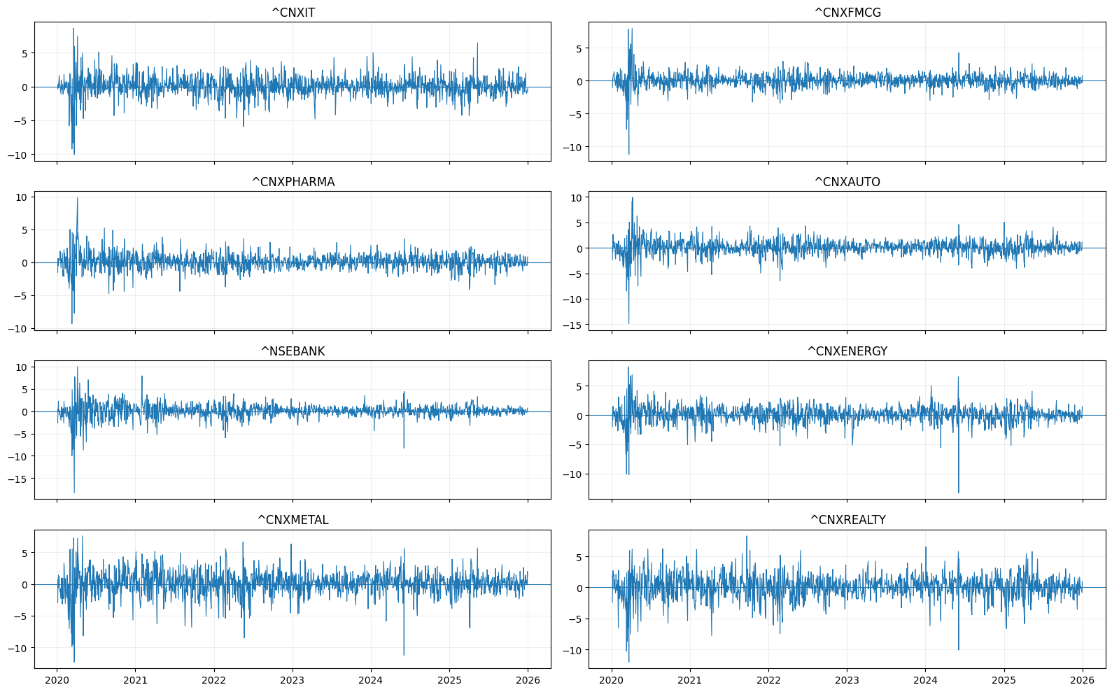
Figure 1: Log Return Plots of 8 stocks
The time-series plots of daily sectoral returns (as shown in Figure 1) reveal pronounced volatility clustering across all indices, with periods of elevated fluctuations concentrated during major market stress episodes. The magnitude and frequency of extreme return movements vary across sectors, with Metals and Realty exhibiting visibly higher volatility relative to more stable sectors such as FMCG and Pharma. These dynamics indicate the presence of time-varying risk and justify the inclusion of macro-financial controls such as volatility (VIX) and global market indicators in the empirical specification. Additionally, the absence of clear deterministic trends reinforces the suitability of modeling returns rather than price levels.
Distributional features and dependence diagnostics
Table 1: Descriptive Statistics of Daily Sectoral Returns
Sector (Index) | N | Mean | Std. Dev. | Skewness | Kurtosis | ACF(1) | Ljung–Box Q(10)
Information Technology (NIFTY IT) | 1430 | 0.061556 | 1.496658 | -0.344517 | 5.312702 | -0.015993 | 0.0041***
Fast-Moving Consumer Goods (NIFTY FMCG) | 1430 | 0.042372 | 1.049924 | -0.524292 | 16.665735 | -0.061155 | <0.0001***
Pharmaceuticals (NIFTY Pharma) | 1430 | 0.072535 | 1.223097 | -0.050079 | 7.747338 | -0.006897 | 0.0018***
Automobiles (NIFTY Auto) | 1430 | 0.085778 | 1.481032 | -0.843849 | 12.038665 | 0.005781 | 0.1956
Banking (NIFTY Bank) | 1430 | 0.042506 | 1.557478 | -1.513126 | 19.645636 | 0.014076 | <0.0001***
Energy (NIFTY Energy) | 1430 | 0.054827 | 1.453249 | -1.060421 | 10.588668 | -0.054149 | <0.0001***
Metals (NIFTY Metal) | 1430 | 0.095017 | 1.912657 | -0.799949 | 4.614698 | -0.016792 | 0.0003***
Realty (NIFTY Realty) | 1430 | 0.074859 | 1.938009 | -0.562501 | 3.766252 | 0.094654 | 0.0010***
Notes:
Daily returns are computed as $r_{t}=100×ln⁡(C_{t}/C_{t-1})$. Skewness and kurtosis describe distributional asymmetry and tail thickness, respectively. The Ljung–Box Q(10) test examines the null hypothesis of no serial correlation up to 10 lags.
*** denotes statistical significance at the 1% level; ** at the 5% level.
Table 1 summarizes the distributional characteristics of daily sectoral returns. Several stylized facts emerge. First, there is clear heterogeneity in volatility across sectors, with Metals and Realty exhibiting the highest standard deviations, while FMCG and Pharma display comparatively lower dispersion, indicating their relatively defensive nature. Second, most sectors exhibit negative skewness, implying that extreme downside movements are more pronounced than positive shocks, particularly in Banking and Energy. Third, kurtosis values are substantially above normal benchmarks, indicating heavy-tailed return distributions and frequent extreme observations. This indicates elevated tail risk and a higher likelihood of extreme market events, reinforcing the importance of modeling cross-sectoral dependence under stress conditions. Finally, Ljung–Box statistics indicate the presence of short-horizon dependence in several sectors, particularly FMCG, Banking, and Energy, motivating the inclusion of lagged own returns in the model specification.
Naïve co-movement versus residual co-movement
Table 2A presents the unconditional correlation matrix of sectoral returns. All correlations are positive and moderately high, indicating strong co-movement across sectors. The highest correlations are observed among cyclical sectors such as Auto, Banking, Energy, and Metals, suggesting that these sectors respond similarly to aggregate economic conditions. In contrast, sectors such as IT and Pharma exhibit relatively lower correlations with the rest of the market. However, these unconditional correlations primarily reflect shared exposure to common macroeconomic and market-wide factors rather than true inter-sectoral dependence.
Table 2B reports the correlation matrix of OLS residuals after controlling for lagged own returns and macro-financial factors. Compared to raw correlations, residual correlations remain positive and substantial across most sector pairs, indicating that a significant degree of contemporaneous co-movement persists even after accounting for observed common drivers. This suggests the presence of latent shared influences or unobserved common shocks affecting multiple sectors simultaneously. Importantly, these residual correlations are interpreted as conditional co-movement rather than structural shock transmission, as they may reflect both genuine interdependence and the effect of omitted factors not explicitly captured in the model.
Table 2A: Pairwise Correlation Matrix of Daily Sectoral Returns
Sector | IT | FMCG | Pharma | Auto | Banking | Energy | Metal | Realty
Information Technology (IT) | 1.000000 | 0.482001 | 0.446486 | 0.495534 | 0.451574 | 0.440372 | 0.469804 | 0.423330
Fast-Moving Consumer Goods (FMCG) | 0.482001 | 1.000000 | 0.507331 | 0.567409 | 0.516190 | 0.507025 | 0.446774 | 0.481974
Pharmaceuticals (Pharma) | 0.446486 | 0.507331 | 1.000000 | 0.488457 | 0.379344 | 0.483439 | 0.489170 | 0.451326
Automobiles (Auto) | 0.495534 | 0.567409 | 0.488457 | 1.000000 | 0.693289 | 0.649973 | 0.638204 | 0.660287
Banking (Bank) | 0.451574 | 0.516190 | 0.379344 | 0.693289 | 1.000000 | 0.630519 | 0.611288 | 0.640507
Energy | 0.440372 | 0.507025 | 0.483439 | 0.649973 | 0.630519 | 1.000000 | 0.730861 | 0.624870
Metals | 0.469804 | 0.446774 | 0.489170 | 0.638204 | 0.611288 | 0.730861 | 1.000000 | 0.627411
Realty | 0.423330 | 0.481974 | 0.451326 | 0.660287 | 0.640507 | 0.624870 | 0.627411 | 1.000000
Notes:
The table reports Pearson correlation coefficients computed from daily log returns over the sample period starting January 2020. All correlations are positive and economically meaningful, indicating substantial co-movement across Table 2B: Correlation Matrix of OLS Residuals (Motivation for SUR Estimation)
Sector | IT | FMCG | Pharma | Auto | Banking | Energy | Metal | Realty
Information Technology (IT) | 1.000000 | 0.463071 | 0.411864 | 0.450751 | 0.400948 | 0.392159 | 0.409477 | 0.387559
Fast-Moving Consumer Goods (FMCG) | 0.463071 | 1.000000 | 0.493521 | 0.561963 | 0.500073 | 0.493712 | 0.429545 | 0.474455
Pharmaceuticals (Pharma) | 0.411864 | 0.493521 | 1.000000 | 0.467674 | 0.355254 | 0.458113 | 0.459544 | 0.435732
Automobiles (Auto) | 0.450751 | 0.561963 | 0.467674 | 1.000000 | 0.670502 | 0.627341 | 0.613048 | 0.643694
Banking (Bank) | 0.400948 | 0.500073 | 0.355254 | 0.670502 | 1.000000 | 0.603084 | 0.579527 | 0.618950
Energy | 0.392159 | 0.493712 | 0.458113 | 0.627341 | 0.603084 | 1.000000 | 0.708477 | 0.605181
Metals | 0.409477 | 0.429545 | 0.459544 | 0.613048 | 0.579527 | 0.708477 | 1.000000 | 0.610504
Realty | 0.387559 | 0.474455 | 0.435732 | 0.643694 | 0.618950 | 0.605181 | 0.610504 | 1.000000
Baseline fit and model diagnostics
Table 3 presents the baseline OLS diagnostics for each sectoral equation. The explanatory power of the model, as measured by R², is relatively modest across sectors, indicating that a substantial portion of return variation remains unexplained by observable macro-financial variables. Durbin–Watson statistics are close to 2 across all sectors, suggesting that first-order autocorrelation has been largely mitigated through the inclusion of lagged own returns. However, Ljung–Box statistics indicate the presence of higher-order serial dependence in certain sectors, particularly FMCG, Pharma, Banking, and Energy. These findings justify the use of a system-based estimation approach that focuses on contemporaneous cross-sectional dependence rather than fully dynamic time-series modeling.
Table 3: Model Specification and Diagnostic Statistics (OLS Baseline, Per Sector)
Sector | T | R² (OLS) | Adj. R² | AIC | BIC | Durbin–Watson | Ljung–Box p(10)
Information Technology (IT) | 1429 | 0.123166 | 0.118226 | 5035.1049 | 5077.2228 | 2.0512 | 0.498009
Fast-Moving Consumer Goods (FMCG) | 1429 | 0.041909 | 0.036511 | 4149.0950 | 4191.2129 | 2.0007 | 0.000000
Pharmaceuticals (Pharma) | 1429 | 0.044404 | 0.039020 | 4581.7050 | 4623.8228 | 2.0391 | 0.004343
Automobiles (Auto) | 1429 | 0.066814 | 0.061556 | 5094.1944 | 5136.3122 | 2.0506 | 0.226448
Banking | 1429 | 0.075780 | 0.070573 | 5224.4040 | 5266.5218 | 2.0554 | 0.000969
Energy | 1429 | 0.061193 | 0.055904 | 5049.2924 | 5091.4103 | 2.0148 | 0.004179
Metals | 1429 | 0.092994 | 0.087884 | 5785.0437 | 5827.1616 | 2.0414 | 0.204642
Realty | 1429 | 0.048328 | 0.042967 | 5891.4946 | 5933.6125 | 2.0329 | 0.193676

SUR coefficient estimates: macro-financial sensitivities
Table 4 reports the estimated coefficients from the SUR–FGLS model. Several key patterns emerge. First, global market influences play a dominant role. The lagged S&P 500 coefficient is positive and highly significant across all sectors, indicating strong international spillover effects from global equity markets to Indian sectoral returns. Second, domestic market exposure, captured through the lagged NIFTY 50 return, is consistently negative across sectors. This reflects the adjusted specification where global and domestic market factors are jointly included, leading to relative reallocation of explanatory power across correlated regressors. Third, volatility effects are generally negative but modest in magnitude, with sectors such as FMCG and Pharma showing stronger sensitivity to changes in market uncertainty. Fourth, exchange-rate effects display substantial heterogeneity across sectors. Banking, Auto, and Realty exhibit positive exposure to USD/INR movements, while Pharma shows a negative association, reflecting differences in external exposure and cost structures. Fifth, commodity price effects are most pronounced in Metals and Energy, where Brent crude coefficients are positive and statistically meaningful, consistent with commodity-cycle dependence. Finally, lagged own returns indicate mild short-term persistence in sectors such as Banking and Realty, while most sectors exhibit limited autocorrelation in conditional mean dynamics.
Table 4: Seemingly Unrelated Regression (SUR) Coefficient Estimates
Variable | IT | FMCG | Pharma | Auto | Banking | Energy | Metals | Realty
Constant | 0.0411 (0.0373) | 0.0398 (0.0273) | 0.0670 (0.0318) | 0.0699 (0.0381) | 0.0299 (0.0398) | 0.0458 (0.0374) | 0.0766 (0.0484) | 0.0547 (0.0503)
Lagged own return (L1_own) | 0.0288 (0.0285) | 0.0256 (0.0267) | 0.0086 (0.0252) | 0.0190 (0.0267) | 0.1107 (0.0384) | 0.0347 (0.0263) | 0.0114 (0.0244) | 0.0660 (0.0248)
Market return (MKT) | -0.2507 (0.0469) | -0.1897 (0.0335) | -0.1529 (0.0367) | -0.1095 (0.0483) | -0.2818 (0.0627) | -0.1905 (0.0475) | -0.2555 (0.0581) | -0.1164 (0.0599)
India VIX (VIX) | -0.0150 (0.0081) | -0.0122 (0.0059) | -0.0086 (0.0069) | 0.0032 (0.0083) | -0.0040 (0.0087) | -0.0096 (0.0082) | -0.0036 (0.0106) | -0.0023 (0.0110)
USD/INR | 0.2130 (0.1092) | 0.0753 (0.0800) | -0.1191 (0.0934) | 0.2541 (0.1113) | 0.3013 (0.1166) | 0.0839 (0.1096) | 0.1221 (0.1417) | 0.2182 (0.1471)
Brent crude (BRENT) | 0.0359 (0.0136) | -0.0146 (0.0100) | 0.0213 (0.0116) | 0.0333 (0.0139) | 0.0187 (0.0146) | 0.0539 (0.0137) | 0.0725 (0.0177) | 0.0271 (0.0184)
S&P 500 | 0.3469 (0.0303) | 0.1242 (0.0222) | 0.1570 (0.0259) | 0.2531 (0.0309) | 0.2727 (0.0324) | 0.1990 (0.0305) | 0.3460 (0.0394) | 0.2527 (0.0409)
Gold | 0.1235 (0.0339) | 0.0519 (0.0248) | 0.0841 (0.0289) | 0.0490 (0.0345) | 0.0578 (0.0362) | 0.0786 (0.0340) | 0.1548 (0.0440) | 0.0668 (0.0457)
Notes: Coefficient estimates with standard errors in parentheses
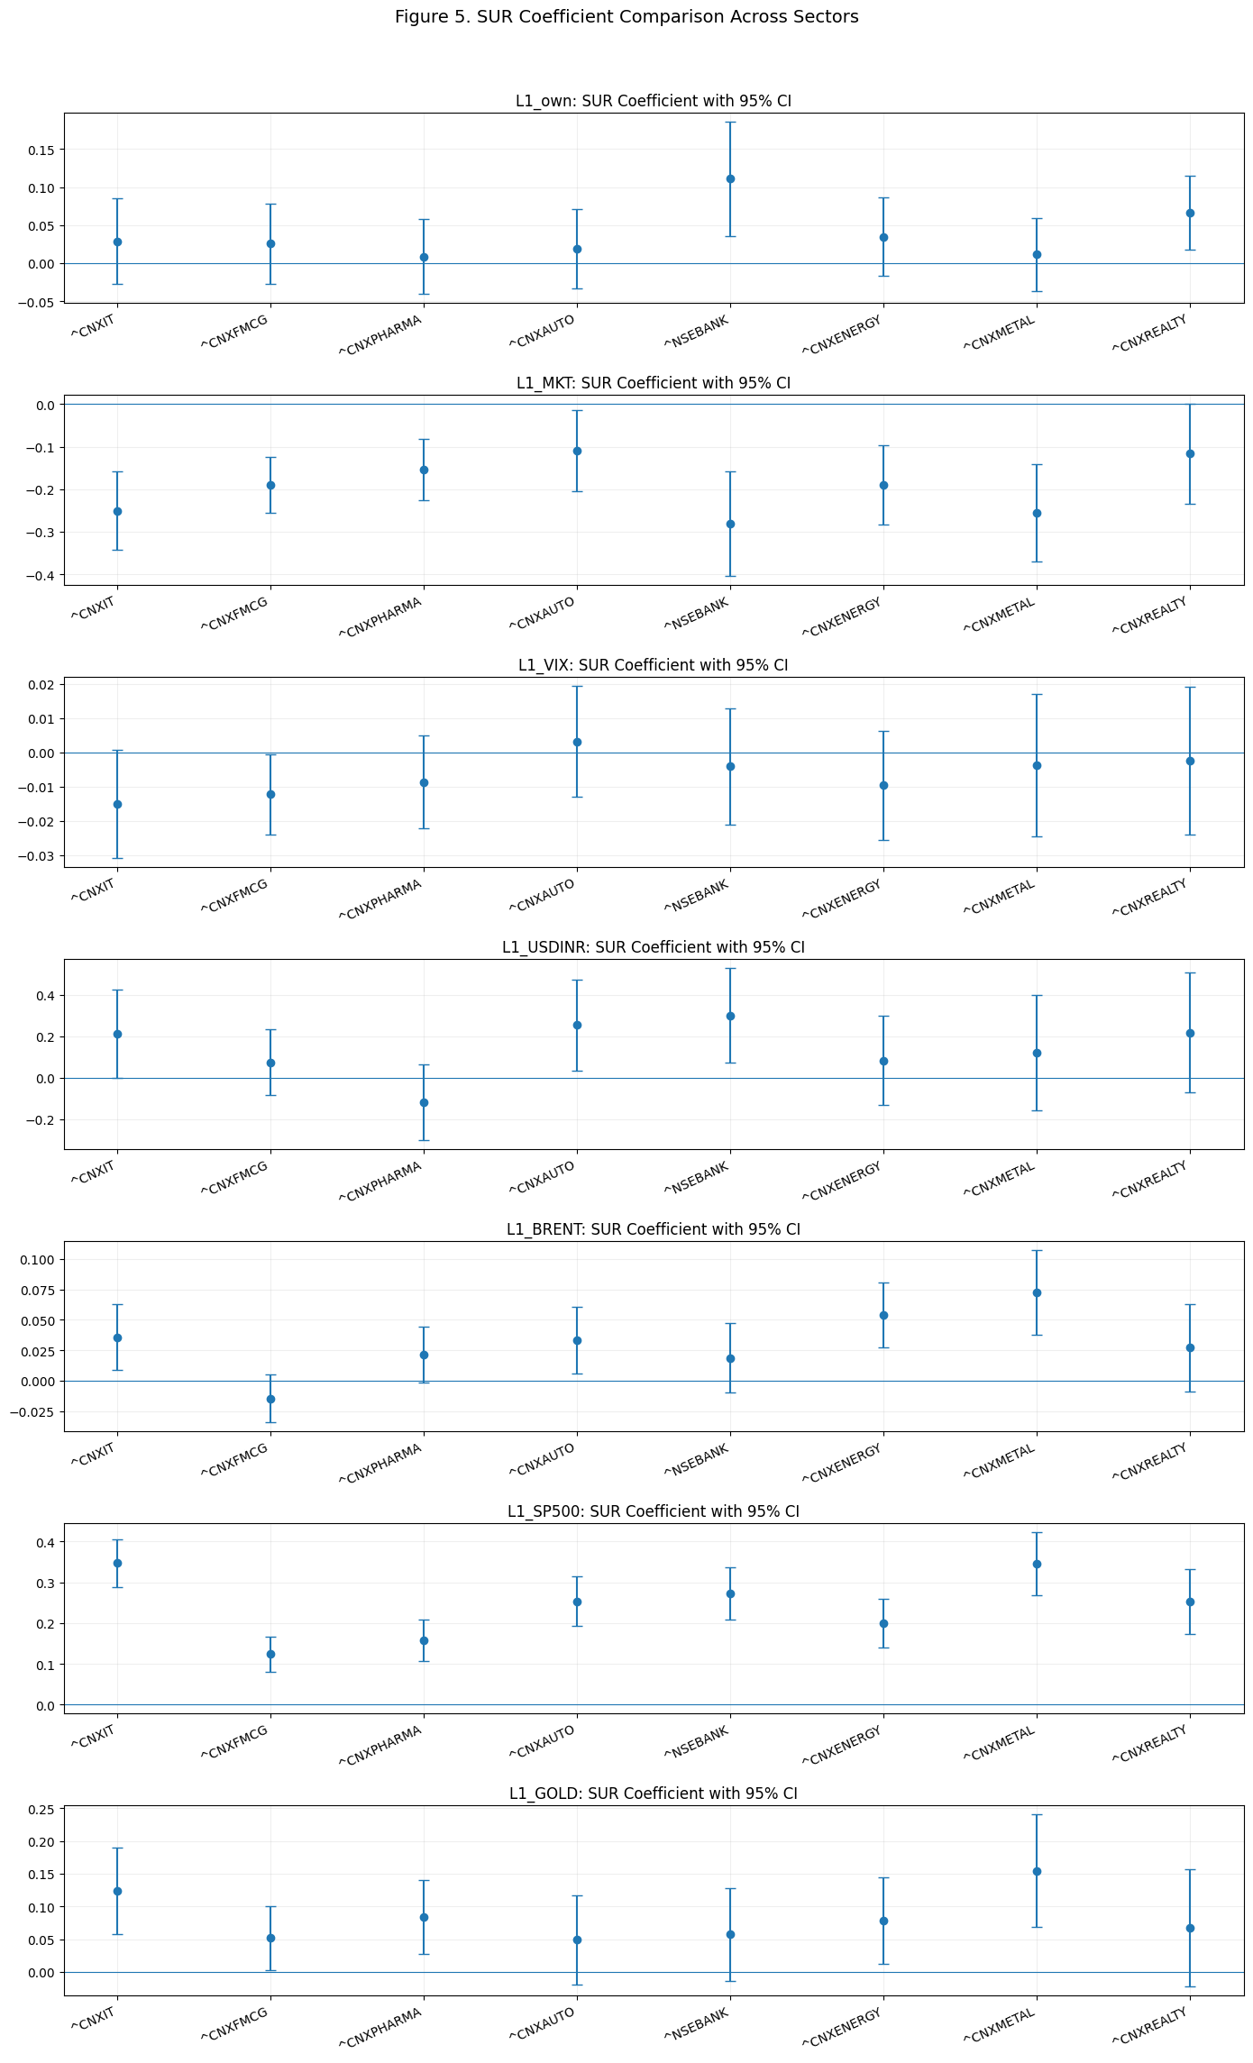
Figure 2: Coefficient comparison (SUR) across stocks for key regressors
Figure 2 provides a visual comparison of SUR coefficient estimates with 95% confidence intervals across sectors. The figure highlights substantial heterogeneity in factor sensitivities. Global market exposure (S&P 500) emerges as the most consistent and significant driver across all sectors, while volatility and currency effects vary considerably. The confidence intervals further indicate that while some factors are statistically robust across sectors, others exhibit sector-specific significance, reinforcing the importance of a system-based modeling approach.
Table 5 reports the percentage reduction in standard errors when moving from OLS to SUR estimation. The largest efficiency gains are observed for lagged own-return coefficients, particularly in cyclical sectors such as Auto, Banking, Energy, and Metals, where reductions exceed 30%. In contrast, efficiency improvements for macro-financial variables are relatively modest. These results confirm the theoretical advantage of SUR, as it exploits contemporaneous cross-equation correlations to improve estimation precision, particularly for sector-specific dynamics.
Table 5: Efficiency Gains from SUR Relative to OLS
Sector | L1 Own Return (%) | Market (MKT) (%) | VIX (%) | USD/INR (%) | Brent (%)
Information Technology (IT) | 16.88 | 5.65 | 0.28 | 0.33 | 0.28
FMCG | 25.17 | 8.00 | 0.32 | 0.32 | 0.42
Pharmaceuticals | 20.07 | 3.64 | 0.38 | 0.51 | 0.28
Automobiles | 37.72 | 16.75 | 0.63 | 0.30 | 0.29
Banking | 33.13 | 22.37 | 0.29 | 0.39 | 0.30
Energy | 35.96 | 15.52 | 0.41 | 0.38 | 0.36
Metals | 35.01 | 11.07 | 1.25 | 0.28 | 0.49
Realty | 32.15 | 9.29 | 1.03 | 0.30 | 0.28
Notes: Percentage reduction in standard errors when moving from OLS to SUR–FGLS
Table 6 summarizes the contemporaneous residual covariance structure derived from the SUR model. Panel A indicates that residual variance differs significantly across sectors, with Metals and Realty exhibiting the highest unexplained volatility, suggesting a greater role for sector-specific shocks.
Panel B highlights the strongest residual correlations, revealing a dense network of positive contemporaneous associations. The strongest linkage is observed between Energy and Metals, reflecting shared exposure to global commodity cycles. Strong positive connections are also evident among Auto, Banking, and Realty, indicating clustering among cyclical sectors. These findings suggest that even after controlling for observed macro-financial drivers, sectoral innovations remain highly interconnected through latent common influences.
Table 6: Contemporaneous Residual Dependence Across NIFTY Sector Indices (SUR Estimates)
Panel A. Contemporaneous Residual Variance (Diagonal of Σ̂)
Sector | Residual Variance
IT | 1.963
FMCG | 1.056
Pharma | 1.429
Auto | 2.046
Banking | 2.241
Energy | 1.983
Metal | 3.318
Realty | 3.574
Panel B. Strongest Residual Correlations (|ρᵢⱼ| ≥ 0.40)
Sector Pair | Residual Correlation
Energy – Metal | 0.708
Auto – Banking | 0.671
Auto – Realty | 0.644
Banking – Realty | 0.619
Energy – Banking | 0.603
Energy – Realty | 0.605
Metal – Realty | 0.611
Auto – Energy | 0.627
Table 7 presents a sensitivity analysis of the residual connectedness network across different correlation thresholds. The network remains fully connected for thresholds up to 0.30, indicating that residual dependencies are pervasive across sectors. Even at higher thresholds, a substantial number of connections persist, demonstrating the robustness of the identified network structure. Notably, the Energy–Metal pair consistently emerges as the strongest linkage across all thresholds, suggesting a stable and economically meaningful relationship. These results confirm that the inferred connectedness is not driven by an arbitrary threshold choice.
Table 7. Threshold Sensitivity of Residual Connectedness Network
Threshold | Number of Edges | Network Density | Strongest Pair | Correlation
0.10 | 28 | 1.000 | Energy – Metal | 0.708
0.20 | 28 | 1.000 | Energy – Metal | 0.708
0.30 | 28 | 1.000 | Energy – Metal | 0.708
0.40 | 25 | 0.893 | Energy – Metal | 0.708
0.50 | 12 | 0.429 | Energy – Metal | 0.708
Table 8 reports post-estimation residual diagnostics from the SUR model. First-order autocorrelation, as measured by ACF(1) and Durbin–Watson statistics, is generally low, indicating that the inclusion of lagged own returns effectively mitigates short-term serial dependence. However, Ljung–Box statistics reveal the presence of higher-order autocorrelation in certain sectors, particularly FMCG, Pharma, Banking, and Energy. These findings suggest that while the model adequately captures immediate temporal dependence, some residual dynamic structure remains, and results should be interpreted primarily in terms of contemporaneous conditional associations.
Table 8. Post-Estimation Residual Serial Correlation Diagnostics
Sector |  | ACF(1) | Ljung–Box p-value (10) | Durbin–Watson
IT |  | -0.044 | 0.346 | 2.088
FMCG |  | -0.005 | < 0.001 *** | 2.010
Pharma |  | -0.021 | 0.004 *** | 2.041
Auto |  | -0.024 | 0.233 | 2.046
Banking |  | -0.003 | 0.001 *** | 2.003
Energy |  | -0.054 | 0.002 *** | 2.105
Metal |  | -0.021 | 0.208 | 2.039
Realty |  | 0.021 | 0.149 | 1.956
Notes:
ACF(1): First-order autocorrelation
Ljung–Box tests null of no serial correlation up to 10 lags
*** indicates significance at 1% level
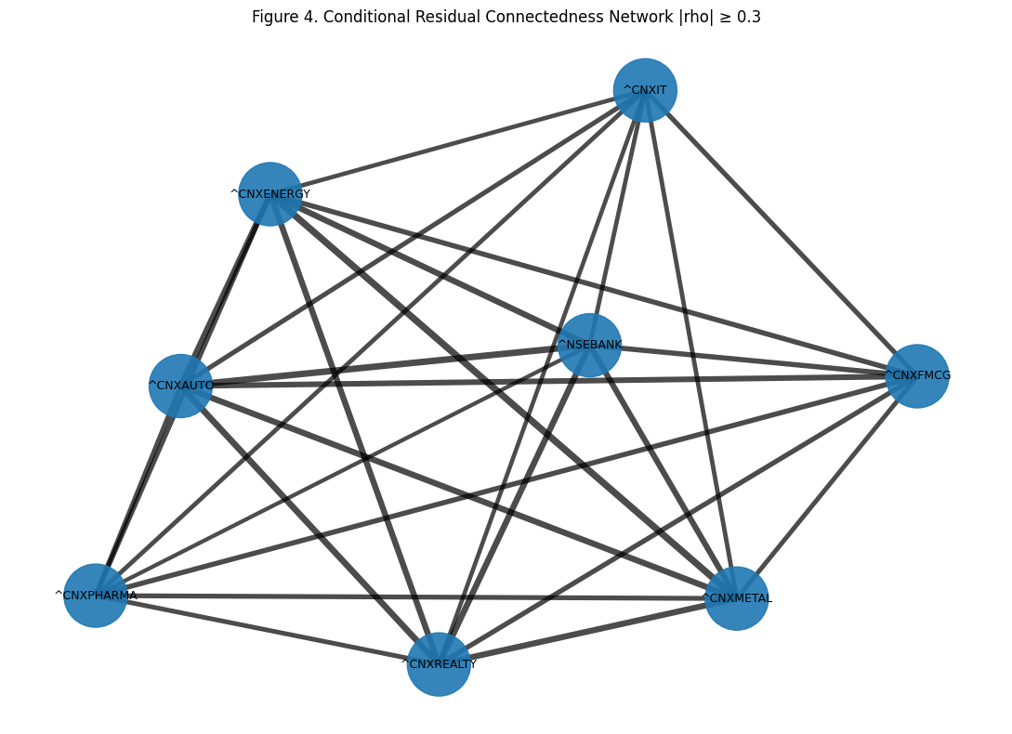
Figure 3: Conditional Residual Connectedness Network |rho|$≥3$
Figure 3 visualizes the residual connectedness network based on the SUR residual correlation matrix. The network exhibits a dense structure with strong clustering among cyclical sectors, particularly Auto, Banking, Energy, and Metals. The most prominent linkage is between Energy and Metals, reflecting common exposure to commodity-related shocks. Overall, the network highlights that sectoral interdependence persists even after controlling for macro-financial factors, emphasizing the presence of latent shared influences across the equity market. These findings remain robust across alternative threshold specifications and diagnostic checks.
DISCUSSION
The empirical results provide a refined understanding of sectoral connectedness in Indian equity markets once common macro-financial influences are explicitly controlled for. A comparison between raw return correlations and residual correlations reveals an important distinction: while unconditional correlations suggest broad-based co-movement across sectors, the conditional framework demonstrates that a substantial portion of this co-movement is attributable to shared exposure to global and domestic risk factors. However, even after accounting for these drivers, residual correlations remain positive and economically meaningful, indicating the presence of latent common influences affecting multiple sectors simultaneously.
A key finding of the study is the dominant role of global market spillovers. The consistently strong and statistically significant coefficients associated with lagged S&P 500 returns across all sectors suggest that Indian sectoral indices are closely integrated with global equity market dynamics. This highlights the increasing globalization of financial markets, where external shocks and international risk sentiment are rapidly transmitted across domestic sectors. In contrast, the domestic market factor (NIFTY 50) exhibits negative coefficients in the presence of global controls, reflecting the redistribution of explanatory power among correlated regressors rather than a literal inverse market relationship. This negative sign should not be interpreted as an inverse market relationship, but rather as a statistical adjustment arising from multicollinearity among correlated market-wide factors. This underscores the importance of carefully specifying factor structures when multiple highly correlated market proxies are included.
Sectoral heterogeneity in macro-financial sensitivities further enriches the interpretation. Volatility effects, captured through the VIX, are generally negative but modest, with stronger sensitivity observed in defensive sectors such as FMCG and Pharma. Exchange-rate effects display substantial variation, with Banking, Auto, and Realty showing positive exposure, while Pharma exhibits a negative relationship. These differences reflect underlying sectoral characteristics, including international exposure, cost structures, and sensitivity to capital flows. Commodity price effects are most pronounced in Metals and Energy, confirming their dependence on global commodity cycles even after controlling for oil prices directly.
The efficiency gains observed from SUR estimation reinforce the methodological contribution of the study. Significant reductions in standard errors, particularly for lagged own-return coefficients in cyclical sectors, demonstrate that exploiting contemporaneous cross-equation covariance improves estimation precision. This provides empirical validation for the use of system-based estimators in multi-sector financial modeling, where ignoring cross-sectional dependence can lead to inefficient inference.
The residual covariance structure offers deeper insights into hidden sectoral connectedness. The persistence of strong positive residual correlations across multiple sector pairs suggests that unobserved common shocks continue to influence sectoral returns beyond what is captured by observable macro-financial variables. In particular, the strong clustering among cyclical sectors such as Auto, Banking, Energy, and Metals indicates the presence of shared latent drivers, potentially related to industrial cycles, credit conditions, or investor sentiment. The consistently strongest linkage between Energy and Metals further supports the existence of a commodity-driven sub-network within the broader market structure.
Importantly, the network-based analysis demonstrates that these findings are robust to variations in correlation thresholds. The residual connectedness network remains dense across a wide range of thresholds, indicating that the observed interdependencies are not driven by arbitrary cutoff choices. This strengthens the reliability of the inferred network structure and suggests that sectoral connectedness in the Indian market is both pervasive and stable in a conditional sense.
From a time-series perspective, residual diagnostics indicate that the inclusion of lagged own returns effectively mitigates first-order autocorrelation, as reflected in Durbin–Watson statistics close to two. However, Ljung–Box tests reveal the presence of higher-order dependence in certain sectors, suggesting that some dynamic structure remains unmodeled. Accordingly, the results are interpreted in terms of contemporaneous conditional associations rather than fully dynamic transmission mechanisms.
Overall, the findings emphasize that sectoral connectedness is inherently conditional. While market-wide and macro-financial factors explain a substantial portion of co-movement, a dense network of residual interdependence persists, reflecting the influence of latent common shocks. This has important implications for portfolio diversification and risk management. Traditional diversification strategies based solely on raw correlations may overestimate risk reduction benefits, as hidden conditional linkages can lead to synchronized sectoral responses during periods of stress. The SUR framework thus provides a more nuanced and informative representation of sectoral interdependence in modern financial markets.
CONCLUSION & FUTURE WORK
This study examines sectoral connectedness in the Indian equity market using a system-based econometric framework built on Seemingly Unrelated Regressions (SUR). By modeling daily returns of eight major NIFTY sectoral indices with lagged macro-financial controls and global market factors, the analysis distinguishes between co-movement driven by observable common influences and residual interdependence arising from latent shared shocks. The findings demonstrate that a significant portion of sectoral co-movement can be explained by global and domestic market conditions, particularly through strong spillover effects from international equity markets. However, even after accounting for these drivers, substantial contemporaneous residual correlations persist across sectors. This indicates that sectoral returns are influenced not only by observable macro-financial variables but also by unobserved common factors that generate conditional interdependence. The residual covariance structure reveals a dense network of positive connections, with particularly strong clustering among cyclical and commodity-linked sectors such as Energy, Metals, Banking, and Automobiles. These patterns highlight the presence of latent economic linkages that remain hidden in traditional correlation-based analyses. Moreover, sensitivity analysis confirms that the structure of this residual connectedness network is robust to alternative threshold specifications, reinforcing the stability of the identified relationships. From a methodological perspective, the results validate the advantages of SUR estimation over equation-by-equation OLS. By explicitly modeling contemporaneous cross-equation dependence, SUR improves estimation efficiency and provides a richer representation of sectoral interactions. At the same time, residual diagnostics suggest that while short-term serial dependence is largely mitigated through lagged specifications, some higher-order dynamics remain, indicating potential avenues for extending the framework. The study has important implications for portfolio management and systemic risk assessment. In particular, it highlights that diversification benefits inferred from unconditional correlations may be overstated, as hidden conditional linkages can lead to synchronized sectoral movements under certain conditions. A system-based approach that accounts for both observable and latent interdependencies therefore offers a more realistic assessment of risk. The study is subject to certain limitations, including the assumption of static contemporaneous relationships and reliance on a fixed set of macro-financial variables. Potential omitted factors and dynamic dependencies may influence the results. Future research may extend this framework in several directions, including the incorporation of regime-switching dynamics, additional macroeconomic or global risk factors, and dynamic system models that capture time-varying connectedness. Exploring predictive applications of residual networks and integrating high-frequency or alternative data sources may further enhance the understanding of sectoral interactions in evolving financial markets. Future research may explore hybrid approaches combining econometric frameworks with machine learning models such as LSTM or graph-based networks to capture nonlinear and time-varying sectoral dependencies.
Abbreviations
SUR: Seemingly Unrelated Regression, OLS: Ordinary Least Squares, FGLS: Feasible Generalized Least Squares, VAR: Vector Autoregression, ACF: Autocorrelation Function, NIFTY: National Stock Exchange Fifty Index, VIX: Volatility Index, USD/INR: US Dollar to Indian Rupee Exchange Rate, BRENT: Brent Crude Oil Benchmark, MKT: Market Return, L1: Lagged Return (First Lag), R²: Coefficient of Determination, AIC: Akaike Information Criterion, BIC: Bayesian Information Criterion, DW: Durbin–Watson Statistic, CAPM: Capital Asset Pricing Model, FMCG: Fast Moving Consumer Goods.
Conflicts of Interest
The authors declare that they have no conflicts of interest.
Ethics Approval
Not applicable.
Privacy Statement
The authors declare that no personal, confidential, or identifiable information has been used in this study. All data utilized are publicly available and used solely for academic and research purposes.
Declaration of Generative AI and AI-Assisted Technologies in the Writing Process
The authors declare that no generative AI or AI-assisted technologies were used in the writing, analysis, or preparation of this manuscript.
Data Availability
The data that support the findings of this study are publicly available from Yahoo Finance. The datasets generated and/or analyzed during the current study are available from the corresponding author on reasonable request.

COMPETING INTERESTS DISCLAIMER:
Authors have declared that they have no known competing financial interests OR non-financial interests OR personal relationships that could have appeared to influence the work reported in this paper.
Disclaimer (Artificial intelligence)

Author(s) hereby declare that NO generative AI technologies such as Large Language Models (ChatGPT, COPILOT, etc.) and text-to-image generators have been used during the writing or editing of this manuscript.

REFERENCES
- Schiavone, A. (2020). Estimating the contagion effect through the portfolio channel using a network approach. The Journal of Network Theory in Finance. https://doi.org/10.21314/jntf.2019.054
- Liu, Z., Liu, Y., and Li, W. (2025). Exploring volatility spillover of Chinese financial system using empirical mode decomposition and multilayer networks. International Journal of Emerging Markets, 1–27. https://doi.org/10.1108/ijoem-04-2025-0727
- Chang, J., Hu, Q., Shi, Z., & Zhang, J. (2025). Empirical likelihood approach for high-dimensional moment restrictions with dependent data. In ArXiv.org. Societa Italiana Di Fisica. https://doi.org/10.48550/arxiv.2502.18970
- Do, H. X., Nepal, R., Pham, S. D., and Jamasb, T. (2024). Electricity market crisis in Europe and cross border price effects: A quantile return connectedness analysis. Energy Economics, 135, 107633. https://doi.org/10.1016/j.eneco.2024.107633
- Rafiq, A., and Hassan, S. (2019). Macro-economic determinant and interdependence of the stock markets. Economic Journal of Emerging Markets, 11(1), 104–112. https://doi.org/10.20885/ejem.vol11.iss1.art11
- Tripathi, A. (2014). A Study of Correlation between Selected Asian, European and American Stock Exchange Market. SSRN Electronic Journal. https://doi.org/10.2139/ssrn.2170019
- Tripathi, A., and Rathore, R. (2016). Impact of Liberalization and Globalization on Stock Exchange Markets A Study of Interdependence and Co-Movement of Selected Asian, European and American Market. JIMS8M: The Journal of Indian Management andamp; Strategy, 21(3), 60. https://doi.org/10.5958/0973-9343.2016.00026.0
- Kaur, P., and Arora, H. (2018). Financial markets interdependence in India: an empirical analysis. International Journal of Economics and Business Research, 16(4), 517. https://doi.org/10.1504/ijebr.2018.10016071
- Chelley-Steeley, P. L. (2000). Interdependence of international equity market volatility. Applied Economics Letters, 7(5), 341–345. https://doi.org/10.1080/135048500351500
- Chong, L., Drew, M., and Veeraraghavan, M. (2003). Stock Market Interdependence: Evidence from Australia. Pacific Accounting Review, 15(2), 51–76. https://doi.org/10.1108/eb037974
- Emenike, K. O. (2021). Interdependence among West African stock markets: A dimension of regional financial integration. African Development Review, 33(2), 288–299. https://doi.org/10.1111/1467-8268.12575
- Ghosh, I., and Chaudhuri, T. D. (2020). Wavelet decomposition approach for understanding time-varying relationship of financial sector variables: a study of the indian stock market. Multiple Criteria Decision Making, 15, 36–65. https://doi.org/10.22367/mcdm.2020.15.03
- Saini, H., and Sharma, D. D. (2025). Volatility Spillover Among Sectoral Indices of the Indian and US Stock Markets. International Journal of Management and Humanities, 11(9), 11–17. https://doi.org/10.35940/ijmh.g1801.11090525
- Chen, J.-H., Ko, C.-C., Wang, Y., and Francis, D. (2013). The Influence of Macroeconomic Factors and Banking Fragility on Offshore Banking Unit (OBU). Asia-Pacific Management Review, 18(4), 407–425. https://doi.org/10.6126/apmr.2013.18.4.04
- Takada, H., Ullah, A., and Chen, Y.-M. (1995). Estimation of the seemingly unrelated regression model when the error covariance matrix is singular. Journal of Applied Statistics, 22(4), 517–530. https://doi.org/10.1080/757584788
- Agarwal, S. (2024). Volatility in the Equity Stock Market in India from 2019 to 2024: An Empirical Analysis. INTERANTIONAL JOURNAL OF SCIENTIFIC RESEARCH IN ENGINEERING AND MANAGEMENT, 08(008), 1–4. https://doi.org/10.55041/ijsrem37237
- Lang, S., Adebayo, S. B., Fahrmeir, L., and Steiner, W. J. (2003). Bayesian Geoadditive Seemingly Unrelated Regression. Computational Statistics, 18(2), 263–292. https://doi.org/10.1007/s001800300144
- Koop, G., Poirier, D. J., and Tobias, J. (2005). Semiparametric Bayesian inference in multiple equation models. Journal of Applied Econometrics, 20(6), 723–747. https://doi.org/10.1002/jae.810
- Onwukwe, E. K., and Ali, P. I. (2018). Weak Form Efficiency of the Insurance Industry: Empirical Evidence from Nigeria. Jurnal Keuangan Dan Perbankan, 22(1). https://doi.org/10.26905/jkdp.v22i1.1800
- Srinivasan, P., and Murugadoss, K. (2015). Relationship between Macroeconomic Variables and Stock Market Indices-Evidence from Bombay Stock Exchange. Asian Journal of Research in Business Economics and Management, 5(2), 23. https://doi.org/10.5958/2249-7307.2015.00027.4

