DETERMINANTS OF SUSTAINABLE INDIGENOUS ATTIRE USAGE IN THE ERA OF MODERN FASHION AMONG HOME ECONOMICS STUDENTS IN DELTA STATE

Abstract
This study investigated the determinants of sustainable indigenous attire usage in the era of modern fashion among Home Economics students in tertiary institutions in Delta State, Nigeria. The study was motivated by the observed decline in the regular use of indigenous clothing among students despite its cultural and educational relevance. Specifically, the study examined socio-cultural, economic, and modern fashion-related factors influencing students’ clothing choices. A descriptive survey research design was adopted, involving a population of 75 students, out of which 70 valid responses were analyzed using mean and standard deviation. Findings revealed that socio-cultural factors such as cultural identity, family influence, peer influence, and participation in cultural events positively influence the use of indigenous attires. Economic factors—including cost of fabrics, income level, and tailoring expenses—were identified as major constraints, limiting regular usage. Additionally, exposure to modern fashion through social media, celebrities, and global trends significantly reduces the frequency of indigenous attire usage, confining it mostly to special occasions. The study is significant as it provides insights for educators, policymakers, and fashion stakeholders on strategies to promote sustainable indigenous fashion. However, the study was limited to a small sample of Home Economics students in two universities in Delta State, which may affect the generalizability of the findings. The study concludes that while positive cultural perceptions exist, economic constraints and the influence of modern fashion hinder the sustainable use of indigenous attires. It recommends curriculum integration, affordability strategies, and modernization of indigenous designs to enhance their adoption.

Keywords: Determinants, Indigenous attire, Sustainable usage, Modern fashion, Home Economics students, Tertiary institutions, Delta State

Introduction
Fashion and clothing are an inherent part of human culture, which fulfils functional, aesthetic, psychological and socio-cultural needs. In addition to offering protection and modesty, clothes are a source of identity, culture, social status, and group membership in societies (Eicher and Sumberg, 1995; Ermilova, 2020). The traditional African culture is very much attached to indigenous attires used by African societies, which represent historical facts, culture, rights and moral values as well as community values. Culturally diverse and locally produced clothing like aso-oke, ankara, George wrappers, isi-agu, and other culturally specific clothes in Nigeria are a demonstration of cultural diversity and craftsmanship that is transmitted both through socialisation and formal education (Adepeko et al., 2023).
The idea of sustainability has become quite popular in the international fashion discourse in recent times. Sustainable fashion focuses on cultural heritage, encouragement of locally produced materials, socially responsible production, and sustainable use of clothing materials. Indigenous fashions, in their turn, are congruent with sustainability principles because they use the local fabric, uphold indigenous industries and advance cultural continuity. Nevertheless, to maintain the use of indigenous clothes in the modern world, there is a need to understand the elements that determine the dressing preference of people.
Modernisation, Westernisation and globalisation have been very instrumental factors that have changed the nature of the contemporary fashion world in Nigeria. Due to the innovations in communication technologies, international trade, mass media, and social networking platforms, globalisation has intensified the cultural interactions across national borders (Giddens, 2003). Most of the non-Western societies, including Nigeria, have embraced modern fashion, which is predominantly Western fashion in terms of jeans, trousers, skirts, suits, T-shirts and sneakers, and fast-fashion trends. This supremacy is especially pronounced in young people in the city and universities and colleges, where contemporary fashion can be equated with convenience, modernity, social mobility, and global identity (Kaiser, 2019).
The growing use of modern fashion has questioned the sustainability of using indigenous attire. Research has indicated that the attitudes, tastes, and consumption habits of the youths have to a great extent been influenced by exposure to the Western media, culture of celebrities, and global brands of fashion, which in most instances has led to a decline in the use of localised attires (Temitope, 2025; Agadagba et al., 2026). As a result, native clothing is becoming more of a cultural rite, festival, and specialty and not for daily usage, which becomes a threat to its sustainability.
In this setting, students of tertiary institutions are a sensitive cohort when it comes to the analysis of the sustainability of using indigenous attire. The campus life leads to the development of identity, socialisation, and exposure to a variety of cultural influences, which influence the dressing patterns of students (Barnard, 2020). The dressing code of students is affected by a variety of factors; these factors may be peer influence, exposure to the media, economic factors, preferences and cultural inclination and perceived social acceptance. All these combines to make or break the continuity of the indigenous attires as they are replaced by modern fashion over time.
It is of special concern to the students of home economics, as their academic education covers clothing and textiles, fashion design, consumer education, and cultural studies. It is hoped that the education of home economics will foster the recognition, usage, and preservation of local textiles and clothes (Azonuche, 2020). These students, as the future teachers and employees working in the clothing and textile-related field, are supposed to be the proponents of sustainable fashion. Nevertheless, most home economics students, notwithstanding their academic background, seem to value the modern style of fashion more than the native wear in their everyday dressing.
In Delta State, which is a culturally diverse area with various native textile cultures, the issue of maintaining indigenous attire wearing is becoming apparent. The state has a number of tertiary institutions, which expose them to the traditional values and the modern fashion trends. The popularity of modern fashion among students has been levelled by the abundance of social media platforms like Instagram, TikTok, and Facebook, as well as the power of fashion influencers, music, and movies (Akintayo, 2021). This can significantly influence the views of fashion, making the fashionable, modern styles more preferred and the indigenous styles less convenient or fashionable.
Even though research on fashion adoption and youth dressing behaviour has been conducted in Nigeria before, most have investigated the general population as well as failed to sufficiently study the factors of sustainable wearing of indigenous attires among certain groups like home economics students (Omenugha et al., 2016; Hughes, 2023; Nwonye et al., 2024). In addition, little has been done to establish the key determinants of the use of indigenous attires in the modern fashion age, including the socio-cultural, economic, educational and psychological determinants. It is thus important to know the determinants of the use of sustainable indigenous attire among home economics students. It is in this context that this research aims at investigating the determinants of the sustainable use of indigenous attires in the time of modern fashion amongst the home economics students of tertiary institutions in Delta State, in an attempt to establish the main influencing factors and their consequences to cultural sustainability and home economics education.

Statement of the Problem
The past few years have witnessed an alarm that has been raised over the dwindling use of indigenous clothing among students in tertiary institutions as more people continue to embrace modern fashion. In the case of home economics students in Delta State, where their professional training requires them to appreciate and promote the indigenous clothes, it is observed that students do not wear them as much and only wear them on special occasions. This movement poses the question of the sustainability of the usage of indigenous clothes in particular when there is a high influence of modern fashion. Their preference towards modern ways of clothing could eventually result in the erosion of the indigenous ways of clothing which are crucial in the preservation of the culture of such communities as well as the local economy. Despite the importance of this issue, there is limited empirical evidence on the specific factors that determine whether Home Economics students sustain the use of indigenous attires in the era of modern fashion. The following question arises: What are the determinants of sustainable indigenous attire usage in the era of modern fashion among Home Economics students in tertiary institutions in Delta State?

Research Questions
- What are the socio-cultural determinants of indigenous attire usage among tertiary institution students in Nigeria?
- What are the economic determinants of indigenous attire usage among tertiary institution students in Nigeria?
- What are the determinants related to modern fashion that influence the usage of indigenous attires among tertiary institution students in Nigeria?

Significance of the Study
This is important research in a number of ways. It will assist students in tertiary institutions to be more conscious of what affects their dress codes, especially wearing indigenous dresses, and cultural identity and pride. The research will be beneficial to the lecturers in home economics and other related areas, enabling them to design more effective methods of teaching that would help to preserve the culture and allow the incorporation of indigenous fashion into the learning process. It will also help curriculum developers to include the content relating to the indigenous clothes and cultural sustainability in the educational programmes. Moreover, the research results will be helpful to policymakers in encouraging policies that will facilitate the maintenance of the Nigerian cultural heritage in the form of indigenous clothes. The results will also be of an advantage to fashion designers and those involved in the manufacture of textiles since they will learn what factors can affect the demand so that they can design attractive and affordable indigenous attires. Lastly, the study will be an effective resource for future researchers concerning indigenous fashion, cultural studies, and sustainable clothing practices.

Methodology
This study adopted a descriptive survey research design to investigate the determinants of sustainable indigenous attire usage in the era of modern fashion among Home Economics students in tertiary institutions in Delta State, Nigeria. The population of the study comprised seventy-five (75) Home Economics students in the two universities offering Home Economics in Delta State, namely, Delta State University, Abraka, and University of Delta, Agbor. There was no sampling due to the manageable size of the population. Data were collected using a structured questionnaire titled Determinants of Sustainable Indigenous Attire Usage Questionnaire (DSIAUQ), developed by the researcher. The instrument consisted of four sections: Section A focused on demographic characteristics of the respondents; Section B measured socio-cultural factors influencing the sustainable use of indigenous attires; Section C examined economic factors affecting indigenous attire usage; while Section D assessed the influence of exposure to modern fashion using a 4-point Likert scale (Strongly Agree, Agree, Disagree, Strongly Disagree).
To ensure the validity of the instrument, the questionnaire was subjected to face and content validation by three experts in Home Economics education and measurement and evaluation. Their suggestions were incorporated to improve the clarity, relevance, and appropriateness of the items in line with the objectives of the study. A pilot study was conducted among 20 Home Economics students from University of Nigeria, Nsukka, outside the study area. The reliability of the instrument was determined using Cronbach’s alpha, which yielded a coefficient of 0.84, indicating a high level of internal consistency. Data collection was carried out with the assistance of trained research assistants. Ethical considerations were strictly observed throughout the study. Respondents were informed of the purpose of the study, assured of confidentiality, and participation was entirely voluntary. Informed consent was obtained before administering the questionnaire. Out of 75 copies of questionnaire that were administered, only 70 copies were completely filled and returned; hence, used for the study. Data were analyzed using means and standard deviations. The benchmark was 2.50, such that any item with mean score of 2.50 and above is regarded as agreed, while those with mean score less than 2.50 was regarded as disagreed.

Results
Research Question 1
What are the socio-cultural determinants of indigenous attire usage among tertiary institution students in Nigeria?
Table 1: Mean and Standard Deviation of Socio-Cultural Factors Influencing Sustainable Indigenous Attire Usage among Home Economics Students (n = 70)
S/N | Statement | Mean (x̄) | SD | Remark
1 | I feel proud wearing indigenous attires | 3.92 | 0.88 | Agreed
2 | My cultural background encourages me to wear indigenous attires regularly | 3.85 | 0.90 | Agreed
3 | Indigenous attires help me express my cultural identity | 4.10 | 0.82 | Agreed
4 | My family influences my use of indigenous attires | 3.75 | 0.95 | Agreed
5 | Peer influence affects my decision to wear indigenous attires | 3.68 | 0.98 | Agreed
6 | Indigenous attires are suitable for everyday use | 3.60 | 1.02 | Agreed
7 | I consider indigenous attires fashionable | 3.45 | 1.05 | Agreed
8 | Society appreciates individuals who wear indigenous attires | 3.80 | 0.91 | Agreed
9 | Religious or cultural events encourage my use of indigenous attires | 4.25 | 0.76 | Agreed
10 | I feel more confident when wearing indigenous attires | 3.95 | 0.89 | Agreed
11 | Indigenous attires promote a sense of belonging in my community | 4.15 | 0.80 | Agreed
12 | My friends’ opinions influence my choice of indigenous clothing | 3.70 | 0.97 | Agreed
13 | Indigenous attires are respected in my society | 3.88 | 0.85 | Agreed
14 | I wear indigenous attires to maintain cultural heritage | 4.30 | 0.70 | Agreed
15 | I perceive indigenous attires as outdated | 2.10 | 1.05 | Disagreed

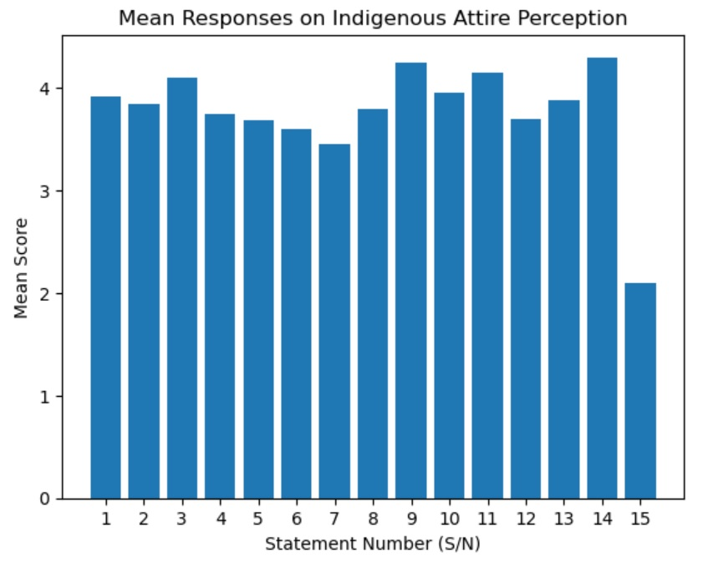
fffffij

Ff
FIG 1: Mean Responses on Indigenous Attire Perception

Table 1 showed that all socio-cultural factors recorded mean scores above 2.50, indicating agreement among respondents that these factors influence their use of indigenous attires. The highest mean was recorded for wearing indigenous attires to maintain cultural heritage (x̄ = 4.30), followed by participation in cultural or religious events (x̄ = 4.25) and promoting a sense of belonging (x̄ = 4.15). This suggests that cultural identity and traditions strongly influence students’ clothing choices. Other factors such as confidence, family influence, peer influence, and societal respect also recorded high mean scores, showing that social relationships and environment play important roles. The item on perceiving indigenous attires as outdated recorded a low mean (x̄ = 2.10), indicating disagreement, which implies that students generally do not see indigenous attires as outdated. Overall, the results indicate that socio-cultural factors significantly influence the sustainable use of indigenous attires among Home Economics students.

Research Question 2
What are the economic determinants of indigenous attire usage among tertiary institution students in Nigeria?
Table 2: Mean and Standard Deviation of Economic Factors Influencing Sustainable Indigenous Attire Usage (n = 70)
S/N | Statement | Mean (x̄) | SD | Remark
16 | Indigenous attires are affordable for me. | 3.55 | 1.00 | Agreed
17 | The cost of indigenous fabrics affects my clothing choices. | 3.90 | 0.92 | Agreed
18 | Indigenous attires are durable. | 4.20 | 0.75 | Agreed
19 | Availability of indigenous fabrics influences my usage. | 3.85 | 0.88 | Agreed
20 | Tailoring cost discourages me from wearing indigenous attires. | 3.60 | 0.97 | Agreed
21 | Ready-made indigenous attires are easily accessible. | 3.40 | 1.02 | Agreed
22 | I prefer cheaper modern clothing to indigenous attires. | 3.75 | 0.95 | Agreed
23 | Financial constraints limit my use of indigenous attires. | 3.80 | 0.90 | Agreed
24 | Indigenous fabrics are more expensive than modern fabrics. | 3.65 | 0.96 | Agreed
25 | I can easily access tailors who sew indigenous attires. | 3.50 | 1.00 | Agreed
26 | Maintenance of indigenous attires is costly. | 3.45 | 1.03 | Agreed
27 | Discounts and promotions influence my clothing choices. | 3.30 | 1.10 | Agreed
28 | I would wear indigenous attires more if they were cheaper. | 4.25 | 0.72 | Agreed
29 | Local production of fabrics encourages me to use indigenous attires. | 4.05 | 0.80 | Agreed
30 | Income level affects my ability to purchase indigenous attires. | 3.95 | 0.85 | Agreed

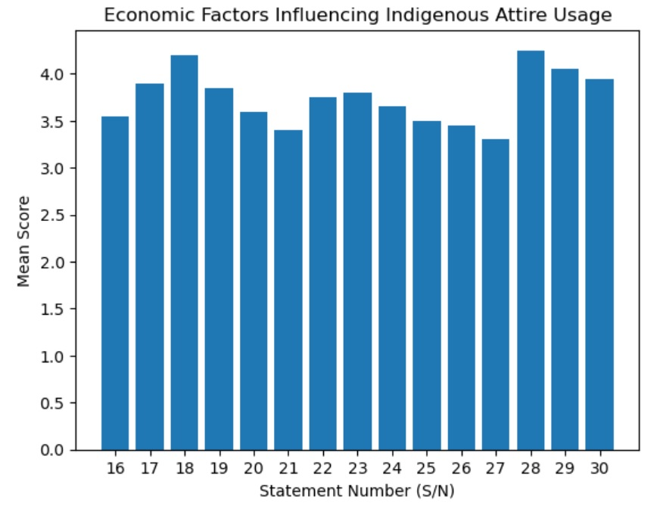

FIG 2:Economic Factors Influencing Indigenous Attire Usage

Table 2 showed that all economic factors recorded mean scores above 2.50, indicating that respondents agreed that these factors influence their use of indigenous attires. The highest mean was recorded for the statement that respondents would wear indigenous attires more if they were cheaper (x̄ = 4.25), followed by the durability of indigenous attires (x̄ = 4.20) and the effect of income level (x̄ = 3.95). The results also show that cost-related factors such as fabric cost (x̄ = 3.90), tailoring cost (x̄ = 3.60), and financial constraints (x̄ = 3.80) influence students’ clothing choices. Availability of fabrics (x̄ = 3.85) and local production (x̄ = 4.05) also encourage the use of indigenous attires. However, factors such as accessibility of ready-made attires (x̄ = 3.40) and maintenance cost (x̄ = 3.45) recorded relatively lower mean scores, though still within the agreed range. This suggests that while economic factors generally support usage, affordability and cost remain key considerations. Overall, the findings indicate that economic factors significantly influence the sustainable use of indigenous attires among Home Economics students, particularly issues related to cost, income, and availability.

Research Question 3
What are the determinants related to modern fashion that influence the usage of indigenous attires among tertiary institution students in Nigeria?

Table 3: Mean and Standard Deviation of Modern Fashion Influence on Indigenous Attire Usage (n = 70)
S/N | Statement | Mean (x̄) | SD | Remark
31 | Social media influences my preference for modern fashion | 4.20 | 0.78 | Agreed
32 | I prefer Western clothing styles to indigenous attires | 3.80 | 0.92 | Agreed
33 | Celebrities and influencers affect my dressing style | 4.15 | 0.80 | Agreed
34 | Modern fashion is more convenient than indigenous attires | 3.90 | 0.85 | Agreed
35 | Exposure to global fashion trends reduces my use of indigenous attires | 4.00 | 0.83 | Agreed
36 | I wear indigenous attires mainly on special occasions | 4.30 | 0.70 | Agreed
37 | Modern fashion makes indigenous attires seem outdated | 3.55 | 0.98 | Agreed
38 | I combine indigenous and modern styles in my dressing | 4.10 | 0.79 | Agreed
39 | Fashion trends influence my dressing choices | 4.25 | 0.75 | Agreed
40 | Western clothing is more acceptable among my peers | 3.95 | 0.88 | Agreed
41 | I follow fashion trends on social media platforms | 4.35 | 0.70 | Agreed
42 | Modern fashion is more comfortable than indigenous attires | 3.85 | 0.90 | Agreed
43 | I feel more fashionable wearing modern clothing | 4.15 | 0.80 | Agreed
44 | Exposure to foreign cultures influences my dressing style | 4.05 | 0.82 | Agreed
45 | Fashion influencers shape my perception of clothing | 4.30 | 0.74 | Agreed

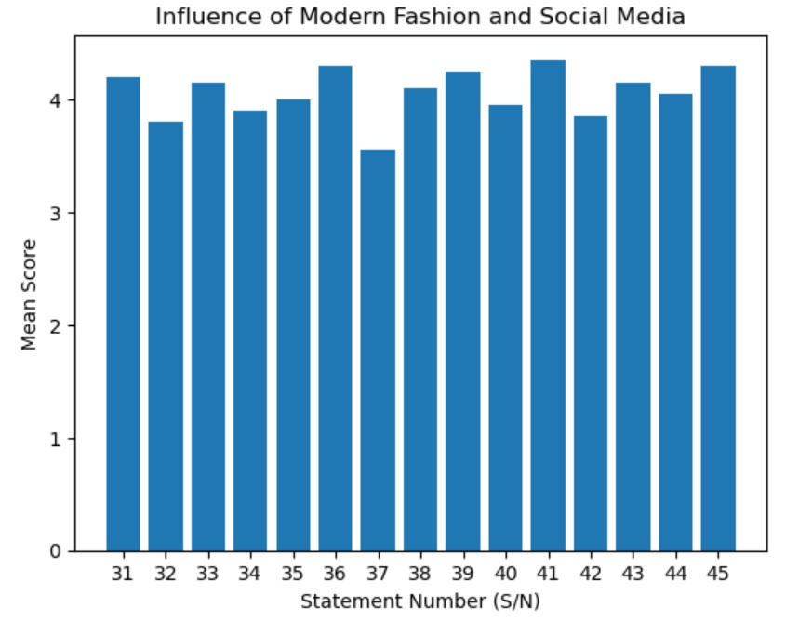

FIG 3: Influence of Modern Fashion and Social Mediaconclu

Table 3 revealed that all items recorded mean scores above 2.50, indicating that respondents agreed that modern fashion influences their use of indigenous attires. The highest mean was recorded for following fashion trends on social media (x̄ = 4.35), followed by wearing indigenous attires mainly on special occasions (x̄ = 4.30) and the influence of fashion influencers (x̄ = 4.30). Other high mean scores were recorded for fashion trends influencing dressing choices (x̄ = 4.25), social media influence (x̄ = 4.20), and the role of celebrities and influencers (x̄ = 4.15). This shows that exposure to media and global fashion strongly affects students’ clothing preferences. The results also indicate that many respondents feel modern fashion is more convenient (x̄ = 3.90), more fashionable (x̄ = 4.15), and more acceptable among peers (x̄ = 3.95). The preference for combining indigenous and modern styles (x̄ = 4.10) suggests a blend of fashion influences. Overall, the findings show that modern fashion significantly influences the reduced and occasional use of indigenous attires among Home Economics students, as exposure to global trends and social media plays a major role in shaping their dressing choices.

Discussion
The outcome of the socio-cultural factors indicated that cultural identity, family influence, peer influence, and engagement in cultural events had a strong impact on the adoption of indigenous attires among the students. This goes in line with recent research that argues that clothing is a powerful tool of cultural identification and social importance among the youths (Kaiser, 2019). On the same note, social influence theory has been reinstated in recent research that indicates that people take up behaviours, including dressing styles, upon interacting with their families and friends (Olajide et al., 2018). The denial of the assumed fact that indigenous attires are outdated is consistent with the research results that show that the more students are culturally aware, the more they will feel proud and embrace positive views about indigenous attire (Diyaolu and Akanmu, 2024).
The economic results showed that cost, income level, availability, and tailoring cost are some of the factors that have an important impact on the use of indigenous attires. This is in line with recent consumer behaviour research that affirms that affordability and accessibility are major determinants of the clothing decisions of students (Nwonye et al., 2024). Moreover, it has been revealed that the expensive prices of native fabrics and customisation restrict their wearability even though they are culturally important (Akintayo, 2021). The contribution of availability and local production also justifies the results that the access to locally made textiles promotes their usage and sustainability (Azonuche, 2020).
The results of the research about contemporary fashion showed that social media, celebrities, and fashion trends across the world largely determine the way students dress and decrease the popularity of local clothes. This is in line with modern data that show that digital media platforms greatly define fashion consciousness and fashion consumption among the youths (Kaiser, 2019). Likewise, the fact that students are exposed to the world of fashion has been identified to have an effect on their view of the contemporary clothes as trendy and more socially acceptable (Temitope, 2025; Perculiar et al., 2025). The fusion of the indigenous and contemporary also helps assess the newly formed perspectives of fashion hybridity whereby the people were mixing traditional and modernistic aspects in reaction to globalisation (Akintayo, 2021; Oduselu-hassan, et al., 2026). The results are consistent with literature that was published in the recent past, which suggests that the socio-cultural, economic, and modern fashion factors all play a role in defining sustainable use of indigenous attires by home economics students.

Conclusion
The study concluded that sustainable use of indigenous attires among Home Economics students in Delta State is determined by socio-cultural, economic, and modern fashion influences. Socio-cultural factors such as cultural identity, family, and peer influence encourage positive attitudes toward indigenous attires. However, economic factors like cost and availability limit their regular use. In addition, modern fashion trends and social media significantly influence students’ preferences, often leading to greater adoption of Western styles and occasional use of indigenous clothing.

Recommendations
The following recommendations were made:
- Educational institutions should integrate practical and engaging indigenous fashion content into the Home Economics curriculum to strengthen students’ appreciation and usage of indigenous attires.
- Government and relevant agencies should support local textile production and subsidize indigenous fabrics to make them more affordable for students.
- Fashion designers and industry stakeholders should modernize indigenous attires to align with current fashion trends and increase their appeal among youths.
- Awareness campaigns should be promoted through social media and other platforms to encourage positive perceptions and regular use of indigenous attires among students.

Consent
As per international standards or university standards, Participants’ written consent has been collected and preserved by the author(s).
Ethical Approval:
As per international standards or university standards written ethical approval has been collected and preserved by the author(s).

Disclaimer (Artificial intelligence)

Author(s) hereby declare that NO generative AI technologies such as Large Language Models (ChatGPT, COPILOT, etc.) and text-to-image generators have been used during the writing or editing of this manuscript.

References

Adepeko, E. O., Oyinloye, M. A., Adepeko, A. O., & Adeloye, A. A. (2023). Preserving Traditional Clothing Identity: An Overview of the Past and Present Uses of Aso-Oke by the Ondo People of Southwest, Nigeria. Journal of Urban Culture Research, 27, 75-88.
Agadagba, L. A., Arubayi, D. O., & Azonuche, J. E. (2026). Students’ attitudes toward indigenous attires among Home Economics students in Universities in Delta State. Asian Basic and Applied Research Journal, 8(1), 95-105.
Akintayo, L. W. (2021). Influence of social media as marketing strategy for establishing youths’ fashion consciousness and purchase intention towards traditional fabrics in Southwest, Nigeria. NIU Journal of Social Sciences, 6(4), 81-91.
Azonuche, J. E. (2020). Revitalizing home economics education in tertiary institutions in Nigeria through ICT use for skill acquisition for global relevance. Journal of Educational and social research, 10(6), 332-340.
Barnard, M. (2020). Fashion theory: A reader. Routledge.
Diyaolu, I. J., & Akanmu, Y. A. (2024). Knowledge, attitude and practice of sustainable fashion consumption among young adults in Ile-Ife, Osun State. Journal of Home Economics Research, 31(1).
Eicher, J., & Sumberg, B. (1995). World fashion, ethnic, and national dress. In JB Eicher (Ed.), Dress and ethnicity. In In JB Eicher (Ed.), Dress and ethnicity (pp. 295-306). Berg Publishing.
Ermilova, D. Y. (2020). Costume as a form of visualization of ethnicity: From tradition to modernity. Rupkatha Journal on Interdisciplinary Studies in Humanities, 12(6).
Giddens, A. (2003). Runaway world: How globalization is reshaping our lives. Taylor & Francis.
Hughes, H. (2023). Constituting Nigerian identities through fashion: the practices, networks and fashion spaces of Lagos and London (Doctoral dissertation, University of Sussex).
Kaiser, S. B. (2019). Material subjects: Making place, making time through fashion. Fashion and Materiality: Cultural Practices in Global Contexts, 21.
Nwonye, N. U., Ibokette, M. U., & Esiowu, P. A. (2024). Socio-economic and Psychological Factors Affecting Clothing Consumption Among Female Undergraduates in University of Uyo, Nigeria. International Journal of Home Economics, Hospitality and Allied Research, 3(2), 104-127.
Oduselu-Hassan, O. E., Oladayo, A. P., Otutuadum, G. A., Oyewale, M. A., Njoseh, I. N., & Tsetimi, J. (2026). The impact of service quality digitalization on customer satisfaction in the Nigerian oil industry: A comparative study of traditional and digital oil channels. Asian Journal of Economics, Finance and Management, 8(1), 283–297. https://doi.org/10.56557/ajefm/2026/v8i1370
Olajide, O. P., Folake, O. C., Olabode, O. T., & Olayinka, A. M. (2018). Social influence and consumer preference for fashion clothing among female undergraduate in Nigeria. Gender and Behaviour, 16(3), 11984-11993.
Omenugha, K. A., Uzuegbunam, C. E., & Ndolo, I. S. (2016). Celebrity culture, media and the Nigerian youth: negotiating cultural identities in a globalised world. Critical Arts, 30(2), 200-216.
Perculiar, O. A., Oduselu-Hassan, E. O., & Jonathan, T. (2025). Exploring the Influence of Artificial Intelligence on Secondary School Students' Cognitive Development and Academic Achievement in Delta State, Nigeria. Asian Research Journal of Current Science, 7(1), 38-49.
Temitope, D. K. O. (2025). Psychological reactions to clothing styles: A study of social norms, trends, and personal identity in Nigeria. Asian Journal of Research and Development Studies, 2(1), 1-15.

