Milk Production and Reproductive Performance of Indigenous Goat in Loka Abaya Woreda, Sidama Region

ABSTRACT
This study was conducted to evaluate milk production and reproductive performance of indigenous goats at Loka Abaya woreda. A total of 50 households were selected for the survey and monitoring study. For milk data collection, 110 does were mentored from September 2021 to November 2022. A general linear model was employed for data analysis. Does constitute the largest proportion (46.6%), followed by kids under 6 months. Goat milk consumption is a common cultural practice, and all family members consume the milk. Average daily milk yield and lactation length of does were 0.65 liters and 89.3 days, respectively. Milk yield was affected (P<0.001) by birth type, parities, and birth season. Parturition was affected by season of birth; thus, the majority of parturitions occurred during the wet season. Average age at first kidding and kidding interval were 12.8±0.0.3 and 8.12 months, respectively. Liter size and fertility rate were 1.5 and 87.3%, respectively. In conclusion, litter size, parity, and season of birth were found to be important sources of variation in milk yield and lactation length. Therefore, goat milk production integrated with forage development and farmer awareness creation should be considered an important developmental intervention.
Keywords: Birth type; flock size; lactation length; milk yield; milk utilization

INTRODUCTION
Ethiopia is endowed with a large goat population estimated at 52.5 million head (CSA, 2021), which are found in various production systems and agro-ecological zones of the country. This number accounts for about 99.97% of the indigenous goat population, which is adapted to the different agro ecological zones of the country. Despite the large goat population, their productivity and contribution to the national economy remain very low (Solomon et al., 2014). In Ethiopia, goats are mostly kept under farmers’ management systems and are used as a source of meat, milk, skin, and manure, and direct cash income (Zeleke T. et al., 2020). Goats in the lowlands are highly valued and reared mainly for milk and meat production (Kassahun and Solomon, 2008). There is also a growing awareness of the importance of goat as a source of milk off-take for home consumption (Tona et al., 2015), and they are normally called the ‘poor man’s cow.
Goat milk is better tolerated than cow milk by people suffering from lactose intolerance, which is a common condition among adults in sub-Saharan Africa (Kumar A., and Sharma A., 2016). It is more highly digestible than cow milk, despite having similar lactose content (Silanikove et al., 2015) with high-value protein and a great content of minerals and vitamins (Brito et al., 2011). The consumption of goat milk in Ethiopia is largely influenced by community cultural attitudes and the low productivity of goats. (Mekuria et al., 2018).
The productivity potential of goats is influenced by their reproductive performance (Khandoker et al., 2018), which is determined by age at first puberty, age at first service, age at first kidding, litter size, and birth weight. A high reproductive rate enhances the efficiency of goat production by increasing the number of animals available for meat and milk production, as well as improving genetic improvement through faster selection response (Khan et al., 2019).
The study area possesses favorable climatic conditions and diverse plant species that support livestock production, particularly goat rearing, which plays an important role in generating cash income, household assets, and nutritious dairy products for smallholder and elderly farmers.
Goat milk consumption is a common practice in the study area, and it is widely consumed by all household members. Despite the large goat population potential in Loka Abaya Woreda, information on milk production and reproductive performance remains limited. Therefore, understanding goat productivity performance is essential for designing appropriate development strategies that support effective breed improvement through selection. Therefore, the objective of this study was to study the milk yield and reproduction performance of ingenuous goat under farmers’ management practices.

MATERIAL AND METHODS

Study Area
The study was conducted in Loka Abaya Woreda of the Sidama Region. Loka Abaya is one of the lowland woredas in the region, characterized by favorable climatic conditions and diverse vegetation, which support livestock production and a relatively large goat population.
The study was conducted in Loka Abaya Woreda of the Sidama Region. Situated in the lowland agroecological zone of the region, it is characterized by favorable climatic conditions and diverse vegetation that support livestock production and a relatively large goat population. The woreda lies at an elevation ranging between 1,170 and 1,500 meters above sea level (m a.s.l.) (Endeshaw, 2007). The precipitation pattern and distribution is irregular. The agricultural production system is a mixed farming system, with livestock production serving as the main component. The major livestock species are; goat, cattle, donkey, and chicken. The major crops are maize, teff, haricot bean, and chat

Data Collection Procedures

Animals and household selection

A total of 50 interested goat keepers who have 3 or more does were purposely selected for field survey (at household level) and monitoring. Households owning fewer than three does were not eligible for inclusion in this study. Initially, 126 does were selected from sampled goat keepers for milk data collection. The selected does were identified with plastic ear tags. During the selection of animals, age and parity were recorded by farmer recall data. For monitoring milk yield data, one enumerator from the local community was assigned. Reproduction data like age at first kidding and kidding interval were obtained from the reproductive histories of female goats.

Data source
Both primary and secondary data sources were collected. The primary data was collected from sampled households using a pre-designed questionnaire. A pre-tested questionnaire was used to collect information on flock characteristics; flock size, goat milk utilization, and reproduction traits (age at first kidding and kidding interval). Secondary data were obtained from zonal and district agricultural offices. Awareness creation was given to the enumerators about milk data recording
On-farm Monitoring Activity
In the monitoring activity, a total of 110 does were included between September 2021 and October 2022. Birth date, type of birth, dam parities, and birth season were recorded within 24 hours of parturition. For each participant farmer, a calibrated cup (250ml capacity) for measuring daily milk yield was provided. Daily milk yield was recorded each morning, beginning on the seventh day after kidding and continuing until the end of the lactation period. Milk yield data were routinely collected and recorded using prepared recording formats with continuous supervision by the researchers. The daily milk yield was then estimated for individual does by doubling the morning milk yield.

Management of Animals
Animals were managed under prevailing management conditions at the farm level with no additional feeding or any other management interventions. Supplemental feeds such as enset (false banana) leaves, salt, and chat residues were provided to pregnant and lactating does. They were also provided with water from nearby water sources once per day. Does grazed on natural pastures, including herbs and shrubs, on communal grazing lands.
Data Analysis

Data were analyzed using the GLM procedure of SAS, and means for significant effects separated using Tukey’s HSD test. Frequencies and percentages were used for qualitative data and goat reproductive performance. The response variables included milk yield and lactation length. Fixed effects fitted in the model were parity (1≥4), birth type (Single, twin), and birth season (Wet and dry).
The Model used

Y_{jkl} = μ++B_{j}+P_{k}+T_{l}+ε_{jkl}

Y_{jkl =} Response variable
μ = overall mean of the respective variable.
B_{j} = the effect of j^{th} birth type (j = single, twin).
Pk=the fixed effects of the k^{th} party (k= 1, 2…)
Tl= the effect of _{l}^{th} season (l= wet, dry season)
Є_{jkl} = random error term.

Litter size =number of kids at birth/number of does giving birth
Fertility rate = (Number of females that gave birth / Number of females served) × 100%

RESULTS AND DISCUSSION

Socio-economic characteristics
The study household gender, age category, and level of education are presented in Table 1. The number of goat-owning female-headed households was significantly lower (p < 0.05) compared to male-headed households. The small number of female-headed households indicates that men play a dominant role in benefiting from live animal transactions. The current study revealed that most goat owners had no formal education, followed by those with basic literacy skills, and the remaining small proportions attended primary school. Different studies conducted in various regions of Ethiopia have reported that most goat owners are unable to read and write.
Education plays a crucial role in influencing household income, technology adoption, and the overall well-being of the family. (Paltasingh and Goyari, 2018). In contrast, in the rural agro-pastoral areas of Uganda, 84.1 % household heads had attained formal education (Byaruhanga et al., 2015).
Table 1. Average family size, and educational status of farmers in the study area (n=50)
Parameters | Average
Household’s size (mean±SD) | 8.9±2.3
Male headed | 5.5±3.1ª
Female headed | 3.3±2.1^{b}
Educational level (%)
Illiterate | 50
Read and write | 30
Elementary school | 20
Where: ^{a&b} P<0.05 values across rows are significant

Flock composition and structures
Goat flock size and composition per household are presented in Table 2. The overall average flock size in the current study is higher than earlier reported values. (5.98±0.547) in low-altitude areas of Sidama zone (Endeshaw, 2007) and Kidane et al., 2014 in North Gender. Goats aged over one year and kids below six months accounted for the largest proportion of the flock. The proportion of adult female goats in the present study was higher than that reported by Belete et al. (2015) (43.2%) and Getaw et al. (2017) (30.23%) in Ethiopia. A higher proportion of does in the flock may result in an increased number of offspring, thereby enhancing the likelihood of selecting females for milk production. On the other hand, male goats were significantly fewer (P < 0.05) in the flocks. Except those kept for reproduction, farmers sell male goats to cover expenses for agricultural inputs and government taxes.
Table 2. Goat flock size and composition
Goats Categories | Flock size (Mean± SD) | Proportions
Breeding does > 1 year | 5.6±5.5ª | 46.6
Breeding bucks> 1 year | 0.4 ±1.2^{d} | 5.2
Doe kids (6 months-1year) | 1.2±1.8^{c} | 10.3
Buck kids (6 months-1year) | 1.3±0.13^{c} | 11.2
Kids less than 6months | 3.1±0.5^{b} | 26.7
Overall flock size | 11.55±4.1 | 100
Where: ^{a,b,c, & d} P<0.05, P<0.01values across columns are significant
Goat types that are found around the study area are bigger in size and varied in coat color patterns, but predominantly white in color, with some fawn and black (Figure 1).
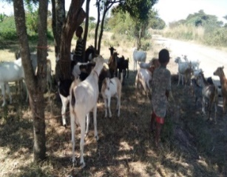
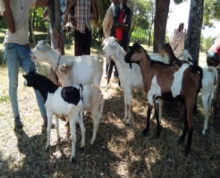

Figure 1: Indigenous goat type in Loka Abaya district

Milk yield and lactation length

The least square means of daily milk yield and lactation length are shown in Table 3. The average daily milk yield recorded in the present study was higher than that reported by by Endeshawe (2007) (0.5 L/day) reported from Dale district, while it was comparable with the findings of Hagos et al. (2017) (0.6 L/day) for Begait does. However, Mestawet et al. (2012) reported higher daily milk yields for indigenous Arsi-Bale and Somali goats, respectively. This variation in milk yield may be attributed to differences in management practices and udder size. The average lactation length was 89.3±13.7 days, which is shorter than the 104.2 days reported by Zeleke et al. (2020) but slightly longer than the 86 days reported by Bedhane et al. (2012) for Arsi-Bale’s goats.

Effect of litter size, parity and season on milk yield and lactation length

The results indicated that several factors influence milk yield and lactation length in does (Table 3).
Litter size
The present study showed that milk yield was significantly (p < 0.001) affected by type of birth. Milk yield increased by 14% in goats giving birth to twins compared with those with single offspring, while goats with triplets showed a 16% increase compared with those with twins. By contrast, Bushara et al. (2013) reported that litter size did not significantly influence milk production; however, does with triplets and twins produced more milk compared to those with single kids. In goats and sheep, increased litter size promotes mammary gland development toward the end of gestation by 20 to 25% (Davis, 2017). The positive relationship between litter size and milk yield, where multiple-bearing does produce more milk than single-bearing ones, is mainly driven by increased suckling stimulation, which enhances prolactin release and stimulates mammary activity (Assan, 2020). Differences in daily milk yield associated with litter size are related to variations in hormonal levels that prepare the udder for lactation, which differ between females carrying multiples and single offspring (Haldar et al., 2013), thus affecting milk production after delivery.
Effect of parity
The effect of parity on daily milk yield and lactation length shows an increasing trend from first to fourth parity. The lowest milk yield was obtained in the first parity, while peak production was recorded in the third parity, which is in agreement with the report of Hamed et al. (2009). Milk yield increases with advancing parity due to hormonal changes in the animal’s body and enhanced metabolic activity that support milk synthesis (Carnicella et al., 2008). Parity had a significant (P < 0.001) effect on lactation duration, with shorter lactation observed in the first parity.
Effect of season
Lactation length was significantly (p < 0.01) affected by the season of kidding. Goats kidding during the wet season had higher daily milk yield and longer lactation length than those goats kidding during the dry season. Does kidded in the dry season had the shortest lactation length, but those kidded during the wet season had the longest lactation length. In agreement with our study, Hagos et al. (2017) demonstrated that Begait does kidding in the dry season exhibited the shortest lactation duration, whereas those kidding in the wet season showed the longest lactation duration. This variation may be attributed to feed availability and quality.

Table 3. Effect of birth type, parity and birth season on daily milk yield and lactation length
Parameters | DMY(liter/day) | LL(days)
Birth type
Single | 0.51±0.14^{c} | 77.3±10.8^{c}
Double | 0.64±0.27^{b} | 89.5±13.3^{b}
Triples | 0.81±.32ª | 101.2±14.3ª
Parity of does
1 | 0.41±0.18^{d} | 69.8±9.2^{d}
2 | 0.79±0.25^{b} | 97.12±11^{b}
3 | 0.83±0.23ª | 102.13±14ª
4 and above | 0.56±0.06^{c} | 88.7±12^{c}
Birth season
Dry season | 0.59±0.14^{b} | 83.4±11.1^{b}
Wet season | 0.71±0.26ª | 95.3±11.2ª
Overall | 0.65±0.18 | 89.3±13.7
NOTES: DMY: daily milk yield; LL: lactation length, ^{a,b,c} P<0.05, P<0.01 significant across columns with different superscripts for each fixed factor differ

\

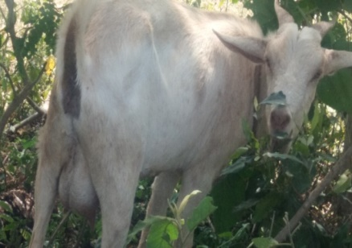
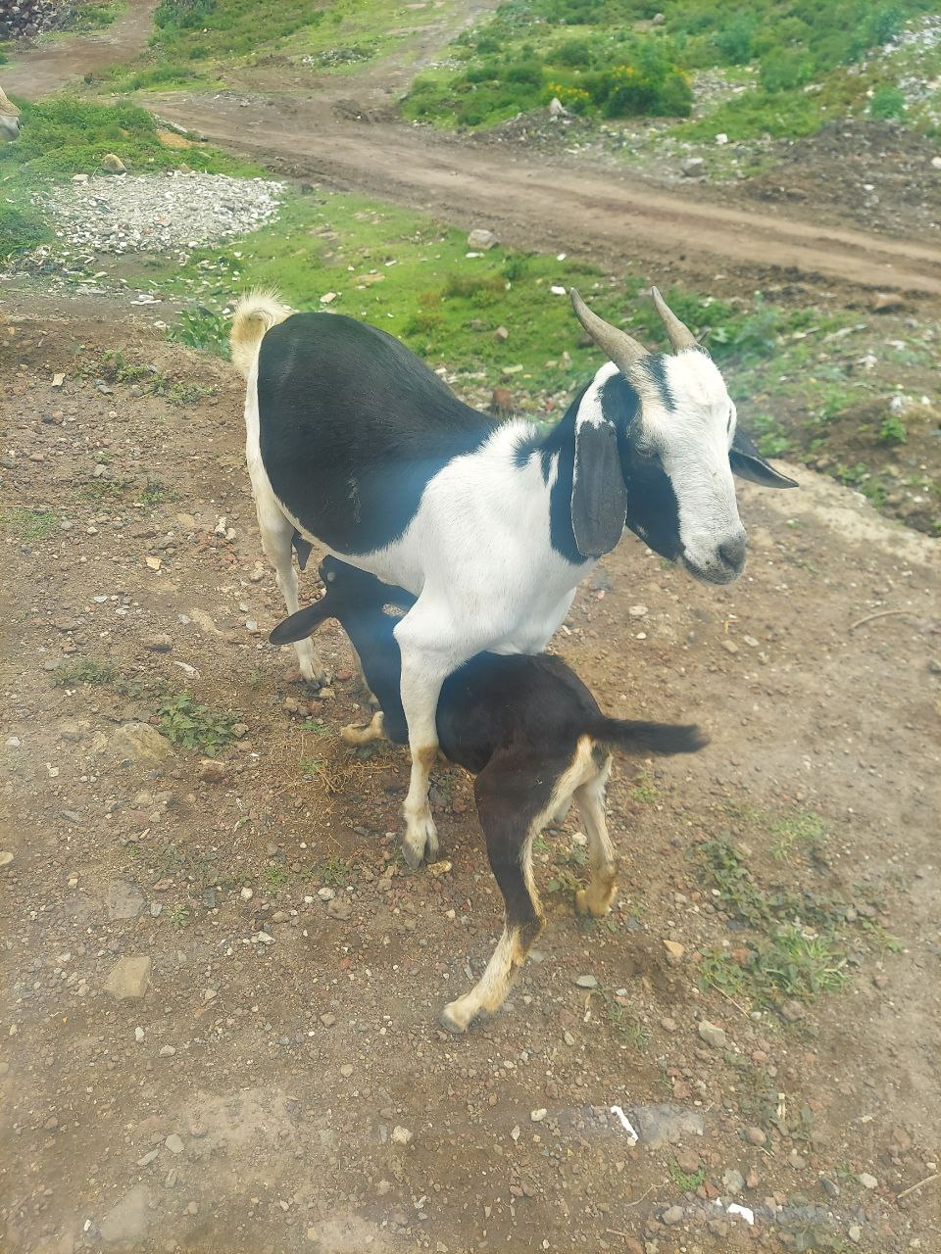
Figure 2: lactating female goats in Loka Abaya district

Milk utilization
Goat keepers in the study area keep milking does primarily for household milk consumption. All family members in a household consume goat milk, with priority given to infants and sick persons (Table 4). According to Azeze et al. (2015), goat milk is primarily consumed by children, followed by individuals who are ill. During the group discussion, participants stated that children who consume goat milk are healthy, strong, and grow well. They also believed that goat milk enhances resistance to diseases and has medicinal value for abdominal ailments. They also believed that goat milk enhances resistance to illnesses and has medicinal value for abdominal diseases. Kumar and Sharma (2016) have shown that goat milk has several advantages over cow or human milk, including higher digestibility of protein and fat, greater alkalinity and buffering capacity, as well as therapeutic benefits in medicine and human nutrition.

Table 4. Goat milk utilization status in the study area
Parameters | Frequency | %
Do you use goats’ milk?
Yes | 46 | 90
No | 4 | 10
Milk utilization in the family
For infant and sick persons | 37 | 74
All family members | 13 | 26

Reproductive Performance

Age at first kidding and kidding interval
A total of 274 and 268 does were assessed through interviews for reproductive traits, including age at first kidding and kidding interval, respectively (Table 5).
Age at first kidding
The age at first kidding is influenced by genetic and environmental factors such as breed, feeding, housing, health care, season of birth, and other management conditions that determine overall productive performance. In the current study, the average age at first kidding was 12.8±0.0.3 months. Amare et al. (2021) reported similar values, whereas Abraham et al. (2019) found a longer age at first kidding for Begait goats maintained under semi-intensive and extensive management systems.
Kidding interval, litter size, fertility, and season of parturition
Kidding interval is the time interval between successive parturitions (two kidding) of the same doe (Hasan et al., 2015). The average kidding interval in the present study was slightly comparable with reports from Dale district (8.56 months; Endeshaw, 2007) and from pastoral and agro-pastoral areas of the Afar Regional State, Ethiopia (8.21 months; Amare et al., 2021). However, the present study result was lower than the reported kidding interval for Arsi-Bale goats under traditional management system, which was 9.77 ± 3.53 months (Dadi, 2008). Kidding interval is influenced by both genetics and environmental factors (nutrition and breeding practices) (Abdella et al. 2015). In addition, Zewdie et al. (2022) also reported that the kidding season, birth type, and parity of does have a significant influence on the kidding interval of Arabs of goats.
Litter size
Litter size is characterized by the twinning rate and the ratio between females mated and kids born. The mean litter size in the current study was lower than that reported by Samuel and Belay (2013) (1.58) from Jimma, Oromia Region, and by Dadi et al. (2008) (1.6) for Arsi-Bale goats maintained under controlled management conditions. The result was also lower than the 2.02 litter size reported by Endeshaw (2007) from the drier areas of Dale Woreda, but higher compared with findings reported by Gemiyo (2009) (1.42) in Alaba zone, Southern Ethiopia, and Asefa et al. (2015) (0.33) in Bale zone, Oromia. The variation in litter size among studies may be attributed to differences in management conditions.
Fertility: The observed fertility rate in this study (Table 5) is higher than the 81.6% reported by Gemiyo (2009) from Alaba Zone, Southern Ethiopia. Fertility rate was also higher than from the report of Kocho (2007), 83.3 % studied in the same zone. Mehlet (2008) reported a reproductive performance of 48.3% for Arsi-Bale goats, which is lower than the present study findings.
Parturition season: based on the monitoring data parturition distribution in the study area is throughout the year; however parturition was a significant (P<0.01) difference among birth season, thus the majority of parturition was occurred in the wet season (April - September) followed by post rainy season (October - November) and the lowest kidding was occurred in the dry season December-march months (Table 5). This may be due to the availability of sufficient forage and browse species during the wet season, ensuring adequate feeding for does. This result is in agreement with the findings of Shenkute (2009), who reported intensive kidding from April to October and reduced kidding rates during low rainfall season in Gomma district.

Table 5. Frequency and descriptive statistics of reproductive traits for indigenous goat

Parameters | N | Mean± SE
Age at first kidding (months) | 274 | 12.8±0.0.3
Kidding interval (months) | 268 | 8.12±0.23
Litter size (mean) | 161 | 1.5
Fertility rate (%) | 110 | 87.3
Season of parturition (%)
Wet season (April - September) | 56 | 51ª
Post rainy season (October - November) | 36 | 32.7^{b}
Dry season (December-march) | 36 | 16.6^{c}
N= number of animals, SE= standard error, ^{a, b,c} , P<0.01 significant across column

CONCLUSION
The present study indicated that flock size per household was 11.55 ± 4.1. Does constitute the largest proportion in the flock, but breeding bucks were small across the flock. Goat milk consumption is common; all family members take milk, while infants and ill individuals are given priority. The average DMY and lactation length of does were 0.65±0.18 liters/day and 89.3 days, respectively. Does with triplet births produce higher milk yield than those with twins and single births. Therefore, goat milk production and utilization need to be encouraged, and further genetic improvement should be done through selection. The significant effects of fixed factors on milk production and calving season should be integrated into forage development and given greater consideration.

Disclaimer (Artificial intelligence)
Author(s) hereby declare that NO generative AI technologies such as Large Language Models (ChatGPT, COPILOT, etc.) and text-to-image generators have been used during the writing or editing of this manuscript.

REFERENCES
- Abdalla, S. A., I.A. Ishag., and M.A. Ahmed.2015. Generic and environmental factors affecting reproduction of Saanen goats raised under Sudan conditions. American Journal of Agricultural Science, 2: 75-79.

- Abrham H., Gizaw, S. and Urge, M. 2019. Growth and reproduction performance of Begait goat under semi-intensive and Extensive management in west Tigray, north Ethiopia, Livestock Research for Rural Development. 31(3). From http://www.lrrd.or/lrrd31/3/hagsa31032.html

- Amare BK, Abrha HB, Birhane H, Shishay GE (2021) On Farm Reproductive Performance and Trait Preferences of Sheep and Goat in Pastoral and Agro-Pastoral Areas of Afar Regional State, Ethiopia. J Anim Sci Res.
- Asefa, B., Kebede, K. and Effa, K. 2015. Assessment of production and reproduction system of indegnouse goat types in Bale Zone, Oromia, Ethiopia. Accadamic Journal of Agricultural Research 3(12): 348-360, DOI:10.15413/ajar.2015. 0143, ISSN: 2315-7739

- Azeze, T., Yilma , Z., Nurfeta, A. and Welearegay, H. 2015. Utilization and quality of goat milk in Hadiya zone, Southern Ethiopia. Global Journal of Food Science and Technology, ISSN: 2408-5472 Vol. 3 (6), pp. 197-203.

Bedhane, M., Haile, A., Dadi, H. and Alemu T.2012. Estimates of genetic and phenotypic parameters for milk traits in Arsi-Bale goat in Ethiopia. Livestock Research for Rural Development 24(98). http://www.lrrd24/6/bedh24098.htm

- Belete E, Goshu G, Tamir B (2015). Productive performance evaluation of Dorper sheep crosses (50% Dorper × pure Adilo indigenous sheep breed) under farmer conditions in different agro ecological zones. International Journal of Livestock Production 6(5):61-68.
- Brito, L.F., Silva, F. G., Melo, A. L. P., Caetano, G. C., Torres, R. A., Rodrigues, M. T. and Menezes, G. R. O. 2011. Genetic and environmental factors that influence production and quality of milk of Alpine and Saanen goats. Genetics and Molecular Research 10, 3794-3802.
- Bushara I, O.M. A., Abdelhad, M. B., Elemam, A. O., Idris, D. M., Mekki, Muna, M. M. and Abu Nikhiala, A. M. 2013. Effect of season of birth and litter size on Taggar goat’s production in western Sudan. Wudpecker Journal of Agricultural Research, Vol. 2(4), pp. 128 – 133.
- Byaruhanga C, Oluka J. and Olinga S. 2015. Socio-economic Aspects of Goat Production in a Rural Agro-pastoral System of Uganda. Universal J Agri Res 3: 203-210.
- Carnicella, D., Dario, M., Consuelo, M., Ayres, C., Laudadio, V. and Dario, C. 2008. The effect of diet, parity, year, and number of kids on milk yield and milk composition in Maltese goat. Small Ruminant Research 77, 71-74.
- CSA (Central Statistical Agency). 2021. Agricultural sample survey (2020/2021). Report on Livestock and Livestock characteristic, Volume II, Addis Ababa, Ethiopia.

- Dadi, H., Duguma, G., Shilma, B., Fayera, T., Tadesse, M., Woldu, T. and Tucho, T. A. 2008. Non Genetic Factors influencing post weaning Growth and Reproductive performances of Arsi-Bale Goats. Livestock Research for Rural Development, 20(114). http://www.lrrd.org/lrrd20/7/dadi20114.htm

- Davis, S.R. 2017. Triennial Lactation Symposium/Bolfa: Mammary growth during pregnancy and lactation and its relationship with milk yield. J. Anim. Sci., 95(12), 5675-5688.
- Endeshaw, A. (2007) Assessment of Production and Marketing System of Goats in Dale District Sidama zone. M.Sc. Thesis, University of Hawssa, Hwassa.

- Gatew. H., Hassen, H., Kebede, K., Haile, A ,. Lobo, R. N. B., Yetayew , A. and Rischkowsky, A. 2017. Husbandry practices and phenotypic characteristics of indigenous goat populations in Ethiopia. African Journal of Agricultural Research. Vol. 12(36), pp. 2729-2741, DOI: 10.5897/AJAR2016.11282

- Gemiyo, D. 2009. On-farm performance evaluation of indigenous sheep and goats in Alaba, Southern Ethiopia. Msc. Thesis. Hawassa University, November, Awassa, Ethiopia.

Hagos, A., Gizaw, S.and Urga, M. 2017. Milk production performance of Beait goat under semi intensive management in Western Tigray, North Ethiopia. Livestock Research for Rural Development. 29. (240). http://www.lrrd.org/lrrd29/12/hags29240.html

Haldar, A., Pal, S.K., Chakraborty, S., Hazorika, M., Pan, S., Majumdar, D. and Prakash, B.S. 2013. Endocrine markers for identifying prolificacy potential and predicting fetal number in goats. Anim. Reprod. Sci., 140(1), 54-61.

Hamed, A., Mabrouk, M. M., Shaat, I. and Bata, S. 2009. Estimation of genetic parameters and some non- genetic factors for litter size at birth and weaning and milk yield traits in Zaraibi goats. Egyptian Journal of Sheep and Goat Sciences 4, 55–64.

- Hasan, M.J., Ahmed, J.U., Alam, M.M., Mojumder, M.L.O. and Ali, M.S. 2015. Reproductive performance of Black Bengal goat under semi-intensive and extensive condition in Rajshahi district of Bangladesh. Asian J Med Biol Res. 1:22–30.
- Kassaun, A. and Solomon, A. 2008. Breeds of sheep and goats. Sheep and goat production handbook for Etiopia: Etiopian Sheep and goat productivity improvement program. pp. 5-26
- Khan, U,M., Khan, A.M. Khan, U.M, and Selamoğlu, Z. 2019. Effect of Seasonal Factors in the Goats’ Reproductive Efficiency. Turkish J Agric Food Sci Technol. 7:1937.
- Khandoker, M., Afini., N, and Azwan, A. 2018. Productive and Reproductive Performance of Saanen Goat at AZ-Zahra farm of Sandakan in Malaysia. Bangladesh J Animal Sci.47:1-12.
- Kidane A., Melaku S., Haile A. 2014. Characterization of Goat Reproduction and Breeding practices of Goat Owners in Gumara-Meksegnit Watershed-North Gonder. Ethiopia, Agricultural Journal Livestock 9(1):5-14, ISSN: 1816-9155.
- Kocho, T. 2007. Production and Marketing system of Sheep and Goats in Alaba, Southern Ethiopia. An MSc thesis, Hawassa University, Etiopia.

Kumar, A, and Sharma, A. 2016. Nutritional and Medicinal Superiority of Goat Milk over Cow Milk in Infants. DOI:10.21088/ijpen.2454.9126.2116.5.

- Mehlet, S. 2008. Reproduction in Arsi-Bale female goats and growth performances of Toggenburg X Arsi-Bale crosses. University of Hawassa, Ethiopia.

- Mekuria, S.A., Teshager , A.A., Endeshawe, A.G., Atinaw, M.B. and Sendeku, A.T. 2018. Small Ruminant Fattening Practices in Amhara region, Ethiopia. Agriculture & Food Security. 7(64). https://doi.org/10.1186/s40066-018-0218-9.

Mestawet, T.A., Girma A., Ådnoy, T., Devoid, T.G., Narvhus, J.A. and Vegarud, G.E. 2012. Milk Production, Composition and Variation at Different Lactation Stages of four GFoat Breeds in Ethiopia. Small Ruminant Research 105(1):176–181.

- Paltasingh, K R. and Goyari P. 2018. Impact of farmer education on farm productivity under varying technologies: case of paddy growers in India. Agricultural and Food Economics, 6 (7): 1-19, https://doi.org/10.1186/s40100-018-0101-9

- Samuel, G. and Dugma, B. 2013. Assessment on Goat Production System with Special Focus on Constraints and Opportunities around Jimma, American-Eurasian J. Agric. & Environ. Sci., 13 (10): 1304-1308, DOI: 10.5829/idosi.aejaes

- Shenkute, B.G. 2009. Production and Marketing Systems of Small Ruminants in Goma District of Jimma Zone, Western Ethiopia. MSc. Hawassa University, Awassam, Ethiopia. 144p.
- Silanikove, N., Leitner, G. and Merin, U.2015. The interrelationships between lactose intolerance and the modern dairy industry: Global perspectives in evolutional and historical background. Nutrients 7, 7312-7331
- Solomon, A.K., Mwai, O., Grum, G., Haile, A., Rischkowsky, B.A., Solomon,G., and Dessie T. 2014. Review of goat research and development projects in Ethiopia. ILRI project report. Nairobe Kenya: International Livestock Research Institute.
- Tona, G. O., Adewumi, O. O. and Olaniyi, E. O. 2015. Milk yield (off take), composition, dam and kid weight changes of West African Dwarf goats fed dietary levels of palm kernel cake. IOSR Journal of Agriculture and Veterinary Science 8, 29-34.
- Zeleke, T., Kefyalw, A., Damitie, K., Teshaye, G., Alemu, K. and and Belaye, D. 2020. Reproductive performance and milk production of Central Highland and Boer x Central Highland goats.Volume 6 (12).
- Zewdie, B., Urge, M., Tadesse, Y., Chavhan A. and Gizaw, S. 2022. Productive and reproductive Performances of Arab Goats in the Western lowlands of Ethiopia. Int J Life Sci. 1,0:21–32.

