Original Research Article

Predicting Growth and Dry Matter Production of Tomato in Response to Exogenous Proline Application under Drought Stress

.
ABSTRACT

Drought, the most common abiotic stress in tomato, can be tolerated by osmotic adjustment through the accumulation of compatible solutes such as proline. A modeling approach is needed to quantify drought response to varying proline inputs and to optimize management options. This research was conducted to develop and evaluate a growth model of tomato describing the responses to proline inputs under drought stress. Two pot experiments were carried out in the polyhouse of the Department of Horticulture, Yezin Agricultural University, during 2024–2025. Experiment one aimed to parameterize for modeling, while experiment two aimed for model evaluation. A split-plot design was used, with water supply (well-watered and drought-stressed) as the main plot factor and five proline levels (0, 20, 40, 60, and 80 ppm) as the subplot factor. At the five-leaf stage, withholding of water and proline sprays (10 ml plant⁻¹) was employed. A drought response of relative leaf expansion rate (RLER) to fraction of transpirable soil water (FTSW) was described by a linear–plateau regression at each level of proline sprays. Leaf expansion rate under well-watered conditions (LER_{ww}) was calculated from non-destructive measurements of individual leaf length and width. Drought stress LER (LER_{ds}) was described as the product of LER_{ww} and RLER. Plant leaf area was estimated from the integration of LER. Shoot dry weight was simulated as linear function of plant leaf area separately for well-watered and drought stress treatments. The model predicted the plant leaf area and shoot dry weight with high accuracy (0.88-0.96) across all proline levels. The model performed better for well-watered conditions than drought-stressed ones. Overall, the model demonstrated good validity in simulating tomato growth and dry matter production under proline sprays and drought treatments. Regarding drought response to proline sprays, the linear plateau model showed some degree of errors, which needed further calibration.

Keywords: Model, Tomato, Drought, Proline, Leaf area, Dry matter production

1. INTRODUCTION

Tomato (Solanum lycopersicum L.) is a globally important horticultural crop and a widely used model species in plant physiological research (Arie et al., 2007; Khan et al., 2015). Tomato growth and productivity are highly sensitive to soil water availability, with water deficit adversely affecting physiological, biochemical, and morphological processes, ultimately reducing biomass accumulation and yield (Torres-Ruiz et al., 2015). Drought stress is one of the most critical environmental factors limiting crop productivity worldwide, particularly in arid and semi-arid regions, and climate change is expected to increase the frequency and severity of such events, further constraining agricultural production systems (Bray, 1997; Dai, 2012).
The plant performance under water-limited environments is evaluated on two fronts: the capacity for sustained productivity and the ability to survive (Myint, 2022). These two responses are not always compatible, and successful drought adaptation requires a balance between them (Myint, 2022). Because of its relatively simple canopy structure and well-defined growth stages, tomato is particularly well-suited for quantitative analysis and modeling of complex growth responses to environmental stress (Guoting et al., 2020).
Plants have evolved several adaptive strategies to cope with drought stress, broadly categorized into drought escape, drought resistance (comprising dehydration avoidance and dehydration tolerance), and drought recovery (Levitt, 1980; Ludlow & Muchow, 1990; Blum, 1999; Myint, 2022). Dehydration avoidance involves maintaining high plant water status through mechanisms such as reduced leaf area expansion and stomatal closure, while dehydration tolerance allows plants to function under low tissue water content through physiological and cellular adjustments (Morgan, 1984; Claeys & Inzé, 2013). A key mechanism underlying dehydration tolerance is osmotic adjustment, which involves the accumulation of compatible solutes to lower cellular osmotic potential, thereby facilitating water uptake and maintaining cell turgor even when soil water availability is limited (Morgan, 1984; Blum, 2017).
Among these compatible solutes, proline is one of the most widely reported. As the only proteinogenic secondary amino acid, proline accumulates in plants under water deficit and other abiotic stresses such as salinity, high temperature, and nutrient starvation (Sairam et al., 2002). Proline plays a multifaceted role in stress tolerance: it contributes to osmotic adjustment, stabilizes proteins and membranes, scavenges reactive oxygen species, and supports cellular redox balance under stress conditions (Boggess et al., 1976; Smirnoff & Cumbes, 1989).
Exogenous application of proline has been shown to enhance plant tolerance to abiotic stresses by improving water relations, photosynthetic capacity, and nutrient uptake (Ashraf & Foolad, 2007). Foliar-applied proline can reduce enzyme denaturation, protect membrane integrity, and regulate stress-responsive metabolic pathways (Iyer & Caplan, 1998). By enhancing osmotic adjustment, proline application helps maintain cell turgor and supports physiological functions under water-deficient conditions.
The effectiveness of exogenous proline is concentration-dependent. In controlled studies, proline is typically applied at 10–100 ppm, with optimal effects commonly observed at 10–50 ppm depending on stress conditions and cultivar. Kahlaoui et al. (2014) reported that 10–20 ppm proline significantly improved growth, leaf area, and fruit yield in salt-stressed tomato, while Elewa et al. (2017) and AlKahtani et al. (2021) demonstrated that 20–40 ppm enhanced plant height, leaf area, and dry matter production under drought stress. In contrast, higher concentrations such as 80 ppm are considerably above the optimal range reported for tomato (10–40 ppm). Heuer (2003) demonstrated that exogenous proline application can seriously inhibit tomato growth, attributed in part to a toxic effect of proline itself. This reduction at elevated concentrations may result from metabolic imbalance, where excessive proline accumulation exerts feedback inhibition on endogenous proline biosynthesis or disrupts cellular nitrogen metabolism and osmotic homeostasis (Ashraf & Foolad, 2007; Claussen, 2005).
Crop growth models provide valuable tools for understanding plant responses to environmental factors and for predicting growth under variable conditions (Marcelis et al., 2008; Soltani, 2012). Many models describe stress responses using soil water status, such as the fraction of transpirable soil water (FTSW). Physiological processes such as leaf expansion often exhibit a linear-plateau (two-segmented) response to declining FTSW (Sinclair & Ludlow, 1986; Ray & Sinclair, 1998). In this relationship, leaf expansion remains unaffected when soil water is above a critical threshold (the break point); once FTSW falls below this threshold, leaf expansion declines linearly with further water deficit (Sadras & Milroy, 1996; Soltani & Sinclair, 2012). This threshold-based response, which quantifies the point at which a process begins to decline, was successfully used by Myint (2022) to parameterize drought responses in tomato introgression lines. These parameters, the break point (FTSW threshold) and the slope (rate of decline), are not static; they can be modified by management practices such as proline application, which may alter the plant's sensitivity to soil water deficit.
Despite the documented benefits of proline, quantitative information on how its application modifies these linear-plateau response parameters and subsequently influences growth dynamics under varying drought stress remains limited. Incorporating such effects into crop growth models can improve their ability to simulate plant adaptive responses to drought (Boote et al., 2013).
Therefore, this study aims to evaluate the plant response of tomato to drought stress and proline application, to construct a model and simulate growth and dry matter production of tomato under drought and proline spray, and to evaluate the performance of the developed model.
2. Materials and Methods
2.1 Experimental conditions and treatments
Two pot experiments were conducted in the polyhouse of the Department of Horticulture at Yezin Agricultural University, Naypyitaw, Myanmar. Experiment 1 (October–December 2024) was conducted for parameterization, and Experiment 2 (March–May 2025) for model evaluation. A 2 × 5 split-plot design was employed with four replications. The main plot factor consisted of well-watered and drought-stressed treatments, and the subplot factor comprised five proline levels (0, 20, 40, 60, and 80 ppm). Each experimental unit consisted of two subunits, spaced 30 cm and 90 cm within and between rows.
The tomato variety used was 'NIRVANA-044', a semi-determinate, fast-growing hybrid. Seeds were sown in plastic seedling trays, and thirteen-day-old seedlings were transplanted into 10-L plastic bags filled with a mixture of garden soil (loamy sand), well-decomposed cow dung, and burnt rice husk (11.5:1:1 v/v). At the five-leaf stage, drought imposition was started by withholding water, and proline treatments were applied. A 1% (w/v) stock solution was prepared by dissolving 1 g of proline in 100 ml of distilled water, and then separately diluted to obtain 400 ml of specific treatment solution. Each plant received 10 ml of the respective solution sprayed onto the leaves until runoff.
2.2 Data collection and parameterization
The plant data from Expt. 1 was collected and used for parameterization
2.2.1 Air temperature and growing degree days
Air temperature inside the polyhouse was hourly recorded by using a data logger. Minimum and maximum temperatures ranged from 22.4°C to 32.6°C in Experiment 1 and from 15.6°C to 31.4°C in Experiment 2. Growing degree day (GDD) was calculated as:
$$GDD=\frac{T_{max}+T_{min}}{2}-T_{base}$$ | Eq. (1)
where T_{max} is the daily maximum air temperature (°C), T_{min}, the daily minimum air temperature (°C), and T_{base}, the base temperature (assumed as 10°C).
2.2.2 Soil water deprivation and daily transpiration determination
In order to prevent water loss through evaporation, the surface of each bag was covered with Styrofoam. The amount of soil water loss through transpiration was measured every two days by the gravimetric method and was replenished for well-watered treatments. The fraction of transpirable soil water (FTSW) under drought stress was calculated as:
$$FTSW=\frac{W_{t}-W_{f}}{W_{i}-W_{f}}$$ | Eq. (2)
where W_{t} = current bag weight, W_{f} = final bag weight (when stressed transpiration reached <10% of well-watered plants), W_{i} = initial bag weight (at 100% WHC).
Daily transpiration rate (TR, kg plant⁻¹day⁻¹) was calculated as:
$$TR \text{=}\frac{\text{W}\text{2 }-\text{W}\text{1}}{\text{t}\text{2 }-\text{t}\text{1}} x {GDD}_{t}$$ | Eq. (3)
where W₁ and W₂ = bag weights at two consecutive measurement times (kg), t₂ and t₁ = thermal times, and GDD_{t} = growing degree days at a specific date.
2.2.3 Leaf length, leaf width, and leaf area
Leaf length (L) and width (L) of the leaf at rank 5 (representative leaf) were taken at two-day intervals from the time of treatment imposition until the drought-stressed plants showed 10% transpiration of the control. At harvest time, in addition to leaf length and leaf width, the leaf areas of all leaves were measured destructively by using Image J software. In parallel to the experiment, destructive measurements of leaf area (LA, cm² leaf⁻¹) and leaf dimensions (length and width) of all leaves were done at the onset of treatment using the reserved plants. The relationship between the length-width product and individual leaf areas was fitted by using a linear regression function (Figure 1) as follows:
$$LA=a_{l} (L×W)$$ | Eq. (4)
where parameter “a_{l}” is a regression constant. The relationship between the single leaf area (at rank 5) and plant leaf area was fitted with a hyperbolic function, which allowed the generalization of plant leaf area (PLA, cm² plant⁻¹) (Figure 2) as follows:
$$PLA =a_{p}×\frac{LA}{(1+b_{p} LA)}$$ | Eq. (5)
where a_{p} and b_{p} are the regression constants.
2.2.4 Daily leaf expansion rate under well-watered conditions
Leaf expansion rate under well-watered conditions (LER_{w}, cm² plant⁻¹ day⁻¹) was calculated as:
$$LER_{w}=\frac{PLA_{2}-PLA_{1}}{t_{2}-t_{1}} x {GDD}_{t}$$ | Eq. (6)
where $PLA_{2}$and $PLA_{1}$are the plant leaf areas at two time points ($t_{2}$and $t_{1})$, expressed in degree days, and GDD_{t}, growing degree days at a specific date. LER followed a typical bell shape function (Figure 3).
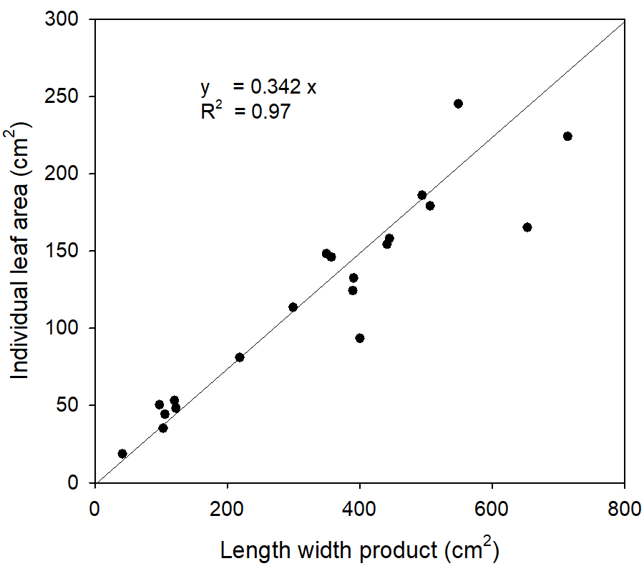
Figure 1. Relationship between length-width product and individual leaf area
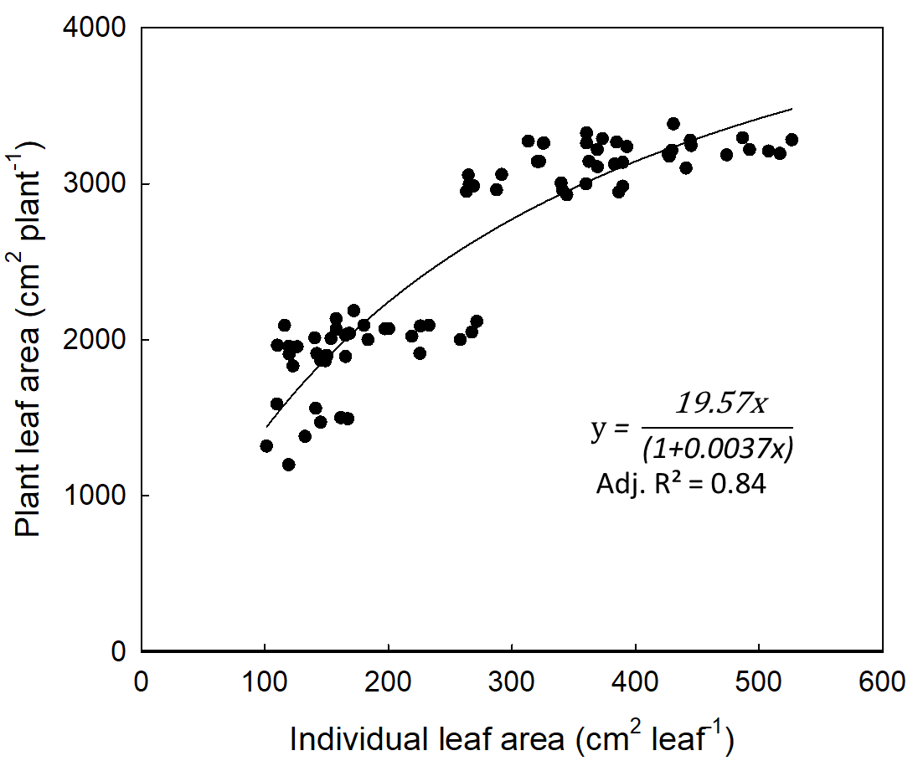
Figure 2. Relationship between individual leaf area and plant leaf area
Figure 3. Leaf expansion rate of tomato over time under well-watered conditions
2.2.5 Relationship between shoot dry weight and plant leaf area
At harvest time, the plant samples were put into an oven at 70ºC until the constant weight was obtained, and the dry weight of shoots (leaves and stems) were recorded. The relationship between shoot dry weight and plant leaf area was fitted with linear regression separately for well-watered and drought-stressed plants (Figure 4).

Figure 4. Allometric relationship between plant leaf area (PLA) and shoot dry weight (SDW) of tomato under well-watered and drought-stressed conditions, respectively
2.5 Model description
2.5.1 Relative leaf expansion rate as a function of FTSW
Relative leaf expansion rate (RLER) is the ratio of LER_{d} to LER_{w} (unitless). The response of RLER to declining soil water availability was described using a (two-segmented) linear-plateau regression (LPR) model (Figure 4), which is commonly used to characterize plant physiological responses to soil drying (Sinclair & Ludlow, 1986; Ray & Sinclair, 1997). This model consists of two phases: an unresponsive phase, where RLER remains at its maximum when soil water is sufficient, and a responsive phase where RLER declines linearly as water deficit increases. The relationship is mathematically expressed as:
$$RLER= \left\{\begin{aligned}1, if FTSW≥c \\ a FTSW +b , else \end{aligned}\right.$$ | Eq. (7)
where RLER is the relative leaf expansion rate, FTSW is the fraction of transpirable soil water, c, breakpoint (FTSW threshold where leaf expansion starts to decline), a, slope of the linear decline, and b, intercept of the regression equation. The parameters, the breakpoint, slope, and intercept of the LPR model were generated from Expt. 1 and used as proline-specific drought response coefficients.
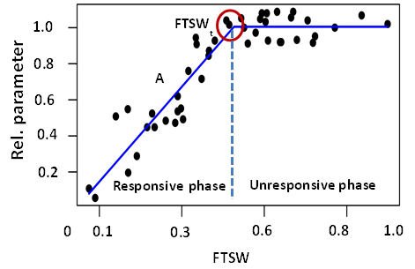
Figure 5. Linear-plateau regresion model describing the response of relative plant parameters to fraction of transpirable soil water (FTSW). FTSW_{t}, FTSW threshold; A, intensity of decline.
2.5.2 Leaf expansion rate under drought stress
Leaf expansion rate under drought stress (LER_{d}, cm² plant⁻¹ day⁻¹) was described as the product of LER_{w} (Eq. 6) and RLER (Eq. 7):
$$LER_{d}=LER_{w}×RLER$$ | Eq. (8)
2.5.3 Plant leaf area
For both of the water regimes, plant leaf area at time t (PLA) was described as the sum of initial leaf area (PLA_{t0}) and the integral of daily leaf expansion rate (LER) during the treatment period:
$$PLA (t)={PLA}_{t_{0}}+\int_{t_{0}}^{t_{i}}{LER}$$ | Eq. (9)
where t₀ is the onset of drought treatment, t_{i} is the current time post drought imposition.
2.5.4 Shoot dry weight
Shoot dry weight (SDW, g plant⁻¹) was described as a linear function of plant leaf area (PLA), separately for well-watered and drought-stressed conditions:
$${SDW}_{w} (t)=a_{sw} ×{ PLA}_{w}$$ | Eq. (10)
$${SDW}_{d} (t)=a_{sd} × {PLA}_{d}$$ | Eq. (11)
where a_{sw} and a_{sd} are the specific shoot masses (g cm⁻²) under well-watered and drought-stressed conditions, respectively.
3. Results and Discussion
3.1 Varying drought responses of leaf expansion rate under proline sprays
In experiment one, the response of relative leaf expansion rate (RLER) was described as a function of fraction of transpirable soil water (FTSW) at each level of proline concentration (Figure 6). Fitting with an empirical model (linear-plateau regression) showed a high coefficient of determination (R² > 0.90) in the responsive phase. The fact that the drought response of RLER to FTSW strongly followed a linear fashion indicates that the decline of RLER was more dependent on soil water status than environmental heterogeneity once it commences the reaction. This threshold-type response is widely reported under progressive soil drying and reflects the regulation of growth processes under drought stress (Sinclair & Ludlow, 1986; Ray & Sinclair, 1997).
At 0 ppm (control) of proline concentration, RLER remained stable until FTSW declined to a break point of 0.75, then decreased linearly (slope = 0.98) to an end point of FTSW (intercept = 0.25) at which the transpiration of droughted plants reached less than 10% of the control (Figure 6A). The high value of the breakpoint indicates that RLER was highly sensitive to early soil moisture depletion as an adaptive (drought avoidance) response of the plant to reduce the plant's water loss through transpiration. This is in agreement with the reports that leaf expansion is among the earliest physiological processes inhibited under drought (Hsiao, 1973).
Application of 20 ppm proline reduced the break point to 0.50, with a steeper decline (slope=1.49) but with a similar intercept (0.25) (Figure 6B). A comparable response was observed at 40 ppm, with a break point of 0.49 and a slope of 1.50 (Figure 6C). These results indicate that moderate proline concentrations (20 - 40 ppm) delayed the onset of stress response, allowing leaf expansion to continue at lower soil moisture levels through increased osmotic adjustment and maintained cell turgor (Ashraf & Foolad, 2007; Szabados & Savoure, 2010).
At higher concentrations (60–80 ppm), the response pattern shifted toward a more gradual decline. Break points increased to 0.62–0.64, with moderate steepness of decline (slope = 1.18–1.20 (Figures 6D & 6E). Higher proline levels enhanced the plant's ability to adjust growth more progressively under drought, possibly through sustained osmotic regulation, membrane stabilization, and enhanced ROS scavenging (Szabados & Savouré, 2010; Verslues & Sharma, 2010). The possible reason for the high value of break points may be that high concentrations of exogenous proline sprays can cause the osmotic imbalance, metabolic disruption, and premature reduction of leaf expansion (Tesfaye et al., 2014; Li et al., 2024).
Across all treatments, break point values ranged from 0.49 to 0.75, indicating that proline altered the FTSW threshold at which leaf expansion began to decline under water deficit. Lower break point values at moderate proline levels (20–40 ppm) suggest that plants were able to maintain leaf expansion at lower soil moisture levels, likely due to improved osmotic adjustment and maintenance of cell turgor. This confirms that proline primarily influences the timing of growth reduction rather than preventing inhibition under extreme water deficit (Ashraf & Foolad, 2007).

Figure 6. Responses of relative leaf expansion rate (RLER) of tomato to fraction of transpirable soil water (FTSW) along the course of drought duration treated with specific levels of proline sprays: (A) 0 ppm (n = 64), (B) 20 ppm (n = 64), (C) 40 ppm (n = 64), (D) 60 ppm (n = 56), (E) 80 ppm (n = 56) derived from Experiment 1. Value above the plateau line in each figure indicates the break point (FTSW threshold).
3.2 Evaluation of model performance
The model for plant leaf area and shoot dry weight of tomato demonstrated a strong predictive performance across all proline treatments under both well-watered and drought-stressed conditions. The high accuracy values (0.907–0.971) and low RMSD values observed in this study are comparable to those reported in other crop modeling studies. For instance, similar accuracy ranges (0.89–0.95) were reported for tomato growth models under water deficit conditions (Guoting et al., 2020; Marcelis et al., 2008).
3.2.1 Plant leaf area
A good agreement was observed between the observed and simulated plant leaf area evaluated at harvest times. Under well-watered conditions, the trend of predicted values represented the 60% (R² = 0.60) of the observed total plant leaf area across all proline concentrations, regardless of the overestimated initial values (intercept = 585.25). According to linear regression, overall performance showed an underestimation by around 22% (regression coefficient = 0.78). The RMSD values ranged from 112.25 to 285.69 cm² plant⁻¹, the bias ranged from −47.61 to 207.23 cm² plant⁻¹, and the accuracy ranged from 0.90 to 0.96. The best performance was obtained at 60 ppm proline, with the lowest RMSD (112.25), relatively low bias (20.17), and the highest accuracy (0.96) (Figure 7). Overall underestimation, particularly observed in higher values, can be explained by the plateau nature of the hyperbolic model with saturation to generalize plant leaf area from a single leaf area. The model performance could be improved if the plant leaf area were described as the product of leaf number and representative leaf area, as modeled elsewhere.
Figure 7. Observed and simulated plant leaf areas of tomato under well-watered conditions at different proline concentrations.

Under drought-stressed conditions, the model maintained a good predictive ability, although deviations were slightly higher than under well-watered conditions. This is consistent with the findings of Soltani and Sinclair (2012), who reported the reduced model performance under drought stress due to increased physiological complexity. RMSD values ranged from 151.04 to 216.10, bias from −147.99 to 106.00, and accuracy from 0.88 to 0.92. The best performance was observed at 40 ppm proline, with an RMSD of 151.04, a bias of −125.46, and an accuracy of 0.92 (Figure 8). Ashraf & Foolad (2007) observed that moderate proline levels enhance plant performance, which could be attributed to osmotic adjustment with delayed response of leaf expansion rate to soil drying. In line with that, the current result indicates that the LPR model describing drought response works well for moderate levels of proline input.
The coefficients of determination (R²) were 0.60 under well-watered conditions and 0.55 under drought-stressed conditions, indicating a moderate agreement between observed and simulated leaf area. The lower R² value under drought conditions reflects increased variability in plant response under stress that the model did not take into account. Overall, the model performed better under well-watered conditions, as evidenced by lower RMSD and higher accuracy values. Nevertheless, the model maintained acceptable predictive performance under drought conditions, demonstrating its robustness across varying water availability levels. This reduction in model performance under drought may be due to an additional source of errors when estimating the parameters (e.g., break point, slope) of the LPR model to describe the relative leaf expansion rate (RLER) as a function of fraction of transpirable soil water (FTSW).

Figure 8. Observed and simulated plant leaf areas of tomato under drought-stressed conditions at different proline concentrations.

3.2.2 Shoot dry weight
The agreement between observed and simulated shoot dry weight was evaluated against the 1:1 line (perfect goodness of fit) (Figure 9). Under well-watered conditions, the model showed around 19% of underestimation (regression coefficient = 0.81) with overestimated initial value (intercept = 4.654) and a low magnitude of coefficient of determination (R² = 0.42) according to linear regression. This trend is in line with results observed for the plant leaf area, which also showed overall underestimation. There was a greater magnitude of errors in estimated shoot dry weight under well-watered conditions than drought conditions (RMSD = 1.60 vs 1.53, Bias = -0.44 vs 0.15). Lower goodness of fit (lower R² value) compared to plant leaf area may be attributed to more sources of errors, apart from uncertainty in simulated leaf area, in parameter estimation (here, specific shoot mass) of the allometric relationship generated from Experiment 1. Despite the low magnitude of representation, the evaluation criteria showed high prediction accuracy (0.92). Under drought-stressed conditions, the model showed improved agreement with the observed data, with an
R² value of 0.57. The slope value of around 1 and the intercept values close to zero indicate an almost perfect alignment of simulated values with observed ones.
With separate evaluations for different proline levels under well-watered conditions, RMSD values ranged from 0.91 to 2.26, bias from −0.70 to 0.33, and accuracy from 0.89 to 0.96. The best performance was observed at 60 ppm proline, with the lowest RMSD (0.91) and highest accuracy (0.96) (Table 1).
Under drought-stressed conditions, the model maintained an acceptable predictive performance, with RMSD values ranging from 0.85 to 2.21, bias from −1.07 to 2.02, and accuracy from 0.85 to 0.94. The best performance was observed in the high proline level (80 ppm), with an RMSD of 0.85 and an accuracy of 0.94 (Table 1).
Overall, the model performed slightly better under drought-stressed conditions than under well-watered conditions in predicting shoot dry weight, as reflected by higher R² values, a perfect slope, and lower estimation errors. The consistent agreement between observed and simulated values across drought and proline treatments supports the model’s usefulness as a decision-support tool for optimizing proline application and predicting tomato growth under soil drying conditions.
Figure 9. Model performance for shoot dry weight under well-watered and drought-stressed conditions.
Table 1. Evaluation of model performance for shoot dry weight of tomato at each level of proline concentration under well-watered and drought-stressed conditions
Proline  (ppm) | Shoot dry weight
Proline  (ppm) | Well – watered |  |  |  | Drought – stressed
Proline  (ppm) | RMSD | Bias | Accuracy |  | RMSD | Bias | Accuracy
0 | 1.72 | -0.28 | 0.91 |  | 2.21 | 2.02 | 0.85
20 | 1.44 | -0.19 | 0.93 |  | 0.42 | 0.15 | 0.91
40 | 2.26 | -1.39 | 0.89 |  | 1.61 | -1.07 | 0.90
60 | 0.91 | -0.70 | 0.96 |  | 1.19 | -0.36 | 0.92
80 | 1.36 | 0.33 | 0.94 |  | 0.85 | 0.04 | 0.94

5. Conclusion
This study evaluated the effects of proline application on drought response of leaf expansion rate, developed a growth model of tomato for varying levels of proline sprays under progressive soil drying conditions, and evaluated its predictive performance for leaf area and shoot dry weight. The model successfully described the drought response of relative leaf expansion rate to fraction of transpirable soil water using a linear–plateau regression model. Different levels of exogenous proline sprays influenced both the break point and the intensity of decline in leaf expansion rate. Moderate proline concentrations (i.e 20–40 ppm) reduced the break point from 0.75 (control) to 0.49-0.50, bringing about the delayed onset of drought response, while higher concentrations (60–80 ppm) resulted in more gradual reductions in plant growth (i.e leaf expansion), as indicated by higher break point values (0.62- 0.64) and lower slope values (1.18–1.20).
Model validation demonstrated a good predictive performance across all treatments. High prediction accuracy was exhibited by the ranges of 0.88 to 0.96 for plant leaf area and 0.85 to 0.95 for shoot dry weight. Separate evaluation on specific proline levels revealed that the model performed better under well-watered conditions than under drought-stressed conditions, possibly attributed to increased complexity of plant physiological responses and interaction between proline levels and drought adaptation mechanisms.
5. Recommendation
Overall, the model provides a reliable framework for predicting tomato growth and dry matter production in response to proline application under varying water regimes. The current growth model could be improved for prediction accuracy or model complexity through the calibration of parameters and structural adjustment (e.g., hyperbolic curve, effect of proline), inputs of additional ambient and soil factors influencing the rate of soil water decline and soil water threshold (e.g., vapour pressure deficit, soil water potential, osmotic potential).

6. References
Alkahtani, M. D., Attia, K. A., Hafez, Y. M., Khan, N., Eid, A. M., Ali, M. A., & Abdelaal, K. A. (2021). Chlorophyll fluorescence parameters and antioxidant defense system as indicators of drought tolerance in tomato (Solanum lycopersicum L.) under proline application. Saudi Journal of Biological Sciences, 28(12), 7036–7044.
Arie, T., Takahashi, H., Kodama, M., & Teraoka, T. (2007). Tomato as a model plant for plant-pathogen interactions. Plant Biotechnology, 24(1), 135–147.
Ashraf, M., & Foolad, M. R. (2007). Roles of glycine betaine and proline in improving plant abiotic stress resistance. Environmental and Experimental Botany, 59(2), 206–216.
Blum, A. (1999). Towards standard assays of drought resistance in crop plants. In J. M. Ribaut & D. Poland (Eds.), Molecular approaches for the genetic improvement of cereals for stable production in water-limited environments (pp. 29–34). CIMMYT.
Blum, A. (2017). Osmotic adjustment is a prime drought stress adaptive engine in support of plant production. Plant, Cell & Environment, 40(1), 4–10.
Boggess, S. F., Stewart, C. R., Aspinall, D., & Paleg, L. G. (1976). Effect of water stress on proline synthesis from radioactive precursors. Plant Physiology, 58(3), 398–401.
Boote, K. J., Jones, J. W., & Hoogenboom, G. (2013). Incorporating stress tolerance traits into crop models. Crop Science, 53(3), 1–15.
Bray, E. A. (1997). Plant responses to water deficit. Trends in Plant Science, 2(2), 48–54.
Claeys, H., & Inzé, D. (2013). The agony of choice: How plants balance growth and survival under water-limiting conditions. Plant Physiology, 162(4), 1768–1779.
Dai, A. (2012). Increasing drought under global warming in observations and models. Nature Climate Change, 3(1), 52–58.
Elewa, T. A., Sadak, M. S., & Saad, A. M. (2017). Proline treatment improves physiological responses in quinoa plants under drought stress. Bioscience Research, 14(1), 21–33.
Guoting, L., Jie, L., & Jin, G. (2020). Effects of drought stress on photosynthetic and physiological parameters of tomato. Journal of the American Society for Horticultural Science, 145(1), 12–17.
Heuer, B. (2003). Influence of exogenous application of proline and glycinebetaine on growth of salt-stressed tomato plants. Plant Science, 165(4), 693–699.
Hsiao, T. C. (1973). Plant responses to water stress. Annual Review of Plant Physiology, 24, 519–570.
Iyer, S., & Caplan, A. (1998). Products of proline catabolism can induce osmotically regulated genes in rice. Plant Physiology, 116(1), 203–211.
Jones, H. G. (1981). Plants and microclimate: A quantitative approach to environmental plant physiology. Cambridge University Press.
Kahlen, K., & Stützel, H. (2011). Modelling photosynthesis of rosette plants: An individual leaf approach. Functional Plant Biology, 38(3), 187–196.
Kahlaoui, B., Hachicha, M., Rejeb, S., Rejeb, M. N., Hanchi, B., & Misle, E. (2014). Response of two tomato cultivars to field-applied proline under irrigation with saline water: Growth, chlorophyll fluorescence and nutritional aspects. Photosynthetica, 52(3), 421–429.
Khan, A., Khan, M. I., & Aslam, M. (2015). Tomato (Solanum lycopersicum L.) as a model crop in plant biology research. International Journal of Agriculture and Biology, 17(5), 857–864.
Kobayashi, K., & Salam, M. U. (2000). Comparing simulated and measured values using mean squared deviation and its components. Agronomy Journal, 92(2), 345–352.
Levitt, J. (1980). Responses of plants to environmental stresses, Volume II: Water, radiation, salt, and other stresses (2nd ed.). Academic Press.
Ludlow, M. M., & Muchow, R. C. (1990). A critical evaluation of traits for improving crop yields in water-limited environments. Advances in Agronomy, 43, 107–153.
Marcelis, L. F. M., Heuvelink, E., & Goudriaan, J. (2008). Modelling biomass production and yield of horticultural crops: A review. Scientia Horticulturae, 74(1–2), 83–111.
Morgan, J. M. (1984). Osmoregulation and water stress in higher plants. Annual Review of Plant Physiology, 35(1), 299–319.
Myint, S. S., Moualeu-Ngangue, D. P., & Stützel, H. (2022). Modelling Morphological and Physiological Responses of Tomato Introgression Lines to Drought Stress [Doctoral dissertation, Leibniz Universität Hannover].
Ray, J. D., & Sinclair, T. R. (1997). Stomatal conductance of maize hybrids in response to drying soil. Crop Science, 37, 803–807.
Ray, J. D., & Sinclair, T. R. (1998). The effect of soil water status on plant water balance of four tropical grain legumes. Field Crops Research, 57(2), 155–163.
Sadras, V. O., & Milroy, S. P. (1996). Soil-water thresholds for the responses of leaf expansion and gas exchange: A review. Field Crops Research, 47(2–3), 253–266.
Sairam, R. K., Veerabhadra Rao, K., & Srivastava, G. C. (2002). Differential response of wheat genotypes to long term salinity stress in relation to oxidative stress, antioxidant activity and osmolyte concentration. Plant Science, 163(5), 1037–1046.
Sinclair, T. R., & Ludlow, M. M. (1986). Influence of soil water supply on the plant water balance of four tropical grain legumes. Australian Journal of Plant Physiology, 13(3), 329–341.
Smirnoff, N., & Cumbes, Q. J. (1989). Hydroxyl radical scavenging activity of compatible solutes. Phytochemistry, 28(4), 1057–1060.
Soltani, A. (2012). Mathematical modeling in plant biology. Springer.
Soltani, A., & Sinclair, T. R. (2012). Modeling physiology of crop development, growth and yield. CAB International.
Szabados, L., & Savouré, A. (2010). Proline: A multifunctional amino acid. Trends in Plant Science, 15(2), 89–97.
Torres-Ruiz, J. M., Díaz-Espejo, A., & Fernández, J. E. (2015). Role of hydraulic and chemical signals in leaves under drought stress. Journal of Experimental Botany, 66(10), 2939–2948.
Verslues, P. E., & Sharma, S. (2010). Proline metabolism and its implications for plant-environment interaction. The Arabidopsis Book, 8, e0140.

