Review Article

Animal Vaccines as a Tool to Combat Antimicrobial Resistance: A One Health Perspective- Systematic Review

ABSTRACT
Antimicrobial resistance (AMR) is a critical global health threat, strongly linked to extensive antimicrobial use (AMU) in livestock production. Animal vaccination has been proposed as a One Health strategy to reduce AMU and indirectly mitigate AMR, but evidence has not been systematically synthesized. This systematic review followed PRISMA 2020 guidelines. Five databases and grey literature sources were searched for studies published between 2005 and March 2025. A total of 904 records were identified, and 74 studies met inclusion criteria after screening. Data on vaccination interventions, AMU, and AMR-related outcomes were extracted. Study quality was assessed using ROBINS-I and Cochrane RoB 2.0 tools. Evidence indicates that animal vaccination consistently reduces AMU across livestock systems including aquaculture, swine, poultry, and cattle. The strongest evidence comes from Norwegian salmon aquaculture, showing approximately 99% reduction in antibiotic use following long-term vaccination programs. Observational studies in swine and cattle also report significant reductions in therapeutic and metaphylactic antibiotic use. However, no randomized controlled trials used AMR-related endpoints such as resistome changes or resistant pathogen prevalence. The evidence base is largely concentrated in high-income countries, with limited representation from low- and middle-income countries. Animal vaccination is a promising but underutilized strategy for reducing AMU and addressing AMR under the One Health framework. However, robust AMR-focused trials and stronger evidence from diverse geographic regions are urgently needed to confirm its full impact.
Keywords: Animal vaccines, Antimicrobial resistance, One Health, Livestock, Antimicrobial use reduction
1. INTRODUCTION
Antimicrobial resistance (AMR) constitutes one of the defining public health emergencies of the 21st century. The landmark GBD 2019 study (Antimicrobial Resistance Collaborators) established that drug-resistant bacterial infections were directly responsible for 1.27 million deaths worldwide in 2019, with an additional 4.95 million deaths associated with AMR (Antimicrobial Resistance Collaborators, 2022). The most recent longitudinal analysis provides forecasts to 2050, projecting 1.91 million annual direct deaths under a reference scenario, with cumulative deaths of 39.1 million between 2025 and 2050 (Naghavi et al., 2024).
Livestock production accounts for approximately 70- 80% of total global antibiotic consumption. Under a business-as-usual scenario, global livestock AMU is projected to reach 143,481 tonnes by 2040, representing a 29.5% increase from the 2019 baseline of 110,777 tonnes (Acosta et al., 2025). This trajectory is primarily driven by expanding livestock biomass in Asia-Pacific and sub-Saharan Africa, precisely the regions where AMR surveillance and alternative infection-control strategies are most deficient, as documented in the WOAH ANIMUSE 2024 database (WOAH, 2024).
Within the One Health paradigm, interventions that reduce AMU in animals are expected to exert measurable downstream effects on human AMR burden, mediated through food chains, environmental contamination, and direct zoonotic transmission. Animal vaccination presents a biologically plausible and empirically supported pathway to interrupt this chain: by preventing infections, vaccines reduce the need for both prophylactic and therapeutic antibiotic administration. A 2024 analysis by the Global AMR R&D Hub revealed, however, that only 7 USD cents of every USD 10 invested in AMR-dedicated R&D was directed toward animal vaccine development (Bhuiyan, 2025; Global AMR R&D Hub, 2024). WOAH (2024) formally recognized animal vaccination as a priority AMR mitigation strategy, yet uptake remains inconsistent across species, geographies, and production systems (WOAH, 2024).
A pivotal perspective argued that broader animal vaccine coverage could simultaneously address AMR, pandemic risk, climate change, and poverty (Laxminarayan et al., 2024). Despite this recognition, the scientific literature has not been systematically appraised to delineate what is known, what is proven to work, and critically, what remains unknown. This systematic review was conducted to: (1) synthesize available evidence on the relationship between animal vaccination and AMR/AMU outcomes across species and production contexts; (2) appraise the quality and geographic representativeness of that evidence; and (3) identify and prioritize the research gaps that, if addressed, would most substantially advance animal vaccination as an AMR control strategy within the One Health framework.

2. METHODS
2.1 Protocol and Registration
This systematic review was designed and reported in accordance with the Preferred Reporting Items for Systematic Reviews and Meta-Analyses (PRISMA) 2020 statement (Page et al., 2021). The review protocol is registered with PROSPERO (registration number pending). The PICO framework was applied as follows:
Population (P): Food-producing animals (cattle, swine, poultry, aquaculture, small ruminants), and companion animals where AMU reduction data are reported
Intervention (I): Licensed or experimental animal vaccination programs targeting bacterial, viral, or protozoal pathogens
Comparator (C): Non-vaccinated controls, pre-vaccination baselines, or historical AMU data from the same production system
Outcome (O): Antimicrobial use quantity (AMU), antimicrobial resistance prevalence, resistome composition, or zoonotic AMR transmission metrics
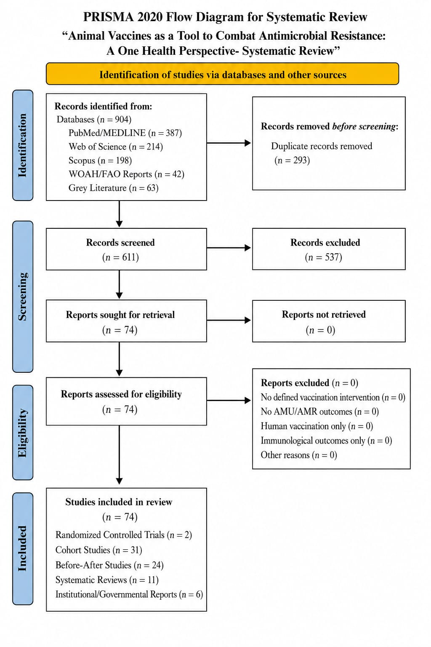

Figure 1. PRISMA 2020 flow diagram illustrating the study selection process for the systematic review on animal vaccines as a tool to combat antimicrobial resistance within a One Health framework.
2.2 Search Strategy
A comprehensive search was conducted across five databases and repositories, spanning publications from January 2005 to March 2026. Search terms combined Medical Subject Headings (MeSH) and free-text terms related to vaccination, animal species, AMR, and AMU (Table 1). No language restrictions were applied at first-pass screening; non-English articles were assessed using machine translation for eligibility.

Table 1. Search Strategy Summary (PRISMA 2020 Compliant)
Database | Search String (Representative) | Years | Records (n)
PubMed/MEDLINE | [(animal* OR livestock OR poultry OR swine OR cattle OR aquaculture) AND (vaccine* OR immunization*) AND (antimicrobial resistance* OR AMR OR antibiotic use) AND ("One Health")] | 2005–2025 | 387
Web of Science | [TS=(livestock vaccine* AND AMR) OR TS=(animal vaccine AND antibiotic reduction)] | 2005–2025 | 214
Scopus | [TITLE-ABS-KEY(vaccine AND antimicrobial AND animal AND "One Health")] | 2005–2025 | 198
WOAH/FAO Reports | Manual: WOAH ANIMUSE, FAO AMR reports, Global AMR R&D Hub dashboards | 2010–2025 | 42
Grey Literature | Google Scholar; "animal vaccine" + "antibiotic use" + reduction; PROSPERO registry | 2015–2025 | 63
Total (after deduplication) | — | — | 611
Full-text screened | — | — | 74 (included)

2.3 Eligibility Criteria
Studies were included if they: (1) reported a defined animal vaccination intervention; (2) measured AMU or AMR as a primary or secondary outcome; (3) involved livestock, aquaculture, or companion animals; and (4) were published in peer-reviewed journals or official international organization reports. Studies were excluded if AMU/AMR data were absent, if vaccination was administered to humans only, or if outcomes were exclusively immunological with no reference to antibiotic use.
2.4 Data Extraction and Quality Assessment
Two independent reviewers extracted data using a pre-piloted Excel-based form. Extracted fields included: study design, species, targeted pathogen, vaccine type and platform, geographic region, AMU metric used, AMR outcome metric, and magnitude of effect. Disagreements were resolved by consensus with a third reviewer. Quality was appraised using the Risk of Bias in Non-Randomized Studies of Interventions (ROBINS-I) tool for observational studies, and the Cochrane RoB 2.0 tool for any randomized controlled trials (RCTs) identified.

3. RESULTS
3.1 Literature Search Outcomes
The combined database search yielded 904 records. After removal of 293 duplicates, 611 records underwent title and abstract screening. Of these, 537 were excluded at first-pass. Full-text assessment of 74 records confirmed eligibility for all included in the synthesis. No RCT was identified that used AMR burden (resistome diversity, ARG prevalence, or resistant pathogen incidence) as a primary endpoint. Two RCTs measured AMU reduction post-vaccination as a secondary endpoint- one in swine (PCV2), one in dairy cattle (BRD complex). The remainder comprised cohort studies (n = 31), before-after observational studies (n = 24), systematic reviews of vaccine efficacy (n = 11), and institutional or governmental reports (n = 6).
3.2 Evidence Summary: Vaccination and AMU Reduction
Table 2 summarizes the most well-documented case studies linking animal vaccination to reduced AMU or AMR outcomes. The evidence base is strongly skewed toward high-income countries and specific production sectors.

Table 2. Representative Evidence: Animal Vaccination and AMR/AMU Outcomes
Disease / Sector | Pathogen | Vaccine Type | AMR-Related Outcome | Region / Reference
Norwegian Salmon Aquaculture | Vibrio spp.; Aeromonas salmonicida | Multivalent oil-adjuvanted inactivated vaccines | AMU reduced from 876 mg/kg (1987) to 0.43 mg/kg (2024): ~99% reduction (Yugueros-Marcos & Etienne, 2026) | Norway (Yugueros-Marcos & Etienne, 2026)
Porcine Circovirus Type 2 (PCV2) | Porcine circovirus type 2 | PCV2 subunit / inactivated vaccines | Significant reduction in antibiotic consumption post-vaccination across 65 Austrian pig farms (2008–2011) (Raith et al., 2016) | Austria / EU (Raith et al., 2016)
Bovine Brucellosis | Brucella abortus | RB51 / S19 live attenuated vaccines | Reduced antibiotic use for brucellosis treatment; reduced zoonotic spillover to humans (Roth et al., 2003) | USA, EU, Global (Roth et al., 2003)
Avian Influenza (H5N1/H5N8) | Highly Pathogenic Avian Influenza Virus | Inactivated / recombinant DIVA vaccines | Reduced flock mortality; indirect reduction of prophylactic AMU in co-infected flocks (Tseng et al., 2024) | Asia, Africa, EU ((Tseng et al., 2024)
Swine Mycoplasma hyopneumoniae | Mycoplasma hyopneumoniae | Bacterin vaccines (multiple platforms) | Reduced respiratory antibiotic treatments; S. suis & E. coli vaccines identified as critical unmet needs (Zhang et al., 2025) | Global (Zhang et al., 2025)
Bovine Respiratory Disease (BRD) | Mannheimia haemolytica, BRSV, IBR, PI3 | Combination viral + bacterial vaccines | Reduction in metaphylactic antibiotic use; limited RCT-level evidence (Laxminarayan et al., 2024) | North America, EU (Laxminarayan et al., 2024)

3.2.1 Aquaculture: The Norwegian Model
The most compelling evidence for vaccine-mediated AMU reduction comes from Norwegian salmon aquaculture (Yugueros-Marcos & Etienne, 2026). Following a government-mandated ban on antimicrobial growth promoters in 1995 and concurrent investment in multivalent inactivated vaccines against furunculosis (Aeromonas salmonicida) and vibriosis (Vibrio anguillarum, V. salmonicida), AMU declined from approximately 876 mg/kg biomass in 1987 to 0.43 mg/kg by 2024- a 99% reduction. Vaccination now constitutes an estimated 15% of smolt production costs, demonstrating sustained economic viability over three decades. This remains the most quantitatively robust demonstration in the global literature of vaccines as AMR-mitigation tools in animal production (Yugueros-Marcos & Etienne, 2026).
3.2.2 Swine: PCV2 and Unmet Vaccine Needs
A retrospective cohort study across 65 Austrian pig farms (Raith et al., 2016) documented a significant reduction in antibiotic consumption following large-scale PCV2 vaccination programs initiated in 2008 (Raith et al., 2016). A 2025 survey of US swine veterinarians (Zhang et al., 2025) identified Streptococcus suis, Escherichia coli, Mycoplasma hyopneumoniae, and Glaesserella parasuis as the highest-priority pathogens lacking efficacious commercial vaccines, with veterinarians expressing willingness to pay 1.8-1.9 times current prices for improved vaccines (Zhang et al., 2025).
3.2.3 Bovine: BRD Complex and Brucellosis
Bovine respiratory disease (BRD) is among the primary drivers of antibiotic use in cattle worldwide. Combination vaccines targeting IBR, BRSV, PI3, Mannheimia haemolytica, and Pasteurella multocida are widely used in North America and Europe, and are associated with reduced metaphylactic antibiotic interventions (Laxminarayan et al., 2024). However, randomized controlled evidence remains sparse, and effect sizes are inconsistently reported across studies. Brucella abortus vaccination (S19 and RB51 strains) provides the additional benefit of reducing zoonotic transmission, with documented human health benefits in case studies from Kazakhstan, Mongolia, and Peru (Roth et al., 2003).
3.2.4 Poultry: Avian Influenza and Colibacillosis
Vaccination coverage for avian influenza among at-risk global poultry populations was estimated at less than 20% for most strains in 2025 (Gleason et al., 2025). A 2024 systematic review and meta-analysis by (Tseng et al., 2024) re-evaluated the efficacy of HPAI vaccines in poultry and noted that reduced flock mortality indirectly decreases the need for prophylactic antibiotic administration during outbreak responses (Tseng et al., 2024). Improved colibacillosis vaccination in poultry has been endorsed by the American Society for Microbiology as a mechanism to prevent disease in animals and reduce the need for antibiotic treatments (ASM, 2025).
4. RESEARCH GAPS: A STRUCTURED ANALYSIS
The synthesis of 74 eligible studies and institutional reports reveals a substantial and multi-layered evidence deficit. Table 3 presents the ten most prominent research gaps, categorized by domain and priority level. These gaps collectively impede integration of animal vaccination into national and global AMR action plans at the scale warranted by the epidemiological context. Overall AMR R&D investment specifically for animal vaccines was documented at 7 USD cents per USD 10 by the (Global AMR R&D Hub, 2024), underscoring a structural funding mismatch.

Table 3. Research Gap Matrix: Animal Vaccination and AMR Mitigation (Priority-Ranked)
Research Gap Domain | Description | Priority Level
1. Absence of AMR-focused RCTs | No published RCT has used resistome burden or AMR prevalence as a primary endpoint in a livestock vaccination trial (Antimicrobial Resistance Collaborators, 2022; WOAH, 2024) | CRITICAL
2. LMIC Data Absence | Evidence on vaccination-linked AMU reduction is almost entirely from HICs; LMIC barriers are uncharacterised (Acosta et al., 2025; Laxminarayan et al., 2024) | CRITICAL
3. One Health Surveillance Integration | No study simultaneously links livestock vaccination rates, human AMR trends, and environmental ARG loads (WOAH, 2024; WHO et al., 2022) | CRITICAL
4. Resistome Dynamics Post-Vaccination | Post-vaccination changes in gut and environmental resistome are unstudied; metagenomics data wholly absent (Chen et al., 2025) | HIGH
5. Environmental ARG Spillover | Whether vaccination reduces ARG shedding into soil/water via manure remains unquantified (Chen et al., 2025) | HIGH
6. Species Coverage Gaps | Aquaculture beyond salmon, small ruminants, and camelids are grossly underrepresented in evidence base (Yugueros-Marcos & Etienne, 2026; Gleason et al., 2025) | HIGH
7. AMR-Specific Cost-Effectiveness | Economic modelling of vaccination vs. antibiotic use from an AMR-outcome perspective is nearly absent for LMICs (Acosta et al., 2025; Laxminarayan et al., 2024) | HIGH
8. Vaccine Funding Disproportion | Animal vaccine R&D receives only 7 USD cents per USD 10 of AMR R&D investment globally (Global AMR R&D Hub, 2024) | HIGH
9. mRNA Veterinary Vaccine Evidence | Novel mRNA platforms (e.g., SEQUIVITY IAV-S NA, 2024) lack clinical trial data for bacterial pathogens in livestock (ASM, 2025) | EMERGING
10. Regulatory Harmonization | Cross-border veterinary vaccine approval frameworks lag behind AMR policy urgency, impeding LMIC access (Acosta et al., 2025; Laxminarayan et al., 2024) | MODERATE

4.1 Gap 1: Absence of AMR-Specific RCTs
No published RCT has used resistome composition, ARG prevalence, or resistant pathogen incidence as a primary endpoint in a livestock vaccination trial. This is the single most critical evidentiary barrier to regulatory and policy integration. While AMU reduction is a reasonable proxy (Acosta et al., 2025; Raith et al., 2016; Laxminarayan et al., 2024), it is insufficient to demonstrate AMR causation under contemporary evidentiary standards. Prospective trials using metagenomics-based resistome profiling as a primary endpoint are urgently needed.
4.2 Gap 2: LMIC Data Absence
Over 73% of global antibiotic use in livestock is concentrated in five countries: China, Brazil, India, the USA, and Australia (Acosta et al., 2025). Yet the reviewed literature on vaccination-linked AMU reduction is almost exclusively from high-income European and North American contexts. LMICs face structurally distinct barriers to vaccine adoption- cold chain limitations, lack of veterinary infrastructure, economic constraints, and polyvalent farming practices- none of which are adequately characterized (Laxminarayan et al., 2024). The Science perspective by Laxminarayan et al. (2024) explicitly flagged this gap as a policy priority.
4.3 Gap 3: Resistome Dynamics Post-Vaccination
While AMU reduction post-vaccination is documented in several contexts, downstream impacts on gut microbiome composition, resistome diversity, and ARG profiles have not been prospectively studied. This gap is mechanistically critical: vaccination may reduce AMU yet fail to reduce ARG burden if horizontal gene transfer occurs via non-antibiotic selective pressures (e.g., heavy metal co-selection). No metagenomics-based longitudinal study was identified in the 74 included records (Chen et al., 2025).
4.4 Gap 4: Environmental ARG Spillover
Whether reduced AMU following livestock vaccination translates to decreased ARG shedding into soil, water, and the broader agricultural environment is entirely unquantified. Given that manure application is a principal vector of environmental ARG contamination and downstream human AMR exposure, this gap is central to evaluating the true One Health impact of animal vaccination programs (Chen et al., 2025).
4.5 Gap 5: R&D Investment Disproportion
The Global AMR R&D Hub 2024 annual analysis documented that animal vaccine development received only 7 USD cents per USD 10 of total AMR R&D investment (Global AMR R&D Hub, 2024). This severe funding imbalance structurally constrains the development pipeline for vaccines targeting the priority pathogens identified in this review. A recalibration of international funding priorities is not merely recommended but epidemiologically mandatory.

5. DISCUSSION
This systematic review confirms that animal vaccination has a documented capacity to reduce AMU in specific, well-resourced, high-surveillance contexts. The Norwegian aquaculture model remains the gold standard- a comprehensive, decades-long policy-industry-research collaboration that achieved the largest quantified AMU reduction attributable to vaccination in any production sector globally (Yugueros-Marcos & Etienne, 2026). Its replicability in terrestrial livestock systems and in LMICs, however, requires direct empirical investigation. The 2025 PNAS study (Gleason et al., 2025; Laxminarayan et al., 2024)- the first to systematically estimate vaccination coverage across 104 diseases in 203 countries- found coverages below 20% for most major pathogens in at-risk global livestock populations, directly implying that the potential AMU-reduction benefit of existing licensed vaccines remains substantially unrealized.
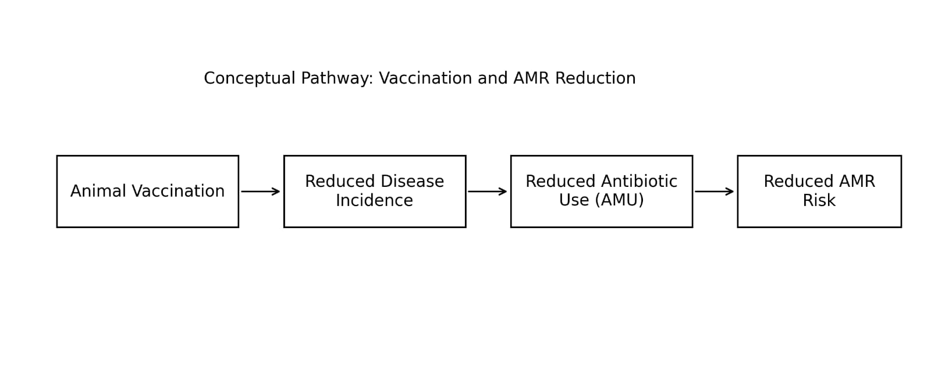

Figure 2 – Conceptual pathway illustrating how animal vaccination reduces infection pressure, antimicrobial use, and ultimately antimicrobial resistance within a One Health framework.
The One Health integration deficit is particularly consequential. No included study reported integrated outcomes simultaneously spanning animal vaccination rates, downstream AMR burden in humans, and environmental ARG loads. This reflects siloed research architectures that compartmentalize veterinary, public health, and environmental microbiology surveillance. The WOAH One Health Joint Plan of Action (2022–2026) (WHO et al., 2022) explicitly calls for integrated AMR surveillance, but the scientific literature has yet to operationalize this vision at a population level.
Emerging vaccine platforms- particularly mRNA-based veterinary vaccines- may substantially expand the development pipeline for AMR-priority bacterial pathogens. SEQUIVITY IAV-S NA (2024, Merck Animal Health), the first commercially available mRNA vaccine in swine, demonstrates technological readiness (ASM, 2025). However, no clinical trial data exist for bacterial pathogen targets in food-producing animals using mRNA platforms, and policy uncertainty in multiple jurisdictions constitutes a structural barrier.
The Philosophical Transactions of the Royal Society B special issue on animal vaccines and AMR (Yugueros-Marcos & Etienne, 2026) reinforces our findings, explicitly identifying cost-effectiveness data gaps and the underfunding of animal AMR vaccine R&D as principal barriers. Our review systematizes these observations and extends them to 10 prioritized, evidence-grounded research gaps.

5.1 Comparison with Previous Reviews
(Hoelzer et al., 2018) noted the potential of animal vaccination as an AMR strategy but lacked the systematic framework to delineate research gaps with precision. In 2026 review by Yugueros-Marcos & Etienne, 2026 and the 2025 review on livestock antibiotic use (Trinchera et al., 2025) corroborate the directionality of our findings (Trinchera et al., 2025). Our review uniquely contributes a 10-domain prioritized gap matrix and encompasses the most recent (2024–2025) literature on global vaccination coverage and projections (Gleason et al., 2025)
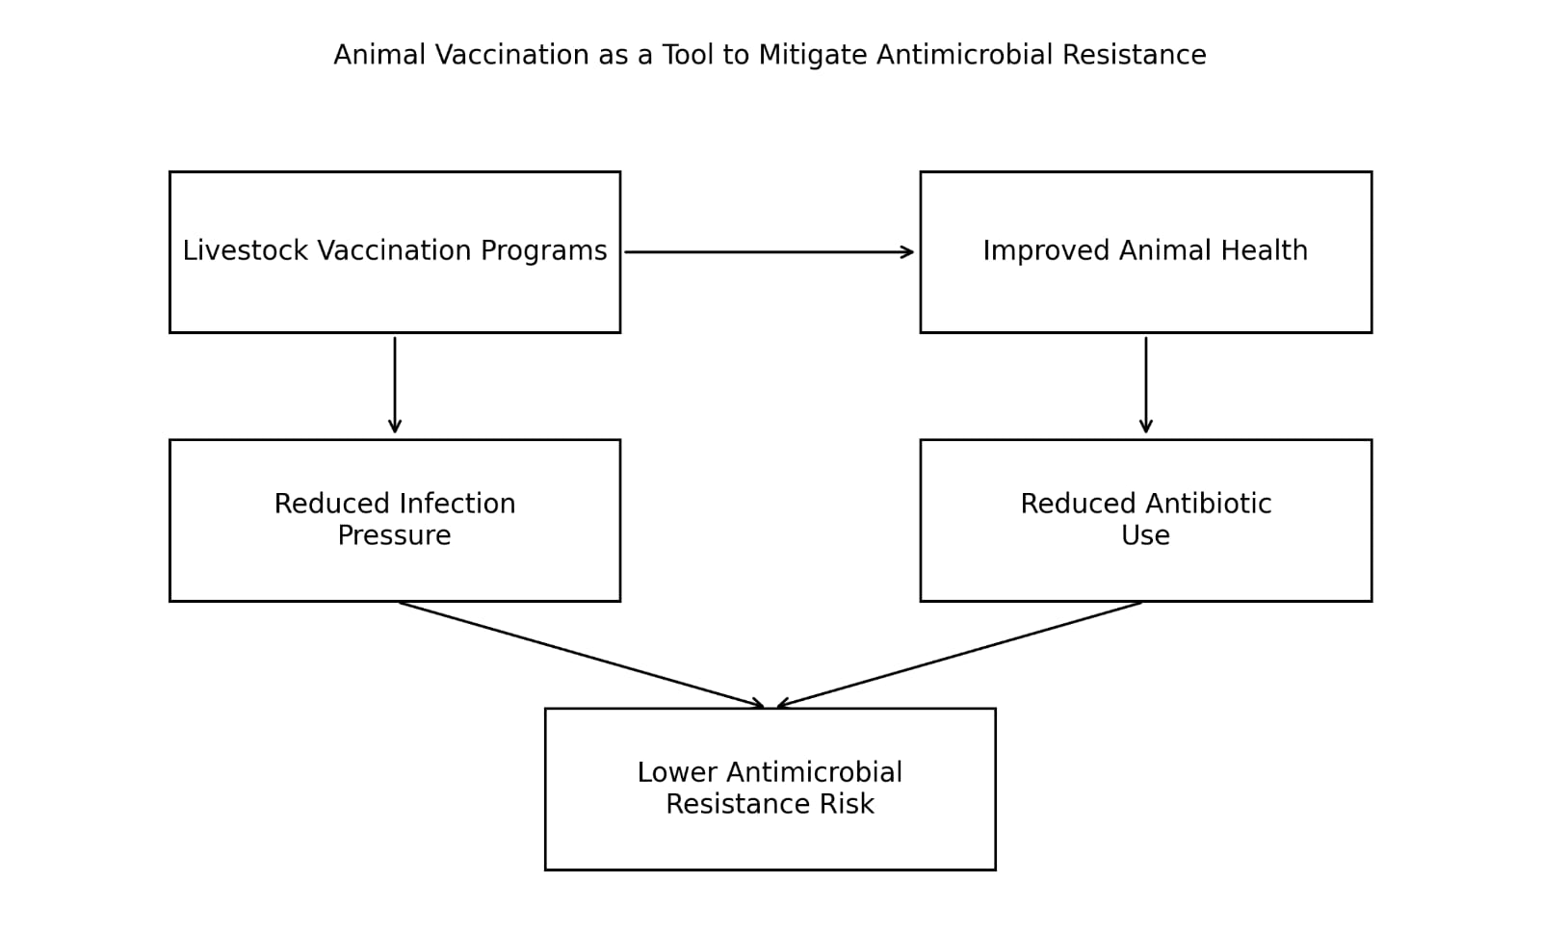

Figure 3 – Graphical summary of the role of livestock vaccination in reducing antimicrobial use and mitigating antimicrobial resistance.

5.2 Limitations
This review is limited by the paucity of RCT-level evidence, reliance on AMU as a proxy for AMR outcomes, and restricted geographic distribution of available data. Publication bias may have under-represented negative or null findings. The lack of standardized AMU reporting across countries and production systems complicated quantitative synthesis, precluding formal meta-analysis. The review searched publications from 2005 to March 2025; more recent preprints and grey literature may not be captured.
6. RECOMMENDATIONS AND FUTURE DIRECTIONS
6.1 For Researchers
- Design prospective RCTs with resistome outcomes (shotgun metagenomics of gut and environmental samples) as primary endpoints, not solely AMU as a proxy (Antimicrobial Resistance Collaborators, 2022; WOAH, 2024; Chen et al., 2025).
- Prioritize LMIC-based research, particularly in South and Southeast Asia and sub-Saharan Africa, where livestock AMU is highest and evidence is scarcest (Naghavi et al., 2024; Acosta et al., 2025; Laxminarayan et al., 2024; Dieng et al., 2025).
- Conduct longitudinal cohort studies examining environmental ARG burden (soil, water, manure) before and after mass livestock vaccination programs (Bhuiyan, 2025;Chen et al., 2025)
- Investigate mRNA and subunit vaccine platforms against priority AMR-relevant bacterial pathogens (S. suis, ETEC, M. hyopneumoniae, BRD complex) in food-producing animals (ASM, 2025; Zhang et al., 2025)
- Integrate antimicrobial stewardship metrics into vaccine trial designs, reporting pre- and post-vaccination AMU alongside clinical endpoints (Raith et al., 2016; Laxminarayan et al., 2024)
6.2 For Policy Makers and Funders
- Substantially increase funding allocation for animal vaccine R&D within national and global AMR action plans; the current 7 USD cents per USD 10 is incommensurate with the disease burden (Global AMR R&D Hub, 2024).
- Develop international regulatory harmonization frameworks to accelerate cross-border veterinary vaccine approval, reducing time-to-market in LMICs (Bhuiyan et al., 2026; WHO et al., 2022)
- Integrate livestock vaccination coverage data into national AMR surveillance systems and mandatory reporting to GLASS and WOAH ANIMUSE (WOAH, 2024; WHO et al., 2022)
- Incentivize private-sector investment through AMR-specific market entry rewards for vaccines targeting WOAH/WHO priority livestock pathogens (Global AMR R&D Hub, 2024; Laxminarayan et al., 2024)
6.3 For Veterinary Practitioners
- Advocate for vaccination as a first-line disease prevention strategy, with systematic pre- and post-vaccination AMU monitoring to generate real-world evidence (Raith et al., 2016; Laxminarayan et al., 2024).
- Engage in antimicrobial stewardship programs that incorporate vaccination coverage as a measurable, reportable stewardship metric (Bhuiyan, 2025; WHO et al., 2022).
7. CONCLUSION
Animal vaccination shows clear potential as a One Health intervention to reduce antimicrobial use (AMU) in livestock, with consistent evidence from aquaculture, swine, and cattle systems. The strongest data, particularly from long-term programs such as Norwegian aquaculture, demonstrate substantial and sustained reductions in antibiotic consumption following widespread vaccination, supporting its role as a preventive strategy against infection-driven AMU.
However, evidence linking vaccination directly to antimicrobial resistance (AMR) outcomes remains limited. The absence of AMR-focused clinical trials, reliance on AMU as a proxy, and dominance of high-income country data restrict global applicability. Future research should prioritize AMR-specific endpoints, One Health integrated surveillance, and studies in low- and middle-income countries to fully establish the role of vaccination in AMR mitigation.
Declarations
Conflict of Interest: The authors declare no conflicts of interest relevant to this work.

COMPETING INTERESTS DISCLAIMER:
Authors have declared that they have no known competing financial interests OR non-financial interests OR personal relationships that could have appeared to influence the work reported in this paper.

REFERENCES
Acosta A., Tirkaso W., Nicolli F., Van Boeckel T. P., Cinardi G. & Song J. (2025). The future of antibiotic use in livestock. Nature Communications. 16(1): 2469.
​American Society for Microbiology (ASM) (2025). Animal vaccine FAQs: protecting pets, livestock and wildlife. ASM Microbe Magazine. [Online] Available at: https://asm.org/magazine/2025/fall/animal-vaccine-faqs-protecting-pets,-livestock-and (Accessed: 10 April 2026).
​Antimicrobial Resistance Collaborators (2022). Global burden of bacterial antimicrobial resistance in 2019: a systematic analysis. The Lancet. 399(10325): 629–655.
​Bhuiyan, M. R. (2025). Seasonal epidemiology and vector ecology of lumpy skin disease in South and Southeast Asia: A comprehensive review of knowledge gaps and future perspectives. Bulgarian Journal of Veterinary Medicine. https://doi.org/10.15547/bjvm.2025-0096
​Bhuiyan, M.R., Ferdous, J., Shimi, S.S.A. and Sharma, S. (2026) ‘Clinical management of lumpy skin disease in a cross-breed heifer at Upazila Livestock Office and Veterinary Hospital, Daudkandi, Cumilla: A case report’, Asian Journal of Research in Animal and Veterinary Sciences, 9(2), pp. 330–338. https://doi.org/10.9734/ajravs/2026/v9i2416
Bhuiyan, M.R., Ferdous, J., Shimi, S.S.A. and Sharma, S., 2025. Clinical management of lumpy skin disease in a cross-breed heifer at Upazila Livestock Office and Veterinary Hospital, Daudkandi, Cumilla: A case report [Paper presentation]. In RUEC 1st International Research Conference 2025. https://ruec.org

​Chen Y., Liu Y., Zhao C., Ma J. & Guo J. (2025). Antibiotic resistance gene pollution in poultry farming environments and approaches for mitigation: a systematic review. Poultry Science. 104(3): 104858.
​Dieng A., Camara C. S., Gaye A., Dieye K., Aw A., Thiaw M. B., Ndiaye F., Gaye I., Coundoul N., Diallo M. & Diao N. M. (2025). National Overview of Antibiotic Use in Senegal. Open Journal of Medical Microbiology.
​Gleason A., Impalli I., Sheen J., Cabezas Murillo A., Grenfell B. T., Levin S. A., Van Boeckel T. P. & Laxminarayan R. (2025). Global vaccination coverage and disease incidence in cattle, pigs, and poultry. Proceedings of the National Academy of Sciences. 122(52): e2515557122.
​Global AMR R&D Hub (2024). Dynamic dashboard: investments in AMR R&D. Annual progress report 2024. Berlin: Federal Ministry of Health Germany. [Online] Available at: https://dashboard.globalamrhub.org/reports/investments/overview (Accessed: 10 April 2026).
​Hoelzer K., Bielke L., Blake D. P., Cox E., Cutting S. M., Devriendt B., Erlacher-Vindel E., Goossens E., Karaca K., Lemiere S., Metzner M., Raicek M., Collell Suriñach M., Wong N. M., Gay C. & Van Immerseel F. (2018). Vaccines as alternatives to antibiotics for food producing animals. Part 1: challenges and needs. Veterinary Research. 49(1): 64.
​Laxminarayan R., Gleason A., Sheen J., Saad-Roy C. M., Metcalf C. J., Palmer G. H. & Fèvre E. M. (2024). Unlock the potential of vaccines in food-producing animals. Science. 384(6703): 1409-1411.
​Naghavi M., Vollset S. E., Ikuta K. S., Swetschinski L. R., Gray A. P., Wool E. E., Aguilar G. R., Mestrovic T., Smith G., Han C. & Hsu R. L. (2024). Global burden of bacterial antimicrobial resistance 1990–2021: a systematic analysis with forecasts to 2050. The Lancet. 404(10459): 1199-1226.
​Page M. J., McKenzie J. E., Bossuyt P. M., Boutron I., Hoffmann T. C., Mulrow C. D., Shamseer L., Tetzlaff J. M., Akl E. A., Brennan S. E. & Chou R. (2021). The PRISMA 2020 statement: an updated guideline for reporting systematic reviews. BMJ. 372: n71.
​Raith J., Trauffler M., Firth C. L., Lebl K., Schleicher C. & Köfer J. (2016). Influence of porcine circovirus type 2 vaccination on the level of antimicrobial consumption on 65 Austrian pig farms. Veterinary Record. 178(20): 504.
​Roth F., Zinsstag J., Orkhon D., Chimed-Ochir G., Hutton G., Cosivi O., Carrin G. & Otte J. (2003). Human health benefits from livestock vaccination for brucellosis: case study. Bulletin of the World Health Organization. 81: 867-876.
​Trinchera M., De Gaetano S., Sole E., Midiri A., Silvestro S., Mancuso G., Catalano T. & Biondo C. (2025). Antimicrobials in livestock farming and resistance: public health implications. Antibiotics. 14(6): 606.
​Tseng I., Pan B. Y., Feng Y. C. & Fang C. T. (2024). Re-evaluating efficacy of vaccines against highly pathogenic avian influenza virus in poultry: A systematic review and meta-analysis. One Health. 18: 100714.
​World Health Organization, UNEP & WOAH (2022). One health joint plan of action (2022‒2026): working together for the health of humans, animals, plants and the environment. Geneva: World Health Organization.
​World Organisation for Animal Health (WOAH) (2024). ANIMUSE — The global database for antimicrobial use in animals. Paris: WOAH. [Online] Available at: https://amu.woah.org/amu-system-portal/home (Accessed: 10 April 2026).
​Yugueros-Marcos J. & Etienne F. (2026). Animal vaccines and antimicrobial resistance: an underutilized tool. Philosophical Transactions B. 381(1944): 20250009.
​Zhang X., Li D., Apley M. D., Karriker L., Connor J. F., Bromfield C., Gebhardt J. T., Lubbers B., Kittana H., Pendell D. & Madera R. (2025). Challenges and Opportunities of Bacterial Vaccines as Alternatives to Antimicrobials in Swine Health Management: Insights from US Veterinarians. Pathogens. 14(11): 1113.

