Case Report

Type 2 Torpedo Maculopathy with Distinct Multimodal Imaging Features: A Case Report

Abstract
Purpose: To report an incidental case of Type 2 torpedo maculopathy in a middle-aged adult, highlighting subtle multimodal imaging features that may aid differentiation from other macular lesions.
Methods: A 45-year-old asymptomatic male underwent comprehensive ophthalmic examination including color fundus photography, fundus autofluorescence (FAF), OCT, OCT angiography (OCTA), and reflectance imaging. Imaging findings were compared with published Type 2 torpedo maculopathy cases.
Results: Fundus examination revealed a torpedo-shaped, hypopigmented lesion temporal to the fovea with subtle hyperautofluorescent tip. OCT showed outer retinal cavitation with preserved inner retina. OCTA revealed a distinct pattern of intact choriocapillaris surrounding the lesion, a feature not highlighted in prior reports. Multimodal imaging allowed precise lesion characterization and differentiation from congenital hypertrophy of the RPE or choroidal nevus.
Conclusion: This case demonstrates Type 2 torpedo maculopathy with unique multimodal imaging features, including hyperautofluorescent tip and OCTA pattern. Emphasis on these subtle markers may enhance diagnostic accuracy and differentiation from other macular lesions, supporting careful clinical assessment and follow-up.
Keywords: Torpedo maculopathy, Type 2, multimodal imaging, OCT, fundus autofluorescence, OCT angiography, differential diagnosis

Introduction
Torpedo maculopathy (TM) is a rare congenital anomaly of the retinal pigment epithelium (RPE), usually discovered incidentally in asymptomatic patients (1). It typically appears as a well-circumscribed, torpedo-shaped hypopigmented lesion temporal to the fovea (1,2). While most lesions are solitary, satellite lesions and torpedo-like lesions outside the macula have been reported, leading to the broader term “torpedo retinopathy” (3,4). TM lesions are often aligned along the horizontal raphe within a kite-shaped area of the temporal macula, suggesting a relationship with retinal nerve fiber layer development (5). Patients generally retain normal visual acuity, although subtle functional defects may occasionally be detected (6).
Optical coherence tomography (OCT) and fundus autofluorescence (FAF) are essential for lesion characterization. OCT can reveal thinning of the outer nuclear layer, loss or attenuation of the ellipsoid and interdigitation zones, and, in Type 2 TM, outer retinal cavitation with or without inner choroidal excavation (7). FAF typically shows hypoautofluorescence corresponding to RPE dysfunction. Multimodal imaging also allows differentiation from other macular lesions, such as congenital hypertrophy of the RPE (CHRPE), choroidal nevus, or post-inflammatory scars (2,8).
The aim of this article is to report an incidental case of Type 2 TM in an asymptomatic adult and to highlight the role of multimodal imaging for accurate diagnosis, classification, and follow-up, with emphasis on features not previously detailed in literature.

Case Report
A 45-year-old male presented for routine ophthalmic examination with no visual complaints. Best-corrected visual acuity was 20/20 in both eyes. Anterior segment examination was unremarkable.
Right eye (OD):
A well-circumscribed torpedo-shaped lesion ~2 disc diameters temporal to the fovea, hypopigmented with subtle hyperpigmentation at the temporal tip (Figure1 A).

Fig 1-Multimodal imaging of unilateral torpedo maculopathy in the right eye.
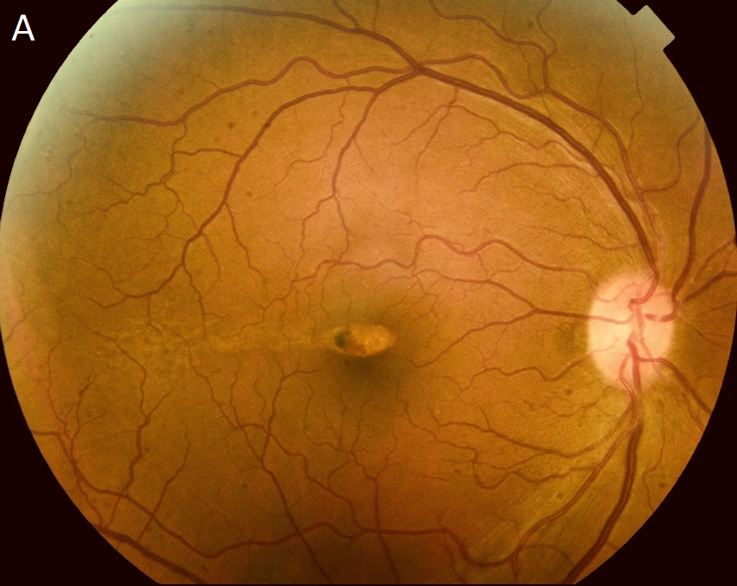
(1A) Color fundus photograph showing a well-defined, torpedo-shaped hypopigmented lesion two disc diameters temporal to the fovea, with subtle hyperpigmentation at the temporal tip
FAF showed hypoautofluorescence with a hyperautofluorescent tip (Figure 1B). Green and infrared reflectance imaging delineated lesion margins and subtle outer retinal reflectivity changes (Figure 1C).

(1B) Fundus autofluorescence demonstrating a hypoautofluorescent lesion with a hyperautofluorescent border at the temporal tip.
(1 C) Green and infrared reflectance images delineating lesion margins with enhanced contrast and highlighting subtle outer retinal reflectivity changes.
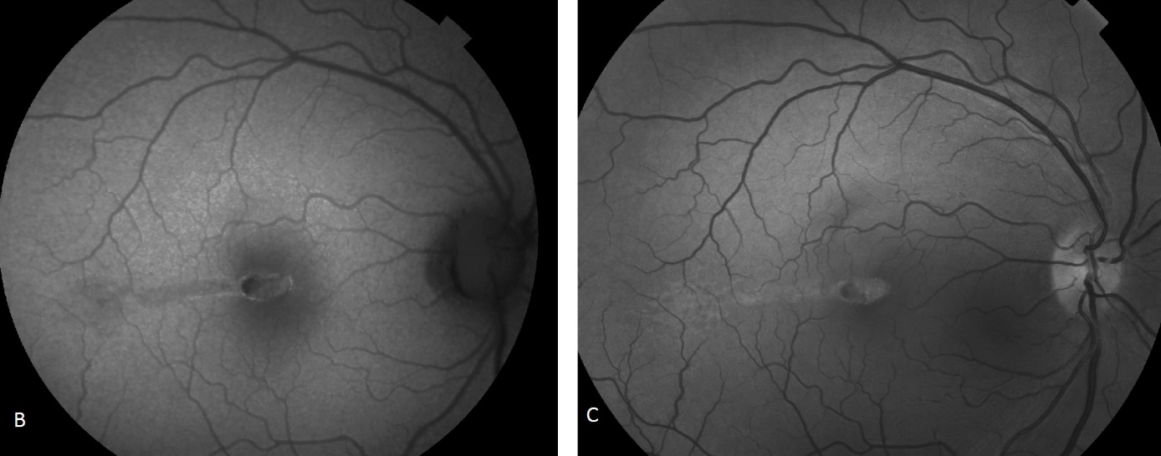
OCT demonstrated preserved inner retinal layers, thinning of the outer nuclear layer, outer retinal cavitation, and increased choroidal signal transmission (Figure 1 D).
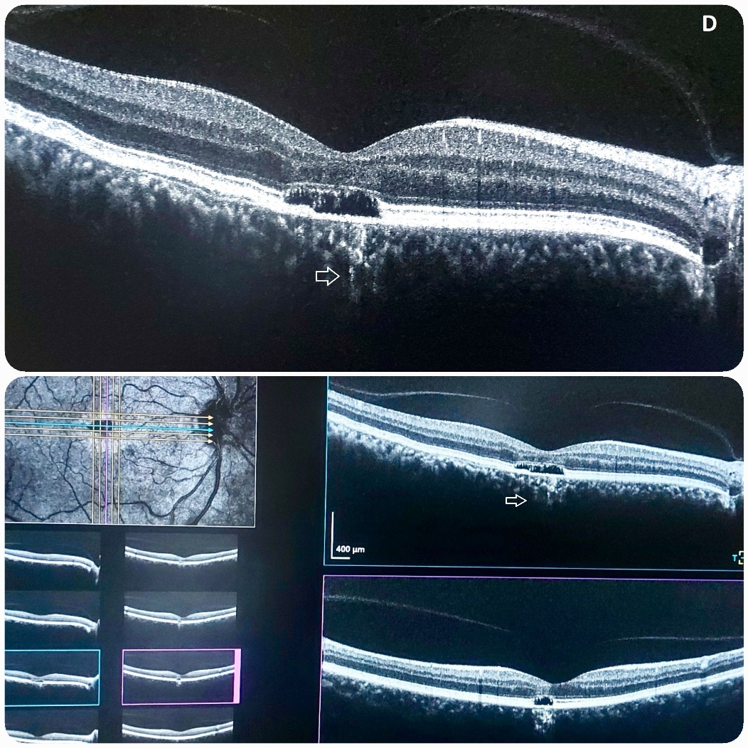

(1 D) OCT B-scan showing preserved inner retina with thinning of the outer nuclear layer associated with outer retinal cavitation and increased choroidal transmission (arrow).

OCTA confirmed absence of choroidal neovascularization and demonstrated a distinct pattern of intact choriocapillaris surrounding the lesion, emphasizing the lesion’s stability and unique vascular architecture (Figure 1E).
(1 E) OCT angiography confirming absence of choroidal neovascularization.

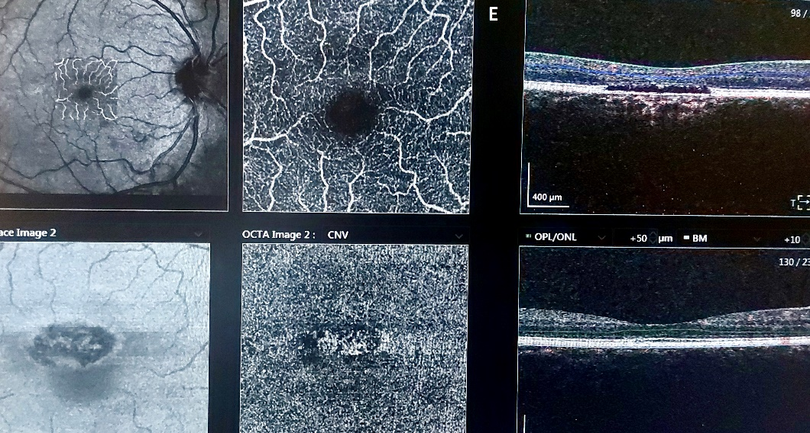

Left eye (OS): Fundus was normal.
The patient was advised to follow up periodically for monitoring potential complications.

Discussion
Torpedo maculopathy (TM) is a rare congenital anomaly of the retinal pigment epithelium (RPE), often discovered incidentally in asymptomatic patients (1). It is typically characterized by a well-circumscribed, torpedo-shaped hypopigmented lesion located temporal to the fovea. Although most lesions are solitary, satellite lesions may occur, and torpedo-like lesions outside the macula have been described, prompting the term “torpedo retinopathy” for such presentations (2,3). Distribution mapping analyses support a congenital etiology, with lesions typically localizing to a kite-shaped region of the temporal macula along the horizontal raphe, suggesting a correlation with retinal nerve fiber layer development (4).
Histopathologic studies and advanced imaging modalities have demonstrated that TM primarily affects the outer retina and RPE. Common OCT findings include thinning of the outer nuclear layer, attenuation or loss of the ellipsoid and interdigitation zones, and outer retinal cavitation, with or without inner choroidal excavation (5,6). Based on OCT morphology, Wong et al. classified TM into two types: Type 1 with outer retinal attenuation without cavitation, and Type 2 with outer retinal cavitation and degeneration, with or without inner choroidal excavation (6). Tripathy et al. proposed a Type 3 variant showing additional inner retinal and choroidal excavation alongside outer retinal degeneration (7). FAF typically shows hypoautofluorescence in the lesion, sometimes with hyperautofluorescent tips, reflecting RPE dysfunction and structural alterations (1,5).
Although TM is generally asymptomatic, functional testing such as microperimetry or perimetry can occasionally reveal scotomas or localized reductions in retinal sensitivity, though normal visual fields are frequently observed (8–10). Vision is usually preserved due to intact inner retinal layers. Some cases exhibit choroidal excavation on OCT, which may predispose to rare complications such as choroidal neovascularization (CNV). CNV in TM has been reported in only a few cases, sometimes associated with focal choroidal excavation, emphasizing the importance of long-term monitoring (11–13). OCT angiography can further assess choriocapillaris integrity and detect early neovascular changes (13).
The clinical spectrum of TM is broad. Lesions are generally oval-shaped, well-demarcated, and hypopigmented, but hyperpigmented variants exist and are rarely documented with long-term follow-up (14–16). TM lesions may present with variable features such as intraretinal clefts, fundus excavation, or visual field defects, highlighting the heterogeneity of presentation. The differential diagnosis includes congenital hypertrophy of the RPE (CHRPE), choroidal nevus, RPE hamartomas, inflammatory scars (e.g., toxoplasmosis), macular coloboma, and post-traumatic lesions (2,17–19). Accurate recognition of these atypical features is critical to avoid misdiagnosis and to guide appropriate follow-up.
Unique imaging perspective in the present case:
- Hyperautofluorescent tip on FAF
- OCTA showing intact choriocapillaris surrounding the lesion
- Preserved inner retina with outer cavitation
These features provide subtle but meaningful diagnostic markers not emphasized in prior reports, including Rickmann et al., 2024. They highlight the value of detailed multimodal imaging in differentiating TM from other hypopigmented macular lesions and emphasize the importance of systematic vascular evaluation, even in asymptomatic adults.
The pathophysiology of TM remains incompletely understood. Recent advances in ocular embryology using animal models and stem-cell-derived RPE suggest that pigmentation alone may not signify fully mature RPE, and polarity interactions between RPE and neural retinal cells continue during differentiation (20). The congenital nature of TM is further supported by lesion stability over long-term follow-up, typical location near the temporal macula, and presentation across a wide age range (4,20,21).
Multimodal imaging plays a pivotal role in the evaluation of TM. Color fundus photography documents lesion morphology, FAF delineates areas of RPE dysfunction, OCT characterizes outer retinal degeneration and cavitation, and OCT angiography assesses choroidal circulation and potential CNV development (1,5,6,13). Reflectance imaging can further delineate lesion margins and subtle structural changes. Periodic follow-up using these modalities allows early detection of complications and accurate monitoring of lesion evolution.
In summary, this case of incidental Type 2 TM illustrates the importance of multimodal imaging in characterizing lesion morphology, classifying TM subtypes, and distinguishing TM from other macular lesions. Recognition of both classic hypopigmented and rare hyperpigmented variants is essential for accurate diagnosis and appropriate monitoring. Although generally benign and non-progressive, rare complications such as CNV may occur, especially in the presence of choroidal excavation, highlighting the need for long-term surveillance.

Competing Interests
The authors declare no competing interests.

Consent
Written informed consent for publication of this case report and accompanying images was obtained from the patient.

Ethical Approval
As this is a retrospective descriptive case series involving anonymized clinical data, formal ethical approval was not required.
Competing interests: None

Abbreviations
TM: Torpedo Maculopathy
RPE: Retinal Pigment Epithelium
OD: Oculus Dexter (Right Eye / Œil droit)
OS: Oculus Sinister (Left Eye / Œil gauche)
FAF: Fundus Autofluorescence
NIR-FAF: Near-Infrared Fundus Autofluorescence
OCT: Optical Coherence Tomography
OCTA: Optical Coherence Tomography Angiography
CNV: Choroidal Neovascularization
CHRPE: Congenital Hypertrophy of the Retinal Pigment Epithelium
BCVA: Best-Corrected Visual Acuity

References
- Shields CL, Guzman JM, Shapiro MJ, Fogel LE, Shields JA. Torpedo maculopathy at the site of the fetal “bulge.” Arch Ophthalmol. 2010;128:499–501.
- Venkatesh R, Jain K, Pereira A, Thirumalesh YNK. Torpedo retinopathy. J Ophthalmic Vis Res. 2020;15:187–191.
- Rickmann A, Bodenbender JP, Gelisken F, Kühlewein L. Type 1 and Type 2 torpedo maculopathy. Clin Exp Ophthalmol. 2024;52:1805–1810.
- Williams PJ, Salek S, Prinzi RA, Bergstrom C, Hubbard GB. Distribution patterns of torpedo maculopathy: evidence of a congenital retinal nerve fiber layer-driven etiology. Saudi J Ophthalmol. 2019;33:260–267.
- Wong EN, Fraser-Bell S, Hunyor AP, Chen FK. Novel optical coherence tomography classification of torpedo maculopathy. Clin Exp Ophthalmol. 2015;43:342–348.
- Kerwat D, Jamall O, Antonakis S, Almeida GC. Torpedo maculopathy: a case series - insights into basic pathology. Eur J Ophthalmol. 2021;31:NP35–NP39.
- Tripathy K, Sarma B, Mazumdar S. Commentary: Inner retinal excavation in torpedo maculopathy and proposed type 3 lesions in optical coherence tomography. Indian J Ophthalmol. 2018;66:1213–1214.
- Buzzonetti L, Petroni S, Catena G, Iarossi G. Optical coherence tomography and electrophysiological findings in torpedo maculopathy. Doc Ophthalmol. 2015;130:65–70.
- Su Y, Gurwood AS. Neurosensory retinal detachment secondary to torpedo maculopathy. Optometry. 2010;81:405–407.
- Sanabria MR, Coco RM, Sanchidrian M. OCT findings in torpedo maculopathy. Retin Cases Brief Rep. 2008;2:109–111.
- Shirley K, O’Neill M, Gamble R, Ramsey A, McLoone E. Torpedo maculopathy: disease spectrum and associated choroidal neovascularisation in a paediatric population. Eye (Lond). 2018;32:1315–1320.
- Parodi MB, Romano F, Montagna M, Albertini GC, Pierro L, Arrigo A, Bandello F. Choroidal neovascularization in torpedo maculopathy assessed on OCT angiography. Ophthalmic Surg Lasers Imaging Retina. 2018;49:e210–e213.
- Banaee T, Doss M, Eller AW. Torpedo maculopathy complicated by choroidal neovascularization. Retina. 2018;38:e52–e55.
- Ranjith PC, Giridhar A. Hyperpigmented torpedo maculopathy. Indian J Ophthalmol. 2019;67:229–233.
- Golchet PR, Jampol LM, Mathura JR, Daily MJ. Torpedo maculopathy. Br J Ophthalmol. 2010;94:302–306.
- Roseman RL, Gass JD. Solitary hypopigmented nevus of the retinal pigment epithelium in the macula. Arch Ophthalmol. 1992;110:1358–1359.
- Pian D, Ferrucci S, Anderson SF, Wu C. Paramacular coloboma. Optom Vis Sci. 2003;80:556–563.
- Shields JA, Shields CL. Tumours and related lesions of the pigment epithelium. In: Intraocular Tumours: An Atlas and Textbook. 2nd ed. Philadelphia, PA: Lippincott Williams & Wilkins; 2008. p.431–480.
- Trevino R, Kiani S, Raveendranathan P. The expanding clinical spectrum of torpedo maculopathy. Optom Vis Sci. 2014;91:e18.
- Bennis A, Jacobs JG, Catsburg LAE, et al. Stem cell-derived retinal pigment epithelium: the role of pigmentation as maturation marker and gene expression profile comparison with human endogenous retinal pigment epithelium. Stem Cell Rev Rep. 2017;13:659–669.
- Shields CL, Mashayekhi A, Ho T, Cater J, Shields JA. Solitary congenital hypertrophy of the retinal pigment epithelium: clinical features and frequency of enlargement in 330 patients. Ophthalmology. 2003;110:1968–1971.
- Giannakaki-Zimmermann H, Wolf S, Fleckenstein M, et al. Choriocapillaris alterations in torpedo maculopathy: OCT-A insights. Graefes Arch Clin Exp Ophthalmol. 2021;259:1021–1029.

