Milk Production and Reproductive Performance of Indigenous Goat in Loka Abaya Woreda, Sidama Region

ABSTRACT
This study was conducted to evaluate milk production and reproductive performance of indigenous goats at Loka Abaya woreda. A total of 50 households were selected for the survey and monitoring study. For milk data collection 110 does were mentored from September 2021 to November 2022. A general linear model was employed for data analysis Does constitute the largest proportion (46.6%), followed by kids under 6 months. Goat milk consumption is a cultural practice and all the family members consumed milk. Average daily milk yield and lactation length of does were 0.65 liters and 89.3 days, respectively. Milk yield was affected (P<0.001) by birth type, parities and birth season. Parturition was affected by birth season; thus, majority of parturition was occurred in the wet season. Average age at first kidding and kidding interval were 12.8±0.0.3 and 8.12 months, respectively. Liter size and fertility rate were 1.5 and 87.3%, respectively. In conclusion: litter size, parity and birth season are found important source of variation in milk yield and lactation length. Thus, goat milk production integrated with forage development and farmers awareness need to be considered as a developmental intervention.
Keywords: Birth type; flock size; lactation length; milk yield; milk utilization

INTRODUCTION
Ethiopia is endowed with a large number of goat populations that estimated to be 52.5 million head (CSA, 2021) which are found in various production systems and agro-ecological zones of the country. This number accounts for about 99.97% of the ingenious goat type, which are adapted to different agro-ecological zones of the country. Despite, large populations of goats, their productivity and contribution to the country’s national economy are very low (Solomon et al., 2014). Goats in Ethiopia are mostly maintained under farmers management system used as source of meat, milk, skin, manure and direct cash income (Zeleke, 2007). Goats in the lowlands are highly valued and reared mainly for milk and meat production (Kassahun and Solomon, 2008). There is also a growing awareness of the importance of goat as a source of milk off-take for home consumption (Tona et al., 2015) and they are normally called the ‘poor man’s cow.).

Goat’s milk is better as compared to cow’s milk for people suffering from lactose intolerance, which is a common phenomenon among adults in Sub Saharan Africa (Kumar and sharma, 2016). Besides to its better digestibility, goat’s milk contains almost same amount of lactose as cow’s milk (Silanikove et al., 2015) with high quality protein and a great content of minerals and vitamins (Brito et al., 2011). Consumption of goat milk in Ethiopia is mainly affected by cultural attitude of the communities and poor productivity of goats (Mekuria et al., 2018).
.
The productivity potential of goat depends on its reproductive performance (Khandoker et al., 2018), which is determined by the age at first puberty, age at first service, age at first kidding, litter size and weight at birth. High reproductive rate enhances the efficiency of goat production, which means more animals for sale as meat, milk and a high selection deferential leading to faster selection response (Khan et al., 2019).

The study area have suitable climatic condition and diversity of plant species which is suitable for livestock production, especially for goats production, which is benefit for small older farmers in generating cash income, assets, as well as milk production, and also goat milk consumption is common and all family members interested to consume goat milk. Despite its goat population potential in Loka Abaya Woreda their milk yield and reproductively performance has not been studied. Therefore, knowing goat productivity performance is essential to design appropriate development intervention that are relevant for better breed improvement program through selection. Therefore the objective of this study was to study the milk yield and reproduction performance of ingenuous goat under farmers’ management condition.

MATERIAL AND METHODS

Study Area
The study was conducted in Loka Abaya woreda of Sidama Region. Loka Abay is one of the lowland woreda in the Region, have suitable climatic condition and diversity of plant growth which is suitable for livestock production and has a high number of goat populations. The woreda is located an altitude ranging from 1170 up to 1500 m asl (Endeshaw, 2007). The rain fall pattern and distribution is erratic. The agricultural production system is mixed livestock- crop production system, where livestock production being the dominant component. The major livestock species are goat, cattle, donkey and chicken. The major crops are maize, teff, haricot bean and chat

Data Collection Procedures

Animals and household selection

A total of 50 interested goat keepers who have 3 or more does were purposely selected for household survey and monitoring. Households with less than 3 does did not eligible in this study. Initially, 126 does were selected from sampled goat keepers for milk data collection. The selected does were identified with plastic ear tags. During the selection of animals age and parity was recorded by farmers recall of animals in the flocks. For monitoring milk yield data one enumerator from the local community was assigned. Reproduction data like age at first kidding and kidding interval was collected from their life histories of female goats.

Data source
Both primary and secondary data sources were collected. The primary data was collected from sampled households using structured questionnaire. Structured questionnaire was used to collect information on socio-economics characteristics, flock size, goat milk utilization, and reproduction traits (age at first kidding and kidding interval). Secondary data were collected from respective zonal, and woreda agricultural woreda agricultural office. Awareness creation was given for data collector about milk data recording
On-farm Monitoring Activity
In the monitoring activity, a total of 110 does were included during September 2021 to October 2022. Birth date, type of birth, dam parities and birth season were recorded within 24 hours of parturition. For each participant farmer, a calibrated cup (250ml capacity) for measuring daily milk yield was provided. The daily milk yield was recorded in the morning starting from 7th day of kidding till the end of lactation. Milk yield was routinely collected and recorded in the record formats by enumerator under close supervision of the researchers. The daily milk yield was then estimated for each doe multiplying morning milk yield by 2.
Management of Animals
Animals were managed according to farmer’s management conditions with no additional feeding or any other management interventions. Farmer’s give some supplemental feed (enset leaves, salt and chat left over) for pregnant and lactate does. They are also watered from revere once per day. The does allowed to natural pasture for herbs and shrubs on free grazing land.
Data Analysis

Data was analyzed by using the GLM procedure of SAS and means of significant effects was separated by using Tukey’s HSD test. Frequencies and percentages were used to describe for qualitative data and reproduction performance of goats. Considered response variables were milk yield and lactation length. Fixed effects fitted in the model were parity (1≥4); birth type (Single, twin) and birth season (Wet and dry).
The Model used

Y_{jkl} = μ++B_{j}+P_{k}+T_{l}+ε_{jkl}

Y_{jkl =} Response variable
μ = overall mean of the respective variable.
B_{j} = the effect of j^{th} birth type (j = single, twin).
Pk=the fixed effects of the k^{th} party (k= 1, 2…)
Tl= the effect of _{l}^{th} season (l= wet, dry season)
Є_{jkl} = random error term.

Litter size =number of kids at birth/number of does giving birth
Fertility rate= (Number of females that gave birth/Number of females to mated) x100%

RESULTS AND DISCUSSION

Socio-economic characteristics
The study household gender, age category and level of education are presented in Table 1. The number of female headed households who owned goats was significantly (p<0.05) smaller as compared to male headed. The small number of females headed household indicated that men play a dominant role in the use of benefits from live animal sale. The current study revealed that most of goat owners in the study area were illiterate followed by read and write and the remaining small proportions attended primary school. Different studies in different part of Ethiopia reported that majority of goat owners were unable to read and write. Education plays a crucial role in influencing household income, technology adoption, and socio-economic status of the family (Paltasingh and Goyari, 2018). In contrast, in the rural agro-pastoral areas of Uganda, majority of (84.1 %) household heads had attained formal education (Byaruhanga et al., 2015).

Table 1. Average family size, and educational status of farmers in the study area (n=50)
Parameters | Average
Household’s size (mean±SD) | 8.9±2.3
Male headed | 5.5±3.1ª
Female headed | 3.3±2.1^{b}
Educational level (%)
Illiterate | 50
Read and write | 30
Elementary school | 20
Where: ^{a&b} P<0.05 values across rows are significant

Flock composition and structures

Goat flock size and composition per household are presented in Table 2. The overall average flock size of the current study is higher than previously average flock size (5.98±0.547) in lowland of Sidama zone (Endeshaw, 2007) and (8.13) Kidane et al., 2014 in North Gonder. Does older than one year and kids less than 6 months were representing the major proportion in the flock. The proportion of adult female goats of the current study was higher than that reported by Belete et al. (2015) (43.2%) and Getaw et al. (2017) (30.23%) in Ethiopia. Larger proportion of does in the flock could lead to a higher number of kids which in turn might increase the probability of selecting females for milk production. On the other hand, the number of bucks were significantly lower (P<0.05) among the flocks. Except breeding bucks, farmers sell male goats to cover expenses for agricultural inputs and government taxes.
Table 2. Goat flock size and composition
Goats Categories | Flock size (Mean± SD) | Proportions
Breeding does > 1 year | 5.6±5.5ª | 46.6
Breeding bucks> 1 year | 0.4 ±1.2^{d} | 5.2
Doe kids (6 months-1year) | 1.2±1.8^{c} | 10.3
Buck kids (6 months-1year) | 1.3±0.13^{c} | 11.2
Kids less than 6months | 3.1±0.5^{b} | 26.7
Overall flock size | 11.55±4.1 | 100
Where: ^{a,b,c, & d} P<0.05, P<0.01values across columns are significant

Goat types that are found around the study area are bigger in size and varied in coat color patterns, but predominantly white in color, with some fawn and black (Figure 1).

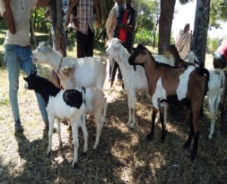
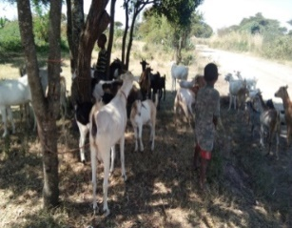

Figure 1: Indigenous goat type in Loka Abaya district

Milk yield and lactation length

The least square mean of daily milk yield and lactation length are presented in Table 3. The average daily milk yield of does obtained in the present study was higher than that reported by Endeshawe (2007) (0.5liter/day) in Dale district, while it was slightly similar with the result of Hagos et al. (2017) 0.6 liter/day for Begait does. However, Mestawet et al. (2012) reported higher daily milk yields for indigenous Arsi-Bale (1.13 liter) and Somali goats (0.85 liter. This milk yield variation could be farmers management condition as well as does udder size. The average lactation length was 89.3±13.7 days, which is shorter than the 104.2 days reported by Zeleke et al. (2020 but, slightly longer than the 86 days reported by Bedhane et al. (2012) for Arsi-Bale’s goats.

Effect of litter size, parity and season on milk yield and lactation length

The result as presented in Tables 3 indicated that some of the factors that influence on does milk yield and lactation length
Litter size
The present study showed that milk yield was significantly (p<0.001) affected by birth types. Milk yield increased by 14% in twin bearing goats than single bearing goats, while triplet bearing goats showed a 16% increase over twin bearing ones. By contrast, Bushara et al. (2013) reported that litter size had not significantly affect milk production, however, does with triplets and twins produced more milk compared to those with single kids. In goats and sheep increased litter size will promote the extent of mammary development at the end of gestation by 20 to 25% (Davis, 2017). The positive association between litter size and milk production, with multiple bearing does outperforming single bearing ones, can be attributed to prolactin stimulation of the udder which is influenced by the intensity of suckling stimulus in response to the number of kids per litter (Assan, 2020). The effect of litter size on daily milk yield can be attributed to the quantity of hormones preparing the udder to lactation phase which differs from females carrying multiples to those carrying singles (Haldar et al., 2013), thus affecting the milk production after delivery.
Effect of parity
The effect of parity on daily milk yield and lactation length shows an increasing trend from first to fourth parity. The lowest milk yield was obtained in the first parity, whereas the highest recorded in 3rd parity, which is in agreement with the report of (Hamed et al. 2009). Milk yield increases with advanced parity due to the hormonal status of in the animal body, metabolic activity, secretary cells and nutrient intake which are used in milk synthesis (Carnicella et al., 2008). Parity had a significant (P<0.001) effect on lactation length where shorter lactation length was exhibited in the first parity.
Effect of season
Lactation length was significantly (p < 0.01) affected by the season of kidding. Goats kidding during the wet season had higher daily milk yield and longer lactation length than those goats kidding during the dry season. Does kidded in the dry season had the shortest lactation length, but those kidded during the wet season had the longest lactation length. In agreement with our study, Hagos et al. (2017) demonstrated that begait does kidded in the dry season had the shortest lactation length, but those kidded during the wet season had the longest lactation length. The variation may be attributed to quantity and quality of feedstuffs supplied.
Table 3. Effect of birth type, parity and birth season on daily milk yield and lactation length
Parameters | DMY(liter/day) | LL(days)
Birth type
Single | 0.51±0.14^{c} | 77.3±10.8^{c}
Double | 0.64±0.27^{b} | 89.5±13.3^{b}
Triples | 0.81±.32ª | 101.2±14.3ª
Parity of does
1 | 0.41±0.18^{d} | 69.8±9.2^{d}
2 | 0.79±0.25^{b} | 97.12±11^{b}
3 | 0.83±0.23ª | 102.13±14ª
4 and above | 0.56±0.06^{c} | 88.7±12^{c}
Birth season
Dry season | 0.59±0.14^{b} | 83.4±11.1^{b}
Wet season | 0.71±0.26ª | 95.3±11.2ª
Overall | 0.65±0.18 | 89.3±13.7
NOTES: DMY: daily milk yield; LL: lactation length, ^{a,b,c} P<0.05, P<0.01 significant across columns with different superscripts for each fixed factor differ

\

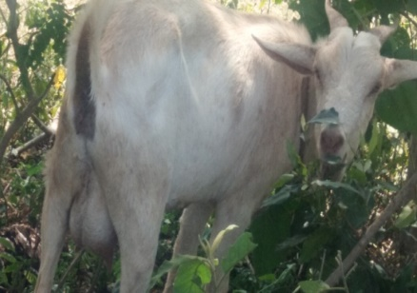
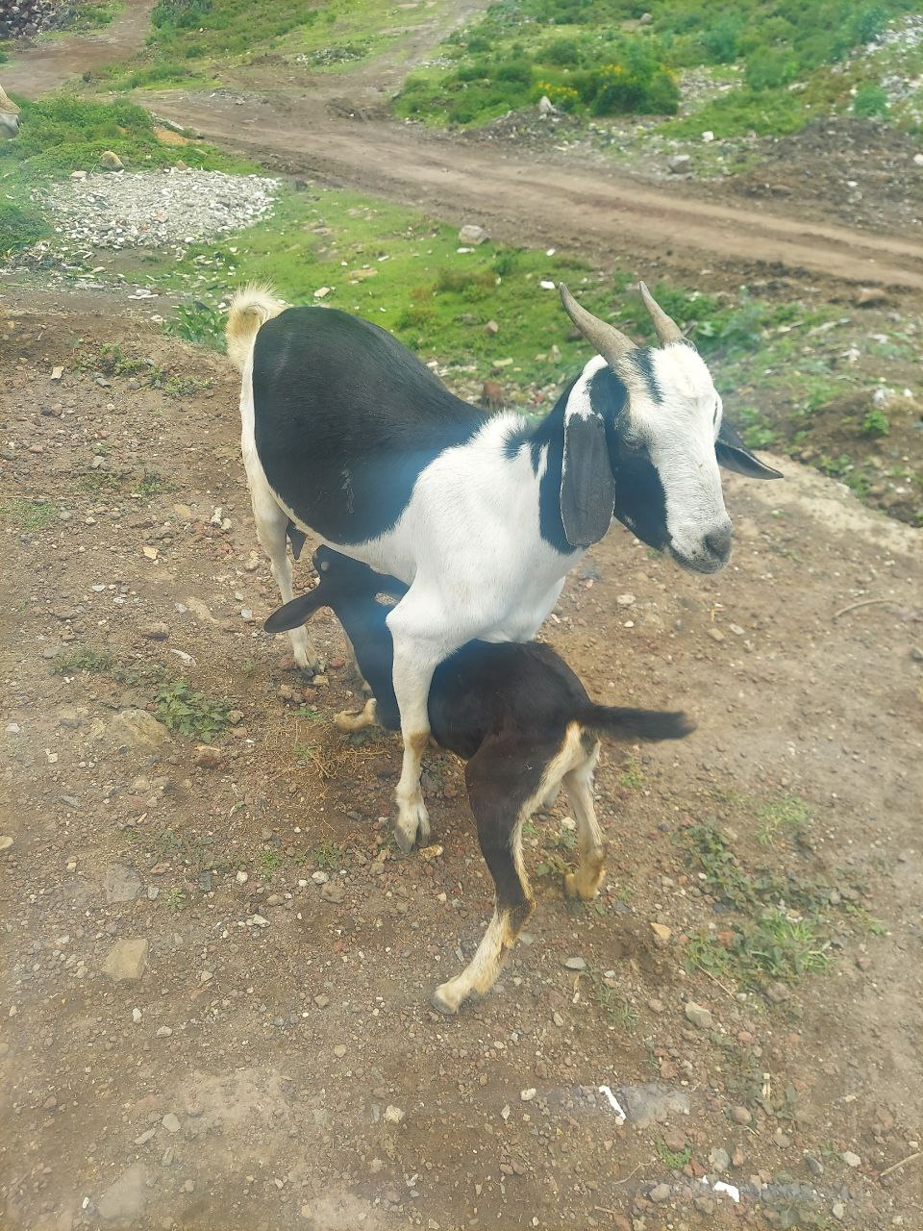
Figure 2: Lactating does

Milk utilization
According to sample respondent goat keepers in the study area keep milking does for household milk consumption. All family members in a household consume goat milk, with priority given to infants and sick persons (Table 4). According to Azeze et al. (2015), goat milk in Hadiya zone is primarily consumed by children, then by the sick ones. During the focused group discussion farmers stated that children who drink goat milk are healthy, strong and grow well. They also believed that goat milk also boosts resistance to illnesses and has medicinal value for abdominal diseases. Kumar and Sharma (2016) have shown that goat milk has several advantages over cow or human milk, including higher digestibility of protein and fat, greater alkalinity and buffering capacity, as well as therapeutic benefits in medicine and human nutrition.

Table 4. Goat milk utilization status in the study area
Parameters | Frequency | %
Do you use goats’ milk?
Yes | 46 | 90
No | 4 | 10
Milk utilization in the family
For infant and sick persons | 37 | 74
All family members | 13 | 26

Reproductive Performance

Age at first kidding and kidding interval
A total of 274 and 268 does were assessed based on interviews for reproduction performance like, age at first kidding and kidding interval, respectively (Table 5).
Age at first kidding
The age at first kidding was influenced by genetic and environmental factors such as breed, feeding, housing, health care, season of birth and other physical conditions that determine the total life time productivity. In the current study, the average age at first kidding was 12.8±0.0.3 months. Amare et al. (2021) reported similar values, whereas Abraham et al. (2019) have found a longer age at first kidding for Begait goats maintained under semi-intensive and extensive management systems.

Kidding interval, litter size, fertility and season of parturition
Kidding interval is the time interval between successive parturitions (two kidding) of the same doe (Hasan et al., 2015). The average kidding interval of goat in the present study was slightly comparable with the finding conducted on Dale district of Sidama zone that was 8.56 months reported by Endeshaw (2007) and 8.21 months by Amare et al. (2021) in pastoral and agro-pastoral areas of Afar Regional State, Ethiopia. However, the present study result was lower than the reported kidding interval for Arsi-Bale goat under extensive system, which was 9.77 ± 3.53 months (Dadi, 2008). Kidding interval is influenced by both genetics and environmental factors (nutrition and breeding practices) (Abdella et al. 2015). In addition, Zewdie et al. (2022) also reported the kidding season, birth type and parity of does have a significant influence on the kidding interval of Arabs of goats.
Litter size
Litter size is characterized by the twinning rate and the ratio between does mated and kids born. The mean litter size of goat in the current study was 12.8 months. lower as compared to that reported from Samuel and Blelay (2013) (1.58) Jimma, Oromia Region and Dadi et al. (2008) (1.6) for Arsi-Bale goats kept under on station condition. The result was also lower from Endeshaw (2007) reported 2.02 litter size for goats in drier parts of Dale woreda, but, it was higher than from the report of Gemiyo (2009) (1.42) in Alaba zone, Southern Ethiopia and Asefa et al. (2015) (0.33) in Bale zone, Oromia. The difference of litter size among the studies might be attributed to management effect.

Fertility: fertility rate of goat observed in this study (Table 5) is higher than the findings of Gemiyo (2009) who reported 81.6% in Alaba zone of Southern Ethiopia. Fertility rate was also higher than from the report of Kocho (2007) 83.3 % studied in the same zone. Mehlet (2008) reported fertility rate of 48.3% for Arsi-Bale goats, which is lower than the current findings.
Parturition season: based on the monitoring data parturition distribution in the study area is throughout the year; however parturition was a significant (P<0.01) difference among birth season, thus the majority of parturition was occurred in the wet season (April - September) followed by post rainy season (October - November) and the lowest kidding was occurred in the dry season December-march months (Table 5). This could be attributed to during the wet season there is sufficient forage and browse species existing which take care a safe feeding for does. This result is in agreement with the findings of Shenkute (2009), who reported intensive kidding during April to October and lowest kidding rate during dry season in Gomma district.

Table 5. Frequency and descriptive statistics of reproductive traits for indigenous goat

Parameters | N | Mean± SE
Age at first kidding (months) | 274 | 12.8±0.0.3
Kidding interval (months) | 268 | 8.12±0.23
Litter size (mean) | 161 | 1.5
Fertility rate (%) | 110 | 87.3
Season of parturition (%)
Wet season (April - September) | 56 | 51ª
Post rainy season (October - November) | 36 | 32.7^{b}
Dry season (December-march) | 36 | 16.6^{c}
N= number of animals, SE= standard error, ^{a, b,c} , P<0.01 significant across column

CONCLUSION
The result of the present study indicated that average flock size of goat per household was 11.55±4.1. Does constitute the largest proportion in the flock, but breeding bucks were small across the flock. Goat milk consumption is a common practice, all family members consumed milk, but infants and sick persons are given priority. The average DMY and lactation length of does were 0.65±0.18 liters/day and 89.3 days, respectively. Triple kidded dams produces higher milk yield than that of double and single kidded dams. Therefore, goat milk production and utilization need to be encouraged and further genetic improvement should be done through selection. The significant effect of fixed effects on milk production and season of parturition is needs to be integrated with forage development and advance consideration.

REFERENCES
Abdalla, S. A., I.A. Ishag., and M.A. Ahmed.2015. Generic and environmental factors affecting reproduction of Saanen goats raised under Sudan conditions. American Journal of Agricultural Science, 2: 75-79.

Abrham H., Gizaw, S. and Urge, M. 2019. Growth and reproduction performance of Begait goat under semi-intensive and Extensive management in west Tigray, north Ethiopia, Livestock Research for Rural Development. 31(3). From http://www.lrrd.or/lrrd31/3/hagsa31032.html

Assan, N. 2020. Effect of Litter Size on Milk Yield and Composition in Goats and Sheep Production. Scientific Journal of Animal Science, 9(7), 635-643.
Asefa, B., Kebede, K. and Effa, K. 2015. Assessment of production and reproduction system of indegnouse goat types in Bale Zone, Oromia, Ethiopia. Accadamic Journal of Agricultural Research 3(12): 348-360, DOI:10.15413/ajar.2015. 0143, ISSN: 2315-7739

Bedhane, M., Haile, A., Dadi, H. and Alemu T.2012. Estimates of genetic and phenotypic parameters for milk traits in Arsi-Bale goat in Ethiopia. Livestock Research for Rural Development 24(98). http://www.lrrd24/6/bedh24098.htm
Brito, L.F., Silva, F. G., Melo, A. L. P., Caetano, G. C., Torres, R. A., Rodrigues, M. T. and Menezes, G. R. O. 2011. Genetic and environmental factors that influence production and quality of milk of Alpine and Saanen goats. Genetics and Molecular Research 10, 3794-3802.
Bushara I, O.M. A., Abdelhad, M. B., Elemam, A. O., Idris, D. M., Mekki, Muna, M. M. and Abu Nikhiala, A. M. 2013. Effect of season of birth and litter size on Taggar goat’s production in western Sudan. Wudpecker Journal of Agricultural Research, Vol. 2(4), pp. 128 – 133.
Carnicella, D., Dario, M., Consuelo, M., Ayres, C., Laudadio, V. and Dario, C. 2008. The effect of diet, parity, year, and number of kids on milk yield and milk composition in Maltese goat. Small Ruminant Research 77, 71-74.
Byaruhanga C, Oluka J. and Olinga S. 2015. Socio-economic Aspects of Goat Production in a Rural Agro-pastoral System of Uganda. Universal J Agri Res 3: 203-210.

CSA (Central Statistical Agency). 2021. Agricultural sample survey (2020/2021). Report on Livestock and Livestock characteristic, Volume II, Addis Ababa, Ethiopia.

Dadi, H., Duguma, G., Shilma, B., Fayera, T., Tadesse, M., Woldu, T. and Tucho, T. A. 2008. Non Genetic Factors influencing post weaning Growth and Reproductive performances of Arsi-Bale Goats. Livestock Research for Rural Development, 20(114). http://www.lrrd.org/lrrd20/7/dadi20114.htm

Davis, S.R. 2017. Triennial Lactation Symposium/Bolfa: Mammary growth during pregnancy and lactation and its relationship with milk yield. J. Anim. Sci., 95(12), 5675-5688.
Fikru, S. and Gebeyew, K. 2015. Sheep and goat production systems in Degehabur Zone, Eastern Ethiopia: Challenge andopportunities. Advances in Dairy Research 9:1-9.

Gemiyo, D. 2009. On-farm performance evaluation of indigenous sheep and goats in Alaba, Southern Ethiopia. Msc. Thesis. Hawassa University, November, Awassa, Ethiopia.

Gatew. H., Hassen, H., Kebede, K., Haile, A ,. Lobo, R. N. B., Yetayew , A. and Rischkowsky, A. 2017. Husbandry practices and phenotypic characteristics of indigenous goat populations in Ethiopia. African Journal of Agricultural Research. Vol. 12(36), pp. 2729-2741, DOI: 10.5897/AJAR2016.11282

Haldar, A., Pal, S.K., Chakraborty, S., Hazorika, M., Pan, S., Majumdar, D. and Prakash, B.S. 2013. Endocrine markers for identifying prolificacy potential and predicting fetal number in goats. Anim. Reprod. Sci., 140(1), 54-61.

Hamed, A., Mabrouk, M. M., Shaat, I. and Bata, S. 2009. Estimation of genetic parameters and some non- genetic factors for litter size at birth and weaning and milk yield traits in Zaraibi goats. Egyptian Journal of Sheep and Goat Sciences 4, 55–64.

Hasan, M.J., Ahmed, J.U., Alam, M.M., Mojumder, M.L.O. and Ali, M.S. 2015. Reproductive performance of Black Bengal goat under semi-intensive and extensive condition in Rajshahi district of Bangladesh. Asian J Med Biol Res. 1:22–30.

Hagos, A., Gizaw, S.and Urga, M. 2017. Milk production performance of Beait goat under semi intensive management in Western Tigray, North Ethiopia. Livestock Research for Rural Development. 29. (240). http://www.lrrd.org/lrrd29/12/hags29240.html

Kassaun, A. and Solomon, A. 2008. Breeds of sheep and goats. Sheep and goat production handbook for Etiopia: Etiopian Sheep and goat productivity improvement program. pp. 5-26

Khan, U,M., Khan, A.M. Khan, U.M, and Selamoğlu, Z. 2019. Effect of Seasonal Factors in the Goats’ Reproductive Efficiency. Turkish J Agric Food Sci Technol. 7:1937.
Khandoker, M., Afini., N, and Azwan, A. 2018. Productive and Reproductive Performance of Saanen Goat at AZ-Zahra farm of Sandakan in Malaysia. Bangladesh J Animal Sci.47:1-12.
Kidane A., Melaku S., Haile A. 2014. Characterization of Goat Reproduction and Breeding practices of Goat Owners in Gumara-Meksegnit Watershed-North Gonder. Ethiopia, Agricultural Journal Livestock 9(1):5-14, ISSN: 1816-9155.
Kocho, T. 2007. Production and Marketing system of Sheep and Goats in Alaba, Southern Ethiopia. An MSc thesis, Hawassa University, Etiopia.

Kumar, A, and Sharma, A. 2016. Nutritional and Medicinal Superiority of Goat Milk over Cow Milk in Infants. DOI:10.21088/ijpen.2454.9126.2116.5.

Mehlet, S. 2008. Reproduction in Arsi-Bale female goats and growth performances of Toggenburg X Arsi-Bale crosses. University of Hawassa, Ethiopia.

Mestawet, T.A., Girma A., Ådnoy, T., Devoid, T.G., Narvhus, J.A. and Vegarud, G.E. 2012. Milk Production, Composition and Variation at Different Lactation Stages of four GFoat Breeds in Ethiopia. Small Ruminant Research 105(1):176–181.

Paltasingh, K R. and Goyari P. 2018. Impact of farmer education on farm productivity under varying technologies: case of paddy growers in India. Agricultural and Food Economics, 6 (7): 1-19, https://doi.org/10.1186/s40100-018-0101-9

Samuel, G. and Dugma, B. 2013. Assessment on Goat Production System with Special Focus on Constraints and Opportunities around Jimma, American-Eurasian J. Agric. & Environ. Sci., 13 (10): 1304-1308, DOI: 10.5829/idosi.aejaes
Silanikove, N., Leitner, G. and Merin, U.2015. The interrelationships between lactose intolerance and the modern dairy industry: Global perspectives in evolutional and historical background. Nutrients 7, 7312-7331
Shenkute, B.G. 2009. Production and Marketing Systems of Small Ruminants in Goma District of Jimma Zone, Western Ethiopia. MSc. Hawassa University, Awassam, Ethiopia. 144p.

Mekuria, S.A., Teshager , A.A., Endeshawe, A.G., Atinaw, M.B. and Sendeku, A.T. 2018. Small Ruminant Fattening Practices in Amhara region, Ethiopia. Agriculture & Food Security. 7(64). https://doi.org/10.1186/s40066-018-0218-9.

Solomon, A.K., Mwai, O., Grum, G., Haile, A., Rischkowsky, B.A., Solomon,G. and Dessie T. 2014. Review of goat research and development projects in Ethiopia. ILRI project report. Nairobe Kenya: International Livestock Research Institute.

Tona, G. O., Adewumi, O. O. and Olaniyi, E. O. 2015. Milk yield (off take), composition, dam and kid weight changes of West African Dwarf goats fed dietary levels of palm kernel cake. IOSR Journal of Agriculture and Veterinary Science 8, 29-34.
Azeze, T., Yilma , Z., Nurfeta, A. and Welearegay, H. 2015. Utilization and quality of goat milk in Hadiya zone, Southern Ethiopia. Global Journal of Food Science and Technology, ISSN: 2408-5472 Vol. 3 (6), pp. 197-203.
Zeleke, T., Kefyalw, A., Damitie, K., Teshaye, G., Alemu, K. and and Belaye, D. 2020. Reproductive performance and milk production of Central Highland and Boer x Central Highland goats.Volume 6 (12).
Zewdie, B., Urge, M., Tadesse, Y., Chavhan A. and Gizaw, S. 2022. Productive and reproductive Performances of Arab Goats in the Western lowlands of Ethiopia. Int J Life Sci. 1,0:21–32.

