Enhancing the Livelihoods and Welfare of Cart Donkey Owners Involved in Solid Waste Management in and Around Hawassa City amid the COVID-19 Pandemic

Abstract
The COVID-19 pandemic intensified occupational and public health risks among informal solid waste collectors, particularly youth operating donkey-drawn carts in Hawassa, Ethiopia. This study evaluated the impact of a One Health–based intervention on occupational safety, socioeconomic outcomes, and donkey welfare using a pre–post intervention design. A baseline census identified over 400 workers and 313 operational carts. The intervention combined cooperative formation, targeted training, provision of personal protective equipment (PPE), and ergonomic cart redesign. Nine savings and credit cooperatives (n = 313 members) were established. A total of 160 participants received structured training on COVID-19 prevention, zoonotic disease control, occupational health, and cooperative management, while 100 workers were equipped with PPE and sanitation materials. An improved, animal-friendly cart prototype was developed and field-tested. Comparative pre- and post-intervention analyses showed statistically meaningful improvements across key indicators. The prevalence of harness-related injuries in donkeys declined from 45% to 12% (absolute reduction: 33 percentage points), indicating a substantial effect size. Access to adequate feed and water increased to 80% of animals. Adoption of safe waste-handling and hygiene practices improved significantly among trained participants (p < 0.05). Household income increased by 20–35%, suggesting positive economic impact associated with enhanced efficiency and cooperative-based market access. Multi-sectorial engagement involving 12 institutions strengthened implementation fidelity and intervention uptake. Overall, the results indicate that integrated interventions grounded in the One Health framework can produce statistically and practically significant improvements in occupational health, animal welfare, and livelihood outcomes. These findings support the scalability of community-based, multi-sectorial models for strengthening informal urban waste management systems in low-resource settings.
Keywords: One Health, informal sector, occupational health, donkey welfare, solid waste management, COVID-19, cooperative development, Ethiopia

1. Introduction
Ethiopia possesses one of the largest equine populations in Africa, with approximately 2.14 million horses, 10 million donkeys, and 0.36 million mules (CSA, 2022). Among these, donkeys play a critical role in sustaining livelihoods and providing essential transport services, including their contribution to solid waste management (SWM) in urban and peri-urban areas.
Municipal solid waste management (MSWM) encompasses the collection, transfer, treatment, recycling, resource recovery, and disposal of solid waste generated within urban environments. Its primary goals are to safeguard environmental and public health, improve urban living conditions, create employment opportunities, and enhance economic productivity (Ogwueleka, 2009).
Rapid population growth, urbanization, and industrial expansion have significantly increased waste generation in both developed and developing countries. In fast-growing urban centers, particularly in low and middle-income countries, waste generation frequently exceeds the capacity of management systems (Kumar & Nandini, 2013). Ineffective waste management leads to serious public health risks, including exposure to infectious agents, environmental contamination, and socioeconomic impacts.
In Ethiopia, urban centers face persistent challenges in effective waste management. A study conducted in Hawassa City reported that existing SWM systems were largely ineffective due to inadequate waste collection coverage, improper storage and disposal, insufficient transportation systems, limited budget allocations, and weak municipal enforcement (Akalewold, 2020).
Solid waste collectors, particularly those in the informal sector, are among the most vulnerable occupational groups. They often work without adequate protective gear, exposing themselves to infectious and toxic agents. The COVID-19 pandemic exacerbated these risks, increasing exposure and further limiting access to occupational health protection.
In Hawassa, a rapidly expanding city in the Sidama Region, hundreds of young workers rely on donkey-drawn carts to collect household waste and transport it to disposal sites. Despite their essential contribution to urban sanitation, these workers remain socially and economically marginalized, lacking protective equipment, social security, and recognition. Their donkeys also experience poor welfare, including overloading, improper harnessing, and inadequate care.
Recognizing these interconnected human and animal welfare challenges, this project aimed to enhance the livelihoods, occupational safety, and welfare of cart donkey owners and youth engaged in solid waste collection in and around Hawassa City amid the COVID-19 pandemic.

2. Background and Rationale of the Study
Urban waste management represents one of the most critical public and environmental health challenges in developing countries. Limited infrastructure, weak institutional capacity, and inadequate waste handling practices expose both workers and communities to serious health risks. Informal solid waste collectors play a vital yet under recognized role in maintaining urban sanitation, particularly in areas under-served by formal collection systems. However, these workers often lack access to occupational safety equipment, health services, and social protection mechanisms.
In Ethiopia, informal waste collection is predominantly undertaken by low-income youth who depend on cart donkeys for transportation. Despite their contribution to municipal hygiene, they remain excluded from formal waste management systems. Consequently, they face elevated risks of infectious diseases, injuries, and psychosocial stress, while their animals endure poor welfare due to heavy workloads and limited care.
The COVID-19 pandemic amplified these challenges, increasing exposure to infectious waste and disrupting livelihoods. Limited access to protective equipment further endangered both workers and their animals. Addressing these intersecting issues requires a holistic, community-based approach that integrates human health, animal welfare, and environmental management — aligning with the One Health framework.
This project was therefore designed to enhance the livelihoods, health, and welfare of cart donkey owners and youth engaged in informal waste collection in and around Hawassa City.

3. Study Objectives
Overall Objective:
To improve the livelihoods, health, and welfare of cart donkey owners and youth engaged in informal solid waste collection in and around Hawassa City during the COVID-19 pandemic.
Specific Objectives:
- Assess the socioeconomic conditions, occupational health risks, and working environments of cart donkey workers.
- Strengthen occupational safety practices through access to protective equipment, hygiene materials, and training.
- Improve donkey welfare through better harnessing systems, veterinary support, and welfare education.
- Promote environmentally safe waste management practices that protect human and animal health.
- Enhance income security and resilience of informal waste collectors through cooperative formation and skills training.

4. Materials and Methods

4.1 Study Area
The study was conducted in Hawassa, the capital of Sidama Regional State, located 275 km south of Addis Ababa. The city, home to approximately 351,000 residents, is recognized for its relative cleanliness, supported in part by the efforts of cart donkey workers.

4.2 Identification of Cart Donkey Workers
A technical team comprising representatives from the municipality, cooperative office, job creation office, and agricultural research center conducted a census of cart donkey workers. Data on age, education, employment status, and equipment condition were collected, identifying over 400 youth and 313 donkey carts.

4.3 Stakeholder Engagement
Twelve stakeholder institutions participated, including municipal office, health bureau, livestock office, cooperative office, and educational bureau. Each organization assumed defined responsibilities such as training, health support, and cooperative development.

4.4 Project Implementation Activities
- Training for Cart Donkey Workers: 160 youth received training on COVID-19 prevention, zoonotic disease control, cooperative management, savings, and donkey welfare.
- Training for Health Extension Workers: 32 female health extension workers were trained to promote household waste safety and segregation.
- Formation of Cooperatives: Nine savings and credit cooperatives, each with ~35 members, were established and legally registered.
- Cart Design Improvement: In collaboration with Hawassa Tegibare-id TVET College, a new ergonomic cart model was designed with load limits, waterproof flooring, a driver’s seat, and improved waste containment. Eleven prototypes were distributed for cooperative members.
- Provision of Protective Equipment: 100 workers received full protective kits (boots, gloves, face masks, overalls, and sanitizers) and plastic sheets for waste covering.
4.5 Ethical approval for the study was obtained from Southern Agricultural Research Institute, Institutional Review Board (IRB).
Informed consent
Written informed consent was secured from all participants prior to data collection. The study adhered to national and international guidelines for research involving human participants and animals, ensuring confidentiality, voluntary participation, and animal welfare

5. Results
Participant profiling and organization
More than 400 cart-donkey waste collectors were identified during the baseline census, of whom approximately 70% were cart owners and 30% were employed workers. Nine formally registered savings and credit cooperatives with 313 members were established, improving members’ access to training opportunities, savings schemes, and collective bargaining mechanisms (Table 1).
Table 1. Established cooperatives with their members
N.O | Cooperatives | Number of members
1 | Bunna Burra saving and credit cooperative | 35
2 | Diaspora saving and credit cooperative | 35
3 | Idiget Saving and credit cooperative | 33
4 | Binifile saving and credit cooperative | 35
5 | Durruma Saving and credit cooperatives | 35
6 | Rehobot saving and credit cooperative | 35
7 | Gumma lallo saving and credit cooperative | 35
8 | Lonise Lophino saving and credit cooperative | 35
9 | Chabicho saving and credit cooperative | 35
 | Total | 313
Capacity building and behavioral change
Post-training evaluations indicated marked improvements in workers’ knowledge and practices related to personal hygiene, COVID-19 prevention, occupational safety, and donkey welfare. Participants demonstrated increased awareness of health risks and greater adoption of safe waste-handling and animal management practices following the intervention (Figure 1).
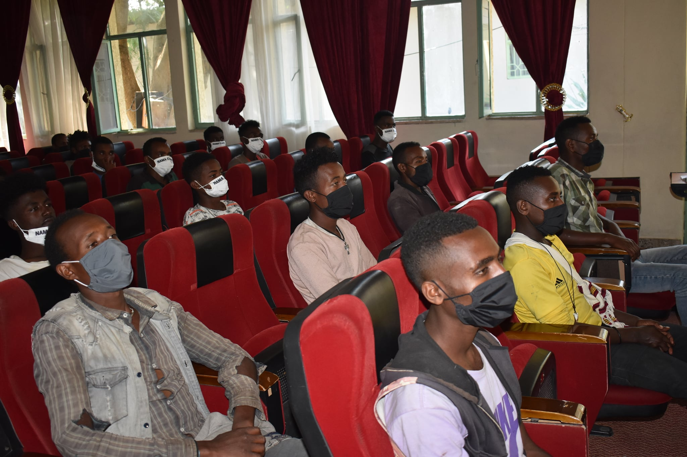
Fig. 1. Participation of Solid Waste Collectors in Training
Ergonomic cart performance
Field testing of the redesigned ergonomic carts showed reduced physical strain on donkeys, improved load balance, and enhanced waste containment. The previous cart performed poorly, making it unsuitable for transporting waste as it often spilled along the way and was not safe or comfortable for the cart donkey (Figure 2). The new cart design minimized waste spillage during transportation and improved the overall safety and efficiency of solid waste collection operations (Figure 3).
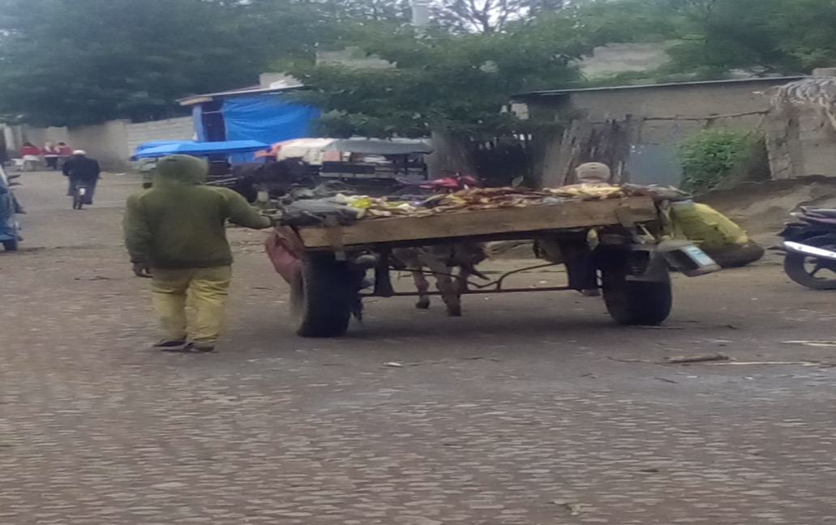
Fig. 2. A previous Poor standard carts, not capable to collect properly

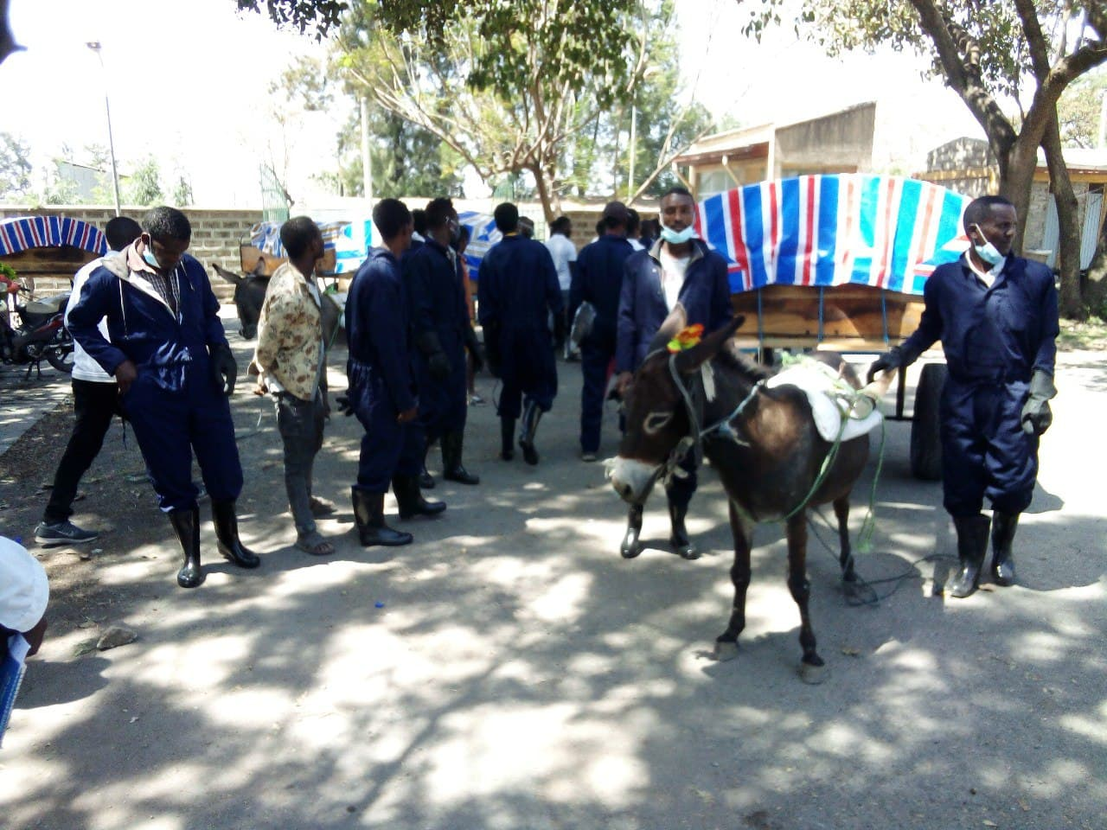
Fig 3. New Cart Design Demonstrated with Worker in Complete Protective Clothing.
Occupational safety and sanitation outcomes
The provision of personal protective equipment, combined with targeted awareness campaigns, resulted in improved workplace safety practices among waste collectors. These measures also contributed to improved public sanitation and environmental hygiene in the serviced communities (Fig.3).
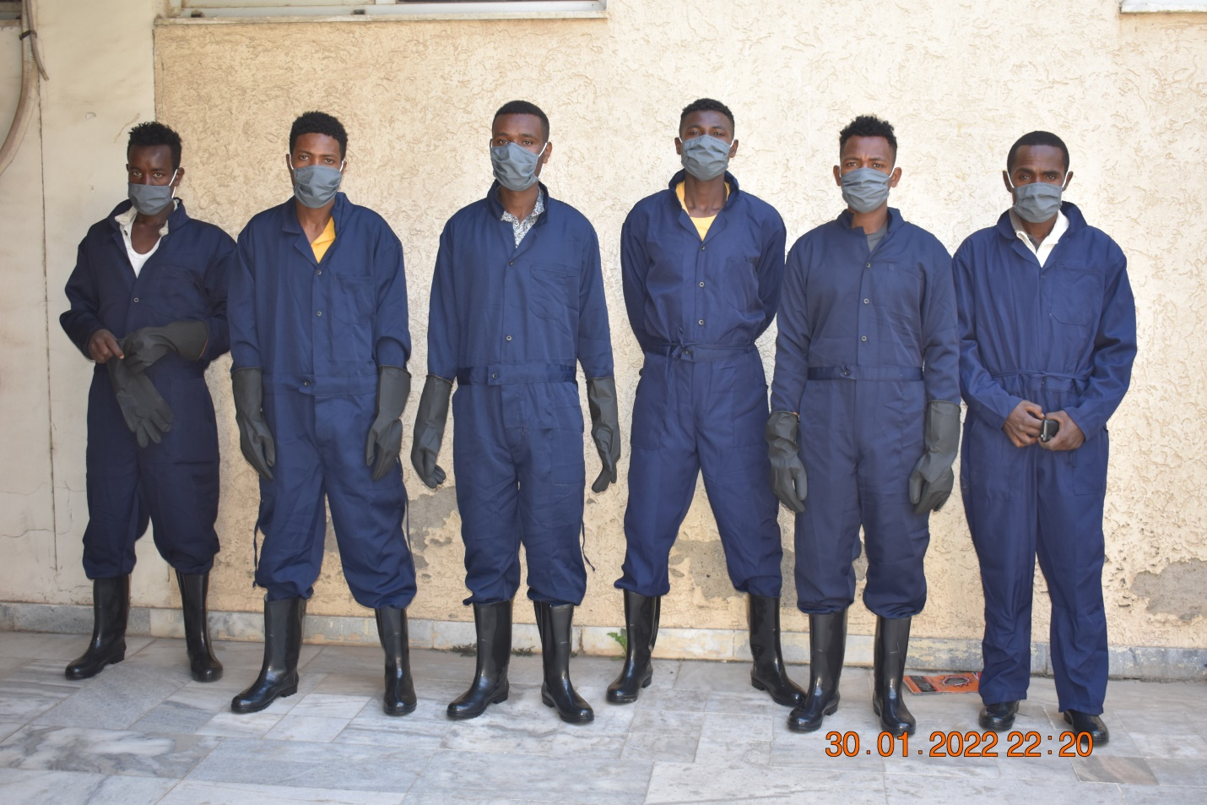
Fig 3. Cart Workers Equipped with Protective Clothing Supplied by the Project
Donkey’s welfare & Livelihood improvement
The prevalence of harness-related injuries decreased from 45% to 12% post-intervention. Access to clean water and supplementary feed increased for 80% of donkeys. Household income from waste collection increased by 20–35% due to improved efficiency and market linkages. 95% of participants reported increased knowledge in donkey husbandry and welfare practices. Participants expressed higher confidence in maintaining their income and animals during COVID-19 disruptions.

- Discussion
This community-based intervention demonstrates that integrating human health, animal welfare, and environmental hygiene can improve outcomes within informal urban waste management systems. Through cooperative organization, targeted training, and participatory technical innovation, the project addressed key occupational, socioeconomic, and animal welfare challenges faced by cart-donkey waste collectors. The observed improvements in safety practices, cooperative functionality, and waste handling highlight the value of multi-sectorial engagement in strengthening informal public services.
Cooperative formation enhanced economic resilience and social organization by improving access to training, savings mechanisms, and representation in municipal processes. Such collective structures are critical for informal workers who often operate outside formal regulatory and support systems. In parallel, the ergonomic redesign of donkey carts reduced animal strain and waste spillage, demonstrating that context-specific, low-cost technical solutions can improve both animal welfare and operational efficiency when end users and technical institutions are actively involved.
The intervention also provides practical insight into the application of the One Health approach at community level. Collaboration among municipal, health, veterinary, and technical institutions supported implementation and contributed to local ownership, which is essential for sustainability. These findings suggest that similar models could be adapted to other urban settings where animal-powered waste collection remains important, provided that local institutional capacities are considered.

Implications for Practice
To apply these findings, municipal and public health practitioners should formally recognize informal waste collectors within urban sanitation systems, support cooperative development, and integrate occupational health and animal welfare training into routine services. Technical institutions can assist with local adaptation of ergonomic carts, while sustained municipal engagement is needed to embed such interventions within existing waste management strategies using a One Health framework.

7. Conclusion
The project significantly improved the socioeconomic status, occupational safety, and welfare of cart donkey workers in Hawassa. Through cooperative organization, training, and technical innovation, the initiative strengthened livelihoods, enhanced animal welfare, and promoted sustainable waste management. Continued technical and institutional support is essential to sustain these gains and expand the model to other urban areas in Ethiopia.

One Health Impact Statement
This project adopted a One Health approach to improve the well-being of informal waste collectors in Hawassa, Ethiopia, who use cart donkeys for solid waste management. By enhancing occupational safety, promoting donkey welfare, and strengthening cooperative organization, the intervention reduced health risks associated with COVID-19 and unsafe working conditions. Provision of protective clothing, sanitation materials, and redesigned animal-friendly carts improved both human and animal safety. The initiative also fostered collaboration among municipal and institutional stakeholders, demonstrating that integrated, community-based approaches can simultaneously enhance public health, animal welfare, and environmental hygiene while improving the livelihoods of vulnerable urban workers.

- References
- Akalewold F. (2020). Solid Waste Management in Hawassa City, Ethiopia: Practices and Challenges. International Journal of Environmental Sustainability and Green Technologies, 11(1), 1–10.
- Central Statistical Agency (CSA). (2022). Agricultural Sample Survey 2021/22, Volume II: Livestock and Livestock Characteristics. Ethiopian Statistics Service.
- Forum for Environment. (2010). Solid Waste Assessment Report, Hawassa City.
- Ogwueleka, T.C. (2009). Municipal solid waste characteristics and management in Nigeria. Iranian Journal of Environmental Health Science & Engineering, 6(3), 173–180.
- Kumar, M., & Nandini, N. (2013). Community attitudes, perceptions, and willingness towards solid waste management in Bangalore City, Karnataka, India. International Journal of Environmental Science, 3(2), 22–29.

