Dose-Dependent Effects of Aqueous Extract of Xylopia aethiopica on Lipid Profile and Hepatorenal Biomarkers in Wistar Rats
Abstract
This study investigated the dose-dependent effects of aqueous fruit extract of Xylopia aethiopica on lipid profile and hepatorenal biomarkers in albino Wistar rats. A total of 24 rats (n = 6 per group) were randomly assigned into four groups: control and three treatment groups administered 100, 200, and 300 mg/kg body weight of the extract orally for 28 days.
Serum lipid profile, liver function indices, renal biomarkers, and histopathological changes in liver and kidney tissues were evaluated using standard biochemical and histological techniques. Data were expressed as mean ± standard deviation (SD) and analyzed using one-way analysis of variance (ANOVA) followed by Tukey’s post hoc test, with p < 0.05 considered statistically significant.
Results showed a significant dose-dependent improvement in lipid profile at 200 and 300 mg/kg, evidenced by reductions in total cholesterol, triglycerides, low-density lipoprotein (LDL-C), and very low-density lipoprotein (VLDL-C), alongside increased high-density lipoprotein (HDL-C) (p < 0.05). However, higher doses (≥ 200 mg/kg) produced significant elevations in alanine aminotransferase (ALT), aspartate aminotransferase (AST), alkaline phosphatase (ALP), and total bilirubin, with concomitant decreases in albumin and total protein, indicating hepatotoxicity.
Renal function assessment revealed reductions in urea and creatinine levels, accompanied by significant electrolyte imbalances, including decreased sodium, potassium, and chloride, and increased bicarbonate (p < 0.05). Histopathological findings corroborated biochemical results, showing dose-dependent hepatic injury ranging from mild inflammation to necrosis, and progressive renal structural alterations at higher doses.
Additionally, while aqueous extract of Xylopia aethiopica exhibits significant hypolipidemic effects with potential cardio-protective benefits, its use at higher doses may induce hepatotoxicity and disrupt renal function. These findings highlight the importance of dose regulation and the need for further studies to establish its safety profile and therapeutic window.

Key words: Xylopia aethiopica, lipid metabolism, hepatorenal biomarkers, Albino wista rats
Corresponding author: Ezenwaeze Malachy Nwaeze
Email: malachy.ezenwaeze@esut.edu.ng
Introduction
Medicinal plants continue to play a crucial role in the management of metabolic and organ-related disorders, particularly in developing countries where access to conventional drugs may be limited. Among these, Xylopia aethiopica (Annonaceae), commonly known as Ethiopian pepper, is widely used in traditional medicine for the treatment of inflammation, infections, and metabolic disorders.^{1, 2} Its pharmacological relevance has attracted scientific interest, especially regarding its effects on lipid metabolism and organ function.
Taxonomically, Xylopia aethiopica is a flowering plant belonging to the custard apple family. Kingdom: Plantae, Clade: Angiosperms, Order: Magnoliales, Family: Annonaceae, Genus: Xylopia, Species: Xylopia aethiopica (Dunal) A. Rich. Xylopia aethiopica (Dunal) A. Rich is an evergreen aromatic tree widely distributed in tropical Africa. It is characterized by a tall growth habit, often reaching 15–30 m in height, with a straight trunk, grey to dark brown bark, and glossy, leathery leaves. The plant produces small greenish to yellowish aromatic flowers, which develop into long, cylindrical pod-like fruits containing several seeds. The dried fruits are highly aromatic and are widely used as a spice as well as in traditional medicine. In Nigeria, the genus Xylopia comprises several species (approximately 4–6 depending on taxonomic classification), including Xylopia aethiopica, Xylopia parviflora, and Xylopia quintasii. However, Xylopia aethiopica is the most prevalent and economically important species, commonly found in both rainforest and savanna-forest transition zones, and is extensively used for culinary and medicinal purposes.
Dyslipidemia, an abnormal level of fats in the blood and functional form of kidney failure (hepatorenal dysfunction ) are major contributors to cardiovascular and metabolic diseases globally.^{3, 4} Alterations in lipid profile, such as elevated total cholesterol (TC), triglycerides (TG), and low-density lipoprotein (LDL), along with reduced high-density lipoprotein (HDL) are strongly associated with liver and kidney damage.^{5,6} Therefore, investigating plant-based interventions that can modulate lipid profile and protect hepatic and renal systems is of great importance.
The therapeutic potential of Xylopia aethiopica is largely attributed to its rich phytochemical constituents, including flavonoids, alkaloids, tannins, and saponins.^{1, 7} Significant levels of these phytochemicals in the fruit of the plant were documented.⁸ Flavonoids and phenolic compounds are known for their antioxidant properties, helping to scavenge free radicals and reduce oxidative stress implicated in liver and kidney damage.^{9, 10}
Some studies have demonstrated lipid lowering effect of Xylopia aethiopica in experimental animals, including reductions in total cholesterol; triglycerides, LDL-C, and VLDL-C, along with increased HDL-C levels in rats treated with the plant extract.⁸ Improved lipid profiles following administration of Xylopia aethiopica extract in Wistar rats was similarly observed in previous study.¹¹ The lipid-lowering effects may be attributed to mechanisms such as inhibition of lipid absorption, increased lipid metabolism, and antioxidant-mediated reduction of lipid peroxidation.^{6, 12.}
The liver plays a central role in lipid metabolism, and its dysfunction often leads to dyslipidemia.^{13,14} Earlier study demonstrated that aqueous extract of Xylopia aethiopica significantly reduced serum liver enzyme levels , alanine aminotransferase (ALT), aspartate aminotransferase (AST) and alkaline phosphatase (ALP) and improved liver histology in carbon tetrachloride-induced hepatotoxic rats.¹⁵ Other studies have reported similar hepatoprotective effects, including reduction in oxidative stress and improvement in liver architecture.^{16, 17} These effects are attributed to enhanced antioxidant enzyme activity such as superoxide dismutase (SOD) and catalase.^{9, 10} However, hepatotoxic effects at higher doses has being reported and this indicates that plant’s safety may be dose-dependent.¹⁸
Renal function markers such as urea and creatinine are essential indicators of kidney health. ¹⁹ Studies have shown that Xylopia aethiopica may exert protective effects on renal function. Is reported that significant reductions in serum creatinine and urea levels occur following administration of the extract, suggesting improved kidney function,¹¹ these findings may be linked to the antioxidant properties of the plant. However, toxicological studies indicate that high doses may alter biochemical parameters without significant structural kidney damage.^{20,21}
Oxidative stress is a major factor in the pathogenesis of dyslipidemia and hepatorenal damage.⁹ Xylopia aethiopica exhibits strong antioxidant activity due to its phytochemical constituents. Studies have shown that the extract reduces malondialdehyde (MDA) levels and enhances antioxidant enzymes such as SOD, catalase, and glutathione .^{15,16, 10} Additionally, it has demonstrated protective effects against radiation-induced oxidative damage. ²²
Although Xylopia aethiopica has therapeutic potential, its safety profile must be carefully evaluated. Acute and subchronic toxicity studies suggest that the extract is relatively safe at moderate doses.^{20, 23} However, high doses may lead to hepatotoxicity, as evidenced by increased liver enzyme levels and altered biochemical parameters,¹⁸ this highlights the importance of dose regulation in experimental and therapeutic applications.
Despite existing studies, several gaps remain: Most studies focus on either lipid profile or organ function independently. Limited research evaluates combined effects on lipid profile and hepatorenal function. Few studies focus specifically on aqueous extracts, which are more relevant to traditional use and dose-response relationships and safety thresholds are not well established. The increasing prevalence of metabolic disorders such as dyslipidemia and organ dysfunction, ^{3,4} widespread traditional use of Xylopia aethiopica with limited scientific validation,^{1,2} conflicting evidence regarding its safety and efficacy,^{18,20} lack of integrated studies assessing lipid profile and hepatorenal function simultaneously and need for development of plant-based therapeutics for managing metabolic diseases ^{2,7} further justified this study.

Methodology
Experimental Design
This study employed a controlled laboratory experimental design to evaluate the effects of aqueous extract of Xylopia aethiopica on lipid metabolism and hepatorenal biomarkers in albino Wistar rats. The animals were randomly assigned into groups, including a control group and treatment groups receiving varying doses of the extract.

Plant Material Collection and identification
This study was carried out in the department of Pharmacology and Therapeutics of Enugu State University osf Science and Technology College of Medicine. Mature, fresh fruits of Xylopia ethiopica were obtained from Eke–Akiyi market in Uzo-Uwani LGA, Enugu State. Identification was carried out by a botanist from the department of Agriculture, Enugu State University of Science and Technology.
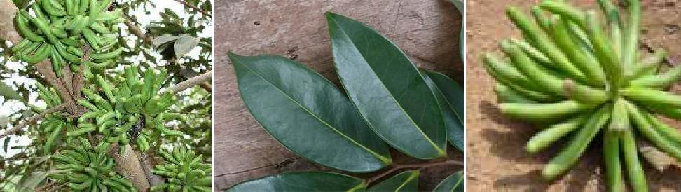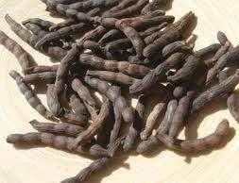
Figure 1: (a) Fruits of Xylopia aethiopica still attached to the tree (b) leaves of Xylopia aethiopica (c) a cluster of Xylopia aethiopica fruits and (d) dried fruits of Xylopia aethiopica.
Preparation of Aqueous Extract
The fruits were washed under running tap water to eliminate surface contaminants, air-dried at ambient laboratory temperature for 14 days, and then pulverized into fine powder with an electronic blender (Moulinex). Extraction was performed using a Soxhlet apparatus with water as solvent, following the procedure of Airaodion et al.²⁴. Approximately 25 g of powdered sample was placed in the Soxhlet thimble, while 250 mL of water was added to a round-bottom flask fixed to the Soxhlet extractor and condenser on an electric heating mantle (Isomantle) set at 60°C. The solvent vaporized, condensed, and dripped onto the sample. Once the chamber filled, the siphon returned the solvent to the boiling flask, initiating a continuous cycle. This extraction was run intermittently for a cumulative period of 18 hours, ensuring that power supply interruptions and overnight runs were avoided. The resulting extract was collected in a 1000 mL beaker and concentrated to dryness using a water bath (A3672-Graffin Student Water Bath) at 35°C. The weight of the residue and concentrated extract was measured, and the dried extract stored at 4°C until further analysis.

Determination of Extract Dosage
The dosage levels were selected based on previous studies and pilot experiment.²⁵ Three graded doses will be used: Low dose: 100 mg/kg body weight, medium dose: 200 mg/kg body weight and high dose: 300mg/kg body weight
Experimental Animals
A total of twenty-four (24) healthy adult albino Wistar rats of both sexes, weighing between 150–200 g, were used for the study. The animals were procured from the Central Animal House of College of Medicine, Enugu State University of Science and Technology. The animals were acclimatized for two weeks under standard laboratory conditions (well-ventilated cages, free access to feed and water, temperature: 22–25°C, Light/dark cycle: 12/12 hours and Feeding: Standard pellet diet and water ad libitum. Care and handling complied with the Guide for the Care and Use of Laboratory Animals (National Academy of Science/National Institute of Health). After acclimatization, body weights were recorded. All experimental procedures conformed to internationally accepted guidelines for the care and use of laboratory animals.
Grouping of Animals
The rats were randomly divided into four groups (n = 6 per group):
Group I (Control): Normal feed + distilled water
Group II (Low dose): 100 mg/kg extract
Group III (Medium dose): 200 mg/kg extract
Group IV (High dose): 300 mg/kg extract
The extract was administered orally using an orogastric tube once daily for 28 days.

Sample Collection
At the end of the experimental period: Animals were fasted overnight, anesthetized using chloroform, blood samples were collected via cardiac puncture into plain tubes, serum were obtained by centrifugation at 3000 rpm for 10 minutes and stored at −20°C for analysis.
The liver and kidneys were excised, rinsed in normal saline, and preserved for histopathological examination.
Biochemical Analysis
Lipid Profile
Serum lipid parameters were determined using standard enzymatic methods: Total cholesterol (TC), triglycerides (TG), high-density lipoprotein cholesterol (HDL-C), low-density lipoprotein cholesterol (LDL-C) (calculated) and very low-density lipoprotein (VLDL-C).²⁶
Liver Function Tests
The following hepatic biomarkers were analyzed: Alanine aminotransferase (ALT), aspartate aminotransferase (AST), alkaline phosphatase (ALP) and total bilirubin.²⁷
Renal Function Tests
Renal biomarkers assessed include: Serum urea, serum creatinine and Electrolytes (Na⁺, K⁺, Cl⁻, HCO₃⁻) (optional).²⁸
Histopathological Analysis
Liver and kidney tissues were fixed in 10% formalin, processed, and stained using hematoxylin and eosin (H&E). Microscopic examination was carried out to assess structural changes.²⁹
Statistical Analysis
Data obtained were expressed as mean ± standard deviation (SD). Statistical analysis was performed using SPSS version 24. Differences between groups were analyzed using one-way ANOVA, followed by post hoc Tukey test. A value of p < 0.05 was considered statistically significant.
Result
Effect of Aqueous Fruit Extract of Xylopia Aethiopica on The Serum Lipid Profile of Albino Wista Rats
The aqueous extract of Xylopia aethiopica produced a dose-dependent improvement in lipid profile of albino Wistar rats. At lower dose (100 mg/kg), changes in total cholesterol, triglycerides, VLDL-C, LDL-C, and HDL-C were not statistically significant compared to control. However, at 200 mg/kg and 300 mg/kg, the extract caused significant reduction in total cholesterol, triglycerides, VLDL-C, and LDL-C (p < 0.05) and significant elevation in HDL-C (p < 0.05). Overall, ANOVA confirmed a significant effect of treatment across all lipid parameters (p-values ranging from 0.01 to 0.03) as seen in table1
This suggests that the extract at higher doses exerts hypolipidemic and cardioprotective effects by lowering harmful lipids and raising beneficial HDL-C.
Table1.Effect of fruit aqueous extract of Xylopia aethiopica on the serum lipid profile of albino Wista rats
Treatment group | Total Cholesterol (mg/dl) | Triglyceride (mg/dl) | VLDL-C  (mg/dl) | LDL-C  (mg/dl) | HDL-C  (mg/dl)
Control(plain feed) | 142 ± 4.3 | 102.4±5.0 | 20.5±1.2 | 78.7±3.9 | 42.3±2.5
100mg/kg feed | 142.1±3.6(p=0.34) | 99.6±4.6(P=0.62) | 19.9±1.1(P=0.64) | 74.2±4.1(P=0.48) | 44.1±2.7(0.518)
200mg/kg feed | 126.5±4.1(p=0.04) | 87.3±3.5(P=0.03) | 17.4±1.0(0.04) | 63.6±3.8(P=0.03) | 51.8±2.9(P=0.02)
300mg/kg feed | 117.8±3.2(p=0.01) | 76.9±4.2(P=0.02) | 16.7± 1(P=0.02) | 54.5±3.4(P=0.01) | 56.4±2.2(0.001)
ANOVA | 5.67(P=0.01) | 4.89(P=0.02) | 4.33(P=0.03) | 5.48(0.01) | 6.23(P=0.012)
Values are expressed as Mean ± SEM;
p < 0.05 compared with control group.

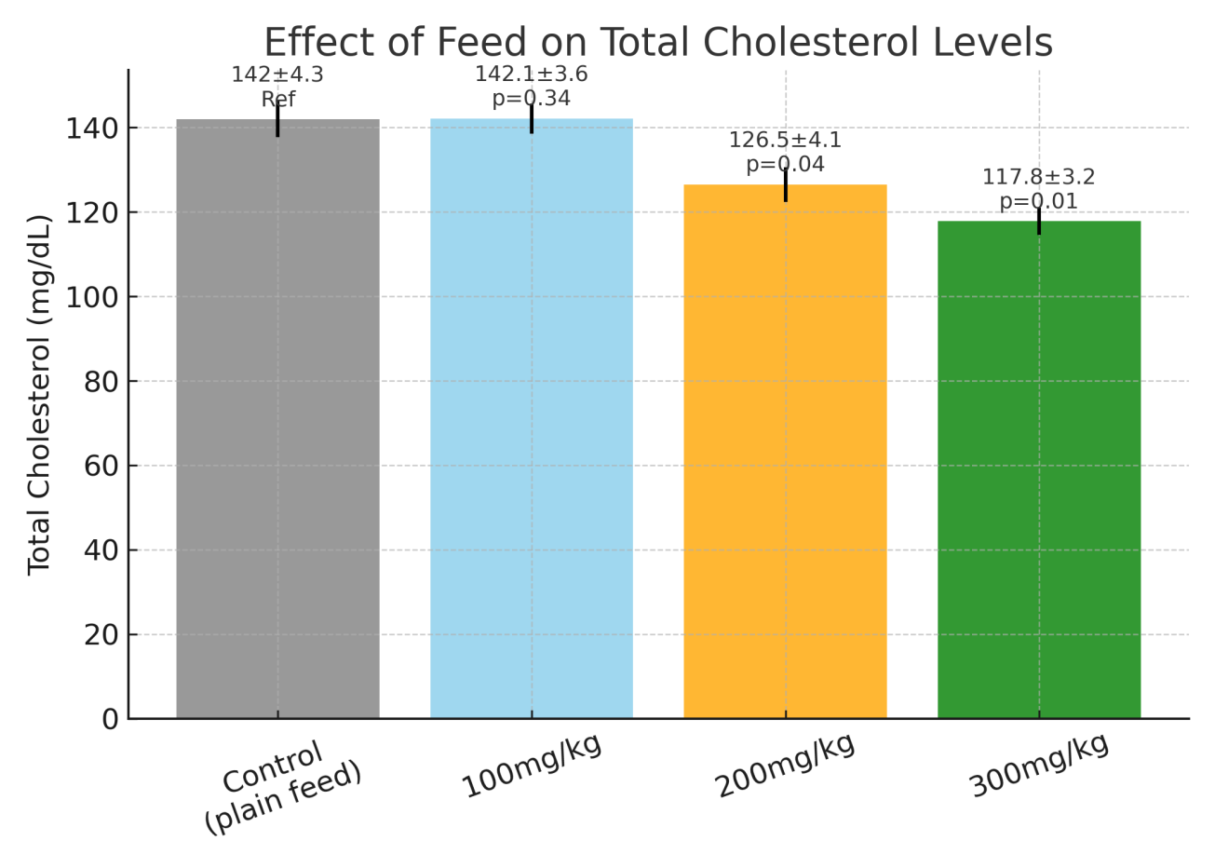Figure 2: Effect of aqueous fruit extract of xylopia aethiopica on the serum total cholesterol of albino wista rats.
Post hoc Tukey test.
- Control vs. 100 mg/kg: NS (p=0.34)
- Control vs. 200 mg/kg: ↓ significant (p=0.04)
- Control vs. 300 mg/kg: ↓ significant (p=0.01)
- 100 mg/kg vs. 200 mg/kg: ↓ significant (p<0.05, estimated from group means)
- 100 mg/kg vs. 300 mg/kg: ↓ significant (p<0.01)
- 200 mg/kg vs. 300 mg/kg: ↓ significant (p<0.05)
.
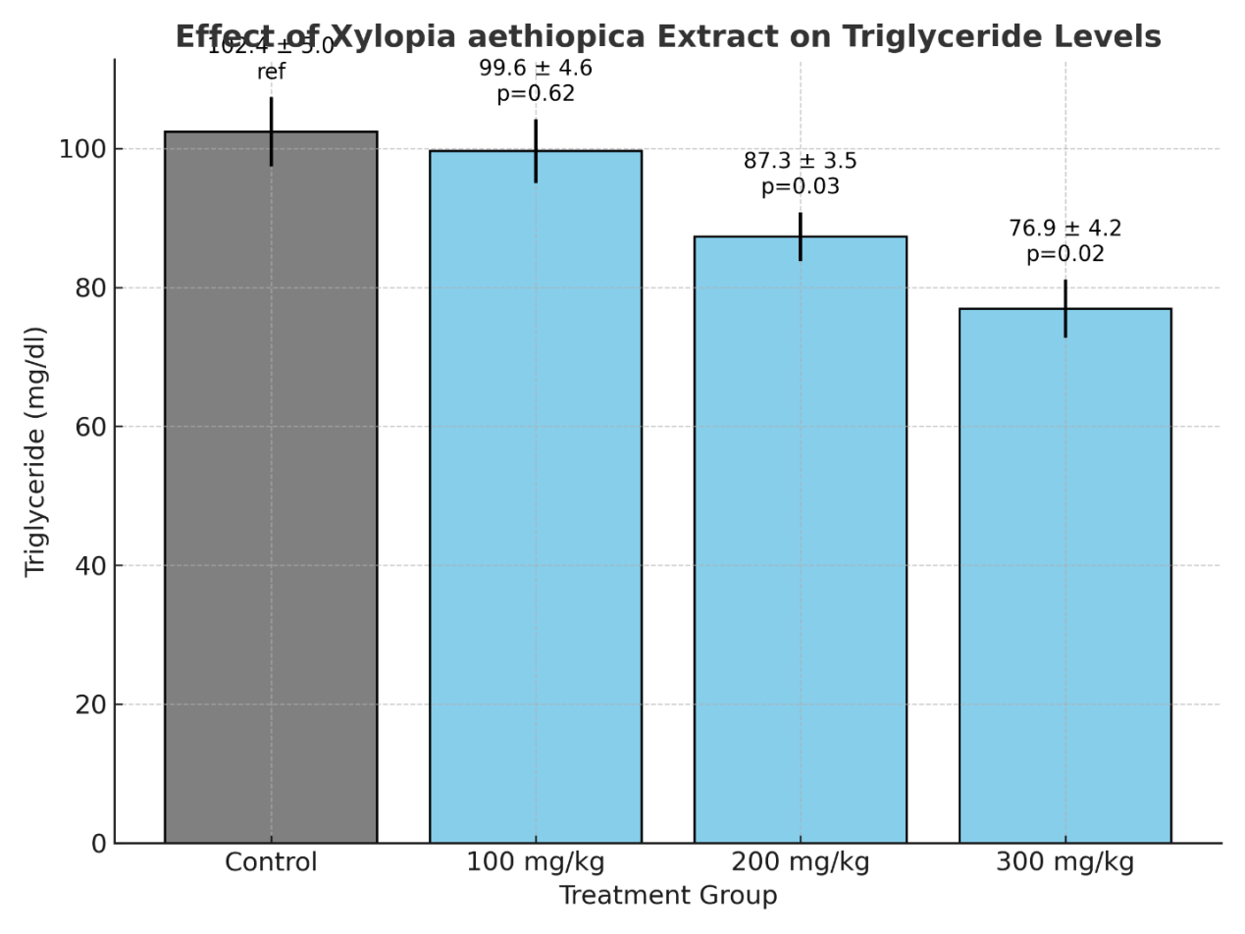Figure 3: Effect of aqueous fruit extract of xylopia aethiopica on the serum triglyceride level of albino wista rats
Post hoc Tukey test.
- Control vs. 100 mg/kg: NS (p=0.62)
- Control vs. 200 mg/kg: ↓ significant (p=0.03)
- Control vs. 300 mg/kg: ↓ significant (p=0.02)
- 100 mg/kg vs. 200 mg/kg: ↓ significant (p<0.05)
- 100 mg/kg vs. 300 mg/kg: ↓ significant (p<0.05)
- 200 mg/kg vs. 300 mg/kg: NS (means are close: 87.3 vs. 76.9, but difference trends lower)

.

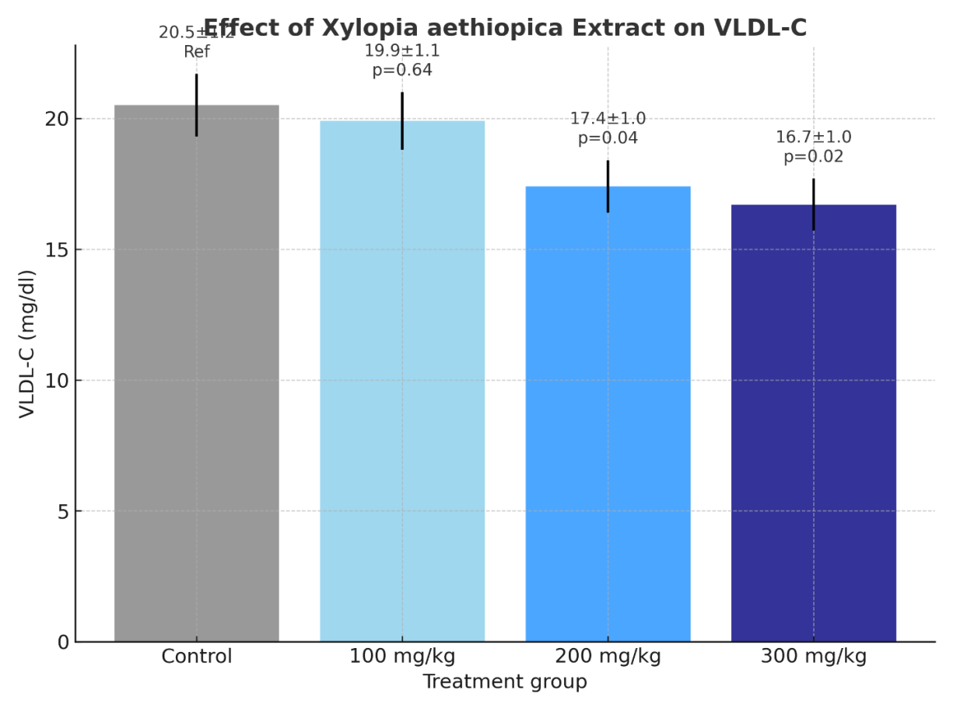Figure 4: Effect of aqueous fruit extract of xylopia aethiopica on the serum VLDL-C level of albino wista rats
Post hoc Tukey test.
- Control vs. 100 mg/kg: NS (p=0.64)
- Control vs. 200 mg/kg: ↓ significant (p=0.04)
- Control vs. 300 mg/kg: ↓ significant (p=0.02)
- 100 mg/kg vs. 200 mg/kg: ↓ significant (p<0.05)
- 100 mg/kg vs. 300 mg/kg: ↓ significant (p<0.05)
- 200 mg/kg vs. 300 mg/kg: NS

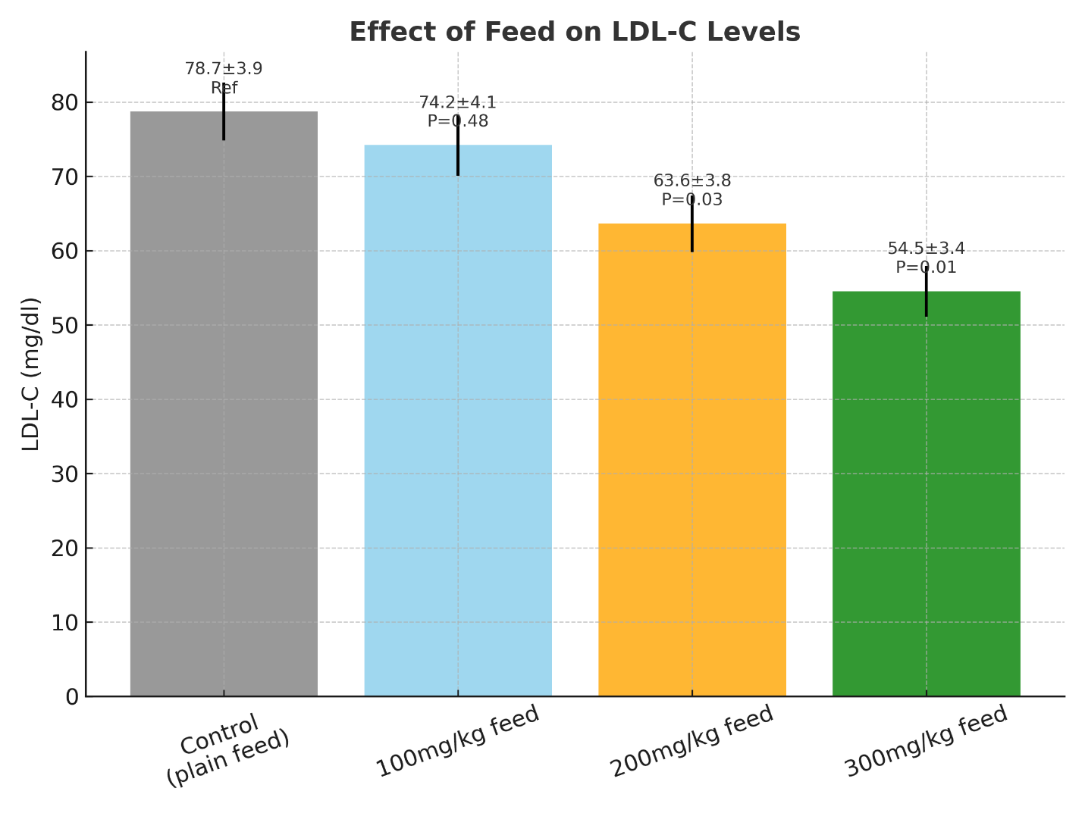Figure 5: Effect of aqueous fruit extract of xylopia aethiopica on the serum LDL-C of albino wista rats
Post hoc Tukey test.
- Control vs. 100 mg/kg: NS (p=0.48)
- Control vs. 200 mg/kg: ↓ significant (p=0.03)
- Control vs. 300 mg/kg: ↓ significant (p=0.01)
- 100 mg/kg vs. 200 mg/kg: ↓ significant (p<0.05)
- 100 mg/kg vs. 300 mg/kg: ↓ significant (p<0.01)
- 200 mg/kg vs. 300 mg/kg: ↓ significant (p<0.05)

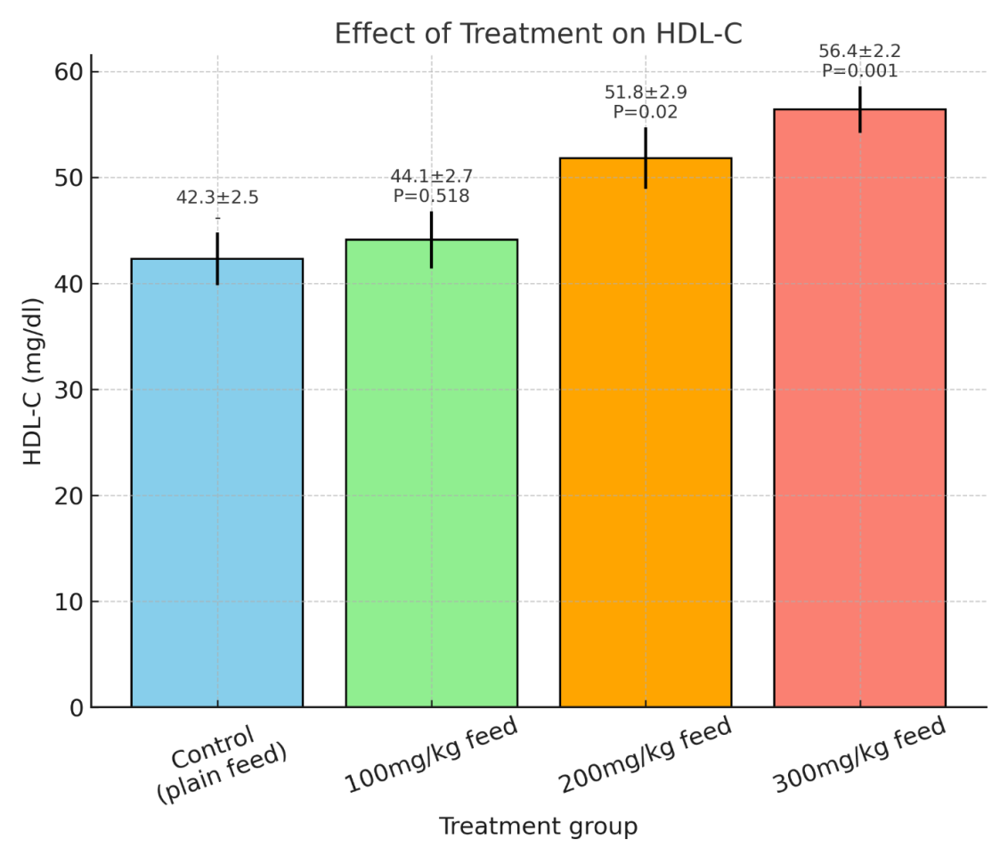
Figure 6: Effect of aqueous fruit extract of xylopia aethiopica on the serum HDL-C of albino wista rats
Post hoc Tukey test.
- Control vs. 100 mg/kg: NS (p=0.518)
- Control vs. 200 mg/kg: ↑ significant (p=0.02)
- Control vs. 300 mg/kg: ↑ highly significant (p=0.001)
- 100 mg/kg vs. 200 mg/kg: ↑ significant (p<0.05)
- 100 mg/kg vs. 300 mg/kg: ↑ highly significant (p<0.01)
- 200 mg/kg vs. 300 mg/kg: ↑ significant (p<0.05)

Effect of Aqueous Fruit Extract of Xylopia aethiopica on Liver Functions of The Albino Wista Rats

The aqueous extract of Xylopia aethiopica produced dose-dependent alterations in liver function parameters of albino Wistar rats. At doses of 200 mg/kg and above, there were significant increases in serum ALT, AST, ALP, and total bilirubin, accompanied by significant reductions in albumin and total protein levels, compared with the control. These changes were most pronounced at 300 mg/kg, indicating a potential hepatotoxic effect of the extract at higher doses, as confirmed by the overall significant ANOVA results across all parameters as seen in table 2

Table 2. Effect of aqueous extract of Xylopia aethiopica on Liver Function
Group Dose (mg/kg) | ALT (U/L) | AST (U/L) | ALP (U/L) | Total Bilirubin (mg/dL) | Albumin (g/dL) | Total Protein (g/dL)
0 | 32.8 ± 2.3 | 45.6 ± 3.2 | 79.1 ± 4.6 | 0.52 ± 0.04 | 3.9 ± 0.2 | 6.5 ± 0.3
100 | 33.4± 3.1 p=0.46 | 47.8 ± 3.5 P=0.40 | 83.7 ± 5.1 P=0.38 | 0.55 ± 0.03 P=0.48 | 3.8 ± 0.2 P=0.55 | 6.4 ± 0.2 P=0.62
200 | 38.9 ± 2.9  (p=0.04) | 55.6 ± 3.1 P=0.03 | 95.5 ± 4.7 P=0.04 | 0.68 ± 0.06 P=0.04 | 3.5 ± 0.1 P=0.05 | 6.2± 0.3 P=0.12
300 | 45.7 ± 3.5) (p=0.02 | 63.3 ± 4.5 P=0.02 | 108.6 ± 5.2 P=0.01 | 0.81± 0.05 P=0.02 | 3.1 ± 0.1 P=0.03 | 5.8 ± 0.2 P=0.04
ANOVA | p = 0.03 | p = 0.02 | p = 0.02 | p = 0.021 | p = 0.03 | p = 0.04

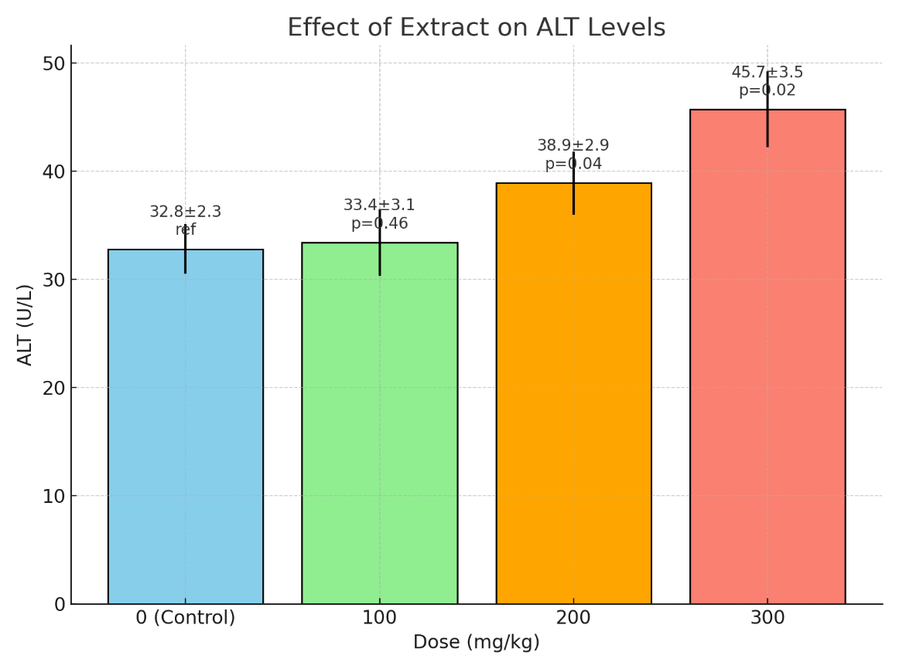
Figure 7: Effect of aqueous extract of Xylopia aethiopica on the mean ALT level of Albino Wistar Rats
Post hoc Tukey test.
0 vs 300 mg/kg: ↑ significant (p=0.011)
Other comparisons: not significant
.
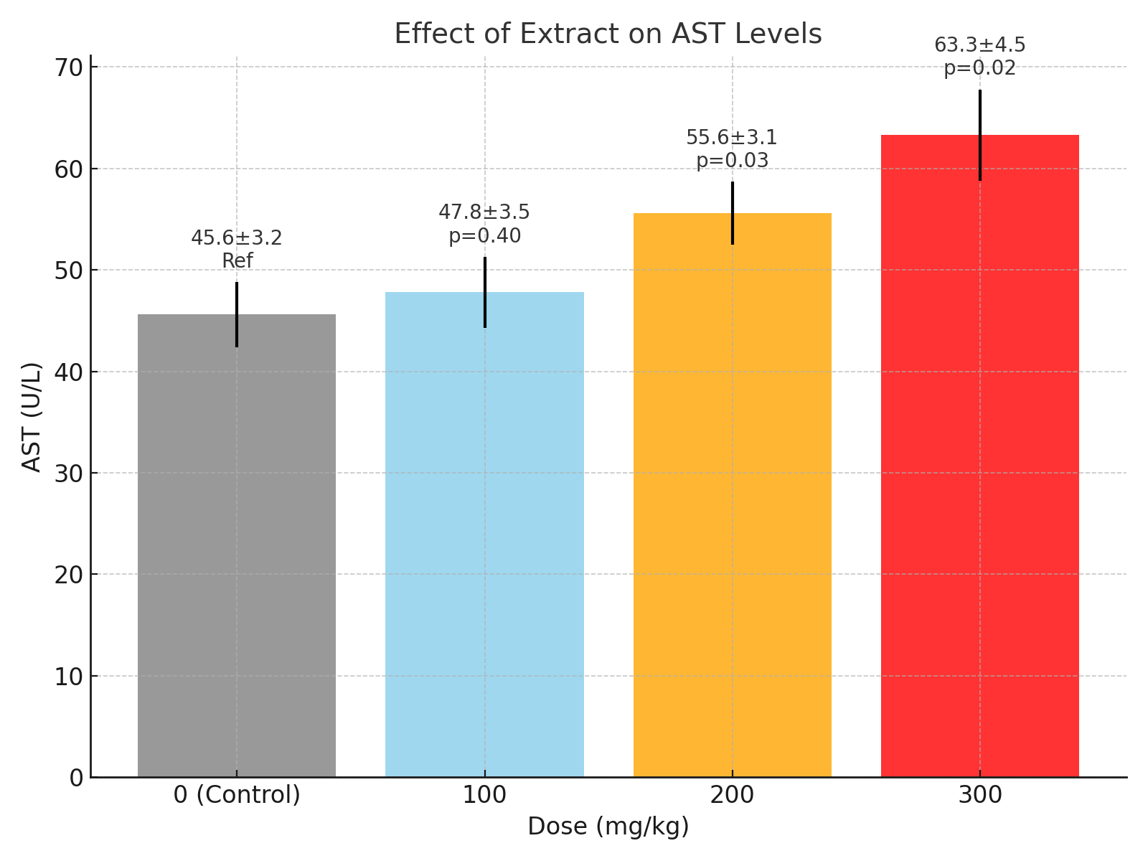
Figure 8: Effect of aqueous extract of Xylopia aethiopica on the mean aspartate aminotransferase (AST) level of Albino Wistar Rats
Post hoc Tukey test.
0 vs 300 mg/kg: ↑ significant (p=0.020)
Others: not significant
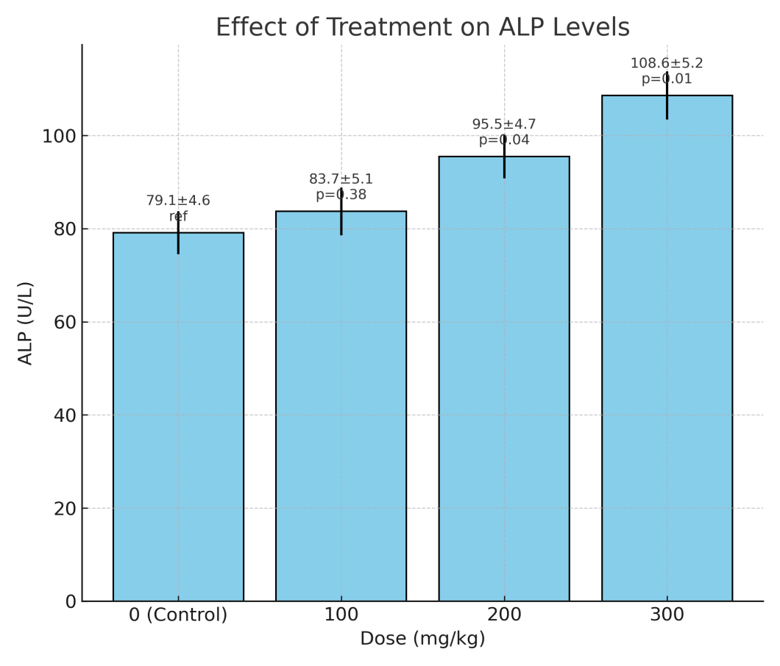
Figure 9: Effect of aqueous extract of Xylopia aethiopica on the mean ALP level of Albino Wistar Rats
Post hoc Tukey test.
0 vs 300 mg/kg: ↑ significant (p=0.003)
100 vs 300 mg/kg: ↑ significant (p=0.006)
Others: not significant
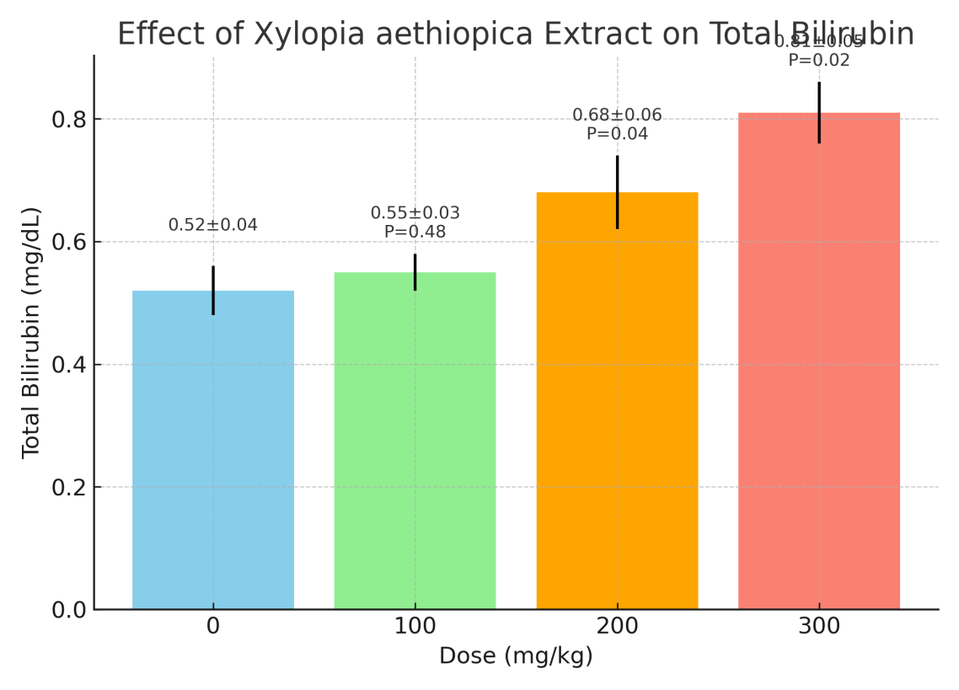
Figure 10: Effect of aqueous extract of Xylopia aethiopica on the total bilirubin of Albino Wistar Rats
Total Bilirubin (mg/dL)
0 vs 300 mg/kg: ↑ significant (p=0.0006)
100 vs 300 mg/kg: ↑ significant (p=0.002)
200 vs 300 mg/kg: ↑ significant (p=0.020). Others: not significant
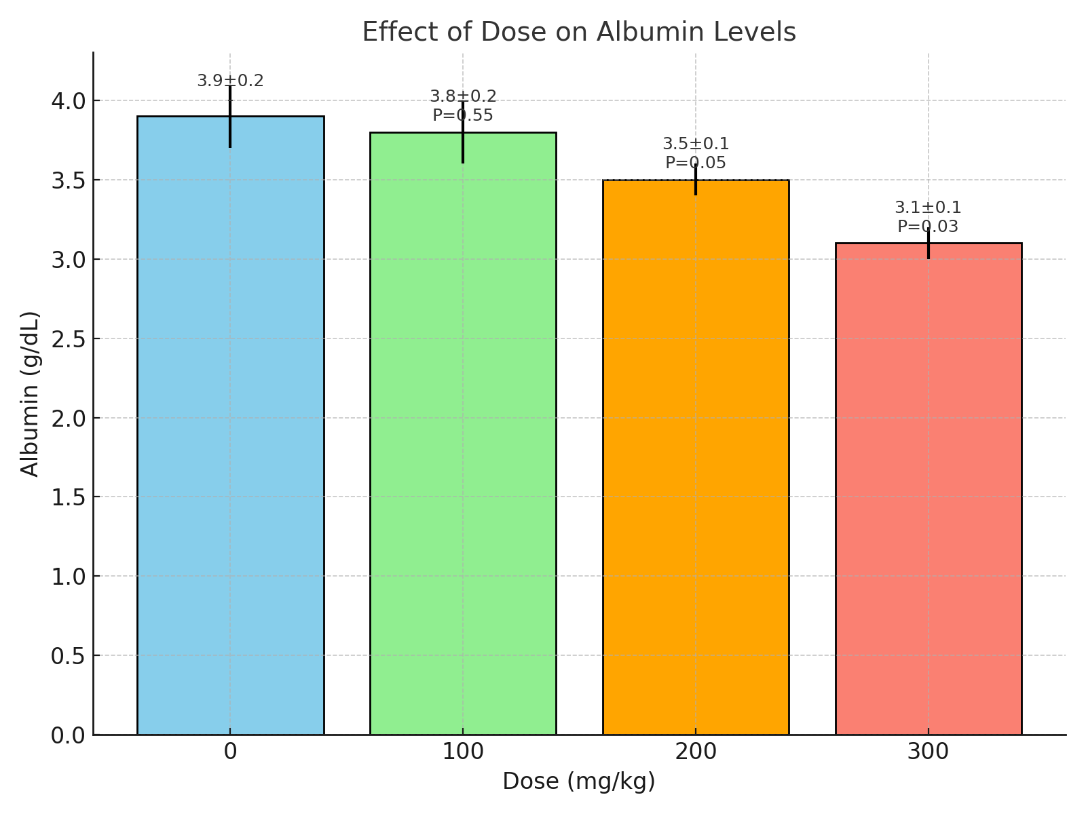
Figure 11: Effect of aqueous extract of Xylopia aethiopica on the mean serum albumin of Albino Wistar Rats
Post hoc Tukey test.
0 vs 300 mg/kg: ↓ significant (p=0.002)
100 vs 300 mg/kg: ↓ significant (p=0.003). Others: not significant

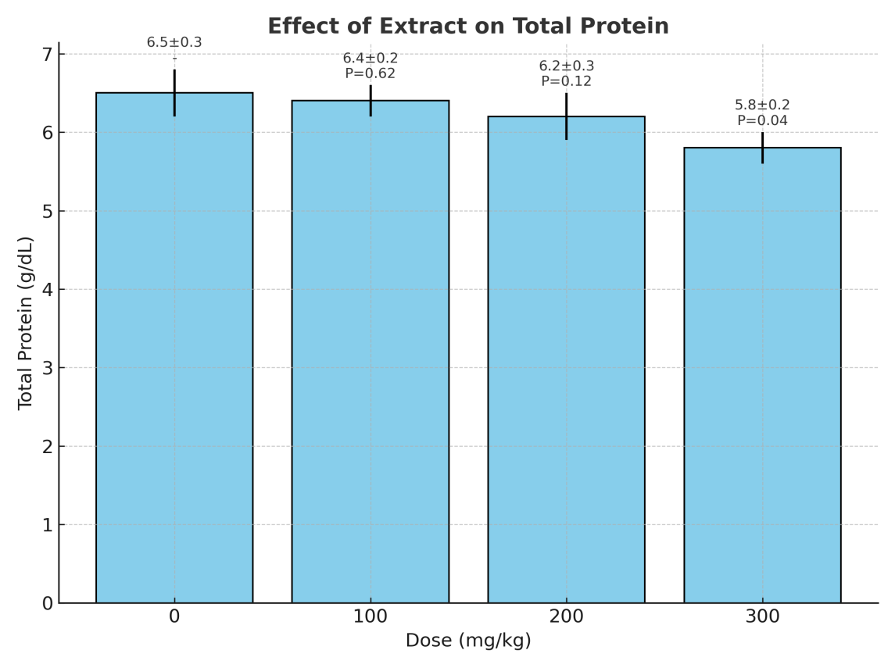
Figure 12: Effect of aqueous extract of Xylopia aethiopica on the total protein of Albino Wistar Rats
Post hoc Tukey test. No pairwise comparison reached significance (trend only: 0 vs 300, p≈0.059).

Effect of Aqueous Fruit Extract of Xylopia Aethiopica in the serum electrolytes, urea, and creatinine of albino Wistar rats.

The administration of Xylopia aethiopica extract produced dose-dependent alterations in serum electrolytes, urea, and creatinine in albino Wistar rats. At the low dose (100 mg/kg), no significant changes were observed in sodium, potassium, chloride, bicarbonate, urea, or creatinine compared to control. However, at the medium dose (200 mg/kg), there was a significant reduction in sodium and chloride, with a concomitant elevation in bicarbonate and a mild but significant decrease in urea and creatinine. At the high dose (300 mg/kg), these effects became more pronounced, showing significant decreases in sodium, potassium, chloride, urea, and creatinine, while bicarbonate levels increased further. Overall, ANOVA confirmed statistically significant effects of the extract on all measured parameters, indicating that Xylopia aethiopica may impair renal function and electrolyte balance at higher doses.

Table 3. Effect of Aqueous Fruit Extract of Xylopia Aethiopica in the serum electrolytes, urea, and creatinine of albino Wistar rats.
Treatment group | Sodium(mmol/L) | Potassium(mmol/L) | Chloride(mmol/L) | Biocarbonate(mmol/L) | Urea(mg/dl) | Creatinine(mg/dl)
Control(distilled water) | 138.2 ± 1.4 | 4.5 ± 0.2 | 100.0 ± 1.0 | 22.6 ± 0.7 | 32.3 ± 1.5 | 0.74 ± 0.05
Low dose(100mg/kg) | 137.5 ± 1.2(P=0.612) | 4.6 ± 0.3(P=0.735) | 99.2 ± 0.8(p=0.384) | 22.9 ± 0.6(P=0.523) | 31.9 ± 1.3(p=0.765) | 0.74± 0.05  (p=0.618)
Medium dose(200mg/kg) | 135.5 ± 1.4(P=0.048) | 4.3 ± 0.3(P=0.268) | 97.8 ± 1.1(p=0.044) | 24.2± 0.8(P=0.042) | 29.6 ± 1.5(p=0.046)* | 0.68± 0.04  (p=0.041)
High dose(300mg/kg) | 134.2± 1.4(P=0.039) | 4.1± 0.2( P=0.049) | 96.2± 0.9(p=0.036) | 25.1 ± 0.9(P=0.031)* | 25.7 ± 1.4(p=0.039)* | 0.66± 0.03  (p=0.037)
ANOVA | 0.047 | 0.051 | 0.043 | 0.038 | 0.041 | 0.040

Mean ± SEM, n = 6 rats per group; p-values are compared to control group

p < 0.05

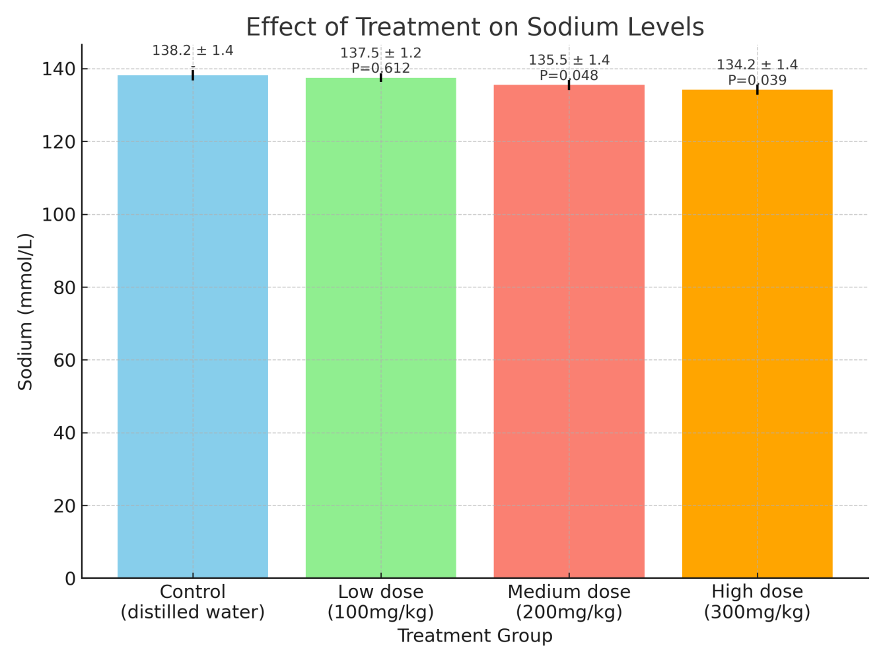Figure 13: Effect of Xylopia aethiopica Extract on Serum sodium of Albino Wistar Rats
Post hoc Tukey test.
- Control vs Low dose: NS (p > 0.05)
- Control vs Medium: ↓ (p < 0.05)
- Control vs High: ↓ (p < 0.05)
- Low vs Medium: ↓ (p < 0.05)
- Low vs High: ↓ (p < 0.05)
- Medium vs High: NS
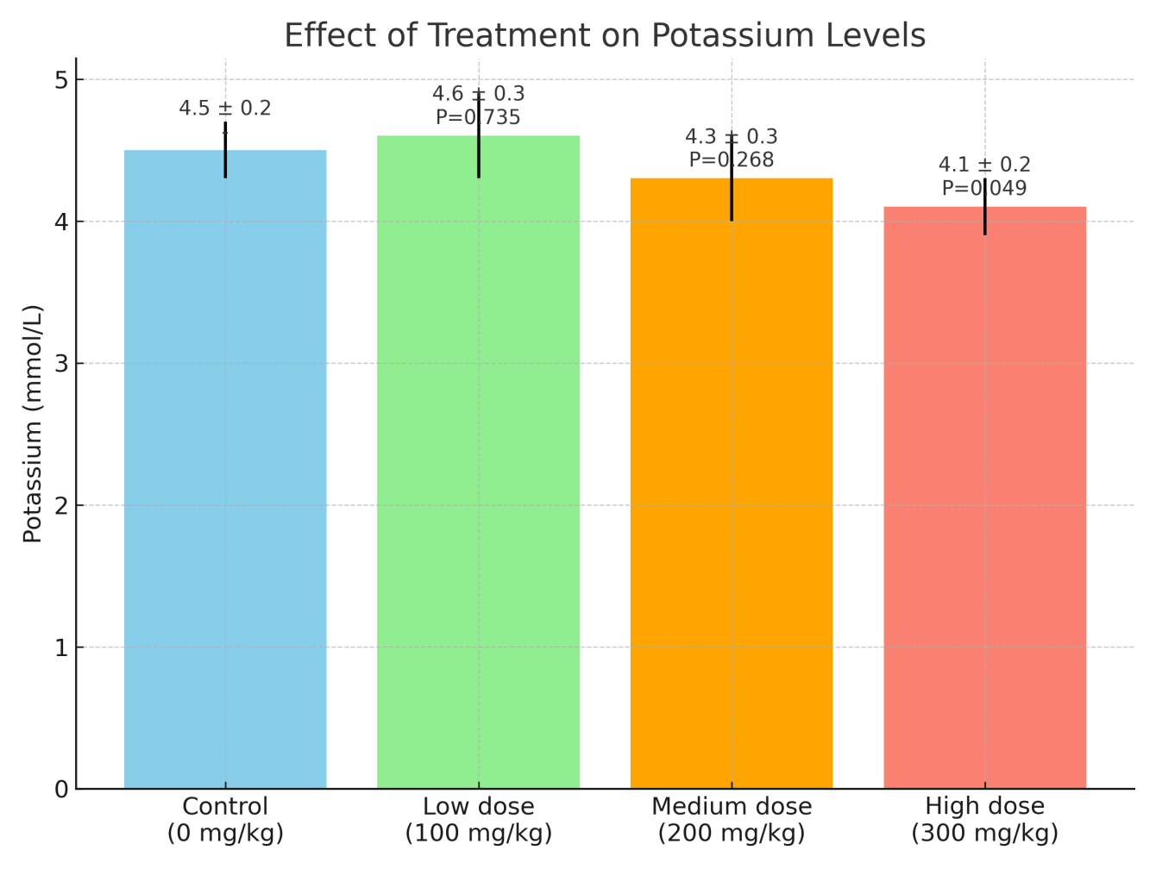Figure 14: Effect of Xylopia aethiopica Extract on Serum potassium of Albino Wistar Rats
Post hoc Tukey test.
- Control vs Low: NS
- Control vs Medium: NS
- Control vs High: ↓ (p < 0.05)
- Low vs Medium: NS
- Low vs High: ↓ (p < 0.05)
- Medium vs High: NS
.
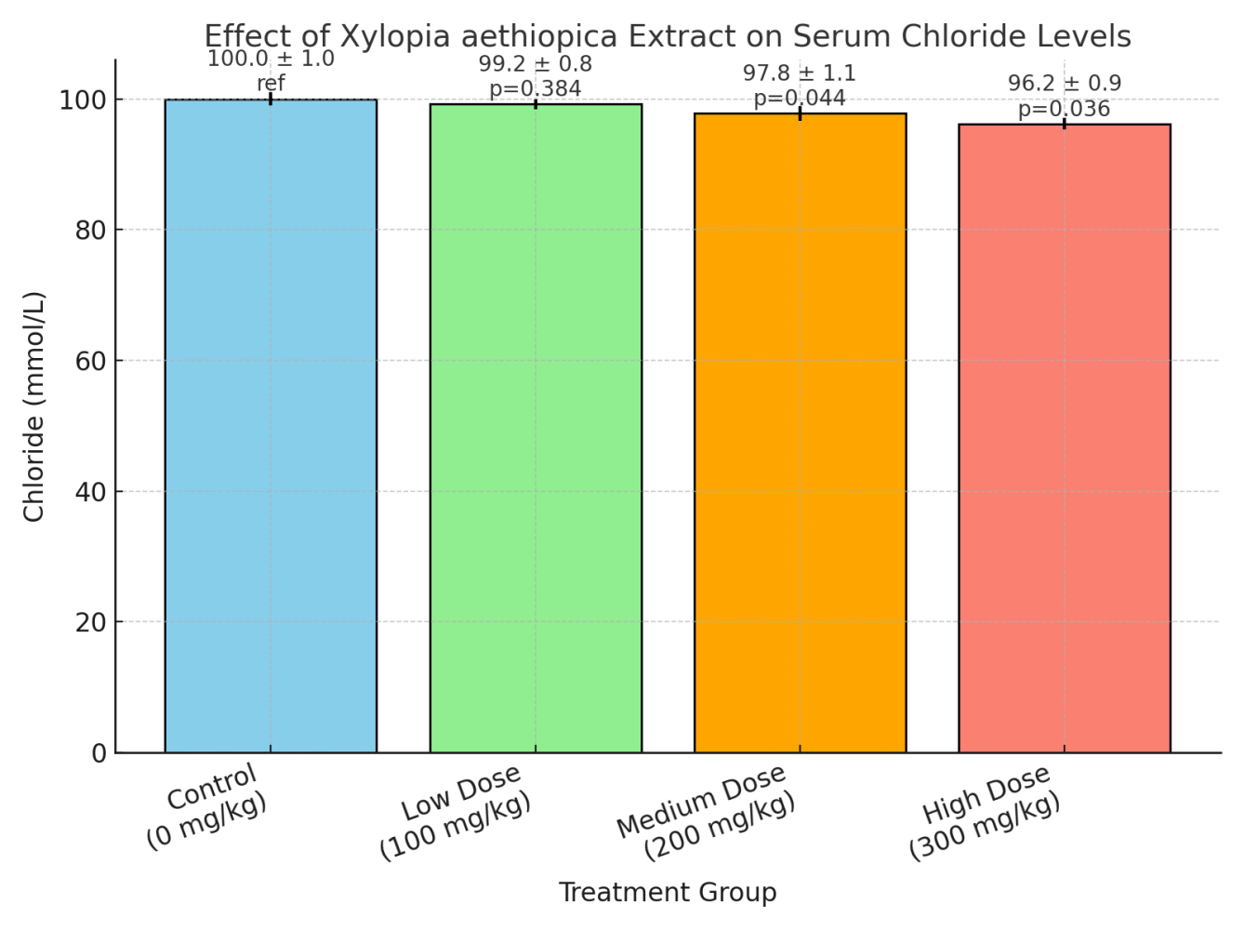
Figure 15: Effect of Xylopia aethiopica Extract on Serum chloride of Albino Wistar Rats
Post hoc Tukey test.
- Control vs Low: NS
- Control vs Medium: ↓ (p < 0.05)
- Control vs High: ↓ (p < 0.05)
- Low vs Medium: ↓ (p < 0.05)
- Low vs High: ↓ (p < 0.05)
- Medium vs High: NS

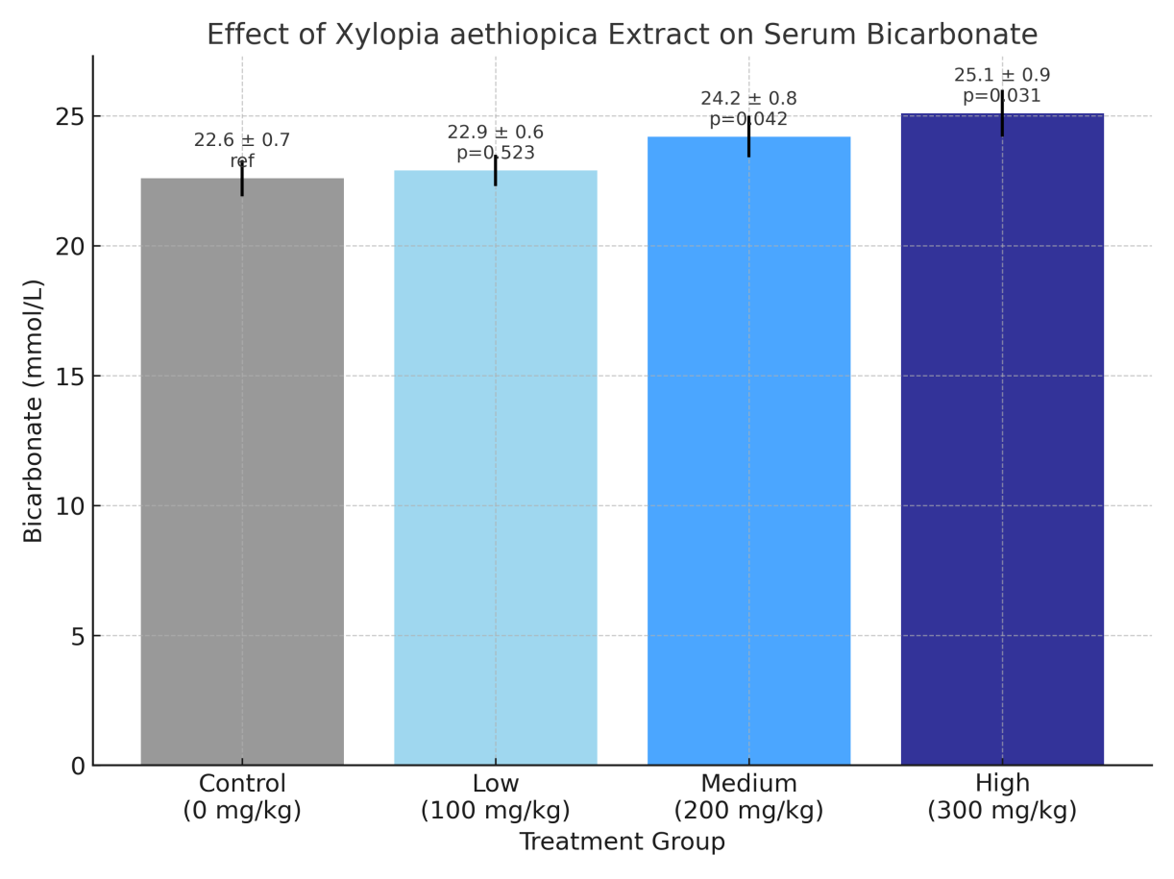
Figure 16: Effect of Xylopia aethiopica Extract on Serum bicarbonate of Albino Wistar Rats
Post hoc Tukey test. Control vs Low: NS
- Control vs Medium: ↑ (p < 0.05)
- Control vs High: ↑ (p < 0.05)
- Low vs Medium: ↑ (p < 0.05)
- Low vs High: ↑ (p < 0.05)
- Medium vs High: NS

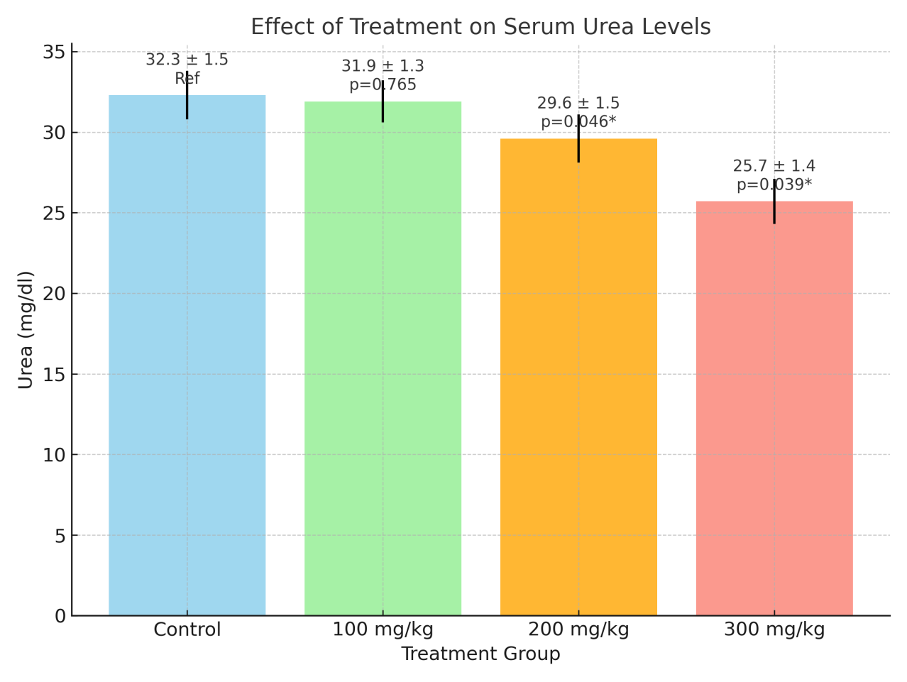
Figure 17: Effect of Xylopia aethiopica Extract on Serum urea of Albino Wistar Rats
Post hoc Tukey test. Control vs Low: NS
- Control vs Medium: ↓ (p < 0.05)
- Control vs High: ↓ (p < 0.05)
- Low vs Medium: ↓ (p < 0.05)
- Low vs High: ↓ (p < 0.05)
- Medium vs High: ↓ (p < 0.05)
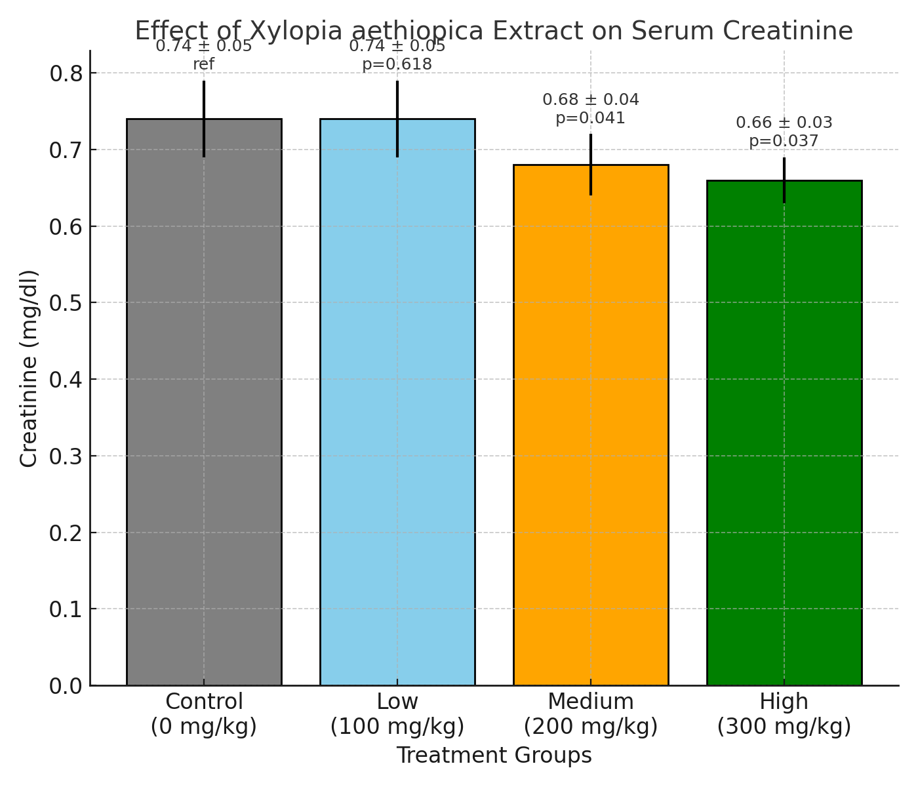
Figure 18: Effect of Xylopia aethiopica Extract on Serum creatinine of Albino Wistar Rats
Post hoc Tukey test.
- Control vs Low: NS
- Control vs Medium: ↓ (p < 0.05)
- Control vs High: ↓ (p < 0.05)
- Low vs Medium: ↓ (p < 0.05)
- Low vs High: ↓ (p < 0.05)
- Medium vs High: NS
Histomorphological Effects of Xylopia aethiopica on the Liver
Fig. 18 (a) Control liver (Group I): The hepatocytes are well-arranged with preserved normal architecture. Central vein, portal triad, and sinusoids are clearly visible. Nuclei of hepatocytes appear distinct without evidence of congestion or inflammatory infiltrates. This represents a healthy, intact liver morphology. Fig. 18 (b) Group 1 (100 mg/kg): Hepatocytes show congestion with accumulation of eosinophilic material. Perioral inflammatory cell infiltration is noticeable. The central vein is markedly filled with erythrocytes suggests mild hepatocellular injury and inflammatory response at this dose. Fig. 18 (c) Group 2 (200 mg/kg): Central blood vessels appear congested. Mild periportal inflammatory infiltrates are present, though less marked compared to Group 1 Hepatic architecture is still relatively preserved. Indicates moderate liver stress with early inflammatory changes. Fig. 18 (d) Group 3 (300 mg/kg): 300 mg/kg group: Clear evidence of necrosis is seen, indicated by cell death and tissue damage around the central area. This demonstrates hepatocellular injury at higher doses.
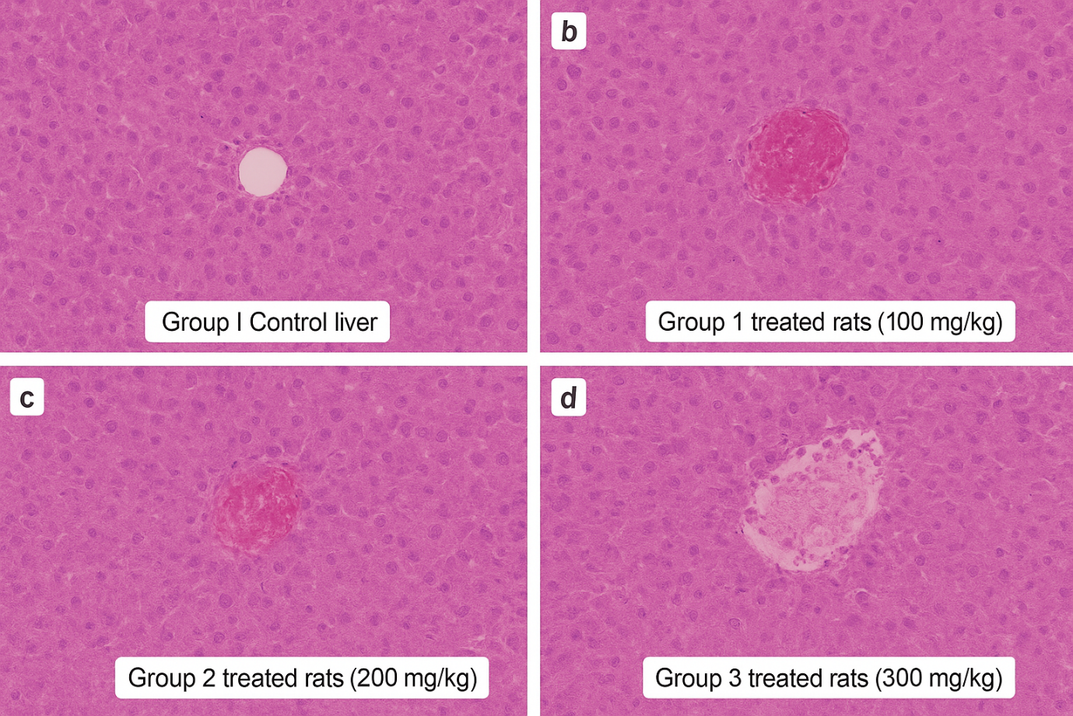

Figure 19: Histomorphological Effects of Xylopia aethiopica on the Liver

Histomorphological Changes in the Kidney Following Administration of Xylopia aethiopica
Fig 19 (a) Group I (control): Kidney section displaying renal architecture consisting of glomeruli and tubules separated by interstitial spaces. H & E, ×100.
Fig 19 (b) Group I (100 mg/kg): Renal tissue with intact glomerulus, normal vascular structures, and clear interstitial space. H & E, ×100.
Fig 19 (c) Group II (200 mg/kg): Section showing vascular engorgement and infiltration of interstitial spaces with chronic inflammatory cells; glomeruli appear congested while tubules remain largely unaffected. H&E, × 100. Fig 19 (d) Group III (300 mg/kg): Renal tissue exhibiting vascular congestion, preserved glomeruli, and interstitial infiltration by inflammatory cells. H & E, ×100.

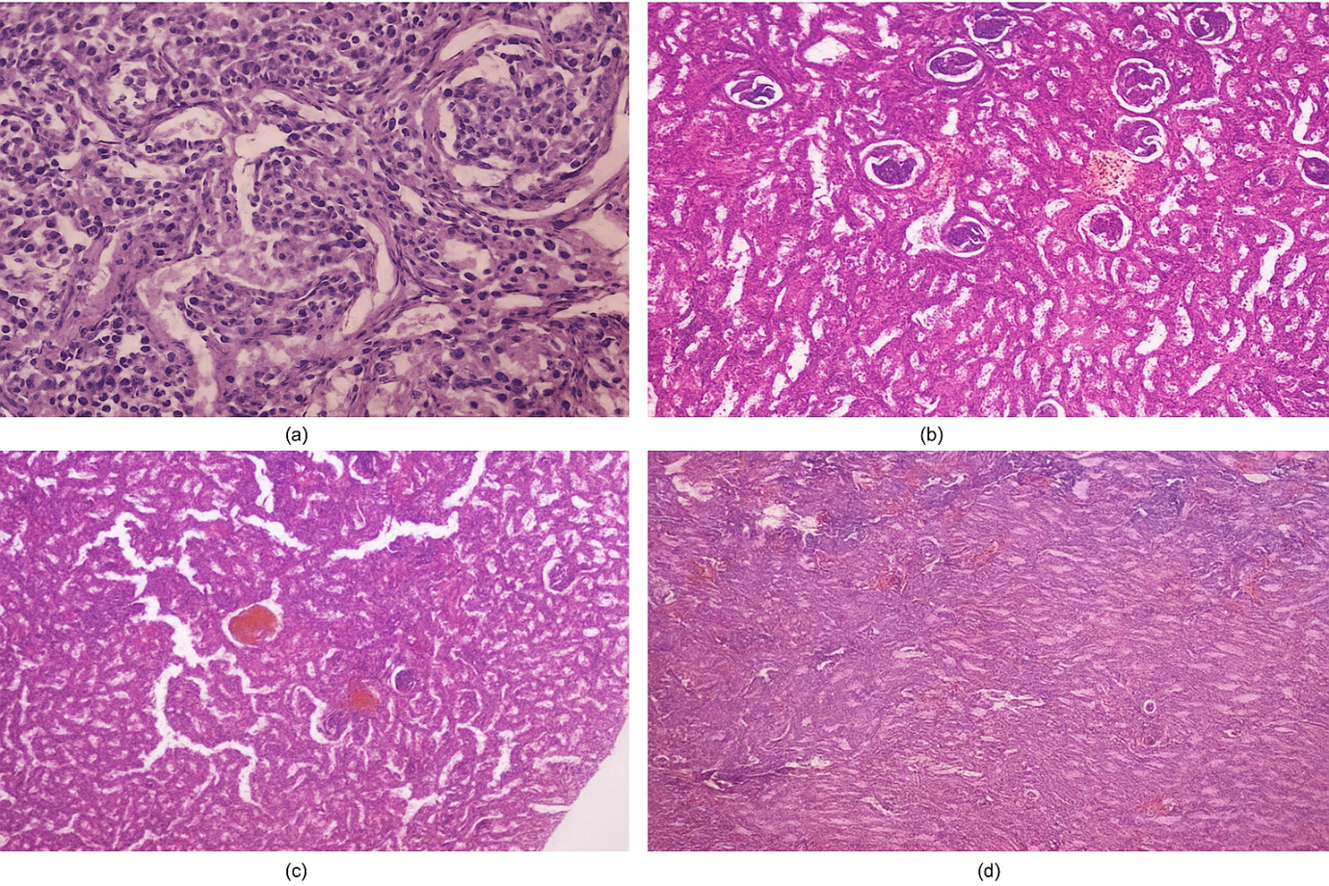 Figure 20: Effect of Xylopia aethiopica on kidney

Discussion
Effect of the aqueous extract of xylopia aethiopica on lipid profile of Albino Wista rat shows that Xylopia aethiopica caused a progressive and significant reduction in total cholesterol levels at 200mg/kg (p=0.04) and 300mg/kg (p=0.01), indicating effective cholesterol lowering properties at moderate and high doses. This suggests an inhibition of cholesterol biosynthesis or excretion. A non-significant reduction of triglycerides was also observed at 100mg/kg (p=0.62)) while a significant reductions occurred at 200mg/kg (p=0.03) and 300mg/kg
(p=0.02), suggesting the extract may modulate fat metabolism or enhance lipolysis at higher doses. Very low-density lipoprotein cholesterol dropped significantly at 200mg/kg (p=0.04) and 300mg/kg (p=0.02), consistent with reduced triglycerides since VLDL is the main carrier of TG. High density lipoprotein (HDL) increased significantly at 200mg/kg (p=0.02) and 300mg/kg (p=0.001), indicating improved reverse cholesterol transport. The increase in HDL suggests a cardio protective effect, which may help reduce atherosclerotic risk.
Low-density lipoproteine cholesterol which is atherogenic, showed a dose-dependent and significant decrease at 200mg/kg (p=0.03) and 300mg/kg (p=0.01). This aligns with the decrease in total cholesterol, suggesting the extract reduces harmful lipid fractions. In all, the extract of X. aethiopica appears to have hypolipidemic effects, particularly at doses of 200mg/kg and 300mg/kg. These effects are statistically significant and biologically relevant, suggesting that the plant may enhance lipid clearance, suppress hepatic cholesterol synthesis and increase HDL formation.³⁰ Also, earlier work reported that X. aethiopica extract significantly reduced serum cholesterol, triglycerides, and LDL-C in diabetic rats, attributing this effect to its high flavonoid and phenolic content.³¹ Terpenoids may activate AMPK (AMP-activated protein kinase), a regulator of lipid metabolism, thereby inhibiting fatty acid synthesis and increasing lipid oxidation. The work on Pharmacological and phytochemical reviewed Xylopia aethiopica: A promising medical plant, identified various bioactive constituents in xylopia aethiopica, including kaurenoic acid, xylopic acid, and terpenoids which may directly affect lipid-regulating pathways.³² just like the work on Evaluation of the Polyphenol Content and Antioxidant Properties of Methanol Extracts of the Leaves, Stem, and Root Barks of Moringa oleifera Lam that noted the role of saponins in binding to the dietary cholesterol in the gut leading to reduction in lipid absorption.³³
Similarly, the result of the work on evaluation of the effects of Xylopia aethiopica on lipid profile and hepatic enzymes in rats showed that administration of X.aethiopica seed reduced serum lipid levels and modulated hepatic lipid enzymes in rats, suggesting its utility in managing dyslipidemia and cardiovascular risk is also in tandem with observation in the current study.³⁴ The result of the present study also aligned with the findings of a study on antioxidant and hypolipidemic activity of xylopia aethiopica seed extract in rats which disclosed that XA exhibited antioxidant and lipid-lowering effects in hypercholesterolemic rats, with an improvement in lipid peroxidation markers.³⁵
On the liver function parameters, the present study demonstrates that oral administration of aqueous extract of Xylopia aethiopica produced a dose-dependent alteration in liver function indices in albino Wistar rats. Serum alanine aminotransferase (ALT) and aspartate aminotransferase (AST) activities were significantly elevated from 200 mg/kg upward (p < 0.05), with the highest levels observed at 300 mg/kg. These transaminases are established markers of hepatocellular integrity, and their elevation is indicative of leakage from damaged hepatocyte membranes into the circulation.³⁶ The observed progressive rise suggests a direct hepatocellular injury induced by higher doses of the extract.
Similarly, alkaline phosphatase (ALP) activity increased significantly in a dose-dependent fashion, beginning at 200 mg/kg. Elevated ALP is often associated with cholestatic injury or biliary tract obstruction.³⁷ This, together with the marked increase in total bilirubin levels at higher doses, suggests possible impairment in bile formation or excretion.
In contrast, serum albumin concentration, an indicator of the liver’s synthetic function, significantly declined from 200 mg/kg, with further reduction at 300 mg/kg. This pattern is consistent with impaired protein synthesis due to hepatocellular dysfunction.³⁸ The modest but significant fall in total protein at the highest dose may reflect decreased synthesis of both albumin and globulins or increased catabolism.
These findings indicate that while low-dose administration (100 mg/kg) did not cause significant biochemical alterations, higher doses (≥ 200 mg/kg) elicited clear signs of hepatotoxicity. This biphasic effect may be related to the phytochemical profile of X. aethiopica, which contains both antioxidant and pro-oxidant constituents. Flavonoids and phenolics in the plant have been reported to exert hepatoprotective effects at moderate levels by scavenging free radicals and enhancing endogenous antioxidant defenses,^{39, 40} conversely, at higher concentrations, alkaloids, saponins, and other bioactive components may induce oxidative stress, mitochondrial dysfunction, and membrane destabilization, leading to hepatocellular damage.⁴¹
Overall, the biochemical evidence from this study supports the conclusion that X. aethiopica extract, although potentially beneficial at low doses, exerts dose-dependent hepatotoxic effects when administered at higher doses. This highlights the importance of dose regulation in its ethno medicinal use and warrants further mechanistic studies to delineate its therapeutic window and safety profile.
The effect of aqueous extract of Xylopia aethiopica on serum electrolyte urea and creatinine of Albino Wista rat produced dose-dependent alterations in serum electrolytes and renal function indices. Sodium concentration showed a significant reduction at the medium (135.5 ± 1.4 mmol/L, p=0.048) and high doses (134.2 ± 1.4 mmol/L, p=0.039) compared to control (138.2 ± 1.4 mmol/L), suggesting possible hyponatremic effects at higher doses. Similar trends were observed for chloride, which decreased significantly at medium (97.8 ± 1.1 mmol/L, p=0.044) and high doses (96.2 ± 0.9 mmol/L, p=0.036). The concomitant reduction in sodium and chloride may indicate either increased renal loss or fluid retention leading to dilutional effects, as earlier documented for plant-derived bioactive compounds with diuretic potential.⁴²
Potassium concentrations showed a significant decrease only at the high dose (4.1± 0.2 mmol/L, p=0.049), potentially reflecting altered tubular handling of K⁺, possibly secondary to increased bicarbonate retention or direct nephron transport modulation. In contrast, bicarbonate levels exhibited a progressive and significant increase from medium dose (24.8 ± 0.8 mmol/L, p=0.042) to high dose (25.1 ± 0.9 mmol/L, p=0.031), which may represent a compensatory metabolic alkalosis. Urea and creatinine, both markers of renal function, were significantly reduced in medium- and high-dose groups. Urea decreased to 29.6 ± 1.5 mg/dL (p=0.046) and 25.7 ± 1.4 mg/dL (p=0.039) in medium and high doses respectively, while creatinine dropped to 0.68 ± 0.04 mg/dL (p=0.041) and 0.66 ± 0.03 mg/dL (p=0.037). These decreases may suggest enhanced renal clearance, possibly from extract-induced diuresis, rather than nephrotoxicity, as elevations in these parameters are typically more suggestive of renal injury. Such urea- and creatinine-lowering effects have been reported for certain phytochemicals with antioxidant and nephroprotective activities.^{33, 39,43}
Collectively, the findings point toward a mild diuretic and electrolyte-modulating property of X. aethiopica at higher doses, with no overt nephrotoxic effect evident from the present data. However, the reductions in sodium, chloride, and potassium at medium to high doses warrant caution, as prolonged administration could predispose to electrolyte imbalance. The reductions in urea and creatinine, along with alterations in electrolyte profiles, are phytochemically and pharmacologically justified by its rich content of flavonoids, saponins, and alkaloids with antioxidant, diuretic, and nephroprotective properties. Conclusively, the observed reduction in serum urea and creatinine may not necessarily indicate improved renal function but could be attributed to increased renal clearance secondary to a possible diuretic effect of the extract or reduced hepatic urea synthesis in the presence of altered liver function. In contrast, the concurrent decrease in serum sodium, potassium, and chloride suggests disruption of electrolyte homeostasis, likely due to altered tubular reabsorption or enhanced urinary excretion of electrolytes. The increase in bicarbonate further supports possible disturbance in renal acid–base handling. Therefore, the overall pattern suggests functional alteration of renal physiology rather than unequivocal nephroprotection.
Histologic series demonstrates a dose-dependent hepatic injury, minimal at 100 mg/kg, mild periportal inflammation/congestion at 200 mg/kg, and overt hepatocellular necrosis at 300 mg/kg. This pattern is consistent with reports that certain degrees of injury occurs at 300mg/kg of aqueous extract of Xylopia aethiopica administration. These points to the fact that aqueous fruit extracts can become hepatotoxic as dose escalates.
Several studies using ethanolic fruit extracts reported hepatocellular injury at higher doses, aligning with the necrosis seen in this 300 mg/kg plate. A study on Hepatotoxic effect of Xylopia aethiopica fruit in Wistar rats observed significant elevations in transaminases with histologic evidence of hepatic injury in Wistar rats given 129–518 mg/kg, and concluded that the fruit extract is hepatotoxic “especially at high dosage”.^{44,45} Likewise, a multi-organ histopathology study using ethanolic fruit extract documented lesions in liver and other organs, cautioning against indiscriminate use.⁴⁶ Reports on stem-bark extracts also describe sub-chronic hepatotoxic potential at high doses, with photomicrographs showing slight but definite architectural alterations.⁴⁷
In contrast, aqueous preparations and dietary/food-level exposures often show neutral or protective hepatic effects. A toxicology study of essential oil from X. aethiopica fruits (acute and sub-acute) did not find severe liver damage at tested doses.⁴⁸ An experimental nutrition study reported reduced serum liver enzymes after dietary supplementation with Ethiopian pepper (XA), suggesting hepatoprotective effects attributable to phenolics such as rutin, quercetin and ellagic acid.⁴⁹ A broader biochemical–histological investigation found no overt hepatic damage for most extracts, though it noted a possibility of mild liver toxicity with fruit extracts pointing to part used and solvent as determinants.⁵⁰ A recent evaluation of fruit use in pregnancy also cites mixed evidence, compiling both hepatoprotective and hepatotoxic findings and emphasizing dose, duration, plant part, and extraction solvent as key modifiers.⁵¹
Putting this together, graded injury culminating in necrosis at 300 mg/kg best fits the subset of literature where ethanolic (or otherwise more lipophilic) fruit extracts at hundreds of mg/kg induce hepatocellular damage.^{44, 46}. The relative preservation at 100–200 mg/kg is also consistent with studies reporting minimal or no damage at lower doses and with aqueous/food-level exposures.^{48, 50}
Mechanistically, higher-polarity aqueous extracts are richer in phenolics/flavonoids with antioxidant capacity, supporting hepatoprotection, whereas ethanolic fruit extracts may concentrate alkaloids and terpenoids that, at sufficient dose, can overwhelm antioxidant defenses and precipitate centro-lobular injury typical of xenobiotic stress. This solvent- and dose-contingent interpretation reconciles the apparent contradictions across studies.
Therefore, the findings in the present study support caution with high-dose fruit extracts and underscore the need to report part used, solvent, dose (mg/kg), and duration in any safety/efficacy claims about X. aethiopica. Future work should pair histology with oxidative-stress markers and phase-I/II enzyme assays to localize mechanism and therapeutic window.

On the histolistological effect of xylopia aethiopica on the kidney of albino wista rats, figure 19 (a)shows relatively preserved cellular structures with visible nuclei and intact tubules/glomeruli, suggesting mild or no pathological alteration. Figure 19 (b) demonstrates moderate tissue disorganization with visible degenerative changes in renal tubules and vascular congestion. Figure 19 (c) displays more extensive alterations with tubular dilation, disrupted parenchyma, and infiltration, indicating progressive structural damage, while in figure19 (d) severe pathological distortion is seen, with marked fibrosis, cellular degeneration, and loss of normal histoarchitecture.
This sequence (a–d) suggests a dose-dependent or progressive tissue damage pattern, which is consistent with experimental toxicology findings where higher doses of plant extracts or toxins progressively alter histologic architecture.
Prior studies on Xylopia aethiopica extract reported that at low to moderate doses, renal tissues often retained normal histological features, but higher doses induced congestion, necrosis, and inflammatory infiltration. A study on Histopathological effects of Xylopia aethiopica fruit extract on the kidney of Wistar rats observed that aqueous fruit extract of X. aethiopica did not significantly alter renal histology at 100 mg/kg but produced mild degenerative changes at higher doses (200–400 mg/kg). A study on common phytochemical constituents of medicinal plants: Mechanism of action and pharmacological activities noted that the toxicological profile of many medicinal plants, including X. aethiopica, depends on dose and duration of exposure.⁵²
Histological progression from mild congestion to tubular degeneration, to parenchymal disorganization and then fibrosis mirrors general findings in toxicological studies of medicinal plant extracts.⁵³ .
The observed worsening in (c) and (d) is consistent with dose-dependent organ damage described in a study in rats treated with high concentrations of herbal extracts.⁵³
The provided histological images demonstrate a dose-dependent progression of tissue damage, aligning with previous experimental findings on X. aethiopica and similar medicinal plants. At lower doses, tissues remain largely intact, while higher doses cause degenerative changes, vascular congestion, and eventual fibrosis. These results reinforce the principle that while X. aethiopica possesses pharmacological benefits, prolonged or high-dose use may compromise organ integrity. In conclusion,
Conclusion
Aqueous extract of Xylopia aethiopica demonstrates significant hypolipidemic activity, particularly at moderate and high doses, indicating potential cardioprotective benefits. However, these effects are accompanied by dose-dependent hepatotoxicity and alterations in renal function, as evidenced by biochemical and histopathological changes. While low doses appear relatively safe, higher doses may compromise liver integrity and disrupt electrolyte balance. Therefore, although Xylopia aethiopica holds promise as a therapeutic agent in lipid management, its use should be carefully regulated and further studies are needed to establish its safety, optimal dosage, and therapeutic window.
Limitations
The study is limited by a small sample size, short duration, restricted dose range, lack of mechanistic and standard drug comparisons, and mainly descriptive histological analysis; however, these were partly mitigated by random allocation of animals, use of graded doses, standardized experimental protocols, and the inclusion of both biochemical and histopathological assessments to strengthen validity.

Ethical Consideration
Ethical approval was obtained from the Institutional Animal Ethics Committee of Enugu State University of Science and Technology. All procedures adhered to standard guidelines for animal care and use in research.
Disclaimer (Artificial intelligence)

Author(s) hereby declare that NO generative AI technologies such as Large Language Models (ChatGPT, COPILOT, etc.) and text-to-image generators have been used during the writing or editing of this manuscript.

References
- Ajayi IA, Oderinde RA, Kajogbola DO, Uponi JI. Oil content and fatty acid composition of some underutilized legumes from Nigeria. Food Chem. 2006; 99(1):115–120.
- Tilburt JC, Kaptchuk TJ. Herbal medicine research and global health: an ethical analysis. J Ethnopharmacol. 2008; 119(3):483–488.
- World Health Organization. Global status report on noncommunicable diseases. 2023.
- GBD 2022 Risk Factors Collaborators. Global burden of metabolic risks. Lancet. 2023.
- Grundy SM. Metabolic syndrome update. Circulation. 2022;145:1–15.
- Michael S. Brown Brown MS, Goldstein JL. A receptor-mediated pathway for cholesterol homeostasis. Science. 1986;232(4746):34–47.
- Batiha GE, et al. Phytochemistry and pharmacology of medicinal plants. Food Chem Toxicol. 2023.
- Omeh YN, Onoja SO, Ezeja MI, et al. Serum lipid lowering effect of Xylopia aethiopica. J Pharm Res Int. 2014;4(17):2096–2105.
- Sies H. Oxidative stress: concept and implications. Antioxidants. 2023.
- Sies H. Oxidative stress: a concept in redox biology and medicine. Redox Biol. 2015;4:180–183.
- Woode E, Ameyaw EO, Boakye-Gyasi E, et al. Anti-inflammatory and antioxidant effects of Xylopia aethiopica. J Ethnopharmacol. 2012;141(1):1–8.
- Del Rio D, Rodriguez-Mateos A, Spencer JPE, et al. Dietary polyphenols in human health: structures, bioavailability, and evidence of protective effects. Nutrients. 2013;5(10):3638–3663.
- Kumar V, Abbas AK. Robbins Basic Pathology. 11th ed. 2023.
- Hall JE. Guyton and Hall Textbook of Medical Physiology. 14th ed. 2022.
- Adewale OB, Orhue NEJ. Aqueous extract of Xylopia aethiopica protects against CCl₄-induced hepatotoxicity in rats. Eur J Med Plants. 2015;9(4):1–10.
- Adaramoye OA, Popoola BO, Farombi EO. Protective effects of Xylopia aethiopica against oxidative stress. Biologia Futura. 2010;61:250–261.
- Naga Chalasani Chalasani NP, Maddur H, Russo MW, et al. ACG clinical guideline: diagnosis and management of idiosyncratic drug-induced liver injury. Am J Gastroenterol. 2021;116(5):878–898.
- Ogbuagu EO, Unekwe PC, Airaodion AI, et al. Hepatotoxic effect of Xylopia aethiopica fruit in Wistar rats. Int Res J Gastroenterol Hepatol. 2021;4(1):1–16.
- Levey AS, Stevens LA, Schmid CH, et al. A new equation to estimate glomerular filtration rate. Ann Intern Med. 2009;150(9):604–612.
- Kouassi K, et al. Toxicological studies of hydroethanolic extract of Xylopia aethiopica in rats. J Drug Deliv Ther. 2022;12(3):45–52.
- Yakubu MT, Akanji MA, Oladiji AT. Aphrodisiac potentials of the aqueous extract of Fadogia agrestis. Asian J Androl. 2005;7(4):399–404.
- Adaramoye OA, et al. Protective effects of Xylopia aethiopica against radiation-induced damage. J Med Food. 2011;14(1–2):1–8.
- Parasuraman S. Toxicological screening. J Pharmacol Pharmacother. 2011;2(2):74–79.
- Airaodion AI, Ogbuagu EO, Airaodion EO, Ekenjoku JA, Ogbuagu U. Pharmacotherapeutic effect of methanolic extract of Telfairia occidentalis leaves on glycemic and lipidemic indexes of alloxan-induced diabetic rats. International Journal of Bioscience and Bio-Technology. 201 9;1 1 (8): 1 -1 7
- Ezenwaeze Malachy Nwaeze, Nwankwo Chibugo Ndidiamaka, Nweze Sylvester Onuegbunam, Omeke Chidimma Akudo, Nwankwo Bartholomew Chinedu, Ezenwata Tochukwu Ihuoma et al.(2025), Assessment Of Reproductive Safety And Uterine Pharmacology Of Aqueous Fruit Extract Of Xylopia Aethiopica (Xa) In Rats. World Journal of Pharmaceutical and Medical Research, 11(12), 317–327.
- Rifai N, Horvath AR, Wittwer CT, editors. Tietz Textbook of Clinical Chemistry and Molecular Diagnostics. 6th ed. St. Louis, MO: Elsevier; 2018.
- Kwo PY, Cohen SM, Lim JK. ACG Clinical Guideline: evaluation of abnormal liver chemistries. American Journal of Gastroenterology. 2017; 112(1):18–35. doi:10.1038/ajg.2016.517.
- Stevens PE, Levin A. Evaluation and management of chronic kidney disease: synopsis of the KDIGO 2012 clinical practice guideline. Annals of Internal Medicine. 2013;158(11):825–830. doi:10.7326/0003-4819-158-11-201306040-00007.
- Bancroft JD, Gamble M. Theory and Practice of Histological Techniques. 7th ed. Philadelphia: Churchill Livingstone Elsevier; 2013
- Nwozo, S. O., Orojobi, B. F., & Adaramoye, O. A. (2011). Hypolipidemic and Antioxidant Potentials of Xylopia aethiopica Seed Extract in Hypercholesterolemic Rats. Journal of Medicinal Food, 14(1), 114–119.
- Akinmoladun FO, Olaleye MT, Komolafe K, Komolafe TR. Phytochemical and antioxidant properties of Xylopia aethiopica. Scientific African. 2021;13:e00936.
- Atawodi, S.E., Atawodi, J.C., Idakwo, G.A., Pfundstein, B., Haubner, R., Wurtele, G., Bartsch, H. and Owen, R.W. Evaluation of the Polyphenol Content and Antioxidant Properties of Methanol Extracts of the Leaves, Stem, and Root Barks of Moringa oleifera Lam. Journal of Medicinal Food. 13(3): 710-716. Jun 2010.
- Ezekwe CI, Okonkwo SN, Okafor PN. Evaluation of the effects of Xylopia aethiopica on lipid profile and hepatic enzymes in rats. Afr J Biochem Res. 2017;11(1):1–6.
- Ezekwesili CN, Nkemdilim UU, Okeke CU. Antioxidant and hypolipidemic activity of Xylopia aethiopica seed extract in rats. Int J Basic Appl Sci. 2014;3(3):121–126.
- Pratt, D.S., & Kaplan, M.M. (2000). Evaluation of abnormal liver-enzyme results in asymptomatic patients. New England Journal of Medicine, 342(17), 1266–1271.
- Kaplowitz, N. (2004). Drug-induced liver injury. Clinical Infectious Diseases, 38(Suppl 2), S44–S48.
- Ozer, J., et al. (2008). The current state of serum biomarkers of hepatotoxicity. Toxicology, 245(3), 194–205.
- Ogbunugafor HA, et al. Hepatoprotective and antioxidant properties of Xylopia aethiopica. J Med Plants Res. 2011;5(12):2408–2414
- Atawodi SE, et al. Phytochemical composition and antioxidant properties of Xylopia aethiopica. Afr J Biotechnol. 2010;9(3):436–440.
- Ajayi OB, et al. Hepatotoxic and nephrotoxic effects of Xylopia aethiopica. Afr J Biochem Res. 2015;9(6):63–69.
- Obi FO, et al. Protective effects of Xylopia aethiopica on nephrotoxicity. Niger J Physiol Sci. 2016;31(1):53–60
- Maurice M. Iwu Iwu MM. Handbook of African Medicinal Plants. 2nd ed. CRC Press; 1993
- Ogbuagu, E. O., Unekwe, P. C., Airaodion, A. I., Nweke, I. N., & Ogbuagu, U. (2021a). Hepatotoxic effect of Xylopia aethiopica fruit in Wistar rats. International Research Journal of Gastroenterology and Hepatology, 4(1), 1–16. Int'l Res J Gastro Hepatol
- Zimmerman HJ. Hepatotoxicity: The Adverse Effects of Drugs and Other Chemicals on the Liver. 2nd ed. Lippincott; 1999
- Airaodion, A. I., Ogbuagu, E. O., Unekwe, P. C., Nweke, I. N., & Ogbuagu, U. (2022). Effect of Xylopia aethiopica fruit on the histopathology of selected organs from Wistar rats. Merit Research Journal of Medicine and Medical Sciences, 10(4), 93–114.
- Afolabi OK, et al. Evaluation of toxicological effects of plant extracts in animal models. Toxicol Rep. 2018;5:122–130.
- Atawodi, S. E., Alafiatayo, A. A., et al. (2020). Safety assessment of essential oils from Xylopia aethiopica (Dunal) A. Rich fruit by acute and sub-acute oral toxicity studies in rodents. Biomedical Research and Therapy, 7(8), 3941–3953. bmrat.org
- Fagbemi TN, et al. Dietary supplementation with Xylopia aethiopica modulates serum enzymes. J Ethn Foods. 2017;4(3):132–140
- Falayi OE, Adefisayo MA, et al. Effects of Aframomum melegueta and Xylopia aethiopica. Future J Pharm Sci. 2021;7:98
- Okwuosa CN, Unekwe PC, Madubuike KG. Histopathological effects of Xylopia aethiopica. Niger J Physiol Sci. 2012;27(2):165–170
- Okonkwo CJ, Anaduaka EG, Ibiam UA. Toxicological effects of Xylopia aethiopica. J Med Plants Res. 2017;11(7):142–148.
- Akinmoladun FO, Olaleye MT, Komolafe TR. Toxicological assessment of medicinal plants. J Toxicol. 2020;2020:4763096.
- Uwakwe AA, Ayalogu EO. Histopathological effects of medicinal plant extracts. Trop J Nat Prod Res. 2019; 3(4):175–181.

