Drying Performance of Monkey Cola: Comparative Analysis of Ripe and Unripe Samples at Different Thicknesses and Temperatures

.
ABSTRACT

Aims: This study examined the influence of slice thickness and drying temperature on the drying kinetics of ripe and unripe monkey cola (Cola lepidota) under hot-air drying conditions.
Study design: An experimental design was used for this study.
Place and Duration of Study: Department of Agricultural and Environmental Engineering, Ado Ekiti, Ekiti State, Nigeria, December 2024 and October 2025.
Methodology: Samples were prepared in three thicknesses (T1, T2, T3) and dried at 40 °C and 50 °C using a tray dryer. Moisture content reduction was monitored over time, and drying rate curves were generated to evaluate the effects of thickness and temperature.
Results: Results showed that thinner slices (T1) consistently exhibited higher drying rates, while thicker slices (T3) retained moisture longer. Increasing temperature from 40 °C to 50 °C significantly enhanced drying efficiency across all thicknesses. Ripe monkey cola dried faster than unripe samples, attributed to softer tissue structure and higher free water content, whereas unripe samples showed slower drying due to denser tissue and higher bound water content. Regression models (polynomial and exponential) fitted the drying data with high accuracy (R² > 0.85), confirming predictable drying behavior.
Conclusion: These findings highlight the importance of optimizing slice thickness and drying temperature to achieve efficient moisture removal while preserving product quality.

Keywords: Monkey cola; drying kinetics; slice thickness; drying temperature; tray dryer

1. INTRODUCTION

Drying is a critical postharvest operation widely employed to reduce moisture content in agricultural products, thereby inhibiting microbial growth, slowing enzymatic activity, and extending shelf life (Inyang et al., 2018). Beyond preservation, drying also reduces bulk weight and volume, facilitating easier handling, packaging, and transportation. In food engineering, drying kinetics are particularly important because they determine the efficiency of moisture removal, energy consumption, and the quality attributes of the final product (Musarat, 2020). Thin-layer drying studies, in particular, provide valuable insights into the mechanisms of heat and mass transfer, enabling optimization of drying parameters for diverse food materials (Inyang et al., 2018).
Monkey cola (Cola lepidota) is an indigenous tropical fruit consumed in parts of West Africa. It is valued for its pleasant taste, nutritional composition, and medicinal properties (Olabinjo & Adeniyan, 2020). Despite its potential, monkey cola remains underutilized due to its high perishability, largely driven by elevated moisture content. Drying therefore represents a critical postharvest intervention to enhance its utilization and reduce postharvest losses (Petikirige et al., 2022).
Previous studies have examined the drying kinetics of monkey cola seeds under varying conditions, highlighting the influence of temperature on moisture reduction and nutrient retention. Findings suggest that higher drying temperatures accelerate moisture removal but may negatively affect heat-sensitive nutrients such as vitamin C (Olabinjo, 2020). Similarly, Musarat (2020) opined that slice thickness has been shown to significantly affect drying rate, with thinner samples exhibiting faster moisture reduction due to reduced diffusion path length. Ripeness stage also plays a role, as biochemical composition and initial moisture content differ between ripe and unripe fruits, influencing drying behavior and final product quality (Petikirige et al., 2022).
However, limited comparative studies exist that simultaneously evaluate the combined effects of ripeness, slice thickness, and drying temperature on monkey cola using a tray dryer. Understanding these interactions is essential for developing optimized drying protocols that balance efficiency with quality preservation. This study therefore investigates the drying performance of ripe and unripe monkey cola samples at different thicknesses and temperatures using a tray dryer by analyzing the moisture reduction and drying rate as functions of drying time. The findings are expected to contribute to improved postharvest handling strategies and value addition for this underutilized tropical fruit. However, this research is limited to the drying performance of ripe and unripe monkey cola using a tray dryer.
The article's conceptual underpinnings are valid, as the findings align with the prevailing drying theory. However, the study exhibits a paucity of methodological rigor, and the gap it addresses is not clearly delineated. The present contribution is twofold: first, it provides data for Cola lepidota, and second, it analyzes the effect of maturation on drying.

2. material and methods

2.1. Sample Collection and Preparation
Fresh monkey cola fruits (Cola Lepidota) were procured from a local market in Ilawe Ekiti, Ekiti State, Nigeria. Fruits were sorted into two categories based on ripeness: ripe (fully matured with characteristic color and softness) and unripe (firm texture, less developed color). The fruits were washed thoroughly with distilled water to remove surface contaminants, peeled, and sliced into three thicknesses: 9 mm (T1), 10 mm (T2), and 11 mm (T3). Each thickness was measured using a digital caliper to ensure uniformity across samples.

2.2. Drying Procedure
Drying experiments were conducted using a tray dryer (Memmert, Germany) equipped with digital temperature control. Two drying temperatures were selected based on preliminary trials and literature reports: 40 °C and 50 °C (Olabinjo & Adeniyan, 2020). For each ripeness category and thickness, samples were spread uniformly on perforated trays to facilitate airflow and minimize overlapping. Drying was carried out until samples reached constant weight, indicating equilibrium moisture content.

2.3. Moisture Content Determination
Initial moisture content of the samples was determined using the oven-drying method at 105 °C for 24 hours, following AOAC guidelines (AOAC, 2016). Moisture reduction during drying was monitored by recording sample weights at 30-minute intervals using a digital balance (±0.01 g accuracy). The moisture ratio (MR) was calculated using the standard expression (equation 1):
$M_{c}= \frac{W_{t}- W_{d}}{W_{t}} X 100$ (1)

2.4. Drying Rate Determination
Drying rate (DR) was computed as the change in moisture content per unit time. Equation 2 was used to determine the drying rate.
$DR= \frac{{MC}_{t+dt}- {MC}_{t}}{d_{t}}$ (2)
Where $d_{t}$is the time interval between successive measurements. Drying rate values were plotted against drying time to evaluate the influence of thickness, temperature, and ripeness.
2.5. Data Analysis
Moisture reduction and drying rate curves were generated using Microsoft Excel and SPSS IBM version 25. Comparative analysis was performed to assess the effects of ripeness, slice thickness, and drying temperature. Statistical significance of differences among treatments was evaluated using analysis of variance (ANOVA) at a 95% confidence level (p < 0.05).

3. results and discussion
Figure 1 and 2 shows the variation of moisture content (%) with drying time (mins) of ripe monkey cola at different thickness dried at 40 ⁰C and 50 ⁰C respectively. While figure 3 and 4 depicts the variation of moisture content (%) with drying time (mins) of ripe monkey cola at different thickness dried at 40 ⁰C and 50 ⁰C respectively. The drying of the ripe and unripe monkey cola at the different thickness dried at 40 ⁰C and 50 ⁰C drying temperature as depicted in figure 5 and 6 respectively.
Fig. 1: Variation of Moisture Content (%) with Drying Time (Mins) Of Ripe Monkey Cola at Different Thickness Dried at 40 ⁰C.

Fig. 2: Variation of moisture content (%) with drying time (mins) of ripe monkey cola at different thickness dried at 50 ⁰C

Fig. 3: Variation of moisture content (%) with drying time (mins) of unripe monkey cola at different thickness dried at 40 ⁰C
Fig. 4: Variation of moisture content (%) with drying time (mins) of unripe monkey cola at different thickness dried at 50 ⁰C

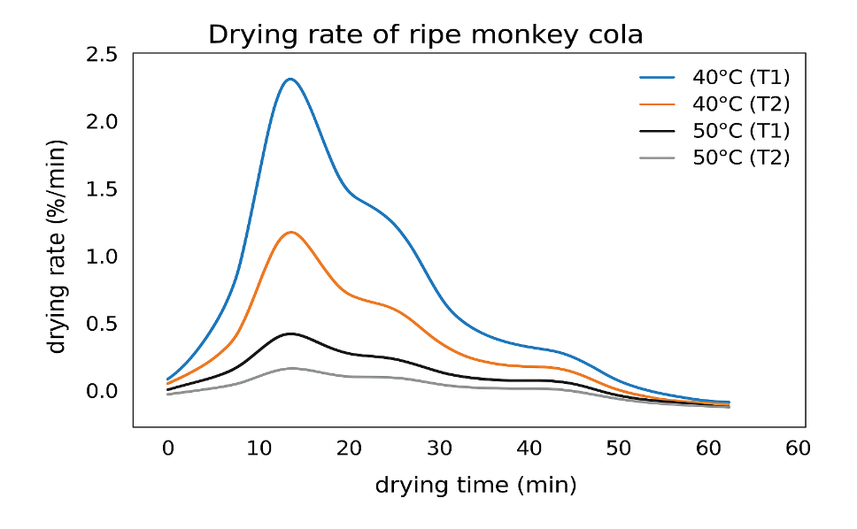
Fig. 5: Drying Rate of the ripe monkey cola

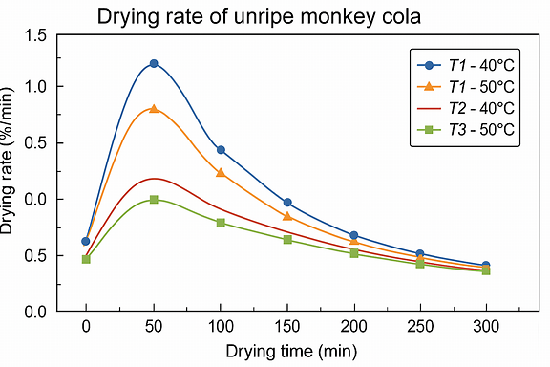
Figure 6: Drying Rate of the unripe monkey cola

3.1. Moisture Removal Trends in Ripe Monkey Cola
At 40 °C (Figure 1), ripe monkey cola slices exhibited gradual moisture reduction. Thin slices (T1) dried fastest, medium slices (T2) showed intermediate drying, and thick slices (T3) retained moisture longer. However, at 40 °C all the samples shows a rapid initial reduction in moisture content, followed by a slow rate of drying. This pattern is common in drying studies, where the initial free water is easily evaporated and as drying progresses, moisture held within cellular structure is removed at a slower rate.
Also, at T2 (10 mm thickness), it was observed that a higher moisture content was retained for a longer period more than T1 (9mm) and T3 (11 mm) as indicated by the orange curve, which drops gradually compared to T1 and T3. This indicate that T2 provides a larger moisture reservoir. From figure 2 at 50 °C, drying accelerated significantly, with sharper declines in moisture content. Additionally, at 50 °C, it was observed that the initial moisture content of the ripe monkey cola was higher at T2 and T3. This aligns with expected drying behavior where thicker samples retained moisture longer due to slower internal moisture diffusion rates.
The effect of thickness was more pronounced at higher temperature, consistent with findings in tomato drying where thinner slices dried faster and higher temperatures shortened drying time (Doymaz, 2017). Similar results were reported in papaya, where slice thickness strongly influenced drying kinetics (Sairam et al., 2017).
However, the unripe monkey cola dried more slowly than ripe samples under identical conditions. Figure 3 depicts that at 40 °C, moisture reduction was gradual, with thick slices (T3) retaining moisture for longer durations. At 50 °C (figure 4), the drying accelerated, but unripe samples still dried more slowly than ripe ones. This difference is attributed to denser tissue structure and higher bound water content in unripe fruits, which increases resistance to moisture migration. Similar maturity-related differences have been observed in mango drying, where unripe slices showed slower moisture loss compared to ripe ones (Kabiru et al., 2016; Falade & Abbo, 2017).
.
3.2. Effect of Thickness on Drying Rate
Thickness had a consistent influence across both ripe and unripe samples. From figure 5 and 6, it was observed that at T1 the drying rate was very high with peaking at the early drying process but at T2 drying rate was moderate with variability in the regression fits and the lowest drying rate was recorded at T3 with slower moisture removal. However, at 40 °C for the ripe samples it was observed that at T1 and T3 there was an exponential decline in the drying rate while at T2 the drying rate trends was a polynomial. But at 50 °C the drying rate of the ripe samples shows a sharp decline at T1 with moderate decline in T2 and T3. This pattern confirms that slice thickness is a critical factor in drying kinetics. Studies on bananas (Chigbo et al., 2024), mangoes (Kabiru et al., 2016), and papaya (Sairam et al., 2017) all report similar findings, reinforcing the universality of thickness effects in fruit drying.

3.3. Effect of Temperature on Drying Rate
Temperature significantly influenced drying rates. At 40 °C, drying was slower and more uniform, with less pronounced differences between thicknesses. At 50 °C, drying rates increased sharply, and thickness-dependent differences became more evident. Ripe samples (Figure 5) benefited more from higher temperature, while unripe samples (figure 6) retained moisture longer. These results align with Guiné (2018), who noted that higher drying temperatures enhance vapor pressure gradients, increasing the driving force for moisture diffusion. However, excessive heat may compromise product quality, including nutrient retention and sensory attributes (Kumar et al., 2016; Doymaz, 2017). Also, drying rates were higher at 50 °C compared to 40 °C with ripe samples drying faster than the unripe samples. This is due to the fact that the ripe monkey cola has a soft tissues and more free water than that of the unripe samples. This collaborates with findings by Doymaz and Ozdemir (2014) when working on pretreatment of tomatoes.

3.4. Practical Implications
The combined influence of thickness and temperature suggests that optimal drying of monkey cola can be achieved using thinner slices at moderately elevated temperatures. Ripe samples dry more efficiently, but unripe samples require longer drying times due to structural resistance. For industrial applications, thickness-specific temperature profiles should be adopted to balance drying speed with quality preservation. Pretreatment methods such as blanching or osmotic dehydration could further improve drying efficiency, as demonstrated in mango and papaya drying studies (Falade & Abbo, 2017; Sairam et al., 2017).

4. Conclusion

Drying behavior of monkey cola is strongly influenced by slice thickness and drying temperature. Thinner slices (T1) consistently dried faster, while thicker slices (T3) retained moisture longer. Higher temperature (50 °C) accelerated drying across all thicknesses, with more pronounced differences between T1, T2, and T3. Ripe monkey cola dried faster than unripe samples, highlighting the combined influence of tissue structure and water availability. These results underscore the importance of optimizing drying parameters to achieve efficient moisture removal while preserving product quality. For efficient drying, use thinner slices (T1) at moderately elevated temperatures (50 °C). Future studies should investigate airflow, humidity, and pretreatment methods to further optimize drying kinetics and industrial drying protocols should incorporate thickness-specific temperature profiles to balance drying speed and quality retention.

Disclaimer (Artificial intelligence)

Author(s) hereby declare that NO generative AI technologies such as Large Language Models (ChatGPT, COPILOT, etc.) and text-to-image generators have been used during the writing or editing of this manuscript.

5. REFERENCES
Inyang, U. E., Oboh, I. O., & Etuk, B. R. 2018. Kinetic Models for Drying Techniques—Food Materials. Advances in Chemical Engineering and Science 8(2), 26 – 35. https://doi.org/10.4236/aces.2018.82003.
Musarat, N. 2022. Experimental Evaluation and Modelling for Drying Kinetics of Fruits and Vegetables. International Journal of Multidisciplinary Research and Growth Evaluation 3(1), 153 – 155.
Olabinjo, O. O., & Adeniyan, A. T. 2020. Modelling the Drying Kinetics of Monkey Cola (Cola parchycarpa). Scientific Modelling and Research 5(1), 1 – 13.
Petikirige, J., Karim, A., & Millar, G. (2022). Effect of Drying Techniques on Quality and Sensory Properties of Tropical Fruits. Institute of Food Science and Technology Review
Olabinjo, O. O. (2020). Evaluating the Nutritive and Effect of Varying Temperatures on Quality Attributes of Monkey Cola (Cola millenii) Seeds. ResearchGate Preprint.
AOAC (2016). Official Methods of Analysis of AOAC International. 20th Edition. AOAC International, Gaithersburg, MD, USA.
Doymaz, İ., & Özdemir, Ö. (2014). Effect of air temperature, slice thickness and pretreatment on drying and rehydration of tomato. International Journal of Food Science and Technology, 49(2), 558–564. https://doi.org/10.1111/ijfs.12337.
Doymaz, İ. (2017). Drying kinetics, rehydration and colour characteristics of convective hot-air dried cherry tomatoes. Food Science and Technology, 37(4), 564–570. https://doi.org/10.1590/1678-457X.32716
Sairam, N. H., Kumar, N., Edukondalu, L., & Kumar, G. Y. (2017). Effect of slice thickness on drying kinetics of papaya using food dehydrator. International Journal of Agriculture, Environment and Biotechnology, 10(6), 749–756.
Kabiru, A. A., Joshua, A. A., & Raji, A. O. (2016). Effect of slice thickness and temperature on the drying kinetics of mango (Mangifera indica). International Journal of Research and Reviews in Applied Sciences, 29(1), 53–62.
Falade, K. O., & Abbo, E. S. (2017). Air-drying and rehydration characteristics of date palm fruits (Phoenix dactylifera L.). Journal of Food Processing and Preservation, 41(2), e12784. https://doi.org/10.1111/jfpp.12784
Kumar, C., Karim, M. A., & Joardder, M. U. H. (2016). Intermittent drying of food products: A critical review. Journal of Food Engineering, 121, 48–57. https://doi.org/10.1016/j.jfoodeng.2013.08.014 (doi.org in Bing)
Chigbo, K. S., Linus-Chibuezeh, A., Moufunanya, U. F., Adindu-Linus, C. O., Adepoju, F. O., Eke, A. B., et al (2024). Mathematical modeling of the effects of thickness and temperature on thin-layer drying kinetics of oven-dried cooking bananas (Musa spp., sub. grp. ABB) slices. Food Production, Processing and Nutrition, 6(51). Springer Nature. https://doi.org/10.1186/s43014-024-00151-3 (doi.org in Bing)
Guiné, R. P. F. (2018). The drying of foods and its effect on the physical-chemical, sensorial and nutritional properties. International Journal of Food Engineering, 14(1–2), 20170071. https://doi.org/10.1515/ijfe-2017-0071 (doi.org in Bing)

