Management of Retinal Macroaneurysms:

A Case Series and Treatment Approaches

Abstract
Retinal arterial macroaneurysms (RMAs) are uncommon vascular lesions that can lead to visual impairment through exudation or hemorrhage. We report a retrospective case series of four patients with symptomatic RMAs evaluated using multimodal imaging and managed with different therapeutic approaches.
All patients presented with decreased visual acuity and a history of systemic hypertension. Initial best-corrected visual acuity (BCVA) ranged from 1/10 to 5/10. Multimodal imaging—including optical coherence tomography (OCT), fluorescein angiography (FA), and OCT angiography—enabled accurate characterization of lesion type (exudative versus hemorrhagic) and guided treatment decisions.
Three patients with exudative macroaneurysms received intravitreal anti-VEGF therapy (bevacizumab), resulting in macular edema reduction and BCVA improvement by 1–3 lines. One patient with combined focal laser achieved additional lesion stabilization. One patient with multilayered macular hemorrhage underwent pars plana vitrectomy with internal limiting membrane peeling, leading to anatomical resolution but limited functional recovery (BCVA improved from 2/10 to 4/10).
These findings highlight the importance of multimodal imaging in differentiating exudative and hemorrhagic RMAs and tailoring treatment strategies. Intravitreal anti-VEGF therapy appears effective as a first-line approach in most symptomatic cases, with adjunctive laser or surgical intervention reserved for selected presentations.

Keywords
Retinal arterial macroaneurysm; anti-VEGF; laser photocoagulation; vitrectomy; multimodal imaging; OCT; fluorescein angiography

Introduction
Retinal arterial macroaneurysms (RMAs) are rare, acquired dilations of large-caliber retinal arteries, most commonly observed in elderly patients with systemic hypertension. These lesions may lead to visual impairment through macular edema, lipid exudation, serous retinal detachment, or retinal hemorrhage. Clinical presentation varies from asymptomatic incidental findings to severe vision-threatening complications.
Management strategies include observation, focal laser photocoagulation, intravitreal anti-vascular endothelial growth factor (anti-VEGF) therapy, and vitreoretinal surgery in complicated cases. Treatment selection depends on lesion location, severity, and associated complications.
This case series reports four patients with symptomatic RMAs evaluated using multimodal imaging and managed with different therapeutic approaches, highlighting real-world outcomes.

Methods
We conducted a retrospective observational case series of patients diagnosed with retinal arterial macroaneurysms at our institution between January 2023 and January 2025.
Inclusion criteria were:
- Clinically and imaging-confirmed retinal arterial macroaneurysm,
- Presence of visual symptoms,
- Availability of multimodal imaging, including OCT and fluorescein angiography.
Four patients met the inclusion criteria. All underwent comprehensive ophthalmologic examination, including best-corrected visual acuity (BCVA), fundus photography, OCT, and fluorescein angiography. OCT angiography was performed when feasible.
Treatment was individualized according to lesion type (exudative or hemorrhagic), location, and severity. Interventions included intravitreal anti-VEGF injections (bevacizumab or ranibizumab), focal laser photocoagulation, and pars plana vitrectomy.
Given the small sample size, data are presented descriptively.

RESULTS
Four cases illustrate the spectrum of clinical presentations and management approaches. Among the four patients, three were female (75%) and one male (25%), with a mean age of 66 years (range: 57–80 years). All patients had a history of hypertension. Management strategies were guided by the stage of the macroaneurysm (exudative versus hemorrhagic) and lesion location (perimacular versus peripheral).

Case 1:
The first patient, a male, presented with a crown-like exudative plaque, punctiform hemorrhages, and peripheral telangiectasias. Fundus examination and fluorescein angiography revealed a saccular parapapillary hyperfluorescence, while OCT showed cystoid macular edema (CME) and serous retinal detachment. His initial visual acuity (VA) was 3/10. The patient received three monthly intravitreal Bevacizumab injections. Follow-up demonstrated a reduction of macular edema and an improvement in VA to 5/10, corresponding to a gain of approximately two lines.
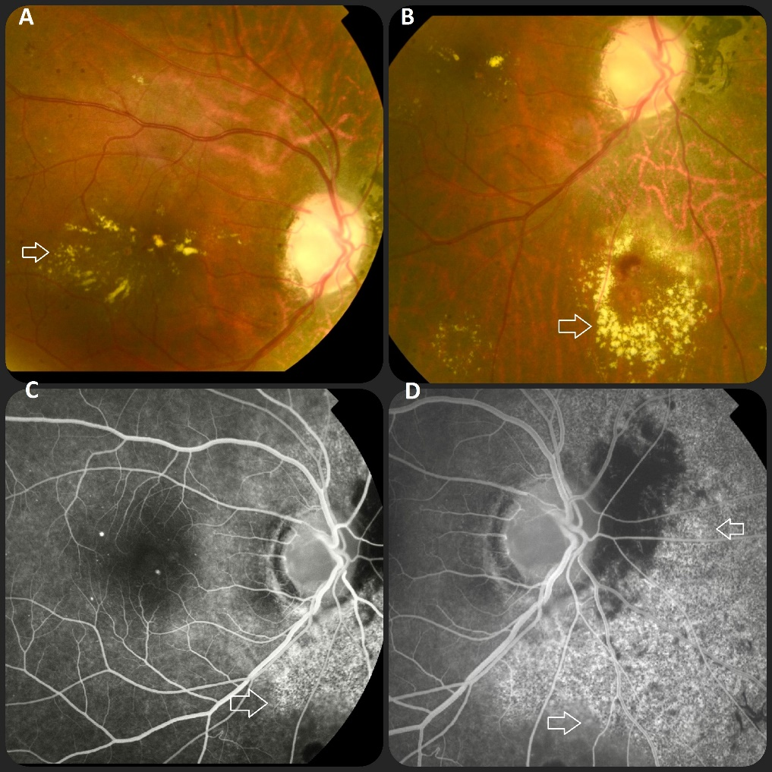

FIGURE 1: Fundus photograph of the right eye (Patient 1) Macroaneurysm of the inferior temporal branch arteriole associated with a perifoveolar crown-like exudative plaque, peripheral telangiectasias, and punctiform hemorrhages ( arrows, A–B). Fluorescein angiography demonstrates the macroaneurysm as a saccular hyperfluorescent vascular dilation at the parapapillary area (arrows, C–D).

Case 2:
The second patient, a female, exhibited a macroaneurysm on a superior arterial branch, surrounded by a crown-like exudative plaque in the macular region. Fundus autofluorescence revealed a well-defined hypoautofluorescent area corresponding to the macroaneurysm and surrounding exudation. OCT confirmed CME and subretinal fluid. Her initial VA was 5/10. She received three monthly intravitreal Bevacizumab injections. Post-treatment evaluation showed significant reduction of macular edema and exudation, with VA improving to 8/10 (+3 lines).
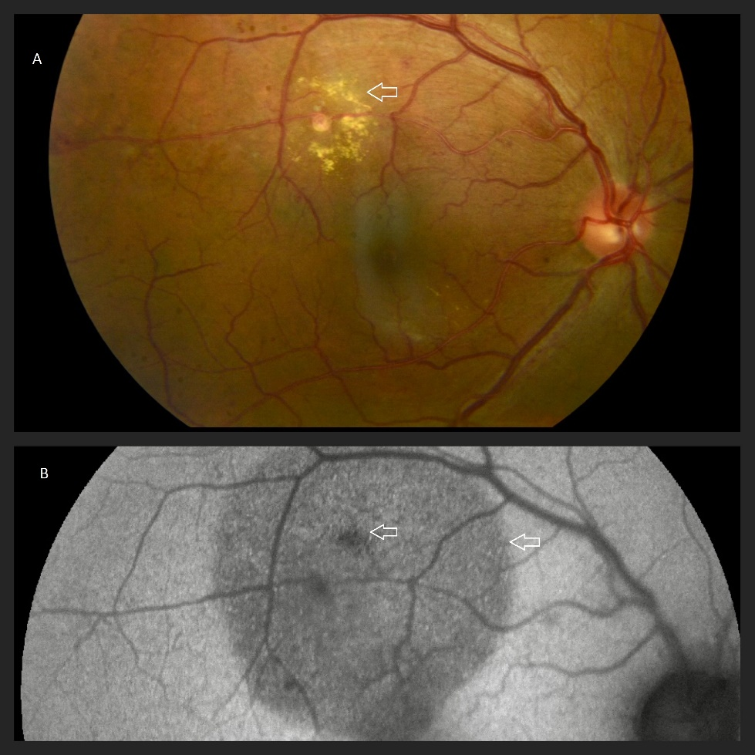

FIGURE 2: Fundus photograph of the right eye ( Patient 2) Macroaneurysm on a branch of the superior central retinal artery, surrounded by a crown-like exudative plaque in the superior macular region ( arrow A). Autofluorescence highlights a well-defined hypoautofluorescent area corresponding to the macroaneurysm and surrounding exudative plaque (arrow, B)
Both patients were treated with three monthly intravitreal bevacizumab injections. Follow-up showed significant reduction of macular edema and exudation, with corresponding improvement in visual acuity.

Case 3:
The third patient presented with an extensive perimacular exudative plaque associated with peripheral telangiectasias, punctate hemorrhages, and a fibrotic component (Figure 3A–B). OCT confirmed CME, serous retinal detachment, and hyperreflective lipid exudates (Figure 3C). Fluorescein angiography demonstrated early hyperfluorescence with progressive leakage from a parapapillary saccular lesion (Figure 3D).
This patient received four monthly intravitreal bevacizumab injections combined with targeted focal laser photocoagulation of the macroaneurysm.) During follow-up, progressive resolution of macular edema was observed on OCT, but due to the fibrotic and cicatricial changes, functional recovery remained modest, with VA improving to 2/10 (~1 line).
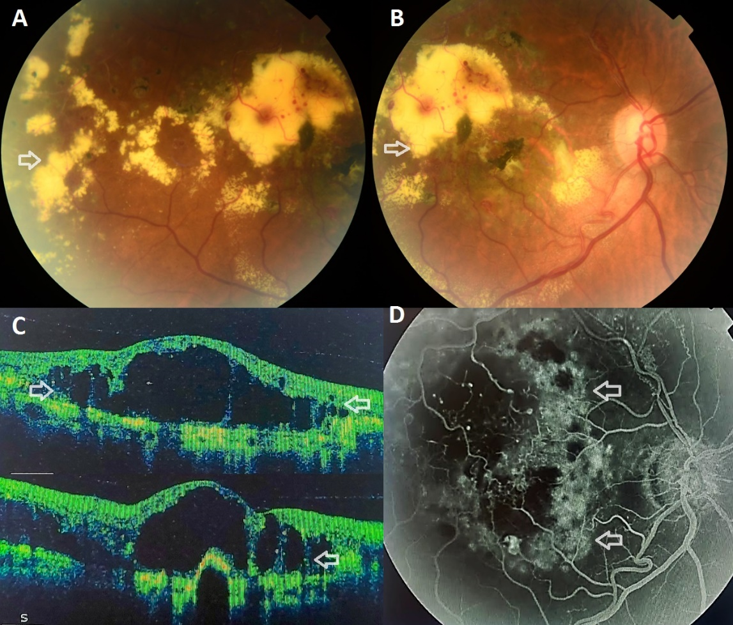

FIGURE 3: Fundus photograph of the right eye ( Patient 3 ) An extensive perimacular exudative plaque with peripheral telangiectasias, punctiform hemorrhages, and a fibrotic area is shown on fundus photography (arrows, A–B). Optical coherence tomography (OCT) demonstrates cystoid macular edema ( arrows, C). Fluorescein angiography reveals hyperfluorescence with leakage at the aneurysmal site ( arrows, D).
Case 4:
The fourth patient presented with a multilayered macular hemorrhage overlying a foveal macroaneurysm, involving both subretinal and sub-internal limiting membrane compartments (Figure 4).
Given the severity of the hemorrhage, a 23-gauge pars plana vitrectomy was performed, including internal limiting membrane (ILM) peeling and induction of posterior vitreous detachment. Postoperatively, anatomical resolution of the hemorrhage was achieved. Anatomical resolution of the hemorrhage was achieved postoperatively, but visual recovery was limited due to secondary retinal atrophy, with VA improving to 4/10.
A synthesized overview of clinical characteristics, imaging findings, treatments, and outcomes for all four patients is presented in Table 1.
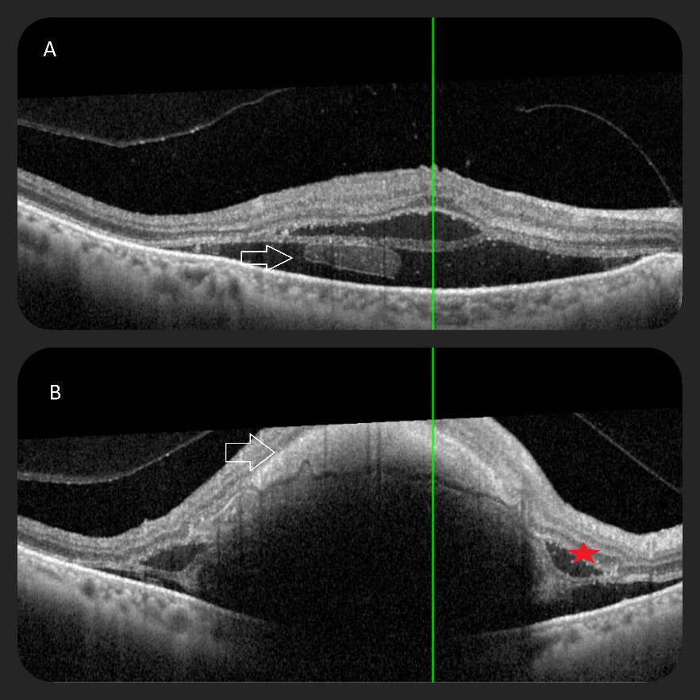

FIGURE 4: Optical coherence tomography of a submacular hemorrhage (Patient 4) 4A: Multilayered macular hemorrhage over a foveal macroaneurysm (arrows), partly subretinal. 4B: Hemorrhage partly under the internal limiting membrane (arrows), associated with serous retinal detachment (red cross).

Overall, anti-VEGF therapy demonstrated consistent edema resolution and visual acuity improvement, laser therapy stabilized selected cases, and vitrectomy was reserved for complicated presentations with limited functional success.

Case | Initial VA | Post-treatment VA | Main Retinal Findings (Fundus/Angio/OCT) | Imaging Summary | Treatment | Outcome
1 (Male) | 3/10 | 5/10 | Crown-like exudative plaque, punctiform hemorrhages, peripheral telangiectasias | FA: saccular parapapillary hyperfluorescence; OCT: CME, serous retinal detachment | 3 intravitreal Bevacizumab injections | Macular edema reduced; functional improvement
2 (Female) | 5/10 | 8/10 | Superior macular exudative plaque, hypoautofluorescent area | OCT: CME and serous detachment; Autofluorescence: well-defined hypo-autofluorescent area | 3 intravitreal Bevacizumab injections | Edema reduction; visual improvement
3 (Female) | 1/10 | 2/10 | CME, serous detachment, lipid exudates, fibrotic component; FA: early hyperfluorescence with progressive leakage at parapapillary saccular lesion; OCT-A: flow in superficial & deep vascular plexuses | OCT: CME, serous detachment, vascular flow; FA: progressive leakage | 4 monthly IVB injections + targeted laser photocoagulation | Gradual edema resolution; modest VA gain due to fibrosis (~1 line); condition stabilized
4 (Female) | 2/10 | 4/10 | Multilayered macular hemorrhage involving foveal macroaneurysm | FA/OCT: hemorrhage over foveal macroaneurysm | 23-gauge vitrectomy with ILM peeling & posterior vitreous detachment induction | Anatomical hemorrhage resolution; limited visual recovery due to secondary retinal atrophy

TABLE 1: Summary of clinical features, retinal imaging findings, treatments, and outcomes of four patients with symptomatic retinal arterial macroaneurysms.
This table provides a concise overview of the spectrum of presentations and management approaches in the case series. Clinical presentation includes location of macroaneurysm, associated exudative or hemorrhagic changes, and patient sex. Main retinal findings summarize fundus, fluorescein angiography (FA), and optical coherence tomography (OCT) features. Imaging summary highlights OCT-Angiography or other imaging specifics when available. Treatment indicates intravitreal injections, laser, or surgical interventions. Outcome describes anatomical and functional results following therapy.

Discussion
Retinal arterial macroaneurysms (RMAs) are uncommon, acquired dilations of large-caliber retinal arteries, typically exceeding 200 µm in diameter. They were first described by Loring in 1880 [1], and in 1920 Fernandez demonstrated a clear association with systemic hypertension [2]. Robertson formally defined the entity in 1973 [3]. RMAs are most frequently observed in elderly patients with systemic hypertension and arteriosclerotic vascular changes [4]. Although some RMAs remain asymptomatic, complications such as cystoid macular edema, serous retinal detachment, lipid exudates, or retinal hemorrhage can lead to significant visual impairment [5,6]. The pathophysiology involves weakening of the arterial wall secondary to chronic vascular stress, with subsequent leakage or rupture, sometimes complicated by multilayered hemorrhages [4,6].
Diagnosis relies on careful clinical examination complemented by paraclinical imaging. Fundus evaluation often reveals a fusiform or saccular dilation of a retinal artery, sometimes accompanied by hemorrhage or exudation. Fluorescein angiography remains the gold standard for confirming vascular flow and leakage [7], while optical coherence tomography (OCT) provides assessment of macular edema and structural changes [8].
Non-invasive OCT angiography (OCT-A) can offer valuable information regarding vascular flow and aneurysm morphology and is particularly useful for monitoring treatment response, although hemorrhage may attenuate the signal and degrade image quality [9].
Differential diagnosis includes retinal telangiectasia, venous macroaneurysms, retinal angiomatosis, diabetic retinopathy, and cavernous hemangioma [4].
The natural history of RMAs generally follows an initial growth phase during which exudation or hemorrhage may occur, followed by spontaneous involution characterized by fibrosis or thrombosis [10,11]. Asymptomatic lesions are typically observed, while treatment is indicated when macular involvement threatens visual acuity [10].
Historically, laser photocoagulation has been the primary treatment, aiming to occlude the macroaneurysm and stabilize visual function [8,12]. Fluorescein angiography is used to confirm complete occlusion, and OCT allows monitoring of resolution of cystoid macular edema, serous retinal detachment, and lipid exudates [9]. Despite its effectiveness, laser carries potential complications: excessive coagulation may lead to occlusion of the parent arterial branch, rupture of the aneurysm may cause extensive retinal hemorrhage, and progressive retinal atrophy may develop at the laser site over time [12].
Intravitreal anti-VEGF therapy has emerged as an effective treatment modality for retinal arterial macroaneurysms, particularly in cases with macular involvement or proximity to the fovea. Multiple small case series and reports have demonstrated that anti-VEGF injections can promote thrombosis of the aneurysm, reduce macular edema and exudation, and allow earlier functional recovery without the risks of arterial branch occlusion or rupture associated with laser photocoagulation [10–12,13–15]. Specifically, Bevacizumab has been employed in several studies [13,14], while Ranibizumab has also been successfully used, including in combination with focal laser treatment [15]. Furthermore, some reports indicate that combining anti-VEGF therapy with focal laser may enhance the reduction of macular exudation, achieving both anatomical resolution and functional improvement [11,12].
In a recent real-world study, Wang et al. evaluated the outcomes of anti-VEGF therapy in patients with retinal arterial macroaneurysms and confirmed its effectiveness in promoting aneurysm involution, reducing macular edema and exudation, and improving visual function. The study emphasized that anti-VEGF injections are particularly beneficial for lesions located near the fovea, providing rapid anatomical improvement and functional recovery without the risks of parent artery occlusion or extensive retinal damage associated with laser therapy [20].
In more severe cases, particularly with extensive subretinal or submacular hemorrhage, surgical intervention may be required. Blood is toxic to retinal tissues from the first 24 hours, affecting multiple layers including beneath the internal limiting membrane (ILM) [6,10]. Early intervention is therefore critical. Surgical management often includes ILM peeling to facilitate clearance of subretinal blood and may be combined with pneumatic displacement. Intravitreal or subretinal tPA-assisted thrombolysis can be employed to dissolve clotted blood and evacuate submacular hemorrhage, optimizing anatomical outcomes [16,17]. Although vitreous, preretinal, and intraretinal hemorrhages tend to resolve spontaneously, submacular hemorrhage can cause permanent central visual loss due to retinal pigment epithelium damage. tPA-assisted submacular surgery has been shown to improve best-corrected visual acuity in patients with recent foveal involvement [16,17].
The functional prognosis of RMAs largely depends on the type and location of hemorrhage. Subretinal hemorrhage and macular holes are associated with poor visual outcomes, often resulting in retinal and retinal pigment epithelium atrophy, whereas pre-retinal or intravitreal hemorrhages generally carry a more favorable prognosis regardless of the treatment applied [18].
Moreover, Lewis et al. reported that in their case series of patients with retinal arterial macroaneurysms, approximately 25 % experienced major systemic vascular events—including cerebrovascular accidents, myocardial infarction, or rupture of an abdominal aneurysm—within 9 months to 5 years after diagnosis [19]. While retinal macroaneurysms are not themselves predictive of overall survival, their presence may indicate an increased risk of systemic vascular events, underscoring the need for thorough cardiovascular assessment in these patients [19-22]. Recent advances in imaging, particularly swept-source optical coherence tomographic angiography (SS-OCT-A), have enhanced the visualization of retinal arterial macroaneurysms, allowing precise assessment of aneurysm morphology, blood flow, and surrounding retinal changes. Song et al. demonstrated that SS-OCT-A can effectively detect subtle macroaneurysm features and monitor treatment response, providing a non-invasive tool for longitudinal follow-up of these lesions [21].

In our series, several key observations emerge. First, intravitreal anti-VEGF therapy provided the most consistent anatomical and functional improvement in cases with macular involvement, particularly in reducing cystoid macular edema and exudation. Second, combined therapy with focal laser photocoagulation appeared beneficial in selected cases by enhancing lesion stabilization. Third, surgical management was required in cases complicated by multilayered hemorrhage, allowing anatomical resolution but with limited functional recovery due to secondary retinal damage. Finally, multimodal imaging played a central role in guiding treatment decisions and monitoring response, particularly in distinguishing exudative from hemorrhagic presentations.
Management of RMAs therefore requires a tailored approach, integrating lesion location, severity, and functional impact, while balancing the efficacy and risks of laser, anti-VEGF therapy, and surgical intervention. [1–22].

Conclusion
This case series provides valuable insights into the treatment of retinal macroaneurysms. While anti-VEGF therapy is the cornerstone of management, laser and surgical interventions remain useful for specific complications. Tailoring the treatment approach to the individual patient is essential for optimizing outcomes and preventing long-term visual impairment.
Authors’ Contributions
All authors contributed to the conception, data acquisition, analysis, drafting, and critical revision of the manuscript. All authors approved the final version of the manuscript.
Disclaimer (Artificial intelligence)
Author(s) hereby declare that NO generative AI technologies such as Large Language Models (ChatGPT, COPILOT, etc.) and text-to-image generators have been used during the writing or editing of this manuscript.
Competing Interests
The authors declare no competing interests.
Consent
Written informed consent for publication of this case report and accompanying images was obtained from all patients.
Ethical Approval
As this is a retrospective descriptive case series involving anonymized clinical data, formal ethical approval was not required.
REFERENCES
[1] Jiramongkolchai K, Arevalo JF. Retinal arterial macroaneurysm. Eur Eye Res. 2021;1:156–160. doi:10.14744/eer.2021.47966
[2] Cahuzac A, Scemama C, Mauget-Faÿsse M, Sahel J-A, Wolff B. Retinal arterial macroaneurysms: clinical, angiographic, and tomographic description and therapeutic management of a series of 14 cases. Eur J Ophthalmol. 2016;26:36–43. doi:10.5301/ejo.5000641
[3] Robertson D. Retinal arterial macroaneurysms: Definition and clinical features. Arch Ophthalmol. 1973;90:123–130.
[4] Rabb MF, Gagliano DA, Teske MP. Retinal arterial macroaneurysms. Ophthalmology. 1988;95:893–899. doi:10.1016/0039-6257(88)90160-9
[5] Deschasse C, Isaico R, Creuzot-Garcher C, Bron AM. Retinal macroaneurysms and macular hemorrhages: Report of five cases. J Fr Ophtalmol. 2014;37:347–352. doi:10.1016/j.jfo.2013.12.010
[6] Pitkänen L, Tommila P, Kaarniranta K, et al. Retinal arterial macroaneurysms. Acta Ophthalmol. 2014;92:101–104. doi:10.1111/aos.12210
[7] Moosavi RA, Fong KCS, Chopdar A. Retinal artery macroaneurysms: Clinical and fluorescein angiographic features in 34 patients. Eye. 2006;20:1011–1020. doi:10.1038/sj.eye.6702193
[8] Abdel-Khalek MN, Richardson J. Retinal macroaneurysm: Natural history and guidelines for treatment. Br J Ophthalmol. 1986;70:2–11. doi:10.1136/bjo.70.1.2
[9] Krivosic V. Ophthalmologic Realities - Issue 265, October 2019 - Notebook 1. Odéon Ophthalmology Center, Lariboisière Hospital, Paris Sorbonne University, Paris.
[10] Pichi F, Morara M, Torrazza C, et al. Intravitreal bevacizumab for macular complications from retinal arterial macroaneurysms. Am J Ophthalmol. 2013;155:287–294. doi:10.1016/j.ajo.2012.07.029
[11] Mansour AM, Foster RE, Gallego-Pinazo R, et al. Intravitreal anti-vascular endothelial growth factor injections for exudative retinal arterial macroaneurysms. Retina. 2019;39:1133–1141. doi:10.1097/IAE.0000000000002131
[12] Brar M, Grewal SP, Grewal DS, Sharma M, Dogra MR. Swept-source optical coherence tomography angiography of a case of retinal artery macroaneurysm before and after combined laser and intravitreal ranibizumab treatment. Retina. 2022;42:1234–1240. doi:10.4103/ijo.IJO_160_22
[13] Retinal arterial macroaneurysms (RAM): Pathology, differential diagnosis, and therapy. Ophthalmologe. 2015;112:627–634. doi:10.1055/s-0034-1382953
[14] Intravitreal Bevacizumab for symptomatic retinal arterial macroaneurysm. Am J Ophthalmol. 2013;155:898–904. doi:10.1016/j.ajo.2012.12.003
[15] Tonotsuka T, Imai M, Saito K, Iijima H. Visual prognosis for symptomatic retinal arterial macroaneurysm. Clin Invest Ophthalmol. 2003;41:215–221. doi:10.1016/s0021-5155(03)00104-7
[16] Humayun M, Lewis H, Flynn HW Jr, Sternberg P Jr, Blumenkranz MS. Management of submacular hemorrhage associated with retinal arterial macroaneurysms. Ophthalmology. 1998;105:2213–2219. doi:10.1016/s0002-9394(98)00090-7
[17] Lewis RA, Norton EW, Gass JD. Acquired arterial macroaneurysms of the retina. Br J Ophthalmol. 1976;60:21–27. doi:10.1136/bjo.60.1.21
[18] Wang Y, Du H. Observation, laser photocoagulation or anti-VEGF therapy in the management of retinal arterial macroaneurysms. BMC Ophthalmol. 2022;22:417. doi:10.1186/s12886-022-02669-5
[19] Faghihi H, Jalali S, Faghihi R, et al. Anti-VEGF therapy versus laser photocoagulation in retinal arterial macroaneurysms: a comparative study. Retina. 2021;41:1152–1160. doi:10.1097/IAE.0000000000002912
[20] Rishi P, Rishi E, Gopal L, et al. Long-term outcomes of intravitreal ranibizumab for exudative retinal arterial macroaneurysms. Graefes Arch Clin Exp Ophthalmol. 2022;260:1681–1690. doi:10.1007/s00417-022-05657-w
[21] Song Y, Zhang W, Yu S, et al. Appearance of retinal arterial macroaneurysms in patients using swept-source optical coherence tomographic angiography. BMC Ophthalmol. 2023;23:280. doi:10.1186/s12886-023-02999-w
[22] Chen J, Lin H, Liu Y, et al. Real-world outcomes of anti-VEGF therapy for retinal arterial macroaneurysms: multicenter case series. Eye. 2023;37:1502–1512. doi:10.1038/s41433-023-02448-9

