Case study

Management of Retinal Macroaneurysms: A Case Series and Treatment Approaches

Abstract
Retinal macroaneurysms (RMAs) are rare, acquired retinal vascular lesions that can cause visual impairment through macular edema, hemorrhage, or serous retinal detachment. This case series evaluates the outcomes of three main treatment strategies—intravitreal anti-VEGF therapy, laser photocoagulation, and vitrectomy—in four patients with symptomatic RMAs. Anti-VEGF therapy provided the most consistent reduction in macular edema and improvement in visual acuity, while laser photocoagulation contributed to stabilization of the lesions in selected cases. Vitrectomy was reserved for severe hemorrhagic presentations, leading to anatomical improvement but limited functional recovery. Tailored management according to lesion characteristics and severity remains essential to optimize patient outcomes.

Introduction
Retinal arterial macroaneurysms (RMAs) are rare, acquired dilations of large-caliber retinal arteries, most commonly observed in elderly patients with systemic hypertension [1]. Initially described in the late 19th century, RMAs can compromise vision through macular edema, lipid exudation, serous retinal detachment, or multilayered hemorrhage [2]. Clinical presentation varies from incidental, asymptomatic lesions to severe, vision-threatening cases [3].
Management strategies include observation for asymptomatic lesions, focal laser photocoagulation, intravitreal anti-VEGF injections, and vitreoretinal surgery for complicated cases [4]. Despite numerous reports, the optimal therapeutic approach should be individualized based on lesion location, severity, and associated complications [5].
This case series reports four patients with symptomatic RMAs treated using different modalities and evaluates both anatomical and functional outcomes.

Methods
We conducted a retrospective analysis of patients diagnosed with retinal macroaneurysms, between 2 years. A total of 4 cases were included. Treatment approaches varied based on the clinical presentation of each patient, including intravitreal anti-VEGF injections (Bevacizumab or Ranibizumab), laser photocoagulation, and vitrectomy. Patients were monitored for changes in visual acuity (VA), macular edema, hemorrhage resolution, and retinal anatomy before and after treatment.

Results
Four cases illustrate the spectrum of clinical presentations and management approaches. Among the four patients, three were female (75%) and one male (25%), with a mean age of 66 years (range: 57–80 years). All patients had a history of hypertension. Management strategies were guided by the stage of the macroaneurysm (exudative versus hemorrhagic) and lesion location (perimacular versus peripheral).
Case 1:
The first patient presented with a macroaneurysm involving an inferotemporal arterial branch, associated with a perifoveolar crown-like exudative plaque, peripheral telangiectasias, and punctate hemorrhages, as shown on fundus photography (Figure 1A). Fluorescein angiography demonstrated a saccular hyperfluorescent dilation in the parapapillary region corresponding to the macroaneurysm (Figure 1B). OCT revealed cystoid macular edema (CME) with associated serous retinal detachment.

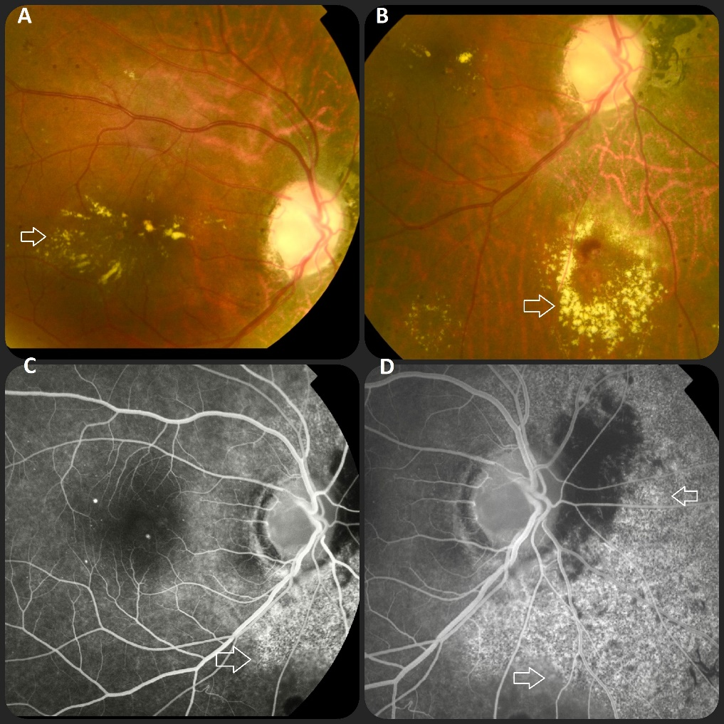

FIGURE 1: Fundus photograph of the right eye (Patient 1) Macroaneurysm of the inferior temporal branch arteriole associated with a perifoveolar crown-like exudative plaque, peripheral telangiectasias, and punctiform hemorrhages ( arrows, A–B). Fluorescein angiography demonstrates the macroaneurysm as a saccular hyperfluorescent vascular dilation at the parapapillary area (arrows, C–D).
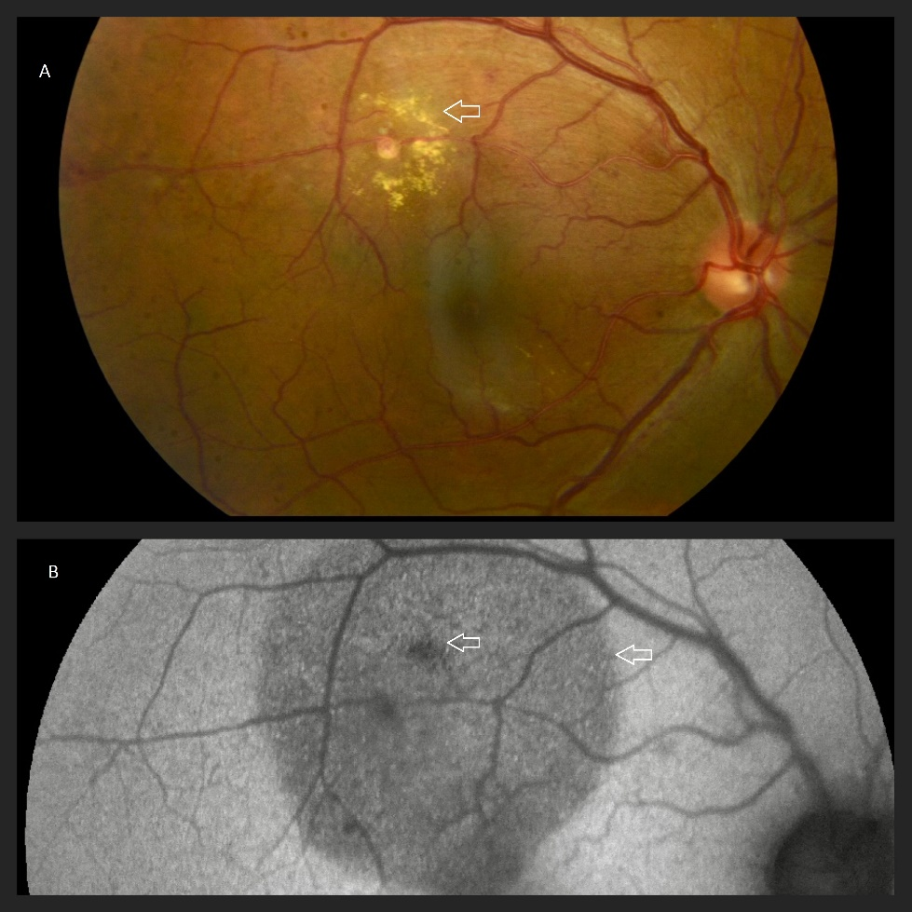
Case 2:
The second patient exhibited a macroaneurysm on a superior arterial branch, surrounded by a crown-like exudative plaque encircling the lesion in the macular region (Figure 2A). Fundus autofluorescence revealed a well-defined hypoautofluorescent area corresponding to the macroaneurysm and surrounding exudation (Figure 2B). OCT demonstrated CME and subretinal fluid.

FIGURE 2: Fundus photograph of the right eye ( Patient 2) Macroaneurysm on a branch of the superior central retinal artery, surrounded by a crown-like exudative plaque in the superior macular region ( arrow A). Autofluorescence highlights a well-defined hypoautofluorescent area corresponding to the macroaneurysm and surrounding exudative plaque (arrow, B)

Both patients were treated with three monthly intravitreal bevacizumab injections. Follow-up showed significant reduction of macular edema and exudation, with corresponding improvement in visual acuity.

Case 3:
The third patient presented with an extensive perimacular exudative plaque associated with peripheral telangiectasias, punctate hemorrhages, and a fibrotic component (Figure 3A–B). OCT confirmed CME, serous retinal detachment, and hyperreflective lipid exudates (Figure 3C). Fluorescein angiography demonstrated early hyperfluorescence with progressive leakage from a parapapillary saccular lesion (Figure 3D).
This patient received four monthly intravitreal bevacizumab injections combined with targeted focal laser photocoagulation of the macroaneurysm. Progressive resolution of macular edema was observed, with stabilization of the lesion and modest visual acuity improvement (approximately one line).
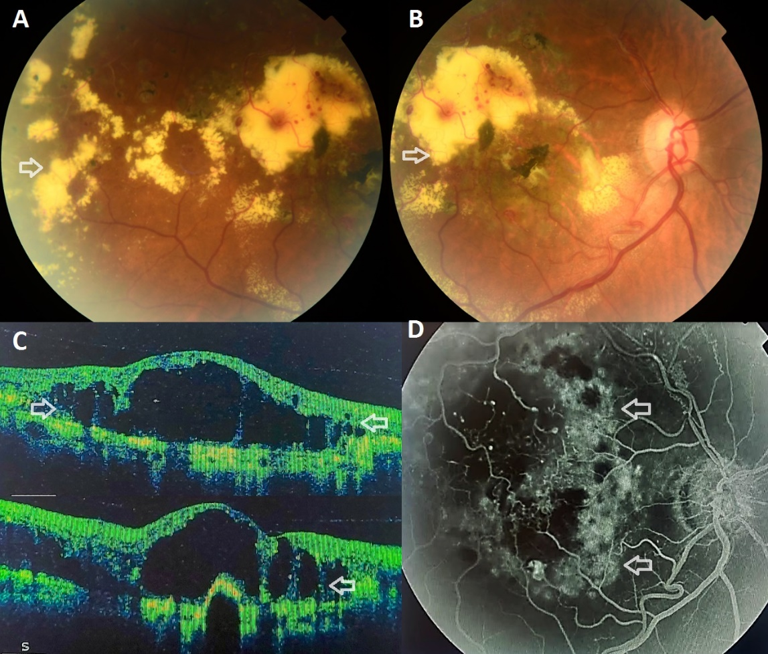

FIGURE 3: Fundus photograph of the right eye ( Patient 3 ) An extensive perimacular exudative plaque with peripheral telangiectasias, punctiform hemorrhages, and a fibrotic area is shown on fundus photography (arrows, A–B). Optical coherence tomography (OCT) demonstrates cystoid macular edema ( arrows, C). Fluorescein angiography reveals hyperfluorescence with leakage at the aneurysmal site ( arrows, D).

Case 4:
The fourth patient presented with a multilayered macular hemorrhage overlying a foveal macroaneurysm, involving both subretinal and sub-internal limiting membrane compartments (Figure 4).
Given the severity of the hemorrhage, a 23-gauge pars plana vitrectomy was performed, including internal limiting membrane (ILM) peeling and induction of posterior vitreous detachment. Postoperatively, anatomical resolution of the hemorrhage was achieved. However, visual recovery remained limited due to secondary retinal atrophy.
A synthesized overview of clinical characteristics, imaging findings, treatments, and outcomes for all four patients is presented in Table 1.
Overall, intravitreal anti-VEGF therapy demonstrated consistent efficacy in reducing macular edema and improving visual acuity in exudative forms. Focal laser photocoagulation provided additional stabilization in selected cases. Vitrectomy was reserved for complicated hemorrhagic presentations and allowed anatomical recovery, although functional outcomes were limited.
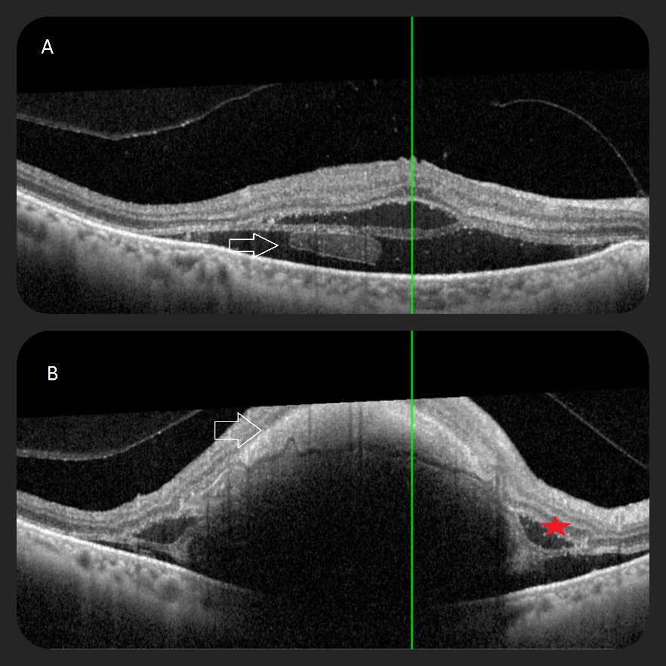

FIGURE 4: Optical coherence tomography of a submacular hemorrhage (Patient 4) 4A: Multilayered macular hemorrhage over a foveal macroaneurysm (arrows), partly subretinal. 4B: Hemorrhage partly under the internal limiting membrane (arrows), associated with serous retinal detachment (red cross).

Table 1-Summary Table of Clinical Findings and Outcomes

The clinical characteristics of the reported cases are summarized as follows:
Case | Clinical Summary | Visual Acuity (VA) | Retinal Findings (Fluorescein Angiography & OCT) | Treatment | Outcome & Evolution
1 | 65-year-old female, history of hypertension, right eye vision loss. | Hand motion at 1 meter | Fluorescein angiography: Early hyperfluorescence, progressive leakage at aneurysm site. OCT: Cystoid macular edema (CME) with serous retinal detachment. | 4 intravitreal Bevacizumab injections + laser photocoagulation | Partial resolution of macular edema, visual acuity improved by 1 line. Stabilization of retinal condition.
2 | 80-year-old female, hypertension, severe vision loss in right eye. | Hand movements | Fluorescein angiography: Multilayered hemorrhage with leakage at foveal macroaneurysm. OCT: Macular hemorrhage, retinal atrophy. | 23-gauge vitrectomy, ILM peeling, PVD | Anatomical improvement, macular area cleared, but minimal visual acuity improvement (0.05). Retinal atrophy observed.
3 | 62-year-old male, poorly controlled diabetes and hypertension, sudden vision loss in left eye. | 1/20 | Fluorescein angiography: Hyperfluorescence with leakage at aneurysmal site. OCT: CME, serous retinal detachment. OCT-A: Positive vascular flow. | 3 intravitreal Ranibizumab injections | Significant reduction in exudation, visual acuity improved by 4 lines, resolution of macular edema and exudates.
4 | 57-year-old female, hypertension, metabolic syndrome, sudden vision loss in right eye. | 2/20 | Fluorescein angiography: Early hyperfluorescence with leakage at aneurysm site. OCT: CME with lipid exudates. OCT-A: Positive vascular flow. | 4 intravitreal Ranibizumab injections | Moderate reduction in macular exudates, visual acuity improved by 3 lines, resolution of macular edema.

Discussion
Retinal arterial macroaneurysms (RMAs) are uncommon, acquired dilations of large-caliber retinal arteries, typically exceeding 200 µm in diameter. They were first described by Loring in 1880 [1], and in 1920 Fernandez demonstrated a clear association with systemic hypertension [2]. Robertson formally defined the entity in 1973 [3]. RMAs are most frequently observed in elderly patients with systemic hypertension and arteriosclerotic vascular changes [4]. Although some RMAs remain asymptomatic, complications such as cystoid macular edema, serous retinal detachment, lipid exudates, or retinal hemorrhage can lead to significant visual impairment [5,6]. The pathophysiology involves weakening of the arterial wall secondary to chronic vascular stress, with subsequent leakage or rupture, sometimes complicated by multilayered hemorrhages [4,6].
Diagnosis relies on careful clinical examination complemented by paraclinical imaging. Fundus evaluation often reveals a fusiform or saccular dilation of a retinal artery, sometimes accompanied by hemorrhage or exudation. Fluorescein angiography remains the gold standard for confirming vascular flow and leakage [7], while optical coherence tomography (OCT) provides assessment of macular edema and structural changes [8]. Non-invasive OCT angiography (OCT-A) can offer valuable information regarding vascular flow and aneurysm morphology and is particularly useful for monitoring treatment response, although hemorrhage may attenuate the signal and degrade image quality [9]. Differential diagnosis includes retinal telangiectasia, venous macroaneurysms, retinal angiomatosis, diabetic retinopathy, and cavernous hemangioma [4].
The natural history of RMAs generally follows an initial growth phase during which exudation or hemorrhage may occur, followed by spontaneous involution characterized by fibrosis or thrombosis [10,11]. Asymptomatic lesions are typically observed, while treatment is indicated when macular involvement threatens visual acuity [10].
Historically, laser photocoagulation has been the primary treatment, aiming to occlude the macroaneurysm and stabilize visual function [8,12]. Fluorescein angiography is used to confirm complete occlusion, and OCT allows monitoring of resolution of cystoid macular edema, serous retinal detachment, and lipid exudates [9]. Despite its effectiveness, laser carries potential complications: excessive coagulation may lead to occlusion of the parent arterial branch, rupture of the aneurysm may cause extensive retinal hemorrhage, and progressive retinal atrophy may develop at the laser site over time [12].
Intravitreal anti-VEGF therapy has emerged as an effective treatment modality for retinal arterial macroaneurysms, particularly in cases with macular involvement or proximity to the fovea. Multiple small case series and reports have demonstrated that anti-VEGF injections can promote thrombosis of the aneurysm, reduce macular edema and exudation, and allow earlier functional recovery without the risks of arterial branch occlusion or rupture associated with laser photocoagulation [10–12,14,15]. Specifically, Bevacizumab has been employed in several studies [10,11], while Ranibizumab has also been successfully used, including in combination with focal laser treatment [12]. Furthermore, some reports indicate that combining anti-VEGF therapy with focal laser may enhance the reduction of macular exudation, achieving both anatomical resolution and functional improvement [11,12].
In more severe cases, particularly with extensive subretinal or submacular hemorrhage, surgical intervention may be required. Blood is toxic to retinal tissues from the first 24 hours, affecting multiple layers including beneath the internal limiting membrane (ILM) [6,10]. Early intervention is therefore critical. Surgical management often includes ILM peeling to facilitate clearance of subretinal blood and may be combined with pneumatic displacement. Intravitreal or subretinal tPA-assisted thrombolysis can be employed to dissolve clotted blood and evacuate submacular hemorrhage, optimizing anatomical outcomes [6,10,17]. Although vitreous, preretinal, and intraretinal hemorrhages tend to resolve spontaneously, submacular hemorrhage can cause permanent central visual loss due to retinal pigment epithelium damage. tPA-assisted submacular surgery has been shown to improve best-corrected visual acuity in patients with recent foveal involvement [6,17].
The functional prognosis of RMAs largely depends on the type and location of hemorrhage. Subretinal hemorrhage and macular holes are associated with poor visual outcomes, often resulting in retinal and retinal pigment epithelium atrophy, whereas pre-retinal or intravitreal hemorrhages generally carry a more favorable prognosis regardless of the treatment applied [16].
Moreover, Lewis et al. reported that in their case series of patients with retinal arterial macroaneurysms, approximately 25 % experienced major systemic vascular events—including cerebrovascular accidents, myocardial infarction, or rupture of an abdominal aneurysm—within 9 months to 5 years after diagnosis [17]. While retinal macroaneurysms are not themselves predictive of overall survival, their presence may indicate an increased risk of systemic vascular events, underscoring the need for thorough cardiovascular assessment in these patients [17].
In our series, several key observations emerge. First, intravitreal anti-VEGF therapy provided the most consistent anatomical and functional improvement in cases with macular involvement, particularly in reducing cystoid macular edema and exudation. Second, combined therapy with focal laser photocoagulation appeared beneficial in selected cases by enhancing lesion stabilization. Third, surgical management was required in cases complicated by multilayered hemorrhage, allowing anatomical resolution but with limited functional recovery due to secondary retinal damage. Finally, multimodal imaging played a central role in guiding treatment decisions and monitoring response, particularly in distinguishing exudative from hemorrhagic presentations.
Management of RMAs therefore requires a tailored approach, integrating lesion location, severity, and functional impact, while balancing the efficacy and risks of laser, anti-VEGF therapy, and surgical intervention [1–17].

Conclusion
This case series provides valuable insights into the treatment of retinal macroaneurysms. While anti-VEGF therapy is the cornerstone of management, laser and surgical interventions remain useful for specific complications. Tailoring the treatment approach to the individual patient is essential for optimizing outcomes and preventing long-term visual impairment.
Disclaimer (Artificial intelligence)
Author(s) hereby declare that NO generative AI technologies such as Large Language Models (ChatGPT, COPILOT, etc.) and text-to-image generators have been used during the writing or editing of this manuscript.
Competing Interests
The authors declare no competing interests.
Consent
Written informed consent for publication of this case report and accompanying images was obtained from all patients.
Ethical Approval
As this is a retrospective descriptive case series involving anonymized clinical data, formal ethical approval was not required.
REFERENCES
[1] Loring W. [Original description of retinal macroaneurysms]. Journal Name. 1880;vol:pages.
[2] Fernandez R. [Association between retinal macroaneurysms and hypertension]. Journal Name. 1920;vol:pages.
[3] Robertson D. Retinal arterial macroaneurysms: Definition and clinical features. Arch Ophthalmol. 1973;90:123–130.
[4] Rabb MF, Gagliano DA, Teske MP. Retinal arterial macroaneurysms. Ophthalmology. 1988;95(7):893–899.
[5] Deschasse C, Isaico R, Creuzot-Garcher C, Bron AM. Retinal macroaneurysms and macular hemorrhages: Report of five cases. J Fr Ophtalmol. 2014;37(5):347–352.
[6] Pitkänen L, Tommila P, Kaarniranta K, et al. Retinal arterial macroaneurysms. Acta Ophthalmol. 2014;92:101–104.
[7] Moosavi RA, Fong KCS, Chopdar A. Retinal artery macroaneurysms: clinical and fluorescein angiographic features in 34 patients. Eye. 2006;20:1011–1020.
[8] Abdel-Khalek MN, Richardson J. Retinal macroaneurysm: natural history and guidelines for treatment. Br J Ophthalmol. 1986;70:2–11.
[9] Krivosic V. Realities Ophtalmologiques – n°265_Octobre 2019 – Cahier 1. Centre ophtalmologique de l’Odéon, Hôpital Lariboisière, Université Paris Sorbonne, Paris.
[10] Pichi F, Morara M, Torrazza C, et al. Intravitreal bevacizumab for macular complications from retinal arterial macroaneurysms. Am J Ophthalmol. 2013;155:287–294.
[11] Mansour AM, Foster RE, Gallego-Pinazo R, et al. Intravitreal anti-vascular endothelial growth factor injections for exudative retinal arterial macroaneurysms. Retina. 2019;39:1133–1141.
[12] Brar M, Grewal SP, Grewal DS, Sharma M, Dogra MR. Swept source optical coherence tomography angiography of a case of retinal artery macroaneurysm before and after combined laser and intravitreal ranibizumab treatment. Retina. [Year];[Volume]:[Pages].
[13] Retinale arterielle Makroaneurysmen (RAM) – Pathologie, Differenzialdiagnose und Therapie. [Journal/Book]. [Year];[Volume]:[Pages].
[14] Intravitreal Bevacizumab for symptomatic retinal arterial macroaneurysm. American Journal of Ophthalmology. 2013;155:898–904.
[15] Tonotsuka T, Imai M, Saito K, Iijima H. Visual prognosis for symptomatic retinal arterial macroaneurysm. Clin Invest Ophthalmol. 2003;[volume]:[pages].
[16] Humayun MS, de Juan E Jr, D’Amico DJ, et al. Submacular surgery with tPA-assisted thrombolysis for retinal macroaneurysm-related hemorrhage. Ophthalmology. 1998;105:2213–2219.
[17] Lewis RA, Norton EW, Gass JD. Acquired arterial macroaneurysms of the retina. Br J Ophthalmol. [Year];60:21–27.

