Correlation Between Auditory Steady-State Responses and Pure-Tone Audiometry in Hearing Threshold Assessment

Abstract
Introduction
Accurate assessment of hearing thresholds is a fundamental component of the diagnosis and management of hearing disorders. Although pure-tone audiometry remains the gold standard, its application may be limited in non-cooperative patients or in certain complex clinical situations. Auditory Steady-State Responses (ASSR) provide an objective, frequency-specific method for estimating hearing thresholds. The aim of this study was to evaluate the correlation between ASSR-derived thresholds and behavioral pure-tone audiometry thresholds, and to assess the clinical contribution of ASSR in audiological evaluation.
Materials and Methods
This observational study included patients evaluated for suspected hearing impairment who underwent both pure-tone audiometry and ASSR testing. Hearing thresholds were analyzed at standard frequencies (500, 1000, 2000, and 4000 Hz). ASSR thresholds were compared with behavioral audiometric thresholds to assess correlation, mean differences, and agreement in audiometric configuration. Statistical analysis was performed to determine the strength and significance of correlations and to evaluate the influence of clinical parameters on test performance.
Results
A statistically significant correlation was found between ASSR-derived thresholds and pure-tone audiometry thresholds, particularly at speech frequencies. Mean differences between the two methods were generally small and clinically acceptable. ASSR accurately reproduced the audiometric configuration in most cases, with greater precision observed in severe to profound hearing loss. Slightly reduced reliability was noted at lower frequencies; however, this did not compromise the overall diagnostic value of the method.
Discussion
These findings confirm the reliability of ASSR as an objective tool for estimating hearing thresholds and its strong agreement with pure-tone audiometry. ASSR is particularly valuable in non-cooperative patients, in cases of severe to profound hearing loss, and in situations requiring objective confirmation of auditory thresholds. While ASSR does not replace behavioral audiometry, it represents an essential complementary tool within an integrated audiological assessment, contributing to improved diagnostic accuracy and therapeutic decision-making in otorhinolaryngology.
Keywords
Auditory Steady-State Responses; ASSR; Pure-tone audiometry; Hearing thresholds; Hearing loss; Audiological assessment.

Introduction:
Hearing plays a fundamental role in the cognitive, linguistic, and socio-professional development of the individual. Any impairment of auditory function constitutes a significant handicap, capable of affecting communication, learning, and social integration [1]. In clinical otolaryngology practice, the accurate assessment of hearing thresholds is therefore an essential step in diagnosing and managing patients with hearing loss.
Conventional pure-tone audiometry remains the gold standard examination for hearing assessment. However, this is a subjective test, the reliability of which depends heavily on patient cooperation, cognitive state, and the examiner's experience [4,5]. These limitations are particularly pronounced in certain adult patients who are uncooperative, fatigued, or exhibit comprehension disorders, sometimes making it difficult to obtain a reliable estimate of the true hearing threshold. In such situations, the use of objective audiological tests becomes essential to confirm and quantify hearing loss.
Auditory evoked potentials are electrophysiological responses recorded from the central nervous system in response to acoustic stimulation. They allow for the objective exploration of the integrity of various structures along the auditory pathway, from the cochlea to the cortical centers [2]. Among these techniques, Auditory Steady-State Responses (ASSR) hold an increasingly important place in clinical audiology.
ASSRs are periodic potentials generated by auditory stimulation using continuous tones modulated in amplitude and/or frequency. When the modulation frequency is sufficiently high, successive neural responses overlap and produce synchronous activity detectable in the frequency domain, centered on the modulation frequency of the stimulus [2]. This characteristic enables automatic and objective response detection based on statistical criteria independent of examiner interpretation.
Compared to techniques using brief stimuli, ASSRs offer the advantage of better frequency specificity due to the absence of spectral distortion associated with acoustic transients [3]. They thus allow for reliable exploration of the entire audiometric spectrum and the construction of electrophysiological audiograms that accurately reflect the configuration of hearing loss, particularly in cases of sensorineural hearing loss.
Despite these theoretical advantages, clinical data comparing thresholds obtained by ASSR with those from conventional pure-tone audiometry remain relatively limited in adults. The actual ability of ASSRs to accurately predict behavioral hearing thresholds, as well as their precise role within the otolaryngological diagnostic toolkit, continue to be debated [2].
In this context, the objective of this study was to evaluate the correlation between hearing thresholds measured by conventional pure-tone audiometry and those obtained by ASSR in adult patients with hearing loss, in order to determine the reliability of ASSR as an objective tool for auditory assessment in otolaryngology clinical practice.

Materials and Methods
This was a prospective comparative study conducted in the Department of Otorhinolaryngology and Cervico-Facial Surgery at the 20 August Hospital, Ibn Rochd University Hospital Center in Casablanca, over a ten-month period from September 2023 to July 2024. The primary objective of this study was to evaluate the agreement between hearing thresholds measured by conventional pure-tone audiometry and those obtained by Auditory Steady-State Responses (ASSR) in adult patients with hearing loss. The study was conducted in accordance with the ethical principles of the Declaration of Helsinki, and written informed consent was obtained from all participants prior to their inclusion.
The study population consisted of fifty-three consecutive patients, corresponding to one hundred and six ears, presenting with unilateral or bilateral hearing loss of varying severity. Inclusion criteria selected adult patients with confirmed hearing loss, defined by an auditory threshold greater than or equal to 20 dB HL. Pediatric patients, as well as subjects with cognitive, neurological, or behavioral disorders likely to compromise the reliability of responses during conventional pure-tone audiometry, were excluded from the study. Clinical data were collected using a standardized form including sociodemographic characteristics, medical and surgical history, and the results of a complete otolaryngological examination.
Conventional pure-tone audiometry was performed in a soundproof booth, in accordance with current international recommendations, using a properly calibrated audiometer. Air conduction thresholds were measured at frequencies of 250, 500, 1000, 2000, 4000, 6000, and 8000 Hz, while bone conduction thresholds were assessed between 250 and 4000 Hz. Threshold determination was based on the standard ascending-descending method, starting at an intensity between 30 and 40 dB HL, with 10 dB steps for descent and 5 dB steps for ascent, allowing for reliable identification of the minimal hearing perception threshold.
The electrophysiological evaluation was performed by recording ASSR using the two-channel Eclipse Interacoustics® EP15 system (Assens, Denmark). Examinations were conducted in a quiet room with low electrical interference, with patients placed in a supine position under conditions conducive to relaxation to minimize muscle artifacts. The auditory stimuli used were pure tones modulated in amplitude and/or frequency, delivered according to a multiple stimulation paradigm (MASTER), allowing simultaneous stimulation at multiple frequencies. Eight carrier frequencies were tested simultaneously, with four per ear, each associated with a specific modulation frequency to avoid interference between responses.
The initial stimulation intensity for ASSR was set at 10 dB above the threshold determined by pure-tone audiometry, or at 100 dB nHL when audiometric thresholds were not measurable. The maximum intensity could reach 100 dB nHL. The ASSR threshold was defined as the lowest intensity level at which a statistically significant response was automatically detected by the software, with a confidence interval set at 95%. The average duration of the ASSR examination was approximately fifteen minutes per patient.
Statistical analysis of the data was performed using the Statistical Package for the Social Sciences (SPSS) software, version 29.0. Hearing thresholds obtained by conventional pure-tone audiometry and by ASSR were compared using the Pearson correlation coefficient to assess the strength of the linear association between the two methods at frequencies of 0.5, 1, 2, and 4 kHz. Means, standard deviations, and inter-method differences were also analyzed. A p-value less than 0.05 was considered statistically significant.
Results:
The study included fifty-three patients, corresponding to a total of one hundred and six ears analyzed. The mean age of the population was 34.6 ± 12.8 years (range: 18–62 years). Thirty-one patients (58.5%) presented with bilateral hearing impairment, while twenty-two (41.5%) had unilateral hearing loss. The distribution according to the degree of hearing loss, based on conventional pure-tone audiometry, showed a predominance of moderate to severe losses, with 28% moderate hearing loss, 42% severe hearing loss, and 30% profound hearing loss.
The mean thresholds obtained by pure-tone audiometry were 46.2 ± 12.1 dB HL at 500 Hz, 52.8 ± 13.6 dB HL at 1000 Hz, 59.4 ± 14.2 dB HL at 2000 Hz, and 63.7 ± 15.1 dB HL at 4000 Hz. Audiometric profiles showed a predominance of high-frequency involvement in 61% of ears, a flat curve in 27%, and a trough-shaped configuration in 12% of cases.
ASSR yielded measurable hearing thresholds in 100% of tested ears. The mean thresholds measured by ASSR were slightly higher than those from behavioral audiometry: 51.5 ± 13.4 dB HL at 500 Hz, 56.9 ± 14.1 dB HL at 1000 Hz, 61.8 ± 14.6 dB HL at 2000 Hz, and 65.9 ± 15.3 dB HL at 4000 Hz. The morphology of the ASSR audiograms faithfully reproduced that observed in pure-tone audiometry, with high qualitative agreement regarding the shape and severity of the hearing loss.
Statistical analysis revealed a strong, positive, and statistically significant correlation between ASSR thresholds and behavioral audiometric thresholds for all studied frequencies. Pearson correlation coefficients were r = 0.82 at 500 Hz, r = 0.87 at 1000 Hz, r = 0.89 at 2000 Hz, and r = 0.85 at 4000 Hz (p < 0.001 for all frequencies). The best correlation was observed at 1000 and 2000 Hz, corresponding to frequencies essential for speech intelligibility.
The mean difference between ASSR thresholds and behavioral thresholds was +5.3 dB at 500 Hz, +4.1 dB at 1000 Hz, +2.4 dB at 2000 Hz, and +2.2 dB at 4000 Hz. These differences decreased significantly with increasing frequency (p < 0.05). In 78% of ears, the difference between the two methods was less than or equal to 5 dB, and in 92% of cases less than or equal to 10 dB, a threshold considered clinically acceptable.
In patients with severe to profound hearing loss, the correlation between ASSR and pure-tone audiometry remained high (r > 0.80 for all frequencies). In this subgroup, ASSR helped to specify hearing thresholds when behavioral audiometry was limited by patient fatigue, poor comprehension of instructions, or response variability. ASSR proved particularly useful in confirming profound bilateral hearing loss, with a diagnostic concordance of 95% with behavioral thresholds.
No statistically significant difference was found between the right and left ears in patients with symmetrical bilateral hearing loss (p > 0.05). Similarly, analysis based on age and sex showed no significant impact on ASSR thresholds or on their correlation with pure-tone audiometry. The reproducibility of ASSR was excellent, with an intra-subject variability of less than 3 dB during repeated recordings.
0.5 kHz
1 kHz
2 kHz
4 kHz
0

-2

-4

-6

-8

-10

-12

-14

-16
RE LE

Mean differences (PTA-ASSR) in dB nHL

Figure 1: Evolution of the mean differences between PTA and ASSR thresholds as a function of frequency.
The average time required to perform the ASSR examination was 14.7 ± 3.2 minutes per patient. No adverse effects or premature interruptions of the examination were reported. Taken together, these results confirm that ASSR constitutes an objective, reliable, and reproducible method for estimating hearing thresholds, offering significant added clinical value, particularly for patients in whom behavioral audiometry is difficult or insufficient.

25
20
15
10
5
0
0.5 kHz
1 kHz
RE
2 kHz
4 kHz
LE

Standard deviation in dB nHL

Figure 2: Evolution of standard deviations between PTA and ASSR thresholds as a function of frequency.
Discussion:
The objective assessment of hearing thresholds is a major challenge in otology, particularly for patients for whom behavioral pure-tone audiometry is difficult, incomplete, or unreliable. Although the latter remains the gold standard for hearing evaluation, its limitations are well-documented, especially in uncooperative subjects, patients with cognitive impairments, profound hearing loss, or clinical-audiometric discrepancies [1,2]. In this context, Auditory Steady-State Responses (ASSR) have emerged as a reliable objective method for the frequency-specific estimation of hearing thresholds [3–4].
The results of our study demonstrate a strong and statistically significant correlation between hearing thresholds obtained by ASSR and those measured by pure-tone audiometry, confirming the clinical validity of this technique. This correlation is particularly pronounced at mid-frequencies (1000 and 2000 Hz), which correspond to frequencies essential for speech comprehension. These findings are consistent with those reported in the literature, where correlation coefficients at speech frequencies are generally high, reflecting excellent agreement between the two methods [5–6].
Detailed analysis of the threshold discrepancies (ASSR–pure-tone audiometry) in our series shows that they remain generally low and clinically acceptable. The observed mean difference, typically less than 10 dB, aligns with published data and can be explained by the electrophysiological nature of the ASSR response, which reflects synchronized neural activity induced by modulated stimuli rather than conscious sound perception [7,8]. Several authors have reported that this discrepancy tends to decrease as the severity of hearing loss increases, reinforcing the utility of ASSR in the assessment of severe to profound hearing loss [9–10].
From a frequency perspective, our study confirms that the accuracy of ASSR varies depending on the tested frequency. The best performance is observed at mid and high frequencies, while low frequencies (500 Hz) may show slightly larger discrepancies. This limitation, widely described in the literature, is attributed to a less favorable signal-to-noise ratio and greater variability of neural responses at low frequencies [11,12]. Nevertheless, despite this limitation, ASSR retains significant diagnostic value, especially when results are interpreted in an integrated manner with other audiological examinations.
A major strength of ASSR highlighted in our work is its ability to faithfully reproduce the audiometric configuration. In the majority of cases, the curve shape obtained by ASSR matched that of behavioral audiometry (flat, sloping, or trough-shaped). This morphological agreement is of considerable clinical interest, as it can help guide the etiology of hearing loss, optimize hearing aid fitting, and inform therapeutic decisions, particularly in the context of cochlear implantation [13–14].
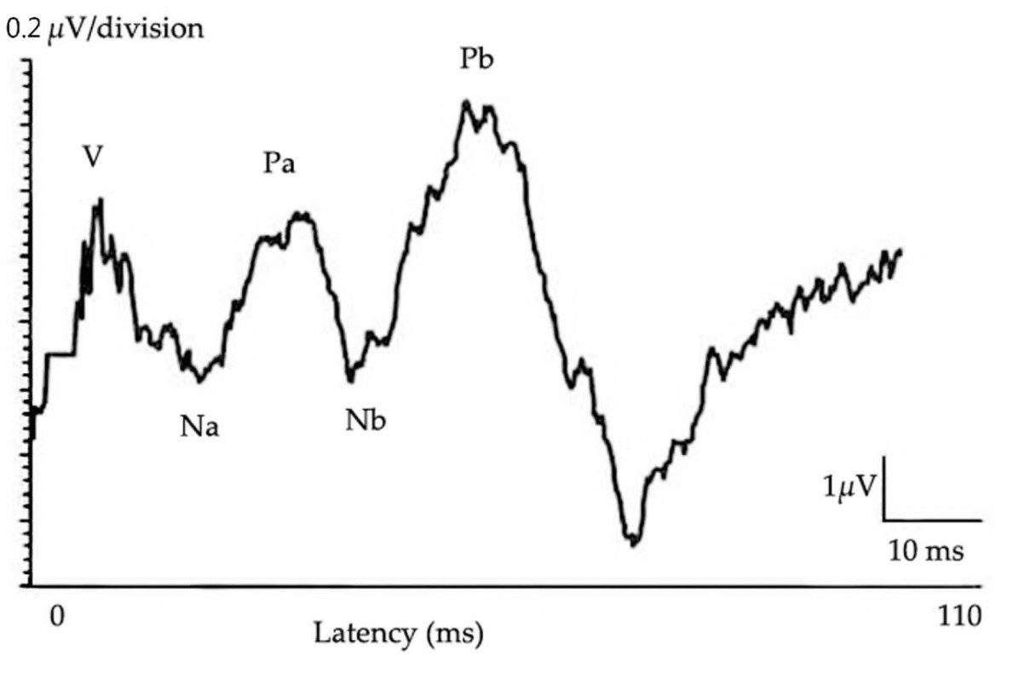

Figure 3: Normal recording of middle latency auditory evoked potentials [21].
From a methodological standpoint, the reproducibility of ASSR observed in our study reinforces its reliability as an objective measurement tool. The absence of significant variations related to age, sex, or ear tested aligns with the conclusions of several previous studies, suggesting that this technique can be used in a standardized manner across heterogeneous populations [15,16]. Furthermore, the recording conditions used in our protocol, in accordance with international recommendations, enabled stable and interpretable responses within an acceptable examination time, compatible with use in routine clinical practice.
However, certain limitations must be discussed. As reported in the literature, ASSR can sometimes overestimate hearing thresholds in patients with mild to moderate losses, necessitating cautious interpretation in this population [17]. Moreover, although ASSR provides accurate frequency-specific estimations, they do not assess speech discrimination or comprehension abilities, which remain the domain of behavioral tests [18]. Therefore, ASSR should not be considered a substitute for pure-tone audiometry, but rather as an indispensable complement within a multimodal diagnostic approach.

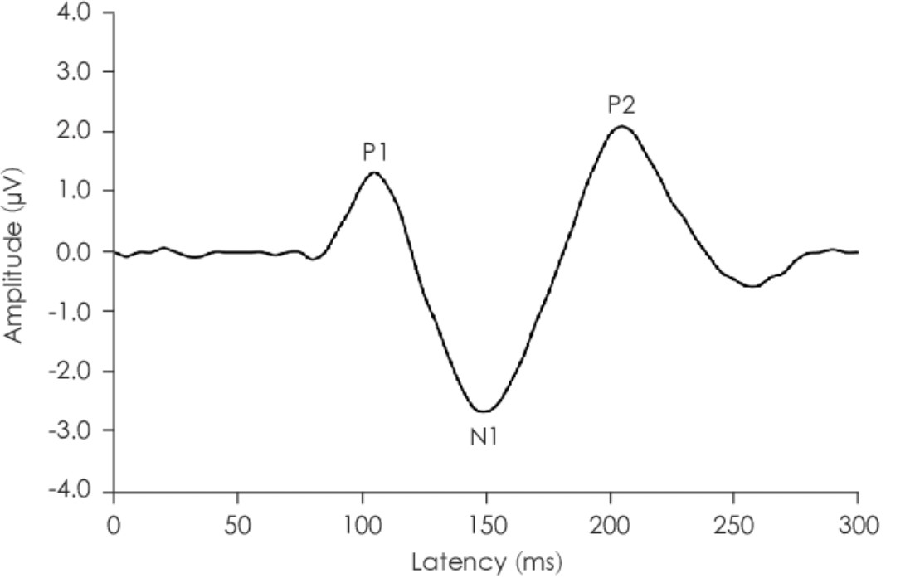
Figure 4: Normal recording of cortical auditory evoked potentials [22]
Clinically, our results confirm the major value of ASSR in several specific situations: evaluation of uncooperative patients, objective confirmation of severe or profound hearing loss, complex pre-hearing aid assessment, and pre-cochlear implant evaluation [19–20]. In these contexts, ASSR contributes to reducing diagnostic uncertainty, supporting therapeutic decision-making, and improving the overall quality of auditory care.
Finally, the systematic integration of ASSR into the audiological diagnostic toolkit appears justified, provided they are interpreted by experienced clinicians and correlated with clinical and audiometric data. Their judicious use optimizes the diagnostic pathway for patients and enhances the precision of therapeutic strategies in otolaryngology.
References :
- Hearing Loss: Determining Eligibility for Social Security Benefits. Washington, D.C.: National Academies Press, 2004, p. 11099. doi: 10.17226/11099.
- Y.-H. Lin, H.-C. Ho, and H.-P. Wu, “Comparison of auditory steady-state responses and auditory brainstem responses in audiometric assessment of adults with sensorineural hearing loss,” Auris. Nasus. Larynx, vol. 36, no. 2, pp. 140–145, Apr. 2009, doi: 10.1016/j.anl.2008.04.009.
- G. Rance, F. W. Rickards, L. T. Cohen, S. De Vidi, and G. M. Clark, “The Automated Prediction of Hearing Thresholds in Sleeping Subjects Using Auditory Steady-State Evoked Potentials:,” Ear Hear., vol. 16, no. 5, pp. 499–507, Oct. 1995, doi: 10.1097/00003446-199510000-00006.
- E. De Groote et al., “Future Perspectives on the Relevance of Auditory Markers in Prodromal Parkinson’s Disease,” Front. Neurol., vol. 11, p. 689, Jul. 2020, doi: 10.3389/fneur.2020.00689.
- “Audiology Pure-Tone Testing: Overview, Indications, Contraindications,” Nov. 2023, Accessed: Jul. 18, 2024. [Online]. Available: https://emedicine.medscape.com/article/1822962-overview?form=fpf#a1.
- “Perspectives on the Pure-Tone Audiogram.,” Read by QxMD. Accessed: Oct. 02, 2024. [Online]. Available: https://read.qxmd.com/read/28722648/perspectives-on-the-pure-tone audiogram.
- J. M. Goldberg, “The vestibular end organs: morphological and physiological diversity of afferents,” Curr. Opin. Neurobiol., vol. 1, no. 2, pp. 229–235, Aug. 1991, doi: 10.1016/0959-4388(91)90083-j.
- M. Lotti and M. L. Bleecker, Occupational neurology. in Handbook of clinical neurology, no. volume 131, 3rd series. Amsterdam, Netherlands: Elsevier, 2015.
- D. L. McCaslin, A. Rivas, G. P. Jacobson, and M. L. Bennett, “The Dissociation of Video Head Impulse Test (vHIT) and Bithermal Caloric Test Results Provide Topological Localization of Vestibular System Impairment in Patients With ‘Definite’ Ménière’s Disease,” Am. J. Audiol., vol. 24, no. 1, pp. 1–10, Mar. 2015, doi: 10.1044/2014_AJA-14-0040.
- S. E. Voss and B. S. Herrmann, “How does the sound pressure generated by circumaural, supra-aural, and insert earphones differ for adult and infantears?,” Ear Hear., vol. 26, no. 6, pp. 636–650, Dec. 2005, doi: 10.1097/01.aud.0000189717.83661.57.
- D. S. Dalton, K. J. Cruickshanks, B. E. K. Klein, R. Klein, T. L. Wiley, and D. M. Nondahl, “The impact of hearing loss on quality of life in older adults,” The Gerontologist, vol. 43, no. 5, pp. 661–668, Oct. 2003, doi: 10.1093/geront/43.5.661.
- R. Chou, T. Dana, C. Bougatsos, C. Fleming, and T. Beil, Screening for Hearing Loss in Adults Ages 50 Years and Older: A Review of the Evidence for the U.S. Preventive Services Task Force. in U.S. Preventive Services Task Force Evidence Syntheses, formerly Systematic Evidence Reviews. Rockville (MD): Agency for Healthcare Research and Quality (US), 2011. Accessed: Oct. 02, 2024. http://www.ncbi.nlm.nih.gov/books/NBK53864/ [Online]. Available:
- B. C. Kung and T. O. Willcox Jr., “EXAMINATION OF HEARING AND BALANCE,” in Neurology and Clinical Neuroscience, Elsevier, 2007, pp. 318–327. doi: 10.1016/B978-0-323-03354-1.50029-8.
- J. Katz, M. Chasin, K. M. English, L. J. Hood, and K. L. Tillery, Eds., Handbook of clinical audiology, Seventh edition. Philadelphia: Wolters Kluwer Health, 2015. Accessed: Oct. 02, 2024. [Online]. Available: http://catdir.loc.gov/catdir/enhancements/fy1503/2014014240-d.html
- J. J. Walker, L. M. Cleveland, J. L. Davis, and J. S. Seales, “Audiometry screening and interpretation,” Am. Fam. Physician, vol. 87, no. 1, pp. 41–47, Jan. 2013.
- “ISO 389-1:2017,” ISO. Accessed: Oct. 02, 2024. [Online]. Available: https://www.iso.org/standard/69855.html
- “Timothy C, Hain, MD. Audiometry. Dizziness-and-balance. 2021. - Recherche Google.” Accessed: Sep. 28, 2024. [Online]. Available: https://www.google.com/search?client=safari&rls=en&q=Timothy+C%2C+ Hain%2C+MD.+Audiometry.+Dizziness-and-balance.+2021.&ie=UTF 8&oe=UTF-8
- R. Smith, A. Shearer, M. Hildebrand, and G. Camp, “Deafness and Hereditary Hearing Loss Overview,” in GeneReviews, 2008.
- F. Tomizy, “A novel Splice Site Mutation in ADGVR1 Detected in Palestinian Family with Hearing Loss by Next Generation Sequencing,” PhD Thesis, Palestine Polytehnic University & Bethlehem University, 2016. Accessed: Jul. 19, 2024. https://scholar.ppu.edu/handle/123456789/184 [Online].
- MED-EL, “Air Conduction vs. Bone Conduction: Candidacy Guide for Bone Conduction Systems,” MED-EL Professionals Blog. Accessed: Jul. 19, 2024. [Online]. Available: conduction-candidacy-audiogram/ https://blog.medel.pro/audiology/bone
- S. M. Theodoroff, R. D. Chambers, R. L. Folmer, and G. P. McMillan, “Auditory middle latency responses in individuals with debilitating tinnitus,” vol. 16, no. 2, 2011.
- S. Z.-M. S. Mukari, C. Umat, S. C. Chan, A. Ali, N. Maamor, and M. N. Zakaria, “Effects of Age and Type of Stimulus on the Cortical Auditory Evoked Potential in Healthy Malaysian Children,” J. Audiol. Otol., vol. 24, no. 1, pp. 35–39, Jan. 2020, doi: 10.7874/jao.2019.00262.

